RPS No. 4184 – Kevin Street Lower, Dublin 8 2
RPS No. 6708 – 1 & 2 Phibsborough Road, Dublin 7 5
RPS No. 7215 – 122 Rathmines Road Lower, Dublin 6 11

RPS No. 4184 – Kevin Street Lower, Dublin 8
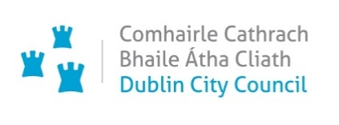
Seandálaíocht, Caomhantas & Oidhreacht
An Roinn Pleanála & Forbairt Maoine
Oifigí na Cathrach, An Ché Adhmaid, Baile Átha Cliath 8

Archaeology, Conservation & Heritage Section
Planning & Property Development Department
Block 3, Floor 3, Civic Offices, Wood Quay, Dublin 8

Tel: (01) 222 3926/3927
Email: Conservation@dublincity.ie

12th November 2021

Planning & Property Development Department

Ref. RPS 4184 DELETION from the Record of Protected Structures

Recommendation: Deletion of 5 Kevin Street Lower, Dublin 8 (existing RPS No. 4184) from the Record of Protected Structures
_________________________________________________________________________

Photograph of Modern Replacement Building
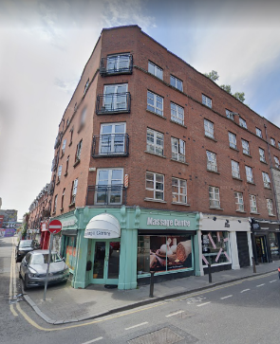

Existing RPS Number in the Dublin City Development Plan 2016-2022: 4184

Request for Deletion:
- Conservation Section, Dublin City Council

Summary of Applicant’s Reasons for Seeking Addition:
The previous structure was demolished as part of a grant of permission issued on 10 Dec 1997, planning ref. no. 0294/97. Demolition of no. 5 Lower Kevin Street and out buildings to rear and for construction of a five storey extension containing 4 no. two bedroom apartments and 4 no. one bedroom apartments over ground floor shop and a 3 storey extension containing 4 no. office suites over garages and workshop with access from Liberty Lane all as an extension to approved apartment development (Reg. Ref. 2582/95) and for addition of 3 no. two bedroom apartments to approved building and for a mansard roof over entire 5 storey building.

Location and Land Use Zoning:
The subject structure is located in an area zoned Objective Z5 “to consolidate and facilitate the development of the central area, and to identify, reinforce, strengthen and protect its civic design character and dignity”.
Figure 1: Location and Land Use Zoning

Recent Planning History:
Planning Ref. Nos. 2922/17, 2565/13, 0571/01, 1149/99, 1210/98.
Relevant Planning ref. no.0294/97. Demolition of no. 5 Lower Kevin Street and out buildings to rear and for construction of a five storey extension containing 4 no. two bedroom apartments and 4 no. one bedroom apartments over ground floor shop and a 3 storey extension containing 4 no. office suites over garages and workshop with access from Liberty Lane all as an extension to approved apartment development (Reg. Ref. 2582/95) and for addition of 3 no. two bedroom apartments to approved building and for a mansard roof over entire 5 storey building. This grant of permission issued on 10 Dec 1997.

Recent Enforcement History:
None on record

Description:
5 Kevin Street, Dublin 8 was described as ‘Shop and upper floors’ and was originally a ‘List 2’ structure under earlier City Development Plans, to 1999. The date upon which the building was ‘listed’ has not been recorded. Nevertheless, this building was demolished following the grant of planning permission, Planning Ref. 0294/97. Demolition of no. 5 Lower Kevin Street and out buildings to rear and for construction of a five storey extension containing 4 no. two bedroom apartments and 4 no. one bedroom apartments over ground floor shop and a 3 storey extension containing 4 no. office suites over garages and workshop with access from Liberty Lane all as an extension to approved apartment development (Reg. Ref. 2582/95) and for addition of 3 no. two bedroom apartments to approved building and for a mansard roof over entire 5 storey building.

A further grant of planning on the 26th of June 2001, Planning Ref. No. 0571/01 permitted the construction of 2 new 2 bedroom penthouse apartments with roof gardens on the existing roof.

The site now contains a modern six-storey structure.

NIAH Record:
There is no NIAH registration number for the building.

NIAH Significance/Rating and Assessment of Special Interest under the Planning and Development Act 2000:
The National Inventory of Architectural Heritage (NIAH) has been carried out for this area, however 5 Kevin Street Lower, Dublin 8 was not surveyed. The NIAH identifies five categories of rating in seeking to rank structures. The NIAH rating values are International, National, Regional, Local and Record Only (I, N, R, L, O). Structures which are considered of International, National, and Regional significance are deemed worthy of inclusion on the RPS.

The Conservation Section, following an external inspection of the site in June 2021 considers the current structure at College Court, 5 Kevin Street Lower, Dublin 8 to be record only. It is not considered to be of any special interest under the provisions of Section 51 of the Planning and Development Act, 2000 (as amended).

Conclusion:
5 Kevin Street, Dublin 8 originally described as ‘Shop and upper floors’ has been demolished. As it no longer exists the entry should be deleted from Dublin City Council’s Record of Protected Structures.

Recommendation:
It is recommended that 5 Kevin Street Lower, Dublin 8 be deleted from the Record of Protected Structures, in accordance with Section 12 of the Planning and Development Act, 2000 (as amended).

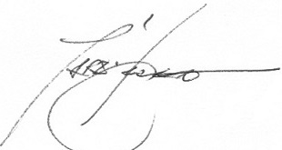 12/11/2021
_______________ ________________
Paraic Fallon
Senior Planner Date

RPS No. 6708 – 1 & 2 Phibsborough Road, Dublin 7
Seandálaíocht, Caomhantas & Oidhreacht
An Roinn Pleanála & Forbairt Maoine
Oifigí na Cathrach, An Ché Adhmaid, Baile Átha Cliath 8

Archaeology, Conservation & Heritage Section
Planning & Property Development Department
Block 3, Floor 3, Civic Offices, Wood Quay, Dublin 8

Tel: (01) 222 3926, 222 3927
Email: conservation@dublincity.ie

1st November 2021

Draft Development Plan 2022-2028

Ref: RPS 6707 & 6708 AMENDMENT to & DELETION from the Record of Protected Structures
_________________________________________________________________________

Recommendation:

Amendment of RPS 6707 and deletion of RPS 6708:

Amendment of RPS 6707: RPS 6707 - 1 Phibsborough Road, Royal Canal Terrace Dublin 7 - Terraced house, including stone wall, railings and gates to now read RPS 6707 – 1-2 Phibsborough Road, Royal Canal Terrace Dublin 7 - House

Deletion of 6708: RPS 6708 – 2 Phibsborough Road, Royal Canal Terrace Dublin 7 - Terraced house, including stone wall, railings and gates
_________________________________________________________________________

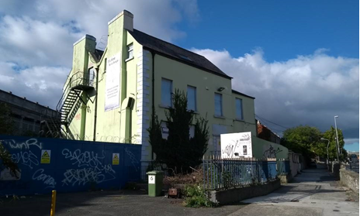

Introduction:
Numbers 1 and 2 Phibsborough Road is one building but has two separate entries in the RPS (6707 & 6708). The building description is also incorrect. RPS 6707 should be amended to include number 2 Phibsborough Road and the new description should read ‘House’. As a result of this amendment, RPS 6708 should be deleted.

Existing Listing 2016-2022
RPS Ref | Address | Description
6707 | 1 Phibsborough Road, Royal Canal Terrace Dublin 7 | Terraced house, including stone wall, railings and gates
6708 | 2 Phibsborough Road, Royal Canal Terrace Dublin 7 | Terraced house, including stone wall, railings and gates

Proposed Listing 2022-2028
RPS Ref | Address | Description
6707 | 1 & 2 Phibsborough Road, Royal Canal Terrace, Dublin 7 | House

Delete following entry
RPS Ref | Address | Description
6708 | 2 Phibsborough Road, Royal Canal Terrace, Dublin 7 | Terraced house, including stone wall, railings and gates

Request for Amendment:
It was identified by Dublin City Council that the address and description for 1 and 2 Phibsborough Road required updating. Furthermore, Dublin City Council was issued with a Ministerial Recommendation on the 4th of June 2014 from the Minister for Culture, Heritage and the Gaeltacht (now Minister for Housing, Local Government and Heritage) to include the building on the Dublin City Record of Protected Structures.

Location and Land Use Zoning:
No. 1-2 Phibsborough Road, Royal Canal Terrace Dublin 7 is located on the west side of Phibsborough Road, abutting the eastern edge of Broadstone. The area is zoned Z2 and the zoning objective for the area is: To protect and/or improve the amenities of residential conservation areas.
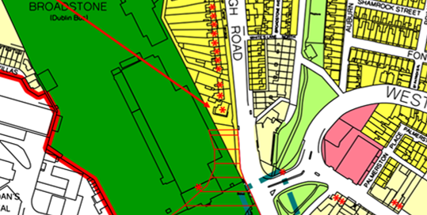
Fig. 1: Location and Land Use Zoning

Relevant Planning History:
Planning Ref. | Description | Decision Date
3258/20 | PROTECTED STRUCTURE: Permission is sought for the following works: Change of use from Hostel (established as pre 1963 use), residential and office (subsequent planning retention grant 4763/88) to Aparthotel. Demolition/removals of: steel staircase to the side, single storey extension to the rear, kitchen extract flue to the side, raised concrete paving to the front and tarmac to the side and rear, modern railings and lightwell to the side; modern shower room partitions to basement floor (BF) room (R) R1, first floor (FF) R5 and R6 and second floor (SF) R1 and R2, all sanitaryware, services, kitchenettes, floor coverings, modern flush doors and modern aluminium windows throughout; lobby partitions at ground floor (GF) R3 and the lobby door to the basement hall. Alterations to: extend lightwell to the front, create new gable walls to lightwells front and rear, block-up window at SF gable and doors at BF and SF gable, add fire-rated mat system to FF and SF floors, reconfigure partitions to FF R2, R3 & R4 and to SF R3 and close the doorway between FF R6 and the stairs; new connecting door between rooms SF R2 and R3. Construction of: single storey building to the rear and a three storey extension to the side, new light timber partitions forming new shower rooms throughout, new wall forming a lobby to the BF Hall, new plumbing, heating and electrics using existing routes throughout, new painted timber sash windows throughout, new waterproofing system to new basement insulated concrete floor slab and basement walls, breathable lime-based insulation to right-hand ‘wing’ external walls; new hard and soft landscaping to entire site, additional railings to secure the site to the front left corner and a new sliding gate inside the front railings. Clean, repair and paint cast iron railings to the front; clean granite steps, cills and string course; decorate previously decorated elements inside and out, local repairs to plaster cornices including the replacement of a short length to room FF R1 and all associated works. | 21 Oct 2020: Refuse Permission

Relevant Planning Enforcement History:
File Ref | Date Opened | Problem Description | Date Closed | Reason for closure
E0512/14 | 10-Jul-2014 | Change of use from school to hostel use | File still open

Summary Description:
(See images at end of report)
Detached, three-bay, two-storey over basement, former house, built c.1750, having two-storey single-bay extension to north elevation. In use as language school until recently, now derelict.

M-profile pitched slate roof, cast-iron rainwater goods, rendered chimneystacks abutting south elevation and to extension, rooflight to front (east) elevation. Rendered walls, render string course over basement, render block-and-start quoins. Square-headed window openings throughout, painted masonry sills and replacement uPVC windows now boarded up. Some steel grilles to windows to rear (west) elevation. Round-headed door opening to front, channelled render surround, moulded lintel, cobweb fanlight over timber panelled door, opening onto granite steps, flanked by cast-iron railings. Door opening now boarded up. Cast-iron railings enclosing curtilage to front.

Assessment:
The Royal Canal was constructed in 1792, connecting the Liffey in Dublin with the Shannon in Longford, as a means of bringing goods and passenger transport from the midlands to the capital city and port of Dublin. An important infrastructural development, its initial success is apparent in the residential development it prompted in the Phibsborough area, adjacent to the Broadstone line, a branch of the canal which linked to the Grand Canal. This substantial house (1-2 Phibsborough Road) is listed as ‘Royal Canal House’ on the third edition Ordnance Survey map and may have had a commercial function associated with the canal. Although it has lost some of its original fabric, this building makes a strong impression on the streetscape due to its prominent location and scale, and its form and character is retained.

It was identified by Dublin City Council that the address and description for 1 and 2 Phibsborough Road required updating. Numbers 1 and 2 Phibsborough Road is actually one building but has two separate entries in the RPS (6707 & 6708). The building description is also incorrect. Therefore RPS 6707 should be amended to include number 2 Phibsborough Road and the new description should read ‘House’. As a result of this amendment, RPS 6708 should be deleted.

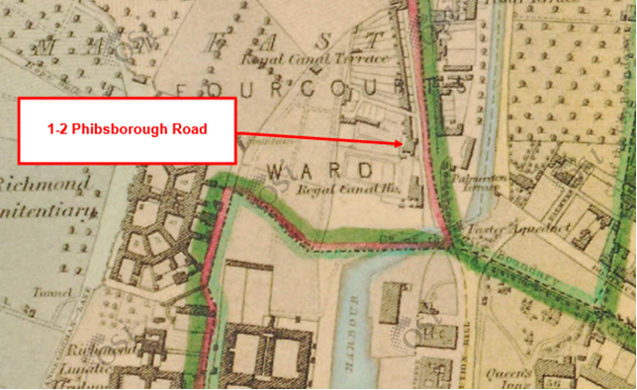
Figure 2: First Edition Ordnance Survey Map showing building

References:
NIAH Entry, Reg No: 50070371: https://www.buildingsofireland.ie/buildings-search/building/50070371/success-college-1-phibsborough-road-dublin-7-dublin

Significance/NIAH Rating:
1-2 Phibsborough Road, Dublin 7 was recorded under Stage 1 of the NIAH for Dublin (Ref 50070371) with Ministerial Recommendations for Stage 1 issued to Dublin City Council on the 4th of June 2014. The structure was assigned a ‘Regional’ rating. These are structures or sites that make a significant contribution to the architectural heritage within their region or area. Structures which are considered of Regional significance are deemed worthy of inclusion on the RPS.

Assessment of Special Interest under the Planning and Development Act 2000:
The National Inventory of Architectural Heritage assigned this building Architectural, Artistic and Social interest. The Conservation Section has considered the opinion of the NIAH and is in agreement with assigning the ARCHITECTURAL ARTISTIC and SOCIAL categories of special interest to the building.

Conclusion & Recommendation:
It is recommended that RPS 6707 be amended to include number 2 Phibsborough Road and the new description should read ‘House’. As a result of this amendment, RPS 6708 should be deleted.

Proposed Amendment to RPS 6707
RPS Ref | Address | Description
6707 | 1 & 2 Phibsborough Road, Royal Canal Terrace, Dublin 7 | House

Proposed Deletion of RPS 6708
RPS Ref | Address | Description
6708 | 2 Phibsborough Road, Royal Canal Terrace, Dublin 7 | Terraced house, including stone wall, railings and gates

01/11/2021
_______________ ________________
Paraic Fallon
Senior Planner Date

Photographic Record

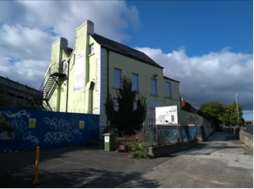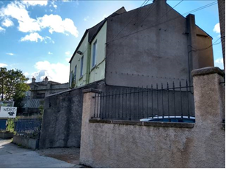
Figure 3: View of front and side elevations of 1 & 2 Phibsborough Road, Royal Canal Terrace, Dublin 7.

RPS No. 7215 – 122 Rathmines Road Lower, Dublin 6
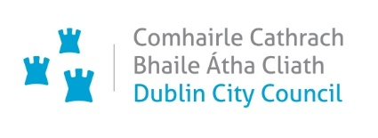
Seandálaíocht, Caomhantas & Oidhreacht
An Roinn Pleanála & Forbairt Maoine
Oifigí na Cathrach, An Ché Adhmaid, Baile Átha Cliath 8

Archaeology, Conservation & Heritage Section
Planning & Property Development Department
Block 3, Floor 3, Civic Offices, Wood Quay, Dublin 8

Tel: (01) 222 3926, 222 3927
Email: conservation@dublincity.ie

1st November 2021

Draft Development Plan 2022-2028

Ref: RPS 7217 & 7215 AMENDMENT to & DELETION from the Record of Protected Structures
_________________________________________________________________________

Recommendation:

Amendment of RPS 7217 and deletion of RPS 7215:

Amendment of RPS 7217 - current entry for 126 Rathmines Road Lower, Dublin 6 – House and business premises, to now read: 126 Rathmines Road Lower, Dublin 6 – House (also known as 122 Rathmines Road, Lower).

Deletion of 7215: RPS 7215 – 122 Rathmines Road Lower, Dublin 6 – House and business premises.
_________________________________________________________________________

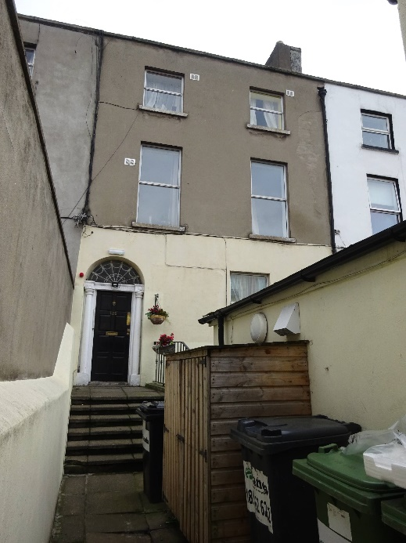

Introduction:
No.126 Rathmines Road Lower, Dublin 6 is on the current Record of Protected Structures (Dublin City Development Plan 2016-2022). The reference number is RPS: 7217 and the description reads ‘House and business premises’. The property is also known as No.122 Rathmines Road Lower, Dublin 6. A separate RPS entry has been provided for this address under reference number RPS: 7215 with a description of ‘House and business premises’. No.126 and No.122 Rathmines Road Lower, Dublin 6 are one and the same property with RPS: 7217 and RPS: 7215 constituting duplicate entries. It is proposed to rationalise the RPS entry for this structure by deleting the duplicate entry and to remove the reference to ‘business premises’ as the property is in residential use. Amendment of the written RPS description for RPS: 7217 for No.126 Rathmines Road Lower, Dublin 6 is proposed, to read ‘House (also known as 122 Rathmines Road, Lower)’. As a result it is proposed to delete the duplicate entry listed as RPS 7215 for No. 122 Rathmines Road Lower, D6.

Existing Listing for RPS 7217:
RPS Ref No | Address | Description
7217 | 126 Rathmines Road Lower, Dublin 6 | House and business premises

Proposed Listing for RPS 7217: Amend description to reflect the dual address of the property. It also proposed to amend the description to read ‘House’ only.
RPS Ref No | Address | Description
7217 | 126 Rathmines Road Lower, Dublin 6 | House (also known as 122 Rathmines Road, Lower)

Delete Following Entry for RPS 7215:
RPS Ref No | Address | Description
7215 | 122 Rathmines Road Lower, Dublin 6 | House and business premises

Request for Investigation:
Conservation Section, Dublin City Council

Location and Land Use Zoning:
The location of No.126 Rathmines Road Lower, Dublin 6 (also known as No.122 Rathmines Road Lower) is indicated by the red arrow below. The zoning objective for the site is Zone 4: To provide for and improve mixed-services facilities.
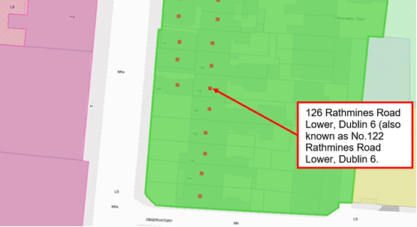
Fig.1: Location and Land Use Zoning

Relevant Planning History:
There are a number of planning applications recorded in relation to the subject site which list the address as No.126 Rathmines Road Lower, Dublin 6 (Planning Ref: 1749/95, 2418/95 and 0335/99).

Relevant Planning Enforcement History:
Three is no relevant planning enforcement history for the subject site.

Summary Description:
(See images at end of report).
Terraced two-bay three-storey house over raised basement built c.1820 having single storey business premises to front (former front garden). The single-storey business premises is listed under separate address, as No.124 Rathmines Road Lower.

Assessment:
The current Record of Protected Structures (Dublin City Development Plan 2016-2022) includes separate entries for No.126 Rathmines Road Lower, Dublin 6 (RPS ref: 7217) and No.122 Rathmines Road Lower Dublin 6 (RPS ref: 7215). The current description for both entries read ‘House and business premises’. Research in the Registry of Deeds and the Land Registry confirms that No.126 and No.122 Rathmines Road Lower, Dublin 6 are one and the same property. As such, RPS: 7217 for No.126 Rathmines Road Lower, Dublin 6 and RPS: 7215 for No.122 Rathmines Road Lower, Dublin 6 constitute duplicate entries.

It is proposed to rationalise the RPS entry for this structure by deleting the duplicate entry and to remove the reference to ‘business premises’ as the property is solely in residential use (multiple occupancy). Note that the single-storey business premises to the front (former front garden) is listed as No.124 Rathmines Road Lower and is individually protected under RPS ref: 7216 with the description reading ‘Business premises’ – no change is proposed to RPS ref: 7216. Amendment of the written RPS description for RPS: 7217 for No.126 Rathmines Road Lower, Dublin 6 is proposed, to read ‘House (also known as 122 Rathmines Road, Lower)’. It is also proposed to delete the duplicate entry listed as RPS 7215 for No. 122 Rathmines Road Lower, D6.

References:
- Ordnance Survey Mapping.
- Registry of Deeds.
- Land Registry.

Significance/NIAH Rating:
The area is currently being surveyed as part of the ongoing NIAH Dublin Survey. There is currently no NIAH record or Ministerial Recommendations for the site.

Assessment of Special Interest under the Planning and Development Act 2000:
The Conservation Section, assigns ARCHITECTURAL interest to No.126 Rathmines Road Lower, Dublin 6 (also known as No.122 Rathmines Road Lower, Dublin 6).

Conclusion & Recommendation:
It is recommended that the RPS description for RPS ref: 7217 for No.126 Rathmines Road Lower, Dublin 6 be amended to – ‘House (also known as No.122 Rathmines Road, Lower)’. It is also recommended to delete the duplicate entry for the property listed as RPS 7215 for No. 122 Rathmines Road Lower, D6.

Delete Following Entry for RPS 7215:
RPS Ref No | Address | Description
7215 | 122 Rathmines Road Lower, Dublin 6 | House and business premises

Proposed Listing for RPS 7217:
RPS Ref No | Address | Description
7217 | 126 Rathmines Road Lower, Dublin 6 | House (also known as 122 Rathmines Road, Lower)

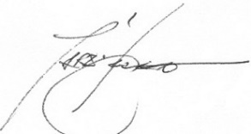 01/11/2021

_______________ ________________
Paraic Fallon
Senior Planner Date

Photographic Record:
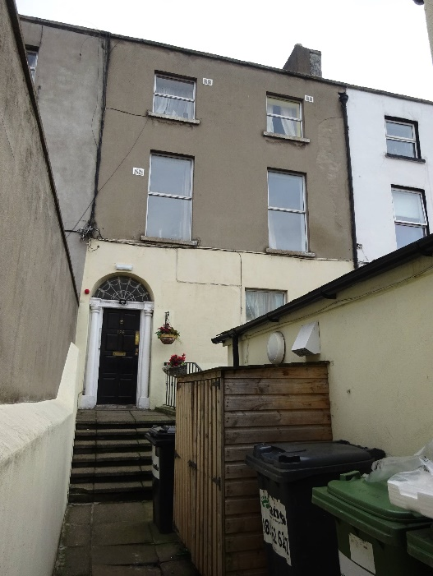 | 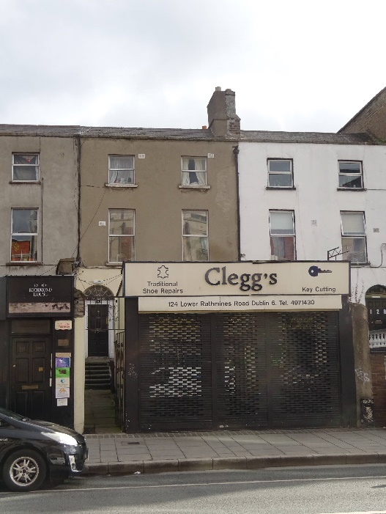
Fig.2: Principal elevation of No.126 Rathmines Road Lower (also known as No.122 Rathmines Road, Lower). | Fig.3: Aspect showing No.126 Rathmines Road Lower (also known as No.122 Rathmines Road, Lower) in context. Note the business premises to front is No.124 Rathmines Road Lower.
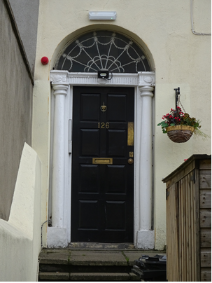
Fig.4: Detail of door to No.126 Rathmines Road Lower (also known as No.122 Rathmines Road, Lower) with door number reading ‘126’.

