Appropriate Assessment Determination
Appropriate Assessment (AA) Screening Determination Under:
Article 6(3) of the EU Habitats Directive (92/43/EEC) and the Planning and Development Act 2000 (as amended) (Section177U)
For:
VARIATION NO. 5 OF THE DUBLIN CITY DEVELOPMENT PLAN 2022 – 2028

RE: To make a technical update to the 2022 – 2028 Dublin City Development Plan in relation to ‘Build-To-Rent’ (BTR) accommodation following the publication of the guidelines ‘Sustainable Urban Housing: Design Standards for New Apartments – Guidelines for Planning Authorities, DHLGH, 2023, with transitional arrangements.
Dublin City Council determined that an Appropriate Assessment of Variation No. 5 of the Dublin City Development Plan 2022 – 2028 is not required, as the Variation, individually or in combination with other plans or projects, does not have the potential to result in any land use effects that could in turn result in likely significant effects on European sites having regard to the conservation objectives of the relevant European sites.

Variation No. 5 does not therefore require an Appropriate Assessment or the preparation of a Natura Impact Report (NIR).
This determination has been made following consideration of:

- the nature of the proposed Variation No. 5 (relating to Build-To-Rent accommodation)
- the Appropriate Assessment Screening Report and Conclusion
- the Dublin City Development Plan 2022 – 2028, and
- the Strategic Environmental Assessment (SEA) Screening Report, and
- the Chief Executive’s Report and Recommendations.

The determination and documentation is available for public inspection at the Dublin City Council Offices and on the Council’s website.
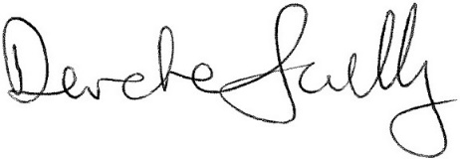
_____________________________________
City Planner

Date: 24.04.24

