Choice Based Lettings Scheme
Braithwaite Street, Off Marrowbone Lane, Dublin 8
Eligible Applicants can apply for 2x2 bed units

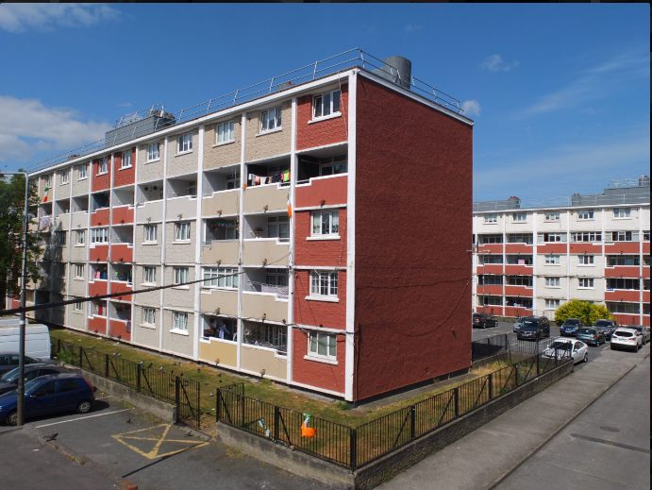

Dublin City Council is inviting eligible applicants from all our waiting lists who have selected Area L as their area of preference to apply for the above unit. It is strongly recommended that you check the website and familiarise yourself with this complex/location before applying.

Furnishings and white goods are not provided

- All Applicants must be listed for Area L. Do not apply if you do not have Area L as a preference.

- This application form can be completed online : www.dublincity.ie/Choice Based Lettings or can be returned to : Braithwaite Street CBL, Dublin City Council, Housing Allocations, Civic Offices, Wood Quay, Dublin 8.

- As the final offer is made to the applicant in the highest position, there is no supporting documentation required as only position on your waiting list is considered.

- All applications will be examined on estate management grounds including rent arrears.

- A successful applicant who refuses a Choice Based Letting will not be eligible for consideration for another Choice Based Letting Unit for a period of one year.

- Under the choice based letting scheme only the successful candidates will be notified.

- Start date of CBL advertisement is 12th April 2024, End date 03rd of May 2024 at 5pm.

- Please note late applications will not be considered.

- As per your Social Housing Application form, Dublin City Council will process your Choice Based Letting application in line with GDPR Guidelines. Please see Dublin City Council Privacy Statement on Dublin City Council website.

Application Form

Name _______________________________

Address _______________________________

_______________________________

PPSN _______________________________

Family Size ______________________________

Housing Reference Number ______________________________

Telephone/ Mobile Number ______________________________

Email address ______________________________

Applying for: Studio _____ One Bed _____ Two Bed ____

Did you read/understand the procedures above: Yes______ No _____

Signature ______________________________

Date ______________________________

