Protected Junctions

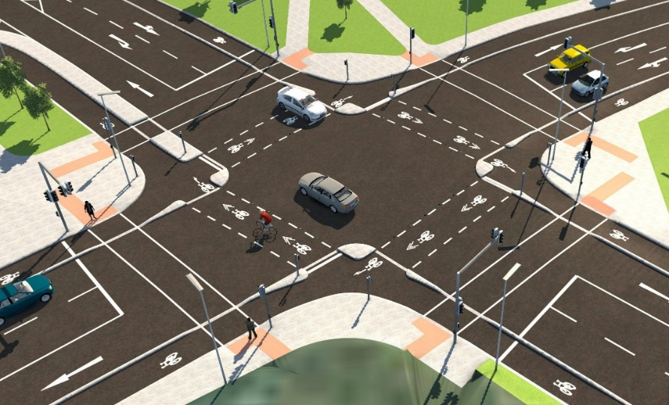

A new, safer, type of junction is being rolled out around the city

What is a protected junction?

It separates pedestrians, cyclists and vehicles as they travel through the junction.
This makes it safer for cyclists using the cycle lanes as they don’t need to mix with vehicles on the road.

Pedestrians have their own crossings, separated from bicycles.

This guide explains how these new protected junctions will work.

Guide for Drivers
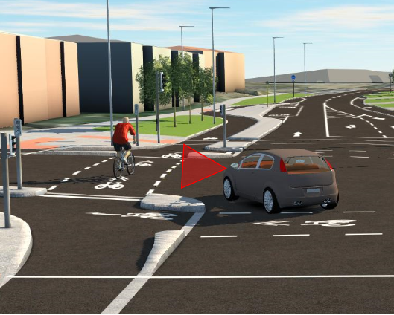
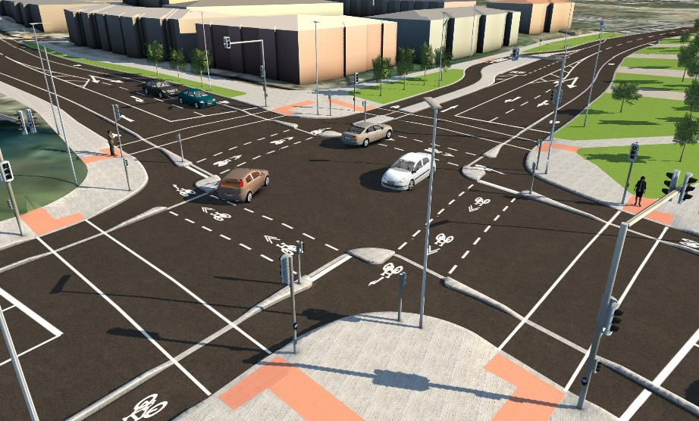
Yield to Cyclists

Proceed through the junction as normal, following the traffic lights. Be aware of the new layout.

Left-turning vehicles must yield to cyclists travelling through the junction

Remember to be alert to cyclists re-joining the carriageway

Guide for Cyclists
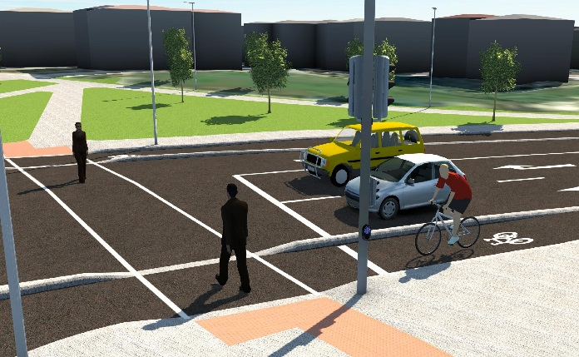
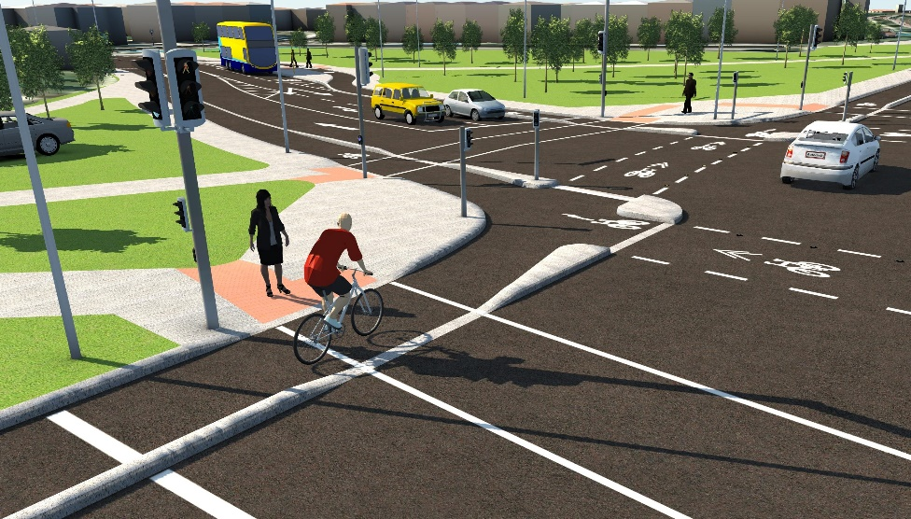

Yield to Pedestrians

Stay within the protected cycle lanes and follow the dedicated cycle signals to guide you safely through the junction.
Cross the junction using the cycle crossings, not the pedestrian crossings.
Cycle with care and always be ready to give way to pedestrians, in particular at bus stop crossing points.

Turning right for Cyclists
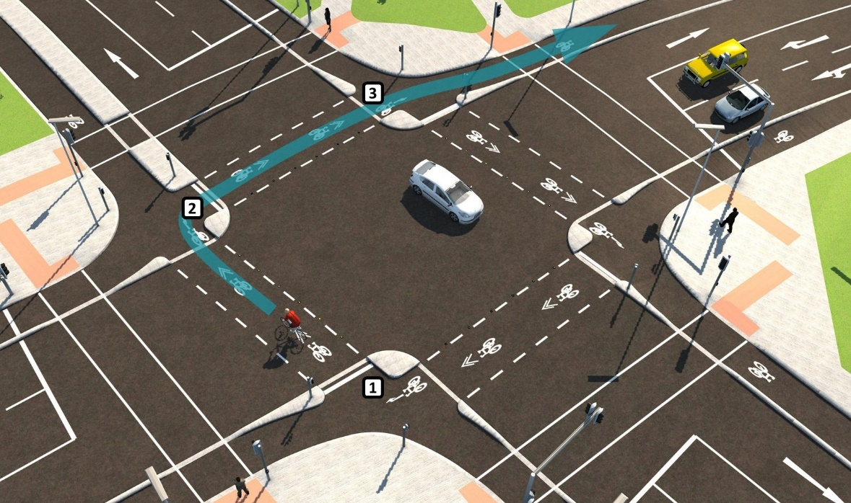

Turning right may be in two stages depending on the traffic lights.
- Cross the road with the first green light (1)
- Wait behind the cycle stop line at (2) if the signal is red
- Proceed to (3) when the signal turns green

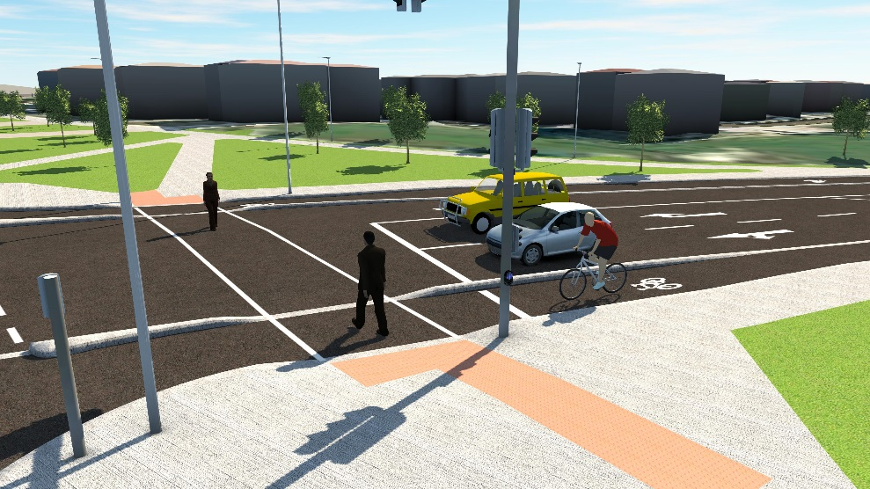

Guide for Pedestrians
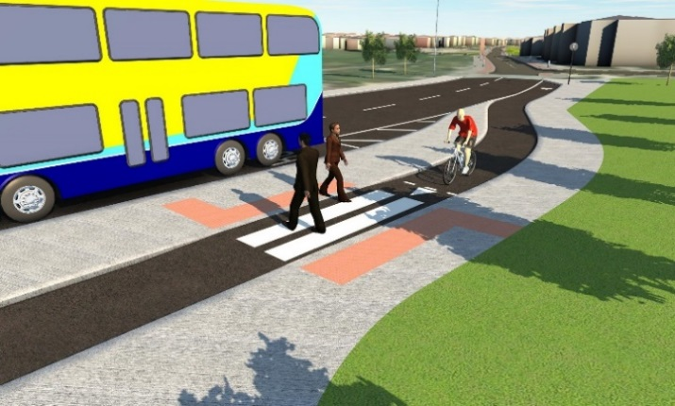
Crossing at Bus Stop Island

Cyclists and pedestrians have separate crossing points.
Wait on the footpath and use the pedestrian crossings as normal. Use the dedicated pedestrian crossing points to cross the cycle lane at the bus islands.
Be aware of approaching cyclists when you cross the cycle lane.
Cross the road using the pedestrian crossings, not the cycle crossings

e for driving

Further user advice and animated guide available at:

www.dublincity.ie/ProtectedJunctions

#Cycledublin #Handshake

