Variation (No. 31)

of the

Dublin City Development Plan

2016-2022

The Statutory Display of the Variation (No. 31)
to the Dublin City Development Plan 2016 -2022
was on view to the public by appointment from
9th November 2020 to 4th December 2020 inclusive
Monday to Friday (excluding Bank Holidays)
between the hours of 9.30 am and 4.30 pm at the

Dublin City Council
Civic Offices
Ground Floor, Block 4,
Wood Quay,
Dublin 8

___________________________________

VARIATION (NO. 31) OF THE DUBLIN CITY
DEVELOPMENT PLAN 2016 -2022

Introduction
Variation no.31 to the City Development Plan 2016-2022 designated North Great George’s Street & Environs, Dublin 1, as an Architectural Conservation Area (ACA).
The variation and the text of the Architectural Conservation Area Report were placed on public display from Monday the 9th of November 2020 to Friday the 4th of December. Following the public display a report was prepared (the Chief Executives Report) identifying, summarising and responding to the submissions received on each variation and gave the Chief Executives response and recommendations to the issues raised.
This Report is required by the variation process set out in Section 13 (4) (a) of the Planning Act 2000 (as amended)
Following consideration of the Report, the Elected Members made the decision to make the Variation on the 11th January 2021.
The rest of this document contains the Chief Executives Report as agreed by the Council, with all recommended changes agreed and included in the final ACA and variation. .

To the Lord Mayor and Report No. 07/2021
Members of Dublin City Council Report of the Chief Executive

Proposed Draft Variation (No. 31) of Dublin City Development Plan 2016 – 2022

Designating NORTH GREAT GEORGE’S STREET & ENVIRONS, DUBLIN 1, as an Architectural Conservation Area
________________________________________________________________

Executive Summary

The Variation
The variation seeks to designate North Great George’s Street & Environs, Dublin 1, as an Architectural Conservation Area (ACA). The proposed variation and text of the Architectural Conservation Area Report were placed on public display from Monday the 9th of November 2020 to Friday the 4th of December 2020 (inclusive).

The Purpose of the Variation
The purpose of an ACA is to protect and enhance the special character of the ACA by:

- Ensuring that all new development is carried out in a manner sympathetic to the special character of the area,

- Encouraging the reinstatement and enhancement of existing structures in a manner sympathetic to the special character of the area.

Submissions
In total 5 submissions were received, all from public bodies. These were the Office of the Planning Regulator, the Eastern and Midlands Regional Assembly, the Health and Safety Authority, Transport Infrastructure Ireland, and the Department of Education.

Issues Raised
All submissions either support the proposed variation or have no comment to make and consider it to be generally consistent with the Regional Spatial and Economic Strategy 2019-2031 and would support compact sustainable growth and the good management of the built heritage. The OPR submission seeks changes to encourage development of the mews lanes.

Chief Executives Response
The proposed designation as an Architectural Conservation Area of North Great George’s Street & Environs, would protect the special historic and architectural character and also support compact sustainable growth of this historic city centre area. Two additional elements of text are proposed to be added as an amendment to the ACA document to clarify the existing proposed policy framework as follows:

To subsection 10.1.1
The implementation and effectiveness of the ACA will be monitored and where it is considered, following an examination of the outcomes, that the aims of the ACA are not being achieved, a review will take place of the ACA and changes recommended.

To subsection 10.17.1 (4):

Any proposed top (fourth) storey shall be integrated within the pitched roof element of the structure or where the design and form is contemporary, it shall be set back 1.5 metres from the front building line.

The variation and ACA is, as amended, recommended for adoption.

Report of the Chief Executive on the Proposed Variation No. 31

- Introduction & Context

This Report is prepared following the public consultation on a proposed variation to the City Development Plan 2016-2022, as required by the variation process set out in Section 13 (4) of the Planning & Development Act 2000 (as amended), to designate North Great George’s Street and Environs, as an Architectural Conservation Area (ACA).

North Great George’s Street is located in the north-east inner city, approximately 0.5 km’s north-east of O’Connell Street. The street and its environs are enclosed by Parnell Square to the east, Mountjoy Square and Gardiner Street to the west, Parnell Street to the south and Dorset Street to the north. This area forms part of a vibrant commercial and residential north inner city community, which is comprised of a strong mix of urban land uses.

The boundaries of the proposed North Great George’s Street & Environs ACA, include; Rutland Place, Parnell Place (part of), North Great Georges Street (part of) the rear of property fronting Parnell Street (south-side), Marlborough Street (part of), Temple Lane North (part of), the rear of property fronting onto Hill Street, Grenville Street (part of), Bath Lane, Grenville Lane, Nerney’s Court (part of), Temple Street (part of), the side and rear of property fronting onto Denmark Street Great (north-side) and Fredericks Lane (part of).

The exact boundaries are delineated on the attached map by the red-lined area and are described in the text of the Architectural Conservation Area Report.

Map 1: Proposed Architectural Conservation Area boundary map for North Great George’s Street and Environs.

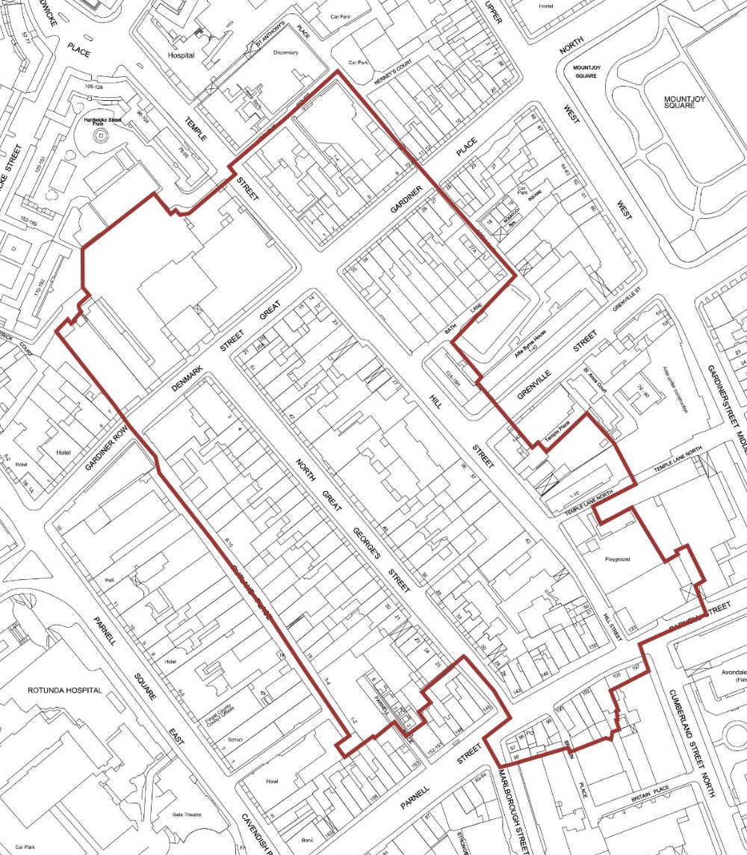

- Purpose of the Variation
It is proposed to vary the Dublin City Council Development Plan 2016-2022 by designating North Great George’s Street and Environs, as an Architectural Conservation Area (ACA). The purpose of an ACA is to protect and enhance the special character of the ACA by:

- Ensuring that all new development is carried out in a manner sympathetic to the special character of the area,

- Encouraging the reinstatement and enhancement of existing structures in a manner sympathetic to the special character of the area.

The area has a significant and varied stock of late eighteenth, nineteenth and twentieth century structures, although it is primarily defined by late eighteenth century buildings laid out in a terraced streetscape, which remains the focal point of the area to the present day. North Great George’s Street is one of the significant historic streets of Dublin city, it was laid out for residential use in the mid-18th Century, with the majority of the houses built in the 1770’s and 1780’s. It was constructed on the basis of a modular plan, adapted to residential plot multiples, allowing developers to enter into leases for the purchase of plots. Belvedere House, on Denmark Street Great was completed in 1786, terminating the vista to the north end of the Street.

The area has a mix of commercial and residential structures that reflects the different building styles of the mid-late eighteenth century, the nineteenth and early twentieth century, as well as more recent periods. The buildings of North Great George’s Street and its environs are laid out mainly in long and short terrace form, although there are two and three storey structures in the area, most of the principal commercial and residential structures are four storeys in height, with some having an additional roof level. These principal buildings are mainly finished externally in red and/or brown brick, though there are some rendered facades. Many original materials and details survive, including pitched roofs with natural slates and ridge detailing, timber sash and some casement windows, ironwork including railings, gates, boot-scrapers etc.

Most of the commercial frontages within the ACA are twentieth century, although a number of important nineteenth century frontages remain. The area consists of a rich urban mix of residential, commercial, institutional and retail uses as part of a vibrant inner city neighbourhood.

The ACA, as proposed, also includes the former mews plots and other lands associated with and/or located to the rear of North Great George’s Street, which are situated on the east side of Rutland Place and on the west side of Hill Street. These plots and parcels of lands and buildings, including modern apartment developments, have an historical association and/or such significant and proximate inter-relationships with the principal buildings of North Great George’s Street, Great Denmark Street, Gardiner Place and Parnell Street, that justifies their inclusion within the boundary of the ACA, in the interest of the protection of the special character of the area and its proper planning and sustainable development.

The proposed designated area (see Map 1 below) of the ACA is configured so that it connects with the already designated O’Connell Street ACA (2001), which already includes the historic streetscape on the southwest corner of North Great George’s Street and the adjoining terraces on Parnell Street’s north side. Similarly, the proposed ACA also extends to the north and east along Gardiner Place, as far as Nerney’s Court, to connect with the Mountjoy Square ACA (adopted in 2012), and incorporates the adjacent part of Hill Street and the lower part of Temple Street (east and west sides).

Procedure followed

Public Notice and Display
Members of the public were invited to make submissions regarding the proposed draft variation. In accordance with the procedures set out in Section 13 of the Planning and Development Acts, 2000-2010, a public notice was inserted in the Irish Independent on 9th November 2020. The proposed variation No. 31 was placed on public display from Monday 9th November 2020 to Friday 4th December 2020 inclusive at the Civic Offices.

Notice and copies of the proposed variation of the Development Plan, together with the SEA and AA screening reports, were made available for inspection, by appointment, at the Civic Offices, Wood Quay, Dublin 8 within the above listed dates. Details were also made available on Dublin City Councils’ website at www.dublincity.ie.

Strategic Environmental Appraisal
The Planning Authority determined, using the screening criteria set out in Schedule 2A Planning and Development Regulations 2001-2010, the DECLG SEA Guidelines and Annex 2 of Directive 2001/42/EC, that a Strategic Environmental Assessment was not required for the proposed draft variation to the Dublin City Development Plan 2016-2022 for the area set out above.

Appropriate Assessment
An Appropriate Assessment Screening was undertaken of the proposed draft variation of the Dublin City Development Plan, in accordance with the requirements of Article 6(3) of the EU Habitats Directive (92/43/EEC). The proposed draft variation is not predicted to have a likely impact on the key features or the conservation function of any Natura 2000 sites.

The prescribed bodies were notified of the above determination in relation to the SEA and AA screening and have not objected to the conclusions within the appropriate period.

- Report on Submissions and Observations

4.1 List of Submissions received
The following persons or bodies made submissions or observations in relation to the proposed variation of the Development Plan:

Submission No | Name | Organisation/Individual
1 | Jim Conway, | Director, Eastern and Midland Regional Assembly,
2 | Tara Horigan, | Health & Safety Authority (HSA) COMAH, Chemical Production & Storage (CCPS), Health and Safety Authority.
3 | Mark Byrne | Regulatory and Administration Unit, Transport Infrastructure Ireland
4 | Alan Hanlon | Statutory Plans, Forward Planning Section, Department of Education
5 | Anne Marie O’Connor | Office of the Planning Regulator.

As a limited number of submissions have been received, each submission shall be addressed separately.

4.2 Submission by the Eastern and Midland Regional Assembly (EMRA)

Summary of Submission
The submission sets out that the Planning Authority shall ensure, when making a variation to the Development Plan, that it is consistent with the Regional Spatial and Economic Strategy for the Eastern and Midland Region. The Regional Assembly welcomes the proposed Variation to the City Development Plan. The Regional Spatial and Economic Strategy (RSES) 2019-2031 sets out strategic policy to promote sustainable compact growth and urban regeneration by making better use of urban lands and promoting consolidation and good management of our built heritage - Regional Strategic Outcomes (RSOs) 1, 2 and 5 refer. The RSES includes a key Regional Policy Objective (RPO) 9.27 to support this through the protection of historic buildings and the promotion of heritage-led regeneration in our cities and towns.

It is considered that the proposed variation is consistent with the Regional Spatial and Economic Strategy (RSES) 2019-2031, which seeks to promote the compact growth of Dublin city and suburbs and would support the provision of sustainable development as set out in the core strategy of the Dublin City Development Plan.

The Regional Assembly has no objection to the proposed variation.

Chief Executive’s Response
The support of the Eastern and Midland Regional Assembly is noted.

Recommendation
No change.

4.3 Submission by the Health and Safety Authority (HSA)

Summary of Submission
The Health & Safety Authority (the Authority) is required to be consulted in relation to Development Plans under sections 11-13 & 24 of the Act.

The approach of the Authority to Land-use Planning is set out in the document ‘Policy & Approach of the Health and Safety Authority to COMAH Risk-based Land-use Planning’.
The document should be consulted to fully understand the advice given in this letter.

The Authority would expect the planning guidelines to contain:
- An indication of planning policy in relation to major accident hazard sites notified under the regulations, which reflects the intentions of Article 13 of Directive 2012/18/EU.

- The Consultation distances and generic advice, where applicable, supplied by the Authority to Dublin City Council in relation to such sites. These distances to be indicated on the various maps included in the plan, as well as any more specific distances and advice supplied by the Authority.

- A policy on the siting of new major hazard establishments, taking account of Article 13 and the published policy of the Authority in relation to new developments, including developments in the vicinity of such establishments.

- There are currently no notified establishments in the area of Variation No.31 – North Great Georges Street.

Chief Executive’s Response
It is noted there are no notified establishments in the variation area and therefore no specific response is required.

Recommendation
No change.

4.4 Submission by Transport Infrastructure Ireland (TII)

Summary of Submission
The southern part of the proposed ACA forms part of the LUAS buffer zone. Accordingly, please be aware that the LUAS Code of Practice applies.

Any proposed development in the LUAS buffer zone shall comply with TII’s “Code of engineering practice for works on, near, or adjacent the Luas light rail system”.

Chief Executive’s Response
This Code of Practice for engineering works is the subject of separate regulatory framework which does not impact on the proposed variation and ACA.

Recommendation
No change.

4.5 Submission by the Department of Education

Summary of Submission
Department of Education has no comment to make.

Chief Executive’s Response
The content of the submission is noted.

Recommendation
No change.

4.6 Office of the Planning Regulator (OPR)

Summary of Submission
The Office of the Planning Regulator (OPR) is required to make observations or recommendations on statutory plans or variations to ensure effective co-ordination of national, regional and local planning requirements. The Office has evaluated and assessed the proposed variation, under the provisions of sections 31AM(1) and (2) of the Act. The National Planning Framework 2040 (NPF), the Regional Spatial and Economic Strategy and the Sustainable Residential Development in Urban Areas Guidelines for Planning Authorities (2009) and the Sustainable Urban Housing: Design Standards for New Apartments (2018) require high density compact growth in inner urban areas. Whilst balanced against objectives to protect and enhance built heritage, the development restrictions under section 10.17 Policy Guidance – Mews Developments has potential to mitigate against regeneration in accordance with compact growth. The Office advises that the effectiveness of the variation in facilitating/encouraging the redevelopment of the properties along Rutland Place for active residential use should be kept under review, with a view to implementing changes to maximise same, as necessary.

It is concluded that no recommendations are warranted under the provisions of section 31AM(3)(a) of the Act, it is advised that the City Council have regard to the above to ensure the appropriate framework for the delivery of compact growth is provided.

Chief Executive’s Response
The submission is noted. The City Council through the City Development Plan is implementing policies for the compact growth of the city. Part of the compact city policy is to enhance and protect the special character of the city; recognising its intrinsic value and in giving the city a quality that is attractive to both residents and investors. The enhancement and protection of the historic city is integral to the overarching policy to create a more compact city.

With regard to subsection 10.17, this refers specifically to the remaking of the rear laneway to North Great George’s Street, Parnell Square East and Cavendish Row, with a more dense development of three storeys and up to 4 storeys in height. This process will assist an increase in the population, stimulate the vitality of the local economy and rebuild a degraded streetscape therefore aiding the regeneration of the local area.

Recommendation
In response to the above submission and in order to clarify the existing proposed policy framework, the following texts shall be added to the ACA –

To subsection 10.1.1
The implementation and effectiveness of the ACA will be monitored and where it is considered, following an examination of the outcomes, that the aims of the ACA are not being achieved, a review will take place of the ACA and changes recommended.

To subsection 10.17.1 (4):

Any proposed top (fourth) storey shall be integrated within the pitched roof element of the structure or where the design and form is contemporary, it shall be set back 1.5 metres from the front building line.

- Recommendation to City Council

Having regard to the submissions received and to the Chief Executive’s response to the issues raised therein, accordingly, it is recommended that the City Council adopt the proposed variation (No.31) of the Dublin City Development Plan 2016-2022 as amended to designate North Great George’s Street and Environs, as an Architectural Conservation Area.

Dated this day the 11th of January 2021.

Owen Keegan
Chief Executive

- Resolution on Adopting Variation 31.

I recommend that the Elected Members adopt the following resolution:

‘The members of the authority having considered the proposed variation and the Chief Executive’s Report No. 07/2021, and the issues raised, the proper planning and sustainable development of the City, the statutory obligations of the local authority and the relevant policies or objectives of the Government or of any Minister of the Government; the City Council resolves that Variation No. 31 of the Dublin City Development Plan 2016-2022 as amended is hereby made and that the necessary notices of the making of Variation No. 31 of the Dublin City Development Plan 2016-2022 be published’.

