RPS No. 834 - Bloomfield Avenue, Dublin 4 3
RPS No. 836 - Bolton Street, Dublin 1 9
RPS No. 838 - 57 Bolton Street, Dublin 1 15
RPS No. 839 - 58-59 Bolton Street, Dublin 1 20
RPS No. 1541 & 1542 & 7863 – 2, 3, & 4 Church Lane & 1-2 Suffolk Street, Dublin 2 25
RPS No. 1901 - Clonliffe Road, Dublin 3 32
RPS No. 2289 - 20, 20a & 21 Denmark Street Great, Dublin 1 37
RPS No. 2302 - D'Olier Street, Dublin 2 44
RPS No. 2330 - 12 Dorset Street Upper, Dublin 1 49
RPS No. 2335 - 75 Dorset Street Upper, Dublin 1 55
RPS No. 2336 - 76 Dorset Street Upper, Dublin 1 60
RPS No. 2337 - 77 Dorset Street Upper, Dublin 1 65
RPS No. 2338 - 78 Dorset Street Upper, Dublin 1 70
RPS No. 2339 - 79 Dorset Street Upper, Dublin 1 76
RPS No. 2361 - 81 Drumcondra Road Lower, Dublin 9 82
RPS No. 2486 – 15-17 Eden Quay, Dublin 1 88
RPS No. 2696 - 9&10 Eustace Street, Dublin 2 96
RPS No. 3300 - Granite Terrace, off Inchicore Terrace South, Dublin 8 103
RPS No. 3328 - 2 Green Street East, Dublin 2 108
RPS No. 3651 - 4 Henrietta Street, Dublin 1 112
RPS No. 3823 - Highfield Road, Dublin 6 118
RPS No. 4051 - 108 James's Street, Dublin 8 124
RPS No. 5267 - 33 Molesworth Street, Dublin 2 129
RPS No. 5268 - 34 Molesworth Street, Dublin 2 134
RPS No. 5412 - 1 Mountjoy Square North, Dublin 1 139
RPS No. 5790 – Mullingar House, 9 Mullingar Terrace, Chapelizod Road, Dublin 20 144
RPS No. 5835 - North Wall Quay, Dublin 1 149
RPS No. 6016 – 1-2 O'Connell Street Upper, Dublin 1 153
RPS No. 6020 – Parnell Monument O'Connell Street Upper, Dublin 1 158
RPS No. 6021 – 37-38 O'Connell Street Upper, Dublin 1 162
RPS No. 6023 - 43 O'Connell Street Upper, Dublin 1 168
RPS No. 6024 - 44 O'Connell Street Upper, Dublin 1 173
RPS No. 6026 - 57 O'Connell Street Upper, Dublin 1 178
RPS No. 6027 - 58 O'Connell Street Upper, Dublin 1 183
RPS No. 6028 - 60 O'Connell Street Upper, Dublin 1 189
RPS No. 6029 - 61 O'Connell Street Upper, Dublin 1 196
RPS No. 6030 - 62 O'Connell Street Upper, Dublin 1 201
RPS No. 6031 – 63-64 O'Connell Street Upper, Dublin 1 206
RPS No. 6033 - 67 O'Connell Street Upper, Dublin 1 212
RPS No. 6034 – 68-69 O'Connell Street Upper (including 31 Henry Street), Dublin 1 218
RPS No. 6707 – 1-2 Phibsborough Road, Royal Canal Terrace Dublin 7 226
RPS No. 7217 - 126 Rathmines Road Lower, Dublin 6 231
RPS No. 7430 - 37 Sandford Road, Dublin 6 236
RPS No. 7468 - 12, 13, 14a, 14b, 14c & 14d Sandymount Green, Dublin 4 240
RPS No. 7542 - Sir John Rogerson's Quay, Dublin 2 247
RPS No. 7547 – 25-27 Sir John Rogerson's Quay, Dublin 2 251
RPS No. 7551 - Smithfield, Dublin 7 258
RPS No. 8553 - 1B Whitefriar Place, Dublin 8 265
RPS No. 8554 - 2 Whitefriar Place, Dublin 8 270
RPS No. 8555 - 3 Whitefriar Place, Dublin 8 275
RPS No. 8560 – 38-46 Wicklow Street, Dublin 2 280

RPS No. 834 - Bloomfield Avenue, Dublin 4
Seandálaíocht, Caomhantas & Oidhreacht
An Roinn Pleanála & Forbairt Maoine
Oifigí na Cathrach, An Ché Adhmaid, Baile Átha Cliath 8

Archaeology, Conservation & Heritage Section
Planning & Property Development Department
Block 3, Floor 3, Civic Offices, Wood Quay, Dublin 8

Tel: (01) 222 3926, 222 3927
Email: conservation@dublincity.ie

29th October 2021

Draft Development Plan 2022-2028

Ref: RPS 834 AMENDMENT to the Record of Protected Structures
_______________________________________________________________________________

Recommendation:
Amendment of current entry for Bloomfield Avenue, Dublin - (a) 18th century core of Bloomfield Hospital, and (b) Swanbrook House. Excluding (i) New Lodge and its 1980s extension, (ii) the single-storey detached structure north of “Westfield”, and (iii) the laundry/ maintenance building, to now read: Bloomfield Avenue, Dublin 4 - Swanbrook House and 18th century core of former Bloomfield Hospital.
_______________________________________________________________________________

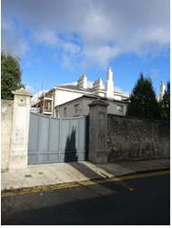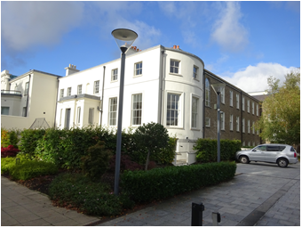

Introduction:
The 18th century core of the former Bloomfield Hospital and the adjacent Swanbrook House are on the current Record of Protected Structures (Dublin City Development Plan 2016-2022). The reference number is RPS: 834 and the description reads ‘(a) 18th century core of Bloomfield Hospital, and (b) Swanbrook House. Excluding (i) New Lodge and its 1980s extension, (ii) the single-storey detached structure north of “Westfield”, and (iii) the laundry/ maintenance building’. The site was redeveloped under Planning ref: 3787/01 which provided for demolition of the New Lodge and its extension, the single-storey detached structure north of “Westfield”, and the laundry/ maintenance building’. Amendment of the RPS entry is proposed to reflect the current site context and to include the postal area in the address field.

Existing Listing:
RPS Ref No | Address | Description
834 | Bloomfield Avenue, Dublin | (a) 18th century core of Bloomfield Hospital, and (b) Swanbrook House. Excluding (i) New Lodge and its 1980s extension, (ii) the single-storey detached structure north of “Westfield”, and (iii) the laundry/ maintenance building.

Proposed Listing: Amend description to reflect the current site context and amend the address field to include the postal area.
RPS Ref No | Address | Description
834 | Bloomfield Avenue, Dublin 4 | Swanbrook House and 18th century core of former Bloomfield Hospital.

Request for Investigation:
Conservation Section, Dublin City Council

Location and Land Use Zoning:
The locations of Swanbrook House and the 18th century core of the former Bloomfield Hospital at Bloomfield Avenue, Dublin 4 are indicated by the red arrows below. The zoning objective for the site is Zone 1: To protect, provide and improve residential amenities.
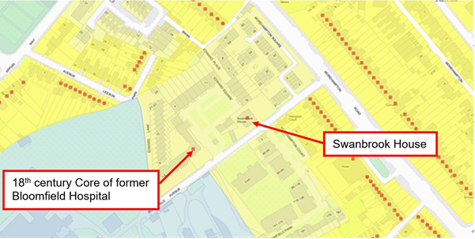
Fig.1 Location and Land Use Zoning

Relevant Planning History:
Planning Ref. | Description | Decision Date
3787/01 | Construction of a residential and office development at Bloomfield House, Bloomfield Avenue, Donnybrook, Dublin 4 to include the demolition of the New Lodge and extension, single storey nurses home, and single storey laundry building. | 15-April-2003 Grant Permission
A number of additional planning applications are recorded in relation to the former Bloomfield Hospital and Swanbrook House site, however these are of no immediate relevance to the subject clarification.

Relevant Planning Enforcement History:
A number of enforcement cases have been raised in relation to the former Bloomfield Hospital and Swanbrook House site, however none are of immediate relevance to the subject clarification.

Summary Description:
(See images at end of report).
The property formerly known as Bloomfield Hospital is a late 18th century six-bay two-storey over raised basement former house having a projecting bow-fronted bay to the north elevation. The property is currently in use as apartments. Swanbrook House, to the east of Bloomfield, is a detached three-bay two-storey house, built c.1820 having two two-storey returns originally forming a ‘U-shaped’ ground plan, now with infill extension. The property boundary is formed by a roughly coursed Calp limestone and granite wall to Bloomfield Avenue, having a variety of granite and rendered piers.

Assessment:
Bloomfield Hospital, on Bloomfield Avenue, Donnybrook was established c.1810 by the Society of Friends (Quakers) for the provision of care facilities for those “afflicted with disorders of the mind”. The hospital grew during the 19th and 20th centuries undergoing significant expansion and extension to include the incorporation of the adjacent early-19th century Swanbrook House.

In April 2001, the 18th century core of Bloomfield Hospital, and Swanbrook House were added to the Record of Protected Structures by Resolution of Dublin City Council (Report of Assistant City Manager Report No.113/01). A number of ancillary buildings, to include: the New Lodge built c.1960 and its 1980's extension; and the single storey detached structure north of 'Westfield' (Westfield was the name given to the early hospital wing running parallel to Bloomfield Avenue) were specifically excluded from protection. In February 2003, a variation to the RPS entry was made to also exclude the laundry/maintenance building from protection (Report of Assistant City Manager Report No.56/2003). Following this the description for the RPS entry for the site on Bloomfield Avenue read ‘(a) 18th century core of Bloomfield Hospital, and (b) Swanbrook House. Excluding (i) New Lodge and its 1980s extension, (ii) the single-storey detached structure north of “Westfield”, and (iii) the laundry/ maintenance building’.

Planning permission was granted in April 2003 under planning ref: 3787/01 for the redevelopment of the former Bloomfield Hospital site at Bloomfield Avenue for residential and office use. The permission granted the demolition of a number of ancillary structures on the site to include the ‘New Lodge and its extension, the single storey nurses home, and single storey laundry building’. GIS Aerial photography for the site indicates that the structures were demolished prior to 2005. On this basis, it is proposed to amend the RPS description for the entry to reflect the current site context and the demolition of the New Lodge and its 1980s extension, the single-storey detached structure north of "Westfield", and the laundry/maintenance building. The building is no longer a hospital and is currently in residential use. As such, it is recommended to amend the description for RPS 834 to read ' Swanbrook House and 18th century core of former Bloomfield Hospital'.

In addition it is recommended that the address field for the RPS entry be amended to include the postal area for the site to read ‘Bloomfield Avenue, Dublin 4’.

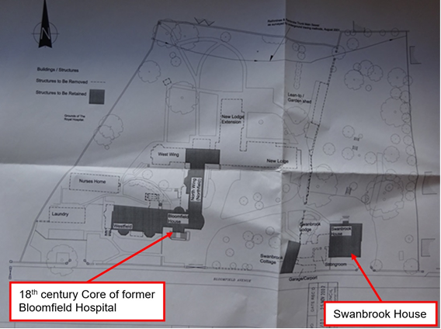
Fig.2 Survey drawing from planning file: 3787/01 identifying structures to be demolished. These are indicated by a dashed line and included New Lodge and its extension, the single-storey detached structure north of Westfield (identified as Nurses Home), and the laundry building.

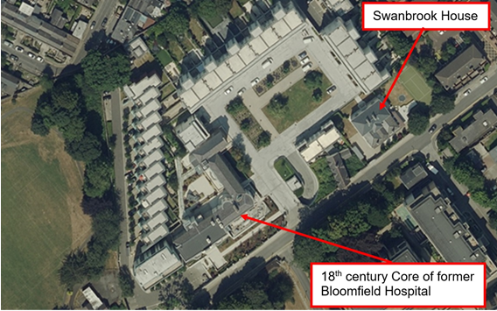
Fig.3 DCC GIS Aerial Photograph dated 2018 showing current site following development. The New Lodge and its 1980s extension, the single-storey detached structure north of Westfield, and the laundry/ maintenance building have been demolished as per granted planning permission file: 3787/01.

References:
- Ordnance Survey Mapping.
- GIS Aerial photography.
- Report of Assistant City Manager Report No.113/01.
- Report of Assistant City Manager Report No.56/2003.
- Planning file ref: 3787/01.

Significance/NIAH Rating:
The area is currently being surveyed as part of the ongoing NIAH Dublin Survey. There are currently no NIAH records or Ministerial Recommendations for the site.

Assessment of Special Interest under the Planning and Development Act 2000:
The Conservation Section, assigns ARCHITECTURAL, HISTORICAL and SOCIAL interest to Swanbrook House and 18th century core of the former Bloomfield Hospital.

Conclusion & Recommendation:
It is recommended that the RPS description for RPS ref: 834 for Bloomfield Avenue, Dublin be amended to – ‘Swanbrook House and 18th century core of former Bloomfield Hospital’ and to amend the address field to include the postal area.

Proposed Listing:
RPS Ref No | Address | Description
834 | Bloomfield Avenue, Dublin 4 | Swanbrook House and 18th century core of former Bloomfield Hospital.

29/10/2021
_______________ ________________
Paraic Fallon
Senior Planner Date

Photographic Record:
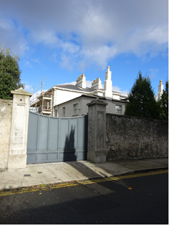 | 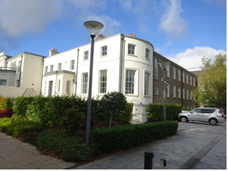
Fig.4 Swanbrook House taken from Bloomfield Avenue. | Fig.5 Former Bloomfield Hospital taken from Bloomfield Avenue.

RPS No. 836 - Bolton Street, Dublin 1
Seandálaíocht, Caomhantas & Oidhreacht
An Roinn Pleanála & Forbairt Maoine
Oifigí na Cathrach, An Ché Adhmaid, Baile Átha Cliath 8

Archaeology, Conservation & Heritage Section
Planning & Property Development Department
Block 3, Floor 3, Civic Offices, Wood Quay, Dublin 8

Tel: (01) 222 3926, 222 3927
Email: conservation@dublincity.ie

29th October 2021

Draft Development Plan 2022-2028

Ref: RPS 836 AMENDMENT to the Record of Protected Structures
_______________________________________________________________________________

Recommendation:
Amendment of current entry for Bolton Street, Dublin 1 – College of Technology: original building only to now read: Original 1911 building including 1930's extension, Technological University Dublin, Bolton Street Campus
_______________________________________________________________________________

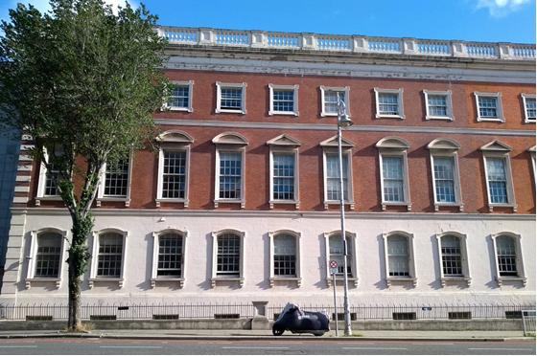

Introduction
There has been a query about the protection of the 8-bay 1930’s extension to Bolton Street College of Technology. Although built in the exact same style as the earlier 13-bay building which had been constructed in 1911 and despite forming part of this significant streetscape, it is not protected. The name of the college has also changed to TU Dublin. Therefore it is recommended to amend the current entry for RPS 836: College of Technology: original building only to now read: Original 1911 building including 1930's extension, Technological University Dublin, Bolton Street Campus.

Existing Listing
RPS Ref No | Address | Description
836 | Bolton Street, Dublin 1 | College of Technology: original building only

Proposed Listing: Amend description to include 1930s extension.
RPS Ref No | Address | Description
836 | Bolton Street, Dublin 1 | Original 1911 building including 1930's extension, Technological University Dublin, Bolton Street Campus

Request for Amendment
It was identified by Dublin City Council that the 1930’s extension to the College of Technology on Bolton Street was not protected. Furthermore, Dublin City Council was issued with a Ministerial Recommendation on the 4th of June 2014 from the Minister for Culture, Heritage and the Gaeltacht (now Minister for Housing, Local Government and Heritage) to include the building on the Dublin City Record of Protected Structures.

Location and Land Use Zoning
The location of the original 1911 building including the 1930's extension at Technological University Dublin, Bolton Street Campus, Dublin 1 is arrowed red below. The main zoning objective is Zone 5: To consolidate and facilitate the development of the central area, and to identify, reinforce, strengthen and protect its civic design character and dignity.
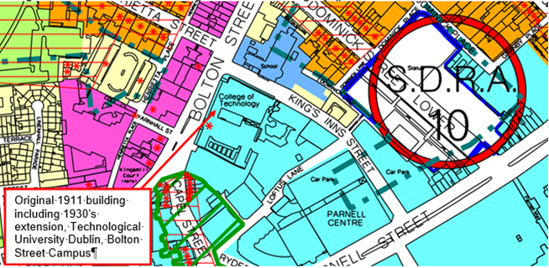
Figure 1: Location and Land Use Zoning

Summary Description
(See images at end of report)
The present college complex is bounded to the north by King’s Inns Street, to the east by Loftus Lane, to the south by the rear gardens and lane to Nos. 68 – 84 Capel Street and to the west by Bolton Street. The NIAH describe the building as follows: Attached twenty-one bay three-storey neo-Classical college building over exposed basement, thirteen southern bays built 1909-11 and having central pedimented entrance breakfront and four-storey brick wings to rear. The NIAH incorrectly attribute the 8-bay facsimile extension to the 1961 work by Hooper and Mayne. This work was carried out in circa 1930-1931 by Robinson & Keefe Architects.

The construction of the original H-shaped four-storey City of Dublin Technical School to designs by Dublin City Architect, Charles J. McCarthy (b.1858 d.1947) was commenced in 1907. It was completed in 1911 by contractors H & J Martin for the sum of £34,000.00. McCarthy held the position of City Architect from 1893 – 1921 and was the son of architect J.J. McCarthy, renowned for his neo-gothic churches and other important buildings throughout the country. Classes in Building Construction and Drawing, and Building Surveying and Estimating moved from the City of Dublin Technical School in Kevin Street to the newly built Bolton Street College in 1911, where a new class in building construction was developed specifically for architects. The original 1911 forms the current protected structure RPS 836.

The building was extended to the north in 1929-30 by Robinson & Keefe Architects; in a facsimile style and materials to match the first building, with a series of large workrooms housed within two-storey and four-storey blocks to the rear. Ralph Henry Byrne of W.H. Byrne & Son also prepared designs for further works in 1934. The building was further extended by a four-storey block along King’s Inns Street in 1961 by Hooper & Mayne, assisted by Donal O’Dwyer with a further large four-storey extension on King’s Inns Street and three-storey block on Loftus Lane completed in 1987 to the designs of Gilroy McMahon on the site of the former Willwood Confectionary Works along Loftus Lane, with a new central courtyard.

The ‘Original Building’, completed in 1911, H-shaped four storey Technical School (present RPS 836)
The principal (west) façade on Bolton Street is built in red brick with a Mountcharles Sandstone rusticated plinth and dressings in a simple domestic classical style and stone balustrade at parapet level. This façade comprises a two-bay pedimented advanced breakfront incorporating the front entrance to the building, with six bays to the south of the breakfront and fourteen bays to the north (incorporating 8 bays of the 1930s extension). The ends of the breakfront and adjoining façades are articulated with stone quoins separated by equal brick bands. The upper three storeys sit above a semi-basement, and the front entrance is accessed through a pair of gated openings within the stone-boundary wall and railings by stone steps either side of a central entrance platform. The ground (semi-basement) and first (entrance) floors are expressed within a rusticated plinth, with the piano nobile and smaller attic storey to the top floor expressed within red brick walls, with moulded stone string courses demarcating the floor levels.

A pedimented Venetian window with stone frieze, pilasters, cornice and plinth sits above the pedimented stone entrance, flanked by glazed side-lights. Timber sash windows to the principal (west) elevation only, with flat-headed 8-over-8 windows to the attic storey, flat-headed 12-over-12 windows to the piano nobile with paired pedimented and segmental pedimented heads and moulded architraves and corbels to the cills, 12-over-12 windows with segmental arched openings at first floor level and flat-headed openings at ground floor (semi-basement) level, with moulded architraves.

The rear walls to the earliest part of the front-range are constructed in red brick, with stone string courses between floors, and flat headed window openings with replacement windows throughout. Walls to the remainder of the H-shaped block are constructed in red brick with cast terracotta lintols, stepped and moulded brick string courses. Flat headed window openings with 4-pane and 6-pane double-glazed windows with top hung opening lights throughout. Stone plinth and stone piers with spherical capping stones to rear (south) elevation of ‘H-block’.

The front range of the ‘H-block’ onto Bolton Street comprises an A-shaped hipped roof with natural slate coverings, with partial return. The rear range, adjacent to the former Cherry Lane, also comprises an A-shaped hipped roof with natural slate coverings, and a further hipped roof with natural slate coverings along the central spine on the south side. The remaining connecting roof areas are flat throughout. Cast iron rainwater goods to parapet gutters.

1930s extension to the front-range with 2-storey and 4-storey blocks to the rear – (may have been remodelled in the 1960s extension)
8-bay extension to the front-range and principal façade onto Bolton Street continues the same architectural arrangement as the original building. However, the roof here is flat rather than pitched. Rendered finish to rear wall on front-range, with flat-headed window openings and replacement windows. Rendered finish to the remaining walls to the 2-storey and 4-storey blocks to the rear, with flat headed window openings and steel pivot and top hung windows to majority of openings. Flat roofs throughout, with a number of large roof-lights to upper level. It is likely that the 1930s extension to the rear of the front block was modified during the 1960s works.

Assessment
The College of Technology, built in the early years of the twentieth century by the city architect, Charles J. McCarthy, is a solid example of a Georgian Revival design. Well maintained, the building retains much of its original fabric despite the alterations and additions, it incorporates generous circulation spaces and adaptable rooms.

The figures in the halls and corridors are casts from John Henry Foley’s models for figures at the base of the Albert Memorial on Leinster Lawn. Despite substantial extensions, the essential historic character of the building has been maintained and the building forms an important part of the surrounding streetscape.

A photograph of the original building (1911) with its 2-bay breakfront flanked by a 6-bay elevation on either side is held in the Irish Architectural Archives (Ref. Dublin City 71/48x1 Bolton St. College of Technology Exterior c1920). This photograph depicts the boundary wall to Bolton Street, which comprises 5 slightly recessed bays between stone piers to either side of the central entrance steps with stone balustrades above, as are present in the parapet wall at roof level. These were replaced by the current painted metal railings, which sweep around the curve between Bolton Street and King’s Inns Street.

The 1930-31 extension by Robinson and Keefe, in particular the front-range facsimile extension to the original 1911 building forms an intrinsic part of the streetscape of Bolton Street, and the continuation of the internal volumes and materials/finishes/detailing present in the front range of the original building. This range retains a significant amount of original detailing including parquet flooring, decorative cornices, simple joinery and glazed screens. The continuation of the 1930s extension to the rear of the front-range, is considered to be of sufficient architectural interest in terms of intactness and detailing to be considered for protection.

References
- NIAH Inventory Reg. Ref 50010690
- Section 57 Building Report D0449-03, DIT, Bolton St

Significance/NIAH Rating
Bolton Street, College of Technology (now TU Dublin), Dublin 1 was recorded under Stage 2 of the NIAH for Dublin (Ref 50010690) with Ministerial Recommendations for Stage 1 issued to Dublin City Council on the 4th of June 2014. The structure was assigned a ‘Regional’ rating. These are structures or sites that make a significant contribution to the architectural heritage within their region or area. Structures which are considered of Regional significance are deemed worthy of inclusion on the RPS.

Assessment of Special Interest under the Planning and Development Act 2000
The National Inventory of Architectural Heritage assigned this building Architectural, Social and Artistic interest. The Conservation Section has considered the opinion of the NIAH and is in agreement with assigning the ARCHITECTURAL, SOCIAL and ARTISTIC categories of special interest to the building.

Conclusion & Recommendation
It is recommended that the RPS entry for RPS 836: College of Technology: original building only to now read: Original 1911 building including 1930's extension, Technological University Dublin, Bolton Street Campus.

Proposed Listing
RPS Ref No | Address | Description
836 | Bolton Street, Dublin 1 | Original 1911 building including 1930's extension, Technological University Dublin, Bolton Street Campus

29/10/2021
_______________ ________________
Paraic Fallon
Senior Planner Date

Photographic Record:
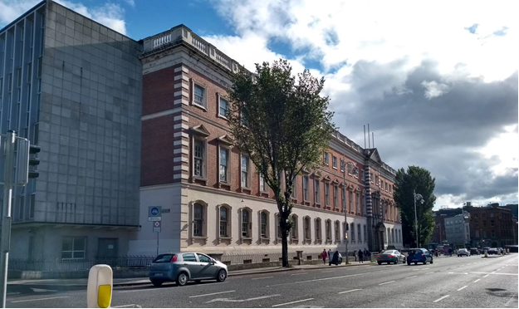
Fig.2: View of Bolton Street Campus, TU Dublin from north. In foreground is the 1961 extension by Hooper and Mayne, followed by the eight-bay 1930-1931 by Robinson Keefe followed by the original 1911 building designed by Charles J. McCarthy
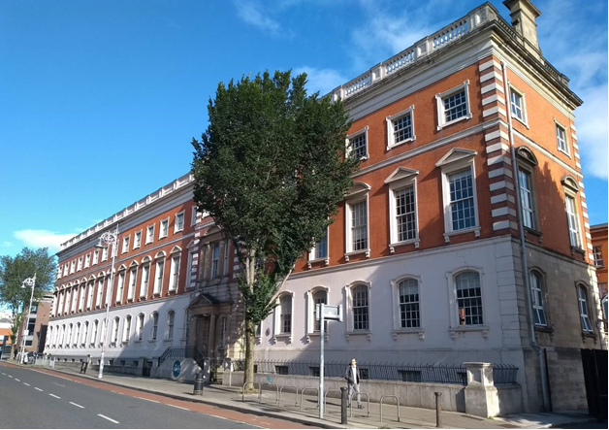
Fig. 3: View of Bolton Street Campus, TU Dublin from south with the original 13-bay, 1911 building designed by Charles J. McCarthy in foreground

RPS No. 838 - 57 Bolton Street, Dublin 1

Seandálaíocht, Caomhantas & Oidhreacht
An Roinn Pleanála & Forbairt Maoine
Oifigí na Cathrach, An Ché Adhmaid, Baile Átha Cliath 8

Archaeology, Conservation & Heritage Section
Planning & Property Development Department
Block 3, Floor 3, Civic Offices, Wood Quay, Dublin 8

Tel: (01) 222 3926, 222 3927
Email: conservation@dublincity.ie

11th November 2021

Draft Development Plan 2022-2028

Ref: RPS 838 AMENDMENT to the Record of Protected Structures
_______________________________________________________________________________

Recommendation:
Amendment of current entry for 57 Bolton Street, Dublin 1 - Ground floor shopfront (granite and brick detailing), to now read: 57 Bolton Street, Dublin 1 - Commercial premises
_______________________________________________________________________________

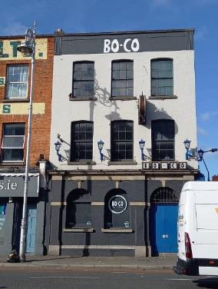

Introduction
There has been a query about whether the RPS entry 57 Bolton Street, Dublin 1, should be amended to include the entire structure.

Existing Listing
RPS Ref No | Address | Description
838 | 57 Bolton Street, Dublin 1 | Ground floor shopfront (granite and brick detailing)

Proposed Listing:
RPS Ref No | Address | Description
838 | 57 Bolton Street, Dublin 1 | Commercial premises

Request for Investigation
Conservation Section, Dublin City Council.

Location and Land Use Zoning
The location of 57 Bolton Street, Dublin 1 is arrowed red below. The main zoning objective is Zone 4. To provide for and improved mixed services facilities.

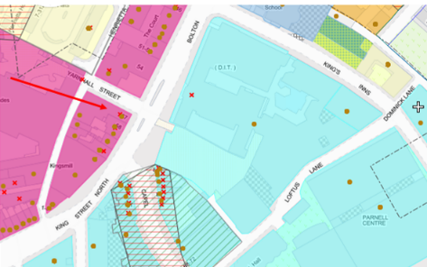
Fig. 1 Location and Land Use Zoning

Recent Planning History
Planning Ref | Description | Decision
PAC0207/14 | 57-59 Bolton Street, Dublin 1 | Link inactive

Recent Enforcement History
None on record

Summary Description:
(See images at end of report)
Description based on National Inventory of Architectural Heritage’s record for site, Ref. 50010607
Exterior:
Corner-sited three-bay three-storey brick public house, built c.1875, having shopfront to front (east) elevation, and recent two-storey extension to rear (west). Replacement flat roof behind parapet with squared granite coping, and replacement uPVC rainwater goods. Brick wall to front elevation laid in stretcher bond, and buff brick to side (north) elevation with chamfered granite plinth course over brick plinth throughout. Clock face and decorative lamps to front elevation with recent raised lettering to parapet. Remains of historic shopfront to side elevation comprising timber fascia with raised lettering, architrave, cornice and console brackets. Gauged camber-headed window openings with brick reveals, granite sills and ogee-horned six-over-six pane timber sliding sash windows throughout. Wrought-iron balconettes to front elevation window openings. Replacement timber-framed casement windows to ground floor of side elevation having steel window guards. Brick and granite shopfront comprising engaged square-plan brick pilasters with granite caps incorporated into granite frieze and cornice. Granite platband to springing of round-headed door and window openings. Openings having raised carved granite keystones and gauged brick voussoirs, with moulded granite sills to window openings. Fixed timber display windows to shopfront having recent wrought-iron window guards. Double-leaf timber panelled doors to entrance with single-pane overlight and granite threshold opening directly onto street. Internal lobby having double-leaf glazed timber doors. Camber-headed door opening to side (north) elevation having recent timber door and overlight.

Additional information from site inspection 18/10/21:
57 Bolton Street has a basement/cellar. The two-storey, seven-bay, yellow brick structure onto Yarnhall forms part of 57 Bolton Street. The public house occupies the ground floor of the section.
The first floor of this Yarnhall facing section is an original open-plan commercial space/workshop, based on an inspection c.2007 by a current City Council architectural conservation officer (in a previous private sector capacity), which confirmed an intact historic interior in the Bolton Street facing structure at that time.

Assessment
Built for use as a commercial building in the late nineteenth century, this pleasant public house stands upon the intersection of Yarnhall and Bolton Street. It has retained much of its historic fabric including sash windows and an unusual shopfront which adds to the variety of the surrounding streetscape and the wider north Georgian city. It provides an example of a Victorian brick and stone shopfront, is well presented and slightly lower roofline contributes to the variety and rhythm of the streetscape while the prominent signage to the parapet ensures that it stands out from its neighbours.
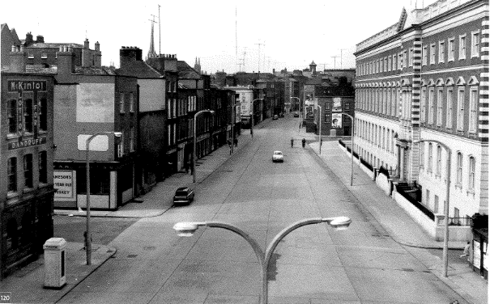
Fig. 2: Black and white photograph with 57 Bolton Street seen in the left corner.
Note: painted signage to upper floors for McKintol Lotion for Dandruff (Source: Dublin, an Urban History)

The Conservation Section has considered the Ministerial Recommendation for the property, in tandem with Chapter 2, Section 2.5.2 of the Architectural Heritage Protection Guidelines for Planning Authorities (2011) which states ‘The protection of a façade alone should generally only be considered where there is no surviving interior of any interest, for example where the building has previously been gutted and the façade is the only remaining feature of the original historic building. Generally a façade relates integrally to its building, which may retain interior detail of note including, for example, the original spatial plan, shop-fittings or decorative elements such as chimneypieces, staircases, window shutters or cornices. Elements of the external envelope and/or within the curtilage may also be of intrinsic interest and worthy of protection; these might include the roof, the rear elevation, outbuildings or other site features’ (pg. 24). As such, the Conservation Section considers that No. 57 Bolton Street, Dublin 1, in its entirety, merits inclusion on the Record of Protected Structures.

References
- McCullough, Niall (2007) Dublin: an urban history, p.117 (photo). Dublin: Associated Editions /Anne Street Press.
- National Inventory of Architecture’s record for site, Ref. 50010607

Significance/NIAH Rating
57 Bolton Street, Dublin 1 was recorded under Stage 1 of the NIAH for Dublin (Ref 50010607) with Ministerial Recommendations for Stage 1 issued to Dublin City Council on 4th June 2014. The structure was assigned a ‘Regional’ rating. These are structures or sites that make a significant contribution to the architectural heritage within their region or area. Structures which are considered of Regional significance are deemed worthy of inclusion on the RPS.

Assessment of Special Interest under the Planning and Development Act 2000
The National Inventory of Architectural Heritage assigned ARCHITECTURAL, ARTISTIC and SOCIAL interest to 57 Bolton Street, Dublin 1.

The Conservation Section has considered the opinion of the NIAH and is in agreement with assigning these categories of special interest to the site.

Conclusion & Recommendation
It is recommended that the RPS entry for 57 Bolton Street, Dublin 1 be amended to 57 Bolton Street, Dublin 1 – Commercial premises; extending protection to the entire structure, including its interior.

Proposed Listing
RPS Ref No | Address | Description
838 | 57 Bolton Street, Dublin 1 | Commercial premises

11/11/2021
_______________ ________________
Paraic Fallon
Senior Planner Date

Photographic Record of Structure:

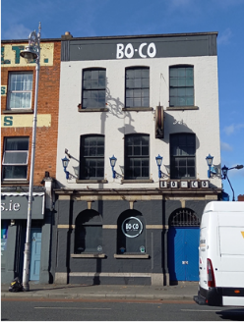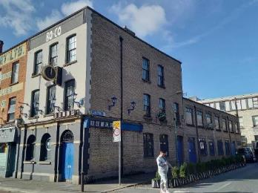
Fig. 3: Front elevation of 57 Bolton Street, D1 Fig. 4: Side elevation of 57 Bolton St onto Yarnhall

RPS No. 839 - 58-59 Bolton Street, Dublin 1

Seandálaíocht, Caomhantas & Oidhreacht
An Roinn Pleanála & Forbairt Maoine
Oifigí na Cathrach, An Ché Adhmaid, Baile Átha Cliath 8

Archaeology, Conservation & Heritage Section
Planning & Property Development Department
Block 3, Floor 3, Civic Offices, Wood Quay, Dublin 8

Tel: (01) 222 3926, 222 3927
Email: conservation@dublincity.ie

11 November 2021

Draft Development Plan 2022-2028

Ref: RPS 839 AMENDMENT to the Record of Protected Structures
_______________________________________________________________________________

Recommendation:
Amendment of current entry for 58-59 Bolton Street, Dublin 1 - Ground floor shopfront (granite and brick detailing), to now read: 58-59 Bolton Street, Dublin 1 - Commercial premises
_______________________________________________________________________________

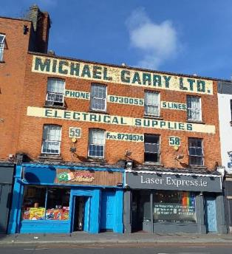

Introduction
There has been a query about whether the RPS entry 58-57 Bolton Street, Dublin 1, should be amended to include the entire structure.

Existing Listing
RPS Ref No | Address | Description
839 | 58-59 Bolton Street, Dublin 1 | Ground floor shopfront (granite and brick detailing)

Proposed Listing:
RPS Ref No | Address | Description
839 | 58-59 Bolton Street, Dublin 1 | Commercial premises

Request for Investigation
Conservation Section, Dublin City Council

Location and Land Use Zoning
The location of 58-59 Bolton Street, Dublin 1 is arrowed red below. The main zoning objective is Zone 4. To provide for and improved mixed services facilities.

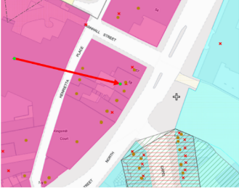
Fig. 1: Location and Land Use Zoning

Recent Planning History
Planning Ref | Description | Decision
PAC0207/14 | 57-59 Bolton Street, Dublin 1 | Link inactive
2183/18 | New penthouse apartment at existing roof level, replacement of existing single storey ground floor extension to rear with new 2-storey apartment, new bin store and utility room outbuildings to rear, together with removal of existing fascias, roller shutters, lights and reinstatement of historic fascias and fanlights over entrance doors to ground floor shopfronts and associated works.  The ground floor shopfronts are Protected Structures (RPS Ref. 839). | Application withdrawn

Recent Enforcement History
59 Bolton Street, Dublin 1
Ref. No. | Opened | Reason | Closed | Reason
E1166/08 | 31/10/08 | Advertising board has been erected outside above property | 18/11/08 | Structure removed

Summary Description
(See images at end of report)
Description of 58 Bolton Street, Dublin 1 based on National Inventory of Architectural Heritage’s record for site, Ref. 50010608
Exterior: Terraced two-bay three-storey house, built c.1875, having shopfront to ground floor. Now in use as commercial premises with accommodation over. Built as one of pair with neighbour to south. Replacement flat roof having pair of corbelled red brick chimneystacks with rendered coping behind red brick parapet with squared granite coping. Red brick Flemish bond wall to front elevation having painted signage to upper floors. Square-headed window openings with granite sills and replacement uPVC windows. Panelled granite and brick shopfront comprising pilasters on ogee-chamfered bases capped by fluted console brackets, shopfront fascia and cornice concealed by recent timber fascia. Recessed porch to shopfront having steel rolling shutters to exterior and glazed timber door to interior. Square-headed door opening to north of shopfront flanked by stone plasters having timber panelled door with paned overlight. Basement light visible in pavement suggesting the presence of a basement level.

Appraisal: Built as one of a pair, this Victorian era shop is recognisable in the streetscape due to the painted advertising to its upper floors. Although partially obscured the older shopfront survives in situ. The building makes a significant contribution to the variety of the streetscape, providing a pleasant example of Victorian architecture in an area largely dominated by Georgian architecture.

Description of 59 Bolton Street, Dublin 1 based on National Inventory of Architecture’s record for site, Ref. 50010609

Exterior: Terraced two-bay three-storey house, built c.1875, having shopfront. Built as one of pair of with neighbour to north. Replacement flat roof having pair of corbelled red-brick chimneystacks with red brick coping behind red brick parapet with squared granite coping. Red brick Flemish bond wall to front elevation having painted signage to upper floors. Camber-headed window openings with gauged voussoirs, granite sills and replacement uPVC windows. Panelled granite and brick shopfront comprising pilasters on ogee-chamfered bases capped by fluted console brackets with medallions. Older fascia and cornice concealed by recent timber fascia. Recessed porch to shopfront having replacement timber door and steel shutters. Square-headed door opening to north end flanked by stone plasters having timber rendered reveals, timber panelled door and three-pane timber overlight. Basement light visible in pavement suggesting the presence of a basement level.

Appraisal: Built as one of a pair, this Victorian building is a recognisable landmark in the streetscape due to the pleasant paint advertising to its upper floors. Although partially obscured the early shopfront also survives in situ and adds interest. The building makes a significant contribution to the variety of the streetscape, providing a pleasant example of Victorian architecture in an area largely dominated by Georgian architecture.

Assessment
The Conservation Section has considered the Ministerial Recommendations for 58-59 Bolton Street, Dublin 1, in tandem with Chapter 2, Section 2.5.2 of the Architectural Heritage Protection Guidelines for Planning Authorities (2011) which states ‘The protection of a façade alone should generally only be considered where there is no surviving interior of any interest, for example where the building has previously been gutted and the façade is the only remaining feature of the original historic building. Generally a façade relates integrally to its building, which may retain interior detail of note including, for example, the original spatial plan, shop-fittings or decorative elements such as chimneypieces, staircases, window shutters or cornices. Elements of the external envelope and/or within the curtilage may also be of intrinsic interest and worthy of protection; these might include the roof, the rear elevation, outbuildings or other site features’ (pg.24). As such, the Conservation Section considers that 58-59 Bolton Street, Dublin 1, in its entirety, merits inclusion on the Record of Protected Structures.

References
- National Inventory of Architecture’s record for site, Refs. 50010608 and 50010609

Significance/NIAH Rating
58-59 Bolton Street, Dublin 1 was recorded under Stage 1 of the NIAH for Dublin (Refs 50010608 & 50010609) with Ministerial Recommendations for Stage 1 issued to Dublin City Council on 4th June 2014. The structures were assigned a ‘Regional’ rating. These are structures or sites that make a significant contribution to the architectural heritage within their region or area. Structures which are considered of Regional significance are deemed worthy of inclusion on the RPS.

Assessment of Special Interest under the Planning and Development Act 2000
The National Inventory of Architectural Heritage assigned ARCHITECTURAL interest to 58 Bolton Street, Dublin 1 while 59 Bolton Street, Dublin 1 was assigned ARCHITECTURAL and ARTISTIC interest. The Conservation Section has considered the opinion of the NIAH and is in agreement with assigning these categories of special interest to the site. However, the Conservation Section also assigns artistic interest to 58 Bolton Street, as the original shopfront detailing and the early painted signage to the upper floors are common to both structures.

Conclusion & Recommendation
It is recommended that the RPS entry for 58-59 Bolton Street, Dublin 1 be amended to 58-59 Bolton Street, Dublin 1 – Commercial premises; extending protection to the entire structure, including its interior.

Proposed Listing
RPS Ref No | Address | Description
838 | 58-59 Bolton Street, Dublin 1 | Commercial premises

11/11/2021
_______________ ________________
Paraic Fallon
Senior Planner Date

Photographic Record
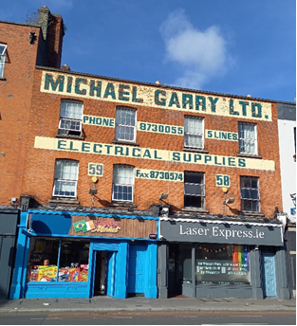 | 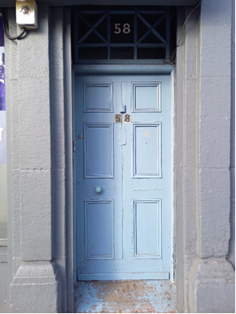
Fig. 2: Front elevation of 58-59 Bolton St, D1 | Fig. 3: Original door and fanlight to upper floors of 58 Bolton St, D1
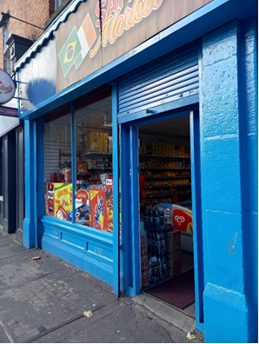 | 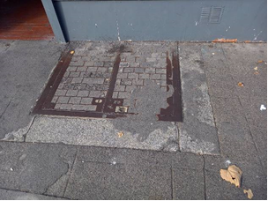
Fig. 4: Original shopfront on 59 Bolton St, D1 | Fig. 5: Basement lightwell with granite surround at 58 Bolton St, D1

RPS No. 1541 & 1542 & 7863 – 2, 3, & 4 Church Lane & 1-2 Suffolk Street, Dublin 2
Seandálaíocht, Caomhantas & Oidhreacht
An Roinn Pleanála & Forbairt Maoine
Oifigí na Cathrach, An Ché Adhmaid, Baile Átha Cliath 8

Archaeology, Conservation & Heritage Section
Planning & Property Development Department
Block 3, Floor 3, Civic Offices, Wood Quay, Dublin 8

Tel: (01) 222 3926, 222 3927
Email: conservation@dublincity.ie

1st November 2021

Draft Development Plan 2022-2028

Ref: RPS 1541, 1542, 7863 AMENDMENT to the Record of Protected Structures
_______________________________________________________________________________

Recommendation:

Amendment of current entries for 2, 3-4 Church Lane and 1-2 Suffolk Street, Dublin 2, so the descriptions reflect the fact that they are part of the one licensed premises.
_______________________________________________________________________________

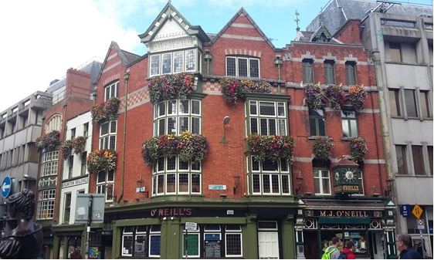

Introduction
There has been a query into the address accuracy and descriptions of 2 Church Lane, 3-4 Church Lane and 1-2 Suffolk Street, Dublin 2. These structures are already listed in the Record of Protected Structures (RPS). However 2 Church Lane is described as shop even though it is part of the adjoining licensed premises.

Existing Listing
2011-17 Ref No | Address | Description
1541 | 2 Church Lane, Dublin 2 | Shop
1542 | 3-4 Church Lane, Dublin 2 | Licensed premises side elevation of 1-2 Suffolk Street
7863 | 1-2 Suffolk Street, Dublin 2 | Licensed premises. (See 3-4 Church Lane)

Proposed Listing: Change descriptions to reflect the fact that 3-4 Church Lane, Dublin 2 and 1-2 Suffolk Street, Dublin 2 are all part of the same licensed premises.

Request for Investigation
Conservation Section, Dublin City Council

Location and Land Use Zoning
The location of the 2, 3-4 Church Lane and 1-2 Suffolk Street, Dublin 2 is shown in red below. The main zoning objective is Zone 5 To consolidate and facilitate the development of the central area and to identify, reinforce and strengthen and protect its civic design character and dignity. The buildings are contained within the red hatched Conservation Area. The grey hatched refers to the fact that the buildings are contained within the South City Retail Quarter Architectural Conservation Area.
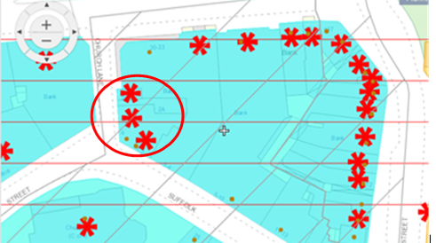
Fig 1: Location and Land Use Zoning

Summary Description

(See images at end of report)

Description based on National Inventory of Architecture’s record for site

2, 3 Church Lane, (Ref 50910120, 50910266) and 1 Suffolk Street incl. 4 Church Lane, 2 Suffolk Street (Ref 50910176, 50910177)

2 Suffolk Street, Dublin 2
Attached four-storey over basement public house, built c. 1890, having three-bay top floor, two-bay middle floors, pub front to ground floor, and set-back dormer attic. Interlinked with adjoining building to west. M-profile slate roof, hipped to west with terracotta ridge tiles, fish-scale leaded hips, and decorative wrought-iron finials, concealed behind red brick parapet with moulded limestone coping. Red brick chimneystack to east party wall with limestone coping and clay pots. Gabled dormer has cusp-headed timber bargeboards with matching finial to apex. Parapet gutters with boxed cast-iron gutter to east side with decorative rosette to hopper. Red brick walls to upper floors, laid to Flemish bond, with ashlar limestone dressings, including banding to impost level and to sill level of top floor, upper walls framed by brick pilasters topped with limestone gablets. Square-headed window openings, shouldered to first and top floors and pointed segmental to second floor, with chamfered brick reveals and moulded limestone sills, latter continuous to first floor and splayed to top floor. Ashlar limestone lintels to first and top floors, with Tudor-arch retaining brick arches over, stone hood-mouldings to second floor with foliate stops and moulded cornice to recessed brick heads. Bipartite side-hung timber casements with overlights to middle floors, and double side-hung casements to top floor. Original Victorian pub front comprising square-headed openings framed by painted masonry pilasters with foliate capitals, hand-painted fascia and foliate cornice flanked by consoles with rosette motifs surmounted by pedimented gablets. Central bipartite timber-framed display window with decorative full-span overlights, polished granite stall-riser with contrasting panels and tiled plinth (panelled timber stall-riser and multiple-pane timber casements to east and west cheeks), flanked by recessed door openings with mosaic-tiled porches and glazed timber panelled doors. Cast-iron lamp standards over pilasters, and projecting hand-painted timber clock made by Stokes of Cork between first floor windows, clock having pyramidal top with ball finial. Basement accessed by steel trapdoor to footpath. Remodelled to form public house complex comprising adjoining buildings Nos. 2-4 Church Lane and 1 Suffolk St.

1 Suffolk Street and 4 Church Lane, Dublin 2
Corner-sited four-storey gable-fronted former commercial building with obtuse L-plan and concealed basement, built 1909-10, having single-bay elevations to Suffolk Street (south) and Church Lane (west), rounded bay to corner, and gables to Church Lane bay and corner bay. Now in use as public house. Pitched slate roof, concealed behind red brick parapet with moulded granite coping, and breakthrough gable-fronted bays with flush ashlar granite stringcourses to apex. Parapet gutters and cast-iron downpipes with decorative hoppers. Machine-made red brick walling, laid to Flemish bond, with continuous checker granite and brick band between top two floors, and having ashlar granite courses above and below. Segmental-headed window openings to top floor with alternating brick and granite voussoirs. Flush ashlar granite sill course to west, projecting lead-lined modillioned sill course to south. Two-tier painted timber box-bay oriel window to south elevation at first and second floor level with timber mullions and transoms, similar canted-bay oriel to west elevation and similar, bowed, oriel window to corner bay. Corner oriel surmounted by gabled oriel with timber panelled apron supported on foliate corbels; topped by moulded modillioned cornice with foliate motifs to bargeboards, latter supported on scrolled brackets with concave moulding; and with rendered gable-head featuring geometric and wave motifs, surmounted by timber finial to apex. Windows throughout are multiple-pane leaded timber casements. Pub front spans both elevations and comprises square-headed openings over contrasting polished granite stall-riser and painted plinth, framed by stepped painted pilasters, latter panelled to west, supporting moulded timber cornice over plain painted fascia rounded to corner and having modern lettering. Leaded fixed timber windows to pub front, with tripartite arrangement, having timber mullions and transoms, and round-headed leaded overlights, latter partly obscured my steel roller shutters. Square-headed doorway to east end of south elevation serves upper floors and has pilasters with foliate corbels support projecting fascia and cornice, moulded timber frame, and nine-panel timber door with overlight having gold lettering 'Suffolk Chambers/1 Suffolk Street'. Recessed door opening to west with multiple-pane overlight, semi-circular canopy and tiled steps leading to modern timber and glazed door. Cast-iron and brass lamps affixed to first floor. Glazed and metal basement cover in pavement to east end of south elevation. Remodelled to form public house complex comprising adjoining buildings Nos. 2-4 Church Lane and 2 Suffolk St.

3 Church Lane, Dublin 2
Attached two-bay four-storey former house, built c. 1800, with return to rear (east) and replacement traditional-style pub frontage. Remodelled and interlinked with adjoining buildings, with shopfront inserted to ground floor. Now in use as public house. Pitched roof, hipped to west, concealed behind painted rendered parapet with masonry coping. Concealed gutters with cast-iron hopper and downpipe breaking through to north end. Painted brick walls, laid to Flemish bond, over painted smooth rendered walling to first floor, with continuous moulded sill course to second floor over rendered frieze having recessed lettering 'Burlington Buildings'. Square-headed window openings, with painted granite sills and brick voussoirs, bowtell rope-moulded reveals to first floor and plain reveals elsewhere. One-over-one pane timber sliding sash windows, with convex horns to top floor and replacements to first floor having ogee horns. Metal grille fixed to upper pane of first floor window. Remodelled to form public house complex comprising adjoining buildings Nos. 2&4 Church Lane and 1-2 Suffolk St.

2 Church Lane, Dublin 2
Attached single-bay four-storey over basement commercial building, built 1910, with two-tier bowed Oriel window to middle floors, and recent shopfront to ground floor. Now in use as public house. Flat roof, concealed behind brick parapet with flush masonry coping having mild-steel railing. Red brick chimneystack to north party wall, with clay pots, and parapet gutters and decorative cast-iron hoppers and boxed downpipes. Machine-made red brick walling laid in Flemish bond. Rendered walling to exposed section of north elevation featuring recent hand-painted signage. Segmental-headed five-light window opening to top floor, with chamfered block-and-start ashlar stone surrounds and mullions, hood-moulding and side-hung multiple-pane metal casements. Oriel has painted timber aprons (festooned to second floor), surmounted by moulded timber cornice, and has six-pane timber casement windows with four-pane overlights, timber mullions, transoms and continuous sills. Basement indicated by concrete pavement lights at street level. Remodelled to form public house complex comprising adjoining buildings Nos. 3&4 Church Lane and 1-2 Suffolk St.

Historical Background
From 1755, the Coleman family operated licensed trade at 2 Suffolk Street, in addition to being grocer, tea, wine and spirit dealers. The Coleman family operated this premises until 1875 when the premises was leased by the Hogan brothers. In the nineteenth century, the site of today's Ulster Bank at numbers 3, 4 and 5 Suffolk Street was the Royal Arcade Hotel and the part of O'Neill's premises which now occupies Church Lane was the location of the Burlington restaurant. It was not until the 2nd of August 1927 that the premises became known as O'Neill's when the family purchased the property from Paul Hogan (source: O’Neills Pub website http://www.oneillsbar.com/about-us/history accessed 07/10/21)

1 Suffolk Street and 4 Church Lane are described by Christine Casey as a large picturesque essay of 1908 by George P. Sheridan, with multiple oriels, bargeboards and leaded windows.

By Goad’s Insurance Map of Dublin, April 1932 (Fig. 2), the interconnection is apparent (dotted line) with 1 Suffolk Street described as FS for Food Store, 4 Church Lane described as PH for public house extending into 2 Suffolk Street which is also described as public house. There appears to be a listing for offs over referring to the fact that the upper floor would have had office use. At this stage, 2 and 3 Church Lane appear to be in separate commercial occupation. Over time as the public house expanded these two buildings were subsumed along with upper floors into the public house use we see today.

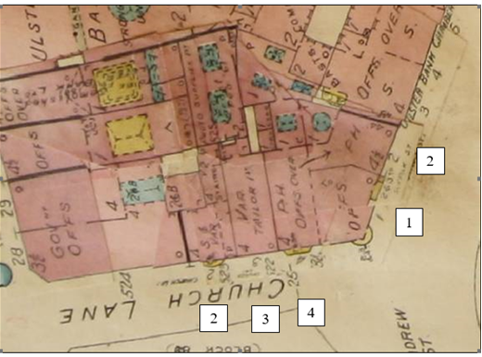

Fig. 2: Extract from Goad’s Insurance Map of Dublin, April 1932 showing the corner sited structures.

References
Casey, Christine (2005) The Buildings of Ireland, Dublin. Published by Yale University Press
O’Neills Pub website http://www.oneillsbar.com/about-us/history accessed 07/10/21
Goad’s Insurance Map of Dublin, DCC Heritage Section digital copy.

Significance/NIAH Rating
2, 3 Church Lane, (Ref 50910120, 50910266) and 1 Suffolk Street incl. 4 Church Lane, 2 Suffolk Street (Ref 50910176, 50910177) Dublin 2 were recorded under Stage 3 of the NIAH for Dublin with Ministerial Recommendations for Stage 3 issued to Dublin City Council on 28th June 2018. The structures was assigned a ‘Regional’ rating. These are structures or sites that make a significant contribution to the architectural heritage within their region or area. Structures which are considered of Regional significance are deemed worthy of inclusion on the RPS.

Assessment of Special Interest under the Planning and Development Act 2000
The National Inventory of Architectural Heritage assigned;
- 2 Church Lane Architectural and Artistic interest.
- 3 Church Lane Architectural interest.
- 1 Suffolk Street incl.4 Church Lane Architectural, Artistic, Historical, Social interest.
- 2 Suffolk Street Architectural, Artistic, Social

The Conservation Section has considered the opinion of the NIAH and is in agreement with assigning the ARCHITECTURAL, ARTISTIC, SOCIAL and HISTORIC categories of special interest but would assign these four categories to all buildings.

Conclusion & Recommendation
It is recommended that the RPS entry descriptions for 2 Church Lane, 3-4 Church Lane and 1-2 Suffolk Street, Dublin 2 be amended so the descriptions reflect the fact that they are part of the one licensed premises.

Proposed Listing
Ref No | Address | Description
1541 | 2 Church Lane, Dublin 2 | Licensed premises side elevation of 1-2 Suffolk Street. (See 1-2 Suffolk Street)
1542 | 3-4 Church Lane, Dublin 2 | Licensed premises side elevation of 1-2 Suffolk Street. (See 1-2 Suffolk Street)
7863 | 1-2 Suffolk Street, Dublin 2 | Licensed premises front elevation. (See 2, 3 & 4 Church Lane)

01/11/2021
_______________ ________________
Paraic Fallon
Senior Planner Date

Photographic Record:
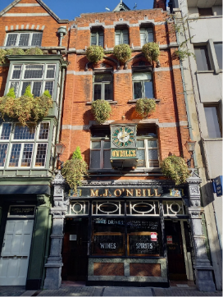 | 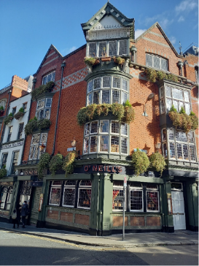
Fig. 3: No. 2 Suffolk Street, Dublin 2 | Fig. 4: Nos. 4 Church Lane & 1 Suffolk Street, Dublin 2
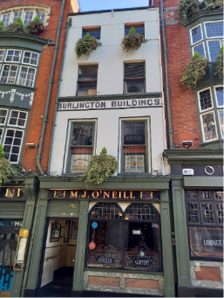 | 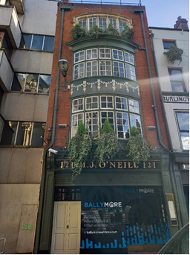
Fig. 5: No. 3 Church Lane, Dublin 2 | Fig. 6: 2 Church Lane, Dublin 2

RPS No. 1901 - Clonliffe Road, Dublin 3
Seandálaíocht, Caomhantas & Oidhreacht
An Roinn Pleanála & Forbairt Maoine
Oifigí na Cathrach, An Ché Adhmaid, Baile Átha Cliath 8

Archaeology, Conservation & Heritage Section
Planning & Property Development Department
Block 3, Floor 3, Civic Offices, Wood Quay, Dublin 8

Tel: (01) 222 3926, 222 3927
Email: conservation@dublincity.ie

29th October 2021

Draft Development Plan 2022-2028

Ref: RPS 1901 AMENDMENT to the Record of Protected Structures
_______________________________________________________________________________

Recommendation:
Amendment of current entry for Clonliffe Road, Dublin 3 - The main College Building (1863); Holy Cross Church; the South Link Building; the Ambulatory; the Assembly Hall, to now read: Former Holy Cross College: The Main College Building (1863); Holy Cross Church; the South Link Building; the Ambulatory; the Assembly Hall; and the single storey arcade forming northern perimeter of college quadrangle.
_______________________________________________________________________________

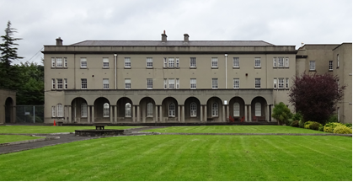

Introduction
The former Holy Cross College is on the current Record of Protected Structures (Dublin City Development Plan 2016-2022). The reference number is RPS: 1901 and the description reads ‘The main College Building (1863); Holy Cross Church; the South Link Building; the Ambulatory; the Assembly Hall’. Assessment of the complex has been undertaken by the Conservation Section to review the current RPS entry and to establish whether further structures should be included in the protection. On foot of this, amendment of the RPS entry is proposed to extend protection to the single storey arcade forming northern perimeter of college quadrangle. For the purposes of clarity, it is not proposed to add the remainder of the three-storey ‘New Wing’ built in 1959 to the Record of Protected Structures.

Existing Listing:
RPS Ref No | Address | Description
1901 | Clonliffe Road, Dublin 3 | The main College Building (1863); Holy Cross Church; the South Link Building; the Ambulatory; the Assembly Hall.

Proposed Listing: Amend description to include the single storey arcade of the former New Wing and to include the name of the site.
RPS Ref No | Address | Description
1901 | Clonliffe Road, Dublin 3 | Former Holy Cross College: The Main College Building (1863); Holy Cross Church; the South Link Building; the Ambulatory; the Assembly Hall; and the single storey arcade forming northern perimeter of college quadrangle.

Request for Investigation
Conservation Section, Dublin City Council

Location and Land Use Zoning
The location of the former Holy Cross College at Clonliffe Road, Dublin 3 is indicated by the red arrow below. The zoning objective for the site is Zone 12: To ensure that existing environmental amenities are protected in the predominantly residential future use of these lands.
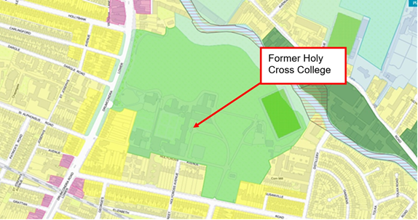
Fig.1 Location and Land Use Zoning.

Relevant Planning History
Planning Ref. | Description | Decision Date
SHD0015/21 | Strategic Housing Development at Holy Cross College, Clonliffe Road, Dublin 3 and Drumcondra Road Lower, Drumcondra, Dublin 9 to include demolition of the New Wing but retention of the cloister colonnade on the North side the college quadrangle. | An Bord Pleanála has not yet made a decision on this application. Decision due 04/11/2021

Relevant Planning Enforcement History
There is no relevant planning enforcement history for the subject site.

Summary Description
Description based on the National Inventory of Architectural Heritage (NIAH) Ref: 50120175.
(Refer to Fig.2 below for layout plan)
Former seminary, built 1863 comprising: Four storey east facing main building having a central pedimented entrance breakfront and rear quadrangle; attached baroque-style Holy Cross church to south built 1873 having an apsidal eastern end and Diocletian windows to side elevations; two-storey ‘South Link Building’ built 1876 connecting principal range with chapel; three-storey ‘New Wing’ to north built on a T-shaped plan c.1951 with its south elevation having a single-storey arcade with paired Doric columns forming northern perimeter of college quadrangle; Ambulatory with arcade of paired Doric columns, built in 1959, enclosing the south and west of quadrangle; Assembly Hall built 1959 to south of site on rectangular plan having gabled elevations with projecting porch to the front and single-storey wings to sides; four storey library wing to north built on a T-shaped plan c.1966 to designs by Nolan & Nevin Architects.

Assessment
Holy Cross College at Clonliffe was founded by Archbishop Cullen in 1859 as a seminary for the training of Catholic Priests. The main building was built to the designs of John Bourke, the Architect for the Mater Hospital. The church was constructed in 1873 to designs by JJ McCarthy, shortly followed by the South Link Building. A number of further additions were constructed in the mid-20th century to coincide with the centenary of the College. These included the ‘New Wing’ built c.1951 to designs by Stanislaus Nevin with its single storey arcade and the ambulatory built c.1959 to designs by Jones and Kelly architects (this replicated the design of Nevins single storey arcade). The arcade, together with the ambulatory form the northern, southern and western perimeter of the college quadrangle, creating an important sense of enclosure which contributes to the setting and formal presentation of the principal college ranges and provided spaces for contemplation and for processional purposes, referencing the medieval cloister plans of early monastic sites.

Assessment of the complex has been undertaken by the Conservation Section to review the current RPS entry which had been adopted by Resolution of Dublin City Council in October 2002 (Report of Assistant City Manager Report No.280/2002). The description for the RPS entry as adopted reads ‘The main College Building (1863); Holy Cross Church; the South Link Building; the Ambulatory; the Assembly Hall’. The Conservation Section concludes that the main College Building (1863); Holy Cross Church; the South Link Building; the Ambulatory; and the Assembly Hall continue to merit inclusion on the Record of Protected Structures. Furthermore, the Conservation Section is of the opinion that the single-storey arcade which forms the northern perimeter of the college quadrangle also contributes to the special significance of the former Holy Cross College and should be included as part of the protection. For the purposes of clarity, it is not proposed to add the remainder of the three-storey ‘New Wing’ built in 1959 to the Record of Protected Structures. It is also proposed to include the name of the site in the RPS description. As such, it is recommended to amend the description for RPS 1901 to read 'Former Holy Cross College: The Main College Building (1863); Holy Cross Church; the South Link Building; the Ambulatory; the Assembly Hall; and the single storey arcade forming northern perimeter of college quadrangle'.

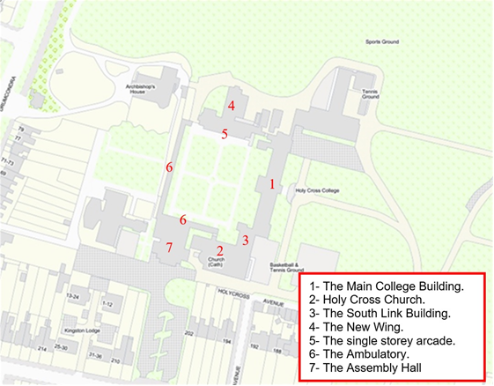
Fig.2: Layout plan referenced to buildings as indicated in the summary description.

References
- Pollard, M., 1962. Holy Cross College, Clonliffe Dublin: College History and Centenary Record, Irish Printers, Ltd.
- National Inventory of Architectural Heritage (NIAH) Ref: 50120175.
- Report of Assistant City Manager Report No.280/2002.
- Planning file ref: 3270/21.
- Planning file ref: SHD0015/21.

Significance/NIAH Rating
Holy Cross College, Clonliffe Road, Dublin 3 was recorded under Stage 5 of the National Inventory of Architectural Heritage (NIAH) for Dublin (Ref: 50120175). There are currently no Ministerial Recommendations for the site however the complex was assigned a ‘Regional’ rating. These are structures or sites that make a significant contribution to the architectural heritage within their region or area. Structures which are considered of Regional significance are deemed worthy of inclusion on the RPS.

Assessment of Special Interest under the Planning and Development Act 2000
The National Inventory of Architectural Heritage assigned ARCHITECTURAL, HISTORICAL, and SOCIAL interest to the former Holy Cross College at Clonliffe Road, Dublin 3. The Conservation Section has considered the opinion of the NIAH and is in agreement with assigning these categories of special interest to the site/complex.

Conclusion & Recommendation
It is recommended that the RPS description for RPS ref: 1901 for Clonliffe Road, Dublin 3 be amended to - 'Former Holy Cross College: The Main College Building (1863); Holy Cross Church; the South Link Building; the Ambulatory; the Assembly Hall; and the single storey arcade forming northern perimeter of college quadrangle'.

Proposed Listing
RPS Ref No | Address | Description
1901 | Clonliffe Road, Dublin 3 | Former Holy Cross College: The Main College Building (1863); Holy Cross Church; the South Link Building; the Ambulatory; the Assembly Hall; and the single storey arcade forming northern perimeter of college quadrangle.

29/10/2021
_______________ ________________
Paraic Fallon
Senior Planner Date

Photographic Record:
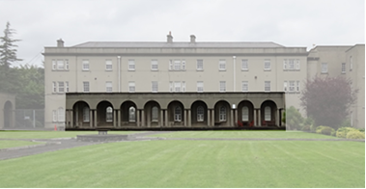
Fig.3: Aspect of single storey arcade having paired Doric columns to north of college quadrangle. For clarity the remainder of the ‘New wing’ has been faded out.

RPS No. 2289 - 20, 20a & 21 Denmark Street Great, Dublin 1
Seandálaíocht, Caomhantas & Oidhreacht
An Roinn Pleanála & Forbairt Maoine
Oifigí na Cathrach, An Ché Adhmaid, Baile Átha Cliath 8

Archaeology, Conservation & Heritage Section
Planning & Property Development Department
Block 3, Floor 3, Civic Offices, Wood Quay, Dublin 8

Tel: (01) 222 3926, 222 3927
Email: conservation@dublincity.ie

29th October 2021

Draft Development Plan 2022-2028

Ref: RPS 2289 AMENDMENT to the Record of Protected Structures
_______________________________________________________________________________

Recommendation:
Amendment of current entry for 21 Denmark Street Great, Dublin 1 – House, to now read: 20, 20a & 21 Denmark Street Great, Dublin 1 – House and Shops.
_______________________________________________________________________________

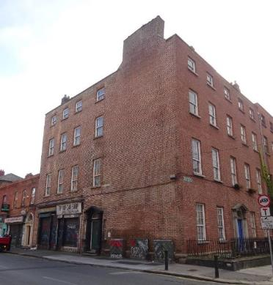

Introduction
There has been a query about whether the RPS entry 21 Denmark Street Great, Dublin 1 – House, should be amended to 20, 20a & 21 Denmark Street Great, Dublin 1 – House and Shops. The building was conceived as a single structure, with the two shops inserted at ground floor in the later nineteenth century. Above ground floor level, it functions as a single structure but the shops have separate building numbers. Furthermore the National Inventory of Architectural Heritage have a separate record for No. 20 and No. 21, which splits the upper floors between the two street numbers. Amending the RPS listing will provide clarity on the extent of the structure that is protected.

Existing Listing
RPS Ref No | Address | Description
2289 | 21 Denmark Street Great, Dublin 1 | House

Proposed Listing: Change address to include the building numbers 20 and 20a and amend the description.
RPS Ref No | Address | Description
2289 | 20, 20a & 21 Denmark Street Great, Dublin 1 | House and Shops

Request for Investigation
Conservation Section, Dublin City Council.

Location and Land Use Zoning
The location of 20, 20a and 21 Denmark Street Great, Dublin 1 is arrowed red below. The main zoning objective is Zone 8: To protect the existing architectural and civic design character, to allow only for limited expansion consistent with the conservation objective. The site is located within the Architectural Conservation Area of North Great George’s Street & Environs and is also within a designated Conservation Area.

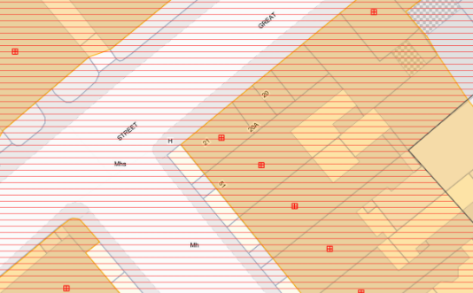

Fig. 1: Location and Land Use Zoning

Recent Planning History
Planning Ref | Description | Decision
0592/19 | EXPP: PROTECTED STRUCTURE: Internal refurbishment and decorations to 6 no. flats, and associated entrance hall and stairwell. Works comprising painting of walls, ceilings, joinery, repairs to floor boards, skirting’s, doors. Renewal of kitchen fittings and white goods. Replacement of bathroom fittings and sanitary ware. | REFUSE EXEMPTION CERTIFICATE  20-Jan-2020

Recent Enforcement History
Ref. No. | Opened | Reason | Closed | Reason
C0020/13 | 15-Jul-2013 | Endangered | 01-Oct-2019 | Resolved

Summary Description
(See images at end of report)
Description based on National Inventory of Architectural Heritage’s records for the site, Refs. 50010962 and 50010963.
Exterior: Corner-sited end-of terrace, four-bay, four-storey over basement house, built c.1790, with two-bay side elevation to North Great George’s Street and shopfronts inserted at ground floor level c.1900. Pitched slate roofs hidden behind rebuilt parapet wall with granite coping and cast-iron hopper and downpipe to east gable. Rendered chimneystack rising from east gable. Yellow brick chimneystack rising from north gable. Red brick walls laid in Flemish bond to granite plinth course over cement-rendered walls to basement; cement-rendered walls to east gable. Gauged brick flat-arched window openings with granite sills and replacement timber sliding sash windows, nine-over-six pane to lower two floors, six-over-six pane to second floor three-over-three pane to top floor, and two-over-two pane to basement. Round-headed door opening and painted stone pedimented Doric door-case to north gable. Replacement timber door and lintel cornice with plain fanlight flanked by engaged Doric columns on raised plinth blocks supporting full entablature blocks to open pediment. Door opens onto two nosed granite steps to street with pair of gauged brick square-headed sidelights having granite sills and metal windows. Timber shopfronts c.1900 to northeast corner. Basement area enclosed to North Great George’s Street by original wrought-iron railing on moulded granite plinth wall.

Assessment
Denmark Street Great was laid out in late eighteenth-century, in tandem with the laying out of North Great Georges Street and the adjoining Gardiner estate. The structure now known as 20, 20a and 21 Denmark Street Great was first depicted on the 1847 Ordnance Survey map, which illustrates a single building at the corner of Denmark Street Great and North Great George’s Street. This building is numbered 52 on North Great Georges Street (west elevation), but appears to be accessed from Denmark Street Great (north elevation) with a basement well illustrated across the entire west elevation with no steps. A possible entrance porch, breaking across a basement well, is shown to the north elevation. There are no building numbers indicated on the south side of Denmark Street Great. There appear to be no changes on the 1864 and 1890 Ordnance Survey revisions, except for the separation of the plot at the eastern end (now Hill Street) and the construction of buildings here by 1864.

By the c.1910 Ordnance Survey, the building was subdivided with what are now Nos. 20 and 20a indicated. The possible entrance porch and basement well to the north elevation have been removed. There also appears to be a structure constructed on the basement well to the east elevation. An image from the Lawrence Collection, held in the National Library of Ireland, shows the Denmark Street Great elevation at that time with the shopfronts in existence by the time of the photo. A visual inspection of the building indicates a scar on the building at sill level to the first floor of the north elevation, where the possible porch structure shown on the earlier maps was located. This ties in with the current entrance, which serves the upper floors across 20, 20a and 21, as well as the entire building fronting onto North Great George’s Street. The door surround, which is typical of those on North Great George’s Street may have been moved to its current location during the c.1900 alterations to the Denmark Street Great elevation.

It is therefore clear from the historical evidence that the buildings now known as 20, 20a and 21 Great Denmark Street were originally constructed as a single structure, with an elevation to North Great George’s Street that mirrored the adjoining building at No.51, completing the symmetry of that street in a fine example of considered town planning. The c.1900 division of the buildings occurred solely at ground floor level with the insertion of the two shopfronts, with the upper floors remaining as a single structure.

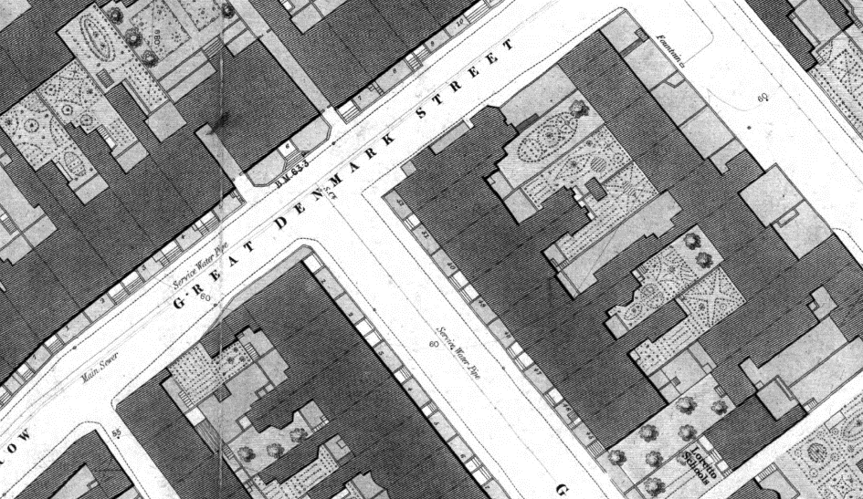

Fig. 2: Extract from 1847 City of Dublin Ordnance Survey plan showing the likely entirety of 52 North Great Georges Street plot at this time. Note the possible entrance to the north elevation and the lack of steps over the basement well to the east elevation
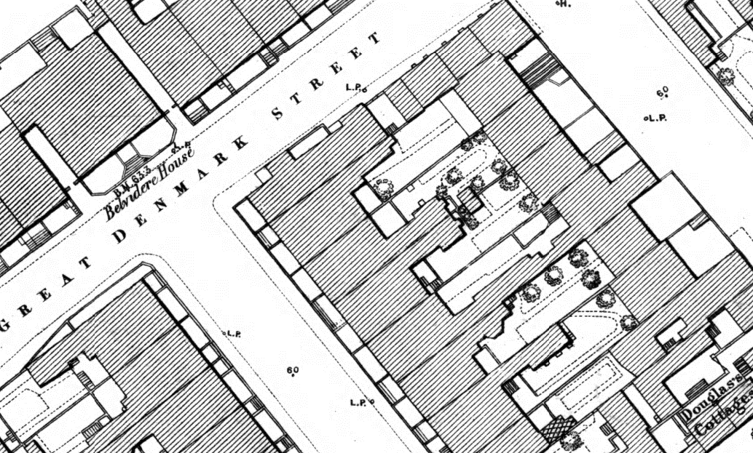

Fig. 3: Extract from 1890 City of Dublin Ordnance Survey plan showing the subdivision of the eastern end to smaller plots

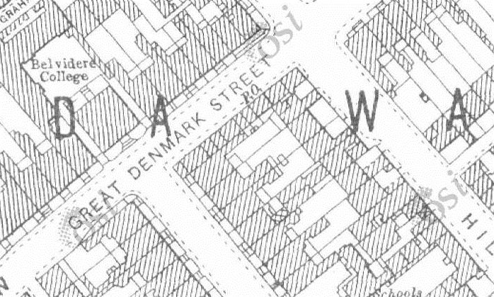

Fig.4 Extract from c.1910 Ordnance Survey revision showing the insertion of the shops at 20 and 20a
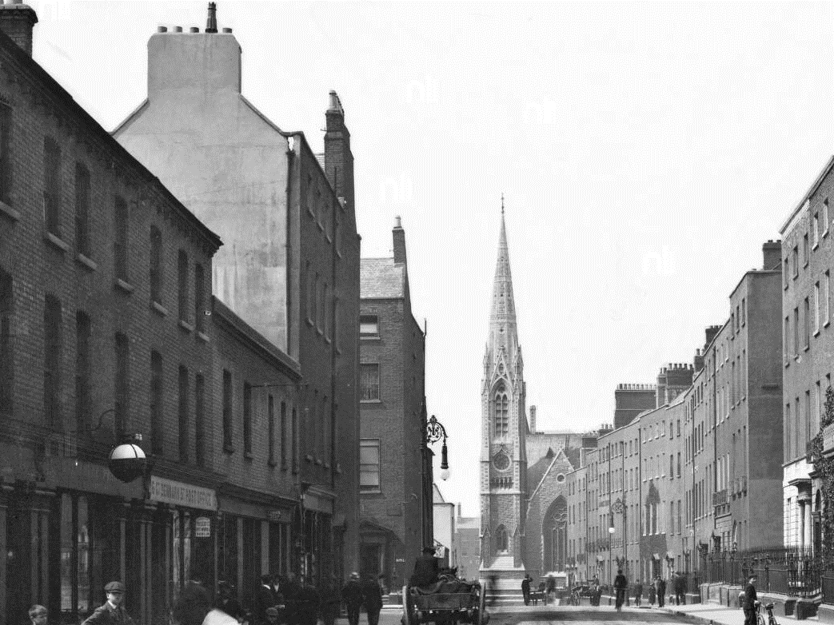

Fig.5: Image from Lawrence Collection in National Library with shopfronts arrowed red; these shopfronts survive to the building

References
- National Inventory of Architectural Heritage References 50010962 and 50010963
- Image from Lawrence Collection showing Great Denmark Street. http://catalogue.nli.ie/Record/vtls000316731 (accessed 28/06/2021)
- http://map.geohive.ie/ (accessed 28/06/2021)
- City of Dublin, held by Ordnance Survey Ireland. © Public domain. Digital content: © Ordnance Survey Ireland, published by UCD Library, University College Dublin, 1847, Sheet 08 http://digital.ucd.ie/view/ucdlib:40823 (accessed 28/06/2021)
- City of Dublin, held by Ordnance Survey Ireland. © Public domain. Digital content: © Ordnance Survey Ireland, published by UCD Library, University College Dublin, 1864, Sheet 08 http://digital.ucd.ie/view/ucdlib:40824 (accessed 28/06/2021)

Significance/NIAH Rating
Nos. 20 and 21 Denmark Street Great were recorded under Stage 1 of the NIAH for Dublin (Ref 50010962 and 50010963 respectively) with Ministerial Recommendations for Stage 1 issued to Dublin City Council on 4th June 2014. The structures were both assigned a ‘Regional’ rating. These are structures or sites that make a significant contribution to the architectural heritage within their region or area. Structures which are considered of Regional significance are deemed worthy of inclusion on the RPS.

Assessment of Special Interest under the Planning and Development Act 2000
The National Inventory of Architectural Heritage assigned ARCHITECTURAL and TECHNICAL interest to No. 20 Denmark Street Great and ARCHITECTURAL, TECHNICAL and ARTISTIC interest to No. 21 Denmark Street Great.
The Conservation Section has considered the opinion of the NIAH and is in agreement with assigning these categories of special interest to the site.

Conclusion & Recommendation
It is recommended that the RPS entry for 21 Denmark Street Great, Dublin 1 be amended to 20, 20a & 21 Denmark Street Great, Dublin 1 – House and Shops, in accordance with Section 12(3) of the Planning and Development Act, 2000 (as amended).

Proposed Listing
RPS Ref No | Address | Description
2289 | 20, 20a & 21 Denmark Street Great, Dublin 1 | House and Shops

29/10/2021
_______________ ________________
Paraic Fallon Date
Senior Planner

Photographic Record:
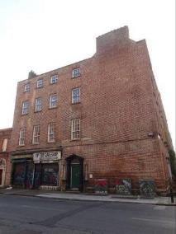 | 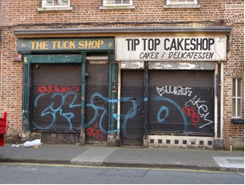
Fig. 6: North elevation | Fig. 7: Shopfronts, north elevation
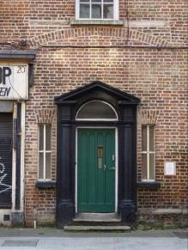

Fig. 8: Door opening, north elevation

RPS No. 2302 - D'Olier Street, Dublin 2
Seandálaíocht, Caomhantas & Oidhreacht
An Roinn Pleanála & Forbairt Maoine
Oifigí na Cathrach, An Ché Adhmaid, Baile Átha Cliath 8

Archaeology, Conservation & Heritage Section
Planning & Property Development Department
Block 3, Floor 3, Civic Offices, Wood Quay, Dublin 8

Tel: (01) 222 3926, 222 3927
Email: conservation@dublincity.ie

15th November 2021

Draft Development Plan 2022-2028

Ref: RPS 2302 AMENDMENT to the Record of Protected Structures
_______________________________________________________________________________

Recommendation:
Amendment of current entry for 16.5 D’Olier Street, Dublin 2 – Façade and façade to Fleet Street, to now read: D’Olier Street – Commercial premises: façade including façade to Fleet Street (brick and stone building at junction of D’Olier Street and Fleet Street also known as Unit 6 The Irish Times Building).
_______________________________________________________________________________

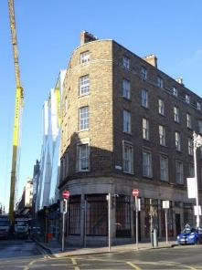

Introduction
No. 16.5 D’Olier Street, Dublin 2 is on the current Record of Protected Structures (Dublin City Development Plan 2016-2022). The reference number is RPS: 2302 and the description reads ‘Façade and facade to Fleet Street’. It is proposed to amend the record to D’Olier Street, Dublin 2 – ‘Commercial premises: façade including façade to Fleet Street (brick and stone building at junction of D’Olier Street and Fleet Street also known as Unit 6 The Irish Times Building)’.

Existing Listing:
RPS Ref No | Address | Description
2302 | 16.5 D’Olier Street, Dublin 2 | Façade and facade to Fleet Street

Proposed Listing:
RPS Ref No | Address | Description
2302 | D’Olier Street, Dublin 2 | Commercial premises: façade including façade to Fleet Street (brick and stone building at junction of D’Olier Street and Fleet Street also known as Unit 6 The Irish Times Building).

Request for Investigation
Conservation Section, Dublin City Council.

Location and Land Use Zoning
The location of the site on D’Olier Street, Dublin 2 is marked by a red arrow below. The zoning objective is Z5: To consolidate and facilitate the development of the central area and to identify, reinforce and strengthen and protect its civic design character and dignity. The site is also located within the designated area of the O’Connell Street Architectural Conservation Area and also in a red hatched Conservation Area.

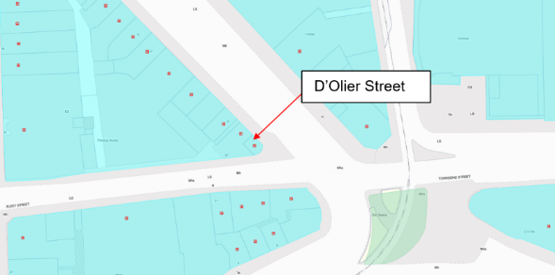
Fig. 1: Location and zoning map.

Relevant Planning History
Planning Ref. | Description | Decision Date
0283/17 | EXPP - PROTECTED STRUCTURE - 3 No. external business advertising signs (300mm high x 920mm wide) hidden screw fixed onto the stone fascia's on North-East, South West & South-East elevations. | Grant Exemption Certificate  11 Oct 2017
3536/16 | PROTECTED STRUCTURE: We, Benefit Cosmetics Ireland Ltd, intend to apply for planning permission at The Times Building (Protected Structure), No.16, D'Olier Street & No. 27 Fleet Street, Dublin 2, at premises therein known as Unit No.6 comprising of ground floor plus mezzanine over basement. Development consists of, 3 No. external business advertising signs (300mm high x 920mm wide) surface fixed onto stone fascia's on North East, South West & South-East and Elevations and 1 No. bracket and protruding sign (500mm high x 800mm wide). | GRANT PERMISSION  05 Oct 2016

Relevant Planning Enforcement History
Ref. No. | Opened | Reason | Closed | Reason
E0531/06 | 01-Jun-2006 | Alleged unauthorised banner fixed to front facade | 24-Jul-2006 | Structure removed.
E0147/09 | 23-Feb-2009 | Alleged breach of condition 7 of PP 4866/07 |  | See notes.

Summary Description
(See images at end of report).

Exterior (based on NIAH record 50020265):
End-of-terrace three-bay, five-storey commercial building c. 1800 having shopfront to ground floor and four-bay, five-storey elevation to Fleet Street. Now in use as commercial premises. M-profile slate roof, hipped to south-west end having brick and rendered chimneystack with clay pots to valley, hidden behind tall parapet. Brown brick laid in Flemish bond to walls. Square-headed window openings having granite sills to first second and third floors and continuous cut granite cill-course to fourth floor. Cut granite architraves to first floor and rendered reveals to second, third and fourth floors. Six-over-six timber sliding sash windows to first, second and third floor and three-over-three timber sliding sash windows to fourth-floor. Granite shopfront comprising Ionic pilasters supporting panelled granite fascia and cornice, replacement display windows on granite risers.

Interior: There interior was not accessed as part of this assessment.

Assessment
The building at the junction of D’Olier Street and Fleet Street (also known as Unit 6, The Irish Times Building) was built to the designs of the Wide Street Commissioners c. 1800. D’Olier Street was named for Jerimiah D’Olier, a Huguenot goldsmith and sheriff of Dublin, who was elected as a Wide Street Commissioner in 1796. D’Olier Street and neighbouring Westmoreland Street were two of the last major redevelopment schemes to be undertaken by the Commissioners. The buildings from 8-16 D’Olier Street (including the subject building) housed the Irish Times between 1882 and 2006. The building was first protected under the Draft Dublin City Development Plan 1980, when it was described as ‘Façade and façade to Fleet Street’ and the address was given as 16 ½ D’Olier Street. The legal search returned for 16 ½ D’Olier Street indicates that this building is located on the opposite east side of D’Olier Street at the junction with Hawkins Street and forms part of D’Olier Chambers. The subject building forms part of No. 16 Fleet Street and is also known as Unit 6, The Irish Times Building, D’Olier Street, Dublin 2. As such, it is recommended that the address given for RPS ref: 2302 is amended to remove the 16 ½ and that the description is changed from ‘Façade and façade to Fleet Street’ to ‘Commercial premises: façade including façade to Fleet Street (brick and stone building at junction of D’Olier Street and Fleet Street also known as Unit 6 The Irish Times Building) and that a cross reference be provided for Unit 6, The Irish Times Building, D’Olier Street, Dublin 2.

References
- Casey, C. (2005). Dublin: The Buildings of Ireland. London: Yale University Press.
- Planning file ref: 0283/17, 3536/16, and 2395/11.
- Crimmins, C. (2007). Architectural Appraisal and Environmental Report on the former Irish Times Premises, D’Olier Street and Fleet Street, Dublin 2 (Planning Ref. 2450/08).

Significance/NIAH Rating
The building at the junction of D’Olier Street and Fleet Street (alternatively known as Unit 6, Irish Times Building, D’Olier Street) was recorded as part of 8-16 D’Olier Street, Dublin 2 under Stage 2 of the NIAH for Dublin (Ref. 50020265) with Ministerial Recommendations for Stage 2 issued to Dublin City Council on 9th August 2017. The structure was assigned a ‘Regional’ rating. These are structures or sites that make a significant contribution to the architectural heritage within their region or area. Structures which are considered of Regional significance are deemed worthy of inclusion on the RPS.

Assessment of Special Interest under the Planning and Development Act 2000
The National Inventory of Architectural Heritage assigned ARCHITECTURAL, ARTISTIC, HISTORICAL and SOCIAL interest to No. 6-16 D’Olier Street, Dublin 2 (which includes the subject building at the junction of D’Olier Street and Fleet Street). The Conservation Section has considered the opinion of the NIAH and is in agreement with assigning these categories of special interest to the property.

Conclusion & Recommendation
It is recommended that the RPS entry for 16.5 D’Olier Street, Dublin 2 – Façade and façade to Fleet Street, be amended to now read: D’Olier Street – Commercial premises: façade including façade to Fleet Street (brick and stone building at junction of D’Olier Street and Fleet Street also known as Unit 6 The Irish Times Building) in accordance with Section 12(3) of the Planning and Development Act, 2000 (as amended) and that a cross reference be provided for Unit 6, The Irish Times Building, D’Olier Street, Dublin 2.

Proposed Listing
RPS Ref No | Address | Description
2302 | D’Olier Street, Dublin 2 | Commercial premises: façade including façade to Fleet Street (brick and stone building at junction of D’Olier Street and Fleet Street also known as Unit 6 The Irish Times Building).

15/11/2021
_______________ ________________
Paraic Fallon
Senior Planner Date

Photographs of Structure:
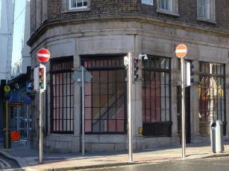
Fig.2: Shopfront, east elevation.
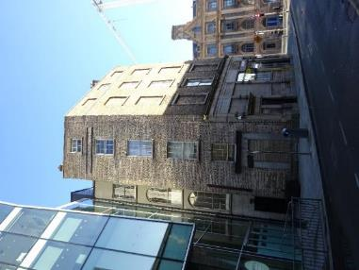
Fig.3: South elevation, Fleet Street.
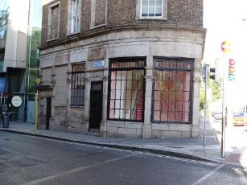
Fig.4: Shopfront, south elevation.

RPS No. 2330 - 12 Dorset Street Upper, Dublin 1
Seandálaíocht, Caomhantas & Oidhreacht
An Roinn Pleanála & Forbairt Maoine
Oifigí na Cathrach, An Ché Adhmaid, Baile Átha Cliath 8

Archaeology, Conservation & Heritage Section
Planning & Property Development Department
Block 3, Floor 3, Civic Offices, Wood Quay, Dublin 8

Tel: (01) 222 3926, 222 3927
Email: conservation@dublincity.ie

29th October 2021

Draft Development Plan 2022-2028

Ref: RPS 2330 AMENDMENT to the Record of Protected Structures
_______________________________________________________________________________

Recommendation:
Amendment of current entry for 12 Dorset Street Upper, Dublin 1 – House to now read: 12 Dorset Street Upper, Dublin 1 – House, exterior of front & side elevation only including roof and chimney.
_______________________________________________________________________________

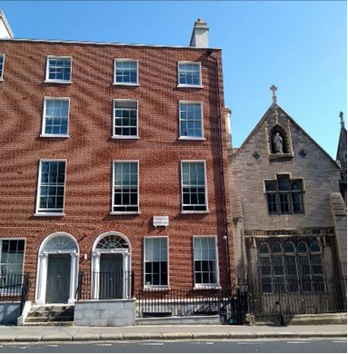

Introduction
There has been a query about whether the RPS entry for 12 Dorset Street Upper, Dublin 1 - House, should be amended to 12 Dorset Street Upper, Dublin 1 – House, exterior of front and side elevation only including roof and chimney. The building was substantially rebuilt in recent years under Planning Reference 4063/08 & 2907/17.

Existing Listing
RPS Ref No | Address | Description
2330 | 12 Dorset Street Upper, Dublin 1 | House

Proposed Listing: Amend description to just the front and side elevation elevations as the structure has been substantially reconstructed.
RPS Ref No | Address | Description
2330 | 12 Dorset Street Upper, Dublin 1 | House, exterior of front & side elevation only including roof and chimney

Request for Investigation
Conservation Section, Dublin City Council

Location and Land Use Zoning
The location of 12 Dorset Upper, Dublin 1 is arrowed red below. The main zoning objective is Zone 1: To protect, provide and improve residential amenities.
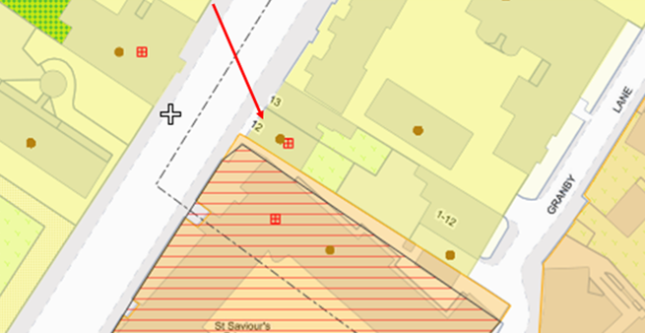
Fig. 1: Location and Land Use Zoning

Relevant Planning History
Planning Ref. | Description | Decision Date
2906/17 | PROTECTED STRUCTURE: Proposed alterations to approved dev. under Reg.Ref.4063/08. | Grant Permission 30-Aug-2017
4063/08/x1 | EXT OF DURATION:PROTECTED STRUCTURE - mixed use residential / medical consultant | Grant Extension of Duration Permission 01-Sep-2014
4063/08 | PROTECTED STRUCTURE - mixed use residential / medical consultant use development | Grant permission 21-Jan-2009

Summary Description
(See images at end of report)
Two-bay, four-storey over basement house, originally built c.1745 and substantially rebuilt in 2019-2020 as a pair with number 13 Dorset Street (Planning Ref 4063/08 & 2907/17). M-shaped roof finished with Blue Bangor slates. Brick façade with wigged brick work, square-headed window openings with granite sills and replacement six-over-six timber sash windows. Round-headed door opening with brick voussoirs and painted masonry doorcase comprising pole-moulded architraves, with engaged Ionic columns on plinth bases supporting fluted frieze embellished with rosettes. Replacement radial fanlight and timber panelled door.

Assessment
Dorset Street was first laid out in 1728 and formed part of the Luke Gardiner Estate. At that time Dorset Street Upper and Lower and Bolton Street were known as Drumcondra Lane. Number 12 Dorset Street is the last surviving example of a Georgian townhouse on this section of Dorset Street, it would originally have formed part of a terrace of similar buildings which are shown on Roques Map of 1756. While the group value of the building has been lost, individual significance has subsequently increased. The solid masonry door case is an example of quality craftsmanship characteristic of the era. The integrity of the building was significantly compromised by the partial demolition/collapse of the upper storeys, however recent works have reinstated the original external form of the building which has made a very positive impact on the streetscape. The playwright and Westminster M.P, Richard Brinsley Sheridan, was born here in 1751.

Prior to the 2019 works, the building was derelict with the upper storeys having been removed with a mono-pitched corrugated-iron roof which partially covering the first floor. Painted red brick walling to front elevation laid to Flemish bond over a random coursed roughly squared limestone rubble basement. It had surviving square-headed window openings with brick voussoirs and painted stone sills to the ground and first floor. Round-headed door opening with brick voussoirs and painted masonry doorcase comprising pole-moulded architraves, with engaged Ionic columns on plinth bases supporting fluted frieze embellished with rosettes. Fanlight blocked and door replaced with temporary door. Door accessed by four granite steps and platform. Opening to basement enclosed by cast-iron railings on moulded granite plinth wall. Opening to basement covered by temporary covering (NIAH, Reg No. 50060595).

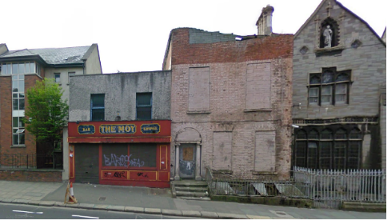
Fig. 2: Google image dated 2009 showing 12 Dorset Street on right hand side. Upper floors removed and internal fabric damaged beyond repair.

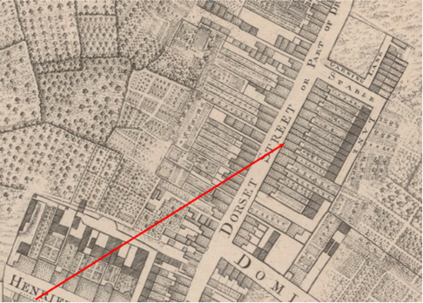
Fig. 3: 1756 John Rocque map showing the terrace on Dorset Street of which number 12 formed part of.

References
- NIAH Inventory Reg Ref 50060595
- O’Connor James (18th of July 2008). Conservation Report: Proposed Development at 12 and 13 Upper Dorset Street, Dublin 1. Unpublished report submitted as part of planning reference 4063/08.
- An Exact Survey of the City & Suburbs of Dublin by John Rocque (1756) https://gallica.bnf.fr/ark:/12148/btv1b530571173.r=rocque%20dublin?rk=107296;4

Significance/NIAH Rating
12 Dorset Street, Dublin 1 was recorded under Stage 2 of the NIAH for Dublin (Ref 50060595) with Ministerial Recommendations for Stage 2 issued to Dublin City Council on the 9th of August 2017. The structure was assigned a ‘Regional’ rating. These are structures or sites that make a significant contribution to the architectural heritage within their region or area. Structures which are considered of Regional significance are deemed worthy of inclusion on the RPS.

Assessment of Special Interest under the Planning and Development Act 2000
The National Inventory of Architectural Heritage assigned this building Architectural and Historical interest. The Conservation Section has considered the opinion of the NIAH and is in agreement with assigning ARCHITECTURAL and HISTORICAL categories of special interest to the building.

Conclusion & Recommendation
It is recommended that the RPS entry for 12 Dorset Street Upper, Dublin 1 be amended to just include the front and side façade.

Proposed Listing
RPS Ref No | Address | Description
2330 | 12 Dorset Street Upper, Dublin 1 | House, exterior of front & side elevation only including roof and chimneys

29/10/2021
_______________ ________________
Paraic Fallon
Senior Planner Date

Photographic Record:
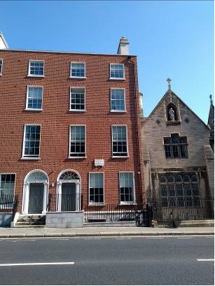 | 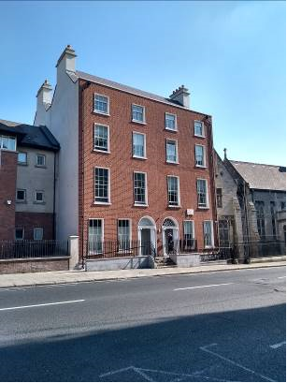
Fig.4: Front elevation of 12 Dorset St Upper | Fig.5: View of 12 and 13 Dorset Street Upper
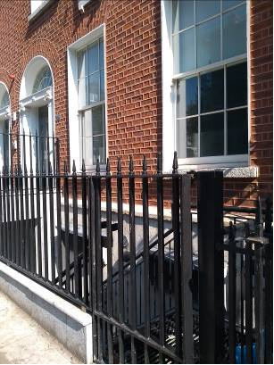 | 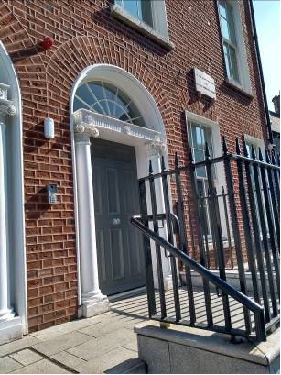
Fig.6: Detail of front elevation of 12 Dorset Street Upper | Fig.7: View of front entrance door to 12 Dorset Street Upper

RPS No. 2335 - 75 Dorset Street Upper, Dublin 1
Seandálaíocht, Caomhantas & Oidhreacht
An Roinn Pleanála & Forbairt Maoine
Oifigí na Cathrach, An Ché Adhmaid, Baile Átha Cliath 8

Archaeology, Conservation & Heritage Section
Planning & Property Development Department
Block 3, Floor 3, Civic Offices, Wood Quay, Dublin 8

Tel: (01) 222 3926, 222 3927
Email: conservation@dublincity.ie

29th October 2021

Draft Development Plan 2022-2028

Ref: RPS 2335 AMENDMENT to the Record of Protected Structures
_______________________________________________________________________________

Recommendation:
Amendment of current entry for 75 Dorset Street Upper, Dublin 1 – Shopfront, to now read: 75 Dorset Street Upper, Dublin 1 – House: external structure including steps and railings.
_______________________________________________________________________________

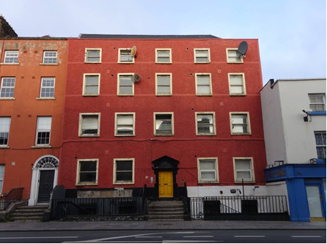

Introduction
There has been a query about whether the RPS entry 75 Dorset Street Upper, Dublin 1 – Doorcase, should be amended to 75 Dorset Street Upper, Dublin 1 – House: external structure including steps and railings as the current protection is limited to the door-case only.

Existing Listing
RPS Ref No | Address | Description
2335 | 75 Dorset Street Upper, Dublin 1 | Doorcase

Proposed Listing
Amend the description to include the extent of the eighteenth-century structure.
RPS Ref No | Address | Description
2335 | 75 Dorset Street Upper, Dublin 1 | House: external structure including steps

Request for Investigation
Conservation Section, Dublin City Council

Location and Land Use Zoning
The location of 75 Dorset Street Upper, Dublin 1 is arrowed red below. The main zoning objective is Zone 4: To provide for and improved mixed services facilities.
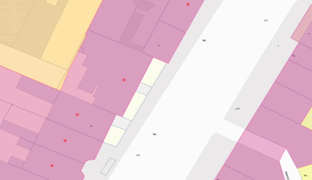
Fig.1: Location and Land Use Zoning

Recent Planning History
Planning Ref | Description | Decision
1190/94 | Alterations to existing 8 apartments and 4-storey extension at rear containing 4 apartments. | GRANT PERMISSION  10-Jan-1995
2746/19 | PROTECTED STRUCTURE: The development will consist of (i) change of use on lower ground floor level from existing 2 no. vacant commercial units to residential use to provide 2 no. studio apartments; (ii) internal modifications to the lower ground floor including provision of bathrooms, storage, kitchen, living area (iii) relocation of fire door of main house from adjacent to staircase on south elevation to under staircase on west elevation; (iv) construction of 10.4 sq.m single storey extension to unit no. 1 at south west (rear) of the building to provide direct access to communal amenity space to rear, provision of private open space and all ancillary works to facilitate the development. No alterations to front facade are proposed. | GRANT PERMISSION  07-Oct-2019

Recent Enforcement History
There is no recent enforcement history on the site.

Summary Description
(See images at end of report) Description based on National Inventory of Architectural Heritage’s record for the site, Ref. 50010704.

Terraced five-bay four-storey over raised basement house, built c.1780 with return to rear. Now in multiple occupancy with extensions c.1995 to rear. Pitched slate roof with clay ridge tiles, hipped to north behind parapet wall with granite coping. Two rendered chimneystacks to rear. Painted roughcast cement rendered walls with smooth render platbands at sill levels to painted granite plinth course and smooth-rendered basement walls. Square-headed window openings with painted masonry sills, rendered surrounds and replacement one-over-one pane timber sliding sash windows; uPVC windows to northern two openings at ground floor level and to rear. Central round-headed door opening with painted stone pedimented doorcase comprising painted stone block-and-start surround to stepped lintel cornice, early Y-tracery timber fanlight to open pediment on scrolled console brackets, and with replacement timber panelled door. Door opens onto concrete paved platform and five granite steps enclosed by replacement steel railings on rendered plinth walls. Basement area also enclosed by replacement steel railing on rendered plinth wall.

Assessment
Built in the latter decades of the eighteenth-century, No. 75 Dorset Street Upper forms part of a terrace of similarly-aged houses along the west side of the street. The streetscape is varied with houses of differing heights and widths. No.75 is the widest structure in the terrace (five bays compared to the two-bay widths of the surrounding buildings) and is also one of the tallest. Its sizeable presence in the streetscape may be due to the limited depth of its plot, which is reduced by the rear sites of structures on Eccles Street. The building line of the structures on this section of Dorset Street Upper step forward as the street travels northwards; this may be due to the curve of the road or to accommodate more space for the structures at the north end of the block where they are most impacted by the Eccles Street properties.

Though the front elevation of No.75 has being much altered with the application of a render and the replacement of the windows with one-over-one sash windows, the building retains its symmetrical façade and the diminishing fenestration pattern typical of Georgian buildings. The fine doorcase including early fanlight is of particular note, however the entire external envelope represents an important survivor of Georgian architecture within the streetscape and warrants protection. The one-over-one timber sash windows, though not original to the building, also contribute to its special character, representing changing patterns in window fashions in the late nineteenth-century. The interior has been altered substantially with the historic planform largely removed including the removal of the historic staircase, with a modern staircase now located in a later extension to the rear.

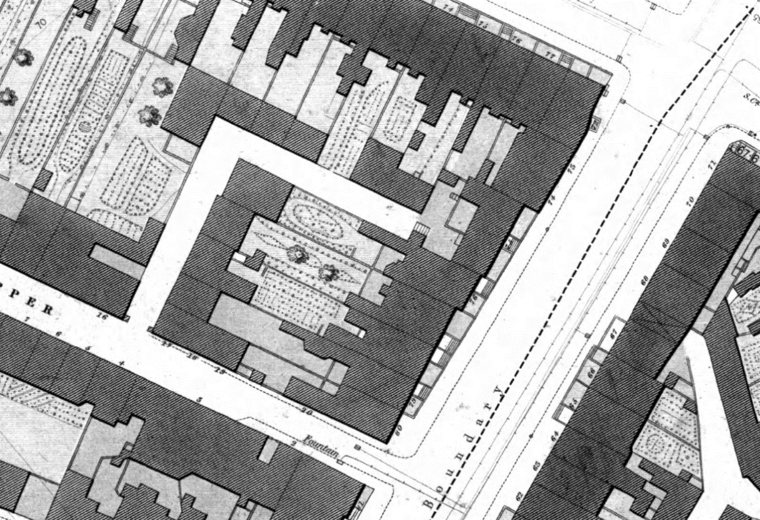

Fig. 2: Extract from 1847 City of Dublin Ordnance Survey plan showing No. 75 Dorset Street Upper; note the difference in depth of the structure compared to those to the south

References
- National Inventory of Architectural Heritage Reference 50010704
- City of Dublin, held by Ordnance Survey Ireland. © Public domain. Digital content: © Ordnance Survey Ireland, published by UCD Library, University College Dublin, 1847, Sheet 8 http://digital.ucd.ie/view/ucdlib:40823 (accessed 18/10/2021)
- City of Dublin, held by Ordnance Survey Ireland. © Public domain. Digital content: © Ordnance Survey Ireland, published by UCD Library, University College Dublin, 1890, Sheet XVIII.37 http://digital.ucd.ie/view/ucdlib:40892 (accessed 18/10/2021)

Significance/NIAH Rating
No. 75 Dorset Street Upper were recorded under Stage 1 of the NIAH for Dublin (Ref 50010704) with Ministerial Recommendations for Stage 1 issued to Dublin City Council on 4th June 2014. The structures were both assigned a ‘Regional’ rating. These are structures or sites that make a significant contribution to the architectural heritage within their region or area. Structures which are considered of Regional significance are deemed worthy of inclusion on the RPS.

Assessment of Special Interest under the Planning and Development Act 2000
The National Inventory of Architectural Heritage assigned ARCHITECTURAL and ARTISTIC interest to No. 75 Dorset Street Upper. The Conservation Section has considered the opinion of the NIAH and is in agreement with assigning these categories of special interest to the site.

Conclusion & Recommendation
It is recommended that the RPS entry for 75 Dorset Street Upper, Dublin 1 be amended as follows:

Proposed Listing
RPS Ref No | Address | Description
2335 | 75 Dorset Street Upper, Dublin 1 | House: external structure including steps

29/10/2021
_______________ ________________
Paraic Fallon Date
Senior Planner

Photographic Record:
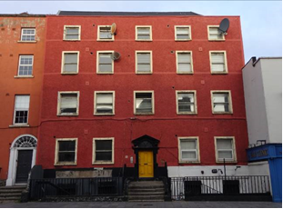 | 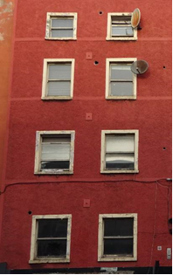
Fig. 3: South elevation | Fig. 4: Window openings, south elevation
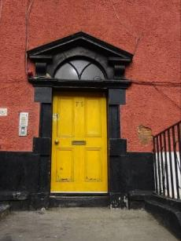 | 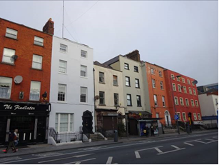
Fig. 5: Door opening, south elevation | Fig. 6: Street context

RPS No. 2336 - 76 Dorset Street Upper, Dublin 1
Seandálaíocht, Caomhantas & Oidhreacht
An Roinn Pleanála & Forbairt Maoine
Oifigí na Cathrach, An Ché Adhmaid, Baile Átha Cliath 8

Archaeology, Conservation & Heritage Section
Planning & Property Development Department
Block 3, Floor 3, Civic Offices, Wood Quay, Dublin 8

Tel: (01) 222 3926, 222 3927
Email: conservation@dublincity.ie

12th November 2021

Draft Development Plan 2022-2028

Ref: RPS 2336 AMENDMENT of the Record of Protected Structures
_______________________________________________________________________________

Recommendation:
Amendment of current entry for 76 Dorset Street Upper, Dublin 1 – Doorcase, to now read: 76 Dorset Street Upper, Dublin 1 – House extending protection to the entire structure to include its interior.
_______________________________________________________________________________

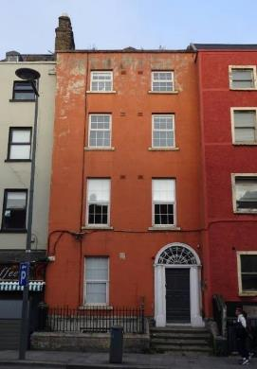

Introduction
There has been a query about whether the RPS entry 76 Dorset Street Upper, Dublin 1 – Doorcase, should be amended to 76 Dorset Street Upper, Dublin 1 – House, thereby extending protection to the entire structure to include its interior. The entire building is considered to be of significance and warrants protection. It forms part of a relatively intact terrace of eighteenth-century structures on the north side of the street.

Existing Listing
RPS Ref No | Address | Description
2336 | 76 Dorset Street Upper, Dublin 1 | Doorcase

Proposed Listing
Amend the description to include the extent of the eighteenth-century structure.
RPS Ref No | Address | Description
2336 | 76 Dorset Street Upper, Dublin 1 | House

Request for Investigation
Conservation Section, Dublin City Council

Location and Land Use Zoning
The location of 76 Dorset Street Upper, Dublin 1 is arrowed red below. The main zoning objective is Z4: To provide for and improved mixed services facilities.
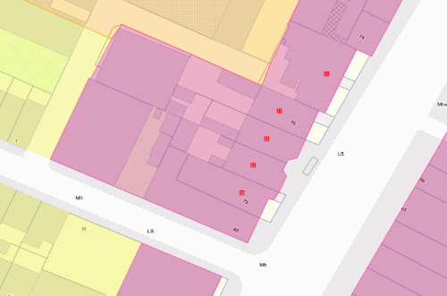
Figure 1: Location and Land Use Zoning

Recent Planning History
There are no recent planning applications on file for the site.

Recent Enforcement History
There is no recent enforcement history on the site.

Summary Description
(See images at end of report)
Description based on National Inventory of Architecture’s record for site, Ref. 50010703.
Terraced two-bay four-storey over raised basement house, built c.1770, on staggered plan. Now in multiple occupancy with later extension to rear. Pitched slate roof on T-plan set behind parapet wall with painted coping having terracotta ridge tiles and gabled rear elevation. Brown brick chimneystack with clay pots rising from south party wall; red brick chimneystack to rear elevation. Painted ruled-and-lined cement render walls to painted granite plinth course and rendered basement. Square-headed window openings with granite sills and replacement uPVC windows. Round-headed door opening with painted masonry Doric doorcase. Original timber door with eight raised-and-fielded panels flanked by engaged Doric columns on plinth bases with moulded lintel cornice, original elaborate cobweb leaded fanlight, and moulded archivolt. Door opens onto concrete paved platform and four granite steps. Platform and basement area enclosed by wrought-iron railings on moulded granite plinth wall.

Assessment
Built in the latter decades of the eighteenth-century, No. 76 Dorset Street Upper forms part of a terrace of similarly-aged houses along the west side of the street. The streetscape is varied with houses of differing heights and widths. No.76 was a substantial townhouse and one of the tallest structures in the terrace. The building line of the structures on this section of Dorset Street Upper step forward as the street travels with No.76 stepping forward from No. 77 and No.75 to the north stepping further forward again. The group of five structures were protected in 1998, and assigned the description Doorcase.

Though the front elevation of No.76 has been much altered with the application of a render and the replacement of its windows, the building retains its symmetrical façade and the diminishing fenestration pattern typical of Georgian buildings. The fine doorcase, which may be an early nineteenth-century insertion, and surviving historic door are of particular note, however the entire external envelope represents an important survivor of Georgian architecture within the streetscape and warrants protection. The gabled rear elevation reflects the transitional nature of the house from Dutch Billy to later Georgian-style architecture, where structures exhibited some features of a Dutch Billy but were not constructed with a gabled front elevation. The building also retains its railed front basement well, together with historic railings and cut-stone plinth.

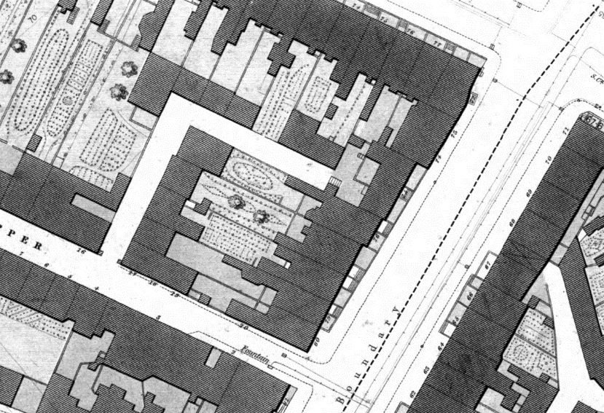

Fig. 2: Extract from 1847 City of Dublin Ordnance Survey showing No. 76 Dorset Street Upper

It is unknown if there is surviving internal historic fabric. However, the external evidence clearly demonstrates that the RPS entry warrants amendment of its description to reflect the importance of this structure to the architectural heritage of Dublin city; also having regard to Chapter 2, Section 2.5.2 of the Architectural Heritage Protection Guidelines for Planning Authorities (2011) which states ‘The protection of a façade alone should generally only be considered where there is no surviving interior of any interest, for example where the building has previously been gutted and the façade is the only remaining feature of the original historic building. Generally a façade relates integrally to its building, which may retain interior detail of note including, for example, the original spatial plan, shop-fittings or decorative elements such as chimneypieces, staircases, window shutters or cornices. Elements of the external envelope and/or within the curtilage may also be of intrinsic interest and worthy of protection; these might include the roof, the rear elevation, outbuildings or other site features’ (pg. 24).

Following assessment of No.76 and having considered the National Inventory of Architectural Heritage’s record/rating and the resulting Ministerial Recommendation (see below), the Conservation Section is of the opinion that the description on the RPS should be amended to read House, ensuring the entire structure, including its interior, is protected.

References
- National Inventory of Architectural Heritage Reference 50010703
- City of Dublin, held by Ordnance Survey Ireland. © Public domain. Digital content: © Ordnance Survey Ireland, published by UCD Library, University College Dublin, 1847, Sheet 8 http://digital.ucd.ie/view/ucdlib:40823 (accessed 18/10/2021)
- City of Dublin, held by Ordnance Survey Ireland. © Public domain. Digital content: © Ordnance Survey Ireland, published by UCD Library, University College Dublin, 1890, Sheet XVIII.37 http://digital.ucd.ie/view/ucdlib:40892 (accessed 18/10/2021)

Significance/NIAH Rating
No. 76 Dorset Street Upper was recorded under Stage 1 of the NIAH for Dublin (Ref. 50010703) with Ministerial Recommendations for Stage 1 issued to Dublin City Council on 4th June 2014. The structure has been assigned a ‘Regional’ rating. These are structures or sites that make a significant contribution to the architectural heritage within their region or area. Structures which are considered of Regional significance are deemed worthy of inclusion on the RPS.

Assessment of Special Interest under the Planning and Development Act 2000
The National Inventory of Architectural Heritage assigned ARCHITECTURAL and ARTISTIC interest to No. 76 Dorset Street Upper. The Conservation Section has considered the opinion of the NIAH and is in agreement with assigning these categories of special interest to the site.

Conclusion & Recommendation
It is recommended that the RPS entry for 76 Dorset Street Upper be amended in accordance with the proposed listing below, extending protection to the entire structure to include its interior.

Proposed Listing
RPS Ref No | Address | Description
2336 | 76 Dorset Street Upper, Dublin 1 | House

12/11/2021
_______________ ________________
Paraic Fallon Date
Senior Planner

Photographic Record:
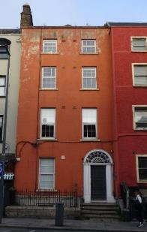 | 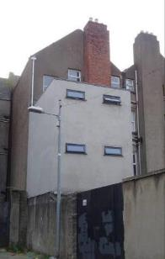
Fig 3. Front (south) elevation of No.76 Dorset Street Upper | Fig 4. Rear (north) elevation of No.76 Dorset Street Upper
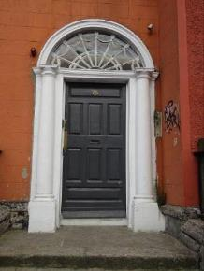 | 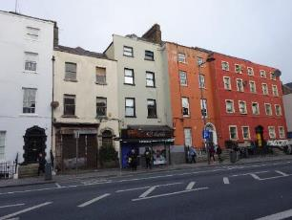
Fig 5. Door opening to front elevation | Fig 6. View from southwest showing position of No.76 within terrace

RPS No. 2337 - 77 Dorset Street Upper, Dublin 1
Seandálaíocht, Caomhantas & Oidhreacht
An Roinn Pleanála & Forbairt Maoine
Oifigí na Cathrach, An Ché Adhmaid, Baile Átha Cliath 8

Archaeology, Conservation & Heritage Section
Planning & Property Development Department
Block 3, Floor 3, Civic Offices, Wood Quay, Dublin 8

Tel: (01) 222 3926, 222 3927
Email: conservation@dublincity.ie

12th November 2021

Draft Development Plan 2022-2028

Ref: RPS 2337 AMENDMENT of the Record of Protected Structures
_______________________________________________________________________________

Recommendation:
Amendment of current entry for 77 Dorset Street Upper, Dublin 1 – Doorcase, to now read: 77 Dorset Street Upper, Dublin 1 – House extending protection to the entire structure to include its interior.
_______________________________________________________________________________

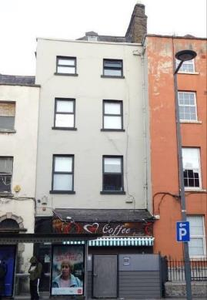

Introduction
There has been a query about whether the RPS entry 77 Dorset Street Upper, Dublin 1 – Doorcase, should be amended to 77 Dorset Street Upper, Dublin 1 – House thereby extending protection to the entire structure to include its interior. The entire building is considered to be of significance and warrants protection. It forms part of a relatively intact terrace of eighteenth-century structures on the north side of the street.

Existing Listing
RPS Ref No | Address | Description
2337 | 77 Dorset Street Upper, Dublin 1 | Doorcase

Proposed Listing
Amend the description to include the extent of the eighteenth-century structure.
RPS Ref No | Address | Description
2337 | 77 Dorset Street Upper, Dublin 1 | House

Request for Investigation
Conservation Section, Dublin City Council

Location and Land Use Zoning
The location of 77 Dorset Street Upper, Dublin 1 is arrowed red below. The main zoning objective is Z4: To provide for and improved mixed services facilities.
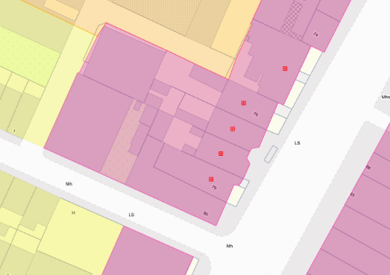
Figure 1: Location and Land Use Zoning

Recent Planning History
There are no recent planning applications on file for the site.

Recent Enforcement History
There is no recent enforcement history on the site.

Summary Description
(See images at end of report)
Terraced two-bay four-storey over basement house, built c.1770, on staggered plan. Now in multiple occupancy with restaurant to ground floor and accommodation inserted to attic; basement well has been filled in. Pitched slate roof on L-plan with terracotta ridge tiles with rear gable set behind parapet wall with granite coping. Brown brick chimneystack with clay pots rising from north party wall; rendered chimneystack to rear elevation. Painted smooth-rendered walls. Square-headed window openings with granite sills and replacement uPVC windows. Later twentieth-century shopfront inserted to ground floor, with replacement timber panelled door to south side of shopfront providing access to upper floors. Shopfront appears to have removed the historic door opening including access steps.

Assessment
Built in the latter decades of the eighteenth-century, No. 77 Dorset Street Upper forms part of a terrace of similarly-aged houses along the west side of the street. The streetscape is varied with houses of differing heights and widths. No. 77 follows the two-bay planform of many of the structures within the terrace. The buildings are varied in size and general design, forming a significant grouping. The group of five structures were protected in 1998, and assigned the description Doorcase. In the case of No.77, there is no apparent surviving historic doorcase to the front elevation, with a later shopfront and plain square-headed door opening inserted to the ground floor. The basement well has been removed and the front door opening has been lowered, removing the steps indicated on historic mapping. It is not clear when this intervention was carried out and whether the original description was an error. The current door location does match the location indicated on historic mapping. Notwithstanding this later intervention, the Conservation Section are of the opinion that the description should be reconsidered to read House, ensuring the entire structure including its interior are protected.

Though the front elevation of No. 77 has being much altered with the application of a render and the replacement of the windows, the building retains its symmetrical façade and the diminishing fenestration pattern typical of Georgian buildings. Together with its neighbours to the east and west, it constitutes the oldest and most intact stretch of buildings on Dorset Street Upper. The L-plan roof and gabled rear elevation reflect the transitional nature of the house from Dutch Billy to later Georgian-style architecture, where structures exhibited some features of a Dutch Billy but were not constructed with a gabled front elevation.

Fig. 2: Extract from 1847 City of Dublin Ordnance Survey plan showing No. 77 Dorset Street Upper; note the difference in depth of the structure compared to those to the south

It is unknown if there is surviving internal historic fabric. However, the external evidence clearly demonstrates that the RPS entry warrants amendment of its description to reflect the importance of this structure to the architectural heritage of Dublin city; also having regard to Chapter 2, Section 2.5.2 of the Architectural Heritage Protection Guidelines for Planning Authorities (2011) which states ‘The protection of a façade alone should generally only be considered where there is no surviving interior of any interest, for example where the building has previously been gutted and the façade is the only remaining feature of the original historic building. Generally a façade relates integrally to its building, which may retain interior detail of note including, for example, the original spatial plan, shop-fittings or decorative elements such as chimneypieces, staircases, window shutters or cornices. Elements of the external envelope and/or within the curtilage may also be of intrinsic interest and worthy of protection; these might include the roof, the rear elevation, outbuildings or other site features’ (pg. 24).

Following assessment of No. 77 Dorset Street Upper, the Conservation Section is of the opinion that the description on the RPS should be amended to read House, ensuring the entire structure, including its interior, is protected.

References
- City of Dublin, held by Ordnance Survey Ireland. © Public domain. Digital content: © Ordnance Survey Ireland, published by UCD Library, University College Dublin, 1847, Sheet 8 http://digital.ucd.ie/view/ucdlib:40823 (accessed 18/10/2021)
- City of Dublin, held by Ordnance Survey Ireland. © Public domain. Digital content: © Ordnance Survey Ireland, published by UCD Library, University College Dublin, 1890, Sheet XVIII.37 http://digital.ucd.ie/view/ucdlib:40892 (accessed 18/10/2021)

Significance/NIAH Rating
No. 77 Dorset Street Upper was not recorded under Stage 1 of the NIAH for Dublin and therefore there is no Ministerial Recommendation for the site. Notwithstanding its omission from the survey, the Conservation Section concludes that the structure warrants a ‘Regional’ rating. These are structures or sites that make a significant contribution to the architectural heritage within their region or area. Structures which are considered of Regional significance are deemed worthy of inclusion on the RPS.

Assessment of Special Interest under the Planning and Development Act 2000
The Conservation Section assigns ARCHITECTURAL interest to No. 77 Dorset Street Upper.

Conclusion & Recommendation
It is recommended that the RPS entry for 77 Dorset Street Upper, Dublin 1 be amended in accordance with the proposed listing below, extending protection to the entire structure to include its interior.

Proposed Listing
RPS Ref No | Address | Description
2337 | 77 Dorset Street Upper, Dublin 1 | House

12/11/2021
_______________ ________________
Paraic Fallon Date
Senior Planner

Photographic Record:
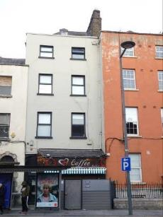 | 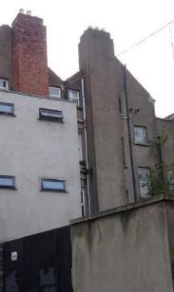
Fig. 3. Front (south) elevation of No. 77 Dorset Street Upper | Fig. 4. Rear (north) elevation of No. 77 Dorset Street Upper
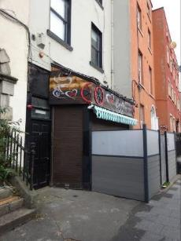 | 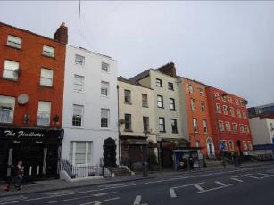
Fig. 5. Door opening and shopfront from southwest | Fig. 6. View from southwest showing position of No.77 within terrace

RPS No. 2338 - 78 Dorset Street Upper, Dublin 1
Seandálaíocht, Caomhantas & Oidhreacht
An Roinn Pleanála & Forbairt Maoine
Oifigí na Cathrach, An Ché Adhmaid, Baile Átha Cliath 8

Archaeology, Conservation & Heritage Section
Planning & Property Development Department
Block 3, Floor 3, Civic Offices, Wood Quay, Dublin 8

Tel: (01) 222 3926, 222 3927
Email: conservation@dublincity.ie

12th November 2021

Draft Development Plan 2022-2028

Ref: RPS 2338 AMENDMENT of the Record of Protected Structures

_______________________________________________________________________________

Recommendation:
Amendment of current entry for 78 Dorset Street Upper, Dublin 1 – Doorcase, to now read: 78 Dorset Street Upper, Dublin 1 – House extending protection to the entire structure to include its interior.
_______________________________________________________________________________

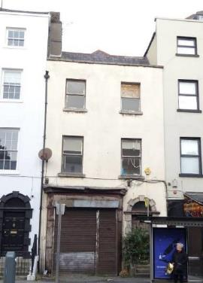

Introduction
There has been a query about whether the RPS entry 78 Dorset Street Upper, Dublin 1 – Doorcase, should be amended to 78 Dorset Street Upper, Dublin 1 – House, thereby extending protection to the entire structure to include its interior. The entire building is considered to be of significance and warrants protection. It forms part of a relatively intact terrace of eighteenth-century structures on the north side of the street. Internally the building retains early fabric, further adding to its significance.

Existing Listing
RPS Ref No | Address | Description
2338 | 78 Dorset Street Upper, Dublin 1 | Doorcase

Proposed Listing
Amend the description to include the extent of the eighteenth-century structure.
RPS Ref No | Address | Description
2338 | 78 Dorset Street Upper, Dublin 1 | House

Request for Investigation
Conservation Section, Dublin City Council

Location and Land Use Zoning
The location of 78 Dorset Street Upper, Dublin 1 is arrowed red below. The main zoning objective is Z4: To provide for and improved mixed services facilities.
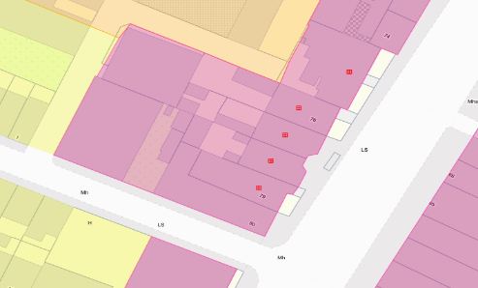
Fig 1: Site Location and Zoning Map

Recent Planning History
Planning Ref | Description | Decision
5100/08 | PROTECTED STRUCTURE - Change of use from residential/shop to office/shop use and for internal alterations and renovations. | GRANT PERMISSION  04 Mar 2009
3036/20 | PROTECTED STRUCTURE: Planning permission is sought by Independent Trust Company as Trustee of Delta Fund I001088 for change of use from shop with residential above to single dwelling of three storey over basement terraced building, modification of existing shopfront and new railing to front boundary, internal alterations and restoration including upgrading of existing services, and all associated site work. | GRANT PERMISSION  16 Mar 2021

Recent Enforcement History
Ref. No. | Opened | Reason | Closed | Reason
E0128/19 | 19-Feb-2019 | Building works without PP | 27-Nov-2019 | Complies with permission

Summary Description
(See images at end of report)
Description based on National Inventory of Architectural Heritage’s record for site, Ref. 50010701.
Terraced two-bay three-storey house, built c.1770, with projecting hardwood shopfront inserted to ground floor and single-storey flat-roofed extensions to rear. Now in multiple occupancy. Pitched slate roof on T-plan, gabled to rear and set behind parapet wall with granite coping. Cast-iron hopper and downpipe breaking through parapet wall and rendered chimneystack to south party wall. Painted cement-rendered walls. Square-headed window openings with granite sills and replacement hardwood windows. Round-headed door opening with Gibbsian granite doorcase including original wood-grained timber door with eight raised-and-fielded panels and plain fanlight. Door opens onto granite platform and four granite steps enclosed by wrought-iron railing set into cement rendered plinth walls, projecting into public domain.

Assessment:
Built in the latter decades of the eighteenth-century, No. 78 Dorset Street Upper forms part of a terrace of similarly-aged houses along the west side of the street. The buildings are varied in size and general design, forming a significant grouping. The group of five structures were protected in 1998, and assigned the description Doorcase. The Conservation Section, following assessment of No.78 and taking into account the National Inventory of Architectural Heritage’s record and resulting Ministerial Recommendation (see below), are of the opinion that the description should be reconsidered to read House, ensuring the entire structure including its interior are protected.

Despite the loss of external fabric, the early doorcase with its intact panelled door and steps clearly indicate the age and style of this building which, together with its neighbours, constitute the oldest and most intact stretch of buildings on Dorset Street Upper. The gabled rear elevation reflects the transitional nature of the house from Dutch Billy to later Georgian-style architecture, where structures exhibited some features of a Dutch Billy but were not constructed with a gabled front elevation. Historic mapping provides evidence that it would originally have had a railed basement well, which was likely infilled when the mid-twentieth-century shopfront was added.

Documentation submitted in support of a planning application in 2020 (Ref 3036/20) shows surviving historic fabric internally including eighteenth-century timber staircase with paired newels and swan-neck handrails, and lugged door architraves. The evidence clearly demonstrates that the RPS entry warrants amendment of its description to reflect the importance of this structure to the architectural heritage of Dublin city. The granted planning permission reflected the significance of the building, ensuring its early fabric is retained.

Fig. 2: Extract from 1847 City of Dublin Ordnance Survey showing No. 78 Dorset Street Upper

References
- National Inventory of Architectural Heritage Reference 50010701
- City of Dublin, held by Ordnance Survey Ireland. © Public domain. Digital content: © Ordnance Survey Ireland, published by UCD Library, University College Dublin, 1847, Sheet 8 http://digital.ucd.ie/view/ucdlib:40823 (accessed 18/10/2021)
- City of Dublin, held by Ordnance Survey Ireland. © Public domain. Digital content: © Ordnance Survey Ireland, published by UCD Library, University College Dublin, 1890, Sheet XVIII.37 http://digital.ucd.ie/view/ucdlib:40892 (accessed 18/10/2021)

Significance/NIAH Rating
No. 78 Dorset Street Upper was recorded under Stage 1 of the NIAH for Dublin (Ref. 50010701) with Ministerial Recommendations for Stage 1 issued to Dublin City Council on 4th June 2014. The structure has been assigned a ‘Regional’ rating. These are structures or sites that make a significant contribution to the architectural heritage within their region or area. Structures which are considered of Regional significance are deemed worthy of inclusion on the RPS.

Assessment of Special Interest under the Planning and Development Act 2000
The National Inventory of Architectural Heritage assigned ARCHITECTURAL and ARTISTIC interest to No. 78 Dorset Street Upper. The Conservation Section has considered the opinion of the NIAH and is in agreement with assigning these categories of special interest to the structure.

Conclusion & Recommendation
It is recommended that the RPS entry for 78 Dorset Street Upper, Dublin 1 be amended in accordance with the proposed listing below, extending protection to the entire structure to include its interior.

Proposed Listing
RPS Ref No | Address | Description
2338 | 78 Dorset Street Upper, Dublin 1 | House

12/11/2021
_______________ ________________
Paraic Fallon Date
Senior Planner

Photographic Record:
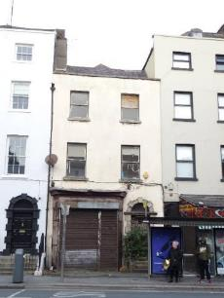 | 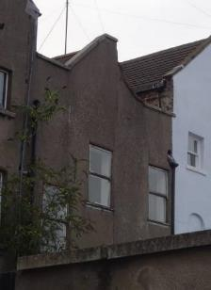
Fig. 3. South (front) elevation | Fig 4. North (rear) elevation
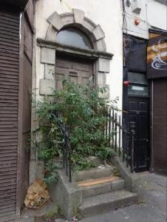 | 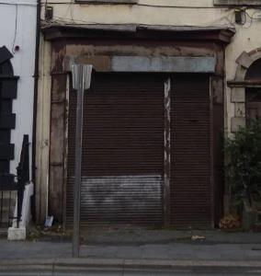
Fig 5. Door opening | Fig 6. Shopfront

RPS No. 2339 - 79 Dorset Street Upper, Dublin 1
Seandálaíocht, Caomhantas & Oidhreacht
An Roinn Pleanála & Forbairt Maoine
Oifigí na Cathrach, An Ché Adhmaid, Baile Átha Cliath 8

Archaeology, Conservation & Heritage Section
Planning & Property Development Department
Block 3, Floor 3, Civic Offices, Wood Quay, Dublin 8

Tel: (01) 222 3926, 222 3927
Email: conservation@dublincity.ie

12th November 2021

Draft Development Plan 2022-2028

Ref: RPS 2339 AMENDMENT of the Record of Protected Structures
_______________________________________________________________________________

Recommendation:
Amendment of current entry for 79 Dorset Street Upper, Dublin 1 – Doorcase, to now read: 79 Dorset Street Upper, Dublin 1 – House extending protection to the entire structure to include its interior.
_______________________________________________________________________________

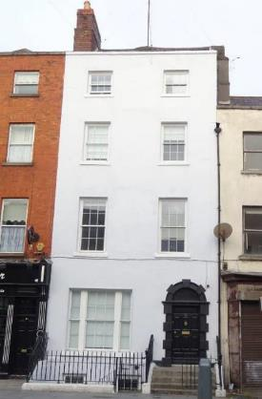

Introduction
There has been a query about whether the RPS entry 79 Dorset Street Upper, Dublin 1 – Doorcase, should be amended to 79 Dorset Street Upper, Dublin 1 – House. The entire building is considered to be of significance and warrants protection. It forms part of a relatively intact terrace of eighteenth-century structures on the north side of the street. Internally the building retains early fabric, further adding to its significance. Internally the building retains early some fabric, further adding to its significance.

Existing Listing
RPS Ref No | Address | Description
2339 | 79 Dorset Street Upper, Dublin 1 | Doorcase

Proposed Listing
Amend the description to include the extent of the eighteenth-century structure.
RPS Ref No | Address | Description
2339 | 79 Dorset Street Upper, Dublin 1 | House

Request for Investigation
Conservation Section, Dublin City Council

Location and Land Use Zoning
The location of 79 Dorset Street Upper, Dublin 1 is arrowed red below. The main zoning objective is Z4: To provide for and improved mixed services facilities.
Figure 1: Location and Land Use Zoning

Recent Planning History
Planning Ref | Description | Decision
4692/18 | PROTECTED STRUCTURE: The development will consist of a reinstatement of full residential use to all levels of an existing four storey over basement (Protected Structure) building (area 348m2) formally Hickey Auctioneers and also partially vacant, including alterations to the existing layout. The proposed alterations to existing layout include (a) ensuites to all bedrooms and toilets off all reception rooms, (b) reinstatement of basements stairs and other sanitary provisions (c) replacement of all existing windows with new up & down painted timber sash windows, (d) new kitchen, utility, store, bin store and services in existing basement, (e) new back porch door & patio doors off livingroom to courtyard, (f) drop floor in basement return to provide for headspace, (g) general upgrade of all floors and walls for fire, sound and thermal performance where possible, (h) complete replacement and upgrade of all mechanical, electrical and heating installations, (i) repair and upgrade to existing front door and stone surround, (j) reinstatement of previously removed railings to street to match existing, (k) new bay window to ground floor reception room, (l) removal of previously inserted subdividing internal walls where required, (m) blocking up, adjusting, moving, replacing existing doors and reusing where possible and matching existing doors and surrounds. Also included are general improvements to the external appearance of the building and roof to prevent further water ingress and damage, general site landscaping including a rear courtyard patio. | GRANT PERMISSION  05 Jul 2019
0015/20 | EXPP: PROTECTED STRUCTURE: Replacement of existing PVC and timber windows to front and rear elevations with Georgian-style, timber sash windows. | Grant Exemption Certificate  11 Jun 2020

Recent Enforcement History
Ref. No. | Opened | Reason | Closed | Reason
E0129/19 | 19-Feb-2019 | Building works without PP

Summary Description
(See images at end of report)
Description based on National Inventory of Architectural Heritage’s record for site, Ref. 50010700.
Terraced two-bay four-storey house over raised basement, built c.1770, with extensions to rear. Pitched cement tiled roof on T-plan, gabled to rear and set behind parapet wall with painted coping. Shared brick chimneystack to south party wall with clay pots and rendered chimneystack to rear elevation. Painted ruled-and-lined rendered walls. Square-headed window openings with painted masonry sills and replacement six-over-six and three-over-three (third floor) windows to front elevation and one-over-one timber sash windows to rear elevation. Wyatt window to ground floor, front elevation comprising six-over-six sash window flanked by two-over two sash windows. Round-headed door opening with painted stone Gibbsian doorcase, original timber door with eight raised-and-fielded panels and with plain fanlight. Door opens onto concrete platform and four concrete steps enclosed by cast-iron railings on moulded granite plinth wall, returning to enclose paved basement area.

Assessment
Built in the latter decades of the eighteenth-century, No. 79 Dorset Street Upper forms part of a terrace of similarly-aged houses along the west side of the street. The buildings are varied in size and general design, forming a significant grouping. The group of five structures were protected in 1998, and assigned the description Doorcase. The Conservation Section, following assessment of No.79 and taking into account the National Inventory of Architectural Heritage’s record and resulting Ministerial Recommendation (see below), are of the opinion that the description should be reconsidered to read House, ensuring the entire structure including its interior are protected.

Despite the loss of some external fabric, the early doorcase with its intact panelled door and railed steps clearly indicate the age and style of this building which, together with its neighbours, constitute the oldest and most intact stretch of buildings on Dorset Street Upper. The gabled rear elevation reflects the transitional nature of the house from Dutch Billy to later Georgian-style architecture, where structures exhibited some features of a Dutch Billy but were not constructed with a gabled front elevation. The integrity of the front elevation has been enhanced by the recent insertion of historically appropriate timber sash windows, reinstating the historic character of the streetscape

Documentation submitted in support of a planning application in 2018 (Ref 4692/18) shows a significant degree of surviving historic fabric internally, including timber staircase, joinery to openings, a fireplace at ground floor level and some decorative plasterwork. The historic floor plan is also evident, despite later insertions. The granted planning permission reflected the significance of the building, ensuring its early fabric is retained. The evidence clearly demonstrates that the RPS entry warrants amendment of its description to reflect the importance of this structure to the architectural heritage of Dublin city.

Fig. 2: Extract from 1847 City of Dublin Ordnance Survey showing No. 79 Dorset Street Upper

References
- National Inventory of Architectural Heritage Reference 50010700
- City of Dublin, held by Ordnance Survey Ireland. © Public domain. Digital content: © Ordnance Survey Ireland, published by UCD Library, University College Dublin, 1847, Sheet 8 http://digital.ucd.ie/view/ucdlib:40823 (accessed 18/10/2021)
- City of Dublin, held by Ordnance Survey Ireland. © Public domain. Digital content: © Ordnance Survey Ireland, published by UCD Library, University College Dublin, 1890, Sheet XVIII.37 http://digital.ucd.ie/view/ucdlib:40892 (accessed 18/10/2021)

Significance/NIAH Rating
No. 79 Dorset Street Upper were recorded under Stage 1 of the NIAH for Dublin (Ref. 50010700) with Ministerial Recommendations for Stage 1 issued to Dublin City Council on 4th June 2014. The structure has been assigned a ‘Regional’ rating. These are structures or sites that make a significant contribution to the architectural heritage within their region or area. Structures which are considered of Regional significance are deemed worthy of inclusion on the RPS.

Assessment of Special Interest under the Planning and Development Act 2000
The National Inventory of Architectural Heritage assigned ARCHITECTURAL and ARTISTIC interest to No. 79 Dorset Street Upper. The Conservation Section has considered the opinion of the NIAH and is in agreement with assigning these categories of special interest to the structure.

Conclusion & Recommendation
It is recommended that the RPS entry for 79 Dorset Street Upper, Dublin 1 be amended in accordance with the proposed listing below, extending protection to the entire structure to include its interior.

Proposed Listing
RPS Ref No | Address | Description
2339 | 79 Dorset Street Upper, Dublin 1 | House

12/11/2021
_______________ ________________
Paraic Fallon Date
Senior Planner

Photographic Record:
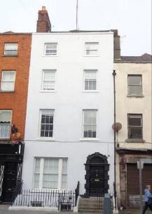 | 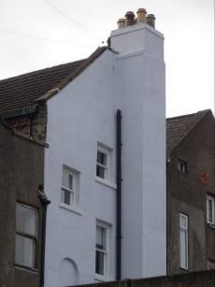
Fig. 3. South (front) elevation | Fig. 4. North (rear) elevation
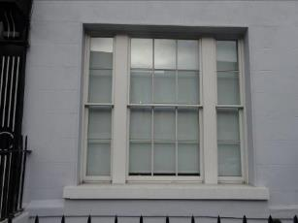
Fig. 5. Window opening | Fig. 6. View from southwest showing position of No.79 within terrace

RPS No. 2361 - 81 Drumcondra Road Lower, Dublin 9
Seandálaíocht, Caomhantas & Oidhreacht
An Roinn Pleanála & Forbairt Maoine
Oifigí na Cathrach, An Ché Adhmaid, Baile Átha Cliath 8

Archaeology, Conservation & Heritage Section
Planning & Property Development Department
Block 3, Floor 3, Civic Offices, Wood Quay, Dublin 8

Tel: (01) 222 3926, 222 3927
Email: conservation@dublincity.ie

1st November 2021

Draft Development Plan 2022-2028

Ref: RPS 2361 AMENDMENT to the Record of Protected Structures
_______________________________________________________________________________

Recommendation:
Amendment of current entry for 81 Drumcondra Road Lower, Dublin 9 - Archbishop’s House: detached Victorian residence/office; gate lodge at entrance; entrance gates, piers, railings and plinth walls, to now read: Drumcondra Road Lower, Dublin 9 - Archbishop's House: detached Victorian residence/office; gate lodge at entrance; entrance gates, piers, railings and plinth walls; milestone in grounds of Archbishop’s House; and stone wall on Drumcondra Road Lower.
_______________________________________________________________________________

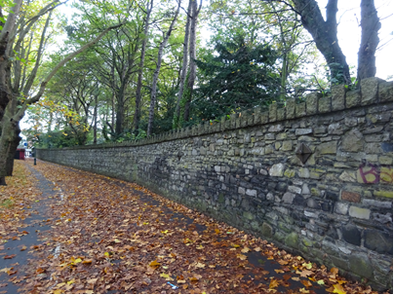

Introduction
The Archbishops House at Drumcondra Road Lower, Dublin 9 is on the current Record of Protected Structures (Dublin City Development Plan 2016-2022). The reference number is RPS: 2361 and the description reads ‘Archbishop’s House: detached Victorian residence/office; gate lodge at entrance; entrance gates, piers, railings and plinth walls’. Inclusion in the Record of Protected Structures of the milestone in the grounds of Archbishop’s House; and the stone wall on Drumcondra Road Lower had been passed by Resolution of Dublin City Council in October 2002 (Report of Assistant City Manager Report No.280/2002) however these specified features have been omitted from the current RPS written description for the site. Amendment of the written RPS entry is proposed to reflect the previous Resolution of Dublin City Council under the Report of Assistant City Manager Report No.280/2002, to extend protection to the milestone in the grounds of Archbishop’s House and the stone wall on Drumcondra Road Lower. It is also proposed to update the street number in the address field for the entry.

Existing Listing:
RPS Ref No | Address | Description
2361 | 81 Drumcondra Road Lower, Dublin 9 | Archbishop’s House: detached Victorian residence/office; gate lodge at entrance; entrance gates, piers, railings and plinth walls.

Proposed Listing: Amend the description to include the milestone in the grounds of Archbishops House and the stone wall on Drumcondra Road Lower. It is also proposed to update the street number in the address field.
RPS Ref No | Address | Description
2361 | Drumcondra Road Lower, Dublin 9 | Archbishop's House: detached Victorian residence/office; gate lodge at entrance; entrance gates, piers, railings and plinth walls; milestone in grounds of Archbishop’s House; and stone wall on Drumcondra Road Lower.

Request for Investigation
Conservation Section, Dublin City Council

Location and Land Use Zoning
The location of the Archbishop’s House at Drumcondra Road Lower, Dublin 9 is indicated by the red arrow below. The zoning objective for the site is Zone 12: To ensure that existing environmental amenities are protected in the predominantly residential future use of these lands.
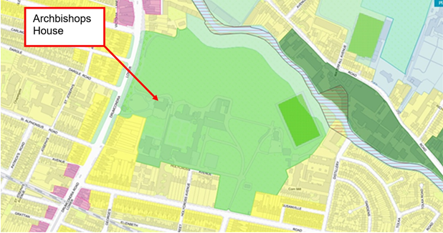
Fig.1 Location and Land Use Zoning

Relevant Planning History
There is no relevant planning history in relation to the subject clarification.

Relevant Planning Enforcement History
There is no relevant planning enforcement history for the subject site.

Summary Description
Description based on the National Inventory of Architectural Heritage (NIAH) Ref: 50120174, 50120272 and 50120173.
(Refer to fig.1 for location plan)
Two-storey archbishop's house, built 1889-91 set back from Drumcondra Road having single-storey gate lodge with associated entrance gateway, built c.1890. Snecked rusticated granite boundary walling having section of cut granite cappings and section of crenelated cappings defining western boundary of Archbishop's House and Holy Cross College. Milestone located within grounds of Archbishops House.

Assessment
The Archbishop’s House at Drumcondra Road Lower was built in 1889-9 to provide accommodation for Archbishop Cullen, founder of the adjacent Holy Cross College. The Archbishop’s House together with the gate lodge, entrance gates, piers, railings and plinth walls were first protected under the Draft Dublin City Development Plan, 1987 (as amended). A subsequent assessment of the site was undertaken by the Conservation Section in 2002. This recommended that a milestone located within in grounds of Archbishop’s House and the stone wall on Drumcondra Road Lower should be included in the Record of Protected Structures as a variation to the existing RPS entry for the site. The proposed variation was passed by Resolution of Dublin City Council in October 2002 (Report of Assistant City Manager Report No.280/2002) however these specified features have been omitted from the current RPS written description for the site.

Amendment of the written RPS entry is proposed to reflect the previous Resolution of Dublin City Council under the Report of Assistant City Manager Report No.280/2002, to extend protection to the milestone in the grounds of Archbishop’s House and the stone wall on Drumcondra Road Lower. It is also proposed to update the street number in the address field for the entry. It is recommended to amend the written description for RPS ref: 2361 to reflect the previous Resolution of Dublin City Council under the Report of Assistant City Manager Report No.280/2002, to read ‘Archbishop's House: detached Victorian residence/office; gate lodge at entrance; entrance gates, piers, railings and plinth walls; milestone in grounds of Archbishop’s House; and stone wall on Drumcondra Road Lower'. In addition it is recommended that the address field for the RPS entry be amended to omit the street number to now read ‘Drumcondra Road Lower, Dublin 9’.

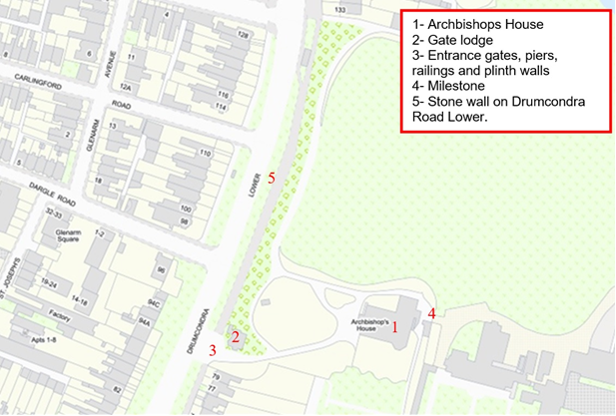
Fig.2: Layout plan referenced to buildings as indicated in the summary description.

References
- Pollard, M., 1962. Holy Cross College, Clonliffe Dublin: College History and Centenary Record, Irish Printers, Ltd.
- National Inventory of Architectural Heritage (NIAH) Ref: 50120174, 50120272 and 50120173.
- Report of Assistant City Manager Report No.280/2002.
- Planning file ref: SHD0015/21.

Significance/NIAH Rating
The Archbishop’s House, gate lodge and the associated gates, railings and walls at Clonliffe Road, Dublin 3 were individually recorded under Stage 5 of the NIAH for Dublin (Ref: 50120174, 50120272 and 50120173). There are currently no Ministerial Recommendations for the site however the structures were assigned a ‘Regional’ rating. These are structures or sites that make a significant contribution to the architectural heritage within their region or area. Structures which are considered of Regional significance are deemed worthy of inclusion on the RPS. The milestone within the grounds of the Archbishop’s house was not recorded by the NIAH.

Assessment of Special Interest under the Planning and Development Act 2000
The National Inventory of Architectural Heritage assigned: ARCHITECTURAL, ARTISTIC, HISTORICAL, and SOCIAL interest to the Archbishop’s House; ARCHITECTURAL, ARTISTIC, and SOCIAL interest to the Gate lodge; and ARCHITECTURAL, ARTISTIC, SOCIAL and TECHNICAL interest to the gates, railings and walls at Drumcondra Road Lower, Dublin 9. The Conservation Section has considered the opinion of the NIAH and is in agreement with assigning these categories of special interest to the individual sites. The conservation section also considers the milestone to be of ARCHITECTURAL, HISTORICAL and SOCIAL significance as a testament to the development of the transport network in the area.

Conclusion & Recommendation
It is recommended that the RPS entry for RPS ref: 2361 be amended to - Drumcondra Road Lower, Dublin 9 - Archbishop's House: detached Victorian residence/office; gate lodge at entrance; entrance gates, piers, railings and plinth walls; milestone in grounds of Archbishop’s House; and stone wall on Drumcondra Road Lower.

Proposed Listing
RPS Ref No | Address | Description
2361 | Drumcondra Road Lower, Dublin 9 | Archbishop's House: detached Victorian residence/office; gate lodge at entrance; entrance gates, piers, railings and plinth walls; milestone in grounds of Archbishop’s House; and stone wall on Drumcondra Road Lower.

01/11/2021
_______________ ________________
Paraic Fallon
Senior Planner Date

Photographic Record:
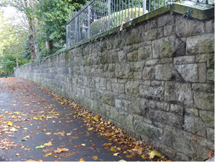 | 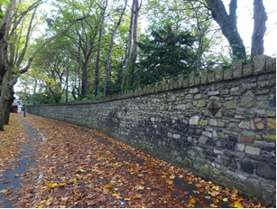
Fig.3 Section of stone wall on Drumcondra Road Upper with cut stone capping. | Fig.4 Section of stone wall on Drumcondra Road Upper with crenelated capping detail.
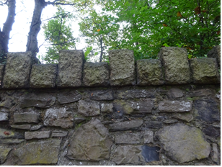 | 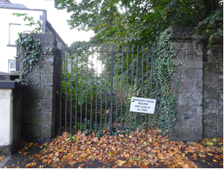
Fig.5 Detail of crenelated capping detail. | Fig.6 Stone piers terminating northern section of stone wall on Drumcondra Road Upper.

RPS No. 2486 – 15-17 Eden Quay, Dublin 1
Seandálaíocht, Caomhantas & Oidhreacht
An Roinn Pleanála & Forbairt Maoine
Oifigí na Cathrach, An Ché Adhmaid, Baile Átha Cliath 8

Archaeology, Conservation & Heritage Section
Planning & Property Development Department
Block 3, Floor 3, Civic Offices, Wood Quay, Dublin 8

Tel: (01) 222 3926, 222 3927
Email: conservation@dublincity.ie

11th November 2021

Draft Development Plan 2022-2028

Ref: RPS 2486 AMENDMENT to the Record of Protected Structures
_______________________________________________________________________________

Recommendation:
Amendment of current entry for 15-17 Eden Quay, Dublin 1 – Business premises (Eden House), to now read: 15-17 Eden Quay, Dublin 1 – Commercial premises (former Eden House): south and west elevations and cast-iron railings. This will limit the protection to the building’s south and west elevations including its cast-iron railings.
_______________________________________________________________________________

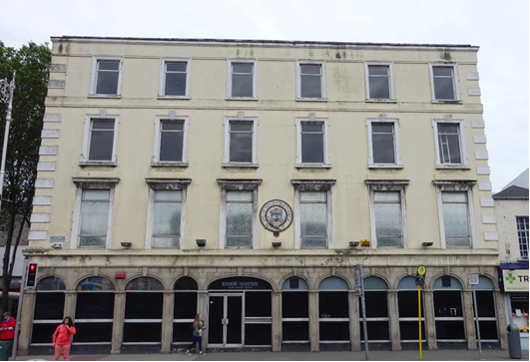

Introduction
There has been a query about whether the RPS entry 15-17 Eden Quay, Dublin 1 – Business premises (Eden House), should be amended to 15-17 Eden Quay, Dublin 1 – Commercial premises (former Eden House): south and west elevations and cast-iron railings. The building was substantially rebuilt in the 1970s with photographs taken while construction was taking place showing the building largely gutted behind the south and west elevations.

Existing Listing
RPS Ref No | Address | Description
2486 | 15-17 Eden Quay, Dublin 1 | Business premises (Eden House)

Proposed Listing: Amend description to just the south and west elevations and cast-iron railings as the structure has been substantially reconstructed.
RPS Ref No | Address | Description
2486 | 15-17 Eden Quay, Dublin 1 | Commercial premises (former Eden House): south and west elevations and cast-iron railings.

Request for Investigation
Conservation Section, Dublin City Council

Location and Land Use Zoning
The location of 15-17 Eden Quay, Dublin 1 is arrowed red below. The main zoning objective is Zone 5: To consolidate and facilitate the development of the central area and to identify, reinforce and strengthen and protect its civic design character and dignity. The site is also located within a Conservation Area
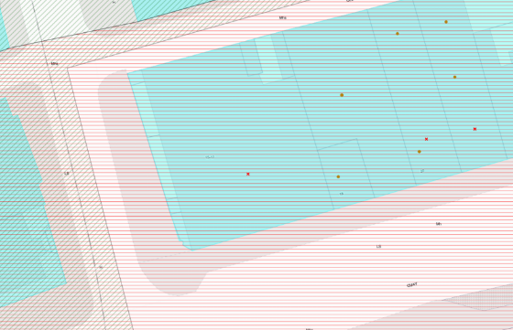
Fig. 1: Location and Land Use Zoning

Recent Planning History:
Planning Ref | Description | Decision
4796/07 | The proposed change of use of existing protected structure's ground floor from office use to new retail use. Including the removal of the existing ground floor windows and re-instatement with proposed new recessed concealed frame glazing to Eden house, with the removal of existing windows to rear 1970's extension re-instatement with new projected flush glazing. The proposal includes re-painting of exterior of building removal of existing 'modern' internal partition walls and construction of proposed layout, remodelling of existing external railing, repaving of both street frontages, proposed new signage/external lighting and the repositioning of existing stairs ( to basement). The new proposal will consist of three new retail units with ancillary services, one opening onto Marlborough Street, with second opening onto Eden Quay and the third opening onto the junction of Eden Quay & Marlborough Street. | GRANT PERMISSION  03-Oct-2007

Recent Enforcement History
No recent enforcement history on the site.

Summary Description
(See images at end of report)
Exterior: Corner-sited six-bay four-storey commercial building, built 1829 (date from NIAH; not verified) with alterations to façade c.1915 and largely rebuilt c.1972 with only façade retained. Exposed basement to Marlborough Street façade. Extension to rear c.1972 on site of No.1 Marlborough Street. Flat roof concealed behind raised rendered parapet wall with moulded masonry coping. Ruled-and lined rendered walls having raised masonry quoins and platbands over second and third floors. Masonry date plaque to first floor of front (south) elevation reads ‘CITY OF DUBLIN STEAM PACKET CO. ESTABLISHED 1823 INCORPORATED FROM 1833’. Masonry sill course to first floor and masonry entablature with moulded cornices over granite arcade to ground floor. Diminishing square-headed window openings with moulded masonry architrave surrounds, masonry sills and replacement aluminium windows throughout. Shouldered-and-kneed surrounds with keystones to second floor openings, moulded lintels to first floor openings. Granite arcade to ground floor comprising pilasters with recessed panels, supporting moulded architrave hood-mouldings with keystones over round-headed and three-centred-arch window openings with replacement aluminium windows with overlights over masonry risers. Central three-centre-arch door opening to front elevation having double-leaf replacement aluminium doors. Three centred-arched door opening to side (west) elevation with timber shuttered doors and overlight. Doors open onto masonry step with concrete platform flanked by original wrought-iron railings.
Interior: There interior was not accessed, however as it was substantially rebuilt c.1972 no historic internal fabric survives
Site: West elevation of building enclosed by wrought-iron railing on granite plinth wall.

Assessment
Eden Quay was developed by the Wide Street Commissioners from c.1790. The buildings on Eden Quay, like other Wide Street Commissioners developments, appear to have had stone arcaded shopfronts, the expense of which was offset by the Wide Street Commissioners in some instances. The only surviving example of an arcaded shopfront is at Nos.15-17, which were possibly rebuilt c.1915 by W.H. Byrne & Son when significant works were carried out to the front façade.
The three buildings (Nos.15, 16 & 17) are rated as individual plots in the earliest Valuation records starting in 1853. The City of Dublin Steam Packet Company occupied the three buildings initially. Established in 1823, the Company was originally known as Charles Wye Williams and operated a service between Dublin and Liverpool. No.16 included a small yard within the plot and both 16 and 17 occupied plots back to Old Abbey Street. No.15 included No.1 Marlborough Street in its valuation. The three buildings were described as four-storey houses; No.1 Marlborough Street was described as a two-storey house. By the late 1870s there is a different occupant in No.17 (W.B. Palgrave & Others) with Nos 15 and 16 continuing to be occupied by the City of Dublin Steam Packet Company. The City of Dublin Steam Packet was wound down in the mid-1920s.
An assessment of historic photographs shows changes to the treatment of the external elevations in the early twentieth century. Records in the Irish Architectural Archive indicate that refacing of the front façade was carried out by G & T Crampton, overseen by W.H. Byrne & Son in 1915. An image from the 1890s shows the front elevation with pediments above the first floor windows and canopies above the windows at second floor. The building appears to be of brick in this image with a heavy eaves cornice and straight quoins (Fig.1). An image dating to 1916 shows changes to the window surrounds, which are the same as those to the building today (Fig.2). The building appears to have been rendered during these works and the eaves course was replaced.
It has been suggested that the arcade may have been rebuilt at this time also, though the extent of this is not clear. An assessment of historic maps shows the railings apparently stopping before the southern arch on the west elevation on the 1847 town plan while the 1864 Town Plan depicts them curving around on their current plan. On site the railings at the southwestern corner of the building are not on a stone plinth with a stone plinth running towards the building between the first and second arches. This would suggest that the original railings stopped here with the southern arch on the western elevation open. This was infilled and the railings continued before 1864. A possible indication that the arcade was reordered at some point is the original configuration of the site as three separate structures which the division of the arcade does not precisely observe now. If this was altered, then this may have only resulted in rearranging some of the arches and not necessarily the entire shopfront.
In the early 1970s Nos.15-17 were significantly altered with the buildings being substantially demolished and only the façade on to Eden Quay and a section of the elevation to Marlborough Street retained (Fig.3). It is concluded that due to the substantial rebuilding of the structure at this time, there is no internal fabric of note surviving.

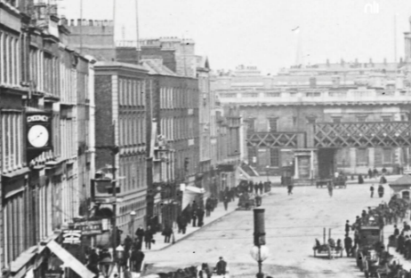

Fig. 2: Image from Eblana Collection post 1891 showing Nos.15-17 Eden Quay; note original render detailing to windows (arrowed red) and plaque to front façade (arrowed blue) (http://catalogue.nli.ie/Record/vtls000559701)

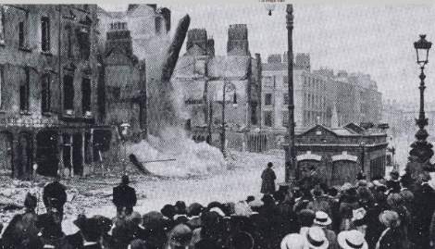

Fig. 3: Image by Keogh Bros of ruins on Eden Quay following the 1916 Rising, showing changed decorative treatment of the building (http://catalogue.nli.ie/Record/vtls000721937)
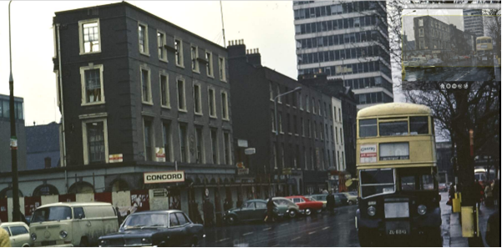

Fig. 4: Image from Michael S. Walker Photographic Collection dated 1972 showing the building with only the façade to the south elevation and arcading to west elevation retained during construction works (http://catalogue.nli.ie/Record/vtls000268934)
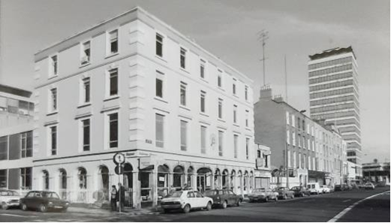

Fig. 5: Image dated 1977 from Irish Architectural Archive showing construction works completed

References
Bennett, D (1991). Encyclopaedia of Dublin. Dublin: Gill & Macmillan Ltd. p.1-163.
Casey, C (2005). The Buildings of Ireland Dublin. New Haven & London: Yale University Press. P.191.
De Courcy, J.W (1996). The Liffey in Dublin. Dublin: Gill & Macmillan Ltd. p.139.
Ordnance Survey Mapping
Rocque, J. (1756) An Exact Survey of the City and Suburbs of Dublin.
National Library of Ireland
Irish Architectural Archive
Valuation Records, Valuation Office of Ireland

Significance/NIAH Rating
No.15-17 Eden Quay was recorded under Stage 1 of the NIAH for Dublin (Ref 50010311) with Ministerial Recommendations for Stage 1 issued to Dublin City Council on 4th June 2014. The structure was assigned a ‘Regional’ rating. These are structures or sites that make a significant contribution to the architectural heritage within their region or area. Structures which are considered of Regional significance are deemed worthy of inclusion on the RPS.

Assessment of Special Interest under the Planning and Development Act 2000
The National Inventory of Architectural Heritage assigned this building Architectural interest.
The Conservation Section has considered the opinion of the NIAH and is in agreement with assigning the ARCHITECTURAL category of special interest to the building. In addition, the Conservation Sections assigns HISTORICAL, ARCHAEOLOGICAL, ARTISTIC, SOCIAL and TECHNICAL interest to the site.

Historical:
- Eden Quay was constructed in the early part of the nineteenth century, as part of a plan by the Wide Street Commission to extend the north quays eastwards. This building’s early date attaches historical significance to it as part of the work of the Commission to redevelop sections of the city to create a network of main thoroughfares.
- The opening of Carlisle (now O’Connell) Bridge in 1794 rendered Eden Quay the limit for seagoing vessels on the River Liffey. Consequently it constituted a centre for shipping commerce, with numerous shipping and emigration agencies operating from the houses which lined it. The City of Dublin Steam Packet Company occupied Nos.15-16 from the early decades of the nineteenth century and for a time No.17. The company, which was established in 1823, operated a service between Dublin and Liverpool.

Archaeological
- Prior to the work of the Wide Street Commission, the site on which Eden Quay was later constructed was occupied by houses and a site named ‘Iron Key’ on John Rocque’s An Exact Survey of the City and Suburbs of Dublin dating to 1756. While it is unlikely that much fabric remains given the presence of a basement at No.15 at least and later rebuilding works on the site, there is still a possibility that early fabric survives.

Artistic
- The plaque to the front elevation, which is present in later nineteenth-century photos therefore predating the 1915 works, adds artistic interest to the building. The plaque is well-crafted and incorporates the three castles included in Dublin’s coat-of-arms. It also includes nautical motifs in the remains of an anchor, possibly a sail and the use of rope-shaped ornamentation around the crest.
- The decorative spearhead finials to the surviving wrought- and cast-iron railings to the Marlborough Street elevation attribute artistic merit to the site.

Social
- The building functioned as a shipping office at a time when steamboats were the means by which transport from Ireland was accomplished. The office would have been the centre of travel to the UK at a time when people would have emigrated from Ireland and therefore could be said to have some social interest.

Technical
- The survival of wrought- and cast-iron railings to the west elevation of the site along Marlborough Street attributes technical interest to the structure.

Conclusion & Recommendation
It is recommended that the RPS entry for 15-17 Eden Quay, Dublin 1 be amended to just include the front façade (south) to Eden Quay, the west elevation on Marlborough Street and the cast-iron railings. The rebuilding works of c.1972 have resulted in the loss of all internal historic fabric.

Proposed Listing
RPS Ref No | Address | Description
2486 | 15-17 Eden Quay, Dublin 1 | Commercial premises (former Eden House): south and west elevations and cast-iron railings

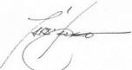 11/11/2021
_______________ ________________
Paraic Fallon Date
Senior Planner

Photographic Record:
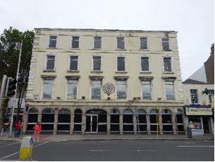 | 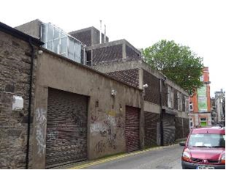
Fig. 7: South elevation | Fig 8: View of north elevation from northeast
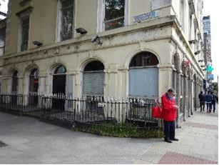 | 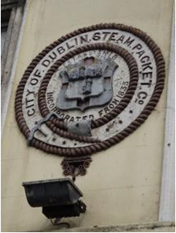
Fig. 9: West elevation arcade from southwest | Fig. 10: Plaque to south elevation
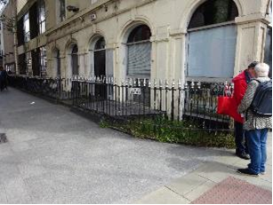

Fig. 11: Railings from southwest

RPS No. 2696 - 9&10 Eustace Street, Dublin 2
Seandálaíocht, Caomhantas & Oidhreacht
An Roinn Pleanála & Forbairt Maoine
Oifigí na Cathrach, An Ché Adhmaid, Baile Átha Cliath 8

Archaeology, Conservation & Heritage Section
Planning & Property Development Department
Block 3, Floor 3, Civic Offices, Wood Quay, Dublin 8

Tel: (01) 222 3926, 222 3927
Email: conservation@dublincity.ie

11th November 2021

Draft Development Plan 2022-2028

Ref: RPS 2696 AMENDMENT of the Record of Protected Structures
_______________________________________________________________________________

Recommendation:
Amendment of current entry for 9-10 Eustace Street, Dublin 2 – Facade to now read: 9-10 Eustace Street, Dublin – Commercial premises extending protection to the entire structure to include its interior. _______________________________________________________________________________

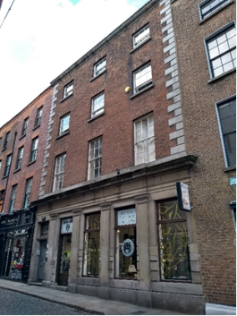

Introduction
No. 9/10 Eustace Street, Dublin 2 is on the current Record of Protected Structures (Dublin City Development Plan 2016-2022). The reference number is RPS: 2696 and the description reads ‘Façade’. It is proposed to amend the description to read ‘Commercial premises’ extending protection to the entire structure to include its interior.

Existing Listing
RPS Ref No | Address | Description
2696 | 9-10 Eustace Street, Dublin 2 | Facade

Proposed Listing: Amend description to read ‘Commercial premises’ extending protection to the entire structure to include its interior.
RPS Ref No | Address | Description
2696 | 9-10 Eustace Street, Dublin 2 | Commercial premises

Request for Amendment
This building was subject to a request to add the entire building to the Dublin City Council Record of Protected Structures by the City Council’s Architectural Conservation Officer on the 7th of May 2014. Dublin City Council received a Ministerial Recommendation on the 9th of August 2017 from the Minister for Culture, Heritage and the Gaeltacht (now Minister for Housing, Local Government and Heritage) to include the building on the Dublin City Record of Protected Structures.

Location and Land Use Zoning
No. 9-10 Eustace Street, Dublin 2 is located on the west side of Eustace Street in Temple Bar. Eustace Street runs north-south from Dame Street to the River Liffey. The area is zoned Z5 and the zoning objective for the area is: To consolidate and facilitate the development of the central area, and to identify, reinforce, strengthen and protect its civic design character and dignity. It is also located at western edge of a Conservation Area (red hatching).

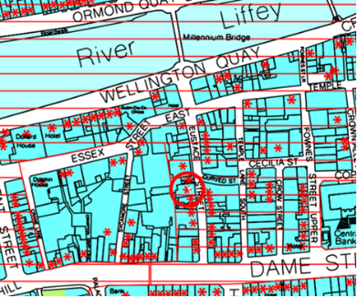
Fig. 1: Location and Land Use Zoning

Relevant Planning History
Planning Ref. | Description | Decision
3546/13 | PROTECTED STRUCTURE: Permission for change of use of the third floor from commercial (office use) to residential use with two one-bedroom apartments of 59.8 sq.m and 70.4 sq.m including renovation works, replacement of windows, insulation throughout, new rooflights, new west facing balcony (7.8 sq.m) with new door openings, fire proofing, alterations to internal walls, new services and associated works to facilitate the change. | Granted Permission 12-Jun-2014
0005/13 | PROTECTED STRUCTURE: Change of use of the ground floor unit of 9-10 Eustace Street (a protected structure - facade only) from offices to daytime retail use (with ancillary cafe) and night-time live music and cultural performance (licensed) venue; works to the rear roof space including installation of new roof light & 4 no. condenser units; access works (including creation of new street entrance), signage and associated works. | Refuse Exemption Certificate. 12-Feb-2013.
3619/13 | PROTECTED STRUCTURE: Change of use of the ground floor unit of 9-10 Eustace Street (a protected structure - facade only) from offices to daytime retail use (with ancillary cafe) and night-time live music and cultural performance (licensed) venue; works to the rear roof space including installation of new roof light & 4 no. condenser units; access works (including creation of new street entrance), signage and associated works. | Split decision (permission & refusal) 14-May-2014
PL29S.243467 | An Bord Pleanála appeal re Planning Authority Reg. Ref.: 3619/13. Change of use of ground floor unit from offices to daytime retail use (with ancillary cafe) and night time live music (licensed) venue and associated works at a Protected Structure | Appeal Decision: Split Decision  Date: 08-Oct-2014
PL29S.243467 | An Bord Pleanála appeal re Planning Authority Reg. Ref.:3546/13. Change of use of third floor from office to residential use with two one-bedroom apartments at a protected structure. | Appeal Decision: Grant permission with revised conditions  Date: 08-Oct-2014
3584/15 | PROTECTED STRUCTURE: Alternations and additions to previously granted permissions (Ref. 3546/13 and 3619/13). Works include: (a) The modification of steps and ground scape at basement level, drainage and enabling works together with a new fire escape stairs and door opening at ground floor level. (b) The construction of a balcony (6.3 sq.m) at third floor level with two doors. (c) Fire lobbies, fire doors and internal alterations at ground, first, second and third floor levels. | Grant Permission: 02-Nov-2015
3585/15 | PROTECTED STRUCTURE: Alternations and additions to previously granted permissions (Ref. 3546/13 and 3619/13). Works are for a new south facing window at third floor level. | Grant Permission 03-Nov-2015
PL29S.245808 | An Bord Pleanála appeal re Planning Authority Reg. Ref.:3585/15. Amendments and Alterations to prior grant of permission under P. A. Reg. Ref. 3646/13 to insert a new window in south elevation of No 9 Eustace Street. LOCATION: Nos. 9 and 10 Eustace Street, Dublin 2. (Protected Structure.) | Appeal decision: Grant permission, 03 Mar 2016
2185/16 | PROTECTED STRUCTURE: Alternations & additions to previously granted permissions (Ref. 3546/13, 3619/13, 3584/15 and 3585/15) for the removal of the mid-19th century strong room and safe door at ground floor, the making good of existing finishes and the temporary and permanent structural works required by its removal. | Refuse Permission: Decision Date: 31-Mar-2016
3546/13x1 | EXT. OF DUR.: PROTECTED STRUCTURE: Permission for change of use of the third floor from commercial (office use) to residential use with two one-bedroom apartments of 59.8 sq.m and 70.4 sq.m including renovation works, replacement of windows, insulation throughout, new rooflights, new west facing balcony (7.8 sq.m) with new door openings, fire proofing, alterations to internal walls, new services and associated works to facilitate the change. | Grant Ext of Duration of Permission:  Decision Date: 17-Apr-2019
3584/15/X1 | EXT. OF DUR: PROTECTED STRUCTURE: Alternations and additions to previously granted permissions (Ref. 3546/13 and 3619/13). Works include: (a) The modification of steps and ground scape at basement level, drainage and enabling works together with a new fire escape stairs and door opening at ground floor level. (b) The construction of a balcony (6.3 sq.m) at third floor level with two doors. (c) Fire lobbies, fire doors and internal alterations at ground, first, second and third floor levels. | Grant Ext of Duration pf Permission: 17-Aug-2020  Extended until 12-Feb-2023

Summary Description
(See images at end of report)
Terraced, three-bay four-storey over basement former house, built c.1740 as two separate buildings. The building is located on the west side of a narrow cobbled street with granite shopfront to front (east) elevation added c.1840-60, now in use as commercial premises.

Exterior:
M-profile pitched roof, set perpendicular to street, hipped to east and additional hipped roofs to rear, with rendered chimneystacks and red brick parapet having projecting carved granite coping. Red brick, laid in Flemish bond, with granite quoins to front, rendered wall to rear, with cast-iron tie bolts to north elevation. Square-headed window openings with granite sills, six-over-six pane timber sliding sash windows to ground (rear) and first floors, six-over-three pane timber sliding sash windows to second floor and three-over-three pane timber sliding sash windows to third floor. Carved granite shopfront comprising plinth course with Doric pilasters supporting stepped fascia and cornice, surrounding partially rusticated window surrounds, with square-headed window openings having recent fixed pane windows. Square-headed door opening with beaded timber panelled door flanked by Doric pilasters, having lintel with multi-pane over-light, and nosed granite step. Corinthian pilasters to entry hall.

Interior:
Originally two buildings, constructed c.1740, the building was refaced and amalgamated into one large commercial building c.1840-60. The façade was completely replaced and repositioned to form a new three-bay elevation. At least one of the staircases was removed (no. 10) and the existing staircase (originally to no. 9) appears to have been subject to changes to the first flight. The remainder of the staircase appears to be original comprising an open-well, closed-string staircase having a heavy, scrolled and ramped handrail. Rococo and Neoclassical decorative plasterwork survives to ground floor rooms of the original number 10. Lugged-and-kneed door architraves to first half-landing of number 10, and historic floorboards surviving in places. An historic safe also survives to the rear ground floor room of number 9.

Assessment
9/10 Eustace Street appears on John Rocque’s Map of 1756. It was originally two houses, which were probably changed to a single commercial structure at the time of the new façade in the mid-19th century. While it has been altered over time, the underlying structure of the building includes surviving early 18th century fabric. More recently planning permission was granted for change of use of ground and third floors to retail and residential use, including new fenestration, insulation, new door openings, alterations to internal layout and provision of new services (Planning Refs 3584/15x1, 3546/13x1, 2185/16, 3585/15, 3584/15, 3619/13, 3546/13). Historic fabric includes 18th century joinery such as: skirting boards, an open-well, closed-string staircase with a heavy, scrolled and ramped handrail and lugged and kneed door architraves. It also retains Rococo and Neoclassical decorative plasterwork, historic floorboards and a 19th century safe.

The National inventory of Architectural Heritage describes the building as a fine residence dating from the early-mid 18th century however it appears from cartographic analysis and from the building itself that the building was originally two narrow buildings, which in the later 19th century were converted into one building, with a new façade and granite frontispiece added. According to the Architectural Heritage Assessment submitted as part of Planning Ref 3585/15, externally the building reads as a single structure of late Georgian architectural character, with brick upper elevation and commercial ground floor. However, on internal inspection, it is evident that the building comprises at least two historic properties amalgamated together in the mid-19th century. At the time of the conversion from two, two-bay houses to one commercial building, the façade was completely replaced from ground level to parapet level including the repositioning of the windows to form a three-bay symmetrical elevation.

As such, it is recommended that the description for RPS Ref: 2696 for No. 9/10 Eustace Street, Dublin 2 is amended to read ‘Commercial premises’, extending protection to the entire structure to include its interior.

A number of 18th century houses were identified on Eustace Street by Christine Casey in her detailed book Buildings of Dublin. However, No. 9/10 only gets a passing mention presumably because of the later granite insert on the ground floor which confuses the dating of the building. The 18th century houses identified by Casey include 11, 14A, 16, 17, 24 and 25. No. 11 has a façade of c.1800 and a wainscoted hall and stair hall of c. 1730. In No. 16, remodelled as artist’s studios in the early 1990s by O’Mahony Pike, the stair is centrally placed between the front and rear parlours. Nos. 24 and 25 are examples of more modest early C18 houses – the latter a 1720s house conserved in 1998 by Arthur Gibney for the Landmark Trust. No. 18 is a large four-bay brick house of c.1820 with an ambitious open-well stair in the rear r. quadrant of the plan. The most ambitious Victorian building is No. 29 on the E side near the S end, four bays and three storeys of red brick over a granite arcade with bearded-head keystones and rich eclectic mouldings. Rebuilt in 1862 for a Mr. Pickering by William Coldbek. Halfway along the west side, No. 10 has a good granite frontispiece of uncertain date to the hall floor (Casey, 2005, 443).

References
- Casey, Christine. (2005), The Buildings of Ireland – Dublin. Yale University Press, New Haven and London.
- Hickey, Donal (2013) Conservation Report, 9/10 Eustace Street. Unpublished report submitted as part of planning application 3546/13.
- Hickey, Donal (2015) Conservation Report, 9/10 Eustace Street. Unpublished report submitted as part of planning application 3585/15.
- Conservation Officers Report dated 18/09/2015 for planning Ref: 3584/15
- An Exact Survey of the City & Suburbs of Dublin by John Rocque (1756) https://gallica.bnf.fr/ark:/12148/btv1b530571173.r=rocque%20dublin?rk=107296;4

Significance/NIAH Rating
9-10 Eustace Street, Dublin 2 was recorded under Stage 2 of the NIAH for Dublin (Ref 50020073) with Ministerial Recommendations for Stage 2 issued to Dublin City Council on the 9th of August 2017. The structure was assigned a ‘Regional’ rating. These are structures or sites that make a significant contribution to the architectural heritage within their region or area. Structures which are considered of Regional significance are deemed worthy of inclusion on the RPS.

Assessment of Special Interest under the Planning and Development Act 2000
The National Inventory of Architectural Heritage assigned this building Architectural, Artistic and Social interest. The Conservation Section has considered the opinion of the NIAH and is in agreement with assigning the ARCHITECTURAL, ARTISTIC and SOCIAL categories of special interest to the building.

Conclusion & Recommendation
It is recommended that the RPS entry for 9-10 Eustace Street, Dublin 2 be amended to read ‘Commercial premises’ thereby extending protection to the entire structure to include its interior.

Proposed Listing
RPS Ref No | Address | Description
2696 | 9-10 Eustace Street, Dublin 2 | Commercial premises

11/11/2021
_______________ ________________
Paraic Fallon
Senior Planner Date

Photographic Record:
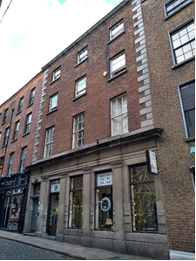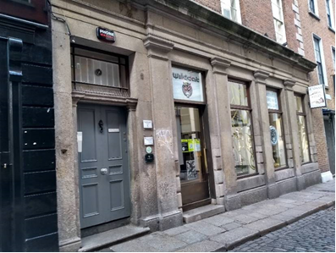

Figs. 2 & 3: View of front elevation and granite ground floor façade. The front elevation was refaced with new brick and the granite frontispiece added in the mid-late 19th century

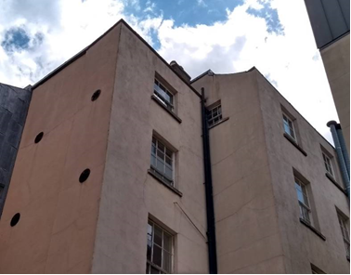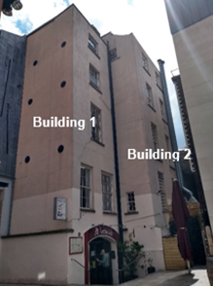
Figs. 4 & 5: View of side and rear elevations. The building was originally 2 buildings until the mid to late 19th century
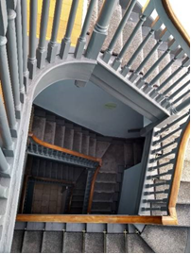 | 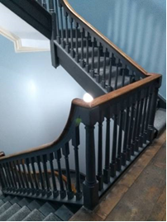 |  | 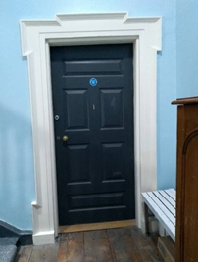
Fig.6: View of 3rd floor landing with low ramped handrail and open well staircase |  | Fig.7: Ramped handrail at 2nd floor landing level | Fig.8: Lugged-and-kneed door architrave on 1st floor landing

RPS No. 3300 - Granite Terrace, off Inchicore Terrace South, Dublin 8
Seandálaíocht, Caomhantas & Oidhreacht
An Roinn Pleanála & Forbairt Maoine
Oifigí na Cathrach, An Ché Adhmaid, Baile Átha Cliath 8

Archaeology, Conservation & Heritage Section
Planning & Property Development Department
Block 3, Floor 3, Civic Offices, Wood Quay, Dublin 8

Tel: (01) 222 3926, 222 3927
Email: conservation@dublincity.ie

29th October 2021

Draft Development Plan 2022-2028

Ref: RPS 3300 AMENDMENT of the Record of Protected Structures
_______________________________________________________________________________

Recommendation:
Amendment of current entry for Granite Terrace, off Inchicore Terrace South, Dublin 8 – Boundary wall along southern boundary of open space facing Granite Terrace, to the rear of 4-6 St. James’s Place, Tyrconnell Lodge and along Inchicore Terrace South abutting Tyrconnell Lodge, to now read: Granite Terrace, off Inchicore Terrace South, Dublin 8 – Granite boundary wall which forms the southern and eastern boundary to the green space facing Granite Terrace and calp limestone boundary wall facing onto Inchicore Terrace South, (see also CIE Railway Estate: boundary wall dating from the 1850’s at Inchicore, Dublin 8).
_______________________________________________________________________________

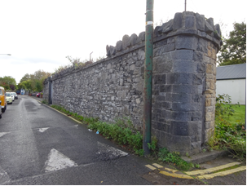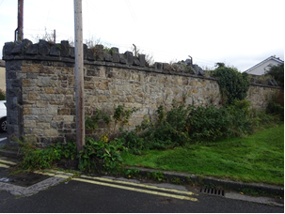

Introduction
The boundary wall at Granite Terrace, off Inchicore Terrace South, Dublin 8 is on the current Record of Protected Structures (Dublin City Development Plan 2016-2022). The reference number is RPS: 3300 and the description reads ‘Boundary wall along southern boundary of open space facing Granite Terrace, to the rear of 4-6 St. James’s Place, Tyrconnell Lodge and along Inchicore Terrace South abutting Tyrconnell Lodge’. The current site context has changed since the boundary wall was first afforded protection under the Draft Dublin City Development Plan, 1998. The description references No. 4-6 St. James’s Place and Tyrconnell Lodge as aids to site identification. Both No. 4-6 St. James’s Place and Tyrconnell Lodge no longer exist. Amendment of the RPS description is proposed to reflect the current site context and to cross-reference this to RPS ref: 8744 CIE Railway Estate: boundary wall dating from the 1850’s at Inchicore, Dublin 8.

Existing Listing:
RPS Ref No | Address | Description
3300 | Granite Terrace, off Inchicore Terrace South, Dublin 8 | Boundary wall along southern boundary of open space facing Granite Terrace, to the rear of 4-6 St. James’s Place, Tyrconnell Lodge and along Inchicore Terrace South abutting Tyrconnell Lodge.

Proposed Listing: Amend description to reflect the current site context and to cross-reference this to RPS ref: 8744 CIE Railway Estate: boundary wall dating from the 1850’s at Inchicore, Dublin 8.
RPS Ref No | Address | Description
3300 | Granite Terrace, off Inchicore Terrace South, Dublin 8 | Granite boundary wall which forms the southern and eastern boundary to the green space facing Granite Terrace and calp limestone boundary wall facing onto Inchicore Terrace South, (see also CIE Railway Estate: boundary wall dating from the 1850’s at Inchicore, Dublin 8).

Request for Investigation
Conservation Section, Dublin City Council

Location and Land Use Zoning
The location of the boundary wall at Granite Terrace, off Inchicore Terrace South, Dublin 8 is indicated by the red line below. The structure marks the limit of a number of zoning objectives to include:
- Zone 1: To protect, provide and improve residential amenities.
- Zone 2: To protect and/or improve the amenities of residential conservation areas.
- Zone 4: To provide for and improve mixed-services facilities.
- Zone 9: To preserve, provide and improve recreational amenity and open space and green networks.
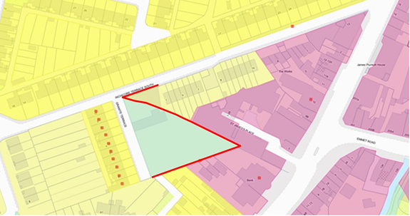
Fig.1 Location and Land Use Zoning

Relevant Planning History
Planning Ref. | Description | Decision Date
2190/93 | Development at site of Tyrconnell Lodge, St. James Place, Tyrconnell Road, Inchicore, Dublin 8. | 12-April-1994  Grant Permission
0046/03 | Development of site at 5-7, Saint James' Place, Inchicore, Dublin 8 comprising demolition of three cottages and construction of apartments. | 06-Feb-2003  Grant Permission

Relevant Planning Enforcement History
There is no relevant planning enforcement history for the subject site.

Summary Description
(See images at end of report).
Mid-19th century boundary wall enclosing the CIE Railway Estate. Comprising coursed granite section with crenelated capping forming the southern and eastern boundary to the green space facing Granite Terrace and having curved dressed stones to the junction of Granite Terrace and Inchicore Terrace South. Coursed calp limestone section with crenelated capping facing onto Inchicore Terrace South.

Assessment
Following the 1844 Act of Incorporation of the Great Southern and Western Railway, land was purchased in the Inchicore area for the development of a railway engineering works and for the construction of workers accommodation. The resulting Railway Estate, to include the Inchicore Model School, was enclosed by a stone wall c.1850. The subject section of boundary wall at Granite Terrace, off Inchicore Terrace South, Dublin 8 was first protected under the Dublin City Development Plan 1989 when it was described as ‘Boundary wall along southern boundary of open space facing Granite Terrace, to the rear of 4-6 St. James’s Place, Tyrconnell Lodge and along Inchicore Terrace South abutting Tyrconnell Lodge’. The current RPS description matches that of the Dublin City Development Plan 1989 however, the area has changed significantly since this date and it is proposed to clarify the description to reflect the current site context.

The section of the wall referred to at the beginning of the current RPS description as ‘Boundary wall along southern boundary of open space facing Granite Terrace’ is clear. The description continues by identifying the section of wall running to ‘the rear of 4-6 St. James’s Place, Tyrconnell Lodge’. Three cottages at No.4-6 St. James Place, understood to include ‘Tyrconnell Lodge’ were replaced by a modern apartment complex under planning file ref: 0046/03. It seems clear then that the coursed granite section of wall running diagonally from the southern section of boundary wall in a north-westerly direction as far as Inchicore Terrace South is being referred to in this part of the description. The rest of the description refers to the coursed calp limestone section of wall running along Inchicore Terrace South.

In addition to specific protection afforded to the subject section of wall under RPS ref: 3300 the wall is also protected under RPS ref: 8744 - the CIE Railway Estate boundary wall at Inchicore, Dublin 8. RPS ref: 8744 extends protection to the entire boundary wall of the CIE estate with the description reading ‘CIE Railway Estate: boundary wall dating from the 1850's (including 20th century reconstructions but excluding modern additions)’. It is recommended that RPS Ref: 3300 for the subject section of boundary wall at Granite Terrace, off Inchicore Terrace South, Dublin 8 is cross-referenced in the Record of Protected Structures to RPS ref: 8744 for the CIE Railway Estate boundary wall at Inchicore, Dublin 8.

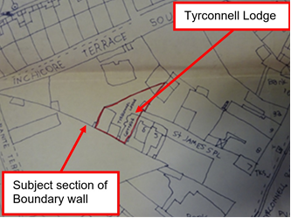
Fig.2: Extract of site plan from planning file 2190/93 showing location of Tyrconnell Lodge, St James Place, Inchicore, Dublin 8.

References
- National Inventory of Architectural Heritage (NIAH) Ref: 50080055.
- Ordnance Survey Mapping.
- Planning file ref: 2190/93; planning file ref: 0046/03.

Significance/NIAH Rating
The boundary wall at Inchicore Railway Works, Dublin 8 was recorded under Stage 2 of the NIAH for Dublin (Ref:50080055) with Ministerial Recommendations for Stage 2 issued to Dublin City Council on 9th August 2017. The structure was assigned a ‘Regional’ rating. These are structures or sites that make a significant contribution to the architectural heritage within their region or area. Structures which are considered of Regional significance are deemed worthy of inclusion on the RPS.

Assessment of Special Interest under the Planning and Development Act 2000
The National Inventory of Architectural Heritage assigned HISTORICAL, SOCIAL and TECHNICAL interest to the boundary wall at Inchicore Railway Works, Dublin 8. The Conservation Section has considered the opinion of the NIAH and is in agreement with assigning these categories of special interest to the site. In addition the Conservation Section considers that the site is of ARTISITC interest due to the skill and craftsmanship evident in elements of its construction.

Conclusion & Recommendation
It is recommended that the RPS description for RPS ref:3300 for the boundary wall at Granite Terrace, off Inchicore Terrace South, Dublin 8 be amended to – ‘Granite boundary wall which forms the southern and eastern boundary to the green space facing Granite Terrace and Calp limestone boundary wall facing onto Inchicore Terrace South, (see also CIE Railway Estate: boundary wall dating from the 1850’s at Inchicore, Dublin 8)’, in accordance with Section 12(3) of the Planning and Development Act, 2000 (as amended).

Proposed Listing
RPS Ref No | Address | Description
3300 | Granite Terrace, off Inchicore Terrace South, Dublin 8 | Granite boundary wall which forms the southern and eastern boundary to the green space facing Granite Terrace and Calp limestone boundary wall facing onto Inchicore Terrace South, (see also CIE Railway Estate: boundary wall dating from the 1850’s at Inchicore, Dublin 8).

29/10/2021
_______________ ________________
Paraic Fallon
Senior Planner Date

Photographic Record:
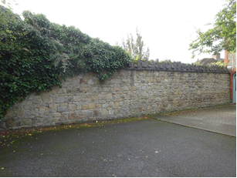 | 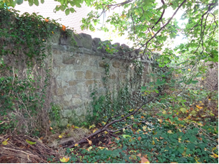
Fig.3: Section of granite boundary wall which forms the southern boundary at Granite Terrace. | Fig.4: Section of granite boundary wall which forms the eastern boundary to the green area fronting onto Granite Terrace.
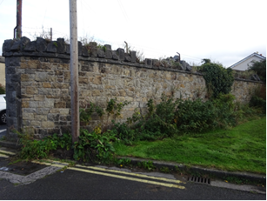 | 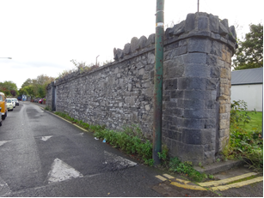
Fig.5: Section of granite boundary wall which forms the eastern boundary to the green area fronting onto Granite Terrace. Note the crenelated capping detail. | Fig.6: Section of Calp limestone boundary wall facing onto Inchicore Terrace South. Note the dressed corner stones and crenelated capping detail.

RPS No. 3328 - 2 Green Street East, Dublin 2

Seandálaíocht, Caomhantas & Oidhreacht
An Roinn Pleanála & Forbairt Maoine
Oifigí na Cathrach, An Ché Adhmaid, Baile Átha Cliath 8

Archaeology, Conservation & Heritage Section
Planning & Property Development Department
Block 3, Floor 3, Civic Offices, Wood Quay, Dublin 8

Tel: (01) 222 3926, 222 3927
Email: conservation@dublincity.ie

11th November 2021

Draft Development Plan 2022-2028

Ref: RPS 3328 AMENDMENT to the Record of Protected Structures
_______________________________________________________________________________

Recommendation:
Amendment of current entry for Green Street East, Dublin 2 – Two-storey warehouse at corner of Britain Quay, to now read: 2 Green Street East, Dublin 2 – Two-storey warehouse at corner of Britain Quay, external walls only.
_______________________________________________________________________________

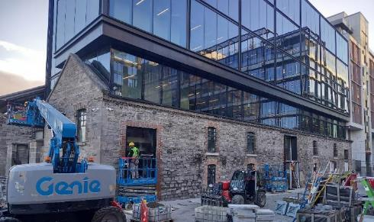

Introduction
A question has arisen in relation to the accuracy of the postal address of Green Street East, Dublin 2, two-storey warehouse at corner of Britain Quay on the Record of Protected Structures (RPS). It has been suggested that 2 Green Street East, Dublin 2 would be the correct address. Also following the implementation of planning permission DSDZ3856/17 that the description be amended to read; Two-storey warehouse at corner of Britain Quay, external walls only.

Existing Listing
RPS Ref No | Address | Description
3328 | Green Street East, Dublin 2 | Two-storey warehouse at corner of Britain Quay

Proposed Listing:
RPS Ref No | Address | Description
3328 | 2 Green Street East, Dublin 2 | Two-storey warehouse at corner of Britain Quay, external walls only

Request for Investigation
Conservation Section, Dublin City Council

Location and Land Use Zoning
The location of the 2 Green Street East, Dublin 2 is shown in red below. The main zoning objective Zone 14 is to seek the social, economic and physical development or rejuvenation of an area with mixed use of which residential and ‘’Z6’’ would be the predominant uses. The red hatching adjacent designates the Conservation Area.

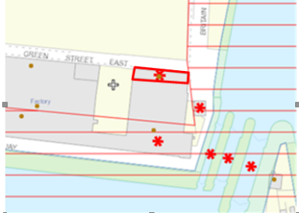
Fig. 1 Location and Land Use Zoning

Recent Planning History
Planning Ref | Description | Decision
DSDZ3856/17 | PROTECTED STRUCTURE: KW Real Estate plc acting for and on behalf of its sub fund KW Irish Real Estate Fund XIII intends to apply for permission for development at a site (c. 0.25 hectares), at Nos.10-12 Hanover Quay (protected structure) and No. 2 Green Street East (protected structure), Dublin 2. Generally bounded by Hanover Quay to the South, Green Street East and 'Britain Square' (under construction) to the north, the Lock Keeper's Cottage (a protected structure) and Britain Quay to the east, and the site of the 'Reflector Building' (under construction) to the west. The proposed development comprises: Demolition of existing boat shed (c.95 sq m gfa). External and internal conservation, alteration, repair, refurbishment and extension works, affecting the existing warehouse (single storey over basement, c.3,787 sq m gfa), stable building (2 -storey over ground, c.352 sq m gfa) and connecting laneway (all protected structures), for use as an office building, including: Conservation and repair of all historic external walls, with some new or reconfigured windows and doors on eastern wall. Removal of all modern internal walls. Removal of all modern roofs. Construction of a new internal concrete and steel frame structure. Replacement of existing modern multi-pitched roof with similar roof form and to existing height at the front of the 3-gabled warehouse building, to a depth of 10m back from the southern gable to Hanover Quay. Construction of a glass and steel framed extension with double apex southern gable, rising c.1.5 storeys over the top of the original walls, set back c.10m from the southern gable and extending to the northern gable of the original warehouse building, with setback also off the original eastern external wall. Construction of a glazed flat roofed extension over the existing laneway between the warehouse and stable building, maintaining the existing original piers, and rising c.2.5 storeys over the top of the original walls of the warehouse and stable buildings. Construction of a glass and steel framed flat roofed extension rising c.1.5 storeys over the top of the original walls of the stable building. Lowering of existing basement level by c.1.6m. Vertical and horizontal internal subdivision of internal space to create four floors of office space and ancillary amenities, from basement to 2nd floor level, in a single office building capable of single or multi-tenant occupancy. Excavation of a sunken lightwell adjoining to the east of the warehouse to new basement level, with additional boundary treatment adjoining the curtilage of the Lock Keeper's Cottage (a protected structure). 110no. bicycle parking spaces within the external sunken lightwell area. Roof plant box extending behind the new glazed atrium over the laneway and along the western edge of the warehouse extension, at roof level. External terraces at 2nd floor level (c.69 sq m in total) on east and south elevations of the warehouse extension component. External terrace at roof level (c.203 sq m) on northern elevation of the stables extension component. Signage zone on southern elevation. Lighting affixed to building. And all associated and ancillary site development and landscape works. The total gross floor area (existing and new) of the proposed office development amounts to c.7,292 sq m. This application relates to a proposed development within the North Lotts & Grand Canal Dock Strategic Development Zone Planning Scheme Area. | 25 May 2018

Recent Enforcement History
None on record

Summary Description
(See images at end of report)
Detached, two-storey, six-bay rubble store former warehouse with two double height sliding timber doors with segmental-headed window openings having granite sills. Pitched hipped roof with natural slate. Constructed c. 1890 renovated 2000 by NBK Designs Ltd for which they won RIAI Irish Architect Award Regional Award 2000. Currently being conserved and integrated into a larger development under DSDZ3856/17 including the conservation and repair of all historic external walls, with some new or reconfigured windows and doors on eastern wall. Removal of all modern internal walls. Removal of all modern roofs.

Significance/NIAH Rating
The National Inventory of Architectural Heritage (NIAH) did not survey this structure; however, its categories of special interest (architectural, historical, archaeological, artistic, cultural, scientific, technical & social) and its rating system has been used to assess the structure in question. The NIAH identifies five categories of rating in seeking to rank buildings. The NIAH rating values are International, National, Regional, Local and Record Only (I, N, R, L, O). Structures which are considered of International, National, and Regional significance are deemed worthy of inclusion on the RPS. Using the NIAH System of rating, the structure is considered to be of Regional significance. This is a structure or site that makes a significant contribution to the architectural heritage within their region or area.

Assessment of Special Interest under the Planning and Development Act 2000
2 Green Street East, Dublin 2 is considered to be of special architectural and historical interest.

Conclusion & Recommendation
For the sake of clarity, it is recommended that the address is amended to read at 2 Green Street East, Dublin 2. It appears that no notification letter was sent to the owner/occupier in 2000 to this address.

Proposed Listing
RPS Ref No | Address | Description
3324 | 2 Green Street East, Dublin 2 | Two-storey warehouse at corner of Britain Quay, external walls only

11/11/2021
_______________ ________________
Paraic Fallon
Senior Planner Date

Photographic Record:
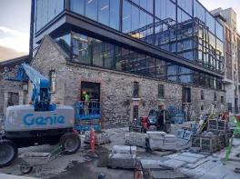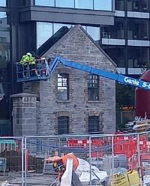
Fig. 2: Warehouse on Green Street East. Fig. 3: Gable view facing Grand Canal lock.

RPS No. 3651 - 4 Henrietta Street, Dublin 1
Seandálaíocht, Caomhantas & Oidhreacht
An Roinn Pleanála & Forbairt Maoine
Oifigí na Cathrach, An Ché Adhmaid, Baile Átha Cliath 8

Archaeology, Conservation & Heritage Section
Planning & Property Development Department
Block 3, Floor 3, Civic Offices, Wood Quay, Dublin 8

Tel: (01) 222 3926, 222 3927
Email: conservation@dublincity.ie

11th November 2021

Draft Development Plan 2022-2028

Ref: RPS 3651 AMENDMENT of the Record of Protected Structures
_______________________________________________________________________________

Recommendation:
Amendment of current entry for 4 Henrietta Street, Dublin 1 - House to now read: 4 Henrietta Street, Dublin 1 – House including ancillary 18th century structures to rear _______________________________________________________________________________

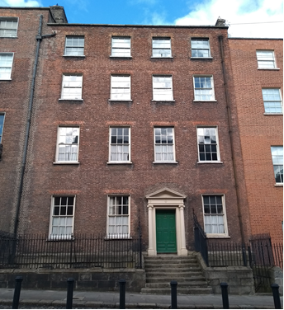

Introduction
It is proposed to amend the description for 4 Henrietta Street from ‘House’ to ‘House including ancillary 18th century structures to rear’ which will ensure that the surviving subsurface tunnel, cellars and remains of former structure within present garden of number 4 Henrietta Street are protected.

Existing Listing
RPS Ref No | Address | Description
3651 | 4 Henrietta Street, Dublin 1 | House

Proposed Listing: Amend description to include the ancillary structures to the rear.
RPS Ref No | Address | Description
3651 | 4 Henrietta Street, Dublin 1 | House including ancillary 18th century structures to rear

Request for Investigation
Conservation Section, Dublin City Council

Location and Land Use Zoning
The location of 4 Henrietta Street, Dublin 1 is arrowed red below. The main zoning objective is Zone 8. To protect the existing architectural and civic design character, to allow only for limited expansion consistent with the conservation objective. The street and houses are also zoned a Conservation Area (red hatched area). The northern rear section of the garden is zoned Zone 1: To protect, provide and improve residential amenities.

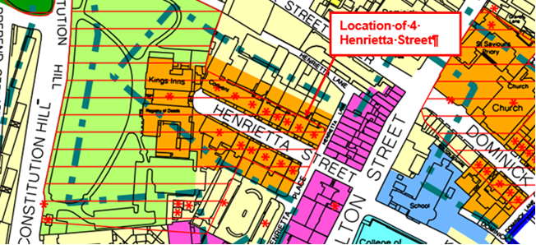
Fig 1: Location and Land Use Zoning

Summary Description
(See images at end of report)
The National Inventory of Architectural Heritage describe the building as a terraced four-bay four-storey house over raised basement, built c.1745. Pitched slate roof to front with pair of hipped sections to west and further pitched section running perpendicular to street and hipped to rear. Roof hidden behind parapet wall with granite coping and cast-iron hopper and downpipe breaking through to east end. Stepped brown brick chimneystacks to both party walls with brick coping and clay pots. Red brick walls laid in Flemish bond on moulded granite plinth course over ruled-and-lined rendered basement walls. Red brick walls laid in Flemish bond to rear elevation advanced beyond neighbouring elevations. Gauged red brick flat-arched window openings with rendered reveals, masonry sills and replacement six-over-six pane timber sliding sash windows, possibly earlier six-over-six pane sashes to basement with wide glazing bars and partly exposed sash boxes. Square-headed door opening with painted stone pedimented Ionic door-case, added c.1780. Early timber door with ten raised-and-fielded panels and stone architrave surround flanked by engaged Ionic columns on plinth blocks supporting architrave, fluted frieze with paterae and triangular dentillated pediment. Door opens onto granite platform and eight granite steps bridging basement. Platform and basement enclosed by wrought-iron railings with decorative scrolled ironwork flanking entrance, corner posts with cast-iron finials, all set on moulded granite plinth wall with matching iron-gate to east providing basement access via stone steps. Rear plot enclosed by timber gate opening onto Henrietta Lane.

The rear garden site within the ownership of number 4 includes a subsurface tunnel accessed from the basement which has cellar areas located off the tunnel. The tunnel originally linked to the rear mews site which is now in separate ownerships. Above ground at the northern end of the garden there is the remains of a former structure which was known as the ‘Supper Rooms’. According to the present owner of No. 4, it was used by the upper classes of the main house for dining. The interior of the supper room included stucco work reflecting its high status use.

Assessment
The NIAH describe that this property was leased by Nathaniel Clements to John Maxwell in 1747, who developed the neighbouring house (No. 3) and mirrors No. 7. Remodelled in the 1780s, the interior retains an original staircase and service stair with original neo-Classical plasterwork and joinery. This well-maintained private residence having a deeper plan than the majority on the terrace and, with its pedimented doorcase, elaborate ironmongery and impressive flight of steps, forms an important part of what has been described as 'Dublin’s Street of Palaces'. Laid out by Luke Gardiner in the 1720s, Henrietta Street is a short cul-de-sac containing the finest early Georgian houses in the city and was named after Henrietta Crofts, the third wife of Charles Paulet, 2nd Duke of Bolton and Lord Lieutenant in 1717-21. The street developed in a piecemeal fashion and set the trends of scale and design in domestic architecture.

Henrietta Street is recognised to be of unique European significance, being the single remaining intact example of an early-18th century street of houses, which was at the forefront of what was to become the Georgian style. Henrietta Street is an entirely unique repository of historical and archaeological data about the built fabric of our early 18th-century city, which is of great rarity in the European context, as well as incorporating surviving evidence for the far more humble partitioned hovels of the late 19th-century and 20th-century poor (Dublin City Council 2006, 26).

The significance of No. 4 Henrietta Street lies not only in the architectural interest of the 1745 Georgian palace but also in the rare survival of its subsurface tunnel, cellars and remains of former mews building/supper room. The tunnel and cellars are of cultural interest reflecting the social values of the time which required servants and servicing of the house and mews to be hidden from the upper class occupants of the house.

The house at No. 4 Henrietta Street is of historic significance for the role it played during the eighteenth century as one of the most sophisticated addresses in Dublin city which was then experiencing one of the most prosperous moments in its history. The integrity of the site at No. 4 Henrietta Street is also of considerable historical interest as a social historical document throwing light on the workings of a sophisticated residential development in the centre of Dublin’s eighteenth-century city.

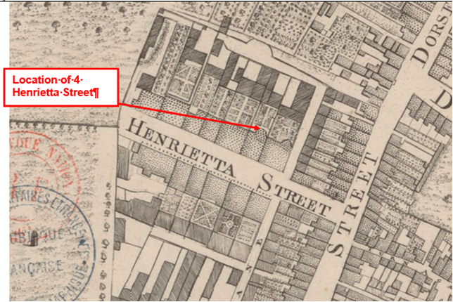
Fig. 2: Extract from the 1756 map by John Rocque showing location of 4 Henrietta Street.

References
- NIAH Inventory Ref 50010682
- An Exact Survey of the City & Suburbs of Dublin by John Rocque (1756) https://gallica.bnf.fr/ark:/12148/btv1b530571173.r=rocque%20dublin?rk=107296;4
- Dublin City Council (2006) Henrietta Street Conservation Plan.

Significance/NIAH Rating
4 Henrietta Street, Dublin 1 was recorded under Stage 1 of the NIAH for Dublin (Ref 50010682) with Ministerial Recommendations for Stage 1 issued to Dublin City Council on the 4th of June 2014. The structure was assigned a ‘Regional’ rating. These are structures or sites that make a significant contribution to the architectural heritage within their region or area. Structures which are considered of Regional significance are deemed worthy of inclusion on the RPS.

Assessment of Special Interest under the Planning and Development Act 2000
The National Inventory of Architectural Heritage assigned this building Architectural and Artistic interest. The Conservation Section has considered the opinion of the NIAH and is in agreement with assigning the ARCHITECTURAL and ARTISTIC categories of special interest to the building. It also considers the structure to be of CULTURAL and HISTORICAL interest.

- CULTURAL: The tunnels and vaults are considered to be of cultural interest reflecting the social values of the time which required servants and servicing of the house and mews to be hidden from the upper class occupants of the house.

- HISTORICAL: The house at No. 4 Henrietta Street is of historical significance for the role it played during the eighteenth century as one of the most sophisticated addresses in Dublin city which was then experiencing one of the most prosperous moments in its history. The integrity of the site at No. 4 Henrietta Street is also of considerable historical interest as a social historical document throwing light on the workings of a sophisticated residential development in the centre of Dublin’s eighteenth-century city. The remains of the former mews, tunnel and vaults are an integral element of that significance.

Conclusion & Recommendation
It is recommended that the RPS entry for 4 Henrietta Street, Dublin 1 be amended to include ancillary structures to the rear.

Proposed Listing
RPS Ref No | Address | Description
3651 | 4 Henrietta Street, Dublin 1 | House including ancillary 18th century structures to rear

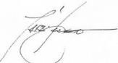 11/11/2021
_______________ ________________
Paraic Fallon
Senior Planner Date

Photographic Record:
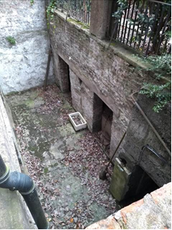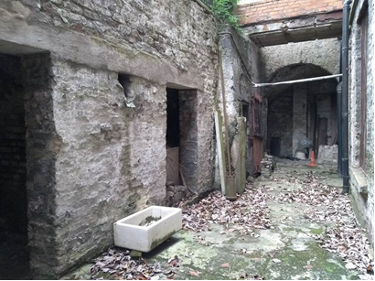
Figs. 3 & 4: View of rear basement area which gives access to tunnel and underground vaulted cellars and access to basement of main house.
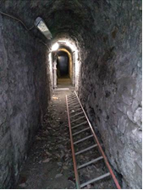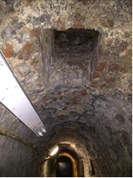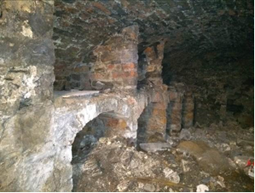
Figs. 5, 6 & 7: View of underground tunnel and vaulted cellars located underneath the garden of 4 Henrietta St.
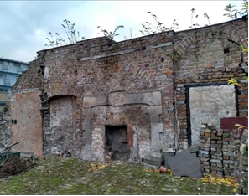 | 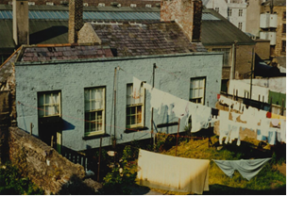
Fig. 8: View of surviving east gable wall of former mews/supper room building with remains of large granite fire place. This fireplace vented into the large chimney which can be seen in the photo of the original mews building on the right. | Fig 9: View of upper ground floor of former L-shaped mews/supper room building at rear of 4 Henrietta St which was burnt down in 1985. Gable walls & floor survive of upper ground floor. Note large chimneystack on east gable on RHS (copy of photograph provided by owner of no. 4 Henrietta Street)

RPS No. 3823 - Highfield Road, Dublin 6
Seandálaíocht, Caomhantas & Oidhreacht
An Roinn Pleanála & Forbairt Maoine
Oifigí na Cathrach, An Ché Adhmaid, Baile Átha Cliath 8

Archaeology, Conservation & Heritage Section
Planning & Property Development Department
Block 3, Floor 3, Civic Offices, Wood Quay, Dublin 8

Tel: (01) 222 3926, 222 3927
Email: conservation@dublincity.ie

16th November 2021

Draft Development Plan 2022-2028

Ref: RPS 3823 AMENDMENT to the Record of Protected Structures
_______________________________________________________________________________

Recommendation:
Amendment of current entry for Rathgar House, St Luke’s Hospital, Highfield Road, Dublin 6 – Rathgar House, St Luke’s Hospital (Orwell Park gate lodge and gates, see Orwell Park) to now read: Rathgar House, St Luke’s Hospital, Highfield Road, Dublin 6 – Rathgar House, St Luke's Hospital (for Orwell Park gate lodge and gates, see Orwell Park) including Oaklands Drive gates, shell house and dairy.

_______________________________________________________________________________

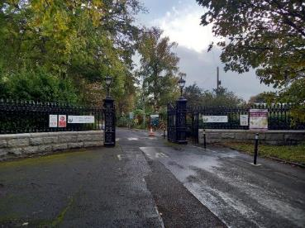

Introduction
There has been a query about whether the RPS entry Rathgar House, St Luke’s Hospital, Highfield Road, Dublin 6, should be amended to include the structures within the complex.

Existing Listing:
RPS Ref No | Address | Description
3823 | Highfield Road, Dublin 6 | Rathgar House, St Luke’s Hospital (Orwell Park gate lodge and gates, see Orwell Park)

Proposed Listing:
RPS Ref No | Address | Description
3823 | Highfield Road, Dublin 6 | Rathgar House, St Luke's Hospital (for Orwell Park gate lodge and gates, see Orwell Park) including Oaklands Drive gates, shell house and dairy.

Request for Investigation
Conservation Section, Dublin City Council

Location and Land Use Zoning
The location of Rathgar House, St Luke’s Hospital, Highfield Road, Dublin 6 is illustrated by the red arrow below. The property is situated in an area zoned objective Z15 “To protected and provide for institutional and community uses”.

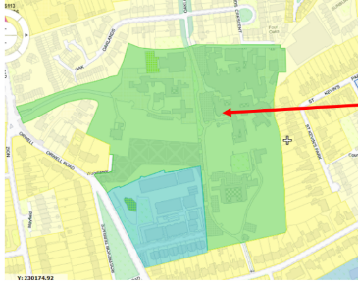
Fig. 1: Location and Land Use Zoning

Recent Planning History
Planning Ref | Description | Decision
2624/14 | Construction of a new lift shaft and all associated site works. | Granted permission 11 Aug 2014
6649/06Sub01 | Construction of a single storey electrical substation building with a floor area of approx 25.5sqm. | Granted permission 20 Mar 2007
1519/06 | Planning Permission is being sought by St Lukes Hospital for the construction of a single storey laboratory building approx 345sqm for a period of 10 years at St Lukes Hospital, Highfield Road, Rathgar, Dublin 6. | Granted permission 08 May 2006
5985/03 | Planning permission sought for prefabricated roankabin dayroom and link corridors at rear of 'The Lodge', St. Lukes Hospital, Highfield Rd., Rathgar, Dublin 6, for the board of Management (Michael Quirey ). | Granted permission 31 Mar 2004
1809/96 | Erect a single storey central supplies building (gross floor area 307 sq.m) between the East Ward Block and the eastern boundary of the site and a single storey extension (gross floor area 70 sq.m) to the existing maintenance building on the eastern boundary and carry out related landscaping works including the maintenance and replacement of the existing tree screen in this location. | Granted permission 19 Dec 1996
0912/95 | Modify approved plans (Plan No. 1721/94), decision date 20/12/94) for the extension to the radiotherapy department; the modifications comprise an increase in floor area of approximately 400 sq. metres to accommodate consultants' office and ancillary accommodation; minor changes to the configuration of the building and a revised elevation to the Avenue on the north boundary. | Granted permission 07 Jul 1995

Recent Enforcement History
Ref. No. | Opened | Reason | Closed | Reason
E0906/20 | 18-Nov-2020 | Unauthorised widening of access | 13-Sep-2021 | Exempted development
E0899/07 | 04-Sep-2007 | alleged that there has been a breach of Condition 3 of pp 6649/06 | 22-Apr-2008 | No evidence
E0263/96 | 05-Mar-1996 | removal of wall | 08-Jul-1997 | None stated

Summary Description
Main Entrance Gates onto Oakland Drive (surveyed 06/11/21)
The main entrance gates were moved to their present location in 1936 when the lands around the main avenue were sold and Oakland Drive was created. These are highly ornate cast- and wrought-iron gates, hanging on cast- and wrought-iron piers and are flanked by curved railings surmounted on granite-rusticated plinths. The piers are capped by lanterns.

(The following descriptions are taken from Add 286 Rathgar report, DCC dated 03/03/09)
Exterior: Rathgar House
Originally comprising a detached, two-storey over basement, multiple-bay, multiple-gable fronted rough-cast rendered building c. 1840. There is a c.1910 extension attached to the north of the building in keeping with the original design. The main elevation faces west. The south elevation has paired double-height bow-ended fenestration, while the east elevation is obscured by the 1950’s hospital buildings. The north elevation is finished by a three-sided bay window. The east elevation is obscured by the hospital buildings.

The house is dressed with granite to the quoins, corbelled cills, plinth and parapet levels, along with dressing on the chimneystacks and entrance doors. The basement is bounded on the west side by a granite balustrade surmounting a plinth while the access to the basement on the north side is sloped. The south basement elevation is hidden behind a grass bank bordered by a granite plinth.

The house and twentieth-century extension have a complex of natural slate pitched roofs with a number of roof lights and decorative finials to the south bow ends. The overhanging eaves are corbelled with the gables constructed in the style of a broken bed pediment. The exposed cast-iron rainwater goods have square profile downpipes and hopper heads. The multiple chimney stacks are rendered with granite corbelled capping and terracotta pots.

The main and secondary entrances are both on the east elevation giving access to the two phases of construction. The main entrance is accessed via granite steps flanked by a ball-capped plinth. The granite entrance porch has rusticated quoins and a decorative balustrade. There is a round-headed porch entrance to the paired panelled doors with side and overlights. The early-twentieth entrance is granite dressed with a canopy to a timber and glazed panelled door reached by granite steps flanked by metal railings.

The window openings are mostly square-headed with granite-corbelled cills. The windows to the main house are timber sashes while the chapel has stained glass windows. The stair hall openings are round-headed. The early twentieth-century wing has timber casements and sash windows including curved glass to the bow end. There are two uPVC replacement casements on this bow-end.

The building is linked to the 1950’s hospital building by a ramped corridor on the east elevation adjacent to the chapel.

Shell House or Summer House
This small rectangular building to the south of the main house was constructed between 1834 and 1861. The exterior render is coated with shells. The entrance porch to the south has a modern timber-panelled door with a decorative bargeboard above. There is a rendered chimneystack and canted-square-headed window. No internal access was afforded at the time of the 2009 survey.

Dairy
Exterior
This building is located to the north east of the main house against the east boundary wall. This detached two-storey, multi-bay, rendered building c.1900 is flanked by two connected single-storey buildings. The slate roof has over hanging timber corbelled eaves. The smooth-rendered elevations has a band course between the ground and first floor. The windows are mostly segmental headed with timber casements and granite cills. There is a decorative ox eye window with rendered frame at first floor level. The segmental and square-headed door openings have timber panelled and glazed doors.

Assessment
On the OSI 1879 map, the present day paired bow-ended house is present and its construction is associated with Joseph Farran. The shell house was a project by his daughters Barbara and Louise who worked on it for a long period until 1861 even when the ownership had changed by the completion date. The property was sold in 1853 after Joseph’s death to one Henry Walker Todd who renamed the house ‘Oakland.’

The next significant period of alterations is associated with Charles Wisdom Hely who purchased Oakland in 1893. He increased the land holding which afforded an entrance onto Orwell Park. His initials and coat of arms are worked into the wrought iron gates and associated red brick gate lodge with the name Oakland. By 1908, a large ballroom/theatre appears to have been constructed along with a billiard room, which is now the chapel. The grounds were extensively landscaped with tree planting, footpaths, ponds and a possible tennis court along with a complex of greenhouses. Traces of these landscape features remain today. Following this, the additional wing to the north was constructed housing many mod cons including bathrooms and various outbuildings including the dairy. In 1939, Mrs. Hely sold the main entrance avenue to a builder and Oakland Drive was created. One of the stipulations of the sale was the relocation of the gates and railings to their present location.

In 1950, her daughter closed the sale of property to the Cancer Association of Ireland. Subsequent to this, the main hospital building was constructed, designed by Thomas Paul Kennedy, architect. This resulted in the loss of the ballroom. The main house, chapel and extension remain today along with the shell house, main gates, rear gate lodge and gates, dairy, an old boiler, some rubble stone boundary walls and gates, the pond, elements of the rockery and the mature planting.

References
- Farmer, Tony. A Haven in Rathgar, St Luke’s and the Irish Experience of Cancer 1952-2007, 2007, A &A Farmer Ltd, Dublin.
- Dixon, Freddie. The History of Rathgar, 1991 (Rathmines Library Local History Series)
- Weston St John, Joyce. The Neighbourhood of Dublin, 1912.

Significance/NIAH Rating
The National Inventory of Architectural Heritage (NIAH) has not yet been carried out for this area.
However, using the significance ratings set out by the NIAH Rathgar House, St Luke’s Hospital, Highfield Road, Dublin 6 is considered to be of ‘Regional’ rating. These are structures or sites that make a significant contribution to the architectural heritage within their region or area.

Assessment of Special Interest under the Planning and Development Act 2000
Based on the National Inventory of Architectural Heritage the Conservation Section assigns ARCHITECTURAL, HISTORICAL and ARTISTIC interest to Rathgar House, St Luke’s Hospital, Highfield Road, Dublin 6.

The main house represents an exemplar of good quality design, in terms of materials used, level of intact architectural detailing and plan-form. The building and its additions demonstrate the harmonious interrelationship of differing styles within one structure dating from the early nineteenth century to the mid twentieth century.

In addition, the associated structures in the grounds also contribute to character of the main house. These include the two sets of entrance gates, the gate lodge, the shell house and dairy building. However, the current Record of Protected Structures (RPS) description, does not include specific reference to the Oaklands Drive gates, shell house and dairy which are curtilage structures that contribute to the significant character of Rathgar House. The Orwell Park gates and associated lodge are separately included on the RPS ref. no. 6130.

Conclusion & Recommendation
It is therefore recommended that the RPS entry for Rathgar House, St Luke’s Hospital, Highfield Road, Dublin 6 be amended to Rathgar House, St Luke’s Hospital, Highfield Road, Dublin 6 – Rathgar House, St Luke's Hospital (for Orwell Park gate lodge and gates, see Orwell Park) including Oaklands Drive gates, shell house and dairy.

Proposed Listing
RPS Ref No | Address | Description
3823 | Rathgar House, St Luke’s Hospital, Highfield Road, Dublin 6 | Rathgar House, St Luke's Hospital (for Orwell Park gate lodge and gates, see Orwell Park) including Oaklands Drive gates, shell house and dairy.

16/11/2021
_______________ ________________
Paraic Fallon
Senior Planner Date

Photographs Record:
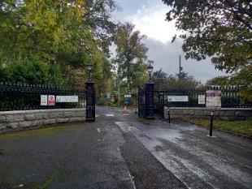 | 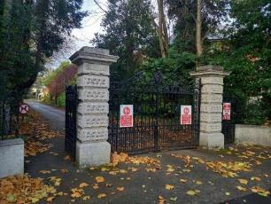
Fig. 3. Oakland Drive gates | Fig. 4. Orwell Park gates with gate lodge in the background

RPS No. 4051 - 108 James's Street, Dublin 8
Seandálaíocht, Caomhantas & Oidhreacht
An Roinn Pleanála & Forbairt Maoine
Oifigí na Cathrach, An Ché Adhmaid, Baile Átha Cliath 8

Archaeology, Conservation & Heritage Section
Planning & Property Development Department
Block 3, Floor 3, Civic Offices, Wood Quay, Dublin 8

Tel: (01) 222 3926, 222 3927
Email: conservation@dublincity.ie

11th November 2021

Draft Development Plan 2022-2028

Ref: RPS 4051 AMENDMENT to the Record of Protected Structures
_______________________________________________________________________________

Recommendation:
Amendment of current entry for 108 James Street, Dublin 8 – South façade, steps, railings, entrance gates to now read: 108 James Street, Dublin 8 – Former Guinness staff residence including railings and entrance gates extending protection to the entire structure to include its interior.
_______________________________________________________________________________

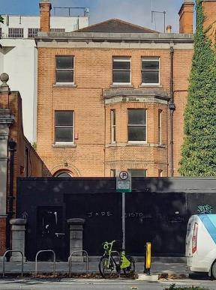

Introduction
There has been a query about whether the RPS entry 108 James Street, Dublin 8, should be amended to include the entire structure in the description.
Existing Listing
RPS Ref No | Address | Description
4051 | 108 James Street, Dublin 8 | South façade, steps, railings, entrance gates

Proposed Listing:
RPS Ref No | Address | Description
4051 | 108 James Street, Dublin 8 | Former Guinness staff residence including railings and entrance gates

Request for Investigation
Conservation Section, Dublin City Council

Location and Land Use Zoning
The location of 108 James Street, Dublin 8 is arrowed red below. The main zoning objective is Zone 5. To consolidate and facilitate the development of the central area, and to identify, reinforce and strengthen and protect its civic design character and dignity.

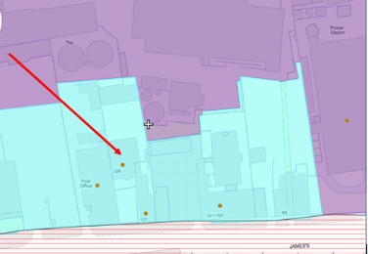
Fig. 1: Location and Land Use Zoning

Recent Planning History
Planning Ref | Description | Decision
0531/19 | Eradication of dry rot infestations; general refurbishment and upgrading of services and finishes; removal of 1970s partitions at basement and ground floor; and removal of 1960s fire escape ladder. Insertion of on door opening and new light-weight partition to room in rear basement; modification and fire proofing of two existing linen presses on landings. Repair and repointing of brick work, and retention of all original external and internal joinery and decorative plasterwork. | 28 Jan 2020  SPLIT DECISION(PERMISSION & REFUSAL)

Recent Enforcement History
None on record

Summary Description
(See images at end of report)
Description based on National Inventory of Architecture’s record for site, Ref. 50080318
Exterior:
Attached two-bay three-story over basement former house , built c.1905, having double-height canted bay window to ground and first floors to front (south) elevation, set back from street. Now in use as offices. Hipped roof set perpendicular to street, hidden behind limestone parapet with carved cornice, cast-iron rainwater goods, terracotta ridge tiles, and red brick chimneystacks having clay chimney pots. Red brick walls laid in English bond with carved limestone plinth course over rusticated limestone walls to basement level to front. Carved limestone cornice and platband over canted bay to front, carved limestone string course over first floor, platbands at sill level to ground and first floors. Square-headed window openings with cut limestone sills, red brick voussoirs and one-over-one pane timber sash windows. Round-headed door opening with red brick voussoirs, carved limestone hood moulding resting on stops, timber panelled door and plain fanlight over, opening onto nosed granite steps with flanking cast-iron railings on carved granite plinth wall, continuing to enclose basement area to front. Double-leaf wrought-iron pedestrian gate flanked by square-profile cut limestone piers to front, with matching railings set on carved limestone plinth walls.

Assessment
No.108 James's Street is listed in Thom’s Directory of 1897 as being the property of Mrs. Keegan, a tobacconist, and in 1903 as having been acquired by Guinness. A large increase in the rates before 1909 indicates that it was rebuilt between these years, following the expansion of the brewing enterprise at Guinness into the site north of James's Street in 1873. This new area was mainly used for cooperage, racking and dispatching, and several buildings along James’ Street to the south were acquired for use as offices or staff accommodation. That many of these were redeveloped or rebuilt reflects the impact that the Guinness brewery made on the streetscape in this area. Set back from the street, this substantial and imposing house is enhanced by subtle limestone detailing, which is repeated in the flanking buildings, creating an eye-catching group in the streetscape.

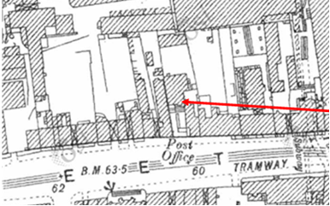

Fig. 2: 25’’ Ordnance Survey of Ireland 1897-1913 showing 108 James’s Street with a large front site and adjacent to the post office.

References
- https://osi.ie/products/professional-mapping/historical-mapping/ (accessed 18/10/21)

Significance/NIAH Rating
108 James’s Street, Dublin 8 was recorded under Stage 2 of the NIAH for Dublin (Ref 50080318) with Ministerial Recommendations for Stage 2 issued to Dublin City Council on 09/08/2017. The structure was assigned a ‘Regional’ rating. These are structures or sites that make a significant contribution to the architectural heritage within their region or area. Structures which are considered of Regional significance are deemed worthy of inclusion on the RPS.

The Conservation Section has considered the Ministerial Recommendation for the property, in tandem with Chapter 2, Section 2.5.2 of the Architectural Heritage Protection Guidelines for Planning Authorities (2011) which states ‘The protection of a façade alone should generally only be considered where there is no surviving interior of any interest, for example where the building has previously been gutted and the façade is the only remaining feature of the original historic building. Generally a façade relates integrally to its building, which may retain interior detail of note including, for example, the original spatial plan, shop-fittings or decorative elements such as chimneypieces, staircases, window shutters or cornices. Elements of the external envelope and/or within the curtilage may also be of intrinsic interest and worthy of protection; these might include the roof, the rear elevation, outbuildings or other site features’ (pg. 24). As such, the Conservation Section considers that No. 108 James Street, Dublin 8, in its entirety, merits inclusion on the Record of Protected Structures; extending protection to the entire structure, including its interior.

Assessment of Special Interest under the Planning and Development Act 2000
The National Inventory of Architectural Heritage assigned ARCHITECTURAL and HISTORICAL interest to 108 James’s Street, Dublin 8. The Conservation Section has considered the opinion of the NIAH and is in agreement with assigning these categories of special interest to the site.

Conclusion & Recommendation
It is recommended that the RPS entry for 108 James’s Street, Dublin 8 be amended to 108 James’s Street, Dublin 8 – Former Guinness staff residence including railings and entrance gates; extending protection to the entire structure, including its interior.

Proposed Listing
RPS Ref No | Address | Description
4051 | 108 James’s Street, Dublin 8 | Former Guinness staff residence including railings and entrance gates

11/11/2021

_______________ ________________
Paraic Fallon
Senior Planner Date

Photographic Record of Structure:
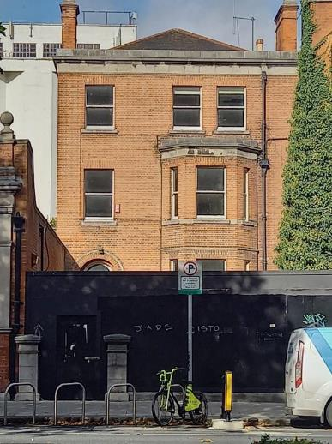
Fig. 3: Front elevation of 108 James’s Street, D8. Hoarding blocking view of ground floor

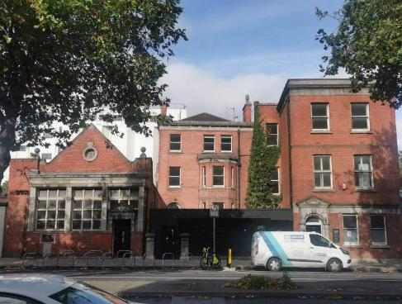
Fig. 4: Street context with post office to the west.

RPS No. 5267 - 33 Molesworth Street, Dublin 2
Seandálaíocht, Caomhantas & Oidhreacht
An Roinn Pleanála & Forbairt Maoine
Oifigí na Cathrach, An Ché Adhmaid, Baile Átha Cliath 8

Archaeology, Conservation & Heritage Section
Planning & Property Development Department
Block 3, Floor 3, Civic Offices, Wood Quay, Dublin 8

Tel: (01) 222 3926, 222 3927
Email: conservation@dublincity.ie

29th October 2021

Draft Development Plan 2022-2028

Ref: RPS 5267 AMENDMENT to the Record of Protected Structures
_______________________________________________________________________________

Recommendation:
Amendment of current entry for 33 Molesworth Street, Dublin 2 - House, to now read: 33 Molesworth Street, Dublin 2 - House excluding all buildings to rear.
_______________________________________________________________________________

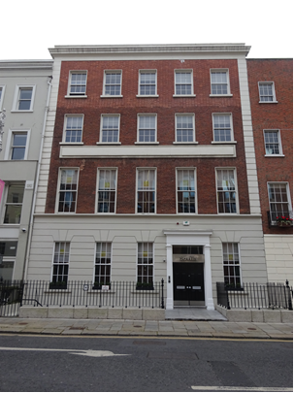

Introduction
No.33 Molesworth Street, Dublin 2 is on the current Record of Protected Structures (Dublin City Development Plan 2016-2022). The reference number is RPS: 5267 and the description reads ‘House’. An assessment of the property was undertaken by the Conservation Section in 2002/03. On foot of this, clarification of the RPS written entry, to specifically exclude all the buildings to the rear of the property, had been passed by Resolution of Dublin City Council in March 2003 (Report of Assistant City Manager Report No.91/2003). The current RPS entry does not reflect this resolution. Amendment of the written RPS entry is proposed, to reflect the previous Resolution of Dublin City Council under the Report of Assistant City Manager Report No.91/2003, to specifically exclude the buildings to the rear of the site from the protection.

Existing Listing:
RPS Ref No | Address | Description
5267 | 33 Molesworth Street, Dublin 2 | House

Proposed Listing: Amend the description to exclude the buildings to the rear.
RPS Ref No | Address | Description
5267 | 33 Molesworth Street, Dublin 2 | House excluding all buildings to rear

Request for Investigation
Conservation Section, Dublin City Council

Location and Land Use Zoning
The location of 33 Molesworth Street, Dublin 2 is indicated by the red arrow below. The zoning objective for the site is Zone 5: To consolidate and facilitate the development of the central area, and to identify, reinforce, strengthen and protect its civic design character and dignity. The property is located within a red hatch conservation area but is located outside the boundary of the Grafton Street and Environs Architectural Conservation Area.

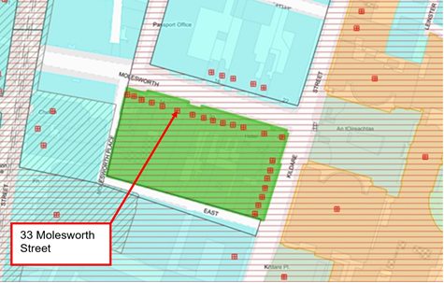
Fig.1 Location and Land Use Zoning

Relevant Planning History
There is no relevant recorded planning history for the subject site.

Relevant Planning Enforcement History
There is no relevant planning enforcement history for the subject site.

Summary Description
(See images at end of report).
Attached five-bay four-storey over basement former house, built c.1735, remodelled c.1880. Altered and significantly extended c.1970. Painted rendered band-rusticated ground floor with Flemish bond red brick walling to upper floors having painted stucco parapet cornice, strip quoins and blind floating fascia panel between first and second floors. Square-headed window openings to ground floor and upwards, with patent reveals and painted masonry sills, with continuous moulded sill course to first floor and segmental-headed openings to basement. Largely replacement six-over-six pane timber sliding sash windows. Square-headed door opening and surround. Recent paved entrance platform with wrought-iron railings to basement area having decorative cast-iron corner piers on a granite base plinth.

Assessment
No.33 Molesworth Street was originally conceived as a gable-fronted mansion c.1735. The property laterally served as the home of Lord Lisle in the 1770’s, from whence it was known as 'Lisle House'. The building was remodelled during the 19th century by George Ashlin, as commercial premises for the Irish National Co-operative Society. Substantial rebuilding is understood to have been undertaken in the mid-1970s to include the addition of an attic story and flat roof (there is no record of planning permission for these works in the Historic Planning File register). Assessment of the property was undertaken by the Conservation Section in 2003/02 following a request for its deletion. This considered the building to be of special architectural and historical significance, as a distinctive component of the streetscape and Georgian area. Though it was acknowledged that the building had been significantly modified the assessment concluded that the main structural elements, floor plan and some internal features continued to merit protection and that removal of the building from the Record of Protected Structures was not warranted. The assessment considered that the buildings to the rear of the site were of ‘no heritage value’ and recommended clarification of the RPS entry to specifically exclude all the buildings to the rear of the site. The proposed variation was passed by Resolution of Dublin City Council in March 2003 (Report of Assistant City Manager Report No.91/2003) however the buildings to the rear of the site are not excluded from protection in the current RPS entry. It is recommended to amend the written description for RPS ref: 5267 to reflect the previous Resolution of Dublin City Council under the Report of Assistant City Manager Report No.91/2003, to read ‘House excluding all buildings to rear'.

References
- Dublin Civic Trust (2012), A Survey of Gable-Fronted Houses and Other Early Buildings of Dublin City. Dublin: Dublin Civic Trust.
- Dictionary of Irish Architects
- National Inventory of Architectural Heritage (NIAH) Ref: 50100158
- Report of Assistant City Manager Report No.91/2003

Significance/NIAH Rating
No. 33 Molesworth Street, Dublin 2 was recorded under Stage 4 of the NIAH for Dublin (Ref: 50100158) and was assigned a ‘Local’ rating. The City Council’s Conservation Section has considered the opinion of the NIAH and does not concur with that rating. It is the opinion of the Conservation Section that notwithstanding the modifications undertaken during the late 20th century, No. 33 Molesworth Street is of sufficient architectural special interest to merit a ‘Regional’ rating and to remain on the City Council’s Record of Protected Structures. The buildings to the rear are considered to be of no special interest under Part IV of the Planning & Development Act 2000 (as amended).

Assessment of Special Interest under the Planning and Development Act 2000
The National Inventory of Architectural Heritage assigned: ARCHITECTURAL and HISTORICAL, interest to No. 33 Molesworth Street, Dublin 2. The Conservation Section is in agreement with these categories of special interest and to a ‘Regional’ rating for the principal structure fronting onto Molesworth Street.

Conclusion & Recommendation
It is recommended that the RPS entry for RPS ref: 5267 be amended to – 33 Molesworth Street, Dublin 2 - House excluding all buildings to rear.

Proposed Listing
RPS Ref No | Address | Description
5267 | 33 Molesworth Street, Dublin 2 | House excluding all buildings to rear

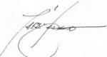 29/10/2021
_______________ ________________
Paraic Fallon
Senior Planner Date

Photographic Record:
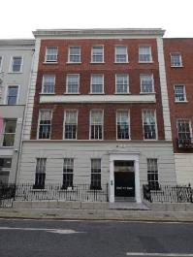 | 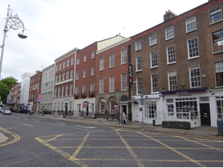
Fig.2: Principal street-facing elevation of No.33 Molesworth Street, Dublin 2. | Fig.3: No.33 Molesworth Street in context with adjacent terraced properties.
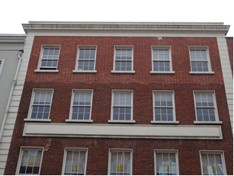 | 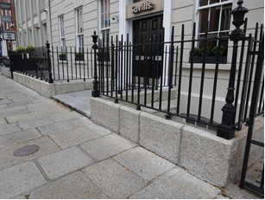
Fig.4: Detail of upper floors showing painted stucco parapet cornice, strip quoins and blind floating fascia panel between first and second floors. | Fig.5: Wrought-iron railings to basement area having decorative cast-iron corner piers on a granite base plinth.

RPS No. 5268 - 34 Molesworth Street, Dublin 2
Seandálaíocht, Caomhantas & Oidhreacht
An Roinn Pleanála & Forbairt Maoine
Oifigí na Cathrach, An Ché Adhmaid, Baile Átha Cliath 8

Archaeology, Conservation & Heritage Section
Planning & Property Development Department
Block 3, Floor 3, Civic Offices, Wood Quay, Dublin 8

Tel: (01) 222 3926, 222 3927
Email: conservation@dublincity.ie

1st November 2021

Draft Development Plan 2022-2028

Ref: RPS 5268 AMENDMENT to the Record of Protected Structures
_______________________________________________________________________________

Recommendation:
Amendment of current entry for 34 Molesworth Street, Dublin 2 - House, to now read: 34 Molesworth Street, Dublin 2 – Front façade only including entrance steps, plinth wall and railings.
_______________________________________________________________________________

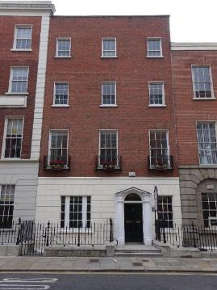

Introduction
No.34 Molesworth Street, Dublin 2 is on the current Record of Protected Structures (Dublin City Development Plan 2016-2022). The reference number is RPS: 5268 and the description reads ‘House’. The property was largely rebuilt during the late 1980s save part of the principal north façade and entrance area. Amendment of the RPS entry is proposed to limit protection to the facade only including entrance steps, plinth wall and railings.

Existing Listing:
RPS Ref No | Address | Description
5268 | 34 Molesworth Street, Dublin 2 | House

Proposed Listing: Amend the description to ‘Facade only including entrance steps, plinth wall and railings’.
RPS Ref No | Address | Description
5268 | 34 Molesworth Street, Dublin 2 | Front façade only including entrance steps, plinth wall and railings

Request for Investigation
Conservation Section, Dublin City Council

Location and Land Use Zoning
The location of 34 Molesworth Street, Dublin 2 is indicated by the red arrow below. The zoning objective for the site is Zone 5: To consolidate and facilitate the development of the central area, and to identify, reinforce, strengthen and protect its civic design character and dignity. The property is located within a red hatch conservation area but is located outside the boundary of the Grafton Street and Environs Architectural Conservation Area.
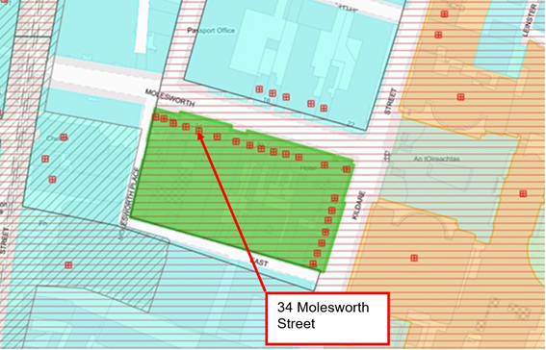
Fig.1 Location and Land Use Zoning

Relevant Planning History
Planning Ref. | Description | Decision Date
1667/89 | Demolition of derelict building at No.34 Molesworth Street and erection of replacement office building, a mezzanine floor, covered link and extension to existing office building at rear of No.35 and erection of a 2-storey office building, basement carpark and vehicular access to rear. | Not recorded
0523/19 | Removal of internal walls and partitions on basement, ground, first, second, and third floors and the construction of new internal walls and partitions on first and second floors. | 06-12-2019 Grant Exemption Certificate

Relevant Planning Enforcement History
There is no relevant planning enforcement history for the subject site.

Summary Description
(See images at end of report).
Attached three-bay four-storey over basement former house, built c.1750, largely rebuilt and significantly extended c.1980. Painted rendered band-rusticated ground floor with Flemish bond red brick walling to upper floors. Square-headed window openings with replacement timber sliding sash windows. Open pedimented doorcase having round-headed fanlight and flanking Doric columns. Recent paved entrance platform with wrought-iron railings to basement area having decorative cast-iron corner piers on a granite base plinth.

Assessment
Molesworth Street was originally laid out during the early-mid 18th century when a building on the site of No.34 Molesworth Street is shown on John Rocque’s map of 1756. The Irish Lace Depot is known to have operated from the address during the early 20th century. In the late 1980s, No.34 Molesworth Street was largely rebuilt when a planning application was lodged for the ‘demolition of derelict building at No.34 and erection of replacement office building’ (Planning Ref: 1667/89). Only part of the principal north/façade, at basement and ground floor, is understood to predate the late 20th century. The current internal plan form does not reflect a historic floor layout and there is no known surviving historic fabric to the interior (Planning Ref: 0523/19). A number of ‘replica historic features’ are recorded to some spaces, largely concentrated within the northern portion of the building, to include replica window joinery and plasterwork. Given the building was largely rebuilt during the late 1980s, save part of the principal north façade, to include entrance steps, plinth wall and railings, and does not retain any historic fabric to the interior, it is recommended to amend the entry for RPS ref: 5268 to read ‘Facade only including entrance steps, plinth wall and railings’.

References
- Dictionary of Irish Architects
- Planning files Reg. Ref: 1667/89 and 0523/19

Significance/NIAH Rating
No. 34 Molesworth Street, Dublin 2 was not recorded as part of Stage 4 of the National Inventory of Architectural Heritage (NIAH) for Dublin. Notwithstanding this, the Conservation Section considers that the principal façade fronting onto Molesworth Street, including entrance steps, plinth wall and railings are of sufficient special interest to merit inclusion on the Record of Protected Structures. The remainder of the building has no special interest under Part IV of the Planning & Development Act 2000 (as amended).

Assessment of Special Interest under the Planning and Development Act 2000
The Conservation Section considers the principal street facing façade of No. 34 Molesworth Street, Dublin 2, including entrance steps, plinth wall and railings to be of ARCHITECTURAL interest.

Conclusion & Recommendation
It is recommended that the RPS entry for RPS ref: 5268 be amended to – 34 Molesworth Street, Dublin 2 - Facade only including entrance steps, plinth wall and railings.

Proposed Listing
RPS Ref No | Address | Description
5267 | 34 Molesworth Street, Dublin 2 | Front façade only including entrance steps, plinth wall and railings

01/11/2021
_______________ ________________
Paraic Fallon
Senior Planner Date

Photographic Record:
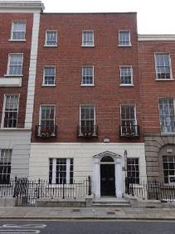
Fig.2 Principal elevation of No.34 Molesworth Street, Dublin 2. | Fig.3 No.34 Molesworth Street in context with adjacent terraced properties.
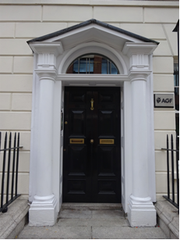 | 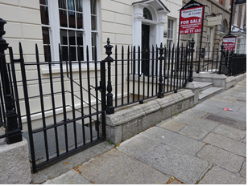
Fig.4 Detail of pedimented doorcase with flanking Doric columns. | Fig.5 Wrought-iron railings to basement area having decorative cast-iron corner piers on a granite base plinth.

RPS No. 5412 - 1 Mountjoy Square North, Dublin 1
Seandálaíocht, Caomhantas & Oidhreacht
An Roinn Pleanála & Forbairt Maoine
Oifigí na Cathrach, An Ché Adhmaid, Baile Átha Cliath 8

Archaeology, Conservation & Heritage Section
Planning & Property Development Department
Block 3, Floor 3, Civic Offices, Wood Quay, Dublin 8

Tel: (01) 222 3926, 222 3927
Email: conservation@dublincity.ie

1st November 2021

Draft Development Plan 2022-2028

Ref: RPS 5412 AMENDMENT of the Record of Protected Structures
_______________________________________________________________________________

Recommendation:
Amendment of current entry for 1 Mountjoy Square North, Dublin 1 - House, including 83 Gardiner Street Upper, to now read: 1 Mountjoy Square North, Dublin 1 - House, including 69 Gardiner Street Upper (also known as 69 Mountjoy Square West).
_______________________________________________________________________________

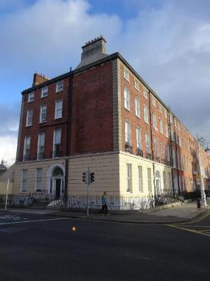

Introduction
No.1 Mountjoy Square North, Dublin 1 is on the current Record of Protected Structures (Dublin City Development Plan 2016-2022). The reference number is RPS: 5412 and the description reads House, including 83 Gardiner Street Upper’. The street number associated with the portion of the property, which fronts onto Gardiner Street Upper, is incorrect. Amendment of the RPS description is proposed to reflect the accurate address.

Existing Listing:
RPS Ref No | Address | Description
5412 | 1 Mountjoy Square North, Dublin 1 | House, including 83 Gardiner Street Upper

Proposed Listing: Amend description to reflect the accurate street address for the portion of the property fronting onto Gardiner Street Upper.
RPS Ref No | Address | Description
5412 | 1 Mountjoy Square North, Dublin 1 | House, including 69 Gardiner Street Upper (also known as 69 Mountjoy Square West)

Request for Investigation
Conservation Section, Dublin City Council

Location and Land Use Zoning
The location of No.1 Mountjoy Square, Dublin 1 is indicated by the red arrow below. The zoning objective for the site is Zone 8: To protect, the existing architectural and civic design character, and to allow only for limited expansion consistent with the conservation objective. The property is located within the Mountjoy Square Architectural Conservation Area and is also located with a red hatch conservation area.
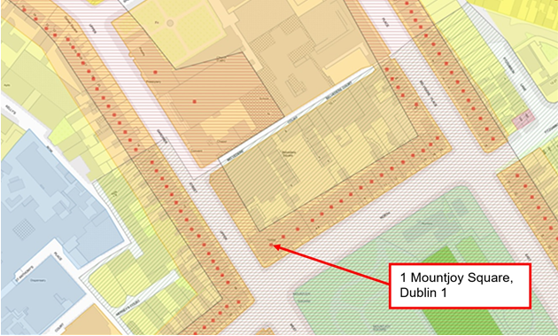
Fig.1 Location and Land Use Zoning

Relevant Planning History
There are a number of planning applications recorded in relation to the subject site which list the address as No.69 Gardiner Street Upper (Planning Ref: 0787/78, 3978/78, 0379/95, 0434/18, 0554/18, 0412/18, 4756/18 and 2045/19).

Relevant Planning Enforcement History
There is no relevant planning enforcement history for the subject site.

Summary Description
(See images at end of report).
Corner-sited end-of-terrace four-storey house over exposed basement, built c.1790, having separate access opening onto both Mountjoy Square North and Gardiner Street Upper.

Assessment
The property on the corner of Mountjoy Square North and Gardiner Street Upper is understood to have originally been conceived c.1790 as three separate properties. These are later depicted on the 1907 Ordnance Survey map as two properties. The RPS description for the address currently reads ‘House, including 83 Gardiner Street Upper’. Research in the Registry of Deeds identified an Indenture of Mortgage recording the property as No’s.1 and 69 Gardiner Street. The research also identified an Indenture of Conveyance and Assignment which records the property as No’s. 1 and 69 Mountjoy Square. Further research of the historic record shows the property recorded in Griffiths Valuation of 1878-1899, as forming part of Mountjoy Square West, despite adjoining the properties on Mountjoy Square North. On this basis, it is proposed to amend the RPS description for the entry to remove reference to No.83 Gardiner Street Upper and to reflect the accurate address as identified through the legal and historic research. It is recommended to amend the description for RPS 5412 to read ‘House, including 69 Gardiner Street Upper (also known as 69 Mountjoy Square West)’.

References
- National Inventory of Architectural Heritage (NIAH) Ref: 50010822.
- Ordnance Survey Mapping.
- Registry of Deeds.
- Griffiths Valuation.

Significance/NIAH Rating
No.1 Mountjoy Square North, Gardiner Street, Dublin 1 was recorded under Stage 1 of the NIAH for Dublin (Ref: 50010822) with Ministerial Recommendations for Stage 1 issued to Dublin City Council on 4th June 2014. The structure was assigned a ‘Regional’ rating. These are structures or sites that make a significant contribution to the architectural heritage within their region or area. Structures which are considered of Regional significance are deemed worthy of inclusion on the RPS.

Assessment of Special Interest under the Planning and Development Act 2000
The National Inventory of Architectural Heritage assigned ARCHITECTURAL and ARTISTIC interest to No.1 Mountjoy Square North, Gardiner Street, Dublin 1. The Conservation Section has considered the opinion of the NIAH and is in agreement with assigning these categories of special interest to the site.

Conclusion & Recommendation
It is recommended that the RPS description for RPS ref: 5412 for No.1 Mountjoy Square North, Dublin 1, be amended to – ‘House, including 69 Gardiner Street Upper (also known as 69 Mountjoy Square West)’.

Proposed Listing
RPS Ref No | Address | Description
5412 | 1 Mountjoy Square North, Dublin 1 | House, including 69 Gardiner Street Upper (also known as 69 Mountjoy Square West)

01/11/2021

_______________ ________________
Paraic Fallon
Senior Planner Date

Photographic Record:
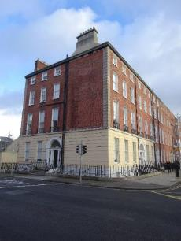 | 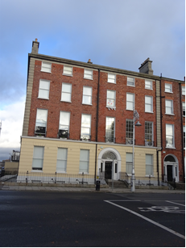
Fig.2: Aspect of No.1 Mountjoy Square North including No.69 Gardiner Street Upper (also known as No.69 Mountjoy Square West). | Fig.3: No.1 Mountjoy Square North including No.69 Gardiner Street Upper (also known as No.69 Mountjoy Square West).
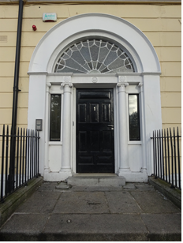 | 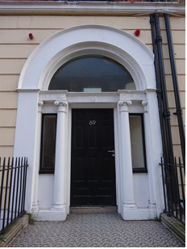
Fig.4: Detail of door to No.1 Mountjoy Square North with door number reading ‘1’. | Fig.5: Detail of door to No.69 Gardiner Street Upper (also known as No.69 Mountjoy Square West) with door number reading ‘69’.

RPS No. 5790 – Mullingar House, 9 Mullingar Terrace, Chapelizod Road, Dublin 20
Seandálaíocht, Caomhantas & Oidhreacht
An Roinn Pleanála & Forbairt Maoine
Oifigí na Cathrach, An Ché Adhmaid, Baile Átha Cliath 8

Archaeology, Conservation & Heritage Section
Planning & Property Development Department
Block 3, Floor 3, Civic Offices, Wood Quay, Dublin 8

Tel: (01) 222 3926, 222 3927
Email: conservation@dublincity.ie

16th November 2021

Draft Development Plan 2022-2028

Ref: RPS 5790 AMENDMENT to the Record of Protected Structures
_______________________________________________________________________________

Recommendation:
Amendment of current entry for 9 Mullingar Terrace, Chapelizod Road, Dublin 20 – Mullingar House: licensed premises, to now read: 9 Mullingar Terrace, Chapelizod Road, Dublin 20 – Mullingar House: licensed premises, including buildings to rear also known as Mulberry Cottage and Rose Cottage.
_______________________________________________________________________________

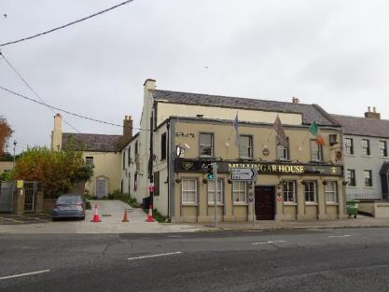

Introduction
No. 9 Mullingar Terrace, Chapelizod Road, Dublin 20 is on the current Record of Protected Structures (Dublin City Development Plan 2016-2022). The reference number is RPS: 5790 and the description reads ‘Mullingar House: licensed premises’. It is proposed to amend the description to read ‘Mullingar House: licensed premises, including buildings to rear also known as Mulberry Cottage and Rose Cottage’.

Existing Listing:
RPS Ref No | Address | Description
5790 | 9 Mullingar Terrace, Chapelizod Road, Dublin 20 | Mullingar House: licensed premises

Proposed Listing: Amend description to read ‘Mullingar House: licensed premises, including buildings to rear also known as Mulberry Cottage and Rose Cottage’.
RPS Ref No | Address | Description
5790 | 9 Mullingar Terrace, Chapelizod Road, Dublin 20 | Mullingar House: licensed premises, including buildings to rear also known as Mulberry Cottage and Rose Cottage

Request for Investigation
Conservation Section, Dublin City Council

Location and Land Use Zoning
The location of 9 Mullingar Terrace (including Mulberry Cottage and Rose Cottage), Chapelizod, Dublin 20 is marked by a red arrow below. The zoning objective is Z1: “To protect, provide and improve residential amenities”. The site is located within the Chapelizod Architectural Conservation Area (ACA) and within a red hatched Conservation Area.

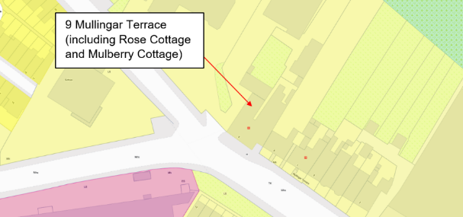
Fig. 1: Location and Land Use Zoning

Relevant Planning History
Planning Ref. | Description | Decision Date
0153/16 | EXPP: Renovation of entire 2-storey, 2 bedroom semi-detached house, currently in poor state of disrepair, to include upgrade insulation, internal services & replace bathroom & kitchen fittings & ancillary works. | ADDITIONAL INFORMATION  25 May 2016
1990/99 | Redevelopment at Mullingar House, a List 2 Building, the reopening of original windows and door openings; the reopening of the former 'archway' to the south elevation; internal layout alterations within the original structures, the demolition of a modern single storey rear extension and its part replacement with a new structure including a cellar; the reinstatement of original slated roof. | GRANT PERMISSION  12 Nov 1999

Relevant Planning Enforcement History
Ref. No. | Opened | Reason | Closed | Reason
E0555/16 | 20-Jul-2016 | Alleged unauthorised gate erected at side of premises | 24-Aug-2016 | Removed
E0157/99 | 22-Feb-1999 | part of roof (back portion) removed | 06-Apr-2001 | Planning permission granted
C0008/21 | 10-Mar-2021 | Protected Structure: endangerment of a Protected Structure | Open | N/A

Summary Description
(See images at end of report)
Description based on National Inventory of Architecture’s record for site, Ref 50060641
Description: The Mullingar House is an end of terrace multiple-bay two-storey house, built c.1800, in use as public house since at least 1907, having flat-roof and one-bay deep, four-bay block projecting to front, with further slightly lower recessed bay to southeast end of main block. Further recent additions to rear. Latter block has seven-bay ground floor of three windows each side of central entrance. Pitched slate roof with one slightly projecting gable-end chimneystack and with parapet to front, and with attic lights to rear slope. Rendered walls throughout, with painted border to front block. Square-headed window openings to projecting block, none visible to main block, with one-over-one pane timber sliding sash windows to front and two-over-two pane to ends, all with stone sills and moulded surrounds.

Lower three-bay two-storey house to north and rear, having square-headed window openings and round-headed centrally-placed doorway. Square-headed window openings having granite cills and timber one-over-one sash windows. Central round-headed door opening having rendered reveals, replacement timber panelled door and plain overlight.

A three-bay, two-storey house, built c. 1760, also known as Rose Cottage, with a single-storey lean-to extension to rear (north) elevation, is attached to the rear north-west. Single-span pitched natural slate roof with red clay ridge tiles, gabled to the west end and hipped to east end, with rendered chimneystacks to south-east and west ends. Roofs rear span retains a course of larger eaves slates to the west end. Cast-iron rainwater goods to front and rear elevations. Painted ruled-and-lined rendered walls to front (south) elevation and rendered walls to side (west) and rear elevations. Square-headed door opening to front elevation with rendered surround and timber panelled door, granite and limestone platform. Square-headed window opening to front elevation with rendered reveals, painted masonry sill and two-over-two timber sash windows with ogee horns dating to late nineteenth century. Square-headed window openings to rear elevation with rendered reveals, granite sills and tripartite timber sash windows comprising two-over-two pane sashes with convex horns, retaining some early glass. The interior contains features indicative of an early building including a timber closed string staircase with interlocking flights and angled chimneystacks to the ground and first floors.

Assessment
No. 9 Mullingar Terrace, Chapelizod, Dublin 20 was first protected under the Draft Dublin City Development Plan 1998 when it was addressed as 10A Main Street, Chapelizod and described as ‘Mullingar House: Licensed premises’. The address of the protected structure was later corrected to 9 Mullingar Terrace in 2009 and the owners were notified.

A Section 5 Declaration application (Ref. No. 0153/16) was submitted in relation to Mulberry Cottage, Chapelizod, Dublin 20. The planner’s response noted that ‘The Mullingar House’ (No. 9 Mullingar Terrace and No. 10A Main Street, Chapelizod) is a Protected Structure; RPS No. 5790. The subject structure forms part of a three building complex of structures referred to as Mullingar House and listed in the National Inventory of Architectural Heritage (NIAH) Reg. No. 50060641’. The applicants were ‘requested to demonstrate that the subject structure was not a curtilage structure or did not form part of the Protected Structure, when Mullingar House was proposed or adopted as a Protected Structure’.

As a result of the Section 5 application a clarification file was set up by the Conservation Section. The clarification requested that the RPS description for Mullingar House be amended to include Mulberry Cottage/Rose Cottage to the rear of Mullingar House. Legal searches undertaken as part of the Section 12 process for the Draft 2022-2028 Development Plan indicate that Mullingar House along with the two houses to the rear are currently in the same ownership. As a result it is proposed to extend the protection afforded to RPS: 5790 to include the two attached buildings to the rear (north and north-west of Mullingar House, also known as Mulberry Cottage and Rose Cottage).

References
- Casey, C. (2005). Dublin: The Buildings of Ireland. London: Yale University Press.
- National Inventory of Architectural Heritage (NIAH) Ref:50060641
- Planning Reg. Refs: 0153/16 and 1990/99.

Significance/NIAH Rating
Mullingar House, 9 Mullingar Terrace, Dublin 20 was recorded under Stage 2 of the NIAH for Dublin (Ref: 50060641). The structure was assigned a ‘Local’ rating. These are structures that make a contribution to the architectural heritage of their locality but which do no not merit inclusion on the RPS.

In November 2019, the Planning & Property Development SPC agreed a methodology to expedite proposed additions/deletions to the RPS in a systematic manner, based on the Architectural Heritage Protection Guidelines 2011 and NIAH/Ministerial Recommendations under Section 53(1) of the Planning and Development Act, 2000 (as amended). The methodology agreed to prioritise industrial, twentieth century, early buildings and underrepresented typologies.

Following the completion of the NIAH survey of Chapelizod, an assessment by the Conservation Section has indicated that the building attached to the north-west end of Mullingar House (also known as Rose Cottage) is an early building retaining features indicative of an early to mid-eighteenth century date.

Assessment of Special Interest under the Planning and Development Act 2000
The National Inventory of Architectural Heritage assigned ARCHITECTURAL and SOCIAL interest to No. 9 Mullingar Terrace, Dublin 20. The Conservation Section has considered the opinion of the NIAH and is in agreement with assigning these categories of special interest to the property in full.

Conclusion & Recommendation
It is recommended that the RPS entry for 9 Mullingar Terrace, Chapelizod Road, Dublin 20 – Mullingar House: licensed premises, to now read: 9 Mullingar Terrace, Chapelizod Road, Dublin 20 – Mullingar House: licensed premises, including buildings to rear also known as Mulberry Cottage and Rose Cottage in accordance with Section 12(3) of the Planning and Development Act, 2000 (as amended).

Proposed Listing
RPS Ref No | Address | Description
5790 | 9 Mullingar Terrace, Chapelizod Road, Dublin 20 | Mullingar House: licensed premises, including buildings to rear also known as Mulberry Cottage and Rose Cottage

15/11/2021

_______________ ________________
Paraic Fallon Date
Senior Planner

Photographs of Structure:
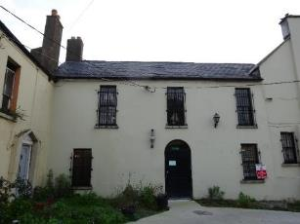 | 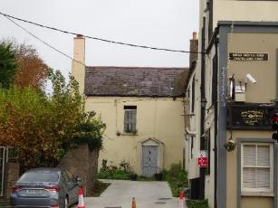
Fig.2: Building adjoining Mullingar House to north. | Fig.3: Building adjoining Mullingar House to north-west.

RPS No. 5835 - North Wall Quay, Dublin 1
Seandálaíocht, Caomhantas & Oidhreacht
An Roinn Pleanála & Forbairt Maoine
Oifigí na Cathrach, An Ché Adhmaid, Baile Átha Cliath 8

Archaeology, Conservation & Heritage Section
Planning & Property Development Department
Block 3, Floor 3, Civic Offices, Wood Quay, Dublin 8

Tel: (01) 222 3926, 222 3927
Email: conservation@dublincity.ie

12th November 2021

Draft Development Plan 2022-2028

Ref: RPS 5835 AMENDMENT to the Record of Protected Structures
_______________________________________________________________________________

Recommendation:
Amendment of current entry for North Wall Quay, Dublin 1 – Granite ashlar quay walls, stone setts, mooring rings, steps, bollards, lamp standards and machinery, to now read: North Wall Quay, Dublin 1 – Granite ashlar quay walls, stone setts, mooring hooks, ladders, hand rails and steps
_______________________________________________________________________________

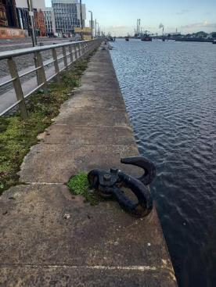

Introduction
There has been a query about whether the RPS entry North Wall Quay, Dublin 1, should be amended to reflect the extant historic fabric, namely the historic fabric that still exists at North Wall Quay: granite ashlar quay walls, stone setts, mooring hooks, ladders, hand rails and steps.

Existing Listing:
RPS Ref No | Address | Description
5835 | North Wall Quay, Dublin 1 | Granite ashlar quay walls, stone setts, mooring rings, steps, bollards, lamp standards and machinery

Proposed Listing:
RPS Ref No | Address | Description
5835 | North Wall Quay, Dublin 1 | Granite ashlar quay walls, stone setts, mooring hooks, ladders, hand rails and steps.

Request for Investigation
Conservation Section, Dublin City Council

Location and Land Use Zoning
The location of North Wall Quay, Dublin 1 is outlined below. There are various land use zonings associated with the quay, as follows;
Zone 9 “to preserve, provide and improve recreational amenity and open space and green networks”; Zone 14 “Strategic Development and Regeneration Area to seek the social, economic and physical development and/or rejuvenation of an area with mixed use of which residential and ‘Z6’ would be the predominant uses”.
Zone 11 “to protect and improve canal, coastal and river amenities”.
The structure is located within a red hatched conservation area and also within the designated area of the North Lotts and Grand Canal Dock Strategic Development Zone (SDZ).

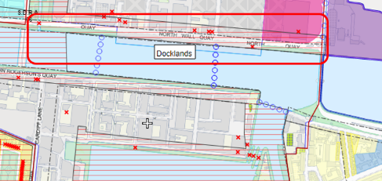
Fig. 1: Location and Land Use Zoning

Recent Planning History
The following is a list of relevant planning applications: 0431/97, 3647/06, DD528, DD280, DSDZ3341/15, DSDZ4164/17, DSDZ3630/15, 3647/06, 0431/97.

Recent Enforcement History
None.

Summary Description
(See images at end of report)
Description based on National Inventory of Architecture’s record for site, Ref. 50010011
Exterior: Stretch of quay wall, erected c.1800, along north embankment of Liffey between Convention Centre and New Wapping Street. Coursed squared granite ashlar quay walls with granite coping, flush to embankment with bull-nosed edges. Several paired iron mooring hooks set into coping and three shallow recesses containing iron ladders. Recently refurbished quayside with replacement diorite setts and grey or pink granite paths. Stainless steel railing and lamp standards along entire quay.

Assessment
Substantial quay walls lining the north side of the Liffey. Built to match the earlier quay walls of Sir John Rogerson’s Quay, these walls completed the channelling of the Liffey providing for safe navigation. The recent refurbishment has removed most of the associated machinery and street furniture while the retention of the iron mooring hooks and ladders provides a link to the maritime character of the area.

Fig.2 shows the original crane machinery that was located on the campshires of the North Wall Quay which was important for the movement of goods on and out commercial vessels docked along the quay. The North Wall Quay was historically an important passenger embarking site and was the largest exist point from Ireland during the Famine period, for soldiers leaving for the Great War and generations of emigrants, with the nearby British Railway Hotel and the North Wall railway station probably being the last buildings they set foot in before departing Irish soil.

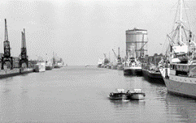
Fig. 2: Dublin Port Archives 1980’s photograph of North Wall Quay (left) and Sir John Rogerson Quay (right)

References
- https://dublinportarchive.com/gallery/the-history-of-the-port/#gallery-10 (accessed 10/11/21)
- http://builtdublin.com/london-and-north-western-hotel-north-wall-quay-dublin-1/ (accessed 09/11/21)
- https://www.buildingsofireland.ie/buildings-search/building/50010009/north-wall-quay-dublin-1-dublin (accessed 09/11/21)

Significance/NIAH Rating
The North Wall Quay, Dublin 1 was recorded under Stage 1 of the NIAH for Dublin (Ref 50010011) with Ministerial Recommendations for Stage 1 issued to Dublin City Council on 4th June 2014. The structure was assigned a ‘Regional’ rating. These are structures or sites that make a significant contribution to the architectural heritage within their region or area. Structures which are considered of Regional significance are deemed worthy of inclusion on the RPS.

Assessment of Special Interest under the Planning and Development Act 2000
The National Inventory of Architectural Heritage assigned ARCHITECTURAL, HISTORICAL and TECHNICAL interest to North Wall Quay, Dublin 1. The Conservation Section has considered the opinion of the NIAH and is in agreement with assigning this category of special interest to the site.

Conclusion & Recommendation
It is recommended that the RPS entry for North Wall Quay, Dublin 1 – Granite ashlar quay walls, stone setts, mooring rings, steps, bollards, lamp standards and machinery, be amended to: North Wall Quay, Dublin 1 – Granite ashlar quay walls, stone setts, mooring hooks, ladders, hand rails and steps.

Proposed Listing
RPS Ref No | Address | Description
5835 | North Wall Quay, Dublin 1 | Granite ashlar quay walls, stone setts, mooring hooks, ladders, hand rails and steps.

12/11/2021
_______________ ________________
Paraic Fallon
Senior Planner Date

Photographic Record:
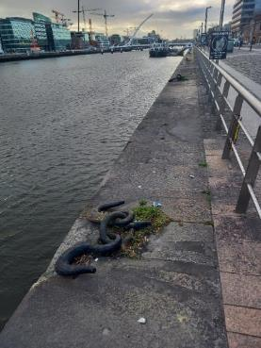 | 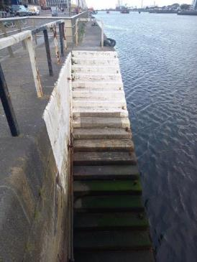
Fig. 3: North Wall Quay with mooring hooks looking towards city | Fig. 4: Granite steps

RPS No. 6016 – 1-2 O'Connell Street Upper, Dublin 1
Seandálaíocht, Caomhantas & Oidhreacht
An Roinn Pleanála & Forbairt Maoine
Oifigí na Cathrach, An Ché Adhmaid, Baile Átha Cliath 8

Archaeology, Conservation & Heritage Section
Planning & Property Development Department
Block 3, Floor 3, Civic Offices, Wood Quay, Dublin 8

Tel: (01) 222 3926, 222 3927
Email: conservation@dublincity.ie

11th November 2021

Draft Development Plan 2022-2028

Ref: RPS 6016 AMENDMENT to the Record of Protected Structures
_______________________________________________________________________________

Recommendation:
Amendment of current entry for 1-2 O’Connell Street Upper, Dublin 1 – Shop and offices: upper floor façades, to now read: 1-2 O’Connell Street Upper, Dublin 1 – Commercial premises: south and west façades, together with entrance door, lobby, stairs and mansard roof.
______________________________________________________________________________

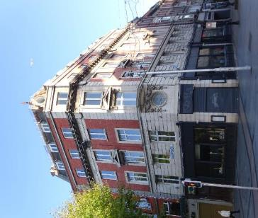

Introduction
No. 1-2 O’Connell Street Upper, Dublin 1 are on the current Record of Protected Structures (Dublin City Development Plan 2016-2022). The reference number is RPS: 6019 and the description reads ‘Shop and offices: upper floor façades’. It is proposed to amend the description to read ‘Commercial premises: south and west façades, together with entrance door, lobby, stairs and mansard roof’.

Existing Listing:
RPS Ref No | Address | Description
6016 | 1-2 O’Connell Street Upper, Dublin 1 | Shop and offices: upper floor facades

Proposed Listing: Amend description to read ‘Commercial premises: south and west façades, together with entrance door, lobby, stairs and mansard roof’.

RPS Ref No | Address | Description
6016 | 1-2 O’Connell Street Upper, Dublin 1 | Commercial premises: south and west façades, together with entrance door, lobby, stairs and mansard roof.

Request for Investigation
Conservation Section, Dublin City Council

Location and Land Use Zoning
The location of 1-2 O’Connell Street Upper, Dublin 1 is marked by a red arrow below. The zoning objective is Z5: To consolidate and facilitate the development of the central area and to identify, reinforce and strengthen and protect its civic design character and dignity. The site is also located within the O’Connell Street Conservation Area and within a red hatched Conservation Area.

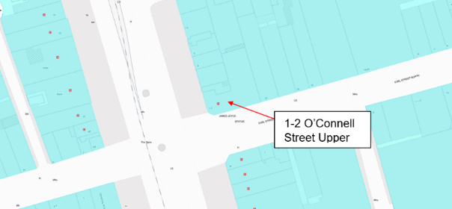
Figure 1: Site location and Zoning Map

Relevant Planning History
Planning Ref. | Description | Decision Date
2150/19 | PROTECTED STRUCTURE: Planning Permission on a site of c.0.03ha located at Nos. 1-2 Upper O'Connell Street and No. 29 North Earl Street, Dublin 1. The upper floor facades of Nos. 1-2 Upper O'Connell Street are a Protected Structure (RPS Ref. 6016). The development will consist of a change of use from office use to hotel use at basement, part ground, first, second, third, fourth and fifth floor levels comprising a total area of c.1,176 sq.m. No alterations are proposed to the existing cafe unit at ground floor level. The proposed development includes the reconfiguration of the internal floorplan layouts to facilitate 41 no. en-suite bedrooms at first to fifth floor levels including a dining/reception area at first floor level. The proposed development also includes a concierge space at ground floor level. The proposed development will include: replacement of the non-original windows at first to fifth floor levels of the building facades facing Upper O'Connell Street and North Earl Street; minor repair works to the building facades at Upper O'Connell Street and North Earl Street; decal signage above the existing door at ground floor level on Upper O'Connell Street; 4 no. external balconies to the rear (north) of the building at second to fifth floor levels; the removal of the external fire escape stair to the rear (north) elevation and the replacement of the external maintenance stair between fifth floor and roof levels; minor modifications to the window/door arrangements to the rear (northern and eastern) building facades; inclusion of water tanks at basement and roof levels; piped infrastructure and services and all associated site development works above and below ground. | GRANT PERMISSION  29 Jul 20190
4732/08 | PROTECTED STRUCTURE - The development will consist of alterations to existing shop front to include replacing existing timber revolving door with new timber and glass swing door. Replacement of existing roller shutter with visi-screen powder coated roller shutter. New timber fascia and new lettering to be constructed. Motorized awning to be integrated into new facia design. The facade of the upper floor only of no. 1-2 Upper O'Connell St is a protected structure and the building is in an architectural conservation area. | GRANT PERMISSION  01 Dec 2008
1057/95 | New security office off ground floor entrance. | GRANT PERMISSION  14 Sep 1995

Relevant Planning Enforcement History
Ref. No. | Opened | Reason | Closed | Reason
E0230/05 | 22-Mar-2005 | Banner advertising English language school | 13-May-2005 | Enforcement notice.
E0824/09 | 18-Sep-2009 | Erection of large banner on front facade w/out pp | 08-Oct-2009 | No evidence

Summary Description
(See images at end of report)
Description based on National Inventory of Architecture’s record for site, Ref. 50010248
Exterior: Corner-sited five-storey commercial building with attic storey, built 1917, having canted frontispiece entrance bay to corner and shopfronts to ground floor. Built to designs of O’Callaghan & Webb. Pie-ended mansard roof with natural slate finish and lucarnes to south and west slopes. Decorative cast-iron trim to visible roof junctions surmounted by iron brattishing. Cast-iron finial to canted section with decorative oval lucarne on scrolled brackets. Red brick chimneystacks to north and east gables with Portland limestone cornice and coping to gables. Roof set back from red brick parapet wall with Portland stone coping and cornice to base. Red brick walls laid in Flemish bond framed by full-height Portland stone rusticated pilasters. Portland stone frieze and cornice over third floor with mutules, dentils and decorative brackets to each pilaster. Channel rusticated Portland stone walls to first floor level surmounted by continuous frieze and moulded sill course. Flush coursed Portland stone ashlar walls to canted frontispiece also framed by rusticated pilasters. Square-headed window openings and replacement uPVC windows throughout. Gauged brick to fourth floor, moulded sills to third floor and Portland stone architrave surrounds to second floor. Frontispiece bay has oculus to first floor with multiple-pane light and gadroon moulded surround having ancon and elaborate swag mouldings with continuous sill forming oriel-type overhang. Second floor window opening pedimented with scrolled console brackets, third floor window having kneed architrave surround with volutes and moulded sills. Second and third floor window treatment repeated to centre of west elevation and twice to south elevation. Replacement timber shopfronts to ground floor of both elevations with replacement door opening to frontispiece entrance bay. To northernmost bay of west elevation is square-headed door opening with double-leaf hardwood panelled doors and rectangular overlight (possibly original) and replacement hardwood surround.

Assessment
No. 1-2 O’Connell Street Upper, Dublin 1 was built to designs of O’Callaghan and Webb in 1917. The building represents part of the reconstruction of the O’Connell Street area following destruction during the 1916 Rising. The building was first protected under the Draft Dublin City Development Plan, 1987 when it was described as ‘Shop and offices: upper floor façade’. Although the shopfront at ground floor was replaced during the twentieth century and now largely comprises a modern timber shopfront, the entrance door and overlight to the north end of the O’Connell Street Upper elevation formed part of the original shopfront.

A planning application granted in 2019 (planning ref. 2150/19) allowed for the ‘reconfiguration of the internal floorplan layouts to facilitate 41 no. en-suite bedrooms at first to fifth floor levels including a dining/reception area at first floor level’. The conservation report submitted with the application indicate that the early twentieth century staircase and ground floor lobby with decorative plasterwork scheme and entrance door to the north end of the building survived intact at the time of the application and were to be retained as part of the development. The report and photographic survey included with the application indicates that the remainder of the interior of the building had been substantially refurbished by that time and the inclusion of the interior of the upper floor interior in the RPS record is not warranted.

As such, it is recommended that the description for RPS ref. 6016 for No. 1-2 O’Connell Street Upper, Dublin 1 is amended to read ‘Commercial premises: south and west façades, together with entrance door, lobby, stairs and mansard roof’.

References
- Casey, C. (2005). Dublin: The Buildings of Ireland. London: Yale University Press.
- National Inventory of Architectural Heritage (NIAH) Ref:50010248
- Planning file ref: 2150/19

Significance/NIAH Rating
No. 1-2 O’Connell Street Upper, Dublin 1 was recorded under Stage 1 of the NIAH for Dublin (Ref:50010540) with Ministerial Recommendations for Stage 1 issued to Dublin City Council on 4th June 2014. The structure was assigned a ‘Regional’ rating. These are structures or sites that make a significant contribution to the architectural heritage within their region or area. Structures which are considered of Regional significance are deemed worthy of inclusion on the RPS.

Assessment of Special Interest under the Planning and Development Act 2000
The National Inventory of Architectural Heritage assigned ARCHITECTURAL and ARTISTIC interest to No. 1-2 O’Connell Street Upper, Dublin 1. The Conservation Section has considered the opinion of the NIAH and is in agreement with assigning these categories of special interest to the property.

Conclusion & Recommendation
It is recommended that the RPS entry for 1-2 O’Connell Street Upper, Dublin 1 – Shop and office: upper floor facades is amended to read 1-2 O’Connell Street Dublin 1 - Commercial premises: south and west façades, together with entrance door, lobby, stairs and mansard roof, in accordance with Section 12(3) of the Planning and Development Act, 2000 (as amended).

Proposed Listing
RPS Ref No | Address | Description
6016 | 1-2 O’Connell Street Upper, Dublin 1 | Commercial premises: south and west façades, together with entrance door, lobby, stairs and mansard roof.

12/11/2021
_______________ ________________
Paraic Fallon Date
Senior Planner

Photographic Record of Structure:
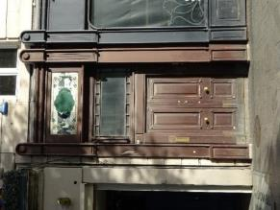 | 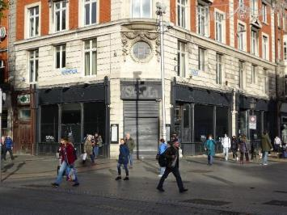
Fig.2: Entrance door to north end of O’Connell Street Upper façade. | Fig.3: Shopfront.

RPS No. 6020 – Parnell Monument O'Connell Street Upper, Dublin 1
Seandálaíocht, Caomhantas & Oidhreacht
An Roinn Pleanála & Forbairt Maoine
Oifigí na Cathrach, An Ché Adhmaid, Baile Átha Cliath 8

Archaeology, Conservation & Heritage Section
Planning & Property Development Department
Block 3, Floor 3, Civic Offices, Wood Quay, Dublin 8

Tel: (01) 222 3926, 222 3927
Email: conservation@dublincity.ie

12th November 2021

Draft Development Plan 2022-2028

Ref: RPS 6020 AMENDMENT of the Record of Protected Structures

_______________________________________________________________________________

Recommendation:
Amendment of current entry for O'Connell Street Upper, Dublin 1 – Parnell Monument and Four cast-iron bollards adjoining Parnell Monument on O’Connell Street mall, to now read: O'Connell Street Upper, Dublin 1 – Parnell Monument.
_______________________________________________________________________________

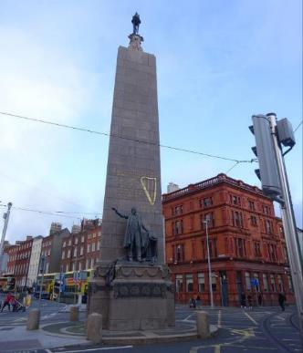

Introduction
There has been a query about whether the RPS entry O'Connell Street Upper, Dublin 1 – Parnell Monument and Four cast-iron bollards adjoining Parnell Monument on O’Connell Street mall should be amended to O'Connell Street Upper, Dublin 1 – Parnell Monument. The four cast-iron bollards were removed to facilitate the construction of the LUAS tracks at this location, as they lay directly in its route. They were reinstated in 2017 to a new location further south along O’Connell Street, just to the north of the Spire, opposite the junction with Cathedral Street.

Existing Listing
RPS Ref No | Address | Description
6020 | O'Connell Street Upper, Dublin 1 | Parnell Monument and Four cast-iron bollards adjoining Parnell Monument on O’Connell Street mall

Proposed Listing
Amend the description to include the extent of the eighteenth-century structure.
RPS Ref No | Address | Description
6020 | O'Connell Street Upper, Dublin 1 | Parnell Monument

Request for Investigation
Conservation Section, Dublin City Council

Location and Land Use Zoning
The location of the Parnell Monument, O’Connell Street Upper is arrowed red below. The Monument is located within the O’Connell Street Architectural Conservation Area and within a re-hatched Conservation Area.
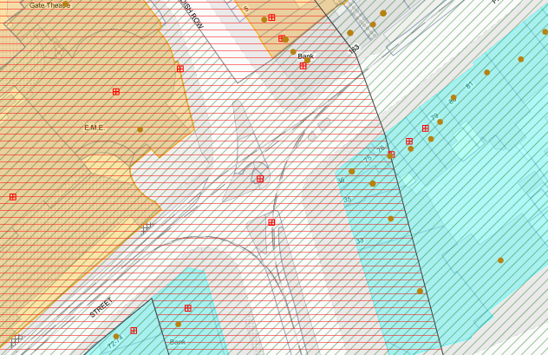
Fig 1: Location and Land Use Zoning

Recent Planning History
There are no recent planning applications on file for the site.

Recent Enforcement History
There is no recent enforcement history on the site.

Summary Description
(See images at end of report)
Description based on National Inventory of Architecture’s record for site, Ref. 50010557.
Freestanding granite obelisk and bronze statue of Charles Stewart Parnell, made 1899-1911, dated 1906, unveiled 1911, designed in neo-Classical Revival style by sculptor Augustus Saint-Gaudens with assistance of architects Henry Bacon and George Sheridan. Located at north end of O’Connell Street on cobbled island site. Polished granite ashlar block construction to tapering obelisk set on raised pedestal with applied bronze decoration and panels naming counties of Ireland and abutted to south by projecting granite pedestal with bronze decoration and lettering naming provinces. Above pedestal is continuous carved festoon with bucrania to corners. South projecting pedestal supports figurative bronze statue of Parnell against draped table and outstretched arm. South face of obelisk has incised gilt lettering extracted from speech by Parnell with gold harp: 'To Charles Stewart Parnell. No Man has a right to fix the boundary to the march of a nation. No man has a right to say to his country "Thus far shalt thou go and no further”. We have never attempted to fix the ne-plus-ultra to the progress of Ireland’s nationhood and we never shall'. 'Go Soirbhighidh Dia Éirer dá chlainn'. Obelisk surmounted by decorative cusped capital supporting bronze tripod and eternal bronze flame. Monument stands on round traffic island with interlocking granite kerbing and cobbles protected by squat domed granite bollards.

Assessment
The Parnell Monument was first protected on 7th January 1991 with the description Parnell Monument as a List 1 structure. The four cast-iron bollards located at the top of O’Connell Street were also first protected in 1991, as a separate entry on List 2. The Dublin City Development Plan 1999-2005 continued to have two separate entries for the structures. However, by the time of the Dublin City Development Plan 2005-2011, the two entries had been amalgamated. This has continued through subsequent development plans. There is no historic relationship between the cast-iron bollards and the Parnell Monument. The bollards were recorded under a separate entry by the NIAH (Ref 50010556), which described them as air vents, dating to c.1880 i.e. predating the Parnell Monument.

During the LUAS Cross City works, the bollards were removed from their location to facilitate the construction of the LUAS tracks, as they lay directly in its route. They were reinstated in 2017 to a new location further south along O’Connell Street, just to the north of the Spire, opposite the junction with Cathedral Street. Therefore, they are no longer in close proximity to the Parnell Monument and consequently their continued inclusion in the RPS entry for the monument is not warranted.

The RPS entry for Parnell Monument, O’Connell Street Upper is to be amended to remove the reference to the “Four cast-iron bollards adjoining Parnell Monument on O’Connell Street mall”. The bollards, which have been assigned a Regional rating by the NIAH and have a Ministerial Recommendation for inclusion on the RPS are to be added to the Record of Protected Structures as a separate entry. The Development Plan mapping will also be updated to reflect the change in location of the bollards.

References
- National Inventory of Architectural Heritage Reference 50010557
- National Inventory of Architectural Heritage Reference 50010556

Significance/NIAH Rating
The Parnell Monument, O’Connell Street Upper was recorded under Stage 1 of the NIAH for Dublin (Ref. 50010557) with Ministerial Recommendations for Stage 1 issued to Dublin City Council on 4th June 2014. The structure has been assigned a ‘National’ rating. These are structures or sites that make a significant contribution to the architectural heritage of Ireland. Structures which are considered of National significance are deemed worthy of inclusion on the RPS.

Assessment of Special Interest under the Planning and Development Act 2000
The National Inventory of Architectural Heritage assigned ARCHITECTURAL, ARTISTIC and HISTORICAL interest to the Parnell Monument. The Conservation Section has considered the opinion of the NIAH and is in agreement with assigning these categories of special interest to the site.

Conclusion & Recommendation
It is recommended that the RPS entry for the Parnell Monument, O’Connell Street Upper be amended as follows:

Proposed Listing
RPS Ref No | Address | Description
6020 | O'Connell Street Upper, Dublin 1 | Parnell Monument

12/11/2021
_______________ ________________
Paraic Fallon Date
Senior Planner

Photographic Record
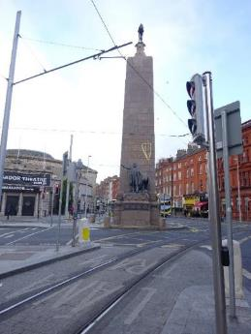 | 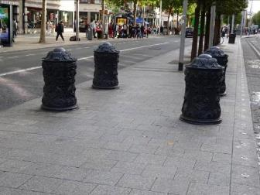
Fig. 2: Parnell Monument | Fig. 3: Cast-iron bollards relocated to O’Connell Street median

RPS No. 6021 – 37-38 O'Connell Street Upper, Dublin 1
Seandálaíocht, Caomhantas & Oidhreacht
An Roinn Pleanála & Forbairt Maoine
Oifigí na Cathrach, An Ché Adhmaid, Baile Átha Cliath 8

Archaeology, Conservation & Heritage Section
Planning & Property Development Department
Block 3, Floor 3, Civic Offices, Wood Quay, Dublin 8

Tel: (01) 222 3926, 222 3927
Email: conservation@dublincity.ie

12th November 2021

Draft Development Plan 2022-2028

Ref: RPS 6021 AMENDMENT to the Record of Protected Structures
_______________________________________________________________________________

Recommendation:
Amendment of current entry for 37-38 O’Connell Street Upper, Dublin 1 – Bank: upper floor façade, to now read: 37-38 O’Connell Street Upper, Dublin 1 – Bank extending protection to the entire structure to include its interior.
_______________________________________________________________________________

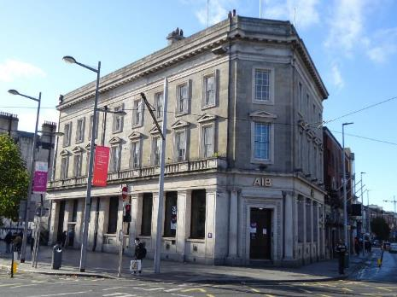

Introduction
Nos. 37-38 O’Connell Street Upper, Dublin 1 is on the current Record of Protected Structures (Dublin City Development Plan 2016-2022). The reference number is RPS: 6021 and the description reads ‘Bank: upper floor façade’. It is proposed to amend the description to read ‘Bank’ extending protection to the entire structure to include its interior.

Existing Listing:
RPS Ref No | Address | Description
6021 | 37-38 O’Connell Street Upper, Dublin 1 | Bank: upper floor façade

Proposed Listing: Amend description to read ‘Bank’ extending protection to the entire structure to include its interior.
RPS Ref No | Address | Description
6021 | 37-38 O’Connell Street Upper, Dublin 1 | Bank

Request for Investigation
Conservation Section, Dublin City Council

Location and Land Use Zoning
The location of 37-38 O’Connell Street Upper, Dublin 1 is indicated by the red arrow below. The zoning objective for the site is Zone 5: “To consolidate and facilitate the development of the central area, and to identify, reinforce, strengthen and protect its civic design character and dignity”. The property is located within the O’Connell Street Architectural Conservation Area and within a red hatched Conservation Area.

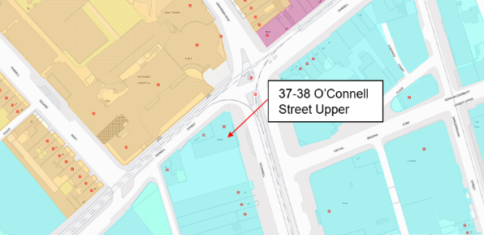
Fig. 1: Location and Land Use Zoning

Relevant Planning History
Planning Ref. | Description | Decision Date
0335/15 | EXPP: PROTECTED STRUCTURE: Proposed Mechanical Work  1. Remove existing redundant air conditioning equipment: Drawing M102 shows the existing air conditioning units and radiators; ACU13 to ACU19 are all located in the ground floor banking hall area.  2. Install new air conditioning units: M302 shows the proposed replacement air conditioning units - these are given new numbers on the drawing.  3. New wall mounted air conditioning units: ACU - 01 to 04 are 4 no. new wall mounted units within the teller area to replace 2 no. similar wall mounted units. All of these are outside the view of public areas except ACU03. Unlike the existing installation, all of the new units and associated pipework for these units are located on a modern partition wall. Pipework to these is to be enclosed in surface conduits or recessed into the modern partition wall.  4. New ceiling mounted air conditioning units: ACU05 & 06 are 2 no. ceiling mounted units to be located on top of the existing ATM room bunker in the banking hall and are to replace 3 no. similar units. There is to be a short length of duct from these units to a grille mounted in a low 'parapet' located on top of the existing modern joinery which conceals the ATM enclosure.  5. New ducted air condition unit: ACU07 is a new unit designed to serve an existing customer interview room and the banking hall area outside. The walls to this enclosure are modern partition walls. This unit and associated ductwork are to be concealed within the suspended ceiling. The unit is to supply cooled air into the banking hall through a new grille in the existing modern partition wall and will extract warm air via a grille in the interview room.  6. New floor mounted air conditioning unit: ACUO8 is a single floor mounted unit designed to replace an existing wall mounted unit. The existing unit is located at eye level behind the customer service desk and is more obvious than it should be. The new unit will be located below the level of the desk and further integrated into the background either by painting the factory casing of the unit or by use of a purpose-made joinery casing. | Grant Exemption Certificate  30 Oct 2015
4381/09 | PROTECTED STRUCTURE: This site forms part of a corner building at 37-38 O'Connell Street Upper and Parnell Street, Dublin 1. The development will consist of the existing 2no. automated teller machines, and the provision of 2 no. new disabled friendly automated teller machines, a stone clad disabled access ramp and stone clad steps to allow access for all, both with associated tactile paving. The new automated teller machines will be set in line with existing window reveals. All new stone work will match existing stonework. All proposed works are to the O'Connell Street facade. | REFUSE PERMISSION  21 Jun 2010
2140/00 | Alteration to front elevation at 37-38 Upper O'Connell Street, Dublin 1 to accommodate an additional automatic teller machine and sundry/ancillary works at ground floor in existing list 2 building. | GRANT PERMISSION  28 Aug 2000

Relevant Planning Enforcement History
Ref. No. | Opened | Reason | Closed | Reason
E0017/13 | 16-Jan-2013 | Roof Fence | 20-Apr-2016 | Minor Breach

Summary Description
(See images at end of report)
Description based on National Inventory of Architecture’s record for site, Ref. 50010558
Corner-sited three-storey neo-Classical bank, built 1921-2 and extended 1936, having eight-bay facade to O'Connell Street, chamfered corner entrance bay and four-bay facade to Parnell Street. Designed by Batchelor and Hicks. Flat roofs hidden behind stepped Portland stone ashlar parapet wall. Three profiled limestone chimneystacks with glazed clay pots. Two square-plan cast-iron downpipes on south end of O’Connell Street elevation with trefoil brackets. Coursed granite ashlar walls with Portland stone ashlar architrave, frieze and deep cornice spanning both elevations. Square-headed window openings with Portland stone architrave surrounds, pedimented to first floor, and original four-over-four pane timber sliding sash windows with margin lights. First floor windows to principal elevation open onto full-span Portland stone balcony with panelled balusters, moulded coping and resting on deep moulded cornice framing ground floor. Ground floor comprises series of hardwood framed single-pane display windows with Portland stone sills and stall risers with decorative bronze vents. Each window flanked by panelled Portland stone piers on granite plinth bases with fluted capital mouldings supporting plain stone fascia spanning entire building. Angled entrance bay, detailed as per above with square-headed door opening having decorative margent architrave surround, fluted lintel cornice and recessed double-leaf hardwood panelled doors opening onto two granite steps. Door opening flanked by Ionic columns on granite plinth blocks to re-entrant angles. Southernmost bay to principal elevation has square-headed door opening with original double-leaf hardwood panelled doors, side panels, fluted lintel cornice and overlight with margin lights, opening onto three granite steps. Further recessed square-headed door opening to north elevation with panelled architrave surround (as per window openings) with fluted lintel cornice and hardwood raised-and-fielded panelled door opening onto three granite steps with recessed overlight. No rear access.

Assessment
No. 37 O’Connell Street Upper, Dublin 1 was designed by the firm of Batchelor and Hicks and built by T. Crampton c. 1921-22. The building was sensitively extended to the south using identical details and materials by W. M. Mitchell and Sons and later by V. McGrane. The building represents part of the reconstruction of the O’Connell Street area following the devastation of 1916. The building was first protected under the Dublin City Development Plan, 1980 where they are described as ‘Commercial premises: upper floor facades’.

The interior of the bank was assessed as part of a survey of bank buildings in Dublin City commissioned by the Heritage Section of Dublin City Council. The interior of the banking hall is described in the accompanying publication as ‘eight bays long and widening from two bays at the entrance to four bays at the southern end. A coffered ceiling is supported on detached striated marble-clad piers and the non-fenestrated walls are also clad in Pazanozzi marble from floor to ceiling. The pier bases and capitals are bronze. Heavy mahogany doors hang in the marble clad walls. Counters beneath the window bays near the entrance are mahogany bench seat survives’ (O’Neill 2011).

The planning applications (Ref. 4381/09 and 2140/00) and Section 5 (Ref. 0335/15) relating to the structure indicate that no significant alterations to the ground plans or interior of the structure have taken place and it still retains a historic banking hall. As such, it is recommended that the description RPS Ref. 6016 for No. 37-38 O’Connell Street Upper, Dublin 1 is amended to read ‘Bank’ extending protection to the entire structure to include its interior.

References
- Casey, C. (2005). Dublin: The Buildings of Ireland. London: Yale University Press.
- National Inventory of Architectural Heritage (NIAH) Ref:50010558
- Planning file Ref. 2140/00, 4381/09, 0035/15.
- O’Neill, M. (2011). Bank Architecture: A History to c. 1940. Dublin: Dublin City Council.

Significance/NIAH Rating
No. 37-38 O’Connell Street Upper, Dublin 1 was recorded under Stage 1 of the NIAH for Dublin (Ref:50010558) with Ministerial Recommendations for Stage 1 issued to Dublin City Council on 4th June 2014. The structure was assigned a ‘Regional’ rating. These are structures or sites that make a significant contribution to the architectural heritage within their region or area. Structures which are considered of Regional significance are deemed worthy of inclusion on the RPS.

Assessment of Special Interest under the Planning and Development Act 2000
The National Inventory of Architectural Heritage assigned ARCHITECTURAL and ARTISTIC interest to No. 37-38 O’Connell Street Upper, Dublin 1. The Conservation Section has considered the opinion of the NIAH and is in agreement with assigning these categories of special interest to the property.

Conclusion & Recommendation
It is recommended that the RPS description for RPS ref: 6021 for No. 37-38 O’Connell Street Upper, Dublin 1 be amended to – ‘Bank’ extending protection to the entire structure to include its interior in accordance with Section 12(3) of the Planning and Development Act, 2000 (as amended).

Proposed Listing
Amend description to read ‘Bank’ extending protection to the entire structure to include its interior.

RPS Ref No | Address | Description
6021 | 37-38 O’Connell Street Upper, Dublin 1 | Bank

12/11/2021
_______________ ________________
Paraic Fallon
Senior Planner Date

Photograph of structure:
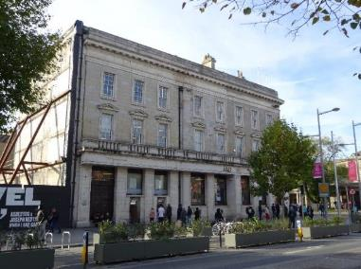
Fig.2: Eastern elevation to O’Connell Street Upper.

RPS No. 6023 - 43 O'Connell Street Upper, Dublin 1
Seandálaíocht, Caomhantas & Oidhreacht
An Roinn Pleanála & Forbairt Maoine
Oifigí na Cathrach, An Ché Adhmaid, Baile Átha Cliath 8

Archaeology, Conservation & Heritage Section
Planning & Property Development Department
Block 3, Floor 3, Civic Offices, Wood Quay, Dublin 8

Tel: (01) 222 3926, 222 3927
Email: conservation@dublincity.ie
11th November 2021

Draft Development Plan 2022-2028

Ref: RPS 6023 AMENDMENT to the Record of Protected Structures
_______________________________________________________________________________

Recommendation:
Amendment of current entry for 43 O’Connell Street Upper, Dublin 1 – Commercial premises: upper floor façade, to now read: 43 O’Connell Street Upper, Dublin 1 – Commercial premises: façade only.
_______________________________________________________________________________

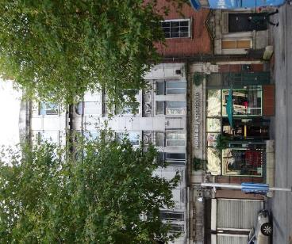

Introduction
No. 43 O’Connell Street Upper, Dublin 1 is on the current Record of Protected Structures (Dublin City Development Plan 2016-2022). The reference number is RPS. 6023 and the description reads ‘Commercial premises: upper floor façade’. It is proposed to amend the description to read ‘Commercial premises: façade only’ to provide protection to surviving historic shop front.

Existing Listing:
RPS Ref No | Address | Description
6023 | 43 O’Connell Street Upper, Dublin 1 | Commercial premises: upper floor façade

Proposed Listing: Amend description to read ‘Commercial premises: façade only’.
RPS Ref No | Address | Description
6023 | 43 O’Connell Street Upper, Dublin 1 | Commercial premises: façade only

Request for Investigation
Conservation Section, Dublin City Council

Location and Land Use Zoning
The location of 43 O’Connell Street Upper, Dublin 1 is indicated by the red arrow below. The zoning objective for the site is Z5: “To consolidate and facilitate the development of the central area, and to identify, reinforce, strengthen and protect its civic design character and dignity”. The property is located within the O’Connell Street Architectural Conservation Area and within a red hatch conservation area.

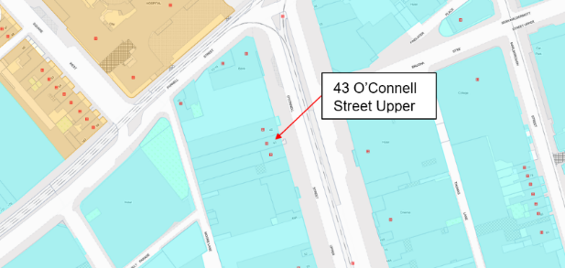
Fig. 1: Location and Land Use Zoning

Relevant Planning History
Planning Ref. | Description | Decision Date
2479/08 | PROTECTED STRUCTURE - 7 year permission for development at an overall site of c 2.17 hectares, at nos 40-41, 42 (a protected structure), 43 (a protected structure), 44 (a protected structure), 45-51, 52-54 (protected structures), 55-56, 57 (a protected structure), 58 (a protected structure), 59, 60 (a protected structure) and 61 (a protected structure) and 60a (otherwise 5 Henry Place) O'Connell Street Upper, Nos 37-41a Henry Street, nos 1-13, 14-17 (protected structures and a national monument) and 18-25 Moore Street, nos 71 and 71a Parnell Street, nos 1-8 O'Rahilly Parade, nos 1-15 Moore Lane, Nos 4-13 (including 3 Moore Lane) and 15-18 Henry Place, nos 6-8 at the junction of Henry Place and Moore Lane and including Clarkes Court off Moore Street, Moore Place off Henry Place, Murphys Court off Moore Lane, part of Moore Lane from the junction of Henry Place and Moore Lane to the junction of Moore Lane and O'Rahilly Parade and part of Henry Place from the junction of Moore Street and Henry Place to the rear of no. 61 O'Connell Street Upper (a protected structure), Dublin 1. The site consists of the majority of a city block bounded by Parnell Street, Moore Lane, O'Rahilly Parade, Moore Street, Henry Street, Henry Place and O'Connell Street Upper, but for the avoidance of doubt excludes nos 70 & 72-75 Parnell St, Nos 37-39 & 62-69 O'Connell St Upper, Nos 31-36 Henry St & Nos 1-3 Henry Place, Dublin 1. Works to protected structures to include the following: the facade of no. 43 O'Connell Street to be retained and integrated into the proposed elevation, facade to be cleaned and repaired, windows and doorways to be removed, repaired and reinstated, all other elements to be demolished new shopfront to be provided over retained stone plinth. | GRANT PERMISSION  15 Dec 2008
2479/08X1 | EXT OF DURATION: PROTECTED STRUCTURE - 7 year permission for development at an overall site of c 2.17 hectares, at nos 40-41, 42 (a protected structure), 43 (a protected structure), 44 (a protected structure), 45-51, 52-54 (protected structures), 55-56, 57 (a protected structure), 58 (a protected structure), 59, 60 (a protected structure) and 61 (a protected structure) and 60a (otherwise 5 Henry Place) O'Connell Street Upper, Nos 37-41a Henry Street, nos 1-13, 14-17 (protected structures and a national monument) and 18-25 Moore Street, nos 71 and 71a Parnell Street, nos 1-8 O'Rahilly Parade, nos 1-15 Moore Lane, Nos 4-13 (including 3 Moore Lane) and 15-18 Henry Place, nos 6-8 at the junction of Henry Place and Moore Lane and including Clarkes Court off Moore Street, Moore Place off Henry Place, Murphys Court off Moore Lane, part of Moore Lane from the junction of Henry Place and Moore Lane to the junction of Moore Lane and O'Rahilly Parade and part of Henry Place from the junction of Moore Street and Henry Place to the rear of no. 61 O'Connell Street Upper (a protected structure), Dublin 1. The site consists of the majority of a city block bounded by Parnell Street, Moore Lane, O'Rahilly Parade, Moore Street, Henry Street, Henry Place and O'Connell Street Upper, but for the avoidance of doubt excludes nos 70 & 72-75 Parnell St, Nos 37-39 & 62-69 O'Connell St Upper, Nos 31-36 Henry St & Nos 1-3 Henry Place, Dublin 1. | GRANT EXT. OF DURATION OF PERMISSION  21 Jul 2016
4380/03 | Planning Permission is sought for a new shop front, new signage, lighting and alterations to existing external ground to basement stairs fronting the building, to Ned Kellys, 43 O'Connell Street, Dublin 1, a PROTECTED STRUCTURE, on behalf of Southwell Investment co. Ltd. | GRANT PERMISSION  31 Oct 2003

Relevant Planning Enforcement History
Ref. No. | Opened | Reason | Closed | Reason
E1036/17 | 08-Sep-2017 | Advertising boards on private landing | 03-Oct-2017 | Removed

Summary Description
(See images at end of report)
Description based on National Inventory of Architecture’s record for site, Ref. 50010553
Terraced two-bay five-storey building over partially exposed basement, dated 1925, with shopfront to ground floor having recent fittings. Now in use as public house with two-storey brick building fronting onto Moore Lane. Flat roof hidden behind Portland stone parapet wall with shallow pediment inscribed 'AD 1925' and deep moulded parapet cornice. Red brick chimneystacks to both party walls. Coursed Portland stone ashlar walls with three pilasters rising from shopfront to parapet interrupted by deep moulded cornice with mutules and frieze over third floor. Outer pilasters have Ionic capitals with lions' heads and foliate mouldings below cornice. Paired window openings throughout, square-headed to first, second and fourth floors, round-headed to third floor with replacement windows throughout. Fourth floor windows have apron panels, continuous impost moulding and keystones. Third floor openings have archivolt mouldings, continuous impost moulding, shared sills and apron panels. First and second floor openings have shared sills, shared string courses to heads and festoon mouldings to second floor aprons. Shopfront has polished granite plinth flanked by polished granite pilasters with bronze straps and Portland stone Ionic capitals with lions' heads and Portland stone fascia. Door opening to north bay has flat-panelled timber door with pedimented lintel panel and festoon moulding with leaded Art Nouveau overlight, providing access to upper floors. To south end of shopfront is railed basement area with iron railings and corner posts on granite plinth wall and steel steps.

Assessment
No. 43 O’Connell Street Upper, Dublin 1 was designed by the firm of Batchelor and Hicks and built in 1925. The building represents part of the reconstruction of the O’Connell Street area following the devastation of 1916. The building were first protected under the Draft Dublin City Development Plan, 1987 where they are described as ‘Commercial premises: upper floor facades’.

While planning permission was granted for a new shopfront in 2003 (Planning ref. 4380/03) recent assessment indicates that the majority of the historic shopfront including the polished granite plinth and pilasters and Portland stone capitals and fascia survive along with the square-headed opening with timber door with leaded overlight, providing access to the upper floors and the railed basement area. As such, it is recommended that the description RPS Ref. 6023 for No. 43 O’Connell Street Upper, Dublin 1 is amended to read ‘Commercial premises: façade only’.

References
- Casey, C. (2005). Dublin: The Buildings of Ireland. London: Yale University Press.
- National Inventory of Architectural Heritage (NIAH) Ref:50010553
- Planning file Ref. 2479/08, 2479/08X1, 4380/03

Significance/NIAH Rating
No. 43 O’Connell Street Upper, Dublin 1 was recorded under Stage 1 of the NIAH for Dublin (Ref. 50010553) with Ministerial Recommendations for Stage 1 issued to Dublin City Council on 4th June 2014. The structure was assigned a ‘Regional’ rating. These are structures or sites that make a significant contribution to the architectural heritage within their region or area. Structures which are considered of Regional significance are deemed worthy of inclusion on the RPS.

Assessment of Special Interest under the Planning and Development Act 2000
The National Inventory of Architectural Heritage assigned ARCHITECTURAL and ARTISTIC interest to No. 43 O’Connell Street Upper, Dublin 1. The Conservation Section has considered the opinion of the NIAH and is in agreement with assigning these categories of special interest to the property.

Conclusion & Recommendation
It is recommended that the RPS description for RPS ref: 6023 for No. 43 O’Connell Street Upper, Dublin 1 be amended to – ‘Commercial premises: façade only’ in accordance with Section 12(3) of the Planning and Development Act, 2000 (as amended).

Proposed Listing
RPS Ref No | Address | Description
6023 | 43 O’Connell Street Upper, Dublin 1 | Commercial premises: façade only

12/11/2021
_______________ ________________
Paraic Fallon
Senior Planner Date

Photograph of Structure:
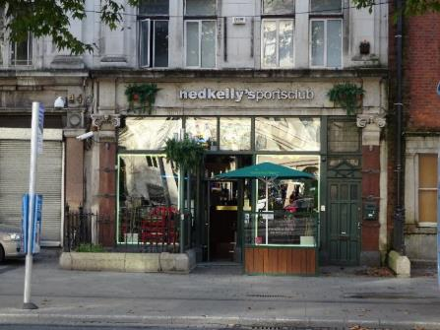
Fig.2: Shopfront, No. 43 O’Connell Street Upper

RPS No. 6024 - 44 O'Connell Street Upper, Dublin 1
Seandálaíocht, Caomhantas & Oidhreacht
An Roinn Pleanála & Forbairt Maoine
Oifigí na Cathrach, An Ché Adhmaid, Baile Átha Cliath 8

Archaeology, Conservation & Heritage Section
Planning & Property Development Department
Block 3, Floor 3, Civic Offices, Wood Quay, Dublin 8

Tel: (01) 222 3926, 222 3927
Email: conservation@dublincity.ie

12th November 2021

Draft Development Plan 2022-2028

Ref: RPS 6024 AMENDMENT to the Record of Protected Structures
_______________________________________________________________________________

Recommendation:
Amendment of current entry for 44 O’Connell Street Upper, Dublin 1 – Commercial premises: upper floor façade, to now read: 44 O’Connell Street Upper, Dublin 1 – Commercial premises: façade only.
_______________________________________________________________________________

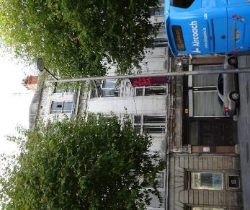

Introduction
No. 44 O’Connell Street Upper, Dublin 1 is on the current Record of Protected Structures (Dublin City Development Plan 2016-2022). The reference number is RPS 6024 and the description reads ‘Commercial premises: upper floor façade’. It is proposed to amend the description to read ‘Commercial premises: façade only’. This will ensure surviving historic detail to the ground floor is protected.

Existing Listing:
RPS Ref No | Address | Description
6024 | 44 O’Connell Street Upper, Dublin 1 | Commercial premises: upper floor façade

Proposed Listing: Amend description to read ‘Commercial premises: façade only’.
RPS Ref No | Address | Description
6024 | 44 O’Connell Street Upper, Dublin 1 | Commercial premises: façade only

Request for Investigation
Conservation Section, Dublin City Council

Location and Land Use Zoning
The location of 44 O’Connell Street Upper, Dublin 1 is indicated by the red arrow below. The zoning objective for the site is Z5: “To consolidate and facilitate the development of the central area, and to identify, reinforce, strengthen and protect its civic design character and dignity”. The property is located within the O’Connell Street Architectural Conservation Area and is also located within a red hatched Conservation Area.

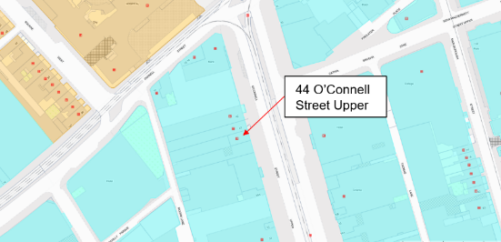
Fig. 1: Location and Land Use Zoning

Relevant Planning History
Planning Ref. | Description | Decision Date
2479/08 | PROTECTED STRUCTURE - 7 year permission for development at an overall site of c 2.17 hectares, at nos 40-41, 42 (a protected structure), 43 (a protected structure), 44 (a protected structure), 45-51, 52-54 (protected structures), 55-56, 57 (a protected structure), 58 (a protected structure), 59, 60 (a protected structure) and 61 (a protected structure) and 60a (otherwise 5 Henry Place) O'Connell Street Upper, Nos 37-41a Henry Street, nos 1-13, 14-17 (protected structures and a national monument) and 18-25 Moore Street, nos 71 and 71a Parnell Street, nos 1-8 O'Rahilly Parade, nos 1-15 Moore Lane, Nos 4-13 (including 3 Moore Lane) and 15-18 Henry Place, nos 6-8 at the junction of Henry Place and Moore Lane and including Clarkes Court off Moore Street, Moore Place off Henry Place, Murphys Court off Moore Lane, part of Moore Lane from the junction of Henry Place and Moore Lane to the junction of Moore Lane and O'Rahilly Parade and part of Henry Place from the junction of Moore Street and Henry Place to the rear of no. 61 O'Connell Street Upper (a protected structure), Dublin 1. The site consists of the majority of a city block bounded by Parnell Street, Moore Lane, O'Rahilly Parade, Moore Street, Henry Street, Henry Place and O'Connell Street Upper, but for the avoidance of doubt excludes nos 70 & 72-75 Parnell St, Nos 37-39 & 62-69 O'Connell St Upper, Nos 31-36 Henry St & Nos 1-3 Henry Place, Dublin 1.  Works to protected structures to include the following: the facade of no. 44 O'Connell Street Upper to be retained and integrated into the proposed elevation, facade to be cleaned repaired, windows and door to be removed, repaired and reinstated, all other elements to be demolished, new shopfront to be provided within existing opes. | GRANT PERMISSION  15 Dec 2008
2479/08X1 | EXT OF DURATION: PROTECTED STRUCTURE - 7 year permission for development at an overall site of c 2.17 hectares, at nos 40-41, 42 (a protected structure), 43 (a protected structure), 44 (a protected structure), 45-51, 52-54 (protected structures), 55-56, 57 (a protected structure), 58 (a protected structure), 59, 60 (a protected structure) and 61 (a protected structure) and 60a (otherwise 5 Henry Place) O'Connell Street Upper, Nos 37-41a Henry Street, nos 1-13, 14-17 (protected structures and a national monument) and 18-25 Moore Street, nos 71 and 71a Parnell Street, nos 1-8 O'Rahilly Parade, nos 1-15 Moore Lane, Nos 4-13 (including 3 Moore Lane) and 15-18 Henry Place, nos 6-8 at the junction of Henry Place and Moore Lane and including Clarkes Court off Moore Street, Moore Place off Henry Place, Murphys Court off Moore Lane, part of Moore Lane from the junction of Henry Place and Moore Lane to the junction of Moore Lane and O'Rahilly Parade and part of Henry Place from the junction of Moore Street and Henry Place to the rear of no. 61 O'Connell Street Upper (a protected structure), Dublin 1. The site consists of the majority of a city block bounded by Parnell Street, Moore Lane, O'Rahilly Parade, Moore Street, Henry Street, Henry Place and O'Connell Street Upper, but for the avoidance of doubt excludes nos 70 & 72-75 Parnell St, Nos 37-39 & 62-69 O'Connell St Upper, Nos 31-36 Henry St & Nos 1-3 Henry Place, Dublin 1. | GRANT EXT. OF DURATION OF PERMISSION  21 Jul 2016
1447/97 | The Department of Justice hereby give notice of their intention to install a Closed Circuit Television Camera System at Garda Office, 44 Upper O'Connell Street, Dublin 1. The site plan showing the location of the CCTV system together with general arrangement drawings and a description of the proposed works are available for inspection at the Department of Justice, 72-76 St. Stephen's Green, Dublin 2 and at the Garda Siochana Office, O'Connell St, Dublin 1 from 9.30 a.m. to 1.00 p.m. and 2.00 p.m. to 5.00 p.m. Monday to Friday for a period of 1 month from the date of this notice. Submissions and/or observations with respect to the proposed development, dealing with the proper planning and development of the area, may be made in writing to The Secretary, Department of Justice, 72-76 St. Stephen's Green, Dublin 2 during the 6 week period commencing 11 June 1997 and ending on 22 July 1997. | OBSERVATIONS  21 Jul 1997

Relevant Planning Enforcement History
There is no enforcement history for the site.

Summary Description
(See images at end of report)
Description based on National Inventory of Architecture’s record for site, Ref. 50010552
Terraced two-bay four-storey former wine and spirit merchants, built c.1925, now in use as Garda station, with original shopfront to ground floor having recent inserted fittings. Site heavily developed to rear. Flat roof having stepped red brick chimneystacks with clay pots, shared with adjoining buildings, concealed behind cement parapet with small central pediment. Portland stone walls to front (east) elevation over limestone plinth, having engaged pilasters to third floor with triglyph and guttae capitals flanking band of key pattern ornamentation. Substantial granite cornice forming sill course to third floor over Doric frieze with round medallions between triglyphs, flanked by squared panels, supported by Portland stone pilasters with acanthus and lotus leaf capitals, on plinths flanking first and second floors. Limestone and pink granite walling to ground floor with cornice forming sill course to first floor. Square-headed window openings with moulded Portland stone reveals and sills to first and second floors. Original quadripartite iron-framed windows with Portland stone mullions, moulded lintel to first floor windows, panelled aprons to second floor windows and shared moulded architraves surrounding first and second floor windows of each bay. Original twelve-over-twelve pane timber sliding sash windows to three-bay third floor with moulded architraves. Shopfront comprising Doric timber piers, flanked by pink granite pilasters on limestone plinths with square panels over having round medallions, supporting plain frieze and with modillion cornice. Square-headed door opening to southern bay housing original timber panelled double-leaf door with brass door studs set to timber surrounds with decorative carved lintel and obscured glass transom over surmounted by louvered vent.

Assessment
No. 44 O’Connell Street Upper, Dublin 1 was designed by George Luke O’Connor ‘on modern lines with cut-stone front’ for Adam Scott and Co. and built c. 1925. The building represents part of the reconstruction of the O’Connell Street area following the devastation of 1916. The building was first protected under the Draft Dublin City Development Plan, 1987 where it is described as ‘Commercial premises: upper floor facades’. However the historic shopfront survives relatively intact to the ground floor retaining polished granite pilasters supporting a limestone frieze and modillion cornice; and a large square-headed opening with timber panelled double-lead door with plain glass overlight. As such, it is recommended that the description RPS Ref. 6024 for No. 44 O’Connell Street Upper, Dublin 1 is amended to read ‘Commercial premises: façade only’.

References
- Casey, C. (2005). Dublin: The Buildings of Ireland. London: Yale University Press.
- National Inventory of Architectural Heritage (NIAH) Ref. 50010552
- Planning file Ref. 2479/08, 2479/08X1, 1447/97.
- Dictionary of Irish Architects (https://www.dia.ie/works/view/37465/CO.+DUBLIN%2C+DUBLIN%2C+O%27CONNELL+STREET+UPPER%2C+NO.+044+%28ADAM+SCOTT+%26+CO.%29)

Significance/NIAH Rating
No. 44 O’Connell Street Upper, Dublin 1 was recorded under Stage 1 of the NIAH for Dublin (Ref. 50010552) with Ministerial Recommendations for Stage 1 issued to Dublin City Council on 4th June 2014. The structure was assigned a ‘Regional’ rating. These are structures or sites that make a significant contribution to the architectural heritage within their region or area. Structures which are considered of Regional significance are deemed worthy of inclusion on the RPS.

Assessment of Special Interest under the Planning and Development Act 2000
The National Inventory of Architectural Heritage assigned ARCHITECTURAL and ARTISTIC interest to No. 44 O’Connell Street Upper, Dublin 1. The Conservation Section has considered the opinion of the NIAH and is in agreement with assigning these categories of special interest to the property.

Conclusion & Recommendation
It is recommended that the RPS description for RPS ref: 6024 for No. 44 O’Connell Street Upper, Dublin 1 be amended to – ‘Commercial premises: façade only’ in accordance with Section 12(3) of the Planning and Development Act, 2000 (as amended).

Proposed Listing
RPS Ref No | Address | Description
6024 | 44 O’Connell Street Upper, Dublin 1 | Commercial premises: façade only

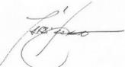 12/11/2021
_______________ ________________
Paraic Fallon
Senior Planner Date

Photograph:
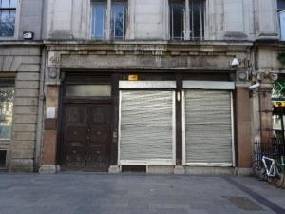
Fig. 2: Shopfront, 44 O’Connell Street Upper.

RPS No. 6026 - 57 O'Connell Street Upper, Dublin 1
Seandálaíocht, Caomhantas & Oidhreacht
An Roinn Pleanála & Forbairt Maoine
Oifigí na Cathrach, An Ché Adhmaid, Baile Átha Cliath 8

Archaeology, Conservation & Heritage Section
Planning & Property Development Department
Block 3, Floor 3, Civic Offices, Wood Quay, Dublin 8

Tel: (01) 222 3926, 222 3927
Email: conservation@dublincity.ie

15th November 2021

Draft Development Plan 2022-2028

Ref: RPS 6026 AMENDMENT to the Record of Protected Structures
_______________________________________________________________________________

Recommendation:
Amendment of current entry for 57 O’Connell Street Upper, Dublin 1 – Commercial premises: upper floor façade, to now read: 57 O’Connell Street Upper, Dublin 1 – Commercial premises: front façade, extending protection to the entire façade.
_______________________________________________________________________________

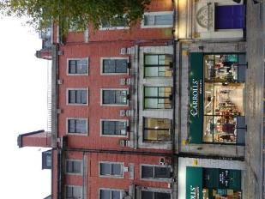

Introduction
No. 57 O’Connell Street Upper, Dublin 1 is on the current Record of Protected Structures (Dublin City Development Plan 2016-2022). The reference number is RPS 6026 and the description reads ‘Commercial premises: upper floor façade’. It is proposed to amend the description to read ‘Commercial premises: front façade.

Existing Listing:
RPS Ref No | Address | Description
6026 | 57 O’Connell Street Upper, Dublin 1 | Commercial premises: upper floor façade

Proposed Listing: Amend description to read ‘Commercial premises: front façade’.
RPS Ref No | Address | Description
6026 | 57 O’Connell Street Upper, Dublin 1 | Commercial premises: front façade

Request for Investigation
Conservation Section, Dublin City Council

Location and Land Use Zoning
The location of 57 O’Connell Street Upper, Dublin 1 is indicated by the red arrow below. The zoning objective for the property is Z5: “To consolidate and facilitate the development of the central area, and to identify, reinforce, strengthen and protect its civic design character and dignity”. The property is also located within the O’Connell Street Architectural Conservation Area (ACA) and within a red hatched conservation area.

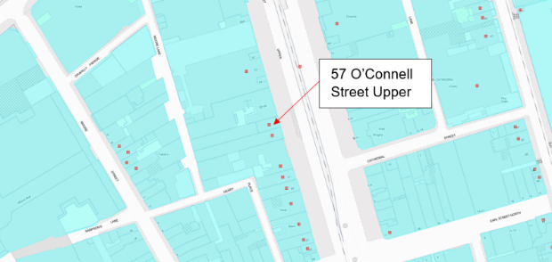
Fig. 1: Location and Land Use Zoning

Relevant Planning History
Planning Ref. | Description | Decision Date
2479/08 | PROTECTED STRUCTURE - 7 year permission for development at an overall site of c 2.17 hectares, at nos 40-41, 42 (a protected structure), 43 (a protected structure), 44 (a protected structure), 45-51, 52-54 (protected structures), 55-56, 57 (a protected structure), 58 (a protected structure), 59, 60 (a protected structure) and 61 (a protected structure) and 60a (otherwise 5 Henry Place) O'Connell Street Upper, Nos 37-41a Henry Street, nos 1-13, 14-17 (protected structures and a national monument) and 18-25 Moore Street, nos 71 and 71a Parnell Street, nos 1-8 O'Rahilly Parade, nos 1-15 Moore Lane, Nos 4-13 (including 3 Moore Lane) and 15-18 Henry Place, nos 6-8 at the junction of Henry Place and Moore Lane and including Clarkes Court off Moore Street, Moore Place off Henry Place, Murphys Court off Moore Lane, part of Moore Lane from the junction of Henry Place and Moore Lane to the junction of Moore Lane and O'Rahilly Parade and part of Henry Place from the junction of Moore Street and Henry Place to the rear of no. 61 O'Connell Street Upper (a protected structure), Dublin 1. The site consists of the majority of a city block bounded by Parnell Street, Moore Lane, O'Rahilly Parade, Moore Street, Henry Street, Henry Place and O'Connell Street Upper, but for the avoidance of doubt excludes nos 70 & 72-75 Parnell St, Nos 37-39 & 62-69 O'Connell St Upper, Nos 31-36 Henry St & Nos 1-3 Henry Place, Dublin 1.  Works to protected structures to include the following: facade of no. 57 O'Connell Street Upper to be retained and integrated into the proposed elevation, facade to be cleaned and repaired windows to be removed, repaired and reinstated, new shopfront to be provided, all other elements to be demolished. | GRANT PERMISSION  15 Dec 2008
2479/08X1 | EXT OF DURATION: PROTECTED STRUCTURE - 7 year permission for development at an overall site of c 2.17 hectares, at nos 40-41, 42 (a protected structure), 43 (a protected structure), 44 (a protected structure), 45-51, 52-54 (protected structures), 55-56, 57 (a protected structure), 58 (a protected structure), 59, 60 (a protected structure) and 61 (a protected structure) and 60a (otherwise 5 Henry Place) O'Connell Street Upper, Nos 37-41a Henry Street, nos 1-13, 14-17 (protected structures and a national monument) and 18-25 Moore Street, nos 71 and 71a Parnell Street, nos 1-8 O'Rahilly Parade, nos 1-15 Moore Lane, Nos 4-13 (including 3 Moore Lane) and 15-18 Henry Place, nos 6-8 at the junction of Henry Place and Moore Lane and including Clarkes Court off Moore Street, Moore Place off Henry Place, Murphys Court off Moore Lane, part of Moore Lane from the junction of Henry Place and Moore Lane to the junction of Moore Lane and O'Rahilly Parade and part of Henry Place from the junction of Moore Street and Henry Place to the rear of no. 61 O'Connell Street Upper (a protected structure), Dublin 1. The site consists of the majority of a city block bounded by Parnell Street, Moore Lane, O'Rahilly Parade, Moore Street, Henry Street, Henry Place and O'Connell Street Upper, but for the avoidance of doubt excludes nos 70 & 72-75 Parnell St, Nos 37-39 & 62-69 O'Connell St Upper, Nos 31-36 Henry St & Nos 1-3 Henry Place, Dublin 1. | GRANT EXT. OF DURATION OF PERMISSION  21 Jul 2016
1355/98 | The Project includes two floors of car-parking below basement level (capacity 720 cars); four floors of mixed Retail and Leisure uses (approx. 40,000 sq.m. gross floor area) and comprising of Department Stores, retail units, restaurants, bars, family entertainment centre and tourist information. Also, on the upper level there are 15 multi- purpose auditoriums for cinema, conference and theatre uses. There is also a 61 bedroom hotel with associated function rooms at 46/49 Upper O'Connell Street which is presently occupied by Fingal County Council. The proposal involves building under, on and over part of Moore Lane. The listed facades of Nos. 57, 58 and Nos.52/54 Upper O'Connell Street are being retained as part of the development. | GRANT PERMISSION  23 Oct 1998  ABP PL29N.109229  GRANT PERMISSION
1355/98/x1 | Extension of Duration - The Project includes two floors of car-parking below | REFUSE EXT. OF DURATION OF PERMISSION  20 Sep 2004

Relevant Planning Enforcement History
Ref. No. | Opened | Reason | Closed | Reason
E1035/17 | 08-Sep-2017 | Advertising boards on private landing | 08-Feb-2018 | Removed
E0698/10 | 25-Aug-2010 | Erection of unauthorised free-standing displays, sandwich boards, etc | N/A | N/A
E1086/06 | 12-Oct-2006 | Alleged that loudspeakers have been erected to front façade | N/A | N/A
E0375/04 | 25-May-2004 | Shop front | 22-Jun-2006 | Lack of evidence

Summary Description
(See images at end of report)
Description based on National Inventory of Architecture’s record for site, Ref. 50010541
Terraced three-bay four-storey commercial building, built c.1925, with shopfront to ground floor. Flat roof with brick chimneystack to north party wall behind granite ashlar parapet wall and iron railing supported on granite blocks with guttae. Red brick walls laid in English garden wall bond. Square-headed window openings with plain granite architrave surrounds, granite sills and original timber sliding sash windows, three-over-six pane to third floor and six-over-six to second floor. Three square-headed window openings to first floor with advanced granite ashlar surround comprising chamfered jambs supporting plain architrave and blocking course with four decorative granite brackets framing second floor windows. Paired one-over-one pane timber sliding sash windows to first floor. Recent shopfront set in original granite ashlar frame with plinth mouldings and continuous panel moulding with incised lettering 'A. & R. THWAITES & Co. Limited'. Plain granite frieze and cornice to first floor sill level. Structure extended to rear.

Assessment
No. 57 O’Connell Street Upper, Dublin 1 was designed by Adam Millar c. 1922 and built between 1924 and 1926 in ‘a modern classical style’. Carving to the façade by Albert George Power. The building represents part of the reconstruction of the O’Connell Street area following the devastation of 1916. The building was first protected under the Draft Dublin City Development Plan, 1980 where it was described as ‘Commercial premises: upper floor facades’. However, recent assessment indicates that the majority of the historic shopfront including the ashlar granite plinth and pilasters supporting a carved granite fascia commemorating A. W. Thwaites & Co., a firm of Irish Mineral Water manufacturers, survives. As such, it is recommended that the description for RPS Ref. 6026 No. 57 O’Connell Street Upper, Dublin 1 is amended to read ‘Commercial premises: front façade’.

References
- Casey, C. (2005). Dublin: The Buildings of Ireland. London: Yale University Press.
- National Inventory of Architectural Heritage (NIAH) Ref:50010541
- Planning file Ref. 2479/08, 2479/08X1, 1355/98, 1355/98X1.
- Dictionary of Irish Architects (https://www.dia.ie/works/view/37477/building/CO.+DUBLIN%2C+DUBLIN%2C+O%27CONNELL+STREET+UPPER%2C+NO.+057+%28A.%26+W.+THWAITES%29).

Significance/NIAH Rating
No. 57 O’Connell Street Upper, Dublin 1 was recorded under Stage 1 of the NIAH for Dublin (Ref. 50010541) with Ministerial Recommendations for Stage 1 issued to Dublin City Council on 4th June 2014. The structure was assigned a ‘Regional’ rating. These are structures or sites that make a significant contribution to the architectural heritage within their region or area. Structures which are considered of Regional significance are deemed worthy of inclusion on the RPS.

Assessment of Special Interest under the Planning and Development Act 2000
The National Inventory of Architectural Heritage assigned ARCHITECTURAL and ARTISTIC interest to No. 57 O’Connell Street Upper, Dublin 1. The Conservation Section has considered the opinion of the NIAH and is in agreement with assigning these categories of special interest to the property.

Conclusion & Recommendation
It is recommended that the RPS description for RPS ref: 6026 for No. 57 O’Connell Street Upper, Dublin 1 be amended to – ‘Commercial premises: front façade’ in accordance with Section 12(3) of the Planning and Development Act, 2000 (as amended); thereby extending protection to the entire façade.

Proposed Listing
RPS Ref No | Address | Description
6026 | 57 O’Connell Street Upper, Dublin 1 | Commercial premises: front façade

15/11/2021
_______________ ________________
Paraic Fallon Date
Senior Planner

Photograph of Structure:
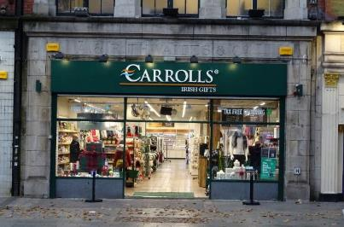
Fig. 2: Shopfront, 57 O’Connell Street Upper.

RPS No. 6027 - 58 O'Connell Street Upper, Dublin 1
Seandálaíocht, Caomhantas & Oidhreacht
An Roinn Pleanála & Forbairt Maoine
Oifigí na Cathrach, An Ché Adhmaid, Baile Átha Cliath 8

Archaeology, Conservation & Heritage Section
Planning & Property Development Department
Block 3, Floor 3, Civic Offices, Wood Quay, Dublin 8

Tel: (01) 222 3926, 222 3927
Email: conservation@dublincity.ie

1st November 2021

Draft Development Plan 2022-2028

Ref: RPS 6027 AMENDMENT to the Record of Protected Structures
_______________________________________________________________________________

Recommendation:
Amendment of current entry for 58 O’Connell Street Upper, Dublin 1 – Commercial premises: upper floor façade, to now read: 58 O’Connell Street Upper, Dublin 1 – Commercial premises: front façade.
_______________________________________________________________________________

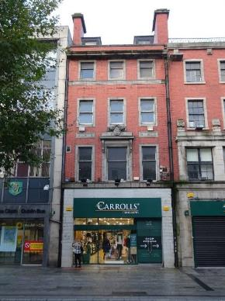

Introduction
No.58 O’Connell Street Upper, Dublin 1 is on the current Record of Protected Structures (Dublin City Development Plan 2016-2022). The reference number is RPS: 6027 and the description reads ‘Commercial premises: upper floor façade’. It is proposed to amend the description to read ‘Commercial premises: front façade’.

Existing Listing:
RPS Ref No | Address | Description
6027 | 58 O’Connell Street Upper, Dublin 1 | Commercial premises: upper floor façade

Proposed Listing: Amend description to read ‘Commercial premises: front façade’.
RPS Ref No | Address | Description
6027 | 58 O’Connell Street Upper, Dublin 1 | Commercial premises: front façade

Request for Investigation
Conservation Section, Dublin City Council

Location and Land Use Zoning
The location of 58 O’Connell Street Upper, Dublin 1 is indicated by the red arrow below. The zoning objective for the site is Zone 5: To consolidate and facilitate the development of the central area, and to identify, reinforce, strengthen and protect its civic design character and dignity. The property is located within the O’Connell Street Architectural Conservation Area and is also located within a red hatch conservation area.
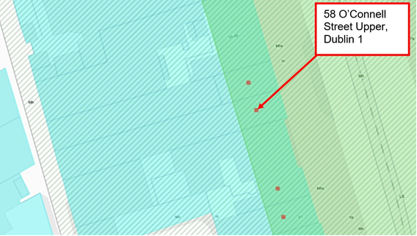
Fig.1 Location and Land Use Zoning

Relevant Planning History
Planning Ref. | Description | Decision Date
2479/08 | Seven year permission for development at the Former Carlton Cinema site covering majority of a city block bounded by Parnell Street, Moore Lane, O'Rahilly Parade, Moore Street, Henry Street, Henry Place and O'Connell Street Upper. The proposal includes the retention and integration of the facade of no. 58 O'Connell Street Upper (facade to be cleaned and repaired, existing windows to be retained and repaired, new shopfront to be provided) and the demolition of all other elements. | DCC Grant Permission  15-Dec-2008  ABP Appeal Grant Permission  24-Mar-2010
2479/08X1 | Extension of duration of permission for Planning Application ref: 2479/08 for development at the Former Carlton Cinema site covering majority of a city block bounded by Parnell Street, Moore Lane, O'Rahilly Parade, Moore Street, Henry Street, Henry Place and O'Connell Street Upper. The proposal includes the retention and integration of the facade of no. 58 O'Connell Street Upper (facade to be cleaned and repaired, existing windows to be retained and repaired, new shopfront to be provided) and the demolition of all other elements. | 21-Jul-2016  Grant of Extension of Duration of Permission Ref:2479/08 (expires 06-May-2022)

Relevant Planning Enforcement History
Ref. No. | Opened | Reason | Closed | Reason
E0375/04 | 25-May-2004 | Shopfront | 22-Jun-2006 | Lack of evidence
E1086/06 | 12-Oct-2006 | Alleged that loudspeakers have been erected to front facade
E0698/10 | 25-Aug-2010 | Erection of unauthorised free-standing displays, sandwich boards, etc
E1035/17 | 08-Sep-2017 | Advertising boards on private landing | 08-Feb-2018 | Removed

Summary Description
(See images at end of report).
Terraced three-bay four-storey commercial building over concealed basement, built c.1925, with tiled shopfront to ground floor c.1980. Mansard type roof arrangement with copper-clad dormers behind red brick parapet wall having a granite coping and cornice. Red brick chimneystacks with moulded granite coping rising over party walls to north and south. Square-profile downpipes set in recesses flanking front elevation. Machine-made red brick walls laid in Flemish Bond to upper floors with moulded granite course below third floor, recessed brick panels above second floor and decorative granite panels between first and second floors. Square-headed window openings with granite surrounds and original one-over-one timber sliding sash windows. Central feature window to first floor with decorative scrolled console brackets and cornice surmounted by cartouche and festoon. Decorative fluted granite sill course with egg-and-dart moulding and paterae at first floor level (likely to have formed part of the original shopfront). Modern tiled shopfront concealing original granite masonry (former shopfront). Cast-iron pavement lights to front.

Assessment
No.58 O’Connell Street Upper, Dublin 1 was built to designs by W.H. Byrne in 1924. The building represents part of the reconstruction of the O’Connell Street area following the devastation of 1916. The building was first protected under the Draft Dublin City Development Plan, 1987 when it was described as ‘Commercial premises: upper floor façade’. Although the shopfront at ground floor was refurbished during the late 20th century and now largely presents as a modern tiled shopfront/facia, the decorative fluted granite sill course with egg-and-dart moulding and paterae at first floor level is likely to have formed part of the original shopfront. A similar treatment is observed at No.57 O’Connell Street Upper where the plain granite frieze and cornice at first floor sill level surmount a granite facia. Furthermore, an external site inspection of No.58 indicates that elements of the original granite shopfront survive concealed behind the modern applied tiled finish. As such, it is recommended that the description for RPS ref: 6027 for No.58 O’Connell Street Upper, Dublin 1 is amended to read ‘Commercial premises: front façade’. It is noted that the Conservation Report prepared by David Slattery Historic Building Consultants (dated October 2008) for the proposed development of the Former Carlton Cinema, including the site of No.58 O'Connell Street Upper, Dublin 1 concurs with this recommendation stating ‘the main elevation of No.58 O’Connell Street is clearly of some interest’ (pg.23). It is further noted that the grant of planning permission under Planning file ref: 2479/08 and 2479/08X1 sets out to retain and conserve the façade of No.58 O’Connell Street Upper to include the removal of the existing shopfront tiling as detailed under submissions by Brian O’Connell Associates Architect’s. As such, it is recommended that the description for RPS ref: 6027 for No.58 O’Connell Street Upper, Dublin 1 is amended to read ‘Commercial premises: front façade’.

References
- Casey, C. (2005). Dublin: The Buildings of Ireland. London: Yale University Press.
- National Inventory of Architectural Heritage (NIAH) Ref:50010540
- Planning file ref: 2479/08 and 2479/08X1
- Brian O’Connell Associates (Feb 2008). Conservation Report: Proposed Development at the Former Carlton Cinema site including No. 58 O'Connell Street Upper, Dublin 1. Unpublished report submitted as part of planning file ref: 2479/08 and 2479/08X1
- David Slattery Historic Building Consultants (Oct 2008). Conservation Report: Proposed Development at the Former Carlton Cinema site including No. 58 O'Connell Street Upper, Dublin 1. Unpublished report submitted as part of planning file ref: 2479/08 and 2479/08X1.

Significance/NIAH Rating
No.58 O’Connell Street Upper, Dublin 1 was recorded under Stage 1 of the NIAH for Dublin (Ref: 50010540) with Ministerial Recommendations for Stage 1 issued to Dublin City Council on 4th June 2014. The structure was assigned a ‘Regional’ rating. These are structures or sites that make a significant contribution to the architectural heritage within their region or area. Structures which are considered of Regional significance are deemed worthy of inclusion on the RPS.

Assessment of Special Interest under the Planning and Development Act 2000
The National Inventory of Architectural Heritage assigned ARCHITECTURAL and ARTISTIC interest to No.58 O’Connell Street Upper, Dublin 1. The Conservation Section has considered the opinion of the NIAH and is in agreement with assigning these categories of special interest to the property.

Conclusion & Recommendation
It is recommended that the RPS description for RPS ref: 6027 for No.58 O’Connell Street Upper, Dublin 1 be amended to – ‘Commercial premises: front façade’.

Proposed Listing
RPS Ref No | Address | Description
6027 | 58 O’Connell Street Upper, Dublin 1 | Commercial premises: front façade.

01/11/2021

_______________ ________________
Paraic Fallon
Senior Planner Date

Photographic Record:
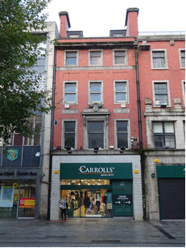 | 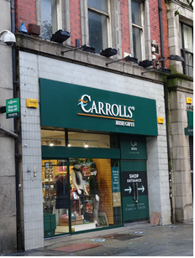
Fig.2: Principal front elevation of No.58 O’Connell Street Upper. | Fig.3: Detail of modern tiled shopfront.
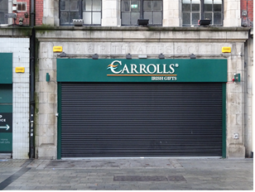 | 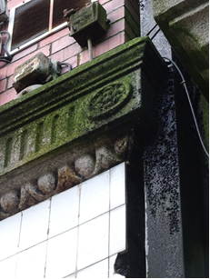
Fig.4: Detail of shopfront to No.57 O’Connell Street Upper (adjacent to No.58 O’Connell Street) having surviving historic granite shopfront. | Fig.5: Detail of decorative fluted granite cill course with egg-and-dart moulding at first floor level which is likely to have formed part of the original shopfront to No.58.
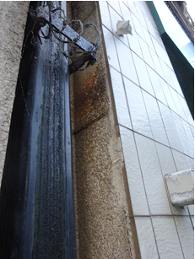 | 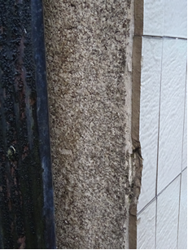
Fig.6: Detail of historic granite shopfront at No.58 O’Connell Street Upper, concealed behind the modern tiling. | Fig.7: Detail of historic granite shopfront at No.58 O’Connell Street Upper, concealed behind the modern tiling.

RPS No. 6028 - 60 O'Connell Street Upper, Dublin 1
Seandálaíocht, Caomhantas & Oidhreacht
An Roinn Pleanála & Forbairt Maoine
Oifigí na Cathrach, An Ché Adhmaid, Baile Átha Cliath 8

Archaeology, Conservation & Heritage Section
Planning & Property Development Department
Block 3, Floor 3, Civic Offices, Wood Quay, Dublin 8

Tel: (01) 222 3926, 222 3927
Email: conservation@dublincity.ie

11th November 2021

Draft Development Plan 2022-2028

Ref: RPS 6028 AMENDMENT to the Record of Protected Structures
_______________________________________________________________________________

Recommendation:
Amendment of current entry for 60 O’Connell Street Upper, Dublin 1 – Commercial premises: upper floor façade, to now read: 60 O’Connell Street Upper, Dublin 1 – Commercial premises extending protection to the entire structure to include its interior.
_______________________________________________________________________________

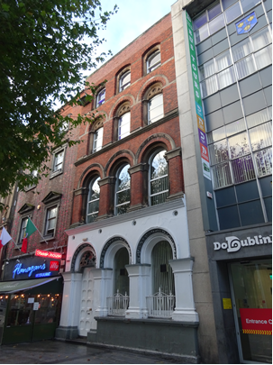

Introduction
No.60 O’Connell Street Upper, Dublin 1 is on the current Record of Protected Structures (Dublin City Development Plan 2016-2022). The reference number is RPS: 6028 and the description reads ‘Commercial premises: upper floor façade’. It is proposed to amend the description to read ‘Commercial premises’ extending protection to the entire structure to include its interior.

Existing Listing:
RPS Ref No | Address | Description
6028 | 60 O’Connell Street Upper, Dublin 1 | Commercial premises: upper floor façade

Proposed Listing: Amend description to read ‘Commercial premises’ extending protection to the entire structure to include its interior.
RPS Ref No | Address | Description
6028 | 60 O’Connell Street Upper, Dublin 1 | Commercial premises

Request for Investigation
Conservation Section, Dublin City Council. Dublin City Council also received a Ministerial Recommendation on the 4th of June 2014 from the Minister for Culture, Heritage and the Gaeltacht (now Minister for Housing, Local Government and Heritage) for inclusion of No.60 O’Connell Street Upper, Dublin 1 (NIAH ref: 50010535) on the Dublin City Record of Protected Structures.

Location and Land Use Zoning
The location of 60 O’Connell Street Upper, Dublin 1 is indicated by the red arrow below. The zoning objective for the site is Zone 5: To consolidate and facilitate the development of the central area, and to identify, reinforce, strengthen and protect its civic design character and dignity. The property is located within the O’Connell Street Architectural Conservation Area and is also located within a red hatch conservation area.
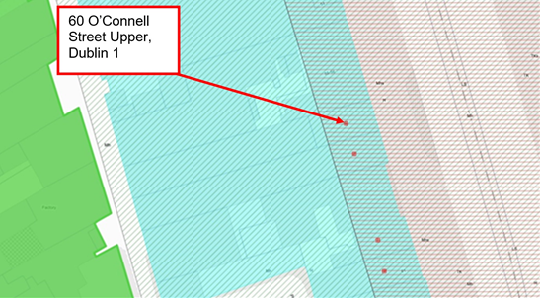
Fig.1 Location and Land Use Zoning

Relevant Planning History
Planning Ref. | Description | Decision Date
2479/08 | Seven year permission for development at the Former Carlton Cinema site covering majority of a city block bounded by Parnell Street, Moore Lane, O'Rahilly Parade, Moore Street, Henry Street, Henry Place and O'Connell Street Upper. The proposal includes the refurbishment of No. 60 O'Connell Street Upper (removal and replacement of windows with sash windows to historical detail or repaired as appropriate, removal of existing modern parapet and replacement with sandstone coping and cornice as original, removal and repair of front door, creation of openings into no. 61 O'Connell Street Upper, the blocking of openings into no. 59 O'Connell Street Upper, temporary supporting works, cleaning and repair of facades, repair of plasterwork, metal work and roof, the demolition of non-original additions and the installation of a solar reflective structure to the rear). | DCC Grant Permission  15-Dec-2008  ABP Appeal Grant Permission  24-Mar-2010
2479/08X1 | Extension of duration of permission for Planning Application ref: 2479/08 for development at the Former Carlton Cinema site covering majority of a city block bounded by Parnell Street, Moore Lane, O'Rahilly Parade, Moore Street, Henry Street, Henry Place and O'Connell Street Upper. The proposal includes the refurbishment of No. 60 O'Connell Street Upper (removal and replacement of windows with sash windows to historical detail or repaired as appropriate, removal of existing modern parapet and replacement with sandstone coping and cornice as original, removal and repair of front door, creation of openings into no. 61 O'Connell Street Upper, the blocking of openings into no. 59 O'Connell Street Upper, temporary supporting works, cleaning and repair of facades, repair of plasterwork, metal work and roof, the demolition of non-original additions and the installation of a solar reflective structure to the rear). | 21-Jul-2016  Grant of Extension of Duration of Permission Ref:2479/08 (expires 06-May-2022)

Relevant Planning Enforcement History
There is no relevant planning enforcement for the property which relates to the subject clarification.

Summary Description
(See images at end of report).

Exterior: Terraced three-bay four-storey former building built 1863 to designs by W.G. Murray though may incorporate fabric from earlier structure c.1750. M-profile slate roof hidden behind parapet having sandstone coping (parapet rebuilt). Red brick chimneystacks to north party wall. Red brick walls laid in Flemish bond to upper levels having sandstone courses and mouldings. Painted stucco finish to ground floor surmounted by continuous first floor cill course. Cement rendered walls to rear elevation. Segmental-headed window openings to third floor with recessed chamfered and shouldered sandstone surrounds; round-headed window openings to second floor having inset decorative recessed sandstone surrounds; round-headed window openings to first floor with sandstone continuous hood-moulding rising from sandstone impost course; round-headed window openings to ground floor each flanked by stepped squat piers and roll-moulded heads with foliate hood-mouldings. Square-headed window openings to rear elevation two round-headed window openings to staircase landings having timber sliding sash windows with radial head. One-over-one timber sliding sash windows to third floor principal elevation with variety of replacement window types to remainder. Round-headed door opening to ground floor principal elevation sharing similar decorative treatment to adjacent ground floor window openings and having timber door with multiple stop-chamfered panels and inset decorative quatrefoil over-panel. Door opens onto nosed stone step and threshold to front pavement. Rendered wall to rear (west) of site with gate giving access to Henry Place.

Interior: The following is based on review of a Conservation Report prepared by Brian O’Connell Associates (dated Feb 2008) for proposed development at the site of the Former Carlton Cinema including the site of No. 60 O'Connell Street Upper, Dublin 1 (refer to Planning file ref: 2479/08 and 2479/08X1). The Conservation Report contains survey drawings and a detailed photographic record of the subject property. The historic floor plan is legible throughout comprising of two principal rooms to one side of an entrance/staircase hall. The layout is repeated at first, second and third floor though some subdivision has taken place at second and third floors to include the introduction of suspended ceilings. The basement comprises of a number of vaulted spaces which partially extend beneath the external public pavement. A dogleg open-string staircase with decorative cast-iron balusters and coiled newel rises through ground to third floor. The principal rooms are largely unaltered retaining a significant degree of historic fabric to include: decorative window joinery; timber panelled doors; embellished plaster cornicing; ceiling roses and ornate fireplaces.

Assessment
60 O’Connell Street Upper, Dublin 1 was built as the ‘Colonial Insurance Company’ in 1863 to the designs of W.G. Murray (b.1822-d.1871). As such, it represents one of the few 19th century structures on O’Connell Street to have survived the devastation of Easter 1916. The NIAH record for the site suggests that the building may incorporate eighteenth-century fabric from Luke Gardiner’s early residential development, though further investigation is required to verify this. Murray was a well-establish and prolific 19th century architect whose commissions included numerous banking and financial institutions. Designed in an accomplished Ruskinian-style, the exterior and interior architectural detailing with carved embellishments and rich ornamentation closely reference his work at the former Hibernian Bank on College Green in the city of 1864 (NIAH Ref: 50910203). The interior largely preserves its original 19th century plan form and the principal rooms and circulation spaces are largely unaltered. These retain a significant degree of historic fabric to include: decorative window joinery; timber panelled doors; embellished plaster cornicing; ceiling roses; ornate fireplaces and a dogleg open-string staircase with decorative wrought and cast-iron balusters. In particular, the intricate detailing to internal joinery and embellished plasterwork elements demonstrate high quality and skilled craftsmanship.

The building was first protected under the Draft Dublin City Development Plan, 1987 when it was described as ‘Commercial premises: upper floor façade’. In 2014 The Minister for Culture, Heritage and the Gaeltacht (now Minister for Housing, Local Government and Heritage) made recommendation to Dublin City Council concerning the inclusion No.60 O’Connell Street Upper, Dublin 1 to the Record of Protected Structures on grounds of its special architectural and artistic interest. The Conservation Section has considered the Ministerial Recommendation for the property and on review of the historic record, external site inspection and assessment of documentation submitted in relation to Planning file ref: 2479/08 and 2479/08X1, considers that No.60 O’Connell Street Upper, Dublin 1, in its entirety, merits inclusion on the Record of Protected Structures. It is noted that the Conservation Report prepared by David Slattery Historic Building Consultants (dated October 2008) for the proposed development of the Former Carlton Cinema, including the site of No. 60 O'Connell Street Upper, Dublin 1 concurs with this recommendation stating ‘[No.60 O’Connell Street Upper, Dublin 1] must be considered of note and significance both externally and internally and merits protected structures status’ (pg.25). It is further noted that the grant of planning permission under Planning file ref: 2479/08 and 2479/08X1 sets out to conserve and restore No.60 O’Connell Street Upper with the conservation works described in detail under submissions by Brian O’Connell Associates Architect’s to include specialist assessments of the interiors and plasterwork. As such, it is recommended that the description for RPS ref: 6028 for No.60 O’Connell Street Upper, Dublin 1 is amended to read ‘Commercial premises’, extending protection to the entire structure to include its interior.

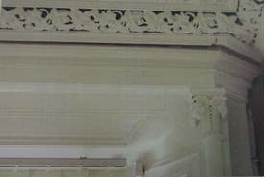 | 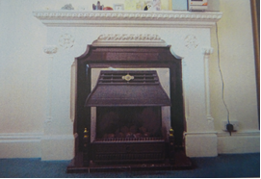
Fig.2: Image from Brian O’Connell Associates Conservation Report (Planning file ref: 2479/08 and 2479/08X1) showing embellished plaster cornicing and decorative window joinery. | Fig.3: Image from Brian O’Connell Associates Conservation Report (Planning file ref: 2479/08 and 2479/08X1) showing ornate fireplace.
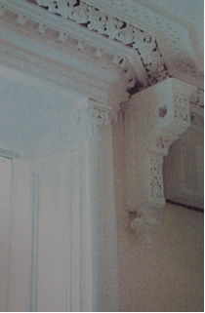 | 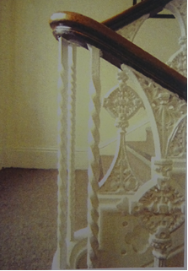
Fig.4: Image from Brian O’Connell Associates Conservation Report (Planning file ref: 2479/08 and 2479/08X1) showing embellished plaster cornicing and decorative window joinery. | Fig.5: Image from Brian O’Connell Associates Conservation Report (Planning file ref: 2479/08 and 2479/08X1) showing staircase with decorative wrought and cast-iron balusters.

References:
- Casey, C. (2005). Dublin: The Buildings of Ireland. London: Yale University Press.
- Dictionary of Irish Architects
- National Inventory of Architectural Heritage (NIAH) Ref: 50010535 and 50910203
- Planning file ref: 2479/08 and 2479/08X1
- Brian O’Connell Associates (Feb 2008). Conservation Report: Proposed Development at the Former Carlton Cinema site including No. 60 O'Connell Street Upper, Dublin 1. Unpublished report submitted as part of planning file ref: 2479/08 and 2479/08X1
- David Slattery Historic Building Consultants (Oct 2008). Conservation Report: Proposed Development at the Former Carlton Cinema site including No. 60 O'Connell Street Upper, Dublin 1. Unpublished report submitted as part of planning file ref: 2479/08 and 2479/08X1.

Significance/NIAH Rating
No.60 O’Connell Street Upper, Dublin 1 was recorded under Stage 1 of the NIAH for Dublin (Ref: 50010535) with Ministerial Recommendations for Stage 1 issued to Dublin City Council on 4th June 2014. The structure was assigned a ‘Regional’ rating. These are structures or sites that make a significant contribution to the architectural heritage within their region or area. Structures which are considered of Regional significance are deemed worthy of inclusion on the RPS.

Assessment of Special Interest under the Planning and Development Act 2000
The National Inventory of Architectural Heritage assigned ARCHITECTURAL and ARTISTIC interest to No.60 O’Connell Street Upper, Dublin 1. The Conservation Section has considered the opinion of the NIAH and is in agreement with assigning these categories of special interest to the property to include both its exterior and interior.

Conclusion & Recommendation
It is recommended that the RPS description for RPS ref: 6028 for No.60 O’Connell Street Upper, Dublin 1 be amended to – ‘Commercial premises’ extending protection to the entire structure to include its interior.

Proposed Listing
Amend description to read ‘Commercial premises’ extending protection to the entire structure to include its interior.
RPS Ref No | Address | Description
6028 | 60 O’Connell Street Upper, Dublin 1 | Commercial premises

11/11/2021
_______________ ________________
Paraic Fallon
Senior Planner Date

Photographic Record:
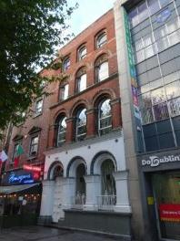 | 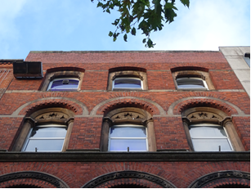
Fig.6: Principal elevation of No.60 O’Connell Street Upper. | Fig.7: Upper floors (principal elevation) showing segmental-and-round headed window openings having surrounds.
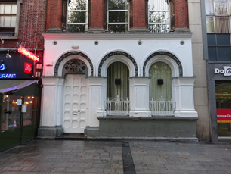 | 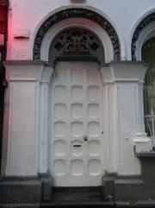
Fig.8: Rendered ground floor to principal elevation having round-headed openings with squat piers and decorative hood-mouldings. | Fig.9: Round-headed door opening to ground floor principal elevation having timber door with multiple stop-chamfered panels.

RPS No. 6029 - 61 O'Connell Street Upper, Dublin 1
Seandálaíocht, Caomhantas & Oidhreacht
An Roinn Pleanála & Forbairt Maoine
Oifigí na Cathrach, An Ché Adhmaid, Baile Átha Cliath 8

Archaeology, Conservation & Heritage Section
Planning & Property Development Department
Block 3, Floor 3, Civic Offices, Wood Quay, Dublin 8

Tel: (01) 222 3926, 222 3927
Email: conservation@dublincity.ie

1st November 2021

Draft Development Plan 2022-2028

Ref: RPS 6029 AMENDMENT of the Record of Protected Structures
_______________________________________________________________________________

Recommendation:
Amendment of current entry for 61 O’Connell Street Upper, Dublin 1 – Commercial premises: upper floor façade, to now read: 61 O’Connell Street Upper, Dublin 1 – Commercial premises: front façade.
_______________________________________________________________________________

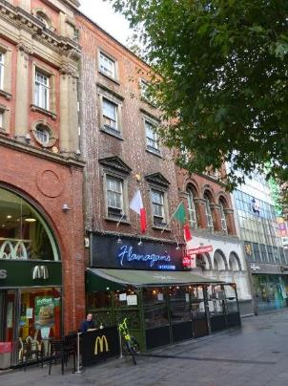

Introduction
No.61 O’Connell Street Upper, Dublin 1 is on the current Record of Protected Structures (Dublin City Development Plan 2016-2022). The reference number is RPS: 6029 and the description reads ‘Commercial premises: upper floor façade’. It is proposed to amend the description to read ‘Commercial premises: front façade’.

Existing Listing:
RPS Ref No | Address | Description
6029 | 61 O’Connell Street Upper, Dublin 1 | Commercial premises: upper floor façade

Proposed Listing: Amend description to read ‘Commercial premises: front façade’.
RPS Ref No | Address | Description
6029 | 61 O’Connell Street Upper, Dublin 1 | Commercial premises: front façade

Request for Investigation
Conservation Section, Dublin City Council

Location and Land Use Zoning
The location of 61 O’Connell Street Upper, Dublin 1 is indicated by the red arrow below. The zoning objective for the site is Zone 5: To consolidate and facilitate the development of the central area, and to identify, reinforce, strengthen and protect its civic design character and dignity. The property is located within the O’Connell Street Architectural Conservation Area and is also located within a red hatch conservation area.
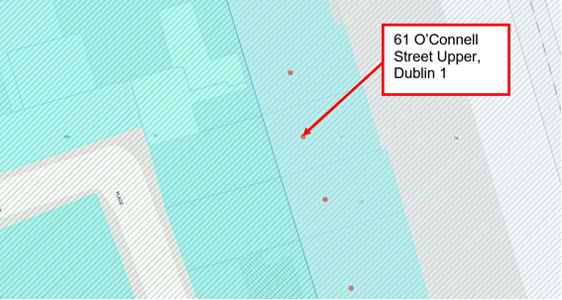
Fig.1: Location and Land Use Zoning.

Relevant Planning History
Planning Ref. | Description | Decision Date
2816/80 | Alterations to shopfront. | DCC Grant Permission  19-Sept-1980
2479/08 | Seven year permission for development at the Former Carlton Cinema site covering majority of a city block bounded by Parnell Street, Moore Lane, O'Rahilly Parade, Moore Street, Henry Street, Henry Place and O'Connell Street Upper. The proposal includes the retention and integration of the facade of no. 61 O'Connell Street Upper (facade to be cleaned and repaired, windows to be removed, repaired and reinstated or replaced with timber sash windows to historical detail' as appropriate all other elements to be demolished, original window proportions to be reinstated, removal of modern shopfront and restoration of underlying stonework, new shopfront to be provided and all ancillary structural services and development works). | DCC Grant Permission  15-Dec-2008  ABP Appeal Grant Permission  24-Mar-2010
2479/08X1 | Extension of duration of permission for Planning Application ref: 2479/08 for development at the Former Carlton Cinema site covering majority of a city block bounded by Parnell Street, Moore Lane, O'Rahilly Parade, Moore Street, Henry Street, Henry Place and O'Connell Street Upper. The proposal includes the retention and integration of the facade of no. 61 O'Connell Street Upper (facade to be cleaned and repaired, windows to be removed, repaired and reinstated or replaced with timber sash windows to historical detail' as appropriate all other elements to be demolished, original window proportions to be reinstated, removal of modern shopfront and restoration of underlying stonework, new shopfront to be provided and all ancillary structural services and development works). | 21-Jul-2016  Grant of Extension of Duration of Permission Ref:2479/08 (expires 06-May-2022)

Relevant Planning Enforcement History
Ref. No. | Opened | Reason | Closed | Reason
E0199/17 | 08-March-2017 | Banner to the front | 02-Dec-2020 | Removed
E0700/10 | 25-Aug-2010 | Erection of signs, free-standing sandwich boards & window boxes to the front of Flanagan’s Restaurant w/out pp

Summary Description
(See images at end of report).
Terraced two-bay four-storey former townhouse, built c.1760, remodelled 1913, with modern shopfront to ground floor c.1980. M-profile slate roof hidden behind parapet wall with granite coping (parapet rebuilt having dentilled brick course). Rendered chimneystacks to north and south party walls. Red brick walls laid in Flemish bond, rebuilt to top floor. Square-headed window openings with concrete sills and replacement timber sliding sash windows. Lugged architrave surrounds to first and second floors, plain architrave surrounds to third floor with pediments to first floor windows and cornices to second floor windows. Modern brick shopfront with awning possibly concealing earlier shopfront. Outdoor seating enclosure.

Assessment
No.61 O’Connell Street Upper is one of the few buildings on O’Connell Street to have survived the destruction of Easter 1916. Despite having been remodelled during the early 20th century, the former townhouse built c.1760 reflects the early development of the street under Luke Gardiner. The NIAH notes that the ‘graduated fenestration pattern is the most obvious sign of its eighteenth-century origins’. The building was first protected under the Draft Dublin City Development Plan, 1987 when it was described as ‘Commercial premises: upper floor façade’.

Although the shopfront at ground floor was refurbished c.1980 and now largely presents as a modern brick shopfront and timber facia, drawings prepared by Brian O’Connell Associates Architect’s as part of Planning file ref: 2479/08 and 2479/08X1 indicate that stonework is retained at ground level. It is further noted that the grant of planning permission under Planning file ref: 2479/08 and 2479/08X1 sets out to retain and conserve the façade of No.61 O’Connell Street Upper to include the removal of modern shopfront and restoration of underlying stonework. As such, it is recommended that the description for RPS ref: 6029 for No.61 O’Connell Street Upper, Dublin 1 is amended to read ‘Commercial premises: front façade’.

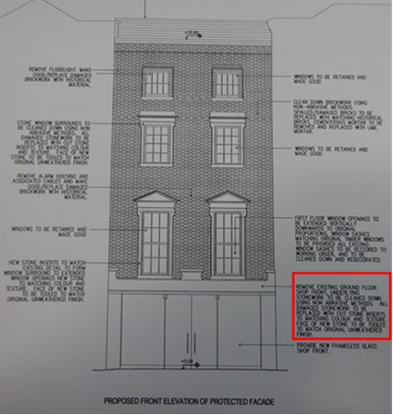
Fig.2: Excerpt from proposed drawing No.5834 prepared by Brian O’Connell Associates Architect’s as part of Planning file ref: 2479/08 and 2479/08X1 specifying removal of existing shopfront and conservation of underlying stonework (highlighted in red).

References
- Casey, C. (2005). Dublin: The Buildings of Ireland. London: Yale University Press.
- National Inventory of Architectural Heritage (NIAH) Ref: 50010534.
- Planning file ref: 2479/08 and 2479/08X.
- Brian O’Connell Associates (Feb 2008). Conservation Report: Proposed Development at the Former Carlton Cinema site including No. 61 O'Connell Street Upper, Dublin 1. Unpublished report submitted as part of planning file ref: 2479/08 and 2479/08X1.
- David Slattery Historic Building Consultants (Oct 2008). Conservation Report: Proposed Development at the Former Carlton Cinema site including No. 61 O'Connell Street Upper, Dublin 1. Unpublished report submitted as part of planning file ref: 2479/08 and 2479/08X1.

Significance/NIAH Rating
No.61 O’Connell Street Upper, Dublin 1 was recorded under Stage 1 of the NIAH for Dublin (Ref: 50010534), with Ministerial Recommendations for Stage 1 issued to Dublin City Council on 4th June 2014. The structure was assigned a ‘Regional’ rating. These are structures or sites that make a significant contribution to the architectural heritage within their region or area. Structures which are considered of Regional significance are deemed worthy of inclusion on the RPS.

Assessment of Special Interest under the Planning and Development Act 2000
The National Inventory of Architectural Heritage assigned ARCHITECTURAL and ARTISTIC interest to No.61 O’Connell Street Upper, Dublin 1. The Conservation Section has considered the opinion of the NIAH and is in agreement with assigning these categories of special interest to the property.

Conclusion & Recommendation
It is recommended that the RPS description for RPS ref: 6029 for No.61 O’Connell Street Upper, Dublin 1 be amended to – ‘Commercial premises: front façade’.

Proposed Listing
RPS Ref No | Address | Description
6029 | 61 O’Connell Street Upper, Dublin 1 | Commercial premises: front façade.

01/11//2021

_______________ ________________
Paraic Fallon
Senior Planner Date

Photographic Record:
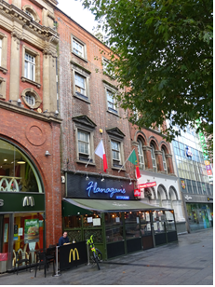 | 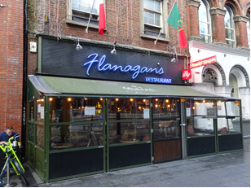
Fig.3: Principal elevation of No.61 O’Connell Street Upper. | Fig.4: Modern timber facia and outdoor seating area at No.61 O’Connell Street Upper.

RPS No. 6030 - 62 O'Connell Street Upper, Dublin 1
Seandálaíocht, Caomhantas & Oidhreacht
An Roinn Pleanála & Forbairt Maoine
Oifigí na Cathrach, An Ché Adhmaid, Baile Átha Cliath 8

Archaeology, Conservation & Heritage Section
Planning & Property Development Department
Block 3, Floor 3, Civic Offices, Wood Quay, Dublin 8

Tel: (01) 222 3926, 222 3927
Email: conservation@dublincity.ie

11th November 2021

Draft Development Plan 2022-2028

Ref: RPS 6030 AMENDMENT to the Record of Protected Structures
_______________________________________________________________________________

Recommendation:
Amendment of current entry for 62 O’Connell Street Upper, Dublin 1 – Commercial premises: upper floor façade, to now read: 62 O’Connell Street Upper, Dublin 1 – Commercial premises extending protection to the entire structure to include its interior.
_______________________________________________________________________________

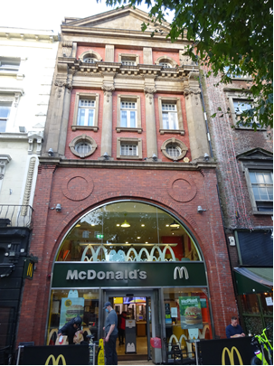

Introduction
No.62 O’Connell Street Upper, Dublin 1 is on the current Record of Protected Structures (Dublin City Development Plan 2016-2022). The reference number is RPS: 6030 and the description reads ‘Commercial premises: upper floor façade’. It is proposed to amend the description to read ‘Commercial premises’ extending protection to the entire structure to include its interior.

Existing Listing:
RPS Ref No | Address | Description
6030 | 62 O’Connell Street Upper, Dublin 1 | Commercial premises: upper floor façade

Proposed Listing: Amend description to read ‘Commercial premises’ extending protection to the entire structure to include its interior.
RPS Ref No | Address | Description
6030 | 62 O’Connell Street Upper, Dublin 1 | Commercial premises

Request for Investigation
Conservation Section, Dublin City Council. Dublin City Council also received a Ministerial Recommendation on the 4th of June 2014 from the Minister for Culture, Heritage and the Gaeltacht (now Minister for Housing, Local Government and Heritage) for inclusion of No.62 O’Connell Street Upper, Dublin 1 (NIAH ref: 50010533) on the Dublin City Record of Protected Structures.

Location and Land Use Zoning
The location of 62 O’Connell Street Upper, Dublin 1 is indicated by the red arrow below. The zoning objective for the site is Zone 5: To consolidate and facilitate the development of the central area, and to identify, reinforce, strengthen and protect its civic design character and dignity. The property is located within the O’Connell Street Architectural Conservation Area and is also located within a red hatch conservation area.
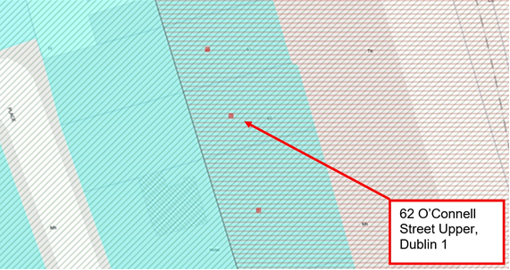
Fig. 1: Location and Land Use Zoning

Relevant Planning History
Planning Ref. | Description | Decision Date
0556/74 | Change of use at basement and ground floor to funfair and carnival centre. | Grant Permission  26-04-1974
3164/75 | Internal alterations to existing café and funfair. | Grant Permission  29-02-1976
0329/78 | Alterations to façade. | Grant Permission  03-03-1978
4205/09 | Provision of a new shopfront at ground at first floor level, including the replacement of a projecting sign. | DCC Grant Permission  02-Nov-2010  ABP Appeal Grant Permission  31-Mar-2011

Relevant Planning Enforcement History
There is no relevant planning enforcement for the property which relates to the subject clarification.

Summary Description
(See images at end of report).

Exterior: Former theatre extending to full depth of site built 1913, to designs by Aubrey O’Rourke comprising terraced three-bay five-storey over basement pedimented building fronting onto O’Connell Street with four-storey flat roofed return to rear, fronting onto Henry Place. Now in use as fast food restaurant to ground and first floor with training facilities to upper floors. Ground and first floors rebuilt c.1970-80, and having recent glazed shopfront c.2009. M-profile slate roof to principal building behind pedimented parapet wall with rendered chimneystacks rising over north party wall.

Red brick walls to O’Connell Street elevation with original Kingscourt brick laid in Flemish bond to upper floors having neo-classical composite stone dressings to include a lower register of giant ionic columns and pilasters supporting an entablature and upper register of fluted pilasters carrying a blank pediment. Replacement red brick laid in stretcher bond to ground and first floors with double-height arch c.1970-80. Buff coloured brick laid in English garden wall bond to rear/west elevation of return having sections of rebuild with partial glazed brick to side/north elevation. Central square window opening to attic storey of principal building with oculi to either side having composite stone surrounds and original multiple-pane windows, repeated to entresol storey. Square-headed window openings to third floor with composite stone surrounds and original timber casement windows with multiple-pane overlights. Square-headed window openings to rear/west elevation of return having pre-cast concrete lintels and replacement windows.

Interior: Building has undergone significant alteration at ground and first floor c.1970 however historic floor plan layouts and fabric may survive at upper floors (understood to be in use as staff facilities for restaurant below).

Assessment
No.62 O’Connell Street Upper, Dublin 1 was built as the ‘Pillar Theatre’ in 1913 to the designs of Aubrey Vincent O’Rourke (b.1822-d.1871). The ordnance survey map of 1939 shows the cinema extending the full depth of the site and it is likely that the flat roofed four-storey return to the rear may have originally housed the auditorium. By the mid-20th century the cinema had closed with the building in use as an entertainment venue comprising a café and bingo hall. It is understood that it was at this time that building was first refaced at ground and first floor, though the current double-height brick archway dates to c.1978 when significant interventions were carried out by the architectural practice of Sam Stephenson. The ground and first floors currently operate as a McDonalds Restaurant with the upper floors understood to house staff facilities for the restaurant employees.

No.62 represents one of the few buildings on O’Connell Street Upper to have survived the devastation of Easter 1916 and is one of at least six purpose-built early 20th century cinemas in the O’Connell Street area. Originally built as the Pillar Theatre in 1913, the building reflects the early cinema building typology which evolved following the 1909 Cinematograph Act. This saw the construction of purpose built cinemas with narrow decorative frontages leading to an auditorium. In contrast, the theatres from the late 1920s and 30’s reflect the monumental ambitions of the large cinema chains, such as the Savoy at No. 16-17 O'Connell Street Upper (NIAH ref: 50010546) and the former Carlton cinema at No. 52-54 O'Connell Street Upper (NIAH ref: 50010543). As such, the former Pillar Theatre is testimony to the early social, cultural and leisure development of the capital.

The building was first protected under the Draft Dublin City Development Plan, 1987 when it was described as ‘Commercial premises: upper floor façade’. In 2014 The Minister for Culture, Heritage and the Gaeltacht (now Minister for Housing, Local Government and Heritage) made recommendation to Dublin City Council concerning the inclusion No.62 O’Connell Street Upper, Dublin 1 to the Record of Protected Structures on grounds of its special architectural and artistic interest. The building clearly has undergone alteration at lower level which most recently saw the rebuilding of the ground and first floor c.1970. Despite these alterations the remaining external envelope is largely intact to include the upper storey elevations as well as the M-profile roof and chimneystacks. It is noted that the alterations granted by planning permission are confined to the lower levels suggesting that historic plan layouts and internal fabric survives to upper floors which are understood to be in use as staff facilities for the restaurant.

The Conservation Section has considered the Ministerial Recommendation for the property, in tandem with Section 2.5.2 of the Architectural Heritage Protection Guidelines for Planning Authorities (2011) which states ‘The protection of a façade alone should generally only be considered where there is no surviving interior of any interest, for example where the building has previously been gutted and the façade is the only remaining feature of the original historic building. Generally a façade relates integrally to its building, which may retain interior detail of note including, for example, the original spatial plan, shop-fittings or decorative elements such as chimneypieces, staircases, window shutters or cornices. Elements of the external envelope and/or within the curtilage may also be of intrinsic interest and worthy of protection; these might include the roof, the rear elevation, outbuildings or other site features’ (pg.24). As such, the Conservation Section considers that No. 62 O’Connell Street Upper, Dublin 1, in its entirety, merits inclusion on the City Council’s Record of Protected Structures. Therefore, it is recommended that the RPS description for 62 O’Connell Street Upper, Dublin 1 is amended to read ‘Commercial premises’, extending protection to the entire structure to include its interior.

References
- Casey, C. (2005). Dublin: The Buildings of Ireland. London: Yale University Press.
- Dictionary of Irish Architects
- National Inventory of Architectural Heritage (NIAH) Ref: 50010533, 50010546 & 50010543.
- Planning file ref: 4205/09
- Goads Insurance Maps of 1932.
- Ordnance Survey Mapping.

Significance/NIAH Rating
No.62 O’Connell Street Upper, Dublin 1 was recorded under Stage 1 of the NIAH for Dublin (Ref: 50010533) with Ministerial Recommendations for Stage 1 issued to Dublin City Council on 4th June 2014. The structure was assigned a ‘Regional’ rating. These are structures or sites that make a significant contribution to the architectural heritage within their region or area. Structures which are considered of Regional significance are deemed worthy of inclusion on the RPS.

Assessment of Special Interest under the Planning and Development Act 2000
The National Inventory of Architectural Heritage assigned ARCHITECTURAL, ARTISTIC and HISTORICAL interest to No.62 O’Connell Street Upper, Dublin 1. The Conservation Section has considered the opinion of the NIAH and is in agreement with assigning these categories of special interest to the property to include the exterior and its interior.

Conclusion & Recommendation
It is recommended that the RPS description for RPS ref: 6030 for No.62 O’Connell Street Upper, Dublin 1 be amended to – ‘Commercial premises’ extending protection to the entire structure to include its interior.

Proposed Listing
Amend description to read ‘Commercial premises’ extending protection to the entire structure to include its interior.

RPS Ref No | Address | Description
6030 | 62 O’Connell Street Upper, Dublin 1 | Commercial premises

11/11/2021
_______________ ________________
Paraic Fallon
Senior Planner Date

Photographic Record:
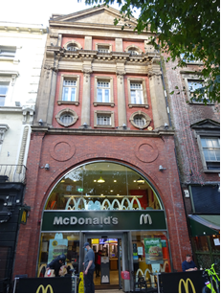 | 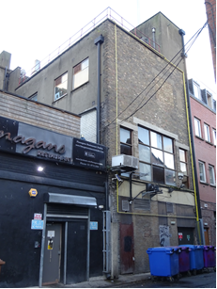
Fig. 2: Principal elevation of No.62 O’Connell Street Upper. Note the archway to ground and first floors was rebuilt c.1970. | Fig. 3: Flat roofed four-storey return to the rear may have originally housed the cinema auditorium.

RPS No. 6031 – 63-64 O'Connell Street Upper, Dublin 1
Seandálaíocht, Caomhantas & Oidhreacht
An Roinn Pleanála & Forbairt Maoine
Oifigí na Cathrach, An Ché Adhmaid, Baile Átha Cliath 8

Archaeology, Conservation & Heritage Section
Planning & Property Development Department
Block 3, Floor 3, Civic Offices, Wood Quay, Dublin 8

Tel: (01) 222 3926, 222 3927
Email: conservation@dublincity.ie

11th November 2021

Draft Development Plan 2022-2028

Ref: RPS 6031 AMENDMENT to the Record of Protected Structures

_______________________________________________________________________________

Recommendation:
Amendment of current entry for 63-64 O’Connell Street Upper, Dublin 1 – Commercial premises: upper floor façade, to now read: 63-64 O’Connell Street Upper, Dublin 1 – Commercial Premises extending protection to the entire structure, including its interior.
_______________________________________________________________________________

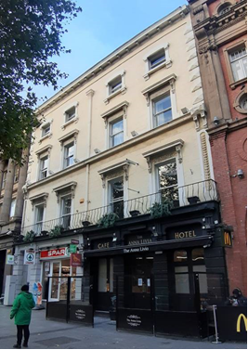

Introduction
There has been a query about whether the RPS entry 63-64 O’Connell Street Upper, Dublin 1 – Commercial premises: upper floor façade, should be amended to include the entire structure. Significant elements of the historic shopfront survive, along with some internal fabric. The building is significant as an eighteenth-century survivor within the streetscape of Upper O’Connell Street. Therefore it is proposed to amend the description to read ‘Commercial premises’ extending protection to the entire structure to include its interior.

Existing Listing
RPS Ref No | Address | Description
6031 | 63-64 O’Connell Street Upper, Dublin 1 | Commercial premises: upper floor façade

Proposed Listing:
RPS Ref No | Address | Description
6031 | 63-64 O’Connell Street Upper, Dublin 1 | Commercial premises

Request for Investigation
Conservation Section, Dublin City Council

Location and Land Use Zoning
The location of 63-64 O’Connell Street Upper, Dublin 1 is arrowed red below. The main zoning objective is Zone 5: To consolidate and facilitate the development of the central area, and to identify, reinforce and strengthen and protect its civic design character and dignity. The site is located within the Architectural Conservation Area of O’Connell Street and is also within a designated Conservation Area.
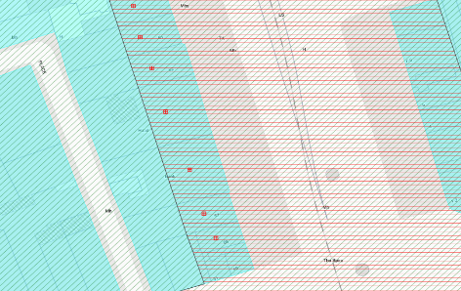
Figure 1: Location and Land Use Zoning

Recent Planning History
Planning Ref | Description | Decision
0125/97 | Alterations to existing ground floor elevation of List 2 building including relocation of A.T.M. service till and associated signage. | GRANT PERMISSION  26-Mar-1997
2223/98 | Change of use of grade 2 listed former bank and offices to holiday hostel and associated restaurant on four floors over basement. | GRANT PERMISSION  25-Sep-1998
1707/99 | Change of use of No.63/64 O Connell Street Upper, Dublin 1, a List 2 building, from approved Holiday Hostel Use Reg. Ref. 2223/98 to 41 bedroom Hotel Use and internal alterations on part Basement, Ground and all of First to Third Floor of the front block and the First Floor to the rear block and the retention and completion and conversion of the pitched roof with dormer windows to the front block and the erection of second and third floor extension to the rear block and alteration to front facade. | GRANT PERMISSION  06-Sep-1999
3610/11 | PROTECTED STRUCTURE - Planning permission sought for a new stainless steel fascia sign. | GRANT PERMISSION  24-Jul-2012

Recent Enforcement History
Ref. No. | Opened | Reason | Closed | Reason
E0104/04 | 17-Feb-2004 | Advertising signage canopy and light fittings | 18-Feb-2004 | Enforcement notice complied with
E0496/09 | 16-Jun-2009 | Unauthorised banner has been erected without PP | 30-Oct-2009 | Enforcement notice complied with
E0497/09 | 16-Jun-2009 | Unauthorised banner erected on front façade | 11-Dec-2009 | Enforcement notice complied with
E0345/11 | 01-Jun-2011 | Non-compliance w/Condition 1 of 3891/10 re seating arrangements | 28-Aug-2013 | No evidence
E0024/16 | 22-Jan-2016 | Advertising sandwich boards | 11-May-2016 | No evidence
E0484/17 | 11-May-2017 | Signage and metal roller shutters

Summary Description
(See images at end of report)
Description based on National Inventory of Architecture’s record for site, Ref. 50010532
Exterior: Terraced four-bay four-storey stucco-fronted former pair of townhouses over concealed basement, built c.1750, converted 1869 to bank, now in use as shop and hotel. Replacement M-profile roof with infilled central valley and three dormers to front pitch. Roof hidden behind parapet wall with modillioned parapet cornice. Brick chimneystacks to both party walls. Steel hopper and downpipe to centre of façade. Painted ruled-and-lined rendered walls with plain frieze below cornice, diamond-faced render quoins to second and third floors and continuous cornice at second floor sill level. First floor flanked by pilasters with coin moulding, paired console brackets and diamond-faced panel. Square-headed window openings with moulded surrounds and single-pane timber sliding sash windows. Third floor windows have lugged and kneed stop-chamfered surrounds with sill brackets, first and second floors having plain surrounds flanked by decorative console brackets supporting hood cornice; panels above first floor windows have foliate decoration. Channel rusticated rendered ground floor with triglyphs framing each opening supporting fluted cornice and full-span bellied iron balcony above. South half has modern shopfront with former opening to south while north half has three openings with replacement timber glazed double-leaf doors. Glazed block panels to the front pavement lighting basement level. Four-storey redbrick extension to rear onto Henry Place.

Assessment
Structures are shown at locations equating to Nos. 63 and 64 O’Connell Street Upper on John Rocque’s An Accurate Survey of the City and Suburbs of Dublin (1756). These houses were constructed as part of the formation of Sackville Mall from c.1749 onwards, when the west side of the previous Drogheda Street was demolished by Luke Gardiner. Images from the mid-nineteenth century show two two-bay four-storey houses displaying typical Georgian features on the plots. In 1874, the buildings were amalgamated and remodelled by Charles Geoghan for the Royal Bank. The front elevations were rendered and window openings to the upper floors were altered to make them uniform across both buildings. The decorative window surrounds and other decorative detailing to the façade, including the ordering of the ground floor, also date to these works. Further works were carried out to the structures in 1925 by Donnelly, Moore and Keating, described as ‘structural improvements’ in the Irish Builder. Both the 1870s and 1920s works appear to have largely retained the eighteenth-century character of the buildings, with Christine Casey stating that much eighteenth-century detail survived until the 1990s. She does note that some raised-and-fielded panelling survives internally along with a mid-eighteenth century stair (2005, 217). This pair of eighteenth-century townhouses is a rare eighteenth-century survivor within the streetscape of O’Connell Street, surviving the 1916 Rising which destroyed most of the building stock along the southern end of the street. The graduated fenestration conforms to the structures’ eighteenth-century origin with the nineteenth and twentieth-century alterations providing much of their current architectural character, enhancing the wealth and variety of architectural styles on the city’s main thoroughfare. The potential survival of internal fabric from the eighteenth-century highlights the significance of the structure to the city’s architectural heritage.
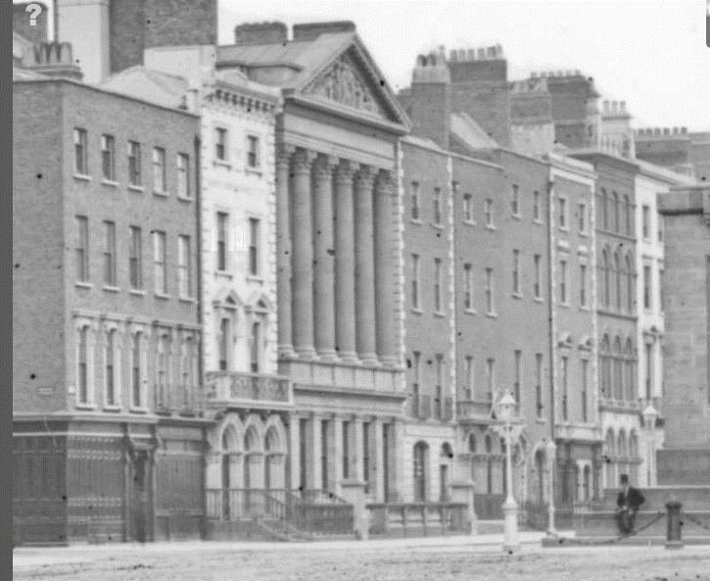
Fig. 2: Image c.1860-1883 from the Stereo Pairs Photograph Collection, held in the National Library of Ireland, showing the pair of townhouses prior to their amalgamation c.1870
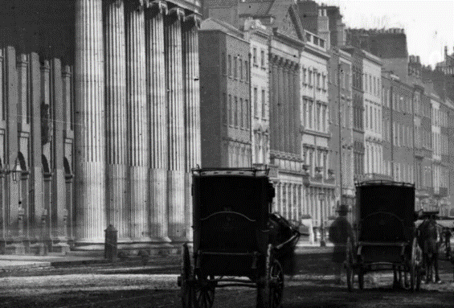
Fig. 3: Image from the Lawrence Photograph Collection, held in the National Library of Ireland, c.1880-1890 showing Nos.63-64 following amalgamation of the structures

References
- National Inventory of Architectural Heritage Reference 50010532
- Image from the Stereo Pairs Photograph Collection, held by the National Library of Ireland, showing O’Connell Street http://catalogue.nli.ie/Record/vtls000566016/Details#tabnav (accessed 17/08/2021)
- Image from the Lawrence Collection, held by the National Library of Ireland, showing O’Connell Street http://catalogue.nli.ie/Record/vtls000338483 (accessed 17/08/2021)
- City of Dublin, held by Ordnance Survey Ireland. © Public domain. Digital content: © Ordnance Survey Ireland, published by UCD Library, University College Dublin, 1847, Sheet 14 http://digital.ucd.ie/view/ucdlib:40835 (accessed 05/10/2021)
- City of Dublin, held by Ordnance Survey Ireland. © Public domain. Digital content: © Ordnance Survey Ireland, published by UCD Library, University College Dublin, 1891, Sheet XVIII.47 http://digital.ucd.ie/view/ucdlib:40897 (accessed 05/10/2021)
- Casey, C. Dublin: The City within the Grand and Royal Canals and the Circular Road with the Phoenix Park, New Haven, CT, and London, 2005
- Irish Builder 67, 11 Jul 1925, p.61

Significance/NIAH Rating
63-64 O’Connell Street Upper was recorded under Stage 1 of the NIAH for Dublin (Ref 50010532) with Ministerial Recommendations for Stage 1 issued to Dublin City Council on 4th June 2014. The structure was assigned a ‘Regional’ rating. These are structures or sites that make a significant contribution to the architectural heritage within their region or area. Structures which are considered of Regional significance are deemed worthy of inclusion on the RPS.

The Conservation Section has considered the Ministerial Recommendation for the property, in tandem with Chapter 2, Section 2.5.2 of the Architectural Heritage Protection Guidelines for Planning Authorities (2011) which states ‘The protection of a façade alone should generally only be considered where there is no surviving interior of any interest, for example where the building has previously been gutted and the façade is the only remaining feature of the original historic building. Generally a façade relates integrally to its building, which may retain interior detail of note including, for example, the original spatial plan, shop-fittings or decorative elements such as chimneypieces, staircases, window shutters or cornices. Elements of the external envelope and/or within the curtilage may also be of intrinsic interest and worthy of protection; these might include the roof, the rear elevation, outbuildings or other site features’ (pg. 24). As such, the Conservation Section considers that 63-64 O’Connell Street Upper, Dublin 1, in its entirety, merits inclusion on the Record of Protected Structures; thereby extending protection to the entire structure, including its interior.

Assessment of Special Interest under the Planning and Development Act 2000
The National Inventory of Architectural Heritage assigned ARCHITECTURAL interest to No.63-64 O’Connell Street Upper, Dublin 1. The Conservation Section has considered the opinion of the NIAH and is in agreement with assigning these categories of special interest to the site.

Conclusion & Recommendation
It is recommended that the RPS entry for 63-64 O’Connell Street Upper, Dublin 1 be amended to 63-64 O’Connell Street Upper, Dublin 1 – Commercial premises, thereby extending protection to the entire structure to include its interior.

Proposed Listing
RPS Ref No | Address | Description
6031 | 63-64 O’Connell Street Upper, Dublin 1 | Commercial premises

11/11/2021
_______________ ________________
Paraic Fallon Date
Senior Planner

Photographic Record:
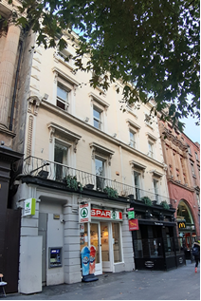 | 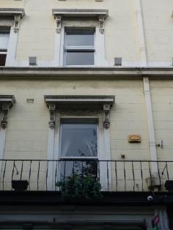
Fig. 4. East elevation from southeast | Fig. 5. Window openings to first and second floors
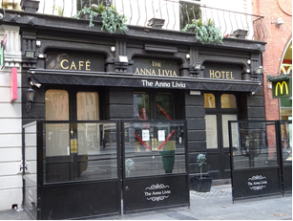

Fig. 6. View of shopfront to No.63

RPS No. 6033 - 67 O'Connell Street Upper, Dublin 1
Seandálaíocht, Caomhantas & Oidhreacht
An Roinn Pleanála & Forbairt Maoine
Oifigí na Cathrach, An Ché Adhmaid, Baile Átha Cliath 8

Archaeology, Conservation & Heritage Section
Planning & Property Development Department
Block 3, Floor 3, Civic Offices, Wood Quay, Dublin 8

Tel: (01) 222 3926, 222 3927
Email: conservation@dublincity.ie

11th November 2021

Draft Development Plan 2022-2028

Ref: RPS 6033 AMENDMENT to the Record of Protected Structures
_______________________________________________________________________________

Recommendation:
Amendment of current entry for 67 O’Connell Street Upper, Dublin 1 – Commercial premises: upper floor façade, to now read: 67 O’Connell Street Upper, Dublin 1 – Commercial Premises extending protection to the entire structure to include its interior.
_______________________________________________________________________________

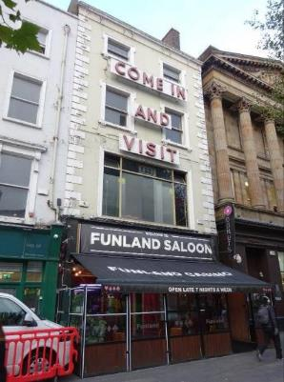

Introduction
There has been a query about whether the RPS entry 67 O’Connell Street Upper, Dublin 1 – Commercial premises: upper floor façade, should be amended to include the entire structure. The structure represents a rare eighteenth-century survivor within the streetscape of O’Connell Street Upper and as such makes a significant contribution to the architectural heritage of the street. Therefore it is proposed to amend the description to read ‘Commercial premises’ thereby extending protection to the entire structure to include its interior.

Existing Listing
RPS Ref No | Address | Description
6033 | 67 O’Connell Street Upper, Dublin 1 | Commercial premises: upper floor façade

Proposed Listing:
RPS Ref No | Address | Description
6033 | 67 O’Connell Street Upper, Dublin 1 | Commercial premises

Request for Investigation
Conservation Section, Dublin City Council

Location and Land Use Zoning
The location of 67 O’Connell Street Upper, Dublin 1 is arrowed red below. The main zoning objective is Zone 5: To consolidate and facilitate the development of the central area, and to identify, reinforce and strengthen and protect its civic design character and dignity. The site is located within the Architectural Conservation Area of O’Connell Street and is also within a designated Conservation Area.
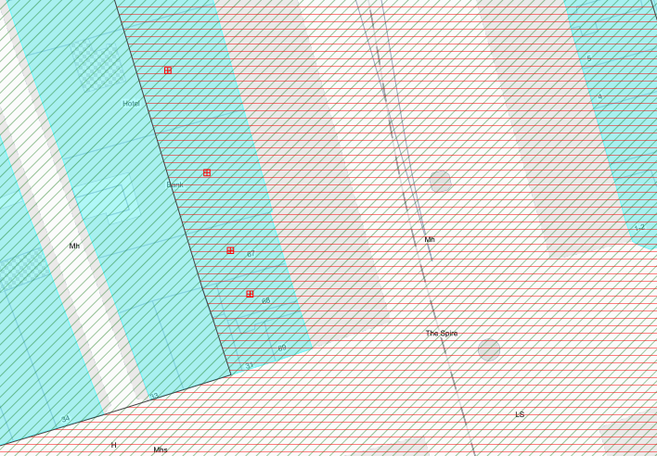
Fig. 1: Location and Land Use Zoning

Recent Planning History
Planning Ref | Description | Decision
2148/92 | New shop front to Funland Amusement Arcade. | GRANT PERMISSION  22-Feb-1993

Recent Enforcement History
Ref. No. | Opened | Reason | Closed | Reason
E0659/02 | 28-Aug-2002 | Use of ground floor as ‘fotoshop’ and erection of projecting sign | 22-Jun-2006 | Lack of evidence
E0164/06 | 22-Feb-2006 | Banner on front façade in absence of planning permission | 06-Dec-2006 | Enforcement notice complied with
E0866/06 | 17-Aug-2006 | Alleged unauthorised signage to front elevation
E0703/10 | 26-Aug-2010 | Erection of sandwich boards & illuminated signs w/out planning permission | 03-May-2016 | Statute barred
E0037/20 | 12-Mar-2020 | Street furniture on a private landing without PP

Summary Description
(See images at end of report)
Description based on National Inventory of Architecture’s record for site, Ref. 50010530
Exterior: Terraced two-bay four-storey over basement house, built c.1750, now in use as amusement centre/arcade, with recent shopfront to ground floor and extensions to rear. Flat roof hidden behind rendered parapet with moulded cornice. Brick chimneystacks to party wall with No.66 to north. Rendered wall to front (east) elevation with raised moulded quoins. Large fluorescent tube lighting on red lettering 'Come in and visit' to upper floors. Rendered rear elevation having angular return to north and replacement uPVC rainwater goods. Diminishing square-headed window openings having moulded rendered shouldered surrounds with moulded brackets below granite sills. One-over-one timber sliding sash windows to second and third floors. Square-headed window opening to first floor having moulded rendered surround and recent timber-framed window. Single-storey extension to rear on Henry Place with pitched roof and recent metal railings.

Assessment
The current structure at No.67 O’Connell Street dates to c.1750, and was constructed as part of the mid-eighteenth century redevelopment of the west side of the street. The structure represents a rare eighteenth-century survivor within the streetscape of O’Connell Street, surviving the 1916 Rising, which destroyed most of the building stock along the southern end of the street. The graduated fenestration conforms to the building’s eighteenth-century origin, with elements of the decorative treatment of the front façade date to the redevelopment of the structure in the nineteenth-century. The structure has social significance through its use as the Cow Pock Institution from the 1807 and 1857, where the poor were inoculated against small pox. Alterations were carried out c.1909 to the structure prior to the opening of a confectionary shop by Noblett’s. A single window was inserted at first floor level as part of this, which is the precursor of the current window. The potential survival of early internal fabric at upper floor level highlights the significance of the structure to the city’s architectural heritage.

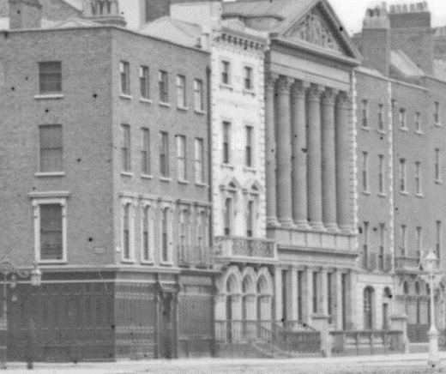

Fig. 2. Image c.1860-1883 from the Stereo Pairs Photograph Collection, held in the National Library of Ireland, showing No.67 shortly after it had ceased operating as the Cow Pock Institution
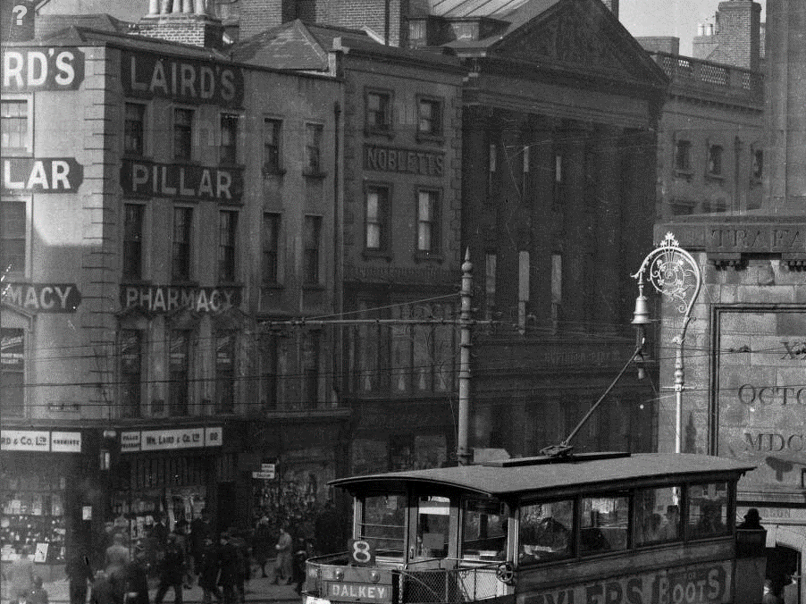

Fig. 3. Image from the Eason Photographic Collection, held in the National Library of Ireland, c.1900-1939 showing No.67 following alterations to façade for Noblett’s confectionary shop

References
- National Inventory of Architectural Heritage Reference 50010532
- Image from the Stereo Pairs Photograph Collection, held by the National Library of Ireland, showing O’Connell Street http://catalogue.nli.ie/Record/vtls000566016/Details#tabnav (accessed 17/08/2021)
- Image from the Eason Photographic Collection, held by the National Library of Ireland, showing O’Connell Street http://catalogue.nli.ie/Record/vtls000557557 (accessed 17/08/2021)
- City of Dublin, held by Ordnance Survey Ireland. © Public domain. Digital content: © Ordnance Survey Ireland, published by UCD Library, University College Dublin, 1847, Sheet 14 http://digital.ucd.ie/view/ucdlib:40835 (accessed 05/10/2021)
- City of Dublin, held by Ordnance Survey Ireland. © Public domain. Digital content: © Ordnance Survey Ireland, published by UCD Library, University College Dublin, 1891, Sheet XVIII.47 http://digital.ucd.ie/view/ucdlib:40897 (accessed 05/10/2021)
- Irish Builder 51, 16 Oct 1909, p.661

Significance/NIAH Rating
No. 67 O’Connell Street Upper was recorded under Stage 1 of the NIAH for Dublin (Ref 50010530) with Ministerial Recommendations for Stage 1 issued to Dublin City Council on 4th June 2014. The structure was assigned a ‘Regional’ rating. These are structures or sites that make a significant contribution to the architectural heritage within their region or area. Structures which are considered of Regional significance are deemed worthy of inclusion on the RPS.

The Conservation Section has considered the Ministerial Recommendation for the property, in tandem with Chapter 2, Section 2.5.2 of the Architectural Heritage Protection Guidelines for Planning Authorities (2011) which states ‘The protection of a façade alone should generally only be considered where there is no surviving interior of any interest, for example where the building has previously been gutted and the façade is the only remaining feature of the original historic building. Generally a façade relates integrally to its building, which may retain interior detail of note including, for example, the original spatial plan, shop-fittings or decorative elements such as chimneypieces, staircases, window shutters or cornices. Elements of the external envelope and/or within the curtilage may also be of intrinsic interest and worthy of protection; these might include the roof, the rear elevation, outbuildings or other site features’ (pg. 24). As such, the Conservation Section considers that 67 O’Connell Street Upper, Dublin 1, in its entirety, merits inclusion on the Record of Protected Structures; thereby extending protection to the entire structure, including its interior.

Assessment of Special Interest under the Planning and Development Act 2000
The National Inventory of Architectural Heritage assigned ARCHITECTURAL interest to No.67 O’Connell Street Upper, Dublin 1. The Conservation Section has considered the opinion of the NIAH and is in agreement with assigning this category of special interest to the site. In addition the Conservation Section has assigned the category of SOCIAL interest to the site due to its use as a centre for the inoculation of the city’s residence against small pox in the first half of the nineteenth-century.

Conclusion & Recommendation
It is recommended that the RPS entry for 67 O’Connell Street Upper, Dublin 1 be amended to 67 O’Connell Street Upper, Dublin 1 – Commercial premises thereby extending protection to the entire structure to include its interior.

Proposed Listing
RPS Ref No | Address | Description
6033 | 67 O’Connell Street Upper, Dublin 1 | Commercial premises

11/11/2021
_______________ ________________
Paraic Fallon Date
Senior Planner

Photographic Record:
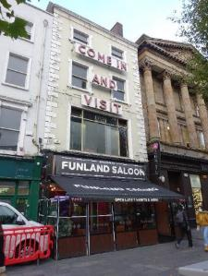 | 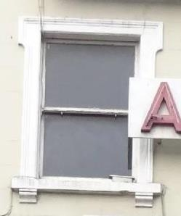
Fig. 4. East elevation from southeast | Fig. 5. Window opening, second floor
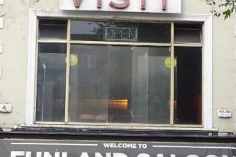

Fig. 6. Window opening, first floor

RPS No. 6034 – 68-69 O'Connell Street Upper (including 31 Henry Street), Dublin 1
Seandálaíocht, Caomhantas & Oidhreacht
An Roinn Pleanála & Forbairt Maoine
Oifigí na Cathrach, An Ché Adhmaid, Baile Átha Cliath 8

Archaeology, Conservation & Heritage Section
Planning & Property Development Department
Block 3, Floor 3, Civic Offices, Wood Quay, Dublin 8

Tel: (01) 222 3926, 222 3927
Email: conservation@dublincity.ie

11th November 2021

Draft Development Plan 2022-2028

Ref: RPS 6034 AMENDMENT of the Record of Protected Structures
_______________________________________________________________________________

Recommendation:
Amendment of current entry for 68 O’Connell Street Upper, Dublin 1 – Commercial premises: upper floor façade, to now read: 68-69 O’Connell Street Upper, Dublin 1 – Commercial Premises extending protection to the entire historic footprint of the structure to include its interior.
_______________________________________________________________________________

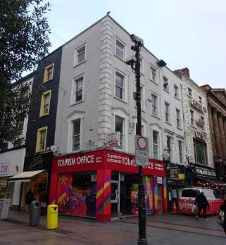

Introduction
There has been a query about whether the RPS entry 68 O’Connell Street Upper, Dublin 1 – Commercial premises: upper floor façade, should be amended to 68-69 O'Connell Street Upper (including 31 Henry Street), Dublin 1 – Commercial Premises. The buildings retains some early fabric internally such as corner fireplaces. Nos.68-69 O’Connell Street Upper and No.31 Henry Street form a significant early survivor within the streetscape of O'Connell Street. Therefore, it is proposed to amend the description to read ‘Commercial premises’ extending protection to the entire historic footprint of the structure to include its interior.

Existing Listing
RPS Ref No | Address | Description
6034 | 68 O’Connell Street Upper, Dublin 1 | Commercial premises: upper floor façade

Proposed Listing
Amend the description to include the extent of the eighteenth-century structure.
RPS Ref No | Address | Description
6034 | 68-69 O'Connell Street Upper (including 31 Henry Street), Dublin 1 | Commercial premises

Request for Investigation
Conservation Section, Dublin City Council

Location and Land Use Zoning
The location of 68 O’Connell Street Upper, Dublin 1 is arrowed red below. The main zoning objective is Zone 5: To consolidate and facilitate the development of the central area, and to identify, reinforce and strengthen and protect its civic design character and dignity. The site is located within the Architectural Conservation Area of O’Connell Street and is also within a designated Conservation Area.
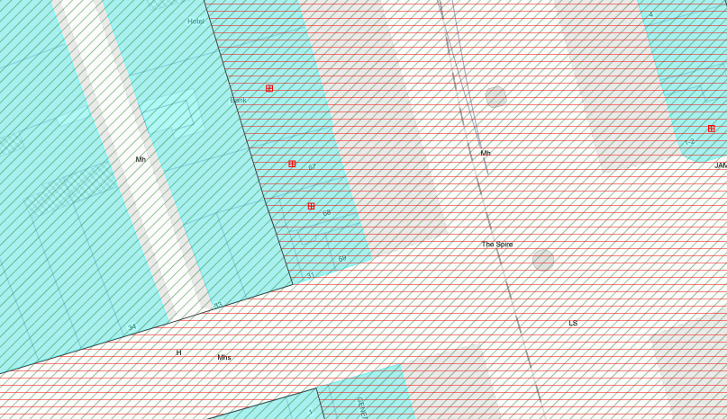
Fig. 1: Location and Land Use Zoning

Recent Planning History
Planning Ref | Description | Decision
2475/01 | Alterations to shopfront and signage (31A Henry Street) | GRANT PERMISSION  20-Dec-2001
4122/04 | Planning permission is being sought for retention of new shop front, signage and canopy at 31A, Henry Street, Dublin 1 for The Irish Chocolate Company Ltd. | GRANT PERMISSION  27/9/2004
5870/04 | Permission is sought to alter the lighting and retain the canopy at previously approved shopfront at 31a Henry Street, Dublin 1, for Butler's Chocolates Ltd. | SPLIT DECISION(PERMISSION & REFUSAL)  18-Feb-2005
2058/11 | PROTECTED STRUCTURE-Planning permission for development at this site at No. 68, 69 O'Connell Street Upper, and No. 31-33 Henry Street, Dublin 1. The site is bounded by Henry Street to the south, O'Connell Street Upper to the east, Henry Place to the west and No. 67 O'Connell Street Upper to the north. The site area is 0.030 ha. No. 68 O'Connell Street Upper is a protected structure. The development will consist of the demolition of no. 32 and 33 Henry Street and the partial demolition and alteration of the interior of no. 68, 69 O'Connell Street Upper and No. 31 Henry Street to facilitate the integration of these buildings. The development will consist of the restoration and refurbishment of the existing upper floor facades of No. 68, 69 O'Connell Street Upper and No. 31 Henry Street. The roof profile of No. 68, 69 O'Connell Street Upper and No. 31 Henry Street will be preserved and refurbished. The existing shop fronts on No. 68, 69 O'Connell Street Upper and No. 31 Henry Street will be replaced with a new shop front. Existing blocked up windows located on the rear of No. 68 O'Connell Street Upper will be reinstated. The existing lightwell located to the rear of No. 68 O'Connell Street Upper will be retained and will be covered by a glass roof at third floor level. A three storey over basement retail unit will be construction in place of No. 32 and 33 Henry Street (Block B) and this unit will be integrated with No. 68, 69 O'Connell Street Upper and No. 31 Henry Street (Block A) to create one retail unit which will be part three storey and part four storey over basement. This unit will have a new shopfront which will integrate with the replacement shopfront on No. 68,69 O'Connell Street Upper and No. 31 Henry Street. The total gross floor area of the proposed development is 1,207sqm of which 560sqm is retained floorspace in No. 68, 69 O'Connell Street Upper and No. 31 Henry Street (Block A) and 647sqm is new floorspace (Block B). The gross floor area of the buildings to be demolished is 661.2sqm. The overall development will comprise 981sqm gross floor area of retail floorspace located at basement, ground, first and second floor level and 226sqm gross floor area of ancillary floorspace including office, storage, plant and staff facilities located at third floor level. A proposed lantern will extend from third floor level in Block B to 4 metres above roof level. The building has a maximum height of 18.9 metres above street level. There will be access to a roof deck area for maintenance purposes only. The retail unit will be accessed from O'Connell Street Upper, Henry Street and Henry Place. The floor levels of the existing basements which partially extend under Henry Street, O'Connell Street Upper and Henry Place will be lowered by 1-1.5 metres. Pavement lights will be placed at street level on Henry Street and Henry Place. The proposal includes the provision of all internal arrangements including lift and stair cores, disabled access arrangements and all site development and ancillary works. | GRANT PERMISSION  31-Jul-2012  ABP Decision PL 29N 239724
2058/11/X1 | As above | Grant Extension of Duration of Permission 24-May-2017

Recent Enforcement History
There is no recent enforcement history on the site.

Summary Description
(See images at end of report)
Description based on National Inventory of Architectural Heritage’s record for site, Ref. 50010529 and 50010493
No.68 O’Connell Street: Terraced two-bay four-storey house over basement, built c.1750 as part of single dwelling with Nos.69 O’Connell Street and 31 Henry Street, now in use as shop and café, with recent shopfront to ground floor. M-profile hipped roof, shared with No.69 to the south, concealed behind rendered parapet with squared granite coping. Red brick chimneystack to party wall with No.67 to north. Ruled-and-lined rendered wall to front (east) elevation, having cast-iron hopper and downpipe breaking through parapet to north of elevation. Brown brick wall to rear elevation laid in English garden wall bond. Diminishing square-headed window openings having moulded render surrounds, rendered reveals, granite sills and one-over-one timber sliding sash windows with ogee horns. Moulded granite cornices and carved brackets to window surrounds to first floor. Two-bay two-storey building to rear of site facing onto Henry Place of machine-made red brick laid in Flemish bond with pitched roof. Gauged brick square-headed window openings to west and north elevations with metal security bars.

No.69 O’Connell Street: Corner-sited four-storey house, built c.1750 as part of single dwelling with Nos.68 O’Connell Street and 31 Henry Street, having three-bay elevation to O'Connell Street and single bay to Henry Street,. Now in use as shop and having recent shopfront to ground floor. M-profile hipped roof, shared with No.68 to the north, with red brick chimneystack having clay chimneypots concealed behind ruled-and-lined rendered parapet wall with masonry coping. Ruled-and-lined rendered walls with block-and-start quoins to upper floors. Diminishing square-headed window openings having masonry sills and rendered architrave surrounds, those to first floor having shouldered pediments with cornices. One-over-one timber sash windows to first and second floors. Replacement timber-framed windows to third floor.

No.31 Henry Street: Terraced single-bay four-storey house, built c.1750, as part of single dwelling with Nos.68 and 69 O’Connell Street. Now in use as café with recent shopfront to ground floor. Hipped roof, shared with No.68 to the north, concealed behind ruled-and-lined rendered parapet wall with masonry coping. Ruled-and-lined rendered walls with block-and-start quoins to upper floors. Diminishing square-headed window openings having stone sills, rendered architrave surrounds and six-over-six (first and second floor) and three-over-three (third floor) timber sash windows.

Assessment
The plot currently occupied by Nos.68 and 69 O’Connell Street Upper and No.31 Henry Street were constructed c.1750 as part of the development of Gardiner’s Mall which saw the demolition of the west side of what was then known as Drogheda Street to form the new Gardiner’s Mall, also known as Sackville Street. John Rocque’s map of 1757 (see Fig. 2) shows a wide structure across what now equates to Nos.68 and 69. It does not appear that the plot ran all the way west to the rear lane (now Henry Lane), with two dwellings indicated fronting onto Henry Street. Historic images from the nineteenth-century show a five-bay four-storey structure on the site, of brick construction with a shopfront at ground floor level and a diminishing fenestration pattern (see Fig. 3). The Ordnance Survey map of 1847 indicates that the building was subdivided by then with the Nos.68 and 69 annotating the plot. An image from the early twentieth-century provides clear evidence of the division of the building with separate shopfronts, signage and the southern three-bays displaying a different decorative treatment of the windows than those of the northern two bays at ground floor level. No.31 Henry Street, to the immediate west of No.69, may have become an independent structure by the mid-nineteenth-century. The image shown at 0 appears to show a change in shopfront at No.31 while a continuous shopfront is shown at Nos. 68 and 69.

Though the original plot has been subdivided into three since the nineteenth-century, the original eighteenth-century house is clearly identifiable. Planning permission was granted in 2012, with a detailed Architectural Heritage Assessment submitted as part of the application, to return the three elements to a single structure reflecting its original planform as much as possible. The report and floor plans submitted with the planning application demonstrate that the building retains some early fabric internally such as corner fireplaces. Nos.68-69 O’Connell Street Upper and No.31 Henry Street form a significant early survivor within the streetscape of O'Connell Street, and is a valuable reminder of the former residential nature of the street.
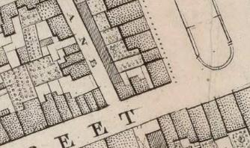

Fig. 2: Extract from Rocque’s An Exact Survey of the City and Suburbs of Dublin (1756) with location of Nos. 68 & 69 O’Connell Street Upper and No. 31 Henry Street arrowed red, indicating original single building occupied site
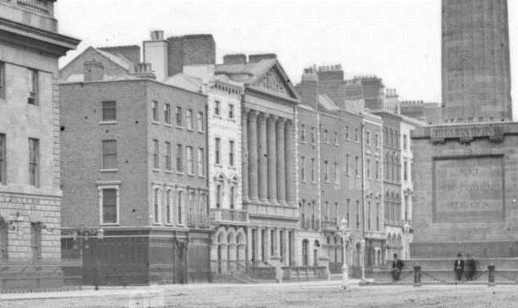

Fig. 3: Image c.1860-1883 from Stereo Pairs Photograph Collection, held in the National Library of Ireland, showing No.68/69 as a single structure
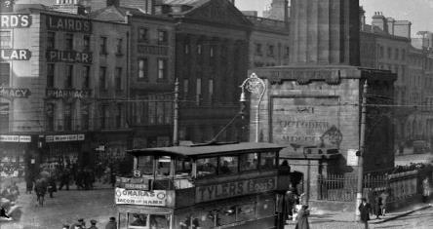

Fig. 4: Image from the Eason Photographic Collection, held in the National Library of Ireland, c.1900-1939 showing Nos.68 & 69 following alterations to the façades.

References
- National Inventory of Architectural Heritage Reference 50010529 and 50010493
- Image from the Stereo Pairs Photograph Collection, held by the National Library of Ireland, showing O’Connell Street http://catalogue.nli.ie/Record/vtls000566016/Details#tabnav (accessed 17/08/2021)
- Image from the Eason Photographic Collection, held by the National Library of Ireland, showing O’Connell Street http://catalogue.nli.ie/Record/vtls000557557 (accessed 17/08/2021)
- City of Dublin, held by Ordnance Survey Ireland. © Public domain. Digital content: © Ordnance Survey Ireland, published by UCD Library, University College Dublin, 1847, Sheet 14 http://digital.ucd.ie/view/ucdlib:40835 (accessed 05/10/2021)
- City of Dublin, held by Ordnance Survey Ireland. © Public domain. Digital content: © Ordnance Survey Ireland, published by UCD Library, University College Dublin, 1891, Sheet XVIII.47 http://digital.ucd.ie/view/ucdlib:40897 (accessed 05/10/2021)
- Rocque, J. An Accurate Survey of the City and Suburbs of Dublin with Additions, and Improvements ; By Mr. Bernard Scalé, 1756 https://gallica.bnf.fr/ark:/12148/btv1b53119647z/f2.item (accessed 08/10/2021)

Significance/NIAH Rating
Nos. 68 and 69 O’Connell Street Upper were recorded under Stage 1 of the NIAH for Dublin (Ref 50010529 and 50010493 respectively) with Ministerial Recommendations for Stage 1 issued to Dublin City Council on 4th June 2014. The structures were both assigned a ‘Regional’ rating. These are structures or sites that make a significant contribution to the architectural heritage within their region or area. Structures which are considered of Regional significance are deemed worthy of inclusion on the RPS.

The Conservation Section has considered the Ministerial Recommendation for the property, in tandem with Chapter 2, Section 2.5.2 of the Architectural Heritage Protection Guidelines for Planning Authorities (2011) which states ‘The protection of a façade alone should generally only be considered where there is no surviving interior of any interest, for example where the building has previously been gutted and the façade is the only remaining feature of the original historic building. Generally a façade relates integrally to its building, which may retain interior detail of note including, for example, the original spatial plan, shop-fittings or decorative elements such as chimneypieces, staircases, window shutters or cornices. Elements of the external envelope and/or within the curtilage may also be of intrinsic interest and worthy of protection; these might include the roof, the rear elevation, outbuildings or other site features’ (pg. 24). As such, the Conservation Section considers that the historic structure at 68-69 O’Connell Street Upper, (including 31 Henry Street), Dublin 1, in its entirety, merits inclusion on the Record of Protected Structures.

Assessment of Special Interest under the Planning and Development Act 2000
The National Inventory of Architectural Heritage assigned ARCHITECTURAL interest to Nos.68 and 69 O’Connell Street Upper. The Conservation Section has considered the opinion of the NIAH and is in agreement with assigning this category of special interest to the two sites.

Conclusion & Recommendation
It is recommended that the RPS entry for 68 O’Connell Street Upper, Dublin 1 be amended to now read: 68-69 O’Connell Street Upper, Dublin 1 – Commercial Premises, extending protection to the entire historic footprint of the structure to include its interior, as follows:

Proposed Listing
RPS Ref No | Address | Description
6034 | 68-69 O'Connell Street Upper (including 31 Henry Street), Dublin 1 | Commercial premises

11/11/2021
_______________ ________________
Paraic Fallon Date
Senior Planner

Photographic Record:
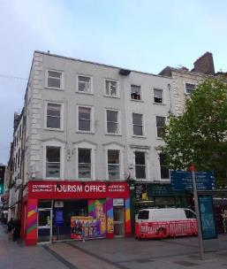 | 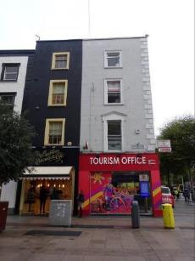
Fig. 5: East elevation of Nos.68-69 O’Connell Street Upper | Fig. 6: South elevation of No.69 O’Connell Street Upper and 31 Henry Street
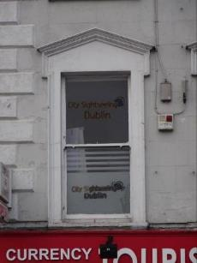 | 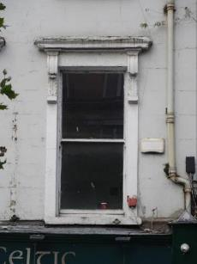
Fig. 7: Window opening, first floor of No.69 O’Connell Street Upper | Fig. 8: Window opening, first floor of No.68 O’Connell Street Upper

RPS No. 6707 – 1-2 Phibsborough Road, Royal Canal Terrace Dublin 7
Seandálaíocht, Caomhantas & Oidhreacht
An Roinn Pleanála & Forbairt Maoine
Oifigí na Cathrach, An Ché Adhmaid, Baile Átha Cliath 8

Archaeology, Conservation & Heritage Section
Planning & Property Development Department
Block 3, Floor 3, Civic Offices, Wood Quay, Dublin 8

Tel: (01) 222 3926, 222 3927
Email: conservation@dublincity.ie

1st November 2021

Draft Development Plan 2022-2028

Ref: RPS 6707 & 6708 AMENDMENT of the Record of Protected Structures
_______________________________________________________________________________

Recommendation:

Amendment of RPS 6707 and deletion of RPS 6708:

Amendment of RPS 6707: RPS 6707 - 1 Phibsborough Road, Royal Canal Terrace Dublin 7 - Terraced house, including stone wall, railings and gates to now read RPS 6707 – 1-2 Phibsborough Road, Royal Canal Terrace Dublin 7 - House

Deletion of 6707: RPS 6708 – 2 Phibsborough Road, Royal Canal Terrace Dublin 7 - Terraced house, including stone wall, railings and gates
_______________________________________________________________________________

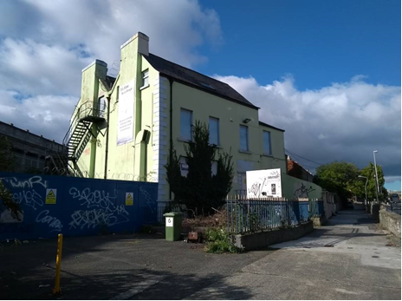

Introduction
Numbers 1 and 2 Phibsborough Road is one building but has two separate entries in the RPS (6707 & 6708). The building description is also incorrect. RPS 6707 should be amended to include number 2 Phibsborough Road and the new description should read ‘House’. As a result of this amendment, RPS 6708 should be deleted.

Existing Listing 2016-2022
RPS Ref | House No | Address | Postal Code | Description
6707 | 1 | Phibsborough Road, Royal Canal Terrace Dublin 7 | Dublin 7 | Terraced house, including stone wall, railings and gates
6708 | 2 | Phibsborough Road, Royal Canal Terrace Dublin 7 | Dublin 7 | Terraced house, including stone wall, railings and gates

Proposed Listing 2022-2028
RPS Ref | House No | Address | Postal Code | Description
6707 | 1 & 2 | Phibsborough Road, Royal Canal Terrace | Dublin 7 | House

Delete following entry
RPS Ref | House No | Address | Postal Code | Description
6708 | 2 | Phibsborough Road, Royal Canal Terrace | Dublin 7 | Terraced house, including stone wall, railings and gates

Request for Amendment
It was identified by Dublin City Council that the address and description for 1 and 2 Phibsborough Road required updating. Furthermore, Dublin City Council was issued with a Ministerial Recommendation on the 4th of June 2014 from the Minister for Culture, Heritage and the Gaeltacht (now Minister for Housing, Local Government and Heritage) to include the building on the Dublin City Record of Protected Structures.

Location and Land Use Zoning
No. 1-2 Phibsborough Road, Royal Canal Terrace Dublin 7 is located on the west side of Phibsborough Road, abutting the eastern edge of Broadstone. The area is zoned Z2 and the zoning objective for the area is: To protect and/or improve the amenities of residential conservation areas.
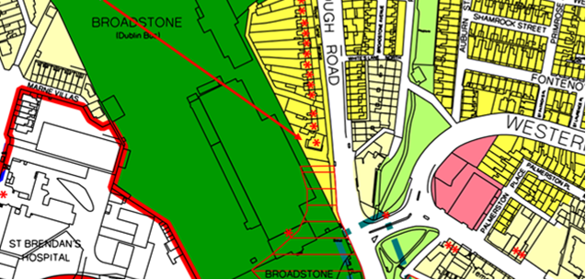
Fig. 1: Location and Land Use Zoning

Relevant Planning History
Planning Ref. | Description | Decision Date
3258/20 | PROTECTED STRUCTURE: Permission is sought for the following works: Change of use from Hostel (established as pre 1963 use), residential and office (subsequent planning retention grant 4763/88) to Aparthotel. Demolition/removals of: steel staircase to the side, single storey extension to the rear, kitchen extract flue to the side, raised concrete paving to the front and tarmac to the side and rear, modern railings and lightwell to the side; modern shower room partitions to basement floor (BF) room (R) R1, first floor (FF) R5 and R6 and second floor (SF) R1 and R2, all sanitaryware, services, kitchenettes, floor coverings, modern flush doors and modern aluminium windows throughout; lobby partitions at ground floor (GF) R3 and the lobby door to the basement hall. Alterations to: extend lightwell to the front, create new gable walls to lightwells front and rear, block-up window at SF gable and doors at BF and SF gable, add fire-rated mat system to FF and SF floors, reconfigure partitions to FF R2, R3 & R4 and to SF R3 and close the doorway between FF R6 and the stairs; new connecting door between rooms SF R2 and R3. Construction of: single storey building to the rear and a three storey extension to the side, new light timber partitions forming new shower rooms throughout, new wall forming a lobby to the BF Hall, new plumbing, heating and electrics using existing routes throughout, new painted timber sash windows throughout, new waterproofing system to new basement insulated concrete floor slab and basement walls, breathable lime-based insulation to right-hand ‘wing’ external walls; new hard and soft landscaping to entire site, additional railings to secure the site to the front left corner and a new sliding gate inside the front railings. Clean, repair and paint cast iron railings to the front; clean granite steps, cills and string course; decorate previously decorated elements inside and out, local repairs to plaster cornices including the replacement of a short length to room FF R1 and all associated works. | 21 Oct 2020: Refuse Permission

Relevant Planning Enforcement History
File Ref | Date Opened | Problem Description | Date Closed | Reason for closure
E0512/14 | 10-Jul-2014 | Change of use from school to hostel use | File still open

Summary Description
(See images at end of report)
Detached, three-bay, two-storey over basement, former house, built c.1750, having two-storey single-bay extension to north elevation. In use as language school until recently, now derelict.

M-profile pitched slate roof, cast-iron rainwater goods, rendered chimneystacks abutting south elevation and to extension, rooflight to front (east) elevation. Rendered walls, render string course over basement, render block-and-start quoins. Square-headed window openings throughout, painted masonry sills and replacement uPVC windows now boarded up. Some steel grilles to windows to rear (west) elevation. Round-headed door opening to front, channelled render surround, moulded lintel, cobweb fanlight over timber panelled door, opening onto granite steps, flanked by cast-iron railings. Door opening now boarded up. Cast-iron railings enclosing curtilage to front.

Assessment
The Royal Canal was constructed in 1792, connecting the Liffey in Dublin with the Shannon in Longford, as a means of bringing goods and passenger transport from the midlands to the capital city and port of Dublin. An important infrastructural development, its initial success is apparent in the residential development it prompted in the Phibsborough area, adjacent to the Broadstone line, a branch of the canal which linked to the Grand Canal. This substantial house (1-2 Phibsborough Road) is listed as ‘Royal Canal House’ on the third edition Ordnance Survey map and may have had a commercial function associated with the canal. Although it has lost some of its original fabric, this building makes a strong impression on the streetscape due to its prominent location and scale, and its form and character is retained.

It was identified by Dublin City Council that the address and description for 1 and 2 Phibsborough Road required updating. Numbers 1 and 2 Phibsborough Road is actually one building but has two separate entries in the RPS (6707 & 6708). The building description is also incorrect. Therefore RPS 6707 should be amended to include number 2 Phibsborough Road and the new description should read ‘House’. As a result of this amendment, RPS 6708 should be deleted.

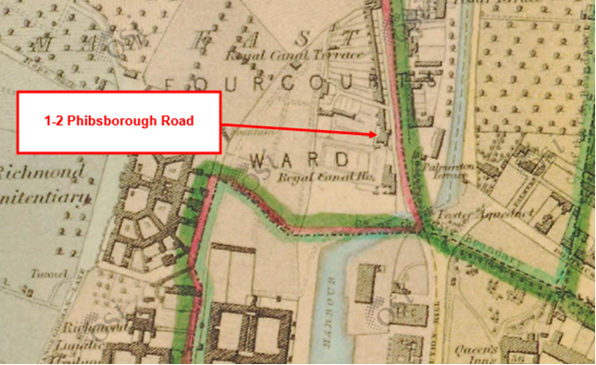
Figure 2: First Edition Ordnance Survey Map showing building

References
NIAH Entry, Reg No: 50070371: https://www.buildingsofireland.ie/buildings-search/building/50070371/success-college-1-phibsborough-road-dublin-7-dublin

Significance/NIAH Rating
1-2 Phibsborough Road, Dublin 7 was recorded under Stage 1 of the NIAH for Dublin (Ref 50070371) with Ministerial Recommendations for Stage 1 issued to Dublin City Council on the 4th of June 2014. The structure was assigned a ‘Regional’ rating. These are structures or sites that make a significant contribution to the architectural heritage within their region or area. Structures which are considered of Regional significance are deemed worthy of inclusion on the RPS.

Assessment of Special Interest under the Planning and Development Act 2000
The National Inventory of Architectural Heritage assigned this building Architectural, Artistic and Social interest. The Conservation Section has considered the opinion of the NIAH and is in agreement with assigning the ARCHITECTURAL ARTISTIC and SOCIAL categories of special interest to the building.

Conclusion & Recommendation
It is recommended that RPS 6707 be amended to include number 2 Phibsborough Road and the new description should read ‘House’. As a result of this amendment, RPS 6708 should be deleted.

Proposed Amendment to RPS 6707
RPS Ref | House No | Address | Postal Code | Description
6707 | 1 & 2 | Phibsborough Road, Royal Canal Terrace | Dublin 7 | House

Proposed Deletion of RPS 6708
RPS Ref | House No | Address | Postal Code | Description
6708 | 2 | Phibsborough Road, Royal Canal Terrace | Dublin 7 | Terraced house, including stone wall, railings and gates

01/11/2021
_______________ ________________
Paraic Fallon
Senior Planner Date

Photographic Record:
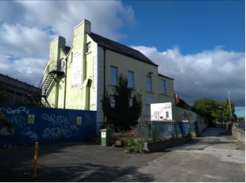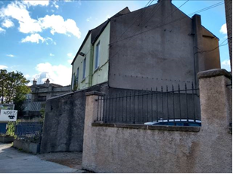
Figure 3: View of front and side elevations of 1 & 2 Phibsborough Road, Royal Canal Terrace, Dublin 7.

RPS No. 7217 - 126 Rathmines Road Lower, Dublin 6
Seandálaíocht, Caomhantas & Oidhreacht
An Roinn Pleanála & Forbairt Maoine
Oifigí na Cathrach, An Ché Adhmaid, Baile Átha Cliath 8

Archaeology, Conservation & Heritage Section
Planning & Property Development Department
Block 3, Floor 3, Civic Offices, Wood Quay, Dublin 8

Tel: (01) 222 3926, 222 3927
Email: conservation@dublincity.ie

1st November 2021

Draft Development Plan 2022-2028

Ref: RPS 7217 & 7215 AMENDMENT of the Record of Protected Structures
_______________________________________________________________________________

Recommendation:

Amendment of RPS 7217 and deletion of RPS 7215:

Amendment RPS 7217 - current entry for 126 Rathmines Road Lower, Dublin 6 – House and business premises, to now read: 126 Rathmines Road Lower, Dublin 6 – House (also known as 122 Rathmines Road, Lower).

Deletion of 7215: RPS 7215 – 122 Rathmines Road Lower, Dublin 6 – House and business premises.
_______________________________________________________________________________

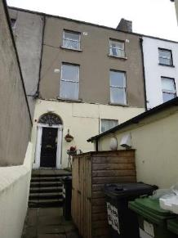

Introduction
No.126 Rathmines Road Lower, Dublin 6 is on the current Record of Protected Structures (Dublin City Development Plan 2016-2022). The reference number is RPS: 7217 and the description reads ‘House and business premises’. The property is also known as No.122 Rathmines Road Lower, Dublin 6. A separate RPS entry has been provided for this address under reference number RPS: 7215 with a description of ‘House and business premises’. No.126 and No.122 Rathmines Road Lower, Dublin 6 are one and the same property with RPS: 7217 and RPS: 7215 constituting duplicate entries. It is proposed to rationalise the RPS entry for this structure by deleting the duplicate entry and to remove the reference to ‘business premises’ as the property is in residential use. Amendment of the written RPS description for RPS: 7217 for No.126 Rathmines Road Lower, Dublin 6 is proposed, to read ‘House (also known as 122 Rathmines Road, Lower)’. As a result it is proposed to delete the duplicate entry listed as RPS 7215 for No. 122 Rathmines Road Lower, D6.

Existing Listing for RPS 7217:
RPS Ref No | Address | Description
7217 | 126 Rathmines Road Lower, Dublin 6 | House and business premises

Proposed Listing for RPS 7217: Amend description to reflect the dual address of the property. It also proposed to amend the description to read ‘House’ only.
RPS Ref No | Address | Description
7217 | 126 Rathmines Road Lower, Dublin 6 | House (also known as 122 Rathmines Road, Lower)

Delete Following Entry for RPS 7215:
RPS Ref No | Address | Description
7215 | 122 Rathmines Road Lower, Dublin 6 | House and business premises

Request for Investigation
Conservation Section, Dublin City Council

Location and Land Use Zoning
The location of No.126 Rathmines Road Lower, Dublin 6 (also known as No.122 Rathmines Road Lower) is indicated by the red arrow below. The zoning objective for the site is Zone 4: To provide for and improve mixed-services facilities.
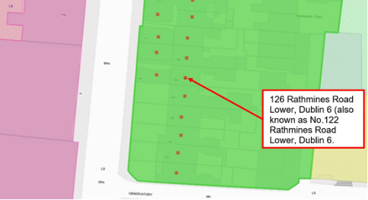
Fig.1: Location and Land Use Zoning

Relevant Planning History
There are a number of planning applications recorded in relation to the subject site which list the address as No.126 Rathmines Road Lower, Dublin 6 (Planning Ref: 1749/95, 2418/95 and 0335/99).

Relevant Planning Enforcement History
Three is no relevant planning enforcement history for the subject site.

Summary Description
(See images at end of report).
Terraced two-bay three-storey house over raised basement built c.1820 having single storey business premises to front (former front garden). The single-storey business premises is listed under separate address, as No.124 Rathmines Road Lower.

Assessment
The current Record of Protected Structures (Dublin City Development Plan 2016-2022) includes separate entries for No.126 Rathmines Road Lower, Dublin 6 (RPS ref: 7217) and No.122 Rathmines Road Lower Dublin 6 (RPS ref: 7215). The current description for both entries read ‘House and business premises’. Research in the Registry of Deeds and the Land Registry confirms that No.126 and No.122 Rathmines Road Lower, Dublin 6 are one and the same property. As such, RPS: 7217 for No.126 Rathmines Road Lower, Dublin 6 and RPS: 7215 for No.122 Rathmines Road Lower, Dublin 6 constitute duplicate entries.

It is proposed to rationalise the RPS entry for this structure by deleting the duplicate entry and to remove the reference to ‘business premises’ as the property is solely in residential use (multiple occupancy). Note that the single-storey business premises to the front (former front garden) is listed as No.124 Rathmines Road Lower and is individually protected under RPS ref: 7216 with the description reading ‘Business premises’ – no change is proposed to RPS ref: 7216. Amendment of the written RPS description for RPS: 7217 for No.126 Rathmines Road Lower, Dublin 6 is proposed, to read ‘House (also known as 122 Rathmines Road, Lower)’. It is also proposed to delete the duplicate entry listed as RPS 7215 for No. 122 Rathmines Road Lower, D6.

References
- Ordnance Survey Mapping.
- Registry of Deeds.
- Land Registry.

Significance/NIAH Rating
The area is currently being surveyed as part of the ongoing NIAH Dublin Survey. There is currently no NIAH record or Ministerial Recommendations for the site.

Assessment of Special Interest under the Planning and Development Act 2000
The Conservation Section, assigns ARCHITECTURAL interest to No.126 Rathmines Road Lower, Dublin 6 (also known as No.122 Rathmines Road Lower, Dublin 6).

Conclusion & Recommendation
It is recommended that the RPS description for RPS ref: 7217 for No.126 Rathmines Road Lower, Dublin 6 be amended to – ‘House (also known as No.122 Rathmines Road, Lower)’. It is also recommended to delete the duplicate entry for the property listed as RPS 7215 for No. 122 Rathmines Road Lower, D6.

Proposed Listing
RPS Ref No | Address | Description
7217 | 126 Rathmines Road Lower, Dublin 6 | House (also known as 122 Rathmines Road, Lower)

01/11/2021
_______________ ________________
Paraic Fallon
Senior Planner Date

Photographic Record:
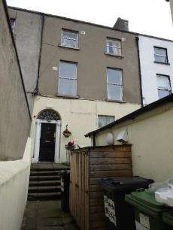 | 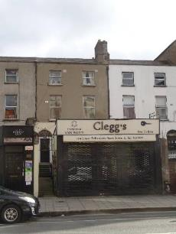
Fig.2: Principal elevation of No.126 Rathmines Road Lower (also known as No.122 Rathmines Road, Lower). | Fig.3: Aspect showing No.126 Rathmines Road Lower (also known as No.122 Rathmines Road, Lower) in context. Note the business premises to front is No.124 Rathmines Road Lower.
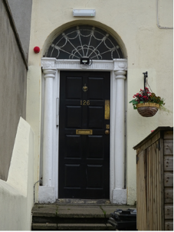
Fig.4: Detail of door to No.126 Rathmines Road Lower (also known as No.122 Rathmines Road, Lower) with door number reading ‘126’.

RPS No. 7430 - 37 Sandford Road, Dublin 6
Seandálaíocht, Caomhantas & Oidhreacht
An Roinn Pleanála & Forbairt Maoine
Oifigí na Cathrach, An Ché Adhmaid, Baile Átha Cliath 8

Archaeology, Conservation & Heritage Section
Planning & Property Development Department
Block 3, Floor 3, Civic Offices, Wood Quay, Dublin 8

Tel: (01) 222 3926, 222 3927
Email: conservation@dublincity.ie

1st November 2021

Draft Development Plan 2022-2028

Ref: RPS 7430 AMENDMENT of the Record of Protected Structures
_______________________________________________________________________________

Recommendation:
Amendment of current entry for RPS ref: Sandford Road, Dublin 6 – Single-storey lodge to front of Sandford Parish Church, to now read: 37 Sandford Road, Dublin 6 – Single-storey lodge to front of Sandford Parish Church.
_______________________________________________________________________________

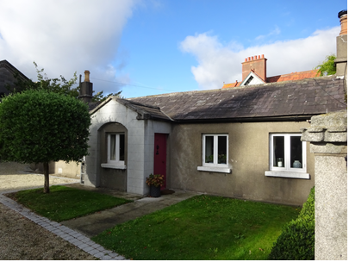

Introduction
The former gate lodge to the front of Sandford Parish Church at Sandford Road, Dublin 6 is on the current Record of Protected Structures (Dublin City Development Plan 2016-2022). The reference number is RPS: 7430 and the description reads ‘Single-storey lodge to front of Sandford Parish Church. The structure was added to the Record of Protected Structures by Resolution of Dublin City Council in May 2002 (Report of Assistant City Manager Report No.122/02) with the address given as No.37 Sandyford Road, Dublin 6. The current RPS address field for RPS ref: 7430 does not include a street number. Amendment of the RPS entry is proposed to reflect the full postal address, including street number. The description shall remain unaltered.

Existing Listing:
RPS Ref No | Address | Description
7430 | Sandford Road, Dublin 6 | Single-storey lodge to front of Sandford Parish Church

Proposed Listing: Amend address to reflect the full postal address, including street number.
RPS Ref No | Address | Description
7430 | 37 Sandford Road, Dublin 6 | Single-storey lodge to front of Sandford Parish Church

Request for Investigation
Conservation Section, Dublin City Council

Location and Land Use Zoning
The location of the former gate lodge to the front of Sandford Parish Church at Sandford Road, Dublin 6 is indicated by the red arrow below. The zoning objective for the site is Zone 2: To protect and/or improve the amenities of residential conservation areas.
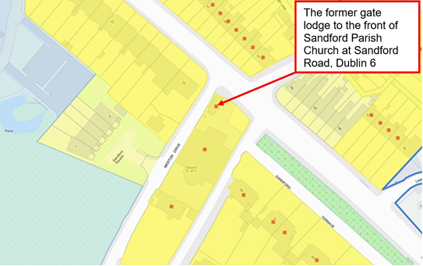
Fig.1: Location and Land Use Zoning

Relevant Planning History
There is no relevant planning history for the subject site.

Relevant Planning Enforcement History
There is no relevant planning enforcement history for the subject site.

Summary Description
(See images at end of report).
Detached single-storey five-bay former gate lodge built c.1830 to front of Sandford Parish Church. The building was originally built as one of a pair flanking the entrance forecourt to the church.

Assessment
The former gate lodge to the front of Sandford Parish Church at Sandford Road, Dublin 6 was added to the Record of Protected Structures by Resolution of Dublin City Council in May 2002 (Report of Assistant City Manager Report No.122/02). The address as approved by resolution of the city council was recorded as ‘No.37 Sandyford Road, Dublin 6’. The EIRCode entry for the property as well as Dublin City Councils GIS mapping address point for the site both list the structure as No.37 Sandford Road, Dublin 6. The current RPS address field for RPS ref: 7430 does not include a street number. Amendment of the RPS entry is proposed to reflect the full postal address, including street number. As such, it is recommended to amend the address field for RPS ref: 7430 to read ‘37 Sandford Road, Dublin 6’. The description shall remain unaltered.

References
- Ordnance Survey Mapping.
- Registry of Deeds.
- Land Registry.

Significance/NIAH Rating
The area is currently being surveyed as part of the ongoing NIAH Dublin Survey. There is currently no NIAH record or Ministerial Recommendations for the site.

Assessment of Special Interest under the Planning and Development Act 2000
The Conservation Section, assigns ARCHITECTURAL interest to 37 Sandford Road, Dublin 6.

Conclusion & Recommendation
It is recommended that the RPS address field for RPS ref: 7430 be amended to ‘37 Sandford Road, Dublin 6’.

Proposed Listing
RPS Ref No | Address | Description
7430 | 37 Sandford Road, Dublin 6 | Single-storey lodge to front of Sandford Parish Church

01/11/2021
_______________ ________________
Paraic Fallon
Senior Planner Date

Photographic Record:
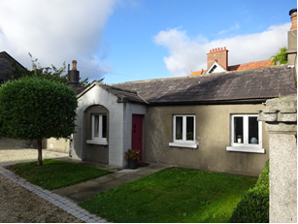 | 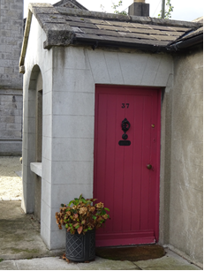
Fig.2: Principal elevation of 37 Sandford Road, Dublin 6. | Fig.3: Detail of door to 37 Sandford Road with door number reading ‘37’.

RPS No. 7468 - 12, 13, 14a, 14b, 14c & 14d Sandymount Green, Dublin 4
Seandálaíocht, Caomhantas & Oidhreacht
An Roinn Pleanála & Forbairt Maoine
Oifigí na Cathrach, An Ché Adhmaid, Baile Átha Cliath 8

Archaeology, Conservation & Heritage Section
Planning & Property Development Department
Block 3, Floor 3, Civic Offices, Wood Quay, Dublin 8

Tel: (01) 222 3926, 222 3927
Email: conservation@dublincity.ie

12th November 2021

Draft Development Plan 2022-2028

Ref: RPS 7468 AMENDMENT of the Record of Protected Structures
_______________________________________________________________________________

Recommendation:
Amendment of current entry for Sandymount Green, Dublin 4 – Sandymount Castle to now read: 12, 13, 14a, 14b, 14c & 14d Sandymount Green, Dublin 4 – Former Sandymount Castle.
_______________________________________________________________________________

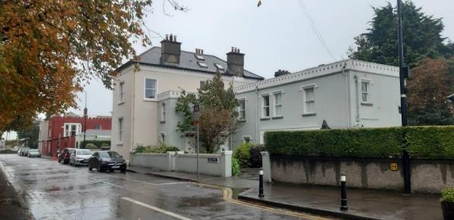

Introduction
There has been a query about whether the RPS entry Sandymount Green, Dublin 4 – Sandymount Castle, should be amended to 12, 13, 14a, 14b, 14c & 14d Sandymount Green, Dublin 4 – Former Sandymount Castle. The former Sandymount Castle was subdivided into multiple structures in the 20th century and the current RPS entry allows some ambiguity with regard to what is protected. It is requested that the entry be amended to provide clarity on the full extent of the protected structure.

Existing Listing
RPS Ref No | Address | Description
7468 | Sandymount Green, Dublin 4 | Sandymount Castle

Proposed Listing
Amend the description to include the extent of the eighteenth-century structure.
RPS Ref No | Address | Description
7468 | 12, 13, 14a, 14b, 14c & 14d Sandymount Green, Dublin 4 | Former Sandymount Castle

Request for Investigation
Conservation Section, Dublin City Council

Location and Land Use Zoning
The location of Nos. 12, 13, 14a, 14b, 14c & 14d Sandymount Green, Dublin 4, is outlined in red below. The main zoning objective is Z2: To protect and/or improve the amenities of residential conservation areas. The buildings are also located within the Architectural Conservation Area for Sandymount Village. Note the positioning of the red asterisks denoting the protected structure is at the western extremity of the structure.
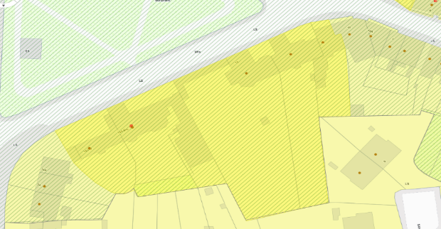
No.12
No.13
Nos.14a & 14b
Nos.14c & 14d
Fig. 1: Site Location & Zoning Map

Recent Planning History
Planning Ref | Description | Decision
0201/07 | Internal alterations. | Grant Exemption Certificate  17 Apr 2007
5747/07 | PROTECTED STRUCTURE - Development comprising:  a) general alterations, repairs and refurbishment to the interior and exterior of the house;  b) demolition and rebuilding of two storey extension to rear to accommodate new utility room and bathroom;  c) new single storey glazed dining room extension to rear;  d) reglazing and new roofing to existing side conservatory;  e) removal/replacement of asbestos slates to main roof and all ancillary works to the property.  12 Sandymount Green | GRANT PERMISSION  28 Jan 2008
3010/15 | PROTECTED STRUCTURE: Construction of a two-storey extension, including a first floor terrace, to the rear of dwelling.  14c & 14d, Sandymount Green | GRANT PERMISSION  15 Sep 2015
WEB1096/16 | The demolition of existing lean-to extension to the side and 2-storey extension and sunroom to the rear and replacement with 2-storey flat roof extension to the side, and part single storey, part 2-storey flat roof extension to the rear, new vehicular access onto Sandymount Green and all ancillary site works.  12 Sandymount Green | GRANT PERMISSION  12 Sep 2016
WEB1497/16 | Permission is sought for minor alteration works for 2 no. car parking spaces comprising (i) part demolition of front boundary wall (north elevation) to provide for a new 2.6 metres vehicular entrance onto Sandymount Green (ii) relocation and repair of existing pedestrian gate (iii) installation of galvanised steel-framed and hardwood sheeted sliding vehicular access gate to match 1.2 metre high wall and (iv) all associated works necessary to facilitate the development at Castleville, 12 Sandymount Green, Sandymount, Dublin 4, by David Leahy. | REFUSE PERMISSION  06 Jun 2017  ABP Ref: PL29S.248096
0338/17 | EXPP - Partial demolition of rear boundary wall which is dilapidated & reinstatement.  12 Sandymount Green | Grant Exemption Certificate  03 Oct 2017
4635/19 | Permission sought for provision of single storey rear extension, demolition of rear chimney, part re-roofing works, window replacements, provision of solar panels to rear and associated ancillary works at Castleton, 13 Sandymount Green, Dublin 4, D04 N156 for Kerril & Louise Burke. Castleton is located in Sandymount Architectural Conservation Area. | GRANT PERMISSION  20 Mar 2020

Recent Enforcement History
Ref. No. | Opened | Reason | Closed | Reason
F0017/18 | 16-Feb-2018 | Non-compliance with financial condition no.2 pp WEB1096/16  12 Sandymount Green | 20-Mar-2018 | Condition complied with
E0778/21 | 21-Sep-2021 | Non-compliance with con 3 attached to PP 4635/19 – Working Hours  13 Sandymount Green

Summary Description
(See images at end of report)
Sandymount Castle, built c.1820, is located on the southeast side of Sandymount Green, historically occupying the entirety of this flank of the Green. The house has been converted into a number of separate residential units. Originally, the house appears to have comprised a two-storey over basement U-plan structure (now Nos. 12 & 13) with canted entrance to central recessed block providing access from Sandymount Green. A shallow structure (now largely demolished) ran southwest from this structure leading to a further group of structures now comprising a four-bay, two-storey house, L-shaped in plan, with a five-bay, two-storey, L-shaped range attached to the southwest side (now Nos. 14a-14d). Part of this structure appears to have functioned as carriage house, evidenced by the remains of carriage openings to the north elevation at the western end. Hipped slate roofs predominate with some pitched roofs visible. Battlemented parapets hide the roof to the eastern sections of the building and to the southwest range. A square-profile battlemented tower is located to the east end of the western house. Walls are rendered throughout. The window openings to the group vary with square-headed and pointed arch openings containing a mix of one-over-one sash windows (some with painted margin lights), six-over-six sash windows and timber casement windows. Windows to the western building have moulded surrounds. Full-height canted bay windows and oriel windows can be seen to the rear and side elevations. The historic door opening is now blocked with later door openings added to Nos. 12 and 13. A square-headed door opening with moulded surround and timber panelled surround accessed via a flight of steps provides access to No.14b. Square-headed door opening c.1900 with timber and glass panelled door provides access to No.14a.

Assessment
Sandymount Castle, originally named Sandymount House on the first edition Ordnance Survey (c.1847), was constructed in the early decades of the nineteenth-century. Mapping indicates that Sandymount House occupied the western end of the site, though the U-plan eastern structure is also indicated. Extensive alterations were carried out in the mid-nineteenth-century, the results of which can be seen on the 1865 Ordnance Survey map revision. The building was embellished with battlemented parapets and the addition of canted bay elements and turrets. The detailing of these embellishments is uniform across the group of structures, attesting to their relationship. The 1865 Ordnance Survey names the eastern structure as Sandymount Castle with a newly constructed link building running westwards to what was previously Sandymount House. Extensive gardens are shown laid out to the south of the grouping. A historic image, ascribed as Sandymount Castle, shows a group sitting outside a porch with battlemented turrets. This is the west elevation of what is now No.13. A twentieth-century L-plan range now occupies part of this area of the former garden. A map of Dublin accompanying a later nineteenth-century Thom’s Almanac and Official Directory denotes the entire block along the south flank of Sandymount Green as Sandymount Castle, though emphasising the eastern portion with the position of the name. The building was occupied by the Yeats family in the mid-nineteenth-century around the time of W.B. Yeats birth, with the family relocating to Sligo shortly after his birth in 1865. Yeats’ place of birth is known to be Sandymount.

Initial subdivision of the structure appears to have taken place prior to c.1910. The Ordnance Survey revision of c.1910 provides three names for the grouping. The eastern structure was divided into separate dwellings – Castleville (No.12) and Castleton (No.13). The western element is simply called The Castle. The gardens have also been subdivided and the extensive landscaping shown in 1865 is no longer visible. Some demolition at the eastern end of No.14a had also occurred by this time, commencing the physical division between the eastern and western ends of the historic structure. Subdivision of the western end of the site to multiple dwellings occurred in the latter half of the twentieth-century, with demolition of the shallow link building occurring at this time. The northern wall of this remains, now forming a boundary wall to the garden of No.13. A later building has been inserted to the south of the wall.

It is clear, particularly from historic mapping, that the structure known as Sandymount Castle comprised the entirety of the block along the south flank of Sandymount Green, with works undertaken c.1850 creating an imposing complex. Around 1900 the structure underwent the first phase of its subdivision with the creation of Castleville (No.12) and Castleton (No.13) from the eastern buildings. The convoluted numbering of the individual units and the alterations that occurred during subdivision of the historic structure have resulted in confusion as to what is protected. It is concluded that the RPS entry for the structure should be amended to ensure that the entirety of the nineteenth-century structure is protected, safeguarding the surviving historic fabric of a building that forms a significant element of the architectural heritage of Sandymount Village. Clarification of the address and description will ensure the integrity of the structure is not further compromised.

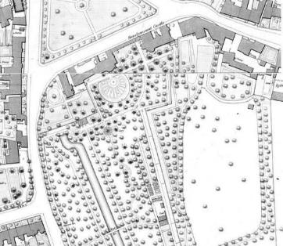

Fig. 2: Extract from 1865 City of Dublin Ordnance Survey plan showing Sandymount Castle; note the eastern section of the site is annotated as Sandymount Castle
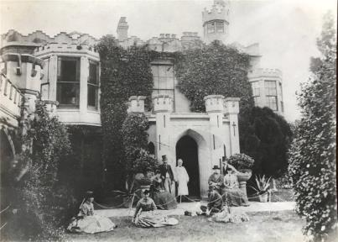

Fig. 3: Historic image showing the west elevation of what is now Castleton (No.13)
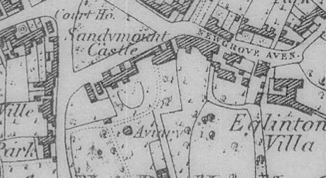

Fig. 4: Extract from Map of the city of Dublin and its environs, constructed for Thom's Almanac and Official Directory 1877 showing Sandymount Castle occupying the southern flank of Sandymount Green; note the emphasis for the naming of the site is on the eastern end.

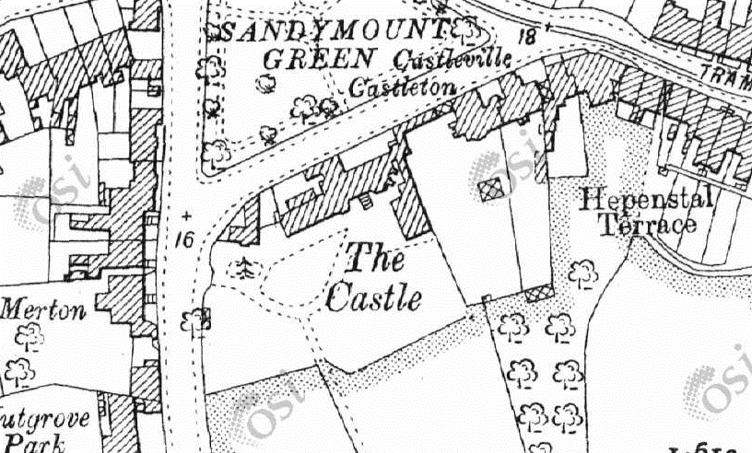

Fig. 5: Extract from c.1910 Ordnance Survey revision showing subdivision of site with Castleville and Castleton now occupying the eastern portion of the site and The Castle to the west end

References
- City of Dublin, held by Ordnance Survey Ireland. © Public domain. Digital content: © Ordnance Survey Ireland, published by UCD Library, University College Dublin, 1865, Sheet DN018_080 http://digital.ucd.ie/view/ucdlib:40935 (accessed 26/10/2021)
- City of Dublin, held by Ordnance Survey Ireland. © Public domain. Digital content: © Ordnance Survey Ireland, published by UCD Library, University College Dublin, 1865, Sheet DN018_090 http://digital.ucd.ie/view/ucdlib:40892 (accessed 26/10/2021)
- Map of the city of Dublin and its environs, constructed for Thom's Almanac and Official Directory, 1877 held by UCD School of Geography, Planning & Environmental Policy. © Public domain. Digital content: © University College Dublin, published by UCD Library, University College Dublin http://digital.ucd.ie/view/ucdlib:33002
- https://webapps.geohive.ie/mapviewer/index.html (accessed 26/10/2021)
- https://www.thejournal.ie/castleton-sandymount-house-3654103-Oct2017/

Significance/NIAH Rating
The National Inventory of Architectural Heritage has not yet surveyed this area of the city and as such there is no NIAH rating issued for the group of structures. The Conservation Section has assessed the building and has assigned a ‘Regional’ rating to it. These are structures or sites that make a significant contribution to the architectural heritage within their region or area. Structures which are considered of Regional significance are deemed worthy of inclusion on the RPS.

Assessment of Special Interest under the Planning and Development Act 2000
The Conservation Section assigns ARCHITECTURAL, ARTISTIC, HISTORICAL and CULTURAL interest to the former Sandymount Castle.

Conclusion & Recommendation
It is recommended that the RPS entry for Sandymount Castle, Sandymount Green be amended as follows:

Proposed Listing
RPS Ref No | Address | Description
7468 | 12, 13, 14a, 14b, 14c & 14d Sandymount Green, Dublin 4 | Former Sandymount Castle

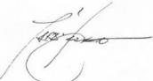 12/11/2021
_______________ ________________
Paraic Fallon Date
Senior Planner

Photographic Record:
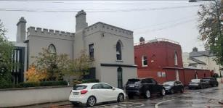 | 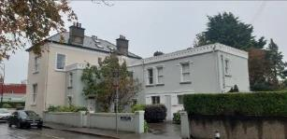
Fig. 6: View of Nos. 12 & 13 from northeast | Fig 7: View of Nos. 14a-14d from northeast
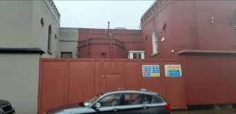 | 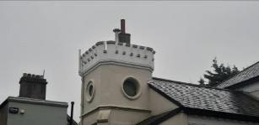
Fig. 8: Location of original main door opening from Sandymount Green | Fig. 9: Battlemented turret to No.14b Sandymount Green

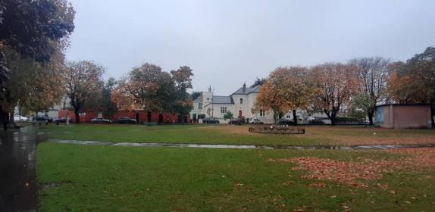

Fig. 10: View of former Sandymount Castle from within Sandymount Green

RPS No. 7542 - Sir John Rogerson's Quay, Dublin 2
Seandálaíocht, Caomhantas & Oidhreacht
An Roinn Pleanála & Forbairt Maoine
Oifigí na Cathrach, An Ché Adhmaid, Baile Átha Cliath 8

Archaeology, Conservation & Heritage Section
Planning & Property Development Department
Block 3, Floor 3, Civic Offices, Wood Quay, Dublin 8

Tel: (01) 222 3926, 222 3927
Email: conservation@dublincity.ie

12th November 2021

Draft Development Plan 2022-2028

Ref: RPS 7542 AMENDMENT to the Record of Protected Structures
_______________________________________________________________________________

Recommendation:
Amendment of current entry for Sir John Rogerson’s Quay, Dublin 2 – Granite ashlar quay walls, stone setts, mooring rings, steps, bollards, lamp standards and machinery, to now read: Sir John Rogerson’s Quay, Dublin 2 – Granite ashlar quay walls, stone setts, mooring rings/hooks, ladders, hand rails and steps
_______________________________________________________________________________

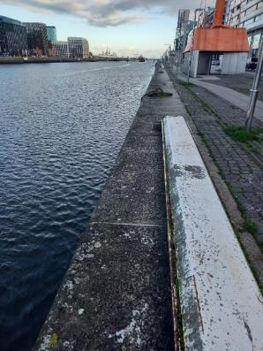

Introduction
There has been a query about whether the RPS entry for Sir John Rogerson’s Quay, Dublin 2, should be amended to reflect the extant historic fabric, namely the historic fabric that still exists at Sir John Rogerson’s Quay: granite ashlar quay walls, stone setts, mooring rings/hooks, ladders, hand rails and steps.

Existing Listing:
RPS Ref No | Address | Description
7542 | Sir John Rogerson’s Quay, Dublin 2 | Granite ashlar quay walls, stone setts, mooring rings, steps, bollards, lamp standards and machinery

Proposed Listing:
RPS Ref No | Address | Description
7542 | Sir John Rogerson’s Quay, Dublin 2 | Granite ashlar quay walls, stone setts, mooring rings/hooks, ladders, hand rails and steps

Request for Investigation
Conservation Section, Dublin City Council

Location and Land Use Zoning
The location of Sir John Rogerson’s Quay, Dublin 2 is outlined below. There are various zonings associated with the quays including Zoning Objective Z9 “to preserve, provide and improve recreational amenity and open space and green networks”. The quay is located within a ‘red hatched Conservation Area’ and also within the designated area of the North Lotts and Grand Canal Dock Strategic Development Zone (SDZ).

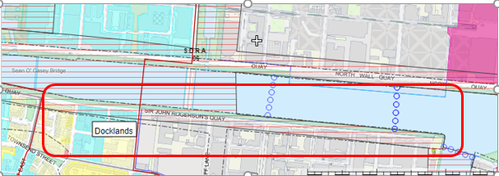
Fig. 1: Location and Land Use Zoning

Recent Planning History
The following is the list of planning applications 0429/97, 0428/97, 3634/13, DD274, DD95, DD519 and DSDZ2723/17.

Recent Enforcement History
None.

Summary Description
(See images at end of report)
Description based on National Inventory of Architecture’s record for site, Ref. 50020465
Exterior:
Ashlar granite quay wall, erected c.1870, with ashlar granite coping. Cast-iron mooring hooks and mooring rings. Timber fenders to north of B. J. Marine building. Granite steps with cast-iron railings. Stone setts and inset cast-iron rails to campshire. Raised in height to east and west of Samuel Beckett Bridge as part of recent works.

Assessment
Sir John Rogerson’s Quay was laid out in the early eighteenth century. It consisted of two parallel stone faces, the space in between filled with material dredged from the Liffey. It was the most ambitious of the privately funded quay developments of the period. It runs from Creighton Street towards Ringsend, where it turns at a right angle at the River Dodder. It is depicted on Brooking’s map of 1728, showing the quay lined with gable fronted buildings, with the land behind ‘as yet inundated by the tides’. Rocque’s map of 1756 depicts a more varied mix of uses with buildings and yards, likely associated with maritime trades such as ship building and provisioning. The end of the eighteenth century saw the completion of the quay, and the start of residential development on streets laid out to its south. The quay walls were rebuilt on two occasions, once in the 1820s and again in 1869, as part of the deepening of the channel along this part of the River Liffey. The quay served an important function, allowing ships to draw alongside for loading and unloading, and is a notable reminder of the maritime heritage of the city. It is well-executed in ashlar granite, attesting to the high level of skill and artisanship employed in its construction and in civil engineering at the time.

Fig. 2: Dublin Port Archives 1980’s photograph of North Wall Quay (left)
and Sir John Rogerson’s Quay (right)

References
- https://dublinportarchive.com/gallery/the-history-of-the-port/#gallery-10 (accessed 10/11/21)
- https://www.buildingsofireland.ie/buildings-search/building/50020465/sir-john-rogersons-quay-dublin-2-dublin (accessed 11/11/21)

Significance/NIAH Rating
Sir John Rogerson’s Quay, Dublin 2 was recorded under Stage 2 of the NIAH for Dublin (Ref 50020465) with Ministerial Recommendations for Stage 2 issued to Dublin City Council on 9th August 2017. The structure was assigned a ‘Regional’ rating. These are structures or sites that make a significant contribution to the architectural heritage within their region or area. Structures which are considered of Regional significance are deemed worthy of inclusion on the RPS.

Assessment of Special Interest under the Planning and Development Act 2000
The National Inventory of Architectural Heritage assigned ARCHITECTURAL, SOCIAL and TECHNICAL interest to Sir John Rogerson’s Quay, Dublin 2. The Conservation Section has considered the opinion of the NIAH and is in agreement with assigning this category of special interest to the site. In addition to this the Conservation section considers the structure to be of HISTORICAL interest due to the important role the construction of this quay had for the commercial development of Dublin city in the eighteenth century.

Conclusion & Recommendation
It is recommended that the RPS entry for Sir John Rogerson’s Quay, Dublin 2 – Granite ashlar quay walls, stone setts, mooring rings, steps, bollards, lamp standards and machinery, be amended to: Sir John Rogerson’s Quay, Dublin 2 – Granite ashlar quay walls, stone setts, mooring rings/hooks, ladders, hand rails and steps.

Proposed Listing
RPS Ref No | Address | Description
7542 | Sir John Rogerson’s Quay, Dublin 2 | Granite ashlar quay walls, stone setts, mooring rings/hooks, ladders, hand rails and steps.

12/11/2021
_______________ ________________
Paraic Fallon
Senior Planner Date

Photographic Record:
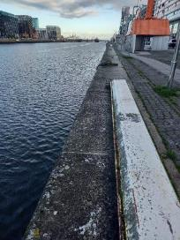 | 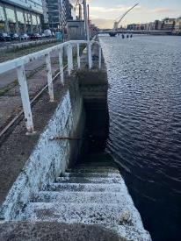 | 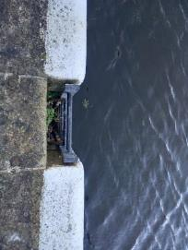
Fig. 3: North Wall Quay with mooring hooks, view towards bay | Fig. 4: Granite steps | Fig. 5: Recessed ladder

RPS No. 7547 – 25-27 Sir John Rogerson's Quay, Dublin 2
Seandálaíocht, Caomhantas & Oidhreacht
An Roinn Pleanála & Forbairt Maoine
Oifigí na Cathrach, An Ché Adhmaid, Baile Átha Cliath 8

Archaeology, Conservation & Heritage Section
Planning & Property Development Department
Block 3, Floor 3, Civic Offices, Wood Quay, Dublin 8

Tel: (01) 222 3926, 222 3927
Email: conservation@dublincity.ie

12th November 2021

Draft Development Plan 2022-2028

Ref: RPS 7547 AMENDMENT of the Record of Protected Structures
_______________________________________________________________________________

Recommendation:
Amendment of current entry for 20-24 Sir John Rogerson’s Quay, Dublin 2 – Former B&I Steampacket Company office building, to now read: 25-27 Sir John Rogerson’s Quay, Dublin 2 – Former B&I Steampacket Company office building.
_______________________________________________________________________________

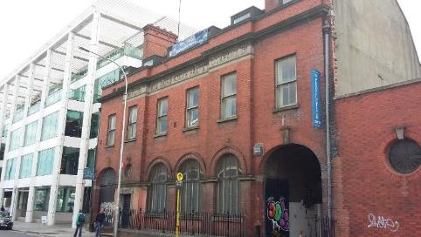
Photograph 05/05/2016

Introduction
There has been a query about whether the RPS entry 20-24 Sir John Rogerson’s Quay, Dublin 2 – Former B&I Steampacket Company office building, should be amended to 25-27 Sir John Rogerson’s Quay, Dublin 2 – Former B&I Steampacket Company office building. Investigation confirms that the numbering of the building on the RPS is incorrect, denoting the site to the west of the building. The RPS entry should be updated to reflect the correct address for the property

Existing Listing
RPS Ref No | Address | Description
7547 | 20-24 Sir John Rogerson’s Quay, Dublin 2 | Former B&I Steampacket Company office building

Proposed Listing
Amend the description to include correct building address.
RPS Ref No | Address | Description
7547 | 25-27 Sir John Rogerson’s Quay, Dublin 2 | Former B&I Steampacket Company office building

Request for Investigation
Conservation Section, Dublin City Council

Location and Land Use Zoning
The location of 25-27 Sir John Rogerson’s Quay, Dublin 2 is arrowed red below. The main zoning objective is Z14: To seek the social, economic and physical development and/or rejuvenation of an area with mixed use of which residential and “Z6” would be predominant uses. The structure is located within a Conservation Area denoted by the red hatching. The red asterisk denoting the location of the protected structure is incorrectly positioned on the Dublin City Development Plan map, due to the error in the address. This will be corrected as part of a review of maps under the Draft Development Plan.

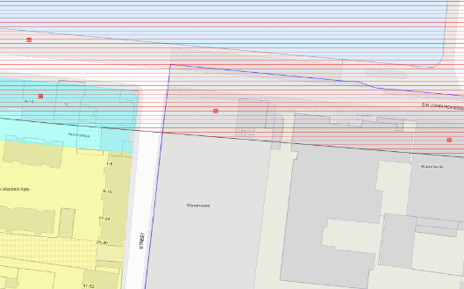
Fig. 1: Site Location and Land Use Zoning

Recent Planning History
(Application descriptions have been condensed)
Planning Ref | Description | Decision
DD150 | Office development, 106 apartments (of which 21 are social and/or affordable), restaurant and retail unit | Section 25 Certificate Granted  19 Apr 2002
DSDZ2607/16 | PROTECTED STRUCTURE: The development will consist of the demolition of all existing structures on site, sewer diversion works and boundary treatments including:  * Demolition of the single storey red brick structure fronting Sir John Rogerson's Quay (nos. 20-24);  * Demolition of brick perimeter wall extending along Lime Street;  * Demolition of warehouse structures located behind buildings fronting Sir John Rogerson's Quay and adjoining Whitaker Lane;  * Demolition of two-storey brick built warehouse both fronting and gabling onto Lime Street and associated perimeter walls and storage buildings at Lime Court;  * Demolition of former commercial buildings located behind buildings fronting Hanover Street East and yards associated with the established use;  * Demolition of walls to level of existing eastern boundary wall at Whitaker Lane frontage;  *Trunk sewer diversion works along Lime Street to Hanover Street East junction;  * Site boundary protection to all frontages and weather protection to exposed building perimeters.  The application relates to a proposed development within the North Lotts and Grand Canal Dock Strategic Development Zone Planning Scheme area. | GRANT PERMISSION  29 Jul 2016
DSDZ2609/16 | PROTECTED STRUCTURE: The development will consist of:  - The demolition of existing structures on side including the red brick single storey building fronting Sir John Rogerson's Quay (nos. 20-24) and annexes to the rear of the 3-storey original office building fronting Sir John Rogerson's Quay (nos. 25-27);  - Change of use from offices to retail/ non-retail services at ground, 1st and 2nd floors and associated internal alterations to the 3-storey structure at 25-27 Sir John Rogerson's Quay;  - Construction of a mixed use development in a building extending to 7-storeys (over lower ground & basement level), including retail/ non-retail services at ground floor, and commercial office development throughout the remainder of the proposed building fronting Sir John Rogerson's Quay and Lime Street;  - Terraces at fifth and sixth floors and roof level plant room;  - Gym, changing facilities, bicycle parking, storage and waste storage at lower ground floor level;  - Car parking and plant rooms at basement level;  - Vehicular entrance to basement from Lime Street;  - All other ancillary site development proposals including sewer diversion works, boundary treatments and landscaping.  - Commercial and Retail signage.  The application relates to a proposed development within the North Lotts and Grand Canal Dock Strategic Development Planning Scheme area. | GRANT PERMISSION  04 Aug 2016
DSDZ2608/16 | PROTECTED STRUCTURE: The development will consist of the demolition of all existing structures on the site including the red brick single storey building fronting Sir John Rogerson's Quay (nos. 20-24). The development will consist of the construction of a 6-7 storey (over lower ground and basement level) mixed use residential development… Vehicular entrance to basement from Lime Street;> Provision of basement car parking and bicycle parking;> All ancillary site works, services and landscaping including a new west-east pedestrian route linking Lime Street to Whitaker Square;> Ancillary signage. The application relates to a proposed development within the North Lotts and Grand Canal Dock Strategic Development Zone Planning Scheme area. | GRANT PERMISSION  08 Aug 2016
DSDZ2043/17 | PROTECTED STRUCTURE - The development will consist of modifications to the development permitted under planning Reg. Ref. DSDZ2609/16. The permitted development provides for demolition of existing structures on site and construction of a 7-storey (over lower ground and basement level) mixed-use commercial development. The application relates to a proposed development within the North Lotts and Grand Canal Dock Strategic Development Zone Planning Scheme Area. | GRANT PERMISSION  04 May 2017
DSDZ2042/17 | PROTECTED STRUCTURE: The development will consist of modifications to the development permitted under planning reg. ref. DSDZ2608/16. The permitted development provides for demolition of existing structures on site and construction of a 6-7 storey (over lower ground and basement level) residential development of 91. no. residential units…The application relates to a proposed development within the North Lotts and Grand Canal Dock Strategic Development Zone Planning Scheme area. | GRANT PERMISSION  04 May 2017
DSDZ4098/17 | PROTECTED STRUCTURE; Balark Investments Limited intend to apply for a 10 year Permission for development within the North Lott's and Grad Canal Dock Strategic Development Zone Planning Scheme area. The Development will consist of modifications to the development permitted under planning Reg. Ref. DSDZ2609/16 and Reg. Ref.DSDZ2043/17. The permitted development provides for demolition of existing structures on site and construction of a 7-storey (over lower ground floor level basement) mixed use commercial development. | GRANT PERMISSION  13 Dec 2017
DSDZ2252/18 | PROTECTED STRUCTURE: A 10 year permission for development at this site at 20-24 Sir John Rogerson's Quay (a Protected Structure), 25-27 Sir John Rogerson's Quay, 1-5, 11/11a, 12-14 Lime Street, Lime Court and at 8-10 Hanover Street East, Dublin 2. The application relates to a proposed development within the North Lotts and Grand Canal Dock Strategic Development Zone Planning Scheme area. The development will consist of: The demolition of existing structures on site on a phased basis including the red brick single storey building fronting Sir John Rogerson's Quay (nos. 20-24), warehouse and annexes to the rear of the 3 storey original office building fronting Sir John Rogerson's Quay (nos. 25-27); 8-10 Hanover Street East, 11 & 11a and 14 Lime Street; Change of use from office to retail/nonretail services at ground, 1st and 2nd floors and associated refurbishment and internal alterations to the 3 storey structure at 25-27 Sir John Rogerson's Quay; Construction of a new office building extending up to 8 storeys (over basement level), including retail/non retail services at ground floor on Lime Street and commercial office development throughout the remainder of the proposed building fronting Sir John Rogerson's Quay and Lime Street; | GRANT PERMISSION  03 Apr 2018
DSDZ2906/18 | PROTECTED STRUCTURE; The application relates to a proposed development within the North Lotts and Grand Canal Dock Strategic Development Zone Planning Scheme area.  The proposed development will consist of; The demolition of existing structures on site on a phased basis which includes the red brick single storey building fronting Sir John Rogerson's Quay (nos.20 - 24), warehouse and annexes to the rear of the 3 storey original office building fronting Sir John Rogerson's Quay (25 - 27); 8 -.10 Hanover Street East, 11 & 11a and 14 Lime Street; provision of 134 no. residential units over ground to set back seventh floor level. | GRANT PERMISSION  26 Jun 2018
DSDZ2668/19 | PROTECTED STRUCTURE: The application relates to a proposed development within the North Lotts and Grand Canal Dock Strategic Development Zone Planning Scheme area. The proposed development will consist of:- * Demolition of 8-10 Hanover Street East; * Construction of a 'build-to-rent' residential development in buildings ranging from 1 storey to 6 storeys plus set back level (over basement); | GRANT PERMISSION  20 Aug 2019
DSDZ4006/19 | PROTECTED STRUCTURE: Balark Investments Limited and  Balark Trading GP intend to apply for a ten year Permission for development at 20-24 Sir John Rogerson's Quay (a Protected Structure), 25-27 Sir John Rogerson's Quay, 1-5, 11/11a, 12-14 Lime Street, Lime Court and at 8-10 Hanover Street East, Dublin 2. The application relates to a proposed development within the North Lotts and Grand Canal Dock Strategic Development Zone Planning Scheme area.  The proposed development will consist of :-  • Change of use from office to retail/non-retail services/café/restaurant at ground floor and associated refurbishment and internal alterations to the 3 storey structure at 25-27 Sir John Rogerson's Quay; | GRANT PERMISSION  24 Jan 2020

Recent Enforcement History
Ref. No. | Opened | Reason | Closed | Reason
E0699/16 | 08-Sep-2016 | Breach C5(a)(c) 6(a)(e) 7(a) of DDA2607/16 | 20-Jun-2017 | Removed
E0134/20 | 19-Feb-2020 | Breach Cond 10 of DSDZ4006/19

Summary Description
Description based on National Inventory of Architectural Heritage’s record for site, Ref. 50020477.
Freestanding, six-bay, two-storey with attic storey, former offices, built 1909, having integral carriage arches to end bays and shallow projections to front (north) elevation, single-storey wing wall to west, and triple-pile goods shed to rear (south) elevation. Now in use as studios. Pitched slate roof with recent square-headed dormer windows, terracotta ridge cresting, red brick chimneystacks, some cast-iron rainwater goods set in recesses, red brick parapet having carved masonry capping. Pitched slate roofs to store with clerestories having timber louvered vents. Red brick, laid in Flemish bond to walls to front (north) range, red brick plinth course having carved limestone capping and string course, some smooth rendered walls, carved stone cornice over fascia with raised lettering to front, brown brick and yellow brick in Flemish bond to east, west and elevations of store to rear. Square-headed window openings having granite sills and one-over-one pane timber sliding sash windows. Round-headed window openings to ground floor to front, with moulded brick archivolts supported on red brick pilasters, carved stone sills and timber and metal framed windows. Square-headed window openings to side having granite sills and timber battened shutters, segmental headed window openings to rear, blocked. Oculi with some terracotta or render keystone details, having metal and timber framed windows and some wrought-iron openwork panels. Square-headed door opening with carved limestone shouldered architrave having date panel over, double-leaf timber panelled door approached by nosed granite step. Elliptical-headed carriage arches with terracotta keystones, and double-leaf timber battened doors, steel grill to over-light to opening to east, cast-iron wheel stops. Elliptical-headed carriage arches to wing wall, with render impost and keystone details, having double-leaf timber battened doors and recent door. Loading platform to goods shed, having render and coursed rubble stone platform, cast-iron and mild-steel girder supports, and corrugated-iron canopy. Cobbled yard. Wrought-iron railings with cast-iron corner posts on carved limestone and red brick plinth wall to front. Situated to south and centre of Sir John Rogerson's Quay, at junction with Lime Street.

Assessment
The Former B&I Steampacket Company office building was initially protected under the Draft Dublin City Development Plan, 1998 on 20th March 1998. This listing of the building did not include a street number. The Dublin City Development Plan 2005-2011 includes the street number ’20-24’ on the entry for the structure for the first time (RPS Ref 7547). It is not clear where this number originated from, as it is not the correct number for the offices but the adjoining warehouse to the west. The RPS description supersedes the building number in this instance as it is very specific as to what is protected i.e. the former offices of the B&I Steampacket Company, which is a red brick six-bay two-storey structure located further eastwards along the block from the junction with Lime Street.

The 1847 City of Dublin Ordnance Survey plan provides street numbers for Sir John Rogerson’s Quay, and while this predates the construction of the subject building, it does provide some evidence as to the correct numbering of the structure. It indicates No.20 Sir John Rogerson’s Quay as the plot at the corner of Sir John Rogerson’s Quay and Lime Street, which runs perpendicular to the quay to the west of the subject site. This historic mapping shows houses along this section of Sir John Rogerson’s Quay beginning with the numbers running in ascending order east of this structure. It is therefore clear that assigning the numbers 20-24 to the subject structure was incorrect. Furthermore, the 1961 Goad’s Insurance Map of Sir John Rogerson’s Quay provides clear evidence that the correct numbering for the B&I Steampacket Company offices is 25-27 Sir John Rogerson’s Quay.

It is therefore clearly evident that the assigning of the street number 20-24 to RPS Ref. 7547 is incorrect and that the correct address for the Former B&I Steampacket Company office building is Nos.25-27 Sir John Rogerson’s Quay, Dublin 2.

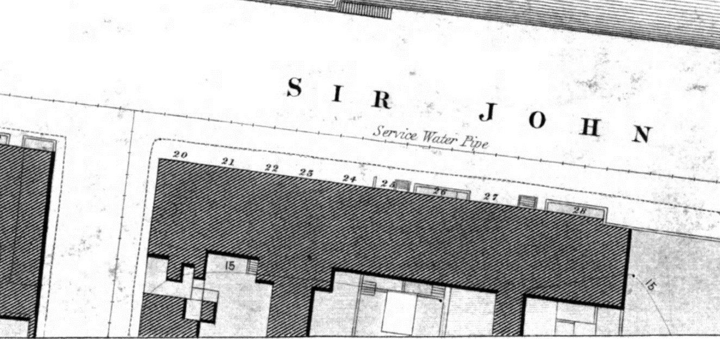

Fig. 2: Extract from 1847 City of Dublin Ordnance Survey plan with No. 20 Sir John Rogerson’s Quay arrowed blue and No. 27 arrowed red.
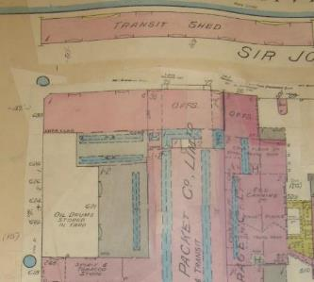

Fig. 3: Extract from Goad’s Fire Insurance Map 1961 clearly showing the offices of the British & Irish Steampacket Co. Ltd as Nos. 25-27 Sir John Rogerson’s Quay

References
- National Inventory of Architectural Heritage Reference 50020477
- City of Dublin, held by Ordnance Survey Ireland. © Public domain. Digital content: © Ordnance Survey Ireland, published by UCD Library, University College Dublin, 1847, Sheet 15 http://digital.ucd.ie/view/ucdlib:40837 (accessed 26/10/2021)
- Goad’s Fire Insurance Map, 1961

Significance/NIAH Rating
The Former B&I Steampacket Company office building, Sir John Rogerson’s Quay, Dublin 2 was recorded under Stage 2 of the NIAH for Dublin (Ref. 50020477) with Ministerial Recommendations issued to Dublin City Council on 9th August 2017. The structure has been assigned a ‘Regional’ rating. These are structures or sites that make a significant contribution to the architectural heritage within their region or area. Structures which are considered of Regional significance are deemed worthy of inclusion on the RPS.

Assessment of Special Interest under the Planning and Development Act 2000
The National Inventory of Architectural Heritage assigned ARCHITECTURAL, ARTISTIC, HISTORICAL and SOCIAL interest to the Former B&I Steampacket Company office building. The Conservation Section has considered the opinion of the NIAH and is in agreement with assigning these categories of special interest to the structure.

Conclusion & Recommendation
It is recommended that the RPS entry for Former B&I Steampacket Company office building, Dublin 2 be amended as follows:

Proposed Listing
RPS Ref No | Address | Description
7547 | 25-27 Sir John Rogerson’s Quay, Dublin 2 | Former B&I Steampacket Company office building

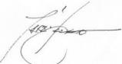 12/11/2021
_______________ ________________
Paraic Fallon Date
Senior Planner

RPS No. 7551 - Smithfield, Dublin 7
Seandálaíocht, Caomhantas & Oidhreacht
An Roinn Pleanála & Forbairt Maoine
Oifigí na Cathrach, An Ché Adhmaid, Baile Átha Cliath 8

Archaeology, Conservation & Heritage Section
Planning & Property Development Department
Block 3, Floor 3, Civic Offices, Wood Quay, Dublin 8

Tel: (01) 222 3926, 222 3927
Email: conservation@dublincity.ie

12th November 2021

Draft Development Plan 2022-2028

Ref: RPS 7551 AMENDMENT of the Record of Protected Structures
_______________________________________________________________________________

Recommendation:
Amendment of current entry for Former Jameson Distillery, stone chimneys and all remaining original structures - Smithfield, Dublin 7 to now read: Former Jameson Distillery: chimneys, kilns and all remaining original structures including historic stone and brick facades at Bow Street, New Church Street, Friary Avenue and Smithfield – Smithfield, Dublin 7
_______________________________________________________________________________

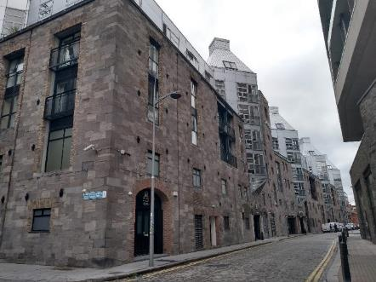

Introduction
It is proposed to amend the description for the former distillery at Smithfield, Dublin 7 from ‘Former Jameson Distillery, stone chimneys and all remaining original structures’ to ‘Former Jameson Distillery: chimneys, kilns and all remaining original structures including historic stone and brick facades at Bow Street, New Church Street, Friary Avenue and Smithfield’ in order to provide clarity as to what is protected.

Existing Listing
RPS Ref No | Address | Description
7551 | Smithfield, Dublin 7 | Former Jameson Distillery, stone chimneys and all remaining original structures

Proposed Listing: Amend description to include the former kilns and specify ‘original structures’ protected.
RPS Ref No | Address | Description
7551 | Smithfield, Dublin 7 | Former Jameson Distillery: chimneys, kilns and all remaining original structures including historic stone and brick facades at Bow Street, New Church Street, Friary Avenue and Smithfield

Request for Investigation
Conservation Section, Dublin City Council

Location and Land Use Zoning
The location of the former Jameson Distillery, Dublin 1 is outlined in red below. The main zoning objective is Z5: To consolidate and facilitate the development of the central area, and to identify, reinforce, strengthen and protect its civic design character and dignity. It also within a red hatched Conservation Area.
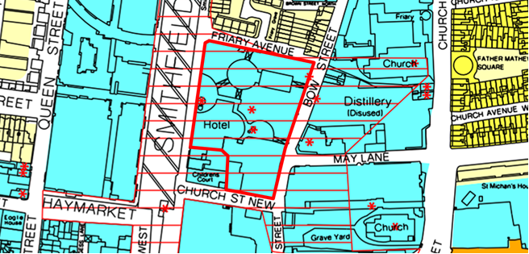
Figure 1: Location and Land Use Zoning

Relevant Planning History
(Note: Application descriptions have been condensed)
Planning Ref. | Description | Decision Date
1799/95 | Redevelopment of the site bounded by Smithfield, Friary Avenue, Bow Street and Church Street New (known as the Old Distillery site) comprising an area of 0.904 hectares to provide for the following: 1. Cultural uses, primarily at ground level, to include 180 seat theatre, art gallery, sculpture gallery and a distillery industrial museum. 2. Range of small scale commercial/retail units. 3. Residential development over ground floor. 4. The retention and adaptation of various structure including those listed for preservation, and the provision of an observation gallery at the top of the large chimney adjoining Smithfield. 5. The Smithfield frontage includes the retention, adaptation and extension of existing perimeter brick walling and also includes the demolition of existing derelict houses at Nos. 18, 19 and 21 Smithfield. 6. The Bow Street, Church Street New and Friary Avenue frontages provide for the retention and adaptation of existing stone walling. 7. Internal circulation within the site is primarily for pedestrians and provides for the re-opening of Duck Lane between Smithfield and Bow Street 8. Basement parking is proposed for 132 cars with access from Friary Avenue. | Grant permission 22 Dec 1995
1143/96 | Revisions comprising: 1. Internal revisions to enlarge the proposed Whiskey Museum adjoining junction of Bow Street and Church Street New. 2. Omission of tower over Block D. 3. Revisions to block B. 4. Revisions within Blocks A, B and D. | Grant permission  18 Jul 1996
0755/97 | Revisions and extensions to previously approved plans (Reg.Ref No.1799/95) to provide visitor, cultural and commercial facilities. | Grant permission  25 Jun 1997
2414/97 | Revisions and amendments to already approved development (reg. ref. 1799/95, 1143/96, 0755/97), | Grant permission  15 Jan 1999
2616/97 | Observation tower and panoramic lift to existing listed chimney for which outline planning permission has already been granted (Reg. Ref. 1799/95). | Grant permission on foot of outline 11 Dec 1997
3596/12 | PROTECTED STRUCTURE: The development will consist of the erection of stainless steel backlit signage to the upper section of the stair tower along Bow Street which forms part of existing protected structure (RPS: 7551). | Grant permission  13 Feb 2013
2113/14 | PROTECTED STRUCTURE: The development will consist of the following: 1) Erection of projecting hanging banners to be affixed to the external facades; 2) Re-decoration of ground floor window frames and entrance doors; 3) Replacement of metal mesh Panels with solid timber panels, timber louvers, historic information display panel and metal link access gate; 4) Replacement of existing lettering located above Bow Street entrance archway with stainless steel backlit lettering. | Grant permission  26 Mar 2014
3795/15 | PROTECTED STRUCTURE: RETENTION: The development will consist of the retention of 5 number banner type advertising signage and 2 number plate type signage fitted to the pillars on the west facade of the development facing onto Smithfield Square. Registered protected structure ref: 7551. | Split decision. Permission & Refusal  30 Nov 2015
2620/16 | The site is within a Conservation Area and a zone of Archaeological interest). 1. The change of use of existing vacant retail/ commercial unit to Café/ Sandwich Bar/ Restaurant. 2. Change of use from retail/ commercial to an individual office space. 3. All associated services including signage & minor external shop front alterations. | Grant permission  14 Jul 2016
2824/16 | PROTECTED STRUCTURE: Planning permission for refurbishment to the existing visitor experience at the Old Jameson Distillery, Bow Street, Smithfield, Dublin 7. | Grant permission  01 Jul 2016
2943/18 | PROTECTED STRUCTURE: The development will consist of the change of use of the unit at ground floor level from retail to office space, with all ancillary site works. (Registered Protected Structure ref: 7551). | Grant permission  02 Jul 2018
4714/18 | PROTECTED STRUCTURE: The development proposed consists of the change of use of the existing 75 sqm basement cinema room to hostel accommodation use with a new skylight, and of 11 sqm of the existing circulation area on the first and second floor to form a total of two single bedrooms within the existing building outline, all facing the internal courtyard. | 21 Feb 2019  Split decision. Permission & Refusal
3895/19 | PROTECTED STRUCTURE & RETENTION: Retention permission at this site, the former Chief O'Neill's Hotel, Smithfield Square, Dublin 7 (protected structure). | Grant retention permission  24 Oct 2019
3550/20 | PROTECTED STRUCTURE: Permission for subdivision of ground floor unit and change of use of basement and partial ground floor unit from office to dentist clinic, together with associated signage, in mixed-use building. | Grant permission  02 Dec 2020
3128/21 | PROTECTED STRUCTURE: Permission for the replacement of the existing pot still feature in The Courtyard, The Old Jameson Distillery, Bow Street, Dublin 7, D07 V57C with a free standing illuminated sculptural feature and all ancillary site development works. The proposed development consists of or comprises the carrying out of works to a protected structure. | Grant permission  21 Oct 2021

Summary Description
The former Jameson Distillery was located on a rectangular block bounded by Friary Avenue to the north, New Church Street to the south, Bow Street to the east and Smithfield to the west. The site was substantially redeveloped in circa 1998 (Planning ref: 1799/95, 1143/96, 0755/97, 2414/97 & 2616/97) and elements of the former distillery were incorporated into the development which includes three brick chimneys; the former calp limestone facades facing Bow Street, New Church and Friary Avenue; the panelled red brick façade on Smithfield and Friary Avenue; the former water tank building; kilns and timber trusses. Two of the chimneys and the former kilns were surveyed by the NIAH (See also images at end of report).

- NIAH Ref 50070323: Freestanding chimney, dated 1895, now in use as viewing platform having circular glass extension, added 1998, to top served by elevator. Cylindrical shaft having octagonal base with separating stone string course. Brown brick laid in English bond. White tiles to south elevation denote '1895'. Round-arched opening to ground floor north and south elevations having recent metal gates. Recent metal elevator shaft frame connected to south elevation with glass housing at ground floor level. Standing on east side of Smithfield Market adjacent to red brick free-standing wall formerly belonging to distillery building. Surrounded to east by recent mixed-use development. This former boiler-house chimney associated with the Jameson Distillery is a recognisable landmark in the Dublin skyline. Its recent adaptation to a viewing platform allows the original form to be readily identified. Its well-constructed brickwork has ensured its survival as a reminder of a once thriving industry with an important social and economic role in the surrounding area.

- NIAH Ref 50070325: Freestanding square-plan industrial chimney, built c.1895, now disused. Brown brick laid in English bond having horizontal metal straps. Segmental-arched opening to base of east elevation having red brick infill. Segmental-arched opening to south elevation having brown brick infill. Standing adjacent to freestanding circular-plan copper vat having recent brick base. This former chimney associated with the Jameson Distillery is a surviving fragment of the site's industrial past, now forming a centrepiece amongst a recent mixed-use development. Its well-constructed brickwork has ensured its survival as a reminder of a once thriving industry, with an important social and economic role in the surrounding area from the late nineteenth century until the 1970s.

- NIAH Ref 50070324. Two freestanding circular-plan industrial kilns, built c.1895, now having a circulation function within visitors centre c.1998. Cylindrical form. Brown brick laid in stretcher bond having whitewash externally. Recent openings having steel lintels. These former kilns associated with the Jameson Distillery are surviving fragments of the site's industrial past, now forming a centrepiece within the visitors centre. The well-constructed brickwork has ensured their survival as a reminder of a once thriving industry with an important social and economic role in the surrounding area from the late nineteenth century until the 1970s.

Assessment
The remains of the former distillery were incorporated into a new development in the late 90s (Planning ref: 1799/95, 1143/96, 0755/97, 2414/97 & 2616/97). The surviving buildings, historic facades, chimneys and other remains provide important character to the streetscape and are a reminder of the site’s industrial past and the once thriving whiskey industry that was located here.

Christine Casey describes the site as follows: the East side of Smithfield is dominated by Smithfield Village of 1998, by A. & D. Wejchert. A six-storey mixed use building (apartments, shops, hotel, theatre and visitor centre) grafted on and into the reduced stone and brick shell of the distillery….. The brown-brick boiler house chimneystack (1895; 38 metres, 124 ft) and the panelled red brick wall on Smithfield (formerly known to Dublin’s homeless as the ‘hot wall’) have been preserved – the wall now opens at the centre as a giant trabeated screen and the chimney is clasped by a lift and surmounted by a viewing tower. The base of the calp rubble walls on Bow Street, Friary Avenue and New Church Street has likewise been retained. Within, the water-tank building which adjoined the boilerhouse has survived, as have a copper vat made by Grant Banffshire Copperworks, Dufftown, a secondary chimneystack, part of the blockhouse, and the S wall of a structure at the NE corner. A visitor centre is devoted to the history of the Jameson distillery. Here the brick bases of the of former wash backs (large cylindrical containers in which fermentation took place) are displayed in situ, while a massive strapped timber truss traverses the exhibition space at an inexplicably low level. This rather piecemeal and doubtless trying incorporation of defunct features is offset by the effectiveness of the plan, which inspiration from the many cylindrical stills and vats discovered on site. Behind the brick screen of the Smithfield façade is a central semi-circular courtyard (containing on the right the chimney viewing tower), leading into an axial interior street which divides the complex in two. A shorter diagonal axis running L or NE from the entrance court leads to a larger circular inner courtyard at the centre of the N side, which in turn is connected to Bow Street by a short rectangular court. On the right or SE of the entrance court, behind the chimney and adjoining the rear of the hotel is a cylindrical brick-clad structure, purpose built as a traditional music heritage centre. The Bow Street elevation is surmounted by a series of metal clad kiln-type roofs (Casey 2005, 263-264).

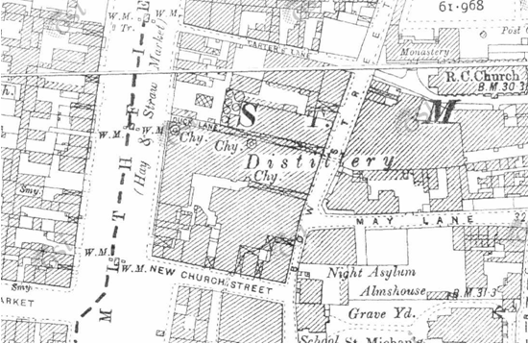
Fig. 2: 25 inch OS Map (circa 1910) showing former distillery. The distillery is bounded by New Church Street to the south, Bow Street to the east and Smithfield to the west. Friary Avenue to the north is called Carter’s Lane at this stage. The three chimneys are clearly visible – marked Chy.

References
- NIAH Inventory Reg Refs: 50070323, 50070324 & 50070325.
  - https://www.buildingsofireland.ie/buildings-search/building/50070324/the-old-jameson-distillery-duck-lane-bow-street-dublin-7-dublin accessed October 2021
  - https://www.buildingsofireland.ie/buildings-search/building/50070325/jameson-distillery-smithfield-dublin-7-dublin accessed October 2021
  - https://www.buildingsofireland.ie/buildings-search/building/50070323/jameson-distillery-bow-st-smithfield-village-smithfield-dublin-7-dublin accessed October 2021
- Casey, Christine (2005). Dublin: The City Within the Grand and Royal Canals and the Circular Road, with the Phoenix Park - Pevsner Architectural Guides: Buildings of Ireland. Yale University Press.

Significance/NIAH Rating
The former Jameson Distillery was recorded under Stage 1 of the NIAH for Dublin (Ref 50070323, 50070324 & 50070325) with Ministerial Recommendations for Stage 1 issued to Dublin City Council on the 4th of June 2014. These structures were assigned a ‘Regional’ rating. These are structures or sites that make a significant contribution to the architectural heritage within their region or area. Structures which are considered of Regional significance are deemed worthy of inclusion on the RPS.

Assessment of Special Interest under the Planning and Development Act 2000
The National Inventory of Architectural Heritage assigned three structures Architectural and Historical interest. The Conservation Section has considered the opinion of the NIAH and is in agreement with assigning the ARCHITECTURAL and HISTORICAL categories of special interest to the structures.

Conclusion & Recommendation
It is recommended that the RPS entry for the former Jameson Distillery be amended to include the historic kilns and the historic stone and brick facades at Bow Street, New Church Street, Friary Avenue and Smithfield.

Proposed Listing
RPS Ref No | Address | Description
7551 | Smithfield, Dublin 7 | Former Jameson Distillery: chimneys, kilns and all remaining original structures including historic stone and brick facades at Bow Street, New Church Street, Friary Avenue and Smithfield

12/11/2021
_______________ ________________
Paraic Fallon Date
Senior Planner

Photographic Record:
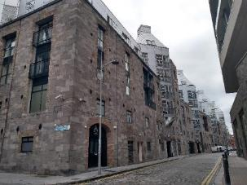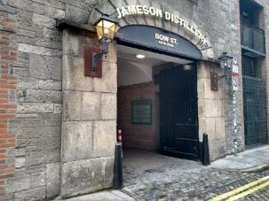
Figs. 3 & 4: Bow Street, view of limestone calp walls with granite dressings to historic entrance opening & cast-iron spur stones.
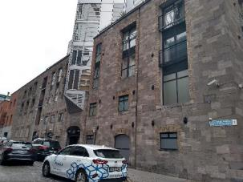 | 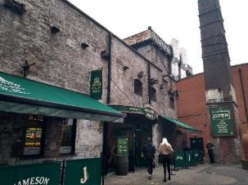
Fig. 5: New Church Street, view of limestone calp walls with historic brick dressings to some window openings. Segmental brick arch to historic entrance. | Fig. 6: Visitors centre which retains brick kilns & timber structural supports. Chimney to right hand side.
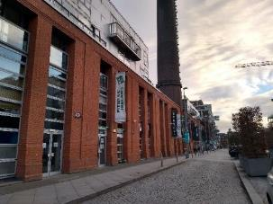 | 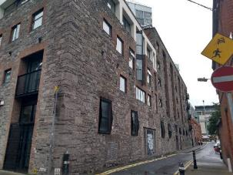
Fig. 7: View from Smithfield of Chimney & red brick panelled wall. | Fig. 8: Friary Avenue, view of former distillery façade with limestone calp walls, brick dressings to a number of historic window openings & red brick panelled wall to west end.

RPS No. 8553 - 1B Whitefriar Place, Dublin 8
Seandálaíocht, Caomhantas & Oidhreacht
An Roinn Pleanála & Forbairt Maoine
Oifigí na Cathrach, An Ché Adhmaid, Baile Átha Cliath 8

Archaeology, Conservation & Heritage Section
Planning & Property Development Department
Block 3, Floor 3, Civic Offices, Wood Quay, Dublin 8

Tel: (01) 222 3926, 222 3927
Email: conservation@dublincity.ie

12th November 2021

Draft Development Plan 2022-2028

Ref: RPS 8553 AMENDMENT to the Record of Protected Structures
_______________________________________________________________________________

Recommendation
Amendment of current entry for 1 Whitefriar Place, Dublin 9 - Shop and house, to now read: 1B Whitefriar Place, Dublin 8 – Commercial premises and house.
_______________________________________________________________________________

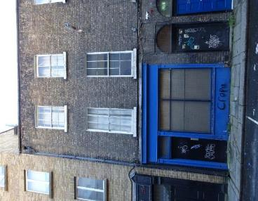

Introduction
No. 1 Whitefriar Place, Dublin 9 – Shop and House is on the current Record of Protected Structures (Dublin City Development Plan 2016-2022). The reference number is RPS 8553 and the description reads ‘Shop and House’. It is proposed to amend the address to No. 1B Whitefriar Place, Dublin 8. No. 1 and No. 1A Whitefriar Place have been replaced with modern structures under a permitted planning application (ref. no. 2179/96).

Existing Listing:
RPS Ref No | Address | Description
8553 | 1 Whitefriar Place, Dublin 9 | Shop and house

Proposed Listing: Change postcode from Dublin 9 to Dublin 8 and street no. from No. 1 to No. 1B.
RPS Ref No | Address | Description
8553 | 1B Whitefriar Place, Dublin 8 | Commercial premises and house

Request for Investigation
Conservation Section, Dublin City Council.

Location and Land Use Zoning
The location of 1B Whitefriar Place, Dublin 8 is arrowed red below. The zoning objective is Zone 5: To consolidate and facilitate the development of the central area, and to identify, reinforce, strengthen and protect its civic design character and dignity.

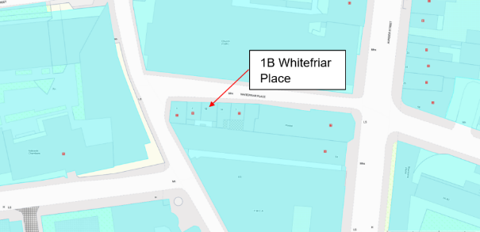
Fig. 1: Location and Land Use Zoning

Recent Planning History
Planning Ref | Description | Decision
2493/97 | Minor amendment to existing approved scheme for extension to Avalon House, 55 Aungier Street to include: refurbishing no. 1B Whitefriar Place in lieu of partial demolition, relocation of escape stair, provision of single shop unit at ground floor instead of double unit currently approved, revision to shopfront. | GRANT PERMISSION  22 Dec 1997
2179/96 | (1) Demolition of 2 no. habitable houses at 1 & 1A Whitefriar Place and the partial demolition of a habitable house at 1B (also known as 2) Whitefriar Place.  (2) Partial re-construction including the retention of the facade to Whitefriar Place and change of use from shop with 2 no. flats to medical surgery at ground floor with hostel use at first and second floors of No. 1B (also known as 2) Whitefriar Place and  (3) for the construction of a new four storey block with mansard roof level at 1 & 1A Whitefriar Place including the provision of a 5 storey stairwell at the rear of 1A & 1B (also known as 2) Whitefriar Place, as extension to existing hostel comprising 26 bedrooms and ancillary accommodation, 2 no. new shop units and a medical surgery at 1, 1A, & 1B (also known as 1, 1A & 2) Whitefriar Place. | GRANT PERMISSION  03 Feb 1997
0499/98 | A) To retain and complete two clerical offices to new mezzanine floor to part of reception area to existing hostel at 55 Aungier Street (a listed building), B) for new public (reception) entrance with canopy to Whitefriar Place, C) for change of use from approved ground floor retail shop to self catering kitchen/common room for hostel residents at No. 1 & 1A Whitefriar Place, D) for change of approved use from retail shop and Medical Surgery to hostel linen store/laundry and relocation of Medical Surgery, all to ground floor of No. 1B (also known as 2) Whitefriar Place, E) for balcony to fourth floor staff room and alterations to window fenestration to rear elevation of No. 1 & 1A Whitefriar Place. | GRANT PERMISSION  27 Apr 1998

Recent Enforcement History
Ref. No. | Opened | Reason | Closed | Reason
C0008/17 | 19-Jun-2017 | Potential endangerment | 28-May-2021

Summary Description
Description based on National Inventory of Architecture’s record for site, Ref. 50110016.
Exterior: Terraced two-bay three-storey former house over basement, built c. 1810, having shopfront to ground floor with accommodation over. Pitched slate roof, hidden behind brick parapet with granite coping, and long brick chimneystack to east party wall lacking pots, but having stovepipe. Some cast-iron rainwater goods. Yellow brick walling, laid in Flemish bond, to front elevation. English garden wall bond brickwork to rear. Square-headed window openings with rendered reveals, masonry sills and six-over-six pane timber sliding sash windows, except one top floor window that is two-over-six pane. Round-headed door opening with moulded render surround, carved timber doorcase comprising panelled pilasters and entablature, plain fanlight and recent door. Shopfront comprising panelled timber pilasters supporting fascia and cornice, plain square-headed display window, and square-headed shop doorway with overlight. Granite kerbing to footpath.

Assessment
Whitefriar Place is located of the west side of Aungier Street and was part of a grid of streets and lanes laid out in the second half of the seventeenth century to facilitate the development of the Aungier Estate. The Aungier Estate was named for Francis Aungier who acquired the land in the early 17th century. The earliest cartographic source depicting the estate is Bernard de Gomme’s Map of Dublin, 1673 which shows the main thoroughfare of Aungier Street running north south through the estate with Whitefriars Alley running off it at right angles to the west. Charles Brookings ‘Map of the City and Suburbs of Dublin, 1728’ indicates that Whitefriars Lane was fully development by the early 18th century. John Rocque’s ‘Plan of the city of Dublin, 1756’ shows a number of buildings, including a Meeting House, on Whitefriars Lane.

The house and shop at No. 1B Whitefriar Place is part of a short terrace of purpose built residential and commercial buildings built on the south side of the street in the early nineteenth century. The 1847 Ordnance Survey map indicates the terrace included four structures though there are no building numbers indicated. The 1892 Ordnance Survey map indicates that the terrace had been extended to the east end to include a fifth structure. A grant of planning in 1996 (ref. 2179/96) allowed for the demolition of the two buildings (No. 1 and No. 1A) at the east end of the terrace. The partial demolition of No. 1B was also planned under this grant of planning but the demolition was amended to refurbishment under a subsequent grant of planning (ref. 2493/97).

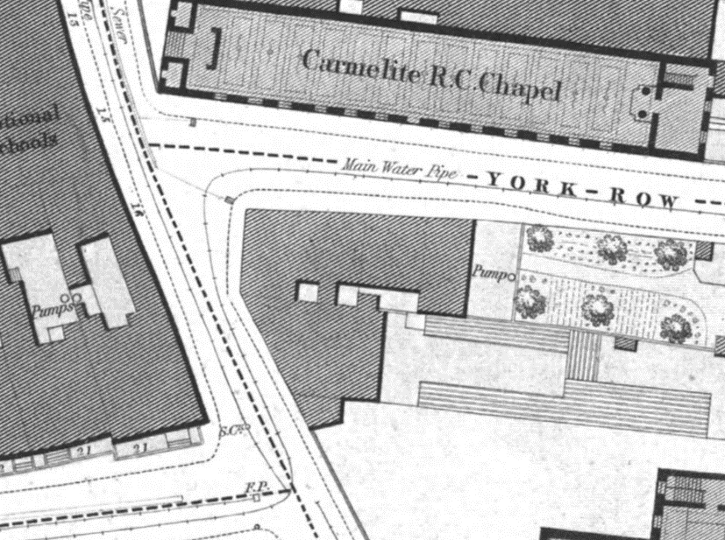

Fig. 2: Extract from 1847 City of Dublin Ordnance Survey showing York Row (now Whitefriar Place)
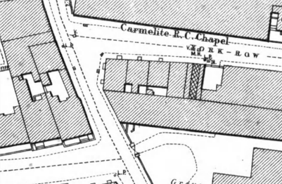

Fig. 3: Extract from 1892 Ordnance Survey showing York Row (now Whitefriar Place).

References
- National Inventory of Architectural Heritage References 50110016
- City of Dublin, held by Ordnance Survey Ireland. © Public domain. Digital content: © Ordnance Survey Ireland, published by UCD Library, University College Dublin, 1847, Sheet 27 https://digital.ucd.ie/view/ucdlib:40863 (accessed 26/10/2021)
- City of Dublin, held by Ordnance Survey Ireland. © Public domain. Digital content: © Ordnance Survey Ireland, published by UCD Library, University College Dublin, 1892, Sheet DN018-067 https://digital.ucd.ie/view/ucdlib:40916 (accessed 26/10/2021)
- Brooking, C. (1728) ‘A map of the city and suburbs of Dublin, 1728’.
- De Gomme, B. (1673) ‘The citty and suburbs of Dublin, 1673’.
- Rocque, J. (1756) ‘Plan of the city of Dublin, 1756’

Significance/NIAH Rating
No. 1B Whitefriar Place (recorded as No. 1 Whitefriar Place) was recorded under Stage 4 of the NIAH for Dublin (Ref. 50110016) with Ministerial Recommendations for Stage 4 issued to Dublin City Council on the 3rd November 2021. The structure was assigned a ‘Regional’ rating. These are structures or sites that make a significant contribution to the architectural heritage within their region or area. Structures which are considered of Regional significance are deemed worthy of inclusion on the RPS.

Assessment of Special Interest under the Planning and Development Act 2000
The National Inventory of Architectural Heritage assigned ARCHITECTURAL and SOCIAL interest. The Conservation Section has considered the opinion of the NIAH and is in agreement with assigning these categories of special interest to the site.

Conclusion & Recommendation
It is recommended that the RPS entry for 1 Whitefriar Place, Dublin 9 be amended to 1B Whitefriar Place, Dublin 8 – Commercial premises and house, in accordance with Section 12(3) of the Planning and Development Act, 2000 (as amended).

Proposed Listing
RPS Ref No | Address | Description
8553 | 1B Whitefriar Place, Dublin 8 | Commercial premises and house

12/11/2021
_______________ ________________
Paraic Fallon Date
Senior Planner

Photograph of Structure:
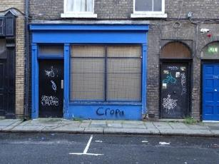

Fig. 4: Shopfront, 1B Whitefriar Place.

RPS No. 8554 - 2 Whitefriar Place, Dublin 8
Seandálaíocht, Caomhantas & Oidhreacht
An Roinn Pleanála & Forbairt Maoine
Oifigí na Cathrach, An Ché Adhmaid, Baile Átha Cliath 8

Archaeology, Conservation & Heritage Section
Planning & Property Development Department
Block 3, Floor 3, Civic Offices, Wood Quay, Dublin 8

Tel: (01) 222 3926, 222 3927
Email: conservation@dublincity.ie

12th November 2021

Draft Development Plan 2022-2028

Ref: RPS 8554 AMENDMENT to the Record of Protected Structures
_______________________________________________________________________________

Recommendation:
Amendment of current entry for 2 Whitefriar Place, Dublin 9 - Shop and house, to now read: 2 Whitefriar Place, Dublin 8 – Shop and house.
_______________________________________________________________________________

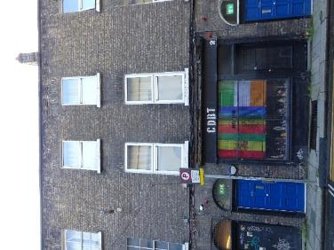

Introduction
No. 2 Whitefriar Place, Dublin 9 – Shop and House is on the current Record of Protected Structures (Dublin City Development Plan 2016-2022). The reference number is RPS 8554 and the description reads ‘Shop and House’. It is proposed to amend the address to No. 2 Whitefriar Place, Dublin 8.

Existing Listing
RPS Ref No | Address | Description
8554 | 2 Whitefriar Place, Dublin 9 | Shop and house

Proposed Listing: Change postcode from Dublin 9 to Dublin 8.
RPS Ref No | Address | Description
8554 | 2 Whitefriar Place, Dublin 8 | Shop and house

Request for Investigation
Conservation Section, Dublin City Council.

Location and Land Use Zoning
The location of 2 Whitefriar Place, Dublin 8 is arrowed red below. The zoning objective is Z5: To consolidate and facilitate the development of the central area, and to identify, reinforce, strengthen and protect its civic design character and dignity.

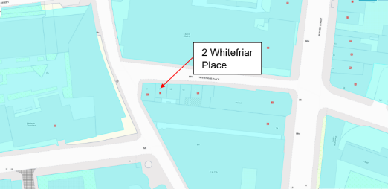
Fig 1: Location and Land Use Zoning

Recent Planning History:
No recent planning history.

Recent Enforcement History
Ref. No. | Opened | Reason | Closed | Reason
C0008/17 | 19-Jun-2017 | Potential endangerment | 28-May-2021 | N/A

Summary Description:
Description (based on NIAH Ref. 50110015).
Exterior: Terraced two-bay three-storey house over basement, built c. 1810, having shopfront to ground floor with accommodation over. Pitched roof, hidden behind brick parapet with granite coping, having long brick chimneystack to west party wall with clay pots. Yellow brick walling, laid in Flemish bond, to front elevation. English garden wall bond brickwork to rear. Square-headed window openings with painted masonry sills and replacement uPVC windows. Round-headed door opening to east end of front elevation with rendered reveals, carved timber architrave with panelled pilasters and cobweb fanlight, and recent timber door. Shopfront comprises panelled timber pilasters supporting fascia and cornice, plain square-headed display window with timber sill and rendered stall-riser, square-headed shop doorway with recent glazed timber door and overlight. Granite kerbing and cast-iron grille to footpath.

Assessment
Whitefriar Place is located of the west side of Aungier Street and was part of a grid of streets and lanes laid out in the second half of the seventeenth century to allow the development of the Aungier Estate. The Aungier Estate was named for Francis Aungier who acquired the land in the early 17th century. The earliest cartographic source depicting the estate is Bernard de Gomme’s Map of Dublin, 1673 which shows the main thoroughfare of Aungier Street running north south through the estate with Whitefriars Alley running off it at right angles to the west. Charles Brookings ‘Map of the City and Suburbs of Dublin, 1728’ indicates that Whitefriars Lane was fully development by the early 18th century. John Rocque’s ‘An exact survey of the city and suburbs of Dublin, 1756’ shows a number of buildings, including a Meeting House, on White Friars Lane. The house and shop at No. 2 Whitefriar Place is part of a short terrace of purpose built residential and commercial buildings located on the south side of the street. The 1847 Ordnance Survey map indicates the terrace included four structures though there are no building numbers indicated. The 1892 Ordnance Survey map indicates that the terrace had been extended to the east end to include a fifth structure. A grant of planning in 1996 (ref. 2179/96) allowed for the demolition of the two buildings (No. 1 and No. 1A) at the east end of the terrace. The partial demolition of No. 1B was also planned under this grant of planning but the demolition was amended to refurbishment under a subsequent grant of planning (ref. 2493/97).

Fig. 2: Extract from 1847 City of Dublin Ordnance Survey showing York Row (now Whitefriar Place)
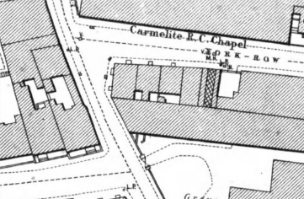

Fig. 3: Extract from1892 Ordnance Survey showing York Row (now Whitefriar Place).

References
- National Inventory of Architectural Heritage References 50110015
- City of Dublin, held by Ordnance Survey Ireland. © Public domain. Digital content: © Ordnance Survey Ireland, published by UCD Library, University College Dublin, 1847, Sheet 27 https://digital.ucd.ie/view/ucdlib:40863 (accessed 26/10/2021)
- City of Dublin, held by Ordnance Survey Ireland. © Public domain. Digital content: © Ordnance Survey Ireland, published by UCD Library, University College Dublin, 1892, Sheet DN018-067 https://digital.ucd.ie/view/ucdlib:40916 (accessed 26/10/2021)
- Brooking, C. (1728) ‘A map of the city and suburbs of Dublin, 1728’.
- De Gomme, B. (1673) ‘The citty and suburbs of Dublin, 1673’.
- Rocque, J. (1756) ‘Plan of the city of Dublin, 1756’

Significance/NIAH Rating
No. 2 Whitefriar Place was recorded under Stage 4 of the NIAH for Dublin (Ref. 50110015) with Ministerial Recommendations for Stage 4 issued to Dublin City Council on the 3rd November 2021. The structure was assigned a ‘Regional’ rating. These are structures or sites that make a significant contribution to the architectural heritage within their region or area. Structures which are considered of Regional significance are deemed worthy of inclusion on the RPS.

Assessment of Special Interest under the Planning and Development Act 2000
The National Inventory of Architectural Heritage assigned ARCHITECTURAL and SOCIAL interest. The Conservation Section has considered the opinion of the NIAH and is in agreement with assigning these categories of special interest to the site.

Conclusion & Recommendation
It is recommended that the RPS entry for 2 Whitefriar Place, Dublin 9 be amended to 2 Whitefriar Place, Dublin 8 – Shop and House, in accordance with Section 12(3) of the Planning and Development Act, 2000 (as amended).

Proposed Listing
RPS Ref No | Address | Description
8554 | 2 Whitefriar Place, Dublin 8 | Shop and house

12/11/2021
_______________ _________
Paraic Fallon Date
Senior Planner

Photograph of Structure:
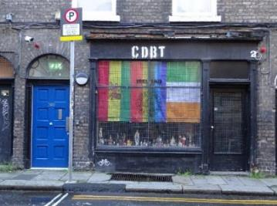

Fig. 4: Shopfront, 2 Whitefriar Place.

RPS No. 8555 - 3 Whitefriar Place, Dublin 8
Seandálaíocht, Caomhantas & Oidhreacht
An Roinn Pleanála & Forbairt Maoine
Oifigí na Cathrach, An Ché Adhmaid, Baile Átha Cliath 8

Archaeology, Conservation & Heritage Section
Planning & Property Development Department
Block 3, Floor 3, Civic Offices, Wood Quay, Dublin 8

Tel: (01) 222 3926, 222 3927
Email: conservation@dublincity.ie

12th November 2021

Draft Development Plan 2022-2028

Ref: RPS 8555 AMENDMENT to the Record of Protected Structures
_______________________________________________________________________________

Recommendation:
Amendment of current entry for 3 Whitefriar Place, Dublin 9 - Shop and house, to now read: 3 Whitefriar Place, Dublin 8 – Shop and house.
_______________________________________________________________________________

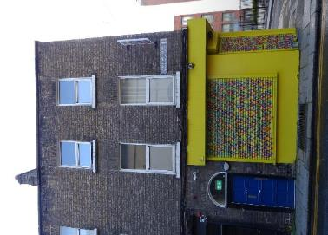

Introduction
No. 3 Whitefriar Place, Dublin 9 – Shop and House is on the current Record of Protected Structures (Dublin City Development Plan 2016-2022). The reference number is RPS 8555 and the description reads ‘Shop and House’. It is proposed to amend the address to No. 3 Whitefriar Place, Dublin 8.

Existing Listing:
RPS Ref No | Address | Description
8555 | 3 Whitefriar Place, Dublin 9 | Shop and house

Proposed Listing: Change postcode from Dublin 9 to Dublin 8.
RPS Ref No | Address | Description
8555 | 3 Whitefriar Place, Dublin 8 | Shop and house

Request for Investigation
Conservation Section, Dublin City Council.

Location and Land Use Zoning
The location of 3 Whitefriar Place, Dublin 8 is arrowed red below. The zoning objective is Z5: To consolidate and facilitate the development of the central area, and to identify, reinforce, strengthen and protect its civic design character and dignity.

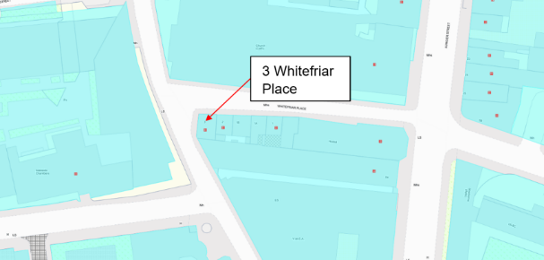
Fig. 1: Location and Land Use Zoning

Recent Planning History
No recent planning history.

Recent Enforcement History
Ref. No. | Opened | Reason | Closed | Reason
C0008/17 | 19-Jun-2017 | Potential endangerment | 28-May-2021 | N/A

Summary Description
Description (based on NIAH Ref. 50110014).
Exterior: Corner-sited end-of-terrace L-plan two-bay three-storey former house over basement, built c. 1810, having two-bay elevation to west (side) elevation and recent wraparound shopfront, with accommodation over. L-plan slate roof, hipped to corner and south end of return, hidden behind brick parapet with granite coping, and having long brick chimneystacks to east party wall and at right angles to junction of front block and return, with clay pots. Yellow brick walling, laid in Flemish bond. Square-headed openings with granite sills and replacement uPVC windows. Round-headed door opening to east end of front elevation with rendered reveals, panelled timber pilasters and plain fanlight. Granite kerbing and cast-iron grille to footpath.

Assessment
Whitefriar Place is located of the west side of Aungier Street and was part of a grid of streets and lanes laid out in the second half of the seventeenth century to allow the development of the Aungier Estate. The Aungier Estate was named for Francis Aungier who acquired the land in the early 17th century. The earliest cartographic source depicting the estate is Bernard de Gomme’s Map of Dublin, 1673 which shows the main thoroughfare of Aungier Street running north south through the estate with Whitefriars Alley running off it at right angles to the west. Charles Brookings ‘Map of the City and Suburbs of Dublin, 1728’ indicates that Whitefriars Lane was fully development by the early 18th century. John Rocque’s ‘Plan of the city of Dublin, 1756’ shows a number of buildings, including a Meeting House, on Whitefriars Lane.

The house and shop at No. 2 Whitefriar Place is part of a short terrace of purpose built residential and commercial buildings constructed on the south side of the street in the early nineteenth century. The 1847 Ordnance Survey map indicates the terrace included four structures though there are no building numbers indicated. The 1892 Ordnance Survey map indicates that the terrace had been extended to the east end to include a fifth structure. A grant of planning in 1996 (ref. 2179/96) allowed for the demolition of the two buildings (No. 1 and No. 1A) at the east end of the terrace. The partial demolition of No. 1B was also planned under this grant of planning but the demolition was amended to refurbishment under a subsequent grant of planning (ref. 2493/97).

Fig. 2: Extract from 1847 City of Dublin Ordnance Survey showing York Row (now Whitefriar Place)
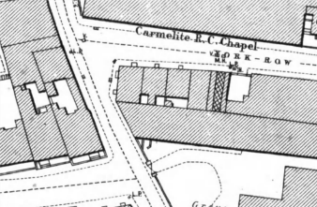

Fig. 3: Extract from1892 Ordnance Survey showing York Row (now Whitefriar Place).

References
- National Inventory of Architectural Heritage References 50110015
- City of Dublin, held by Ordnance Survey Ireland. © Public domain. Digital content: © Ordnance Survey Ireland, published by UCD Library, University College Dublin, 1847, Sheet 27 https://digital.ucd.ie/view/ucdlib:40863 (accessed 26/10/2021)
- City of Dublin, held by Ordnance Survey Ireland. © Public domain. Digital content: © Ordnance Survey Ireland, published by UCD Library, University College Dublin, 1892, Sheet DN018-067 https://digital.ucd.ie/view/ucdlib:40916 (accessed 26/10/2021).
- Brooking, C. (1728) ‘A map of the city and suburbs of Dublin, 1728’.
- De Gomme, B. (1673) ‘The citty and suburbs of Dublin, 1673’.
- Rocque, J. (1756) ‘Plan of the city of Dublin, 1756’

Significance/NIAH Rating
No. 3 (including 3A) Whitefriar Place was recorded under Stage 4 of the NIAH for Dublin (Ref. 50110014) with Ministerial Recommendations for Stage 4 issued to Dublin City Council on 3rd November 2011. The structure was assigned a ‘Regional’ rating. These are structures or sites that make a significant contribution to the architectural heritage within their region or area. Structures which are considered of Regional significance are deemed worthy of inclusion on the RPS.

Assessment of Special Interest under the Planning and Development Act 2000
The National Inventory of Architectural Heritage assigned ARCHITECTURAL and SOCIAL interest. The Conservation Section has considered the opinion of the NIAH and is in agreement with assigning these categories of special interest to the site.

Conclusion & Recommendation
It is recommended that the RPS entry for 3 Whitefriar Place, Dublin 9 be amended to 3 Whitefriar Place, Dublin 8 – Shop and House, in accordance with Section 12(3) of the Planning and Development Act, 2000 (as amended).

Proposed Listing
RPS Ref No | Address | Description
8555 | 3 Whitefriar Place, Dublin 8 | Shop and house

12/11/2021
_______________ ________________
Paraic Fallon Date
Senior Planner

Photograph of Structure
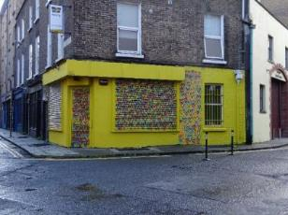 | 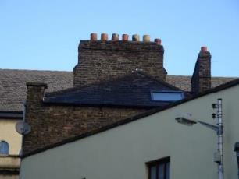
Fig. 4: Shopfront, 3 Whitefriar Place. | Fig. 5: Roof and chimneystack, 3 Whitefriar Place.

RPS No. 8560 – 38-46 Wicklow Street, Dublin 2
Seandálaíocht, Caomhantas & Oidhreacht
An Roinn Pleanála & Forbairt Maoine
Oifigí na Cathrach, An Ché Adhmaid, Baile Átha Cliath 8

Archaeology, Conservation & Heritage Section
Planning & Property Development Department
Block 3, Floor 3, Civic Offices, Wood Quay, Dublin 8

Tel: (01) 222 3926, 222 3927
Email: conservation@dublincity.ie

22nd November 2021

Draft Development Plan 2022-2028

Ref: RPS 8560 AMENDMENT to the Record of Protected Structures
_______________________________________________________________________________

Recommendation:
Amendment of current entry for 38-46 Wicklow Street, Dublin 2 - Including 1-3 Clarendon Street: shopfront window facade, from junction with Clarendon Street halfway to junction with Grafton Street, to now read: 38-46 Wicklow Street, Dublin 2 – Shopfront and façade excluding modern shopfront (see also 1-3 Clarendon Street and 88-95 Grafton Street)
_______________________________________________________________________________

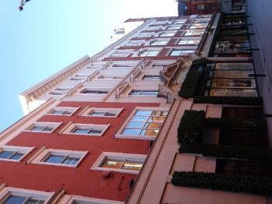

Introduction
No. 38-46 Wicklow Street, Dublin 2 is on the current Record of Protected Structures (Dublin City Development Plan 2016-2022). The reference number is RPS 8560 and the description reads ‘Including 1-3 Clarendon Street: shopfront window facade, from junction with Clarendon Street halfway to junction with Grafton Street’. It is proposed to amend the description to read ‘Shopfront and façade excluding modern shopfront (see also 1-3 Clarendon Street and 88-95 Grafton Street)’.

Existing Listing:
RPS Ref No | Address | Description
8560 | 38-46 Wicklow Street, Dublin 2 | Including 1-3 Clarendon Street: shopfront window facade, from junction with Clarendon Street halfway to junction with Grafton Street

Proposed Listing: Amend the description to read ‘Shopfront and façade excluding modern shopfront (see also 1-3 Clarendon Street and 88-95 Grafton Street)’.
RPS Ref No | Address | Description
8560 | 38-46 Wicklow Street, Dublin 2 | Shopfront and façade excluding modern shopfront (see also 1-3 Clarendon Street and 88-95 Grafton Street)

Request for Investigation
Conservation Section, Dublin City Council

Location and Land Use Zoning
The location of 38-46 Wicklow Street, Dublin 2 is indicated by the red arrow below. The zoning objective for the site is Zone 5: “To consolidate and facilitate the development of the central area, and to identify, reinforce, strengthen and protect its civic design character and dignity”. The property is located within the Grafton Street Architectural Conservation Area and within a red hatched Conservation Area.

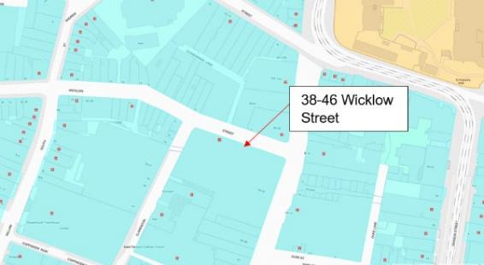
Fig. 1: Location and Land Use Zoning

Relevant Planning History
Planning Ref. | Description | Decision Date
0424/15 | PROTECTED STRUCTURE: Whether routine maintenance consisting of (a). The painting and repair where necessary of the windows and surrounds on Wicklow Street & Clarendon Street, and (b). The stripping off of the existing are of render on Wicklow Street and its replacement to the same dimensions and extent with new lime painted render, is a development requiring permission. | SPLIT DECISION(PERMISSION & REFUSAL)  13 Jan 2016
2674/09 | PROTECTED STRUCTURE-Planning permission for a new display window and new entrance and exit doors with surface mounted signage over to the Wicklow Street elevation of the Brown Thomas store bounded by Grafton Street, Wicklow Street & Clarendon Street. The works are to include the removal of the existing projecting stone facade and a new opening in an existing internal wall. | GRANT PERMISSION  23 Jun 2009
4237/08 | PROTECTED STRUCTURE: For a new display window and entrance door to the Wicklow Street elevation of the Brown Thomas store bounded by Grafton St., Wicklow St. & Clarendon St. Dublin 2. Works to include the removal existing projecting canopy and part of the existing stone facade. This building is a protected structure and within an architectural conservation area. | REFUSE PERMISSION  21 Oct 2008
2020/01 | New public entry in lieu of existing emergency egress doors and associated canopy, lighting and signage, to Wicklow St. at Brown Thomas Department Store. | GRANT PERMISSION  11 Sep 2001
4280/00 | Installation of a new glass canopy, and new doors to existing entries off Wicklow Street.(a protected structure) | GRANT PERMISSION  29 Mar 2001
1606/94 | New ground floor shop front and new access at corner returning onto Wicklow Street. | GRANT PERMISSION  14 Dec 1994

Relevant Planning Enforcement History
There is no recent planning enforcement history relating to this structure.

Summary Description
(See images at end of report).

Description based on National Inventory of Architectural Heritage’s record for site. 50910122, 50910123, and 50910124)

No. 38-46 Wicklow Street, Dublin 2 is a multiple bay, four- to six-storey over concealed basement commercial building comprising four individual structures (No. 38, No. 39-43, No. 44 and No. 45-46) which have been amalgamated to the interior. Elements of the ground floor shop front have been replaced.

No. 38 Wicklow Street comprises a corner-site attached six-storey commercial building, built c. 1910 with single-bay elevation to Wicklow Street, canted corner bay and three-bay elevation to Clarendon Street. Modern flat roof hidden behind brick parapet with masonry coping. Machine-made red brick walls laid in English Garden Wall bond with rock-faced granite quoins to upper floors. Square- and segmental-headed openings to upper floors with granite sills and replacement timber single-pane sash windows. Square-headed display window continuous sill course to first floor. Early twentieth century shopfront to ground floor comprising large display windows with curved end bay having decorative overlights, framed by brass colonettes with recent stone clad fascia.

No. 39-43 Wicklow Street is an attached five-bay four-storey commercial building, built c. 1910. Replacement flat roof hidden behind rendered projecting stucco parapet. Machine-made red brick walls to upper floors. Square- and segmental-headed window openings framed by red brick pilasters will stucco capitals, having stucco surrounds to first and third floors and stucco surrounds with scrolled keystones to second floor. Early twentieth century shopfront to ground floor comprising large display windows having decorative overlights, framed by brass colonettes with recent stone clad fascia.

No. 44 Wicklow Street is an attached three-bay, four-storey commercial building, built c. 1904. Hipped roof with projecting moulded cornice with console brackets. Painted rendered walls to upper floors with stucco dressings. Square-headed window openings to first floor with stucco surrounds and triangular pediments; segmental-headed window openings with continuous stucco cill course, stucco surrounds and flat pediments and stucco keystones to second floor; paired segmental-headed openings to third floor with continuous stucco cill course, lugged stucco surrounds with keystones. Early twentieth century shopfront to ground floor comprising stone clad fascia with swan-neck pediment framed by scrolled console brackets over large display window on polished granite stall-riser.

No. 45-46 Wicklow Street is an attached corner-sited four-storey commercial building having four-bay elevation to Wicklow Street, canted corner bay and two–bay elevation to Grafton Street and recent shopfront to ground floor. M-profile pitched roof hidden behind render parapet. Red-brick walls, laid in Flemish bond to upper floors. Square-headed window openings, tripartite window openings to east end with continuous sill course, moulded colonettes and flat pediments over. Square-headed window openings to second and third floor with painted masonry cills and render surrounds. Recent stone clad shopfront to ground floor.

Assessment
No. 38-46 Wicklow Street consists of a complex of late nineteenth to early twentieth century commercial buildings which were formerly occupied by Switzer’s Department Store. The complex was substantially reconstructed to the designs of Scott Tallon Walker in the late twentieth century but the façades to Wicklow Street were retained and a shopfront provided to the east and west of the principal entrance bay to No. 44. The development of Switzer’s Department Store commenced at No. 91 Grafton Street in the 1830s and had expanded by the 1860s to include the Wicklow Street facade. By the late nineteenth century the store covered almost the entire block at the junction of Grafton Street and Wicklow Street with its principal entrance in the centre of the Wicklow Street façade.

The building was first protected under the Dublin City Development Plan, 1987 where it is described as ‘Including 1-3 Clarendon Street: shopfront window facade, from junction with Clarendon Street halfway to junction with Grafton Street’.

The planning applications (Ref. 2674/09, 4237/08, 2020/01, 4280/00 and 1606/94) and Section 5 (Ref. 0424/15) relate to the structure indicate that the exterior façade is significantly intact apart from the ground floor shopfront which was replaced in the late 1990s. As such, it is recommended that the description for RPS Ref. 8560 for No. 38-46 Wicklow Street, Dublin 2 is amended to read ‘Shopfront and façade excluding modern shopfront (see also 1-3 Clarendon Street and 88-95 Grafton Street)’.

References
- Casey, C. (2005). Dublin: The Buildings of Ireland. London: Yale University Press.
- National Inventory of Architectural Heritage (NIAH) Ref: 50910122, 50910123, 50910124.
- Planning file Ref. 0424/15, 2674/09, 4237/08, 2020/01, 4280/00 and 1606/94.

Significance/NIAH Rating
No. 38, No. 39-43 and No. 44 Wicklow Street were recorded under Stage 3 of the NIAH for Dublin (Ref. 50910122, 50910123, 50910124) with Ministerial Recommendations for Stage 3 issued to Dublin City Council on 28th June 2018. The structures were assigned a ‘Regional’ rating. These are structures or sites that make a significant contribution to the architectural heritage within their region or area. Structures which are considered of Regional significance are deemed worthy of inclusion on the RPS.

Assessment of Special Interest under the Planning and Development Act 2000
The National Inventory of Architectural Heritage assigned ARCHITECTURAL, ARTISTIC and HISTORICAL interest to No. 38 Wicklow Street, Dublin 2; ARCHITECTURAL, ARTISTIC and HISTORICAL interest to No. 39-43 Wicklow Street, Dublin 2 and ARCHITECTURAL and ARTISTIC to No. 44 Wicklow Street, Dublin 2. The Conservation Section has considered the opinion of the NIAH and is in agreement with assigning these categories of special interest to the structures.

Conclusion & Recommendation
It is recommended that the description for RPS ref. 8560 for No. 38-46 Wicklow Street, Dublin 2 be amended to read ‘Shopfront and façade excluding modern shopfront (see also 1-3 Clarendon Street and 88-95 Grafton Street)’ in accordance with Section 12(3) of the Planning and Development Act, 2000 (as amended).

Proposed Listing
Amend description to read ‘Shopfront and façade excluding modern shopfront (see also 1-3 Clarendon Street and 88-95 Grafton Street)’.

RPS Ref No | Address | Description
8560 | 38-46 Wicklow Street, Dublin 2 | Shopfront and façade excluding modern shopfront (see also 1-3 Clarendon Street and 88-95 Grafton Street)

22/11/2021
_______________ ________________
Paraic Fallon
Senior Planner Date

Photographs of structure
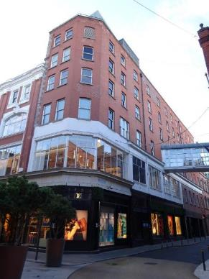 | 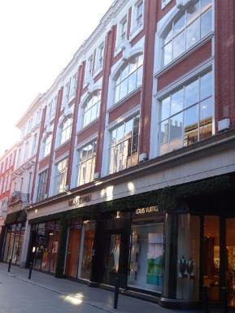
Fig.2: No. 38 Wicklow Street. | Fig.3: No. 39-43 Wicklow Street.
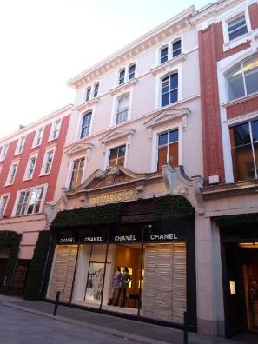 | 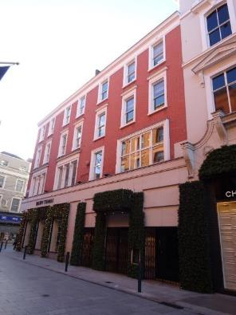
Fig.4: No. 44 Wicklow Street. | Fig.5: No. 45-48 Wicklow Street.

Notices in The Architect and Building News, May 9th and 16th 1930 for extension to Bolton St. Schools by Messrs. John J.Robinson & Richard C. Keefe.
Notices in The Architect and Building News, May 9th and 16th 1930 for extension to Bolton St. Schools by Messrs. John J.Robinson & Richard C. Keefe.
Refer to O.S. Sheet 018-07 1936. Irish Architectural Archive Dictionary of Irish Architects refers to Robinson & Keefe extension 1929 – 1920 and designs dated 1934 by Ralph Henry Byrne.
Bennett, Douglas, The Encyclopedia of Dublin

