Contact Dublin City Hall
Event Enquiries
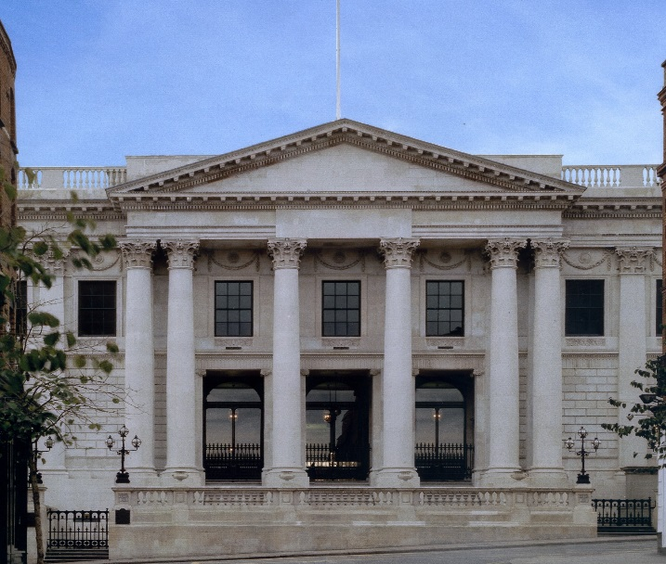
Proposed Event Date Yes, my date is flexible

Name

Telephone

Email

Number of guests

Message

