Strand Road Cycle Trial
Beach Road Options
Report on the Public Consultation
February 2021
Contents
INTRODUCTION 1
Covid-19 and Mobility in the City 1
Background 1
Beach Road 1
Consultation Feedback 2
Overview of Feedback 2
Question 1 One way/Two way option 3
Question 2 Concerns 4
Question 3 Comments 7
Conclusions 8
Next steps 8

INTRODUCTION

Covid-19 and Mobility in the City
The Covid-19 pandemic has affected all our lives and the way in which we work, socialise and communicate. It also has had enormous impacts on our transport system, radically reducing travel levels and is likely to alter our patterns of movement for some time to come.
Currently (Jan/Feb 21) car traffic in the Sandymount area is at approximately 50% of pre Covid levels. At present under level 5 the capacity of public transport is set at 25% of normal with Government advice to avoid public transport and leave for essential workers only. As these, social distancing requirements are likely to remain in place for the foreseeable future, the overall patterns of travel, in the short-term at least, will be significantly different from those that existed pre Covid.
To facilitate these new patterns of travel, some reallocation of road space needs to continue to be introduced across the city.

Background

Beach Road
Beach road runs from the Sean Moore road junction to Newgrove Avenue in the Sandymount area of Dublin. Dublin City Council in conjunction with the NTA is proposing to trial the implementation of cycle facilities along the Strand Road and Beach Road in order to offer an alternative transport option for work, school and leisure activities. It is proposed to undertake a six month trial of a 2 way separated cycle track from Merrion Gates to Sean Moore Rd with links either side as they are developed.
Dublin City Council carried out a non-statutory public consultation from 21st August 2020 to 14th September 2020 on the Strand Road cycle trial. During that consultation Beach Road was shown as maintaining two way vehicular traffic and taking the footpath for a cycle track. During the consultation we received submissions relating to Beach road:
- Clarification from the National Transport Authority (NTA) that Beach Rd does not currently need to cater for two way traffic for bus routes
- Objecting to the removal of the footpath for a cycle lane
- Concerns from residents of Marine Drive and Leahy’s terrace that vehicles heading to Sean Moore Rd would use these streets
In response to this DCC prepared a design layout on Beech Road that is as per the Strand Road trial arrangement with one lane of outbound traffic, a 2 way cycle lane using what is currently the outbound traffic lane and no changes to the footpath.
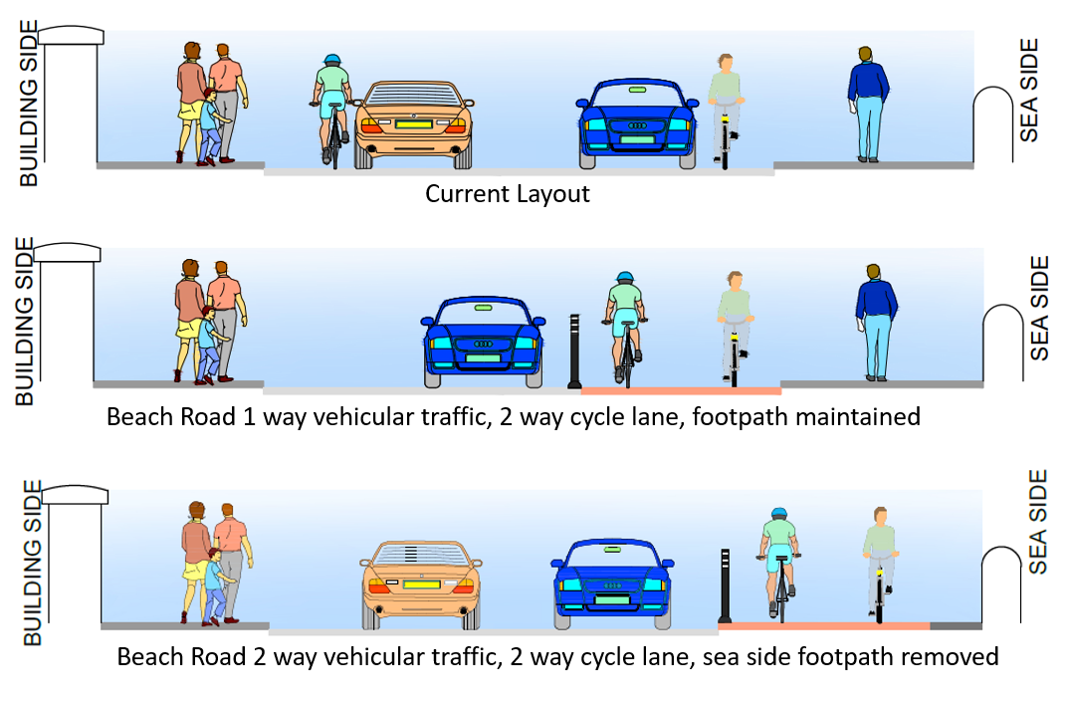
Figure 1 Current layout, 1 way vehicular traffic layout, 2 way vehicular traffic layout

A consultation on specifically Beach Road was published on the 7th of December 2020 to gather feedback to find out for this specific change to the Strand road cycle route trial. The consultation closed on the 22nd of January.

Consultation Feedback

Overview of Feedback
A total of 3,712 submissions were received. Dublin City Council wishes to thank everyone who took the time to contribute to this consultation process.
Source and number
Consultation Hub responses 3,706
Email 6
Total 3,712

The breakdown of online submissions respondents was:
Submission by: No.
Member of the public 2,046
Resident 1,726
Commuter 821
Other 88
Residents' Association / Community Group 54
Employer 52
School 37
Retailer 24
Public Representative 12
Emergency services 7

Several people selected more than one option.

Three questions were asked on the consultation hub.

Question 1 One way/Two way option
1 - “Would you prefer this revised option with one way for traffic with the footpaths retained and the cycle lane at road level on Beach Road between Sean Moore Road and Marine Drive or the original option with two way vehicular traffic and the cycle lane using the footpath.
One way – revised option
Two way – original option”
687 people did not answer this question. Of the 3,019 who did, 57% were in favour of Beach Road being one way:
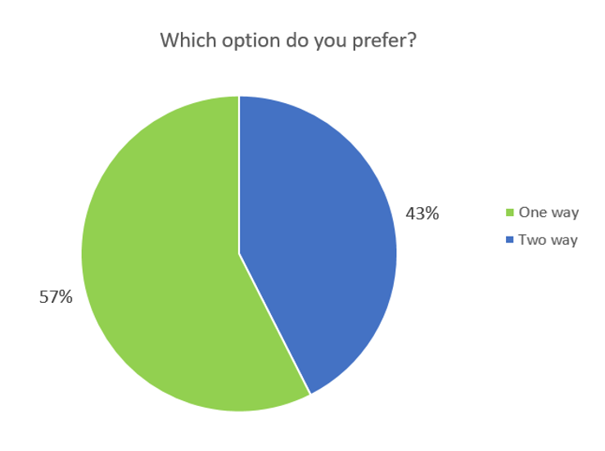
Figure 2 Question 1 results

Question 2 Concerns
Question 2 was “Do you have any concerns about this proposal?”
The main concerns from those who responded “One way Option” were:
- None
- The trial not going ahead
- Width of the cycle lane (should be wider)
- Retention of parking
- Keeping the existing footpaths for pedestrians
- Additional traffic in Sandymount
Addressing these issues:
- DCC are planning on proceeding with the six month Strand Road cycle trial
- The 3m width is to keep a consistent width throughout the trial
- There will be no loss of parking
- The one way option would retain the footpaths as they currently are
The traffic concern is addressed below.

The main concern of those who selected “Two way option” was
- Additional traffic in Sandymount
The majority of these concerns relate to the Strand Road cycle trial. Many of the concerns raised were answered as part of that consultation. The report on that consultation including the responses is available on the Strand Road Cycle Trial Webpage
There were also some concerns that came up frequently:
Increased traffic in Sandymount village
It is not envisaged there will be any significant increase of vehicles within the village. There is no change proposed to the existing right turn bans from Merrion Road towards Sandymount village. The traffic modelling does not show any significant increase within the village. As part of the mitigation measures two pedestrian crossings have been installed in the village along with a new traffic camera which allows DCC to monitor in real time what’s happening in the village.

Traffic increase of 322% in Sandymount
There were many identical submissions quoting that there will be a predicted increase in traffic in Sandymount of up to 322%. The wording to these submissions was very similar to information on a leaflet distributed in the area. This is erroneous information as it comes from the model which shows that that percentage increase applies to a minor road only, Marine Drive, and is an increase from 7 to 29 vehicles. The largest increase the modelling shows in Sandymount is 16%. The modelling was based on pre covid traffic volumes. Traffic volumes in Sandymount are currently at 50% of pre covid volumes.
Trucks
Currently there are approximately 130 Heavy Goods Vehicles (HGVs) per day travelling northbound on Strand road. This includes anything with a rigid 2 axle (such as an ambulance) or higher. The majority of these HGVs (70%) are 2 or 3 axles. There are no changes to the right turn bans on Merrion Road towards Sandymount village proposed; the ban at Ailesbury road and Sandymount Avenue will remain in place at the start of the trial. The entirety of Sandymount is covered by the 5 axle HGV ban. In addition most of the roads are also covered by 3.5 tonne limits

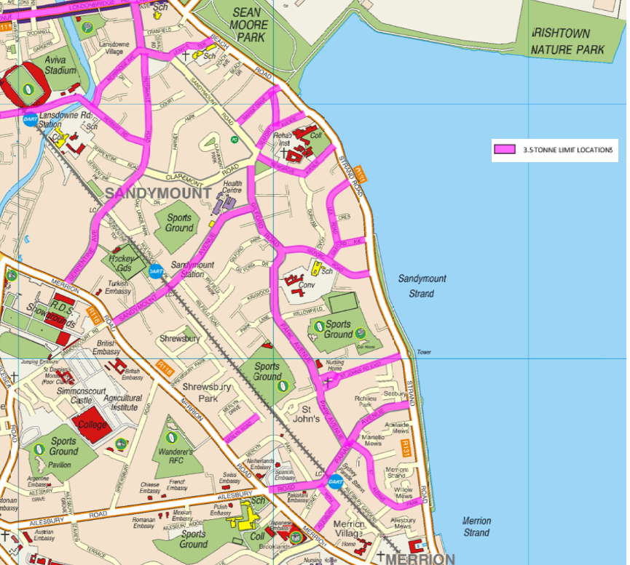
Figure 4 3.5 tonne limit areas

Strand Road is not a designated HGV route to the port or the waste to energy plant and has not been since 2007. In the Transport Infrastructure Ireland plan for Brexit related issues at the Port, Strand Road is not mentioned as it is not the route for hauliers. As the Transport maps on the TII website show the M50 is the route for northbound traffic to Dublin Port. It should be further pointed out that the HGV strategy, which was introduced in 2007, removed 433 5+ axle vehicles a day from Strand Road who diverted to the M50 and to the Tunnel without adverse consequences. DCC will look to extend the current 5+ axle ban in the Sandymount area to 24 hours during the cycle trial.
Similarly, the main concerns of those who didn’t answer question 2 related to additional traffic.

Question 3 Comments
Question 3 was “Any other comments? “
The responses to this question were mainly:
- Support of the trial
- Rejection of the trial
- Why an off road cycling route can’t be provided instead

The main off road cycling options would be using the footpath, using the promenade or constructing a boardwalk.
Converting the footpath to a cycle track would mean a loss of footpath on the sea side. This footpath is five times busier than the house side footpath and would be a loss of amenity, especially during Covid restrictions. We would also need to extend the footpath, reconstruct the footpath, move lighting columns to the back and install new drainage which is a significant piece of work and not a rapid deployment scheme. The carriageway width would need to be reduced, most likely resulting in the loss of informal parking along Strand road. Even if this was implemented there is still 300m on the approach to Merrion Gates where it is not possible to provide any cycle protection without the removal of a traffic lane.
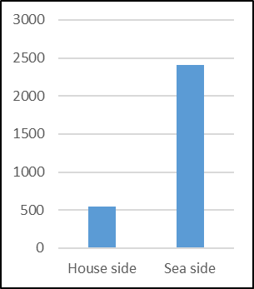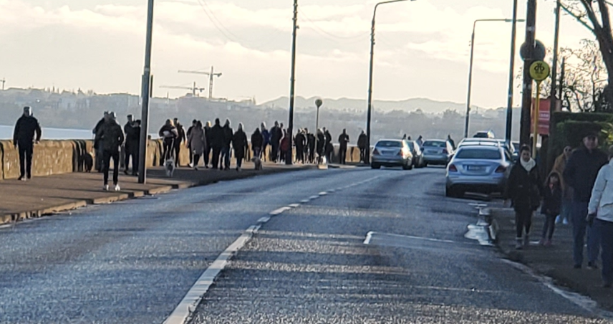
Figure 5 Pedestrians numbers on Strand Road November, 2020

A cycle track on the existing promenade would require Part 8 planning permission and a full environmental assessment. It would be a loss of some of the green space amenity and provides a solution for just 35% of the route. Using the promenade does not address what happens either side of the promenade or how to bring cyclists through the stretch on the approach to Merrion Gates. There is no guarantee that planning permission would be granted and it would take a number of years to go through the process.
The construction of a boardwalk is not a short term solution and in light of climate change may not be suitable as a long term solution. Due to the environmental sensitivities, a screening is likely to show it would require a Natura Impact Statement (NIS) and need to go to An Bord Pleanála. This would take many years to carry out the necessary studies and to prepare an application with no guarantee that approval would be granted. Any works in the bay would also need to be designed in collaboration with flood design works and the projects would need to be developed together as one project. This would cause a significant delay in the provision of safe cycling infrastructure in the area.

Conclusions

This consultation was held to obtain views on whether, as part of the Strand Road cycle trial, to make the Beach road section the footpath is repurposed as a cycle track with two-way vehicular traffic for Beach road, or for the cycle track to be on road, with one way for vehicular traffic and no changes to existing footpaths.

The majority of respondents to the consultation indicated a preference for the cycle track to be on road, with one way for vehicular traffic and no changes to existing footpaths. This option also has a number of benefits:

- Ties in with the arrangement on Strand road
- No changes to existing footpath
- Is easier to reverse this arrangement post trial if the cycle route is to be removed
- Little civil works involved (using the footpath would require a buildout and the repositioning of the lighting columns to the back of the footpath
- The modelling shows the one way option results in smaller traffic increases in the area than keeping two way traffic. It also shows a large benefit to Strand road, Irishtown and Ringsend area.

Next steps

The cycle route implementation in this area will be on road resulting in one way traffic on Beach Road. Dublin City Council would like to thank everyone who responded to the consultation.

