**Addenda to**

**Chief Executive’s Report on Draft Plan Consultation Process**

**Report No. 119 2022**

**Report to Council Under Section 12 (4) of the Planning and Development Act 2000, (as amended)**

**Review of the Dublin City Development Plan 2016-2022 and Preparation of a New City Development Plan 2022-2028**

**24th May 2022**

**Addenda to Chief Executive’s Report on Draft Plan Consultation Process**

**Report No. 119 2022**

**Addendum 1:** The following issue raised in submission reference DCC-C38-DRAFT-1741 – The Irish Province of the Order of the Carmelites was inadvertently omitted during the collation of the final Chief Executive’s Report published on the 29th of April 2022. The issue relates to the section in the Chief Executive’s Report in Volume 3: Zoning Maps and Map G regarding the zoning of the subject lands at Terenure College, Fortfield Road, Terenure, Dublin 6W as set out below.

**Addendum 2:** The following amendments to Map K were inadvertently omitted during the collation of the final Chief Executive’s Report published on the 29th of April 2022:

* Amend Map K to include the existing and public transport alignments within the SDRAs.
* Amend Map K to correct alignment of SDRA 10 and 13 boundaries to be consistent with the guiding principles maps in Chapter 13 of the Draft Plan.

Maps are uploaded on Sharefile and paper copies are available on request.

**Addendum 1**

Volume 3: Zoning Maps: p. 446 of Chief Executive’s Report on Draft Plan Consultation Process: Add Submission Number 1741.

Volume 3: Zoning Maps: Map G Table p. 753 of Chief Executive’s Report on Draft Plan Consultation Process: Add site reference G-0022 for lands at Terenure College, Fortfield Road, Terenure, Dublin 6W as set out below.

|  |  |  |  |  |  |
| --- | --- | --- | --- | --- | --- |
| **Site Address** | **Draft Plan Zoning** | **Requested Zoning** | **CE Recommendation** | **Map Sheet** | **Map Reference** |
| Scoil Colm Crumlin | Z15 | Z12 | Z15 | Map G | G-0001 |
| Circle K Sundrive Road, Kimmage Road Lower Dublin 6W | Z1 | Z3 | Z3 | Map G | G-0002 |
| Ben Dunne Gym and Former Art Gallery, Kimmage Road West | Z9 / Z1 | Z10 | Z10 | Map G | G-0005 |
| Circle K Westway, Kylemore Road, Inchicore, Dublin 12 | Z6 | Z4 | Z6 | Map G | G-0006 |
| Assumption of the Blessed Virgin Mary, Walkinstown | Z9/Z15 | Z12 | Z9/ Z15 | Map G | G-0007 |
| BOC Gases Bluebell | Z6 | Z6 | Z6 | Map G | G-0008 |
| Brooks Builders Merchants / Naas Road Industrial Estate , Naas Road | Z6 | Z14 | Z14 | Map G | G-0009 |
| Drimnagh Castle Primary School, Long Mile Road, Walkinstown, Dublin 12 | Z15 / Z9 | Z12 | Z15/ Z9 | Map G | G-0010 |
| Marist National School, Clogher Road, Crumlin Dublin 12 | Z15 | Z12 | Z15 | Map G | G-0011 |
| St. Bernadette's, Clogher Road, dublin 12 | Z15 | Z12 | Z15 | Map G | G-0011 |
| Our Lady of Good counsel Infant NS (Muire Na Dea Chomhairl Infant NS), Mourne Road, Drimnagh, Dublin 12 | Z15 | Z12 | Z15 | Map G | G-0012 |
| Our Lady of Hope School, Armagh Road, Crumlin, Dublin 12 | Z15 | Z12 | Z15 | Map G | G-0013 |
| Scoil Eoin, Armagh Road, Crumlin, Dublin 12 | Z15 | Z12 | Z15 | Map G | G-0014 |
| Scoil Una Naofa, Armagh Road, Crumlin, Dublin 12 | Z15 | Z12 | Z15 | Map G | G-0014 |
| Scoil Mhuire Ogh II, Loreto Junior School, Crumlin Road, Dublin 12 | Z15 | Z12 | Z15 | Map G | G-0015 |
| Assumption Junior School, Walkinstown Dublin 12 | Z15 | Z12 | Z15 | Map G | G-0016 |
| Assumption Senior Girls NS, Walkinstown, Dublin 12 | Z15 | Z12 | Z15 | Map G | G-0017 |
| Our Lady's Hospital School, Crumlin Dublin 12 | Z15 | Z12 | Z15 | Map G | G-0021 |
| Lands at Terenure College, Fortfield Road, Terenure, Dublin 6W | Z15 | Z1 or Z12 | Z15 | Map G | G-0022 |

Zoning Map G: Add site reference G-0022 for lands at Terenure College, Fortfield Road, Terenure, Dublin 6W as shown below:

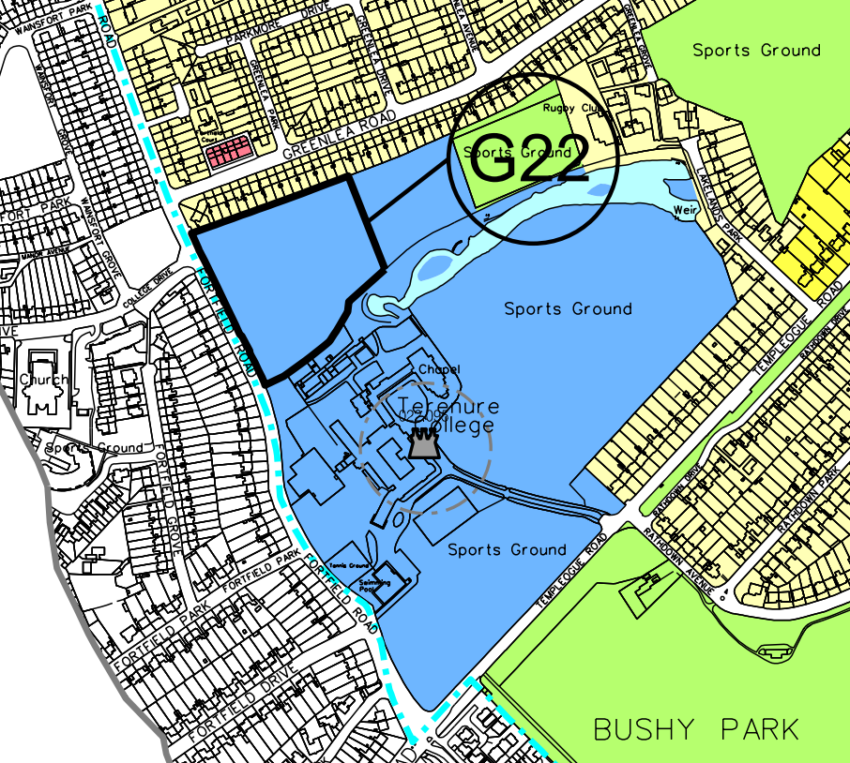

Volume 3: Zoning Maps: Page 773 of Chief Executive’s Report on Draft Plan Consultation Process: Add site report G-0022 for lands at Terenure College, Fortfield Road, Terenure, Dublin 6W as follows:

**Map Reference:** G-0022

**Site Address:** Lands at Terenure College, Fortfield Road, Terenure, Dublin 6W

**Draft Plan Zoning:** Z15

**Requested Zoning:** Z1 or Z12

**CE Recommended Zoning:** Z15

**Summary**

The submission seeks the rezoning of Lands at Terenure College, Fortfield Road, Terenure, Dublin 6W to Z1 or Z12 (Z15 under Draft Plan) on the basis that the former playing pitches/institutional grounds are surplus to the requirements of the college due to the closure of the primary school, the development of further sports facilities on site and the extent of the overall Z15 landholding in the control of the Carmelite Order. The submission notes that Terenure College is well provisioned in terms of institutional land when compared to other schools and Department of Education Guidance.

It is stated that the lands are not required for social or community purposes and that their rezoning would facilitate investment in the College, would support the Order’s charitable endeavours and would help address housing requirements in line with the objectives of the Core Strategy.

The submission also raises broader concerns with Z15 policy objectives.

**Chief Executive’s Response**

A detailed response to the matter of educational use and to the broader concerns with Z15 policy objectives raised in the submission is set out in the CE response to Chapter 14. With regard to the rezoning request, the Department of Education (DES) has made a detailed submission to the Draft Development Plan, highlighting the challenges to the Department in developing schools in the city. Their submission seeks strong and explicit support from the City Council regarding the protection of school sites and specific protection of their curtilage. The submission in particular notes that as the city’s population grows, the most viable and deliverable option to meet expanded requirements of an area is to more intensively develop the sites of the existing schools that serve the area.

Having regard to the submission of the Department, it is considered that the lands at Terenure College should remain zoned Z15 to protect the essential community and social infrastructure role that they serve. With regard to points raised in the submission, that such a rezoning would facilitate further investment in the college, the CE notes that the Draft Plan provides for limited residential development where it can be demonstrated to the satisfaction of the Planning Authority, that such a development is required in order to maintain or enhance the function/operational viability of the primary institution on the lands.

It is noted that part of the lands are located in Flood Zone A and B.

**Chief Executive’s Recommendation**

Retain Z15 zoning.

Strategic Environmental Assessment, Appropriate Assessment and Strategic Flood Risk Assessment: Part 3: Assessment of Recommended Amendments to Draft Plan Maps: Zoning Map G: Add site reference G-0022 for lands at Terenure College, Fortfield Road, Terenure, Dublin 6W as set out below.

