General View Shots/ B-roll Film Application
Lead in time required minimum 7 working days in advance of your shoot date.
Please completed application and detail everything the Film Office need to know [your name and contact info, company name and contact info, location(s), and your date(s)], and your insurance certificate is attached-it usually takes just a few days to process a GV/ B-roll permit.
Submitting "TBC"s, leaving locations box blank, or putting N/A in your equipment box will delay processing of your shoot.
If you have special requests, parking, Garda, traffic control etc., anything that is not hand held equipment, 1 week will likely NOT be enough lead time. Please use form called “All Production Sizes”.
Name of producer/ Applicant

Applicants phone number

Email address for invoicing/ financial statements
Name of production

Name of insured production

Address

List streets required

Date(s)

Start / End time

Equipment in use; Please list all revenant audio/visual equipment

Number of people on location

Production budget €

Production spend (in Dublin) €

I confirm this application is correct and the production has less than 5 people and is only using handheld equipment for capturing general views shots of Dublin and b-roll.
Signed;
Date;
Once completed please email completed form to Filming@dublincity.ie along with;
- Public Liability Insurance with specific indemnity to Dublin City Council,
- Safety Statement
- Risk Assessment

General view shots of Dublin City
Person to Camera shots
B roll content
List of permitted equipment
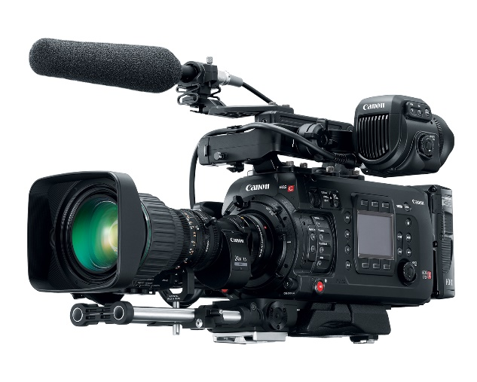
- Handheld Cameras – such as Blackmagic, Canon EOS, Nikon, Sony, Panasonic, FiLMiC Pro, Mirrorless camera.
- Vlogging camera
- Steadicam
- Gimbals
- Stabilisers
- Go Pro – and other similar models of micro camera
- All lens
- Tripods
Reflectors –
- Collapsible Reflector
- Reflector arm and stand
- Polyboard under 1.5M Sq.

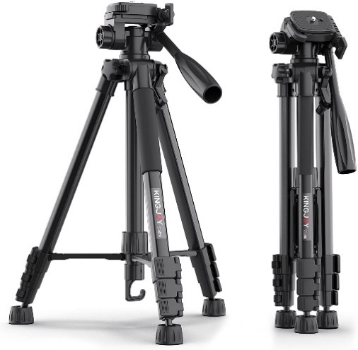
Please note;
No Scripted content scenes or Semi scripted content
Permitted for PTC* from a contributor - opening PTC- when presenter opens-up the news/doc, and introduce themselves to the audience.

Doesn’t allow for PTC* from Talent/ Professional Actors/ Hires/ Extra’s * Please use “All Production Size application”
Minimal audio on location/ Minimal Audio Sync required.
*Person to camera/ Piece to Camera
Terms and conditions of filming in Dublin City
- Additional Terms and Conditions may be added to your production once full details of the filming request is received.
- Filmmakers must ensure that Dublin City Council is kept fully informed of the intentions of the production company.
- Productions should nominate a member of crew to liaise with the relevant agencies and services, that person should be an experienced Location Manager or Unit Production Manager, where possible.
- Filming to take place at the stated locations, dates and times only.
- It is recognised that audiovisual production companies must act in a responsible and professional manner. However, all producers/Location managers need to take their surroundings into consideration and must not;
  - Obstruct others from carrying out their business;
  - Cause a disturbance or safety hazard or impede the mobility of pedestrians, goods or services without adequate prior consultation.
  - Dublin City Council has a duty of care towards residents and businesses and will exercise control if a particular production is causing an unreasonable nuisance.
  - The selection of film locations that may have the potential to affect normal traffic flow and should only be done in consultation with An Garda Síochána and Dublin City Council’s Roads and Traffic Department.
- If required all road closures must be applied for and agreed in advance of filming.
- There must be no interference with vehicular or pedestrian traffic unless specifically applied for and a Traffic Management Plan is received and approved by An Garda Síochána Dublin City Council.
- Notify relevant Garda station/s.
- An Garda Síochána and Dublin City Council have the right to terminate any permits granted, should prior agreements not be adhered to.
- Any filming undertaken is the responsibility of the applicant. Adequate notice must be given to An Garda Síochána and Dublin City Council when making any arrangements.
- Dublin City Council must be credited in the production titles for their assistance in the making of the programme/film/series and the DCC logo included where possible. Please contact Dublin City Council’s Events Team for the Council Logo in various formats.
- The requirements DCC’s Building Control Section, must be complied with in full and the certificate the event structural engineer, in relation to the erection of temporary structures must be submitted to buildingcontrol@dublincity.ie prior to commencement of the production.
- Any additional requirements of the statutory agencies must be resolved directly with them prior to holding of the filming.
- There must be no obstruction of access or egress to retail or other premises
- No litter to be created as a result of the filming
- Parking permits and suspension of parking if required must be applied for and permits granted prior to commencement of filming.
- Positioning of vehicle applications and equipment if required, must be made and granted prior to commencement of filming.
- Only essential services and prop vehicles to be parked at location. Cast, crew and talent parking should be arranged off site.
- All consultation with businesses/residents and other premises to be complete prior to commencement of filming.
- Noise should be kept to a minimum and generators should be baffled or integrated with the location vehicle.
- Noise levels should not be considered a nuisance and consideration must be given any noise sensitive premises in the area.
- Crew members should aim to dress professionally at all times, in all weathers. Dress codes imposed at particular locations for religious or other reasons must be adhered to.
- Crew and cast should refrain from using lewd or offensive language.
- It is the responsibility of the applicant to ensure that All Emergency Medical Technicians (EMTs), Paramedics (Ps) and Advanced Paramedics (APs) must be registered with the Pre-Hospital Emergency Care Council in order to legally practice in Ireland. The Pre-Hospital Emergency Care Council (PHECC) maintains a statutory register of all pre-hospital emergency care practitioners who meet the required standards.
- The applicant must satisfy themselves that the person responsible for drawing up and implementing the Health and Safety Statement and Risk Assessment Plan for their filming is competent to do so. Sole responsibility lies with the applicant to ensure that all elements of plans are carried out as stated in the documentation submitted to Dublin City Council for the duration of the filming.
- Dublin City Council bears no responsibility for the management of safety for the duration of the filming
- The applicant must comply with all Health and Safety Legislation, the Safety, Health and Welfare at work Act 2005, Health and Welfare at work Act (Construction) 2013, Health and Welfare at work Act (General) 2007, Fire Services Act 1981 and 2003. All regulations made there under, and all other relevant legislation, regulations and approved Codes of Practice, to ensure the safe running of this event.
- This decision notice does not apply to Grand Canal Square or Henrietta Street or Council owned Parkland.
- This decision notice does not permit you to film outside Department of Justice properties, Department of Defence properties, any national embassies, any national consulate offices, or airports.
- As part of the terms and conditions of a permit an applicant may be required to submit a refundable bond, where Parks and Landscape Services decide that the proposed filming is of a scale that is likely to cause damage to the park surface from construction, vehicular or crew/cast movement, or any other activity associated with the production.
- A pre-production on-site meeting must be arranged at least 14 days in advance of the filming with the District Parks Officer for the particular park to discuss any potential impact to the site.
- Dublin City Council or An Garda Síochána reserves the right to suspend / terminate any and/or all proposed activities being held in the park/open space for reasons of public safety, congestion or nuisance or any other reason. Any such termination would be without any claim or liability on the statutory bodies. Dublin City Council reserves the right to cancel or withdraw consent at any time in parks/open spaces.
- Dublin City Council may require the applicant to curtail, relocate or cancel an event on or before the booking date, in circumstances of emergency or other legitimate access requirements for which there is no satisfactory alternative arrangement that can be made.

Insurance
- All productions should provide Dublin City Council evidence of insurance we will require; Submission of Public Liability Insurance indemnifying Dublin City Council up to €6.5million will be required along with proof of Employers Liability of €13 million.
- The production company will be expected to indemnify any third party property owners, whose property is intended for use as a film location, against any claims or proceedings arising directly from any injury to persons or damage to property as a result of the activities of the production company or its agents.

Privacy Notice
- All information requested is for the sole purpose of processing your application. We do not collect personal information for commercial marketing or distribution to private organisations. It may be necessary from time to time to pass your contact information on to trusted third parties in order to assist with the processing of your application, such as our statutory agency partners, e.g. An Garda Síochána, as long as those parties agree to keep this information confidential.
- Access to any non-public personal information that you provide will be restricted to only those employees who need to know that information to process your application.
- It is our policy to retain collected information for a five year period after which your information will be disposed of securely.
Contact our Data Protection Officer on dataprotection@dublincity.ie or 01 222 3775.

