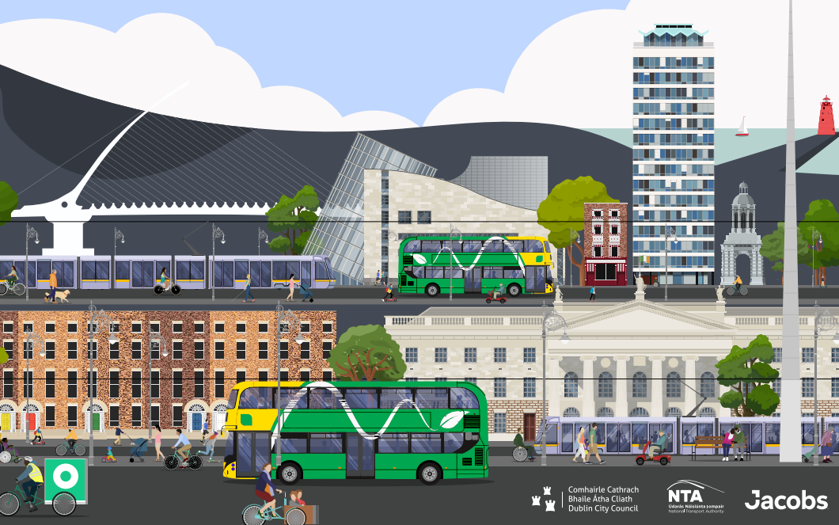

Report on Non Statutory Public Consultation
Feb 2024
Table of Contents
Introduction 1
Consultation 2
Consultation Approach 2
Consultation Promotions 3
Consultation Results 5
Consultation Submissions 6
Respondents information 7
Traffic Free Area at Liberty Place or Custom House Quay 10
Resident submissions 11
Elected Representatives 15
State and government agencies 16
Health groups and organistaions 17
Disabled Users and groups 19
Businesses 20
Business groups 21
Individual Businesses 22
Car parks 23
Resident Associations 24
Transport Providers and Operators 25
Education 26
Other groups and organisations 26
Conclusion and next steps 29
APPENDIX A 30

Introduction
Dublin City Council, in partnership with the National Transport Authority, developed the draft Dublin City Centre Transport Plan 2023. The development of this plan is an objective of the Dublin City Development Plan 2022 -2028 which was adopted by the elected members in November 2022, and is line with the Transport Strategy for the Greater Dublin Area, as approved by the Minister for Transport in December 2022.
The Dublin City Development Plan 2022-2028 sets out an inspiring vision for the city, and in the area of transport sets out very challenging and ambitious targets to be achieved, including a 40% reduction in general traffic and significant increases in walking, cycling and public transport.
In order to meet the vision within the Development plan it has been necessary to consider how this level of change can be accomplished and what are the tools that can be used to achieve this.
The transport vision, as set out in the draft plan, sets out a series of traffic management changes in the city centre which aims to create a low traffic city centre with public transport, walking and cycling being prioritised. It draws lessons from the response to the Covid pandemic whereby low traffic volumes allowed very ambitious changes to be undertaken in areas such as Capel Street, Nassau Street and along the North and South Quays.
The traffic management changes envisaged as part of this plan aim to significantly reduce volumes of car traffic in the city centre, opening up space for the sustainable modes, and significantly improving the public realm by allowing greening and the development of new public spaces for residents, workers and visitors to the city centre. It looks to envisage a city centre not dominated by traffic and the opportunities that could be opened up by this change. It emphasises the role that public transport plays as the biggest mover of people to from and around the city centre and seeks to ensure fast and reliable services can work in the city centre while acknowledging that the economic life of the city needs to be protected during and after these changes.

Consultation
Consultation Period
The draft Dublin City Centre Transport Plan 2023 was presented to the Dublin City Council Traffic and Transport SPC and subsequently published on September 13th 2023. A period of public consultation took place over 11 weeks from September 13th to December 1st 2023. The City Council and the NTA wishes to thank all those who took part in this process and who took the time to attend briefings, fill in submissions and make their observations.
Consultation Objectives
The objectives of the consultation exercise were to:
  - Raise Public Awareness about the Draft City Centre Transport Plan.
  - Capture and understand Public Sentiment towards Draft City Centre Transport Plan.
  - Produce an Informed City Centre Transport Plan.

Consultation Approach
Online Consultation Page
The Draft City Centre Transport Plan 2023 consultation webpage was published on Dublin City Council’s Citizen Space platform on September 13th. The webpage included the following resources:
- Text introduction to the Draft Plan
- Draft Plan (English)
- Drachtphlean (Gaeilge)
- Accessible (screen-reader friendly) Draft Plan
- Video presentation overview of Draft Plan
- September 13th Draft Plan SPC Presentation
- September 13th Draft Plan SPC Presentation with Alt Text
- Equality Impact Assessment (EIA)
- Natura Impact Statement (NIS) in support of the Appropriate Assessment (AA)
- Strategic Environmental Assessment Environmental Report
- SEA Environmental Report Appendix II: Non-Technical Summary
The consultation webpage invited input via a number of different channels outlines below:

- Online Survey
A public online survey was published on the Draft Plan consultation webpage (questions asked are included in Appendix A). The overarching purpose of the survey was to understand public sentiment towards key principles of the Draft Plan. Further, more targeted consultation exercises will be carried out in relation to specific proposed schemes within the Draft Plan prior to implementation.
- Email Submissions
The City Centre Transport Projects team email address was provided for soft-copy submissions.
- Postal Submissions
The City Centre Transport Projects team postal address was provided for hard-copy postal submissions.
Consultation Desk and Paper Survey (Civic Offices)
From September 13th – December 1st 2023 a consultation desk was established in the atrium of Dublin City Council’s Civic Offices. The consultation desk included a large Draft City Centre Transport Plan Poster, with A2 and A3 hardcopies of the Draft Plan on display and paper copies of the survey (Appendix A) available to complete with a submission box.

Consultation Promotions
- Press Engagement
- A media release regarding the Draft Plan and consultation was published on September 13th 2023.
- A second media release was published on November 16th 2023.
The draft Plan was covered by the national broadcaster including on the 9 o’clock news, national newspapers, and radio stations. It reached 1.4 milllion people: 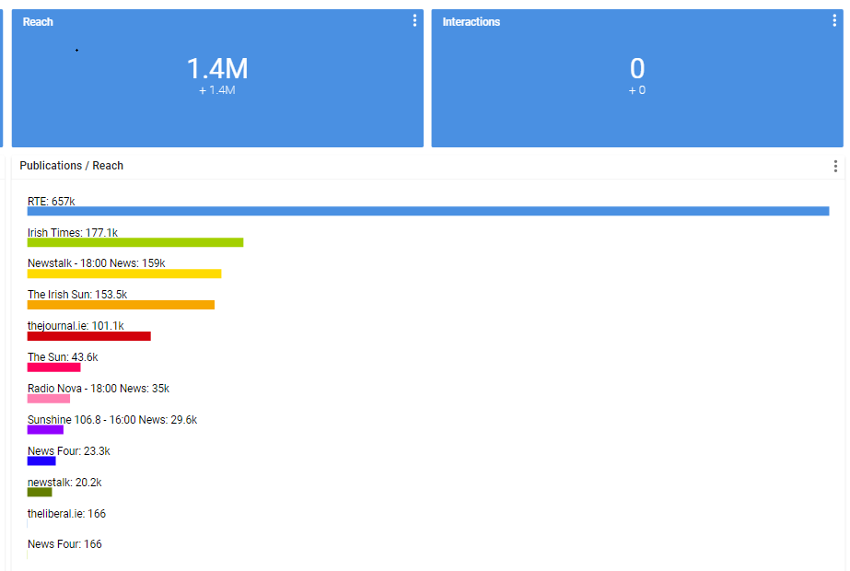
- Social and Digital Media
Social media posts were published by DCC accounts across three platforms Twitter, Instagram and Facebook. The Draft City Centre Transport Plan Presentation (Public Sector Transformation Week) was uploaded to YouTube Video 800 + views.
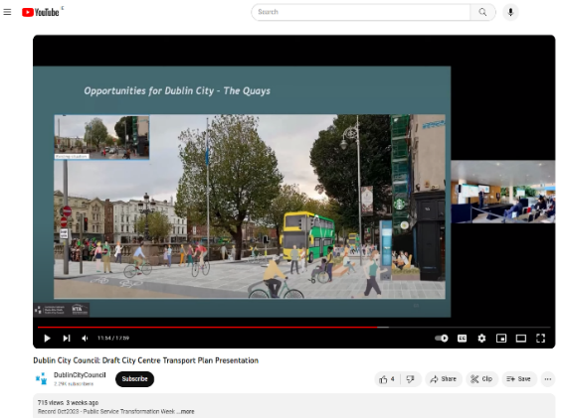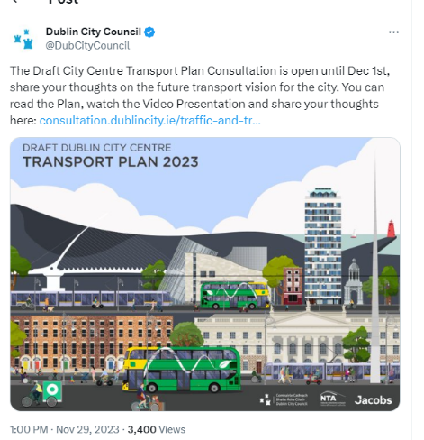

- Events
Dublin City Council and the NTA presented an overview of the Draft City Centre Transport Plan at a number of key events and briefings with key stakeholders:
Event | Attendees (Approx.)
Dublin Town, Lord Mayors Business Forum & An Garda Siochana | 20
Chamber of Commerce Infrastructure committee | 80
On line Briefing IBEC | 180
Open Session Dublin Chamber of Commerce | 70
Westbury Hotel | 1
Public Sector Transformation Week | 100 (DCC Staff)
NTA Transport User Group 13th Oct 2023 | *
*NTA Transport User Advisory Group is made up of 15 people who represent: People with disabilities (rep from Irish Wheelchair association, National Council of the Blind and National and Platform of Self Advocates who represents people with intellectual disabilities); Public Transport Users (4 no.; Pedestrians; Cyclists; Older persons; Students; Taxi Users; Local Link; Chamber of Commerce; Tourism

Consultation Results
The following submissions were received:
Submissions | Number
Online Survey | 3,487
Paper Survey | 11
Email | 77
Postal | 17
TOTAL | 3,592

A copy of the submissions will be available on the Consultation Hub website - https://consultation.dublincity.ie/traffic-and-transport/draft-dublin-city-centre-transport-plan/

m

Consultation Submissions
It was very clear from reading the submissions received that the objectives and vision contained in the Development plan and the subsequent strategy set out in the draft transport plan resonated with large numbers of respondents. There was very clear support for the ambition and strategy shown within the city Centre Transport plan and that there is a strong desire from citizens to see these implemented.
There was a high level of support for giving more transport choice, more traffic free spaces, improving pedestrian space, allocating more road space to public transport and reducing through traffic.
.

Respondents information

There was a stronger response rates from Males than females with 59% male, 37% female and 3% prefer not to say.

There was a good mix of responses from different transport users with public transport users being the highest respondents which matches with the cordon count data which shows public transport is the main method of travelling into the city centre. Public transport users clearly saw that the plan as set out would improve their journey times and experience within the city centre.

A very large majority of public transport users clearly saw the benefits of reducing through traffic in the city centre but notably a clear majority of car users were also in favour of this measure.

Public transport users clearly wanted a more efficient public transport and felt that reducing space for private vehicles would help to achieve this. However it should be noted a majority of car users also felt that this reduction of space for private vehicles was justified.

There was also strong support across all age ranges with 88% approval in the 18-29 age group and 75% in the 50-69 cohort.

Traffic Free Area at Liberty Place or Custom House Quay
The consultation asked respondents whether they would prefer to see options for creating a Traffic Free space at Liberty Place (Beresford Place) or Custom House Quay. The majority selected Custom House Quay.

3,100 respondents gave their preference with 1,932 responses selecting Customs House Quay, 1,170 selecting Liberty Place and some respondents asking to vote for both and neither.
While a clear majority were in favour of Customs House Quay there was also a significant number who saw merit in Liberty Place; therefore more work on both options will be undertaken to see what interim changes could be made and what would be a longer term project.

Resident submissions
The people who responded to the consultation selected where they are based. The answers show a good mix of locations with responses from those within the Dublin City Council area making up the majority but also many responses from those outside the city council area:
- Dublin City Centre (Between the canals) – 28%
- Dublin City Suburbs (From the canals to the M50) – 53%
- Dublin City Commuter Belt / Outside County Dublin (Beyond the M50) – 18%

Overall, there was a very positive response for reducing “through traffic” and providing more transport choices. There was a slightly more positive responses from those living within the core city area and between the canals and the M50 than those outside the M50 although over 75% of those responses were in favour.

There was very strong support from residents from all areas (above 75%) for reducing private vehicles to facilitate a more efficient public transport system and also support for more traffic free civic spaces in the city centre. Again there was greater support for those living in the city and the suburbs.

Respondents were also asked whether they were in favour of high quality pedestrian and cycle facilities in the city centre. There was very high support from all residents for high quality pedestrian facilities with 95% of residents within the city and the suburbs in favour. There was similar high levels of support for cycling (89% and 92% for those within the M50) and slightly less at 81% for those outside the M50.

The results show overall a very positive response to reducing the through traffic through the city centre in favour of improving public transport efficiencies and choices, more traffic free and civic spaces and improving pedestrian and cycle facilities. The objectives within the development plan of setting out reduction of private car use, increase in traffic free spaces and improving public transport and the strategy to achieve this set out in the City Centre Transportation plan, a very clear majority of respondents agreed with.
The main aspects of the Plan that respondents liked were:
- The overall vision set out in the Plan
- Allowing public transport to move better through the City
- Making the city a healthier place to be in
- Providing more opportunities for greening and seating
- Making the city safer for pedestrians and cyclists
- More Traffic Free areas
Some of the positive comments that were received include:
“This is great, really welcome. This could really revitalise the city centre. Through traffic adds nothing to the city except noise, pollution, and danger to pedestrians and cyclists.”
“Many people complain about how slow busses are. They’d be twice as fast if not getting caught in through traffic from taxis and private cars. Especially on the quays.”
“I am very happy with the Transport Plan and I think that it will greatly enhance the lives of everyone who spends time in Dublin city centre. I would encourage the Council and the other groups implementing the plan to, as much as possible, resist attempts to water down the proposals due to pressure from private car users; private car use should not be a priority for any forward-looking Transport Plan nor any modern city in general.”
“Fantastic and exciting plan to transform our city. All elements would be transformative, notably the priority given to bus routes over private vehicles. No more sitting in mile-long traffic on the quays!”
“As a car owner, I recognise the importance of sharing space with other road users.”
“I think the plan has a huge amount of promise. The key matter is urgency. This simply needs to be started ASAP. For too long the city has been choked by private vehicles and resident of the city deserve to reclaim space”
The main concerns raised related to those who have no alternative to cars, particularly those outside the city where there are less public transport options. There is a concern from some that there will be no cars permitted in the city. This however is not the case. The intention is to prioritise public transport and to make better space for walking and cycling, however there will always be vehicular access required the aim is to ensure that traffic that is still there has a reason to be there which contributes to the city centre.
There are also some concerns that the measures are being brought in before major public transport enhancements are in place.
- Response:- Public transport numbers at present are higher than pre Covid and the public transport system in its current configuration moves the majority of people to and from the city centre. As has been pointed out in the Dublin Bus submission, congestion on the road network is the major problem they face while delivering their services across Dublin. Any changes which will allow public transportation services to operate more efficiently and to provide a more reliable service will benefit the majority of people access Dublin city centre. It should also be noted that two of the Bus Connects corridor now have planning permission and design work on these will commence shortly with construction of the corridors beginning in Q1 2025.

Overall submissions from the public were very positive across all demographics. Those who use public transport and those based in the city and surrounding areas are most supportive of the measure. But the there is also majority support from those who mainly travel by private car and those who are based outside the M50.

Elected Representatives
Submissions were received from :
- Ivana Bacik TD
- Neasa Hourigan TD and Cllr Janet Horner
- Cllr Donna Cooney
These submissions were very supportive of the draft Transport Plan. A number of comments and suggestion were made including the type of materials used (such as bollards), more greening space and play space, ensuring accessibility issues are incorporated, re-routing, monitoring of measures, ensuring effective communication of any planned measures, protection of existing trees and biodiversity.
- Response :- The various submissions made reference to different individual proposals and the comments and suggestion relating to these will be considered in any designs. The Parnell square proposal which was not included in the draft Plan is now referred to in the Final version.
There were also a number of comments outside the scope of the City council such as relating to enforcement which will need to be discussed with the relevant bodies.
A submission was also received from Senator Michael McDowell. Comments relate to the Plan being too radical, that the Plan utterly discounts any positive effects of private vehicle access to the city or the need for same and will make it make cross city car and commercial traffic almost impossible from the inner suburbs north and south.
- Response:- The aims of the plan are to reduce through traffic in the city centre and to make traffic management changes at a number of key locations to achieve this. DCC and the NTA are very conscious of the need to ensure that commercial business can continue to operate in the city centre and will be carefully monitoring the changes.
Overall submissions from elected representatives were very positive with some very constructive suggestions for particular elements and locations.

State and government agencies
Submissions were received from the following:
- The Office of the Planning Regulator OPR – “Please be advised that the Office of the Planning Regulator has reviewed the consultation documents but does not have a comment to make on the non-statutory plan at this time.”

- The Office of Public Works (OPW) – The OPW “in general support the general aspirations of the Draft Dublin City Centre Transport Plan 2023 to provide a reduction in general traffic, to facilitate walking, cycling and increased use of public transport, to open up space for sustainable modes, to provide new public spaces and provide for the greening/improvement of the existing public realm.” They would like to see the public and staff to their buildings within the area. They also made some specific comments relating to College Green and Dame Street; Parliament Street; Liberty Place; Custom House Quay; Pearse Street and Tara Street; Lincoln Place. The OPW are supportive of these schemes whilst having some specific queries on each.

  - Response :- DCC will liaise directly with the OPW prior to any scheme being implemented and work with them for each location.

- The Houses of the Oireachtas Commission offered a number of observations relating to Impact on travel between Leinster House and areas north, northwest and west of Leinster House, Lack of provision for traffic with city centre destination, Nature of the parliamentary community and Public protests.

  - Response :- There are no plans for access and egress points to be impacted by the Plan. Most routes to Leinster House will be unaffected by the proposals and for measures such as changes to the quays there will be alternative routes. DCC will liaise directly with the Houses of the Oireachtas Commission particularly for measures that may have a more direct impact such as at Lincoln Place.

- The Road Safety Authority (RSA) state how important to acknowledge recent road safety
Developments which, while Ireland has experienced a long-term decrease in road user fatalities, there has been a significant increase in fatalities this year (2023). They point out that following a recent analysis of cyclist serious injuries4 that occurred between 2018 and
2022 as a result of road traffic collisions reported to An Garda Síochána, just over half (53%)
of 1,327 occurred in Dublin County. Of those 700 seriously injured cyclists in Dublin, 63.4%
were injured in the Dublin City Council area. Of all cyclists’ serious injuries almost half (47%) occurred at a junction (88% of which on urban roads) and over 8 in 10 cyclists were
seriously injured in multiple vehicle collisions, most commonly with a car or light goods
vehicle. They would like to see that road safety is a key consideration in the draft Dublin City Centre Transport Plan, and that this aligns with the Government’s Road Safety Strategy (2021-2030) and Phase 1 Action Plan (2021-2024).

- Response:- DCC are happy to engage further the RSA on both the Plan and on monitoring post implementation.

- The Land Development Agency (LDA) provided details in their submission of a number of LDA sites within the city centre. They welcome the Plan as they aim to create sustainable form of living and enabling access for new and existing communities to sustainable mobility options, amenities and services without undue reliance on the private car.

Overall submissions from state and government agencies were very positive with a great willingness to work with DCC/NTA on developing and implanting the Plan.

Health groups and organistaions
A number of other groups and organisations contributed to the consultation.
There was very strong support from a number of groups in the healthcare sector and an overall submission from the Health Alliance some of whose members are:-
- Irish Cancer Society
- Irish Doctors for the Environment,
- Irish College of General Practitioners,
- Irish Nutrition and Dietetic Institute,
- Irish Society of Chartered Physiotherapists,
- Irish Heart Foundation,
- Asthma Society of Ireland,
- Royal College of Physicians of Ireland,
- Royal College of Surgeons of Ireland,
- University College Dublin, School of Public Health,
- Physiotherapy & Sports Science, National Children’s Hospital Ireland,
- Irish Gerontological Society,
- Stroke Association Northern Ireland,
- Irish Global Health Network,
- Association for Health Promotion Ireland,
- Irish Medical Organisation,
They recognise that “Implementing this plan will deter the public from using private fossil-fuelled motorised vehicles in favour of active travel forms of transport such as walking and cycling. Not only will this deliver environmental benefits through reduced levels of greenhouse gas emissions, it will deliver a dual health benefit of improved air quality and increased physical activity, whilst also benefiting mental health and producing economic dividends for the local and national economy.”
The Irish Heart Foundation are supportive of the proposal “The Irish Heart Foundation wholeheartedly supports the Draft Dublin City Centre Transport Plan to reduce ‘through traffic’ to improve the amenity of Dublin’s city centre and facilitate greater use of walking, wheeling, cycling and public transport. This proposal to remove private motor vehicles and through traffic from Dublin’s city centre will deliver a multitude of physical health, mental health, environmental, and economic benefits for the local community..”
The Public Health, HSE Dublin and North-East (covering counties Cavan, Louth, Meath, Monaghan and North Dublin) and HSE Dublin and South East Public Health Department made a submission and
“support the development and implementation of measures that encourage uptake of active and public transport options to discourage the use of private motorised vehicles. The transport sector is a major contributor to greenhouse gases, and ambient air pollutants that cause increased morbidity and mortality from cardiovascular, and respiratory diseases. It is also well documented that reliance on private motor vehicles is a significant contributor to lack of physical activity, which in turn is a cause of chronic diseases. Increased use of active and public transport delivers direct and indirect benefits for personal, community, and environment and health”. “Increased use of active transport has been shown to offer both direct and indirect benefits for personal, community, and environmental health. Direct benefit that will be appreciated will include increased physical activity, reduced traffic congestion, and reduced exposure to common ambient air pollutants and noise pollution.” “Indirect benefits from active and public transport include building social capital and improving social connectedness, as well as reduced greenhouse gas production which will mitigate climate change impacts. Improvements to social capital and connectedness occur because people may interact with others whom they see on their shared journeys or while out riding/walking around or commuting to known destination. This has the potential to reduce socio-economic inequalities (by facilitating social inclusion and well-being), and has mental health benefits as it reduces peoples’ sense of insularity”.
As well as suggestion for improved safety for cyclists and pedestrians, they have provided a number of suggestion for including the social dimension of transport into the Plan and considering the needs of certain groups who may face barriers to social inclusion.
The Roya College of Surgeons Ireland (RCSI) submitted a detailed document on specific traffic issues on roads around its premises. They presented a number of interesting proposals for reducing vehicular traffic and improving the pedestrian and cycle environment in that area.
- Response :- These will be further examined by the team in detail and direct liaison with RCSI will be undertaken.
Overall, the health related submissions were extremely positive. They highlighted the importance of health and how the Plan could assist in improving physical and mental health .These are very important considerations to take account of and something that can often be overlooked in any discussion about changes to a traffic layout.

Disabled Users and groups
Ninety-five of the online submissions received related to access for disability users. These were concerns over access to various parts of the city for blue badge holders, mobility and visually impaired citizens and how close to their destination they can get and if there would be big changes to their route, bus stop or parking.
- Response: Maintaining access for everyone is a key component of the Plan. Whilst some route for vehicles may change, access to most areas of the city will be maintained. The number of disabled spaces will not decrease and if any are to be moved they will be relocated as close as possible to their current location. It is not envisaged that there will be a significant relocation of spaces. Where possible additional spaces will be installed close to key areas. Decluttering and removal of unnecessary street signage will be undertaken to improve footpath areas and anywhere there are changes at crossing these will be brought up to standard if currently insufficient with the correct dropped kerbs, ramps and tactile. Taxis can use the majority of bus lanes at present so they will continue to provide access within the city.
A number of groups also made submissions:
- Irish Wheelchair Association (IWA) “commend the overarching objective of ‘ensuring that the city is accessible to all’ in the Dublin City Transport Plan”. They also include some comments relating to shared space, floating bus stops islands, location of disabled parking bays that are lined with traffic on both sides and un-signalised crossings. The IWA raise a number of important points including meaningful consultation of people with disabilities and ensuring that public transport is accessible, usable and attractive for people with disabilities.
  - Response:- The comments raised will be a key factor in any design carried out for measures under the Plan.

- PPN – “In general the PPN is very supportive of the plan to improve footpaths and cycle lanes in the city centre and realises that if it is done correctly that it will benefit all members of society. The plans are very good in theory and if they work as stated then it should be easier for residents to walk cycle and commute safely within the Dublin City area.” They have included details on design of footpaths, cycle lanes, crossings and parking. They have also submitted detailed observations and suggestions on the different measures.
  - Response :- These will be brought into the design of each location as a starting point of any designs. The importance of consultation and providing information is also noted.

- Voice of Vision Impairment submitted a response to the consultation. Their submission raised the issue of limited access to all areas for blue badge holders and SPVs; segregated safe zone for pedestrians; safe pedestrian crossings; clearance on footways, wayfinding in open areas; access to public transport, works and maintenance.

  - Response :- The details provided will be considered for each individual measure.
Overall, submissions from disability groups were positive with the requirement for specific needs to be taken into account at an early stage for all measures. The importance of consultation and communication was also raised by many and is something we recognise the importance of.

Businesses
Submissions were received by businesses and business organisations through the consultation hub and by email submissions.
- An Post
- Apoca
- BT Arnotts
- Christchurch Car Park
- Dublin Chamber
- Dublin City Centre Transport Traders Alliance (DCCTA)
- Diageo
- Dublin Can be Heaven
- Dublin Town
- Fitzsimon Hotel
- Fleet Street Car Park
- Freight Transport Association Ireland (FTAI)
- Grafton Carpark
- Hammerson (Illac)
- IFSC Car Park
- Irish Life Assurance
- Irish Life Investment Managers
- Irish Parking Association
- IWA
- Jobcare
- MPMRA
- ParkRite and Q-Park
- Temple Bar Company
- Tesco
- The Spire Car Park
- Trinity St Car Park
- UPS
- Westbury
Overall the submissions were quite balanced and positive. Certain submissions requested further engagement on specific measures (such as College Green) which will be carried out and contact made.

Business groups
Dublin Chamber were very welcoming and supportive of the Plan. Dublin Town have indicated there is some anxiety from businesses on the Plan which is largely due to uncertainty of the impact of the Plan and how it might affect their business.
- Response :- We are aware of the importance of communicating any changes and have already committed to listening and addressing concerns as they arise. Meetings have already taken place with Dublin Town and with representatives from the Lord Mayors forum and more are already scheduled.. We will also be carrying out more targeted consultation as specific measures are due to be implemented so we can respond to any queries or concerns. We note Dublin Town’s suggestion for holding workshops etc to provide information on any measures.
The Temple Bar Company welcome and support the overall Plan. They had a number of queries mostly relating to access for deliveries and access in the area relating to the proposals for bachelors Walk and Aston Quay as well as College Green.
- Response:- In advance of those measures being implemented we will liaise with Temple Bar Company to show the routes in and out of the area and to ensure we address any specific concerns.
The Freight Transport Association Ireland are seeking that the Plan supports urban logistics for Freight services and courier services. They have included a number of valid suggestions including off peak deliveries, ensuring sufficient loading spaces within the city, trials for consolidated deliveries, Final mile delivery and clear signage
- Response:- We will examine and respond to the various suggestions made.
Concerns were raised from The Dublin City Centre Transport Traders Alliance (DCCTA) submission on the Plan, specifically relating to legislation and a consultation survey they submit is flawed. They also reserve their position to consider the institution of judicial proceedings.
- Response:- The concerns are noted but for clarity it should be stated that the submission repeatedly refers to a joint Plan by DCC and TII – TII are not involved with this Plan and it is a DCC/NTA Plan.
The Dublin Can be Heaven group are concerned the Plan will be detrimental to city centre businesses and hospitality by removing car borne shoppers.
- Response:- It is not the intention to remove “car borne shoppers”. The intention of the Plan is to remove the large volume of through traffic travelling through the very centre of the city that do not stop or have a destination within the city centre but that create congestion and delays to those travelling to the city for businesses or shopping and for those delivering and carrying out maintenance for businesses.

Individual Businesses
A number of businesses provided submissions. Many such as An Post and Tesco were supportive of the Plan and some had requests for further engagement on specific measures (such as College Green).. UPS were generally very supportive of the Plan and requested that consideration is given to the needs of freights and deliveries in the city
Hamerson PLC (Ilac) welcome the intention of the Plan. They raised some comments relating to ensuring there is continuing consultation, what the alternative route options are for customers and will they experience delays; restricted delivery times; traffic modelling details; balance between vehicles and public transport; taxi holding areas; initiatives for cycling and pedestrians would be a benefit for the Ilac centre; proper planning process and consultation will take place.
- Response :- Further consultation and engagement with businesses will be taking place and specific queries will be addressed. The modelling report will be made available on the consultation hub.
Businesses concerns:
BT Arnotts – Whilst they commend the Plan’s overall aim to foster a more sustainable and vibrant city while striving for inclusivity and accessibility for all residents and visitors, they are concerned of a potential deterrent for customers accessing their stores, particularly those coming from areas not well served by public transport. They are also concerned the Plan proceeds public transport initiatives.
Diageo – concerned about unable for their HGVs to drive between St James gate and Dublin Port via the city centre (Bachelors Walk and Aston Quay)
Irish Life campus – concerns over access
The Westbury – concerns over access, including as currently stands due to illegal parking particularly on Wicklow Street.
- Response :- Most of the concerns naturally relate to access and potential new arrangements. In the case of Irish Life access will be maintained as is. In the case of BT Arnotts as proposals are further developed for that area further engagement will take place. As stated previously, the intention of the Plan is to remove traffic that has no destination in the city centre. The city centre will still be accessible by car although access to some specific locations may require a different route to the current route.
For the very specific concerns of the Westbury Hotel the specific problems around the Wicklow St area will be looked at to try and address the concerns. .
Whilst the role and contribution of Diageo to the city is acknowledged and it is Dublin City Councils wish to ensure that their role and contribution continues, maintaining a route through the very core of the city for large HGV vehicles as requested is extremely difficult. Currently over 90% of the 5 axle HGVs travelling on Bachelors Walk during the permit hours are movements from Diageo. We will engage directly with Diageo regarding their submission and how to maintain access and egress.
Overall there was a lot of support for the vision of the Plan. There were queries, some relating to specific businesses. It is proposed to continue to meet with businesses in a collaborative fashion and to take opportunities to discuss measures when and as they are proposed to be implemented. We will also liaise with individual businesses as required for the different measures.

Car parks
The Irish Parking Association had a number of requests including full access to be maintained to all city centre off-street carparks, clear communication to the public of the access routes; using carparks as last mile logistic hubs; electric charging stations, drone landing centres, shared vehicle centres and basis for alternative transport devices including e-scooters; a coherent strategy which recognises the role of off-street public multi storey parking facilities; addresses disadvantage by providing the differently-able with full access to the city centre by vehicle.
- Response :- DCC/NTA welcome the potential multi uses for carparks including for delivery hubs and sharing hubs for various mode and would be keen to explore further. Whilst specific route maps for each carpark are not deemed necessary, we will be engaging with the various mapping companies to ensure they changes are captured on the different navigation and mapping tools to ensure the correct route is provided.
Apoca Parking, ParkRite and QPark along with a number of individual carparks (Christchurch carpark, Fleet St carpark, Grafton carpark, IFSC carpark, The Spire carpark, Trinity St carpark) made submissions. These submission mainly related to access to the carparks.
- Response:- As various measures are being implemented details on access in particular areas will be provided which will include access to carparks within that area.
Stanberry Investment Limited, who own the Grafton Carpark formerly Brown Thomas Car Park, are strongly opposed to the Plan and state that “The Draft Transport Plan traffic management principles would “decimate city centre retail business”. Their submission also states that “The underlying principle of the draft plan is to reduce private car access by two thirds”. A further statement in their submission is that “The plan actively seeks to close our client’s business” and they describe the plan as an “elastic band around the centre of the city rather than envisioning how to support the quality of public life in the city “”
- Response :- The plan does not seek to reduce private car access by two thirds, rather it is to reduce the through traffic element in the city centre. Access to the city centre will be maintained with some potential changes in routings. The plan does not seek to close any business and in fact the aim of this transport plan is to ensure the continuance of businesses in the city centre while acknowledging that changes are needed in the current traffic arrangements in the city centre.

Overall there was some support for the overall vision but a lot of concerns regarding impact on the numbers of cars using city centre car parks and how this would affect businesses in their car parks.

Resident Associations
A number of resident organisations also took part in the consultation. These included:
- Calm Crumlin Road – whilst the area is outside the scope of the Dublin City Centre Transport Plan the concerns of the routes in the area as high speed, heavy volume routes and lack of cycle facilities.
  - Response :- The comments are noted and will be examined by the area engineers in the interim until the longer term Bus Connects scheme for this area is implemented.

- Camden Residents association, representing residents in the area of Camden Street/Pleasants Street/Heytesbury Street/Harrington Street. The submission was supportive of the overall vision with some comments relating to improvements for pedestrian facilities and safety.
  - Response : The comments and suggestions have been noted.

- Christchurch View – concerns were raised by Management and residents of Christchurch View and a petition received relating to the removal of railing at the Peace Park.

  - Response: Whilst the Plan does refer to opening up the Northern Interface of the Peace park there are no plans at present for such measures. Potential changes are related to the Chrishchurch junction but options have yet to be developed and would be shared with local stakeholders in advance of any changes.

- Kilmainham Lane residents - whilst the area is outside the scope of the Dublin City Centre Transport Plan, a number of submissions were received from residents on Kilmainham lane relating to a number of options dropped into residents on a leaflet.

  - Response: These options were not out forward by Dublin City Council and the leaflet was not issued by ourselves. The source of the leaflet is unknown. DCC currently has no proposals for Kilmainham lane.

- Metro South West Group – a submission was received from Metro South West Group relating to Metro and Bus Connects.
  - Response: The area and issues are outside the scope of the Dublin City Centre Transport Plan. A copy has been sent to the NTA.

- Pearse Square Residents Association – This submission is from resdients of Pearse Square, located off Pearse Street, Dublin 2. Concerns raised include the current levels of traffic in the area which they describe as “horrendous”. They are concerned that the proposed measure at Westland Row (no left turn for private, all traffic to turn right) will further increase traffic levels in the area. Concerns over lack of study into traffic flows and no EIS were also raised.

- Response: We note their concerns and have already reached out to them and they have agreed they would meet with us meeting to discuss the items raised.

- Richview Residents association, representing Cowper Road, Merton Road, Temple Gardens, Richmond Avenue South, Richview Park, Palmerston Park, Palmerston Lane, Temple Road, Temple Villas.
- Response: This area is outside the scope of the Dublin City Centre Transport Plan. The queries raised relate to cycling and in particular the Active Travel network. A copy of the submission has been sent to the Active Travel Office.

- MPM Residents Association (MPMRA) represents residents of Mountjoy Street Middle, Palmerston Place, Mountjoy Street (West), Dominick Street Upper and Temple Cottages. They are supportive of many aspects of the Plan and have a number of specific requests including supporting the aim of reducing through private traffic in the city centre, supporting a 30 kmh speed limit within the city, reducing the widths of a number of roads to slow vehicles, suggestions for additional areas of pedestrianisation as “Capel Street has been a valuable inner north destination since the pedestrianisation” , segregated cycleway, priority for public transport, improvements to the Public Realm, and improved maintenance and cleaning of footpath.
- Response: These suggestions will be further assessed and included where possible.

Overall there was positive submissions from resident associations. A number of associations would be outside the scope and area of the Plan but their submissions and comments were welcomed. Where there are very specific queries such as with the Pearse St resident association we will be engaging with them directly.

Transport Providers and Operators
Dublin Bus’s submission fully supports the vision of the Plan are they are ready to work with DCC and the NTA to bring it to life. They emphasise that they are very clear that the number of cars in the core city centre must be reduced and they welcome the removal of cars from the Bachelors walk and Aston Quay. They do have a query over achieving both increased public transport and pedestrian priority. it is an aim of the Plan to do both without either negatively impacting the other. We will work closely with Dublin Bus on the implementation of any measures as was successfully done on the changes to the north and south quays under the previous plan as well as many other measures.
No other submission from transport providers or operators were received.
Overall the submission from Dublin Bus was very positive and we will work closely with them and all relevant transport providers and operators as individual measures are progressed.

Education
Submissions were received from Trinity College Dublin and TU Dublin.
Trinity College welcomed the City Centre Transport Plan. The would like to see the Plan implemented as a matter of urgency. Their key requirements are on the priority routes between their campuses; continuing their operations and any restrictions at the Lincoln gate could have; implementing the Plan to support more students and staff to walk and cycle to campus; adding as much biodiversity as possible and ensuring a universal design mind set and working with DPOs; how will cycling be added to Pearse St and ensuring pedestrian and cyclist safety; more biodiversity to College Green plans and segregated cycling on Dame Street, including George St in the Plan. The would also like to see the Plan “highlight the health benefits of its implementation, prioritise active travel of sustainable travel, set more ambitious targets for walking and cycling, and celebrate success stories to date like Dublin City Council’s recent Suffolk Street transformation.”
- Response: DCC/NTA welcome the detailed submission received from Trinity College. Any plans at Lincoln Place will ensure the Lincoln gate is accessible at all times. We will also be engaging directly on specific measures as they are being implementing and look forward to bringing the Plan to life in the area.
TU Dublin support the draft City Centre Transport Plan and that the boundary includes the Grangerorman campus as well as Bolton St and Aungier St. their own travel survey showed the vast majority (94%) use sustainable transport, mostly public transport. They believe the changes to Capel St have resulted in great improvements and welcome the extension to Parliament St. They would like to see future stages consider extending the spine northwards to Bolton St. and Henrietta St., leading on to Grangegorman, reinstating the 18th C civic spine of the city.
- Response: DCC/NTA welcome the detailed submission received from TU Dublin and will be considering the suggestions put forward.

Overall the submissions were very positive from Trinity College Dublin and TU Dublin.

Other groups and organisations
A number of submissions were received from other groups:
- D12 Cycle Bus – welcome the vision and objective of the Plan. They urge DCC/NTA to “take a lead and active role in the promotion of community-based cycling in the greater Dublin area, specifically the urban towns and villages of Dublin, our communities”. The would like to see “Expand the scope of the Dublin City Transport plan to the surrounding urban towns and villages of Dublin” though appreciate that the requirement from driving in areas outside the city area must be reduced first.
  - Response: The D12 area is outside the scope of the Plan but as is pointed out a reduction on private vehicle should benefit many areas. There is also an Active Travel Network which does cover many areas of D12 and surrounding areas.

- Dublin Civic Trust – “warmly supports the primary aims of the Draft Dublin City Centre Transport Plan 2023 document.” They support the reduction of private traffic, upgradinag and expansion of public transport and that the public realm opportunities “would represent significant improvements in pedestrian-friendliness, assist in the development of more attractive and visually appealing streets, and reduce air and noise pollution in the areas in question. These points would, in turn, improve the attractiveness of Dublin City Centre as a place to live, work, and spend leisure time for a wider cohort of people, and in a more socially inclusive way owing to universal design.”

The have also noted a number of items including the existing establishment of a baseline of materials palette for public realm in Dublin; making provision for “default green-lighting of pedestrian crossings wherever the traffic red light phase allows for it”; considering any proposed improvements on Gardiner St in the context of it being a key Georgian street with a protected view from Mountjoy Square to the dome of the Custom House”; comments on the proposals for Custom House Quay; consider more ambitious public realm enhancements of the ChristChurch area; prioritising enhancements of O’Connell Bridge; consider including the area surrounding Croke Park particularly in terms of coach parking and traffic management.

- Response: As plans for the different areas are worked through we will consider in more details the very useful suggestions and observations submitted.

- Dublin Commuter Coalition support the Draft Dublin City Centre Transport Plan. They have made a number of comments and suggestions including secure bike parking, no mention of Parnell square scheme (included now in the final version of the Plan); College Green (comments will be sent to the College Green team); Parliament St (supportive of making Traffic Free and would like to see a particular area for outdoor dining – this will be forwarded to City Recovery for the short term and taken into consideration for the Traffic Free measure); removal of the toll on Tom Clarke Bridge and detailed comments on various public realm proposals which will be taken into account as each measure is progressed.

- Response: Overall this was a very positive submission with many useful and practical comments. There are a number of suggestions outside the scope of the Plan such as the use of ANPR for enforcement for a number of measures. However we will liaise with the relevant authorities on such issues.

- Dublin Cycling Campaign have commended and applauded the vision of the Plan. They support the target of doubling the mode share of cycling from 6% to 13% (as set out in the Development Plan). They have queried if there are conflicts with some plans such as for the south quays. However we work closely with Dublin City Active Travel section and the NTA and will ensure the ambitions of the various plans and network align.
They “strongly support the removal of through traffic, especially private motorist traffic, from the Quays” and “note the proposed changes that provide opportunities for safer and more direct movement of active travel users, both pedestrians and cyclists, throughout the City Centre”. They would like to see consideration of taxis in bus lanes as their stopping in bus or cycle lanes can cause issues and would support a taxi hub in a multi-story carpark.
- Response: Overall a very positive submission. This submission has highlighted the potential health impacts of the Plan which could be very positive. Comments on monitoring, delivery and public realm were also welcomed.

- Grace Bible Fellowship are located at 29 Pearse Street. Their main comments relate to concern that the Plan as proposed will have some negative impacts on the footfall and attractiveness of the street; the critical need for at least a set-down space outside our church premises for elderly or mobility impaired congregants, and on occasions a wedding car or hearse; the retention of some of the existing parking on the north side of the street for the sake of those inadequately served by public transport and they believe that two cycle lanes (rather than one) are unnecessary, and the proposal for one being contraflow introduces a potential safety hazard.

- Response: These relate to measures for Pearse St and Westland Row. We will engage directly relating to access and parking as implementation measures are developed.

- Jobcare is a charity operating on Pearse Street. They have some concerns regarding access and loading arrangements and contra flow cycle lanes.
- Response: These will be taken into account as measures for Pearse Street and Westland row are developed.

- Sociology Association of Ireland – “strongly supportive of the measures to reduce the accessibility provided by driving in the city centre and simultaneously expand the accessibility and directness of cycling, walking and public transport.”

  - Response: this was a supportive submission. They had two recommendations relating to Chrichchurch junction and south quays which we will consider as measures are developed for each area.

Overall the submissions from a number of diverse groups were very positive. There were some queries on local matters which we will seek to resolve for those particular measures. Generally the Plan was warmly welcomed.

Conclusion and next steps
The response to this consultation has been very positive and wide ranging and from the responses received it is clear that there is a desire for change in the City Centre. We acknowledge the responses from the various health organisations and the HSE which emphasised the contribution to the health off the citizens of the city which the implementation of this plan would have, and believe that this is a very powerful argument for completing this plan and moving to implementation. The concerns raised by disabled users and organisations are also noted and will be carefully considered as this plan moves forward.
We thank the businesses and the business groups who has made submission to the plan and who took the time to meet with us during the consultation and reiterate our desire to work with them throughout the implementation of this plan.
In particular we thank the residents of the city and the surrounding area who have taken the time to make a submission on this plan and who have overwhelmingly endorsed the aims and vision of this plan. We note that across all ages, whether resident within the city area or adjacent to it and across all transport modes, including private car users, there is support for the measures and objectives set out in the Draft plan.
Therefore we have prepared a final version of the City Centre Transport Plan in conjunction with the National Transport Authority and this will be presented at the Transportation SPC in February 2024.
Within the City Centre Transport Plan there is an implementation plan showing what is hoped to be implemented in each year and this has now been updated in response to the consultation. We are very cognisant of the need to communicate and engage with various parties who have raised concerns
To conclude, there was overwhelming support for the vision set out in the City Centre Transport plan, which is an objective of the City Development plan 2022 - 2028 as adopted by the elected members, and which takes as its base the objectives and vision set out in the City Development plan.

APPENDIX A
The questions asked in the online and paper consultation were as follows:
- Do you think that reducing ‘through traffic’ will improve the amenity value of Dublin’s city centre? ('Through traffic' is traffic that does not have a destination in the city centre).

- Do you support the principle of giving commuters more transport choices when they decide to come to Dublin City Centre?

- Do you think that road space for private vehicles in the core city centre should be reduced to facilitate a more efficient public transport system that has increased capacity?

- Are you in favour of high quality cycle facilities in the city centre?

- Are you in favour of high quality pedestrian facilities in the city centre?

- Do you support the concept of more traffic-free ‘civic spaces’ in the city centre?

- How do you normally travel to Dublin city centre?:
Public Transport/Cycle/Walk/Private Car/Taxi/Motorcycle/Escooter

- "Page 32-35 of the draft Plan explore options to create a traffic-free area at 1) Liberty Place (Beresford Place) and at 2) Custom House Quay. What area would you prefer to see become traffic-free?

- Please select where you live:
Dublin City Centre (Between the canals)/ Dublin City Suburbs (From the canals to the M50)/
Dublin City Commuter Belt, Outside County Dublin (Beyond the M50)

- Please select your gender:
Male/Female/Prefer not to say

- Please select your age bracket:
Under 18/18-29/30-49/50-69/70+

- "Please share any other thoughts or opinions on the draft City Centre Transport Plan.

