The Dublin City Community Enhancement Programme

Application Form 2018
Please read the Dublin City Community Enhancement Programme Guidelines 2018 before completing this form.
Please read the Terms and Conditions on Page 2 of this application form.
All questions on this form must be answered.
Please sign the DECLARATION on Page 9 of this application form.

Please return completed, signed application forms to:
lcdc@dublincity.ie

OR

Dublin City Local Community Development Committee
Housing and Community Services
Dublin City Council
Civic Offices
Block 1, Floor 3, Wood Quay
Dublin 8

By 5pm, 30thJuly 2018
Late, incomplete or unsigned applications will not be accepted

The Department of Rural and Community Development (the Department) operates a community enhancement capital grant scheme through the Dublin City Local Community Development Committee (LCDC) and Dublin City Council.

The Dublin City LCDC is now inviting applications for funding under the Dublin City Community Enhancement Programme 2018. Community and voluntary groups or organisations or State Departments or agencies can apply for funding to undertake capital projects or work that will contribute to Goal 5 of the Dublin City Local Economic and Community Plan 2016 – 2021:

Provide and protect a range of public, safe and affordable amenities, activities and facilities that are relevant and accessible to people of all ages and abilities and that contribute to the health and wellbeing of all.

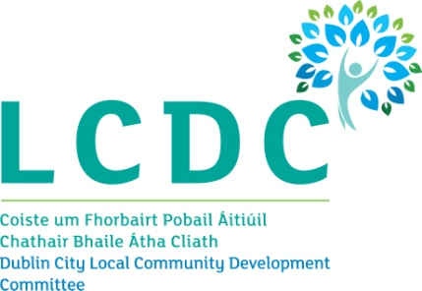
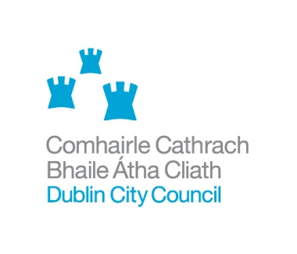
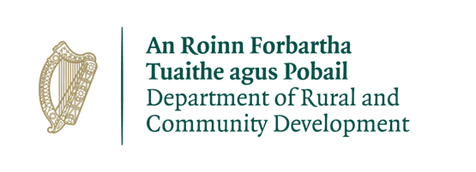

The Dublin City Community Enhancement Programme 2018

Terms and Conditions

- The Department, under the Community Enhancement Programme 2018, will support capital projects subject to available resources.
- The capital project must be consistent with Goal 5 of the Dublin City Local Economic and Community Plan 2016 - 2021.
- Applications must be for projects or works to be carried out within the Dublin City Council area.
- The information supplied by the applicant group /organisation must be accurate and complete and signed. Misinformation may lead to disqualification and/or the repayment of any grant made.
- All information provided in respect of the application for a grant will be held electronically. Information provided will only be used for the purpose of administering the Community Enhancement Programme 2018.
- The LCDC, in evaluating proposals received, may seek advice and consult with other agencies and may disclose information on projects under consideration to those experts and agencies.
- The Department, the Dublin City LCDC and Dublin City Council reserve the right to publish a list of all grants awarded including the name of the group or organisation in receipt of funding and the general location of the group.
- The Freedom of Information Act 2014 applies to all records held by the Department and Dublin City Council.
- It is the responsibility of each organisation to ensure that it has proper procedures and policies in place including appropriate insurance where relevant.
- Where relevant, successful applicants must have in place a child protection policy including a vetting procedure, in accordance with national child protection policy.
- Applicants must ensure that all necessary statutory permissions or consents have been obtained before any works commence. This includes but is not confined to planning permission.
- Applications must be on the official Dublin City Community Enhancement Programme Application Form 2018.
- Applications must include evidence of the cost of the proposed project.
- If the project is being part-funded from another source, evidence of the availability of any balance to the funding must be provided.
- Evidence of expenditure, receipts /invoices must be retained and provided together with a short report on the use of the funding to the Dublin City LCDC or Dublin City Council during 2019.
- The Department, the Dublin City LCDC and Dublin City Council must be publicly acknowledged in all materials associated with the purpose of the grant.
- Generally no third party or intermediary applications will be considered.
- Late applications will not be considered.
- Applications by post should use the correct value of postage stamps and allow sufficient time to ensure delivery not later than the closing date of Monday 30 July 2018 at 5pm. Claims that any application form has been lost or delayed in the post will not be considered, unless applicants have a Post Office Certificate of Posting in support of such claims.
- The funding offered must only be used for the purposes specified in the application and any alterations to the proposed grant must be approved in advance by the Dublin City LCDC.
- The full amount of the grant must be spent by 30 September 2019. Any unspent funding must be returned to the Department via Dublin City Council.
- The Department, Dublin City LCDC or Dublin City Council may carry out unannounced site visits to verify compliance with the terms and conditions.
- Breaches of the terms and conditions of the grants scheme may result in sanctions including disbarment from future grant applications.

SECTION 1

APPLICANT GROUP OR ORGANISATION DETAILS
Name of Group / Organisation

Address
(please include Eircode)

Year group or organisation established

Contact Name

Role in organisation

Telephone number

Email address

Registered Charity Number (if applicable)

Tax Reference Number (if applicable)

Tax Clearance Access Number (if applicable)

SECTION 2

PURPOSE OF GRANT
Please answer each of the questions below to outline the purpose of the grant you are applying for under the Dublin City Community Enhancement Programme 2018. Remember that your application will be assessed against the information provided on this form only so your answers should be as specific as possible. (Please attach extra sheet if necessary).

Please provide a description of the proposed work or project

How will the work or project contribute to Goal 5 of the Dublin City Local Economic and Community Plan 2016 – 2021?
Provide and protect a range of public, safe and affordable amenities, activities and facilities that are relevant and accessible to people of all ages and abilities and that contribute to the health and wellbeing of all.

How many people approximately will benefit from the proposed project or work (directly or indirectly)?

Where in Dublin City will the project or work be carried out or used? Where relevant, please confirm the owner of the site or building where the project or work will take place.

SECTION 3

TYPE AND STRUCTURE OF APPLICANT GROUP/ ORGANISATION
Please provide a description of the purpose / aims of your group or organisation and if you work with any particular group or groups of people?

Please provide a brief description of the structure of your group or organisation, for example committee or board structure, meeting schedule, number of members or people involved in the group etc.

Has your group or organisation registered with the Dublin City Public Participation Network?

YES / NO (please delete as appropriate)

If you would like to know more about, or register with, the Dublin City Public Participation Network please go to www.dublincity.ie/ppn

How does your organisation link in with other groups or organisations in your local area or in your area of interest?

SECTION 4

PROJECT BUDGET
Please provide the exact costing of the project or work below. You must supply evidence for the cost of the project or element of the project that is being applied for under the Dublin City Community Enhancement Programme 2018. A written quote or a print-out from the website of a supplier will count as evidence. If the project is being part-funded from another source please provide evidence of the availability of any balance to the funding. If you do not provide this documentation with this form, your application will not be considered.

How much funding are you applying for under the Community Enhancement Programme 2018? (Please attach evidence of exact cost of project or work)

Grant Scale | Tick | Exact amount applied for (€)
Capital grant of up to €1,000  (€65,000 has been ring-fenced for this category) |  | €
Capital grant of €1,000 - €5,000 |  | €
Capital grant of €5,000 - €10,000 |  | €
Capital grant of €10,000 - €15,000 |  | €

Is this amount the partial or total cost of the project or work? Partial / Total (delete as appropriate)

If Partial, please give the total project cost €

Where will your group or organisation source any shortfall in funding?

Other sources of funding for this project or work  Please attach evidence of other sources of funding with this application. | Amount
 | €
 | €
 | €
 | €

SECTION 5

OTHER FUNDING
Have you received any other funding or grants within the last three years?

YES / NO (please delete as appropriate)

If YES please give details:

Year funding or grant received | Funding organisation | Amount awarded
2016 |  | €
2017 |  | €
2018 |  | €

If you have received any funding through Dublin City Council, have you submitted your Bank Account Details previously?

YES / NO (please delete as appropriate)

If Yes, Please give the details of your group or organisation that appear on the Bank Account

Name of Group or Organisation
Address
Contact name

Email address

Checklist for Dublin City Community Enhancement Programme Application Form 2018
Sections 1 to 6, Pages 3 - 9 completed

Section 4, Page 7 - Evidence of cost of proposed project / work attached with application form
Section 4, Page 7 - If proposed project will be part-funded from another source evidence of the availability of that funding attached with application form

Section 6, Page 9 - Declaration completed and signed by group / organisation Chair, Secretary or Treasurer

If the application is being posted, a Post Office Certificate of Posting obtained

SECTION 6

DECLARATION
I declare that the information supplied on this form is accurate and complete.

I confirm that I have read and fully understood the Terms and Conditions of the Dublin City Community Enhancement Programme 2018 (see page 2 of this application form) and that this application is submitted in acceptance of and compliance with those Terms and Conditions.

I confirm that I have read the Dublin City Community Enhancement Programme 2018 Guidelines (available at www.dublincity.ie/lcdc) prior to completing this form.

I confirm that the applicant group or organisation does not have the funding to undertake the work/project without this grant aid or alternatively that with the grant the applicant group or organisation will now undertake a larger project which they otherwise would not be able to afford.

I confirm that the applicant group or organisation is tax compliant (if tax registered).

Name (on behalf of group or organisation)

Position held in group or organisation
(Chairperson, Secretary or Treasurer)

Signature

Date

