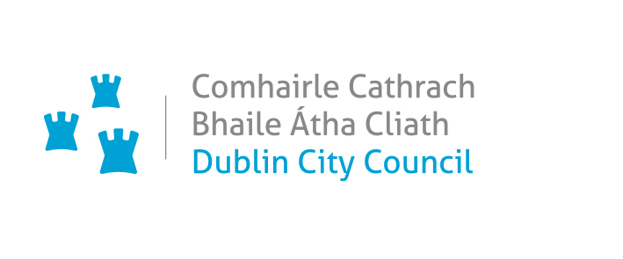 Small Scale Outdoor Events/ Promotions Application Form

Applications for use of the public domain for on-street activations require a minimum of 20 working days to process.

Late applications will not be accepted.

Office Use Only | Reference No: |  | Date Received:
Comments:

Event / Promotion Summary
Name of Event/Promotion

Event Location

Event Dates / Times |  | Date | Start Time | Finish Time

Date and time to enter event area to set up |  | Date |  | Time

Date and time event area will be vacated after event |  | Date |  | Time

Description of event:

Please also include the reasons for organising your event/promotion

Small Scale Outdoor Events / Promotions Application Form

Event Organiser Details
Name of Organisation
Event Organiser
Contact Address
(including postcode)
Event Controller on site
(if different to event organiser)
Tel No: Work
Mobile No
Email address
Event Safety Officer (on site)
Mobile No.
Email: address

Public Enquiries
Please supply details (if different from above) of how people can get in touch with you if they want to find out more about your event. This information may also be used by the City Council on any supporting publicity.

Name
Event public telephone enquiries no.
Email address
Website / Social Media
Small Scale Outdoor Events / Promotions Application Form

Event Details
Approximate number of people expected to attend?

Has the event taken place before? | Yes | No

Nature of Event:-
Charity event |  | Festival
Non commercial |  | Sport
commercial |  | Concert
Brand to Hand Sampling only |  | Brand to Hand Sampling with an on-street activations
On-Street Promotional Activation with no sampling |  | Other (please specify)
For Charity Event – Name of Charity
Charity Registration Number

Will there be an on-street charity fund raising collection?  Please note that this will require a collection permit from An Garda Siochana. |  |  |  | Yes | No
Will all the income raised go to the Charity concerned? |  |  |  | Yes | No
If no, please give details:

Is the event free? | Yes | No | If no, what is the admission price?
How will the event be publicised?

Will the event be accessible to all? |  |  |  | Yes | No

Small Scale Outdoor Events/ Promotions Application Form

Event Elements

Do you intend to include any of the following elements at the event? Please indicate with a ✓ for yes and and × for no.

Stage/Riser (please supply dimensions of same). |  | Power Supply Requirements
Vehicle (specify location) |  | Branding
Marquee/Gazebo |  | Toilets
Sale of food – Food/Drink Concessions |  | Stewarding/Security (PSA approved) –
PA System |  | Any advance notice signage
Car Parking Spaces Required |  | Compresses Gas Helium / LPG
Barriers/Fencing |  | Face Painting
Carnival Processions |  | Fireworks / Pyrotechnics / Fire Eaters / Lasers
Electrical Installations |  | Fuel storage
Fairground Equipment |  | Hot Air Ballons
Generator (only diesel permitted) |  | Live Entertainment
Helium balloon launch |  | Lost Children’s Point / Information / Welfare
Inflatable’s (Bouncy castles etc) |  | Park & Ride Facilities

Please list any other elements of your event which are not covered by the check list

After this application has been submitted, no additional items may be included with the prior consent of the Event Management department.

Small Scale Outdoor Events/Promotions Application Form

Traffic Management
Do you anticipate the need for:
Road closure(s) |  | Traffic diversion(s)
Suspension of Parking Bays |  | Positioning of Equipment/Crane/vehicle etc.
If you ticked any of the above, please provide full details of locations, dates and times. (A separate application is required for all of the above. Please note an application for a formal road closure must be submitted 5 weeks prior to the event date. A full Traffic Management Plan must accompany the application.

Please list name and time of the roads you are proposing to close for your event.

Environmental Issue -

Portaloos - (include numbers and location if applicable)

Waste Management Plan

Small Scale Outdoor Events/Promotions Applications Form

Crowd Management:- (include the number of stewards and professional security if applicable and name and contact details of the main security contact on site on the day of the event)

Medical Plan/First Aid Cover
Please supply details of medical/ first aid cover to be provided.

Checklist
I have enclosed the following:

Signed Terms and Conditions |  | Insurance (must have a specific indmenity for Dublin City Council to the sum of €6.4m.
Site Plan / Route Plan |  | Risk assessment.

Terms & Conditions:-

- I understand that the submission of my application does not mean I have the permission to hold the event and that I may be required to provide more information before the application can be processed.
- I confirm that I am over 18 years of age and I have the full authority of my organisation/company to make this application. I certify that the information supplied is accurate. I will accept the undertakings requested by this application.
- I understand that false information supplied could result in being excluded for consideration to hold any event on Dublin City Council property, park or open space.
- I agree to pay all fees in relation to processing the application which includes all charges and cancellation fees if applicable.
- I understand that Dublin City Council recommends that the event organiser does not announce press release, marketing information or advertising for their event without the prior consent of Dublin City Council.
- All consultation with business/residents and other premises to be complete prior to commencement of event.
- It is the responsibility of the event organiser to ensure that any copyright music being played is appropriately licensed by IMRO.
- I certify that the organisation/company will conform to all legal requirements and abide by the terms of the approval
- The applicant is responsible for all and any claims that may arise directly from this event
- The Events Unit or An Garda Siochana reserves the right to cancel an event.
- The applicant must satisfy themselves that the person responsible for drawing up and implementing their Health & Safety Statement & Risk Assessment Plan for their event, is competent to do so. Sole responsibility lies with the applicant to ensure that all elements of plans are carried out as stated in the documentation submitted to Dublin City Council for the duration of the event.
- Dublin City Council bears no responsibility for the management of safety for the duration of the event.
- Comply with all Health & Safety Legislation, the Safety, Health & Welfare at Work Act 2005, all regulations made there under, and all other relevant legislation, regulations and approved Codes of Practice, to ensure the safe running of this event.
- Further site specific terms and conditions apply if approval is granted.

Acceptance of Terms and Conditions

Print name

Signature

Position in organisation

Date

Privacy Notice
All information requested is for the sole purpose of processing your application. We do not collect personal information for commercial marketing or distribution to private organisations. It may be necessary from time to time to pass your contact information on to trusted third parties in order to assist with the processing of your application, such as our statutory agency partners, e.g. An Garda Siochána, as long as those parties agree to keep this information confidential.
Access to any non-public personal information that you provide will be restricted to only those employees who need to know that information to process your application.
It is our policy to retain collected information for a five year period after which your information will be disposed of securely.
Contact our Data Protection Officer on dataprotection@dublincity.ie or 01 222 3775.

