18 June 2020

24 June 2020

02 July 2020

09 July 2020

16 July 2020

23 July 2020

30 July 2020

07 Aug 2020

14 Aug 2020

21 Aug 2020

28 Aug 2020

11 Sept 2020

18 Sept 2020

02 Oct 2020

09 Oct 2020

16 Oct 2020

23 Oct 2020

30 Oct 2020

06 Nov 2020

13 Nov 2020

20 Nov 2020

28 Nov 2020

04 Dec 2020

22 Dec 2020

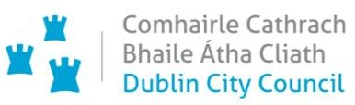

**Mobility Measures Update**

18 June 2020

Contents

1. Introduction 1

2. Implementation of Measures 1

2.1 Pedestrian Areas 2

2.2 Pedestrian Signal Crossings and Waiting Times 2

2.3 Protected Cycle Facilities, Contra-Flow Facilities and Cycle Parking 2

***Protected cycle facilities and contra-flow cycle facilities*** 2

***Cycle Parking*** 2

2.5 Reduced Speed Limits 2

2.6 Queueing Space at Bus Stops 3

2.7 Outdoor Areas/Business Liaison 3

2.8 School Mobility Programme 3

3. Communications 3

3.1 Website 3

3.2 Dedicated COVID-19 Mobility Measure Request Form 3

3. 3 COVID-19 Mobility E-mail 4

3.4 Councillor Updates 4

3.5 Social Media 4

# 1. Introduction

We are currently implementing Phase 1 of the COVID-19 Mobility Programme for the City Council area. This focuses on the following:

* areas with high footfall within the city centre;
* key radial routes into the city with highest cycling & pedestrian numbers (based on cordon counts) and
* busy retail locations in urban villages with footpath pinch points (i.e. a row of shops etc.) Traffic volumes across the city have recovered and are now at 70% of pre-COVID-19 levels.

# 2. Implementation of Measures

The following measures have been completed to date:

## 2.1 Pedestrian Areas

Space has been re-allocated at the following locations:

* Space has been re-allocated to pedestrians at the following locations:
* Capel Street, Suspension of on-street parking;
* Dorset Street, Suspension of on-street parking;
* Fairview, Suspension of loading bay;
* Stoneybatter, Suspension of loading bay;
* Rathmines, Suspension of loading bay;
* North Circular Road, Trial of bus stop build out with modular material;
* Nassau Street, Trial of footpath build out with asphalt;

## 2.2 Pedestrian Signal Crossings and Waiting Times

To reduce the time that people are waiting for pedestrian crossings to turn green, the maximum amount of time allocated to a complete traffic signal cycle, (allowing all movements in the junction to operate, if demanded) has been reduced from 120 seconds to 80 seconds throughout the City Council area. As the amount of time for the pedestrian green and amber man is based on the time taken to safely cross the road, and therefore remains the same, the additional time has been taken from that allocated to vehicles.

A new type of pedestrian button which has contactless activation is currently being trialled and if successful will be rolled out at a number of locations along with information notices advising that there is no necessity to make physical contact.

## 2.3 Protected Cycle Facilities, Contra-Flow Facilities and Cycle Parking

### Protected cycle facilities and contra-flow cycle facilities

New facilities have been added at the following locations:

South Leinster Street (Contra-Flow)

Nassau Street (Contra-Flow)

College Green

Richmond Street

Camden Street

Bridgefoot Street

Westland Row

Ranelagh Village

North Quays

### Cycle Parking

Temporary cycle parking was installed in Bull Island and the Botanic Gardens. Dublin City Council intends to install in excess of 1,000 new Sheffield stands in 2020.

***2.4 Car Parking Spaces and Loading Bays***

Car parking spaces and loading bays have been removed in the areas listed in 2.1 above to allow for greater provision for pedestrians.

## 2.5 Reduced Speed Limits

The concept proposal of the draft for the ‘Dublin City Council Special Speed Limit Bye-Laws June, 2020 (COVID-19)’ was noted at the June Transportation Strategic Policy Committee meeting and approved at the June City Council meeting. The public consultation phase will take place over the period July to August.

## 2.6 Queueing Space at Bus Stops

A temporary modular bus stop build out, to accommodate increased space for queueing at bus stops was trialled on the North Circular Road on 10 June. Representatives from disability organisations were invited to give feedback on the accessibility of the measure and also were present at a further trial of a footpath build out using asphalt and temporary kerbs which was implemented on Nassau Street on 16 June. Feedback is being taken on board to inform further roll out with the busy bus stops in the city centre the focus for the next roll out.

## 2.7 Outdoor Areas/Business Liaison

There is a dedicated Business Liaison Team in the COVID-19 Mobility Section, dealing specifically with requests and queries from businesses and retailers and it is also engaging with them on a number of particular mobility proposals. As part of dealing with these requests, the Business Liaison Team co-ordinates with colleagues in the Area Offices, Dublin Fire Brigade and the Environment & Transportation Department, including the Street Furniture Unit.

We are currently finalising the structures for processing these various business requests and this will shortly enable us to have improved reporting mechanisms on the type and areas that the requests relate to.

At this stage, we can report that we have received a sizeable number of outdoor seating requests, including suggestions on areas that would benefit from outdoor seating, and pedestrianisation and wider footpaths requests. We have also received various other types of business requests such as queries on deliveries, queuing systems and loading bays.

## 2.8 School Mobility Programme

A survey has been disseminated via the Green-Schools Programme inviting schools to communicate any concerns they may have plus potential solutions in relation to pupils accessing the school grounds when schools resume in September. Feedback from schools will be used to inform a ‘***Return to School***’ mobility strategy.

# 3. Communications

## 3.1 Website

A dedicated webpage, [www.dublincity.ie/COVID-19mobilityprogramme](http://www.dublincity.ie/covidmobilityprogramme), has been developed to provide information on all aspects of the programme and will be updated regularly to keep the general public informed of COVID-19 mobility interventions.

## 3.2 Dedicated COVID-19 Mobility Measure Request Form

To prioritise requests under the COVID-19 Mobility Programme, we have set up a dedicated request form. To date, we have had 596 requests for COVID-19 Mobility Measures via this dedicated form. Prior to the set-up of this form, we received 119 requests for COVID-19 Mobility Measures via the Transport Request Form. We are currently merging the two request systems to give us a full overview and breakdown of requests as follows:

* by type of requestor,
* by area and
* by measure

Given the high number of requests and the unprecedented workload that has arisen due to the COVID-19 pandemic, the TAG Service Request form for non-COVID-19 mobility related requests has been temporarily suspended. Notification has been put on our website and directly on the form advising the public of this suspension and directing them to the new form. An exception has been made for the processing of disabled car parking requests and these will continue to be facilitated.

## 3. 3 COVID-19 Mobility E-mail

A dedicated e-mail address has been set up to receive and respond to all COVID-19 mobility related queries. To date, many of the queries received by this email are actual COVID-19 mobility intervention requests and these are inputted manually by the COVID-19 Mobility Team into the COVID-19 Mobility Request form. We are encouraging the public and Councillors to input requests directly via the dedicated form to free up time for the team to respond to other queries that arise. The intention is that the e-mail is for general queries and the COVID-19 Mobility Request Form should be used for specific requests at specific locations.

## 3.4 Councillor Updates

Updates on COVID-19 mobility measures will be included in the COVID-19 Updates to Elected Members issued by the Chief Executive and Lord Mayor. Updates via email will also be issued to all appropriate stakeholders via the Transport SPC and the NTA accessibility network.

## 3.5 Social Media

We are utilising the Dublin City Council Social Media Channels for the following:

* to highlight COVID-19 mobility measures that have been implemented;
* to encourage the public to walk or cycle where possible;
* to encourage social distancing as people move around the city and
* to encourage more respect for vulnerable road users.



**Mobility Measures Update**

24 June 2020

Contents

1. Introduction 5

1.1 General Traffic Volumes 5

2. Implementation of Measures 6

2.1 Pedestrian Areas 6

2.2 Pedestrian Priority 6

2.3 Protected Cycle Facilities, Contra-Flow Facilities, Cycle Parking and ‘Filtered Permeability’ 6

Protected cycle facilities and contra-flow cycle facilities 6

Filtered Permeability 6

Grangegorman Filtered Permeability Trial 6

Pigeon House Road Filtered Permeability Trial 7

2.4 Car Parking Spaces and Loading Bays 7

2.5 Reduced Speed Limits 7

2.6 Bus Stop and Footpath Extensions 7

2.7 Outdoor Areas/Business Liaison 8

2.8 School Mobility Programme 8

3. Communications 8

3.1 Website 8

3.2 Dedicated COVID-19 Mobility Measure Request Form 8

3.3 COVID-19 Mobility E-mail 9

3.4 Councillor Updates 9

3.5 Social Media 9

3.6 Active Travel Promotion Campaign 9

# 1. Introduction

Implementation of Phase 1 of the COVID-19 Mobility Programme for the City Council area continues.

## 1.1 General Traffic Volumes

Traffic volumes across the city have increased and are now at 75 % of pre-COVID-19 levels.

# 2. Implementation of Measures

The following measures have been completed.

## 2.1 Pedestrian Areas

Space has been re-allocated at the following locations:

* Space has been re-allocated to pedestrians at the following locations:
* Capel Street, Suspension of on-street parking;
* Dorset Street, Suspension of on-street parking;
* Fairview, Suspension of loading bay;
* Stoneybatter, Suspension of loading bay;
* Rathmines, Suspension of loading bay;
* North Circular Road, Trial of bus stop build out with modular material;
* Nassau Street, Trial of footpath build out with asphalt;

## 2.2 Pedestrian Priority

The reduced cycle times and shorter waiting times for pedestrians remain in place. A new type of pedestrian button which has contactless activation is in place at Nassau Street. Its operation is being assessed.

## 2.3 Protected Cycle Facilities, Contra-Flow Facilities, Cycle Parking and ‘Filtered Permeability’

### Protected cycle facilities and contra-flow cycle facilities

New facilities have been added at the following locations:

South Leinster Street (Contra-Flow)

Nassau Street (Contra-Flow)

Doyle’s Corner to Monck Place

Clontarf Road inbound (Alfie Byrne Road to Railway Bridge)

Fairview outbound (Malahide Road to Railway Bridge)

College Green

Richmond Street

Camden Street

Bridgefoot Street

Parkgate Street

Wolfe Tone Quay

Westland Row

Ranelagh Village

North Quays

### Filtered Permeability

Filtered permeability in this case is like a ‘cycle gate’ which means that cyclists will be able to travel through the ‘cycle gate’ but private cars will not. Implementation of filtered permeability will not result in any changes to existing footpath facilities.

### Grangegorman Filtered Permeability Trial

Following the recent request from a number of Councillors and Residents Groups and in light of the current COVID-19 pandemic, it is our intention to carry out an initial four week temporary trial of ‘filtered permeability’ at a location close to the Clocktower on Grangegorman Road Lower.

Given that this area is projected to have high footfall and cyclist numbers due to proximity of the TUD Campus, it is important that active mobility and public transport are optimised at this particular location and that social distancing is facilitated.

The exact location and design of the intervention is currently being finalised. It is likely to involve a series of bollards and planters across the carriageway along with street furniture and associated line markings and signage. From a cost benefit standpoint we intend re- using planters which are currently in storage, which contain a palm tree, for the initial trial. If the trial is successful bespoke planters which contain flowers and/or trees can be considered.

The trial is expected to commence in early July. Feedback can be submitted during the four week trial period on [covidmobility@dublincity.ie](mailto:covidmobility@dublincity.ie). Following the four week trial period, a review based on the feedback received will be carried out and the option to extend the trial for a 12-month period can be considered.

### Pigeon House Road Filtered Permeability Trial

A proposal to carry out a ‘filtered permeability trial on Pigeon House Road was circulated to all South East Area Councillors. Closing date for comments and observations is Friday 26 June. If agreed by Councillors, the intervention will be trialled for an initial four week period, in the first instance. Following the four week trial period, based on feedback and review, the option to extend the trial for a 12-month period can be considered.

## 2.4 Car Parking Spaces and Loading Bays

Car parking spaces and loading bays have been removed in the areas listed in 2.1 above to allow for greater provision for pedestrians.

In addition to areas listed in 2.1, on-street parking has been rescinded on sections of South William Street with bollards to be erected shortly.

## 2.5 Reduced Speed Limits

The concept proposal of the draft for the ‘***Dublin City Council Special Speed Limit Bye-Laws June, 2020 (COVID-19)***’ was noted at the June Transportation Strategic Policy Committee meeting and approved at the June City Council meeting. The public consultation phase will take place over the period 2 July to 12 August.

## 2.6 Bus Stop and Footpath Extensions

A modular bus stop build out is now in place on the North Circular Road.

At Nassau Street a trial of temporary footpath widening is now in place.

Following on from this, works are now being undertaken to widen the footpath at College Green between Trinity College and Church Lane to create additional space for queueing at bus stops at this location while leaving the footpath clear for pedestrians.

Works will take place from 10am on Wednesday 24 June until midnight on Saturday 27 June.

While works are being carried out, outbound bus services at bus stops 4521 and 4522, will be moved to stops 1278 and 1279 located on the adjacent street to the west. This will affect routes 13, 27, 40, 49, 56a, 65/b, 77a & 151 for the period of works only, after this usual service will resume with enhanced footpath space available.

Pre COVID-19 an average of **20,000** pedestrians walked on the footpath outside Abercrombie every day.

New measures will maintain a lane for other buses and for traffic to overtake buses stopped at the enhanced bus stop. Bollards and any other unnecessary street clutter will be removed to provide as much space as possible.

## 2.7 Outdoor Areas/Business Liaison

The dedicated Business Liaison Team in the COVID Mobility Section continues to deal with a high number of requests and queries from businesses and retailers. ‘Tables and chairs’ requests are one of the most common form of submissions that we have received to date. These requests are primarily dealt with by the Street Furniture Unit in the Environment & Transportation Department, but the COVID Business Liaison Team feeds these requests into the existing approval process. Also, some applications for ‘tables and chairs’ will only become a possibility, from a space perspective alone, if road space is re-allocated to facilitate this.

The Business Liaison Team has also completed consultation with businesses regarding two traffic proposals for the north-eastern section of Sandymount Green and also continues to liaise with businesses along some of the 14 key routes identified in **‘*Enabling the City to Return to Work - Interim Mobility Intervention Programme for Dublin City’***. One of the key tasks of the COVID Business Liaison Team is to support the retailers at locations where mobility interventions have been carried out in order to facilitate their deliveries either by identifying alternative loading areas or timing deliveries to occur off-peak.

## 2.8 School Mobility Programme

A survey has been disseminated via the Green-Schools Programme inviting schools to communicate any concerns they may have plus potential solutions in relation to pupils travelling to school when schools resume in September. This is due back next week. Feedback from schools will be used to inform a ‘***Return to School***’ mobility strategy. Green-Schools are producing a ***‘Front of School Solutions’*** document to go with the results, which will be disseminated to all local authorities next week.

# 3. Communications

## 3.1 Website

A dedicated webpage, [www.dublincity.ie/COVID-19mobilityprogramme,](http://www.dublincity.ie/COVID-19mobilityprogramme) has been developed to provide information on all aspects of the programme and will be updated regularly to keep the general public informed of COVID-19 mobility interventions.

## 3.2 Dedicated COVID-19 Mobility Measure Request Form

To prioritise requests under the COVID-19 Mobility Programme, we have set up a dedicated Request Form. To date, we have had 901 requests for COVID-19 Mobility Measures (782 via the dedicated Covid Mobility Request Form and 119 via the Service Request Form). The measures requested are broken down as follows:

Contra-flow cycle lanes, 97 requests;

Cycle parking facilities, 106 requests;

Footpath widening, 184 requests;

Journey planning, 21 requests;

Other, 75 requests;

Pedestrian area, 299 requests;

Protected cycle lanes, 290 requests;

Support/advice for active travel (walk/cycle), 75 requests;

Commercial/Retail deliveries support, 20 requests;

Increasing queuing space at bus stops, 35 requests;

Outdoor seating area, 177 requests;

Note: Some Request Forms sought the implementation of a number of measures.

Given the high number of requests and the unprecedented workload that has arisen due to the COVID-19 pandemic, the TAG Service Request Form for non-COVID-19 mobility related requests has been temporarily suspended. Notification has been put on our website and directly on the form advising the public of this suspension and directing them to the new form. An exception has been made for the processing of disabled car parking requests which will continue to be facilitated.

## 3.3 COVID-19 Mobility E-mail

A dedicated e-mail address has been set up to receive and respond to all COVID-19 mobility related queries. To date, many of the queries received by this e-mail are actual COVID-19 mobility intervention requests and these are inputted manually by the COVID-19 Mobility Team into the COVID-19 Mobility Request Form. We are encouraging the public and Councillors to input requests directly via the dedicated Form to free up time for the Team to respond to other queries that arise. The intention is that the e-mail is for general queries and the COVID-19 Mobility Request Form should be used for specific requests at specific locations.

## 3.4 Councillor Updates

Updates on COVID-19 mobility measures will be included in the COVID-19 Updates to Elected Members issued by the Chief Executive and Lord Mayor every week. Updates via e- mail will also be issued to all appropriate stakeholders via the Transport SPC and the NTA accessibility network.

## 3.5 Social Media

We are utilising the Dublin City Council Social Media channels for the following:

* + - to highlight COVID-19 mobility measures that have been implemented;
    - to encourage the public to walk or cycle where possible;
    - to encourage social distancing as people move around the city and
    - to encourage more respect for vulnerable road users.

## 3.6 Active Travel Promotion Campaign

The COVID Mobility Section is putting together a social media campaign to promote and encourage active travel, and cycling in particular. Key messages include the following;

* + - If you live within 2km of the City Centre, consider walking if you are able to
    - If you live within 5km of the City Centre, consider cycling if you are able to
    - Leave space on public transport for those who really need it
    - Encourage all road users to “*Share with Care*”
    - Highlight the benefits of active travel: health, environment, economy

We will collaborate with key strategic partners (e.g. NTA, Healthy Ireland, Schools & 3rd level Institutions) to promote these messages.

**COVID-19 Mobility Measures Update**

2 July 2020

Contents

1. Introduction 12

1.1 General Traffic Volumes 12

1.2 Cycling Volumes 12

1.3 Pedestrian Volumes 12

2. Implementation of Measures 12

2.1 Pedestrian Areas 12

*Fairview Road* 12

*Rathgar Road* 12

*Orwell Road, Rathgar* 12

*Vernon Avenue* 12

2.2 Pedestrian Traffic Signal Priority 13

2.3 Grafton Street Area – Weekend Pedestrian Friendly Proposal 13

2.3 Protected Cycle Facilities, Contra-Flow Facilities, Cycle Parking and ‘Filtered Permeability’ 13

*Protected cycle facilities and contra-flow cycle facilities* 13

*Temporary Cycle Parking* 13

*On-street Cycle Parking – Sheffield Stands* 13

*Filtered Permeability* 14

2.4 Car Parking Spaces and Loading Bays 15

2.5 Reduced Speed Limits 15

2.6 Bus Stop and Footpath Extensions 15

2.7 Outdoor Areas/Business Liaison 15

2.8 School Mobility Programme 16

3.Communications 16

3.1 Website 16

3.2 Dedicated COVID-19 Mobility Measure Request Form 16

3.3 COVID-19 Mobility E-mail 16

3.4 Councillor Updates 16

3.5 Social Media 16

3.6 Active Travel Promotion Campaign 17

# 1. Introduction

Implementation of Phase 1 of the COVID Mobility Programme for the City Council area continues.

## 1.1 General Traffic Volumes

Traffic volumes across the city have now risen to over 75% of pre-COVID levels.

## 1.2 Cycling Volumes

Total weekday cycling volumes have also recovered to 75% of pre-COVID levels. However, morning peak cycling levels are still only a third of pre-COVID levels, while off peak cycling volumes are 50% above pre-COVID levels.

## 1.3 Pedestrian Volumes

Pedestrian numbers throughout the city have fallen dramatically since early March and although numbers have increased slightly in the last number of weeks, footfall is still well below pre-COVID levels.

# 2. Implementation of Measures

## 2.1 Pedestrian Areas

Space has been re-allocated to pedestrians at the following locations:

* Capel Street, Suspension of on-street parking;
* Dorset Street, Suspension of on-street parking;
* Fairview, Suspension of loading bay;
* Stoneybatter, Suspension of loading bay;
* Rathmines, Suspension of loading bay;
* North Circular Road, Trial of bus stop build out with modular material;
* Nassau Street, Trial of footpath build out with asphalt;
* Fairview Road, Suspension of on-street parking and footpath build out;
* Rathgar Road, Suspension of on-street parking;
* Orwell Road, Rathgar, Wands inserted to prevent parking on footpath.

### Fairview Road

Works were completed on 3 indented parking bays on the park side of Fairview Road. One indented parking bay was completely infilled with tarmacadam to provide a wider footpath. One indented parking bay was bollarded-off, to allow pedestrians to step off the narrow footpath as required. The existing kerb heights meant that it wasn’t possible to infill this area with tarmacadam. The corner of a third bay was partially infilled to remove a pinch point in the footpath.

### Rathgar Road

Six on-street parking bays have been suspended on Rathgar Road.

### Orwell Road, Rathgar

Wands have been inserted (from Churchtown Road to the centre of Rathgar Village) to prevent cars mounting the footpath. Cars partially parked on the footpath were restricting pedestrian movement in the area.

### Vernon Avenue

An attempt was made to change on-street parking on Vernon Avenue, on the approach to the junction with the Clontarf Road, from ‘nose-to-kerb’ to parallel parking. This would have reduced a traffic hazard and provided a safer environment and additional space for pedestrians. Unfortunately, before the works were complete and the new parking bays installed, the bollards were illegally removed. The City Council is engaging with the relevant businesses to explain the changes being made. A report will be brought to the next Area Committee meeting before the proposed measures are implemented.

## 2.2 Pedestrian Traffic Signal Priority

The reduced cycle times and shorter waiting times for pedestrians remains in place. Some increase in cycle lengths are being made where there is evidence of serious congestion delaying buses and where the additional time is required to allow cyclists clear the junction. Assessment continues on a new type of pedestrian button installed at a pedestrian crossing on Nassau Street, which has contactless activation.

## 2.3 Grafton Street Area – Weekend Pedestrian Friendly Proposal

It is proposed to close a number of streets around Grafton Street to vehicular traffic for four weekends beginning on 25July from 11:00hrs to 19:00hrs. The streets are as follows:

* Anne Street South from the junction of Dawson Street
* Duke Street from the junction of Dawson Street
* South William Street from the Brown Thomas carpark exit to Chatham Row
* Drury Street from Fade Street to the Drury Street carpark
* Dame Court from Exchequer Street

Footfall around the Grafton Street area has not recovered as well as the Henry Street area. At the weekends, footfall in Henry Street is at approximately 50% of pre-COVID levels but it is at only 20% around Grafton Street. In addition, 65% of all business requests that have been received for Covid Mobility measures are in Dublin 2, mainly in the streets around the Grafton Street area.

## 2.3 Protected Cycle Facilities, Contra-Flow Facilities, Cycle Parking and ‘Filtered Permeability’

### Protected cycle facilities and contra-flow cycle facilities

New facilities have been added at the following locations:

* South Leinster Street (Contra-Flow)
* Nassau Street (Contra-Flow)
* Doyle’s Corner to Monck Place
* Clontarf Road inbound (Alfie Byrne Road to Railway Bridge)
* Fairview outbound (Malahide Road to Railway Bridge)
* College Green
* Richmond Street
* Camden Street
* Bridgefoot Street
* Parkgate Street
* Wolfe Tone Quay
* Westland Row
* Ranelagh Village
* North Quays

### Temporary Cycle Parking

Temporary cycle parking was implemented at Bull Island and the Botanic Gardens during the COVID-19 restrictions.

### On-street Cycle Parking – Sheffield Stands

Due to lockdown restrictions, cycle parking installations were on hold from 30 March to 25 May 2020. Cycle parking was installed at the following locations between 20 March 2020 and 30 March 2020:

* Haddington Road
* Clancarthy Road
* Northumberland Road
* Anglesea Road,
* Cork Street

Cycle parking was installed at the following locations between 25 May 2020 and 19 June 2020:

* Kevin Street Lower
* Trinity Business School, Pearse Street
* Daniel Street
* Erne Street Upper
* Lennox Street
* Merrion Square South
* Pearse Street
* Ravensdale Park
* Bishop Street
* Bride Road
* New Street South
* New Street South 2
* Lombard Street East
* Flye fit Gym Macken Street
* Centra, Pearse Street
* Fit4less, Cork Street
* Intreo, Cork Street
* Southside Angling, Cork Street
* All Saints Drive, Raheny
* Maldern hotel, New Street South
* Causeway Road, Clontarf

Cycle parking is due to be installed before week ending 5 July 2020 at the following locations:

* Brunos Newsagent, Cowper Street
* The Mascott, Oxmantown Road

### Filtered Permeability

Filtered permeability is effectively a ‘cycle gate’ - cyclists are able to travel through the ‘cycle gate’ but other vehicles cannot. Implementation of filtered permeability will not result in any changes to existing footpath facilities.

The filtered permeability trial on ***Grangegorman Lower*** is due to commence on 6 July 2020. The measure will use bollards to prevent motorised through traffic in order to create a pedestrian and cycle friendly zone and a safer space for local residents and for thousands of pedestrians and cyclists arriving at TUD from September 2020.

Drivers will no longer be able to use this route as a short-cut from North Circular Road to the Quays, and vice versa. Local vehicular access to Grangegorman Lower will be retained although some journeys will be required to take a more circuitous route. Vehicular access points to TUD Campus would be unaffected and access through the bollards will be maintained for emergency vehicles. No changes will be made to existing footpaths.

Turning restrictions (except for cyclists and access) will also be introduced from North Circular Road onto Grangegorman Upper and Rathdown Road, and from North Brunswick Street onto Grangegorman Lower to minimise the amount of motorised traffic entering the wider area. These restrictions, in conjunction with the proposed measures on Grangegorman Lower, are likely to create a safer and more liveable area for residents of Grangegorman Upper & Lower, Rathdown Road, Marne Villas, Fitzwilliam Place North, Stanhope Street and Kirwan Street.

Feedback received from Councillors in regards to a filtered permeability trial on ***Pigeon House Road*** is currently being assessed.

## 2.4 Car Parking Spaces and Loading Bays

Car parking spaces and loading bays have been removed in the areas listed in 2.1 above to allow for greater provision for pedestrians.

## 2.5 Reduced Speed Limits

A six week public consultation period on the extension of the 30km/h zones in the city will run from 2 July 2to 13 August 13. All details can be found at: <https://consultation.dublincity.ie/traffic-and-transport/consultation-proposed-special-speed-limit-2020/>

As part of the public consultation process, a survey has been created which explores public perception of driver behaviour and speed limit compliance. Click the link [here](https://consultation.dublincity.ie/traffic-and-transport/consultation-proposed-special-speed-limit-2020/) to go directly to the survey (scroll to the bottom of the page).

## 2.6 Bus Stop and Footpath Extensions

Works to widen the footpath at College Green between Trinity College and Church Lane to create additional space for queueing at bus stops at this location while leaving the footpath clear for pedestrians are now complete. As part of these works a number of items of street furniture were removed and bus stops were moved further out towards the edge of the new kerb

A site visit was organised for PPN thematic members as well as members of other disability groups and reaction has been strongly positive, this will now be the template design for further temporary footpath and bus stop build outs.

## 2.7 Outdoor Areas/Business Liaison

The Business Liaison Team in the COVID Mobility Section continues to deal with requests received via the online COVID Mobility consultation form and also queries from businesses and retailers received via the COVID Mobility Measures email [COVIDMOBILITY@dublincity.ie](mailto:COVIDMOBILITY@dublincity.ie). ‘Tables and chairs’ requests are the most common form of submissions that we have received to date. These requests are primarily dealt with by the Street Furniture Unit in the Environment & Transportation Department and the COVID Mobility Section feeds into the existing approval process for any such requests. Some applications for ‘tables and chairs’ will only become a possibility, from a space perspective alone, if road space is re-allocated to facilitate this.

The planned trial pedestrianisation for the Grafton Area from the last weekend in July, will open up the possibility for some tables and chairs applications to be granted, subject to them meeting the Street Furniture Unit’s conditions and receiving their approval. This planned trial pedestrianisation will also require additional communication with businesses and retailers regarding the operation of their deliveries, given that deliveries will not be possible in the pedestrianised areas between the hours of 11:00am and 7:00pm on Saturdays and Sundays during the trial. Instead, deliveries required during the hours of the trial pedestrianisation will have to use alternative loading areas or change the deliveries to occur off-peak.

The Business Liaison Team has engaged with businesses and other stakeholders in a number of ongoing COVID mobility schemes across the city and with businesses along some of the 14 key routes identified in **‘*Enabling the City to Return to Work - Interim Mobility Intervention Programme for Dublin City’***.

## 2.8 School Mobility Programme

Feedback from the survey disseminated via the Green-Schools Programme inviting schools to communicate any concerns they may have plus potential solutions in relation to pupils accessing the school grounds when schools resume in September is due to be circulated to local authorities next week. Feedback from schools will be used to inform a ‘*Return to School*’ mobility strategy. Green Schools are also compiling a ‘front of school ideas’ pack for schools.

# 3.Communications

## 3.1 Website

The COVID Mobility webpage, [www.dublincity.ie/COVID-19mobilityprogramme,](http://www.dublincity.ie/covidmobilityprogramme) is being updated regularly to keep the general public informed of COVID-19 mobility interventions.

## 3.2 Dedicated COVID-19 Mobility Measure Request Form

In the past week, we have received 169 new submissions. We recently updated the form to allow people to make multiple submissions on one form. The total new requests received in the past week is 346. This bring the total number of COVID Mobility submissions to 1,070 and the total number of requests to 1,818. A breakdown of these requests is given below:

Contra-flow cycle lanes, 124 requests;

Cycle parking facilities, 165 requests;

Footpath widening, 238 requests;

Journey planning, 25 requests;

Other, 116 requests;

Pedestrian area, 343 requests;

Protected cycle lanes, 381 requests;

Support and advice for active travel (walking & cycling), 92 requests;

Commercial / Retail deliveries support, 27 requests;

Increasing queuing space at bus stops, 47 requests;

Outdoor seating area, 249 requests;

Not answered, 11 requests.

## 3.3 COVID-19 Mobility E-mail

The dedicated e-mail address continues as the primary channel to contact the Covid Mobility Team. We continue to encourage the public and Councillors to input requests directly via the dedicated form to free up time for the Team to respond to other queries that arise. The intention is that the e-mail is for general queries and the COVID-19 Mobility Request Form should be used for specific requests at specific locations.

## 3.4 Councillor Updates

Updates on COVID-19 mobility measures will be issued on a weekly basis to Elected Members. Updates via email will also be issued to all appropriate stakeholders via the Transport SPC and the NTA accessibility network.

## 3.5 Social Media

We are continuing to utilise the Dublin City Council Social Media Channels for the following:

* to highlight COVID-19 mobility measures that have been implemented;
* to encourage the public to walk or cycle where possible;
* to encourage social distancing as people move around the city and
* to encourage more respect for vulnerable road users.

## 3.6 Active Travel Promotion Campaign

Filming of a short video to highlight the new COVID Mobility Measures and to encourage Active Travel took place on Friday 26 June at 4 locations, Nassau Street, College Green, Capel Street and Stoneybatter. The primary purpose of the video is to encourage those who can to walk or cycle to their workplace and to save space on public transport and on the road for those who really need it. The video highlights the new COVID Mobility Measures that have been put in place and features pedestrians and cyclists moving around the city.

A cycling promotional strategy is being finalised to support the ambitious aims for increasing cycling numbers. The promotional campaign will target three main audiences:

1. Commuters – to encourage workers to use active travel for their commute to work. CSO data shows that 29% of travel is for work purposes.
2. Car drivers – 26% of car journeys are less than 2km (CSO), which for many people would be doable by walking or cycling. This group will be encouraged to leave their car at home for short journeys which will free up space on the road for those who need it most.
3. Parents – our Safe Routes to School promotional campaign will focus on encouraging more parents to allow their children to walk or cycle to school. Green-Schools surveys show that 80% of students would prefer to walk or cycle to school.

We are collaborating with key strategic partners (e.g. NTA Smarter Travel, Healthy Ireland, Green- Schools and third level institutions) to share our message.

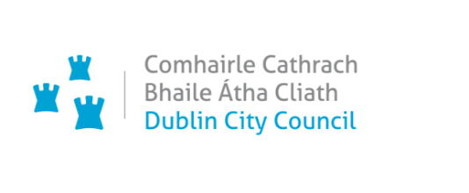

**COVID-19 Mobility Measures Update**

9 July 2020

Contents

**1.**  **Introduction** 19

**1.1** **General Traffic Volumes** 5

**1.2** **Cycling Volumes** 19

**1.3**  **Pedestrian Volumes** 19

**2.** **Implementation of Measures** 19

**2.1** **Pedestrian Areas** 19

**2.2** **Pedestrian Traffic Signal Priority** 19

**2.3** **Grafton Street Area – Weekend Pedestrian Friendly Proposal** 20

**2.3**  **Protected Cycle Facilities, Contra-Flow Facilities, Cycle Parking and ‘Filtered Permeability’** 20

***Protected cycle facilities and contra-flow cycle facilities*** 6

***Cycle parking*** 20

***Filtered permeability*** 21

**2.4** **Car Parking Spaces and Loading Bays** 21

**2.5** **Reduced Speed Limits** 21

**2.6** **Bus Stop and Footpath Extensions** 22

**2.7** **Outdoor Areas/Business Liaison** 22

**2.8** **School Mobility Programme** 22

**3.**  **Communications** 22

**3.1** **Website** 22

**3.2** **Dedicated COVID-19 Mobility Measure Request Form** 22

**3.3**  **COVID-19 Mobility E-mail** 23

**3.4** **Councillor Updates** 23

**3.5** **Social Media** 23

**3.6** **Active Travel Promotion Campaign** 23

# 1. Introduction

Implementation of Phase 1 of the COVID Mobility Programme for the City Council area continues.

## 1.1 General Traffic Volumes

Traffic volumes across the city continue to increase and are now at approximately 80% of pre-COVID-19 levels.

## 1.2 Cycling Volumes

Total weekday cycling volumes have also recovered to 75% of pre-COVID levels. However, morning peak cycling levels are still only a third of pre-COVID levels, while off peak cycling volumes are 50% above pre-COVID levels.

## 1.3 Pedestrian Volumes

Pedestrian numbers throughout the city have fallen dramatically since early March and although numbers have increased slightly in the last number of weeks, footfall is still well below pre-COVID levels.

# 2. Implementation of Measures

## 2.1 Pedestrian Areas

Space has been re-allocated to pedestrians at the following locations:

Capel Street, Suspension of on-street parking;

Dorset Street, Suspension of on-street parking;

Fairview, Suspension of loading bay;

Stoneybatter, Suspension of loading bay;

Rathmines, Suspension of loading bay;

North Circular Road, Trial of bus stop build out with modular material;

Nassau Street, Trial of footpath build out with asphalt;

Fairview Road, Suspension of on-street parking and footpath build out;

Rathgar Road, Suspension of on-street parking;

Orwell Road, Rathgar, Wands inserted to prevent parking on footpath.

## 2.2 Pedestrian Traffic Signal Priority

The reduced cycle times and shorter waiting times for pedestrians remains in place. Some increase in cycle lengths are being made where there is evidence of serious congestion, delaying buses and where the additional time is required to allow cyclists clear the junction.

Assessment continues on a new type of pedestrian button installed at a pedestrian crossing on Nassau Street, which has contactless activation.

## 2.3 Grafton Street Area – Weekend Pedestrian Friendly Proposal

Consultation is on-going with stakeholders regarding the proposed pedestrian trials in the Grafton Street Area. The trials are proposed for four weekends from 25 July until 16 August for the following streets:

* Anne Street South from the junction of Dawson Street
* Duke Street from the junction of Dawson Street
* South William Street from the Brown Thomas carpark exit to Chatham Row
* Drury Street from Fade Street to the Drury Street carpark
* Dame Court From Exchequer Street

Footfall in this area remains significantly lower than pre-Covid levels.

## 2.3 Protected Cycle Facilities, Contra-Flow Facilities, Cycle Parking and ‘Filtered Permeability’

### Protected cycle facilities and contra-flow cycle facilities

New facilities have been added at the following locations:

South Leinster Street (Contra-Flow)

Nassau Street (Contra-Flow)

Doyle’s Corner to Monck Place

Clontarf Road inbound (Alfie Byrne Road to Railway Bridge)

Fairview outbound (Malahide Road to Railway Bridge)

College Green

Richmond Street

Camden Street

Bridgefoot Street

Parkgate Street

Wolfe Tone Quay

Westland Row

Ranelagh Village

North Quays

Manor Street, Stoneybatter

Rathmines – part of route 1, Swan Centre to Canal

### Cycle parking

116 additional new ***Sheffield stands*** have been installed at the following locations:

Brunos Newsagent, Cowper Street – 5 Stands

The Mascott, Oxmantown Road – 4 Stands

Military Road, Rathmines – 7 Stands

Blessington Street – 7 Stands

Goldsmith Hall, Pearse Street – 4 Stands

North Circular Road, Phibsborough – 6 Stands

Moss Street – 4 Stands

Spar, North Circular Road – 5 stands

Phibsborough Road – 3 Stands

Cabra Road – 4 Stands

Daniel Street – 5 Stands

Lennox Street – 4 Stands

Ravensdale Park – 6 Stands

Military Road, Rathmines – 7 Stands

Goldsmith Hall, Pearse Street – 4 Stands

Bride Road – 5 Stands

Blessington Street – 7 Stands

Euro Car Park, North Circular Road – 6 Stands

Macken Street – 5 Stands

Moss Street – 4 Stands

Oxmantown Road – 4 Stands

Cowper Street – 5 Stands

North Circular Road – 5 Stands

### Filtered permeability

The ***filtered permeability measures*** were installed at Grangegorman Lower and the trial commenced on the morning of 6 July 2020. The trial includes the provision of a series of bollards and temporary planters placed on Grangegorman Lower, with appropriate signage and road markings. Some supplementary signage is also being added in the coming days.

Implementation of this trial results in the elimination of motorised through traffic from Grangegorman Lower and drivers are no longer able to use this route as a short-cut from North Circular Road to the Quays, and vice versa.

Filtered permeability through the bollards, enables pedestrians and cyclists to continue to take this route. This creates a safer space for local residents and for the large numbers of pedestrians and cyclists at TUD.

Local vehicular access to Grangegorman Lower is retained, although some journeys are required to take a more circuitous route. Vehicular access points to TUD Campus are unaffected and access through the bollards is maintained for emergency vehicles.

Consultation with local residents was initiated with notification leaflets informing them of the upcoming trial due for commencement and the temporary changes to traffic movements on Grangegorman Lower. This information leaflet was delivered between Thursday 2 July and Friday 3 July to all households on Grangegorman Upper & Lower, Rathdown Road, Marne Villas, Fitzwilliam Place North, Stanhope Street and Kirwan Street. In the leaflet, residents are invited to the provide feedback on the trial to our dedicated email address.

A review of this measure and of the feedback submitted will be carried out after the four week trial period and the option to either remove or extend the measure will be considered.

A proposal to carry out a ***filtered permeability trial on Pigeon House Road*** was circulated to all South East Area Councillors for comments and observations by Friday 26 June. Following feedback received, the location of the trial has been moved from Cambridge Avenue to east of the entrance to the Poolbeg Quay Apartments. The draft design should be ready for review on Friday 10 July 2020.

## 2.4 Car Parking Spaces and Loading Bays

Car parking spaces and loading bays have been removed in the areas listed in 2.1 above to allow for greater provision for pedestrians.

## 2.5 Reduced Speed Limits

A six week public consultation period on the extension of the 30km/h zones in the city will run from 2 July to 13 August 2020. All details can be found at: <https://consultation.dublincity.ie/traffic-and-transport/consultation-proposed-special-speed-limit-2020/>

As part of the public consultation process, a survey has been created which explores public perception of driver behaviour and speed limit compliance. Click the link [here](https://consultation.dublincity.ie/traffic-and-transport/consultation-proposed-special-speed-limit-2020/) to go directly to the survey (scroll to the bottom of the page).

## 2.6 Bus Stop and Footpath Extensions

Works to widen the footpath at College Green between Trinity College and Church Lane to create additional space for queueing at bus stops at this location while leaving the footpath clear for pedestrians are now complete. As part of these works a number of items of street furniture were removed and bus stops were moved further out towards the edge of the new kerb. Feedback from accessibility advocates on this measure has been extremely positive.

## 2.7 Outdoor Areas/Business Liaison

The Business Liaison Team in the COVID Mobility Section continues to deal with requests received via the online COVID Mobility request form and also queries from businesses and retailers received via the COVID Mobility Measures email [COVIDMOBILITY@dublincity.ie](mailto:COVIDMOBILITY@dublincity.ie). ‘Tables and chairs’ requests remain the most common form of submissions that we have received to date. These requests are primarily dealt with by the Street Furniture Unit in the Environment & Transportation Department and the COVID Mobility Section feeds into the existing approval process for any such requests. Some applications for ‘tables and chairs’ will only become a possibility, from a space perspective alone, if road space is re-allocated to facilitate this.

The planned trial pedestrianisation for the Grafton Street Area from the last weekend in July, will open up the possibility for some tables and chairs applications to be granted, subject to them meeting the Street Furniture Unit’s conditions and receiving their approval. This planned trial pedestrianisation will also require additional communication with businesses and retailers regarding the operation of their deliveries, given that deliveries will not be possible in the pedestrianised areas between the hours of 11:00am and 7:00pm on Saturdays and Sundays during the trial. Instead, deliveries required during the hours of the trial pedestrianisation will have to use alternative loading areas or change the deliveries to occur off-peak.

The Business Liaison Team has engaged with businesses and other stakeholders in a number of ongoing COVID mobility schemes across the city and specifically with nearby businesses and retailers where new COVID mobility measures were initiated at the following locations: Vernon Avenue, Rathgar Road, Orwell Road, Grangegorman Lower, Manor Street and South William Street.

## 2.8 School Mobility Programme

Initial feedback from Green-Schools reveals that only 11 of the 307 Dublin City based schools on the Green-Schools database completed the return to school mobility survey.

These survey results plus the TAG Area Engineers in-depth local knowledge of all schools in Dublin City will be used to develop a ‘*Return to School*’ mobility strategy. This strategy will include both hard and soft measures.

# 3. Communications

## 3.1 Website

The COVID Mobility webpage, [www.dublincity.ie/COVID-19mobilityprogramme,](http://www.dublincity.ie/covidmobilityprogramme) is being updated regularly to keep the general public informed of COVID-19 mobility interventions.

## 3.2 Dedicated COVID-19 Mobility Measure Request Form

In the past week, we have received 260 new requests for Covid Mobility Measures. This brings the total number of COVID Mobility requests to 2,078. A breakdown of these requests is given below:

Contra-flow cycle lanes, 142 requests;

Cycle parking facilities, 190 requests;

Footpath widening, 264 requests;

Journey planning, 27 requests;

Other, 137 requests;

Pedestrian area, 365 requests;

Protected cycle lanes, 484 requests;

Support and advice for active travel (walking & cycling), 112 requests;

Commercial / Retail deliveries support, 31 requests;

Increasing queuing space at bus stops, 51 requests;

Outdoor seating area, 264 requests;

Not answered,11.

## 3.3 COVID-19 Mobility E-mail

The dedicated e-mail address continues as the primary channel to contact the Covid Mobility Team. We continue to encourage the public and Councillors to input requests directly via the dedicated form, to free up time for the Team to respond to other queries that arise. The intention is that the e-mail is for general queries and the COVID-19 Mobility Request Form should be used for specific requests at specific locations.

## 3.4 Councillor Updates

Updates on COVID-19 mobility measures will be issued on a weekly basis to Elected Members. Updates via email will also be issued to all appropriate stakeholders via the Transport SPC and the NTA accessibility network.

## 3.5 Social Media

We are continuing to utilise the Dublin City Council Social Media Channels for the following:

* to highlight COVID-19 mobility measures that have been implemented;
* to encourage the public to walk or cycle where possible;
* to encourage social distancing as people move around the city and
* to encourage more respect for vulnerable road users.

## 3.6 Active Travel Promotion Campaign

A short video, filmed over 2 days (26 June and 8 July), highlighting the new COVID Mobility Measures and to encourage Active Travel, is due to be finalised this week and published online the week commencing June 13.

A cycling promotional strategy is being finalised to support the ambitious aims for increasing cycling numbers. The promotional campaign will target three main audiences:

1. Commuters – to encourage workers to use active travel for their commute to work. CSO data shows that 29% of travel is for work purposes.
2. Car drivers – 26% of car journeys are less than 2km (CSO), which for many people would be doable by walking or cycling. This group will be encouraged to leave their car at home for short journeys which will free up space on the road for those who need it most.
3. Parents – our Safe Routes to School promotional campaign will focus on encouraging more parents to allow their children to walk or cycle to school. Green-Schools surveys show that 80% of students would prefer to walk or cycle to school.

We are collaborating with key strategic partners (e.g. NTA Smarter Travel, Healthy Ireland, Green- Schools and third level institutions) to share our message.



**COVID-19 Mobility Measures Update**

**16 July 2020**

Contents

**1.**  **Introduction** 25

**1.1** **General Traffic Volumes** 25

**1.2** **Cycling Volumes** 25

**1.3**  **Bus Passenger Numbers** 25

**1.4**  **Pedestrian Volumes** 25

**2.** **Implementation of Measures** 25

**2.1** **Pedestrian Areas** 25

**2.2** **Pedestrian Traffic Signal Priority** 25

**2.3** **Grafton Street Area – Weekend Pedestrian Friendly Proposal** 26

**2.4** **Protected Cycle Facilities, Contra-Flow Facilities, Cycle Parking and ‘Filtered Permeability’** 26

**2.5** **Reduced Speed Limits** 26

**2.6** **Bus Stop and Footpath Extensions** 26

**2.7** **Outdoor Areas/Business Liaison** 26

**2.8** **School Mobility Programme** 26

**3.**  **Communications** 26

**3.1** **Website** 27

**3.2** **Dedicated COVID-19 Mobility Measure Request Form** 27

**3.3**  **COVID-19 Mobility E-mail** 27

**3.4** **Councillor Updates** 27

**3.5** **Social Media** 27

**3.6** **Active Travel Promotion Campaign** 27

**3.7 Frequently Asked Questions** 28

# 1. Introduction

Implementation of Phase 1 of the COVID Mobility Programme for the City Council area continues.

## 1.1 General Traffic Volumes

There has been no significant increase in traffic volumes across the city in comparison to last week. Traffic volumes are at approximately 80% of pre-COVID-19 levels.

## 1.2 Cycling Volumes

Total weekday cycling volumes have also recovered to approximately 65% of pre-COVID levels. However, morning peak cycling levels are just over a third of pre-COVID levels.

## 1.3 Bus Passenger Numbers

The trend in bus passenger numbers (BAC and GAI) shows continuing recovery. Weekday passenger numbers are now at 40% of pre COVID levels with an even stronger recovery at weekends.

## 1.4 Pedestrian Volumes

Pedestrian numbers throughout the city have fallen dramatically since early March. There has been another slight increase in pedestrian numbers in the past week but footfall is still well below pre-COVID levels.

# 2. Implementation of Measures

## 2.1 Pedestrian Areas

In the past week, on-street parking has been suspended and space has been re-allocated to pedestrians on South Anne Street.

## 2.2 Pedestrian Traffic Signal Priority

The reduced cycle times and shorter waiting times for pedestrians remain in place except where there is evidence of serious congestion. Assessment continues on a new type of pedestrian button installed at a pedestrian crossing on Nassau Street, which has contactless activation.

## 2.3 Grafton Street Area – Weekend Pedestrian Friendly Proposal

Consultation is on-going with stakeholders regarding the proposed pedestrian trials in the Grafton Street Area for four weekends from 25 July until 16 August.

Five disabled parking bays will be moved to alternative locations during the times of the trials. The three disabled parking bays on Drury Street and the one disabled parking bay on Dame Court will be moved to Exchequer Street. The disabled parking bay on South Anne Street will be moved to Molesworth Street.

Footfall in this area has risen slightly in the past week but still remains significantly lower than pre-Covid levels.

## 2.4 Protected Cycle Facilities, Contra-Flow Facilities, Cycle Parking and ‘Filtered Permeability’

***Protected cycle facilities*** have been introduced on Parnell Street in the past week.

Two hundred and twenty new ***Sheffield stands*** have now been installed since 25 March. A full list of locations is set out in the Appendix.

The trial of the ***filtered permeability measures*** installed at Grangegorman Lower on 6 July 2020 continues. The trial includes the provision of a series of bollards and temporary planters placed on Grangegorman Lower, with appropriate signage and road markings. A review of this measure and of the feedback submitted will be carried out after the four week trial period and the option to either remove or extend the measure will be considered.

A proposal to carry out a ***filtered permeability trial on Pigeon House Road*** was circulated to all South East Area Councillors for comments and observations by Friday 26 June. Following feedback received, the location of the trial has been moved from Cambridge Avenue to east of the entrance to the Poolbeg Quay Apartments. The final design is currently being reviewed.

## 2.5 Reduced Speed Limits

The six week public consultation period on the extension of the 30km/h zones continues until 13 August 2020. All details can be found at: <https://consultation.dublincity.ie/traffic-and-transport/consultation-proposed-special-speed-limit-2020/>

## 2.6 Bus Stop and Footpath Extensions

The additional space created at the bus stop at College Green, by building out the footpath has been extremely well received.

## 2.7 Outdoor Areas/Business Liaison

The Business Liaison Team has engaged with businesses and other stakeholders in a number of ongoing COVID mobility schemes across the city and specifically with nearby businesses and retailers where new COVID mobility measures were initiated. ‘Tables and chairs’ requests remain the most common form of submissions that we have received to date.

## 2.8 School Mobility Programme

The Covid Mobility Team are currently developing a ‘*Return to School*’ mobility strategy. This strategy will include both hard and soft measures.

# 3. Communications

## 3.1 Website

The COVID Mobility webpage, [www.dublincity.ie/COVID-19mobilityprogramme](http://www.dublincity.ie/COVID-19mobilityprogramme%20) is being updated regularly to keep the general public informed of COVID-19 mobility interventions.

## 3.2 Dedicated COVID-19 Mobility Measure Request Form

In the past week, we have received 236 new requests for Covid Mobility Measures. This brings the total number of COVID Mobility requests to 2,314. A breakdown of these requests is given below:

Contra-flow cycle lanes, 165 requested;

Cycle parking facilities, 214 requested;

Footpath widening, 297 requested;

Journey planning, 31 requested;

Other, 158 requested;

Pedestrian area, 383 requested;

Protected cycle lanes, 554 requested;

Support and advice for active travel (walking & cycling), 127 requested;

Commercial / Retail deliveries support, 35 requested;

Increasing queuing space at bus stops, 59 requested;

Outdoor seating area, 280 requested;

Not answered, 11 requested;

**Total, 2314**

## 3.3 COVID-19 Mobility E-mail

The dedicated e-mail address continues as the primary channel to contact the Covid Mobility Team and is attracting huge volumes of queries and feedback. We continue to encourage the public and Councillors to input requests directly via the dedicated form, to free up time for the Team to respond to other queries that arise. The intention is that the e-mail is for general queries and the COVID-19 Mobility Request Form should be used for specific requests at specific locations.

## 3.4 Councillor Updates

Updates on COVID-19 mobility measures are issued on a weekly basis to Elected Members. Updates via email are also be issued to stakeholders via the Transport SPC and the NTA accessibility network.

## 3.5 Social Media

We are continuing to utilise the Dublin City Council Social Media Channels for the following:

* to highlight COVID-19 mobility measures that have been implemented;
* to encourage the public to walk or cycle where possible;
* to encourage social distancing as people move around the city and
* to encourage more respect for vulnerable road users.

## 3.6 Active Travel Promotion Campaign

A short video, filmed over 2 days (26 June and 8 July), highlighting the new COVID Mobility Measures and to encourage Active Travel, was published on the Dublin City Council website and on social media this week. The video has receive great interaction to date. I would encourage all Councillors to help us promote the message. Please see links below and please like, share and re-tweet!

<https://www.facebook.com/watch/?v=609238513312629>

<https://twitter.com/DubCityCouncil/status/1282703981710577664?ref_src=twsrc%5Egoogle%7Ctwcamp%5Eserp%7Ctwgr%5Etweet>

<https://www.youtube.com/watch?v=mZqeCqj56DA&feature=youtu.be>

Our cycling promotional strategy supports the ambitious aims for increasing cycling numbers. The promotional campaign is initially targeting commuters. We are liaising with Green Schools to develop a Safe Routes to School promotional campaign focusing on encouraging more parents to allow their children to walk or cycle to school.

We are also collaborating with key strategic partners (e.g. NTA Smarter Travel, Healthy Ireland, Green- Schools and third level institutions) to share our message.

## 3.7 Frequently Asked Questions

Answers to some of the most frequently asked questions from a disability and accessibility perspective are now available on our website. <https://www.dublincity.ie/covidmobilityprogramme> The document is available in accessible format.

**Appendix Locations of newly installed Sheffield Stands**

Two hundred and twenty new ***Sheffield stands*** have now been installed and a full list of locations are detailed in the Appendix.

|  |  |
| --- | --- |
|  | Pay and Display Removed |
|  | Free Parking Removed |

|  |  |  |  |
| --- | --- | --- | --- |
| **25th March 2020 - 30th March** | | | |
| **Location** | **No of Stands** | **Pay & Display** | **Free Parking** |
| Haddinton Road | 5 | 1 | 0 |
| Northumberland Road | 8 | 0 | 0 |
| Clancarthy Road | 5 | 0 | 1 |
| Angelesea Road | 5 | 0 | 0 |
| Centrz, Cork Street | 4 | 0 | 0 |
| **Total** | **27** | 1 | 1 |
|  |  |  |  |
| **30th March 2020 - 25th May 2020** | **Cycle Parking Suspended due to lockdown** |  |  |
| **25th May - 10th June 2020** | | | |
| **Location** | **No of Stands** | **Pay & Display** | **Free Parking** |
| Kevin Street Lower | 10 | 2 | 0 |
| Trinity Business School, Pearse Street | 10 | 0 | 0 |
| Erne Street Upper | 5 | 1 | 0 |
| Merrion Square South | 9 | 2 | 0 |
| Pearse Street | 3 | 0 | 0 |
| Bishop Street | 9 | 2 | 0 |
| New Street South | 4 | 0 | 0 |
| New Street South 2 | 4 | 0 | 0 |
| Lombard Street East | 3 | 0 | 0 |
| Centra, Pearse Street | 4 | 0 | 0 |
| Intreo, Cork Street | 4 | 0 | 0 |
| Southside Angling, Cork Street | 5 | 0 | 0 |
| Causeway Road | 27 | 0 | 4 |
| **Total** | **97** | 7 | 4 |
|  |  |  |  |
| **10th June 2020 - 8th July** | | | |
| **Location** | **No of Stands** | **Pay & Display** | **Free Parking** |
| Fit4less, Cork Street | 6 | 0 | 0 |
| All Saints Drive, Raheny | 5 | 0 | 1 |
| Cabra Road | 4 | 0 | 0 |
| Daniel Street | 5 | 1 | 0 |
| Lennox Street | 4 | 1 | 0 |
| Ravensdale Park | 6 | 0 | 1 |
| Military Road, Rathmines | 7 | 0 | 0 |
| Goldsmith Hall, Pearse Street | 4 | 0 | 0 |
| Bride Road | 5 | 1 | 0 |
| Blessington Street | 7 | 0 | 0 |
| North Circular Road, Phibsborough | 6 | 0 | 0 |
| Flye fit Gym Macken Street | 5 | 0 | 0 |
| Moss Street | 4 | 0 | 0 |
| Brunos Newsagents, Cowper Street | 5 | 0 | 1 |
| The Mascot, Oxmantown Road | 4 | 0 | 0 |
| Spar, North Circular Road | 5 | 0 | 0 |
| Maldern hotel, New Street South | 4 | 0 | 0 |
| Phibsborough Road | 3 | 0 | 0 |
| **Total** | **89** | 3 | 3 |
|  |  |  |  |
| **9th July** | | | |
| **Location** | **No of Stands** | **Pay & Display** | **Free Parking** |
| Wilde & Green, Milltown | 4 | 0 | 0 |
| Conrad Hotel, Earlsfort Terrace | 3 | 0 | 0 |
| **Total** | **7** | 0 | 0 |
|  |  |  |  |
| **Total installed so far in Batch 13** | **220** | 11 | 8 |



**Chief Executive’s Office**

**Floor 4 Block 4**

**Civic Offices**

**Wood Quay**

23 July 2020

**To the Lord Mayor and**

**Elected Members of the City Council**

**COVID-19 Mobility Measures Update**

Contents

**1.**  **Introduction** 31

**1.1** **General Traffic Volumes** 31

**1.2** **Cycling Volumes** 31

**1.3**  **Bus Passenger Numbers** 31

**1.4**  **Pedestrian Volumes** 31

**2.** **Implementation of Measures** 32

**2.1** **Pedestrian Areas** 32

**2.2** **Grafton Street Area – Weekend Pedestrian Friendly Proposal** 32

**2.3**  **Protected Cycle Facilities, Contra-Flow Facilities, Cycle Parking and ‘Filtered Permeability’** 32

**2.4** **Bus Stop and Footpath Extensions** 33

**2.5** **School Mobility Programme** 33

**2.6**  **Deliveries** 33

**3.**  **Communications** 33

**3.1** **Website** 33

**3.2** **Dedicated COVID-19 Mobility Measure Request Form** 33

**3.3**  **COVID-19 Mobility E-mail** 33

**3.4** **Councillor Updates** 33

**3.5** **Social Media** 34

**3.6** **Active Travel Promotion Campaign** 34

**3.7 Frequently Asked Questions** 34

# 1. Introduction

Implementation of Phase 1 of the COVID Mobility Programme for the City Council area continues.

## 1.1 General Traffic Volumes

There has been no significant increase in traffic volumes across the city in comparison to last week. Traffic volumes are at approximately 80% of pre-COVID levels.

## 1.2 Cycling Volumes

The City Council has been carrying out traffic counts at 9 key cordon locations (Baggot Street, Richmond Street South, Phibsborough Road, Clanbrassil Street Upper, Dorset Street, Ringsend Bridge, Ormond Quay, Newcomnon Bridge, Dolphins Road) since early May. For the am peak (7am – 10am) commuting by bike is at 25% of pre COVID levels, pedestrian volumes are at 20%, whilst car traffic is at 75%.

## 1.3 Bus Passenger Numbers

The trend in bus passenger numbers (BAC and GAI) shows continuing recovery. Weekday passenger numbers are just over 40% of pre-COVID levels with an even stronger recovery at weekends.

## 1.4 Pedestrian Volumes

Pedestrian numbers throughout the city have fallen dramatically since early March. For the am peak (7am – 10am) pedestrian traffic is at 20% of pre COVID levels.

# 2. Implementation of Measures

## 2.1 Pedestrian Areas

Parking has been removed from South William Street and protection has been added to the extra pedestrian space. Loading facilities are still being provided.

Extra pedestrian space and space for outdoor seating have been made on Drury Street. Two loading bays have been retained.

## 2.2 Grafton Street Area – Weekend Pedestrian Friendly Proposal

The Grafton Street area pedestrianisation trials are scheduled to take place over four weekends beginning on Saturday 25 July and ending on Sunday 16 August. The trials will take place each Saturday and Sunday from 11am – 7pm.

The pedestrianisation trial locations are as follows:

* Anne Street South from the junction of Dawson Street
* Duke Street from the junction of Dawson Street
* South William Street from the Brown Thomas carpark exit to Chatham Row
* Drury Street from Fade Street to the Drury Street carpark
* Dame Court From Exchequer Street

Five disabled parking bays will be moved to alternative locations during the times of the trials. The three disabled parking bays on Drury Street and the one disabled parking bay on Dame Court will be moved to Exchequer Street. The disabled parking bay on South Anne Street will be moved to Molesworth Street. More information is available [on our website](http://www.dublincity.ie/main-menu-services-roads-and-traffic-dublin-city-covid-mobility-programme/grafton-street-area).

Footfall in this area in both Henry Street and Grafton Street remains significantly lower than pre-COVID levels.

## 2.3 Protected Cycle Facilities, Contra-Flow Facilities, Cycle Parking and ‘Filtered Permeability’

Temporary cycle parking has been installed, with 30 parking spaces at Liffey Street Lower, adjacent to Arnott’s and 26 parking spaces at Prince’s Street North, off O’Connell Street.

Since 25 March, 252 new Sheffield stands have been installed. Recent works have installed new cycle parking stands in the Macro Community Resource Centre, King Street North (5 stands), Mount Prospect Avenue (5 stands), RSCI, St Stephen’s Green (4 stands), The Law Society, Blackhall Place (4 stands), St Agnes Road, Crumlin (4 stands), Bridgefoot Street (10 stands).

A new section of protected cycle lanes has been installed between Thomas Street and Bonham Street.

On Route 2 (Fairview), cycle protection has been installed outbound on both sides of Annesley Bridge, adjacent to the shops.

As agreed at the July Central Area Committee meeting, the trial of the **filtered permeability measures at Grangegorman Lower** has been extended to 28 September 2020 to facilitate feedback from the Councillors at the September Area Committee meeting. A report on this trial will be presented to Councillors at the September meeting and feedback will be sought from the Councillors on whether the trial should be removed, amended or extended for a period of 12 months etc.

The final design for a **filtered permeability trial on Pigeon House Road** has been approved. The bollards, signs, poles and planters have been ordered. The expected date for the beginning of this trial is the 4th of August 2020. This date is dependent on the delivery of all the bollards, signs, poles and planters.

## 2.4 Bus Stop and Footpath Extensions

The footpath buildout works on Parnell Square West (opposite the Rotunda Hospital) started last week with the lower section to be completed this week (circa 70m). The buildout of the upper section is due to start this Monday.

## 2.5 School Mobility Programme

The Covid Mobility Team are currently developing a ‘*Return to School*’ mobility strategy. This strategy will include both hard and soft measures. The team is working with the NTA and Green schools to identify schools for interventions.

## 2.6 Deliveries

A new 2 hour loading bay has been installed on the west side of Manor Street in Stoneybatter. The hours of operation are 11.00 – 12.00hrs from Monday to Friday.

# 3. Communications

## 3.1 Website

The COVID Mobility webpage, [Covid mobility website](http://www.dublincity.ie/COVID-19mobilityprogramme) is being updated regularly to keep the general public informed of COVID-19 mobility interventions.

## 3.2 Dedicated COVID-19 Mobility Measure Request Form

In the past week, we have received 149 new requests for Covid Mobility Measures. This brings the total number of COVID Mobility requests to 2,463. A breakdown of these requests is given on the next page:

|  |  |
| --- | --- |
| **New requests** |  |
| **Mobility measure requested** | **Number** |
| Contra-flow cycle lanes | 12 |
| Cycle parking facilities | 12 |
| Footpath widening | 27 |
| Journey planning | 3 |
| Other | 17 |
| Pedestrian area | 30 |
| Protected cycle lanes | 22 |
| Support and advice for active travel (walking & cycling) | 6 |
| Commercial / Retail deliveries support | 5 |
| Increasing queuing space at bus stops | 4 |
| Outdoor seating area | 11 |
| Not answered | 0 |
|  | 149 |

## 3.3 COVID-19 Mobility E-mail

The dedicated e-mail address continues as the primary channel to contact the Covid Mobility Team and is attracting huge volumes of queries and feedback. We continue to encourage the public and Councillors to input requests directly via the dedicated form, to free up time for the Team to respond to other queries that arise. The intention is that the e-mail is for general queries and the COVID-19 Mobility Request Form should be used for specific requests at specific locations.

## 3.4 Councillor Updates

Updates on COVID-19 mobility measures are issued on a weekly basis to Elected Members. Updates via email are also be issued to stakeholders via the Transport SPC and the NTA accessibility network.

## 3.5 Social Media

We are continuing to utilise the Dublin City Council Social Media Channels for the following:

* to highlight COVID-19 mobility measures that have been implemented;
* to encourage the public to walk or cycle where possible;
* to encourage social distancing as people move around the city and
* to encourage more respect for vulnerable road users.

## 3.6 Active Travel Promotion Campaign

Our cycling promotional strategy supports the ambitious aims for increasing cycling numbers. The promotional campaign is initially targeting commuters. We are liaising with Green Schools to develop a Safe Routes to School promotional campaign focusing on encouraging more parents to allow their children to walk or cycle to school.

We are also collaborating with key strategic partners (e.g. NTA Smarter Travel, Healthy Ireland, Green- Schools and third level institutions) to share our message.

## 3.7 Frequently Asked Questions

Answers to some of the most frequently asked questions from a disability and accessibility perspective are now available on our website. [Covid mobility website](https://www.dublincity.ie/covidmobilityprogramme). The document is available in accessible format.

Owen P Keegan

**Chief Executive**



**Chief Executive’s Office**

**Floor 4 Block 4**

**Civic Offices**

**Wood Quay**

30 July 2020

**To the Lord Mayor and**

**Elected Members of the City Council**

**COVID-19 Mobility Measures Update**

Contents

**1.**  **Introduction** 35

**1.1** **Pedestrian Volumes** 35

**1.2** **Cycling Volumes** 35

**1.3**  **Bus Passenger Numbers** 36

**1.4**  **General Traffic Volumes** 36

**2.** **Implementation of Measures** 36

**2.1** **Grafton Street Area – Weekend Pedestrian Friendly Trials** 36

**2.2**  **Bus Stop and Footpath Extensions** 36

**2.3**  **Protected Cycle Facilities, Contra-Flow Facilities, Cycle Parking and ‘Filtered Permeability’** 36

**2.4** **School Mobility Programme** 37

**2.5**  **Street Furniture Temporary Permits** 37

**3.**  **Communications** 37

**3.1** **Website** 37

**3.2** **Dedicated COVID-19 Mobility Measure Request Form** 37

**3.3**  **COVID-19 Mobility E-mail** 38

**3.4** **Councillor Updates** 38

**3.5** **Social Media** 38

**3.6** **Active Travel Promotion Campaign** 38

# 1. Introduction

Implementation of Phase 1 of the COVID Mobility Programme for the City Council area continues.

## 1.1 Pedestrian Volumes

Pedestrian numbers throughout the city have fallen dramatically since early March. There are two data sources that the City Council monitors. Firstly, there are the footfall counters which count continuously and provide 24 hour data. These counters are located between Stephen’s Green and Henry St. These show that the footfall in this core area is back to just 50% of pre-COVID levels.

For the am peak (7am – 10am) pedestrian traffic is at just 20% of pre-COVID levels*.*

Secondly pedestrian counts at 9 key cordon locations that have been carried out. These show that the numbers commuting by foot in the morning peak are also only at 20% of pre-COVID levels.

## 1.2 Cycling Volumes

Cycling volumes have been monitored by two methods. Firstly, using the City Council’s counters which are located at Grove Road, North Strand Road, Charleville Mall and Guild Street which monitor volumes continuously. This shows overall cycling numbers at approximately 70% of pre-Covid numbers. However at the peak morning time, 7am to 10am, cycling numbers are at approximately 30% of pre-COVID levels. Comparing February to July of this year, to last year we can see that morning commuter cycling numbers remain significantly reduced.

The City Council has also been carrying out traffic counts at 9 key cordon locations (Baggot Street, Richmond Street South, Phibsborough Road, Clanbrassil Street Upper, Dorset Street, Ringsend Bridge, Ormond Quay, Newcomnon Bridge, Dolphins Road) since early May. For the am peak (7am – 10am) commuting by bike is at 25% of pre-Covid levels, pedestrian volumes are at 20%, whilst car traffic is at 75%.

## 1.3 Bus Passenger Numbers

The trend in bus passenger numbers (BAC and GAI) shows continuing recovery. Weekday passenger numbers are just over 40% of pre-COVID levels with an even stronger recovery at weekends.

## 1.4 General Traffic Volumes

There has been no significant increase in traffic volumes across the city in comparison to last week. Traffic volumes are at approximately 80% of pre-COVID levels.

# 2. Implementation of Measures

## 2.1 Grafton Street Area – Weekend Pedestrian Friendly Trials

The Grafton Street area pedestrianisation trial commenced last weekend (25 and 26 July). These measures are being taken to support the economic recovery of the city by providing more space for pedestrians during weekends to encourage people to return for shopping and to make use of the many cafes and restaurants in the area and to enjoy the city centre.

Temporary street furniture permits were granted to the following cafes/restaurants on South Anne Street, Drury Street and Dame Court:

South Anne Street: Coffee Angel, Isabelle’s Restaurant and Dolce Sicily (All parking bays, loading bay and disabled bay).

Dame Court: UKIYO Restaurant Exchequer Street (5 parking spaces on Dame Court East side).

Drury Street: Industry Café (Loading Bay outside their premises).

In addition to these a number of further applications are currently being assessed by the Street Furniture Unit for the upcoming Bank Holiday weekend. The Street Furniture Unit had 10 staff on duty (on rotas) ensuring an on-street presence from 10am to 11pm on both days.

Reaction over the weekend was largely positive and businesses in the area certainly seemed to benefit from these measures. We have received 290 responses to our online survey on the trials and feedback has been overwhelmingly positive.

A survey of traders showed takings up from anything between 40% to almost 100%. In response to feedback received to date, we are extending the hours of the trial to 11pm this weekend (i.e. 11am to 11pm). We will continue to review the feedback to assess if other changes are required.

Footfall in this area in both Henry Street and Grafton Street remains lower than pre-COVID levels but has been rising and is now at approx. 50% pre-Covid levels on Grafton St and up to 80% on a Sunday on Henry St. The weekend of the trials was the highest footfall in the Grafton St area since early March.

## 2.2 Bus Stop and Footpath Extensions

The bus stop buildout on Parnell Square West between Parnell Street and Granby Row was completed and opened last Friday. Works on the bus stop buildout north of Granby Row started on Monday and is due to be completed this coming Friday.

## 2.3 Protected Cycle Facilities, Contra-Flow Facilities, Cycle Parking and ‘Filtered Permeability’

The new road marking for protected cycle lanes on the lower end of Church Street have been installed. Installation of bollards to protect these cycle lanes have begun. This is part of the Phibsborough to City Centre route.

Modifications to the protected cycle lanes on Annesley Bridge are on-going.

## 2.4 School Mobility Programme

A recent survey conducted by Green-Schools sought feedback from Principals across Ireland about the main challenges at their ‘front of school’, as well as supported measures to address challenges. One of the survey’s main findings is that vehicle-induced traffic congestion is a major concern of schools. Out of the 271 responses nationwide, 11 were from schools within the Dublin City Council administrative area. The Covid Mobility Team is assessing the requests from these 11 schools and will implement any appropriate interventions. In addition, we have received 99 requests via the Covid Mobility Request Form that mention schools. These requests are also being reviewed by the Team.

In response to the survey results, Green-Schools published a [**Safe to School - An Ideas Document for Safe Access to Schools**](https://scanmail.trustwave.com/?c=17268&d=_6-Z35VyuFGWRcgDVGuv9dnuQIaREYPtasYaB9XrJQ&s=342&u=https%3a%2f%2feur03%2esafelinks%2eprotection%2eoutlook%2ecom%2f%3furl%3dhttps%253A%252F%252Fgreenschoolsireland%2eorg%252Fwp-content%252Fuploads%252F2020%252F07%252FSafe-to-School-An-Ideas-Document-for-Safe-Access-to-School-1%2epdf%26data%3d02%257C01%257C%257C12737d655d8941df076208d82f07e7a3%257C9b3403b7a34f4d1fbb4111c343a1fcc7%257C0%257C1%257C637311058635497160%26sdata%3d59e3lXDrRQa6rv5wWZdYcHntRseDaIaj3SeSjvU0Yws%253D%26reserved%3d0). The objective for the publication is to encourage schools to take the initiative and plan creatively (with Green-Schools support) towards a return to school that allows for safe physical distancing and vehicle-free spaces at the school gate.

Although School-led initiatives are the focus here, it is noted that some measures presented will require local authority involvement.The document looks at the following 8 measures:

Measure 1: Create a vehicle-free entrance for pedestrians and cyclists

Measure 2: Visual or creative initiatives at front of school

Measure 3: Discouraging or preventing illegal parking

Measure 4: Park ‘n’ stride – an alternative to front of school congestion

Measure 5: The cycle bus – a parent-led initiative

Measure 6: Temporary or informal car-free zones

Measure 7: Implement a ‘school street’ – a formal vehicle-free zone during peak times

Measure 8: New or widened footpaths, pedestrian crossings and cycleways

## 2.5 Street Furniture Temporary Permits

In addition to the temporary permits listed in item 2.2 above (Grafton Street Area – Weekend Pedestrian Friendly Trials), 19 permits have been issued citywide, 4 are awaiting further information, 54 are closed as they are not suitable and 7 are currently with the Public Spaces Working Group for final approval. Forty additional applications can be accommodated but only if additional on-street interventions are implemented.

# 3. Communications

## 3.1 Website

The COVID Mobility webpage, [www.dublincity.ie/COVID-19mobilityprogramme](http://www.dublincity.ie/COVID-19mobilityprogramme%20) is being updated regularly to keep the general public informed of COVID-19 mobility interventions.

## 3.2 Dedicated COVID-19 Mobility Measure Request Form

In the past week, we have received 399 new requests for Covid Mobility Measures. This brings the total number of COVID Mobility requests to 2,862. A breakdown of these requests is as follows:

Footpath widening, 383 requested;

Increasing queuing space at bus stops, 75 requests;

Pedestrian area, 512 requests;

Protected cycle lanes, 637 requests;

Contra-flow cycle lanes, 192 requests;

Cycle parking facilities, 262 requests;

Outdoor seating area, 355 requests;

Commercial / Retail deliveries support, 46 requests;

Support and advice for active travel (walking & cycling), 158 requests;

Journey planning, 37 requests;

Other,194 requests;

Not answered 11

**TOTAL 2862**

## 3.3 COVID-19 Mobility E-mail

The dedicated e-mail address continues as the primary channel to contact the Covid Mobility Team and is attracting huge volumes of queries and feedback. We continue to encourage the public and Councillors to input requests directly via the dedicated form, to free up time for the Team to respond to other queries that arise. The intention is that the e-mail is for general queries and the COVID-19 Mobility Request Form should be used for specific requests at specific locations.

## 3.4 Councillor Updates

Updates on COVID-19 mobility measures are issued on a weekly basis to Elected Members. Updates via email are also being issued to stakeholders via the Transport SPC and the NTA accessibility network.

## 3.5 Social Media

We are continuing to utilise the Dublin City Council Social Media Channels for the following:

* to highlight COVID-19 mobility measures that have been implemented;
* to encourage the public to walk or cycle where possible;
* to encourage social distancing as people move around the city and
* to encourage more respect for vulnerable road users.

## 3.6 Active Travel Promotion Campaign

Dublin City Council has signed up to take part in the NTA Smarter Travel Cycle Local challenge. Cycle Local is a workplace team-based challenge encouraging staff to cycle in their local areas. The City Council has 8 teams taking part in the challenge, despite many staff members continuing to work remotely. The challenge runs from 20 July to 9 August.

We continue to evolve our Active Travel Campaign in collaboration with key strategic partners (e.g. NTA Smarter Travel, Healthy Ireland, Green- Schools and third level institutions).

Owen P Keegan

**Chief Executive**



**Chief Executive’s Office Floor 4 Block 4**

**Civic Offices Wood Quay**

7 August 2020

**To the Lord Mayor and**

**Elected Members of the City Council**

**COVID-19 Mobility Measures Update**

Contents

1. Introduction 40

1.1 Pedestrian Volumes 40

1.2 Cycling Volumes 40

1.3 Bus Passenger Numbers 41

1.4 General Traffic Volumes 41

2. Implementation of Measures 42

2.1 Grafton Street Area – Weekend Pedestrian Trial 42

2.2 Bus Stop and Footpath Extensions 42

2.3 Protected Cycle Facilities, Contra-Flow Facilities, Cycle Parking and ‘Filtered Permeability’ 42

2.4 School Mobility Programme 43

2.5 Proposed Strand Road Two-Way Cycle Track 43

2.6 Outdoor Areas/Business Liaison 43

3. Communications 43

3.1 Website 44

3.2 Dedicated COVID-19 Mobility Measure Request Form 44

3.3 COVID-19 Mobility E-mail 44

3.4 Councillor Updates 44

3.5 Social Media 44

3.6 Active Travel Promotion Campaign 44

# 1. Introduction

Implementation of Phase 1 of the COVID Mobility Programme for the City Council area continues.

## Pedestrian Volumes

Pedestrian numbers throughout the city have fallen dramatically since early March. There are two data sources that the City Council monitors. Firstly, there are the footfall counters which count continuously and provide 24 hour data. These counters are located between St. Stephen’s Green and Henry St. These show that the footfall in this core area is back to just 50% of pre-COVID levels. Secondly, pedestrian counts at 9 key cordon locations have been carried out. These showed that the number of pedestrians commuting by foot in the morning peak period was only 20% of pre- COVID levels at the start of July. Further counts will be undertaken for late August and early September to monitor any changes.

## Cycling Volumes

Cycling volumes are being monitored by two methods. Firstly, using the City Council’s counters which are located at Grove Road, North Strand Road, Charleville Mall and Guild Street which monitor volumes continuously. This shows overall cycling numbers at approximately 70% of pre- COVID levels. However, during the peak morning time, 7am to 10am, cycling numbers are at approx. 30% of pre-COVID levels. Comparing February to July of this year, to last year we can see that morning commuter cycling numbers remain significantly reduced compared with 2019 levels.

## Bus Passenger Numbers

The trend in bus passenger numbers (BAC and GAI) shows continuing recovery. Weekday passenger numbers are just over 40% of pre-COVID levels, with an even stronger recovery at weekends.

## General Traffic Volumes

There has been a very slight reduction in traffic volumes across the city in comparison with last week. Traffic volumes are at approximately 78% of pre-COVID levels.

The volumes though are uneven across the various cordon crossing points.

# Implementation of Measures

## Grafton Street Area – Weekend Pedestrian Trial

The second week of the Grafton Street area pedestrianisation trial took place last weekend (from 1 to 3 August) with an extended time until 11pm. These measures are being taken to support the economic recovery of the city by providing more space for pedestrians during weekends to encourage people to return for shopping, to make use of the many cafes and restaurants in the area and to enjoy the city centre. The extended times will continue this weekend.

Temporary street furniture permits were granted to the following cafes/restaurants on South Anne Street, Drury Street and Dame Court:

South Anne Street: Coffee Angel, Isabelle’s Restaurant and Dolce Sicily Dame Court: UKIYO Restaurant Exchequer Street

Drury Street: Industry Café

Duke Street: Butlers Chocolate Cafe

South William St: Sole Seafood & Grill and Platform 61

The Street Furniture Unit had staff on duty from 10am to 11pm on the three days.

Reaction over the weekend was largely positive and businesses in the area certainly seemed to benefit from these measures. We have received 850 responses to our online survey on the trials and feedback remains overwhelmingly positive.

Following feedback on the location of disabled bays for the trial, the location of the disabled bays (normally on Drury St and Dame Court) was changed to Clarendon St. This will be the location for the remaining periods of the trial.

Footfall in both Henry Street and Grafton Street remains lower than pre-COVID levels but has been rising and is now at approx. 50% pre-COVID levels on Grafton St. and up to 80% on Sundays on Henry St. Comparison with the August Bank Holiday in 2019 shows that the Bank Holiday weekend of the pedestrian trial compared very favourably with last year.

## 2.2 Bus Stop and Footpath Extensions

Both bus stop build-outs on Parnell Square West, north of Parnell Street, have been completed.

A buildout on Anne St South is currently under construction and will provide space for outdoor seating during the week. It is due for completion this evening.

## 2.3 Protected Cycle Facilities, Contra-Flow Facilities, Cycle Parking and ‘Filtered Permeability’

Modifications to the protected cycle lanes on Annesley Bridge are now complete.

The final design for a **filtered permeability trial on Pigeon House Road** has been approved. The bollards, signs, poles and planters have been ordered. The expected date for the start of this trial is during the week beginning Monday 10 August 2020. This date is dependent on the delivery of all the bollards, signs, poles and planters.

Two cycle rack units, facilitating the parking of 10 cycles were installed on North Strand Road opposite Shamrock Place last Thursday. In addition, four Sheffield cycle stand units were installed on the footpath outside the Garda Station, Saint Agnes Road.

## 2.4 School Mobility Programme

The COVID Mobility Team is currently assessing the feasibility of interventions to create vehicle-free entrances and discourage/prevent illegal parking at a number of school gates. The aim of any intervention will be to increase safety for school children.

The Team is supporting initiatives taken by schools, parents and communities to make the area around school entrances safer. A number of City Council staff joined a trial of a new cycle bus set up by parents of the Greenlanes National School in Clontarf. The Cycle Bus is a group of school children who cycle to school supervised by adult marshals. There are a number of dedicated stops along the way where more children can join the cycle bus. We are encouraging more schools and parents to take similar measures to enable more children to cycle, walk or scoot to school. This will help reduce congestion and increase safety at the school entrance. The City Council will liaise with co-ordinators of these initiatives and where feasible implement measures to improve the safety of the route.

A segregated cycle route will be installed next week on Griffith Avenue extension and this will form part of a safer routes to school initiative in this area.

## 2.5 Proposed Strand Road Two-Way Cycle Track

Preliminary designs for a rapid deployment two way cycle track on Strand Road, which will replace one of the existing traffic lanes, are being finalised and will be circulated to Councillors on the South East Area Committee over the next two weeks together with an outline plan for the implementation of this scheme.

## 2.6 Outdoor Areas/Business Liaison

In addition to the temporary permits listed in item 2.1 above (Grafton Street Area – Weekend Pedestrian Trial), 21 permits have been issued citywide with a further 10 approved, 15 are awaiting further information, 58 are closed as they are not suitable and 3 are currently with the Public Spaces Working Group for final approval. Forty-one additional applications can be accommodated, but only if additional on-street interventions are implemented.

The Business Liaison Team has been liaising beforehand, and taking feedback afterwards, from businesses in relation to the trial pedestrianisation of the Grafton Street Area. The Team has been engaging with businesses on Manor Street regarding alternative loading areas and in relation to other issues that have arisen for businesses as a consequence of the newly installed bollards protecting the cycle lane and enforcing the clearway.

The Business Liaison Team has engaged with businesses and retailers on Montague Street following on from a COVID mobility request submitted by retailers seeking mobility improvements to the street.

# Communications

## Website

The COVID Mobility webpage, [www.dublincity.ie/COVID-19mobilityprogramme](http://www.dublincity.ie/COVID-19mobilityprogramme) is being updated regularly to keep the general public informed of COVID-19 mobility interventions.

## Dedicated COVID-19 Mobility Measure Request Form

In the past week, we have received 106 new requests for COVID Mobility Measures. This brings the total number of COVID Mobility requests to 2,968. A breakdown of these requests is as follows:

**Mobility measure requested**

Footpath widening, 398 requests;

Increasing queuing space at bus stops, 83 requests;

Pedestrian area, 520 requests;

Protected cycle lanes, 664 requests;

Contra-flow cycle lanes, 200 requests;

Cycle parking facilities, 269 requests;

Outdoor seating area, 361 requests;

Commercial / Retail deliveries support 46

Support and advice for active travel (walking & cycling), 163 requests;

Journey planning, 37 requests;

Other, 216 requests;

Not answered, 11;

Total requests, 2968

## COVID-19 Mobility E-mail

The dedicated e-mail address continues as the primary channel to contact the COVID Mobility Team and is attracting huge volumes of queries and feedback. We continue to encourage the public and Councillors to input requests directly via the dedicated form, to free up time for the Team to respond to other queries that arise. The intention is that the e-mail is for general queries and the COVID-19 Mobility Request Form should be used for specific requests at specific locations.

## Councillor Updates

Updates on COVID-19 mobility measures are issued on a weekly basis to Elected Members. Updates via email are also being issued to stakeholders via the Transport SPC and the NTA accessibility network.

## Social Media

We are continuing to utilise the Dublin City Council Social Media Channels for the following:

* + - to highlight COVID-19 mobility measures that have been implemented;
    - to encourage the public to walk or cycle where possible;
    - to encourage social distancing as people move around the city and
    - to encourage more respect for vulnerable road users.

## Active Travel Promotion Campaign

In addition to continuing to encourage commuters to choose active travel, we are placing a strong focus on active commute to school over the coming weeks.

We continue to evolve our Active Travel Campaign in collaboration with key strategic partners (e.g. NTA Smarter Travel, Healthy Ireland, Green- Schools and third level institutions).

Owen P Keegan

**Chief Executive**



**Chief Executive’s Office Floor 4 Block 4**

**Civic Offices Wood Quay**

14 August 2020

**To the Lord Mayor and**

**Elected Members of the City Council**

**COVID-19 Mobility Measures Update**

Contents

1. Introduction 46

1.1 Pedestrian Volumes 46

1.2 Cycling Volumes 47

1.3 Bus Passenger Numbers 47

1.4 General Traffic Volumes 47

2. Implementation of Measures 47

2.1 Grafton Street Area – Weekend Pedestrian Friendly Trials 47

2.2 Bus Stop and Footpath Extensions 48

2.3 Protected Cycle Facilities, Contra-Flow Facilities, Cycle Parking and ‘Filtered Permeability’ 48

2.4 School Mobility Programme 48

2.5 Outdoor Areas/Business Liaison 49

3. Communications 49

3.1 Website 49

3.2 Dedicated COVID-19 Mobility Measure Request Form 49

3.3 COVID-19 Mobility E-mail 49

3.4 Councillor Updates 50

3.5 Social Media 50

3.6 Active Travel Promotion Campaign 50

# 1. Introduction

Implementation of Phase 1 of the COVID Mobility Programme for the City Council area continues.

## Pedestrian Volumes

Pedestrian numbers throughout the city have fallen dramatically since early March. There are two data sources that the City Council monitors. Firstly, there are the footfall counters which count continuously and provide 24 hour data. These counters are located between Stephen’s Green and Henry St. These show that the footfall in this core area is back to just 50% of pre-COVID levels.

Secondly, pedestrian counts at 9 key cordon locations have been carried out. These showed that the number commuting by foot in the morning peak was only at 20% of pre-COVID levels at the start of July. Further counts will be taking place over the coming weeks to monitor any further changes in pedestrian volumes.

## Cycling Volumes

Cycling volumes, continuously monitored by City Council’s counters, which are located at Grove Road, North Strand Road, Charleville Mall and Guild Street, show overall cycling numbers at approximately 70% of pre-COVID numbers with this level holding steady since the start of June.

However at the peak morning time, 7am to 10am, cycling numbers are at approx. 30% of pre- COVID levels. Comparing February to August of this year, to last year, we can see that morning commuter cycling numbers remain significantly reduced.

In contrast the off peak cycling figures have recovered to the same levels as in 2019, occasionally surpassing 2019 levels.

## Bus Passenger Numbers

The trend in bus passenger numbers (BAC and GAI) shows continuing recovery. Weekday passenger numbers are at just over 40% of pre-COVID levels with a stronger recovery in weekend numbers.

## General Traffic Volumes

Traffic volumes have reduced slightly (by approximately 5%) compared with the trend over the last 4 weeks and are similar to mid-June levels.

# Implementation of Measures

## Grafton Street Area – Weekend Pedestrian Friendly Trials

The third week of the Grafton Street area weekend pedestrianisation trial took place on 8 and 9 August with an extended time until 11pm. These measures are being taken to support the economic recovery of the city by providing more space for pedestrians during weekends to encourage people to return for shopping, to make use of the many cafes and restaurants in the area and to enjoy the city centre.

Temporary street furniture permits were granted to the following cafes/restaurants:

South Anne Street: Coffee Angel, Isabelle’s Restaurant and Dolce Sicily Dame Court: UKIYO Restaurant Exchequer Street

Drury Street: Industry Café

Duke Street: Butlers Chocolate Cafe

South William St: Sole Seafood & Grill and Platform 61

Reaction over the weekend was largely positive and businesses in the area certainly seemed to benefit from these measures. We have received 1,010 responses to our online survey on the trials and feedback remains overwhelmingly positive with over 90% of respondents in favour of pedestrianising these streets on a permanent basis.

The pedestrian trials will be extended to the remaining two weekends in August and from next week 7 day permissions for tables and chairs will be given at a number of locations.

Footfall in both Henry Street and Grafton Street remains below pre-COVID levels but is recovering steadily. Levels are currently at approximately 50% pre-COVID levels on Grafton St and up to 80% on a Sunday on Henry St. The three weekends of trials to date have shown the highest footfall in the Grafton St area since early March.

The data also shows footfall in the Grafton Street area on the August Bank Holiday Saturday was higher this year than for the same Bank Holiday Saturday in 2019. Feedback from some retailers has also indicated higher sales volumes over the Bank Holiday this year compared to last year.

## Bus Stop and Footpath Extensions

The buildout on South Anne St was completed on Friday. This has allowed retailers to use the space not just during the pedestrianisation trials but also during the week

A bus buildout is currently underway on College Green at Stop 1,359 between Anglesea Street and Foster’s Place to provide more space for bus users. Work on a second build out across the street will start shortly.

## Protected Cycle Facilities, Contra-Flow Facilities, Cycle Parking and ‘Filtered Permeability’

Two hundred and ninety new **cycle parking stands providing** 580 cycle parking spaces have been installed since 25 March 2020. (Please see attached Excel file with details of locations)

The final design for a **filtered permeability trial on Pigeon House Road** has been approved. Signage for the trial is due to commence on 14 August with full bollards, signs, poles and planters in place on 16 August. The trial will run from 16 August to 27 September. A letter drop was carried out informing all local residents and businesses of the trial. The aim of the trial is to create a safer space for local residents and for the large volumes of pedestrians and cyclists using this route. Local vehicular access to Pigeon House Road will be retained although some journeys will be required to take a more circuitous route. Access will be maintained for emergency vehicles.

Design work continues on the Strand Road two way cycle track. A detailed report on the scheme, details of the layout etc. will be circulated to Councillors next week. The report will set out the consultation process that is being proposed.

Design work is underway on a contra flow cycle track on Parnell Square East linking O’Connell Street to North Frederick Street as well as on a contra flow cycle track on Werburgh Street. The provision of pedestrian crossings at the Mountjoy Square/Gardiner Street intersection is currently being progressed.

Constitution Hill will be resurfaced by Road Maintenance over the coming weeks and once completed protected cycle tracks will be put in place.

## School Mobility Programme

The COVID Mobility Team is currently assessing the feasibility of interventions to create vehicle-free entrances and discourage or prevent illegal parking at school gates. The aim of any intervention implemented will be to increase safety for children. The Team will also be assessing the implementation of bespoke solutions for a number of schools over the coming weeks.

A project is underway to provide a 3.5km rapid deployment segregated cycling route initially from Ballygall Road to Malahide Road. This will require provision of additional crossings and a contra flow cycling facility from Griffith Avenue extension to Griffith Avenue. This link will act as a main spine with extensions either side over time to enable safe cycling to schools and colleges in the area along this route. Work on the first element of the route at Griffith Avenue extension will begin next week. Regular updates will be given as the design and installation progress.

We have added a page on our website with links to tips and resources on increasing active travel to school and creating a safer school gate environment, including how to set up a walking bus or a cycle bus. Please visit, [Make the School Gate Safe, Tips and Resources](https://www.dublincity.ie/main-menu-services-roads-and-traffic-dublin-city-covid-mobility-programme/make-school-gate-safe-tips)

We have written to all schools in the Dublin City Council administrative area directing them to our webpage and asking them to communicate with parents to encourage them, where possible, to choose active modes for the school run.

## Outdoor Areas/Business Liaison

In addition to the temporary permits listed in item 2.1 above (Grafton Street Area – Weekend Pedestrian Friendly Trials), 22 street furniture permits have been issued citywide with a further 10 approved and awaiting return of application form, 15 are awaiting further information, 62 are closed as they are not suitable and 4 are currently with the Public Spaces Working Group for final approval. 43 additional applications can be accommodated, but only if additional on-street interventions are implemented.

The Business Liaison Team continues to deal with requests for interventions to facilitate ‘*tables and chairs’* applications and various other COVID mobility measures. We have engaged with a number of businesses on Manor Street regarding issues that have arisen for the businesses from the newly installed bollards protecting the cycle lane and enforcing the clearway. We will now proceed to survey the remainder of the relevant businesses and provide a summary of the feedback.

# Communications

## Website

The COVID Mobility webpage, [www.dublincity.ie/COVID-19mobilityprogramme](http://www.dublincity.ie/COVID-19mobilityprogramme) is being updated regularly to keep the general public informed of COVID-19 mobility interventions.

## Dedicated COVID-19 Mobility Measure Request Form

In the past week, we have received 55 new requests for COVID Mobility Measures. This brings the total number of COVID Mobility requests to 3,023. A breakdown of these requests is given below:

Mobility measure requested

Footpath widening, 405 requests;

Increasing queuing space at bus stops, 85 requests;

Pedestrian area, 526 requests;

Protected cycle lanes, 680 requests;

Contra-flow cycle lanes, 203 requests;

Cycle parking facilities, 270 requests;

Outdoor seating area, 366 requests;

Commercial / Retail deliveries support, 48 requests;

Support and advice for active travel (walking & cycling), 165 requests;

Journey planning, 39 requests;

Other, 225 requests;

Not answered, 11

**Total requests, 3023**

## COVID-19 Mobility E-mail

The dedicated e-mail address continues as the primary channel to contact the COVID Mobility Team and is attracting huge volumes of queries and feedback. We continue to encourage the public and Councillors to input requests directly via the dedicated form, to free up time for the Team to respond to other queries that arise. The intention is that the e-mail is for general queries and the COVID-19 Mobility Request Form should be used for specific requests at specific locations.

## Councillor Updates

Updates on COVID-19 mobility measures are issued on a weekly basis to Elected Members. Updates via e-mail are also being issued to stakeholders via the Transport SPC and the NTA accessibility network.

## Social Media

We are continuing to utilise Dublin City Council Social Media Channels for the following:

* + - to highlight COVID-19 mobility measures that have been implemented;
    - to encourage the public to walk or cycle where possible;
    - to encourage social distancing as people move around the city and
    - to encourage more respect for vulnerable road users.

## Active Travel Promotion Campaign

In addition to continuing to encourage commuters to choose active travel, we are placing a strong focus on active commute to school over the coming weeks.

We continue to evolve our Active Travel Campaign in collaboration with key strategic partners (e.g. NTA Smarter Travel, Healthy Ireland, Green- Schools and third level institutions).

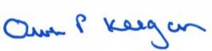

Owen P Keegan

**Chief Executive**

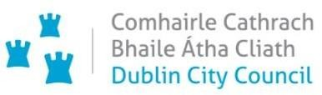

**Chief Executive’s Office Floor 4 Block 4**

**Civic Offices Wood Quay**

21 August 2020

**To the Lord Mayor and**

**Elected Members of the City Council**

**COVID-19 Mobility Measures Update**

Contents

1. Introduction 51

1.1 Pedestrian Volumes 51

1.2 Cycling Volumes 52

1.3 Bus Passenger Numbers 52

1.4 General Traffic Volumes 52

2. Implementation of Measures 52

2.1 Grafton Street Area – Weekend Pedestrian Friendly Trials 52

2.2 Bus Stop and Footpath Extensions 52

2.3 Protected Cycle Facilities, Contra-Flow Facilities, Cycle Parking and ‘Filtered Permeability’ 53

2.4 School Mobility Programme 53

2.5 Outdoor Areas/Business Liaison 54

3. Communications 54

3.1 Website 54

3.2 Dedicated COVID-19 Mobility Measure Request Form 54

3.3 COVID-19 Mobility E-mail 54

3.4 Councillor Updates 55

3.5 Social Media 55

3.6 Active Travel Promotion Campaign 55

# 1. Introduction

Implementation of the COVID Mobility Programme for the City Council area continues.

## Pedestrian Volumes

Pedestrian numbers throughout the city have fallen dramatically since early March. There are two data sources that the City Council monitors. Firstly, there are the footfall counters which count continuously and provide 24 hour data. These counters are located between Stephen’s Green and Henry St. These show that the footfall in this core area is back to just 50% of pre-COVID levels.

Secondly, pedestrian counts at 9 key cordon locations have been carried out. These showed that the number commuting by foot in the morning peak was only at 20% of pre-COVID levels at the start of July. Further counts to assess how many pedestrians are commuting into the city centre got underway this week.

## Cycling Volumes

Cycling volumes, continuously monitored by City Council’s counters, which are located at Grove Road, North Strand Road, Charleville Mall and Guild Street, show overall cycling numbers at approximately 70% of pre-COVID numbers with this level holding steady since the start of June.

However at the peak morning time, 7am to 10am, cycling numbers are at approx. 30% of pre- COVID levels. Comparing February to August of this year, to last year, we can see that morning commuter cycling numbers remain significantly reduced.

In contrast the off peak cycling figures have recovered to the same levels as in 2019, occasionally surpassing 2019 levels, most notably in the last few weeks.

Similar to the pedestrian counts, additional cycling counts have started this week to monitor the numbers commuting by bike. These counts will continue for the next few weeks.

## Bus Passenger Numbers

The trend in bus passenger numbers (BAC and GAI) shows continuing recovery. Weekday passenger numbers are at just over 40% of pre-COVID levels with a stronger recovery in weekend numbers.

## General Traffic Volumes

Traffic volumes are still below 80% of pre COVID volumes. There are wide variations across the city with some routes down 35% and others almost at pre COVID levels.

# Implementation of Measures

## Grafton Street Area – Weekend Pedestrian Friendly Trials

The fourth week of the Grafton Street area weekend pedestrianisation trial took place on 15 and 16 August from 11am to 11pm. The pedestrian trials have been extended to the remaining two weekends in August and 7 day permissions for tables and chairs have been given at a number of locations in South Anne Street, Drury Street, South William Street and Dame Court.

Reaction over the weekend was largely positive and businesses in the area certainly seemed to benefit from these measures. We have received 1,010 responses to our online survey on the trials and feedback remains overwhelmingly positive with over 90% of respondents in favour of pedestrianising these streets on a permanent basis.

Footfall in both Henry Street and Grafton Street remains below pre-COVID levels but is recovering steadily. Levels are currently at approximately 50% pre-COVID levels on Grafton St and up to 80% on a Sunday on Henry St. The four weekends of the trial to date have shown the highest footfall in the Grafton St area since early March.

## Bus Stop and Footpath Extensions

A bus buildout was completed at College Green at Stop 1359 between Anglesea Street and Foster’s Place to provide more space for bus users.

Bus buildouts will be completed on College Green at stops 1278 and 1279 this week. The 3 build outs completed to date in this area provide almost 300 m2 of additional space for pedestrians and public transport users.

## Protected Cycle Facilities, Contra-Flow Facilities, Cycle Parking and ‘Filtered Permeability’

The **new filtered permeability trial on Pigeon House Road** commenced on 16 August with full bollards, signs, poles and planters in place. The aim of the trial is to create a safer space for local residents and for large volumes of pedestrians and cyclists using this route. Local vehicular access to Pigeon House Road will be retained although some journeys will be required to take a more circuitous route. Access will be maintained for emergency vehicles. The scheme is being monitored and more signage will be installed at the junction of Pigeon House Road, Cambridge Road and York Road. This is in addition to the new signs that will inform and highlight to the public that there is no through access to Seamus Ennis Road by motorised vehicles. Access will be maintained for pedestrians and cyclists.

Design work is underway on a **contra flow cycle track on Parnell Square East** linking O’Connell Street to North Frederick Street as well as on a **contra flow cycle track on Werburgh Street**. The provision of **pedestrian crossings at the Mountjoy Square/Gardiner Street intersection** is currently being progressed and designs for review will be available shortly.

Constitution Hill will be resurfaced by Road Maintenance over the coming weeks and once completed protected cycle tracks will be put in place.

Protected cycle lanes have been installed on North King Street, between Church Street and Queen Street.

A report on the proposed six month trial of a two way cycle track along the Strand Road is attached.

A public consultation process, via the City Council’s consultation hub, will commence next week and continue until 14 September. A full set of drawings, a detailed report and additional information will be made available and the public will be invited to comment on the proposals and make suggestions for changes.

## School Mobility Programme

The COVID Mobility Team is currently assessing the feasibility of interventions to create vehicle- free entrances and discourage or prevent illegal parking at school gates. The aim of any intervention implemented will be to increase safety for children.

Designs are currently being finalised for the creation of a “School Zone” at two schools, in the city - Francis Street CBS, John Dillon Street, Dublin 8 and Central Model School, Deverill Place, Gardiner St, Dublin

1. The design objective is that people driving vehicles in the **School Zone** area are:
   * Encouraged to slow down via specific and eye catching traffic calming measures.
   * Encouraged not to stop, even to drop off passengers in the Zone. This prevents parked or stopped cars blocking visibility of pedestrians crossing.
   * Encouraged not to park any wheels on pavements.

The Team is also assessing the implementation of bespoke solutions for a number of other schools in the city. It is engaging directly with the Greenlanes National School, Clontarf and the D12 Cycle Bus to assess potential interventions on the Cycle Bus route.

Work has commenced on the contra flow cycling facility from Griffith Avenue extension to Griffith Avenue. The first element of the 3.5km rapid deployment segregated cycling route is from Ballygall Road to Malahide Road. Full implementation will require provision of additional crossings as well as the contra flow cycling facility from Griffith Avenue extension to Griffith

Avenue. This intervention will provide a safe route for students walking and cycling to the various schools and colleges in the vicinity. Regular updates will be given and feedback and suggestions are invited from the public, as the design evolves and the installation progresses, via [covidmobility@dublincity.ie](mailto:covidmobility@dublincity.ie)

We continue to update our webpage, [Make the School Gate Safe, Tips and Resources](https://www.dublincity.ie/main-menu-services-roads-and-traffic-dublin-city-covid-mobility-programme/make-school-gate-safe-tips), to assist schools in creating a safer school gate environment and to promote and increase active travel to school.

## Outdoor Areas/Business Liaison

In addition to the temporary permits associated with the Grafton Street Area weekend pedestrian trial, 25 street furniture permits have been issued citywide with a further 13 approved and awaiting return of the application form, 15 are awaiting further information, 71 are closed as they are not suitable and 4 are currently with the Public Spaces Working Group for final approval. A further 50 applications can be accommodated, but only if additional on-street interventions are implemented.

The Business Liaison Team continues to deal with requests for interventions to facilitate ‘tables and chairs’ applications and various other COVID mobility measures, particularly from streets which are part of or adjoining the Grafton Street area trial pedestrianisation. We continue to work with the Street Furniture Unit to facilite tables and chairs being placed by businesses in the public realm. We have completed the engagement with a number of businesses on Manor Street regarding issues that have arisen for the businesses from the newly installed bollards protecting the cycle lane and enforcing the clearway.

# Communications

## Website

The COVID Mobility webpage, [www.dublincity.ie/COVID-19mobilityprogramm](http://www.dublincity.ie/COVID-19mobilityprogramme)e is being updated regularly to keep the general public informed of COVID-19 mobility interventions.

## Dedicated COVID-19 Mobility Measure Request Form

In the past week, we have received 376 new requests for COVID Mobility Measures. This brings the total number of COVID Mobility requests to 3,399. A breakdown of these requests is given below:

**Mobility measure requested**

Footpath widening, 445 requests;

Increasing queuing space at bus stops, 99 requests;

Pedestrian area, 567 requests;

Protected cycle lanes, 780 requests;

Contra-flow cycle lanes, 254 requests;

Cycle parking facilities, 316 requests;

Outdoor seating area, 397 requests;

Commercial / Retail deliveries support, 52 requests;

Support and advice for active travel (walking & cycling), 192 requests;

Journey planning, 46 requests;

Other , 240 requests;

Not answered, 11 requests;

**Total requests, 3,399**

## COVID-19 Mobility E-mail

The dedicated e-mail address continues as the primary channel to contact the COVID Mobility Team and is attracting huge volumes of queries and feedback. We continue to encourage the public and Councillors to input requests directly via the dedicated form, to free up time for the Team to respond to other queries that arise. The intention is that the e-mail is for general queries and the COVID-19 Mobility Request Form should be used for specific requests at specific locations.

## Councillor Updates

Updates on COVID-19 mobility measures are issued on a weekly basis to Elected Members. Updates via e-mail are also being issued to stakeholders via the Transport SPC and the NTA accessibility network.

## Social Media

We are continuing to utilise Dublin City Council Social Media Channels in order to:

* + - highlight COVID-19 mobility measures that have been implemented;
    - encourage the public to walk or cycle where possible;
    - encourage social distancing as people move around the city and
    - encourage more respect for vulnerable road users.

## Active Travel Promotion Campaign

In addition to continuing to encourage commuters to choose active travel, we are placing a strong focus on active commute to school over the coming weeks.

We continue to develop our Active Travel Campaign in collaboration with key strategic partners (e.g. NTA Smarter Travel, Healthy Ireland, Green Schools and third level institutions).

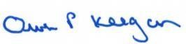

Owen P Keegan

**Chief Executive**



**Chief Executive’s Office Floor 4 Block 4**

**Civic Offices Wood Quay**

28 August 2020

## To the Lord Mayor and

**Elected Members of the City Council**

Contents

To the Lord Mayor and 56

1.1 Pedestrian Volumes 56

1.2 Cycling Volumes 57

1.3 Bus Passenger Numbers 57

1.4 General Traffic Volumes 57

2. Implementation of Measures 57

2.1 Grafton Street Area – Weekend Pedestrian Friendly Trials 57

2.2 Bus Stop and Footpath Extensions 57

2.3 Protected Cycle Facilities, Contra-Flow Facilities, Cycle Parking and ‘Filtered Permeability’ 57

2.4 School Mobility Programme 58

2.5 Outdoor Areas/Business Liaison 59

3. Communications 59

3.1 Website 59

3.2 Dedicated COVID-19 Mobility Measure Request Form 59

3.3 COVID-19 Mobility E-mail 60

3.4 Councillor Updates 60

3.5 Social Media 60

3.6 Active Travel Promotion Campaign 60

Chief Executive 60

**COVID-19 Mobility Measures Update**

1. **Introduction**

Implementation of the COVID Mobility Programme for the City Council area continues with an emphasis now on school reopening.

## Pedestrian Volumes

Pedestrian numbers throughout the city have fallen dramatically since early March. There are two data sources that the City Council monitors. Firstly, there are the footfall counters which count continuously and provide 24 hour data. These counters are located between Stephen’s Green and Henry St. These show that the footfall in this core area is back to just 50% of pre-COVID levels.

Secondly, pedestrian counts at 9 key cordon locations were carried out in May, June and July. These showed that the number commuting by foot in the morning peak was only at 20% of pre-COVID levels at the start of July. Further counts to assess how many pedestrians are commuting into the city centre commenced last week.

## 1.2 Cycling Volumes

Cycling volumes which are continuously monitored by City Council’s counters located at Grove Road, North Strand Road, Charleville Mall and Guild Street, show overall cycling numbers at approximately 70% of pre-COVID numbers with this level holding steady since the start of June.

However, at the peak morning time, 7am to 10am, cycling numbers are at approx. 30% of pre- COVID levels. Comparing February to August of this year, to last year, we can see that morning commuter cycling numbers remain significantly reduced.

In contrast, the off peak cycling figures have recovered to the same levels as in 2019, occasionally surpassing 2019 levels, most notably in the last few weeks although cycling numbers have dropped in the last 7 days.

Similarly to the pedestrian counts, cycling counts started last week to monitor the numbers commuting by bike. These counts will continue for the next number of weeks.

## 1.3 Bus Passenger Numbers

The trend in bus passenger numbers (BAC and GAI) shows continuing gradual recovery. Weekday passenger numbers are at just over 40% of pre-COVID levels with a stronger recovery in weekend numbers.

## 1.4 General Traffic Volumes

Traffic volumes are still flat and have not shown any growth over recent weeks with some locations still well below pre-COVID levels.

# Implementation of Measures

## Grafton Street Area – Weekend Pedestrian Friendly Trials

The Grafton Street area weekend pedestrian street trials conclude this weekend. We have received 1,220 responses to our online survey on the trials and feedback remains overwhelmingly positive with over 90% of respondents in favour of pedestrianising these streets on a permanent basis. Footfall in both Henry Street and Grafton Street remains below pre-COVID levels but was recovering steadily at least until recent weeks. Levels are currently at approximately 50% pre-COVID levels on Grafton St and up to 80% on a Sunday on Henry St. Feedback from premises that were given 7 day permissions for tables and chairs has been very positive as the areas are being used midweek. While the pedestrian trials will finish this weekend a report on the trials and lessons learned as well as proposals for the future will be prepared and the permission for 7 day tables and chairs will continue as before in Drury Street, South Anne Street, South William Street and Dame Court.

## Bus Stop and Footpath Extensions

Bus buildouts were completed on College Green at Stops 1278 and 1279 this week to provide more space for bus users and pedestrians passing.

## Protected Cycle Facilities, Contra-Flow Facilities, Cycle Parking and ‘Filtered Permeability’

Thefiltered permeability trial on Pigeon House Road and at Grangegorman Lower continue.

Design work is almost complete on a **contra flow cycle track on Parnell Square East** linking O’Connell Street to North Frederick Street and on a contra flow cycle track on Werburgh Street linking to City Hall. Both of these schemes will be put on the Consultation Hub for comments next week. A preliminary design is almost complete for two pedestrian crossings at the Mountjoy Gardiner Street junction and site investigations will commence shortly.

Constitution Hill will be resurfaced by Road Maintenance over the coming weeks and once completed protected cycle tracks will be put in place along both sides and the road layout adjusted.

The Government stimulus package is funding a number of road resurfacing contracts and work is on-going to design new road layouts, including protected cycle ways where appropriate, once the resurfacing works are complete.

***Strand Road Trial Rapid Deployment Cycle Route***

A public consultation process on the proposed scheme commenced on Friday 21August. It will run until 14 September. To date 825 submissions have been received. There is both strong support for and opposition to the scheme.

The City Council is updating information on the Consultation Hub to provide clarification and as additional information comes to hand. The City Council is committed to looking at improvements which can be made in the area as part of this trial including complementary traffic management measures, which will help to address local concerns.

## School Mobility Programme

Two new School Zones were implemented this week in Francis Street School, John Dillon Street, Dublin 8 and Central Model School, Deverill Place, Gardiner St, Dublin 1. In a school zone the overall design objective is to reduce congestion and increase safety at the front of the school, and thereby prioritise active travel to and from school. Specific design objectives are**:**

* to highlight the presence of the school and students;
* to encourage traffic to slow down via specific and eye catching traffic calming measures;
* To encourage motorists not to stop, not even to drop off in or near the School Zone and not to park on pavements. This prevents parked or stopped cars blocking visibility of pedestrians crossing.

The Team is also assessing the implementation of bespoke solutions for a number of other schools in the City Council area and we are engaging directly with the Greenlanes National School, Clontarf and the D12 Cycle Bus to assess potential interventions on route. Following a request from St Christopher’s Primary School on Haddington Road, a disabled parking bay has been installed.

We continue to update our webpage, [Make the School Gate Safe, Tips and Resources](https://www.dublincity.ie/main-menu-services-roads-and-traffic-dublin-city-covid-mobility-programme/make-school-gate-safe-tips), to assist schools in creating a safer school gate environment and to promote and increase active travel to school.

***Griffith Avenue - Safe Routes to School & College***

Dublin City Council is currently investigating the options for implementation of a 3.5km protected cycle lane on both sides of Griffith Avenue from Ballygall Road East as far as the Malahide Road.

The main aim of this scheme is to provide protected, safe and continuous cycling for all ages and abilities along this route. This is especially important with the numbers of schools in the area as well as the different DCU campus locations.

The design of the protected cycle lanes through the junctions of Ballymun Road/St Mobhi Road/Griffith Avenue and also Drumcondra Road/Griffith Avenue are challenging and these will be developed separately.

In the meantime the City Council has commenced work on the first element of the route, at Griffith Avenue extension, and developed a design for the first 500m section of the protected cycle lane heading east along Griffith Avenue between St Mobhi Road and Walnut Rise. The width of the carriageway on this section of Griffith Avenue is generous (12.3 m approximately) and will facilitate the provision of a 2 meter wide, high quality, protected cycle lane, on both sides of the carriageway while retaining generous traffic lanes in both directions and access to existing driveways.

Protection of the cycle lanes will be provided by bollards and orcas in the first instance as these can be easily adjusted if necessary before a more permanent protection is put in place. The layout is on the Consultation Hub and as more sections are designed these will also be available there. If residents have particular concerns or suggestions regarding these proposals we would invite them to send them into us at [COVIDMOBILITY@dublincity.ie](mailto:COVIDMOBILITY@dublincity.ie) (with Griffith Ave in the subject bar).

## Outdoor Areas/Business Liaison

In addition to the temporary permits issued for the Grafton Street Area – Weekend Pedestrian Friendly Trials, 29 temporary street furniture permits have been issued citywide with a further 13 approved and awaiting return of application form/insurance. 19 are awaiting further information, 73 are closed as they are not suitable and 5 are currently with the Public Spaces Working Group for final approval. Fifty-three additional applications can be accommodated, but only if additional on-street interventions are implemented. A trial street furniture scheme will commence in Smithfield Square next week.

The Business Liaison Team continues to deal with requests for interventions to facilitate ‘tables and chairs’ applications and various other COVID mobility measures, particularly from streets part of or adjoining the Grafton Street area trial pedestrianisation. We continue to work with the Street Furniture Unit as part of facilitating tables and chairs being placed by businesses in the public realm, including both paths and re-purposed carriageway.

# Communications

## Website

The COVID Mobility webpage, [COVID-19 mobility programme](http://www.dublincity.ie/COVID-19mobilityprogramme) is being updated regularly to keep the general public informed of COVID-19 mobility interventions.

## Dedicated COVID-19 Mobility Measure Request Form

In the past week, we have received 115 new requests for COVID Mobility Measures. This brings the total number of COVID Mobility requests to 3,514. A breakdown of these requests is given below:

Total requests Number

Mobility measure requested

Footpath widening 452

Increasing queuing space at bus stops 100

Pedestrian area 575

Protected cycle lanes 815

Contra-flow cycle lanes 269

Cycle parking facilities 341

Outdoor seating area 401

Commercial / Retail deliveries support 52

Support and advice for active travel (walking & cycling) 200

Journey planning 48

Other 250

Not answered 11

Total requests 3514

## COVID-19 Mobility E-mail

The dedicated e-mail address continues as the primary channel to contact the COVID Mobility Team and is attracting huge volumes of queries and feedback. We continue to encourage the public and Councillors to input requests directly via the dedicated form, to free up time for the Team to respond to other queries that arise. The intention is that the e-mail is for general queries and the COVID-19 Mobility Request Form should be used for specific requests at specific locations.

## Councillor Updates

Updates on COVID-19 mobility measures are issued on a weekly basis to Elected Members. Updates via e-mail are also being issued to stakeholders via the Transport SPC and the NTA accessibility network.

## Social Media

We are continuing to utilise Dublin City Council Social Media Channels:

* + - to highlight COVID-19 mobility measures that have been implemented;
    - to encourage the public to walk or cycle, where possible;
    - to encourage social distancing as people move around the city and
    - to encourage more respect for vulnerable road users

## Active Travel Promotion Campaign

In addition to continuing to encourage commuters to choose active travel, we are placing a strong focus on active commute to school over the coming weeks.

We continue to evolve our Active Travel Campaign in collaboration with key strategic partners (e.g. NTA Smarter Travel, Healthy Ireland, Green- Schools and third level institutions).

Owen P Keegan

## Chief Executive



**Chief Executive’s Office Floor 4 Block 4**

**Civic Offices**

**Wood Quay**

11 September 2020

**To the Lord Mayor and**

**Elected Members of the City Council**

**COVID-19 Mobility Measures Update**

Contents

1. Introduction 61

1.1 Pedestrian Volumes 61

1.2 Cycling Volumes 62

1.3 Bus Passenger Numbers 62

1.4 General Traffic Volumes 62

2. Implementation of Measures 62

2.1 Grafton Street Area – Weekend Pedestrian Friendly Trials 62

2.2 Protected Cycle Facilities, Contra-Flow Facilities, Cycle Parking and ‘Filtered Permeability’ 62

2.3 School Mobility Programme 63

2.4 Outdoor Areas/Business Liaison 64

3. Communications 64

3.1 Website 64

3.2 DCC Consultation Hub/Citizen Space 64

3.3 Dedicated COVID-19 Mobility Measure Request Form 64

3.4 COVID-19 Mobility E-mail 65

3.5 Councillor Updates 65

3.6 Social Media 65

3.7 Active Travel Promotion Campaign 65

# 1. Introduction

Implementation of the COVID Mobility Programme for the City Council area continues with an emphasis now on school reopening.

## Pedestrian Volumes

There are two data sources that the City Council monitors. Firstly, there are the footfall counters which count continuously and provide 24 hour data. These counters are located between Stephen’s Green and Henry St. These show that the footfall in this core area is back to almost 60% of pre-COVID levels.

Secondly, pedestrian counts at 9 key cordon locations were carried out in May, June and July. These showed that the number commuting by foot in the morning peak was only at 20% of pre-COVID levels at the start of July. Further counts to assess how many pedestrians are commuting into the city centre commenced mid-August. The results show that pedestrian commuters had not increased at the end of August. Counts are currently underway to ascertain what effect the return to school is having.

## 1.2 Cycling Volumes

Cycling volumes, which are continuously monitored by City Council’s counters located at Grove Road, North Strand Road, Charleville Mall and Guild Street, show overall cycling numbers at approximately 70% of pre-COVID numbers with this level holding steady since the start of June.

However, at the peak morning time, 7am to 10am, cycling numbers are at approx. 30% of pre-COVID levels. Comparing February to September of this year, to last year, we can see that the morning commuter cycling numbers remain significantly reduced.

In contrast, the off peak cycling figures have recovered to the same levels as in 2019, occasionally surpassing 2019 levels, most notably in the last few weeks. Similarly to the pedestrian counts, cycling counts started last week to monitor the numbers commuting by bike. These show that at the end of August cyclist commuter numbers had not yet recovered.

## 1.3 Bus Passenger Numbers

The trend in bus passenger numbers (BAC and GAI) shows continuing gradual recovery. Weekday passenger numbers are at just over 40% of pre-COVID levels with a stronger recovery in weekend numbers.

## 1.4 General Traffic Volumes

Traffic volumes are still flat and have not shown any growth over recent weeks with some locations still well below pre-COVID levels.

# Implementation of Measures

## Grafton Street Area – Weekend Pedestrian Friendly Trials

The Grafton Street area weekend pedestrian trials concluded on the weekend of the 29-30August. A report on the trials and lessons learned, as well as proposals for the future is being prepared. Footfall in both Henry Street and Grafton Street remains below pre-COVID levels but was recovering steadily, at least until recent weeks.

Improvements have continued in transforming South Anne St.

## Protected Cycle Facilities, Contra-Flow Facilities, Cycle Parking and ‘Filtered Permeability’

The Grangegorman filtered permeability trial will continue until at least the 31Jan 2021 following approval by Elected Members at the September 2020 Central Area Committee Meeting. A further report on the trial will be presented to the January Area meeting. We will continue to receive feedback on this trial at covidmobility@dublincity.ie with ‘Grangegorman’ in the subject bar. Thanks for all your feedback so far.

The Pigeon House Road filtered permeability measures continues to be monitored by City Council staff. All feedback on this trial should be sent to [covidmobility@dublincity.ie](mailto:covidmobility@dublincity.ie) with ‘Pigeon House Road’ in the subject bar.

Design work is progressing and almost complete on a **contra flow cycle track on Parnell Square East** linking O’Connell Street to North Frederick Street.

Designs for phase 1 of a cycle route on Werburgh Street and Castle Street, including a contra flow, are available for comment on our Consultation Hub. Work continues on the development of the next phase which involves a link towards Bride Street. This phase requires more extensive works and details of this will be made available when ready.

A preliminary design is nearing completion for two pedestrian crossings at the Mountjoy Gardiner Street junction and these will be available to view shortly.

Constitution Hill will be resurfaced by Road Maintenance over the coming weeks and once completed protected cycle tracks will be put in place along both sides with the road layout adjusted.

The Government stimulus package is funding a number of road resurfacing contracts and work is on-going to design new road layouts, including protected cycle ways where appropriate, once the resurfacing works are complete.

A report on the consultation on the change of Bye Laws for speed limits in the city making 30km/h the default speed limit was presented to the SPC and is on the agenda for the City Council meeting on 14 September for decision of the Elected Members.

The protection of cycle facilities got underway this week on the Harold’s Cross route between the canals and Bride Road.

***Strand Road Trial Rapid Deployment Cycle Route***

The public consultation process on the proposed scheme, which commenced on Friday 21August has received over 1,600 submissions to date. There is both strong support for and opposition to the scheme. This phase of consultation will run until 14 September. However, as we have received a large number of proposed changes to the scheme, as well as requests for additional measures to mitigate adverse impacts associated with diverted traffic further consultation using the Consultation Hub will take place over the next couple of weeks to ensure any revisions to the scheme or other traffic management measures proposed are clearly communicated to the public, before a decision is made on the proposed scheme.

Dublin City Council is updating information on the Consultation Hub to provide clarification and as additional information comes to hand. The City Council is committed to looking at improvements which can be made in the area as part of this trial including complementary traffic management measures, which will help to address local concerns. Additional traffic counts and monitoring is being put in place to allow us to more accurately capture the changed traffic patterns across this area and this will be used to inform the modelling work that is underway. The results of this modelling work will be put on the Consultation Hub as soon as it is completed.

## School Mobility Programme

Following the implementation of two new School Zones and subsequent invitations to all primary level schools in the Dublin City Council administrative area, to complete a survey if they were interested in having a school zone installed at their school, we received 50 requests. The COVID Mobility Technical Team are assessing all submissions for suitability and schools will be contacted with timelines, if it is deemed an appropriate intervention at that location.

The Team is also assessing the implementation of bespoke solutions for a number of other schools in the City Council area. We are awaiting delivery of school ***cycle parking stands,*** after which we will deliver to all schools who have requested this measure.

We continue to update our webpage, [Make the School Gate Safe, Tips and Resources](https://www.dublincity.ie/main-menu-services-roads-and-traffic-dublin-city-covid-mobility-programme/make-school-gate-safe-tips), to assist schools in creating a safer school gate environment and to promote and increase active travel to school.

***Griffith Avenue - Safe Routes to School & College***

Work continues on the Griffith Avenue 3.5km protected cycle facility. Details of the scheme is available on the Consultation Hub,

<https://consultation.dublincity.ie/traffic-and-transport/griffith-avenue-protected-cycle-track/>.

We have received extensive comments and suggestions to date via our COVID Mobility Email, all of which is being reviewed by the COVID Mobility Team. Much of the of correspondence received to date highlights concerns that the implementation of the proposals will greatly reduce the amount of space available for parents dropping off and collecting children from the schools along the route. The main aim of this scheme is to provide protected, safe and continuous cycling for all ages and abilities along this route and in particular to enable students of the numerous educational establishments to cycle to school and college and reduce vehicle congestion at school gates. We will therefore be engaging with the schools along this route over the coming weeks and months to discuss active travel initiatives and options.

## Outdoor Areas/Business Liaison

In addition to the temporary permits issued for the Grafton Street Area – Weekend Pedestrian Friendly Trials, 31 temporary street furniture permits have been issued citywide with a further 13 approved and awaiting return of application form/insurance. 18 are awaiting further information, 75 are closed as they are not suitable and 2 are currently with the Public Spaces Working Group for final approval. Fifty-seven additional applications can be accommodated, but only if additional on-street interventions are implemented.

# Communications

## Website

The COVID Mobility webpage, [www.dublincity.ie/COVID-19mobilityprogramme](http://www.dublincity.ie/COVID-19mobilityprogramme) is being updated regularly to keep the general public informed of COVID-19 mobility interventions. As previously advised we will be making more extensive use of the DCC consultation hub also in order to provide more information on measures.

## 3.2 DCC Consultation Hub/Citizen Space

In order to address the concerns raised by the Elected Members and by members of the public regarding consultation and prior notification of changes, while also trying to ensure that the multiple requests received across the city can be speedily addressed we will be making more extensive use of the DCC Consultation Hub. This allows us to provide details of upcoming schemes major interventions and provide a method for us to receive suggestions and concerns regarding any proposals.

Details of schemes on the consultation hub at present include

Griffith Avenue, <https://consultation.dublincity.ie/traffic-and-transport/griffith-avenue-protected-cycle-track/>

Strand Road, <https://consultation.dublincity.ie/traffic-and-transport/strand-road-trial-cycle-route/>

Werburgh Street and Castle Street, <https://consultation.dublincity.ie/traffic-and-transport/werburgh-street-cycle-route-phase-1/>

The consultation on the Grafton Street Area Weekend Pedestrian Trials concluded on 2 September.

Each week we will alert Members to any new proposals which are available to view on the Consultation Hub and aim to have a more dynamic process for ensuring that support for projects, suggestions for how to improve and concerns and issues which may need to addressed can be better handled. Any feedback on this approach is welcome.

## 3.3 Dedicated COVID-19 Mobility Measure Request Form

In the past week, we have received 46 new requests for COVID Mobility Measures. This brings the total number of COVID Mobility requests to 3,650. A breakdown of these requests is given below:

**Mobility measure requested**

Footpath widening, 470 requests;

Increasing queuing space at bus stops, 104 requests;

Pedestrian area, 583 requests;

Protected cycle lanes, 858 requests;

Contra-flow cycle lanes, 281 requests;

Cycle parking facilities, 355 requests;

Outdoor seating area, 407 requests;

Commercial / Retail deliveries support, 53 requests;

Support and advice for active travel (walking & cycling), 213 requests;

Journey planning, 53 requests;

Other, 262 requests;

Not answered, 11

**Total requests, 3,650**

## 3.4 COVID-19 Mobility E-mail

The dedicated e-mail address continues as the primary channel to contact the COVID Mobility Team. It is attracting huge volumes of queries and feedback. The intention is that the e-mail is for general queries and the COVID-19 Mobility Request Form should be used for specific requests at specific locations.

## 3.5 Councillor Updates

Updates on COVID-19 mobility measures are issued on a weekly basis to Elected Members. Updates via e-mail are also being issued to stakeholders via the Transport SPC and the NTA accessibility network.

## 3.6 Social Media

We are continuing to utilise Dublin City Council Social Media Channels:

* + - to highlight COVID-19 mobility measures that have been implemented;
    - to encourage the public to walk or cycle, where possible;
    - to encourage social distancing as people move around the city and
    - to encourage more respect for vulnerable road users

## 3.7 Active Travel Promotion Campaign

**Bike Week, which takes place from 19 to 27 September** is a celebration and promotion of all that's great about bikes and cycling. Held over an extended week each year, with bike themed events organised by local authorities, community groups and cycling groups throughout Ireland. As part of Dublin City Council’s Bike Week campaign, Active Travel Promotion Posters went live on Bus Shelters and Digi Panels around the City on Sunday promoting an Active Commute to work and to school.

During Bike Week we will also be using our social media channels to promote all things cycling including: the number of new protected cycle routes in the city; the diverse benefits of cycling, both on an individual and societal level.

‘8 Reasons you should get on your bike’, is a new promotional video by Dublin City Junior Bicycle Mayor; promoting cycling initiatives in the city including School Cycle Buses and the Monthly Cycles. There will also be an inclusive Active Mobility Webinar. In addition, Smart Dublin will launch a cycle buddy app during Bike Week to help support new cyclists to navigate their way around the city safely.

A number of Bike Week activities, planned in schools and communities and with DCC staff, will proceed if possible subject to COVID-19 Government Guidelines.

We also continue to evolve our Active Travel Campaign in collaboration with key strategic partners (e.g. NTA Smarter Travel, Healthy Ireland, Green- Schools and third level institutions).

Owen P Keegan

**Chief Executive**



**Chief Executive’s Office Floor 4 Block 4**

**Civic Offices**

**Wood Quay**

18 September 2020

To the Lord Mayor and

**Elected Members of the City Council**

**COVID-19 Mobility Measures Update**

Contents

1. Introduction 67

1.1 Pedestrian Volumes 67

1.2 Cycling Volumes 68

1.3 Bus Passenger Numbers 68

1.4 General Traffic Volumes 68

2. Implementation of Measures 68

2.1 Grafton Street Area – Weekend Pedestrian Friendly Trials 68

2.2 Temple Bar Area 68

2.3 Protected Cycle Facilities, Contra-Flow Facilities, Cycle Parking and ‘Filtered Permeability’ 68

*Strand Road Trial Rapid Deployment Cycle Route* 69

2.4 School Mobility Programme 69

*Griffith Avenue - Safe Routes to School & College* 70

2.5 Outdoor Areas/Business Liaison 70

3. Communications 70

3.1 Website 70

3.2 DCC Consultation Hub/Citizen Space 70

3.3 Dedicated COVID-19 Mobility Measure Request Form 70

3.4 COVID-19 Mobility E-mail 71

3.5 Councillor Updates 71

3.6 Active Travel Promotion 71

# 1. Introduction

Implementation of the COVID Mobility Programme for the City Council area continues with an emphasis now on school re-opening.

## Pedestrian Volumes

There are two data sources that the City Council monitors. Firstly, there are the footfall counters which count continuously and provide 24 hour data. These counters are located between Stephen’s Green and Henry St. These show that the footfall in this core area is back to almost 60% of pre-COVID levels.

Secondly, pedestrian counts at 9 key cordon locations were carried out in May, June and July. These showed that the number commuting by foot in the morning peak was only at 20% of pre-COVID levels at the start of July. Further counts to assess how many pedestrians are commuting into the city centre commenced mid-August. The results show that pedestrian commuters had not increased at the end of August. There has been a slight increase in the first week of September with pedestrians at the highest level since before COVID but still only at 35% of pre-COVID numbers.

## 1.2 Cycling Volumes

Cycling volumes, which are continuously monitored by City Council’s counters located at Grove Road, North Strand Road, Charleville Mall and Guild Street, show overall cycling numbers at approximately 80% of pre-COVID numbers with this level holding steady since the start of June.

However, at the peak morning time, 7am to 10am, cycling numbers are at approx. 30% of pre-COVID levels. Comparing February to September of this year, to last year, we can see that the morning commuter cycling numbers remain significantly reduced although they have been climbing slowly since the start of September. In contrast, the off peak cycling figures have recovered to the same levels as in 2019, occasionally surpassing 2019 levels, most notably in the last few weeks.

## 1.3 Bus Passenger Numbers

The trend in bus passenger numbers (BAC and GAI) shows continuing gradual recovery. Weekday passenger numbers are at just over 40% of pre-COVID levels with a stronger recovery in weekend numbers.

## 1.4 General Traffic Volumes

Traffic volumes are still flat and have not shown any growth over recent weeks with some locations still well below pre-COVID levels.

# Implementation of Measures

## Grafton Street Area – Weekend Pedestrian Friendly Trials

The Grafton Street area weekend pedestrian trials concluded on the weekend of the 29-30August. A report on the trials and lessons learned, as well as proposals for the future is being prepared. Footfall in both Henry Street and Grafton Street remains below pre-COVID levels but was recovering steadily, although it has decreased slightly since the start of September.

One item highlighted by the trials was the need to improve the quality of road surface. Resurfacing works on Drury Street, South William Street and Dame Court are all scheduled over the next weeks, as part of the Government stimulus package.

## 2.2 Temple Bar Area

A number of flexible bollards are due to be placed in Temple Bar next week to enforce the existing pedestrian zones. These will be removed daily between 6am and 11am to allow access for deliveries. There is no change to the existing pedestrian hours in the area.

## 2.3 Protected Cycle Facilities, Contra-Flow Facilities, Cycle Parking and ‘Filtered Permeability’

The Pigeon House Road filtered permeability measures continue to be monitored by City Council staff. All feedback on this trial should be sent to [covidmobility@dublincity.ie](mailto:covidmobility@dublincity.ie) with ‘*Pigeon House Road*’ in the subject bar. A report on the trial will be presented to the South East Area Committee in October.

The consultation for Werburgh Street cycle route closed on 15September. All businesses along the route were contacted and details of the consultation were provided. All the submissions will now be reviewed.

Design work is complete on a **contra flow cycle track on Parnell Square East** linking O’Connell Street to North Frederick Street and is now open to public consultation. For further information including drawings, please visit: <https://consultation.dublincity.ie/traffic-and-transport/parnell-square-east-contraflow/>

A preliminary design is nearing completion for two pedestrian crossings at the Mountjoy/Gardiner Street junction and these will be available to view shortly.

Constitution Hill will be resurfaced by Road Maintenance over the coming weeks and once completed protected cycle tracks will be put in place along both sides with the road layout adjusted.

The Government stimulus package is funding a number of road resurfacing contracts and work is on-going to design new road layouts, including protected cycle-ways where appropriate, once the resurfacing works are complete.

The Speed Limit Bye Laws, which would have made 30 kph the default speed limit in Dublin, while allowing for specifically signed roads to have different speed limits as appropriate, were not passed at the City Council meeting. A report will be prepared for the SPC on speed limits taking account of the issues raised at the City Council meeting.

The protection of cycle facilities on the Harold’s Cross route between the canals and Bride Road is mostly complete. There is one small section at Leonard’s Corner inbound outside a row of shops to be installed where the parking will be placed outside of the cycle lane to provide a protected cycle route.

### Strand Road Trial Rapid Deployment Cycle Route

The public consultation process on the proposed scheme, which commenced on Friday 21 August finished on September 14. A total of 2,865 submissions were received of which 54% were in support, 27% opposed and a further 17% expressed concerns without either opposing or supporting the scheme. Work is proceeding on the Merrion Road section link to the DLRCC boundary and this will be available on the consultation hub in the next week or so.

A clarification was issued to the South East Area Committee on September 16 relating to Motion 15 which concerned the Strand Road scheme. As the motion was defeated the report no longer stands and it was confirmed that the COVID Mobility Team will revert to the Area Committee in October with a further report following review of the submissions received.

## 2.4 School Mobility Programme

We have received 88 School Zone requests from primary level schools. The COVID Mobility Technical Team are assessing all submissions for suitability and schools will be contacted with timelines, if it is deemed an appropriate intervention at that location. The Team is also engaging with a number of schools to support the establishment of cycle buses. A short promotional video of Greenlanes Cycle Bus is available [HERE](https://www.facebook.com/DublinCityCouncil/videos/greenlanes-ns-cycle-bus/3441857779186964/)

We continue to update our webpage, [Make the School Gate Safe, Tips and Resources](https://www.dublincity.ie/main-menu-services-roads-and-traffic-dublin-city-covid-mobility-programme/make-school-gate-safe-tips), to assist schools in creating a safer school gate environment and to promote and increase active travel to school.

The following schools are the next to have the School Zone interventions designed and implemented.

**Southside**

(1) Star of the Sea B.N.S., Leahys Terrace.

(2) Canal Way Educate Together National School, Basin View, Dublin 8.

**Northside**

(1) St. Peters National School, St. Peters Road, Phibsboro.

(2) Green lanes National School – Seafield Avenue – Clontarf.

### Griffith Avenue - Safe Routes to School & College

Work continues on the Griffith Avenue 3.5km protected cycle facility. Details of the scheme is available on the Consultation Hub

<https://consultation.dublincity.ie/traffic-and-transport/griffith-avenue-protected-cycle-track/>.

## 2.5 Outdoor Areas/Business Liaison

In addition to the temporary permits issued for the Grafton Street Area – Weekend Pedestrian Friendly Trials, 31 temporary street furniture permits have been issued citywide with a further 13 approved and awaiting return of application form/insurance. 19 are awaiting further information, 76 are closed as they are not suitable and 2 are currently with the Public Spaces Working Group for final approval. Fifty-seven additional applications can be accommodated, but only if additional on-street interventions are implemented.

The Business Liaison Officer conducted consultations with a number of businesses along Castle Street, Werburgh Street and Bride Street as part of the proposed Werburgh Street Cycle Route Phase 1.

# Communications

## Website

The COVID Mobility webpage, [www.dublincity.ie/COVID-19mobilityprogramme](http://www.dublincity.ie/COVID-19mobilityprogramme) is being updated regularly to keep the general public informed of COVID-19 mobility interventions. As previously advised we will be making more extensive use of the DCC consultation hub also in order to provide more information on measures.

## 3.2 DCC Consultation Hub/Citizen Space

Details of schemes on the consultation hub at present include:

Parnell Square East Contraflow cycle lane, <https://consultation.dublincity.ie/traffic-and-transport/parnell-square-east-contraflow/>

Griffith Avenue, <https://consultation.dublincity.ie/traffic-and-transport/griffith-avenue-protected-cycle-track/>

Each week we will alert Members to any new proposals which are available to view on the Consultation Hub and aim to have a more dynamic process for ensuring that support for projects, suggestions for how to improve and concerns and issues which may need to addressed can be better handled. Any feedback on this approach is welcome.

## 3.3 Dedicated COVID-19 Mobility Measure Request Form

In the past week, we have received 64 new requests for COVID Mobility Measures. This brings the total number of COVID Mobility requests to 3,714. A breakdown of these requests is given below:

Total requests

Footpath widening, 475 requests;

Increasing queuing space at bus stops, 104 requests;

Pedestrian area, 586 requests;

Protected cycle lanes, 879 requests;

Contra-flow cycle lanes, 284 requests;

Cycle parking facilities, 366 requests;

Outdoor seating area, 409 requests;

Commercial / Retail deliveries support 53

Support and advice for active travel (walking & cycling), 220 requests;

Journey planning, 54 requests;

Other, 273 requests;

Not answered 11

Total requests, 3714

## 3.4 COVID-19 Mobility E-mail

The dedicated e-mail address continues as the primary channel to contact the COVID Mobility Team. It is attracting huge volumes of queries and feedback. The intention is that the e-mail is for general queries and the COVID-19 Mobility Request Form should be used for specific requests at specific locations.

## 3.5 Councillor Updates

Updates on COVID-19 mobility measures are issued on a weekly basis to Elected Members. Updates via e-mail are also being issued to stakeholders via the Transport SPC and the NTA accessibility network.

## 3.6 Active Travel Promotion

We are continuing to utilise Dublin City Council Social Media Channels:

* + - to highlight COVID-19 mobility measures that have been implemented;
    - to encourage the public to walk or cycle, where possible;
    - to encourage social distancing as people move around the city and
    - to encourage more respect for vulnerable road users

**The following will be promoted on social media over the coming 2 weeks:**

* **European Mobility Week, Theme: Zero Emissions, September 16 – 22;**
* **Bike Week, September 19 – 27;**
* **Car Free Day, September 22.**

Dublin City Council has been working with Smart Dublin and Dublin Cycling Campaign to produce a new Cycling App. This ‘Go-To’ cycle routing and gamification App has been curated just for Dublin. Through the participation of our cycling community, this App will continue to crowd-source critical information to provide more ‘localised’ and accurate cycle routing data which will help Dublin City Council to create a safer and more bike-friendly environment for all. Dublin Cycling Buddy will be launched during Bike Week. You can download the app at either:

The iOS App store [here](https://apps.apple.com/us/app/dublin-cycling-buddy/id1489472081?ls=1)

The Android Play store [here](https://play.google.com/store/apps/details?id=com.umotional.ucdublin)

A number of Bike Week activities, planned in schools and communities and with DCC staff, will proceed if possible subject to COVID-19 Government Guidelines.

We also continue to evolve our Active Travel Campaign in collaboration with key strategic partners (e.g. NTA Smarter Travel, Healthy Ireland, Green- Schools and third level institutions).

Owen P Keegan

**Chief Executive**



**Chief Executive’s Office Floor 4 Block 4**

**Civic Offices**

**Wood Quay**

2 October 2020

**To the Lord Mayor and Elected Members of the City Council**

**COVID-19 Mobility Measures Update**

Contents

1.1 Pedestrian Volumes 72

1.2 Cycling Volumes 72

1.3 Bus Passenger Numbers 73

1.4 General Traffic Volumes 73

2. Implementation of Measures 73

2.1 Grafton Street Area – Weekend Pedestrian Friendly Trials 73

2.2 Protected Cycle Facilities, Contra-Flow Facilities, Cycle Parking and ‘Filtered Permeability’ 73

2.3 School Mobility Programme 74

2.4 Outdoor Areas/Business Liaison 74

3. Communications 74

3.1 Website 74

3.2 DCC Consultation Hub/Citizen Space 74

3.3 Dedicated COVID-19 Mobility Measure Request Form 75

3.4 COVID-19 Mobility E-mail 75

3.5 Councillor Updates 75

3.6 Active Travel Promotion 75

1. **Introduction**

Implementation of the COVID Mobility Programme for the City Council area continues with an emphasis now on schools following their re-opening. The recent move to Level 3 restrictions emphasises the need to continue to respond to this health crisis with a range of appropriate interventions.

## Pedestrian Volumes

There are two data sources that the City Council monitors. Firstly, there are the footfall counters which count continuously and provide 24 hour data. These counters are located between Stephen’s Green and Henry St. These show that the footfall in this core area had reached a high of around 60% of pre-COVID levels, although there has now been a marked decrease especially since the Level 3 restrictions were imposed.

## 1.2 Cycling Volumes

Cycling volumes, which are continuously monitored by City Council’s counters located at Grove Road, North Strand Road, Charleville Mall and Guild Street, show overall cycling numbers at approximately 80% of pre-COVID numbers with this level holding steady since the start of June. This had begun to increase again in September although has decreased again in the last week. However, at the peak morning time, 7am to 10am, cycling numbers are at approx. 35% of pre-COVID levels. Comparing February to September of this year, to last year, we can see that the morning commuter cycling numbers remain significantly reduced although they have been climbing slowly since the start of September. In contrast, the off peak cycling figures have exceeded the 2019 levels, most notably in the last few weeks, although again there has been a decline in the last week or so since Level 3 restrictions were imposed.

## 1.3 Bus Passenger Numbers

The trend in bus passenger numbers (BAC and GAI) shows continuing gradual recovery. Weekday passenger numbers are close to 50% of pre-COVID levels. Although weekend passenger numbers declined after the initial announcement of the Level 3 restrictions in Dublin, there was a recovery last weekend.

## 1.4 General Traffic Volumes

The trend shows a slight decrease in traffic volumes probably again due to the Level 3 restrictions.

# Implementation of Measures

## Grafton Street Area – Weekend Pedestrian Friendly Trials

A report on the trials and lessons learned, as well as proposals for the future is being prepared. Footfall in both Henry Street and Grafton Street remains below pre-COVID levels but had been recovering steadily. Since the Level 3 restrictions commenced there has been a sharp drop in footfall figures on Henry Street while Grafton Street has remained relatively static.

***Additional Pedestrian Counters***

Additional pedestrian footfall counters have been installed at a number of Canal cordon crossing points and are now operational. This will allow us to better analyse trends and see the impact of various measures and of different COVID restrictions. The locations are as follows;

* Phibsorough
* North Wall Quay
* Grand Canal
* Baggot Street
* Richmond Street
* Newcomen Bridge

## 2.2 Protected Cycle Facilities, Contra-Flow Facilities, Cycle Parking and ‘Filtered Permeability’

The Pigeon House Road filtered permeability measures continue to be monitored by City Council staff. All feedback on this trial should be sent to [covidmobility@dublincity.ie](mailto:covidmobility@dublincity.ie) with ‘*Pigeon House Road*’ in the subject bar. A report on the trial will be presented to the South East Area Committee in November.

Resurfacing works are due to commence on Constitution Hill on Monday 5 October and once complete a new road layout will be in place allowing cycle lanes either side of the road. These cycle lanes will have extruded kerb protection installed once all the resurfacing works are complete.

***Strand Road Cycle Route Trial***

A report on the public consultation and next steps is being finalised and will be discussed at the SEAC meeting on 12 October.

***Griffith Avenue Cycle Route***

The drawings for the section of the scheme between Walnut Rise and Drumcondra Road were published on the [Consultation Hub](https://consultation.dublincity.ie/traffic-and-transport/griffith-avenue-protected-cycle-track/) on Monday 28 September. Pre-marking and preparation for installing the first section will commence shortly.

## 2.3 School Mobility Programme

We have received 65 School Zone requests from primary level schools. The COVID Mobility Technical Team are assessing all submissions for suitability and schools will be contacted with timelines, if it is deemed an appropriate intervention at that location. The Team is also engaging with a number of schools to support the establishment of cycle buses.

We continue to update our webpage, [Make the School Gate Safe, Tips and Resources](https://www.dublincity.ie/main-menu-services-roads-and-traffic-dublin-city-covid-mobility-programme/make-school-gate-safe-tips), to assist schools in creating a safer school gate environment and to promote and increase active travel to school.

Work on implementing School Zone interventions will take place in the following schools this week:

**Southside**

(1) Star of the Sea B.N.S., Leahy’s Terrace.

(2) Canal Way Educate Together National School, Basin View, Dublin 8.

**Northside**

(1) St. Peters National School, St. Peters Road, Phibsboro.

(2) Green lanes National School – Seafield Avenue – Clontarf.

We have scheduled a roll out of 4 schools per week for school interventions. Next week School Zones to be implemented are as follows:

Northside: St Mary’s Primary School and St. Vincent’s Finglas

Southside: St Catherine’s National School, Donore Avenue and Scoil Iosagain, Crumlin.

## 2.4 Outdoor Areas/Business Liaison

The Business Liaison Team has been dealing with requests for interventions to facilitate ‘tables and chairs’, parklet applications and various other COVID mobility measures. We continue to work with the Street Furniture Unit as part of facilitating tables and chairs being placed by businesses in the public realm, including both paths and re-purposed carriageway.

# Communications

## Website

The COVID Mobility webpage, [www.dublincity.ie/COVID-19mobilityprogramme](http://www.dublincity.ie/COVID-19mobilityprogramme) is being updated regularly to keep the general public informed of COVID-19 mobility interventions. As previously advised we will be making more extensive use of the DCC consultation hub in order to provide more information on measures.

## 3.2 DCC Consultation Hub/Citizen Space

Details of schemes on the consultation hub at present include:

Griffith Avenue, <https://consultation.dublincity.ie/traffic-and-transport/griffith-avenue-protected-cycle-track/>

Mountjoy/Gardiner Street junction, <https://consultation.dublincity.ie/traffic-and-transport/pedestrian-crossing-at-mountjoy-square/>

The revised layout for Constitution Hill will shortly appear on the consultation hub for information.

Each week we will alert Members to any new proposals which are available to view on the Consultation Hub and aim to have a more dynamic process for ensuring that support for projects, suggestions on how to improve them and concerns and issues which may need to addressed can be better handled. Any feedback on this approach is welcome.

## 3.3 Dedicated COVID-19 Mobility Measure Request Form

In the past week, we have received 99 new requests for COVID Mobility Measures. This brings the total number of COVID Mobility requests to 4,467. A breakdown of these requests is given below:

**Mobility measure requested**

Footpath widening, 582 requests;

Increasing queuing space at bus stops, 124 requests;

Pedestrian area, 729 requests;

Protected cycle lanes, 1012 requests;

Contra-flow cycle lanes, 338 requests;

Cycle parking facilities, 431 requests;

Outdoor seating area, 522 requests;

Commercial / Retail deliveries support, requests;72

Support and advice for active travel (walking & cycling), 271 requests;

Journey planning, 68 requests;

Other, 307 requests;

Not answered, 11

**Total requests,4467**

## 3.4 COVID-19 Mobility E-mail

The dedicated e-mail address continues as the primary channel to contact the COVID Mobility Team. It is attracting huge volumes of queries and feedback. The intention is that the e-mail is for general queries and the COVID-19 Mobility Request Form should be used for specific requests at specific locations.

## 3.5 Councillor Updates

Updates on COVID-19 mobility measures are issued on a weekly basis to Elected Members. Updates via e-mail are also being issued to stakeholders via the Transport SPC and the NTA accessibility network.

## 3.6 Active Travel Promotion

We are continuing to utilise Dublin City Council Social Media Channels:

* + - to highlight COVID-19 mobility measures that have been implemented;
    - to encourage the public to walk or cycle, where possible;
    - to encourage social distancing as people move around the city and
    - to encourage more respect for vulnerable road users

We also continue to evolve our Active Travel Campaign in collaboration with key strategic partners (e.g. NTA Smarter Travel, Healthy Ireland, Green- Schools and third level institutions).

Owen P Keegan

**Chief Executive**



**Chief Executive’s Office Floor 4 Block 4**

**Civic Offices**

**Wood Quay**

9 October 2020

**To the Lord Mayor and Elected Members of the City Council**

**COVID-19 Mobility Measures Update**

Contents

1.1 Pedestrian Volumes 76

1.2 Cycling Volumes 76

1.3 Bus Passenger Numbers 77

1.4 General Traffic Volumes 77

2. Implementation of Measures 77

2.1 Grafton Street Area – Weekend Pedestrian Friendly Trials 77

2.2 Protected Cycle Facilities, Contra-Flow Facilities, Cycle Parking and ‘Filtered Permeability’ 77

2.3 Urban Villages 77

2.4 School Mobility Programme 78

2.5 Outdoor Areas/Business Liaison 78

3. Communications 78

3.1 Website 78

3.2 DCC Consultation Hub/Citizen Space 79

3.3 Dedicated COVID-19 Mobility Measure Request Form 79

3.4 COVID-19 Mobility E-mail 79

3.5 Councillor Updates 79

3.6 Active Travel Promotion 79

1. **Introduction**

Implementation of the COVID Mobility Programme for the City Council area continues with an emphasis now on schools following their re-opening. The recent move to Level 3 restrictions emphasises the need to continue to respond to this health crisis with a range of appropriate interventions.

## Pedestrian Volumes

There are two data sources that the City Council monitors. Firstly, there are the footfall counters which count continuously and provide 24 hour data. These counters are located between Stephen’s Green and Henry St. These show that the footfall in this core area had reached a high of around 60% of pre-COVID levels, although there has been a marked decrease, especially since the Level 3 restrictions were imposed.

## 1.2 Cycling Volumes

Cycling volumes, which are continuously monitored by City Council’s counters located at Grove Road, North Strand Road, Charleville Mall and Guild Street, show overall cycling numbers at approximately 80% of pre-COVID numbers with this level holding steady since the start of June. Numbers had begun to increase again in September but they have decreased more recently.

However, during the peak morning time, 7am to 10am, cycling numbers are at approx. 35% of pre-COVID levels. Comparing February to September of this year, to last year, we can see that the morning commuter cycling numbers remain significantly reduced, although they have been climbing slowly since the start of September. In contrast, the off peak cycling figures have exceeded the 2019 levels, most notably in the last few weeks, although again there has been a decline in the last week or so since Level 3 restrictions were imposed.

## 1.3 Bus Passenger Numbers

The trend in bus passenger numbers (BAC and GAI) was showing a steady recovery, however in recent weeks this has tailed off. Weekday passenger numbers are close to 50% of pre-COVID levels. Weekend passenger numbers declined after the initial announcement of the Level 3 restrictions in Dublin and have stayed down.

## 1.4 General Traffic Volumes

The trend shows a slight decrease in traffic volumes probably again due to the Level 3 restrictions.

Please note that these are the volumes up to 4 October 2020 and so will not pick up any decline due to the additional level 3 measures in surrounding counties.

# Implementation of Measures

## Grafton Street Area – Weekend Pedestrian Friendly Trials

A report on the trials and lessons learned, as well as proposals for the future is being prepared. Footfall in both Henry Street and Grafton Street remains below pre-COVID levels but had been recovering steadily. Since the Level 3 restrictions commenced Grafton Street has remained relatively static. The footfall counter on Henry St is currently being moved due to building works.

## 2.2 Protected Cycle Facilities, Contra-Flow Facilities, Cycle Parking and ‘Filtered Permeability’

Resurfacing works commenced on Constitution Hill on Monday 5 October 2020 and once complete a new road layout will be in place allowing cycle lanes either side of the road. These cycle lanes will have extruded kerb protection installed, once all the resurfacing works are complete.

***Inchicore cycle route***

As part of the Government Stimulus Programme 2020 the red surfacing and bollards have been placed on the existing 2 way cycle facility on Inchicore Rd.

***Strand Road Cycle Route Trial***

A report on the public consultation and next steps has been circulated to Councilors and will be discussed at the SEAC meeting on 12 October. The report is also available on the consultation hub, <https://consultation.dublincity.ie/traffic-and-transport/strand-road-trial-cycle-route/>

***Griffith Avenue Cycle Route***

The drawings for the section of the scheme between Walnut Rise and Drumcondra Road were published on the [Consultation Hub](https://consultation.dublincity.ie/traffic-and-transport/griffith-avenue-protected-cycle-track/) on Monday 28 September. Line markings were installed on part of the route this week. Installation of the protection for the cycle track and additional sections will begin next week.

## 2.3 Urban Villages

***Sandymount Village***

The installation of two controlled pedestrian crossing (one near Borzas Takeaway on northern arm of Sandymount Green and one near Bennetts Auctioneers on the southern arm of Sandymount Green), one uncontrolled crossing (at the junction of Claremont Road and Sandymount Green) and a ramp on the eastern arm of Sandymount Green are planned for Sandymount Green. Tenders have been assessed and construction due to commence in late October 2020.

***Finglas Village***

The installation of two uncontrolled crossings at the junction with Finglas Main St. and Jamestown Road and the upgrade of the footpath along Finglas Main St. from Mace to Iceland is planned for Finglas Village. Tenders are currently being assessed with construction due to commence in early November 2020.

## 2.4 School Mobility Programme

We have received 69 School Zone requests from primary level schools to date. The COVID Mobility Technical Team are assessing all submissions for suitability and schools will be contacted with timelines, if it is deemed an appropriate intervention at that location. The Team is also engaging with a number of schools to support the establishment of cycle buses.

School Zones are now implemented at the following schools:

**Southside**

Francis Street School, John Dillon Street, D8

Star of the Sea B.N.S., Leahy’s Terrace, Sandymount, D4

Canal Way Educate Together National School, Basin View, Dublin 8

**Northside**

Central Model School, Deverell Place, D1

Greenlanes National School, Seafield Avenue, Clontarf, D3

St. Peters National School, St. Peters Road, Phibsboro

The following School Zones are due for completion in the next week:

**Southside**

St. Catherine’s National School, Donore Avenue, D8

Scoil Iosagain, Aughavannagh Road, Crumlin, D12

**Northside**

St Mary’s National School, Paradise Place, Phibsborough, D7

St Finian’s National School, Glenties Park, Finglas, D11

We continue to update our webpage, [Make the School Gate Safe, Tips and Resources](https://www.dublincity.ie/main-menu-services-roads-and-traffic-dublin-city-covid-mobility-programme/make-school-gate-safe-tips), to assist schools in creating a safer school gate environment and to promote and increase active travel to school.

## 2.5 Outdoor Areas/Business Liaison

The Business Liaison Team has been dealing with requests for interventions to facilitate street furniture (tables and chairs) and parklet applications across a variety of areas including the city centre, Sandymount, Cabra, Stoneybatter and Phibsborough. We have also been engaging with some schools as part of the Griffith Avenue Protected Cycle Track proposal.

# Communications

## Website

The COVID Mobility webpage, [www.dublincity.ie/COVID-19mobilityprogramme](http://www.dublincity.ie/COVID-19mobilityprogramme) is being updated regularly to keep the general public informed of COVID-19 mobility interventions. As previously advised we will be making more extensive use of the DCC Consultation Hub in order to provide more information on measures.

## 3.2 DCC Consultation Hub/Citizen Space

Details of schemes on the Consultation hub at present include:

Strand Road Cycle Route Trial,<https://consultation.dublincity.ie/traffic-and-transport/strand-road-trial-cycle-route/>

Griffith Avenue, <https://consultation.dublincity.ie/traffic-and-transport/griffith-avenue-protected-cycle-track/>

Mountjoy/Gardiner Street junction, <https://consultation.dublincity.ie/traffic-and-transport/pedestrian-crossing-at-mountjoy-square/>

The revised layout for Constitution Hill will shortly appear on the Consultation Hub for information. Each week we will alert Members to any new proposals which are available to view on the Consultation Hub and aim to have a more dynamic process for ensuring that support for projects, suggestions on how to improve them and concerns and issues which may need to be addressed can be better handled. Any feedback on this approach is welcome.

## 3.3 Dedicated COVID-19 Mobility Measure Request Form

In the past week, we have received 29 new requests for COVID Mobility Measures. This brings the total number of COVID Mobility requests to 4,496. A breakdown of these requests is given below:

Mobility measure requested

Footpath widening, 587 requests;

Increasing queuing space at bus stops, 124 requests;

Pedestrian area733, requests;

Protected cycle lanes, 1019 requests;

Contra-flow cycle lanes, 338 requests;

Cycle parking facilities, 435 requests;

Outdoor seating area, 525 requests;

Commercial / Retail deliveries support, 72 requests;

Support and advice for active travel (walking & cycling) 272 requests;

Journey planning, 69 requests;

Other, 311 requests;

Not answered 11

**Total requests, 4496**

## 3.4 COVID-19 Mobility E-mail

The dedicated e-mail address continues as the primary channel to contact the COVID Mobility Team. It is attracting huge volumes of queries and feedback. The intention is that the e-mail is for general queries and the COVID-19 Mobility Request Form should be used for specific requests at specific locations.

## 3.5 Councillor Updates

Updates on COVID-19 mobility measures are issued on a weekly basis to Elected Members. Updates via e-mail are also being issued to stakeholders via the Transport SPC and the NTA accessibility network.

## 3.6 Active Travel Promotion

We are continuing to utilise Dublin City Council Social Media Channels:

* + - to highlight COVID-19 mobility measures that have been implemented;
    - to encourage the public to walk or cycle, where possible;
    - to encourage social distancing as people move around the city and
    - to encourage more respect for vulnerable road users

We also continue to evolve our Active Travel Campaign in collaboration with key strategic partners (e.g. NTA Smarter Travel, Healthy Ireland, Green- Schools and third level institutions).

Owen P Keegan

**Chief Executive**



**Chief Executive’s Office Floor 4 Block 4**

**Civic Offices**

**Wood Quay**

16 October 2020

**To the Lord Mayor and Elected Members of the City Council**

**COVID-19 Mobility Measures Update**

1. **Introduction**

Implementation of the COVID Mobility Programme for the City Council area continues with a continued emphasis on schools and safe zones. The recent restrictions emphasise the need to continue to respond to this health crisis with a range of appropriate interventions.

## Pedestrian Volumes

The footfall counters count continuously and provide 24 hour data. These counters are located between Stephen’s Green and Henry St. These show that the footfall in this core area had reached a high of around 60% of pre-COVID levels.

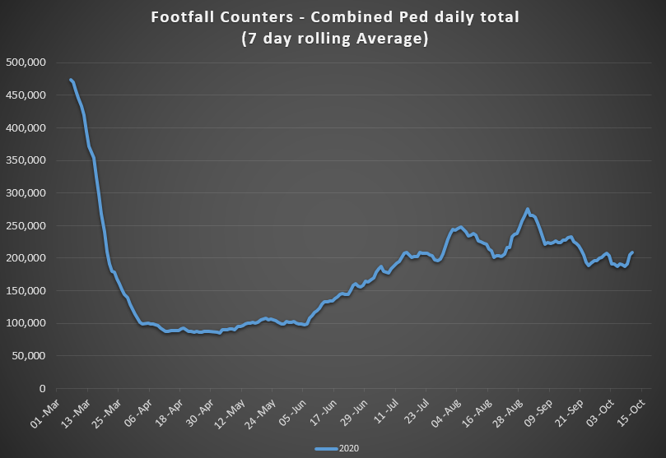

Comparing the monthly totals of 2019 to 2020 it can be seen that footfall levels have been pretty steady over the summer, dropping slightly in September.

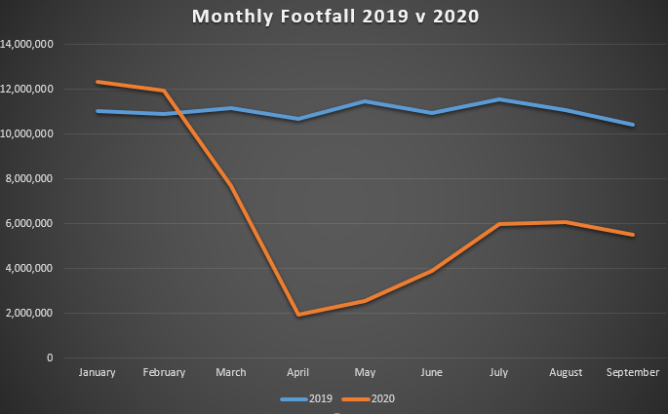

## 1.2 Cycling Volumes

Cycling volumes, which are continuously monitored by City Council’s counters located at Grove Road, North Strand Road, Charleville Mall and Guild Street, show overall cycling numbers at approximately 80% of pre-COVID numbers with this level holding steady since the start of June. Numbers had begun to increase again in September but they have decreased more recently.

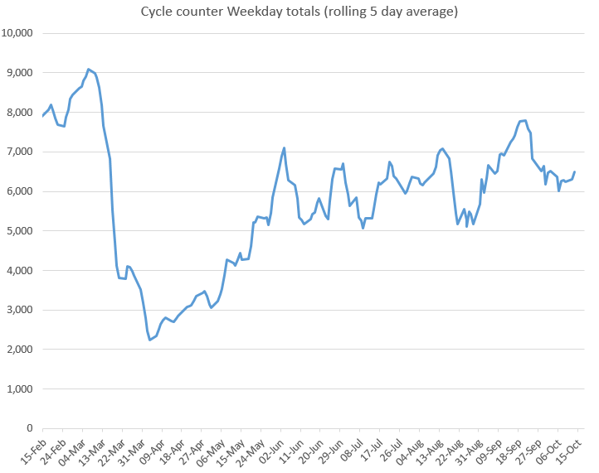

However, during the peak morning time, 7am to 10am, cycling numbers are at approx. 35% of pre-COVID levels. Comparing February to September of this year, to last year, we can see that the morning commuter cycling numbers remain significantly reduced.

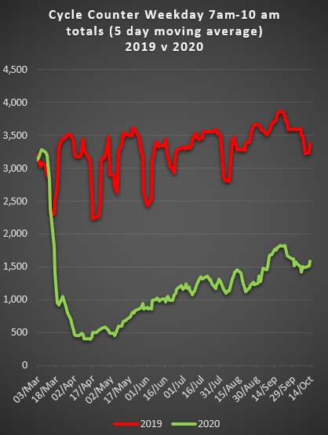 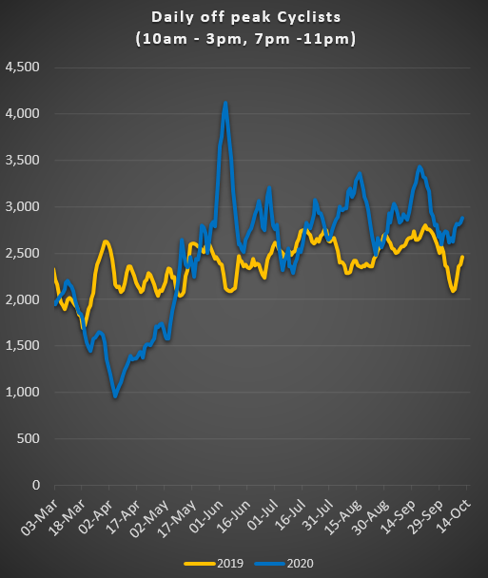

In contrast, the off peak cycling figures have exceeded the 2019 levels, most notably in the last few weeks.

## 1.3 Bus Passenger Numbers

The trend in bus passenger numbers (BAC and GAI) was showing a steady recovery, however in recent weeks this has tailed off. Weekday passenger numbers are close to 50% of pre-COVID levels. Weekend passenger numbers declined after the initial announcement of the Level 3 restrictions in Dublin and have stayed down.

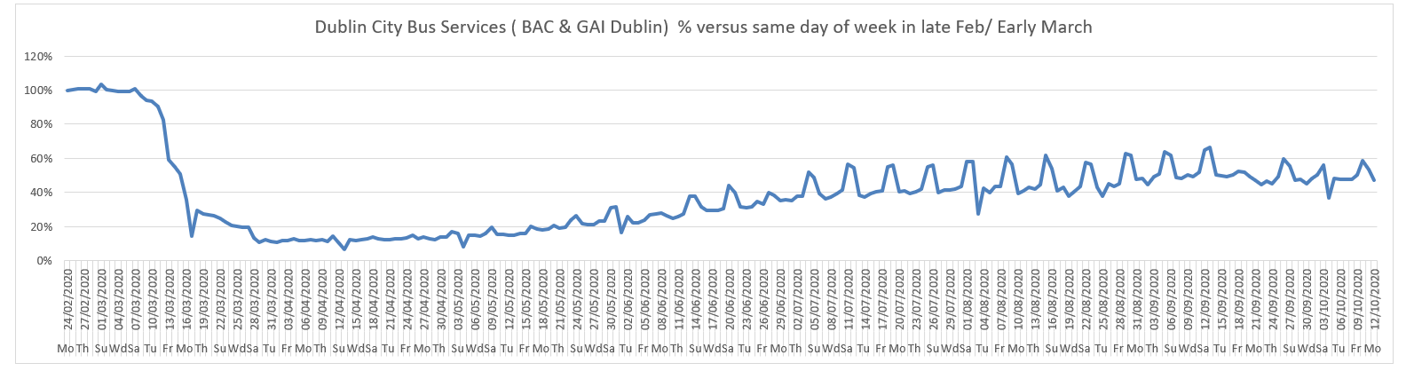

## 1.4 General Traffic Volumes

Since the introduction of level 3 restrictions in Dublin, there has been a clear drop in outbound traffic volumes. Changes to inbound traffic volumes are not as obvious.

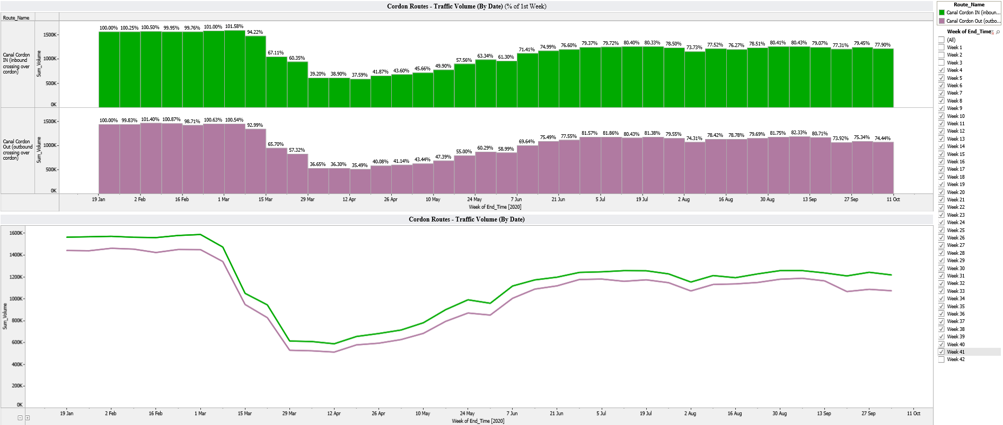

# Implementation of Measures

## Grafton Street Area – Weekend Pedestrian Friendly Trials

A report on the trials and lessons learned, as well as proposals for the future is being prepared. Footfall in both Henry Street and Grafton Street remains below pre-COVID levels but had been recovering steadily. Since the Level 3 restrictions commenced Grafton Street footfall has remained relatively static. (The gap in data for Henry St was due to building works obstructing the counter.)

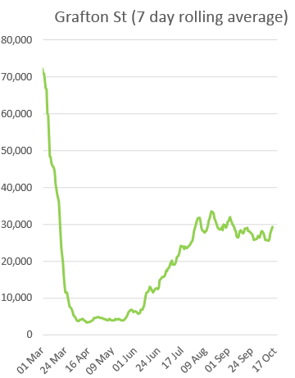 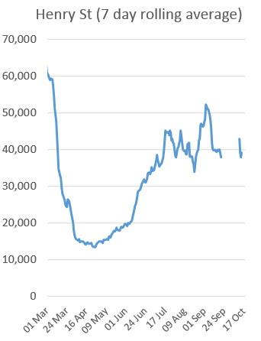

## 2.2 Protected Cycle Facilities, Contra-Flow Facilities, Cycle Parking and ‘Filtered Permeability’

***Early start for cyclists***

New signals giving cyclists an early start ahead of vehicular traffic have been installed on Thomas Street at Bridgefoot Street and Francis Street. A wraparound pedestrian phase has also been added at both sites.

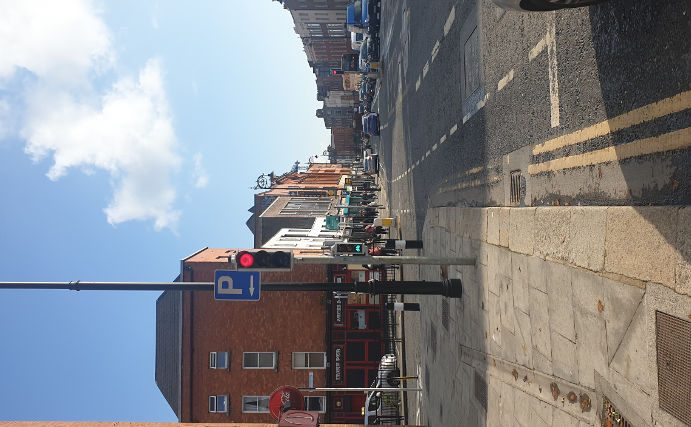 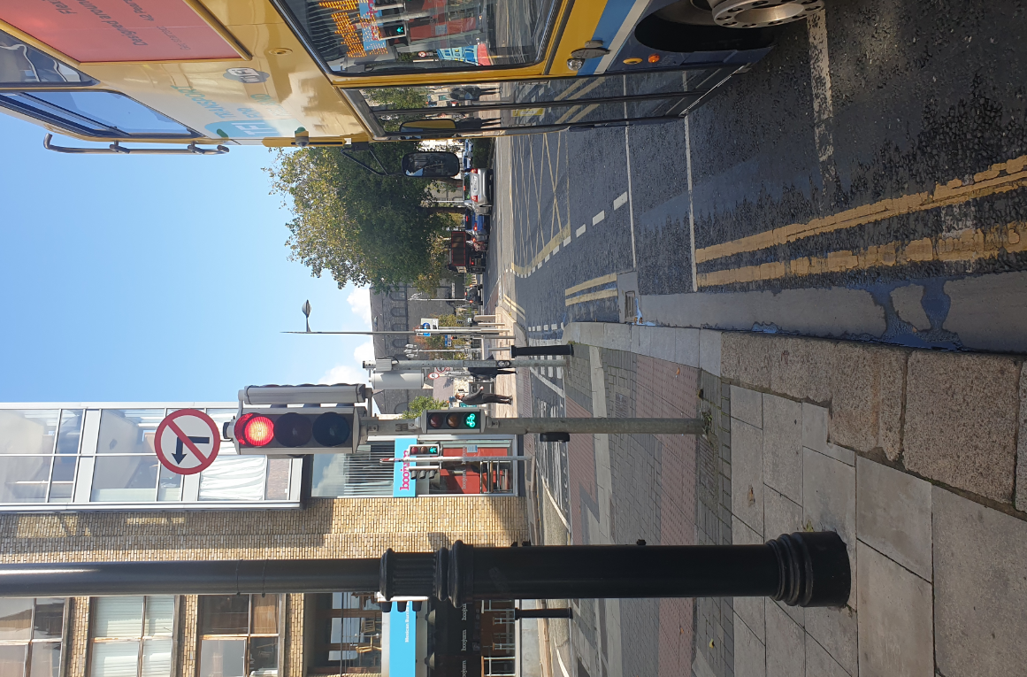

***Interim Fitzwilliam Cycle Way***

New road markings were installed on Merrion Square East as part of the Interim Fitzwilliam Cycle Way.

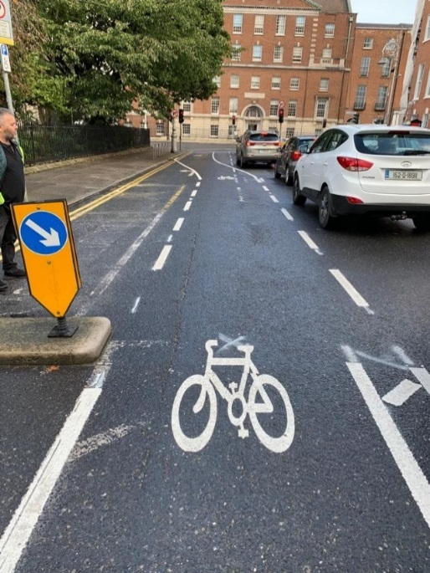 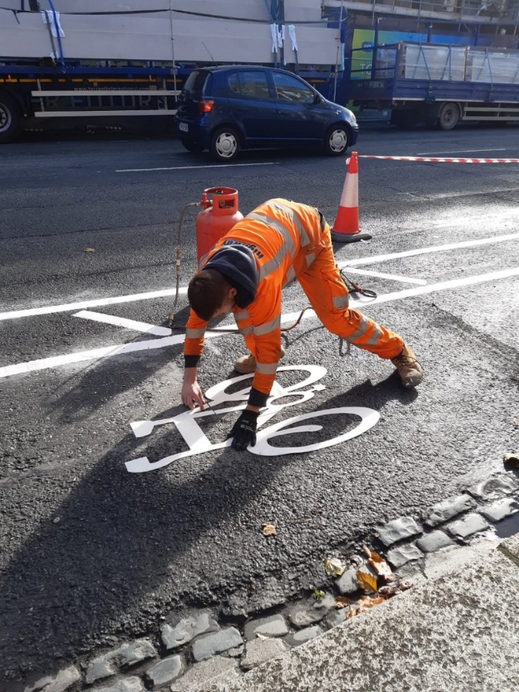

***Strand Road Cycle Route Trial***

During the consultation we received almost 3,000 submissions. After the consultation ended on 5 October we received an Alternative Proposal to provide cycle facilities on Strand Road from the STC Community Group. As part of its ongoing engagement with interested groups DCC officials met with this Group on 9 October. At the South East Area Committee meeting on 12October it was agreed that we would assess the STC alternative proposal.

Due to the level of interest in the proposal and with the consent of the STC Community Group the alternative proposal is being made available to the public on the [Consultation Hub](https://consultation.dublincity.ie/traffic-and-transport/strand-road-trial-cycle-route/). The DCC assessment report will also be made available once complete.

***Griffith Avenue Cycle Route***

An information leaflet giving an overview, key design features and progress of the Griffith Avenue Cycle Track was delivered to residents and businesses along Griffith Ave between St Mobhi Road and the Malahide Road this week. Information on the scheme plus drawings remain on the [Consultation Hub](https://consultation.dublincity.ie/traffic-and-transport/griffith-avenue-protected-cycle-track/). Please note that the bollards are intended to be temporary to initially protect the scheme, with a more suitable longer term protection being installed once the scheme has bedded in.

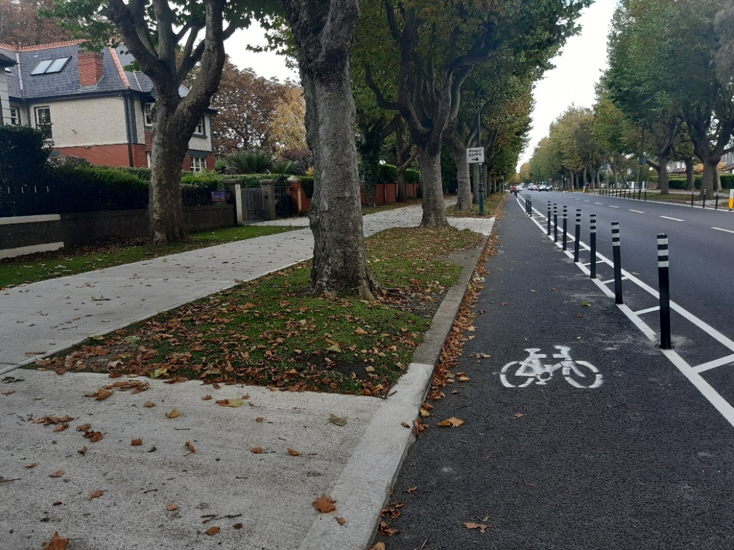

*New bollards in place on Griffith Avenue Cycle Lane*

***Grangegorman Filtered Permeability Trial***

At the September 2020 Central Area Committee meeting, the Elected Members agreed that the trial should be extended until 31 January 2021. A letter drop has been carried out to all residents and businesses in the area inviting feedback on the trial. Details have also been placed on the [Consultation Hub](https://consultation.dublincity.ie/traffic-and-transport/grangegorman-filtered-permeability-trial/).

All submissions should be emailed to [covidmobility@dublincity.ie](mailto:covidmobility@dublincity.ie) with the title ‘Grangegorman Trial Feedback’ preferably in the subject box. Alternatively, feedback can also be submitted via post to the COVID Mobility Team, Block 2, Floor 7, Civic Offices, Wood Quay, Dublin 8, Ireland, D08 RF3F.

***Cycle parking***

Batch 13: A total of 294 stands have been installed. All installations are now complete.

Batch 14: 169 stands have been installed, installations are ongoing.

Batch 15: 24 stands have been installed, installations are ongoing.

Batch 16: Tenders are currently being assessed. It is expected that the installations will commence at the start of November 2020.

Batch 17: Design work is ongoing. Due to go to tender in January 2021.

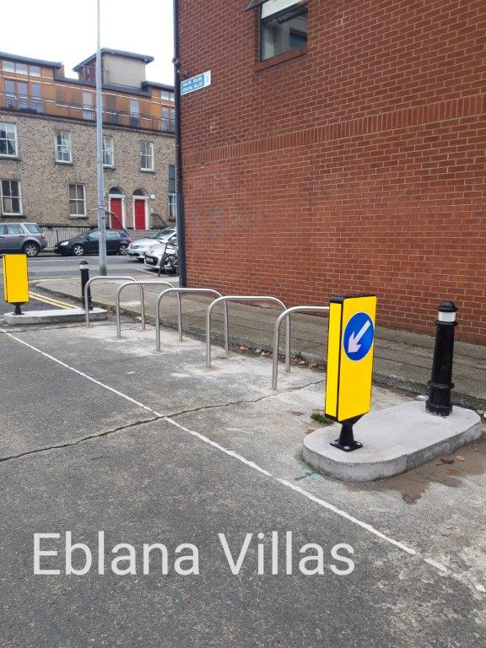 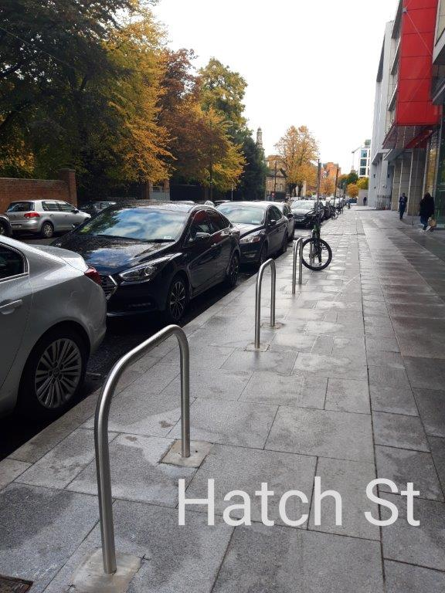

*Eblana Villas cycle parking Hatch Street Upper cycle parking*

## 2.4 School Mobility Programme

We have received 69 School Zone requests from primary level schools to date. The COVID Mobility Technical Team are assessing all submissions for suitability and schools will be contacted with timelines, if it is deemed an appropriate intervention at that location. The Team is also engaging with a number of schools to support the establishment of cycle buses.

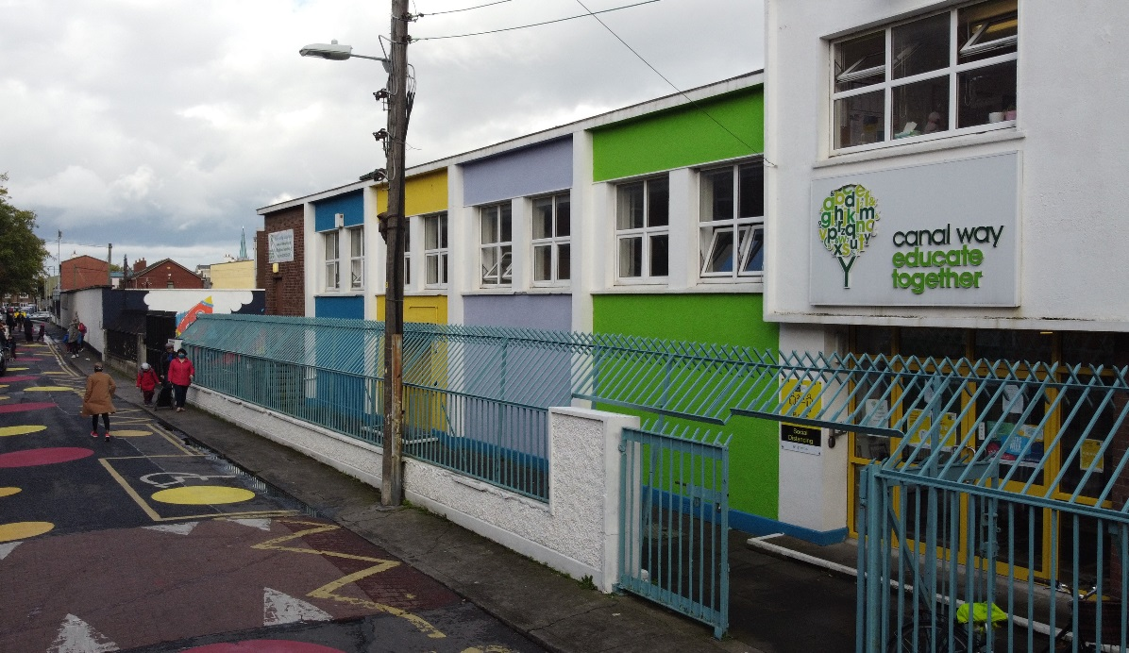

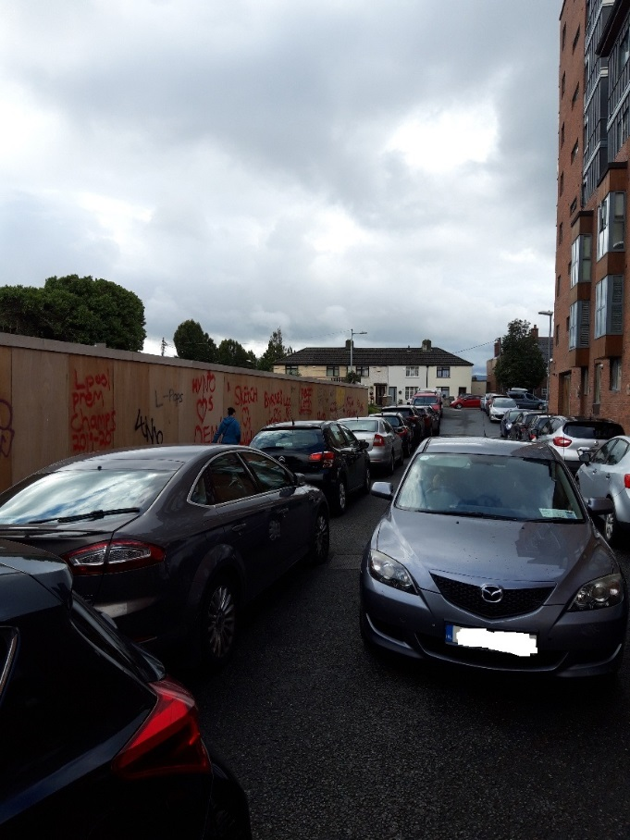 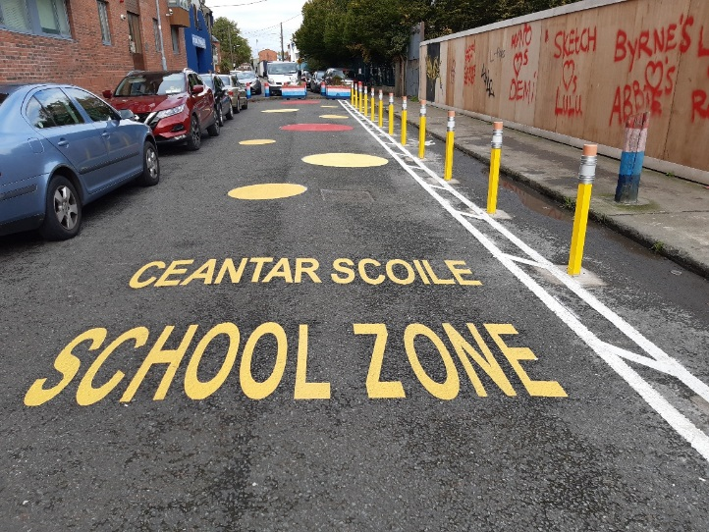

*Before and after images at Canal Way Educate Together, Basin View, Dublin 8*

School Zones are being installed this week at

* St. Catherine’s National School, Donore Avenue, D8
* Scoil Iosagain, Aughavannagh Road, Crumlin, D12
* St Mary’s National School, Paradise Place, Phibsborough, D7
* St Finian’s National School, Glenties Park, Finglas, D11

Designs are currently being finalised for the following four Schools:

* St. Audoens National School, Cook St., D8
* Bunscoil Sancta Maria (ERST) Primary School National School, Synge St., D8
* Scoil Bharra, Fassaugh Avenue, Cabra, D7
* St. Vincents Boys & Girls National School, North William Street, D1

# Communications

## Website

The COVID Mobility webpage, [www.dublincity.ie/COVID-19mobilityprogramme](http://www.dublincity.ie/COVID-19mobilityprogramme) is being updated regularly to keep the general public informed of COVID-19 mobility interventions. As previously advised we will be making more extensive use of the DCC Consultation Hub in order to provide more information on measures.

## 3.2 DCC Consultation Hub/Citizen Space

Details of schemes on the Consultation hub at present include:

Grangegorman Filtered Permeability Trial, <https://consultation.dublincity.ie/traffic-and-transport/grangegorman-filtered-permeability-trial/>

Strand Road Cycle Route Trial,<https://consultation.dublincity.ie/traffic-and-transport/strand-road-trial-cycle-route/>

Griffith Avenue, <https://consultation.dublincity.ie/traffic-and-transport/griffith-avenue-protected-cycle-track/>

The revised layout for Constitution Hill will shortly appear on the Consultation Hub for information.

Each week we will alert Members to any new proposals which are available to view on the Consultation Hub and aim to have a more dynamic process for ensuring that support for projects, suggestions on how to improve them and concerns and issues which may need to be addressed can be better handled. Any feedback on this approach is welcome.

## 3.3 Dedicated COVID-19 Mobility Measure Request Form

In the past week, we have received 257 new requests for COVID Mobility Measures. This brings the total number of COVID Mobility requests to 4,753. A breakdown of these requests is given below:

|  |  |
| --- | --- |
|  |  |
| **Mobility measure requested** | **Number** |
| Footpath widening | 636 |
| Increasing queuing space at bus stops | 129 |
| Pedestrian area | 769 |
| Protected cycle lanes | 1077 |
| Contra-flow cycle lanes | 357 |
| Cycle parking facilities | 453 |
| Outdoor seating area | 566 |
| Commercial / Retail deliveries support | 75 |
| Support and advice for active travel (walking & cycling) | 283 |
| Journey planning | 73 |
| Other | 324 |
| Not answered | 11 |
| **Total requests** | **4,753** |

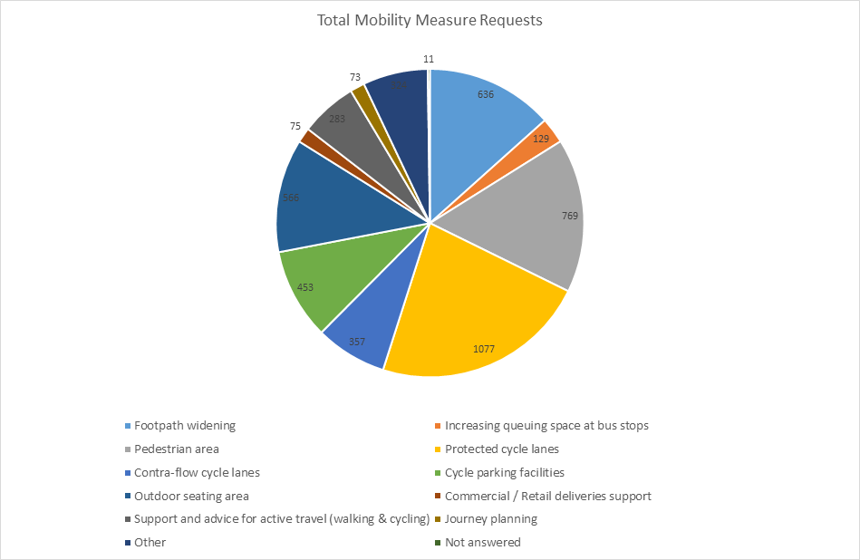

## 3.4 COVID-19 Mobility E-mail

The dedicated e-mail address continues as the primary channel to contact the COVID Mobility Team. It is attracting huge volumes of queries and feedback. The intention is that the e-mail is for general queries and the COVID-19 Mobility Request Form should be used for specific requests at specific locations.

## 3.5 Councillor Updates

Updates on COVID-19 mobility measures are issued on a weekly basis to Elected Members. Updates via e-mail are also being issued to stakeholders via the Transport SPC and the NTA accessibility network.

## 3.6 Active Travel Promotion

We are continuing to utilise Dublin City Council Social Media Channels:

* + - to highlight COVID-19 mobility measures that have been implemented;
    - to encourage the public to walk or cycle, where possible;
    - to encourage social distancing as people move around the city and
    - to encourage more respect for vulnerable road users

We also continue to evolve our Active Travel Campaign in collaboration with key strategic partners (e.g. NTA Smarter Travel, Healthy Ireland, Green- Schools and third level institutions).

Owen P Keegan

**Chief Executive**



**Chief Executive’s Office Floor 4 Block 4**

**Civic Offices**

**Wood Quay**

23 October 2020

**To the Lord Mayor and Elected Members of the City Council**

**COVID-19 Mobility Measures Update**

Contents

1. Introduction 91

1.1 Pedestrian Volumes 91

1.2 Cycling Volumes 92

1.3 Bus Passenger Numbers 92

1.4 General Traffic Volumes 92

2. Implementation of Measures 92

2.1 Grafton Street Area – Weekend Pedestrian Friendly Trials 92

2.2 Bus Stop Build Out 92

2.3 Protected Cycle Facilities, Contra-Flow Facilities, Cycle Parking and ‘Filtered Permeability’ 92

***College Green protected cycle lane improvements*** 92

***Grangegorman Filtered Permeability Trial*** 92

***Griffith Avenue Cycle Route*** 93

***Resurfacing works*** 93

2.4 School Mobility Programme 93

3. Communications 93

3.1 Website 93

3.2 DCC Consultation Hub/Citizen Space 94

3.3 Dedicated COVID-19 Mobility Measure Request Form 94

3.4 COVID-19 Mobility E-mail 94

3.5 Councillor Updates 94

3.6 Active Travel Promotion 94

# 

# 1. Introduction

Implementation of the COVID Mobility Programme for the City Council area continues with a continued emphasis on schools and safe zones. The recent move to level 5 restrictions emphasises the need to continue to respond to this health crisis with a range of appropriate interventions.

## Pedestrian Volumes

The footfall counters count continuously and provide 24 hour data. These counters are located between Stephen’s Green and Henry St. These show that the footfall in this core area had reached a high of around 60% of pre-COVID levels.

Data from the new footfall counters that were installed at key pedestrian locations (Phibsborough, Newcomen Bridge, Baggot St, Grand Canal, North Wall Quay) Richmond St, Newcomen Bridge is now available. These will allow us to further monitor footfall, in particular pedestrians commuting to work, as we move through different levels of restrictions.

## 1.2 Cycling Volumes

Cycling volumes, which are continuously monitored by City Council’s counters located at Grove Road, North Strand Road, Charleville Mall and Guild Street, show overall cycling numbers at approximately 80% of pre-COVID numbers with this level holding steady since the start of June. Numbers had begun to increase again in September followed by a slight decrease and are now holding steady. However, during the peak morning time, 7am to 10am, cycling numbers are at approx. 35% of pre-COVID levels. Comparing February to October of this year, to last year, we can see that the morning commuter cycling numbers remain significantly reduced. In contrast, the off peak cycling figures are still exceeding 2019 figures

## 1.3 Bus Passenger Numbers

The trend in bus passenger numbers (BAC and GAI) was showing a steady recovery, however in recent weeks this has tailed off. Weekday passenger numbers were close to 50% of pre-COVID levels. The move to level 5 restrictions means that buses move back to having 25% capacity and this is presently causing some issues.

## 1.4 General Traffic Volumes

Since the introduction of level 3 restrictions in Dublin, up to the end of last week there has been a slight reduction in traffic volumes.

**Introduction of Level 5 Restrictions**

Comparing volumes across the canal cordon on Thursday 22October (first full day of level 5) with Thursday 15October there was a 13.5 % drop in traffic volumes. We will have a more comprehensive report on the impact of the restrictions next week.

# Implementation of Measures

## Grafton Street Area – Weekend Pedestrian Friendly Trials

A report on the trials and lessons learned, as well as proposals for the future is being prepared. Footfall in both Henry Street and Grafton Street remains below pre-COVID levels but had been recovering steadily. Since the Level 3 restrictions commenced Grafton Street footfall has remained relatively static.

## 2.2 Bus Stop Build Out

A temporary modular bus stop has been installed on Townsend St. This was a narrow footpath with little room for bus passengers waiting. Buses also had issues trying to access the kerb.

## 2.3 Protected Cycle Facilities, Contra-Flow Facilities, Cycle Parking and ‘Filtered Permeability’

### College Green protected cycle lane improvements

The protected cycle lane on College Green that was installed in early June has been improved by the removal of redundant bollards and the seasonal upgrading of planting.

### Grangegorman Filtered Permeability Trial

At the September 2020 Central Area Committee meeting, the Elected Members agreed that the trial should be extended until 31 January 2021. A letter drop, providing an update on the trial and inviting feedback, was carried out to all residents and businesses in the area. A further letter drop to the wider catchment area, including Monck Place, Avondale Terrance and their surrounding streets, will be carried out in the coming week or so inviting feedback on the trial. All details on the trail are available on the [Consultation Hub](https://consultation.dublincity.ie/traffic-and-transport/grangegorman-filtered-permeability-trial/).

It is important to reiterate that all submissions should be emailed to [covidmobility@dublincity.ie](mailto:covidmobility@dublincity.ie) with the title ‘Grangegorman Trial Feedback’ preferably in the subject box. Alternatively, feedback can also be submitted via post to the COVID Mobility Team, Block 2, Floor 7, Civic Offices, Wood Quay, Dublin 8, Ireland, D08 RF3F.

### Griffith Avenue Cycle Route

Road markings and bollards are complete between St Mobhi Road and Walnut Rise.

### Resurfacing works

Resurfacing works are now complete on **Constitution Hill**. It is intended to install an extruded kerb starting next week to protect the inbound and outbound cycle lanes on Constitution Hill.

Resurfacing works commenced on **North Frederick Street** this week. Once complete new road markings will be installed and a protected inbound cycle lane will be provided on North Frederick Street.

More space allocated for cyclists as part of the resurfacing on **Kildare Street**.

## 2.4 School Mobility Programme

We have received 74 ***School Zone*** requests from primary level schools to date. The COVID Mobility Technical Team are assessing all submissions for suitability and schools will be contacted with timelines, if it is deemed an appropriate intervention at that location.

Installation of School Zones are currently being completed at the following schools:

* St. Catherine’s National School, Donore Avenue, D8
* Scoil Iosagain, Aughavannagh Road, Crumlin, D12
* St Mary’s National School, Paradise Place, Phibsborough, D7
* St Finian’s National School, Glenties Park, Finglas, D11

Designs are completed and installation imminent for the following Schools:

* St. Audoens National School, Cook St., D8
* Bunscoil Sancta Maria (ERST) Primary School, Synge St., D8
* Scoil Bharra, Fassaugh Avenue, Cabra, D7
* St. Vincents Boys & Girls National School, North William Street, D1

Designs are currently being finalised for the following schools:

* St. Malachys National School, St. Helena’s Road, Finglas, D11
* Scoil Eoin, Thornville Road, Donaghmede, D5
* St. Louis’ Infant and Senior Primary Schools, Williams Park, Rathmines, D6
* Presentation Primary School, Warrenmount, Blackpitts, Dublin 8.

The Team continues to engage with schools seeking to establish cycle buses and park & stride initiatives.

# Communications

## Website

The COVID Mobility webpage, [www.dublincity.ie/COVID-19mobilityprogramme](http://www.dublincity.ie/COVID-19mobilityprogramme) is being updated regularly to keep the general public informed of COVID-19 mobility interventions. As previously advised we will be making more extensive use of the DCC Consultation Hub in order to provide more information on measures.

## 3.2 DCC Consultation Hub/Citizen Space

Details of schemes on the Consultation hub at present include:

Grangegorman Filtered Permeability Trial, <https://consultation.dublincity.ie/traffic-and-transport/grangegorman-filtered-permeability-trial/>

Strand Road Cycle Route Trial,<https://consultation.dublincity.ie/traffic-and-transport/strand-road-trial-cycle-route/>

Griffith Avenue, <https://consultation.dublincity.ie/traffic-and-transport/griffith-avenue-protected-cycle-track/>

The revised layout for Constitution Hill will shortly appear on the Consultation Hub for information.

Each week we will alert Members to any new proposals which are available to view on the Consultation Hub and aim to have a more dynamic process for ensuring that support for projects, suggestions on how to improve them and concerns and issues which may need to be addressed can be better handled. Any feedback on this approach is welcome.

## 3.3 Dedicated COVID-19 Mobility Measure Request Form

In the past week, we have received 83 new requests for COVID Mobility Measures. This brings the total number of COVID Mobility requests to 4,836. A breakdown of these requests is given below:

**Mobility measure requested**

Footpath widening, 651 requests;

Increasing queuing space at bus stops, 130 requests;

Pedestrian area, 778 requests;

Protected cycle lanes, 1100 requests;

Contra-flow cycle lanes, 362 requests;

Cycle parking facilities, 461 requests;

Outdoor seating area, 572 requests;

Commercial / Retail deliveries support, 77 requests;

Support and advice for active travel (walking & cycling), 284 requests;

Journey planning, 75 requests;

Other, 335 requests;

Not answered, 11

**Total requests, 4836**

## 3.4 COVID-19 Mobility E-mail

The dedicated e-mail address continues as the primary channel to contact the COVID Mobility Team. It is attracting huge volumes of queries and feedback. The intention is that the e-mail is for general queries and the COVID-19 Mobility Request Form should be used for specific requests at specific locations.

## 3.5 Councillor Updates

Updates on COVID-19 mobility measures are issued on a weekly basis to Elected Members. Updates via e-mail are also being issued to stakeholders via the Transport SPC and the NTA accessibility network.

## 3.6 Active Travel Promotion

We are continuing to utilise Dublin City Council Social Media Channels:

* + - to highlight COVID-19 mobility measures that have been implemented;
    - to encourage the public to walk or cycle, where possible;
    - to encourage social distancing as people move around the city and
    - to encourage more respect for vulnerable road users.

We also continue to evolve our Active Travel Campaign in collaboration with key strategic partners (e.g. NTA Smarter Travel, Healthy Ireland, Green- Schools and third level institutions).

Owen P Keegan

**Chief Executive**



**Chief Executive’s Office Floor 4 Block 4**

**Civic Offices**

**Wood Quay**

30 October 2020

**To the Lord Mayor and Elected Members of the City Council**

**COVID-19 Mobility Measures Update**

Contents

1. Introduction 96

1.1 Pedestrian Volumes 96

1.2 Cycling Volumes 97

1.3 Bus Passenger Numbers 97

1.4 General Traffic Volumes 97

2. Implementation of Measures 97

2.1 Grafton Street Area – Weekend Pedestrian Friendly Trials 97

2.2 Protected Cycle Facilities, Contra-Flow Facilities, Cycle Parking and ‘Filtered Permeability’ 97

2.3 Urban Villages 98

2.4 School Mobility Programme 99

3. Communications 99

3.1 Website 99

3.2 DCC Consultation Hub/Citizen Space 99

3.3 Dedicated COVID-19 Mobility Measure Request Form 100

3.4 COVID-19 Mobility E-mail 100

3.5 Councillor Updates 100

3.6 Active Travel Promotion 100

# 1. Introduction

Implementation of the COVID Mobility Programme for the City Council area continues with a continued emphasis on schools and safe zones. The recent move to level 5 restrictions emphasises the need to continue to respond to this health crisis with a range of appropriate interventions.

## Pedestrian Volumes

The footfall counters count continuously and provide 24 hour data. These counters are located between Stephen’s Green and Henry St. These show that the footfall in this core area had reached a high of around 60% of pre-COVID levels. Footfall has dropped since Level 5 restrictions were introduced.

Data from the new footfall counters that were installed at key pedestrian locations (Phibsborough, Newcomen Bridge, Baggot St, Grand Canal, North Wall Quay, Richmond St, Newcomen Bridge) is now available. These allow us to further monitor footfall, in particular pedestrians commuting to work, as we move through different levels of restrictions. It is clear there has been a drop since Level 5 restrictions came into force.

## 1.2 Cycling Volumes

Cycling volumes, which are continuously monitored by the City Council’s counters located at Grove Road, North Strand Road, Charleville Mall and Guild Street, show overall cycling numbers at approximately 80% of pre-COVID numbers with this level holding steady since the start of June. Numbers had begun to increase again in September followed by a slight decrease. As with the pedestrian figures, the numbers have dropped in the last week.

However, during the peak morning time, 7am to 10am, cycling numbers are at approx. 35% of pre-COVID levels. Comparing February to October of this year, to last year, we can see that the morning commuter cycling numbers remain significantly reduced. In contrast, the off peak cycling figures are still exceeding 2019 figures.

## 1.3 Bus Passenger Numbers

The trend in bus passenger numbers (BAC and GAI) was showing a steady recovery, however in recent weeks this has tailed off. Weekday passenger numbers were close to 50% of pre-COVID levels. The move to Level 5 restrictions means that buses are restricted to 25% and this is presently causing some issues.

## 1.4 General Traffic Volumes

There has been a significant drop in traffic volumes since the introduction of Level 5 restrictions last Wednesday week. The chart below covers a full week at Level 5 and shows volumes to be approximately 61% of what they were in a similar week in January. Note, the Bank Holiday Monday would also have contributed to the reduction in traffic volumes.

# Implementation of Measures

## Grafton Street Area – Weekend Pedestrian Friendly Trials

A report on the trials and lessons learned, as well as proposals for the future is attached to this report. Road resurfacing will take place on a number of the streets in the Grafton Quarter during November as well as some other more minor changes. A period of consultation on the proposed traffic changes in the Grafton Street area will commence in November.

Since the Level 5 restrictions commenced Grafton Street footfall has dropped substantially along with Henry Street.

## 2.2 Protected Cycle Facilities, Contra-Flow Facilities, Cycle Parking and ‘Filtered Permeability’

***Strand Road Cycle Route***

We have received an Alternative Option - Version 2 from STC Community Group. We have placed this on the [Consultation Hub](https://consultation.dublincity.ie/traffic-and-transport/strand-road-trial-cycle-route/) and directed people to this submission via our Social Media platforms. The Council’s response to this proposal will be presented to the next meeting of the South East Area Committee on Thursday.

***Griffith Avenue Cycle Route***

The next section of the protected cycle lanes on Griffith Avenue between St Mobhi Road and Walnut Rise was installed over the past few weeks. We have received comments regarding aspects of this section which we are continuing to monitor and are making modifications as required. Details of some of the issues raised of late are included on the [Consultation Hub](https://consultation.dublincity.ie/traffic-and-transport/griffith-avenue-protected-cycle-track/), see document ‘*Public Consultation Summary Update 27/10/20’* included in supporting documents at the bottom of the page. We have also included a copy of the information leaflet that was delivered to residents of Griffith Avenue on 12 October.

Drawings for the next section of Griffith Avenue, between Walnut Rise and Drumcondra Road (Section 2), are now finalised, taking into consideration feedback we have received since the draft drawings were initially published on the site in late September. We would hope to start installing this section in the coming weeks. We hope to publish drawings for the junction of Griffith Avenue and Drumcondra Road next week and draft drawings for Section 3, Drumcondra Road to Grace Park Road, early the following week.

***Parnell Square East Contraflow***

Resurfacing works have begun on North Frederick Street and Parnell Square East. Once the resurfacing works are completed we intend installing new road markings that will allow for the installation of the contra-flow cycle lane linking O’Connell Street to Dorset Street via North Frederick Street. However we have yet to complete civil works to allow cyclists safely pass from O’Connell Street onto Parnell Square East and again from Parnell Square East onto North Frederick Street. Until these works are completed we only intend allowing access to the new cycle lanes on North Frederick Street.

We also have to make changes to the junction of North Frederick Street and Dorset Street and in the interim period the current arrangements will remain with all vehicles including cyclists having to turn left from North Frederick Street onto Dorset Street. It is intended that in the coming months all civils will be completed to allow the contra-flow to be fully operational. A summary of the feedback received since the original proposals is available on the [Consultation Hub](https://consultation.dublincity.ie/traffic-and-transport/parnell-square-east-contraflow/).

***Grangegorman Filtered Permeability Trial***

At the September 2020 Central Area Committee meeting, the Elected Members agreed that the trial should be extended until 31 January 2021. A letter drop, providing an update on the trial and inviting feedback, was carried out to all residents and businesses in the area. A further letter drop to the wider catchment area, including Monck Place, Avondale Terrance and their surrounding streets, was carried out recently inviting feedback on the trial. All details of the trail are available on the [Consultation Hub](https://consultation.dublincity.ie/traffic-and-transport/grangegorman-filtered-permeability-trial/).

***Pigeon House Road Filtered Permeability Trial***

The report for Pigeon House Road will be presented at the November South East Area Committee meeting with DCC’s recommendation to extend the trial for 1 year.

***Resurfacing works***

Resurfacing works are now complete on **Constitution Hill.** This has allowed the cycle tracks to be clearly marked on either side as well as a bus lane on the approach to Church Street junction. It is intended to install an extruded kerb starting next week to protect the inbound and outbound cycle lanes on Constitution Hill and to finish the road markings in the area.

## 2.3 Urban Villages

***Sandymount Village***

Construction has commenced on the installation of three pedestrian crossings in Sandymount Green - two controlled pedestrian crossing (one near Borzas Takeaway on northern arm of Sandymount Green and one near Bennetts Auctioneers on the southern arm of Sandymount Green), as well as one uncontrolled crossing at the junction of Claremont Road and Sandymount Green. A ramp on the eastern arm of Sandymount Green is also included in the works.

***Finglas Village***

The installation of two uncontrolled crossings in Finglas Village, at the junction with Finglas Main Street and Jamestown Road, will commence in early November 2020. The upgrade of the footpath on Finglas Main Street from Mace to Iceland is included in the works.

## 2.4 School Mobility Programme

***School Zones***

We have received 78 ***School Zone*** requests from primary level schools to date. The COVID Mobility Technical Team are assessing all submissions for suitability and schools will be contacted with timelines, if it is deemed an appropriate intervention at that location.

Bad weather caused slight delays on the installation of School Zones this week. The following were due for completion by the end of this week:

* St. Audoens National School, Cook St., D8
* Bunscoil Sancta Maria (ERST) Primary School, Synge St., D8
* Scoil Bharra, Fassaugh Avenue, Cabra, D7
* St. Vincents Boys & Girls National School, North William Street, D1

Work will commence on School Zones at the following schools next week:

* St. Malachys National School, St. Helena’s Road, Finglas, D11
* Scoil Eoin, Thornville Road, Donaghmede, D5
* St. Louis’ Infant and Senior Primary Schools, Williams Park, Rathmines, D6
* Presentation Primary School, Warrenmount, Blackpitts, Dublin 8

***School cycle parking***

Since the start of September 52 cycle parking stands were delivered to 18 schools. We intend to deliver cycle parking stands to a further 52 schools over the coming weeks.

The Team continues to engage with schools seeking to establish cycle buses and park & stride initiatives.

# Communications

## Website

The COVID Mobility webpage, [www.dublincity.ie/COVID-19mobilityprogramme](http://www.dublincity.ie/COVID-19mobilityprogramme) is being updated regularly to keep the general public informed of COVID-19 mobility interventions. As previously advised we will be making more extensive use of the DCC Consultation Hub in order to provide more information on measures.

## 3.2 DCC Consultation Hub/Citizen Space

Details of schemes on the Consultation Hub at present include:

Grangegorman Filtered Permeability Trial, <https://consultation.dublincity.ie/traffic-and-transport/grangegorman-filtered-permeability-trial/>

Strand Road Cycle Route Trial,<https://consultation.dublincity.ie/traffic-and-transport/strand-road-trial-cycle-route/>

Griffith Avenue, <https://consultation.dublincity.ie/traffic-and-transport/griffith-avenue-protected-cycle-track/>

The revised layout for Constitution Hill will shortly appear on the Consultation Hub for information.

Each week we will alert Members to any new proposals which are available to view on the Consultation Hub and aim to have a more dynamic process for ensuring that support for projects, suggestions on how to improve them and concerns and issues which may need to be addressed can be better handled. Any feedback on this approach is welcome.

## 3.3 Dedicated COVID-19 Mobility Measure Request Form

In the past week, we have received 36 new requests for COVID Mobility Measures. This brings the total number of COVID Mobility requests to 4,872. A breakdown of these requests is given on the next page:

**Mobility measure requested**

Footpath widening, 657 requests;

Increasing queuing space at bus stops, 130 requests;

Pedestrian area, 781 requests;

Protected cycle lanes, 113 requests;

Contra-flow cycle lanes, 364 requests;

Cycle parking facilities, 464 requests;

Outdoor seating area, 575 requests;

Commercial / Retail deliveries support, 77 requests;

Support and advice for active travel (walking & cycling), 286 requests;

Journey planning, 75 requests;

Other, 339 requests;

Not answered, 11;

**Total requests, 4,872**

## 3.4 COVID-19 Mobility E-mail

The dedicated e-mail address continues as the primary channel to contact the COVID Mobility Team. It is attracting huge volumes of queries and feedback. The intention is that the e-mail is for general queries and the COVID-19 Mobility Request Form should be used for specific requests at specific locations.

## 3.5 Councillor Updates

Updates on COVID-19 mobility measures are issued on a weekly basis to Elected Members. Updates via e-mail are also being issued to stakeholders via the Transport SPC and the NTA accessibility network.

## 3.6 Active Travel Promotion

We are continuing to utilise Dublin City Council Social Media Channels:

* + - to highlight COVID-19 mobility measures that have been implemented;
    - to encourage the public to walk or cycle, where possible;
    - to encourage social distancing as people move around the city and
    - to encourage more respect for vulnerable road users.

We also continue to evolve our Active Travel Campaign in collaboration with key strategic partners (e.g. NTA Smarter Travel, Healthy Ireland, Green- Schools and third level institutions).

Owen P Keegan

**Chief Executive**



**Chief Executive’s Office Floor 4 Block 4**

**Civic Offices**

**Wood Quay**

6 November 2020

**To the Lord Mayor and Elected Members of the City Council**

**COVID-19 Mobility Measures Update**

Contents

1. Introduction 102

1.1 Pedestrian Volumes 102

1.2 Cycling Volumes 103

1.3 Bus Passenger Numbers 103

1.4 General Traffic Volumes 103

2. Implementation of Measures 103

2.1 Grafton Street Area – Weekend Pedestrian Friendly Trials 103

2.2 Protected Cycle Facilities, Contra-Flow Facilities, Cycle Parking and ‘Filtered Permeability’ 103

2.3 School Mobility Programme 104

3. Communications 104

3.1 Website 104

3.2 DCC Consultation Hub/Citizen Space 104

3.3 Dedicated COVID-19 Mobility Measure Request Form 105

3.4 COVID-19 Mobility E-Mail 105

3.5 Councillor Updates 105

3.6 Active Travel Promotion 105

# 1. Introduction

Implementation of the COVID Mobility Programme for the City Council area continues with an emphasis on schools and safe zones. The Level 5 restrictions reinforce the need to continue to respond to this health crisis with a range of appropriate interventions.

## Pedestrian Volumes

The footfall counters count continuously and provide 24 hour data. These counters are located between Stephen’s Green and Henry St. These show that the footfall in this core area had reached a high of around 60% of pre-COVID levels. Footfall dropped when Level 5 restrictions were introduced but appears now to have leveled off.

Data from the new footfall counters that were installed at key pedestrian locations (Phibsborough, Newcomen Bridge, Baggot St, Grand Canal, North Wall Quay) Richmond St, Newcomen Bridge is now available. These will allow us to further monitor footfall, in particular pedestrians commuting to work, as we move through different levels of restrictions.

It is clear that footfall in the morning peak period has declined since Level 5 restrictions came into force.

## 1.2 Cycling Volumes

Cycling volumes, which are continuously monitored by City Council’s counters located at Grove Road, North Strand Road, Charleville Mall and Guild Street, show overall cycling numbers at approximately 80% of pre-COVID numbers with this level holding steady since the start of June. Numbers had begun to increase again in September followed by a slight decrease. As with the pedestrian figures, the numbers have dropped since Level 5 restrictions came into force.

However, during the peak morning time, 7am to 10am, cycling numbers are at approx. 35% of pre-COVID levels. Comparing February to October of this year, to last year, we can see that the morning commuter cycling numbers remain significantly reduced. In contrast, the off peak cycling figures are still exceeding 2019 figures

## 1.3 Bus Passenger Numbers

Bus passenger numbers are at under 40% of pre-COVID levels.

## 1.4 General Traffic Volumes

Last week, traffic volumes were down by approx. 40% from pre-COVID levels. However, if we exclude last Monday, which was a bank holiday, and only consider the Tuesday to Friday figures, we see an average reduction of approx. 30% from pre-COVID levels.

# Implementation of Measures

## Grafton Street Area – Weekend Pedestrian Friendly Trials

A report on the trials and lessons learned, as well as proposals for the future was circulated to Councilors on Monday. This report is now available on the [Consultation Hub](https://consultation.dublincity.ie/traffic-and-transport/feedback-on-grafton-street-area-pedestrianisation/) with an accompanying online survey. A consultation note on the proposed pedestrianisation of Dame Court, Drury Street (part), South William Street (part) and South Anne St is now available on the [Consultation Hub](https://consultation.dublincity.ie/traffic-and-transport/pedestrianisation-of-grafton-street-area/).

## 2.2 Protected Cycle Facilities, Contra-Flow Facilities, Cycle Parking and ‘Filtered Permeability’

***Strand Road Cycle Route***

The trial of this cycle route is now scheduled to commence on 15January for a six month period. Reports on alternative proposals and updates on the scheme are all on the Consultation Hub.

***Griffith Avenue Cycle Route***

Drawings for the junction of Griffith Avenue and Drumcondra Road were published last week on the [Consultation Hub](https://consultation.dublincity.ie/traffic-and-transport/griffith-avenue-protected-cycle-track/).

Drawings for Section 3 of the Griffith Avenue cycle route between Drumcondra Road and Gracepark Road were published on 5 November. We intend to publish the drawings for the last two sections that will take the route as far as the Malahide Road over the next two weeks.

***Pigeon House Road Filtered Permeability Trial***

The report on the Pigeon House Road, with DCC’s recommendation to extend the trial for 1 year, will be presented to the South East Committee on November 9th.

***Resurfacing Works***

Resurfacing works are now complete on Constitution Hill and we started works to install an extruded kerb on both the inbound and outbound lane on 3 November. It is intended that these works will be completed this week.

***Werburgh Street***

The Werburgh Street contra flow cycle route will start to be installed next week.

***Cycle Lane Protection***

We intend to install an extruded concrete kerb on Ormond Quay to protect the interim Liffey Cycle Route starting from next Tuesday, 10 November.

***Cycle Parking***

599 cycle stands have been installed at 121 locations so far this year. This includes three cargo bike stands installed at St. Stephen’s Green. The Sustainable Mobility and Projects Section intends to have the tarmac underneath the cargo bike stands painted blue and a cargo bike logo put on it.

## 2.3 School Mobility Programme

***School Zones***

We have received four new applications for ***School Zone*** in the past week, bringing the total to 84. The COVID Mobility Technical Team are assessing all submissions for suitability and schools will be contacted with timelines, if it is deemed an appropriate intervention at that location.

Designs have been finalised for the following schools, with implementation to follow:

* Drimnagh Castle National School, Walkinstown, Dublin 12
* St John Scottus National School, Northumberland Rd, Ballsbridge, Dublin 4,
* Holy Spirit National School, Silloge Road, Ballymun, Dublin 11

Designs are currently being finalized for:

* Christ the King NS, Annaly Road, Cabra, Dublin 7
* Marian School, St Catherine’s and Casa Caterina, Dominican Campus, Ratoath Road, Cabra, Dublin 7
* Scoil Fhursa, Cromcastle Green, Kilmore West, Dublin 5
* Scoil Ída GNS, Cromcastle Green, Kilmore West, Dublin 5

***School Cycle Parking***

Since the start of September we have delivered of 52 cycle parking stands to 18 schools. We intend to deliver cycle parking stands to a further 52 schools in the coming weeks. The Team continues to engage with schools seeking to establish cycle, buses and park & stride initiatives.

# Communications

## Website

The COVID Mobility webpage, [www.dublincity.ie/COVID-19mobilityprogramme](http://www.dublincity.ie/COVID-19mobilityprogramme) is being updated regularly to keep the general public informed of COVID-19 mobility interventions. As previously advised we will be making more extensive use of the Consultation Hub in order to provide more information on measures.

## 3.2 DCC Consultation Hub/Citizen Space

Details of schemes on the Consultation hub at present include:

Grangegorman Filtered Permeability Trial, <https://consultation.dublincity.ie/traffic-and-transport/grangegorman-filtered-permeability-trial/>

Strand Road Cycle Route Trial,<https://consultation.dublincity.ie/traffic-and-transport/strand-road-trial-cycle-route/>

Griffith Avenue, <https://consultation.dublincity.ie/traffic-and-transport/griffith-avenue-protected-cycle-track/>

College Green, [https://consultation.dublincity.ie/traffic-and-transport/proposed-extension-of-the-civic-plaza-at-college-g/](https://consultation.dublincity.ie/traffic-and-transport/proposed-extension-of-the-civic-plaza-at-college-g/%20)

Grafton Street Area Pedestrianisation, [https://consultation.dublincity.ie/traffic-and-transport/pedestrianisation-of-grafton-street-area/](https://consultation.dublincity.ie/traffic-and-transport/pedestrianisation-of-grafton-street-area/%20)

The revised layout for Constitution Hill will shortly appear on the Consultation Hub for information.

Each week we will alert Members to any new proposals which are available to view on the Consultation Hub and aim to have a more dynamic process for ensuring that support for projects, suggestions on how to improve them and concerns and issues which may need to be addressed can be better handled. Any feedback on this approach is welcome.

## 3.3 Dedicated COVID-19 Mobility Measure Request Form

In the past week, we have received 12 new requests for COVID Mobility Measures. This brings the total number of COVID Mobility requests to 4,884. A breakdown of these requests is given on the next page.

**Mobility measure requested**

Footpath widening, 659 requests;

Increasing queuing space at bus stops, 131 requests;

Pedestrian area, 782 requests;

Protected cycle lanes, 1116 requests;

Contra-flow cycle lanes, 365 requests;

Cycle parking facilities, 465 requests;

Outdoor seating area, 576 requests;

Commercial / Retail deliveries support, 77 requests;

Support and advice for active travel (walking & cycling), 286 requests;

Journey planning, 75 requests;

Other, 341 requests;

Not answered, 11

**Total requests 4,884**

## 3.4 COVID-19 Mobility E-Mail

The dedicated e-mail address continues as the primary channel to contact the COVID Mobility Team. It is attracting huge volumes of queries and feedback. The intention is that the e-mail is for general queries and the COVID-19 Mobility Request Form should be used for specific requests at specific locations.

## 3.5 Councillor Updates

Updates on COVID-19 mobility measures are issued on a weekly basis to Elected Members. Updates via e-mail are also being issued to stakeholders via the Transport SPC and the NTA accessibility network.

## 3.6 Active Travel Promotion

We are continuing to utilise Dublin City Council Social Media Channels:

* + - to highlight COVID-19 mobility measures that have been implemented;
    - to encourage the public to walk or cycle, where possible;
    - to encourage social distancing as people move around the city and
    - to encourage more respect for vulnerable road users

We also continue to evolve our Active Travel Campaign in collaboration with key strategic partners (e.g. NTA Smarter Travel, Healthy Ireland, Green- Schools and third level institutions).

Owen P Keegan

**Chief Executive**



**Chief Executive’s Office Floor 4 Block 4**

**Civic Offices**

**Wood Quay**

13 November 2020

**To the Lord Mayor and Elected Members of the City Council**

***COVID-19 Mobility Measures Update***

Contents

1. Introduction 107

1.1 Pedestrian Volumes 107

1.2 Cycling Volumes 108

1.3 Bus Passenger Numbers 108

1.4 General Traffic Volumes 108

2. Implementation of Measures 108

2.1 Grafton Street Area – Proposed Pedestrianisation of a Number of Streets in the Grafton Street Area 108

2.2 Protected Cycle Facilities, Contra-Flow Facilities, Cycle Parking and ‘Filtered Permeability’ 108

2.3 School Mobility Programme 109

3. Communications 109

3.1 Website 109

3.2 DCC Consultation Hub/Citizen Space 109

3.3 Dedicated COVID-19 Mobility Measure Request Form 110

3.4 COVID-19 Mobility E-Mail 110

3.5 Councillor Updates 110

3.6 Active Travel Promotion 111

# 1. Introduction

Implementation of the COVID Mobility Programme for the City Council area continues with an emphasis on schools and safe zones. The Level 5 restrictions reinforce the need to continue to respond to this health crisis with a range of appropriate interventions.

It is intended to bring a report to the December City Council meeting on progress to date under COVID Mobility Programme, together with proposals to restart the TAG service.

## Pedestrian Volumes

The footfall counters count continuously and provide 24 hour data. These counters are located between Stephen’s Green and Henry St. These show that footfall in this core area had reached a high of around 60% of pre-COVID levels. Footfall dropped when Level 5 restrictions were introduced but it has increased modestly since then.

Data from the new footfall counters that were installed at key pedestrian locations (Phibsborough, Newcomen Bridge, Baggot St, Grand Canal, North Wall Quay, and Richmond Street), is now available. These will allow us to further monitor footfall, in particular pedestrians commuting to work, as we move through different levels of restrictions. Footfall in the morning peak period declined slightly when Level 5 restrictions came into force but is has already recovered.

## 1.2 Cycling Volumes

Cycling volumes, which are continuously monitored by City Council’s counters (located at Grove Road, North Strand Road, Charleville Mall and Guild Street), show overall cycling numbers at approximately 80% of pre-COVID numbers with this level holding steady since the start of June. Numbers had begun to increase again in September. As with the pedestrian figures, the numbers have dropped since Level 5 restrictions came into force although they also appear to have recovered slightly over the past two weeks.

During the peak morning time, 7am to 10am, cycling numbers are at approx. 35% of pre-COVID levels. Comparing February to October of this year, to last year, we can see that the morning commuter cycling numbers remain significantly reduced. In contrast, the off peak cycling figures are still exceeding 2019 figures.

## 1.3 Bus Passenger Numbers

Bus passenger numbers are currently at under 40% of pre-COVID levels.

## 1.4 General Traffic Volumes

Last week, traffic volumes were down by approx. 40% from pre-COVID levels. The graph shows a slight increase since then, but traffic volumes levels are still at around 35% less than pre COVID.

# Implementation of Measures

## Grafton Street Area – Proposed Pedestrianisation of a Number of Streets in the Grafton Street Area

An online survey for the proposed pedestrianisation of a number of streets in the Grafton Street area has been available on our [Consultation Hub](https://consultation.dublincity.ie/traffic-and-transport/pedestrianisation-of-grafton-street-area/) since 6 November. We have received 324 submissions to date.

## 2.2 Protected Cycle Facilities, Contra-Flow Facilities, Cycle Parking and ‘Filtered Permeability’

***Strand Road Cycle Route***

The trial of this cycle route is now scheduled to commence on 15January for a six month period. Reports on alternative proposals and updates on the scheme are all on the [Consultation Hub](https://consultation.dublincity.ie/traffic-and-transport/strand-road-trial-cycle-route/).

***Griffith Avenue Cycle Route***

Installation of the second section of the Griffith Avenue Cycle Route from Walnut Rise to the Junction of Drumcondra Road Lower are due to commence by the end of next week. Further details on the [Consultation Hub](https://consultation.dublincity.ie/traffic-and-transport/griffith-avenue-protected-cycle-track/).

***Pigeon House Road Filtered Permeability Trial***

The report on the Pigeon House Road, with the City Council’s recommendation to extend the trial for 1 year, will be presented to the South East Committee on 9 November.

***Resurfacing Works***

Resurfacing works are now complete on Constitution Hill and the extruded kerbs on both the inbound and outbound lanes were completed on 10 November. Road marking and surface colouring is still to be completed.

***Werburgh Street***

The first phase of the Werburgh Street contra flow cycle route commenced earlier this week.

***Cycle Lane Protection***

We intend to install an extruded concrete kerb on Ormond Quay to protect the interim Liffey Cycle Route starting from next Tuesday, 10 November.

***Cycle Parking***

A further 15 cycle stands were installed in the past week bringing the total installed this year to 614 stands at 126 locations.

## 2.3 School Mobility Programme

***School Zones***

We have received three new applications for ***School Zone*** in the past week, bringing the total to 87. The COVID Mobility Technical Team are assessing all submissions for suitability and schools will be contacted with timelines, if it is deemed an appropriate intervention at that location.

Works are due for completion at Warrenmount School, Blackpitts, Dublin 8 this week and are underway at St. Louis Senior and Infant Primary School, Williams Park, Rathmines.

The next Schools Zones will be implemented:

* Drimnagh Castle National School, Walkinstown, Dublin 12
* St. John Scottus National School, Northumberland Rd, Ballsbridge, Dublin 4
* Holy Spirit National School, Silloge Road, Ballymun, Dublin 11

Designs are currently being finalized for:

* Shellybanks ETNS, Roslyn Park, Newgrove Ave, Sandymount, Dublin 4
* Scoil Úna Naofa, Armagh Road, Crumlin, Dublin 12
* Mary Queen of Angels, Gurteen Road, Ballyfermot.
* Scoil Tereasa Naofa, Petrie Road, Dublin 8
* Christ the King NS, Annaly Road, Cabra, Dublin 7
* Marian School, St Catherine’s and Casa Caterina, Dominican Campus, Ratoath Road, Cabra, Dublin 7
* Scoil Fhursa, Cromcastle Green, Kilmore West, Dublin 5
* Scoil Ída GNS, Cromcastle Green, Kilmore West, Dublin 5

***School Cycle Parking***

Since the start of September we have delivered 52 cycle parking stands to 18 schools. We intend to deliver cycle parking stands to a further 52 schools in the coming weeks. The Team continues to engage with schools seeking to establish cycle, buses and park & stride initiatives.

# Communications

## Website

The COVID Mobility webpage, [www.dublincity.ie/COVID-19mobilityprogramme](http://www.dublincity.ie/COVID-19mobilityprogramme) is being updated regularly to keep the general public informed of COVID-19 mobility interventions. As previously advised we will be making more extensive use of the Consultation Hub in order to provide more information on measures.

## 3.2 DCC Consultation Hub/Citizen Space

Details of schemes on the Consultation hub at present include:

Grangegorman Filtered Permeability Trial, <https://consultation.dublincity.ie/traffic-and-transport/grangegorman-filtered-permeability-trial/>

Strand Road Cycle Route Trial,<https://consultation.dublincity.ie/traffic-and-transport/strand-road-trial-cycle-route/>

Griffith Avenue, <https://consultation.dublincity.ie/traffic-and-transport/griffith-avenue-protected-cycle-track/>

Grafton Street Area Pedestrianisation, [https://consultation.dublincity.ie/traffic-and-transport/pedestrianisation-of-grafton-street-area/](https://consultation.dublincity.ie/traffic-and-transport/pedestrianisation-of-grafton-street-area/%20)

College Green, [https://consultation.dublincity.ie/traffic-and-transport/proposed-extension-of-the-civic-plaza-at-college-g/](https://consultation.dublincity.ie/traffic-and-transport/proposed-extension-of-the-civic-plaza-at-college-g/%20)

The revised layout for Constitution Hill will shortly appear on the Consultation Hub for information.

Each week we will alert Members to any new proposals which are available to view on the Consultation Hub and aim to have a more dynamic process for ensuring that support for projects, suggestions on how to improve them and concerns and issues which may need to be addressed can be better handled. Any feedback on this approach is welcome.

## 3.3 Dedicated COVID-19 Mobility Measure Request Form

In the past week, we have received 66 new requests for COVID Mobility Measures. This brings the total number of COVID Mobility requests to 4,951. A breakdown of these requests is given on the next page.

**Mobility measure requested**

Footpath widening, 665 requested;

Increasing queuing space at bus stops, 131 requested;

Pedestrian area, 785 requested;

Protected cycle lanes, 1148 requested;

Contra-flow cycle lanes, 370 requested;

Cycle parking facilities, 473 requested;

Outdoor seating area, 578 requested;

Commercial / Retail deliveries support, 77 requested;

Support and advice for active travel (walking & cycling), 290 requested;

Journey planning, 76 requested;

Other, 347 requested;

Not answered, 11

Total requests, 4,951

## 3.4 COVID-19 Mobility E-Mail

The dedicated e-mail address continues as the primary channel to contact the COVID Mobility Team. It is attracting huge volumes of queries and feedback. The intention is that the e-mail is for general queries and the COVID-19 Mobility Request Form should be used for specific requests at specific locations.

## 3.5 Councillor Updates

Updates on COVID-19 mobility measures are issued on a weekly basis to Elected Members. Updates via e-mail are also being issued to stakeholders via the Transport SPC and the NTA accessibility network.

## 3.6 Active Travel Promotion

We are continuing to utilise Dublin City Council Social Media Channels:

* + - to highlight COVID-19 mobility measures that have been implemented;
    - to encourage the public to walk or cycle, where possible;
    - to encourage social distancing as people move around the city and
    - to encourage more respect for vulnerable road users

We also continue to evolve our Active Travel Campaign in collaboration with key strategic partners (e.g. NTA Smarter Travel, Healthy Ireland, Green- Schools and third level institutions).

Owen P Keegan

**Chief Executive**



**Chief Executive’s Office Floor 4 Block 4**

**Civic Offices**

**Wood Quay**

20 November 2020

**To the Lord Mayor and Elected Members of the City Council**

***COVID-19 Mobility Measures Update***

Contents

1. Introduction 112

1.1 Pedestrian Volumes 112

1.2 Cycling Volumes 113

1.3 Bus Passenger Numbers 113

1.4 General Traffic Volumes 113

2. Implementation of Measures 113

2.1 Grafton Street Area – Proposed Pedestrianisation of a Number of Streets in the Grafton Street Area 113

2.2 Protected Cycle Facilities, Contra-Flow Facilities, Cycle Parking and ‘Filtered Permeability’ 113

2.3 School Mobility Programme 114

3. Communications 115

3.1 Website 115

3.2 DCC Consultation Hub/Citizen Space 115

3.3 Dedicated COVID-19 Mobility Measure Request Form 115

3.4 COVID-19 Mobility E-Mail 116

3.5 Councillor Updates 116

3.6 Business Liaison 116

3.7 Active Travel Promotion 116

# 1. Introduction

Implementation of the COVID Mobility Programme for the City Council area continues with an emphasis on schools and safe zones. The Level 5 restrictions reinforce the need to continue to respond to this health crisis with a range of appropriate interventions.

It is intended to bring a report to the December City Council meeting on progress to date under the COVID Mobility Programme, together with proposals to restart the TAG service.

## Pedestrian Volumes

The footfall counters count continuously and provide 24 hour data. These counters are located between Stephen’s Green and Henry St. These show that footfall in this core area had reached a high of around 60% of pre-COVID levels. Footfall dropped when Level 5 restrictions were introduced but it has increased modestly since then before declining over the past week.

Data from the new footfall counters that have been installed at key pedestrian locations (Phibsborough, Newcomen Bridge, Baggot Street, Grand Canal, North Wall Quay, and Richmond Street), shows that footfall in the morning peak period declined slightly when Level 5 restrictions came into force but it has already recovered showing more people moving around their local areas.

## 1.2 Cycling Volumes

Cycling volumes, which are continuously monitored by City Council’s counters (located at Grove Road, North Strand Road, Charleville Mall and Guild Street), show overall cycling numbers at approximately 80% of pre-COVID numbers with this level holding steady since the start of June. Numbers had begun to increase again in September. As with the pedestrian figures, the numbers have dropped since Level 5 restrictions came into force. They also appear to have recovered slightly over the past two weeks and eased off in the past week.

During the peak morning time, 7am to 10am, cycling numbers are at approx. 35% of pre-COVID levels. Comparing February to November of this year, to last year, we can see that the morning commuter cycling numbers remain significantly reduced. In contrast, the off peak cycling figures are still exceeding 2019 figures.

## 1.3 Bus Passenger Numbers

Bus passenger numbers remain at approximately 40% below pre-COVID levels.

## 1.4 General Traffic Volumes

Traffic levels have remained at around 70% of pre-COVID levels since the introduction level 5 restrictions.

# Implementation of Measures

## Grafton Street Area – Proposed Pedestrianisation of a Number of Streets in the Grafton Street Area

An online survey for the proposed pedestrianisation of a number of streets in the Grafton Street area has been available on our Consultation Hub since 6 November. We have received 324 submissions to date. The majority of submissions received have been from the general public with very few from businesses. As the majority of businesses in the streets where changes are proposed are currently closed, it seems reasonable for us to propose to extend the deadline for the consultation to 11 December. A Government decision regarding what restriction will apply in December is awaited.

## 2.2 Protected Cycle Facilities, Contra-Flow Facilities, Cycle Parking and ‘Filtered Permeability’

***Strand Road Cycle Route***

Work on the trial cycle route is now scheduled to commence in mid-January 2020. The trial will last for 6 months. A Consultative Forum which will be chaired by the Lord Mayor is being established. Reports on alternative proposals and updates on the scheme are all on the Consultation Hub.

***Griffith Avenue Cycle Route***

Pre-marking for the road markings on Section 2 is now complete. Details of Section 4 were published on the Consultation Hub last Friday, 13November.

Installation of the second section of the Griffith Avenue Cycle Route from Walnut Rise to the Junction of Drumcondra Road Lower is due to commence by the end of next week.

***Pigeon House Road Filtered Permeability Trial***

The report on the Pigeon House Road, with the City Council’s recommendation to extend the trial for 1 year, was agreed at the South East Area Committee on 9 November.

***Resurfacing Works***

Resurfacing works are now complete on Constitution Hill and the extruded kerbs on both the inbound and outbound lanes were completed on 10 November. Road marking and surface colouring works are still to be completed.

***Cycle Lane Protection***

The work to install an extruded concrete kerb on Ormond Quay to protect the interim Liffey Cycle Route has been completed, with road markings and colour surfacing to follow.

The extruded kerb was installed over two days Tuesday and Wednesday, with minimal impact on traffic. It provides protection for cyclists and is less visually intrusive than the previous plastic bollards. As the required excavation depth is very shallow, at a maximum of 175mm which is above the level of underground services, meaning no services need to be moved during installation which speeds up the process considerably. The periodic gaps are to allow for drainage and to ensure that the people can easily leave or join the route. All of the extruded kerbs are designed to be easily removed, as in this case when the final Liffey Cycle route is being put in.

***Inns Quay***

Our colleagues in the Parks Department have kindly assisted the COVID Mobility Team and designed a series of planters to replace the plastic bollards at this location outside the Four Courts. These are due to be installed this weekend.

***Cycle Parking***

A further 14 cycle stands were installed in the past week bringing the total installed this year to 628 stands at 128 locations.

## 2.3 School Mobility Programme

***School Zones***

We have received two new applications for ***School Zone*** in the past week, bringing the total to 89. The COVID Mobility Technical Team are assessing all submissions for suitability and schools will be contacted with timelines, if it is deemed an appropriate intervention at that location. Works are underway at:

* St. Louis Infant and Senior Schools, Rathmines, Dublin 6
* St. John Scottus National School, Northumberland Rd, Ballsbridge, Dublin 4
* Our Lady Immaculate Senior School, Darndale, Dublin 17

The next Schools Zones will be implemented at:

* Drimnagh Castle National School, Walkinstown, Dublin 12
* Shellybanks ETNS, Roslyn Park, Newgrove Ave, Sandymount, Dublin 4
* Scoil Úna Naofa, Armagh Road, Crumlin, Dublin 12
* Mary Queen of Angels, Gurteen Road, Ballyfermot.
* Scoil Tereasa Naofa, Petrie Road, Dublin 8
* Christ the King NS, Annaly Road, Cabra, Dublin 7
* Marian School, St Catherine’s and Casa Caterina, Dominican Campus, Ratoath Road, Cabra, Dublin 7
* Scoil Fhursa, Cromcastle Green, Kilmore West, Dublin 5
* Scoil Ída GNS, Cromcastle Green, Kilmore West, Dublin 5

Note the works being undertaken on the Schools Zones are funded from the Government stimulus package for 2020. We are putting additional resources into this project at the moment to ensure maximum draw down of Government funding by year end.

***School Cycle Parking***

The next batch of cycle parking to schools will begin next week. The order will deliver 128 cycle parking stands to 57 schools throughout the city.

# Communications

## Website

The COVID Mobility webpage, [www.dublincity.ie/COVID-19mobilityprogramme](http://www.dublincity.ie/COVID-19mobilityprogramme) is being updated regularly to keep the general public informed of COVID-19 mobility interventions. As previously advised we will be making more extensive use of the Consultation Hub in order to provide more information on measures.

## 3.2 DCC Consultation Hub/Citizen Space

Details of schemes on the Consultation hub at present include:

Grangegorman Filtered Permeability Trial, <https://consultation.dublincity.ie/traffic-and-transport/grangegorman-filtered-permeability-trial/>

Strand Road Cycle Route Trial,<https://consultation.dublincity.ie/traffic-and-transport/strand-road-trial-cycle-route/>

Griffith Avenue, <https://consultation.dublincity.ie/traffic-and-transport/griffith-avenue-protected-cycle-track/>

Grafton Street Area Pedestrianisation, [https://consultation.dublincity.ie/traffic-and-transport/pedestrianisation-of-grafton-street-area/](https://consultation.dublincity.ie/traffic-and-transport/pedestrianisation-of-grafton-street-area/%20)

College Green, [https://consultation.dublincity.ie/traffic-and-transport/proposed-extension-of-the-civic-plaza-at-college-g/](https://consultation.dublincity.ie/traffic-and-transport/proposed-extension-of-the-civic-plaza-at-college-g/%20)

Each week we will alert Members to any new proposals which are available to view on the Consultation Hub and aim to have a more dynamic process for ensuring that support for projects, suggestions on how to improve them and concerns and issues which may need to be addressed can be better handled. Any feedback on this approach is welcome.

## 3.3 Dedicated COVID-19 Mobility Measure Request Form

In the past week, we have received 56 new requests for COVID Mobility Measures. This brings the total number of COVID Mobility requests to 5,007. A breakdown of these requests is given below.

Mobility measure requested

Footpath widening, 670 requests;

Increasing queuing space at bus stops, 132 requests;

Pedestrian area, 791 requests;

Protected cycle lanes, 1163 requests;

Contra-flow cycle lanes, 375 requests;

Cycle parking facilities, 486 requests;

Outdoor seating area, 580 requests;

Commercial / Retail deliveries support, 79 requests;

Support and advice for active travel (walking & cycling), 292 requests;

Journey planning, 77 requests;

Other, 351 requests;

Not answered, 11 requests;

**Total requests, 5,007**

## 3.4 COVID-19 Mobility E-Mail

The dedicated e-mail address continues as the primary channel to contact the COVID Mobility Team. It is attracting huge volumes of queries and feedback. The intention is that the e-mail is for general queries and the COVID-19 Mobility Request Form should be used for specific requests at specific locations.

## 3.5 Councillor Updates

Updates on COVID-19 mobility measures are issued on a weekly basis to Elected Members. Updates via e-mail are also being issued to stakeholders via the Transport SPC and the NTA accessibility network.

## 3.6 Business Liaison

The Business Liaison Officer continues to engage and consult with businesses on a number of COVID Mobility Measures citywide and provides advice to cafés, restaurants and bars, on the process for street furniture (tables and chairs) applications.

## 3.7 Active Travel Promotion

We are continuing to utilise Dublin City Council Social Media Channels:

* + - to highlight COVID-19 mobility measures that have been implemented;
    - to encourage the public to walk or cycle, where possible;
    - to encourage social distancing as people move around the city and
    - to encourage more respect for vulnerable road users

We also continue to evolve our Active Travel Campaign in collaboration with key strategic partners (e.g. NTA Smarter Travel, Healthy Ireland, Green- Schools and third level institutions).

Owen P Keegan

**Chief Executive**



**Chief Executive’s Office Floor 4 Block 4**

**Civic Offices**

**Wood Quay**

28 November 2020

**To the Lord Mayor and Elected Members of the City Council**

***COVID-19 Mobility Measures Update***

Contents

1. Introduction 117

1.1 Pedestrian Volumes 117

1.2 Cycling Volumes 118

1.3 Bus Passenger Numbers 118

1.4 General Traffic Volumes 118

2. Implementation of Measures 118

2.1 Grafton Street Area – Proposed Pedestrianisation of a Number of Streets in the Grafton Street Area 118

2.2 Footpath extensions 118

2.2 Protected Cycle Facilities, Contra-Flow Facilities, Cycle Parking and ‘Filtered Permeability’ 118

2.3 School Mobility Programme 119

3. Communications 120

3.1 Website 120

3.2 DCC Consultation Hub/Citizen Space 120

3.3 Dedicated COVID-19 Mobility Measure Request Form 121

3.4 COVID-19 Mobility E-Mail 121

3.5 Councillor Updates 121

3.6 Business Liaison 121

3.7 Active Travel Promotion 121

# 1. Introduction

Implementation of the COVID Mobility Programme for the City Council area continues with an emphasis on schools and safe zones. The planned easing of Government restrictions will raise issues across the city which will have to be carefully monitored.

A report on progress to date under the COVID Mobility Programme, plans for 2021 together with proposals to restart the TAG service will be submitted to the December City Council meeting.

## Pedestrian Volumes

The footfall counters count continuously and provide 24 hour data. These counters are located between Stephen’s Green and Henry St. These show that footfall in this core area had reached a high of around 60% of pre-COVID levels. Footfall dropped when Level 5 restrictions were introduced but it has increased modestly since then and has stabilized over the past two weeks and is now at the levels seen in early July.

Data from the new footfall counters that have been installed at key pedestrian locations (Phibsborough, Newcomen Bridge, Baggot Street, Grand Canal, North Wall Quay, and Richmond Street), shows that footfall in the morning peak period declined slightly when Level 5 restrictions came into force, but it has already recovered showing more people moving around their local areas.

Weekend footfall on Grafton Street and Henry Street was particularly affected by the Level 5 restrictions although the footfall did increase again the past two weekends.

## 1.2 Cycling Volumes

Cycling volumes, which are continuously monitored by City Council’s counters (located at Grove Road, North Strand Road, Charleville Mall and Guild Street), show overall cycling numbers at approximately 80% of pre-COVID numbers with this level holding steady since the start of June. Numbers had begun to increase again in September. As with the pedestrian figures, the numbers dropped when the Level 5 restrictions came into force. They also appear to have recovered slightly over the past two weeks and eased off in the past week.

During the peak morning period, 7am to 10am, cycling numbers are at approx. 35% of pre-COVID levels. Comparing February to November of this year, to last year, we can see that the morning commuter cycling numbers remain significantly reduced. In contrast, the off peak cycling figures are still exceeding 2019 figures.

## 1.3 Bus Passenger Numbers

Bus passenger numbers remain at approximately 40% below pre-COVID levels.

## 1.4 General Traffic Volumes

Traffic levels have remained at around 70% of pre-COVID levels since the introduction of level 5 restrictions.

# Implementation of Measures

## Grafton Street Area – Proposed Pedestrianisation of a Number of Streets in the Grafton Street Area

An online survey on the proposed pedestrianisation of a number of streets in the Grafton Street area has been available on our Consultation Hub since 6 November. We have received 390 submissions to date. 2% of the submissions were from business and retail. To provide the opportunity for businesses to also take part in the consultation we have extended the deadline for submissions until 11 December.

## 2.2 Footpath extensions

A footpath extension has been completed on Drury St allowing for extra space for pedestrians and space for outdoor dining. A footpath extension also got underway this week on South William Street and is due to be completed early next week.

The planned easing of restrictions and the restarting of businesses across the city and especially in the city centre will be a key focus over the next few weeks.

## 2.2 Protected Cycle Facilities, Contra-Flow Facilities, Cycle Parking and ‘Filtered Permeability’

***Strand Road Cycle Route***

A Consultative Forum chaired by the Lord Mayor will have its first meeting next week. Reports on alternative proposals and updates on the scheme are all on the Consultation Hub.

***Griffith Avenue Cycle Route***

Pre-marking for the road markings on Section 2 is now complete. Details of Section 4 were published on the Consultation Hub on Friday, 13November.

Installation of the second section of the Griffith Avenue Cycle Route from Walnut Rise to the Junction of Drumcondra Road Lower is due to commence by the end of next week.

***Resurfacing Works***

Resurfacing works and extruded kerbs are complete on Constitution Hill with road marking and surface colouring works now also substantially complete.

***Cycle Lane Protection***

The work to install an extruded concrete kerb on Ormond Quay to protect the interim Liffey Cycle Route has been completed, with road markings and colour surfacing to follow.

***Inns Quay***

Our colleagues in the Parks Department have kindly assisted the COVID Mobility Team and designed a series of planters to replace the plastic bollards outside the Four Courts.

***Werburgh Street Cycle Route***

Phase 1 of the cycle route on Werburgh Street has been installed. This includes protection of the existing outbound cycle lane and a new inbound contra flow cycle lane. Phase 2 is currently underway with a detailed design progressing on signalising the Bride Street/Bride Road junction and options for bringing cyclists out onto Christchurch Place being explored. Once the route is established, options for protection instead of bollards will also be considered.

***Cycle Parking***

A further 14 cycle stands were installed in the past week bringing the total installed this year to 671 stands at 137 locations.

## 2.3 School Mobility Programme

***COVID Mobility Schools Outreach Officer***

Niamh Ní Cholmain has recently joined the Business & Communication Unit of the COVID Mobility Team as a dedicated Schools Outreach Officer. Niamh will work specifically with schools to support them and to develop behaviour and education programmes to enhance the effectiveness of the School Zone installations.

***School Zones***

We have received three new applications for ***School Zones*** in the past week, bringing the total to 92. The COVID Mobility Technical Team are assessing all submissions for suitability and schools will be contacted with timelines, if it is deemed an appropriate intervention at that location.

School Zones have been complete recently at:

* St Patrick’s Boys National School (Junior) , Millbourne Avenue Drumcondra
* Mary Queen of Angels, Gurteen Road, Ballyfermot.

A School Zone is nearly completion at:

* Drimnagh Castle National School, Walkinstown, Dublin 12.

Designs are complete and works planned at the following locations:

* Shellybanks ETNS, Roslyn Park, Newgrove Ave, Sandymount, Dublin 4.
* Scoil Mhuire GNS, Gilford Road, Sandymount, Dublin 4.
* Scoil Úna Naofa, Armagh Road, Crumlin, Dublin 12.
* Scoil Tereasa Naofa, Petrie Road, Dublin 8.
* Christ the King NS, Annaly Road, Cabra, Dublin 7.
* Marian School, St Catherine’s and Casa Caterina, Dominican Campus, Ratoath Road, Cabra, Dublin 7.
* Scoil Fhursa, Cromcastle Green, Kilmore West, Dublin 5.
* Scoil Ída GNS, Cromcastle Green, Kilmore West, Dublin 5.
* Harold’s Cross National School, Clareville Road, Dublin 6.
* St. Clare’s Primary School, Harold’s Cross Road, Dublin.
* Harold’s Cross Educate Together, Harold’s Cross Road Dublin.

Preliminary designs have been completed for the following school locations:

* Glasnevin Educate Together National School, Griffith Ave, Glasnevin, Dublin 11.
* St Vincent’s Primary School, St Philomena’s Road, Glasnevin Dublin 11.
* St Joseph’s Senior National School, Balbutcher Lane, Ballymun.
* Broombridge Educate Together, Bannow Road, Cabra Dublin 7.

Note the works being undertaken on the Schools Zones are funded from the Government stimulus package for 2020. We are putting additional resources into this project at the moment to ensure maximum draw down of Government funding by year end.

***School Cycle Parking***

Delivery of the next batch of cycle parking to schools has commenced. This delivery will bring to 1,162 the numbers of cycle parking spaces delivered to 57 schools across the city.

# Communications

## Website

The COVID Mobility webpage, [www.dublincity.ie/COVID-19mobilityprogramme](http://www.dublincity.ie/COVID-19mobilityprogramme) is being updated regularly to keep the general public informed of COVID-19 mobility interventions. As previously advised we will be making more extensive use of the Consultation Hub in order to provide more information on measures.

## 3.2 DCC Consultation Hub/Citizen Space

Details of schemes on the ***Consultation Hub*** at present include:

Grangegorman Filtered Permeability Trial, <https://consultation.dublincity.ie/traffic-and-transport/grangegorman-filtered-permeability-trial/>

Strand Road Cycle Route Trial,<https://consultation.dublincity.ie/traffic-and-transport/strand-road-trial-cycle-route/>

Griffith Avenue, <https://consultation.dublincity.ie/traffic-and-transport/griffith-avenue-protected-cycle-track/>

Grafton Street Area Pedestrianisation, [https://consultation.dublincity.ie/traffic-and-transport/pedestrianisation-of-grafton-street-area/](https://consultation.dublincity.ie/traffic-and-transport/pedestrianisation-of-grafton-street-area/%20)

College Green, [https://consultation.dublincity.ie/traffic-and-transport/proposed-extension-of-the-civic-plaza-at-college-g/](https://consultation.dublincity.ie/traffic-and-transport/proposed-extension-of-the-civic-plaza-at-college-g/%20)

Each week we will alert Members to any new proposals which are available to view on the Consultation Hub and aim to have a more dynamic process for ensuring that support for projects, suggestions on how to improve them and concerns and issues which may need to be addressed can be better handled. Any feedback on this approach is welcome.

## 3.3 Dedicated COVID-19 Mobility Measure Request Form

In the past week, we have received 41 new requests for COVID Mobility Measures. This brings the total number of COVID Mobility requests to 5,048. A breakdown of these requests is given below.

Mobility measure requested

Footpath widening, 675 requests;

Increasing queuing space at bus stops, 132 requests;

Pedestrian area, 795 requests;

Protected cycle lanes, 1172 requests;

Contra-flow cycle lanes, 377 requests;

Cycle parking facilities, 496 requests;

Outdoor seating area, 582 requests;

Commercial / Retail deliveries support, 79 requests;

Support and advice for active travel (walking & cycling), 295 requests;

Journey planning, 77 requests;

Other, 357 requests;

Not answered, 11

**Total requests, 5,048**

## 3.4 COVID-19 Mobility E-Mail

The dedicated e-mail address continues as the primary channel to contact the COVID Mobility Team. It is attracting huge volumes of queries and feedback. The intention is that the e-mail is for general queries and the COVID-19 Mobility Request Form should be used for specific requests at specific locations.

## 3.5 Councillor Updates

Updates on COVID-19 mobility measures are issued on a weekly basis to Elected Members. Updates via e-mail are also being issued to stakeholders via the Transport SPC and the NTA accessibility network.

## 3.6 Business Liaison

The Business Liaison Officer continues to engage and consult with businesses on a number of COVID Mobility Measures citywide and provides advice to cafés, restaurants and bars, on the process for street furniture (tables and chairs) applications.

## 3.7 Active Travel Promotion

We are continuing to utilise Dublin City Council Social Media Channels:

* + - to highlight COVID-19 mobility measures that have been implemented;
    - to encourage the public to walk or cycle, where possible;
    - to encourage social distancing as people move around the city and
    - to encourage more respect for vulnerable road users

We also continue to evolve our Active Travel Campaign in collaboration with key strategic partners (e.g. NTA Smarter Travel, Healthy Ireland, Green- Schools and third level institutions).

Owen P Keegan

**Chief Executive**



**Chief Executive’s Office Floor 4 Block 4**

**Civic Offices**

**Wood Quay**

4 December 2020

**To the Lord Mayor and Elected Members of the City Council**

***COVID-19 Mobility Measures Update***

Contents

1. Introduction 123

1.1 Pedestrian Volumes 123

1.2 Cycling Volumes 124

1.3 Bus Passenger Numbers 124

1.4 General Traffic Volumes 124

2. Implementation of Measures 124

2.1 Grafton Street Area – Proposed Pedestrianisation of a Number of Streets in the Grafton Street Area 124

2.2 Footpath Extensions 124

2.2 Protected Cycle Facilities, Contra-Flow Facilities, Cycle Parking and ‘Filtered Permeability’ 124

2.3 School Mobility Programme 125

3. Communications 126

3.1 Website 126

3.2 DCC Consultation Hub/Citizen Space 126

3.3 Dedicated COVID-19 Mobility Measure Request Form 126

3.4 COVID-19 Mobility E-Mail 127

3.5 Councillor Updates 127

3.6 Business Liaison 127

3.7 Active Travel Promotion 127

# 1. Introduction

Implementation of the COVID Mobility Programme for the City Council area continues with an emphasis on schools and safe zones.

A report on progress to date under the COVID Mobility Programme, plans for 2021 together with proposals to restart the TAG service, has been circulated and is on the Agenda for the December City Council meeting.

## Pedestrian Volumes

The footfall counters count continuously and provide 24 hour data. These counters are located between Stephen’s Green and Henry St. These show that footfall in this core area had reached a high of around 60% of pre-COVID levels. Footfall dropped when Level 5 restrictions were introduced, however, it has increased since the Level 3 restrictions came into effect on 1December.

A comparison of footfall between 2019 and 2020 is shown on the next page. Footfall in November 2020 was just 35% of its 2019 level.

The footfall figures for Grafton St and Henry St for the last month are shown below. Thre was a significant increase in footfall on Henry St on 1 Decemeber 2020 compared to 1 December 2019.

## 1.2 Cycling Volumes

Cycling volumes, which are continuously monitored by City Council’s counters (located at Grove Road, North Strand Road, Charleville Mall and Guild Street), show overall cycling numbers at approximately 80% of pre-COVID numbers with this level holding steady since the start of June. Numbers had begun to increase again in September. As with the pedestrian figures, the numbers dropped when Level 5 restrictions came into force. They have recovered slightly over the past two weeks.

During the peak morning time, 7am to 10am, cycling numbers are at approx. 35% of pre-COVID levels. Comparing February to November of this year, to last year, we can see that the morning commuter cycling numbers remain significantly reduced. In contrast, the off peak cycling figures are still exceeding 2019 figures.

## 1.3 Bus Passenger Numbers

Bus passenger numbers increased slightly in the past week.

## 1.4 General Traffic Volumes

Traffic levels, which remained at around 70% of pre-COVID levels since the introduction of Level 5 restrictions, have shown a slight increase in the past week.

# Implementation of Measures

## Grafton Street Area – Proposed Pedestrianisation of a Number of Streets in the Grafton Street Area

An online survey for the proposed pedestrianisation of a number of streets in the Grafton Street area has been available on our Consultation Hub since 6 November. We have received 410 submissions to date. Only 11 of these submissions were from businesses. Our Business Liaison Officer has been in touch with Dublin Chamber, Dublin Town and ‘Dublin can be Heaven’ highlighting the consultation process. To provide an opportunity for more businesses to take part in the consultation we have extended the deadline for submissions until 11 December.

## 2.2 Footpath Extensions

A footpath extension has been completed on South William Street allowing for extra space for pedestrians and space for outdoor dining.

## 2.2 Protected Cycle Facilities, Contra-Flow Facilities, Cycle Parking and ‘Filtered Permeability’

***Strand Road Cycle Route***

The Consultative Forum chaired by the Lord Mayor held its first meeting on 3 December.

***Griffith Avenue Cycle Route***

Proposals for Section 5 of the scheme, between Turlough Parade and Malahide Road, were published on the [Consultation Hub](https://consultation.dublincity.ie/traffic-and-transport/griffith-avenue-protected-cycle-track/) this week.

If residents have particular concerns or suggestions regarding any of these proposals we would invite them to send them to us at [covidmobility@dublincity.ie](mailto:covidmobility@dublincity.ie) (with Griffith Ave in the subject bar).

***Resurfacing Works***

Resurfacing works are now complete on Drury Street and South William Street.

***Cycle Parking***

A further 14 cycle stands were installed in the past week bringing the total installed this year to 689 stands at 140 locations.

## 2.3 School Mobility Programme

We received one application for a ***School Zone*** in the past week, bringing the total to 96. The COVID Mobility Technical Team are assessing all submissions for suitability and schools will be contacted with timelines, if it is deemed an appropriate intervention at the particular location.

Schools with works completed:

* Drimnagh Castle National School, Walkinstown, Dublin 12.
* Shellybanks ETNS, Roslyn Park, Newgrove Ave, Sandymount, Dublin 4.

The next Schools Zones will be implemented at:

* Scoil Úna Naofa, Armagh Road, Crumlin, Dublin 12.
* Scoil Tereasa Naofa, Petrie Road, Dublin 8.
* Christ the King NS, Annaly Road, Cabra, Dublin 7.
* Marian School, St Catherine’s and Casa Caterina, Dominican Campus, Ratoath Road, Cabra, Dublin 7.
* Scoil Fhursa, Cromcastle Green, Kilmore West, Dublin 5.
* Scoil Íde, GNS, Cromcastle Green, Kilmore West, Dublin 5.
* Harrold’s Cross National School, Clareville Road, Dublin 6.
* St. Clares Primary School, Harrold’s Cross Road, Dublin.
* Harrold’s Cross Educate Together, Harrold’s Cross Road Dublin.

Preliminary designs have been completed for the following schools:

* Glasnevin Educate Together National School, Griffith Ave, Glasnevin, Dublin 11
* St Vincent’s Primary School , St Philomena’s Road, Glasnevin Dublin 11
* St Joseph’s Senior National School, Balbutcher Lane, Ballymun
* Broombridge Educate Together, Bannow Road, Cabra Dublin 7.
* Scoil Mhuire GNS, Gilford Road, Sandymount, Dublin 4

Initial school liaison visits involving consultation with school principals, parents and residents as well as observations of travel to school behavior have been conducted at:

* Scoil Mológa, Bóthar Thigh Chláir BÁC 6w, Clareville Road, Dublin 6
* St Louise De Marillac National School , Drumfinn Rd, Ballyfermot, Dublin 10
* Mary Queen of Angels, Gureteen Rd, Drumfinn Rd, Ballyfermot, Dublin 10

Visits are planned for:

* Scoil Áine, Girls School Raheny, Dublin 5
* Nai-Scoil Íde, Raheny, Dublin 5
* Scoil Assaim, Boys National School , All Saints Drive, Raheny Dublin 5

The interviews and observations during these visits will facilitate the co-design of supports and resource material with schools, communities and An Taisce Green-Schools. Schools within a proposed or completed school zone location will be encouraged to work together on community initiatives.

Note the works being undertaken on the Schools Zones are funded from the Government stimulus package for 2020. We are putting additional resources into this project at the moment to ensure maximum draw down of Government funding by year end.

***School Cycle Parking***

Delivery of the next batch of cycle parking to schools is now complete. We have to date provided 1,530 cycle parking spaces to 71 schools across the city.

# Communications

## Website

The COVID Mobility webpage, [www.dublincity.ie/COVID-19mobilityprogramme](http://www.dublincity.ie/COVID-19mobilityprogramme) is being updated regularly to keep the general public informed of COVID-19 mobility interventions. As previously advised we will be making more extensive use of the Consultation Hub in order to provide more information on measures.

## 3.2 DCC Consultation Hub/Citizen Space

Details of schemes on the Consultation Hub at present include:

Strand Road Cycle Route Trial,<https://consultation.dublincity.ie/traffic-and-transport/strand-road-trial-cycle-route/>

Griffith Avenue, <https://consultation.dublincity.ie/traffic-and-transport/griffith-avenue-protected-cycle-track/>

Grafton Street Area Pedestrianisation, [https://consultation.dublincity.ie/traffic-and-transport/pedestrianisation-of-grafton-street-area/](https://consultation.dublincity.ie/traffic-and-transport/pedestrianisation-of-grafton-street-area/%20)

College Green, [https://consultation.dublincity.ie/traffic-and-transport/proposed-extension-of-the-civic-plaza-at-college-g/](https://consultation.dublincity.ie/traffic-and-transport/proposed-extension-of-the-civic-plaza-at-college-g/%20)

Each week we will alert Members to any new proposals, which are available to view on the Consultation Hub and aim to have a more dynamic process for ensuring that support for projects, suggestions on how to improve them and concerns and issues, which may need to be addressed, can be better handled. Any feedback on this approach is welcome.

## 3.3 Dedicated COVID-19 Mobility Measure Request Form

In the past week, we have received 21 new requests for COVID Mobility Measures. This brings the total number of COVID Mobility requests to 5,069. A breakdown of these requests is given below.

**Mobility measure requested**

Footpath widening, 675 requests;

Increasing queuing space at bus stops, 132 requests;

Pedestrian area, 796 requests;

Protected cycle lanes, 1177 requests;

Contra-flow cycle lanes, 378 requests;

Cycle parking facilities, 498 requests;

Outdoor seating area, 582 requests;

Commercial / Retail deliveries support, 79 requests;

Support and advice for active travel (walking & cycling), requests;296

Journey planning, 77 requests;

Other, 368 requests;

Not answered, 11

**Total requests, 5,069**

## 3.4 COVID-19 Mobility E-Mail

The dedicated e-mail address continues as the primary channel to contact the COVID Mobility Team. It is attracting huge volumes of queries and feedback. The intention is that the e-mail is for general queries and the COVID-19 Mobility Request Form should be used for specific requests at specific locations.

## 3.5 Councillor Updates

Updates on COVID-19 mobility measures are issued on a weekly basis to Elected Members. Updates via e-mail are also being issued to stakeholders via the Transport SPC and the NTA accessibility network.

## 3.6 Business Liaison

The Business Liaison Officer continues to engage and consult with businesses on a number of COVID Mobility Measures citywide and provides advice to cafés, restaurants and bars, on the process for street furniture (tables and chairs) applications.

## 3.7 Active Travel Promotion

We are continuing to utilise Dublin City Council Social Media Channels:

* + - to highlight COVID-19 mobility measures that have been implemented;
    - to encourage the public to walk or cycle, where possible;
    - to encourage social distancing as people move around the city and
    - to encourage more respect for vulnerable road users

We also continue to evolve our Active Travel Campaign in collaboration with key strategic partners (e.g. NTA Smarter Travel, Healthy Ireland, Green- Schools and third level institutions).

Owen P Keegan

**Chief Executive**



**Chief Executive’s Office Floor 4 Block 4**

**Civic Offices**

**Wood Quay**

22 December 2020

**To the Lord Mayor and Elected Members of the City Council**

***COVID-19 Mobility Measures Update***

Contents

1. Introduction 128

1.1 Pedestrian Volumes 128

1.2 Cycling Volumes 129

1.3 Bus Passenger Numbers 129

1.4 General Traffic Volumes 129

2. Implementation of Measures 129

2.1 Grafton Street Area – Proposed Pedestrianisation of a Number of Streets in the Grafton Street Area 129

2.2 Protected Cycle Facilities, Contra-Flow Facilities, Cycle Parking and ‘Filtered Permeability’ 130

2.3 School Mobility Programme 130

3. Communications 132

3.1 Website 132

3.2 DCC Consultation Hub/Citizen Space 132

3.3 Dedicated COVID-19 Mobility Measure Request Form 132

3.4 COVID-19 Mobility E-Mail 133

3.5 Councillor Updates 133

3.6 Business Liaison 133

3.7 Active Travel Promotion 133

# 1. Introduction

Implementation of the COVID Mobility Programme for the City Council area continues with an emphasis on schools and safe zones.

A report on progress to date under the COVID Mobility Programme, plans for 2021 together with proposals to restart the TAG service, was circulated and noted at the December City Council meeting.

## Pedestrian Volumes

The footfall counters count continuously and provide 24 hour data. These counters are located between Stephen’s Green and Henry St. These show that footfall in this core area had reached a high of around 60% of pre-COVID levels. Footfall dropped when Level 5 restrictions were introduced, however, it has increased since the Level 3 restrictions came into effect on 1December.

The footfall figures for Grafton St and Henry St from 2 November 2020 and 2019 show a significant increase in footfall on Henry Street from 1 December 2020 with footfall since early December slightly higher than typical for December. Footfall also increased on Grafton Street though not as much.

## 1.2 Cycling Volumes

Cycling volumes, which are continuously monitored by City Council’s counters (located at Grove Road, North Strand Road, Charleville Mall and Guild Street), show overall cycling numbers at approximately 80% of pre-COVID numbers with this level holding steady since the start of June. Numbers had begun to increase again in September. As with the pedestrian figures, the numbers dropped when Level 5 restrictions came into force. They have recovered slightly over the past two weeks.

During the peak morning time, 7am to 10am, cycling numbers are at approx. 35% of pre-COVID levels. Comparing February to November of this year, to last year, we can see that the morning commuter cycling numbers remain significantly reduced. In contrast, the off peak cycling figures are still exceeding 2019 figures.

## 1.3 Bus Passenger Numbers

Bus passenger numbers increased again slightly in the past week.

## 1.4 General Traffic Volumes

Since moving from Level 5 to Level 3 restrictions, traffic volumes crossing the cordon have increased by approximately 18%. They are now at approximately 86% of pre-COVID levels for both inbound and outbound.

# Implementation of Measures

## Grafton Street Area – Proposed Pedestrianisation of a Number of Streets in the Grafton Street Area

An online survey for the proposed pedestrianisation of a number of streets in the Grafton Street area has been available on our Consultation Hub since 6 November. We have received 583 submissions to date. Only 24 of these submissions were from businesses (12 from affected streets, 12 from adjoining streets). Our Business Liaison Officer has been in touch with Dublin Chamber, Dublin Town and ‘Dublin can be Heaven’ highlighting the consultation process and has also engaged with a number of businesses on the affected streets directly.

The submissions to-date from the businesses on the affected streets, reveal that 60% are in favour of the proposed pedestrianisation. Of those on the adjacent streets, 67% are in favour. The response from the general public was that 97% are in favour of pedestrainsiation.

A report on the consultation and the proposed date for implementation of measures will be issued early January, 2021.

## 2.2 Protected Cycle Facilities, Contra-Flow Facilities, Cycle Parking and ‘Filtered Permeability’

***Strand Road Cycle Route***

Proposals for the Beach Road section of the trial was published on the [Consultation Hub](https://consultation.dublincity.ie/traffic-and-transport/strand-road-cycle-trial-beach-road-options/) this week.

***Griffith Avenue Cycle Route***

Proposals for Section 5 of the scheme, between Turlough Parade and Malahide Road, were published on the [Consultation Hub](https://consultation.dublincity.ie/traffic-and-transport/griffith-avenue-protected-cycle-track/) last week. If residents have particular concerns or suggestions regarding any of these proposals we would invite them to send them to us at [covidmobility@dublincity.ie](mailto:covidmobility@dublincity.ie) (with Griffith Ave in the subject bar).

***Bull Wall***

The first section of works at the Bull Wall are now complete. Bollards have been installed between the Happy Out Café and the Golf Club Access Road to protect the footpaths. The cycle stands and disabled parking are now complete. In the New Year we intend on continuing with the protection of the footpath working towards the Wooden Bridge.

***Cycle Parking***

A further 26 cycle stands at 5 new locations were installed in the past week bringing the total installed this year to 715 stands at 145 locations. Between December 3rd and 10th, cycle parking was installed at the following locations:

RMDS, Old Mountpleasant, 9 stands

Ellis Street, 7 stands

Mount Pleasant Square, 5 stands

Richmond Street North, 5 stands

Total, 26 stands

In addition, temporary cycle stands, catering for 10 bicycles have been placed on South William Street.

## 2.3 School Mobility Programme

The application list for a ***School Zone*** stands at 97 schools. The COVID Mobility Technical Team are assessing all submissions for suitability and schools will be contacted with timelines, if it is deemed an appropriate intervention at the particular location.

Installation of School Zones are underway at:

* Gaelscoil Bharra, Faussagh Ave, Cabra Dublin 7
* Christ the King NS, Annaly Road, Cabra, Dublin 7
* Scoil Eoin, Greendale Road, Dublin 5

The next Schools Zones will be implemented at:

* Our Lady of Good Counsel GNS, Mourne Road, Drimnagh, D12
* Scoil Úna Naofa, Armagh Road, Crumlin, Dublin 12
* Scoil Tereasa Naofa, Petrie Road, Dublin 8
* Marian School, St Catherine’s and Casa Caterina, Dominican Campus, Ratoath Road, Cabra, Dublin 7
* Harold’s Cross National School, Clareville Road, Dublin 6
* St. Clares Primary School, Harrold’s Cross Road, Dublin 6
* Harrold’s Cross Educate Together, Harrold’s Cross Road, Dublin 6
* Scoil Fhursa, Cromcastle Green, Kilmore West, Dublin 5
* Scoil Íde, GNS, Cromcastle Green, Kilmore West, Dublin 5

Preliminary designs have been completed for the following schools:

* Glasnevin Educate Together National School, Griffith Ave, Glasnevin, Dublin 11
* St Vincent’s Primary School , St Philomena’s Road, Glasnevin, Dublin 11
* St Joseph’s Senior National School, Balbutcher Lane, Ballymun, Dublin 9
* Broombridge Educate Together, Bannow Road, Cabra, Dublin 7

***Scoil Mhuire GNS, Gilford Road, Sandymount, Dublin 4***

Following telephone consultations with the school principal and a representative from the Parents Association regarding proposed School Zone installation, a site visit was organized by the Covid Mobility Schools Outreach Officer on December 8. During this site visit the Outreach Officer held a meeting with the principal and a representative from the Schools Board of Management.

They reviewed the design and were advised that due to concerns in the neighborhood about traffic issues and the aesthetics of the design (pencils and colourful circles) they did not wish to proceed with the installation at this time. They were supportive of the school road signage to alert road users that they were entering the area and they listed their continuing concerns about safety on the road. They are willing to organize and host further online consultation with their neighbors and DCC as needed.

During this site visit, the Outreach Officer also engaged a number of residents of Gilford Road, some of whom were also parents of the school children. They expressed opposition to the installation of the School Zone because of their understanding of other traffic measures in the area, their perception of effects on off street parking, the aesthetics of the design and the need for further consultation with them directly on all measures for the road. They were supportive of safety measures for children at the entrances. It was agreed to put the proposed programme of works for a School Zone on hold.

***Raheny Site Visit***

Initial school liaison visits involving consultation with school principals, parents and residents, local Gardaí and school wardens as well as observations of travel to school behavior have been conducted at:

* Scoil Áine, Girls School Raheny, Dublin 5
* Nai-Scoil Íde, Raheny, Dublin 5
* Scoil Assaim, Boys National School, All Saints Drive, Raheny Dublin 5

The Parents Associations are committed to work on a joint programme of raising awareness with parents and the community on the use of the school zone. Further meetings are planned for the coming weeks as the parking and the traffic flow in the area at school times needs to be addressed by all schools together.

Future consultation and site visit meetings scheduled for

* Our Lady of Good Counsel GNS, Mourne Road, Drimnagh,D12
* Scoil Tereasa Naofa, Petrie Road, Dublin 8
* St Vincents School Chareville Mall
* City Quay Gloucester Street South, Dublin 2
* Rutland Street National School, Lower Gloucester Place, Dublin 1

The interviews and observations during these visits will facilitate the co-design of supports and resource material with schools, communities and An Taisce Green-Schools. Schools within a proposed or completed school zone location will be encouraged to work together on active travel initiatives.

Note the works being undertaken on the School Zones are funded from the Government stimulus package for 2020. We are putting additional resources into this project at the moment to ensure maximum draw down of Government funding by year end.

# Communications

## Website

The COVID Mobility webpage, [www.dublincity.ie/COVID-19mobilityprogramme](http://www.dublincity.ie/COVID-19mobilityprogramme) is being updated regularly to keep the general public informed of COVID-19 mobility interventions. As previously advised we will be making more extensive use of the Consultation Hub in order to provide more information on measures.

## 3.2 DCC Consultation Hub/Citizen Space

Details of schemes on the Consultation Hub at present include:

[Strand Road Cycle Route Trial - Beach Road options](https://consultation.dublincity.ie/traffic-and-transport/strand-road-cycle-trial-beach-road-options/)

[Griffith Avenue Protected Cycle Track](https://consultation.dublincity.ie/traffic-and-transport/griffith-avenue-protected-cycle-track/)

[College Green](https://consultation.dublincity.ie/traffic-and-transport/proposed-extension-of-the-civic-plaza-at-college-g/)

Each week we will alert Members to any new proposals, which are available to view on the Consultation Hub and aim to have a more dynamic process for ensuring that support for projects, suggestions on how to improve them and concerns and issues, which may need to be addressed, can be better handled. Any feedback on this approach is welcome.

## 3.3 Dedicated COVID-19 Mobility Measure Request Form

In the past week, we have received 7 new requests for COVID Mobility Measures. This brings the total number of COVID Mobility requests to 5,081. A breakdown of these requests is given below.

Mobility measure requested

Footpath widening, 678 requests;

Increasing queuing space at bus stops, 132 requests;

Pedestrian area, 798 requests;

Protected cycle lanes, 1180 requests;

Contra-flow cycle lanes, 379 requests;

Cycle parking facilities, 499 requests;

Outdoor seating area, 582 requests;

Commercial / Retail deliveries support, 79 requests;

Support and advice for active travel (walking & cycling), 296 requests;

Journey planning, 77 requests;

Other, 370 requests;

Not answered, 11

Total requests, 5081

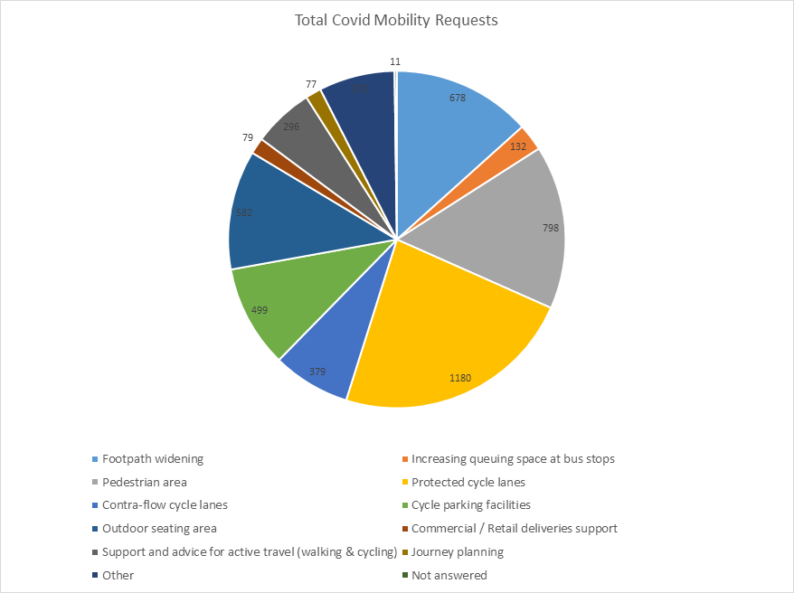

## 3.4 COVID-19 Mobility E-Mail

The dedicated e-mail address continues as the primary channel to contact the COVID Mobility Team. It is attracting huge volumes of queries and feedback. The intention is that the e-mail is for general queries and the COVID-19 Mobility Request Form should be used for specific requests at specific locations.

## 3.5 Councillor Updates

Updates on COVID-19 mobility measures are issued on a weekly basis to Elected Members. Updates via e-mail are also being issued to stakeholders via the Transport SPC and the NTA accessibility network.

## 3.6 Business Liaison

The Business Liaison Officer continues to engage and consult with businesses on a number of COVID Mobility Measures citywide and provides advice to cafés, restaurants and bars, on the process for street furniture (tables and chairs) applications.

## 3.7 Active Travel Promotion

We are continuing to utilise Dublin City Council Social Media Channels:

* + - to highlight COVID-19 mobility measures that have been implemented;
    - to encourage the public to walk or cycle, where possible;
    - to encourage social distancing as people move around the city and
    - to encourage more respect for vulnerable road users

We also continue to evolve our Active Travel Campaign in collaboration with key strategic partners (e.g. NTA Smarter Travel, Healthy Ireland, Green- Schools and third level institutions).

Owen P Keegan

**Chief Executive**