Covid-19 Public Health Civil Emergency

Enabling the City to
Return to Work
Interim Mobility Intervention Programme for Dublin City.
May 2020.
Prepared by Dublin City Council and the National Transport Authority.
Background graphics and logos have been removed in this document to support those using assistive technology.
If you require this document in any other accessible format such as large print, braille or other format this will be provided where reasonably practicable. Please contact covidmobility@dublincity.ie

Contents
1. Introduction and Background 3
2. Scope and Objectives 4
3. Movement Capacity 6
4. Methodology and Approach 11
5. Proposed Mobility Measures 15
6. Proposed Measures by Location 19
7. Proposed Bus Network Measures 24
8. Accessibility 27
9. Communications 28
10. Implementation and Next Steps 29
11. Appendices 31

Introduction and Background
The Covid-19 pandemic has affected all our lives and the way in which we work, socialise and communicate. It also has had enormous impacts on our transport system, radically reducing travel levels and likely to alter our patterns of movement for some time to come.
During the period of maximum restrictions, when all but essential workers were required to stay at home, there were, not unexpectedly, dramatic declines in the numbers of people travelling each day. Car traffic fell to about 30% of pre-Covid levels, bus usage on city services dropped by 90% and rail usage reduced by about 97%.
The overall aim of this document is enabling the city to return to work, to enable retail and leisure activities to restart and allow people to visit family and friends and, in time, schools and colleges to reopen all in line with government guidelines and timescales.
As the restrictions are eased with workplaces, schools and shops re-opening, the numbers of people travelling and moving around the city will start to increase again. More space is required to be allocated to social distancing and to supporting shops and businesses operate in the new environment.
In addition, during the period that a 2-metre spacing between passengers is required, there will continue to be a dramatic reduction in the capacity of the public transport system, down to about 20% of its normal levels. As these, or some updated form of social distancing requirements are likely to remain in place for some time, the overall patterns of travel, in the short-term at least, will be significantly different from those that existed just a few months ago.
In our most recent analysis, from November of last year, 116,287 people travelled into the city centre by public transport during the 7am to 10am peak period, representing just over half of the total numbers travelling to the city centre during this period. With a reduced public transport capacity, only about a fifth of this number will be able to use buses, trams and rail for these journeys in the coming months.
What this means is that fewer people will be travelling on public transport and more people will need to be accommodated on other modes. Consequently, there will be many more people cycling each day, there will be an increase in the number of people walking and more people will wish to travel by car.
To facilitate these new patterns of travel, some reallocation of road space will need to be introduced on many streets. These changes will also have to be considered in conjunction with social distancing requirements, which means that changes are needed to various footpaths and public areas to meet these requirements and optimise the use of the space available. In addition, there is a need to consider the needs of businesses, many of which may require additional external space to operate successfully.
There is a need to implement these changes in an integrated, co-ordinated way. Accordingly, this report sets out a framework of proposals developed by Dublin City Council and the National Transport Authority (NTA) to address the new and urgent needs which have emerged as a result of the Covid-19 Public Health Emergency in Ireland.

Scope and Objectives
The programme initially looks at the links from the nearer urban villages to the city centre and within the city centre it looks at how a more pedestrian, cycling and public transport friendly centre can be set out. This is very much a “live” programme and over the next number of weeks, additional areas of the city and proposals will be added. The gradual reopening of the economy and society as set out by the Government strategy will present new challenges as it unfolds, so this must, of necessity, be a live programme, the implementation of which will be clearly evident on the ground across Dublin City over the coming months.
The goal of this programme, in essence, is to allow the city to function under the new arrangements arising from the Covid-19 Public Health Emergency, both in terms of providing space for safe movement plus business activities, and in accommodating the changed transport patterns. At the heart of this plan are the following high-level aims:
- To ensure safe access to and movement within Dublin City for all users;
- To provide sufficient movement capacity to cater for the changed travel patterns; and
- To support the economic recovery of the city and the region.
These high-level aims have been translated into transport-specific objectives as follows:
- To improve pedestrian safety through the provision of additional space for movement and enhanced pedestrian areas;
- To enable more people to cycle by providing safer cycling facilities;
- To provide additional space at many bus stops in order to facilitate social distancing while waiting;
- To accommodate a certain level of car use, calibrated with other transport needs, including possible additional parking provision on the periphery of the city core area; and
- To implement various bus route changes required to enable the roll-out of cycling and walking measures while still maintaining a strong public transport network.
The measures developed in response to these objectives are being introduced to respond to a new and unprecedented emergency caused by the Covid-19 pandemic. They are being implemented on a temporary basis to respond to the urgent and immediate needs of the city. They will be reviewed periodically to assess their effectiveness and, because of their nature and type of implementation, can be modified as needed to respond to changing needs and requirements.

Movement Capacity

Future Trends
As the economy re-opens on a post-Covid basis, travel patterns will change dramatically. Many more people will use walking and cycling to access work, school and shop. While social distancing requirements persist, there will be a greatly reduced passenger capacity available on public transport. Many people will use their cars to travel to their places of employment and other destinations.

2019 Canal Cordon Count
The overall capacity of the city to accommodate movement into the city centre during peak periods will be reduced and it will be important that the level of demand to access the city is calibrated, as far as possible, against the available access capacity during peak periods. In addition, the receiving environment both of the city centre and the urban villages has to be considered carefully so as to ensure that unsafe conditions are not being created.
The table below sets out the number of persons crossing the canal cordon around the city centre in the inbound direction for the period from 7.00am to 10.00am in November 2019. A total of 217,223 persons accessed the city through this cordon during this period, with just over half (53.5%) travelling by public transport.
Means of Travel, 2019
Bus 65,048
Rail 37,407
LUAS 13,832
All Public Transport 116,287
Car 57,985
Taxi 2,661
Walk 24,691
Cycle 13,131
Goods 983
Motorcycles 1,485
Total Person Trips 217,223

Change in Public Transport and Car Capacity
During the period of the 2-metre social distancing requirement on public transport, capacity will reduce to around 20% of pre-Covid-19 levels. While the theoretical capacity of public transport over the three-hour morning peak period will be around 37,000 passengers, the practical capacity (assuming 2-metre spacing) will be less, as not every bus, tram and DART can be perfectly filled over this period. Applying a factor of 0.8 to account for unevenness of passenger loadings indicates a likely public transport capacity of about 30,000 people. Clearly, if the 2-metre social distancing requirement was altered in the future, the capacity levels would similarly alter.
Additionally, the capacity of the overall vehicular system is also reduced, albeit by a much smaller amount. Traffic signal timings across the city have been adjusted to reduce pedestrian waiting times and also, particularly in the city centre, pushbuttons are automated between 07:00-19:00. These combined changes will assist in reducing any build-up of pedestrians waiting to cross and will need to be kept in place for the foreseeable future.
These changes, together with the need to utilise some road space to create wider footpaths for social distancing measures plus the implementation of temporary cycling facilities, will result in an overall reduction in car capacity to access the city centre during peak periods. While it is difficult to exactly quantify, it is estimated that there will be approximately a 30% reduction in vehicular capacity at junctions throughout the city.
Potentially, 2019 Public Transport figures of 113,382 will reduce to 30,000 and 2019 car traffic figures of 57,985 reduce to 41,000.

Overall Change in Transport Capacity
While there is expected to be a significant reduction in public transport capacity and a smaller decrease in car capacity, there is also clear evidence emerging that the numbers of people walking and cycling will increase in the coming months. It is part of this programme to encourage, where possible, people to walk and cycle, both as a way of safely travelling but also to reduce demand on public transport and vehicular traffic and leave these modes to people who cannot use an alternative for whatever reason.
While predicting future numbers is challenging, it does appear, having regard to trends and activities elsewhere, that a tripling of cycling numbers across the canal cordon is a reasonable target, coupled with a doubling of the numbers walking to employment and other activities. This would provide the following capacity /usage comparison between the situation prior to Covid-19 and the position in the coming months.
Numbers using public transport in 2019 was 116,287. With the capacity in public transport expected to reduce by 80%, potential future figure is 30,000.
Car figures 2019 = 57,985; assumed reduction of 30%; potential future figure = 41,000.
Taxi figures 2019 = 57,985, assumed reduction of 30%; potential future figure = 1.900.
Walking figures 2019 = 24,691, target increase of 100%; potential future figure = 50,000.
Cycling figures 2019 = 13,131, target increase of 300%; potential future figure = 39,000.
Motor Cycle figures 2019 = 1,485, no change expected.
Total persons traveling in 2019 was 217,223, this is expected to reduce to 164,385
If the above very substantial increases in walking and cycling are to be achieved, there must be a commensurate increase in facilities to accommodate these figures and this is why so much emphasis is placed on safety for pedestrians and cyclists. However, even if these substantial changes are achieved we still will have a deficit of over 50,000 people trips across the morning peak.
To allow the various transport modes to operate effectively in the months ahead, arrangements to reduce the number of people travelling during the peak period by this amount, roughly 25% of the total 2019 peak period travel, will need to be put in place. This means encouragement of measures such as more people working from home, travelling to shops at non-peak hours for some people, and staggering work start times to move some journeys to outside of peak hours. This is a matter which we would urge individual companies and organisations to consider in their planning for dealing with the relaxation of restrictions.

Increased Cycling and Walking
Fundamental to the above outcome, is the need to very significantly increase the numbers of people walking and cycling into, and around, the city. Part of the purpose of this programme is to support that increase through temporary interventions on various streets to enhance pedestrian arrangements and provide better cycling facilities.
The following figure shows the various key locations within the 2km and 5km band and the linkages that exist to, and between, those centres. While cycling and walking will not be feasible for some people, it is clear that it will become a viable alternative for many more people in the period ahead. By choosing to walk or cycle users will not only accommodate their own mobility but will leave the public transport system for those who don’t have the same alternatives and we would therefore ask people to carefully consider if this represents a viable option for them.
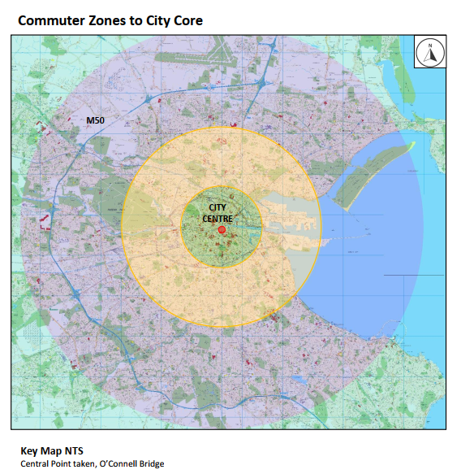
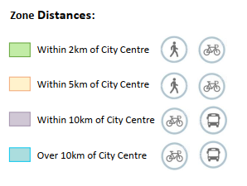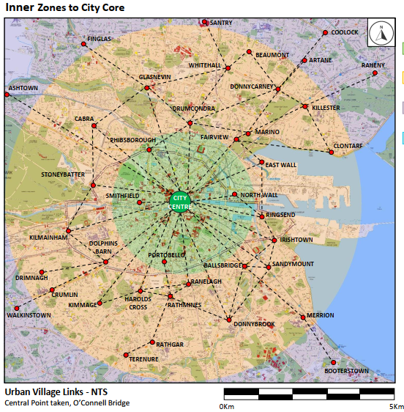

Methodology and Approach

Scope of Programme
This section outlines the approach adopted by the Council and the NTA in developing proposals to address the changed travel patterns that are likely to apply in the coming months.
Given the urgency of developing a framework to guide the introduction of the necessary measures, this initial version of the Covid-19 - Dublin City Interim Mobility Intervention Programme is focussed on the city centre, the radial routes approaching the central area and a number of urban village interventions. It is acknowledged that additional measures and interventions are required in other areas of the city. Accordingly, it is intended that this initial version of the overall programme will be updated on an on-going basis with proposals in respect of those other areas.
In particular work is underway on assessing the numerous requests for interventions that have been received from the public and elected representatives. It is therefore intended to expand this document in the future to include measures to assist in the urban villages and to have a school focussed program to assist in return to school mobility.

Approach
In preparing this programme, the overall approach has considered all modes but with a particular emphasis on active modes given the anticipated increases in those forms of movement. The on-going requirement for social distancing, together with the likely needs of some businesses for additional external space, has also been considered.
The process undertaken has sought to identify routes and locations where the implementation of specific measures can provide the most benefits. Mapping and desktop surveys have been undertaken, supported by on-street visual analysis, to identify potential arrangements for implementation in those areas. However, given the limited information available at this stage, the planned measures may have to be modified and amended to reflect more detailed site-specific information. A key part of the overall process of implementation is adopting a flexible approach to issues as they arise, and to this end we will have a dedicated information channel to allow for quick communications and resolution.

Identification of Locations for Measures
As the initial scope for this programme is focussed on access to and movement within the city centre, it has been decided to prioritise the radial links with the highest levels of cycling and walking movement, together with the core city centre streets. The emphasis is on rapid and temporary types of intervention using preformed materials i.e. bollards, orcas, etc.
However, it is also acknowledged that, as these measures will be in place for a considerable period of time, other types of intervention such as the use of preformed materials for build outs and the use of temporary road materials to build up some sections of road to footpath level will have to be considered. The use of planters and other innovative designs will also feature as this programme expands, particularly into the urban villages and other areas.
In order to identify the particular routes, the Canal Cordon Count was analysed to determine where greatest demand for walking and cycling was recorded. The figure below graphs the number of people crossing the canal cordon (both directions) during the morning peak period from 7am to 10am in November 2019.

Within the city centre, various locations will be identified which could be considered for pedestrianisation in order to both facilitate social distancing and to provide the potential for use of some of the external space by adjacent businesses.
Both the Council and the NTA are acutely aware of the needs of the city’s retailers, cafés, restaurants and bars. As such, a balance will need to be struck between the need for space for pedestrians, queueing outside shops and space that may be desirable for outdoor tables and seating. A range of measures may be explored, including allowing additional outdoor space at particular times.

Extent of Measures
While a key part of this programme is focussed on active travel modes, continuing to facilitate the efficient movement of public transport as well as managing car movement throughout the city remain important objectives. In developing the planned portfolio of interventions, care has been taken to carefully balance the needs of each of these modes in deriving the various proposals.
In relation to bus transport, despite the lower numbers of passengers per vehicle, the same number of buses will be operating on the city streets as operated prior to the current pandemic. Accordingly, it will be important to maintain the current levels of bus priority on the various streets in order to enable the service to operate as efficiently as possible.
There is the potential for increased car use in the months ahead as people, at present, may feel safer in their own vehicle rather than sharing a public transport journey with others. This reality has been carefully considered in the preparation of this programme. As a result, measures which facilitate continued car use have been identified and incorporated into this framework. However, this has to be calibrated against the other needs for road space and junction capacity which exist.
Other supporting measures have also been included in the programme such as reducing vehicular speeds, changing traffic signal timings at junctions, arrangements for delivery and additional potential off-street parking provision. In addition, the need for focussed communications around the changed city environment and the altered transport arrangements has been recognised.
Details of the proposed temporary measures are set out in the following chapter with further details provided in the attached appendix.

Proposed Mobility Measures
This section details the different types of temporary mobility measures that are proposed to facilitate increased numbers of pedestrians and cyclists, and the efficient movement of public transport, while managing access for deliveries and private car use during the period of the Covid-19 emergency.

Pedestrian Areas
In order to create more space for pedestrians required to facilitate social distancing, it is proposed to expand pedestrian areas where possible, and to do so in a safe and clear manner. The priority locations for such measures will be in the city core and in the urban villages, where there is both a high pedestrian footfall and where footpath widths are constrained. Such temporary measures would require a review of the use of the existing road space adjacent to the footpath. For example, depending on the location, where there is queueing outside shops and cafés, pedestrian areas may be expanded into loading bays by using protective bollards.
The Council is open to the idea, and willing to explore the potential of, increasing the number and extent of pedestrian areas in the city core. Options that may be considered include restricting deliveries to certain times at different locations. This may facilitate the pedestrianisation of some city streets, and free up some additional space for businesses to operate while complying with Covid-19 restriction requirements.
The Council will work with relevant stakeholder to develop a potential list of locations and options with the focus on facilitating businesses returning to commercial activity.

Pedestrian Signal Crossings and Waiting Times
In order to reduce the time that people are waiting for pedestrian crossings to turn green, the maximum amount of time allocated to a complete traffic cycle, (allowing all movements in the junction operate, if demanded) has been reduced from 120 seconds to 80 seconds throughout the city. As the amount of time for the pedestrian green and amber man is based on the time taken to safely cross the road, and therefore remains the same, the additional time has been taken from that allocated to vehicles.
This has resulted in shorter green times at all junctions and an expected reduction in traffic capacity of up to 30%. As traffic volumes increase, following advancement through the different phases of the government roadmap for easing of restrictions, and while the requirement for social distancing remains in place, the cycle length will remain capped at 80 seconds. This will result in major reduction in capacity for motorised vehicles going forward. The impact of this on public transport journey times and reliability will also require careful monitoring.
In addition to reducing the wait times for all junctions, a number of pedestrian crossings in the city centre and key locations in urban villages have been set to automatically operate from 7am-7pm to reduce vehicular speed, to aid pedestrian movement and to minimise contact with signal push buttons.
It is of vital importance that the city centre is not used by through traffic which has no requirements to be in the city centre and which can use alternative routes. The orbital routing system, which was recently updated on street, will assist with this.

Protected Cycle Facilities, Contra-Flow Facilities & Cycle Parking
To facilitate a much higher number of cyclists, it is proposed to provide safer cycling infrastructure through the implementation of protected cycle lanes. This may involve reusing existing road space by removing on-street parking and protecting that road space for cycling via protection bollards and other cyclist protection measures. An example of this is the recently reallocation of the North Quays on-street parking for a wider pedestrian area and a cycle lane.
Other locations may involve reducing the number of traffic lanes to accommodate protected cycling facilities on both sides of the road, while maintaining a balance for other required services in that area.
It is also intended to provide safe contra-flow cycle facilities on streets where demand for such movement has been identified. An example of this has already been implemented on Nassau Street.
Despite the suspension of the installation works due to lockdown, cycle parking design works have continued over the last few months. With the resumption of installation works and the easing of restrictions, we are targeting the installation of at least 1000 new stands this year. In addition, we will seek to install new cycle parking in key locations to compliment the overall Covid-19 mobility strategy.

Continuous Bus Lanes and Bus Priority Measures
As traffic volumes are expected to increase over the coming weeks and months, it is important, insofar as is practicable, to maintain the reliable and consistent bus journey times that have been experienced during the period of restrictions. Such measures would include the provision of contra-flow bus lanes, extending existing bus lanes to the stop line, providing early starts for buses at traffic signals and providing traffic signal priority for buses. In some locations, the provision of an additional bus lane to allow passing buses to overtake stopping buses without undue delay may be required.
Providing contra-flow bus lanes on selected approaches to the Quays will provide improved connectivity for cross-city bus services, while facilitating pedestrian and cycle measures in the core. One such proposal is to provide a southbound contra-flow bus lane on Winetavern Street, thus reducing the requirement for buses to travel into College Green and so reduce pressure on the pedestrian space in this area.

Car Parking Spaces & Loading Bays
In some locations, on-street car parking and loading bays may have to be removed or relocated to allow for greater provision for pedestrians. Where possible alternative delivery locations will be provided. The option of identifying specific delivery times off-peak for goods deliveries is also to be considered.

Off-Street Car Parks
As people return to work, alternative locations for car parking may need to be identified. For example, allowances for driving partially into the periphery of the city, parking and completing the remainder of the journey by foot or by bicycle. While existing city centre car parks will remain accessible, alternatives to driving into the core of the city will be encouraged.

Reduce Speed Limits
In line with other European cities consideration is been given to temporarily reducing vehicular speed limits on many of the routes to 30km per hour, in order to protect the larger numbers of pedestrians, cyclists and vulnerable road users moving around in these areas and on the road carriageway due to Covid-19 travel restrictions and social distancing requirements. This measure will require the consent of the elected Councillors and a proposal in this regard will be brought to them shortly.

Queuing Space at Bus Stops
Consideration will be given to the location of bus stops on footpaths to ensure there is sufficient space for people to pass bus passengers waiting at the stops and, similarly, in relation to people in outdoor seating for restaurants/cafés/bars.
Temporary buildout platforms of various types have been pioneered in other cities and, in the next number of weeks; a pilot installation will be put in place at a trial location in the city. If this is successful, this technique will be considered in locations where there are high numbers of people queueing and the footpath is very narrow. In some cases bus stops may be temporarily suspended or moved if social distancing cannot be maintained.
Further information on bus stops can be found in Chapter 7.

Outdoor Areas
In order to help businesses function within the Covid-19 restrictions, businesses may require space outside their premises either for waiting areas or some form of outdoor use. The Council is open to considering these requests where the existing space is adequate or where additional space can be provided, subject to the suitability of the location. Of necessity, these will be considered on a street by street basis as requests are made.

Proposed Measures by Location
The specific interventions proposed are indicated at a concept level on the maps in the Appendix, which cover each of the routes included in this initial version of the framework plus the city centre area.
Because of the urgent need to quickly introduce these measures to accommodate the revised travel patterns, the interventions have been identified and developed on an accelerated basis, largely based on desktop work, camera surveys and limited on-street visual analysis. Accordingly, the planned measures may have to be modified in advance of, or during, implementation to address site-specific issues and additional constraints that may be identified.

Routes
The 14 route maps detailing the interventions are included in the Appendix in the following sequence:
- Rathmines – Richmond Street South – George’s Street – Dame Street
The Rathmines to Dame Street routes is the busiest artery on the southside of the city in terms of pedestrians and cyclists. In addition it has a large number of retail outlets, cafés and restaurants along its route.
- Fairview – North Strand – Newcomen Bridge – Amiens Street – Beresford Place
This route collects all of the demand from the north-eastern suburbs of Dublin via the Clontarf Road, Howth Road and Malahide Road. It also contains Connolly Station and Busáras. The presence of two major national transport facilities here reinforces the requirement for an improved pedestrian environment.
- Harold’s Cross – Clanbrassil Street – Dame Street
Harold’s Cross collects travel demand from a number of suburbs from the south and south west, as Kimmage Road Lower and Harold’s Cross Road converge close to the canal. Clanbrassil Street is a wide dual-carriageway further in with potential for road space reallocation.
- Donnybrook – Leeson Street – College Green
This is a major arterial link for the city, taking in demand from Bray through multiple suburbs and connecting with the major trip attractor of UCD along the route. It feeds directly into the office core of the southeast city centre and the retail core at Grafton Street.
- Drumcondra – Dorset Street – O’Connell Street
The Drumcondra route is an extremely busy link, taking in demand from major suburbs such as Swords and Santry. Drumcondra and Dorset Street comprise very important local centres with extensive economic activity along the routes.
- Grand Canal Street – Pearse Street
This route is a vital link from the southside suburbs into Grand Canal Docks and onwards into the north Docklands. Both Grand Canal Dock and Pearse rail stations feed out onto this crossing point, requiring measures to cater for increased pedestrian and cycle movement.
- Ranelagh – Charlemont Street
Ranelagh village is a major centre of activity and a significant generator of walking and cycling trips over the canal towards Charlemont street and onward towards Camden Street to the west, and the southeast office core to the east.
- Baggot Street Lower – Merrion Row
This route is at the heart of the south city business district and contains a significant number of local retail outlets, cafés and restaurants catering for workers and residents in the area. It also connects the southeast retail core at St. Stephen’s Green directly to Ballsbridge.
- Ballsbridge – Mount Street – College Green
Ballsbridge comprises an extension of the southeast business district and its connection to the city centre will be vital during this period. There is considerable office and local retail activity along this route and it contains the National Maternity Hospital and Merrion Square Park.
- Phibsborough – Church Street – North Quays
The Phibsborough route is an important one for bus movements from the northside of the city. It also carries a high number of cyclists and pedestrians into the city. It is highly constrained in terms of width in certain locations closer to the city centre.
- Ballybough – Summerhill Parade
This link connects directly to O’Connell Street via Parnell Street, providing an alternative route for all modes to the much busier Amiens Street link, and as such carries a significant number of pedestrians and cyclists. This is a generally wide roadway, incorporating dual-carriageways in parts.
- Docklands – North Wall Quay
Docklands is one of the most important generators and attractors of trips in the city and as the economy reactivates, it will be important to ensure that travel demand to and from this area can be accommodated.
- Crumlin – Cork Street – Kevin Street – St. Stephen’s Green
Much of the demand from the southwest suburbs of Dublin converges onto the Crumlin Road radial route. As it approaches the city, it picks up further significant demand from the inner city residential areas of Dublin 8.
- Grand Canal
The Grand Canal greenway runs from the Docklands as far as Portobello. From there westwards, there is no segregated provision for cyclists, despite the link catering for a significant number of cycle trips along its entire length.

City Centre
The preceding sections set out the measures proposed on the radial routes approaching the city. It is important that the full benefits of these measures are realised as the routes converge on the city centre. The guiding principles of this programme for the city centre are as follows:
- Provide wide footpaths and enhance pedestrian areas;
- Support, where feasible, business requests for increased outdoor space up to and including car free areas either all the time or at designated hours if appropriate;
- Facilitate delivery of goods particularly in off-peak times;
- Reduced pedestrian waiting times at signalised crossings;
- Provide safe cycling facilities and cycle parking facilities;
- Provide additional space at bus stops to facilitate social distancing while queueing;
- Accommodate a certain level of car use and maintain access to off-street car parking; and
- Implement various bus route changes required to enable the roll out of walking and cycling enhancement measures.
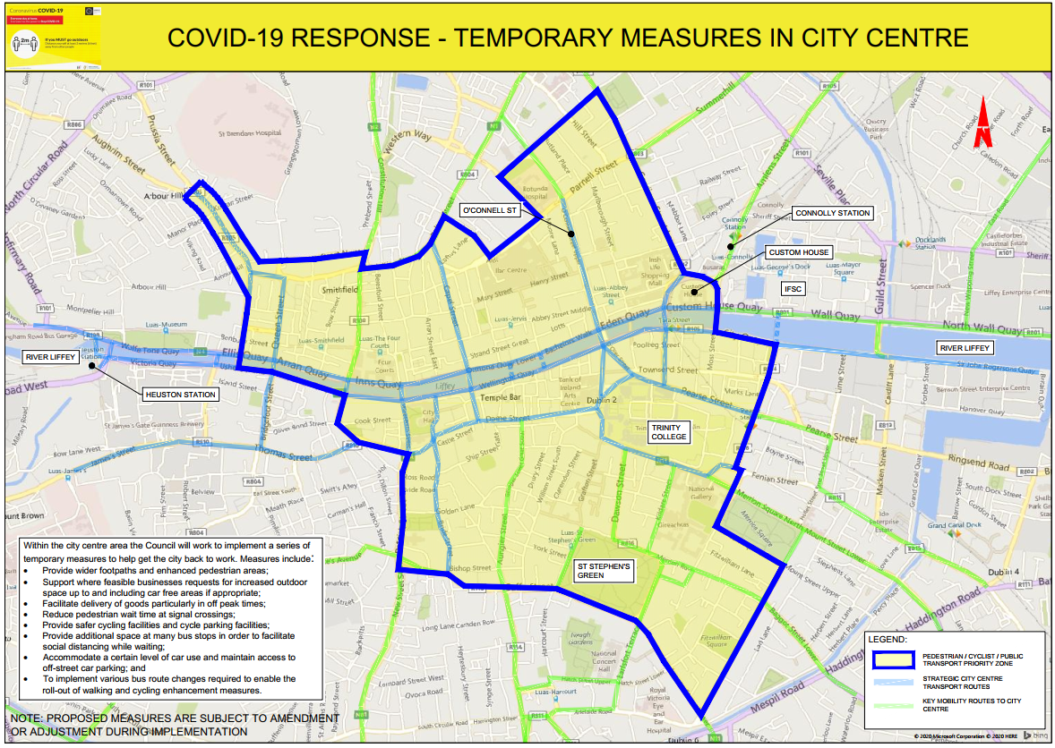

Overall Map of Proposals.
The following map shows the network combination of the overall proposals for Phase 1. Further areas and interventions will be added in later versions.

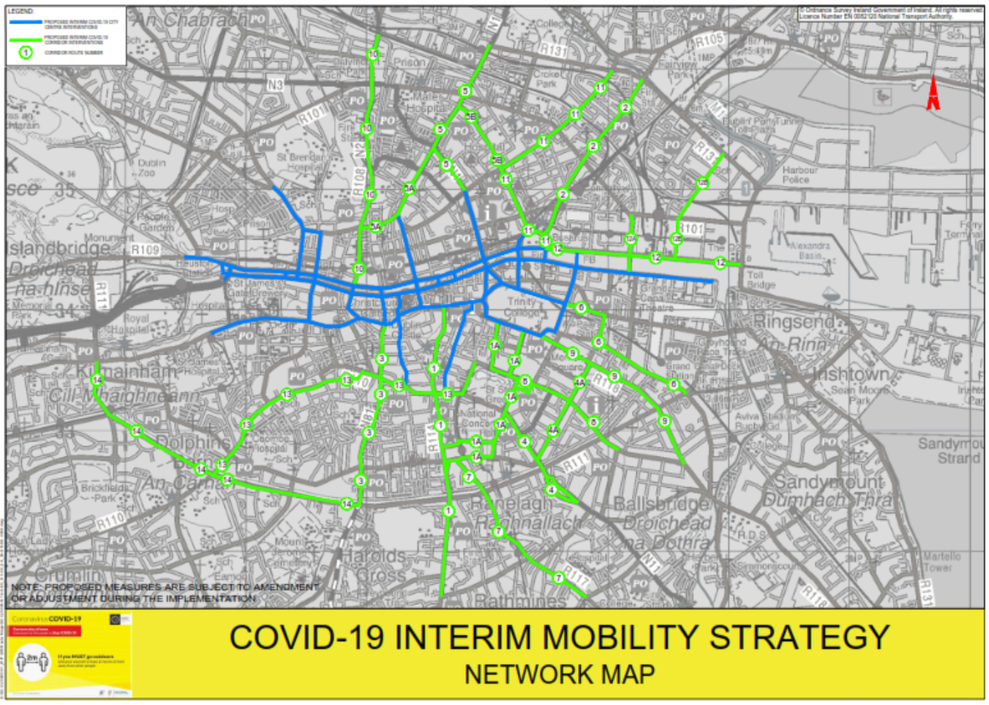

Proposed Bus Network Measures

Introduction
In line with the requirement to free up space on our urban realm to provide for social distancing requirements, there is a need to review the current use of space, including that used by buses in the city centre.
Increased space for walking and cycling, as well as changes to traffic signalling and other required traffic management interventions, will have knock-on effects on how buses can access and serve the city centre. Opportunities will also be created which may offer better routing options for some bus routes serving the city and providing additional bus priority.

Reasons for Change
‘Spreading the load’ of bus services across the city streets
Dublin City centre’s streetscape is restricted and congested, meaning that space is at a premium. Now with social distancing restrictions, more space is required for pedestrians and cyclists, and taking space currently used for roads, in most cases, is the only option available.
There will need to be a changing of some bus routes onto routes which are capable of both providing safe queueing space and ensuring that there is a good level of bus priority. Therefore, what is being looked at is to spread the loading around the city and in particular move routes from the Camden Street Georges Street routes on to the Stephens Green Dawson Street alignments as well as provide a contra-flow bus lane on Winetavern Street. This will allow the Georges Street alignment to have much better pedestrian and cycling facilities and in turn the reduction of bus services in the Dame Street area will allow for footpath widening which is a key priority.
In the College Green area, existing space for pedestrians will be increased and the protected cycle route will be extended. As services are diverted in a phased manner, then this will allow for gradually increased space for pedestrians and eventually the conversion of the complete space to allow for better pedestrian and cycling provision along the College Green and Dame Street route.
Social Distancing at Bus Stops
Everyone likes to be able to get on their bus at their favourite stop. However, the space available at some of our city centre bus stops will not facilitate an appropriate level of social distancing unless significant modifications are made.
Accordingly, it is likely that the use of bus stops will need to be distributed over a wider area to allow more room for social distancing, both while people are waiting for buses and while dispersing after disembarking. This is likely to mean that the number of buses stopping at specific stops may need to be reduced while some other bus stops may need to be removed completely. It is likely that passengers will be required, in some instances, to walk further to bus stops to ensure a safer spread of bus loading /unloading.
Varying bus routes along different streets to spread the load of passengers to a number different bus stops, as well as using bus stops with more kerb space for waiting passengers to social distance, will be a critical element in addressing this issue.

Proposed Interventions
It is proposed to divert a number of bus routes traversing the south side of the city centre. This area has a high density of bus routes, and corresponding busy bus stops. Coupled with the various interventions planned on these routes to enable safe pedestrian movement and cycling facilities, the existing bus service pattern would make it impossible to facilitate or manage social distancing at an appropriate level on many of these streets.
On the south side of the city centre, the current pattern of bus movement is very heavily reliant on the spine route of College Street and Dame Street with several bus services using this route. This area also represents the highest concentration of pedestrian footfall in the city, with a high number of people traversing College Green on an average day.
Catering for these levels of both bus and pedestrian movement in these areas is no longer feasible given social distancing requirements. As such, it is proposed to amend the routes of bus services using this link, and adjacent areas, to ensure that space can be provided for pedestrians in particular, and that bus stop locations can be more carefully managed. It is proposed that the bus routings will be altered to avail of existing and improved access routes, predominately centred on bridges crossing the Liffey River.
It is proposed to develop three predominant bus access radial routes – aligned around the O’Connell Bridge–Grafton Street Lower – axis as follows:
- West
- Central and
- East
West Access Radial Route
This route will allow buses coming from the Cork Street and High Street directions to use the river crossing at O’Donovan Rossa Bridge via Winetavern Street.

These bus routes, along the western alignment will be facilitated by a new contra-flow bus lane on Winetavern Street as well as measures on other streets.

Central Access Radial Route
This route will cater for the majority of bus routes currently running along the O’Connell Street alignment to the south of the city, as well as some services coming from the Quays to the south side of the city centre. It will run via D’Olier Steet–Westmoreland Street to Grafton Street Lower and Dawson Street-Kildare Street. Limited services will also operate via Hawkins Street.
This route will serve buses travelling to/ from the south and south east side of the city, with new route options on St. Stephens Green South and Earlsfort Terrace.
Eastern Access Radial Route
This route will cater for the majority of bus routes currently running along the Quays and onto the south of the city. This route will use the river crossings at O’Connell Bridge, Rosie Hackett Bridge and Memorial Bridge, with routes then running on Townsend Street and Pearse Street, and in most cases routeing along Westland Row to travel south / north.
This link will serve buses from the north and west of the city, accessing the south east city centre quadrant. Improved bus priority, including the potential for a northbound bus gate on Westland Row will aid the operation of the increased services on this alignment.

Accessibility
In developing this overall strategy to address mobility-related issues that have emerged as a result of the Covid-19 pandemic, both the Council and the NTA have been conscious of the particular needs of people with disabilities.
Some of the measures being developed will be directly assistive to people with disabilities. For example, traffic signals in the city centre have been adjusted to provide automatic activation of a pedestrian crossing signal during daytime hours. This has the additional benefit of reducing waiting times and reducing crowding at crossing points.
While there are a range of measures proposed under the programme, it is intended that the proposals will not diminish or reduce any of the accessibility arrangements already in place. Many of the measures will, directly or indirectly, assist in movement by various categories of disabled users. For instance, the allocation of some road space to accommodate pedestrians, through temporary bollards, should ensure that a person in a wheelchair, or a visually impaired person, will continue to able to use the footpath while able-bodied users can use the road carriageway, thereby ensuring appropriate social distancing.
At all stages the focus will be to ensure that the temporary measures are safe and do not impact on any existing provisions for mobility or visual impaired users. While initial interventions will largely be through temporary materials such as plastic bollards and barriers, it may be possible that more physical widening of footpaths can be achieved in later phases, which would allow more accessibility elements to be considered.
Because interventions are being developed and implemented in response to a national emergency, and are time critical, the normal levels of consultation and dialogue are not feasible. However, as part of the implementation stage, it is intended that a dialogue process will be established to facilitate more focussed input in relation to accessibility issues into individual proposals.
Measures implemented will be subject to on-going review and where feasible, modifications
can be accommodated where necessary.

Communications
Communication is an imperative in generating public awareness of, and fostering public support for this programme. The communication strategy will ensure all information in relation to the programme is up-to-date, accessible and coherent. It will focus on the following key messages:
- Why this getting back to work mobility intervention programme is required and what it aims to achieve;
- The measures to be implemented at each phase;
- Progress on implementation;
- The promotion of active travel modes; and
- Advice and support on travel plans for businesses.
Multiple communication methods and channels will be established and used to disseminate information and ensure optimum reach with all stakeholders. Images, maps and videos will be developed and published where possible. Channels will include regular Councillor briefings, a dedicated public webpage, social media platforms and dissemination of flyers. A dedicated email address will also be established to allow for regular feedback on the measures.

Implementation and Next Steps
There will be a phased approach to implementation over a six to twelve month period. Measures will be implemented on a temporary basis and will be subject to review.
Other locations will be added to the framework as areas are surveyed, equipment becomes available and local intervention proposals are developed.
Local intervention works across the city commenced in late April and these form part of the mosaic of measures to be implemented as part of the Council’s Covid-19 response.
Some of examples of local works implemented to-date include:
- Increased footpath capacity:
- Closure of loading bays at Dorset Street, Capel Street, Rathmines, Stoneybatter and Fairview; and
- Cycle Safety interventions:
  - Installation of Nassau Street contra-flow cycle track from Clare Street to Dawson Street; and
  - Partial installation of Quays Section of Interim Liffey Cycle route. On-street car parking has been removed from Inns Quay and Ormond Quay and section of work from Church Street to Halfpenny Bridge will be substantially completed by mid-May. Works to then commence on other sections of the route.
A program of further specific works and interventions is being developed for implementation based on the methodology outlined in Chapter 4. These works are being prioritised in areas of high footfall and cycling numbers to ensure that the maximum number of people can move freely throughout the city on safe, connected and coherent transport routes.
The works program will determine locations for priority intervention, with many of the key locations for intervention identified and development of site specific interventions underway.
The proposed interventions will be rolled out in a phased sequence to allow the city to open up gradually whilst remain operational and accessible.
Following the installation of any intervention, a monitoring and review of works will be undertaken as there may be a need to adjust these interventions as restrictions are lifted and travel patterns begin to evolve.

Appendices
Appendix 1 Route 1 and 1A Rathmines 32
Appendix 2 Route 2 Fairview 33
Appendix 3 Route 3 Harold’s Cross 34
Appendix 4 Route 4 and 4A Donnybrook 35
Appendix 5 Route 5, 5A and 5B Drumcondra 36
Appendix 6 Route 6 Grand Canal Street 37
Appendix 7 Route 7 Ranelagh 38
Appendix 8 Route 8 Baggot Street Lower 39
Appendix 9 Route 9 Ballsbridge 40
Appendix 10 Route 10 Phibsborough 41
Appendix 11 Route 11 Ballybough 42
Appendix 12 Route 12 and 12A Docklands 43
Appendix 13 Route 13 Crumlin 44
Appendix 14 Route 14 Grand Canal 45
Appendix 15 City Centre Measures 46

Appendix 1 Route 1 and 1A Rathmines
Proposed measures on Route 1 and 1A from Rathmines to Dame Street and College Green include widened pedestrian areas, protected cycle facilities in both directions and bus priority measures. Please note, proposed measures are subject to amendment or adjustment during implementation.
Map not shown to assist screen reading technology. To view map, please refer to website or pdf document.

Appendix 2 Route 2 Fairview
Proposed measures on Route 2 from Fairview to Beresford Place include widened pedestrian areas and footpaths, protected cycle facilities, segregated cyclist and pedestrian facilities and bus priority measures. Please note, proposed measures are subject to amendment or adjustment during implementation.
Map not shown to assist screen reading technology. To view map, please refer to website or pdf document.

Appendix 3 Route 3 Harold’s Cross
Proposed measures on Route 3 from Harold’s Cross to Dame Street nclude protected cycle facilities in both directions and bus priority measures. Please note, proposed measures are subject to amendment or adjustment during implementation.
Map not shown to assist screen reading technology. To view map, please refer to website or pdf document.

Appendix 4 Route 4 and 4A Donnybrook
Proposed measures on Route 4 and 4A from Donnybrook to Stephens Green and Merrion Square include enhanced pedestrian areas, protected cycle facilities and bus priority measures. Please note, proposed measures are subject to amendment or adjustment during implementation.
Map not shown to assist screen reading technology. To view map, please refer to website or pdf document.

Appendix 5 Route 5, 5A and 5B Drumcondra
Proposed measures on Route 5, 5A and 5B from Drumcondra to O’Connell Street include widened of footpaths, protected cycle facilities in both directions and bus priority measures. Please note, proposed measures are subject to amendment or adjustment during implementation.
Map not shown to assist screen reading technology. To view map, please refer to website or pdf document.

Appendix 6 Route 6 Grand Canal Street
Proposed measures on Route 6 from Grand Canal Street to Pearse Street include widened pedestrian areas and protected and contra-flow cycle facilities. Please note, proposed measures are subject to amendment or adjustment during implementation.
Map not shown to assist screen reading technology. To view map, please refer to website or pdf document.

Appendix 7 Route 7 Ranelagh
Proposed measures on Route 7 from Ranelagh to Charlemont Street include widened pedestrian areas and protected cycle facilities. Please note, proposed measures are subject to amendment or adjustment during implementation.
Map not shown to assist screen reading technology. To view map, please refer to website or pdf document.

Appendix 8 Route 8 Baggot Street Lower
Proposed measures on Route 8 from Baggot Street Lower to Merrion Row include widened pedestrian areas and protected cycle facilities in both directions. Please note, proposed measures are subject to amendment or adjustment during implementation.
Map not shown to assist screen reading technology. To view map, please refer to website or pdf document.

Appendix 9 Route 9 Ballsbridge
Proposed measures on Route 9 from Ballsbridge to College Green include widened pedestrian areas and protected cycle facilities in both directions. Please note, proposed measures are subject to amendment or adjustment during implementation.
Map not shown to assist screen reading technology. To view map, please refer to website or pdf document.

Appendix 10 Route 10 Phibsborough
Proposed measures on Route 10 from Phibsborough to North Quays include widened footpaths and protected cycle facilities in both directions. Please note, proposed measures are subject to amendment or adjustment during implementation.
Map not shown to assist screen reading technology. To view map, please refer to website or pdf document.

Appendix 11 Route 11 Ballybough
Proposed measures on Route 11 from Ballybough to Summerhill Parade include widened footpaths and protected cycle facilities in both directions. Please note, proposed measures are subject to amendment or adjustment during implementation.
Map not shown to assist screen reading technology. To view map, please refer to website or pdf document.

Appendix 12 Route 12 and 12A Docklands
Proposed measures on Route 12 and 12A from Docklands to North Wall Quay include widened pedestrian areas and protected cycle facilities in both directions. Please note, proposed measures are subject to amendment or adjustment during implementation.
Map not shown to assist screen reading technology. To view map, please refer to website or pdf document.

Appendix 13 Route 13 Crumlin
Proposed measures on Route 13 from Crumlin to St. Stephen’s Green include widened pedestrian areas, protected cycle facilities in both directions, contraflow cycle facilities and bus priority measures. Please note, proposed measures are subject to amendment or adjustment during implementation.
Map not shown to assist screen reading technology. To view map, please refer to website or pdf document.

Appendix 14 Route 14 Grand Canal
Proposed measures on Route 14 along the Grand Canal from the Docklands to Portobello include protected cycle facilities in both directions. Please note, proposed measures are subject to amendment or adjustment during implementation.
Map not shown to assist screen reading technology. To view map, please refer to website or pdf document.

Appendix 15 City Centre Measures
Map shows the pedestrian, cyclist, public transport priority zone in the city centre, the strategic city centre transport routes and the key mobility routes into the city centre.
Map not shown to assist screen reading technology. To view map, please refer to website or pdf document.

