

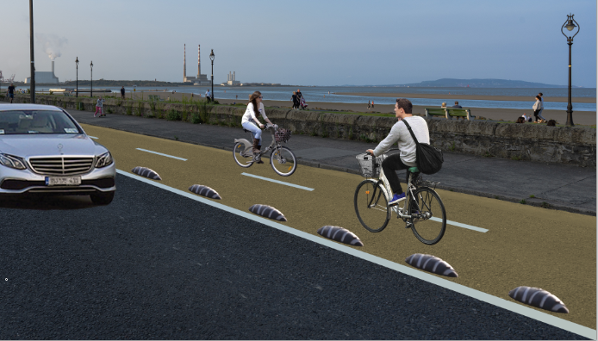

**Trial of Strand Road Rapid Deployment Cycle Route**

**Report on Public Consultation**

(October 2020 Report)**)**

Contents

INTRODUCTION 1

Covid-19 and Mobility in the City 1

Dublin City Covid Mobility Programme 1

Background 2

Strand Road area 2

Genesis of Trial 6

Why is the strand road cycle route so important 7

Trial Design Details 8

Consultation 9

Pre-Implementation 9

Consultation Feedback 9

Overview of Feedback 9

Question 1 - Concerns 10

Traffic concerns 12

Question 2 - Suggestions 21

Question 3 – complementary measures 22

Changes to the scheme 23

Monitoring of the scheme 23

Next steps 23

Conclusion and time line for implemetation 25

Appendix A 26

Consultation Twitter Post And Statistics 26

Appendix B 29

Consultation Facebook Post And Statistics 29

# INTRODUCTION

## Covid-19 and Mobility in the City

The Covid-19 pandemic has affected all our lives and the way in which we work, socialise and communicate. It also has had enormous impacts on our transport system, radically reducing travel levels and is likely to alter our patterns of movement for some time to come.

During the period of maximum restrictions, when all but essential workers were required to stay at home, there was, not unexpectedly, dramatic declines in the numbers of people travelling each day. Car traffic fell to about 30% of pre-Covid levels, bus usage on city services dropped by 90% and rail usage reduced by about 97%.

As the restrictions are eased with workplaces, schools and shops re-opening, the numbers of people travelling and moving around the city started to increase again. More space is required to allow for social distancing and to support shops and businesses operate in this new environment.

At present under level 3 the capacity of public transport is set at 50%, however if Dublin moves to level 4 or 5 the capacity will be at 25% of normal, with Government advice to avoid public transport and leave for essential workers only. As these, or some updated form of social distancing requirements are likely to remain in place for the foreseeable future, the overall patterns of travel will be significantly different from those that existed pre Covid.

In our most recent analysis of the Cordon Counts, from November 2019, 116,287 people travelled into the city centre by public transport during the 7am to 10am peak period, representing just over half of the total numbers travelling to the city centre during this period. With reduced public transport capacity, and varying advice depending on level of restriction, public transport numbers will be reduced for the foreseeable future.

In addition what is becoming clear is that the impact on transportation numbers is unequal across the city with some areas remaining substantially down and others approaching pre Covid numbers. These tend to be related to areas where working from home is the norm, such as the IFSC and where technology companies are based. One of the hardest items to estimate is whether these changes are permanent, will home working still continue at the rates we have seen and has the pattern of commuter travel been permanently changed

To facilitate these new patterns of travel, some reallocation of road space needs to continue to be introduced across the city.

## **Dublin City Covid Mobility Programme**

Dublin City Council and the National Transport Authority recently published the paper “Enabling the City to Return to Work, Interim Mobility Intervention Programme for Dublin City” which sets out a framework of proposals to address the new and urgent needs which have emerged as a result of the Covid-19 Public Health Emergency in Ireland.

The goal of this programme, in essence, is to allow the city to function under the new arrangements arising from the Covid-19 Public Health Emergency, both in terms of providing space for safe movement plus business activities, and in accommodating the changed transport patterns.

At the heart of this plan are the following high-level aims:

* To ensure safe access to and movement within Dublin City for all users;
* To provide sufficient movement capacity to cater for the changed travel patterns; and
* To support the economic recovery of the city and the region.

These high-level aims have been translated into transport-specific objectives as follows:

* To improve pedestrian safety through the provision of additional space for movement and enhanced pedestrian areas;
* To enable more people to cycle by providing safer cycling facilities;
* To provide additional space at many bus stops in order to facilitate social distancing while waiting;

The measures developed in response to these objectives are being introduced to respond to a new and unprecedented emergency caused by the Covid-19 pandemic. They are being implemented on a temporary basis to respond to the urgent and immediate needs of the city. They will be reviewed periodically to assess their effectiveness and, because of their nature and type of implementation, can be modified as needed to respond to changing needs and requirements. They are in line with Government advice from DTTAS regarding Covid mobility as contained in the [Design Manual for Urban Roads and Streets (DMURS) interim advice note Covid 19](https://www.dmurs.ie/supplementary-material) and are being funded by the National Transport Authority.

# Background

## Strand Road area

Strand Road is located in the Sandymount area of Dublin and runs between Merrion Gates and Beach Road/ Sean Moore Road. Dublin City Council in conjunction with the NTA is proposing to trial the implementation of cycle facilities along the Strand Road (there are none at present) in order to offer an alternative transport option for work, school and leisure activities. It is proposed to undertake a six month trial of a 2 way separated cycle track from Merrion Gates to Sean Moore Rd with links either side as they are developed.

Strand Road (R131) is mainly made up of residential dwellings on the west side of the road with the Irish Sea on the east side. There are also stretches of green areas and car parks on the east side and a number of properties on the approach to Merrion Gates.

Pre Covid outbound traffic on the Strand Road had a higher volume than inbound traffic and this trend has continued. One of the first items to consider, once a trial of converting a lane to cycle track was being looked at, was which direction traffic should remain in.

Inbound traffic that currently turns towards Strand Road at Merrion Gates has multiple options to reach its destinations, depending on its origin, and can divert via the M50, the Stillorgan Road and Merrion Road. In the case of outbound traffic if vehicles coming from Sean Moore Road and Ringsend Village could not use Strand Road then they would have no alternative but to use Sandymount Village or Irishtown in order to reach its destination.

For this reason for the duration of the trial one lane of traffic will be a converted to a two way cycle route. The outbound traffic will be maintained on Strand Road and moved to the side of the road that currently travels inbound. The cycle route is being placed on the sea side of the road due to the number of driveways and side roads on the building side.

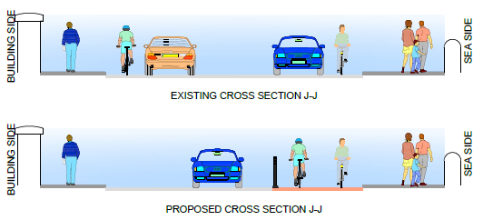

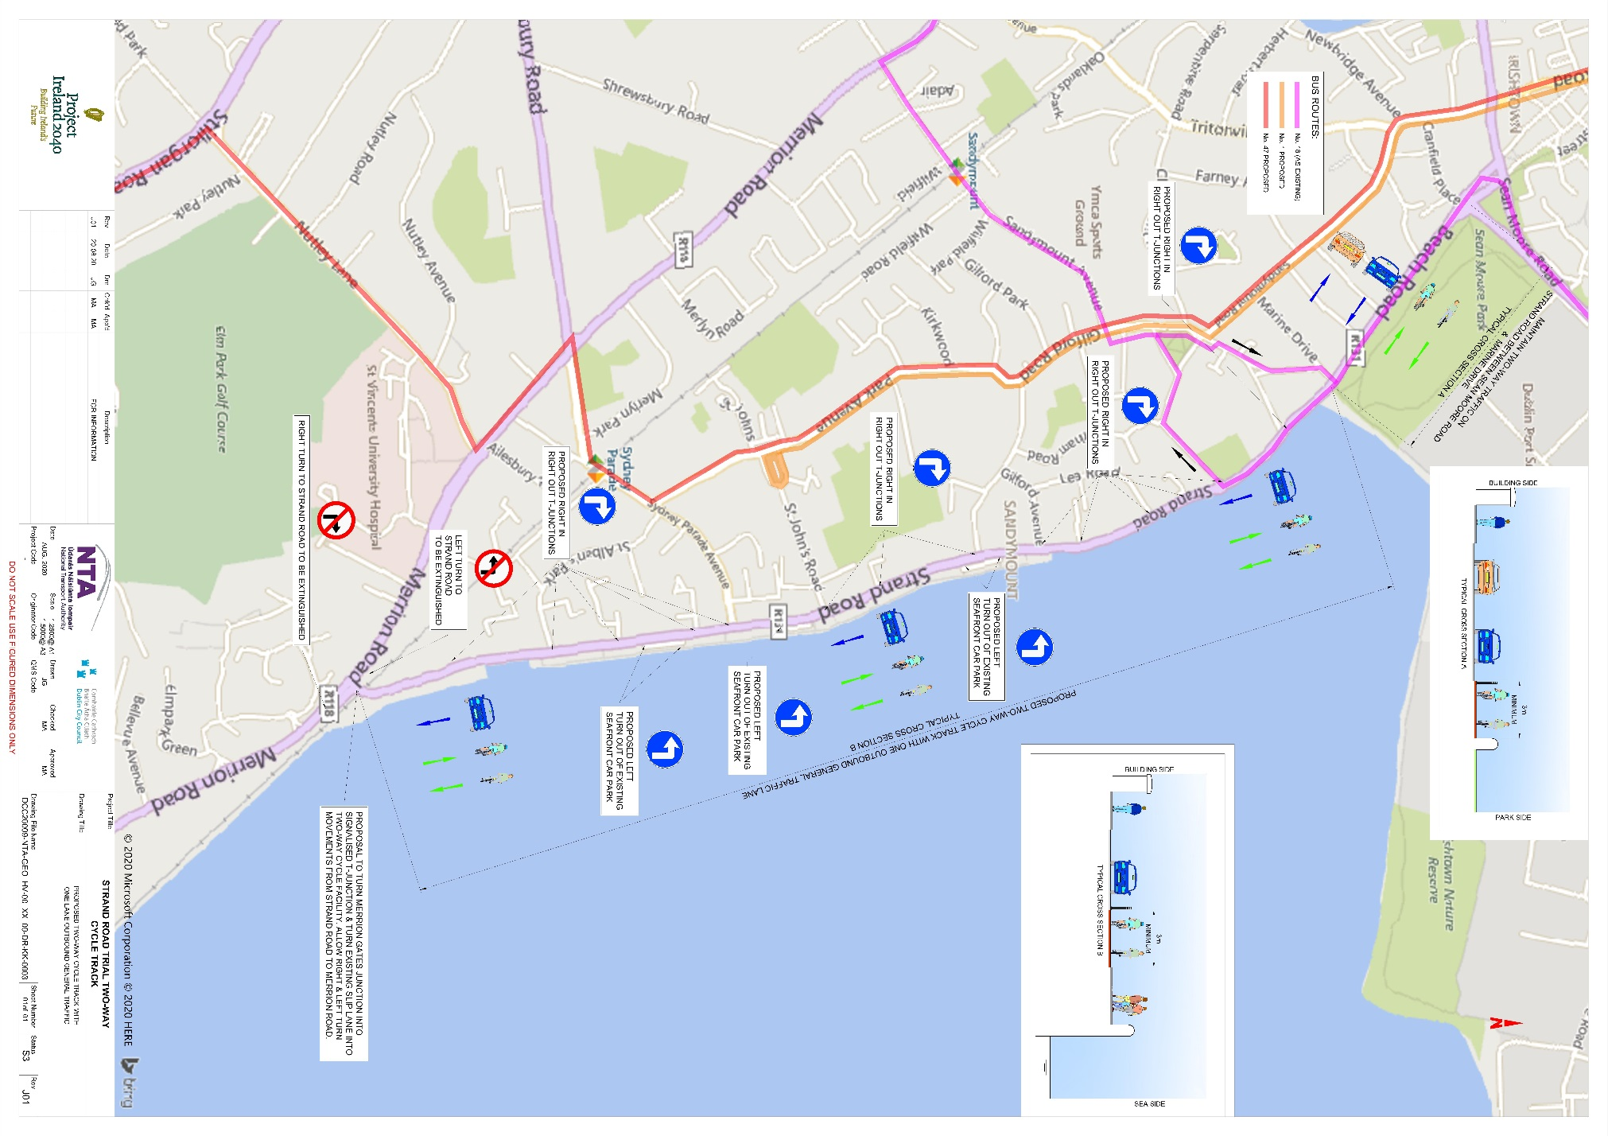

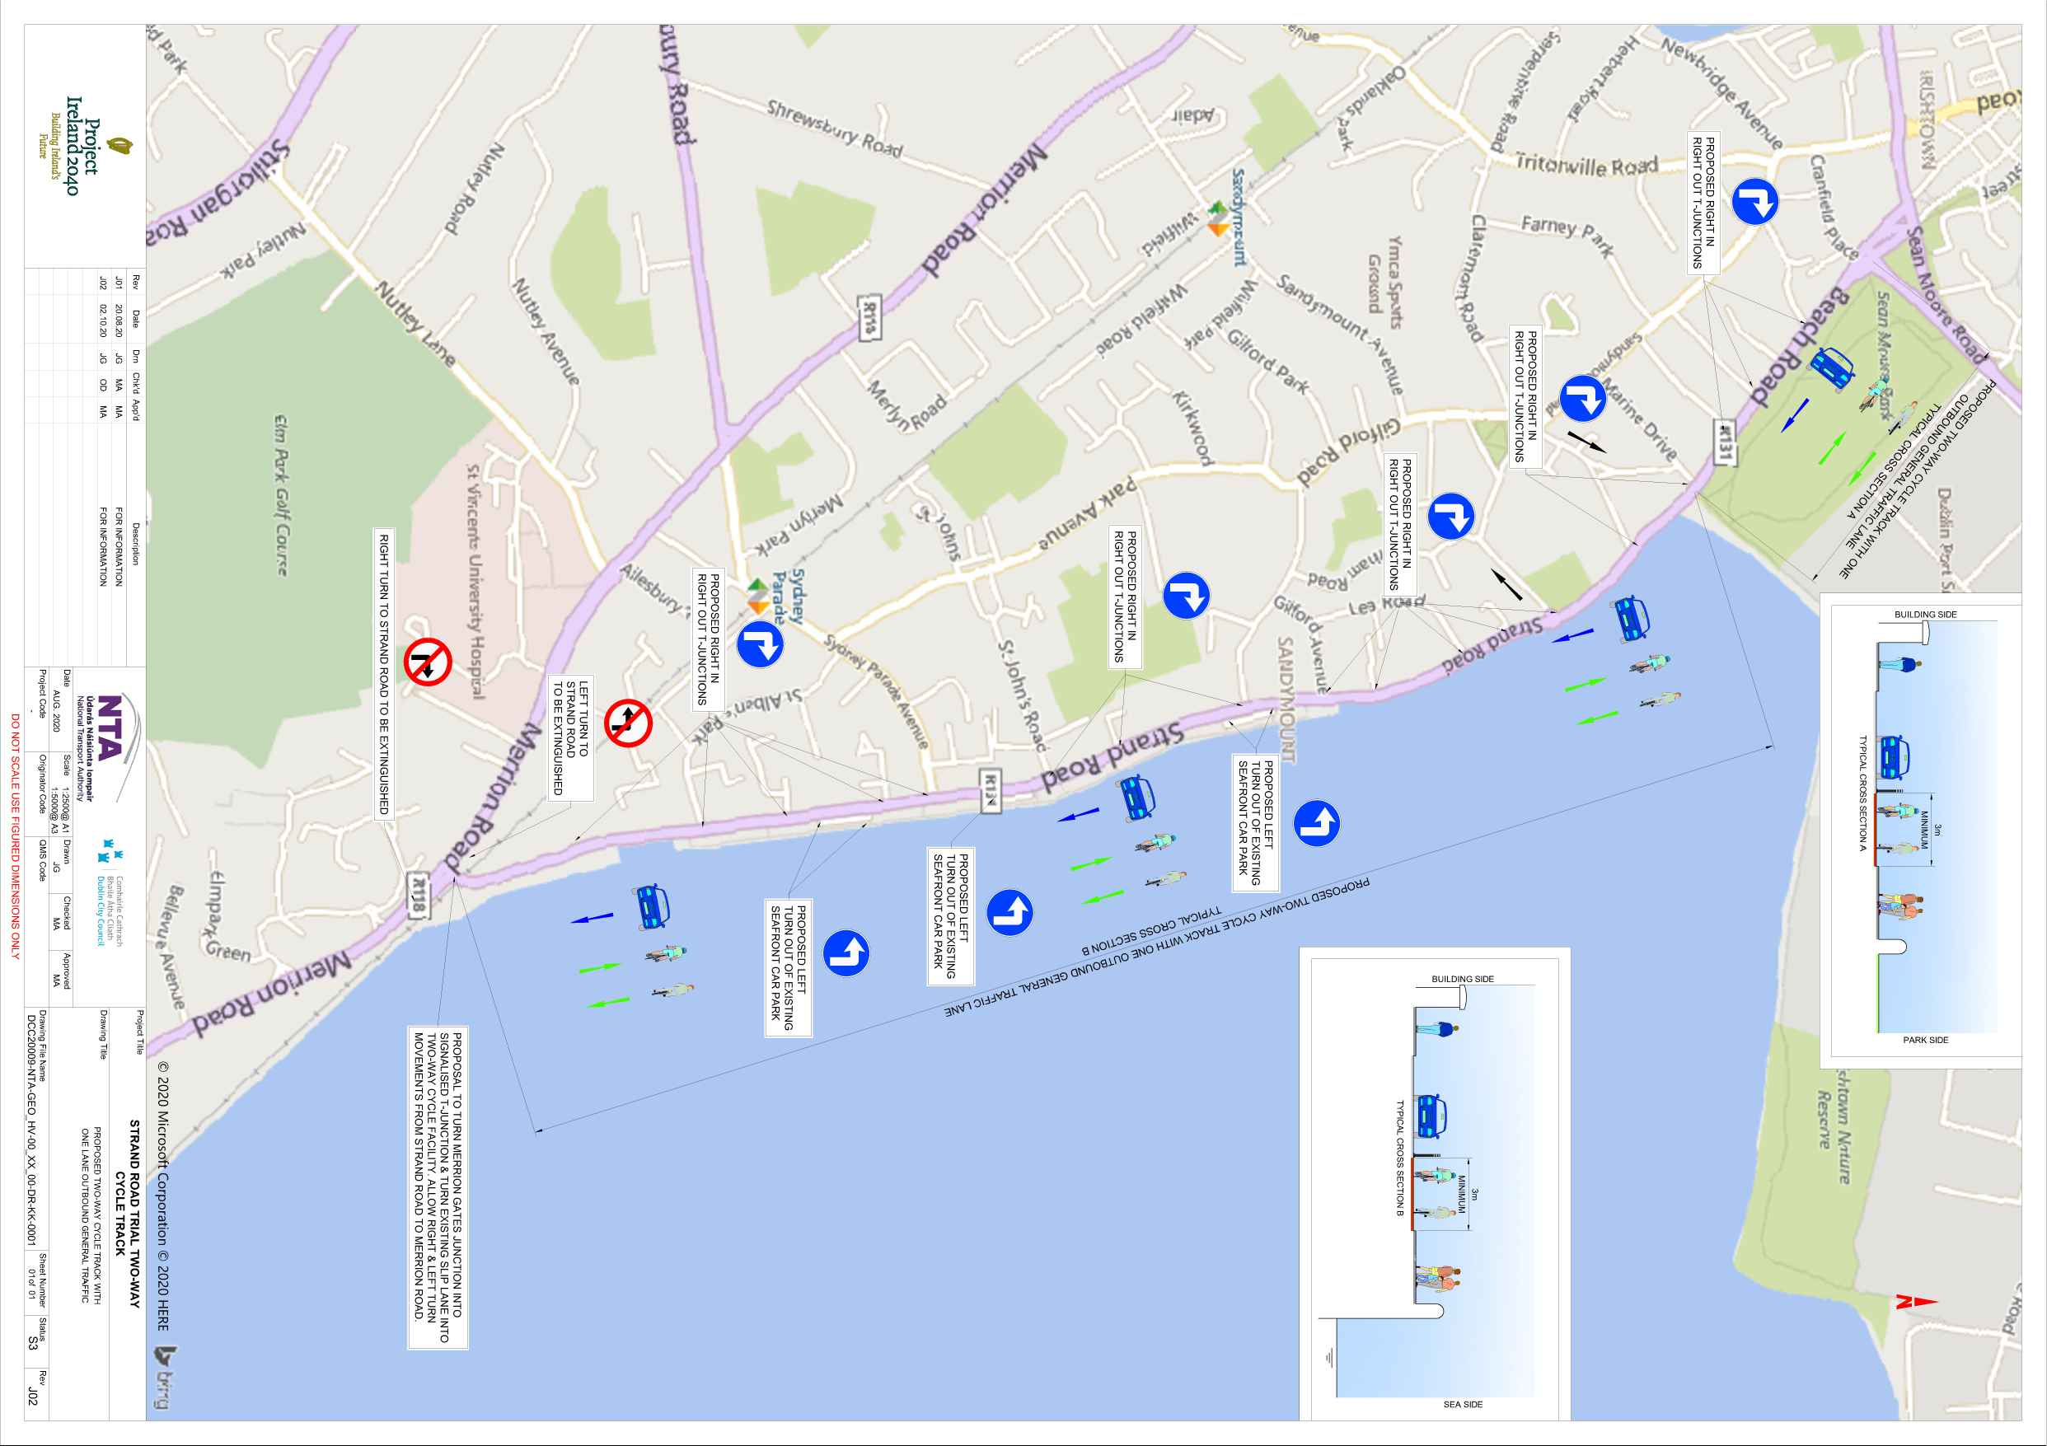

Figure 2 Revised proposal showing one way running Sean Moore Road and Marine Drive

## Genesis of Trial

Introduction of cycle facilities in this area has been a continuing objective of DCC and the NTA and is part of the Greater Dublin Area cycle network, previous schemes have examined the provision of improved cycle facilities in this location while also maintaining 2 way traffic. Doing this in an environmentally sensitive location is extremely challenging.

The beach area along Strand Road and Beach Road is an important natural heritage site with the following designations:

* Special Area of Conservation (South Dublin Bay SAC ref. 000210) designated under the EU Habitats Directive (1992),
* Special Protection Area (Sandymount Strand/Tolka Estuary SPA ref. 004024) designated under the EU Birds Directive (1979) and
* The entirety of Dublin Bay was designated as a UNESCO Biosphere in 2015.

Schemes which try to maintain two way traffic have required some or all of the following:

* removal of all on street parking on Strand Road
* construction of a new pedestrian & cycle DART crossing/bridge and possible compulsory purchase of land at Merrion Gates and
* A reduction in the amount of footpath space available for pedestrians.
* Construction of a boardwalk in the bay area.

These schemes will also take many years before construction can commence due to the environmentally sensitive nature of this location. However the current situation of no cycling facilities at all means that this route is not an attractive route and is unsuitable for cycling to schools in the area.

Therefore at a time when the government is urging people to walk and cycle where possible, the lack of a safe route in this area is highlighted.

The road width along the Strand Road is such that it is impossible to provide for safe cycling facilities unless a more radical and innovative approach is taken. While for sections of the route there is space in the parkland on the sea side to provide cycle facilities, it cannot be provided along the complete route and options to provide a new road and bridge cannot be taken forward in any short time scale.

It is now possible using rapid deployment techniques and materials to quickly provide segregated facilities which provide protection, stay within the existing roadway and do not require major roadworks and works that would affect the sensitive receiving environment. The benefit of this approach is that a safe protected cycle route can quickly and easily be put in place, it is not permanent and allows for a trial where the positive and negative impacts of the scheme can be evaluated and if necessary all the materials can be removed and the road returned to its former use.

This proposed six month trial would allow for a full evaluation of the proposed option, its benefits and any adverse impacts. Changing the use of the sea side lane to a two way cycle track means almost no changes are proposed on the property side along Strand Road and the vast majority of informal parking can remain as before. In addition it will considerably reduce traffic levels on Strand Road and so a number of submissions from the Strand road area were fully in favour of this scheme.

## Why is the strand road cycle route so important

The trial of this route will firstly provide safe protected cycling facilities where there is none at present and will help with journeys to school and within the local area. If this link is in place then we can connect across to the DLRCC boundary and to the Coastal Mobility route on the South side. The route then from Strand road to the Dun Laoghaire Coastal Mobility Route will provide 10kms of mostly protected safe cycling facilities.

Continuing the route on further north and joining to the Canal Way cycle route then provides connection to a number of safe protected cycle lanes which can be used.

The Strand Road route will then be linked to the North and South cycle routes across the Samuel Beckett Bridge from Portobello to Newcomen Bridge and along the Royal canal and Grand Canal. At Newcomen Bridge in will in turn link to the Clontarf to city centre route and to the existing cycle route to Sutton.

In addition the Canal way cycle route links to the South and North Quays Campshire cycle routes, which in turn will link in to the interim LIffey Cycle route scheme.

Projects such as the Dodder Greenway scheme will also be linked once complete.

This will substantially advances a network of connected protected cycle routes in the city. In addition it provides links to multiple schools and leisure facilities as well as providing opportunities for enhancement of a number of areas along the route.

Includes DLR Cycle Route, Grand Canal Cycle Route, South Campshires Cycle Route, Proposed Liffey Cycle Route, Proposed Dodder Cycle Route, Proposed Royal Canal Cycle Route, Proposed Fairview Cycle Route. 


Figure 3 Cycle route connections

## Trial Design Details

It is proposed to undertake a six month trial of a 2 way separated cycle track from Merrion Gates to Sean Moore Rd. In order to install this safe continuous and protected cycle track the inbound traffic lane will be removed between Merrion Gates and Sean Moore Road and the road converted to a two way cycle track on the sea side with outbound general traffic in one direction on the building side. Access to all properties will be maintained and the vast majority of informal parking along Strand Road will remain as is. The scheme will involve minimal civil works and will be installed in such a way as to allow for localised alterations and to minimise any alterations to existing road surface or kerbs.

Protection will be provided by bollards and orcas in the first instance, which are easily adjusted and can be simply removed. More permanent protection will be installed if the trial is successful. The emphasis will be on ensuring that the level of protection is adequate to safely delineate the cycle route from the vehicle running lanes. At a number of locations some civil works is required including at Merrion Gates, some of the mini roundabouts and the pedestrian crossings on the route. In additional works will be required at the Beach Road Sean Moore junction. Again all of these changes are reversible.

The Traffic signals in the area with be equipped with Smart Micro technology which DCC have successfully deployed at several junctions over the last two years. These allow us to automatically detect and count cyclists as well as provide classification of vehicles and these are all linked to the DCC SCATS Traffic control system.

# Consultation

## Pre-Implementation

The proposed measures were first highlighted via the weekly Covid Mobility update issued by the Chief Executive on 7th of August 2020, notifying Councillors that “Preliminary designs for a rapid deployment two way cycle track on Strand Road, which will  
replace one of the existing traffic lanes, are being finalised and will be circulated to Councillors  
on the South East Area Committee over the next two weeks together with an outline plan for the implementation of this scheme”.

A consultation then ran from the 21st August 2020 to 14th September on Dublin City Council’ which contained full details of the proposals. A briefing was held for Councillors on the 1st September and the project was also considered at the September South East area committee meeting.

# Consultation Feedback

## Overview of Feedback

A total of 2,922 submissions were received and Dublin City Council wishes to thank everyone who took the time to contribute to this consultation process.

Breakdown of submissions by source were as follows:

Consultation Hub responses, 2,657;

Email responses, 265;

Total responses, 2,922

Submissions were in general received from individuals, resident associations and some local businesses. Within the submissions received were 190 submissions who were objecting to the scheme using the same pro forma text, all others were individually phrased.

Three questions were asked on the consultation hub:

1 - “Please share any specific concerns you have in relation to any aspects of the proposal”

2 - “Do you have any suggestions for improvements to the proposal?”

3 - “Are there any complementary measures that you feel should be introduced in tandem with this scheme? “

Having assessed all the submissions, 56% were found to be strongly in favour of proceeding with trial, 17% had some concerns about the trial but did not state if they were in favour or opposed to the trial and 27% objected to a trial. However it should be noted that DCC did not directly ask the public to either approve or disapprove of the scheme.

## Question 1 - Concerns

There were concerns raised by 334 of those in favour of the trial as well as those with reservations about the trial. The main concerns of those in favour of the trial were:

* Trial not going ahead, 119 concerns;
* Segregation and the protection of cycle lanes, 143 concerns;
* Link to other routes, 39 concerns;
* Time of year of the trial, 33 concerns.

There was also a large amount of submissions (995) who had no concerns.

**Response to concerns**

**Concern** – Trial not going ahead, length of trial, time of the year isn’t suitable

**Response** – The submissions received in this consultation and the issues raised both for and against scheme have not fundamentally changed Dublin City Council’s view that the trial is worth implementing. While we have looked to respond to concerns and provide some mitigation measures we still would believe that the scheme is beneficial and should go ahead.

Six months will allow time for the scheme to settle in, for new patterns of movement to be established and for movement data to be gathered. During the initial period of the trial it is normal that there are changes in pattern and levels of interventions required and so by the end of the trial the situation should have reached a stable situation. In addition we will be flexible enough to make changes as the trial progresses to deal with specific issues which may arise and six months gives us time to undertake changes as required.

Cycling numbers do not actually fluctuate by much throughout the year. Data from one of the DCC cycle counters of cycling numbers on the Grove Road, for 4 years through all the seasons, shows no big drop off during the winter month. The only major decrease in cycling numbers during this 4 year period was during Storm Emma in March 2018.

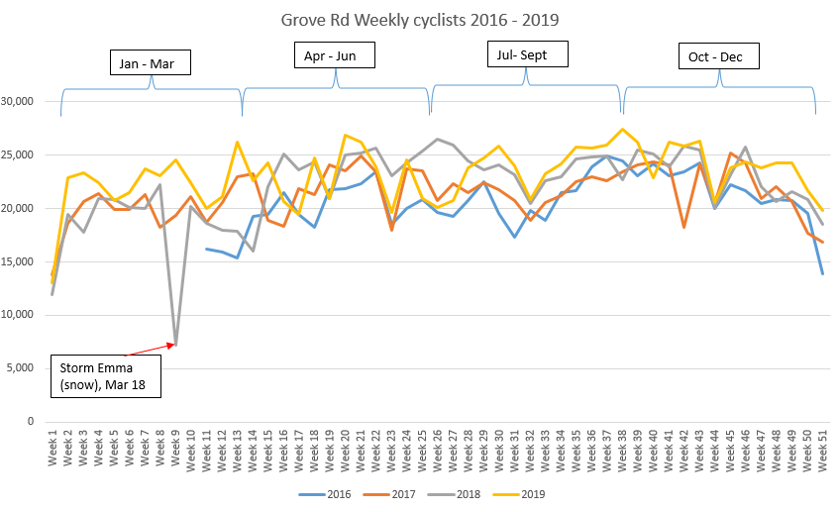

Figure 5 Cyclist numbers throughout the year 2016 - 2019

**Concern** - Connection to other cycle facilities

**Response** - DCC have been working with the NTA and DLRCC on providing a continuous connection to the DCC boundary and into the DLRCC area and the section from Merrion Gates to the DCC boundary is now complete and will be available shortly on the consultation hub. On the northern end a connection to Ringsend is intended to be designed as will be new cycle lanes on Sean Moore Rd.

**Concern** - Separation of cycle lane from traffic

**Response -** The cycle lane will be separated from the traffic lane using mini orcas. These prevent vehicles from encroaching onto the cycle lane but are also flexible enough to be adjusted if required. These are suitable for emergency vehicles to drive over if required to use the cycle route to access any location along it. In addition as the road periodically receives sea spray they are more suitable for this location than other materials.

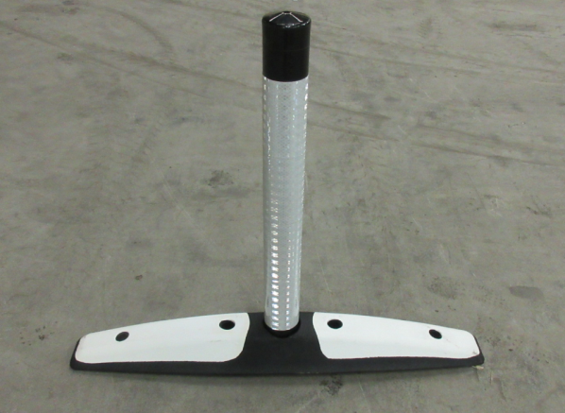

Concerns of those opposed or non-opposed with reservations.

The main concerns of those either opposed or with reservations of the trial were:

* Traffic concerns, 990 concerns;
* Access to the East Link/Port Tunnel/Airport, 304 concerns;
* Parking, 86 concerns;
* Changes to bus routes, 40 concerns.

## Traffic concerns

There were very few submissions received which opposed the provision of safe protected cycling facilities on Strand Road and, if it was possible to provide them is such a fashion as to not interfere with the current traffic layout, then there would be almost no objections.

However as has been made clear before it is just not feasible to do so at this time. Therefore the issue of traffic diversions and what happens to existing traffic is the main item to be addressed in order to ensure that the trial can be successful.

It is important to state that the City Council believes that the trial is an opportunity in general to reduce the traffic volumes on Strand Road while implementing a range of measures to ensure that the traffic volumes on other streets do not reach levels which would have any seriously adverse impacts on residents.

A balance needs to be struck across this trial area between all the mobility needs in the area while, as per the Design Manual for Roads and Streets (DMURS), ensuring that the most vulnerable are accorded the most protection. It is also worth noting that considerable numbers of submissions were received in favour of the scheme from residents within the Sandymount area and especially on Strand Road.

**Concerns re HGV traffic**

A specific concern was raised about the use of alternative roads by HGVs seeking access to the Port area and the waste to energy plant as well as the blocking of a route to the port for HGVs and that Strand Road is a designated route to the port area.

**Response**

Strand Road is not a designated route to the port area and has not been one since the Port Tunnel and HGV Management Strategy were put in place in 2007.

Strand Road is instead a designated entry and exit route to the HGV cordon for those HGVs who have obtained permits to load/ unload within the cordon area.

The HGV cordon does not include the Port areas or the Waste to energy plant.

Both the North and South Port areas can only be accessed during the hours of the HGV cordon via the Port Tunnel and not by driving through the cordon. A driver of a HGV covered by the regulations found without a valid permit within the cordon is liable to an 800 Euro fine.

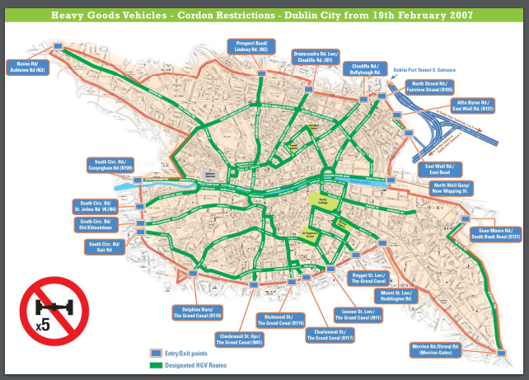

It should be noted that all of the Sandymount area including Stand Road is within the HGV cordon and that when the cordon was introduced after the opening of the port tunnel HGV numbers using the Sean Moore road decreased by 84%. HGVs that used Strand Road to access the port area now do so via the M50 and Port Tunnel. DCC operate a HGV toll rebate scheme at the Eastlink for HGVs affected by the HGV cordon. For the duration of the trial this route will now only be an exit point from the cordon.

The following figures tell the numbers of vehicles that use Strand Rd in the AM peak hour. Counts taken in February 2020 at the right turn at Merrion Gates and in September 2020 at Beach Road and % change.

33% decrease in Cars from 572 down to 381;

83% increase in Large Good Vehicles from 23 to 42;

37% decrease in Motorcycles from 19 to 12;

40 % decrease in 2and 3 axle vehicles from 5 to 3;

75% decrease in 4+ axle vehicles from 4 to 1;

14% decrease in Taxis from 14 to 12.

In order to ensure that HGVs do not use this area to illegally access the port additional signage and messaging will be put in place. In addition people are reminded to download the HGV tracker app which allows the public to check if HGVs have a permit to be within the cordon.

**General Traffic**

While general traffic is reduced to less than 80% of normal volumes there is considerable concern expressed regarding where the vehicles who normally turn right at Merrion Gates would not go.

The volume of vehicles that can use the turns to Strand Road at Merrion Gates is currently determined by the frequency of the closure of the DART level crossing and the graph below illustrates this with the gates being closed anything up to 30 minutes in every hour during peak hours. It should be further noted that the frequency of gate closures has increased by 20% since 2018 in response to the more frequent DART services and this in turn has reduced the turning volumes by around 10%. Future DART expansion will increase the amount of time that the gates will remain closed.

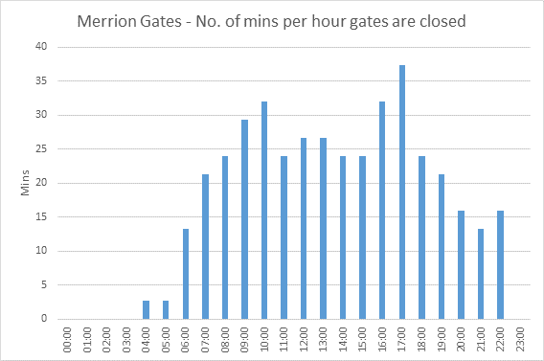

Figure 7 Merrion Gates - No. of minutes per hour gates are closed

In order to assist the project with trying to estimate where the traffic would reroute to and what impact it would have on various different areas, the NTA traffic modelling section ran the Eastern Regional Model with Strand Road reduced to one lane and no entry at Merrion Gates. More information is available on the NTA website on the [NTA Eastern Regional Traffic model](https://www.nationaltransport.ie/wp-content/uploads/2018/06/ERM_Road_Model_Development_Report_Final-2.pdf)

In addition they provided us with modelled destinations for traffic heading Northbound on Beach Road and we have included this information on the Traffic modelling and management PowerPoint which will be circulated with the report.

Changes in overall traffic Am Peak hour as predicted by the Eastern Regional Model with the scheme in place

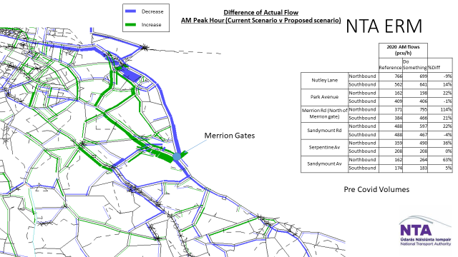

Figure 8 ERM Difference of Actual Flow AM peak hour

The above extract from the ERM shows the modelled changes

We must caveat that the model data is based on pre Covid information and so can only give us a guide to what is likely to happen without being able to give us any definitive answers.

It does not take into account the drop in traffic levels brought about by Covid or the changed patterns of movement that we have seen, nor does it take into account the high proportion of people still working from home.

It can be seen as expected that volumes along Strand Road, Beach Road and Ringsend all decrease, there is also decreases approaching Merrion Gates along the Rock Road and when we look at the city wide graph we can see that this is caused by vehicles rerouting to the M50.

The increases are shown to be unsurprisingly on Merrion Road where city bound traffic in general will now use along with vehicles wanting to access the East Link.

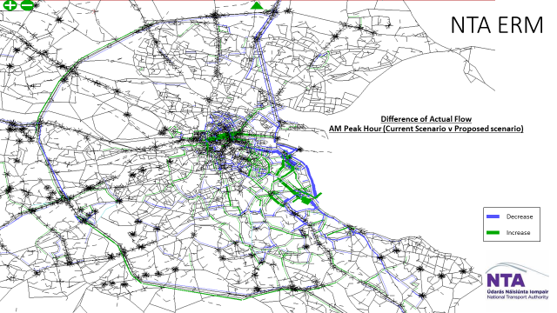

Figure 9 ERM Difference of Actual flow AM peak hour

On a city wide level we can see increases in volumes on the N11 and also on the M50 and vehicles reroute around the area.

**From the submissions received we have categorised by road concerns raised.**

Listed in order from highlest to lowest:
Sandymount Village, Merrion Road, Serpentine Avenue, Park Avenue, Tritonville Road, Gilford Road, Sydney Parade Avenue, Ailesbury Road, Marine Drive, Claremont Avenue, Sandymount Avenue, Leahy’s Terrace, Seafort Avenue, New Grove Avenue, St. Alban’s Park.

Figure 10 Area of concern for rerouted traffic

Taking the modelling data as a percentage indicator rather than an absolute figure due to the changes in pattern, because of Covid, we now examine each area to determine likely impact.

**Concern** – Additional Traffic in Sandymount Village and Gilford Road

The modelling shows that it’s likely that there could be an increase of up to 20% in the village along Park Avenue and through Sandymount Village towards Sandymount Road. Traffic volumes are in general down 80% of pre Covid so this level of increase will at worst return this area to pre Covid volumes. The model assumes no shift to cycling as a result of the new cycle facilities.

**Response**

Sandymount Green will have two pedestrian crossings installed over the next 4- 6 weeks which will provide safe crossings points for all users as well as regulate traffic speeds. A Traffic camera added so as to allow the DCC control to carefully monitor traffic in the Village area. In addition this location will have traffic count equipment fitted to the pedestrian crossings in order to allow monitoring in real time of traffic volumes.

**Concern** – Additional traffic on Merrion Road

The modelling shows that the biggest impact is on the Merrion Road with volumes predicted to double on the section north of Merrion Gates with 798 vehicles per hour. The SCATS traffic control system shows that this section of the road is currently at 70% of previous volumes and so has capacity for additional vehicles, however this will have to be carefully monitored.

**Response**

This area is covered by the SCATS traffic control system as is the roads in the area including the N11, entire Merrion Road from Blackrock to City Centre as well as signals in the Sandymount area. This allows DCC to monitor and adjust traffic signals in real time as problems build up. In addition the SCATS system will allow us to continuously monitor the volumes to determine where vehicles are diverting to. The Variable Message sign at Merrion Gates will be used to warn drivers of traffic changes.

**Concern** - Additional traffic on Serpentine Avenue and Tritonville Avenue

The modelling data shows that traffic along this route may increase by up to 36% and so this route is the one that will require the most careful monitoring. The traffic volumes currently in this area are at less than 80% of pre Covid but if the full predicted increase happens then this route will have around 10% additional traffic over and above pre Covid times.

**Response**

This route main junction at Irishtown Garda station is already on the SCATS traffic control system and is equipped with CCTV linked to the DCC traffic Control centre, in addition there is a CCTV installation at the junction of Tritonville Road/ Newbridge Avenue which again is linked to the DCC traffic control centre. It is proposed to undertake speed measurements in the area to determine if and where speed warning signs should be installed and also suitable locations for additional traffic calming measures will be identified if during the course of the trial it is found they are needed,

**Concern** – Additional traffic on Marine Drive and Leahy’s Terrace, removal of the footpath on Beach Road

**Response** – The concern for increased traffic on these roads is due to through traffic using the roads to access the two way layout on Beach Road. The removal of the footpath on the park side of Beach Road was to facilitate keeping this section two way. The reason for keeping two way on Beach Road was to accommodate bus services at the request of the National Transport Authority (NTA). The NTA have subsequently clarified that the two way running is not required in this section. Because of this it is now proposed to also make Beach Road one way for traffic (outbound) with the cycle route using the current outbound traffic lane. This will eliminate through traffic using Marine drive and Leahy’s Terrace and will leave the footpath on the park side in situ. As this is quite different in this area from that which was proposed we will be putting up details of this change on the DCC consultation hub shortly and inviting comments for a limited time to ensure that if this proposal causes additional concerns that they can be captured.

**Concern -** Access to the Port Tunnel and the airport

**Response –** The Port Tunnel is not a dedicated route for the airport or a commuter route, which is why it is free for HGVs and tolled for general traffic. Its purpose is to divert HGVs away from the city centre by providing a link from the Port to the motorway network. The M50 is a more suitable route from the south side of Dublin to the airport and not through the trial area. For those who wish to use the Port tunnel alternatives routes exist.

**Concern** - Access to properties near Merrion Gates from the Blackrock direction and also access to Sandymount Village by car for these residents.

There were many submissions particularly from residents near the Merrion Gates proposing that a right turn should be provided along the Merrion Road before Serpentine Avenue as the detour that they would have to make to access their houses by car was considerable. The residents on Strand Road near Merrion Gates after St Albans Park also felt that access by car to Sandymount Village would involve a long detour and asked for some changes with the turn bans along Merrion Road to facilitate their access.

**Response**

It is not proposed to make any changes on the Merrion Road for the first 2 months to allow time for the scheme to settle and for some clarity regarding the traffic patterns to emerge. This will then be reviewed and if concerns of residents in this area still persist it is proposed a time limited right turn at the Merrion Road / Ailesbury Road may be facilitated. The existing ban would stay in place during peak periods Mon – Fri 7am to 10am and 4pm – 7pm to discourage commuting traffic from using that route.

**Concern -** Cycle facilities should use the green spaces or a boardwalk should be built

**Response -** Using all the footpath on the sea side for a cycle route would require us to extend the footpath over the entire length, narrow the carriageway to 6m and remove all informal parking along the entire length of Strand Road. Even if this was implemented there is still 300m on the approach to Merrion Gates where it is not possible to provide any cycle protection without the removal of a traffic lane. Regarding using the green areas for a cycle route, 40% of the route between Merrion Gates and Sean Moore Road does not have green space available to use and we would still not end up with a safe, continuous, protected route.

The beach area along Strand Road and Beach Road is an important natural heritage sit

* Special Area of Conservation (South Dublin Bay SAC ref. 000210) designated under the EU Habitats Directive (1992).
* Special Protection Area (Sandymount Strand/Tolka Estuary SPA ref. 004024) designated under the EU Birds Directive (1979).
* The entirety of Dublin Bay was designated as a UNESCO Biosphere in 2015.

Schemes to provide an alternative bridge over the DART line and to provide a boardwalk around the properties on the sea side have been proposed. They all present significant environmental and construction difficulties, will struggle to get approval and take many years to implement.

**Concern -** Rerouting of buses on narrow streets

**Response –** The NTA and Dublin bus have assessed the route and deemed it acceptable.

**Concern** – Loss of parking on Strand Road

**Response –** There is currently informal parking at a number of locations along Strand Rd. It is not proposed to make any changes to the parking arrangements at the start of the trial. If the trial is successful and the cycle route is to remain then there will be scope to formally mark parking spaces along large sections of Strand Rd.

**Concern –** Lack of a Traffic Management Plan

**Response** – Details of the traffic management for when the trial will be installed will be made available in advance of the trial commencing. Advance warning signs and diversion routes will be clearly displayed

**Concern** – Ignoring the NTA Sandymount / Merrion to Blackrock Cycle Route Corridor Feasibility & Options Assessment Report - Part A Coastal Route. A number of submissions quoted from the report that for the option of having a one way traffic system on Strand Rd the report stated “it is unlikely that the traffic impacts of this option would be considered acceptable or proportionate for the objective of this cycleway project”

**Response** – It must be clearly stated that the proposal contained in that report differs from what is proposed for the trial. In the NTA report it proposed “single traffic lane in alternate directions between various side road junctions on suitable link routes inland to Sandymount Road, Gilford Road and Park Avenue”

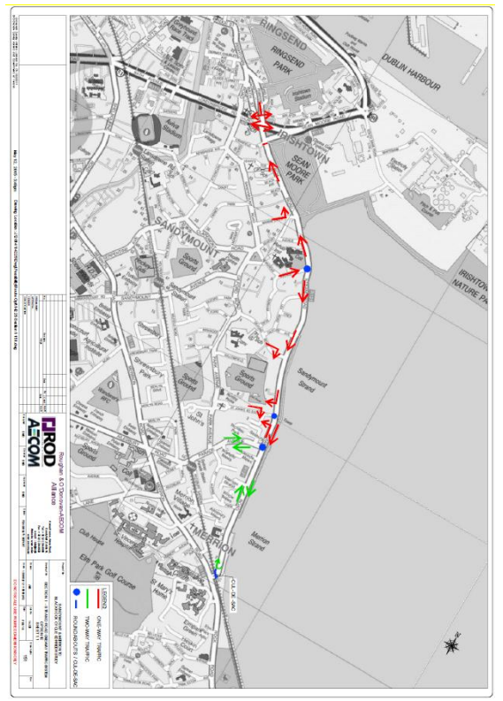

Figure 2015 Proposal

The report does point out that “It would restore traffic conditions on Strand Road to less than what they may have been like before the East Link Bridge opened up”, that it would have no impact on the frontage of properties, that on-street parking could be provided on some sections of the road where there is demand from frontage residences and direct encroachment into the SAC or SPA with no resulting Qualifying Interest (QI) habitat loss.

The current proposal differs to the 2015 proposal which reversed the flow of traffic at different points along Strand Rd. The 2015 report also proposes the road would be reduced to one-way in the northbound direction and southbound traffic would be diverted right, westward at the Sydney Parade Avenue junction on Strand Road.

The trial will have a completely different layout with one single land of outbound traffic for the entirety so the conclusions regarding traffic from the 2015 report are not applicable to this trial.

## Question 2 - Suggestions

Question 2 asked ““Do you have any suggestions for improvements to the proposal?”

There was a large number of suggestions for improvements received. Some of the suggestions that are being considered initially include:

* Further restricting HGVs in the area to include a ban on 4 axle vehicles.
  + DCC are open to this idea and are investigating it.
* Adequate protection to keep cars from encroaching onto the cycle lane.
  + Protection proposed we believe is adequate for the trial but can be upgraded if needed.
* Links to other cycle routes and the city centre.
  + These are being work on and the section to the DCC/DLRCC boundary is now complete.
* An additional right turn from the Merrion Road at Ailesbury Road
  + See proposal above.
* Additional cycle parking along the route.
  + Will be installed
* Connection from the cycle route to Sandymount village.
  + This is an item that we are committed to investigating to try and ensure that the village benefits from having the cycle route in place. We are open to any further suggestions as to how this may be achieved.
* Connection from the cycle route to local schools.
  + School zones are being installed throughout the city and including the Sandymount area and links from schools to the cycle route will be investigated.
* Speed display signs at various locations.
  + Speed surveys will be carried out and locations identified if required where displays could be put in.
* Provide filtered permeability on Durham Road so as to allow Pedestrian and cycling access to schools in the area but ensure that through traffic will not be allowed.
  + DCC are open to this suggestion and if agreement can be reached amongst the residents in the area for this scheme we would be willing to implement and trial it.
* Additional turn bans including time limited or class of vehicle options
  + DCC are open to assessing any suggestions in this regard and we have now set up a dedicated email contact for this scheme.

## Question 3 – complementary measures

Question 3 asked ““Are there any complementary measures that you feel should be introduced in tandem with this scheme? “

Many of the complementary measures were also mentioned in the “Suggestions” question. The main complementary measures that are currently being perused are:

* 2 new pedestrian crossings in Sandymount village
* Additional CCTV and Smart Micro detection.
* Additional automatic counters as well as monthly traffic counts
* connections to other cycle routes
* connections to the village to bring benefits to local businesses
* connections to local schools and “School zones” to be implemented
* a dedicated contact for any further suggestions or issues – [strandcycletrial@dublincity.ie](mailto:strandcycletrial@dublincity.ie)

## Changes to the scheme

Based on the feedback from the consultation and as per further advice from the NTA, the following are the main changes to the scheme:

* Beach road is now proposed to also have one way traffic outbound with the cycle route taking the position of the current outbound lane of traffic and the footpath will not be used for the cycle route. This new version will be displayed on the DCC consultation hub for a short period of consultation on this change.

## Monitoring of the scheme

The City Council will carefully monitor the impact of the scheme both on Strand Road and on the wider area and we will look at the following items:-

1. Safety of all road users in the trial area and especially on Strand Road as a result of the changes.
2. Traffic volumes with the trial area using both existing traffic sensors and additional ones which will be deployed during the trial period.
3. How cyclist use the new route and its links to Sandymount village and to DLRCC and the city centre at either end.
4. Noise and environmental data from the DCC and EPA national monitors.
5. Feedback of Concerns and issues raised during the trial period

# Next steps

Over the next number of weeks a number of items will be progressed to allow the trial to be commenced, these include:-

Engagement with residents groups who have requested meetings.

Sandymount Village

* Work will begin on the new pedestrian crossings in Sandymount Village.
* New CCTV and Smart detection will also be put in the village.

Merrion Gates

* Work will commence on modifying the median to allow for the new right turn.
* Additional ducts and cabling will be installed for the new signalised exit.
* A new pedestrian crossing will be installed
* The existing signals will be upgraded and Smart Micros added.

Rock Road

* The design work on the section from Merrion Gates to the DCC boundary is now complete and discussions with DLRCC are progressing re joint implementation.
* Preparatory works to commence for its installation.

Sean Moore Road/ Beach Road Junction.

* Upgrade works to junction to allow one way operation unless major difficulties with this change are flagged during consultation.

Strand Road

* Some of the mini roundabouts need come changes to allow for the cycle track to be installed.
* Pedestrian crossings will all be upgraded and fitted with Smart Micros to allow cycle counting and vehicle classification.
* Protection equipment, signage and road markings to be finalised and ready for completion.

Bus services

* Agree new Bus stop locations NTA Dublin Bus.
* Dublin Bus require eight weeks’ notice of change of services stop locations.

Trial Area

* Speed and traffic count surveys.
* Statutory signage review and planning.

Publicity campaign

* Preparation of the necessary information campaign for people affected.
* Ensuring that advance notification and signage is in place prior to start of trial.

**Proposed strand road cycle lane interventions:**

1. Change from two way to one way running
2. Speed surveys across areas or locations of speed warning signs
3. Install Pedestrian crossings and CCTV
4. Upgrade Pedestrian crossings along Strand Road with Smart Micros and cycle signals
5. Statutory signage and advisory signage  to be put in place
6. Traffic signal changes to allow Right Turn movement
7. Two way protected cycle track to DLRCC boundary

# Conclusion and time line for implemetation

Dublin City Council would like to thank everyone who responded to the consultation and hope that this report captures the main issues that were raised with us. We still believe that the trial is appropriate and worthwhile to undertake and will set out to work through issues as they arise to try and ensure that more is gained by the trial than any potential downsides.

There is considerable work to be undertaken as set out above and some of this has now commenced. It is likely that the above will take 8 to 10 weeks to complete and once these are in place the trial can proceed.

It should be noted that with the uncertainty regarding the Level of restrictions which may be imposed on Dublin, depending on the severity of the restrictions this may impact on the above timescale.

# Appendix A

## Consultation Twitter Post And Statistics

Posts published on Dublin City Council Twitter Platform:

21st August, 2020:

Visualisation of 2-way cycle lane plus right turning traffic at Merrion Gates. “Take a look at the initial designs for the proposed Strand Road coastal mobility route. A six month trial of a 2-way separated cycle track from Merrion Gates to Sean Moore Rd is proposed. Consultation will be open next week so stay tuned!”.

* Impressions, 60,800
* Engagements, 11,461
* Retweets, 80
* Replies, 62
* Likes, 422
* User profile clicks, 203
* url clicks, 14

22nd August, 2020:

Re-tweet of August 21st post, “Our consultation for the Strand Road coastal mobility route is now live. Take a look here and have your say (link to consultation)”

* Impressions, 23,036
* Engagements, 1,339
* Retweets, 37
* Replies, 12
* Likes, 85
* User profile clicks, 32
* Url clicks, 409

Start September, 2020, Twitter post:

“Thanks to the hundreds of people who have already engaged with our Strand Road Consultation. Have you checked out the FAQ,s? They might answer some of your questions. Find them and other details on the Consultation Hub (url provided plus sample FAQ). Closing date 14th September #cycledublin #covidmobility

* Impressions,14,712
* Engagements,423
* Retweets,10
* Replies,3
* Likes,27
* User profile clicks,19
* Url clicks,95

Start September, 2020:

“Thanks again to everyone who has engaged with our Strand Road consultation. A few of our most frequently asked questions are below – find these and all other details here (url provided plus sample of frequently questions). #cycledublin #covidmobility

* Impressions,9,391
* Engagements,659
* Retweets,12
* Replies,9
* Likes,34
* User profile clicks,19
* Url clicks,66

14th September:

Visualisation of 2-way cycle lane plus right turning traffic at Merrion Gates. “Don’t forget our Strand Road consultation closes today. Have your say (Url provided). #covidMobility #Dublin #YourDublin

* Impressions,27,001
* Engagements, 2,711
* Retweets, 42
* Replies, 16
* Likes, 86
* User profile clicks, 25
* Url clicks, 216

15th September:

Visualisation of 2-way cycle lane. “Thank you to everyone who took part in our Strand Road Consultation. Over 2500 submissions were received! These will be reviewed and a report will follow. We may require further consultation at a later date. The trial itself has been deferred to Jan 2020. #CovidMobility #Dublin

* Impressions, 13,755
* Engagements, 810
* Retweets, 6
* Replies, 11
* Likes, 44
* User profile clicks, 17
* Url clicks, 4

23rd September, 2020:

Visualisation of 2-way cycle lane at Martello Tower. “Thank you to everyone who contributed to Strand Road consultation, we received 2,865 submissions and are identifying key concerns and next steps. Work is proceeding on the design of the section from Merrion Gates to the DLRCC boundary and this will be up on the consultation hub soon.

* Impressions, 15,848
* Engagements, 1,233
* Retweets, 16
* Replies, 4
* Likes, 133
* User profile clicks, 28
* Url clicks, 5

All tweets:

* Impressions, 164,543
* Engagements, 18,626
* Retweets, 203
* Replies, 117
* Likes, 831
* User profile clicks, 343
* Url clicks, 809

# Appendix B

## Consultation Facebook Post And Statistics

The following posts regarding the Strand Road Cycle Route Trial were posted on Dublin City Councils Facebook Platform.

21st August, 2020:

Visualisation of 2-way cycle lane plus right turning traffic at Merrion Gates. “Take a look at the initial designs for the proposed Strand Road coastal mobility route. A six month trial of a 2-way separated cycle track from Merrion Gates to Sean Moore Rd is proposed. Consultation will be open next week so stay tuned!”.

* People Reached, 23,243
* Engagements, 7,963
* Comments, 180
* Shares, 43
* Reactions, 248

Share of August 21st post with comment, “Our consultation for the Strand Road coastal mobility route is now live. Take a look here and have your say (link to consultation)”

* People Reached, 5,442
* Engagements, 444
* Comments, 13
* Shares, 7
* Reactions, 23

15th September, 2020:

Visualisation of 2-way cycle lane. “Thank you to everyone who took part in our Strand Road Consultation. Over 2500 submissions were received! These will be reviewed and a report will follow. We may require further consultation at a later date. The trial itself has been deferred to Jan 2020. #CovidMobility #Dublin

* People Reached, 6,518
* Engagements, 515
* Comments, 38
* Shares, 5
* Reactions, 41

23rd September, 2020:

Visualisation of 2-way cycle lane at Martello Tower. “Thank you to everyone who contributed to Strand Road consultation, we received 2,865 submissions and are identifying key concerns and next steps. Work is proceeding on the design of the section from Merrion Gates to the DLRCC boundary and this will be up on the consultation hub soon.

* People Reached, 14.115
* Engagements, 2,162
* Comments, 187
* Shares, 8
* Reactions, 124

All facebook posts:

* Impressions, 49,318
* Engagments, 10,814