

**Chief Executive’s Office Floor 4 Block 4**

**Civic Offices**

**Wood Quay**

18 January 2021

**To the Lord Mayor and Elected Members**

**of the City Council**

**COVID-19 Mobility Measures Update**

Contents

1. Introduction 1

1.1 Pedestrian Volumes 2

1.2 Cycling Volumes 3

1.3 Bus Passenger Numbers 5

1.4 General Traffic Volumes 5

2. Implementation of Measures 6

2.1 Grafton Street Area – Proposed pedestrianisation of a number of streets 6

2.2 Pedestrian Crossings 6

*Mountjoy Square* 6

2.3 Protected Cycle Facilities and Contra-Flow Facilities 6

*Strand Road Cycle Route Trial* 6

*Griffith Avenue Cycle Route* 6

*Parnell Square East Contra-flow* 6

*Bull Wall* 7

2.4 Filtered Permeability 7

*Grangegorman Filtered Permeability Trial* 7

2.5 On-street Cycle Parking 7

3. Communications 9

3.1 Website 9

3.2 DCC Consultation Hub/Citizen Space 9

3.3 Dedicated COVID-19 Mobility Measure Request Form 9

3.4 COVID-19 Mobility E-Mail 10

3.5 Councillor Updates 10

3.6 Business Liaison 10

3.7 Active Travel Promotion 10

# 1. Introduction

Implementation of the COVID Mobility Programme for the City Council area continues with an emphasis on schools and safe zones. The recent reintroduction of Level 5 restrictions means that there are reduced volumes and activity, however walking and cycling projects and particularly those being implemented as part of a COVID response are deemed to be critical infrastructure and work can proceed in these areas.

As some members of the COVID Mobility Team have now transferred to TAG the amount of projects being undertaken will reduce.

## Pedestrian Volumes

The footfall counters count continuously and provide 24 hour data. These counters are located between Stephen’s Green and Henry St. These show that footfall in this core area had reached a high of around 60% of pre-COVID levels. Footfall increased during December but has dropped dramatically since Level 5+ restrictions were re-introduced.

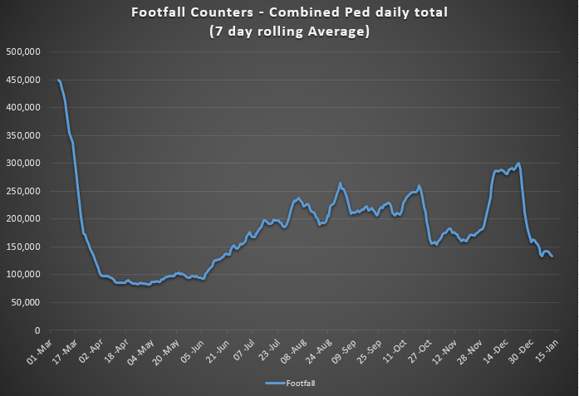

The footfall figures for Grafton Street from November 2, 2020 and 2019 and and Henry Street from November 2, 2020 and 2018 (counter was not working in 2019) are shown below.

Footfall on Henry Street was higher than average (by approxiametly 8,000 people a day) than previous years during Decemeber 2020, whilst on Grafton Stret footfall was only at 50% of previous years. Both streets have seen a sharp decrease in footfall since Level 5+ restrictions were re-introduced.

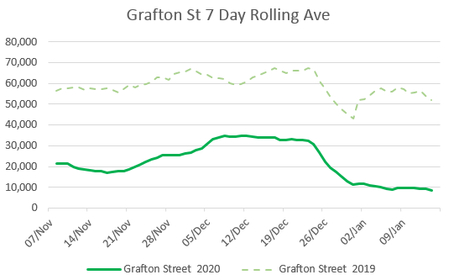

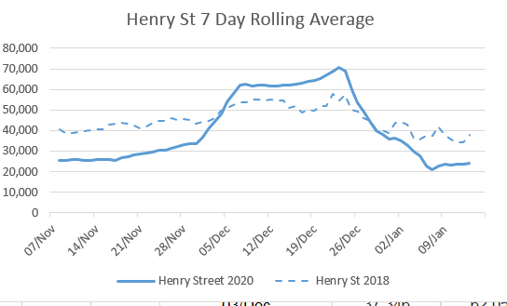

## 1.2 Cycling Volumes

Cycling volumes, which are continuously monitored by City Council’s counters (located at Grove Road, North Strand Road, Charleville Mall and Guild Street show numbers held steady during December but have since decreased to the levels last seen back in April 2020.

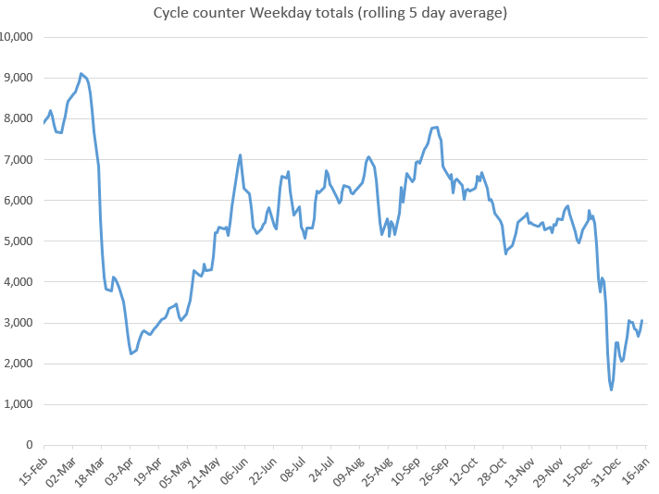

During the peak morning time, 7am to 10am, cycling numbers are at approximately 20% of pre-COVID levels for January 2021. In contrast, the off peak cycling figures which exceeded 2019 weekly figures for most of 2020 are showing slightly lower levels in January 2021, than was seen in January 2020.

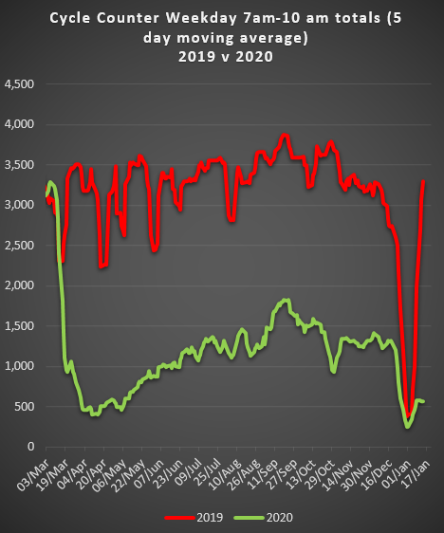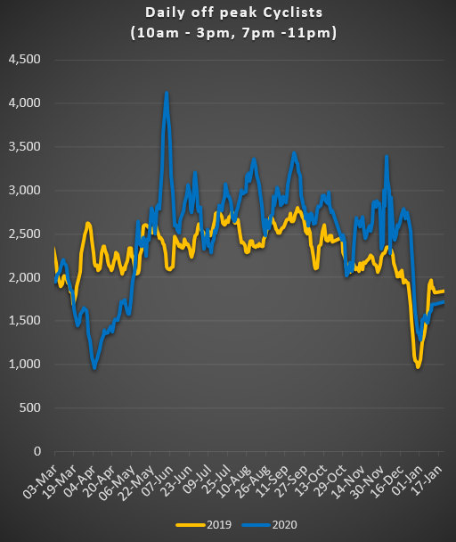

## 1.3 Bus Passenger Numbers

Bus passenger numbers, which increased in the lead up to Christmas then declined sharply during the over Christmas. Numbers have risen slightly since then but remain very low.

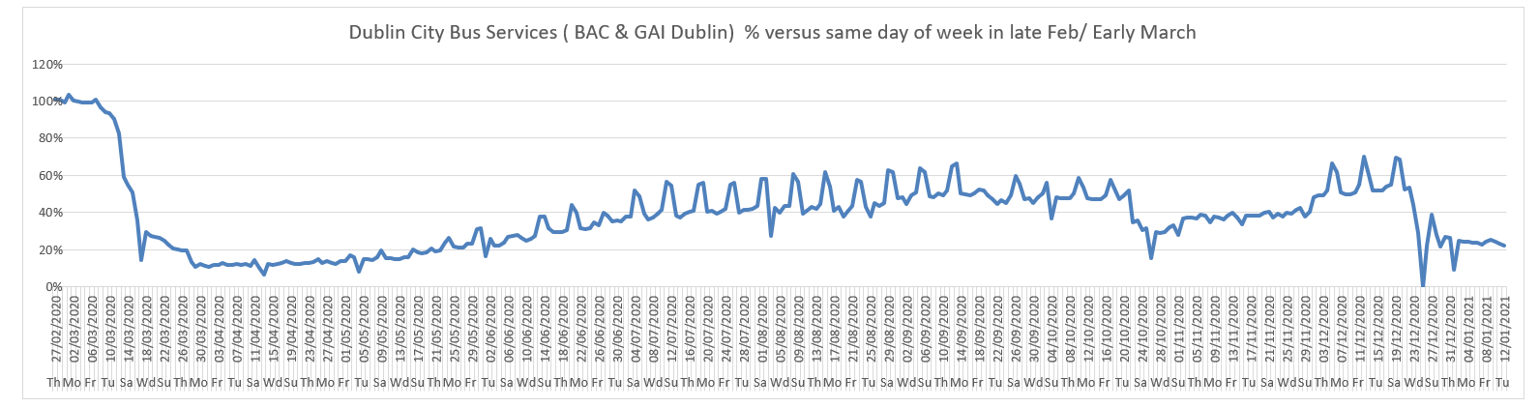

## 1.4 General Traffic Volumes

For the 1st full working week in 2021, from Sunday 3 to Saturday 9 January, the trend shows that traffic is at 57% to 59% compared to pre-COVID levels.

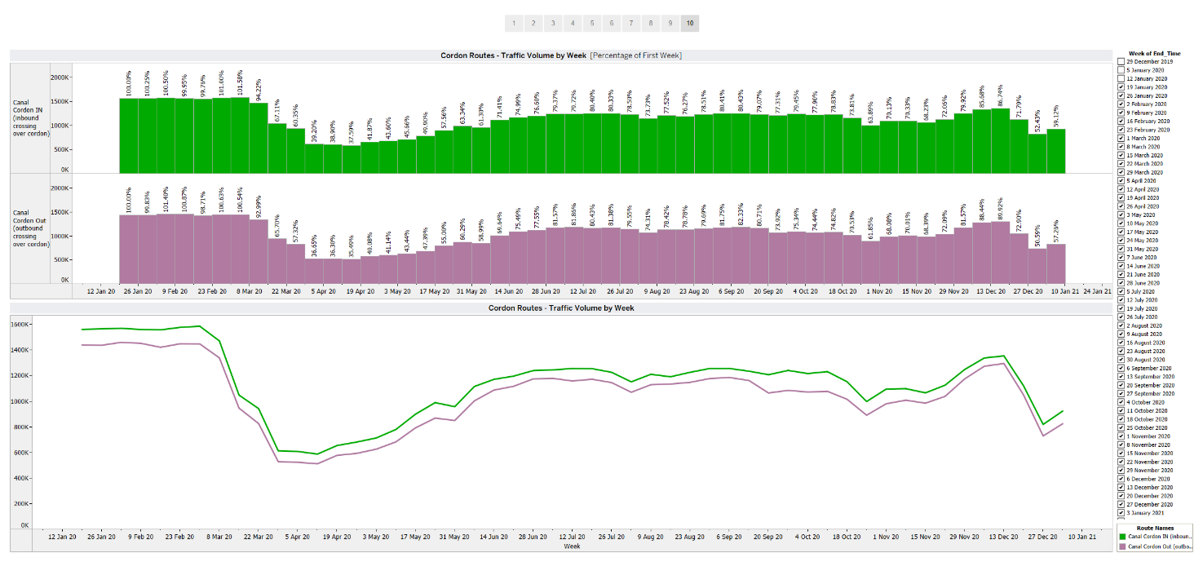

# Implementation of Measures

## Grafton Street Area – Proposed pedestrianisation of a number of streets

Due to the current level of COVID restrictions it is not planned to implement the proposed traffic restrictions in January. The timetable for the implementation will align instead with the restrictions being eased.

## 2.2 Pedestrian Crossings

### *Mountjoy Square*

Invitations to tender have been issued for Phase 1 of the proposed upgrade of the north western junction of Mountjoy Square North/Gardiner Street/Gardiner Place. The works will involve the provision of a new pedestrian crossing both on Gardiner Place, just west of Gardiner Street, and on Gardiner Street, just south of Gardiner Place.

## 2.3 Protected Cycle Facilities and Contra-Flow Facilities

### *Strand Road Cycle Route Trial*

The consultation for the Beach Road section of the trial was extended for two weeks, until 22 January 2021, following a request from disability advocates. We have received 2,012 submissions to date on the Beach Road options. The second Community Forum meeting was held on 7 January 2021. Towards the end of the meeting, a statement was read out on behalf of a number of groups in the Sandymount area informing the Council they would be seeking a Section 5 declaration from An Bord Pleanála, and requesting the trial and the Forum be paused. Advice from the City Council’s Law Department highlighted the following:

* The scheme is being carried out under Section 38 of the Road Traffic Act 1994 and is therefore exempt from the Part VIII planning process;
* Appropriate Assessment and Environmental Impact Assessment screening reports, commissioned from an independent consultant, confirmed that approval from An Bord Pleanála is not required and there is no legal obligation to defer planned works while a declaration is sought under Section 5 of the Planning & Development Act, 2000.

Taking on board the above points and given the urgent need to provide improved cycling infrastructure on Strand Road and taking into account that this is a six month trial, the City Council will continue to prepare for and implement the trial. The City Council will put in place appropriate methods to monitor the impacts for the trial and take part in the Community Forum with all interested parties. A new dedicated webpage has been set up to keep stakeholders informed of all up-to-date information on the [Strand Road Cycle Route Trial](https://www.dublincity.ie/residential/transportation/strand-road-trial-cycle-route/reports-presentations).

### *Griffith Avenue Cycle Route*

Works are planned to resume next week continuing the installation of the protected cycle lanes between Walnut Rise and the Swords Road.

### *Parnell Square East Contra-flow*

Works have begun to modify the junctions along the route on Parnell Square East to facilitate the contra-flow. It is anticipated that we will be in a position to open the contraflow next month.

### *Bull Wall*

Two Additional Disabled Parking Bays and a Cargo Bike/Disabled Cycle Parking Bay have been installed on the Bull Wall opposite the Happy Out Café.

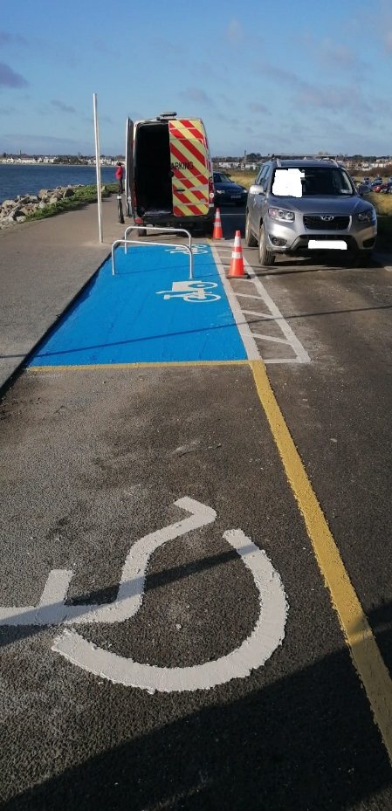

## 2.4 Filtered Permeability

### *Grangegorman Filtered Permeability Trial*

Following Tuesday’s Central Area Committee meeting, the filtered permeability measures at Grangegorman will be made permanent. I would like to thank the Elected Members for their support on this project.

We have also committed to reviewing the impact of these measures over the next 12-18 months among other actions. These measures help to improve road safety, providing a safe walking and cycling route through the area particularly for children. Consultation and design work will now commence on more permanent improvements at this location.

## 2.5 On-street Cycle Parking

A total of 736 cycle parking stands catering for 1,472 bicycles were installed at 150 locations in 2020.

**2.6 School Mobility Programme**

A second Schools Mobility Officer, Sinead Mooney, joined the COVID Mobility Team this year. Sinead will work with Niamh Ní Cholmain to enhance engagement with schools and the school community.

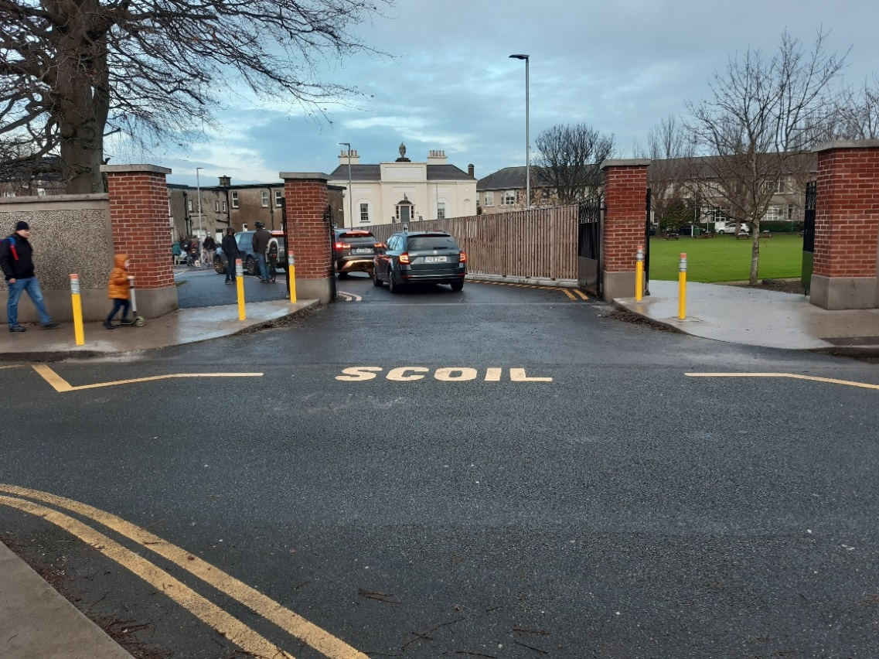

*School Zone installation at Shellybanks School, Sandymount*

The application list for a ***School Zone*** stands at 101 schools. The COVID Mobility Technical Team are assessing all submissions for suitability and schools will be contacted with timelines, if it is deemed to be an appropriate intervention at the particular location.

Twenty-nine Schools Zones, 15 on the northside and 14 on the southside) have been completed to date which the next installations due to take place at:

* Scoil Fhursa, Cromcastle Green, Kilmore West, Dublin 5.
* Scoil Íde, GNS, Cromcastle Green, Kilmore West, Dublin 5.
* Our Lady of Good Counsel GNS Drimnagh.

There are a further 9 schools, 2 on the northside and 7 on the southside at final design stage. Subject to final consultation with school Principals and the NTA these will be completed over the coming weeks.

Site observation visits from technical and School Mobility officers will be conducted for all schools who have applied. The current COVID restrictions and the closure of schools will mean that in general, works will be completed on schools where the designs have already been agreed and survey work and design proposals drawn up for other locations.

The interviews and observations during these visits will facilitate the co-design of supports and resource materials appropriate for each school. Schools within a proposed or completed school zone location will be encouraged to work collaboratively with the community to gain the best possible outcome from the School Zone installation.

Of the 101 schools that have applied, 37 have self-reported that they are located in 50 km/h speed limit zone, one identifies as being within a 60km/h and 1 in an 80 km/h zone. Two are located on dual carriageway roads. DCC and the NTA are working together to determine what is the most appropriate intervention for schools in 50km/h zones. Assessments have been carried out on a number of schools in 50km/h zones and the intervention measures proposed vary depending on the unique characteristics at each location.

# Communications

## Website

The [COVID Mobility webpage](http://www.dublincity.ie/COVID-19mobilityprogramme), is being updated regularly to keep the general public informed of COVID-19 mobility interventions. As previously advised we will be making more extensive use of the Consultation Hub in order to provide more information on measures.

## 3.2 DCC Consultation Hub/Citizen Space

Details of schemes on the Consultation Hub at present include:

[Strand Road Cycle Route Trial - Beach Road options](https://consultation.dublincity.ie/traffic-and-transport/strand-road-cycle-trial-beach-road-options/)

[Griffith Avenue Protected Cycle Track](https://consultation.dublincity.ie/traffic-and-transport/griffith-avenue-protected-cycle-track/)

[College Green](https://consultation.dublincity.ie/traffic-and-transport/proposed-extension-of-the-civic-plaza-at-college-g/)

Members are alerted on a regular basis to any new proposals, which are available to view on the Consultation Hub and aim to have a more dynamic process for ensuring that support for projects, suggestions on how to improve them and concerns and issues, which may need to be addressed, can be better handled. Any feedback on this approach is welcome.

## 3.3 Dedicated COVID-19 Mobility Measure Request Form

Since our last update on December 22, 2020, we have received 22 new requests for COVID Mobility Measures. This brings the total number of COVID Mobility requests to 5,103. A breakdown of these requests is given below.

Footpath widening, 680 requests;

Increased queuing space at bus stops, 133 requests;

Pedestrian area, 799 requests;

Protected cycle lanes, 1182 requests;

Contra-flow cycle lanes, 380 requests;

Cycle parking facilities, 499 requests;

Outdoor seating area, 584 requests;

Commercial / Retail deliveries support, 79 requests;

Support and advice for active travel (walking & cycling), 300 requests;

Journey planning, 78 requests;

Other, 378 requests;

Not answered, 11

**Total requests, 5103**

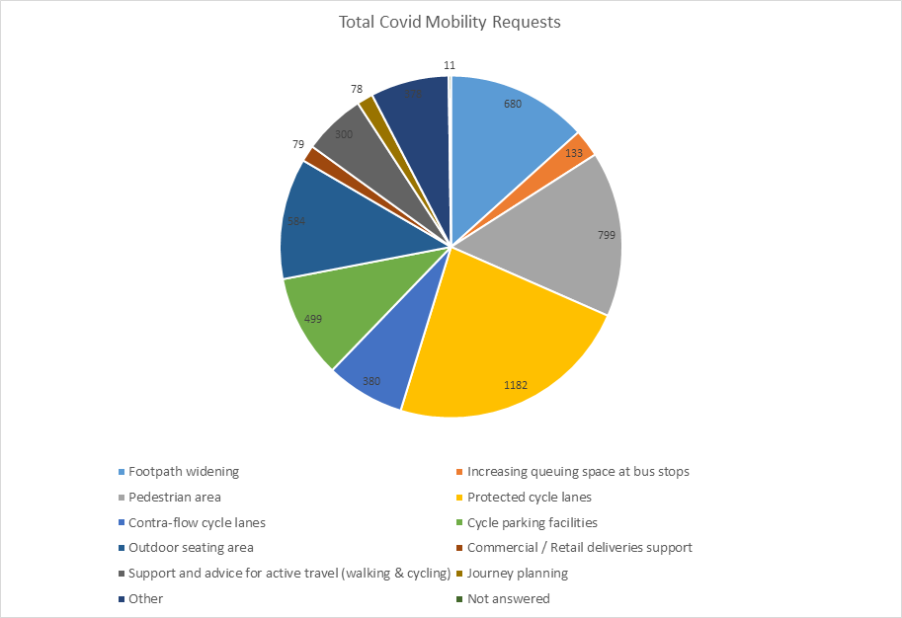

## 3.4 COVID-19 Mobility E-Mail

The dedicated e-mail address continues as the primary channel to contact the COVID Mobility Team. It is attracting huge volumes of queries and feedback. The intention is that the e-mail is for general queries and the COVID-19 Mobility Request Form should be used for specific requests at specific locations.

## 3.5 Councillor Updates

Updates on COVID-19 mobility measures will be issued regularly to Elected Members. Updates via e-mail are also being issued to stakeholders via the Transport SPC and the NTA accessibility network.

## 3.6 Business Liaison

The Business Liaison Officer continues to engage and consult with businesses on a number of COVID Mobility Measures citywide and provides advice to cafés, restaurants and bars, on the process for street furniture (tables and chairs) applications.

## 3.7 Active Travel Promotion

We are continuing to utilise Dublin City Council Social Media Channels:

* + - to highlight COVID-19 mobility measures that have been implemented;
    - to encourage the public to walk or cycle, where possible;
    - to encourage social distancing as people move around the city and
    - to encourage more respect for vulnerable road users

We also continue to evolve our Active Travel Campaign in collaboration with key strategic partners (e.g. NTA Smarter Travel, Healthy Ireland, Green- Schools and third level institutions).

Owen P Keegan

**Chief Executive**