Contact Dublin City Hall

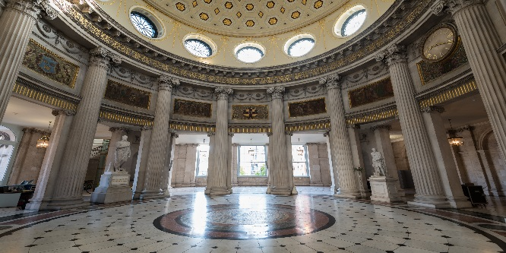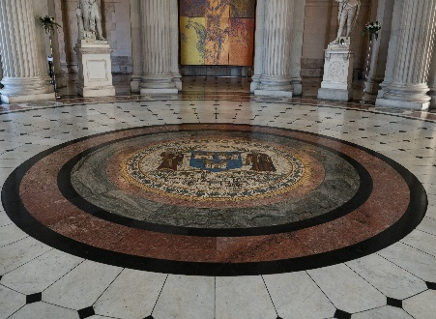

Wedding Enquiries

Proposed Wedding Date Yes, my date is flexible

Name

Telephone

Email

Number of guests

Message

