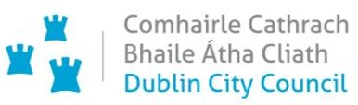

**Chief Executive’s Office**

**Floor 4 Block 4**

**Civic Offices**

**Wood Quay**

**15 February 2021**

**Memo to the Lord Mayor and Elected Members**

**of the City Council**

**COVID-19 Mobility Measures Update**

Contents

1. Introduction 3

1.1 Pedestrian Volumes 3

1.2 Cycling Volumes 4

1.3 Bus Passenger Numbers 5

1.4 General Traffic Volumes 6

2. Implementation of Measures 6

2.1 Pedestrian Crossings 6

*Mountjoy Square* 6

*Finglas Village* 6

2.2 Protected Cycle Facilities and Contra-Flow Facilities 7

*Strand Road Cycle Route Trial* 7

*Griffith Avenue Cycle Route* 8

*Parnell Square East Contra-flow* 8

*Bull Wall* 8

2.3 On-street Cycle Parking 8

2.4 School Mobility Programme 9

2.5 Cycle & Scooter Parking for Schools & Sports Clubs 10

3. Communications 10

3.1 Website 10

3.2 DCC Consultation Hub/Citizen Space 10

3.3 Dedicated COVID-19 Mobility Measure Request Form 11

3.4 COVID-19 Mobility E-Mail 11

3.5 Councillor Updates 12

3.6 Business Liaison 12

3.7 Active Travel Promotion 12

# 1. Introduction

Implementation of the COVID Mobility Programme for the City Council area continues with an emphasis on schools and safe zones. The continuation of Level 5 restrictions means that there are reduced volumes and activity, however walking and cycling projects and particularly those being implemented as part of a COVID response are deemed to be critical infrastructure and work can proceed in these areas.

As some members of the COVID Mobility Team have now transferred to TAG the number of projects being undertaken has reduced.

## 1.1 Pedestrian Volumes

The footfall counters count continuously and provide 24 hour data. These counters are located between Stephen’s Green and Henry St. These show that footfall in this core area had reached a high of around 60% of pre-COVID levels. Footfall increased during December but has dropped dramatically since Level 5+ restrictions were re-introduced and has remained pretty steady since then.

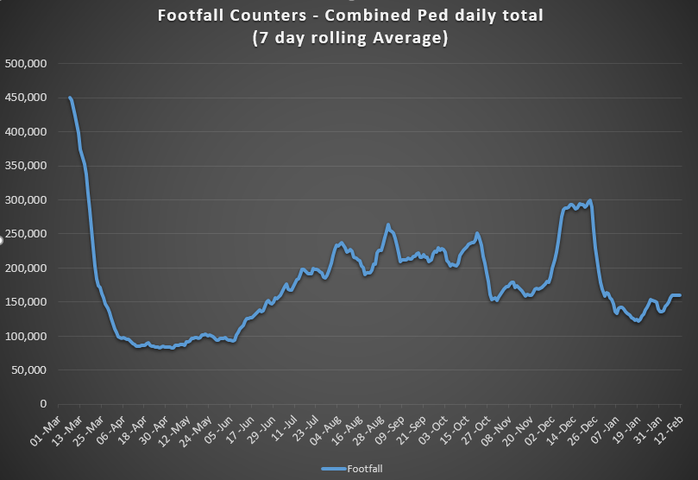

Looking back over 2020, and comparing it to 2019, it is clear how footfall in the city centre was affected by Covid-19. While footfall rose during the summer months and in December, when restrictions were more relaxed, levels were still far below pre-Covid volumes.

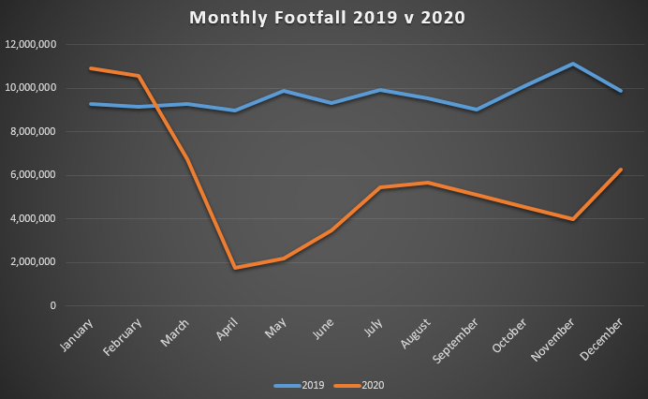

## 1.2 Cycling Volumes

Cycling volumes, which are continuously monitored by City Council’s counters (located at Grove Road, North Strand Road, Charleville Mall and Guild Street) show numbers held steady during December but have since decreased to the levels last seen back in April 2020.

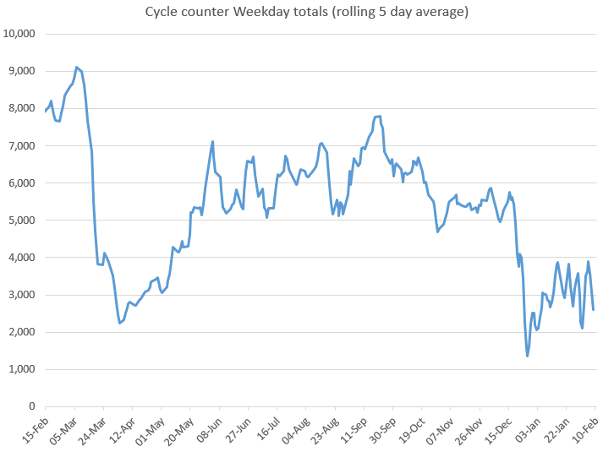

A monthly comparison of 2019 and 2020 shows that cycle numbers overall were down in 2020 but not to the same extent as footfall. Cycling numbers at the weekend increased quite dramatically during 2020.

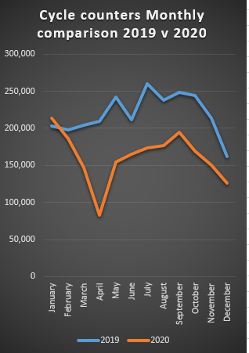 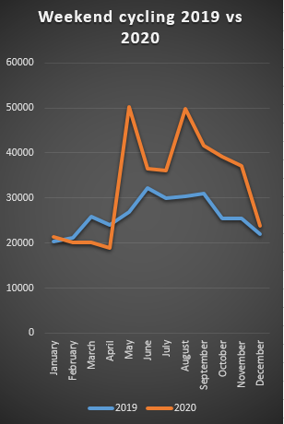

## 1.3 Bus Passenger Numbers

Passenger numbers increased steadily following the relaxation of capacity restrictions in June from 20% to 50%. The return of students to public passenger services in September pushed passenger numbers to 50% of pre-COVID levels. Passenger demand declined slightly from mid-September following the introduction of Level 3 restrictions for Dublin. The co-occurrence of mid-term break (26 October) and level 5 restrictions (capacity was reduced to 25%) saw passenger numbers fall to 26% of pre-COVID levels. Passenger numbers improved to 35% of pre-COVID passenger levels following the mid-term break. The relaxation of the restrictions to Level 3 in December resulted in an immediate improvement in passenger numbers to 50% of pre-COVID levels. Passenger levels currently remain static at approximately 23% of January 2020 levels.

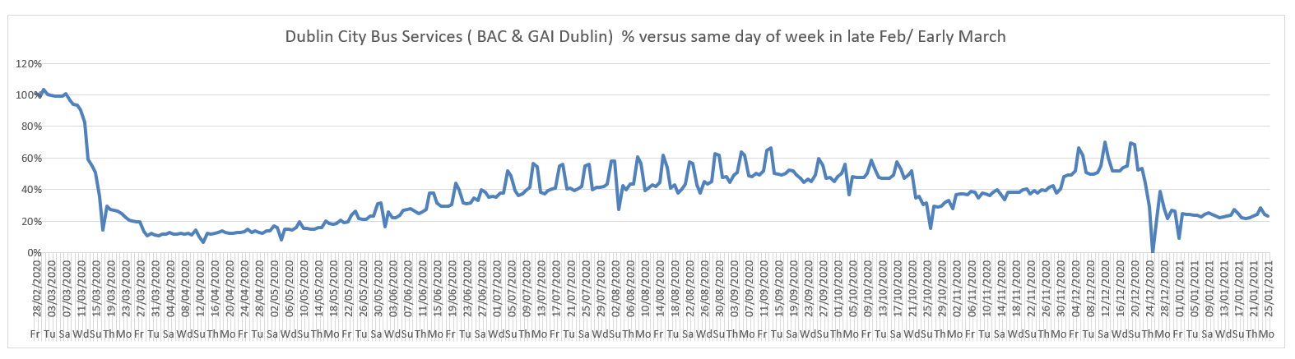

## 1.4 General Traffic Volumes

For the month of January, with Level 5 restrictions, traffic volumes crossing the canal cordon have remained at a consistent 55% to 59% compared to pre-COVID volumes.

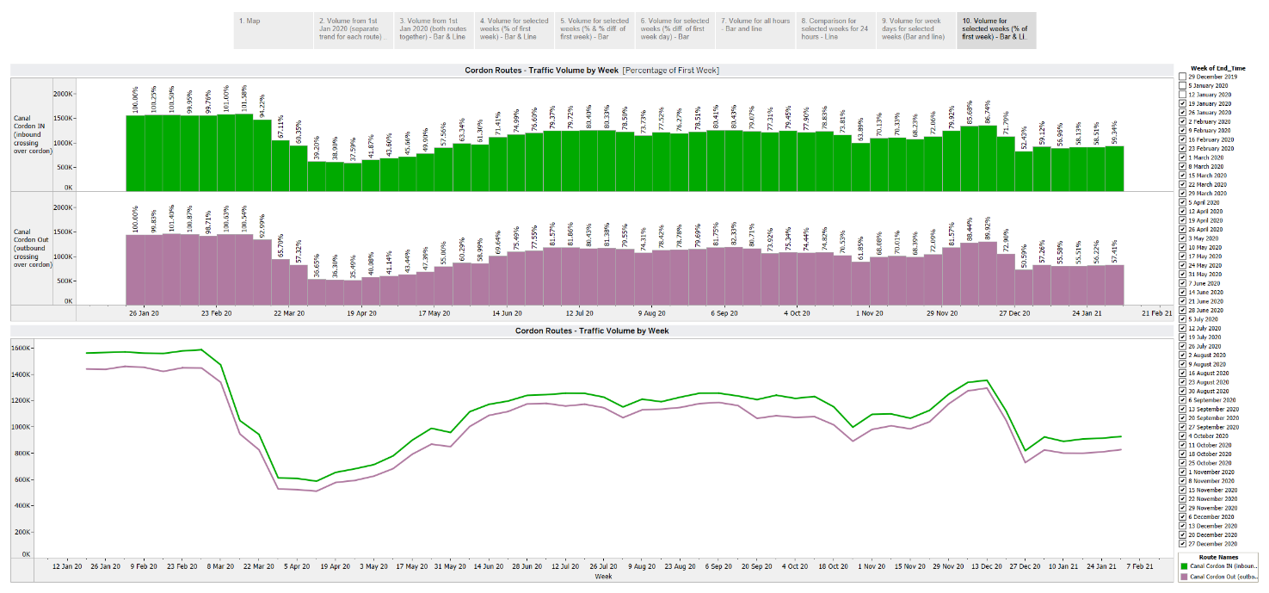

# 2. Implementation of Measures

## 2.1 Pedestrian Crossings

### *Mountjoy Square*

We are in the process of awarding the contract and hope to start works later this month.

### *Finglas Village*

The installation of two uncontrolled crossings in Finglas Village, at the junction with Finglas Main Street and Jamestown Road, is now complete. The upgrade of the footpath on Finglas Main Street from Mace to Iceland is also complete.

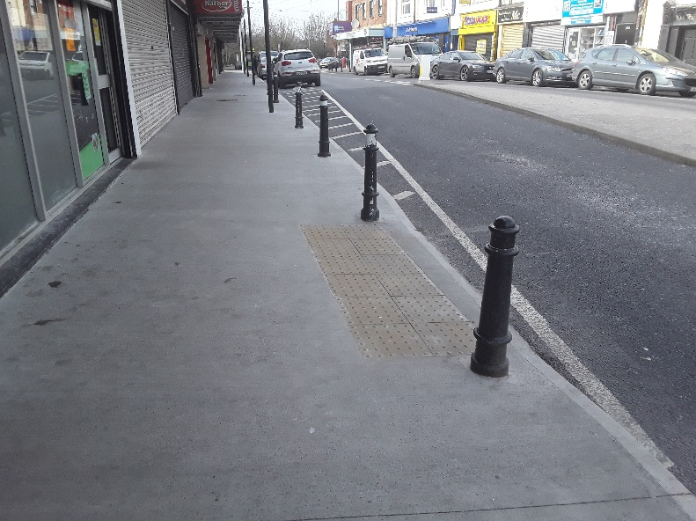 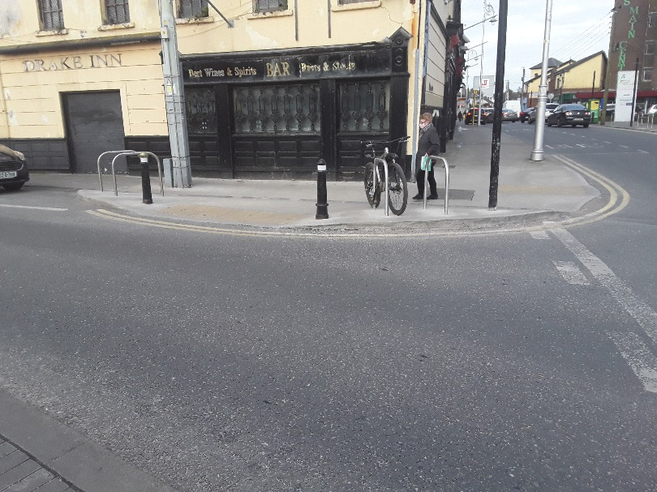

*Footpath upgrade, Main Street, Finglas Uncontrolled pedestrian crossings, Finglas Village*

## 2.2 Protected Cycle Facilities and Contra-Flow Facilities

### *Strand Road Cycle Route Trial*

The report for the Beach Road consultation was published on 5 February 2021. The conclusions were as follows:

* 3,712 submissions were received as part of the non-statutory public consultation process and
* 57% of respondents who chose an option preferred the one way vehicular traffic, on road cycle lanes and retaining the footpath option

The Beach Road arrangement for the trial will be one way traffic, on road cycle lane and no changes to the footpaths.

Advance works for the installation of the cycle route will begin on 15 February 2021. This includes works at the pedestrian crossings and roundabouts. There will be no changes to existing traffic until 1 March 2021.

**Traffic changes in the area – starting 1 March, 2021 are as follows:**

* Southbound vehicular traffic only on Strand Road and Beach Road.
* No right or left turn from Merrion Road to Strand Road.
* All existing right turn bans from Merrion Road towards Sandymount will remain.
* Two way traffic between Merrion Gates and St Alban’s Park will be maintained temporarily to facilitate local traffic until the works at Merrion Road, including the new right turn from Strand Road, are complete.

The cycle lane will open by the end of March 2021.

Leaflets are being distributed this week to approximately 8,000 households in the Sandymount, Irishtown, Ringsend and Ballsbridge area. A new air monitor Unit has been installed in Sandymount village. The data is available online at <https://dublincityairandnoise.ie/>

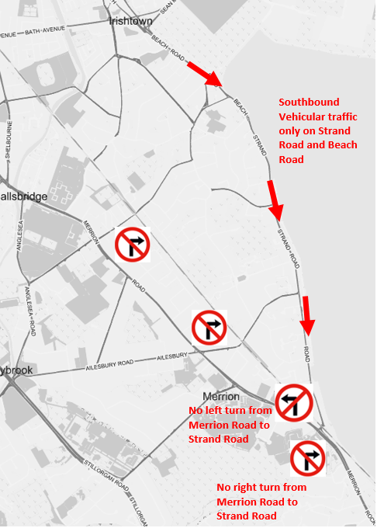

### *Griffith Avenue Cycle Route*

Bollards protecting the cycle lanes on the section between Walnut Rise and Swords Road were installed last weekend. The weather has been too cold and/or wet to install road markings at present. The remaining road markings for this section will be laid as soon as the weather is suitable.

### *Parnell Square East Contra-flow*

Civil works are now complete. Progress is being impacted by the fact that the weather is not conducive to making the necessary alterations to the road markings. However, these will be completed as soon as the weather permits and we are still aiming to have the contra-flow lane operational by the end of this month (February).

### *Bull Wall*

Feedback has been positive on the works completed to date and we now intend on extending the footpath protection and the introduction of formal parking as far as the Wooden Bridge.

## 2.3 On-street Cycle Parking

Under the 2020 programme, contracts for the installation of 819 stands at 168 locations were awarded. A further 74 stands at 16 locations will be installed as part of the 2020 programme.

Under the 2021 programme, the installation of a further 1,000 stands is planned. It is expected that a contractor for the next batch (165 stands at 34 locations) will be appointed officially before the end of February with installations due to commence in March/April.

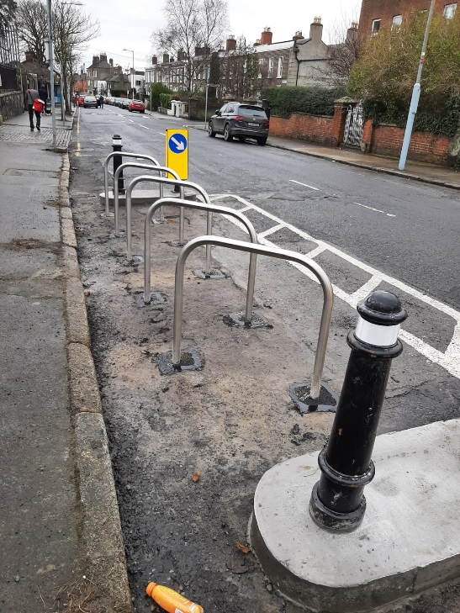 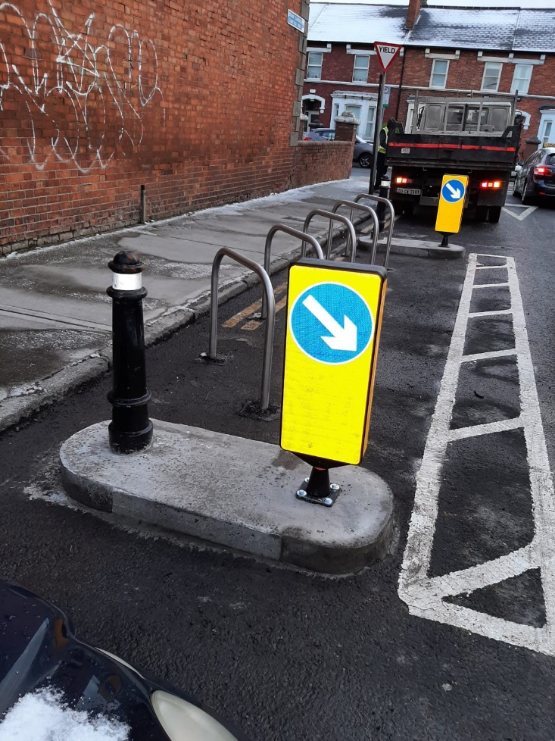

*Aughrim Street, Stoneybatter Clareville Road, Harold’s Cross*

## 2.4 School Mobility Programme

The application list for a ***School Zone*** stands at 105 schools. The COVID Mobility Technical Team are assessing all submissions for suitability and schools will be contacted with timelines, if it is deemed to be an appropriate intervention at the particular location.

The breakdown of the School Zones completed per administrative area of Dublin City is 10 for the South Central Area, 9 for the South East Area, 9 for the Central Area, 4 for the North West Area and 3 for the North Central Area.

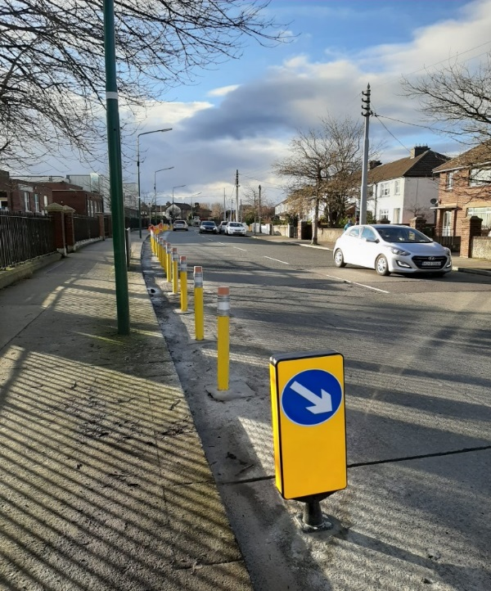

*Pencils Bollards installed outside Scoil Mologa Clareville Road, Harold’s Cross*

In the past two weeks, installation of the School Zone Treatment occurred at the following schools:

* St Ultan’s School, Cherry Orchard Avenue, Cherry Orchard,
* Harold’s Cross Primary School, Clareville Road Harold’s Cross and
* Scoil Mológa, Clareville Road, Harold’s Cross.

The next installations are due to take place at:

* Scoil Fhursa, Cromcastle Green, Kilmore West, Dublin 5,
* Scoil Íde, GNS, Cromcastle Green, Kilmore West, Dublin 5,
* Our Lady of Good Counsel GNS, Knocknarea Road, Drimnagh,
* Our Lady of Good Counsel BNS, Sperrin Road, Drimnagh,
* Our Lady of Good Counsel Infant School, Drimnagh,
* Scoil Una Naofa, Armagh Road, Crumlin and
* Ranelagh Multi Denomination, Ranelagh.

There are a further 9 schools, 6 on the Northside and 5 on the Southside at design stage, subject to final consultation with school Principals and the NTA. These will be completed over the coming weeks.

Site observation visits by technical staff and School Mobility Officers will be conducted for all schools who have applied. The current COVID restrictions and the closure of schools will mean that in general, works will be completed on schools where the designs have already been agreed and survey work and design proposals drawn up for other locations.

The interviews and observations during these visits will facilitate the co-design of supports and resource materials appropriate for each school. Schools within a proposed or completed school zone location will be encouraged to work collaboratively with the community to gain the best possible outcome from the School Zone installation.

## 2.5 Cycle & Scooter Parking for Schools & Sports Clubs

The City Council has been granted funding from the NTA to deliver cycle and scooter parking to schools and sports clubs in the DCC administrative area. This round of applications is open until 15 February, 2021. We have received applications from 31 schools and 28 sports clubs so far. Applications can be made online:

* [Application page for Schools](https://consultation.dublincity.ie/traffic-and-transport/c1f02224/)
* [Application page for Sports Clubs](https://consultation.dublincity.ie/traffic-and-transport/ab3e6bf0/)

# 3. Communications

## 3.1 Website

The [COVID Mobility webpage](http://www.dublincity.ie/COVID-19mobilityprogramme), is being updated regularly to keep the general public informed of COVID-19 mobility interventions. As previously advised we will be making more extensive use of the Consultation Hub in order to provide more information on measures.

## 3.2 DCC Consultation Hub/Citizen Space

Details of schemes on the Consultation Hub at present include:

[Griffith Avenue Protected Cycle Track](https://consultation.dublincity.ie/traffic-and-transport/griffith-avenue-protected-cycle-track/)

Members are alerted on a regular basis to any new proposals, which are available to view on the Consultation Hub and aim to have a more dynamic process for ensuring that support for projects, suggestions on how to improve them and concerns and issues, which may need to be addressed, can be better handled. Any feedback on this approach is welcome.

## 3.3 Dedicated COVID-19 Mobility Measure Request Form

Since our last update on 1 February 2021, we have received 12 new requests for COVID Mobility Measures. This brings the total number of COVID Mobility requests to 5,157. A breakdown of these requests is given below.

**Mobility measure requested Number**

Footpath widening 689

Increased queuing space at bus stops 134

Pedestrian area 803

Protected cycle lanes 1195

Contra-flow cycle lanes 381

Cycle parking facilities 512

Outdoor seating area 587

Commercial / Retail deliveries support 79

Support and advice for active travel (walking & cycling) 303

Journey planning 78

Other 385

Not answered 11

**Total requests 5,157**

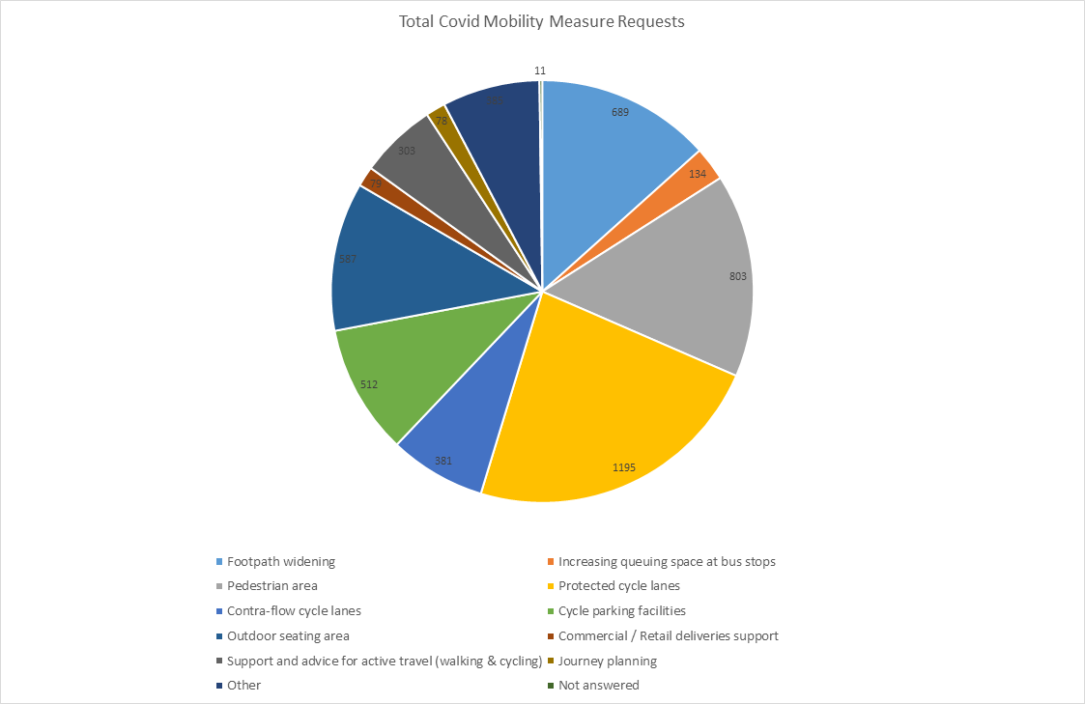

## 3.4 COVID-19 Mobility E-Mail

The dedicated e-mail address continues as the primary channel to contact the COVID Mobility Team. It is attracting huge volumes of queries and feedback. The intention is that the e-mail is for general queries and the COVID-19 Mobility Request Form should be used for specific requests at specific locations.

## 3.5 Councillor Updates

Updates on COVID-19 mobility measures are issued on a fortnightly basis to Elected Members. Updates via e-mail are also being issued to stakeholders via the Transportation SPC and to the NTA for distribution to disability user groups.

## 3.6 Business Liaison

The Business Liaison Officer continues to engage and consult with businesses on a number of COVID Mobility Measures citywide.

## 3.7 Active Travel Promotion

We are continuing to utilise Dublin City Council Social Media Channels:

* + - to highlight COVID-19 mobility measures that have been implemented;
    - to encourage the public to walk or cycle, where possible;
    - to encourage social distancing as people move around the city and
    - to encourage more respect for vulnerable road users

Owen P Keegan

**Chief Executive**