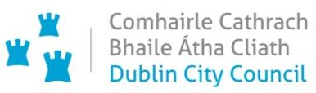

**Chief Executive’s Office**

**Floor 4 Block 4**

**Civic Offices**

**Wood Quay**

**1 February 2021**

**To the Lord Mayor and Elected Members**

**of the City Council**

**COVID-19 Mobility Measures Update**

Contents

1. Introduction 2

1.1 Pedestrian Volumes 2

1.2 Cycling Volumes 2

1.3 Bus Passenger Numbers 4

1.4 General Traffic Volumes 4

2. Implementation of Measures 5

2.1 Pedestrian Crossings 5

*Mountjoy Square* 5

2.2 Protected Cycle Facilities and Contra-Flow Facilities 5

*Strand Road Cycle Route Trial* 5

*Griffith Avenue Cycle Route* 5

*Parnell Square East Contra-flow* 5

*Bull Wall* 6

2.3 On-street Cycle Parking 6

2.4 School Mobility Programme 6

2.5 Cycle & Scooter Parking for Schools & Sports Clubs 7

3. Communications 7

3.1 Website 7

3.2 DCC Consultation Hub/Citizen Space 7

3.3 Dedicated COVID-19 Mobility Measure Request Form 8

3.4 COVID-19 Mobility E-Mail 8

3.5 Councillor Updates 9

3.6 Business Liaison 9

3.7 Active Travel Promotion 9

# 1. Introduction

Implementation of the COVID Mobility Programme for the City Council area continues with an emphasis on schools and safe zones. The reintroduction of Level 5 restrictions means that there are reduced volumes and activity, however walking and cycling projects and particularly those being implemented as part of a COVID response are deemed to be critical infrastructure and work can proceed in these areas.

As some members of the COVID Mobility Team have now transferred to TAG the number of projects being undertaken will reduce.

## 1.1 Pedestrian Volumes

The footfall counters count continuously and provide 24 hour data. These counters are located between Stephen’s Green and Henry St. These show that footfall in this core area had reached a high of around 60% of pre-COVID levels. Footfall increased during December but has dropped dramatically since Level 5+ restrictions were re-introduced with a slight increase in the last week.

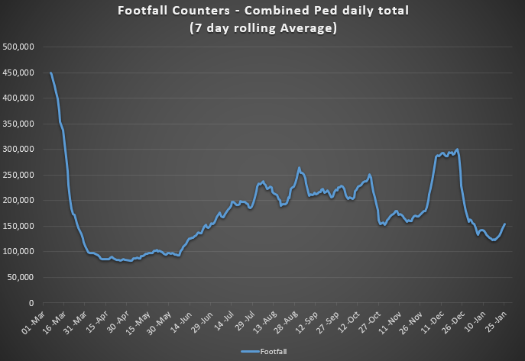

## 1.2 Cycling Volumes

Cycling volumes, which are continuously monitored by City Council’s counters (located at Grove Road, North Strand Road, Charleville Mall and Guild Street) show numbers held steady during December but have since decreased to the levels last seen back in April 2020.

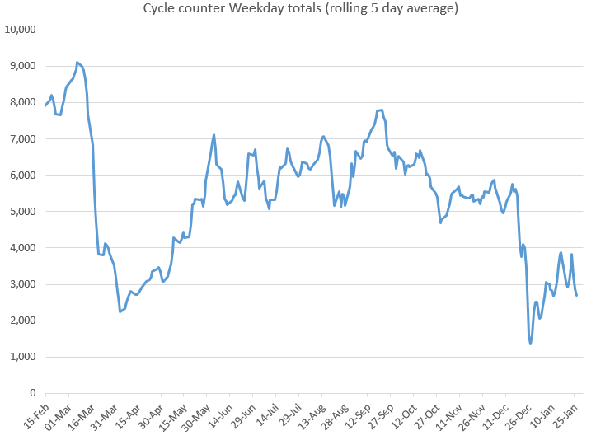

During the peak morning time, 7am to 10am, cycling numbers are at approximately 20% of pre-COVID levels for January 2021. In contrast, the off peak cycling figures which exceeded 2019 weekly figures for most of 2020 are showing slightly lower levels in January 2021, than was seen in January 2020.

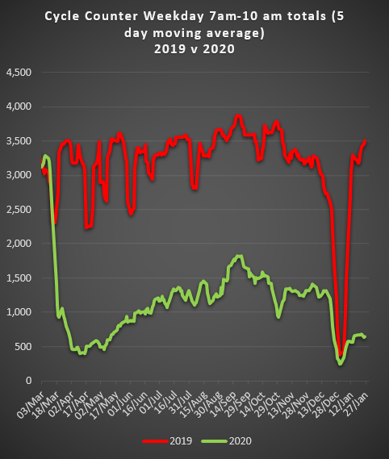 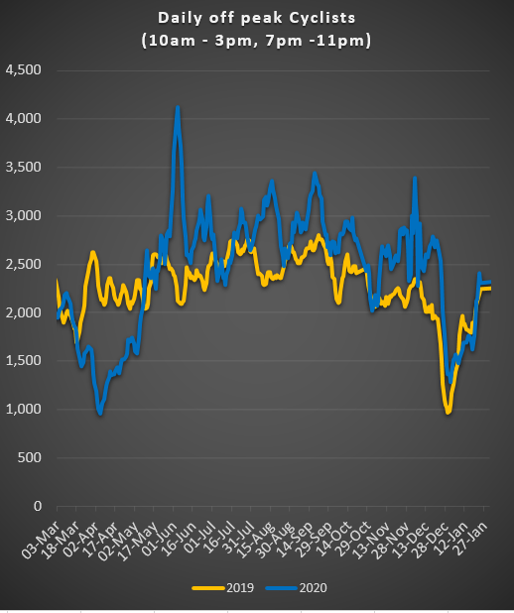

## 1.3 Bus Passenger Numbers

Passenger numbers increased steadily following the relaxation of capacity restrictions in June from 20% to 50%. The return of students to public passenger services in September pushed passenger numbers to 50% of pre-COVID levels. Passenger demand declined slightly from mid-September following the introduction of level 3 restrictions for Dublin. The co-occurrence of mid-term break (26 October) and level 5 restrictions impacted passenger numbers significantly, capacity was reduced to 25% and passenger numbers fell to 26% of pre-COVID levels. Passenger numbers improved to 35% of pre-COVID passenger levels following the mid-term break. The relaxation of the restrictions to level 3 in December resulted in an immediate improvement in passenger numbers to 50% of pre-COVID evels. Passenger levels currently remain static at approximately 23% of January 2020 levels.

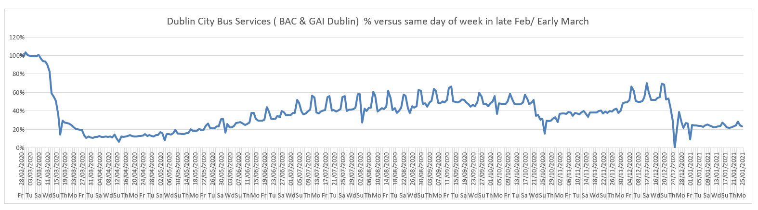

## 1.4 General Traffic Volumes

Traffic volumes crossing the cordon have maintained a constant 55% to 59% of pre COVID levels over the last 3 weeks.

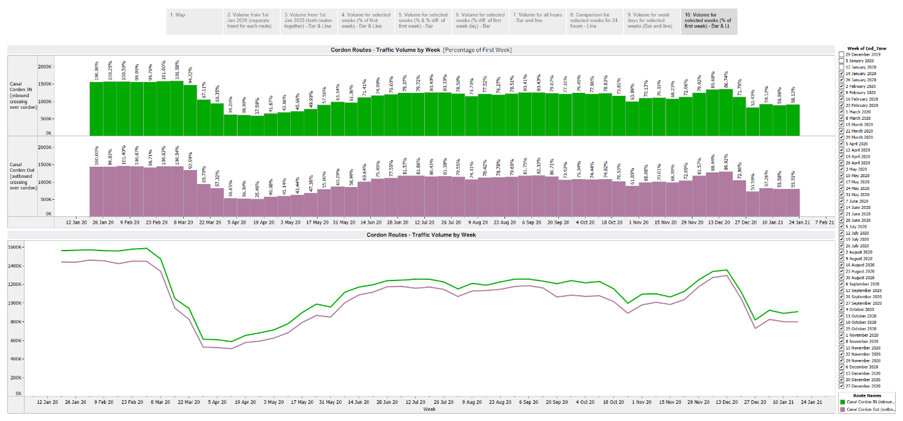

# 2. Implementation of Measures

## 2.1 Pedestrian Crossings

### *Mountjoy Square*

We are currently assessing the tenders received for this project and would intend to have a contractor appointed in early February, 2021.

## 2.2 Protected Cycle Facilities and Contra-Flow Facilities

### *Strand Road Cycle Route Trial*

The consultation for the Beach Road section of the trial finished on 22 January. There were 3,706 online submissions which are currently being assessed.

### *Griffith Avenue Cycle Route*

Bollards protecting the cycle lanes on the section between Walnut Rise and Swords Road were installed last weekend. The weather has been too cold and/or wet to install road markings at present. The remaining road markings for this section will be laid as soon as the weather is suitable.

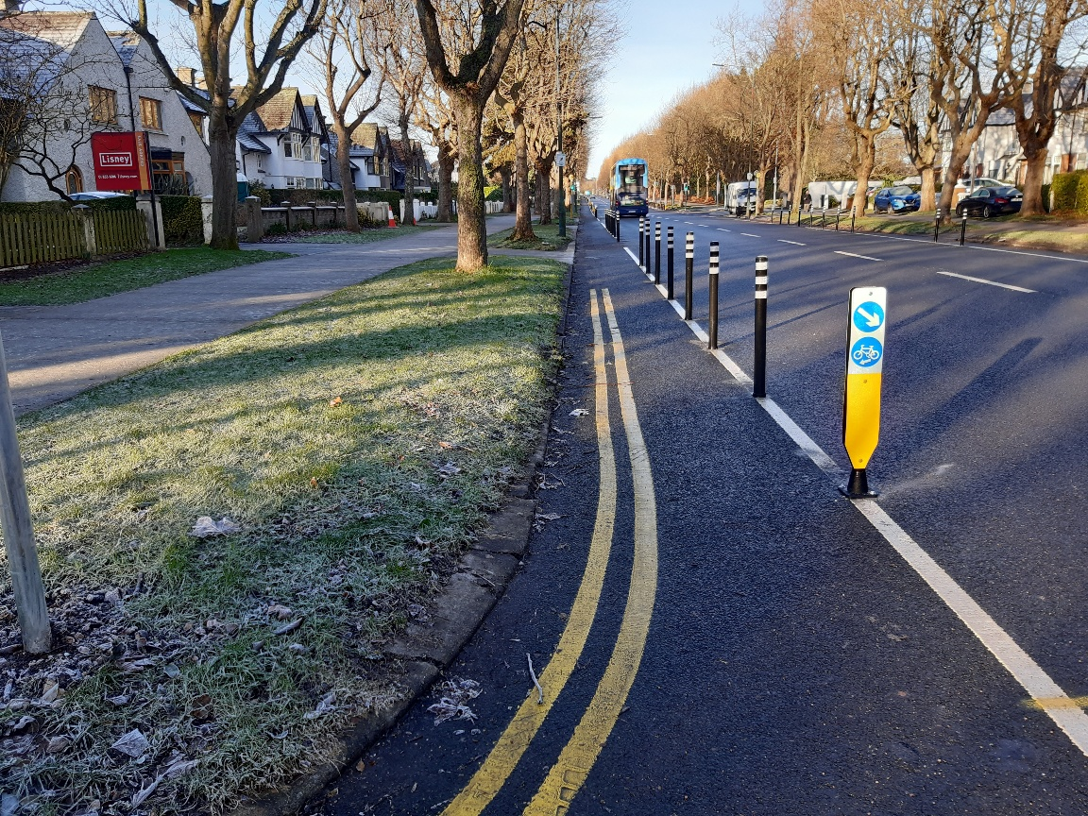 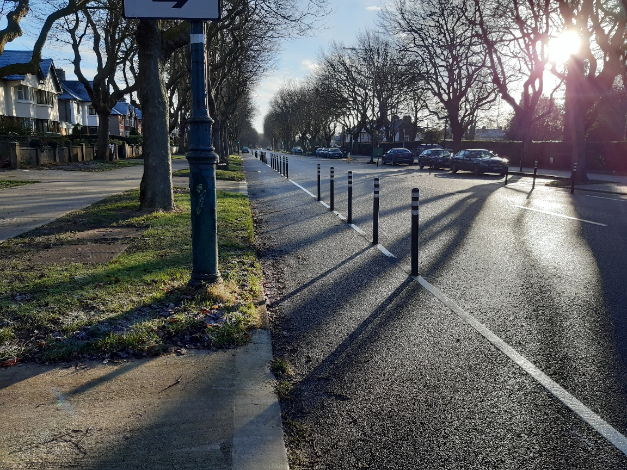

### *Parnell Square East Contra-flow*

Works to modify the junctions along the route on Parnell Square East to facilitate the contra-flow are continuing. It is anticipated that we will be in a position to open the contraflow next month.

### *Bull Wall*

We have requested feedback on the recent measures installed on the Bull Wall. If feedback is positive, works to extend the protection of the footpath and the introduction of formal parking bays as far as the Wooden Bridge will take place during February.

## 

## 2.3 On-street Cycle Parking

Under the 2020 programme, contracts for the installation of 819 stands at 168 locations were awarded. A further 74 stands at 16 locations will be installed as part of the 2020 programme.

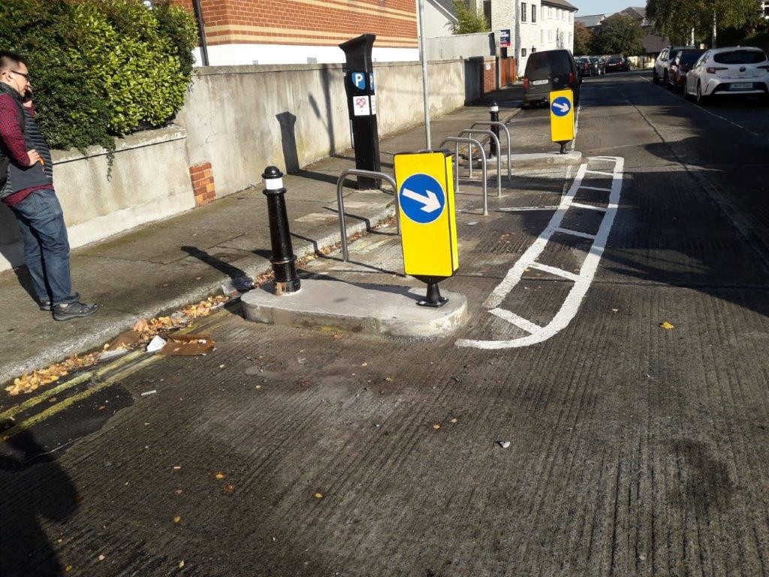 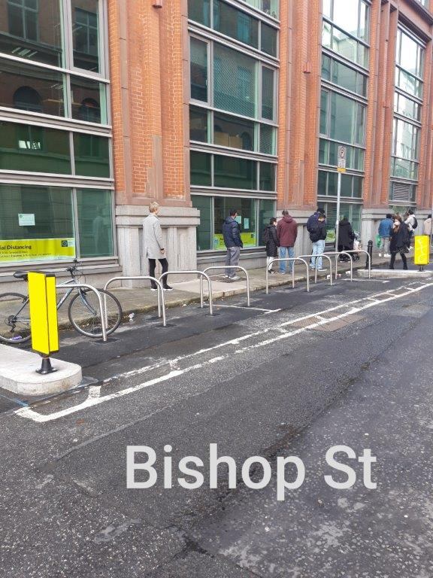

## 2.4 School Mobility Programme

The application list for a ***School Zone*** nowstands at 103 schools. The COVID Mobility Technical Team are assessing all submissions for suitability. Schools will be contacted with timelines, if it is deemed to be an appropriate intervention at the particular location.

The breakdown of the 29 School Zones completed to date by administrative area is as follows:

* South Central Area 7
* South East Area 7
* Central Area 9
* North West Area 3
* North Central Area 3

The next installations are due to take place at:

* Scoil Fhursa, Cromcastle Green, Kilmore West, Dublin 5
* Scoil Íde, GNS, Cromcastle Green, Kilmore West, Dublin
* Our Lady of Good Counsel GNS, Knocknrea Road, Drimnagh, Dublin 12
* Our Lady of Good Counsel BNS, Sperrin Road, Drimnagh, Dublin 12
* Our Lady of Good Counsel Infant School, Drimnagh, Dublin 12
* St Ultan’s School, Cherry Orchard Avenue, Cherry Orchard, Dublin 10
* St Harold’s Cross Primary School, Clareville Road Harold’s Cross, Dublin 6
* Scoil Mológa, Clareville Road, Harrold’s Cross, Dublin 6

There are a further 5 schools, 3 on the Northside and 2 on the Southside, at final design stage. Subject to final consultation with school Principals and the NTA, these will be completed over the coming weeks.

There are 10 schools at preliminary design stage with the NTA, 8 of which are in a 50km/h speed limit zone and 1 which requires design to have regard to the conservation of cobblestones.

Site observation visits from technical and Schools Outreach Officers will be conducted for all schools who have applied. The current COVID restrictions and the closure of schools will mean that, in general, works will be completed on schools where the designs have already been agreed and survey work and design proposals drawn up for other locations. The interviews and observations during these visits will facilitate the co-design of supports and resource materials appropriate for each school. Schools within a proposed or completed School Zone location will be encouraged to work collaboratively with the community to gain the best possible outcome from the School Zone installation.

## 2.5 Cycle & Scooter Parking for Schools & Sports Clubs

The City Council has been granted funding from the NTA to deliver cycle and scooter parking to schools and sports clubs in the DCC administrative area. This round of applications is open until 15 February, 2021. We have received applications from 13 schools and 15 sports clubs so far. Applications can be made online:

* [Application page for Schools](https://consultation.dublincity.ie/traffic-and-transport/c1f02224/)
* [Application page for Sports Clubs](https://consultation.dublincity.ie/traffic-and-transport/ab3e6bf0/)

# 

# 3. Communications

## 3.1 Website

The [COVID Mobility webpage](http://www.dublincity.ie/COVID-19mobilityprogramme), is being updated regularly to keep the general public informed of COVID-19 mobility interventions. As previously advised we will be making more extensive use of the Consultation Hub in order to provide more information on measures.

## 3.2 DCC Consultation Hub/Citizen Space

Details of schemes on the Consultation Hub at present include:

[Griffith Avenue Protected Cycle Track](https://consultation.dublincity.ie/traffic-and-transport/griffith-avenue-protected-cycle-track/)

Members are alerted on a regular basis to any new proposals, which are available to view on the Consultation Hub and aim to have a more dynamic process for ensuring that support for projects, suggestions on how to improve them and concerns and issues, which may need to be addressed, can be better handled. Any feedback on this approach is welcome.

## 3.3 Dedicated COVID-19 Mobility Measure Request Form

Since our last update on 18 January , 2020, we have received 42 new requests for COVID Mobility Measures. This brings the total number of COVID Mobility requests to 5,145. A breakdown of these requests is given below.

Footpath widening, 686

Increasing queuing space at bus stops, 134

Pedestrian area, 802

Protected cycle lanes, 1,191

Contra-flow cycle lanes, 381

Cycle parking facilities, 510

Outdoor seating area, 587

Commercial / Retail deliveries support, 79

Support and advice for active travel (walking & cycling), 303

Journey planning, 78

Other, 383

Not answered, 11

**Total requests, 5,145**

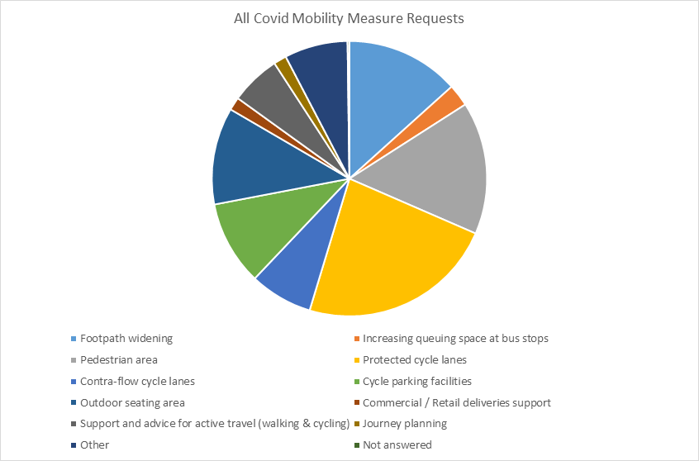

## 3.4 COVID-19 Mobility E-Mail

The dedicated e-mail address continues as the primary channel to contact the COVID Mobility Team. It is attracting huge volumes of queries and feedback. The intention is that the e-mail is for general queries and the COVID-19 Mobility Request Form should be used for specific requests at specific locations.

## 3.5 Councillor Updates

Updates on COVID-19 mobility measures are issued on a weekly basis to Elected Members. Updates via e-mail are also being issued to stakeholders via the Transportation SPC and to the NTA for distribution to disability user groups.

## 3.6 Business Liaison

The Business Liaison Officer continues to engage and consult with businesses on a number of COVID Mobility Measures citywide.

## 3.7 Active Travel Promotion

We are continuing to utilise Dublin City Council Social Media Channels:

* + - to highlight COVID-19 mobility measures that have been implemented;
    - to encourage the public to walk or cycle, where possible;
    - to encourage social distancing as people move around the city and
    - to encourage more respect for vulnerable road users

Owen P Keegan

**Chief Executive**