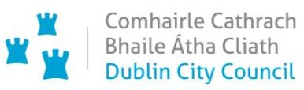

**Chief Executive’s Office**

**Floor 4 Block 4**

**Civic Offices**

**Wood Quay**

**16 March 2021**

**Memo to the Lord Mayor and Elected Members**

**of the City Council**

**COVID-19 Mobility Measures Update**

Contents

1. Introduction 2

1.1 Pedestrian Volumes 2

1.2 Cycling Volumes 3

1.3 Bus Passenger Numbers 4

1.4 General Traffic Volumes 4

2. Implementation of Measures 5

2.1 Protected Cycle Facilities, Contra-Flow Facilities and On-Street Cycle Parking 5

Strand Road Cycle Route Trial 5

Griffith Avenue Cycle Route 6

Parnell Square East Contra-flow 6

Bull Wall 6

On-Street Cycle parking 7

2.2 School Mobility Programme 7

2.3 Cycle & Scooter Parking for Schools & Sports Clubs 8

3. Communications 9

3.1 Website 9

3.2 DCC Consultation Hub/Citizen Space 9

3.3 Dedicated COVID-19 Mobility Measure Request Form 9

3.4 COVID-19 Mobility E-Mail 10

3.5 Councillor Updates 10

3.6 Business Liaison 10

3.7 Active Travel Promotion 10

# 1. Introduction

Implementation of the COVID Mobility Programme for the City Council area continues with an emphasis on schools and safe zones. The continuation of Level 5 restrictions means that there are reduced volumes and activity. However, walking and cycling projects, particularly those being implemented as part of a COVID response, are deemed to be critical infrastructure and work can proceed in these areas.

As some members of the COVID Mobility Team have now transferred to TAG the number of projects being undertaken has reduced.

## 1.1 Pedestrian Volumes

The footfall counters count continuously and provide 24 hour data. These counters are located between Stephen’s Green and Henry Street. These show that footfall in this core area had reached a high of around 60% of pre-COVID levels. Footfall increased during December but has dropped dramatically since Level 5+ restrictions were re-introduced and has been increasing at a steady but slow rate.

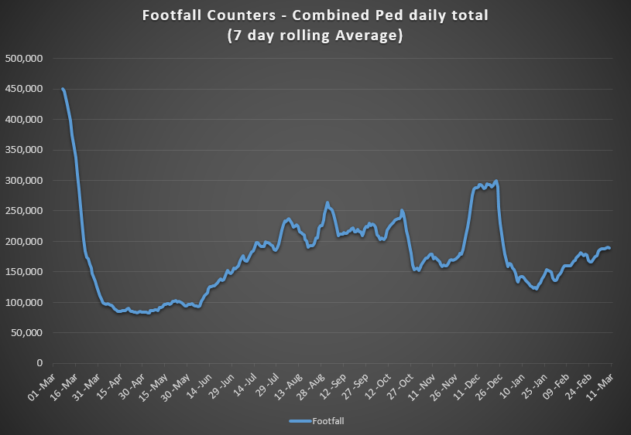

The monthly footfall for the first two months of 2021 compared to the previous 2 years at selected sites shows the signifcant differrence in footfall in the city centre compared to pre-Covid levels.

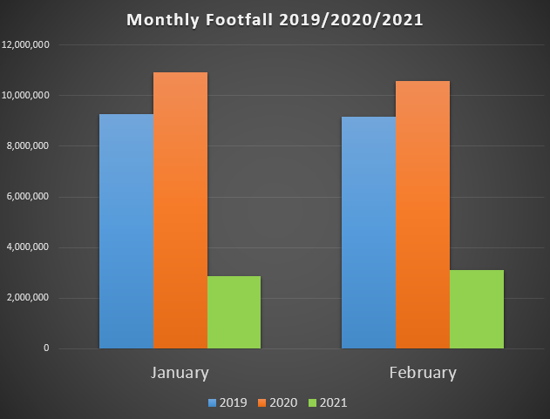

## 1.2 Cycling Volumes

Cycling volumes, which are continuously monitored by City Council’s counters (located at Grove Road, North Strand Road, Charleville Mall and Guild Street) show numbers held steady during December but have since decreased to approximately 50% of pre-Covid levels, although rising slightly during the last two weeks.

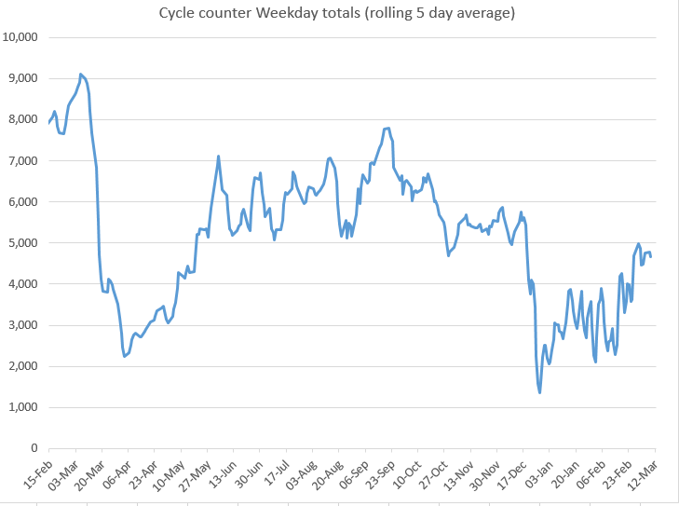

Cyclist numbers for 2021 show how the numbers have been increasing since the start of the year. Typically weekend figures for 2021 are greater than 2020.

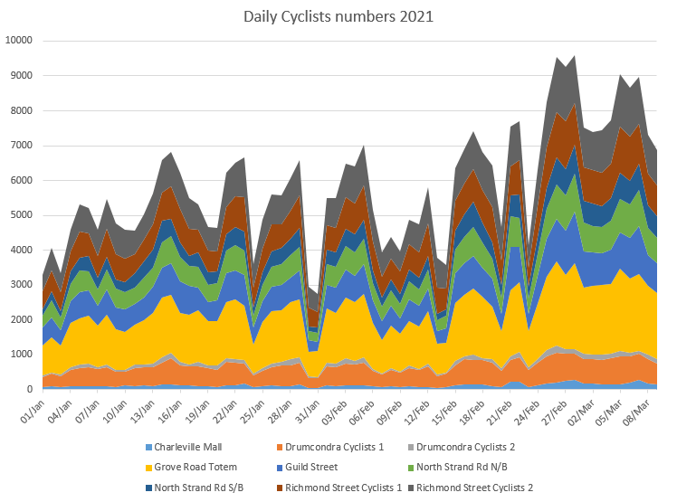

## 1.3 Bus Passenger Numbers

Bus passenger numbers remained reduced in 2021 with only minor fluctuations seen each week.

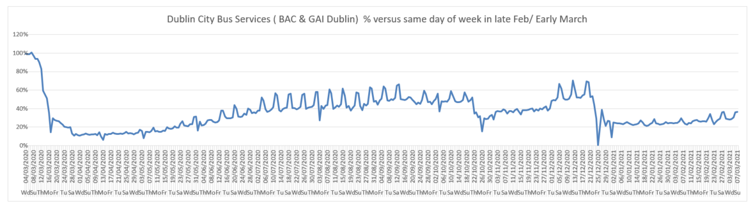

## 1.4 General Traffic Volumes

Over the last few weeks in 2021, the trend shows a slight increase in traffic volumes crossing the cordon. Volumes have increased approximately 1 to 2% in the past week.

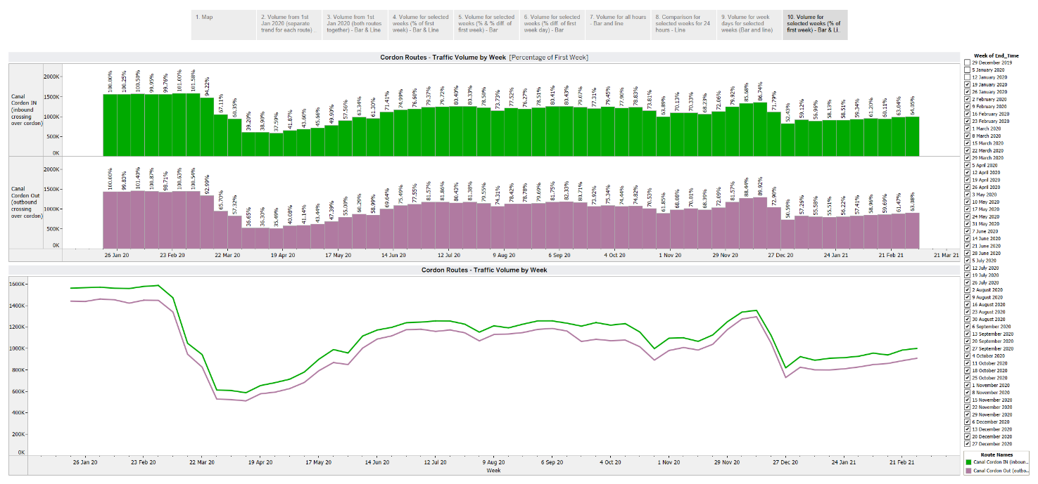

# 2. Implementation of Measures

## 2.1 Protected Cycle Facilities, Contra-Flow Facilities and On-Street Cycle Parking

### Strand Road Cycle Route Trial

The High Court stay on the City Council continuing the works on Strand Road means that the roadworks are now suspended and unfinished. In the interest of safety, from Monday 15 March, an enforceable 30km/h speed limit has been in place on Strand Road and Beach Road and will remain in place until further notice.

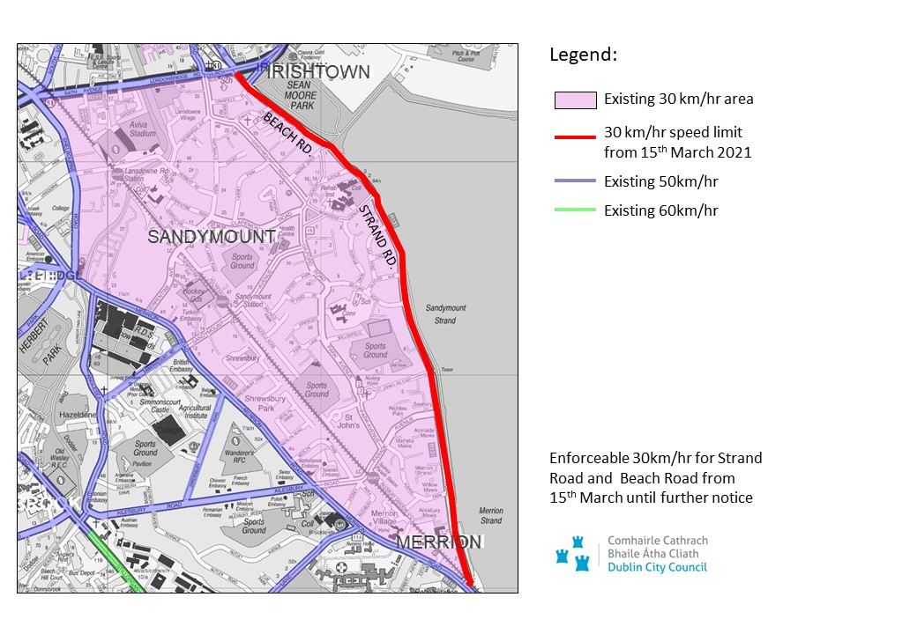

### Griffith Avenue Cycle Route

Works are continuing on installing road markings and it is intended that the protected cycle lanes will be installed between the Swords Road and Grace Park Road in the coming weeks.

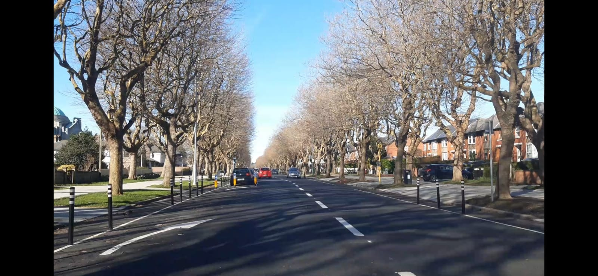

### Parnell Square East Contra-flow

Planters are due to be delivered at the end of March and when installed will significantly improve the appearance of the Contraflow. Works to extend the Contraflow up Blessington Street are anticipated to take place later this month

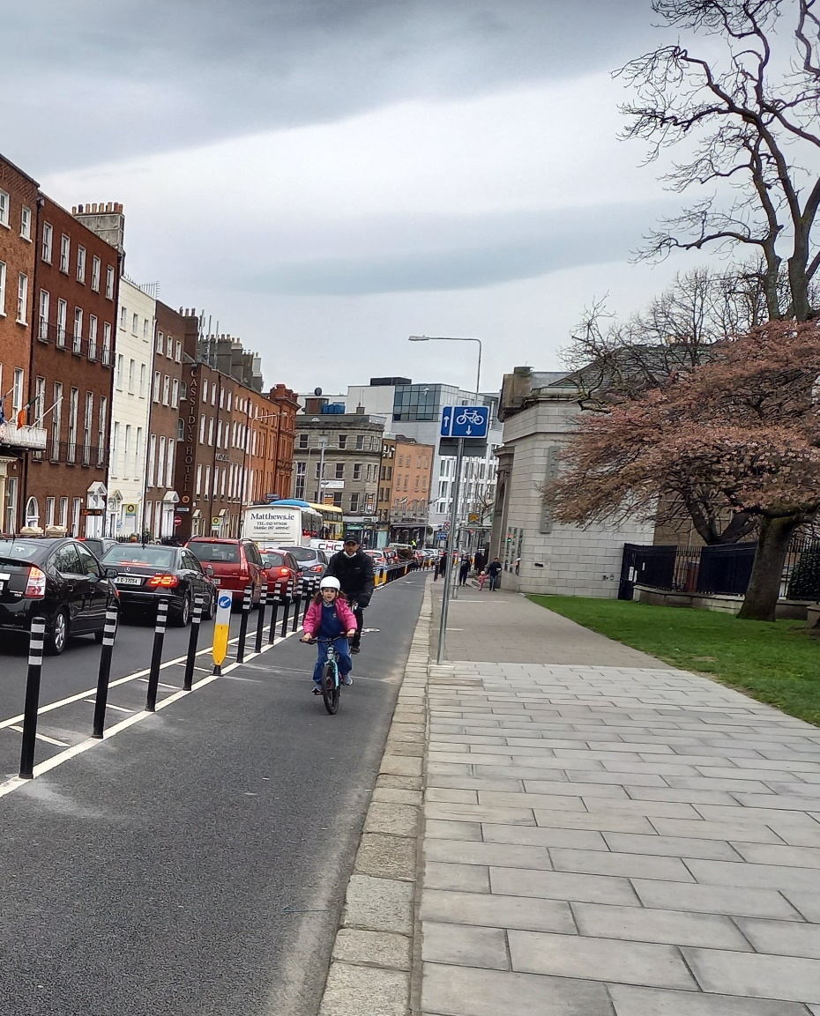

*Parnell Square East Protected Contra-Flow Cycle Lane*

### Bull Wall

Works taking place to protect the footpaths and regulate parking have been completed.

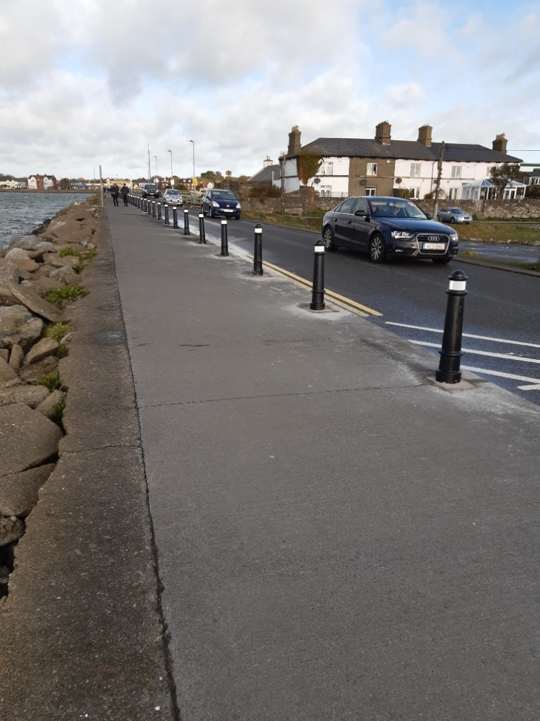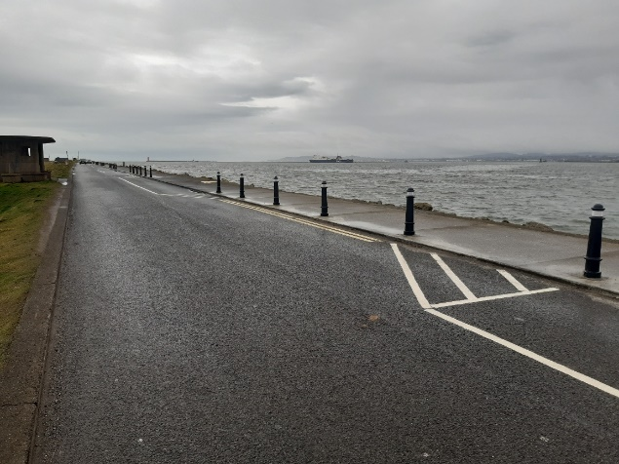

*Bollards protecting the footpath from illegal parking at Bull Wall*

### On-Street Cycle parking

There will be a slight delay in issuing the next batch of cycle parking as we are currently reviewing it to ensure it takes account of recent and upcoming cycle parking interventions in schools and also the latest standards for cycle parking that were recently adopted by the Traffic and Transportation Strategic Policy Committee.

## 2.2 School Mobility Programme

The application list for a ***School Zone*** currentlystands at 110 schools. The COVID Mobility Technical Team are assessing all submissions for suitability and schools will be contacted with timelines, if it is deemed to be an appropriate intervention at the particular location.

To date a total of 38 School Zones have been installed across the city. The breakdown of the School Zones completed per administrative area of Dublin City are 13 for the South Central Area, 9 for the South East Area , 9 for the Central Area , 4 for the North West Area and 3 North Central Area.

There are a total of 32 schools, 25 on the Northside and 7 on the Southside at design stage, subject to final consultation with school Principals and the NTA and we are aiming to have the below 11 School Zones installed in March/April.

* Our Lady of Lourdes NS, Vincent Street West, Inchicore, Dublin 8
* Scoil Úna Naofa, Armagh Road, Crumlin, Dublin 12
* Scoil Colaiste Eoin, Armagh Road, Crumlin, Dublin 12
* Scoil Fhursa, Cromcastle Green, Kilmore West, Dublin 5
* Scoil Íde GNS, Cromcastle Green, Kilmore West, Dublin 5
* Gaiscoil Nai-Ide, All Saints Drive, Raheny, Dublin 5
* Scoil Aine GNS, All Saints Drive, Raheny, Dublin 5
* Scoil Assaim BNS, Raheny, Dublin 5
* St Oliver Plunkett’s JNS, St Helena’s Drive Finglas, South, Dublin 11
* St. Kevin's Boys National School, Barry Avenue, Finglas West, Dublin 11
* St. Josephs GNS, Barry Avenue, Finglas West, Dublin 11.

Since the last report dated 26.2.2021 the Schools Outreach Officers have conducted a total of 32 site visits with School and Local Communities. This included site assessments with Neighborhood Engineers, site observation visits of travel to assess school behavior and meetings with school Principals and local communities. The Schools Outreach Officers will continue to carry out these visits on a weekly basis.

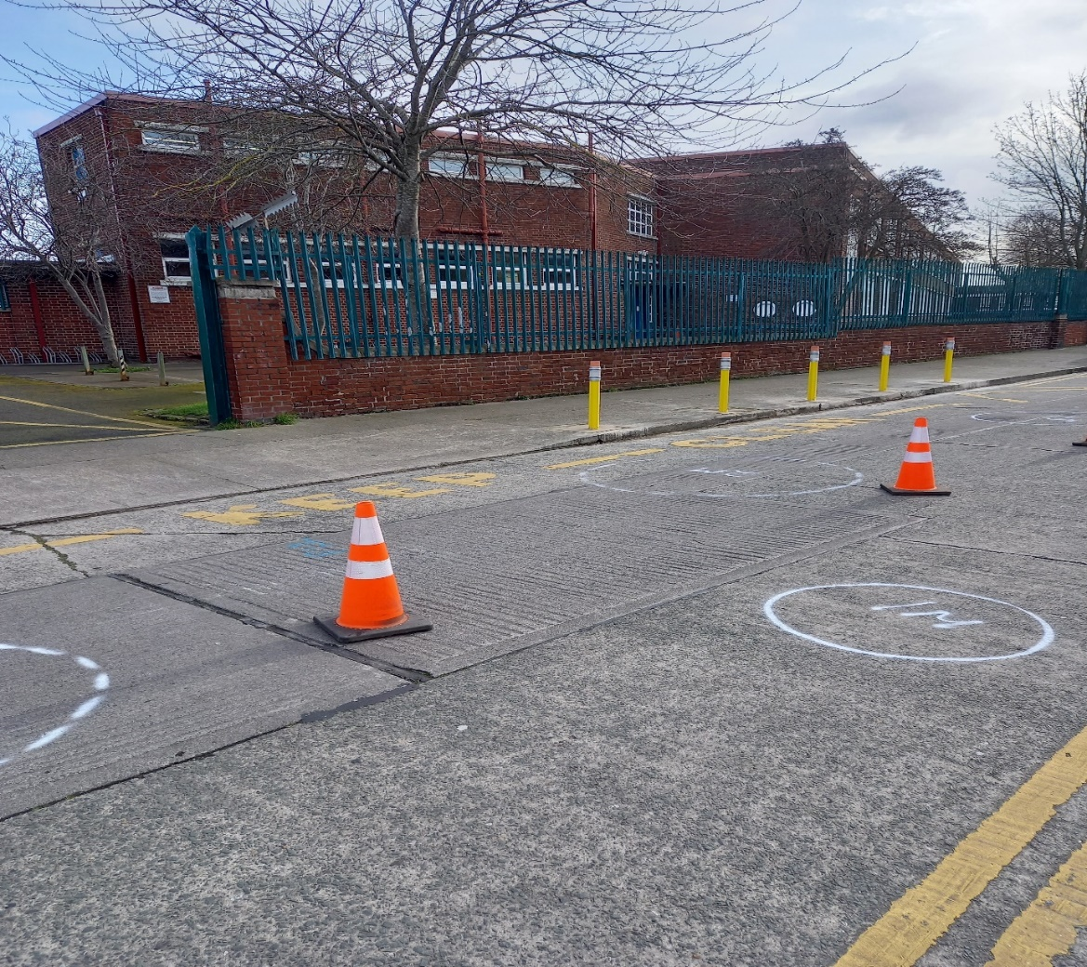

***Image of SZ markings being installed at Our Lady of Good Counsel Knocknarea Road on 11.03.21***

On March 1st the School Outreach Officers welcomed back School Children to the newly installed School Zones for Scoil Mologa and Harolds Cross National School on Clareville Road. They carried out observations on parent and student use of the School Zone. They spoke to parents and most of the feedback in relation to the School Zone was positive with parents saying it is “encouraging them to walk or cycle to the school” because of reduced parking at the school gate. The Principal of Harold’s Cross National School has said that the “safety outside the school gate has improved immensely since the installation of the School Zone”. There are still some issues in relation to cars parking on the footpaths opposite the school and doing u turns within the School Zone and the School Outreach Officers have asked the Principals to reiterate to the parents not to drop off and collect children within the School Zone.

## 2.3 Cycle & Scooter Parking for Schools & Sports Clubs

Applications for cycle and scooter parking for schools and sports clubs have now closed. Over 80 schools and sports clubs have applied for cycle and scooter parking. The tender process for manufacture and delivery of the cycle parking is now complete. Deliveries are expected to take place after Easter.

The installation of School Zones and school cycle parking will be advanced in collaboration with the NTA and under the funding umbrella of a national Active Travel Schools program.

# 3. Communications

## 3.1 Website

The [COVID Mobility webpage](http://www.dublincity.ie/COVID-19mobilityprogramme), is being updated regularly to keep the general public informed of COVID-19 mobility interventions. As previously advised we will be making more extensive use of the Consultation Hub in order to provide more information on measures.

## 3.2 DCC Consultation Hub/Citizen Space

Details of schemes on the Consultation Hub at present include:

[Griffith Avenue Protected Cycle Track](https://consultation.dublincity.ie/traffic-and-transport/griffith-avenue-protected-cycle-track/)

Members are alerted on a regular basis to any new proposals, which are available to view on the Consultation Hub and aim to have a more dynamic process for ensuring that support for projects, suggestions on how to improve them and concerns and issues, which may need to be addressed, can be better handled. Any feedback on this approach is welcome.

## 3.3 Dedicated COVID-19 Mobility Measure Request Form

Since our last update on 1 February 2021, we have received 26 new requests for COVID Mobility Measures. This brings the total number of COVID Mobility requests to 5,202. A breakdown of these requests is given on the next page:

**Mobility measure requested**

Footpath widening 697

Increasing queuing space at bus stops 135

Pedestrian area 806

Protected cycle lanes 1201

Contra-flow cycle lanes 382

Cycle parking facilities 520

Outdoor seating area 591

Commercial / Retail deliveries support 79

Support and advice for active travel (walking & cycling) 305

Journey planning 78

Other 397

Not answered 11

**Total requests 5202**

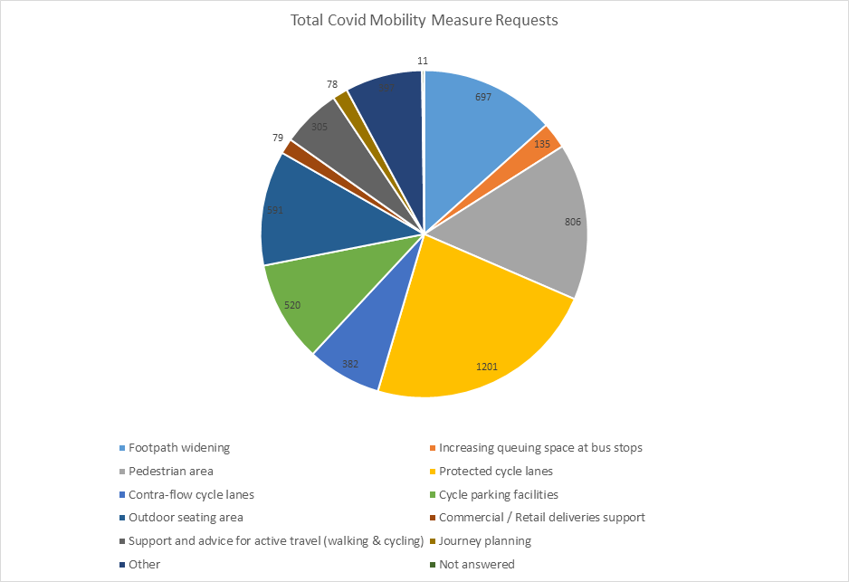

## 3.4 COVID-19 Mobility E-Mail

The dedicated e-mail address continues as the primary channel to contact the COVID Mobility Team. It is attracting huge volumes of queries and feedback. The intention is that the e-mail is for general queries and the COVID-19 Mobility Request Form should be used for specific requests at specific locations.

## 3.5 Councillor Updates

Updates on COVID-19 mobility measures are issued on a fortnightly basis to Elected Members. Updates via e-mail are also being issued to stakeholders via the Transportation SPC and to the NTA for distribution to disability user groups.

## 3.6 Business Liaison

The Business Liaison Officer continues to engage and consult with businesses on a number of COVID Mobility Measures citywide.

## 3.7 Active Travel Promotion

We are continuing to utilise Dublin City Council Social Media Channels:

* + - to highlight COVID-19 mobility measures that have been implemented;
    - to encourage the public to walk or cycle, where possible;
    - to encourage social distancing as people move around the city and
    - to encourage more respect for vulnerable road users

Owen P Keegan

**Chief Executive**