

**Chief Executive’s Office**

**Floor 4 Block 4**

**Civic Offices**

**Wood Quay**

**1 March 2021**

**Memo to the Lord Mayor and Elected Members**

**of the City Council**

**COVID-19 Mobility Measures Update**

Contents

1. Introduction 2

1.1 Pedestrian Volumes 2

1.2 Cycling Volumes 2

1.3 Bus Passenger Numbers 3

1.4 General Traffic Volumes 4

2. Implementation of Measures 4

2.1 Pedestrian Crossings 4

Sandymount Village 4

2.2 Protected Cycle Facilities and Contra-Flow Facilities 5

Strand Road Cycle Route Trial 5

Griffith Avenue Cycle Route 6

Parnell Square East Contra-flow 6

Bull Wall 7

2.3 School Mobility Programme 7

Schools in 50km/h Zones 8

Collaboration with An Taisce Green-Schools 8

2.4 Cycle & Scooter Parking for Schools & Sports Clubs 9

3. Communications 9

3.1 Website 9

3.2 DCC Consultation Hub/Citizen Space 9

3.3 Dedicated COVID-19 Mobility Measure Request Form 9

3.4 COVID-19 Mobility E-Mail 10

3.5 Councillor Updates 10

3.6 Business Liaison 10

3.7 Active Travel Promotion 11

# 1. Introduction

Implementation of the COVID Mobility Programme for the City Council area continues with an emphasis on schools and safe zones. The continuation of Level 5 restrictions means that there are reduced volumes and activity. However, walking and cycling projects, particularly those being implemented as part of a COVID response, are deemed to be critical infrastructure and work can proceed in these areas.

As some members of the COVID Mobility Team have now transferred to TAG the number of projects being undertaken has reduced.

## 1.1 Pedestrian Volumes

The footfall counters count continuously and provide 24 hour data. These counters are located between Stephen’s Green and Henry Street. These show that footfall in this core area had reached a high of around 60% of pre-COVID levels. Footfall increased during December but has dropped dramatically since Level 5+ restrictions were re-introduced and has remained pretty steady since then.

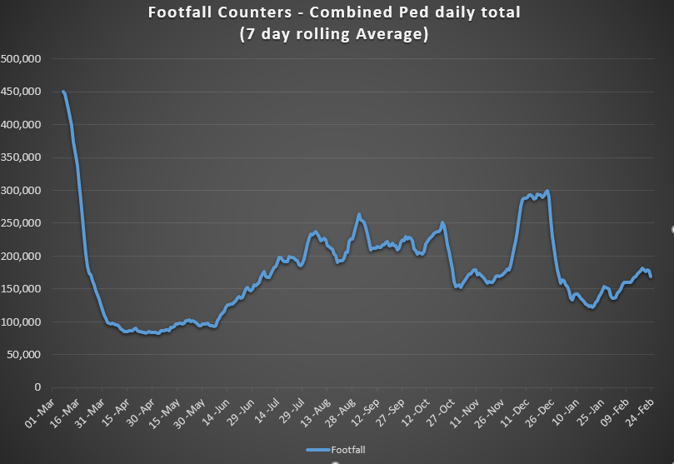

## 1.2 Cycling Volumes

Cycling volumes, which are continuously monitored by City Council’s counters (located at Grove Road, North Strand Road, Charleville Mall and Guild Street) show numbers held steady during December but have since decreased to approximately 50% of pre-Covid levels.

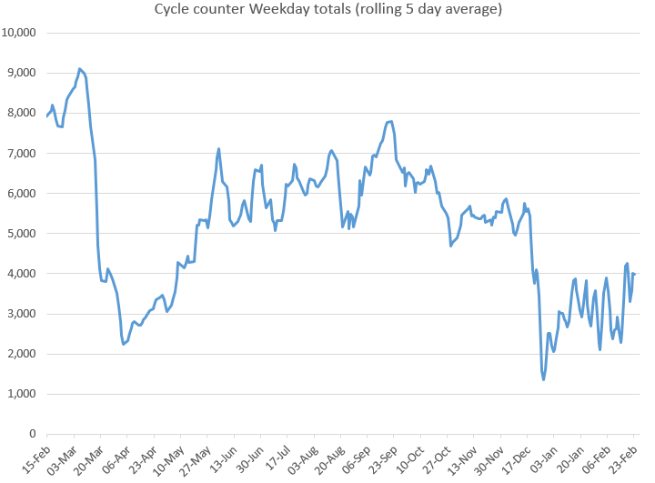

## 1.3 Bus Passenger Numbers

Passenger numbers increased steadily following the relaxation of capacity restrictions in June from 20% to 50%. The return of students to public passenger services in September pushed passenger numbers to 50% of pre-COVID levels. Passenger demand declined slightly from mid-September following the introduction of Level 3 restrictions for Dublin.

The co-occurrence of mid-term break (26 October) and level 5 restrictions (capacity was reduced to 25%) saw passenger numbers fall to 26% of pre-COVID levels. Passenger numbers improved to 35% of pre-COVID passenger levels following the mid-term break.

The relaxation of the restrictions to Level 3 in December resulted in an immediate improvement in passenger numbers to 50% of pre-COVID levels. Passenger levels currently remain static at approximately 23% of January 2020 levels.

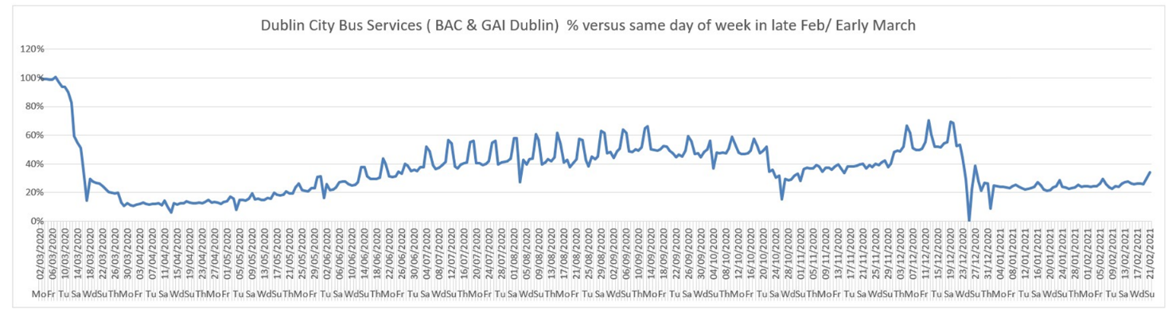

## 1.4 General Traffic Volumes

For the month of February, with continued Level 5 restrictions, traffic volumes crossing the Canal Cordon have remained at a consistent 57% to 60% compared to pre-COVID volumes.

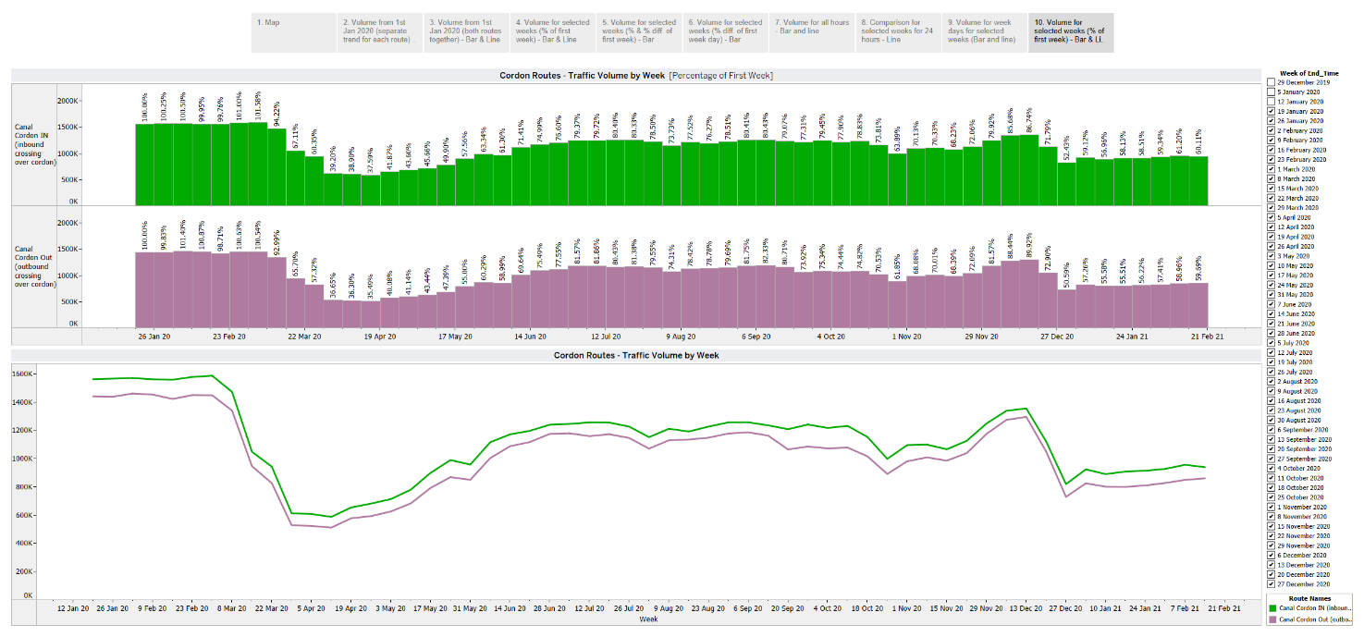

# 2. Implementation of Measures

## 

## 2.1 Pedestrian Crossings

### Sandymount Village

Construction is now complete on the installation of three pedestrian crossings in Sandymount Green - two controlled pedestrian crossing (one near Borzas Takeaway on the northern side of Sandymount Green and one near Bennetts Auctioneers on the western side of Sandymount Green), as well as one uncontrolled crossing at the junction of Claremont Road and Sandymount Green. A ramp on the eastern arm of Sandymount Green has also been installed.

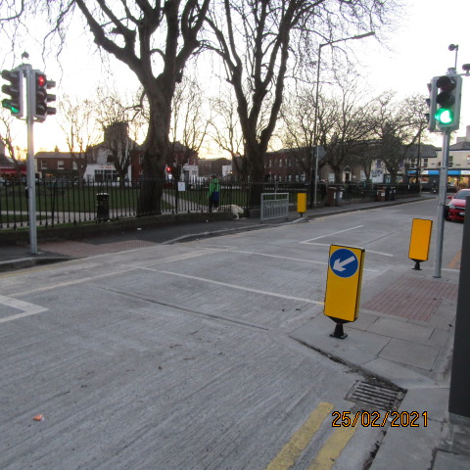 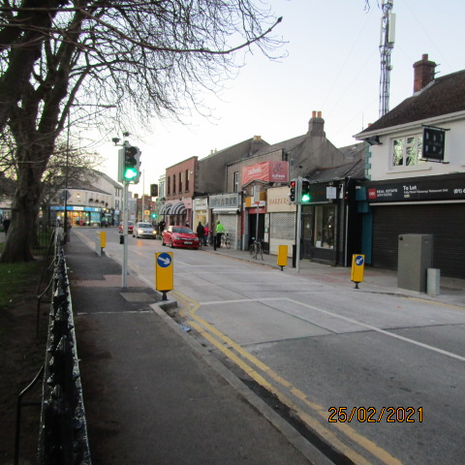*Signalised pedestrian crossing on the northern side of Sandymount Green*

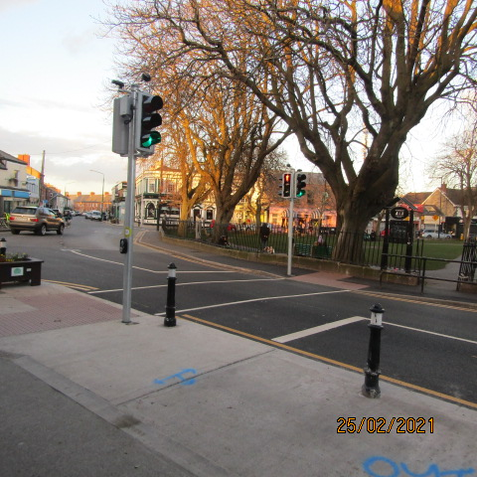 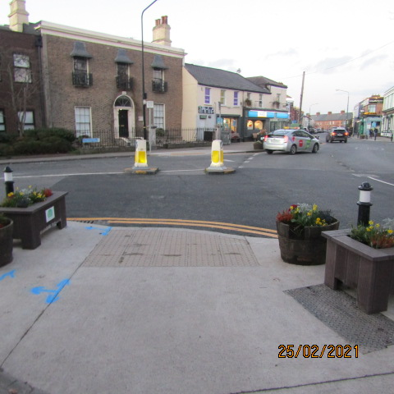

*Signalised pedestrian crossing on the Uncontrolled junction of Claremont Road*

*western side of the Green and Sandymount Green*

## 2.2 Protected Cycle Facilities and Contra-Flow Facilities

### 

### Strand Road Cycle Route Trial

Advance works for the installation of the cycle route began on 15 February 2021. This includes works at the pedestrian crossings and roundabouts. Leaflets were distributed to approximately 8,000 households in the Sandymount, Irishtown, Ringsend and Ballsbridge area on week ending 13 February. A further leaflet drop was delivered to Strand Road and Beach Road residents highlighting specific changes on those roads on week ending 28February.

A new air monitor Unit has been installed in Sandymount village. The data is available online at <https://dublincityairandnoise.ie/>

As part of the trial our Parks department prepared indicative designs for enhancing areas of Strand Road with greening, seating and additional bike parking (including cargo and disabled spaces).

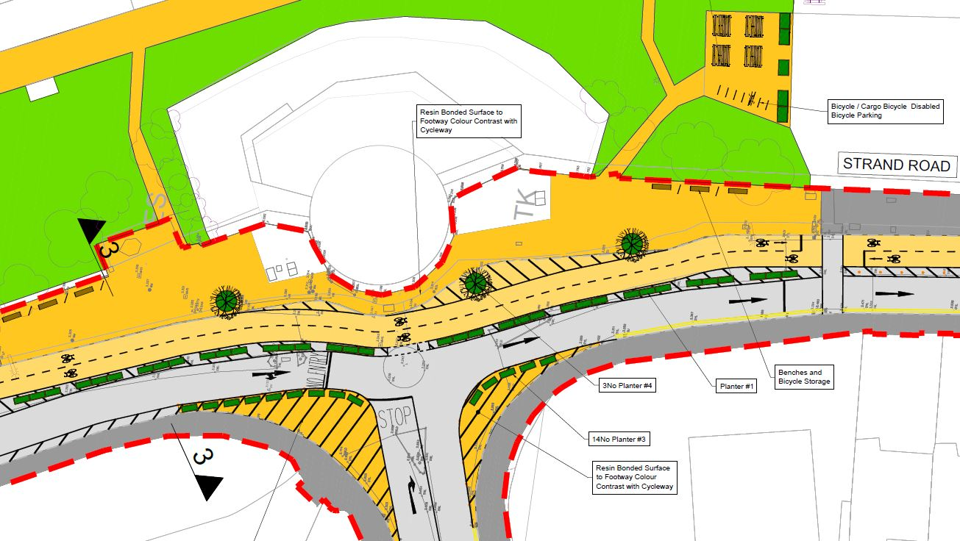

The cycle lane was due to open before the end of March 2021. However the High Court on 26 February granted a stay, which required Dublin City Council to halt work on the project. A number of minor works have to be completed for safety reasons but otherwise the City Council has stopped work on the installation of the route and any other works including any changes to statutory signs etc.

The City Council believes that the proposed works associated with the Strand Road cycle route are in compliance with Government Guidelines, in accordance with the Design Manual for Urban Roads and Streets (DMURS) and in compliance with the City Council Development Plan. It is hoped that the substantive case will be heard at the earliest opportunity so that the works can recommence. The Council had obtained independent advice regarding the requirements for an Environmental Impact Assessment (EIA) and an Appropriate Assessment (AA). Both were screened for and found not to be required. These screening reports are available on the Dublin City Council website in the Strand Road cycle trial section.

### Griffith Avenue Cycle Route

Road markings are now complete on Griffith Avenue between Walnut Drive and Skerkin Gardens.

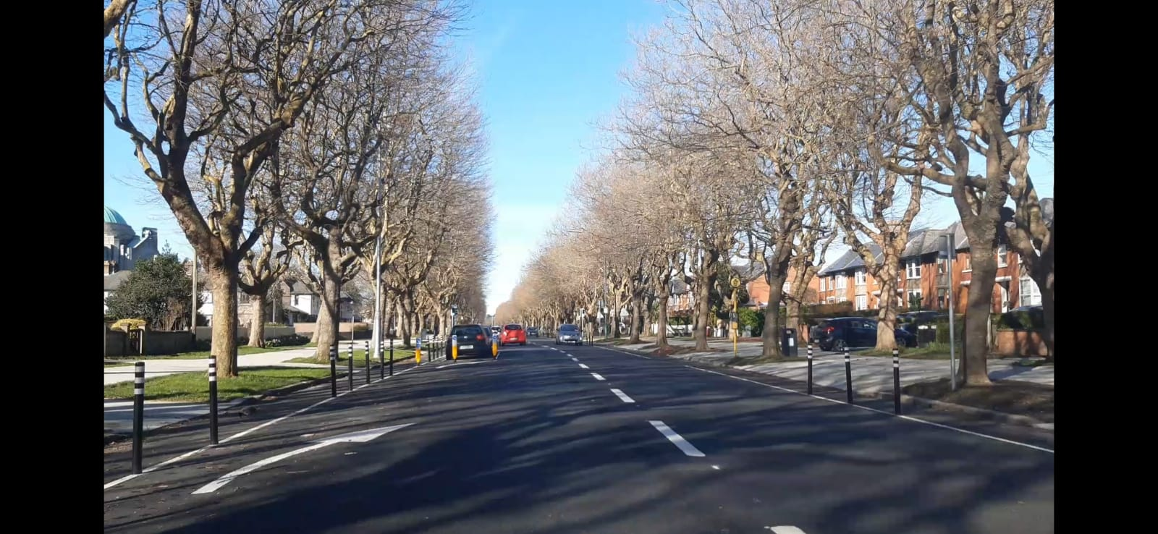

### Parnell Square East Contra-flow

The contraflow cycle lane on Parnell Square is now operational with temporary bollards to prevent illegal parking while awaiting the delivery of planters.

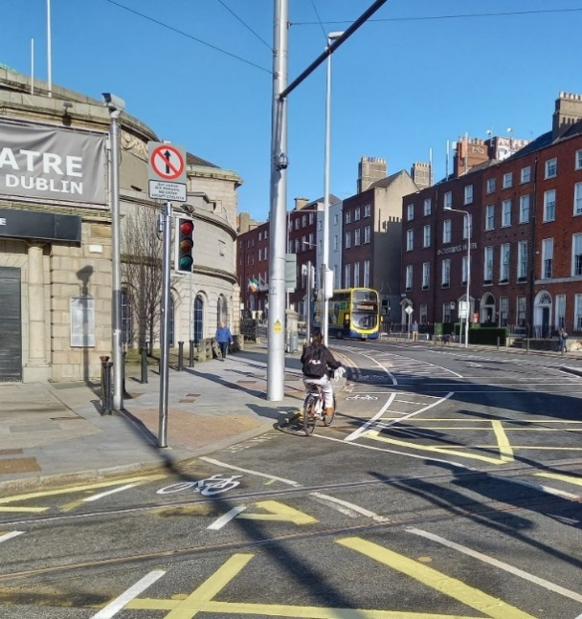 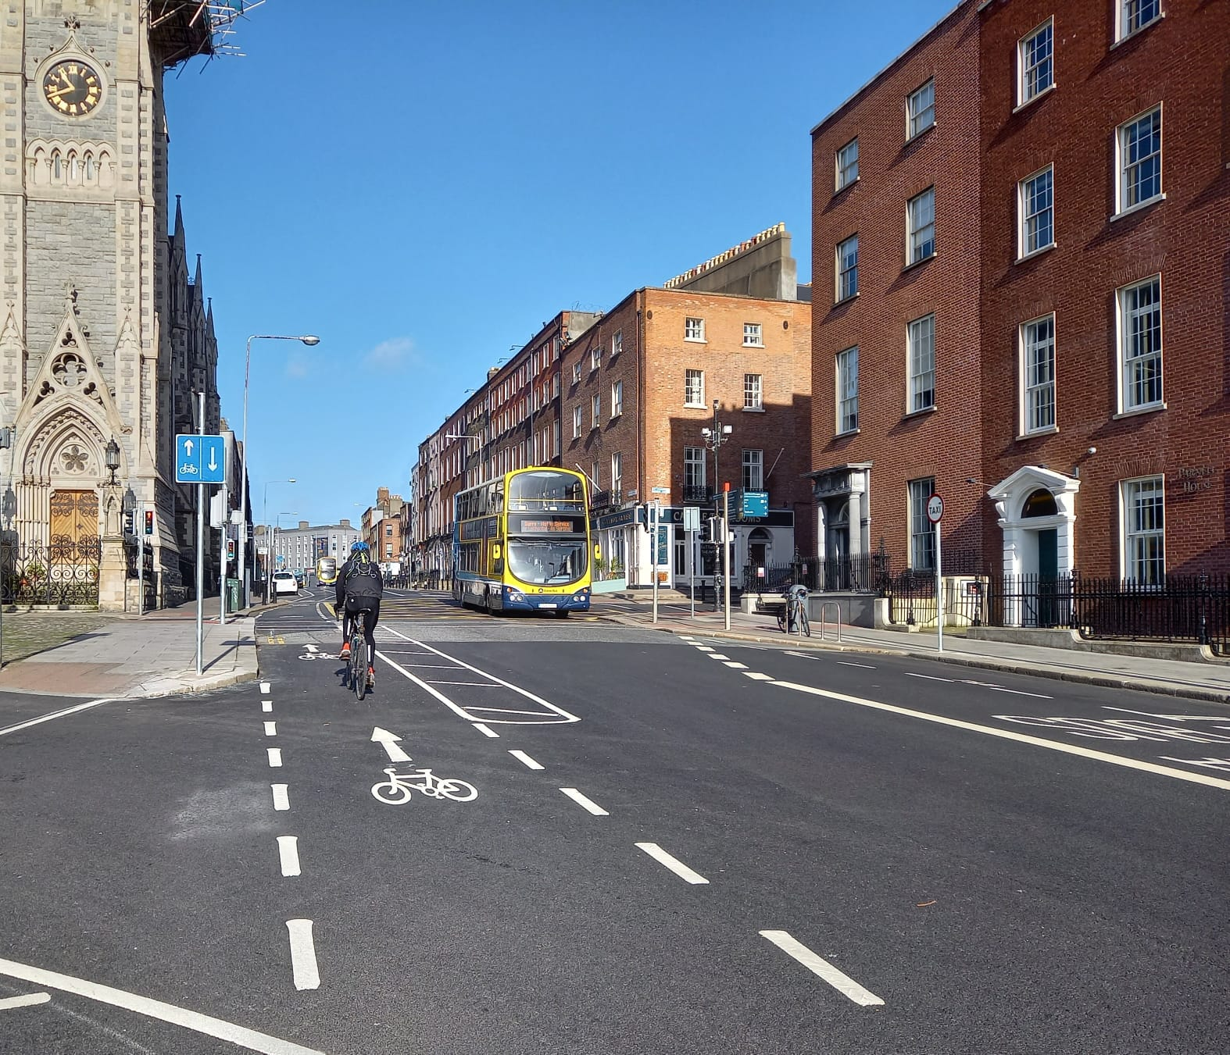

### Bull Wall

Work has begun extending the footpath protection and the introduction of formal parking as far as the Wooden Bridge.

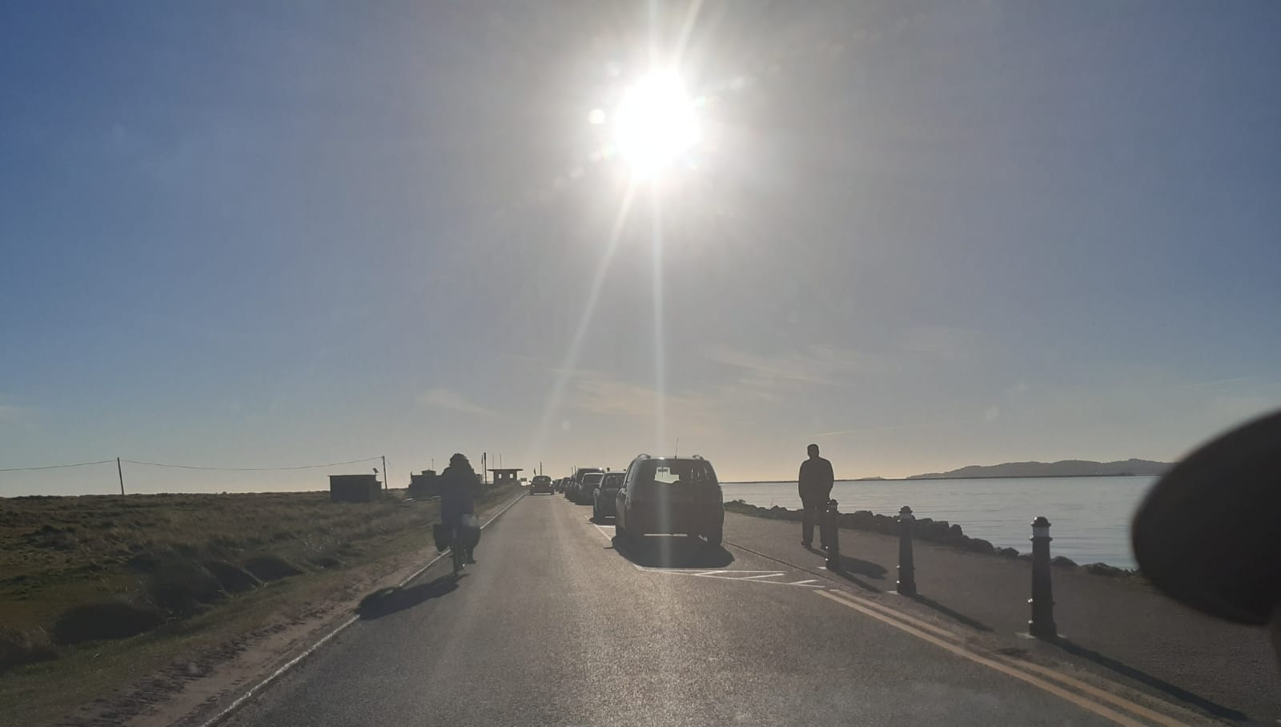

*Formal parking near the Wooden Bridge*

## 2.3 School Mobility Programme

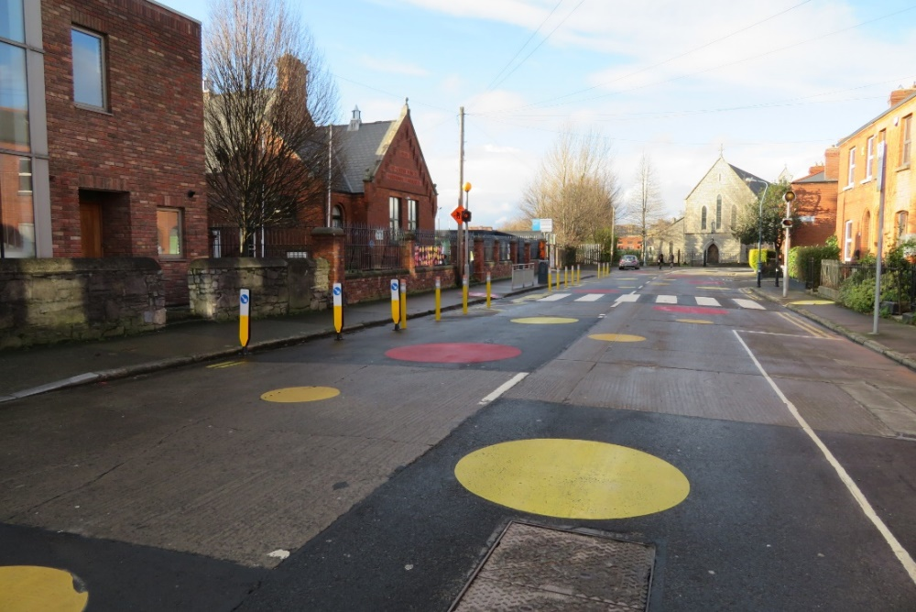

The application list for a ***School Zone*** stands at 105 schools with 37 completed. With the Government’s urgent call now for school communities and areas adjacent to schools not to become areas where people are in close contact, the extra space provided by Schools Zones is paramount. Using the School Zone effectively will help with our national effort for the next few months to keep our Schools open.

Site visits by the Schools Outreach Officers involve meeting with Principals, neighborhood engineers, taking pre and post School Zone installation photos, assessing potential for park and stride locations and assessing post installation issues. If the school is at the design phase, the school Principal and the school community are facilitated to read and understand the designs and make observations which are taken into account prior to installation. Education is provided on benefits of the School Zone treatment including increased safety for pupils, additional space for social distancing, improved health and wellbeing for students due to active travel, and reduced air pollution due to less car idling. These measures are taken to support Principals to communicate to their school community and their neighbors as to what to expect from the School Zone treatment.

The breakdown of the School Zones completed per administrative area of Dublin City are as follows:

|  |  |  |  |  |  |
| --- | --- | --- | --- | --- | --- |
| **Area** | **No. of School Zone Applications** | **No. of School Zones completed** | **No. of School Zones at design stage** | **Site visits carried out by Schools Outreach Officers** | **No. of schools**  **self-reported**  **as 50 km/h**  **zones** |
| Central | 32 | 9 | 11 | 11 | 12 |
| North Central | 20 | 3 | 7 | 4 | 10 |
| North West | 17 | 4 | 6 | 4 | 8 |
| South Central | 18 | 10 | 4 | 9 | 4 |
| South East | 21 | 9 | 6 | 11 | 11 |
| **Total** | **108** | **35** | **34** | **39** | **47** |

### Schools in 50km/h Zones

The installation of School Zones as currently being rolled out are not deemed suitable for 50km/h zones as outlined in the Section 5 of the NTA School Zone Design Principles which states as follows:

School Zones are suitable on the following roads:

* Local roads and some link roads as defined by DMURS;
* Roads with one lane or less in each direction;
* Where illegal parking at school time is an issue;
* Where vehicular speeds of 30kph are desirable;
* Where actual vehicular speeds are already 30kph or where School Zone traffic management elements are likely to bring speeds down to 30kph.

Assessments and site visits with Principals have been carried out on a number of schools in 50km/h zones. As the School Zone treatment is not appropriate at these locations, DCC and the NTA are working together to determine appropriate infrastructure interventions for schools in 50km/h zones.

### Collaboration with An Taisce Green-Schools

We are collaborating with Green-Schools on the following initiatives:

* Co-designing resource material including standard observations checklists at school entrances for pre- and post-School Zone evaluations;
* Linked up a selection of schools with the school-based Globe Air Quality Campaign which allows students to collect data about traffic- related air quality at their school and
* Developing behavior change interventions to complement and increase the effectiveness of the School Zone treatment.

## 2.4 Cycle & Scooter Parking for Schools & Sports Clubs

Applications for cycle and scooter parking for schools and sports clubs have now closed. Over 80 schools and sports clubs have applied for cycle and scooter parking. A tender for the supply of the stands has now gone out and delivery of stands will be arranged with schools and sports clubs once this tender process is complete.

The installation of School Zones and school cycle parking will be advanced in collaboration with the NTA and under the funding umbrella of a national Active Travel Schools program.

# 3. Communications

## 3.1 Website

The [COVID Mobility webpage](http://www.dublincity.ie/COVID-19mobilityprogramme), is being updated regularly to keep the general public informed of COVID-19 mobility interventions. As previously advised we will be making more extensive use of the Consultation Hub in order to provide more information on measures.

## 3.2 DCC Consultation Hub/Citizen Space

Details of schemes on the Consultation Hub at present include:

[Griffith Avenue Protected Cycle Track](https://consultation.dublincity.ie/traffic-and-transport/griffith-avenue-protected-cycle-track/)

Members are alerted on a regular basis to any new proposals, which are available to view on the Consultation Hub and aim to have a more dynamic process for ensuring that support for projects, suggestions on how to improve them and concerns and issues, which may need to be addressed, can be better handled. Any feedback on this approach is welcome.

## 3.3 Dedicated COVID-19 Mobility Measure Request Form

Since our last update on 1 February 2021, we have received 12 new requests for COVID Mobility Measures. This brings the total number of COVID Mobility requests to 5,176. A breakdown of these requests is given on the next page:

Footpath widening, 694

Increasing queuing space at bus stops, 135

Pedestrian area, 803

Protected cycle lanes, 1,197

Contra-flow cycle lanes, 381

Cycle parking facilities, 516

Outdoor seating area, 590

Commercial / Retail deliveries support, 79

Support and advice for active travel (walking & cycling), 303

Journey planning, 78

Other, 389

Not answered, 11

**Total requests, 5,176**

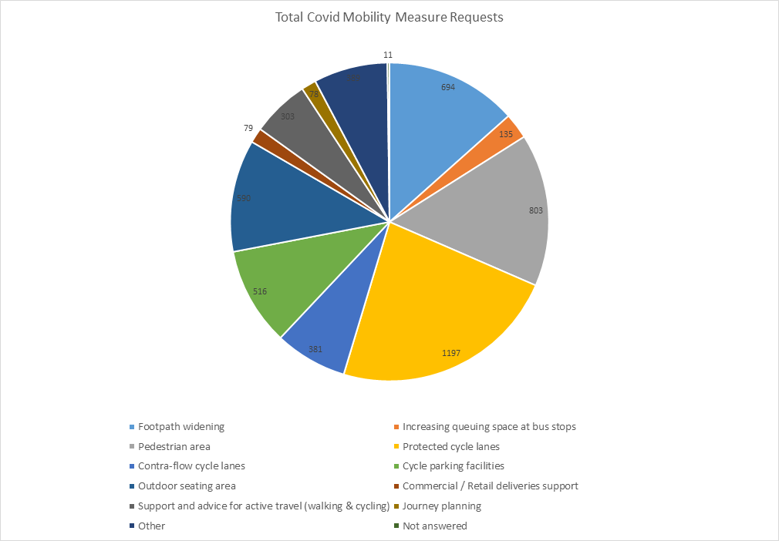

## 3.4 COVID-19 Mobility E-Mail

The dedicated e-mail address continues as the primary channel to contact the COVID Mobility Team. It is attracting huge volumes of queries and feedback. The intention is that the e-mail is for general queries and the COVID-19 Mobility Request Form should be used for specific requests at specific locations.

## 3.5 Councillor Updates

Updates on COVID-19 mobility measures are issued on a fortnightly basis to Elected Members. Updates via e-mail are also being issued to stakeholders via the Transportation SPC and to the NTA for distribution to disability user groups.

## 3.6 Business Liaison

The Business Liaison Officer continues to engage and consult with businesses on a number of COVID Mobility Measures citywide.

## 3.7 Active Travel Promotion

We are continuing to utilise Dublin City Council Social Media Channels:

* + - to highlight COVID-19 mobility measures that have been implemented;
    - to encourage the public to walk or cycle, where possible;
    - to encourage social distancing as people move around the city and
    - to encourage more respect for vulnerable road users

Owen P Keegan

**Chief Executive**