Proposed Draft Variation (No. 32)

of the

Dublin City Development Plan
2016-2022
PROPOSED DRAFT VARIATION (NO. 32) OF THE DUBLIN CITY DEVELOPMENT PLAN 2016 – 2022
RE: Lands at Pembroke Road, Ballsbridge (former Jury’s Hotel).

PROPOSAL
It is proposed to vary the Dublin City Development Plan 2016-2022, by changing the land use zoning of the subject lands at the junction of Pembroke Road and Lansdowne Road, Ballsbridge, Dublin 4.

From: Zoning Objective Z1 – To protect, provide and improve residential amenities

To: Zoning Objective Z6 – To provide for the creation and protection of enterprise and facilitate opportunities for employment creation.

This proposed draft variation is delineated on the attached map, an extract from Map E, Volume 3 of the Dublin City Development Plan 2016 – 2022

SITE LOCATION AND DESCRIPTION.

The lands in question are the former Ballbridge Hotel (previously Jury’s Hotel) lands; located at the junction of Pembroke Road and Lanesdown Road, within the urban village of Ballbridge, located in the South East quarter of the City, approximately 3km from the City Centre. There is a current hotel building and surface parking in the lands, and the boundary is railed. There are a number of mature trees within the lands.
These have been identifed in the observations made by the Development Applications Unit (DAU) of the Department of Tourism, Culture, Arts, Gaeltacht, Sport and Media during the Environmental Bodies consultation period, prior to public display. This observation provides the following recoomendation:
‘In order to protect biodiversity, the proposed Variation No. 32 of the Dublin City Development to rezone the Ballsbridge Hotel site should include the condition that the existing trees boundaries of the site, if in a healthy condition, should be retained.’
As this is a rezoning variation, it is considered reasonable that such a condition would attach to any future planning application made on the site based on existing policy of the development plan such as Green Infrastructure Objective no. 26 which states:
GI26:‘To have regard to the conservation and enhancement of significant non-designated areas of ecological importance in accordance with development standards set out in this plan.’
This site is 1.7ha is extent. The current access is from Pembroke Road. Pembroke Road (R116) links the City centre to Blackrock, via Ballsbridge and Merrion, and contains dedicated bus and cycle lanes on both directions and two car lands southbound and one car lane northbound and in both directions.
The lands form part of a larger block of lands, framed by Shelbourne Road, Lannsdowne Road and Pembroke Road. Within this block, the predominant zoning is residential, with two parcels of land zoned employment/office to the immediate south, and south east; and two further zonings (Z2- residential conservation, and Z3- commercial/retail) to the south. The zoning to the north of the proposed variation lands is a mix of Z2 and Z6, with the Z6 zoning on the opposing corners of the junction of Northumberland Road and Landsdown Road. Z6 zoning applies to the extent of frontage onto Pembroke Road on the western side.
Uses within the area is a mixture of low density residential, office and embassy uses within the historic residential areas, increasing to a more mixed quality with apartments, larger scale office and retail closer to the core of Ballsbridge urban village, with the American Embassy located on the junction of Pembroke Road and Elgin Road.
Office developments in proximity to the lands include Carrisbrook House, Lansdowne House, Number One Ballsbridge, Hume House, the Bank of Ireland offices, the existing American Embassy and the new Facebook campus. There are a significant number of Embassy buildings in the wider Ballsbridge area.

Planning History
There are a series of planning applications attaching to the site, the most recent of which has a 2019 plan reference. There are four applications with a 2017 plan reference and one earlier 2009 plan reference number that covers a wider area. Some other applications covering this site pre-date the 2009 planning application, and are no longer valid.

The 2009 planning application (4015/09), covers a wider area than the subject site and is called the “parent permission” in subsequent planning applications for the subject site, some of which divided the site into two parts. The four applications with a 2017 register reference date all amend the parent permission (4015/09). This “parent permission” and amending permissions expire in September 2021.
The most recent 2019 application is similar in form to the original 2009 permission as amended by the 2017 permissions. The detailed description of the 2019 permission is set out below, and the earlier permissions are included in Appendix A.

3502/19 - Permission granted by Dublin City Council for development of a c.1.73ha site at the Ballsbridge Hotel, Pembroke Road, Ballsbridge, Dublin 4 bounded generally by Lansdowne Road to the north, Lansdowne Place development (currently under construction) to the east, Pembroke Road to the west and One Ballsbridge to the south, at Ballsbridge, Dublin 4, consisting of a mixed use scheme comprising 313 no. residential, units, a 152 no. bedroom hotel, retail, non-retail services, licenced restaurants, bars, cafes and ancillary uses above and below ground (81,024.7sq.m gross floor area) that also include the demolition of structures on site all located with 7 building blocks, ranging in height 8 storeys stepping up to 10 storeys with a feature 13 storey landmark over a 2 level basement, (that will also consist of vehicular connections at Basement Levels -1 and -2 to adjoining basement of previously permitted mixed-use scheme (under construction) at 'Lansdowne Place' - Dublin City Council Reg. Ref. 4015/09 (An Bord Pleanala Ref. PL29S.237454), as revised by subsequent permissions, Dublin City Council Reg. Refs. 4344/15, 2244/16, 2578/16, 2849/16, 3386/16, 3468/16, 3532/16, 4369/16, 2853/17, 4601/17 and 3620/18).

PURPOSE OF THE PROPOSED DRAFT VARIATION

The Planning Authority is proposing to change the zoning of the subject lands from Z1 (residential) to Z6 (employment and enterprise) in response to a request from the State Department of the United States to consider such a change. This change will align the zoning policy to facilitate the consideration of a proposed development of a new Embassy of the United States of America on the lands. The new Embassy will have an office character and function as such the Z6 zoning is considered appropriate. The proposed new zoning will provide a more suitable zoning context for such a use.

The State Department has informed the Planning Authority that it needs to develop a new larger facility, as the current building is no longer suitable in scale to cater for their needs. The location of these lands, located in close proximity of the current Embassy will allow the long established continuing presence of the US Embassy in Ballsbridge. The site is also close to the traditional embassy belt in Ballsbridge, and at 1.7ha, it is large enough to provide for growing Embassy as it responds to the increasing trade and services between the USA and Ireland.

The desire to relocate the Embassy is due to a number of reasons including:
- The existing building is almost over 55 years old and no longer meets the requirements in terms of size of the expanding American diplomatic presence in Ireland.
- The current building is too small and there is an urgent need for expansion due to the growing activity across the Embassy’s diplomatic, foreign trade delegation, trade office and public embassy office functions.
- The building does not conform to new construction and security requirements issued by the State Department in Washington DC
- The current embassy has a capacity for only 150-200 staff and this is not adequate to meet the growing demands placed on the various diplomatic and trade activities of the Embassy.
- It has a large atrium, is not efficient for modern occupational needs, nor modern environmental/sustainability objectives.
- The existing building will remain as the US Embassy, or as an Annex to the US Embassy over the next 5-10 years during the transition period between the existing operation to the new US Embassy on this site.

In relation to the proposed new embassy the following information is provided:
- The US have been upgrading their embassies around the world to modern sustainable buildings. One of the most recent examples of this is in London, where the new Embassy was opened to the public on the 13 December 2017.
- The new embassy in Dublin will provide a larger presence for the US in Ireland which will increase and enhance the exceptional relationship already in place between the two countries and will facilitate the required expansion in activity across the Embassy’s diplomatic, foreign trade delegation, trade office and public embassy office functions.
- The building will facilitate modern functional space and is in line with the US State Departments’ desire to be sustainable from an environmental perspective which will be capable of doubling the numbers of staff present; or up to 400 employees.
- In addition, the envisaged increased scale of the building, together with the increased number of employees at the US Embassy will lead to a commensurate knock-on economic benefit to the local service providers catering for the existing US Embassy.
- The US Embassy team in Ireland works to protect and promote U.S. interests in Ireland with the US. US companies have over $160 billion foreign direct investment in Ireland. This equates to approximately 8% of all US investment in the EU.
- The relocation of the US Embassy to this site, will retain the US Embassy in the now well established ‘embassy belt’ in Ballsbridge.
- During the construction phase of the project it is estimated that there will be approximately 500 jobs created. There will also be significant knock-on multiplier effects in the local economy during this construction phase as construction workers spend in local shops, cafes and services.

CONCLUSION
For all of the reasons and considerations noted above, this Variation is proposed to the Dublin City Development Plan 2016-2022 in respect of the Ballsbridge Hotel site which would change the land use zoning objective pertaining to the lands:-

From: Zoning Objective Z1 – To protect, provide and improve residential amenities

To: Zoning Objective Z6 – To provide for the creation and protection of enterprise and facilitate opportunities for employment creation

The Z1 Residential zoning in the City Development land does not provide for the type of embassy uses proposed for the US embassy, in that the uses will be primarily office accommodation, including diplomatic, foreign trade and public embassy functions.

ENVIRONMENTAL ASSESSMENT CONCLUSION STATEMENTS

Strategic Environmental Appraisal
Determination of Strategic Environmental Assessment (SEA) Screening under Section 13K of the Planning and Development Regulations, 2001, as amended and the Planning and Development Act 2000, as amended for the Proposed Draft Variation (No. 32) of the Dublin City Development Plan 2016-2022 to change 1.7 ha of land on Pembroke Road/Lansdowne Road from Z1 (residential) to Z6 (office and enterprise).

A Strategic Environmental Assessment (SEA) Screening Determination has been made by Dublin City Council regarding the proposed Variation (No.32) to the Dublin City Development Plan 2016 – 2022. The Planning Authority has determined that the proposed Variation (No. 32) would not be likely to have significant effects on the environment, taking account of relevant criteria set out in Schedule 2A of the Planning and Development Regulations, 2001, as amended.

Appropriate Assessment Screening
Determination of Appropriate Assessment Screening in compliance with Article 6(3) of the EU Habitats Directive (92/43/EEC) and EU Birds Directive (79/409/EEC), as transposed into Irish legislation by the Natura 2000 Communities (Birds and Natural Habitats) Regulations 2011 and Planning and Development Act 2000 (as amended) (Section 177U) for the Proposed Draft Variation (No. 32) of the Dublin City Development Plan 2016-2022 to change 1.7 ha of land on Pembroke Road/Lansdowne Road from Z1 (residential) to Z6 (office and enterprise).

An Appropriate Assessment (AA) screening determination has been made by Dublin City Council (in compliance with Section 177U of the Planning and Development Act 2000 as amended) regarding the proposed Variation. The Stage 1 Screening determines that Appropriate Assessment of the Proposed Variation is not required as the proposal, individually or in combination with other plans or projects will not have a significant effect on a European site. Therefore it is not considered necessary to undertake any further stages of the Appropriate Assessment process.

In carrying out this Assessment, the Council took into account the relevant matters specified under the Planning and Development Act 2000 (as amended), including:
• Existing Dublin City Development Plan 2016-2016 (and associated AA Screening, NIS and SEA reports);
• The Strategic Environmental Assessment Screening Report on the proposed Variation, and
• Observations made by the EPA (dated 22 February 2021) and the Development Applications Unit (DAU) of the Department of Tourism, Culture, Arts, Gaeltacht, Sport and Media, (dated 5 March 2021).

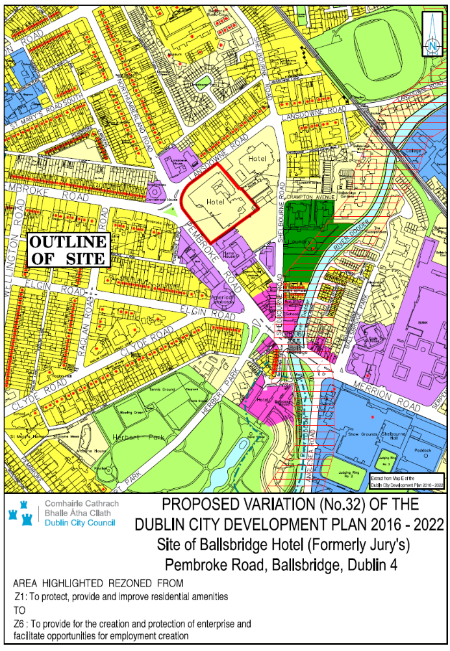

Appendix A: Recent Planning History of the Lands

- 4015/09 – Ten year planning permission (expiring 14 September 2021) granted by An Bord Pleanala for a proposal that, in summary, sought development of a 2.98 ha site that consists of a mixed use scheme comprising residential (568 no. units accommodated in 11 no. blocks), 135 no. bedroom hotel, retail, non-retail services, licensed restaurants, bars, cafes, childcare facilities, healthcare facilities and ancillary uses above and below ground totally 106,290sqm of Gross Floor Area that also includes demolition of existing structures on site all located with 12 building blocks over a 2 / part 3 level basement, ranging in height 6 storeys stepping up to 10 storeys with two feature 15 storey landmark elements defining the Pembroke Road vista located at lands comprising the northern part of a triangular urban block bounded by Lansdowne Road to the north, Shelbourne Road to the east, Pembroke Road to the west, and the former Veterinary College site to the south, located at Ballsbridge, Dublin 4, including some 0.2 hectares of external pavements and part of the Lansdowne Road / Shelbourne Road junction.

- 2561/17 - Permission granted by Dublin City Council for a proposal that, in summary, sought amendments to a previously permitted mixed use scheme Dublin City Council Reg. Ref.4015/09; An Bord Pleanala Ref. PL29S.237454 - the 'parent permission', resulting in an increase in the gross floor area of the permitted development above ground by c.543.3 sq. m and an increase in the permitted Basement Level - 01 and Level -02 footprint by c. 549 sq.m the provision of 12 no. additional car parking spaces and 12 no. additional cycle parking spaces; and all associated development works located on a of c. 0.35 ha occupied by Block 1, 2 and 11 located on a site referred to as Site 2 of parent permission at the Ballsbridge Hotel, being part of a wider site known as the D4 Hotels site / former Jury's Hotel site, generally bounded by Lansdowne Road to the north, Shelbourne Road to the east and Pembroke Road to the west Ballsbridge Dublin 4.
- 3008/17 - Permission granted by Dublin City Council for a proposal that, in summary, sought amendments to a previously permitted mixed use scheme Dublin City Council Reg. Ref.4015/09; An Bord Pleanala Ref. PL29S.237454 - the 'parent permission', resulting in an increase in the gross floor area of the permitted development above ground by c. 997.8 sq.m; And all associated development works; on site of c. 0.143 ha occupied by Block 8, located on a site referred to as Site 2 of parent permission at the Ballsbridge Hotel, being part of a wider site known as the D4 Hotels site / former Jury's Hotel site, generally bounded by Lansdowne Road to the north, Shelbourne Road to the east and Pembroke Road to the west Ballsbridge Dublin 4.

- 3184/17 - Permission granted by Dublin City Council for a proposal that, in summary, sought amendments to a previously permitted mixed use scheme Dublin City Council Reg. Ref.4015/09; An Bord Pleanala Ref. PL29S.237454 - the 'parent permission', resulting in a reduction in the gross floor area of the permitted development above ground by c. 74.1 sq.m; and all associated site development works on a site of c. 0.11 ha occupied by Block 10, located on a site referred to as Site 2 of parent permission at the Ballsbridge Hotel, being part of a wider site known as the D4 Hotels site / former Jury's Hotel site, generally bounded by Lansdowne Road to the north, Shelbourne Road to the east and Pembroke Road to the west Ballsbridge Dublin 4.

- 3488/17 - Permission granted by Dublin City Council for a proposal that, in summary, sought amendments to a previously permitted mixed use scheme Dublin City Council Reg. Ref.4015/09; An Bord Pleanala Ref. PL29S.237454 - the 'parent permission', resulting in the omission of the previously approved basement level -03 (c.10,413.3sqm), the provision of 2no. additional bicycle spaces at basement level -01; revisions to the access cores under Block 8 and 10 to correspond with access cores proposed above ground in Block 8 and 10 under planning applications Reg. Ref. 3008/17 and Reg. Ref. 3184/17; all associated site development works; on a site of c. 1.7 ha located on a site referred to as Site 2 of parent permission at the Ballsbridge Hotel, being part of a wider site known as the D4 Hotels site / former Jury's Hotel site, generally bounded by Lansdowne Road to the north, Shelbourne Road to the east and Pembroke Road to the west Ballsbridge Dublin 4.

- 3502/19 - Permission granted by Dublin City Council for a proposal that, in summary, sought development of a c.1.73ha site at the Ballsbridge Hotel, Pembroke Road, Ballsbridge, Dublin 4 bounded generally by Lansdowne Road to the north, Lansdowne Place development (currently under construction) to the east, Pembroke Road to the west and One Ballsbridge to the south, at Ballsbridge, Dublin 4, consisting of a mixed use scheme comprising 313 no. residential, units, a 152 no. bedroom hotel, retail, non-retail services, licenced restaurants, bars, cafes and ancillary uses above and below ground (81,024.7sq.m gross floor area) that also include the demolition of structures on site all located with 7 building blocks, ranging in height 8 storeys stepping up to 10 storeys with a feature 13 storey landmark over a 2 level basement, (that will also consist of vehicular connections at Basement Levels -1 and -2 to adjoining basement of previously permitted mixed-use scheme (under construction) at 'Lansdowne Place' - Dublin City Council Reg. Ref. 4015/09 (An Bord Pleanala Ref. PL29S.237454), as revised by subsequent permissions, Dublin City Council Reg. Refs. 4344/15, 2244/16, 2578/16, 2849/16, 3386/16, 3468/16, 3532/16, 4369/16, 2853/17, 4601/17 and 3620/18).

