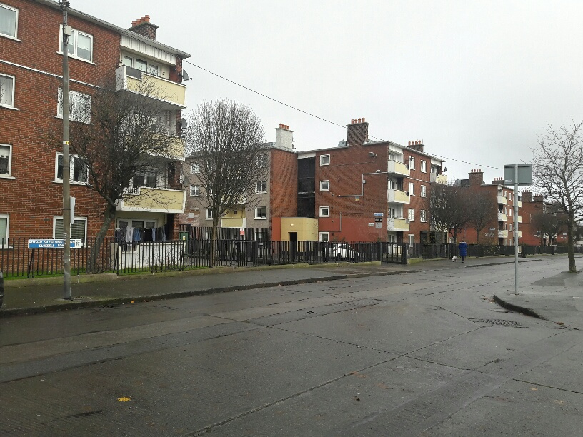
Units Available
Three 1 Bed Units and One 2 Bed Unit

Dublin City Council is inviting applicants from all our waiting lists who have selected Area J as their area of preference to express an interest in Bernard Curtis House, Bluebell Road, Bluebell Dublin 12.
Bernard Curtis House is situated on Bluebell Road, Bluebell. Bernard Curtis House is within walking distance from all the local amenities including schools, shops, hospitals, the Luas, the Bluebell Recreational Centre and the M50 motorway. Bernard Curtis House comprises 120 flats containing various size units, spread over five well-maintained blocks. Flats on offer are fully refurbished; including gas central heating, double-glazed throughout on site and off street parking. Furnishings and white goods are not provided.

Expressions of interest for Three 1 Bed units and one 2 bedroomed unit that will be available are now been invited

Please Turn Over for our Choice Based Lettings procedures and application form.

Procedure and Application Form
- All Applicants must be listed for area J
- All Applications will be examined on estate management grounds including rent arrears
- Applicants are invited to register their interest with Dublin City Council for Properties that are available for re-let in this area and will be advertised in Ballyfermot Civic Centre, and on Dublin City Council web site.
- There will be a two-week timeframe for applicants to register their interest. Start date Tuesday 13th April end date Tuesday 27th April 2021
- This application form must be returned to Ballyfermot Civic Centre mentioned in section 3 or emailed direct to sharon.mason@dublincity.ie or patrick.delaney@dublincity.ie
- Please Note Late Applications Will Not Be Considered.
- If a number of applicants express an interest in the same property, the final offer will be made to the applicant with the highest position on the list and most appropriate family size. This will be subject to an Estate Management clearance
- Under the choice based letting scheme only the successful candidates will be notified.
- A successful applicant who refuses a Choice Based Letting will not be eligible for consideration for another Choice Based Letting Unit for a period of one year
- If you need Further information regarding the choice based letting scheme, please contact Tel 2224668 / 4646
Application Form
Your Name_________________________________________________________________
Your Address______________________________________________________________________
Your Date of Birth _______________
Your Family Size________________
Your Housing Reference Number____________________
Your Telephone/ Mobile Number____________________________________
Size of property 1 or 2 Bed _________________________________________________________________________________
_________________________________________________________________________________
Did you read and understand the procedures above___________________?
Signature_________________________________________

