Conservation Section, Planning & Development Department
Civic Offices, Wood Quay, Dublin 8
An Rannóg Caomhantais, An Roinn Pleanála agus Forbairt Maoine
Oifigí na Cathrach, An Ché Adhmaid, Baile Átha Cliath 8
T. 01 222 3927 F. 01 222 2830

1st July 2021

To the Chairperson and Members of the Central Area Committee

Initiation of the Statutory Process for the Proposed Addition of No.19 Capel Street, Dublin 1, to the Record of Protected Structures in accordance with Section 54 and 55 of the Planning and Development Act, 2000 (as amended).

The initiation of the statutory addition process was noted by the Central Area Committee of Dublin City Council at its monthly meeting on the 13th of July 2021

PHOTOGRAPH OF STRUCTURE

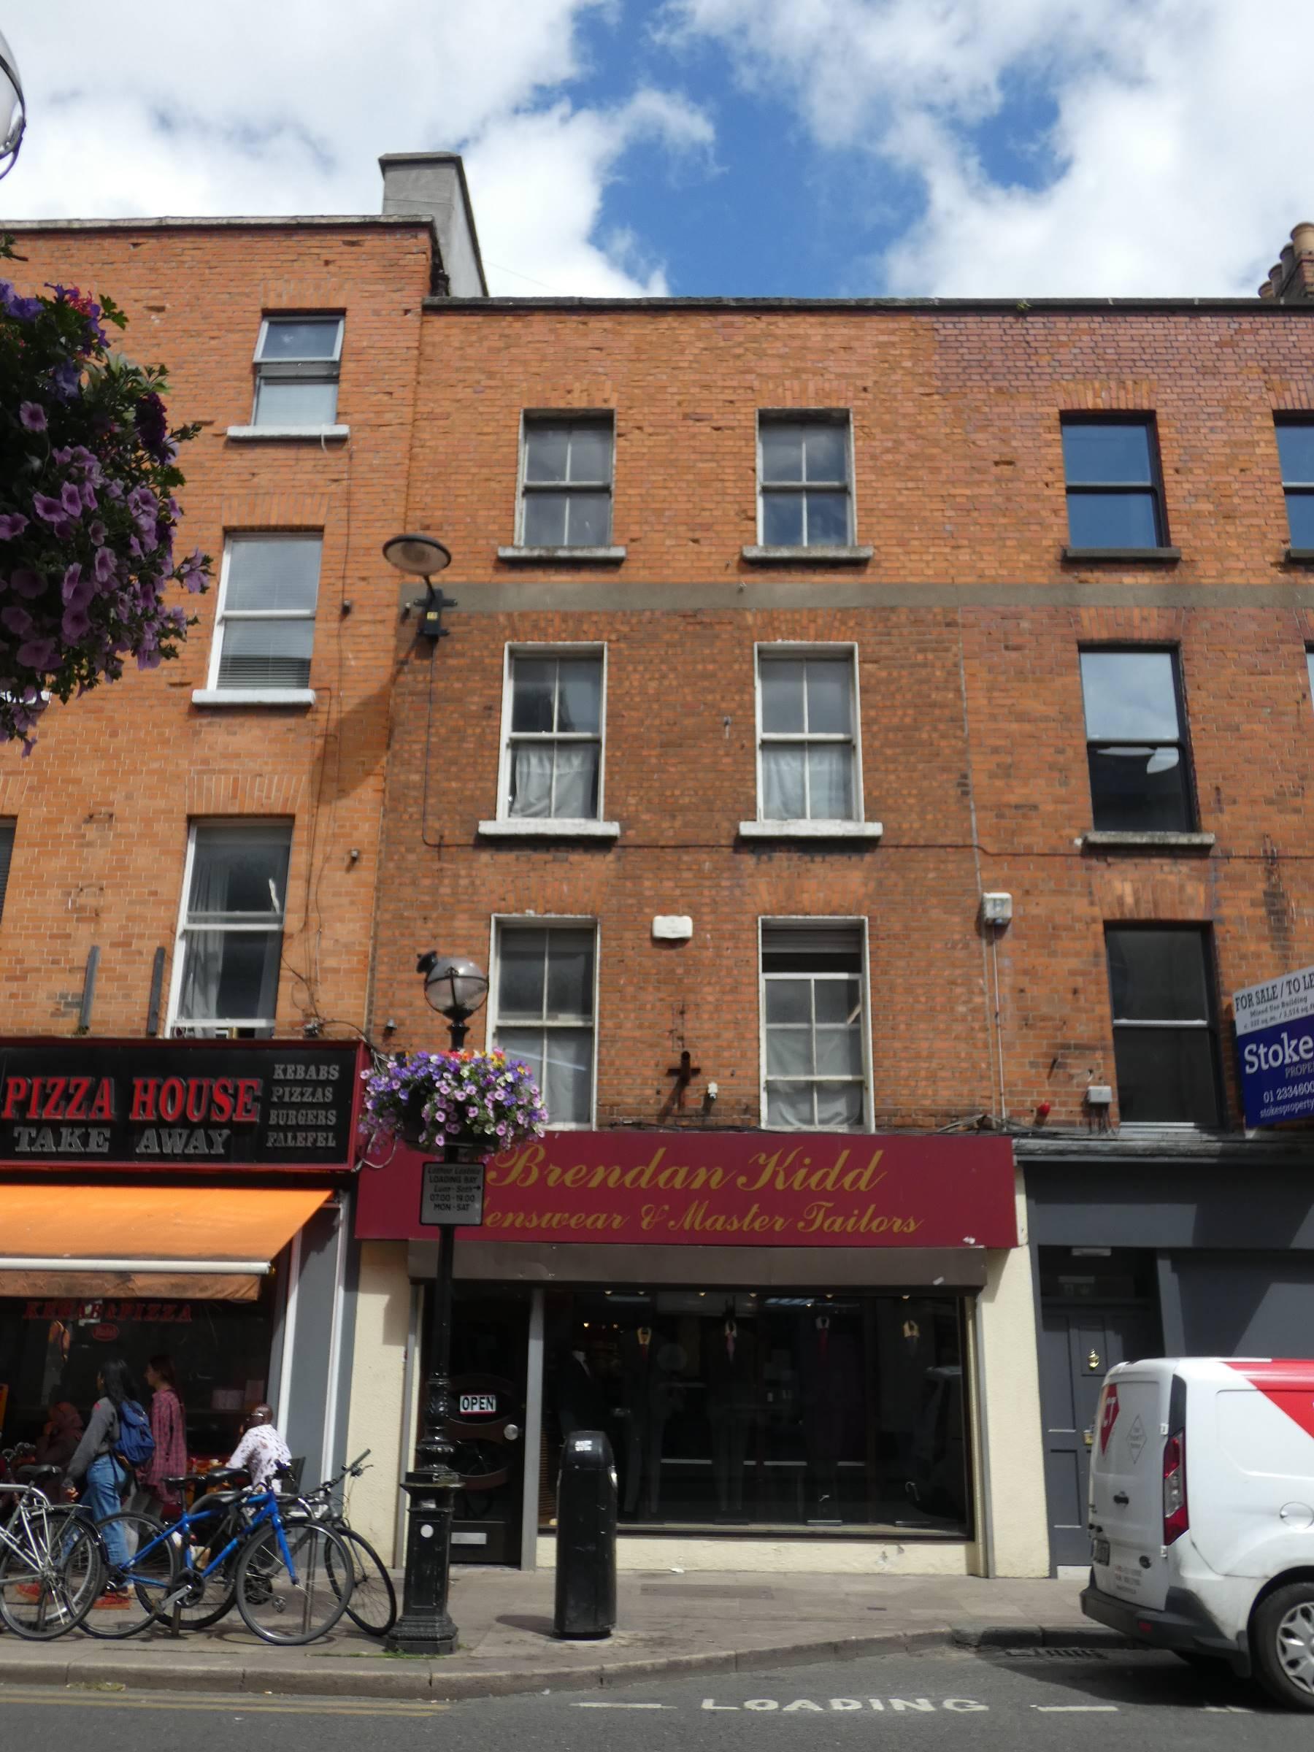

Introduction
It is proposed to initiate procedures under Section 54 and Section 55 of the Planning & Development Act 2000 (as amended) to add ‘No.19 Capel Street, Dublin 1’ to Dublin City Council’s Record of Protected Structures.

Recommendation for Addition
- Minister for Culture, Heritage and the Gaeltacht (now Minister for Housing, Local Government and Heritage) on the 4th June 2014.

Summary of Reasons for Proposed Addition
- Minister for Culture, Heritage and the Gaeltacht: List of recommendations for inclusion on the RPS of structures deemed as being of ‘Regional’ significance or higher identified during Stage 1 of the Dublin Survey carried out by the National Inventory of Architectural Heritage. No. 19 Capel Street has been assigned a Regional rating. The Stage 1 recommendations were issued to Dublin City Council on the 4th June 2014, in accordance with Section 53 of the Planning and Development Act, 2000 (as amended).

Methodology for Assessing Early Buildings
In November 2019, the Planning & Property Development SPC agreed a methodology to expedite proposed additions/deletions to the RPS in a systematic manner, based on the Architectural Heritage Protection Guidelines 2011 and NIAH/Ministerial Recommendations under Section 53(1) of the Planning and Development Act, 2000 (as amended). The methodology agreed to prioritise industrial, twentieth century, early buildings and underrepresented typologies. On foot of this the Conservation Section carried out a screening process for Early Buildings. No. 19 Capel Street, Dublin 1 has been identified as an Early Building and is included on Rocque’s Map of Dublin, 1756 and in the Dublin Civic Trusts Survey of Gable-fronted Houses and Other Early Buildings of Dublin City (Dublin Civic Trust, 2012).

Site Location & Zoning Map
Zoning: Z5: City Centre – To consolidate and facilitate the development of the central area, and to identify, reinforce, strengthen and protect its civic design character and dignity.

No. 19 Capel Street, Dublin 1 is located on the east side of Capel Street, mid-terrace between the junctions with Abbey Street Upper and Strand Street Great. The site is L-shaped with a secondary elevation fronting onto Abbey Street Upper. The property is located within the Capel Street Architectural Conservation Area (adopted 5th January 2009).

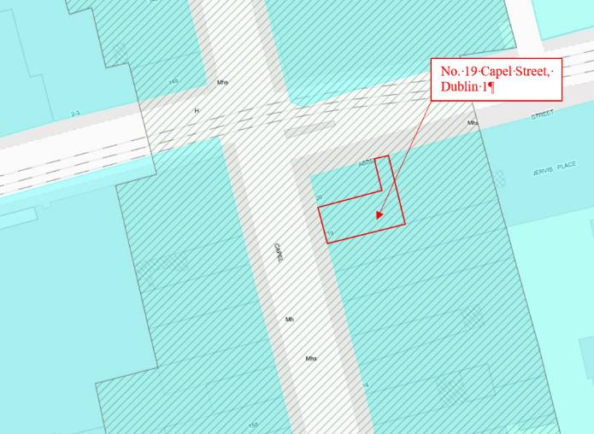
Fig. 1: Site location and zoning map for No. 19 Capel Street, Dublin 1 (indicated with red arrow). The land use and zoning objective is Z5. The site is located within the Capel Street Architectural Conservation Area (hatched area).

Relevant Planning History
There is no recorded planning history for the subject site.

Relevant Planning Enforcement History
There is no recorded planning enforcement history for the subject site.

Site Access
A site inspection of No. 19 Capel Street was carried out by Anne Cuffe Fitzgerald, on behalf of Dublin City Council, on 23rd December 2016.

A request to carry out an updated site inspection was issued by letter on the 8th November 2020 to Brendan Kidd Ltd., the occupier of No. 19 Capel Street. A response was not received to this letter. Following completion of the Title Search for the property, a further request was issued on the 11th June 2021 to the registered owner of the building Mr. Brendan Kidd. No response was received in relation to this letter. A survey of the exterior of the property was carried out on 25th March 2021 and again on 11th June 2021.

Summary Description
Exterior:
No. 19 Capel Street is a terraced two-bay four-storey former house, built c. 1715, with single-storey return and two-storey extension to the rear (east) elevation, now in commercial use. Refurbished c. 1800-1840 with recent shopfront to ground floor to front elevation. Hipped tiled roof with clay ridge tiles, ridge running perpendicular to street, hidden behind red brick parapet with granite coping to front elevation, half-hipped with partial gable to rear (Fig. 5). Large chimneystack to party wall with No. 20 Capel Street, uPVC rainwater goods. Red brick walls to front elevation, laid in Flemish bond, refaced with machine made brick to upper floor, having cement render plat band between second and third floors to front elevation (Fig. 3). Ruled-and-lined cement rendered walls to rear elevation and corrugated metal cladding to extension (Fig. 5).

Square-headed window openings with painted masonry sills, raised painted render reveals and timber two-over-two sash windows with ogee horns to front elevation. Square-headed window openings with masonry sills to rear elevation, six-over-six timber sliding sash window to first floor (Fig. 6) and timber casement window to second floor, remained infilled with concrete breeze block or corrugated metal sheeting. The heights of the openings are staggered to the southernmost bay reflecting their location on the half-landings of the staircase.

Current street frontage to Abbey Street Upper comprises a narrow two-bay single-storey elevation with rendered walls and square-headed openings, both containing metal roller shutters.

Interior:
Internal details are based on the description and photographs from survey by Anne Cuffe Fitzgerald, on behalf of Dublin City Council, on 8th November 2016.

The general floor plan comprises two principle rooms and a hallway/stair hall to each floor. The building retains large angled chimneybreasts to the front and rear rooms at first, second and third floor levels to the north party wall. This plan form and chimneybreast location is typical of Type 1 ‘Dutch Billy’ (Dublin Civic Trust 2012). The chimneybreast to the first floor rear room has a fire surround which appears to be slate, more typical of a mid-nineteenth century date.

A timber staircase rises from the ground to third floors through a series of half-landings. The flights between the ground and first floor appear to be a later replacement. A timber dog-leg closed string staircase rises from first to third floors with interlocking flights, turned timber balusters on block bases and a low timber handrail and is also indicative of an early date.

Little historic joinery e.g. timber panelling, doors or architraves was noted in the accessible rooms, though wide timber floorboards were noted to the second and third floors and bressumer beams were noted to the front rooms to the first, second and third floors. Sections of simple run in situ plaster cornice, consistent with an early eighteenth century date, were evident to the first floor front and rear rooms and to the second floor rear rooms but were missing from the third floor.

The original roof line and main roof structure is relatively intact. The internal roof construction (supported by aerial photographs of the site) indicate that the roof was originally of cruciform plan with a large brick chimneystack to the centre of the north wall, both indicative of an early construction date. The roof timbers are supported on the walls of hand-made brick. The attic windows to the rear elevation have a shared timber lintel and the positioning at close proximity may indicate the survival of at least part of the rear gabled wall.

Historical Background
Capel Street, which formed part of the Jervis Estate, was laid out and developed by Sir Humphrey Jervis in the latter part of the seventeenth century. The estate was located north of the River Liffey on lands which formerly belonged to St. Mary’s Abbey. In the early phase of development large plots were laid along Capel Street and substantial mansion houses constructed, set within courtyards or gardens (Casey 2005, 105). Early residents on the street include Jervis himself and William Connolly, Speaker of the House of Commons. A subsequent phase of development in the early eighteenth century is characterised by the subdivision of these large plots and the construction of the terraced two-bay houses which survive today (James 2001, 16-17).

A plot of the same layout and scale as No. 19 Capel Street appears on Rocque’s map of 1756 (see Fig. 7). Though Dublin Civic Trust had attributed an early nineteenth century date to the building (James 2001, 62), this was based on the appearance of the front elevation of the building and its ground floor which had been significantly remodelled in the nineteenth century. Dublin Civic Trust has since identified No. 19 as an ‘early building’ dating to the first quarter of the eighteenth century (Dublin Civic Trust 2012). Rocque’s map indicates a house with a possible closet return to the rear (east) elevation. A large yard, possibly shared with the buildings on the south side of Little Abbey Street (now Abbey Street Upper), is located to the rear of the structure with a site boundary wall further east.

By the late eighteenth and early nineteenth century, residential development had shifted to the southern and eastern parts of the city. Capel Street had become one of principal commercial streets in Dublin and street directories indicate a wide variety of commercial activities including bookselling and printing, spirit merchants, grocers and chemists. One of these directories Shaw’s ‘Dublin Pictorial Guide and Directory of 1850’ includes illustrations of the principal commercial thoroughfares of the city including Capel Street. No. 19 is illustrated as a two-bay four-storey building with a traditional timber shopfront to the ground floor with a centrally placed round-headed opening giving access to the shop and a square-headed opening to the south end giving access to the upper floors (see Fig. 8). The façade is classically restrained with no ornamentation to the upper floors and a regular fenestration pattern that diminishes in height to the upper floors. The roof is concealed behind a flat parapet but there is an indication of a tall chimneystack to the party wall with No. 20 to the north. The term ‘Dutch Billy’ is commonly used to describe gable-fronted houses constructed in Dublin and in other European cities from the mid-seventeenth to the mid-eighteenth century. Casey (2005, 30) notes that the majority of the buildings, constructed on Capel Street by the first quarter of the eighteenth century were of this type. Characteristics of this building form include cruciform-shaped roofs, corner chimneybreasts and joinery details such as barley-sugar staircase balustrades, wall panelling and lugged and shouldered architraves (Dublin Civic Trust 2012). Modifications to the façade of No. 19 including the alteration of the fenestration pattern, the building up of the front elevation to create a flat parapet and the re-facing of the brickwork reflect changes in architectural taste in the late eighteenth and early nineteenth century (Dublin Civic Trust 2012). The survival of early fabric within the interior of No. 19 however, indicates this redevelopment was not wholesale, but limited to the front elevation and shop floor level of the property.

The 1847 Ordnance Survey map of Dublin (Sheet 14) indicates that the ground plan of No. 19 had extended to cover the majority of the rear plot by the mid-nineteenth century, with a large return to the north side and a small enclosed yard to the south (see Fig. 9). The western elevation of No. 1 Abbey Street abuts the eastern wall of the return. Griffiths Primary Valuation of Tenements (1847-1864) indicates that No. 19 was occupied by Benjamin Maddock on lease from Ignatius Kennedy and consisted of a house and small yard valued at £30. By 1862 Kennedy’s wholesale leather merchant and manufacturing business had extended from No. 18 to include No. 19 (Thom’s Almanac and Official Directory, 1862). It is possible that the re-facing of the brickwork to the front elevation was undertaken at this time as similar brickworks and a shared rendered plat band are evident on both properties.

The OS maps of 1864 and of 1892 (Sheet XVIII.57) indicates little change in the ground plan. Goad’s Fire Insurance Plan of 1893 includes valuable details on the form of the building in the late nineteenth century including, its use, number of storeys, construction materials and specific fire risks to the building. At this time No. 19 was described as a four-storey building to the Capel Street frontage, rising to 52’ in height, with a slate roof and brick walls with a two-storey return having a slate roof indicated to the rear. It was in use as a shop. While the ground plan is similar to that shown on the 1892 OS map, the buildings which formerly stood at 1, 2 and 3 Abbey Street Upper had been demolished and replaced with a Builder’s Yard. The OS 25” map c. 1905-15 shows a similar ground plan with a small structure extends north along the rear of No. 20 providing access onto Abbey Street Upper (see Fig. 10).

The building is currently utilised as a tailor’s shop with a retail unit to the ground floor and work rooms and offices to the upper floors.

References
- Casey, C. (2005). Dublin: The Buildings of Ireland. London: Yale University Press.
- Dublin City Council (2009). Capel Street and Environs Architectural Conservation Area.
- Dublin Civic Trust (2012), A Survey of Gable-Fronted Houses and Other Early Buildings of Dublin City. Dublin: Dublin Civic Trust.
- Goad’s Insurance mapping for the City of Dublin, 1893 (source https://www.bl.uk/onlinegallery/onlineex/firemaps/ireland/mapsu145ubu4u2uf001r.html).
- Griffith’s Primary Valuation of Tenements, 1847-1864 (source http://www.askaboutireland.ie/griffith-valuation/index.xml?action=placeSearch)
- Irish Architectural Archive, press cuttings file.
- James, O. (2001) Capel Street, Dublin 1: A Study of the Past, a Vision for the Future.
- Ordnance Survey mapping, 1847, 1864, 1892, and c. 1910.
- Rocque’s ‘Exact Survey of the City and Suburbs of Dublin, 1756’.
- Shaw, H. 1988. The Dublin Pictorial Guide and Directory of 1850. Belfast.
- Thom’s Irish Almanac and Official Directories.

NIAH Significance/Rating
The National Inventory of Architectural Heritage (NIAH) has been carried out for this area. The NIAH uses eight categories of special interest (architectural, historical, archaeological, artistic, cultural, scientific, technical & social) and identifies five categories of rating in seeking to rank buildings. The NIAH rating values are International, National, Regional, Local and Record Only (I, N, R, L, O). Structures which are considered of International, National, and Regional significance are deemed worthy of inclusion on the RPS.

The NIAH record provided in Appendix 2 of this report has assigned No. 19 Capel Street a Regional rating. These are ‘structures or sites that make a significant contribution to the architectural heritage within their region or area. They also stand in comparison with similar structures or sites in other regions or areas within Ireland. Examples would include many Georgian terraces; Nenagh Courthouse, Co. Tipperary; or the Bailey Lighthouse, Howth. Increasingly, structures that need to be protected include structures or sites that make a significant contribution to the architectural heritage within their own locality. Examples of these would include modest terraces and timber shopfronts’.

Accordingly, the Minister for Culture, Heritage and the Gaeltacht (at that time) recommended the addition of No. 19 Capel Street, Dublin 1, to the City Council’s RPS as part of the Stage 1 recommendations issued to Dublin City Council on the 4th of June 2014, in accordance with Section 53 of the Planning and Development Act, 2000 (as amended).

Assessment of Special Interest under the Planning & Development Act 2000
The National Inventory of Architectural Heritage assigned this building ARCHITECTURAL interest.

The Conservation Section, following an external inspection of the site on 25th March 2021 and 11th June 2021 and using detail from an internal inspection undertaken on behalf of Dublin City Council on 8th November 2016, has considered the opinion of the NIAH and is in agreement with the categories of special interest assigned. In addition the Conservation Section assigns HISTORICAL interest to the sites. As a result No. 19 Capel Street is considered to be of special interest under the following headings:

- ARCHITECTURAL:
- No. 19 Capel Street appears on Rocque’s map of 1756, and despite some modifications to the external fabric and to the internal layout of the ground floor of the structure, the building and plot are comparable to that depicted on Rocque. The plan form is indicative of early building typologies (recorded as a ‘Type 1’ early building by Dublin Civic Trust in 2012) with two principal rooms per floor with angled chimneybreasts to the shared dividing wall and a narrow staircase to the south party wall with No. 18 Capel Street.

- The survival of the early roof structure, including a number of substantial roof timbers, is particularly noteworthy. The cruciform plan which is identifiable from the internal roof structure supported by aerial photographs and the large chimneystack to the party wall with No. 20 Capel Street, indicate an early date.

- Capel Street took on its current appearance and form in the early nineteenth century, with retail replacing residential uses. As at No 19 changes in function were reflected in alterations to building facades including modifications to the fenestration pattern, the introduction of shopfronts, the re-facing of brickwork and the alteration of the parapet lines to reflect contemporary architectural tastes.

- While the appearance of the front elevation of No. 19 belies its early origins, the rear elevation with its irregular fenestration pattern, part gabled wall and half-hipped roof profile are consistent with an early eighteenth century date. The interior retains further features indicative of this date including corner chimney breasts, the timber dog-leg staircase having interlocking flights, and the surviving early roof structure.

- HISTORICAL
- Capel Street is one of the most historically significant streets in Dublin City forming part of the Jervis Estate developed on the former lands of St. Mary’s Abbey. The Jervis Estate was the first large-scale residential scheme to be executed in the city in such a short time period. The street, terminated to the south by Essex Bridge, provided the primary link between the north and south sides of city until the completion of O’Connell Bridge at the end of the eighteenth century.

- Capel Street is identified by architectural historians as one of the most intact commercial streets remaining in the city. While modern interventions are evident, particularly to shopfronts and shop floors, the continuity of commercial activity on the street can be traced back to the early nineteenth century.

Conclusion
Dublin City Council Conservation Section has carried out an assessment of the building and has also considered the Ministerial Recommendation and concludes that No. 19 Capel Street, Dublin 1 merits inclusion on the Record of Protected Structures.

The extent of the proposed Protected Structure status and curtilage is outlined in Fig.2 of this document (below).

It is now proposed to initiate the statutory process for the proposed addition of this structure to the Record of Protected Structures. This includes undertaking a statutory public consultation process in accordance with Section 55 of the Act. Following the statutory consultation process, a further report will be prepared taking any submissions and observations received into consideration, with a recommendation to the City Council to proceed or not with the proposed addition, or with a recommendation including amendments to the proposed addition.

The initiation of the statutory addition process was noted by the Central Area Committee of Dublin City Council at its monthly meeting on the 13th of July 2021.

Recommendation
It is recommended that the statutory process to initiate the proposed addition of No.19 Capel Street, Dublin 1, to the Record of Protected Structures, in accordance with Section 54 and 55 of the Planning and Development Act, 2000 (as amended), be noted.

Recommendation
Address | Description
19 Capel Street, Dublin 1 | Commercial Premises

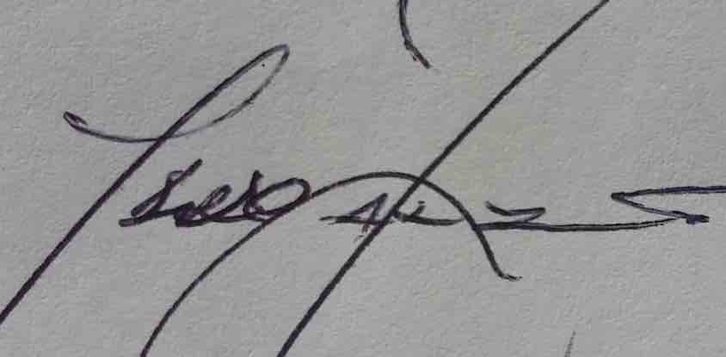 01/07/2021
_______________ _________________
Paraic Fallon Date
Senior Planner

Extent of Protected Structure Status
The extent of protected structure status & curtilage is shown on the map below in red.
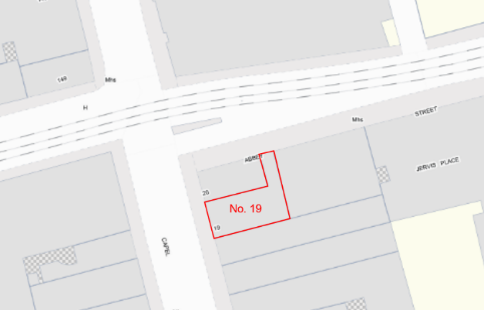
Fig.2: No.19 Capel Street, Dublin 1: extent of Protected Sturcture status and curtilage outlined in red.

Appendix 1: Short Photographic Record & Historical Maps

 | 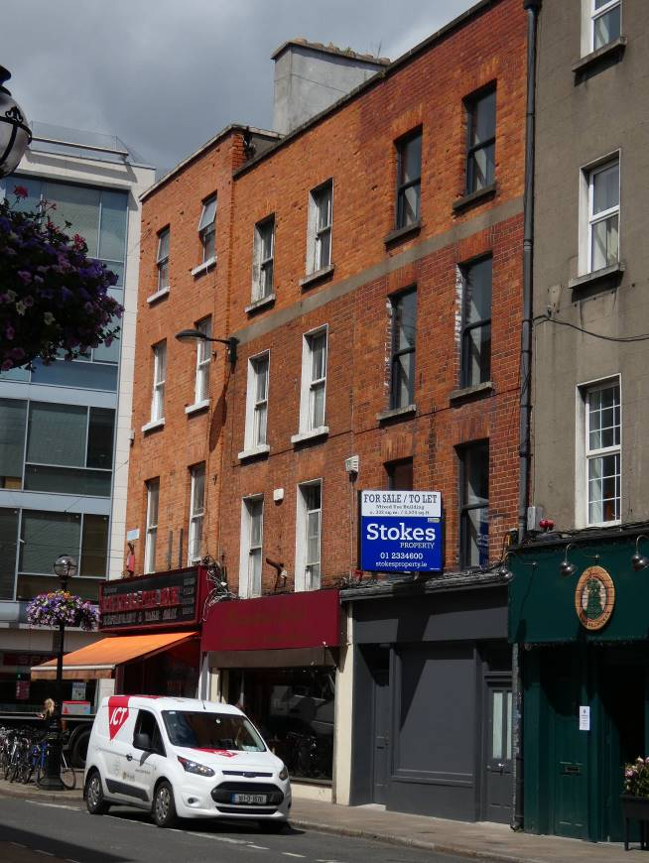
Fig. 3: Front (west) elevation. Note the re-faced brickwork to upper level. | Fig. 4: Context from southwest.
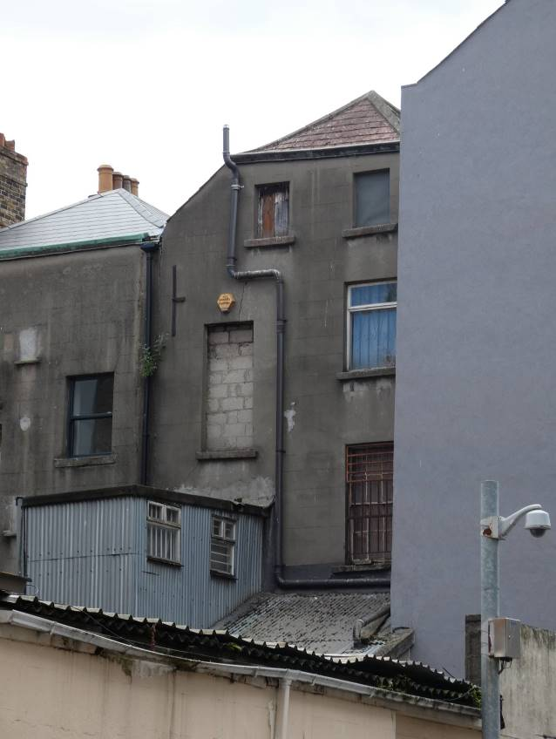 | 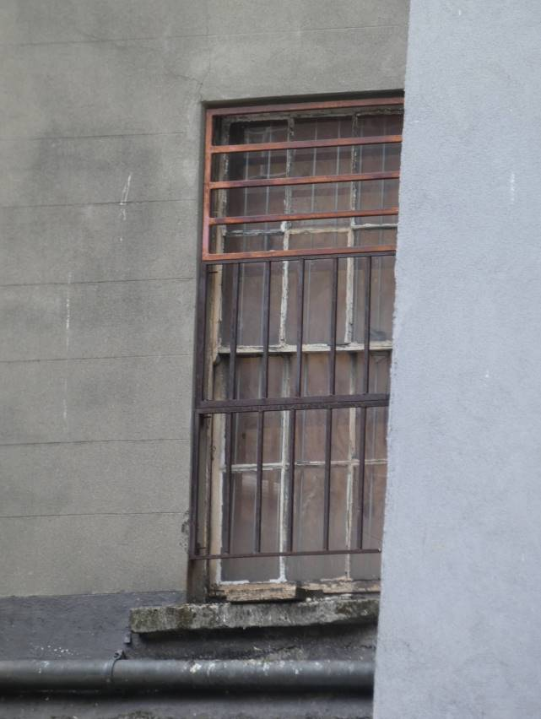
Fig. 5: Rear elevation from northeast showing part gabled elevation and half-hipped roof. | Fig. 6: Timber sash window with convex horns to rear elevation.
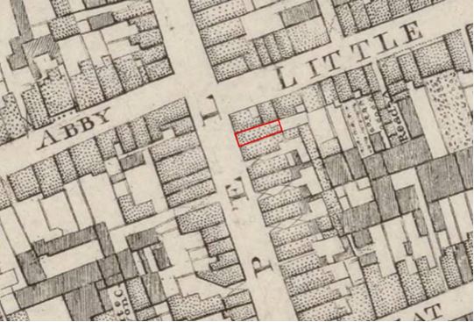
Fig. 7: Extract from John Rocque’s ‘An Exact Survey of the City and Suburbs of Dublin, 1756’ with approximate location of No. 19 Capel Street outline in red.
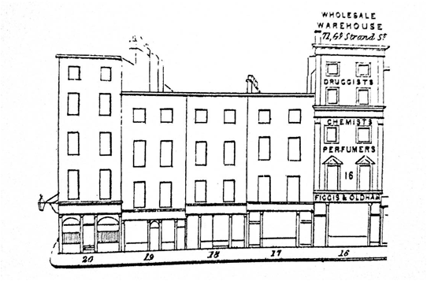
Fig. 8: Extract from Shaw’s ‘The Pictorial Guide and Directory of 1850’, showing No. 19 Capel Street and adjoining buildings.
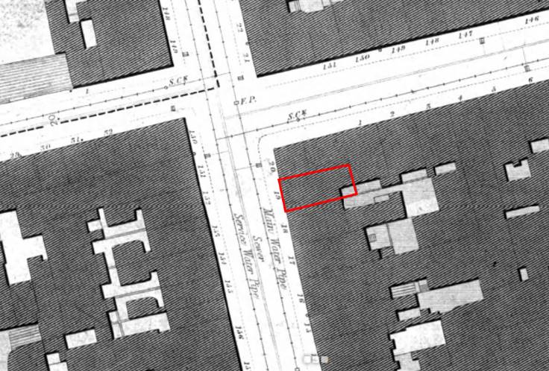
Fig. 9: Extract from 1847 Ordnance Survey Sheet 14, with location of No. 19 Capel Street outlined in red.
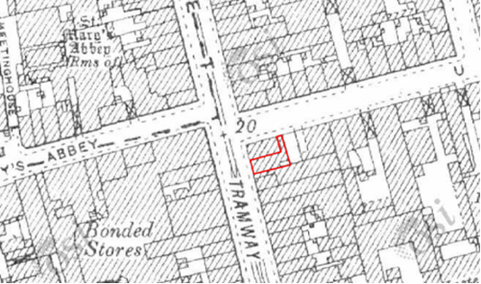
Fig. 10: Extract from Ordnance Survey 25” map, c. 1905-1915, with location of No. 19 Capel Street outlined in red, and extension added to north.

Appendix 2: NIAH Record for 19 Capel Street, Dublin 1

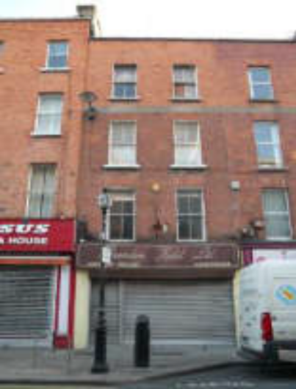
  Reg. | 50010424
  Date | 1690 - 1740
  Previous Name
  Townland
  County | Dublin
  Coordinates | 315389, 234364
  Categories of Special Interest | ARCHITECTURAL
  Rating | Regional
  Original Use | House
  In Use As | Shop/Retail Outlet
Description: Terraced two-bay four-storey townhouse, built c.1715, having facade of machine-made bricks, c.1810. Now in commercial use with shopfront to ground floor and offices above. Hipped roof concealed behind low parapet wall having granite coping. Rectangular-plan chimneystack to north. Red brick walls laid in English garden wall bond, rebuilt to third floor, having render band between second and third floors, and recent shopfront to ground floor. Gauged brick square-headed window openings with patent reveals and painted granite sills to second floor and third floors. Two-over-two pane timber sliding sash windows throughout.
Appraisal: This structure forms part of the historic fabric of Capel Street, laid out in the seventeenth century by Humphrey Jervis as a residential area and later redeveloped to become one of the important commercial centres of the city. This building, while much altered, maintains the classical proportions of the streetscape. Its façade is enlivened by the render band which is continuous with the neighbouring property to the south. The retention of timber sash windows and granite sills provides detail of architectural interest.

