Conservation Section, Planning & Development Department
Civic Offices, Wood Quay, Dublin 8
An Rannóg Caomhantais, An Roinn Pleanála agus Forbairt Maoine
Oifigí na Cathrach, An Ché Adhmaid, Baile Átha Cliath 8
T. 01 222 3927 F. 01 222 2830

21st July 2021

To the Chairperson and Members of the Central Area Committee

Initiation of the Statutory Process for the Proposed Addition of No.56 Capel Street, to the Record of Protected Structures in accordance with Section 54 and 55 of the Planning and Development Act, 2000 (as amended).

The initiation of the statutory addition process was noted by the Central Area Committee of Dublin City Council at its monthly meeting on the 13th of July 2021

PHOTOGRAPH OF STRUCTURE

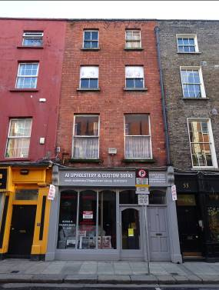
Introduction
It is proposed to initiate procedures under Section 54 and Section 55 of the Planning & Development Act 2000 (as amended) to add ‘No.56 Capel Street to include the Mews Structure (known both as No.56A Capel Street and No.56 Jervis Lane Upper), Dublin 1’ to Dublin City Council’s Record of Protected Structures.

Recommendation/Request for Addition
- Minister for Culture, Heritage and the Gaeltacht (now Minister for Housing, Local Government and Heritage) on the 4th of June 2014.
- Dublin Civic Trust on the 21st November 2016.

Summary of Reasons for Proposed Addition
- Minister for Culture, Heritage and the Gaeltacht (now Minister for Housing, Local Government and Heritage): List of recommendations for inclusion on the RPS of structures deemed as being of ‘Regional’ significance or higher identified during Stage 1 of the Dublin Survey carried out by the National Inventory of Architectural Heritage. No.56 Capel Street, Dublin 1 has been assigned a ‘Regional’ rating. The Stage 1 recommendations were issued by the Minister to Dublin City Council on the 4th of June 2014, in accordance with Section 53 of the Planning and Development Act, 2000 (as amended). .
- Dublin Civic Trust: Identified as an early building post completion of Dublin Civic Trusts 2012 ‘Survey of Gable-Fronted Houses and Other Early Buildings of Dublin City’.

Methodology for Assessing Early Buildings
In November 2019, the Planning & Property Development SPC agreed a methodology to expedite the proposed additions/deletions to the RPS in a systematic manner, based on the Architectural Heritage Protection Guidelines 2011 and NIAH/Ministerial Recommendations under Section 53(1) of the Planning and Development Act, 2000 (as amended). The methodology agreed to prioritise industrial, twentieth century, early buildings and underrepresented typologies. On foot of this the Conservation Section carried out a screening process for Early Buildings. No.56 Capel Street, Dublin 1 has been identified as an Early Building (appearing on Roque’s map of 1756).

Site Location & Zoning Map

No.56 Capel Street, Dublin 1 is located on the east side of Capel Street, mid-terrace between the junctions with Parnell Street and Mary Street. The site is bounded to the rear/east by Jervis Lane Upper. The property is located within the Capel Street Architectural Conservation Area (2009). A number of the adjacent properties are included on the RPS, marked by red asterisks on the map below (fig.1).

The structure in question is zoned Z5: City Centre – “To consolidate and facilitate the development of the central area, and to identify, reinforce, strengthen and protect its civic design character and dignity”, in the Dublin City Development Plan 2016-2022.

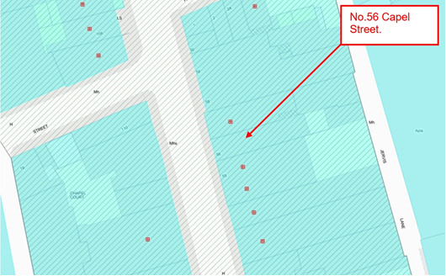
Fig.1: Site location and zoning map for No.56 Capel Street, Dublin 1 (arrowed red). The land use and zoning objective is Z5. The site is located within the Capel Street Architectural Conservation Area. A number of the adjacent buildings are designated as Protected Structures (identified by red asterisks).

Relevant Planning History
Planning Ref: | Description: | Decision:
2260/97 | Conversion of existing premises to three number one-bed apartments and commercial development at rear. Additional information was requested by the Planning Department on 10th December 1997 to include the submission of a complete photographic survey of the existing interior and architectural features. There was no response from the applicant to the request for Additional Information. | No response to request for  ADDITIONAL INFORMATION  dated  10-Dec-1997
4737/08 | Construction of a mixed use development at Jervis Lane Upper (the rear of No.’s 56 & 57 Capel Street, Dublin 1) consisting of the demolition of existing structures and the construction of a 5 storey over basement building. | REFUSE PERMISSION  10-Jul-2009

Relevant Planning Enforcement History

Planning Ref: | Opened: | Reason: | Closed: | Reason:
E0771/00 | 03-Aug-2000 | Alleged door interconnecting with No.57 Capel Street. | 08-May-2006 | Established use – more than 7 years.

Site Access
A request to carry out an update site inspection was sought by letters issued on the 12th November 2020 and again on the 28th April 2021. These were addressed for the attention of the named owners and occupiers of both No. 56 Capel Street and of the property to the rear, known as both No.56A Capel Street and No.56 Jervis Lane Upper. No response was received in relation to No. 56 Capel Street. The Company Secretary of ‘Lobelia Investments Limited’, which had been identified by the legal search as the property owner of No. 56A Capel Street, also known as No.56 Jervis Lane Upper confirmed through various communication that they were not the owners of that property. As such, a survey of the exterior of the subject property/properties was carried out on 27th January 2021 and the 1st June 2021.

Previously, a site inspection of No. 56 Capel Street was carried out by Ann Cuffe Fitzgerald of Fitzgerald Kavanagh & Partners, on behalf of Dublin City Council, on 20th December 2016. Access was provided to both the exterior and interior of No. 56 Capel Street. The property at the rear of 56 Capel Street, known as both No. 56A Capel Street and No. 56 Jervis Lane Upper was not accessed as part of that site inspection.

Summary Description
Composition
Terraced two-bay, four-storey over concealed basement, formerly gable-fronted townhouse built 1720-50, with gabled full height closet return to rear/east. Refurbished c.1800-40 with principal/west elevation refaced c.1900 and late 20th century shopfront inserted to ground floor. Substantial late 20th century single storey extension to rear/east elevation. Enclosed yard to rear/east with two-storey mews building/warehouse fronting onto Jervis Lane Upper (known as both No. 56A Capel Street and No. 56 Jervis Lane Upper).

External Description
Replacement felt roof covering to principal building hidden behind parapet wall, hipped to front/west, terminating in a gabled rear elevation to east, with ridge set perpendicular to street. Pitched felt roof to closet return terminating in a gabled elevation to the east. Truncated chimneystack to centre of north party wall with No. 57 Capel Street. Cast-iron hopper and downpipe to principal/west elevation breaking through parapet wall to south end. uPVC hopper and downpipe to rear/east elevation. No rainwater goods to closet return. Machine-made red brick walls laid in Flemish bond to principal/west elevation c.1900 rising to form a parapet, having granite coping. Early handmade brick walls (no identifiable bonding pattern) to rear/east elevation and to closet return with trace remains of former harling coat. Square-headed window openings to principal/west elevation diminishing in scale to upper floors and having gauged brick flat arches, exposed brick reveals and concrete cills to first floor with granite cills to second and third floors. Timber sliding sash windows comprising a one-over-one arrangement without horns to first floor and two-over-two arrangement with ogee horns to second and third floors. Square-headed window openings to rear/east elevation and to closet return, staggered to southernmost bay reflecting corresponding staircase half-landings. Gauged rubbed brick flat arches with feathered reveals and granite cills. Replacement casement windows to upper floors with a number of blocked opes to lower level appearing to retain timber sash windows. Late 20th century timber and glazed shopfront to principal/west elevation incorporating separate door access to upper floors. Modern paving to footpath retaining historic granite kerb stones.

Substantial single-storey extension abutting rear/east elevation having mono-pitched corrugated-iron roof with glazed lantern.

Two-storey mews building/warehouse fronting onto Jervis Lane Upper with flat roof incorporating skylights. Exposed coursed calp limestone and brick walling having traces of ruled-and-lined cement render and with section of corrugated iron sheeting to upper floor (east elevation). Square-headed window opening to first floor having uPVC casement window. Large doorway with late 20th century double-leaf metal doors with adjoining single-leaf pedestrian doorway to side having glazed overlight. Setted street pavement to Jervis Lane Upper.

Internal Overview
The following internal overview reflects a site inspection of No.5 6 Capel Street carried out by Ann Cuffe Fitzgerald of Fitzgerald Kavanagh & Partners, on behalf of Dublin City Council on 20th December 2016.

The floor plan conforms to an early 18th century layout comprising two principal rooms to one side of a hall/stairhall with a closet return accessed off the rear room (northeast corner of plan). The layout is most clearly identifiable at first and second floors (third floor was inaccessible at the time of survey). The ground floor plan has been altered through the part removal of the spine wall between the original front and rear rooms as well as through the addition of a significant single-storey extension to the rear/east, despite this the former early domestic room configuration remains clearly legible.

The floor plans are dominated by substantial corner chimneybreasts which are shared back-to-back between front and rear principal rooms, and which are placed along the north party wall with No. 57 Capel Street. The chimneybreast has been removed to the ground floor front room though evidence at ceiling level indicates the position of the former chimney beast, which corresponds with that on upper floors.

A dogleg open-string staircase having slender tapered balusters, a sweeping/curved handrail at landings and a ball-finial newel post typical of the mid-to-late 19th century, rises from ground to third floor. A concrete stair descends to basement level.

Floor to ceiling heights are generously scaled to ground and second floors having plaster and painted ceilings throughout (some with modern plasterboard repair/replacement sections). Moulded plaster cornice having a foliate upper register to the first floor front room. Plaster and painted walls with various skirting and door joinery items dating to the 20th century. Floorboards present at first and second floors. Late 20th century finishes throughout to substantial single-storey extension to rear/east.

Historical Background
Capel Street has its origins in the late 17th century when the former lands of the medieval Abbey of St Mary’s, to the north of the River Liffey, were developed by Sir Humphrey Jervis. In c.1676 Jervis built a bridge at Capel Street using stones from the ruins of St. Marys Abbey. The new bridge, named ‘Essex bridge’ was to establish Capel Street as one of the city’s principal thoroughfares. Capel Street quickly became a fashionable and sought-after residential address for the city’s gentry and most powerful public figures, with William Connolly, Speaker of the House of Commons, listed among the street’s early residents.

The initial late 17th century plots were large, facilitating grand freestanding houses set within private courtyards and gardens (Casey, 2005, pg.105). By the turn of the 18th century subdivision provided denser plot ratios creating the terraces of narrow largely two-bay townhouses which characterise the street today, (James, 2001,pg.16). No. 56 Capel Street first appears on Rocques map of 1756 (Fig. 7). The footprint of the townhouse depicted by Rocque, to include the closet return, remains clearly identifiable in the current plan layout. Though James had initially attributed a late 18th century date to the building (2001, pg.62), Dublin Civic Trust has since identified No. 56 as an ‘early building’ with analysis of the historic record and physical fabric suggesting that the property had formed part of the early 18th century development of the street.

Rocque records two enclosed yards to the immediate east of the property with a mews house or outbuilding having direct access to Stable Lane (renamed Jervis Lane by c.1810). An offset is recorded in the rear party boundary between No.56 and No. 57 Capel Street, this anomaly remains clearly legible in the current mapping of the site. Despite Rocque indicating some limited residential use to the east side of the laneway, Stable Lane as suggested by its name, provided stabling for the principal residences on Capel Street. This reflected the first time that mews lanes were provided in the city (James, 2001, gp.17). Casey draws stark contrast between the earlier medieval landlocked plots around St Patricks Cathedral and what she terms the ‘suave urbanity’ of Capel Street, where houses have access to a mews lane (2010, pg.20).

By the late 18th century, new city districts had been developed under the Fitzwilliam and Gardiner Estates. As residential focus shifted to the south and east of the city, trade and commerce took hold on Capel Street becoming by the mid-1800’s one of the city’s leading commercial thoroughfares. It is during this period that No.56 is likely to have been adapted for commercial use with Thom’s Almanac and Official Directory of 1847 recording that a Mr Patrick McKernan, Law and general stationer, printer and account book manufacturer was operating from the premises. The Ordnance Survey Map published in that year (1847) records the mews house on an enlarged footprint with the plot to the rear of No.56 Capel shown laid out in a formal planting arrangement.

An image of the Building illustrated by Henry Shaw in his Dublin Pictorial Guide and Directory of 1850 captures the principal street facing elevation of No.56 (Fig. 8). This records the building in the occupancy of the above-named McKernan’s General Printing Office with a shop at ground level. Shaw’s illustration indicates that at the time the building had an irregular fenestration pattern with two windows to first floor, three to second floor and a single window to the third/attic floor. The distribution of the windows, having a pinched fenestration pattern to the attic storey, is entirely suggestive of a former ‘Dutch Billy’ arrangement conforming to a ‘Type 2a’ house (fig.9) as defined in Dublin Civic Trusts Survey of Gable-fronted Houses and Other Early Buildings of Dublin City (2012). Dutch Billys are characterised by having a gable-fronted elevation not unlike the buildings of Amsterdam. While Casey notes that most domestic buildings on Capel street built prior to 1720 were of the Dutch Billy type (2010, Pg.30), by the mid-point of the 18th century fashions had changed when the flat parapet was preferred to the gable front. Dublin Civic Trust notes that these changes in architectural fashion resulted in many existing early buildings being modified through the building up of the parapet around the upper attic storey windows (Dublin Civic Trust. 2012). Shaw’s illustration confirms that No. 56 Capel Street was originally conceived as an early 18th century Dutch Billy. This was later modified circa the first half of the 1800’s to reflect changes in polite taste, which favoured the concealed roof behind a flat parapet.

Goad’s Fire Insurance Plan of the City of Dublin dated 1893 records the site in some considerable detail with Goad’s assessors reporting No.56 Capel Street as a four-storey masonry building with a slate roof (Fig.10). The early 18th century footprint with closet return remains clearly discernible. The building is by then listed in restaurant use at ground floor with tenement occupancy to upper floors, reflecting the social decline of the north city area which would characterise Capel Street for much of the 20th century. The mews building to Stable Lane, by now renamed Jervis Lane Upper, is recorded as a masonry structure of two stories with a slate roof. At this date the building is indicated in use as stabling. The mews is now shown on a reduced rectangular footprint. Its redrawn western elevation would appear to correspond with the position of a boundary wall which had previously been indicated on Rocque’s map of 1756 (Fig. 7). The familiar offset in the party boundary between No.56 and No.57 remains firmly recorded.

No. 56 remained in mixed residential and commercial use during the first half of the 20th century with the city’s street directories for the period indicating that occupants included a ‘grocers’ and latterly a ‘dairy’, having tenements overhead. Goad’s updated insurance plan of 1932 (Fig. 10) records the footprint and site layout for No. 56 Capel Street unaltered though by this date the mews, previously shown as stabling, is in use as a ‘straw and box store’, now with a patent felt roof covering.

A photograph of Capel Street looking toward the former Royal Exchange (now City Hall) dated 1975 captures an oblique aspect of No.56 (Fig.11). This records the current principal street-facing elevation which is thought to have been refaced in machine made red brick c.1900. The new facade replaced the irregular fenestration pattern as had been depicted by Shaw in 1850 to present an orthodox 19th century two-bay arrangement, which is today prevalent on the street (Fig. 8). Gone were the outward signs of the early Dutch Billy (at least when viewed from Capel Street), replaced by a façade of late 19th century appearance.

The property is currently in use as a furniture retailer with showrooms to ground, first and second floors (the third floor was vacant at the time of the survey). The ground floor retail unit was significantly extended c.1997 enclosing much of the rear yard under a single-storey corrugated-iron roof. Despite this the plan form with closet return, together with the vestigial remains of the mews building and the associated boundary walls would appear to accord with that depicted by Rocque in 1756 (fig.7).

References
- Irish Architectural Archive.
- Dublin City Archive.
- Rocque’s Exact Survey of the City and Suburbs of Dublin (1756).
- Ordnance Survey Mapping.
- Goads Insurance Mapping for the City of Dublin.
- Aerial and satellite photography provided by google maps.
- Thom’s Irish Almanac and Official Directories.
- Bennett, D. (1991). Encyclopaedia of Dublin. Dublin: Gill and Macmillan.
- Casey, C. (2005). Dublin: The Buildings of Ireland . London: Yale University Press.
- Casey, C (2010). The Eighteenth-century Dublin Townhouse. Dublin: Four Courts Press.
- Craig, M (2006) Dublin 1660-1860, The Shaping of a City, Dublin: Liberties Press
- Dublin City Council (adopted 2009). Capel Street and Environs Architectural Conservation Area, Dublin City Council.
- Dublin Civic Trust (2012), A Survey of Gable-Fronted Houses and Other Early Buildings of Dublin City. Dublin: Dublin Civic Trust.
- Fitzgerald Kavanagh & Partners, (2017). Report on Request for Addition to The Record of Protected Structures of No. 56 Capel Street: Unpublished.
- James, O. (2001). Capel Street D1: A Study of the Past, A Vision for the Future. Dublin: Argos Press.
- M'Cready, C. T. (1892). Dublin Street Names, Dated and Explained. Dublin: Carraig Books.
- Pearson, P. (2001). The Heart of Dublin. Dublin: The O'Brien Press.

NIAH Significance/Rating
The National Inventory of Architectural Heritage (NIAH) has been carried out for this area. The NIAH uses eight categories of special interest (architectural, historical, archaeological, artistic, cultural, scientific, technical & social) and identifies five categories of rating in seeking to rank buildings. The NIAH rating values are International, National, Regional, Local and Record Only (I, N, R, L, O). Structures which are considered of International, National, and Regional significance are deemed worthy of inclusion on the RPS.

The NIAH record provided in Appendix 2 of this report has assigned No. 56 Capel Street, Dublin 1 a ‘REGIONAL’ rating. These are structures or sites that make a significant contribution to the architectural heritage within their region or area.

Accordingly, the Minister for Culture, Heritage and the Gaeltacht (at that time) recommended the addition of No. 56 Capel Street, Dublin 1, to the City Council’s RPS as part of the Stage 1 recommendations issued to Dublin City Council on the 4th of June 2014, in accordance with Section 53 of the Planning and Development Act, 2000 (as amended).

Assessment of Special Interest under the Planning & Development Act 2000
The National Inventory of Architectural Heritage assigned this building ARCHITECTURAL interest (see NIAH Record in Appendix 2).

The Conservation Section, following an external inspection of the site on 27th January 2021 and again on the 1st June 2021, and taking into account the internal inspection of 20th December 2016, has considered the opinion of the NIAH and is in agreement with the category of special interest assigned. In addition, the Conservation Section assigns HISTORICAL interest to the site. As a result No. 56 Capel Street, Dublin 1 is considered to be of special interest under the following headings:

- ARCHITECTURAL:
- The property appears on Rocque’s map of 1756 and despite later additions, comparison with current mapping of the site would suggest the extant building, together with the plot boundaries and mews structure is that depicted by Rocque (fig. 7). The interior floor plan conforms to an established typology of the period with two principal rooms per floor with back-to-back chimney breasts and a closet return opening off the rear room. As such, No. 56 is one of twenty six known early 18th century structures on the street which collectively represent an important grouping of early building stock in the city.

- No. 56 has been identified by Dublin Civic Trust as an early 18th century building which confirms to the key classification factors of the study to include: early host street origin; early roof structure; early plan form including closet return; and centrally placed substantial chimney stacks. Henry Shaw’s image of the building dated 1850, records the building prior to its subsequent re-facing c.1900 (fig. 8). The diminished fenestration depicted by Shaw to the attic floor would indicate that this was built as a gable-fronted house confirming to a ‘Type 2a’ house as categorised by Dublin Civic Trusts 2012 survey (fig. 9). Only nine ‘Type 2A’ houses have been identified in the city by Dublin Civic Trust.

- The building presents a rich layering of modifications dating to the 19th and early 20th centuries which chart the changing tastes in Dublin’s architectural evolution. Originally built as an early 18th century gable-fronted Dutch Billy, the façade was reworked pre-1850 as changes in polite tastes favoured the concealed roof behind a flat parapet over the (by then) outdated exposed gabled storey. The building was later modified c.1900 when it was re-faced to present its current aspect. Though the present street facing façade now belies the buildings early origins, the rear elevation together with the gabled roof profile and full height gabled closet return, visible from Jervis Lane Upper, are indicative of the buildings early date.

- The principal street-facing elevation, refaced c.1900 thus obscuring the buildings early 18th century origins, is restrained in terms of detailing and presents an orthodox 19th century two-bay arrangement which exhibits its own architectural merit as a well-appointed late 19th/early 20th century façade. This conforms with the mainly two-bay elevations, which characterise the street today and together with the similarly-scaled adjacent structures, contributes to the architectural character of the area.

- By 1800 the street had become one of the city’s principal commercial thoroughfares. No. 56 Capel Street has remained in commercial use since at least 1850 and the street in general continues to be characterised by small shop units. Capel Street is regarded as one of the most intact historic commercial streets in Dublin.

- Capel Street represents the first time that mews lanes were provided in Dublin. As such the mews house to the rear site, fronting onto Jervis Lane Upper may reflect one of the earliest mews buildings in the city. Few mews structures dating from the early 18th century survive and although the building has been significantly modified/adapted for warehouse/workshop use, the vestigial remains enhance the setting and context of the site.

- HISTORICAL:
- Initially laid out by Humphrey Jervis in the 1670s as a prestigious residential district, the section of Upper Capel Street to include No. 56 reflects a second wave of early development on the street which took place between c.1720 and c.1740.

- No. 56 is an integral part of the streetscape and provides historic context to one of Dublin’s 18th century principal thoroughfares and to the view south along Capel Street, towards the former Royal Exchange (now City Hall), widely considered to be one of the finest vistas in the city.

Conclusion
The Conservation Section has considered the Ministerial Recommendation and the applicants’ reasons for seeking addition and concludes that No. 56 Capel Street, Dublin 1 comprising the two-bay three storey house with closet return to include the rear yard, boundary’s and mews structure (known as both 56A Capel Street and 56 Jervis Lane Upper) merits inclusion on the Record of Protected Structures.

The initiation of the statutory addition process was noted by the Central Area Committee of Dublin City Council at its monthly meeting on the 13th of July 2021.

Recommendation
It is recommended that the statutory process to initiate the proposed addition of 56 Capel Street, Dublin 1, to the Record of Protected Structures, in accordance with Section 54 and 55 of the Planning and Development Act, 2000 (as amended), be noted.

Recommendation
Address | Description (to appear on RPS)
56 Capel Street,  Dublin 1 | Two-bay, three storey house with closet return, including the rear yard, boundaries and mews structure (known as both 56A Capel Street and 56 Jervis Lane Upper); See also 56 Jervis Lane Upper
56 Jervis Lane Upper,  Dublin 1 | Mews structure (known as both 56A Capel Street and 56 Jervis Lane Upper); see also 56 Capel Street

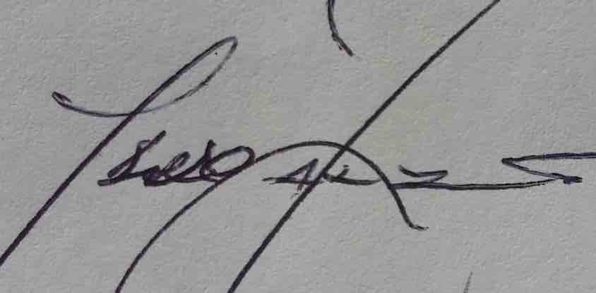 29/06/2021
_______________ _________________
Paraic Fallon Date
Senior Planner

Extent of Protected Structure Status
The extent of protected structure status & curtilage is shown on the map below in red.
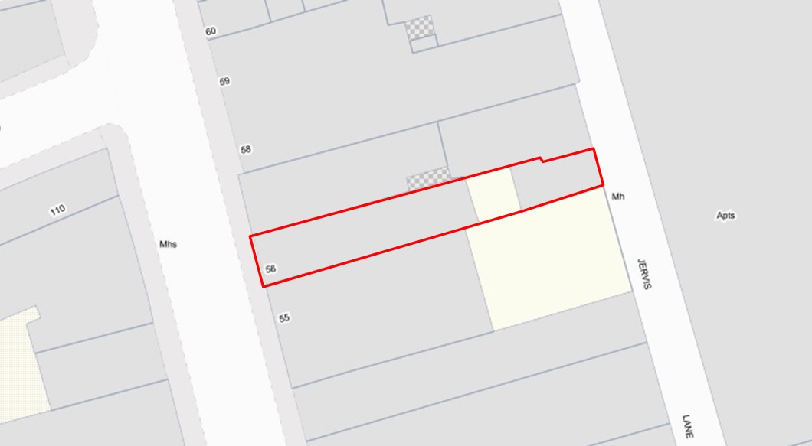
Fig.2: No.56 Capel Street, Dublin 1 to include the mews structure (known as both 56A Capel Street and 56 Jervis Lane Upper): extent of Protected Structure status and curtilage outlined in red.

Appendix 1: Short Photographic Record & Historical Maps

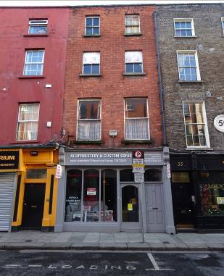 | 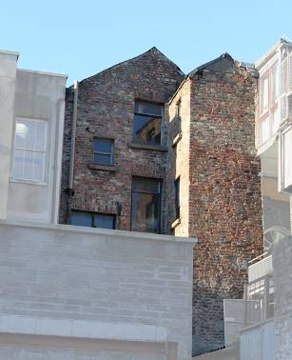
Fig.3: Principal/west elevation. Note the machine made red brick façade reflecting a re-facing of the early 18th century building c.1900. | Fig.4: Rear/east elevation taken from Jervis Lane Upper. Note the early handmade brickwork, gabled elevation and gabled full-height closet return. For clarity the adjacent properties have been faded out.
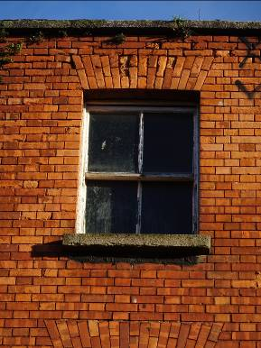 | 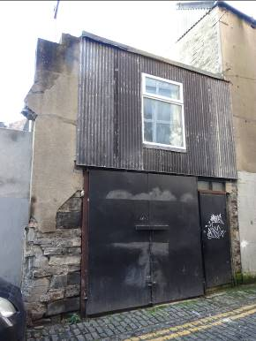
Fig.5: Detail of third floor window opening with granite cill and two-over-two timber sash window. Note the machine made brick to elevations laid in Flemish bond. | Fig.6: Two-storey mews building/warehouse fronting onto Jervis Lane Upper (known as both 56A Capel Street and 56 Jervis Lane Upper). Note the exposed sections of coursed calp limestone and brick masonry to lower level.
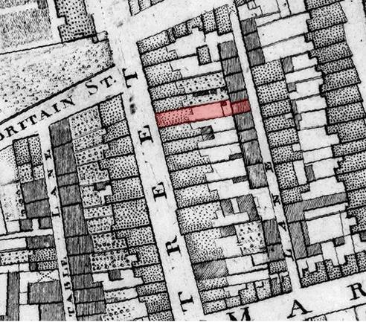
Fig.7: Rocque’s Exact Survey of the City and Suburbs of Dublin (1756). No. 56 Capel Street with closet return, rear yard and mews house/outbuilding is hatched red. Note the offset recorded in the rear party boundary between No.56 and No.57 Capel Street, this anomaly remains clearly legible in the current mapping of the site.
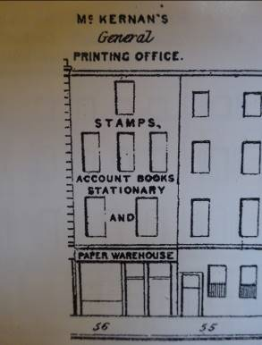 | 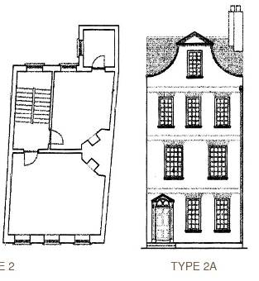
Fig.8: Henry Shaw’s Pictorial Directory of Dublin of 1850 illustrating No.56 Capel Street then in use by ‘McKernan’s General Printing Office’. Note the irregular fenestration pattern with single window to the third/attic floor suggestive of a former ‘Dutch Billy’ arrangement. | Fig.9: ‘Type 2a’ house as defined in Dublin Civic Trusts Survey of Gable-fronted Houses and Other Early Buildings of Dublin City (2012). Note the distribution of the windows with pinched fenestration pattern to the gable-fronted attic storey.
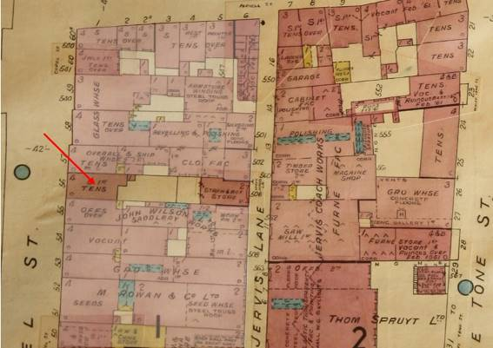
Fig.10: Goad’s Fire Insurance Map of Dublin revised 1932. No.56 Capel Street is arrowed red. Note that the mews house/outbuilding is now shown on a rectangular footprint and that the stepped western building line which had been recorded on the 1847 O.S map is no longer evident. For clarity the adjacent properties have been faded out.
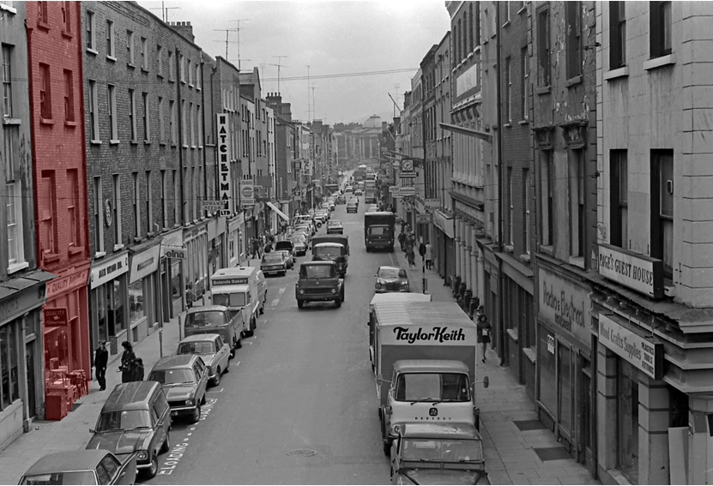
Fig.11: A photograph of Capel Street looking toward the former Royal Exchange (now City Hall) dated 1975 captures an oblique aspect of No.56 (hatched red). Image courtesy of the Dublin City Archive – Dublin City Council Photographic Collection ref no: 42782.
Appendix 2: NIAH Record for No.56 Capel Street, Dublin 1.

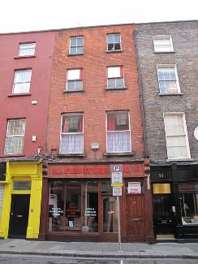
  Reg. No. | 50010574
  Date | 1730- 1770
  Previous Name | N/A
  Townland
  County | Dublin City
  Coordinates | 315329, 234603
  Categories of Special Interest | ARCHITECTURAL
  Rating | Regional
  Original Use | House
  In Use As | Shop/retail outlet
Description: Terraced two-bay four-storey brick house, built c.1750, possibly as pair with No. 57, with recent shopfront to ground floor. Slate roof set perpendicular to street, hipped to front, gabled to rear. Roof hidden behind parapet wall with granite coping and cast-iron hopper and downpipe breaking through to south end. Machine-made red brick walls laid in Flemish bond. Gauged brick flat-arched window openings with granite sills and timber sliding sash windows, two-over-two pane to second and third floors, single-pane to first floor.

Appraisal: The proportions and scale of this building would suggest eighteenth-century origins, with refacing in ed c.1900 [sic]. Positioned among similarly-scaled townhouses, this example sits comfortably into the predominant typology and contributes to the rhythmic character of this historic streetscape. Capel Street was laid out in 1680 by Humphrey Jervis as a prestigious residential street and named after Arthur Capel the Earl of Essex. By 1800 the street had become one of the city’s principal commercial thoroughfares with the current plot ratios reflecting the layout of that period.

Note: The NIAH suggests that No.56 may have been built as one of a pair with No.57. However, review of Rocque’s Map indicates that it is more likely that No.57 and No.58 form a pair, having back-to-back closet returns and that No.56 reflects a one-off speculative development (research into the leases and land registry papers for these properties may yield further insight).

Dublin Civic Trust: Identified No.56 as an early building, post completion of Dublin Civic Trusts 2012 ‘Survey of Gable-Fronted Houses and Other Early Buildings of Dublin City’.
No.56 Capel Street was not identified as an early building until after publication of Dublin Civic Trusts Survey of Gable-fronted Houses and Other Early Buildings of Dublin City (2012).

