Conservation Section, Planning & Development Department
Civic Offices, Wood Quay, Dublin 8
An Rannóg Caomhantais, An Roinn Pleanála agus Forbairt Maoine
Oifigí na Cathrach, An Ché Adhmaid, Baile Átha Cliath 8
T. 01 222 3927 F. 01 222 2830

27th May 2021

To the Chairperson and Members of the Central Area Committee

Initiation of the Statutory Process for the Proposed Addition of 26 Kings Inn Street, Dublin 1, to the Record of Protected Structures in accordance with Section 54 and 55 of the Planning and Development Act, 2000 (as amended).

The initiation of the statutory addition process was noted by the Central Area Committee of Dublin City Council at its monthly meeting on the 13th of July 2021

PHOTOGRAPH OF STRUCTURE

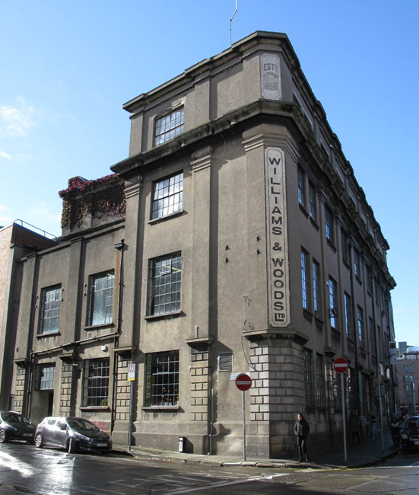

Introduction
It is proposed to initiate procedures under Section 54 and Section 55 of the Planning & Development Act 2000 (as amended) to add 26 Kings Inn Street, Dublin 1 to Dublin City Council’s Record of Protected Structures.

Request for Addition
- Minister for Housing, Local Government and Heritage as ministerial recommendation based on National Inventory of Architectural Heritage on the 04/06/14.

Summary of Reasons for Seeking Addition
Minister for Culture, Heritage and the Gaeltacht (now the Minister for Housing, Local Government & Heritage): Stage 1 Ministerial Recommendations. List of recommendations for inclusion on the RPS of structures deemed as being of ‘Regional’ significance or higher identified during Stage 1 of the Dublin Survey carried out by the National Inventory of Architectural Heritage. 26 Kings Inns Street, Dublin 1 has been assigned a Regional rating. The Stage 1 recommendations were issued to Dublin City Council on the 04/06/14.

Methodology for Assessing 20th Century Structures
In November 2019, the Planning & Property Development SPC agreed a methodology to expedite the proposed additions/deletions to the RPS in a systematic manner, based on the Architectural Heritage Protection Guidelines 2011 and NIAH/Ministerial Recommendations under Section 53(1) of the Planning and Development Act, 2000 (as amended). The methodology agreed to prioritise industrial, twentieth century, early buildings and underrepresented typologies. On foot of this the Conservation Section carried out a screening process for 20th century structures. 26 Kings Inn Street, Dublin 1 was identified as a potential 20th century structures.

Site Location & Zoning Map

The structure in question is zoned Z5: “To consolidate and facilitate the development of the central area, and to identify, reinforce and strengthen and protect its civic design character and dignity”, in the Dublin City Development Plan 2016-2022.

The building is located on a prominent corner at the junction of Kings Inn Street and Loftus Lane.

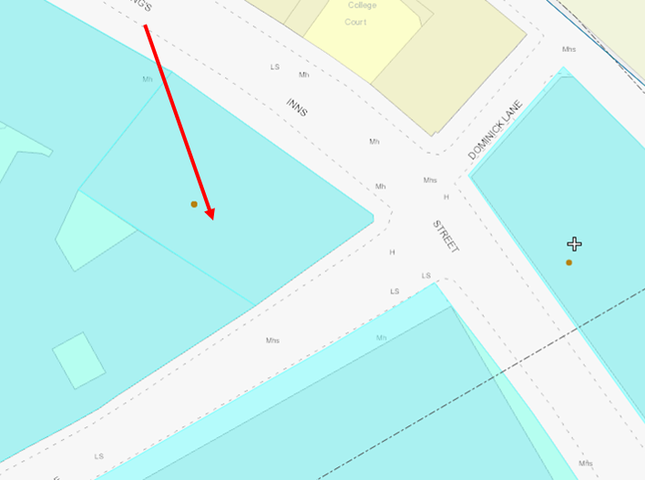
Fig.1: Site location and zoning map for 26 Kings Inn Street, Dublin 1.

Recent Planning History:

Ref No. | Description | Decision
3790/15 | Permission for change of use of 209m2 of basement floor of existing building from commercial storage facility to post-production studio, change of use of 460m2 of first floor of existing building from commercial storage facility to multi-media use & change of use of 525m2 of second floor of existing building from commercial storage facility to studio space. | GRANT PERMISSION  26-Oct-2016
3271/14 | For change of use of 52.9m2 of first floor of existing building from commercial storage facility to post-production studio. | GRANT PERMISSION  08-Oct-2014
2193/12 | The development will consist of change of use of 36.2msq of ground floor of existing building from commercial storage facility to coffee shop. | GRANT PERMISSION  11-Apr-2012

Recent Enforcement History:

Ref. No. | Opened | Reason | Closed | Reason
F0065/14 | 15-Aug-2014 | Non-compliance with financial condition no. 9 attached to PP 2193/12 | 27-Oct-2016 | Condition complied with
E0629/17 | 12-Jun-2017 | Noise issues | 19-Apr-2018 | No evidence
E0260/13 | 29-Apr-2013 | recording studio and shed to roof | 25-May-2017 | Complies with permission

Site Access
A site inspection was carried out by Carl Raftery of Dublin City Council’s Conservation Section on 21/09/18 and 14/04/21. Access was limited to the exterior only of the property and to the publicly accessible ground floor café. Access letters was requested of the Building Manger addressed to the site on 14th November 2018, and subsequently, following a legal search, to the registered owner on the 11th December 2020 and the 11th January 2021. No response was received in relation of these access request letters.

Summary Description
Exterior: Corner-sited L-plan seven-bay four-storey factory, built 1910 and extended c.1925 and 1941, with angled corner bay and two-bay two-storey extension to rear (southeast) elevation. Flat roof, hidden behind rendered parapet wall having moulded deep cornice. Cast-iron rainwater goods. Rendered walls, ruled-and-lined to ground floor, with rendered engaged square-profile Doric style pilasters on channel rusticated masonry bases dividing bays, surmounted by moulded masonry deep cornice to base of first floor level. Similar moulded capitals over second floor level with moulded masonry deep cornice under third floor forming sill course to latter. Stepped ashlar granite plinth course, rendered to south-east elevation. Painted sign to angled end bay and exposed part of northwest elevation onto the former Cherry Lane. Yellow brick visible to north elevation. Square-headed window openings having masonry sills, blocked throughout. Steel grilles to ground floor windows. Square-headed door opening to front (north-west) elevation with steel door.
Interior: Internal access was limited to the ground floor entrance and public café. Entrance lobby ceiling showing cast concrete ribs, painted concrete floors, concrete stairs to basement with red brick walls and multiple door openings including access to main stair case. The ground floor café contains the original timber floor boards, an open plan space with chamfered detail to cast concrete pillars and ceiling ribs. Large scale original steel framed Fenestra multi-pane casement windows with some original glazing having central pivot opening sections to King’s Inn Street and Loftus Lane. The upper floors and basement were not accessed however they may follow the same design exhibited on the ground floor with timber floor boards and chamfered detail to cast concrete pillars and ceiling ribs.

Historical Background
The construction of this distinctive factory building at 26 King’s Inn Street was a flagship building for the expanding Williams and Woods Company, C. 1910. They had up until then occupied an existing building, namely the former Simpson Hospital on Parnell Street. The architect designed a distinctive reinforced concrete construction which ensured this building stood out in an area surrounded by decaying tenement buildings. It employed the latest in modern construction technology while retaining more traditional architectural detailing. It is important to remember at this point, however, that while many of Dublin’s early twentieth century public buildings revived older styles through stone cladding and architectural ornament, they were actually structured out of very modern techniques like steel frames and poured concrete foundations, floor slabs and stairways. (Rowley, Ed. 2016, 25).

Williams and Woods moved to Great Britain Street (now Parnell Street) in 1875, operating as confectionary manufacturers and wholesalers. The company acquired adjacent sites, including land across Loftus Lane, and had a factory complex that produced sweets, preserves, canned goods and vinegar. This particular part of the factory seems to have been built around 1900, completely destroyed by fire in 1908, and built again by 1910 (a jam factory designed by Donnelly & Moore). The 1936 Ordnance Survey shows raised walkways across Loftus Lane, linking it back to the factory on Parnell Street. Willwood, as the company was then known, left the Parnell Street area for Tallaght in 1975.

References
- http://map.geohive.ie/mapviewer.html (Digital record accessed 07/04/21)
- https://digital.ucd.ie/view/ucdlib:46819 (Digital record accessed 07/04/21)
- http://archiseek.com/2013/1787-simpsons-hospital-parnell-st-dublin/ (Digital record accessed 07/04/21)
- http://builtdublin.com/factory-26-kings-inns-street-dublin-1/ (Digital record accessed 07/04/21)
- Mac Manus, Ruth. Crampton Built 2008, Gill & Macmillan, Dublin
- Rowley, Ellen (editor), More than Concrete Blocks; Dublin city’s twentieth-century buildings and their stories Vol. 1 1900-40, 2016, Dublin

NIAH Significance/Rating
The National Inventory of Architectural Heritage (NIAH) survey has been carried out for the area under Phase 1 of the Dublin City programme (see Appendix 2).

The NIAH uses eight categories of special interest (architectural, historical, archaeological, artistic, cultural, scientific, technical & social) and identifies five categories of rating in seeking to rank buildings. The NIAH rating values are International, National, Regional, Local and Record Only (I, N, R, L, O). Structures which are considered of International, National, and Regional significance are deemed worthy of inclusion on the RPS.

The NIAH record provided in Appendix 2 of this report has assigned 26 Kings Inn Street, Dublin 1 a ‘Regional’ rating. These are structures or sites that make a significant contribution to the architectural heritage within their region or area.

The NIAH record comprises the entire structure at 26 Kings Inn Street, Dublin 1 based on an external survey only.

26 Kings Inn Street, Dublin 1 was recommended by the Minister for Culture, Heritage and the Gaeltacht (now the Minister for Housing, Local Government & Heritage) under Stage 1 Ministerial Recommendations issued to the Dublin City Council on the 04/06/21

Assessment of Special Interest under the Planning & Development Act 2000
26 Kings Inn Street, Dublin 1 is considered by the Conservation Section of Dublin City Council to be of special interest under the following headings:

- ARCHITECTURAL: The architect designed a distinctive reinforced concrete construction which ensured this building stood out in an area surrounded by decaying tenement buildings. It is an exemplar of good quality architectural design. The design embraces the unusual site plan to create a strong architectural statement. It was designed by Donnelly & Moore, and constructed by G & T. Crampton. It has a prominent presence in the streetscape and is a statement of emerging twentieth century design. Internally the steel and concrete form allowed for the creation of an open plan versatile work space. The NIAH Appraisal further states: ‘This substantial building was designed as a jam and sweet factory by Donnelly & Moore, and constructed by G. & T. Crampton for Williams & Woods in 1910, on the site of an earlier confectionary factory established c.1856. ..It has a formidable presence on the streetscape, prominently sited at the corner of Loftus Lane and Kings Inn Street, and its façade articulated by deep cornices and engaged pilasters with rusticated granite plinths’.
- ARTISTIC: The artistic interest is attributed to the structure itself through its strong vertical expression juxtaposed against the oversized cornice runs. The original painted signage on the angled corner bay provides contextual and artistic interest and adds to the character of the structure. (There is also semi-hidden signage on the former Cherry Lane). This distinctive corner building is reminiscent of the unique Flatiron building in New York, constructed in 1902.
- TECHNICAL: It employed the latest in modern construction technology while retaining more traditional architectural detailing. It is important to remember at this point, however, that while many of Dublin’s early twentieth century public buildings revived older styles through stone cladding and architectural ornament, they were actually structured out of very modern techniques like steel framed and poured concrete foundations, floor slabs and stairways (Rowley, Ed 2016, 25).

Conclusion
Dublin City Council Conservation Section has carried out an assessment of 26 Kings Inn Street, Dublin 1. The section has considered the Ministerial Recommendation and the reasons for seeking addition and concludes that the structure merits inclusion on the Record of Protected Structures.

The extent of the proposed Protected Structure status and curtilage is outlined in Fig.2 of this document (below).

It is now proposed to initiate the statutory process for the proposed addition of this structure to the Record of Protected Structures. This includes undertaking a statutory public consultation process in accordance with Section 55 of the Act. Following the statutory consultation process, a further report will be prepared taking any submissions and observations received into consideration, with a recommendation to the City Council to proceed or not with the proposed addition, or with a recommendation including amendments to the proposed addition.

The initiation of the statutory addition process was noted by the Central Area Committee of Dublin City Council at its monthly meeting on the 13th of July 2021.

Recommendation
It is recommended that the statutory process to initiate for the proposed addition of 26 Kings Inn Street, Dublin 1, to the Record of Protected Structures, in accordance with Section 54 and 55 of the Planning and Development Act, 2000 (as amended), be noted.

Recommendation
Address | Description
26 Kings Inn Street, Dublin 1 | Former Williams & Woods Ltd Jam & Confectionary Factory

Cross reference
Loftus Lane, Dublin 1 | Former Williams & Woods Ltd Jam & Confectionary Factory- see 26 Kings Inn Street, Dublin 1

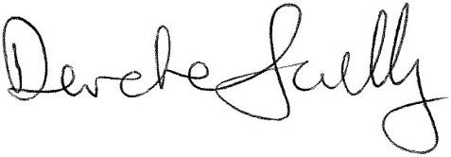 01/06/2021
_______________ _________________
Deirdre Scully Date
Deputy City Planner
Extent of Protected Structure Status
The extent of protected structure status & curtilage is shown on the map below in red.
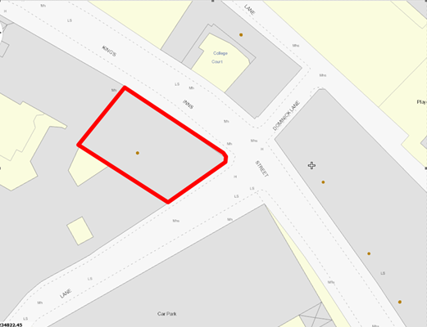
Fig.2: 26 Kings Inn Street, Dublin 1: extent of Protected Sturcture status and curtilage outlined in red.

Appendix 1: Short Photographic Record & Historical Maps
Dated 14/04/21
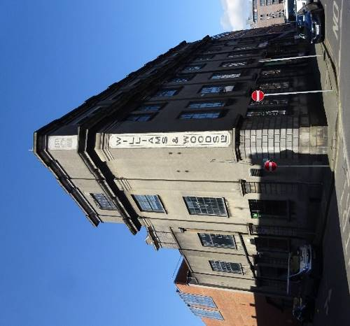 | 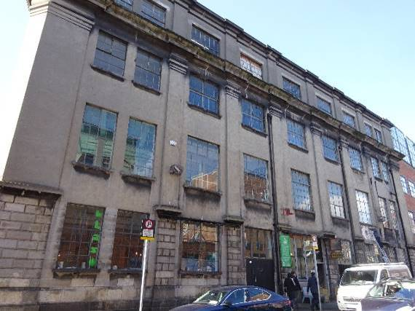
View from corner of Loftus Lane and Kings Inn Street | Kings Inn Street elevation

Dated 21/09/18
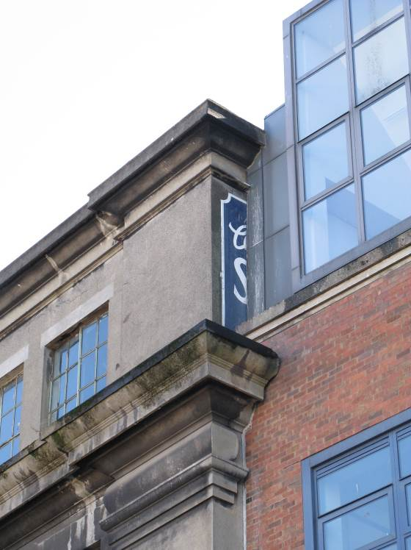 | 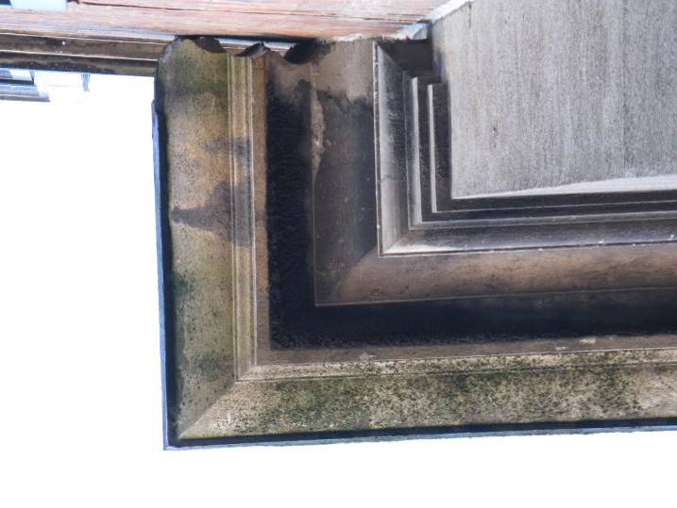
Hidden signage on the former Cherry Lane | Profile of cornice
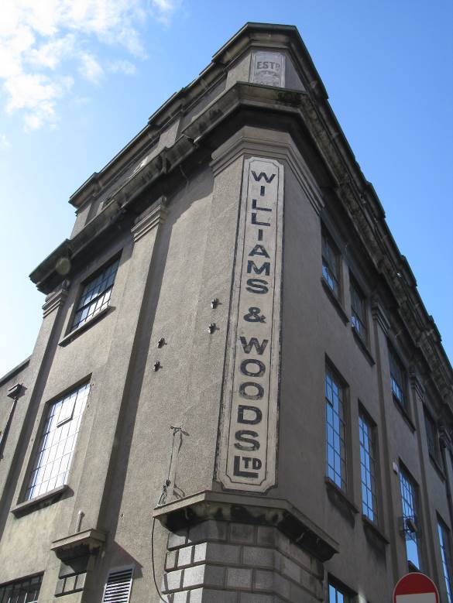 | 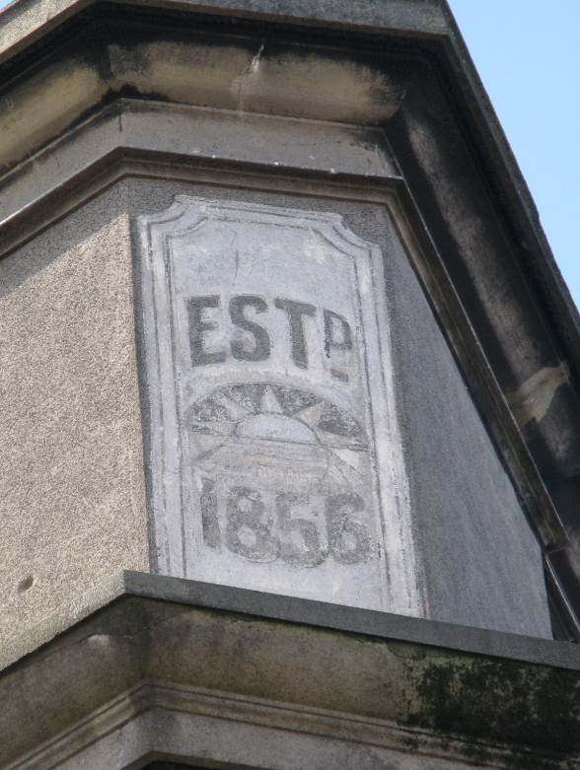
Original signage | Original date plaque for establishment of Williams & Woods
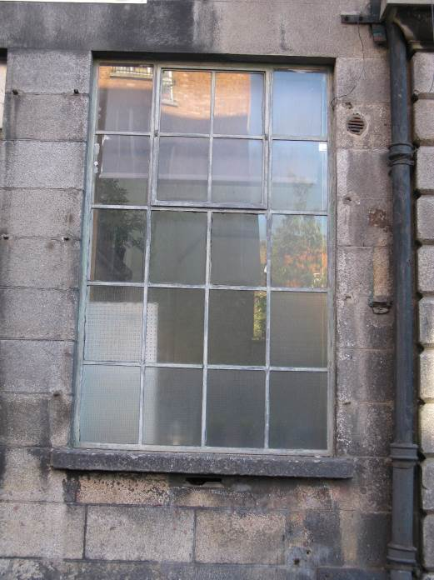 | 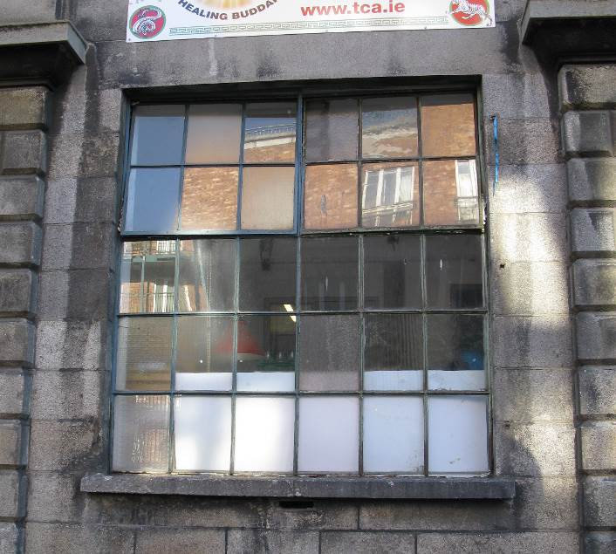
Early metal window with central pivot opening section on Loftus Lane | Original metal window with pair of central pivot opening sections retaining panes of early glazing on Kings Inn Street elevation
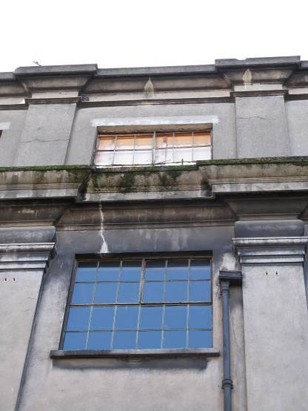 | 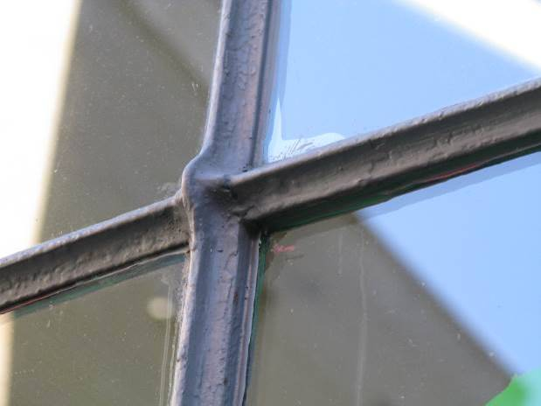
Various opening sizes of metal windows | T bar threaded glazing bars to original casements
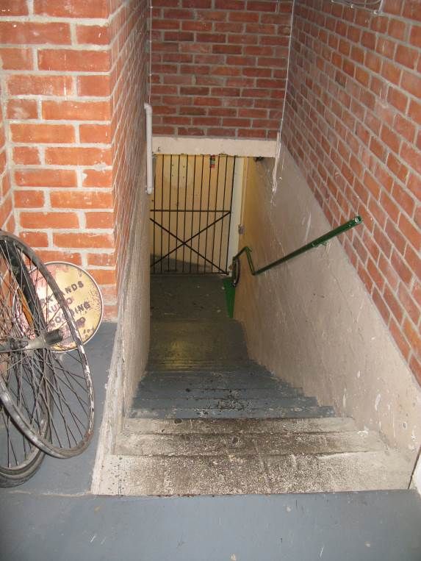 | 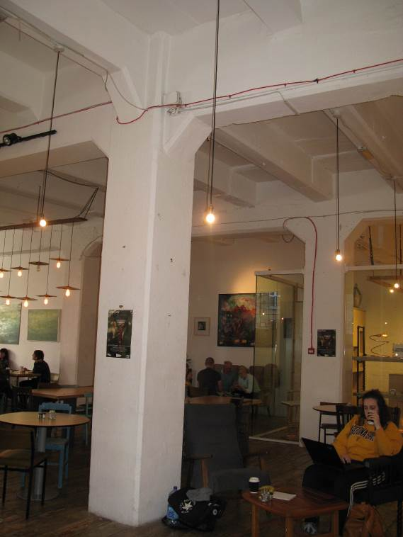
Original basement steps | Chamfered detail to cast concrete pillars
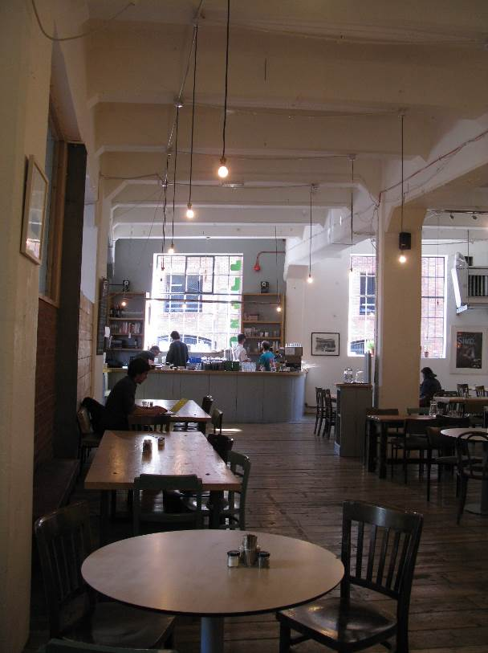 | 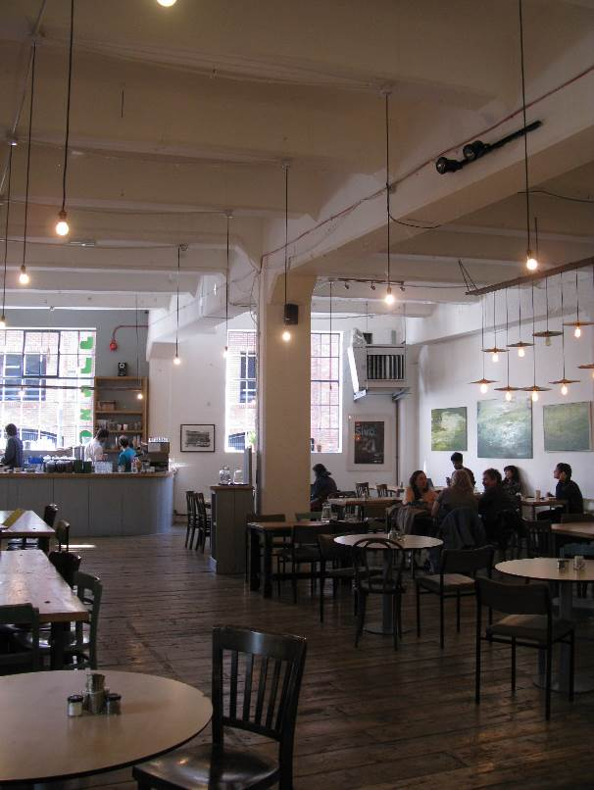
Open plan ground floor space with reinforced concrete ribbed pillars and ceiling slabs | Original wide timber floorboards

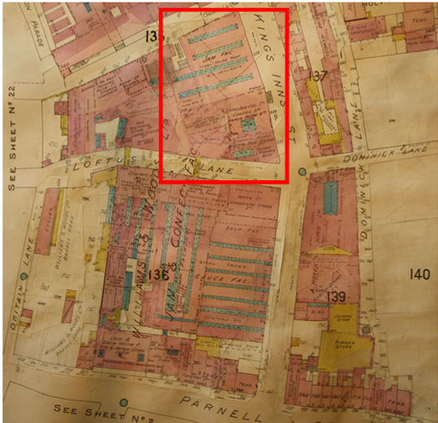
Goad’s Insurance map 1926

Appendix 2: NIAH Record

NIAH Ministerial Recommendation for No. 26 Kings Inns Street, Dublin 1
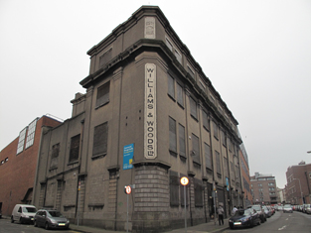
  Reg. No. – 50010691
  Date - 1905 – 1945
  Previous Name – N/A
  Townland – N/A
  County – Dublin City
  Categories of Special Interest – ARCHITECTURAL, ARTISTIC;
  Rating –Regional
  Original Use – factory, food processing site, industrial
  In Use As – building misc, unassigned, unassigned
Description: Corner-sited L-plan seven-bay four-storey factory, built 1910 and extended c.1925 and 1941, with angled corner bay and two-bay two-storey extension to rear (southeast) elevation. Flat roof, hidden behind rendered parapet wall having moulded deep cornice. Cast-iron rainwater goods. Rendered walls, ruled-and-lined to ground floor, with rendered engaged square-profile Doric style pilasters on channel rusticated masonry bases dividing bays, surmounted by moulded masonry deep cornice to base of first floor level. Similar moulded capitals over second floor level with moulded masonry deep cornice under third floor forming sill course to latter. Stepped ashlar granite plinth course, rendered to south-east elevation. Painted sign to angled end bay and exposed part of northwest elevation. Yellow brick visible to north elevation. Square-headed window openings having masonry sills, blocked throughout. Steel grilles to ground floor windows. Square-headed door opening to front (north-west) elevation with steel door.
Appraisal: This substantial building was designed as a jam and sweet factory by Donnelly & Moore, and constructed by G. & T. Crampton for Williams & Woods in 1910, on the site of an earlier confectionary factory established c.1856. It has since been used as a data storage facility. As a food production site, it constitutes a component part of the social and industrial history of this part of Dublin, contextualised by nearby linen and yarn warehouses and a paper manufacturing site. It has a formidable presence on the streetscape, prominently sited at the corner of Loftus Lane and Kings Inn Street, and its façade articulated by deep cornices and engaged pilasters with rusticated granite plinths. A painted sign to the angled corner bay provides contextual and artistic interest.

