To the Lord Mayor and Report No. 103/2021

Members of Dublin City Council Report of the Assistant Chief Executive and City Engineer



**Report on Covid Mobility Measures and on Major Walking and Cycling Projects**

**Environment and Transportation Department**

**7 April 2021**

Contents

**Foreword…………………………………………………………………………………………3**

**Part A Covid Mobility Measures Update**…………………………………………………**4**

**1. Introduction** 4

1.1 Pedestrian Volumes 4

1.2 Cycling Volumes 5

1.3 Bus Passenger Numbers 6

1.4 General Traffic Volumes 6

**2. Implementation of Measures** 7

2.1 Pedestrian Crossings 7

2.2 Protected Cycle Facilities and Contra-Flow Cycle Facilities 7

2.3 On-Street Cycle Parking 8

2.4 School Mobility Programme 8

2.5 Cycle & Scooter Parking for Schools & Sports Clubs 9

**3. Speed Limits** 9

**4. Business Support** 10

**5. Communications** 10

5.1 Website 10

5.2 DCC Consultation Hub/Citizen Space 10

5.3 COVID-19 Mobility E-Mail 11

5.4 Councillor Updates 11

5.5 Active Travel Promotion 11

**Part B Walking & Cycling Major Infrastructure Projects** 12

1. 5-Year Walking and Cycling Infrastructure Delivery 12

2. Schemes with Statutory Planning Approval 12

Royal Canal Greenway 12

Dodder Greenway (Herbert Park to Donnybrook) 13

Clontarf to City Centre 13

The Point Junction Improvement Scheme 13

3 Interim Schemes 13

Liffey Cycle Route 13

Fitzwilliam Street Cycle Route 14

**Appendix 1: Proposed locations of new Pedestrian Crossings 15**

# Foreword

For almost a year a regular weekly report was circulated to Elected Members regarding the works being undertaken by the COVID Mobility Team, which enabled Members to be kept up-to-date with how projects are progressing. In 2021, the reporting frequency was changed to every fortnight, as the reassignment of engineers from the COVID Mobility Team to the TAG area structure meant that there were not as many projects being undertaken. At the request of Elected Members a monthly report on major walking and cycling projects has been circulated to members for the City Council meeting since October 2020.

This report combines the two above mentioned reports in order to have a single report covering the various walking and cycling activities and major projects underway. With the agreement of the Elected Members It is proposed to issue this report on a monthly basis and to place it on the City Council Agenda every quarter.

# Part A COVID Mobility Measures Update

## 1. Introduction

The continuation of Level 5 restrictions means that there are reduced volumes and activity. However, the Government has designated walking and cycling projects, particularly those being implemented as part of a COVID response, to be critical infrastructure, and work can proceed in these areas.

### 1.1 Pedestrian Volumes

Dublin City Council (DCC) footfall counters on Stephen’s Green and Henry Street show the footfall in these core city centre areas. Footfall has been consistent throughout March and is at around 40% of pre-COVID levels.

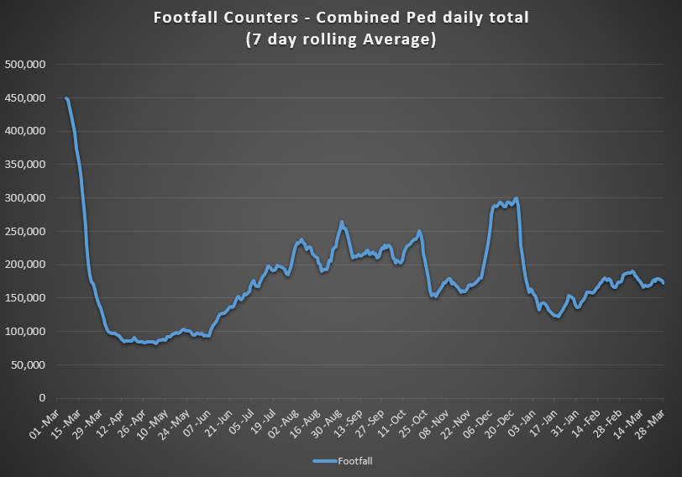

### 1.2 Cycling Volumes

Cycling volumes, are continuously monitored by City Council’s counters, located at Grove Road, North Strand Road, Charleville Mall and Guild Street. Cycling numbers have been increasing steadily since January, with the week day totals now around 75% of pre-COVID levels.

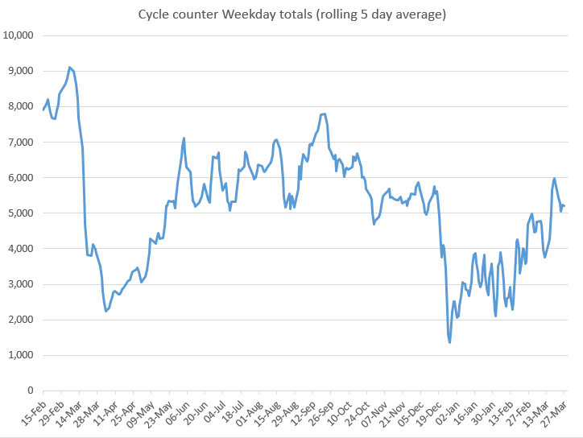

While there has been a drop in commuter cycling, there has been a significant increase in weekend cycling. Comparing Q1 totals for 2021 to Q1 2019 and 2020 data, indicates that there has been a 46% increase in cycling, despite the Level 5 restrictions.

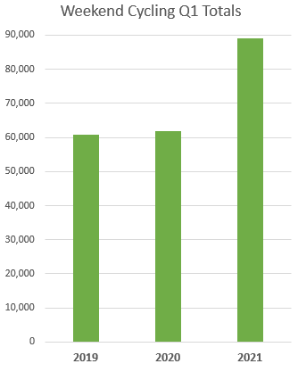

### 1.3 Bus Passenger Numbers

Bus passenger numbers remain around 35% of previous numbers in 2020, with only minor fluctuations seen each week.

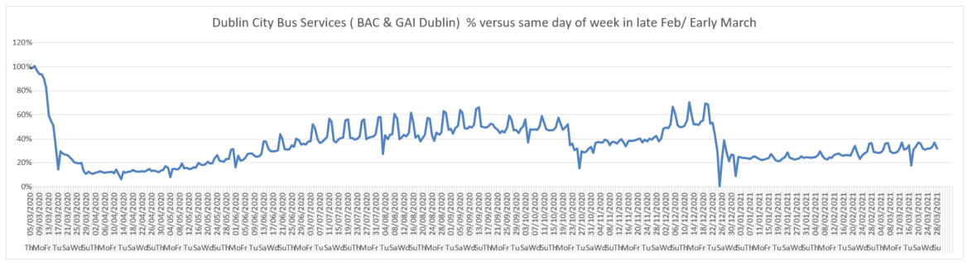

### 1.4 General Traffic Volumes

The trend over the last 11 weeks, shows a steady increase in volumes from approx. 59% to 65%, with an overall average of approx. 60% of pre-COVID levels. The volumes are higher on the North side than the South side, with the NCR/Doyle’s Corner at 70%, the Merrion and Stillorgan Roads at 60%, and Pearse Street at 52% of pre-COVID traffic levels.

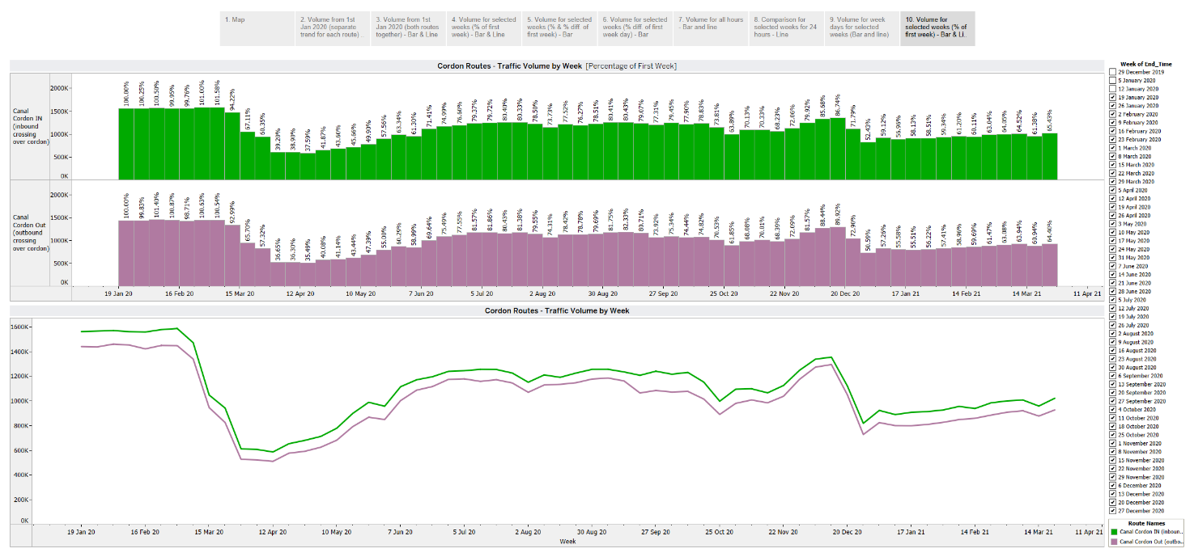

## 2. Implementation of Measures

### 2.1 Pedestrian Crossings

NTA funding of €3million has been approved to install new pedestrian crossings across the city. A list of proposed locations, awaiting final NTA approval, is given in Appendix 1.

### 2.2 Protected Cycle Facilities and Contra-Flow Cycle Facilities

#### Strand Road Cycle Route Trial

24 June 2021 has been set for the hearing of the case in the High Court. In the meantime, a stay on the works is in place, so only works required for safety purposes can be undertaken.

A Part 5 application was made to Dublin City Council as the Planning Authority, and the Planning Department has issued a Declaration and Referral on Development and Exempted Development, in accordance with Article 5 of the Planning & Development Act 2000. This concluded as follows:

*‘Accordingly, it is considered that the works proposed are considered exempted development when assessed in accordance with the Planning and Development Act 2000 to 2010 and the Regulations made thereunder’*

#### Griffith Avenue Cycle Route

Installation of road markings on Section 3 of Griffith Avenue between Drumcondra Road and Gracepark Road has recently commenced. An update was provided to the North Central Area Committee at a meeting on 1 April. Detailed design drawings for the junctions of St. Mobhi Road and Ballymun Road with Griffith Avenue are almost complete. It is expected that this work will go out to tender in April.

#### Parnell Square East Protected Contra-flow Cycle Lane

In conjunction with our colleagues in the Parks Department, planters have been installed on the Parnell Square East protected contra-flow cycle lane. Some of the bollards will now be removed.

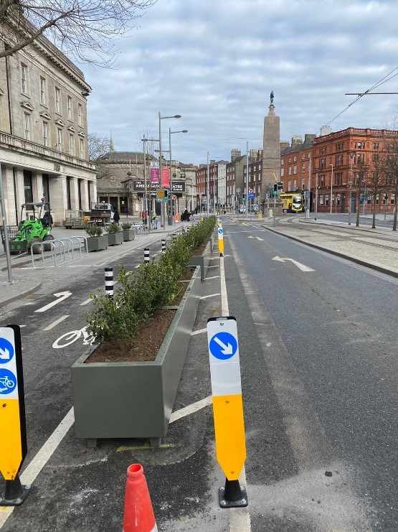 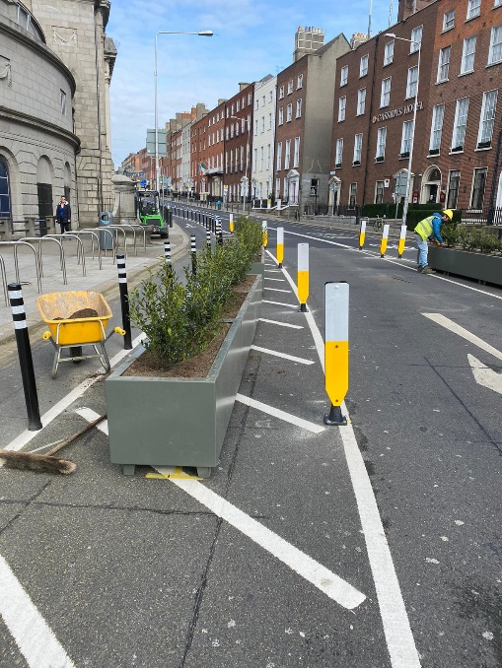 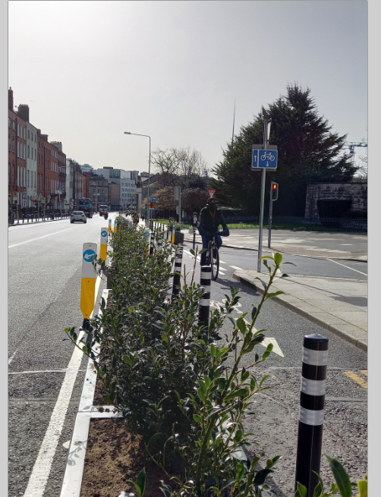

*Planter protection being installed on Parnell Square East Protected Contra-Flow Cycle Lane*

#### Blessington Street Protected Contra-flow Cycle Lane

Works began on the contraflow cycle lane on Blessington Street on Monday 22 March and are proceeding well. It is expected that this section of the contraflow lane will be opened towards the end of April.

#### Collins Avenue Extension Cycle Route

Preliminary designs have been developed for a protected cycle lane on both sides of Collins Avenue Ext. The proposals will provide good linkage to DCU from the Ballymun Road to the west, and Larkhill Road to the east, and have been approved by the NTA. Works on this project are expected to start in April.

#### Infirmary Road Cycle Protection

New mandatory cycle lanes have been introduced on Infirmary Road linking the North Circular Road with Parkgate Street. Bollards to protect these cycle lanes are due to be installed in April.

#### South Circular Road Cycle Protection

Cycle protection on South Circular Road from Bulfin Road to Conyngham Road will be installed during April.

#### Sean Moore Road Cycle protection

Cycle lane protection will be provided on Sean Moore Road to link it to Pigeon House Road. Further details will be available on the website next week. This is expected to be installed in early May.

### 2.3 On-Street Cycle Parking

We are preparing to retender Batch 17 to take account of a number of changes since it was originally tendered including:

1. Changes to the specifications for cycle parking that have recently been adopted by the SPC to take account of the requirement for social distancing necessitated by Covid-19.
2. The increased roll out of cycle parking in schools has reduced the requirement for cycle parking outside schools and
3. The Parks Department would like to see opportunities for landscaping considered as part of future batches of cycle parking.

It is expected that a revised package will be prepared during April with a view to going to tender in early May.

### 2.4 School Mobility Programme

The application list for a School Zonecurrentlystands at 112 Schools. The COVID Mobility Technical Team are assessing all submissions for suitability and schools will be contacted with timelines, if it is deemed to be an appropriate intervention at the particular location.

To date a total of 38 School Zones have been installed across the city. The breakdown of the School Zones completed per City Council administrative area is: South Central Area -13; South East Area - 9; Central Area - 9; North West Area - 4; North Central Area - 3.

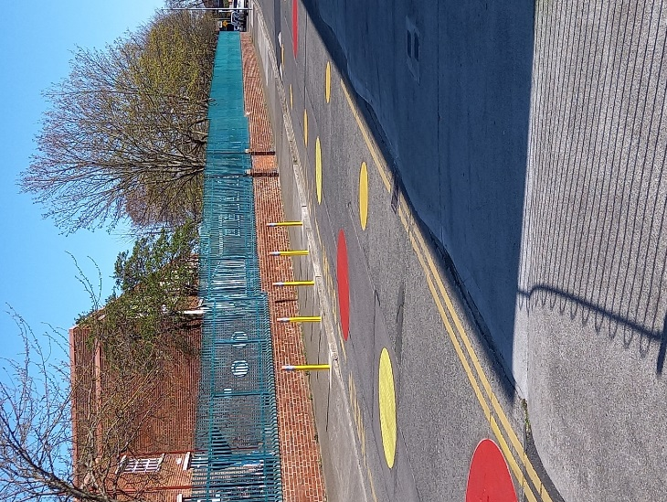

*School Zone, Our Lady of Good Counsel Knocknarea Road*

The following School Zones are due for installation in the next month:

* Our Lady of Lourdes NS, Vincent Street West, Inchicore, Dublin 8
* Scoil Fhursa, Cromcastle Green, Kilmore West, Dublin 5
* Scoil Íde GNS, Cromcastle Green, Kilmore West, Dublin 5
* St. Kevin's Boys National School, Barry Avenue, Finglas West, Dublin 11
* St. Josephs GNS, Barry Avenue, Finglas West, Dublin 11
* Lindsay Road National School, Lindsay Road, Dublin 9
* St Columba’s National School, Iona Road, Dublin 9
* Scoil Úna Naofa, Armagh Road, Crumlin, Dublin 12
* Scoil Colaiste Eoin, Armagh Road, Crumlin, Dublin 12
* Gaiscoil Nai-Ide, All Saints Drive, Raheny, Dublin 5
* Scoil Aine GNS, All Saints Drive, Raheny, Dublin 5
* Scoil Assaim BNS, Raheny, Dublin 5
* St Oliver Plunkett’s JNS, St Helena’s Drive Finglas, South, Dublin 11
* Broombridge Educate Together National School, Cabra, Dublin 7
* St Catherine’s Rathoath Rd Cabra West, Dublin 7

A total of 37 schools, 29 on the Northside and 8 on the Southside, are at design stage, subject to final consultation with School Principals and the NTA.

Since the last Covid Mobility update, the Schools Outreach Officers have conducted a total of 18 site visits with schools and local communities. These site visits include site assessments with Neighborhood Engineers, observation of ‘travel to school’ behavior and meetings withSschool Principals and local communities. The Schools Outreach Officers will continue to carry out these visits with all School Zone applicants.

### 2.5 Cycle & Scooter Parking for Schools & Sports Clubs

Applications for cycle and scooter parking for schools and sports clubs have now closed. Over 80 schools and sports clubs have applied for cycle and scooter parking. The tender process for manufacture and delivery of the cycle parking is now complete. Deliveries are expected to take place later this month.

The installation of School Zones and school cycle parking will be advanced in collaboration with the NTA and under the funding umbrella of a National Active Travel Schools Programme.

## 3. Speed Limits

Presentations were made to all Area Committees on the ‘***Loving 30’*** campaign, which proposes to set the default speed limit in the city to 30km/h, with some roads having special speed limits higher than this. A 2-week Non-Statutory Public Consultation will take place from 6to 20 April 2021 to gain initial feedback on the proposed speed limits. Submissions will inform the final proposals put forward for Statutory Public Consultation in the summer.

## 4. Business Support

The Covid Mobility Measures Section has received a number of requests from various locations across the city to facilitate the re-opening of the city, as Government restrictions are eased. A number of measures including footpath build-outs and traffic management changes are currently under investigation in order to facilitate outdoor trading/dining.

The Covid Mobility Business Liaison Officer continues to engage and consult with businesses on a number of COVID Mobility Measures citywide.

## 5. Communications

### 5.1 Website

The [COVID Mobility webpage](http://www.dublincity.ie/COVID-19mobilityprogramme), is being updated regularly to keep the general public informed of COVID mobility interventions. As previously advised we will be making more extensive use of the Consultation Hub to provide information on proposed measures.

### 5.2 DCC Consultation Hub/Citizen Space

Details of schemes on the Consultation Hub at present include:

[Griffith Avenue Protected Cycle Track](https://consultation.dublincity.ie/traffic-and-transport/griffith-avenue-protected-cycle-track/)

Members are alerted on a regular basis to any new proposals, which are available to view on the Consultation Hub. The aim is to have a more dynamic process for ensuring that support for projects, suggestions on how to improve them and concerns and issues, which may need to be addressed, can be handled. Any feedback on this approach is welcome.

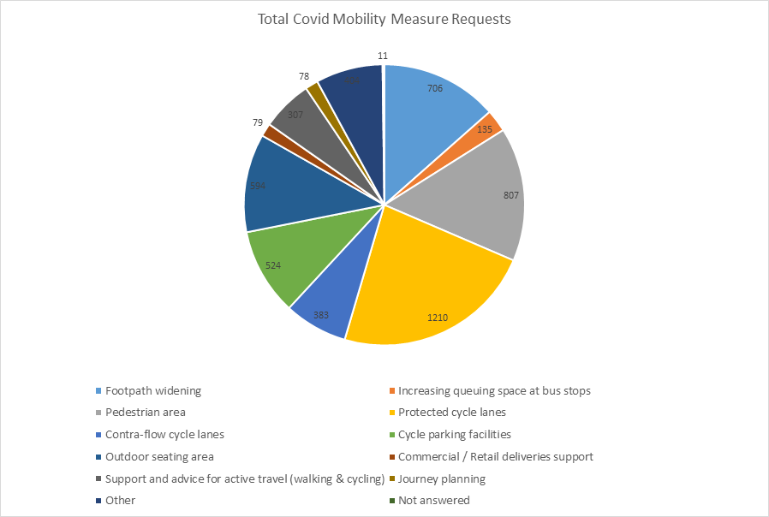

### 5.3 COVID Mobility E-Mail

The dedicated e-mail address continues as the primary channel to contact the COVID Mobility Team. It is attracting huge volumes of queries and feedback. The intention is that the e-mail is for general queries and the COVID Mobility Request Form should be used for specific requests at specific locations.

### 5.4 Councillor Updates

Updates on COVID-19 mobility measures will in future be issued to Elected Members via the combined monthly report on a monthly basis. Updates via e-mail are also being issued to stakeholders via the Transportation SPC and to the NTA for distribution to disability user groups.

### 5.5 Active Travel Promotion

We are continuing to utilise Dublin City Council Social Media Channels:

* + - to highlight COVID-19 mobility measures that have been implemented;
    - to encourage the public to walk or cycle, where possible;
    - to encourage social distancing as people move around the city and;
    - to encourage more respect for vulnerable road users

# Part B Walking & Cycling Major Infrastructure Projects

## 1. 5-Year Walking and Cycling Infrastructure Delivery

Over the next five years, Dublin City Council will undertake the planning and implementation of up to 140km of cycling and walking infrastructure. This is made up of 55km from 27 existing projects and 85km from 31 new projects. The full list was circulated in Report No 67/2021 issued in February 2021. Over the next six months, as Project Teams are set up, these projects will be assessed further in order to develop a comprehensive programme for delivery. In addition, a number of infrastructure projects that had been paused will be resumed.

Regarding additional staff; confirmation on funded numbers has been received from the NTA. The recruitment process will commence shortly.

## 2. Schemes with Statutory Planning Approval

There are no new schemes undergoing the statutory planning process. This is unchanged from last month. There are four projects with statutory planning consent. These are;

1. Royal Canal Greenway
2. Dodder Greenway
3. Clontarf to City Centre
4. The Point Junction Improvement Scheme

### *Royal Canal Greenway*

The Royal Canal Greenway is being delivered in four phases.

Phase 1: Implemented.

Phase 2: Tree planting was carried out during March 2021.

Phase 3: Tenders leading to the appointment of a Contractor were issued on 19 March 2021. It is anticipated that a Contractor appointment will be made in Q3 2021

Phase 4: Site investigations are still ongoing. During March, ecological surveys were commenced. These will be used to update existing records and to inform the final design. It was initially intended to deliver Phase 4B of the main line using lands currently available in advance. This would be followed by Phase 4C that relied on carrying out a number of CPOs. This approach to implementation was based on very limited resources that were available at the time. Further discussions with Waterways Ireland have presented a more effective way of widening the towpath, while enhancing the ecological corridor. This can be achieved by widening into the canal. In addition, widening of the canal between the 6th Lock and Coke Oven Cottages is now proposed. This may be achieved by relocating a historic wall to the boundary of Waterways Ireland and CIÉ. This was not in the original scheme. The Project Team is currently engaging with residents on these proposals. An amended Part 8 will be required to facilitate these changes. These changes will avoid CPOs and to cater for increased demand for walking and cycling along the route. The public consultation process for the additional works will commence in May 2021. The target date for the issuing of construction tender documents for the mainline works has slipped into Q2 2021. However, the project team is still working to have a contractor on site in Q4 2021.

### *Dodder Greenway (Herbert Park to Donnybrook)*

A project team will shortly be formed for this project and a date will then be communicated for the Consultative Committee meeting.

### *Clontarf to City Centre*

Information on the project is now accessible on the DCC webpages. The address is [www.dublincity.ie/c2cc](http://www.dublincity.ie/c2cc). The following information is now available;

* Project Overview and Progress Update
* Drawings and Visualisations
* Bus Stop Design

During the month, the Project Team has been engaging with disability groups and organisations. The preparation for consultation with other stakeholders, including residents and businesses along the route, is progressing well. The bus stop design proposal has been circulated to stakeholders. A Communications Plan was circulated to Members on 1March 2021. A follow up meeting with Members of the North Central and Central Area Committees has been scheduled for 14 April 2021.

### *The Point Junction Improvement Scheme*

The Point junction improvement scheme has now been incorporated into the new Pedestrian and cycling bridge beside the Tom Clarke Bridge and will allow the design team to integrate the changes required at the Point roundabout with the new Bridge and its interface with the new Dodder Bridge on the South Side. In addition we are in discussion with Dublin Port Company in order to incorporate a proposed Greenway within DPC lands into the overall cycling infrastructure provision in this area allowing to be linked for leisure and other uses.

## 3. Interim Schemes

The implementation of two interim schemes to facilitate immediate safety improvements for cyclists is ongoing. This is to compensate for delays in the delivery of the main schemes. These are:

1. Liffey Cycle Route
2. Fitzwilliam Cycle Route

### *Liffey Cycle Route*

Work is still ongoing at Bridge Street/Merchants Quay junction and are substantially complete, with road resurfacing and road markings scheduled for April 2021. This will facilitate the roll out of the scheme from Grattan Bridge to James Joyce Bridge. Works at St John’s Road West/Victoria Quay junction have been progressing slower than anticipated due to the challenges with accommodating existing services. As a result, it is now likely that works at this location will extend into June 2021. The designs from O’Connell Bridge to Matt Talbot Memorial Bridge, for both the North Quays and South Quays are being finalised. Tenders leading to the appointment of Contractors will be issued in April 2021.

For the full permanent scheme, Dublin City Council has appointed service providers to provide the baseline archaeology, architectural heritage and conservation reports. The archaeology report has been finalised. The conservation report has been reviewed by Dublin City Council enabling the final report to be finalised in April 2021. The drafting of the public realm and opportunities study will resume thereafter.

### *Fitzwilliam Street Cycle Route*

In order to finalise the design of the permanent scheme, cellar surveys started in November 2020. These were completed in March 2021. Dublin City Council had received representations to provide enhanced greening along the route as part of the permanent scheme. Following consultation with DCC landscape and conservation architects, it was considered that in the interest of conservation these proposals could not be incorporated in the scheme.

The contract for ground investigations at junctions, to facilitate the replacement of a section of water-mains, was awarded in December 2020. Works commenced on site in January 2021and are ongoing. They are scheduled for completion during this month.

Brendan O’Brien

**Executive Manager (Traffic)**

John W. Flanagan

**Assistant Chief Executive & City Engineer**

**7 April 2021**

## Appendix 1: Proposed locations of new Pedestrian Crossings

Note, all are signalised pedestrian crossings unless otherwise stated.

**Central Area**

1 Mountjoy Square

2 Blackhorse Avenue @ Nephin Road

3 Ossory Road @ West Road

4 East Wall Road / East Road

5 Ballyboggan Road Central

6 Marys Lane Central

7 Western Way

8 Botanic Avenue / Drumcondra Road

9 Cumberland St. / Parnell St.

**North Central Area**

10 Seafield Road West North Central (Uncontrolled Pedestrian Crossing)

11 Collins Avenue East @ Scoil Ciarans National School (Uncontrolled Pedestrian Crossing)

12 Collins Avenue @ Grace Park Road

13 Swords Road @ Shantalla Road

14 Clontarf Road / Clontarf Baths

15 Coolock Drive / Bunratty Road

**North West Area**

16 Ballygall Road East / Fitzmaurice Road

17 Ballygall Road West / Beneavin Road

18 Ballygall Road East @ St. Kevins College

19 Wellmount Road @ St. Brigids Senior School (Uncontrolled Pedestrian Crossing)

20 Ballymun Road @ Ballymun Library

**South Central Area**

21 Brookwood Avenue / Gracefield Road

22 Scr / Conyngham Road

23 Marrowbone Lane @ Earl Street South (Uncontrolled Pedestrian Crossings / Buildouts)

24 Cherry Orchard Avenue @ Blackditch Road

25 Scr / Donore Avenue

**South East Area**

26 Clogher Road / Sundrive Road

27 Palmerstown Road / Cowper Road

28 Rathmines Road Upper @ Church Avenue

29 Armagh Road @ Scoil Eoin

30 Thorncastle St. / Bridge St.