To the Lord Mayor and Report No. 139/2021

Members of Dublin City Council Report of the Assistant Chief Executive

and City Engineer

Dublin City Council Logo.

**Report on Covid Mobility Measures and on Major Walking and Cycling Projects**

**Environment and Transportation Department**

**May 2021**

Contents

Foreword 3

Part A COVID Mobility Measures Update 4

1. Introduction 4

1.1 Pedestrian Volumes 4

1.2 Cycling Volumes 5

1.3 Bus Passenger Numbers 5

1.4 General Traffic Volumes 6

2. Implementation of Measures 7

2.1 Pedestrian Crossings 7

2.2 Protected Cycle Facilities and Contra-Flow Cycle Facilities 7

2.3 On-Street Cycle Parking 8

2.4 Filtered Permeability/Low Traffic Neighbourhoods 8

2.5 School Mobility Programme 9

2.6 Cycle & Scooter Parking for Schools & Sports Clubs 10

3. Special Speed Limits Bye-Laws 2020 10

4. Business Support 11

5. Communications 11

5.1 Website 11

5.2 DCC Consultation Hub/Citizen Space 11

5.3 Dedicated COVID-19 Mobility Measure Request Form 11

5.3 COVID Mobility E-Mail 12

5.4 Councillor Updates 12

5.5 Active Travel Promotion 13

Part B Walking & Cycling Major Infrastructure Projects 14

1. 5-Year Walking and Cycling Infrastructure Delivery 14

2. Schemes with Statutory Planning Approval 14

Royal Canal Greenway 14

Dodder Greenway (Herbert Park to Donnybrook) 15

Clontarf to City Centre 15

The Point Junction Improvement Scheme 15

3. Interim Schemes 15

Liffey Cycle Route 15

Fitzwilliam Street Cycle Route 16

# Foreword

For almost a year a regular weekly report was circulated to Elected Members regarding the works being undertaken by the COVID Mobility Team, which enabled Members to be kept up-to-date with how projects are progressing. In 2021, the reporting frequency was changed to every fortnight, as the reassignment of engineers from the COVID Mobility Team to the TAG area structure meant that there were not as many projects being undertaken. At the request of Elected Members a monthly report on major walking and cycling projects has been circulated to members for the City Council meeting since October 2020.

This report combines the two above mentioned reports in order to have a single report covering the various walking and cycling activities and major projects underway. With the agreement of the Elected Members It is proposed to issue this report on a monthly basis and to place it on the City Council Agenda every quarter.

# Part A COVID Mobility Measures Update

## 1. Introduction

The continuation of Level 5 restrictions means that there are reduced volumes and activity. However, the Government has designated walking and cycling projects, particularly those being implemented as part of a COVID response, to be critical infrastructure, and work is proceeding on these project.

### 1.1 Pedestrian Volumes

Dublin City Council (DCC) footfall counters in the city centre show footfall in the core city area. Footfall has remained consistent throughout April with no significant changes since the start of the year.

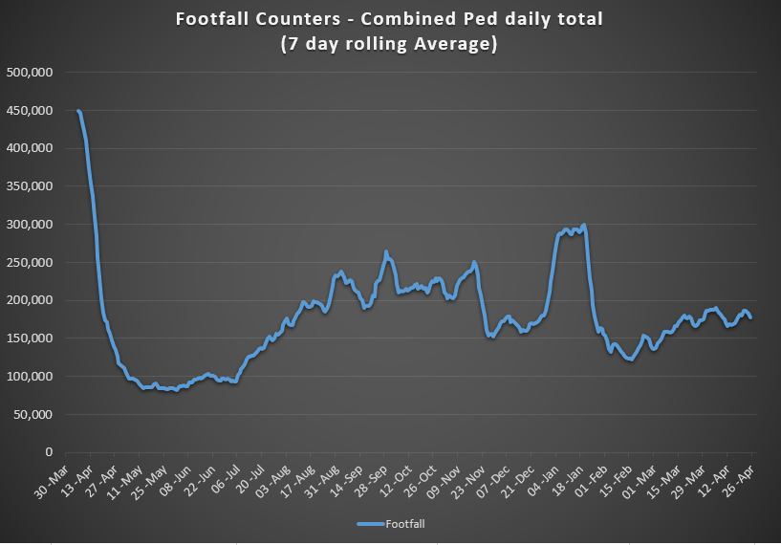

### 1.2 Cycling Volumes

Cycling numbers continue to increase, with the week day totals now around 80% of pre-COVID levels.

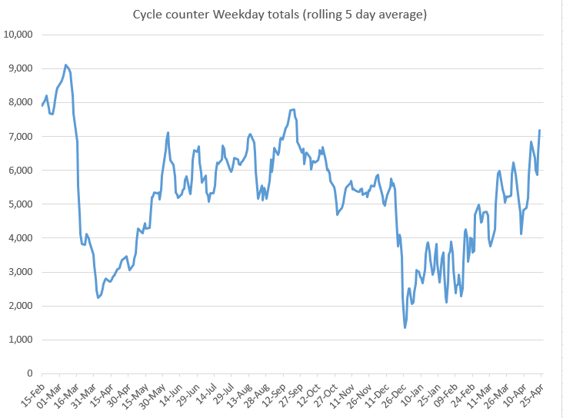

### 1.3 Bus Passenger Numbers

Passenger levels have been relatively static following the introduction of level 5 restrictions in January, however there has been a noticeable increase in demand since the Easter mid-term break and the Government announcement for a phased easing of restrictions. Passenger volumes currently stands at approximately 35% of pre-Covid volumes.

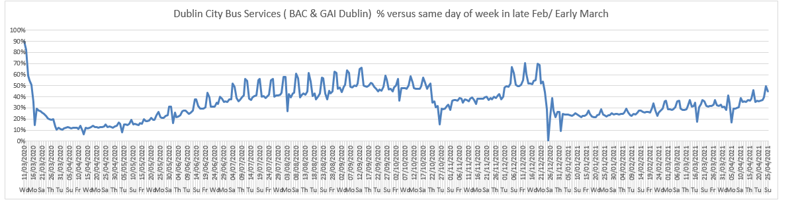

### 1.4 General Traffic Volumes

Over the last 2 weeks, with the start of the easing of restrictions, there has been an increase in general traffic volumes to between 70% and 73% of pre-COVID levels.

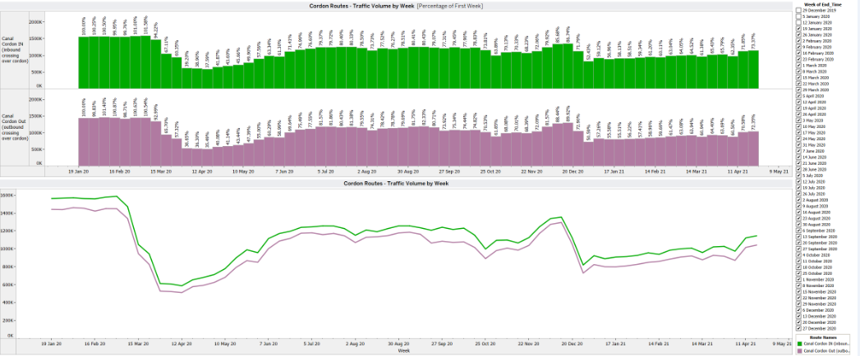

## 2. Implementation of Measures

### 2.1 Pedestrian Crossings

#### Mountjoy Pedestrian Crossing

Civil works have been completed on the installation of the pedestrian crossings at the north-west corner of Mountjoy Square. Following rewiring of the junction and installing the signal heads we would intend on having the crossings operational later in May.

### 2.2 Protected Cycle Facilities and Contra-Flow Cycle Facilities

#### Griffith Avenue Cycle Route

Installation of road markings on Section 3 of Griffith Avenue between Drumcondra Road and Gracepark Road has recently commenced. The tender documents for the upgrading of the junctions of St. Mobhi Road and Ballymun Road with Griffith Avenue are almost complete and will be going to tender in the coming days.

#### Blessington Street Protected Contra-flow Cycle Lane

This contraflow cycle track is now open.

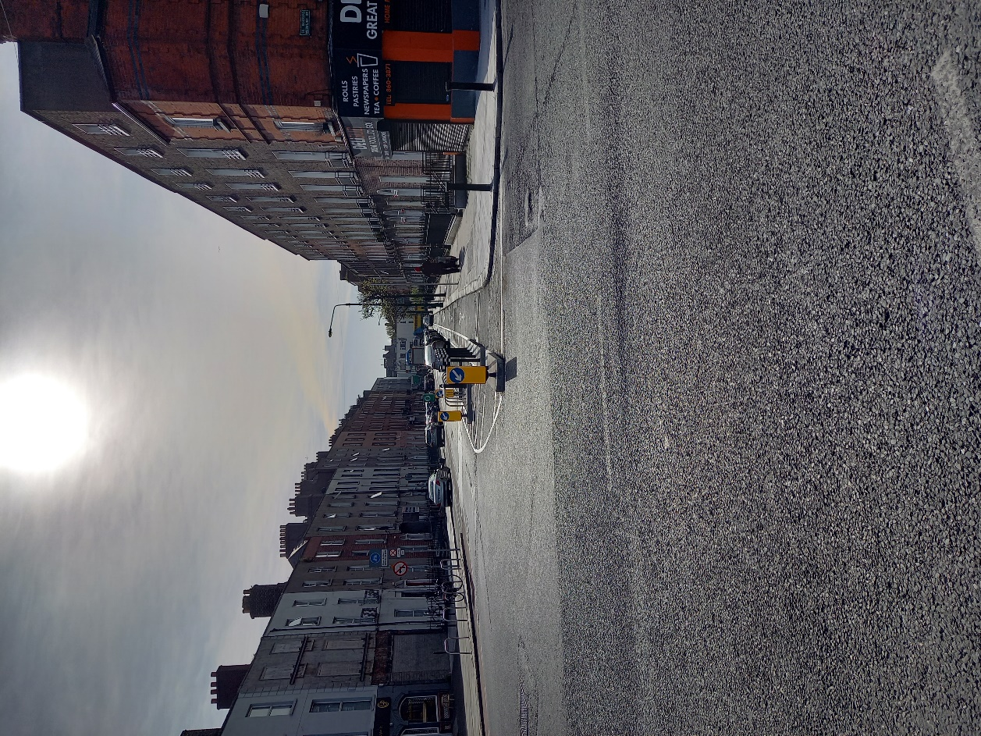

*Contra-flow cycle lane on Blessington Street.*

#### Collins Avenue Extension Cycle Route

Works have started on the installation of protection for the Cycle Lanes on Collins Avenue at DCU including the junction at the entrance to DCU.

#### Montpellier Hill Cycle Protection

Protection has been installed on Montpelier Hill to stop illegal parking blocking the cycle slip lane.

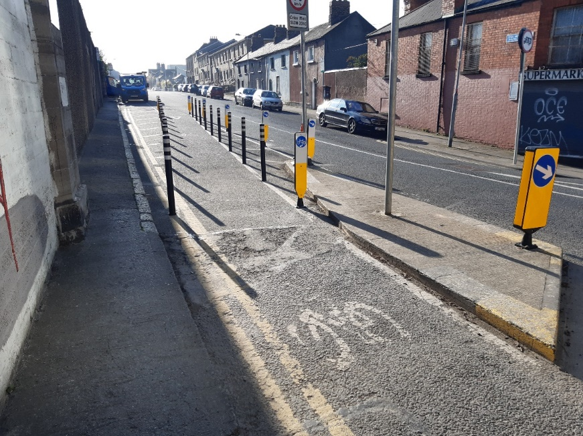 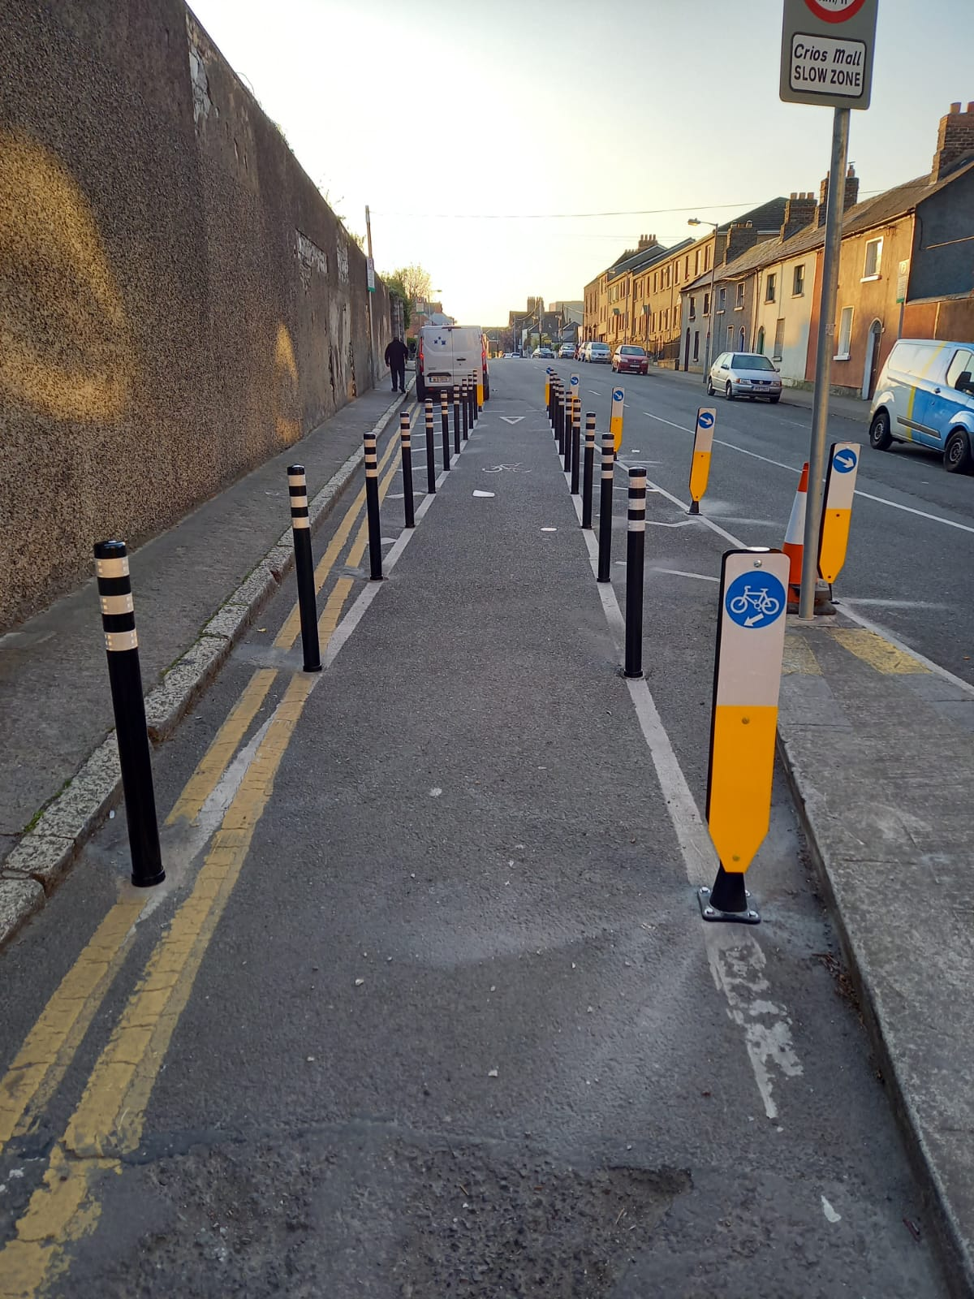

*Intervention on Montpellier Hill*

#### Infirmary Road Cycle Protection

New mandatory cycle lanes have been introduced on Infirmary Road linking the North Circular Road with Parkgate Street. Bollards to protect these cycle lanes are on order and will be installed as soon as they are delivered.

#### South Circular Road Cycle Protection

The installation is due to start in the coming weeks. The drawings will be published on the consultation hub when they are complete.

***Rathgar Road Cycle Protection***

Cycle protection on Rathgar Road on the approach to the junction with Highfield Road has been provided following numerous requests through the Covid Mobility Request form.

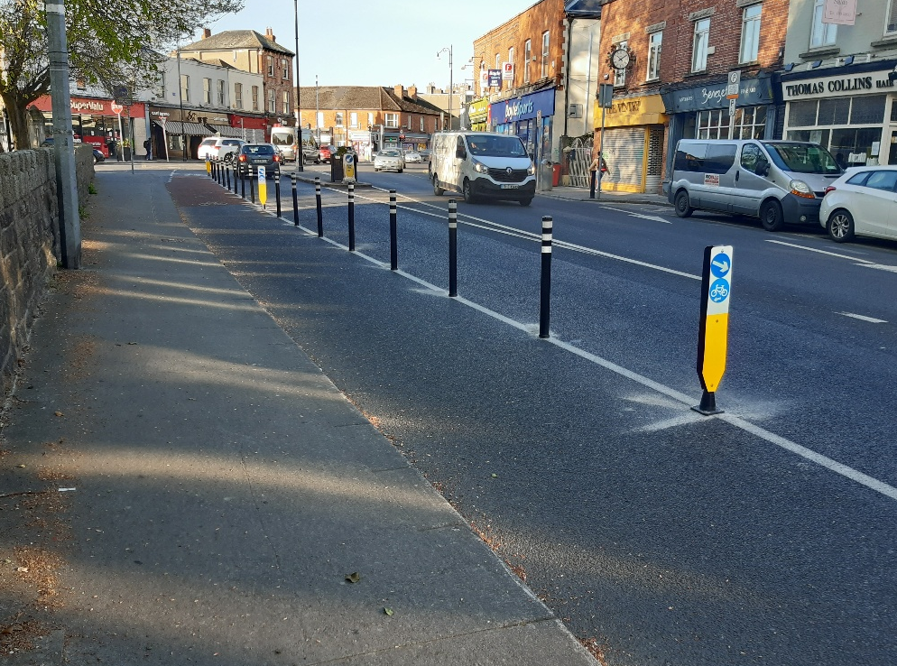 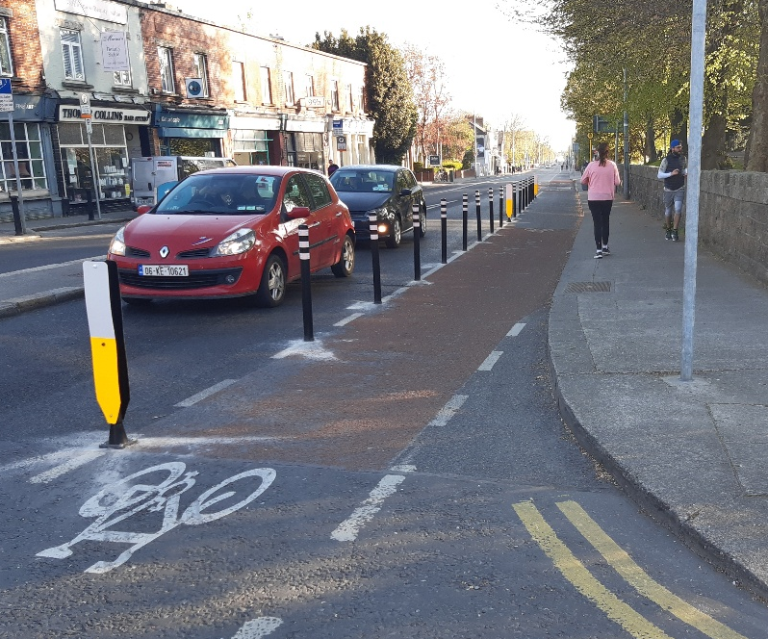

*Cycle lane protection on Rathgar Road*

***Strand Road Cycle Trial***

The date for the two day hearing of this case in the High Court is set for the 24 and 25 June.

### 2.3 On-Street Cycle Parking

We are currently completing an internal review of Batch 17 and intend to retender in the first week in May.

### 2.4 Filtered Permeability/Low Traffic Neighbourhoods

The interim improvement scheme for Grangegorman was presented to Councillors at the April Central Area Committee meeting and the comments submitted during the meeting are currently being considered. The design is at an advanced stage and we are accepting any final feedback from Members over the coming days.

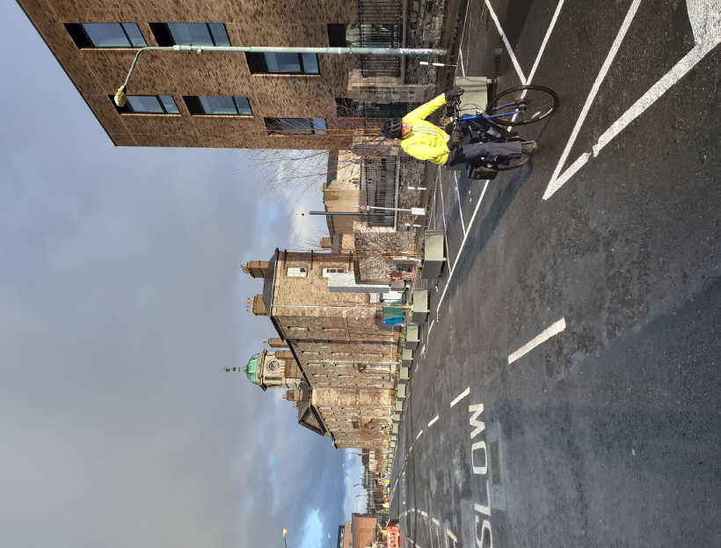

### 2.5 School Mobility Programme

The application list for a School Zonecurrentlystands at 120 Schools. The COVID Mobility Technical Team are assessing all submissions for suitability and schools will be contacted with timelines if it is deemed to be an appropriate intervention at the particular location.

To date a total of 44 School Zones have been installed across the city. The breakdown of the School Zones completed per administrative area of Dublin City are, 14 for the South Central Area, 9 for the South East Area, 9 for the Central Area, 7 for the North West Area and 5 for the North Central Area.

There are a total of 43 schools at design stage, subject to final consultation with school Principals and the NTA. The following School Zones are expected to be installed by the end of May.

* Scoil Úna Naofa, Armagh Road, Crumlin, Dublin 12
* Scoil Colaiste Eoin, Armagh Road, Crumlin, Dublin 12
* Lindsay Road National School, Lindsay Road, Dublin 9
* St Columba’s National School, Iona Road, Dublin 9
* Broombridge Educate Together National School, Cabra, Dublin 7
* St Catherine’s Ratoath Rd Cabra West, Dublin 7
* St. Dominic’s College, Ratoath Road, Cabra West, Dublin 7
* Holy Child National Boys National School, Larkhill Road, Whitehall, Dublin 9
* Holy Child National Girls National School, Larkhill Road, Whitehall, Dublin 9
* Georges Hill, PPS, Halston Street, Dublin 7.

Since the last report on 30 March, the Schools Outreach Officers have conducted a total of 36 site visits at schools across the city. This included site assessments with Neighborhood Engineers, site observation visits of travel to and from schools and behavior at the school gates and meetings with School Principals and local communities. The Schools Outreach Officers will continue to carry out these visits on a weekly basis

On 15 April, we installed our 40th School Zone at Scoil Fhursa, Cromcastle Green, Kilmore West, Dublin 5. They call themselves *“The Happiest School in Ireland*” and the Principal, the students and residents were brilliant to work with and are thrilled with their School Zone as can been seen from the feedback received:

*“visually friendly”*

*“feels like a community project”*

*“very inviting for the school and the children”*

*“visual reminder to people who are busy in their cars that there is a school here”*

*“keeping traffic away from the school gate”*

*“helping with social distancing”*

*“cars don’t park at the side of the gates now so children can get past”*

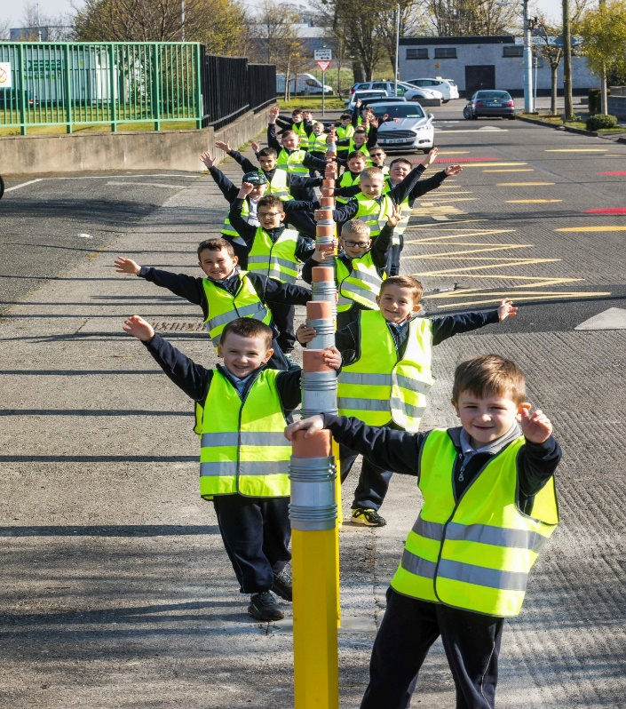 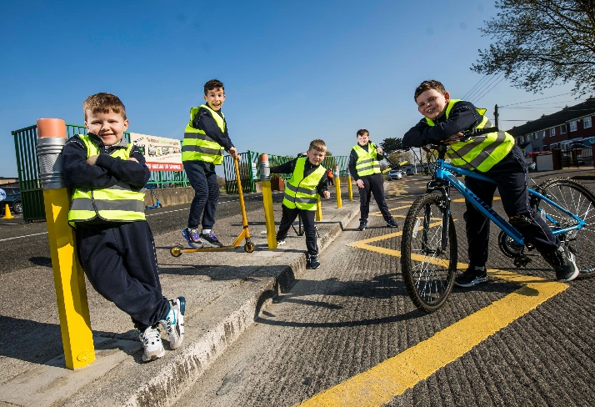

*Children celebrating the new School Zone at Scoil Forsa.*

### 2.6 Cycle & Scooter Parking for Schools & Sports Clubs

Delivery of cycle and scooter parking to 91 schools and sports clubs across the city began week commencing 26 April. There is still some cycle and scooter parking available which interested schools and sports clubs can apply for online.

* [Application for schools](https://consultation.dublincity.ie/traffic-and-transport/416141f7/)
* [Application for sports clubs](https://consultation.dublincity.ie/traffic-and-transport/5ed856ea/)

## 3. Special Speed Limits Bye-Laws 2020

In regards to Phase 4 of the Special Speed Limit Bye-Laws 2020, DCC is implementing the 30km/h speed limit signage in residential areas as per the approved Phase 4 - Speed Limit Bye-Laws 2020. This process was delayed due to temporary redirecting of resources to Covid-19 related actions. This will be completed by August 2021.

.A 2 week Non-Statutory Public Consultation was carried out from Friday the 9th of April 2021 to Friday the 23rd of April, 2021 on proposals for speed limits on the arterial roads. This 2 week Non-Statutory Public Consultation has concluded and we are in the process of reviewing it. A full report will be presented in the May 2021 SPC meeting.

## 4. Business Support

The Covid Mobility Measures Section has received a number of requests from various locations across the city to facilitate the re-opening of the city, as Government restrictions are eased. A number of measures including footpath build-outs and traffic management changes are currently under investigation in order to facilitate outdoor trading/dining.

The Covid Mobility Business Liaison Officer continues to engage and consult with businesses on a number of COVID Mobility Measures citywide.

## 5. Communications

### 5.1 Website

The [COVID Mobility webpage](http://www.dublincity.ie/COVID-19mobilityprogramme), is being updated regularly to keep the general public informed of COVID mobility interventions. As previously advised we will be making more extensive use of the Consultation Hub to provide information on proposed measures.

### 5.2 DCC Consultation Hub/Citizen Space

Details of schemes on the Consultation Hub at present include:

[Griffith Avenue Protected Cycle Track](https://consultation.dublincity.ie/traffic-and-transport/griffith-avenue-protected-cycle-track/)

Members are alerted on a regular basis to any new proposals, which are available to view on the Consultation Hub. The aim is to have a more dynamic process for ensuring that support for projects, suggestions on how to improve them and concerns and issues, which may need to be addressed, can be handled. Any feedback on this approach is welcome.

[Merrion Row Consultation](https://consultation.dublincity.ie/traffic-and-transport/merrion-row-consultation/consultation/intro/)

A consultation for Merrion Row ran from the April 16th to April 30th. Submissions will be assessed and a trial on the traffic arrangement will be held during a weekend May if there is support for this.

### 5.3 Dedicated COVID-19 Mobility Measure Request Form

Since our last update on March 30th, 2021, we have received 243 new requests for COVID Mobility Measures. This brings the total number of COVID Mobility requests to 5,481. A breakdown of these requests is below. We are currently collaborating with UCD to build a heat map of these requests. This map is due for completion in early May.

**Mobility measure requested Number**

Footpath widening 747

Increasing queuing space at bus stops 144

Pedestrian area 841

Protected cycle lanes 1249

Contra-flow cycle lanes 402

Cycle parking facilities 556

Outdoor seating area 635

Commercial / Retail deliveries support 83

Support and advice for active travel 323

Journey planning 80

Other 410

Not answered 11

**Total requests 5481**

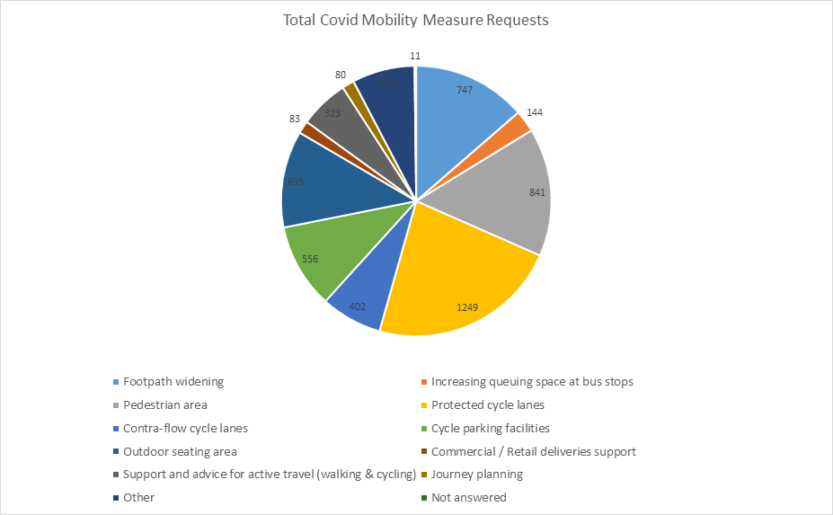

### 5.3 COVID Mobility E-Mail

The dedicated e-mail address continues as the primary channel to contact the COVID Mobility Team. It is attracting huge volumes of queries and feedback. The intention is that the e-mail is for general queries and the COVID Mobility Request Form should be used for specific requests at specific locations.

### 5.4 Councillor Updates

Updates on COVID-19 mobility measures will in future be issued to Elected Members via the combined monthly report on a monthly basis. Updates via e-mail are also being issued to stakeholders via the Transportation SPC and to the NTA for distribution to disability user groups.

### 5.5 Active Travel Promotion

We are continuing to utilise Dublin City Council Social Media Channels:

* + - to highlight COVID-19 mobility measures that have been implemented;
    - to encourage the public to walk or cycle, where possible;
    - to encourage social distancing as people move around the city and;
    - to encourage more respect for vulnerable road users

# Part B Walking & Cycling Major Infrastructure Projects

## 1. 5-Year Walking and Cycling Infrastructure Delivery

Over the next five years, Dublin City Council will undertake the planning and implementation of up to 140km of cycling and walking infrastructure. This is made up of 55km from 27 existing projects and 85km from 31 new projects. The full list was circulated in Report No 67/2021 issued in February 2021. Over the next six months, as Project Teams are set up, these projects will be assessed further in order to develop a comprehensive programme for delivery. In addition, a number of infrastructure projects that had been paused will be resumed.

Regarding additional staff; confirmation on funded numbers has been received from the NTA. The recruitment process will commence shortly.

## 2. Schemes with Statutory Planning Approval

There are no new schemes undergoing the statutory planning process. This is unchanged from last month. There are four projects with statutory planning consent. These are;

1. Royal Canal Greenway
2. Dodder Greenway
3. Clontarf to City Centre
4. The Point Junction Improvement Scheme

### 2.1 Royal Canal Greenway

The Royal Canal Greenway is being delivered in four phases.

Phase 1: Implemented.

Phase 2: The site is looking great and this summer it will enhance opportunities for communities to walk and cycle as well as a visual amenity. Landscaping is now substantially complete. There will be additional work required in August-September to plant all the spring bulbs. These will provide even more attraction.

The landscaping has been led by DCC Parks and includes over 4,300m2 of wildflower meadow, with over a 100 species, 135 trees and over 400m of hedge of which circa 130 linear metres is native hedgerow mix.

Phase 3: The project is still out on tender for the appointment of a contractor for the works. Tenders leading to the appointment of a Contractor were issued on 19 March 2021. It is anticipated that a Contractor appointment will be made in Q3 2021. This is as reported last month.

Phase 4: Site investigations are still ongoing. During March, ecological surveys were commenced. These will be used to update existing records and to inform the final design. It was initially intended to deliver Phase 4B of the main line using lands currently available in advance. This would be followed by Phase 4C that relied on carrying out a number of CPOs. Further discussions with Waterways Ireland have presented a more effective way of widening the towpath, while enhancing the ecological corridor. This can be achieved by widening into the canal. In addition, widening of the canal between the 6th Lock and Coke Oven Cottages is now proposed. This may be achieved by relocating a historic wall to the boundary of Waterways Ireland and CIÉ. This was not in the original scheme. The Project Team is currently engaging with residents on these proposals. An amended Part 8 will be required to facilitate these changes. These changes will avoid CPOs and to cater for increased demand for walking and cycling along the route. The Part 8 process for the additional works will commence in May 2021. The target date for the issuing of construction tender documents for the mainline works has slipped into Q2 2021. However, the project team is still working to have a contractor on site in Q4 2021. The schedule remains unchanged from the last report.

### 

### 2.2 Dodder Greenway (Herbert Park to Donnybrook)

A project team will shortly be formed for this project team and it is anticipated that meetings of the Consultative Committee will resume in May 2021. A preferred tender for constructing the works has now been identified.

### 2.3 Clontarf to City Centre

The project is currently out on tender for the procurement of a works contractor. The tenders will close in May 2021.

Information on the project is now accessible on the DCC webpages. The address is [www.dublincity.ie/c2cc](http://www.dublincity.ie/c2cc). The following information is now available;

* Project Overview and Progress Update
* Drawings and Visualisations
* Bus Stop Design
* Temporary Traffic Management (added in April 2021)

During the month, the Project Team has been engaging with disability groups and organisations. The preparation for consultation with other stakeholders, including residents and businesses along the route, is progressing well. The bus stop design proposal has been circulated to stakeholders. A Communications Plan was circulated to Members on 1March 2021. A follow up meeting with Members of the North Central and Central Area Committees was held on 14 April 2021. Valuable feedback was received, in particular the need for DCC to communicate effectively by tailoring the communication channels in order to reach out to different communities and to bring people along.

### 2.4 The Point Junction Improvement Scheme

The Point junction improvement scheme has now been incorporated into the new Pedestrian and cycling bridge beside the Tom Clarke Bridge and will allow the design team to integrate the changes required at the Point roundabout with the new Bridge and its interface with the new Dodder Bridge on the South Side. In addition we are in discussion with Dublin Port Company in order to incorporate a proposed Greenway within DPC lands into the overall cycling infrastructure provision in this area allowing to be linked for leisure and other uses.

## 3. Interim Schemes

The implementation of two interim schemes to facilitate immediate safety improvements for cyclists is ongoing. This is to compensate for delays in the delivery of the main schemes. These are:

1. Liffey Cycle Route
2. Fitzwilliam Cycle Route

### 3.1 Liffey Cycle Route

Works have been completed at a number of locations on the South Quays from Fishamble Street to Queen Street.

Works at St John’s Road West/Victoria Quay junction have been progressing slower than anticipated due to the challenges with accommodating existing services. As a result, it is now likely that works at this location will extend into June 2021. The designs from O’Connell Bridge to Matt Talbot Memorial Bridge, for both the North Quays and South Quays are being finalised. Tenders leading to the appointment of Contractors will be issued in May 2021. This is a month later than was previously proposed.

For the full permanent scheme, Dublin City Council has appointed service providers to provide the baseline archaeology, architectural heritage and conservation reports. The archaeology has received the final draft report. This will enable the screening report to be finalised in June 2021. The drafting of the public realm and opportunities study will resume thereafter.

### 3.2 Fitzwilliam Street Cycle Route

A road safety audit of the interim scheme was completed during the month. It is intended to monitor the performance of the interim scheme over the coming months.

**Brendan O’Brien**

**Executive Manager (Traffic)**

**John W. Flanagan**

**Assistant Chief Executive & City Engineer**

**4th May 2021**