Expression of Interest for 2 bedroom apartment Long Term Lease with Tuath Housing.

2 BEDROOM APARTMENT IN :- BLOCK 3, BELMONT HALL, MID GARDINER STREET, DUBLIN 1 (4TH FLOOR APT)
with Tuath Housing.
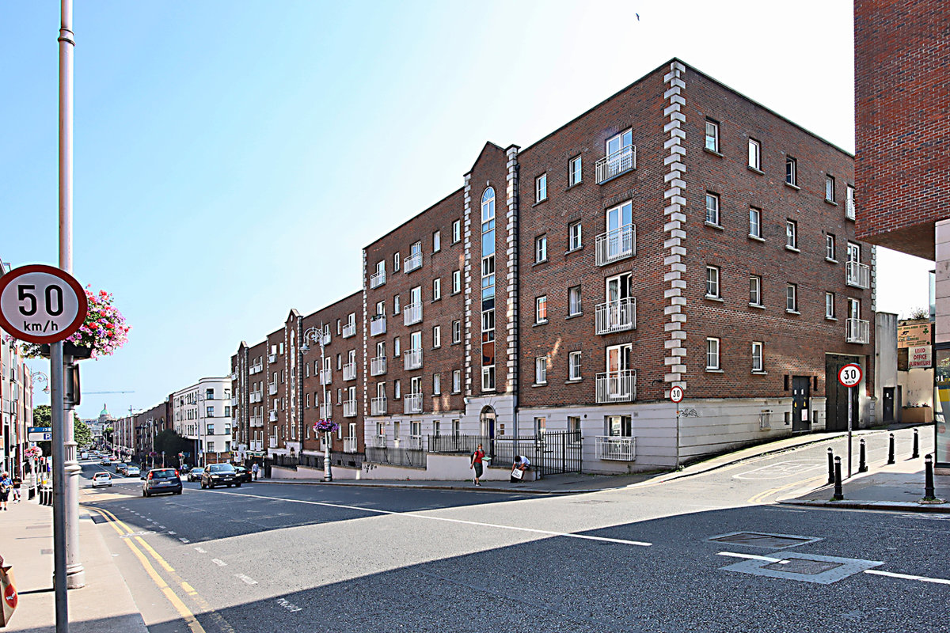

Dublin City Council is inviting applicants from all our waiting lists who have selected Area H as their area of preference to express an interest in
Furnishing and white goods are provided.
Expressions of interest for a 2 bedroomed unit are now been invited.

Please Turn Over for our Choice Based Lettings procedures and application form.
Procedure and Application Form
- All Applicants must be listed for area H
- All Applications will be examined on estate management grounds including rent arrears
- Interested applicants can email their details to Siobhan Tivnan, Housing Allocations, Civic Offices, Dublin 8 at siobhan.tivnan@dublincity.ie
- For further information, you may call 01 222 2207
- Closing date for applications is 2nd of November 2021 at 5pm.
- If a number of applicants express an interest in the same property, the final offer will be made to the applicant with the highest position on the list and most appropriate family size. This will be subject to an Estate Management clearance
- Under the choice based letting scheme only the successful candidates will be notified.
- A successful applicant who refuses a Choice Based Letting will not be eligible for consideration for another Choice Based Letting Unit for a period of one year
- These properties are managed by Tuath Housing. Successful applicants will be nominated to Tuath Housing.
- As per your Social Housing Application form, Dublin City Council will process your application in line with DGPR Guidelines. Please see Dublin City Council Privacy Statement on Dublin City Council website.

Application Form
Your Address______________________________________________________________________
Your Date of Birth _______________
Your Family Size________________
Your Housing Reference Number____________________
Your Telephone/ Mobile Number____________________________________
Size of property 2 Bed _________________________________________________________________________________
_________________________________________________________________________________
Did you read and understand the procedures above___________________
Signature_________________________________________

