THE FOLLOWING PROPERTY WILL BE ALLOCATED USING THE CHOICE BASED LETTINGS SCHEME – 15 GATEWAY MEWS, BALLYMUN, DUBLIN 11

Closing Date for Applications: Monday 29th November at 5pm

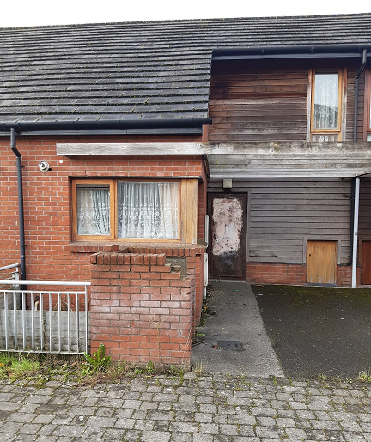

PLEASE NOTE THAT ONLY SUCCESSFUL APPLICANTS WILL BE NOTIFIED.

15 Gateway Mews, Ballymun, Dublin 11 is a 2 bedroom house. The property comprises of a kitchen, dining/living room, bathroom and two bedrooms.No floor covering is provided.

It is strongly recommended that you familiarise yourself with this dwelling/location before applying.
Only applicants who have a current live application and their requirements are for a two bedroom accommodation and have selected Area D as a preference under the Scheme of Letting Priorities will be considered for this property.
Please Note Late Applications Will Not Be Considered.

Please read and complete application form below
Procedure and Application Form
- All Applicants must be listed for Area D.
- All Applications will be examined on estate management grounds including rent arrears.
- Applicants are invited to register their interest with Dublin City Council for this property. Any properties that become available for re-let in this area will be advertised in the Ballymun Area Office, Housing Allocations, Civic Centre, Main Street, Ballymun, Dublin 9 and the Dublin City Council website.
- There will be a three-week timeframe for applicants to register their interest from Friday 05th November to Monday 29th November at 5pm
- Completed application forms must be returned to the Ballymun Area Office, Housing Allocations, Civic Centre, Main Street, Ballymun, Dublin 9 or completed forms can be emailed to ballymuncbl@dublincity.ie
- Please Note Late Applications Will Not Be Considered.
- If a number of applicants express an interest in the same property, the final offer will be made to the applicant with the highest position on the list and most appropriate family size. This will be subject to an Estate Management clearance.
- Under the Choice Based Letting Scheme only the successful candidates will be notified.
- A successful applicant who refuses a Choice Based Letting will not be eligible for consideration for another Choice Based Letting for a period of one year.
- If you need further information regarding the Choice Based Letting Scheme, please contact the Ballymun Area Office on 01-222-5610.
__________________________________________________________________________________
Application Form
15 Gateway Mews, Ballymun, Dublin 11

Your Name: ______________________________________________________

Your Address: ____________________________________________________

________________________________________________________________

Your Family Size: __________________________________________________

Your Housing Reference Number: ____________________________________

Your Telephone/ Mobile Number: ____________________________________

Did you read and understand the procedures above: ____________________

Signature: ______________________________ Date: ____________________
As per your Social Housing Application form, Dublin City Council will process your application in line with GDPR Guidelines. Please see Dublin City Council Privacy Statement on Dublin City Council website.

