THE FOLLOWING 4 BED PROPERTY WILL BE ALLOCATED USING THE CHOICE BASED LETTING SCHEME

78 Ratoath Avenue, Finglas, Dublin 11.

Closing Date for Applications; Wednesday 17th November 2021 @5p.m

“Please Note that only successful applicants will be notified.”

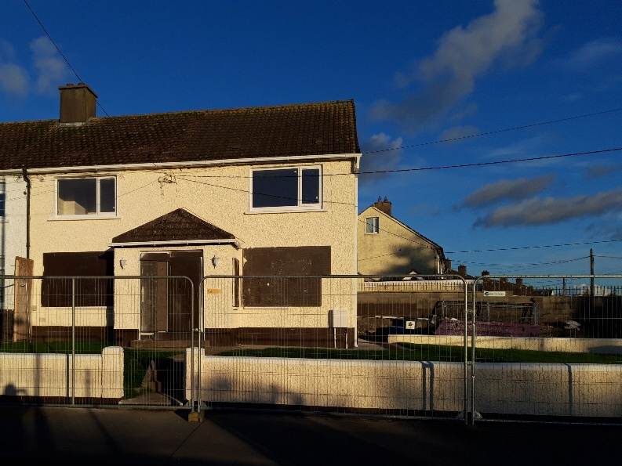

78 Ratoath Avenue is a 4 bedroom end of terrace house, with a large front/side garden and back garden.
The Property comprises of a living room, kitchen, bathroom and 4 bedrooms.
It is strongly recommended that you familiarise yourself with this dwelling/location before applying.
Applicants must meet the following criteria:
- current active application
- Their requirements are for 4 bedroom accommodation
- Have Area E(Finglas/Cabra) as an area of preference

Please note:
- Late applications will not be considered.

- Applicants will be subject to Estate Management clearance.

Application Form

Name _______________________________

Address _______________________________

_______________________________

PPSN _______________________________

Family Size ______________________________

Housing Reference Number ____________________

Telephone/ Mobile Number __________________________

Signature __________________________

Date _____________________

Applicants should register their interest in this property
By Email to finglasareaoffice@dublincity.ie

By Phone; 01 222 5400

Closing Date 17th November 2021@ 5p.m

As per your Social Housing Application form, Dublin City Council will process your application in line with GDPR Guidelines. Please see Dublin City Council Privacy Statement on Dublin City Council website.

“Please Note that only successful applicants will be notified.”

