THE FOLLOWING 3 BED PROPERTY WILL BE ALLOCATED USING THE CHOICE BASED LETTING SCHEME

BERRYFIELD DRIVE, FINGLAS

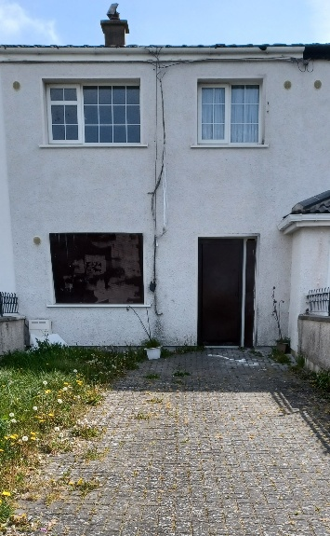

Closing Date for Applications; 5 p.m. Wednesday 11TH May 2022

This is a mid-terrace house, with a front and back garden, which must be maintained.
The Property comprises of a living room, kitchen, bathroom and 3 bedrooms.
It is strongly recommended that you familiarise yourself with this dwelling/location before applying.
Please read and complete application form
Criteria and Application Form:

Applicants must meet the following criteria:
- current active application
- Their requirements are for 3 bedroom accommodation
- Have Area E as an area of preference
Please note:
- Late applications will not be considered.

- Applicants will be subject to Estate Management clearance.

- If a number of applicants express an interest in the same property, the final offer will be made to the applicant with the highest position on the list and most appropriate family size. This will be subject to an Estate Management clearance.
- A successful applicant who refuses a Choice Based Letting will not be eligible for consideration for another Choice Based Letting for a period of one year.

Application Form

Name _______________________________

Address _______________________________

_______________________________

PPSN _______________________________

Family Size ______________________________

Housing Reference Number ____________________

Telephone/ Mobile Number __________________________

Signature __________________________
Date _____________________

Completed forms can be emailed to finglasareaoffice@dublincity.ie

Or
Posted to Finglas Area Office, Mellowes Road, PH 012225400

Closing Date 11th May 2022 @ 5.p.m.
As per your Social Housing Application form, Dublin City Council will process your application in line with GDPR Guidelines. Please see Dublin City Council Privacy Statement on Dublin City Council website.

“Please Note that only successful applicants will be notified.”

