Pay-As-You-Go Rates – P.A.Y.G
Adult Swim - €7.65 Gym & Swim - €8.65
Child Swim - €3.80 Teen Gym - €4.85
Family Swim – (1 Adult & 1 Child) - €10.20
Family Swim – (1 Adult & 2 Child) - €13.75
Family Swim – (1 Adult & 3 Child) - €17.35
Family Swim – (1 Adult & 4 Child) - €20.40
Family Swim – (2 Adult & 1 Child) - €18.60
Family Swim – (2 Adult & 2 Child) - €21.15
Family Swim – (2 Adult & 3 Child) - €24.75
Unemployed/Student Gym & Swim - €5.90
45-Minute Fitness Class - €8.65
Membership Options
Monthly Roll-Over (Direct Debit) - €34
Monthly Adult - €54 Monthly Couple - €98
3 Month Adult - €102 6 Month Adult - €180
Monthly Family (2 Adult & 2 Child) - €107
Monthly Unemploy./Student - €44 (proof required)
Annual Adult - €310 Annual Couple – €580
Annual Student - €280
Annual Family (2 Adult & 2 Child) - €850

Family Memberships
Child Rate - 4 to 12 years - €110 per child
Child Rate – 13 to 17 years – €135 per child
*Child memberships may only be taken out alongside annual adult/couple memberships*
Over 60’s Memberships
Monthly – No Classes - €15
Monthly – With Classes - €20
Annual – No Classes - €150
Annual – With Classes - €200
P.A.Y.G - €3
Over 65’s Memberships
Gym & Swim Annual Admin Fee - €20
Monthly – With Classes - €20
Annual – With Classes - €200
Teen-Gym Membership Options
Monthly - €32 Annual - €165
Annual Instalment Plan - €53 first month/ €11 every month after.
- Teen Gym is ages 13-17
- Parental Consent must be obtained at reception prior to use

Swimming Lesson Levels
- Starfish works on building the child’s confidence in the water and putting their face in.
- Turtles focus on learning basic technique and Seals work on developing those techniques in shallow water.
- Ray introduces student to swim from shallow to deep water with various strokes
- Dolphin looks to develop the child’s endurance and technique
- Sharks tests the child’s endurance & strokes in the full 25m pool.
Lessons are €80 per child per 10-week block. Discounts apply for siblings.
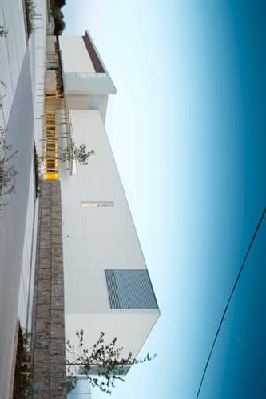

Opening Times
Monday to Thursday: 7am – 9:45pm
Friday: 7am – 8:45pm
Saturday: 9:15am – 5:45pm
Sunday: 9:15am – 3:45pm


Blackditch Road, Ballyfermot, Dublin 10

 01 – 222 8575
Sports & Fitness Ballyfermot
 sportsandfitnessballyfermot
 @DCCSportnFit

Astro Pitch Bookings (5-a-side)
Peak price (Mon-Fri: 6pm – 10pm)
€60 per hour
Off-Peak Price (7am – 6pm & Weekends)
€35 per hour
Sports Hall Bookings
€55 per hour (Monday – Sunday)
Bookings must be made by emailing aimee.heather@dublincity.ie for sports hall and emer.wilson@dublincity.ie for pitches
Birthday Parties
We host pool and pitch birthday parties for up to 20 children. Please ask at reception for further information.
Sports Development officer
Sharon Kelly is the Sports Development officer for the Ballyfermot area. For enquiries please contact Sharon at sharon.kelly@dublincity.ie or on 087-689 9273
Child Entry
Children under the age of 8 are not permitted entry without an adult. Children aged 8 - 12 must have been registered at reception and be supervised in the centre at all times.
No completed form, no entry.

