Rathmines Avenue , Rathmines , Dublin 6

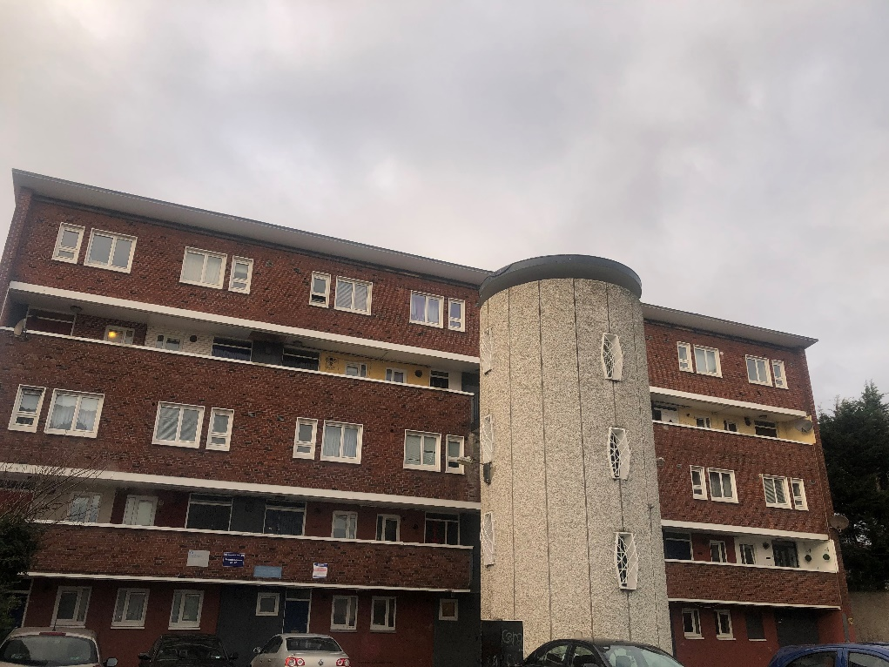
Dublin City Council are inviting applicants from all our waiting lists to express an interest in a one bedroom unit at Rathmines Avenue, Rathmines , Dublin 6. Only applicants who have selected Area N as a preference under the Scheme of Letting Priorities, and have a requirement for 1 bedroom accommodation, will be considered for this property.
Rathmines Avenue flat complex is situated on Rathmines Road Upper and is within walking distance to Harold’s Cross and Rathmines. It is close to all local amenities including schools, shops, Swan Centre Leisure Centre, Bus & Rail Services. The City Centre is only a short walk away. Rathmines Avenue complex comprises of four blocks of flats of various size units. The accommodation comprises of a living room, kitchen, 1 bedroom, and a bathroom. This flat will be fully refurbished. Furnishings and white goods are not provided. Expressions of interest are now being invited, for this ground floor 1 bedroom unit which will be available for letting in late May 2022.

Start date for applications will be Monday 9th May 2022 , End date May 20th 2022 @ 5.00pm.
Please Note Late Applications Will Not Be Considered.

Please turn over for our Choice Based Lettings procedures and application form

Procedure and Application Form
- All Applicants must be listed for area N
- All Applications will be examined on estate management grounds including rent arrears
- Applicants are invited to register their interest with Dublin City Council. Properties that become available for re-let in this area will be advertised in Crumlin Area Office, Housing Allocations, Civic Offices, Fishamble Street, Dublin 8 and Dublin City Council website.
- There will be a two- week timeframe for applicants to register their interest.
Start date 9th May 2022 ,end date 20th May 2022 @ 5.00pm.
- This application form must be returned to the centre of your choice mentioned in Section 3 above or email to aine.tobin@dublincity.ie
- Please Note Late Applications Will Not Be Considered.
- If a number of applicants express an interest in the same property, the final offer will be made to the applicant with the highest position on the list and most appropriate family size. This will be subject to an Estate Management clearance.
- Under the choice based letting scheme only the successful candidates will be notified.
- A successful applicant who refuses a Choice based letting will not be eligible for consideration for another Choice Based letting for a period of one year.
- If you need Further information regarding the choice based letting scheme, please contact Aine Tobin on 2225511/2225500
Application Form

Your Name_________________________________________________________________
Your Address______________________________________________________________________
Your Family Size________________
Your Housing Reference Number____________________
Your Telephone/ Mobile Number____________________________________
Size of Property/Properties you are interested in_______________________________________________________________________________
_________________________________________________________________________________
_________________________________________________________________________________

Did you read and understand the procedures above___________________

Signature_________________________________________
Date --

