Pearse House, Hanover Street, Dublin 2

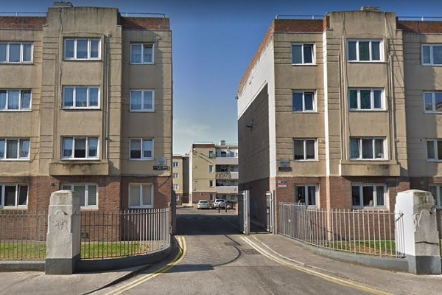

Dublin City Council are inviting applicants from all our waiting lists, who have selected Area M as their area of preference, to express an interest in Pearse House, Dublin 2.
Pearse House, situated off Hanover Street is within walking distance from all the local amenities including schools, shops, Pearse Street Primary Care Centre, Markievicz Leisure Centre, Bus & Rail Services. The City Centre is only a short walk away. Pearse House comprises 345 flats containing various size units, spread over sixteen well-maintained blocks. Flats will be fully refurbished; including gas central heating, double-glazed throughout. Furnishings and white goods are not provided. A children’s playground and an all-weather football pitch are located within the complex.
Expressions of interest are now being invited, for the following vacancies which are ready to let:-
Two x One Bedroom Flats
Five x Two Bedroom Flats
Start date for applications will be 16th May 2022 End date 24th May 2022 @ 5.00pm.
Please Note Late Applications Will Not Be Considered.

Please turn over for our Choice Based Lettings procedures and application form.

Procedure and Application Form
- All Applicants must be listed for area M
- All Applications will be examined on estate management grounds including rent arrears
- Applicants are invited to register their interest with Dublin City Council. Properties that become available for re-let in this area will be advertised in Allocations and transfers Civic Offices, Fishamble Street, Dublin 08.
- There will be a ten day timeframe for applicants to register their interest.
- Start date 16th May 2022 end date 24th May 2022 @ 5.00pm. This application form must be returned to Fiona O’Brien, South East Area Office, Block 2, Floor 4, Civic Offices, Fishamble Street, Dublin 8. Or by email to Fiona.obrien@dublincity.ie
- Please Note Late Applications Will Not Be Considered.
- If a number of applicants express an interest in the same property, the final offer will be made to the applicant with the highest position on the list and most appropriate family size.
- Under the choice based letting scheme only the successful candidates will be notified.
- Applicants who refuse a CBL will not be eligible for consideration for another Choice Based letting for a period of one year.
- If you need Further information regarding the choice based letting scheme, please contact Fiona O’Brien on 222 5446
- As per your Social Housing Application form, Dublin City Council will process your Choice Based Letting application in line with GDPR Guidelines. Please see Dublin City Council Privacy Statement on Dublin City Council website.
Application Form

Your Name_________________________________________________________________
Your Address______________________________________________________________________
Your Family Size________________
Your Housing Reference Number____________________
Your Telephone/ Mobile Number____________________________________
Size of Property/Properties you are interested in_______________________________________________________________________________
_________________________________________________________________________________
Did you read and understand the procedures above___________________

Signature_________________________________________
Date --

