CHOICE BASED LETTINGS

The Plaza, Apartments, Park West Avenue, Park West, Dublin 12.

41 apartments comprising of 19 x 1 Beds and 22 x 2 Beds.

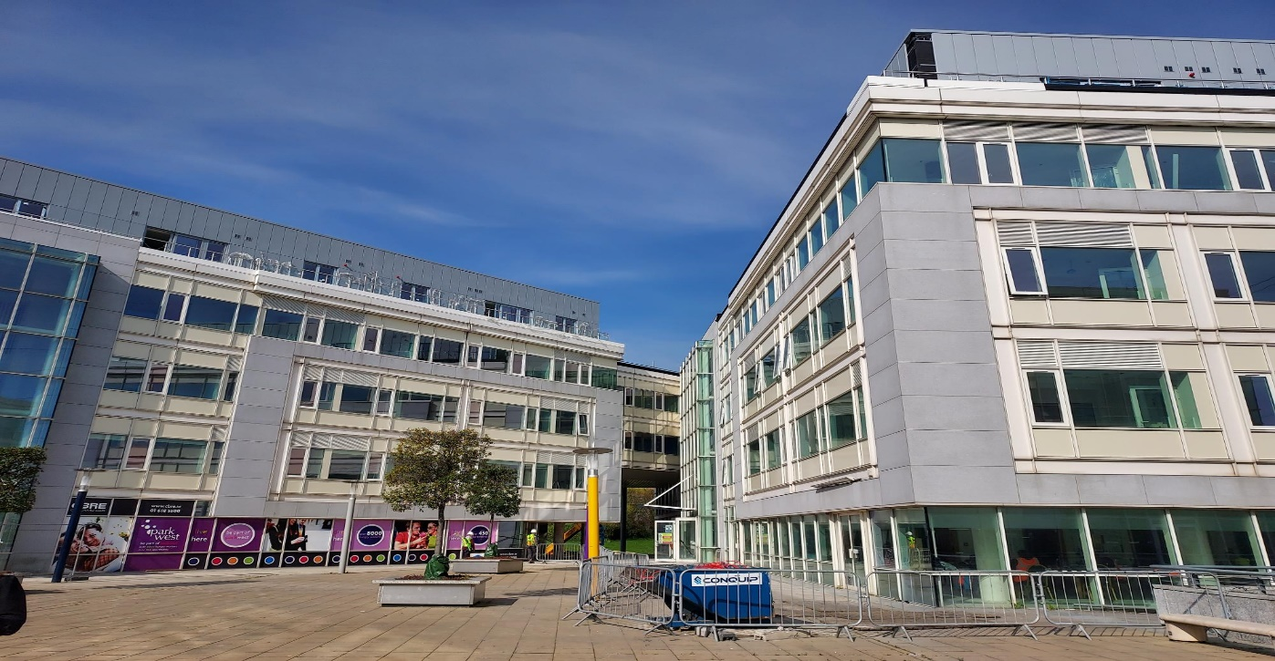

Dublin City Council invites applicants from our Housing and Transfer Lists, who have selected Area J as their area of preference to express an interest in the above property. This development is with Tuath Housing, with Dublin City Council having nominations to this development. Do not apply if you do not have Area J as a Preference.

The Plaza Apartments is a 41 unit development consisting of 19 no. 1 bed apartments and 22 no. 2 bed apartments. It is located in Park West.

All apartments are supplied with fitted kitchen, fitted wardrobes and tiled bathrooms.

The location is convenient to many local amenties,which includes Local schools, Childcare facilities and shops. Liffey Valley shopping complex is a short drive away. Park West Train Station is within easy walking distance with a direct link to Heuston Station. There is a choice of bus routes on your door step.

Procedure and Application Form

- All Applicants Must be listed for Area J. Do not apply if you do not have Area J as a preference.

- All Applications will be examined on estate management grounds including rent arrears.

- Applications are invited to register their interest with Dublin City Council. Properties that become available for re- let in this area will be advertised in the Ballyfermot Civic Centre, Ballyfermot, Dublin 10, Housing Allocations, Civic Offices, Fishamble Street, Dublin 8 and the Dublin City Council web site, https://www.dublincity.ie/residential/housing/i-am-looking-home/choice-based-lettings
- Start date of CBL advertisement is Monday the 16th of May, End date Wednesday 25th of May 2022.

- This application form must be returned to the centre of your choice mentioned in section 3 above or email completed application to CBLBallyfermot@dublincity.ie

- If a number of applicants express an interest in the same property, the final offer will be made to the applicant with the highest position on the list .This will be subject to Estate Management clearance. As the final offer is made to the applicant in the highest position there is no supporting documentation required as only position on your waiting list is considered.

- A successful applicant who refuses a Choice Based Letting will not be eligible for consideration for another Choice Based Letting Unit for a period of one year.

- If you need Further information regarding the choice based letting scheme, please contact Tel. 2224668 or 2224666

- Under the choice based letting scheme only the successful candidates will be notified.

- Please Note Late Applications Will Not Be Considered.

- As per your Social Housing Application form, Dublin City Council will process your Choice Based Letting application in line with GDPR Guidelines. Please see Dublin City Council Privacy Statement on Dublin City Council website.

Application Form

You’re Name_________________________________________________________________
You’re Address_____________________________________________________________
Your Family Size________________
You’re Housing Reference Number____________________
Your Telephone/ Mobile Number____________________________________
Did you read and understand the procedures above___________________
Signature_________________________________________

