Director of Services Report
South Central Area Committee Meeting
16th November, 2022

SOUTH WEST INNER CITY ELECTORAL AREA

Public Realm & Capital Programmes

Francis Street Environmental Improvement Scheme: The programme continues to January 2023.

Dolphin’s Barn Interim Environmental Improvements: The Area Office is now in a position to award a tender for these works. Discussion will then take place with the winning bidder to schedule these works.

Housing

St Michael’s Estate, Emmet Road, Dublin 8.
Planning Lodged 5th October, 2022

Tyrone Place Dublin 8. Regeneration.
A review of the development options for the regeneration of Tyrone Place is currently being undertaken by Housing Management, the Local Area Office and City Architects. All are cognisant that redevelopment options will need to take into consideration the large social and cost rental housing scheme that is planned for the adjacent site at Emmet Road.

School Street.
DCC received Stage 1 approval from the DHLGH for the regeneration of School Street and Thomas Court Bawn with a number of queries. These queries have now been replied to and submitted to the D.H.L.G.H. Upon approval, the commencement of the procurement of an integrated design team for the redevelopment project will begin.

Oliver Bond Regeneration.
DCC have received Stage 1 project approval from the Department of Housing Local Government and Heritage for the first phase of the regeneration of Oliver Bond, which is for the redevelopment of Blocks L, M and N. We also received funding for a Community Development Worker to be appointed to the Oliver Bond regeneration project.

DCC City Architects and Housing Regeneration staff are currently reviewing queries
received as part of our Stage 1 project approval to seek project budget approval.

Football Pitch
Works complete and license agreement signed. Extra security has been added to the fence surrounding the pitch to prevent access when pitch has been closed.

Side gates to green area at rear of Block B have been upgrade with extra security measures. Painting programme ongoing. Regular power washing is continuing throughout the whole complex.

Bin chambers upgrading is currently being revisited by our Housing maintenance section

Bonham St .Dublin 8. Volumetric Build - 57 Units
26 x 1 bed
26 x 2 bed
5 x 3 bed

On site. Current Estimated Completion of Scheme Q2 2023

DCC have designated a community liaison (Trevor Martyn) to engage with residents
regarding their concerns.

Trevor can be contacted @ 087 2925013 trevor.martyn@dublincity.ie

Dolphin House Regeneration Masterplan Dublin 8.

The Dolphin House Regeneration Masterplan approved on the 4th Feb 2021 by the DH
Regeneration Board. DCC will progress the masterplan in conjunction with the Dolphin House Regeneration Board and the Dolphin House Community.

Dolphin 1B - Stage 1 project and funding approval has been received for the construction of approximately 25 new homes. Design development is progressing.
It is planned to lodge Part 8 Planning Application end of Q2 2023.
Demolition Block 1 and Block 2 have been demolished. Rubble export ongoing, monitoring of dust, noise, vibration still ongoing and to date all have been at acceptable levels. MCB in communication with ESB in relation to installing public lighting and new CCTV poles. First window cleaning to commence week of 14/11/22 or 21/11/22, second cleaning will be before MCB finish onsite.
New Blocks – new entrance doors fitted to all the blocks and working well. New courtyard doors have been ordered for blocks C and D and should be ready to install week 14/11/22.
Interim Playground Facilities – Dublin City Council have received new drawings to show the alterations of the play equipment and layout which has been approved. We are currently awaiting confirmation on when the works will commence. It is hoped to commence resurfacing works on the old playground and awaiting a start date of works from Housing Maintenance section
Painting of railways – currently underway, Canal railways first. Painting of stairwells in old blocks underway.
Donore Avenue - (former Saint Teresa’s Gardens)

Donore Forum
The first meeting of the new Donore Forum took place on 29th September 2022. The main focus of DPCF will be around construction related matters; to support development of 543 social and cost rental housing units of the Donore Project, but also community facilities and infrastructure; to get updates from LDA, Hines and DCC; while making sure the voice of the local community is also heard and taken into account when various plans are being proposed and implemented.

Donore Boxing Club
Will be relocating to the Ferrini Youth club on the South Circular Road pending facility works that need to be carried out for the members of the club. This will pave the way for demolition works of the two remaining blocks to commence.

LDA
This project will provide for the delivery of approximately 543 homes in a collaboration between Dublin City Council and the Land Development Agency, under a working title ‘Donore Project’

28% of the homes provided will be for social housing and 72% for cost rental housing.

The breakdown of the social homes include:

41% 1 bed which 50% will be available for Older Person Accommodation
48% 2bed
11% 3 Bed

A Part 10 planning application is due for lodgement late Q4 2022

Margaret Kennedy Road/Court
Purcell are undertaking remedial works on the drainage system in the coming weeks. New security measures have now been implemented in Margaret Kennedy Court. Works on the heating defects are ongoing.

Herberton 39 units Part 5
9 x 3 bed
24 x 2 bed
6 x 1 bed

All these units will be allocated under the Choice Based Lettings scheme, selections and viewings are currently ongoing.

The CCTV system in the Reuben/Herberton area is being upgraded.

Cork Street / Chamber St Volumetric - 55 Units

32 x 1 bed
10 x 2 bed
13 x 3 bed

Current Estimated Completion of scheme End of Q2 2023

These units will be allocated under the scheme of letting priorities

DCC have designated a community liaison (Laura Kenny) to engage with residents regarding their concerns.

Laura can be contacted @ 0871863675 laura.kenny@dublincity.ie

Community

Shinning a Light on Our Volunteers
On Monday 14th November various groups and individuals from across the South West Inner will attend a Volunteer Appreciation evening at The Hyatt Centric Hotel.
This event is about Shinning a Light on the Trojan work which is carried out on a daily basis by our wonderful volunteers.
Groups in attendance will range from Senior Citizens Groups, Sporting Organisations, Heritage Groups, Residents Groups, and Irish Language Groups to those who were at the Coal Face delivering meals and food parcels during the pandemic.
Refreshments and musical entertainment will be provided and all volunteers will receive The Lord Mayors Certificate and a volunteer pin.

Dancing the Winter Blues Away

The Community Development team are organising a number of Afternoon Tea Dances in the coming weeks.
The First event will take place in St James’s Primary School Hall on Tuesday 22nd November.
Afternoon Tea and musical entertainment will be provided.

A Festive Tea Dance will take place on Monday 12th December at St James’s Primary School
These event are open to all local residents.
We would like to express our sincere thanks to the school principal Ciaran Cronin who has very kindly offered the use of the school hall for local social activities.

Christmas Tree Lighting Ceremonies

The Dolphin’s Barn Tree Lighting Ceremony will take place on Tuesday 6th December at 4.45pm.
Musical entertainment will be provided by the pupils from Loreto Primary School and mince pies will be served in Our Lady of Dolours Church.

The Cornmarket Christmas Tree Lighting Ceremony will take place on Tuesday 29th November at 6pm.
MASAMBA will provide the musical entertainment and refreshments will be served afterwards in St Audeons National School.

Environmental Workshops

A number of Local Schools have been invited to attend a morning of environmental workshops on Wed 23rd November at Weaver Park.
Pupils from Francis Street CBS, St Brigids, St Catherines and Scoil Treasa Naofa will attend these fun workshops and games. The will also be planting up a selection of Spring Bulbs.

Additional Festive events are currently at the planning stage and will take place locally in early December.

The local community development team are working with local youth services and residents groups with a view to organising a Special First Year festive celebration in Bridgefoot Street Park to include: A Visit from Santa, Refreshments and Music.
This year’s festive Wonder Lights will also be a feature in the park throughout the Month of December

Other Festive events will take place in:
- Islandbridge Court
- Memorial Court
- Robinsons Court
- St Andrews Community Centre

Kilmainham Inchicore Network
Next meeting 21st November 2022 at 5.30pm, 6 Tyrconnell Road

KIN Strategic Planning Process
KIN Vision and Strategic Plan facilitated process has begun with Colm Byrne, The Ladder. Key stakeholder meetings have been held and a co-design sprint process will begin mid- November. The facilitated design sprint will take the form of in person workshops with KIN delegates, a community public on street survey and the outcomes from both captured in a KIN Strategic Plan for the next five years.
As part of this process a booklet is being prepared for circulation to local households outlining the work of KIN, encouraging greater engagement in planning and attending events. Information will be shared on developments, organisations and services in our area. This booklet will be ready for circulation shortly.

Liffey Gaels/ East Timor Park Master Plan:
Alastair Ferrar, Cunnane Stratton Reynolds Consultant have had their remit extended to include reviewing increased access from the park over to Irish National War Memorial Gardens. This will also be included in a Master Plan for Liffey Gaels Park on behalf of DCC.

Grand Canal - Activation and Animation of Grand Canal between Portobello and Kylemore Road: (presentation at SCAM September 2022)
Irish Leisure Consultants (ILC) have completed their Report identifying the potential recreational Activation and Animation measures along the Grand Canal between Portobello and the Kylemore bridge, commissioned by Dublin City Council and Waterways Ireland. They consulted with local organisations, individuals and agencies regarding the current and potential future recreational use of the canal, as well as identifying appropriate approaches to forward the project. The Report will be launched in January 2023. A second stage of this project that will see progress and implementation of outcomes is under discussion. More details to follow.

Fairs at Richmond Barracks
KIN, in partnership with Dublin South City Partnership and Dublin City Council Culture Company, are organising 4 fairs at Richmond Barracks over the next year. The Christmas Fair Saturday 26th and Sunday 27th November is currently being organised. The Harvest Fair took place 24th and 25th September, with over 3500 visitors. KIN is currently offering and organising outreach workshops to all local schools in the area in advance of the Fair – with sustainable decoration and gift making as the theme as well as building awareness of the Fairs. Many local Choirs have been asked to give recitals at the Fair over the weekend.

Local makers, local food suppliers will be present as well as festive workshops and entertainment taking place as part of the offering on that weekend. There is a further Spring Imbolg Fair (5th and 6th February 2023) planned.

Office in Inchicore – 6 Tyrconnell Road
The office at 6 Tryconnell Road is now open for hosting KIN and IRCF meetings, public opening hours will be issued shortly.

Inchicore Regeneration Consultative Forum – next meeting 21st November 2022 at 7pm. 6 Tyrconnell Road.

The IRCF have written to Coilin O Reilly requesting written clarification and confirmation that the ERD residential tenure will be 100% public housing, this follows verbal confirmation of the same.
The ERD application, lodged to An Bord Pleanála on 7th October 2022 was discussed at the October IRCF meeting. It was agreed to invite the Integrated Design Team to meet with IRCF delegates to discuss the application and role of IRCF in the process as well as get advice on observation by IRCF to An Bord Pleanála.
This meeting took place 9th November 2022. Merritt Bucholz and Karen Hassey, BMCEA attended a special meeting of IRCF. Merritt outlined how the consultation process with the IRCF had influenced certain design aspects of the Emmet Road Development, in particular the Community Hub Library building and the open space/street scape public realm. This information will inform the observation that the IRCF will make to on the Emmet Road Development to An Bord Pleanála. Deadline for submissions to An Bord Pleanála is 27th November 2022.

See www.emmetroad.ie for full application information. Hard copies of the application are available for viewing at Inchicore Library, Richmond Barracks; Dublin City Council, South Central Area Office, Eblana House, Marrowbone Lane, Dublin 8 and Dublin City Council Civic Offices, Wood Quay, Dublin 8.

Subcommittees:

A reflection on the experience and learning of Regeneration Boards / Forums in Dublin 8, 10 and 12 this event took place Tuesday 12th October 2022. Members from 4 Regeneration Boards attended, along with representation from Department of Housing Local Government and Heritage. This second Community of Practice Shared Learning Experience Regeneration Event, attended by 30 people, followed on from a Reflection on Learning and Experience of Regeneration Boards and Forums in D8 and D10 event held in May 2022.

It explored “What would perfect look like?” in the context of Regeneration Boards/Forums - in particular asking about decision making and participation processes. A Report from Community Action Network will be prepared and circulated.
A further event will be held in order to delve into the themes highlighted, identify actions necessary to put in place a process for progression.

Public Domain
- Graffiti has been removed from Augustine Street, Bridgefoot Street, Hanover Lane & Arch, John Dillon Street, Lambe Alley, Cornmarket, and Iveagh Market.
- Manual Weed Treatment commenced 22nd October at Gray Street, Gray Square, Pimlico Cottages, Reginald Street, The Coombe, Brabazon Street, Newmarket Street, Meath Square, and The Coombe. Summer Street, Braithewaite Street & Marrowbone Lane, Thomas Davis Street, Power Square, Lambe Alley, John St South Kevin’s Avenue, St. Michael’s Terrace, Warrenmount, Clanbrassil Street Lower, Donore Avenue and Terraces.
- E&T have arranged for the overhanging shrubbery to be trimmed and shredded on-site by Gecko Tree Care on Cromwells Quarters Steps, Bow Lane West, Brookfield Road, Grand Parade, Sarsfield Road and Shannon Terrace.
- 20 Clean-ups have been facilitated by Public Domain. Leaf Collections by Waste Management crews at SCR and Heuston Station.

Kilmainham Mill

Stabilisation works began in August and will be completed in Spring 2023 at a cost of €1.7m.

Asbestos and waste removal is continuing by specialist safety subcontractors alongside temporary works to prop unstable floors within the buildings. Roof repair works are ongoing. Throughout, the existing significant industrial heritage features will be recorded and protected in situ.

The single storey structure at the entrance of the site has been demolished which required the temporary removal of the stone boundary wall. The stone from this wall has been salvaged and will shortly be used to rebuild the boundary.

Report from: -

Bruce Phillips,
Senior Executive Officer
South West Inner City Local Electoral Area.

BALLYFERMOT/DRIMNAGH ELECTORAL AREA

Housing

Cornamona
The end of Quarter 1, 2023 continues to be the anticipated date for handover of the completed units.

Springvale
The anticipated completion date for the units remains mid-2023.

Canal Bridge Apartments Kylemore Road /Bluebell
This development is now fully occupied and is owned and managed by Respond approved housing body.
Lissadel Maisonettes
Work is ongoing preparing a stage 1 application to the Department of Housing, Local Government & Heritage with an anticipated submission of date Quarter 1, 2023.

Bernard Curtis House
The repainting of the units is continuing.

Labre Park
Preparation of the necessary documentation to support a stage 2 application for funding to the Department of Housing, Local Government & Heritage is ongoing.

Hillside Manor
The units are still being finished out and the offers are being processed.

Claddagh Court
The replacement of the intercom system is currently being carried out.

Sons of Divine Providence
Interaction with the Department of Housing, Local Government & Heritage is ongoing with a view to submitting a stage 2 application in Quarter 1, 2023.

Bluebell
The Land Development Agency are continuing with site investigation works.

Rafters Road
A response from the Department of Housing, Local Government & Heritage in relation to the stage 2 application is awaited.

Community

Community Participation

Halloween Events
There were 9 events organised in Ballyfermot on Halloween Day. 10 local organisations were involved hosting activities and the 5 Council Parks had family friendly activities taking place. In addition to the events the real success of Halloween 2022 was the amount of young people involved in organising the entertainment, The haunted house in the equine centre in Cherry Orchard had 45 young people involved for weeks preparing the props and organising the scares on the day, Candle held workshops in the lead up to Halloween engaging older teenagers in lantern making and the BMX Club practiced for weeks to put on their show. The involvement of so many young people really made for a celebration of the community.
The events were fantastic and were all over subscribed, particularly the zombie run, haunted house and fire show in Markievicz Park. The events could not have taken place without the support of the local youth organisations whose staff were working over the entire weekend and bank holiday to organise the events.
The Council would like to thank: Foroige, Candle, FamiliBase, Cherry Orchard Integrated Youth Project, Cherry Orchard Running Club, The Orchard Centre, St. Johns Ambulance, Community Civic Centre and the BMX club. Great credit is due to The Ballyfermot Youth Service for animating parks, queues and the entire area with 40 young people from their Erasmus programme. The young people provided fabulous entertainment and colour to Halloween this year.
The City Council established the Halloween Committee in Bluebell who organised the programme of events including a spectacular fire show by Rogu and a spooky parade funded by the City Council. The community hall had 200 local residents of all ages enjoying the seasonal activities and live music. The council would like to thank the Bluebell Residents Committee, Bluebell Youth Project, Bluebell CDP and all the Community Centre staff for hosting an incredible event. The Council will continue to work with the group and hope to strengthen the committee with a view to organising further community events next year. For festival highlights check out: https://vimeo.com/766037814/b6719f0b3b

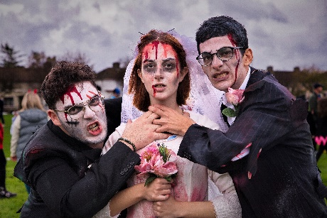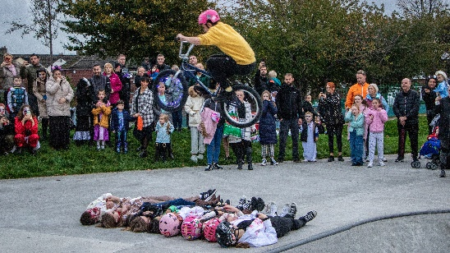

Discretionary Funds 2022 Community Building Repair Fund

The 2022 Discretionary Fund Community Building repair fund has been allocated to the following projects:
Teanga Beo Small repairs and fencing
Ballyfermot Sports Complex Contribution towards smoke alarm upgrades
Walkinstown Community Centre Replacing Fire door
D12 Men’s Shed Purchase of extractor fan, refurbishing shed area
W.S.A.F, Moran Rd Replacing old radiators
The Bungalow Replacing fire exit door
Lower Cherry Orchard Hall Fire door replacement throughout the building

All of the above groups are managed locally and the support the contribution provides is really appreciated as an acknowledgement of their commitment to the community.

Older Peoples Autumn /Winter Age Friendly Programme

The Autumn Winter Programme of events taking place in the Civic Centre on a weekly basis has been a tremendous success with all 9 events fully booked out.

There is a real need to provide local activities that encourage Older People to get back out and socialize post Covid.

The programme is running in Ballyfermot and Walkinstown

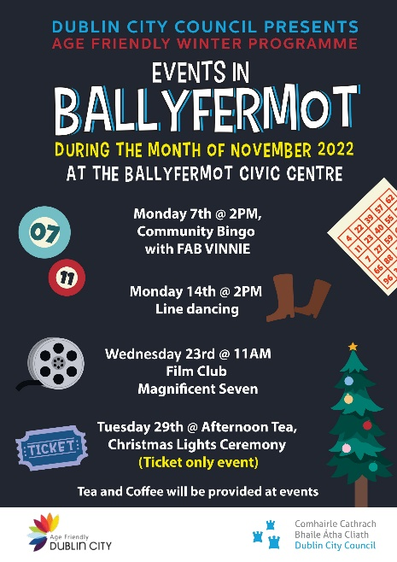
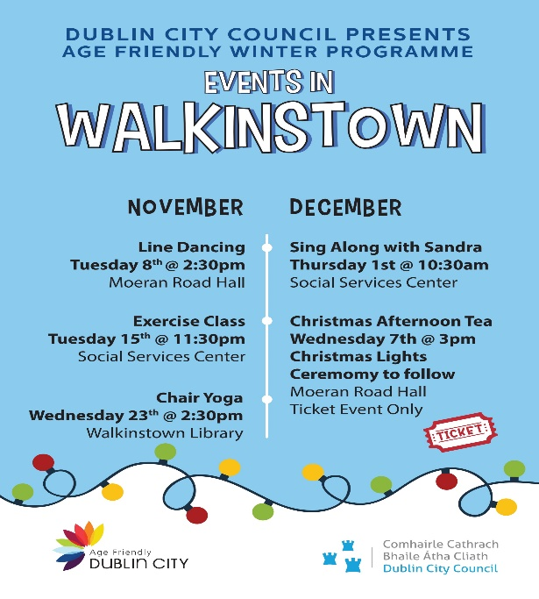

Integration and inclusion Week

The City Council is supporting the following events during Integration and Inclusion Week which takes place from Nov. 7th to Nov. 14th

Liffey Gaels and Good Counsel GAA are hosting an Open Day for Inclusion and Integration Week. The family fun day which will showcase the local sports talent and encourage new members will take place on Saturday 12th of November at 1.00 pm in Good Council GAA, Davitt Road.

The Ballyfermot / Chapelizod Disability Active Collective will host a coffee morning in the Orchard Community Centre to launch a new facilitation training programme that is open to the community on Thursday 10th at 11:00AM

The Ballyfermot Sports Complex will host a week long morning programme of fitness classes targeting Parents from the 3 neighbouring primary schools. The classes are free and open to all.

Chapelizod Tidy Towns will host an event on Saturday 12th November 2022 from 12-3pm. celebrating Chapelizod’s culturally diverse community with an open afternoon of bring and share’ dishes from different countries

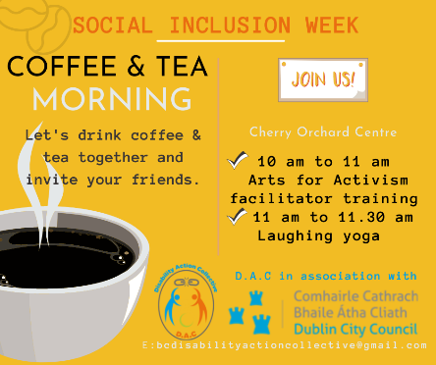
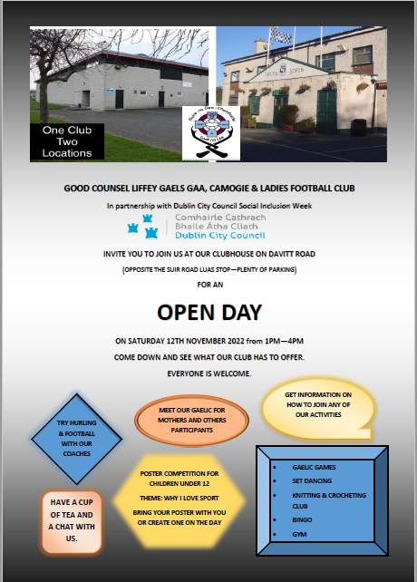

Volunteer Appreciation Night

The City Council has invited representatives from 60 local resident Groups, community organisations and volunteers from the Ballyfermot/ Drimnagh Ward that have been active in the area during 2022.
The Shine a Light on Volunteers will celebrate community volunteers
The event takes place on Tuesday November 15th at 7:30PM in Ballyfermot Civic Centre.

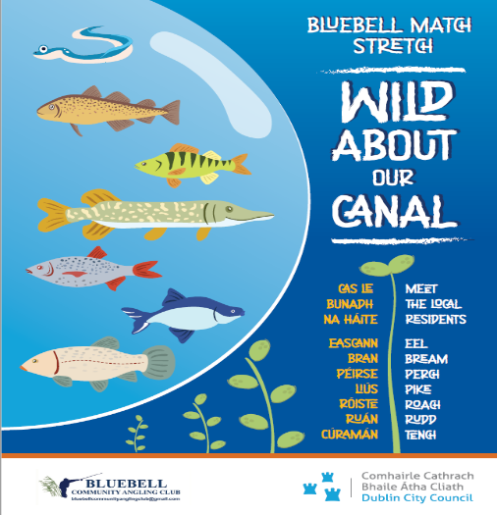
Bluebell Canal Information Sign

In consultation with the Bluebell Anglers Club the
City Council has replaced the old fishing
Information sign on the Canal.

The new sign is more child friendly and has received
Positive feedback from the community

Christmas tree Lighting
Ceremonies will take place throughout the area commencing on Tuesday Nov. 29th In Ballyfermot.

Local resident groups are involved in organising the events in Chapelizod, Bluebell, Drimnagh and Cherry Orchard.

In Ballyfermot the tree lighting will take place after the age friendly Christmas tea dance

Orchard Community Centre

On 31st October to bring Halloween 2022 to a conclusion The Orchard Centre in conjunction with residents Dublin Circus Project put on 2 child friendly Circus Shows.
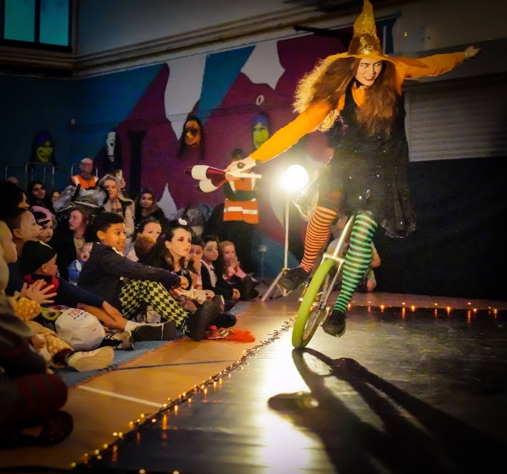
We had an attendance of just under 200 parents and children to the 2 shows. This new event was aimed at children who are too young to go along to the haunted house event in the Equine Centre.
The Circus was a great success and everyone attending left with huge smiles on their faces. The photo shows the children in the front rows fully focused on the magic happening on stage.

Our Annual Halloween Fireworks Display was attended by what we believe was the biggest crowd to date.
As always, The Orchard Centre was the base for all Health & Safety staff and equipment for the fireworks event in the park on the night. Staff were on hand from early on to give all people working on the fireworks event a place to have breaks, tea/coffee/lunch. The first aid team used the centre for the day along with the event management team.
Lasting 12 minutes and well worth the investment, all those in attendance enjoyed a safe (and noisy) display that was supported by An Garda Síochána, community volunteers, youth services and our very own Dublin City Council Staff.
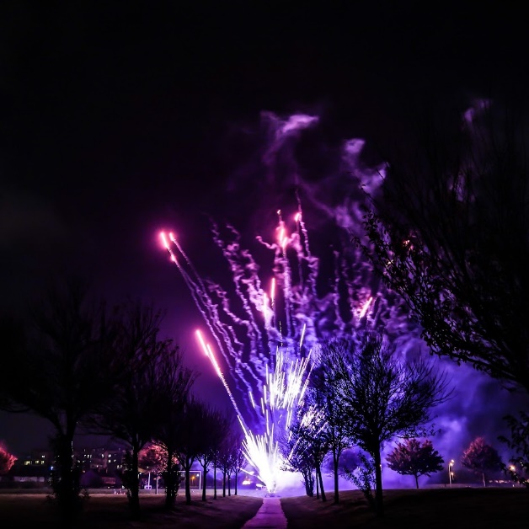
Click https://tinyurl.com/D10Halloween for Cherry Orchard Halloween Pics.
Integration & Inclusion Week 7th-14th November.
Each year the centre puts on events for this important date in the calendar.
This year for social inclusion week there will be an indoor bowling open day. The event is free and will be held on Tuesday 8th November 11.30am-1pm. Tea/coffee/snacks will also be provided free on the day.
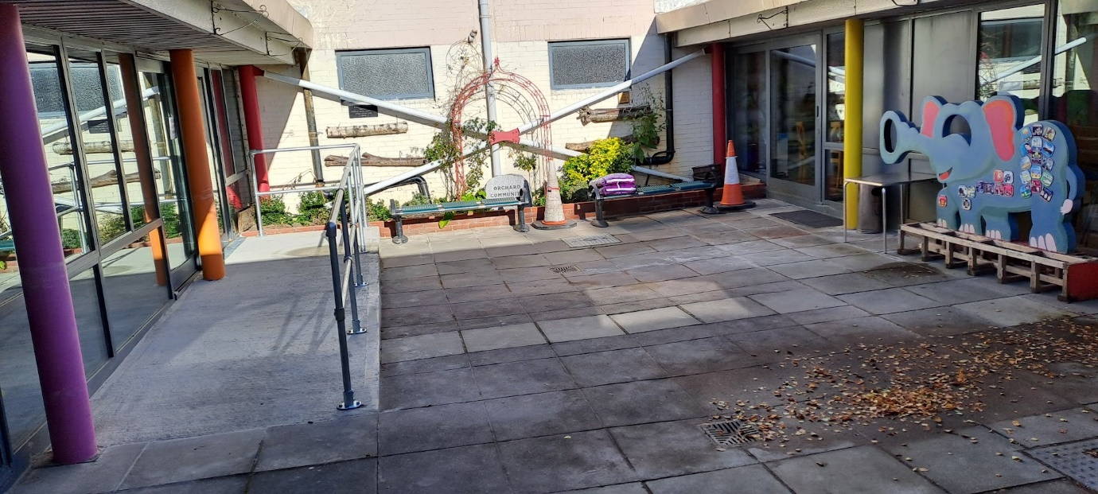
With thanks to the Discretionary Fund 2022 we were able to repair the inner courtyard and install a wheel chair accessible ramp to further expand the service for all our community users.

Weekly Activities
Our many groups are continuing on with their many weekly events. The centre has activities for all ages ranging from new born to the oldest members of our community. A full list of activities is available by emailing the centre manager at paul.smyth@dublincity.ie or at our reception area or any staff member will gladly answer any questions people have on what we offer the community.

Public Domain

- 38 Public Domain supported clean-ups this month.
- Graffiti has been removed from Kylemore/Landen Road bridge.
- Weed respraying has begun in the area as part of the roads contract.
- Leaf Collections by Waste Management crews at Lansdowne Valley Drimnagh, Dromard Road, Walkinstown Park/Green Rafters Lane, Road and Lissadel Road/Avenue.
- Deep clean and weeding at Dromard Road. Illegal dumping removed from lane to the rear of Balfe Road.
- Rapid Response assisted in Bluebell Allotments Clean-up

Report from: -

Alan Sherry,
Senior Executive Officer
Ballyfermot/Drimnagh Local Elec

