Director of Services Report
South Central Area Committee Meeting
14th December, 2022

SOUTH WEST INNER CITY ELECTORAL AREA

Public Realm & Capital Programmes

A look ahead to some planned and prospective projects in 2023:

Francis Street Environmental Improvement Scheme: The project will complete early next year. Remaining works in January include final areas of paving and tree pit construction (Bertram Court to Thomas Street section), remaining tree planting and landscaping, installation of new street lighting scheme, resurfacing of carriageway (Iveagh Markets to Thomas Street and Hanover Lane). Planters will be installed on the street later in spring.

Dolphin’s Barn Village Improvements:
- A contractor has now been appointed to undertake various interim improvements along Dolphin’s Barn Street including a planted area, street furniture (planters, seats and cycle parking) and the removal of barriers and on pavement parking etc. It is expected to complete works in Q1/23 or subject to the lead in time for street furniture elements.
- The Area Office and local Parks Services will make further improvements to the linear park area next year, building on recent changes to the space, including improved surfaces and paths.
- It is expected that detailed design work on the Dolphin’s Barn Public Realm Improvement Project (approved by Part VIII in 2018) will commence in 2023 following tendering for a design team.

Meath Street Public Realm Project: It is hoped to progress this project through Part VIII consent in 2023.

Tree Planting and Greening: The Area Office will be supporting Parks Services to design and implement street tree planting schemes at Bonham Street, Carman’s Hall, Haroldville Avenue/St Anthony Road, St Augustine Street/John’s Street and Cook Street. The projects remain subject to feasibility and cost.

Revised proposals for Blackpitts will be developed.

Local Parks Services also have a programme of tree planting of green areas and estate areas underway over this planting season.

Suir Road to Thomas Street Cycle and Walking Interim Scheme: Installation of this interim cycling/walking scheme is expected to take place early next year. The scheme was recently subject to a non-statutory public consultation. The scheme is being installed by the Active Travel Office.

St James’s Linear Park: Parks Services will be implementing Phase II of the linear park refurbishment in February/March 2023. This section runs between Basin Lane/Brandon Terrace and Fatima Luas Stop and includes play areas, new paths, planting and the creation of a community garden/grow space.

Economic Development

A look ahead to some planned and prospective projects in 2023:

Shopfront Improvement Scheme: The 2023 scheme will be announced in February, subject to agreement on the Discretionary Fund.

Smart D8: A two-year extension of this programme, which launched in 2020, was recently agreed by the consortium partners, including the Area Office. This follows the recent appointment of a new Ecosystem Manager to lead day-to-day work. It is expected to issue a further call for pilot projects in Spring 2023, as well as to deepen collaboration among the partners and engagement with the wider D8 community in the coming year.

Tourism: The Area Office will continue to support local tourism partners and cultural institutions to develop the distinctive visitor offer of the area and improve cultural amenities for local residents. The fifth Culture Date With Dublin 8 event will take place in May. We’ll support other local festivals and activities, and it is hoped to develop more events and activities in local parks over the summer period, in partnership with Parks Services.

Housing

St Michael’s Estate, Emmet Road, Dublin 8.
Planning Lodged 5th October, 2022

Tyrone Place Dublin 8. Regeneration.
A review of the development options for the regeneration of Tyrone Place is currently being undertaken by Housing Management, the Local Area Office and City Architects. All are cognisant that redevelopment options will need to take into consideration the large social and cost rental housing scheme that is planned for the adjacent site at Emmet Road.

School Street.
DCC received Stage 1 approval from the DHLGH for the regeneration of School Street and Thomas Court Bawn with a number of queries. These queries have now been replied to and submitted to the D.H.L.G.H. Upon approval, the commencement of the procurement of an integrated design team for the redevelopment project will begin.

Oliver Bond Regeneration.
DCC have received Stage 1 project approval from the Department of Housing Local Government and Heritage for the first phase of the regeneration of Oliver Bond, which is for the redevelopment of Blocks L, M and N. We also received funding for a Community Development Worker to be appointed to the Oliver Bond regeneration project.

DCC City Architects and Housing Regeneration staff are currently reviewing queries
received as part of our Stage 1 project approval to seek project budget approval.

Football Pitch
Works complete and license agreement signed. Extra security has been added to the fence surrounding the pitch to prevent access when pitch has been closed.

Planting of new Holly trees in the existing seven planters surrounding the pitch will commence in the coming weeks, DCC will have the trees next week to give to the residents committee to begin planting.

Side gates to green area at rear of Block B have been upgrade with extra security measures. Painting programme ongoing. Regular power washing is continuing throughout the whole complex.

Housing maintenance have confirmed that works on the new bin chambers under the new contractors will commence shortly.

New bollards are being installed Thursday 15th December 2022, to prevent the rat run from Oliver Bond Street through the complex to exit at the archway at Ushers quay. Contractors will be onsite for two days and then works will be complete. This measure was requested by the residents of the complex and DCC agreed after relevant checks were carried out by the team.

Bonham St .Dublin 8. Volumetric Build - 57 Units
26 x 1 bed
26 x 2 bed
5 x 3 bed

On site. Current Estimated Completion of Scheme Q2 2023

DCC have designated a community liaison (Trevor Martyn) to engage with residents
regarding their concerns.

Trevor can be contacted @ 087 2925013 trevor.martyn@dublincity.ie

Dolphin House Regeneration Masterplan Dublin 8.

The Dolphin House Regeneration Masterplan approved on the 4th Feb 2021 by the DH
Regeneration Board. DCC will progress the masterplan in conjunction with the Dolphin House Regeneration Board and the Dolphin House Community.

Dolphin 1B - Stage 1 project and funding approval has been received for the construction of approximately 25 new homes. Design development is progressing.
It is planned to lodge Part 8 Planning Application end of Q2 2023.
Demolition Block 1 and Block 2 have been demolished. Rubble export ongoing, monitoring of dust, noise, vibration still ongoing and to date all have been at acceptable levels. MCB in communication with ESB in relation to installing public lighting and new CCTV poles. First window cleaning to commence week of 14/11/22 or 21/11/22, second cleaning will be before MCB finish onsite.
New Blocks – new entrance doors fitted to all the blocks and working well. New courtyard doors have been ordered for blocks C and D and should be ready to install week 14/11/22.
Interim Playground Facilities – The start date for works on the DH playground is the first week in January. A site meeting has been arranged between the contractor, DCC officials and DHCDA reps for the 14th December. DCC will also be carrying out works on the surface area in the vicinity of the Community Buildings and the new playground, following installation of the playground additional surface works will be carried out in due course. These works require dry, mild weather for optimum results.

Painting of railings – currently underway, Canal railings first. Painting of stairwells in old blocks underway.
Donore Avenue - (former Saint Teresa’s Gardens)

Donore Forum
The second meeting of the Donore Forum took place on 24th November 2022. The main focus of DPCF will be around construction related matters; to support development of 543 social and cost rental housing units of the Donore Project, but also community facilities and infrastructure; to get updates from LDA, Hines and DCC; while making sure the voice of the local community is also heard and taken into account when various plans are being proposed and implemented.

LDA – Martin Donlon Senior Architect agreed to provide presentation of what is being submitted in planning application and confirmed that the intention was to submit by December 2022. Group also asked for a model of the overall development to include LDA / Hines structures – Martin advised that these can take up to 6-9 months to construct but he would follow up on the request.
Community Centre – Again a large portion of the meeting consisted of discussion around lack of community space within the area – Further to this I have spoken to Helen Burke, Community Officer who has agreed the community room in the Timberyard could provide an alternative space for groups to meet. Helen also advised the principal of Basin Street School is agreeable to groups / clubs using the school hall – advanced booking required for both options. This will be brought to the next Forum meeting.
Community Health Worker – It was confirmed that the Community Health Worker Pamela Carroll who is funded through the HSE will now be managed by SWICN.
Minutes – To be signed off by DCC prior to distribution.
Public Lighting – A request was made to increase the public lighting along Donore Avenue and in particular at the Saint Teresa’s Gardens site as it has become quite desolate.

LDA
This project will provide for the delivery of approximately 543 homes in a collaboration between Dublin City Council and the Land Development Agency, under a working title ‘Donore Project’

28% of the homes provided will be for social housing and 72% for cost rental housing.

The breakdown of the social homes include:

41% 1 bed which 50% will be available for Older Person Accommodation
48% 2bed
11% 3 Bed

A Part 10 planning application was lodged to An Bord Pleanála on December 9th 2022.

Donore Boxing Club
Will be relocating to the Ferrini Youth club on the South Circular Road pending facility works that need to be carried out for the members of the club. This will pave the way for demolition works of the two remaining blocks to commence. An on-site meeting with the Senior Architect Martin Donlon and members of the Ferrini Board of Management is scheduled to take place on December 13th to progress these works.

Margaret Kennedy Road/Court
Purcell have stated remedial works on the drainage system. Works to replace the vandalized solar panels on the Margaret Kennedy Court apartment block have been approved and are scheduled to commence in the coming weeks. New security measures have now been implemented in Margaret Kennedy Court. Works on the heating snags are ongoing.

Herberton 39 units Part 5
9 x 3 bed
24 x 2 bed
6 x 1 bed

Dublin City Council recently ran a choice based letting competition for 39 units in the Herberton Complex. This competition attracted significant interest from housing applicants and following extensive work by the local housing team applicants who met the criteria for these units were selected. All of the successful applicants were subsequently invited to view the unit they were being offered but they were advised during the viewing process that as these units had been unoccupied for a number of years they would require essential maintenance works and it would likely be sometime before we could allocate them.
Following recent inspections we have now been advised by Housing Department that the works required to bring these units up to fire & safety standard regulations are extensive and this in turn mean the delays may be significant, to that end DCC have written to all of the applicants advising them of this and providing them with the option of removing their names from the selection if so desired.
A meeting has been arranged with Housing Department and Councillors and is scheduled to take place Monday 19th December at 4 p.m.
The CCTV system in the Reuben/Herberton area is being upgraded.

Cork Street / Chamber St Volumetric - 55 Units

32 x 1 bed
10 x 2 bed
13 x 3 bed

Current Estimated Completion of scheme End of Q2 2023

These units will be allocated under the scheme of letting priorities

DCC have designated a community liaison (Laura Kenny) to engage with residents regarding their concerns.

Laura can be contacted @ 0871863675 laura.kenny@dublincity.ie

Community

Bridgefoot Street Park Festive Event
A Christmas event took place in Bridgefoot Street Park on Thursday 8th December.
Santa made a surprise visit on a horse and cart with a very large sack filled with goodies for the local children. There was Carol Singing, Music and mince pies.

Festive Afternoon Tea Dance

Senior residents from the South West Inner City attended a Festive Afternoon Tea Dance in St James’s Primary School Hall on Monday 12th December.
Afternoon Tea was served followed by music and dance. Special guests included the Children from Grand Canal Way after schools club who gave a Christmas Carol recital.

Kilmainham Inchicore Network - next meeting 19th December 2022 at 5.30pm, 6 Tyrconnell Road

KIN Strategic Planning Process
KIN Vision and Strategic Plan facilitated process is well underway; 3 in person facilitated design Sprint sessions completed with Colm Byrne, The Ladder. The outcomes from the design sprint will inform the KIN Strategic Plan 023-2027.
As part of this process a booklet is being prepared for circulation to local households outlining the work of KIN, encouraging greater engagement in planning and attending events. Information will be shared on developments, organisations and services in our area. This booklet will be ready for circulation shortly.
The KIN website is being overhauled at present www.kilmainham-inchicore.ie and will be live early 2023.

Liffey Gaels/ East Timor Park Master Plan:
Alastair Ferrar, Cunnane Stratton Reynolds Consultant have had their remit extended to include reviewing increased access from the park over to Irish National War Memorial Gardens. This will also be included in a Master Plan for Liffey Gaels Park on behalf of DCC.

Grand Canal - Activation and Animation of Grand Canal between Portobello and Kylemore Road: (presentation at SCAM September 2022)
Irish Leisure Consultants (ILC) have completed their Report identifying the potential recreational Activation and Animation measures along the Grand Canal between Portobello and the Kylemore bridge, commissioned by Dublin City Council and Waterways Ireland. They consulted with local organisations, individuals and agencies regarding the current and potential future recreational use of the canal, as well as identifying appropriate approaches to forward the project. The Report will be launched on 25th January 2023 11am at Richmond Barracks (all local elected councillors invited – see invite below). Please RSVP via Eventbrite to confirm your attendance. A second state of this project that will see progress and implementation of outcomes is under discussion. More details to follow.
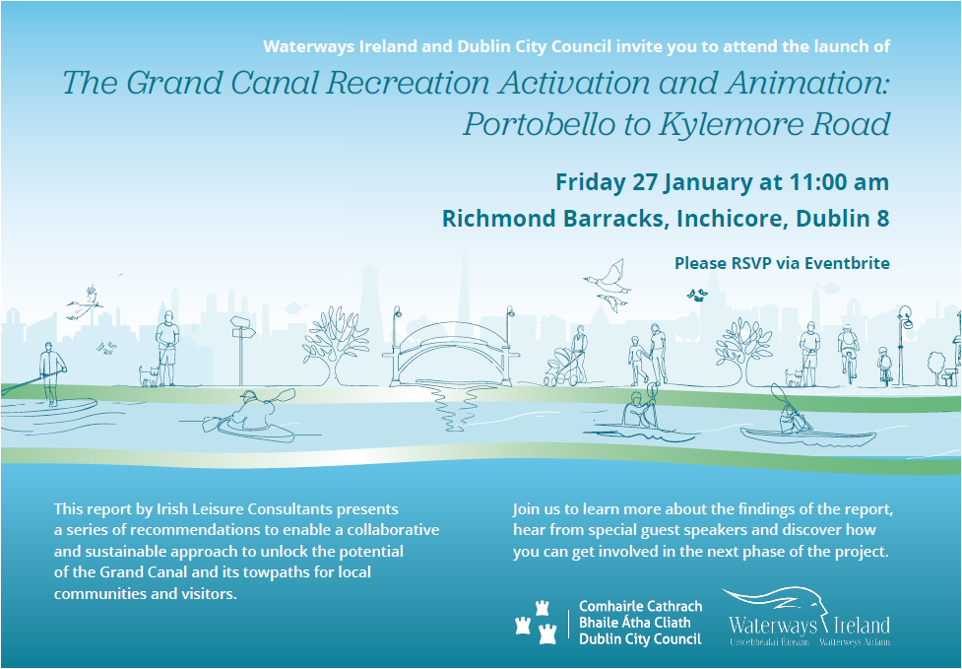

Fairs at Richmond Barracks
KIN, in partnership with DSCP and DCCCC, have organised 4 fairs at Richmond Barracks over the last year, with on average over 3000 attendees at each fair this initiative has been a great success. A review of the pilot programme will be undertaken in Q1 2023. There is a further Spring/ Imbolg Fair due to take place 5th /6th February 2023 the theme based on celebrating Women in business.

Office in Inchicore – 6 Tyrconnell Road
The office at 6 Tryconnell Road is now open for hosting KIN and IRCF meetings.

Inchicore Regeneration Consultative Forum – next meeting 19th December 2022 7pm. 6 Tyrconnell Road.

The IRCF lodged an observation to An Bord Pleanála re ERD during the observation period. This observation is available for viewing at www.kilmainham-inchicore.ie/ircf.

See www.emmetroad.ie for full application information.

Public Domain
- Weeding and scraping at Inchicore Village, and Bulfin Road Estate by Waste Management Crews. The foamstream weed re-spray has just been completed in the area.
- Fallen Leaf Removals at , South Circular Road, Mount Shannon, Brookfield, Pimlico, Emmet Road, Grattan Crescent
- 13 Community Clean-ups supported in the area. Compostable Leaf Bags & clean-up equipment supplied
- Graffiti removal and over painting completed at: St Augustine Street, Hanover Arch & Lane, Iveagh Markets, Cornmarket, Thomas Street, Tyrone place, Emmet Crescent & Vincent Street West. School Street and Reuben Street.
- Community Clean-ups & Leaf Collections
- Francis Street School won the City Neighbourhoods Schools Competition and were awarded their certificate by Lord Mayor Caroline Conlon at the Mansion House Dec 2nd.

Report from: -

Bruce Phillips,
Senior Executive Officer
South West Inner City Local Electoral Area.

BALLYFERMOT/DRIMNAGH ELECTORAL AREA

Housing

Cornamona
The end of Quarter 1, 2023 continues to be the anticipated date for handover of the completed units. The area office team is engaging with tenants that have expressed an interest in downsizing in relation to this development.

Springvale
The anticipated completion date for the units remains mid-2023.

Lissadel Maisonettes
Work is ongoing preparing a stage 1 application to the Department of Housing, Local Government & Heritage with an anticipated submission date of Quarter 1, 2023. The insulation works are ongoing.

Bernard Curtis House
The repainting of the units is continuing.

Labre Park
Preparation of the necessary documentation to support a stage 2 application for funding to the Department of Housing, Local Government & Heritage is continuing.

Hillside Manor
The units are still being finished out and the offers are being processed.

Claddagh Court
The replacement of the intercom system is completed.

Sons of Divine Providence
Interaction with the Department of Housing, Local Government & Heritage is ongoing with the aim of submitting a stage 2 application in Quarter 1, 2023.

Bluebell
The Land Development Agency is continuing with site investigation works.

Rafters Road
Work is ongoing in relation to queries raised by the Department of Housing, Local Government & Heritage as part of the stage 2 application.

Chapelizod Hill Road
The Council’s long term leasing team has entered an agreement with the developer of this site (formerly Faulkner’s factory) to lease all of the 174 units being developed. The anticipated completion date is mid-2023.

Voids
There are 31 Voids in the area, 8 of which are under offer at present. In relation to the void units, 3 of the last senior citizens units available in the area have been allocated to tenants surrendering 2 no. 3 bedroom houses and 1 no. 4 bedroom house. In addition 2 no. 3 bedroom houses have also come back to the Council due to transfers to smaller units.
Community

A priority focus for the Community Development Team in 2022 was to support and encourage the voluntary groups to reform and to organise local events after the long Covid closures.
Festival Committees, Environmental Projects, Ladies Clubs, Men’s Sheds, music, youth and cultural events were supported financially to meet insurance costs, small building repairs and programme costs.
Community staff supported groups in practical ways, including attending & co-ordinating planning meetings, assisting with programme planning and organising events.
In 2022 the Council worked to establish:
Cherry Blossoms, a month of events throughout Cherry Orchard to celebrate community organisations and to promote the positive many activities in the area.
The Ballyfermot Dementia Singing group which takes place every Thursday in the Family Resource Centre at 2:00PM and is a very special event for those with dementia, their family members and care givers.
The Linkage Group to organise a programme of activities for older people. The Singing Group takes place the first Thursday of every month in the Green Kitchen at 10:30AM.
The Together FM Film Club which hosts a monthly free film show in the Ballyfermot Civic Centre with the support of the Community Development Section.
The Bluebell Festival Committee was established by the City Council to organise a Halloween festival. The group is now organising a community Christmas party for the local youth. Building on the success of the group, the Council will continue to support the group to start planning for a summer festival in 2023.
The Wonderful Walkinstown Festival was the biggest community event of the Summer. It took place in Walkinstown Park on Sunday the 5th of September. The Council set up the festival committee and supported the group over 8 months to organise the event.
The Council organised the following events:
4 Walk and Talk events, 3 Dog Shows and 2 Opera in the Park concerts which were held during community festivals and to animate our Parks during the summer months.
The Council, working with local resident groups organised 9 local Summer Play day during July which were attended by over 1,200 children and residents.
The Council supported the Halloween Festivals in Ballyfermot, Drimnagh and Bluebell.
5 Community Plant Sales were held providing 2,500 bedding plants grown locally in the Orchard Community Garden.
17 events were held as part of our Autumn /Winter Older Peoples programme. Tea Dances, Line Dancing, Chair Yoga, Bingo and film shows were held in the Civic Centre Ballyfermot, Walkinstown Library and Moran Hall.
The Shine a Light on Volunteers evening was held in November celebrating 60 local voluntary groups that were presented with a Lord Mayors certificate in recognition of their commitment to the community.
The Council supported the following Events
The Council supported the Community Festival committees in Ballyfermot, Cherry Orchard, Drimnagh, Chapelizod and Walkinstown financially with funding from the area office and discretionary budget.
The Council worked and supported the Ballyfermot Youth Organisations to host Cruinniú 2022, which showcased local youth talent at the Unsung Youth Concert and wellbeing fair that was held in the Ballyfermot Civic Centre on Saturday June 11th.
We also supported, through Familibase, the establishment of the Ballyfermot LGBTQ+ Group to take part in the Cruinniú event.
The Council has continued to support environmental groups in the Ballyfermot/Drimnagh ward. In March we connected the twelve environmental groups together by inviting the key members to attend an environmental information session in the Ballyfermot Civic Centre to plan how groups can enhance their efforts and support each other.

The Council has supported two new environmental groups in Walkinstown and Drimnagh.
Make Walkinstown Great was established late last year and has organised bimonthly clean ups and were involved in the “Welcome to Walkinstown” sign project and the installation of twelve blue planters.

Ben Madigan Residents Group has organised regular clean ups, planted bulbs around the green and had a very success family fun day. During the summer it organised a visit by President Michael D Higgins to unveil a memorial bench in honor of deceased Ben Madigan resident, the late Johnny Murphy, best known for his role in the commitments as “Joey “The Lips” Fagan”

The Council has supported the two community allotments committees in Bluebell and Chapelizod. The council has provided funding for the maintenance of the communal areas, removal of waste and general upgrades. The Chapelizod committee has utilized some of the communal area for a group planting project and the Bluebell committee is planning a Harvest Summer Festival for 2023.

Administration
Administration of Community Grants and Community Discretionary projects.
Distribution of the Friends of South Central monthly newsletter to 704 subscribers.
Information on funding sources and support with applications for community organisations.

2022 in pictures
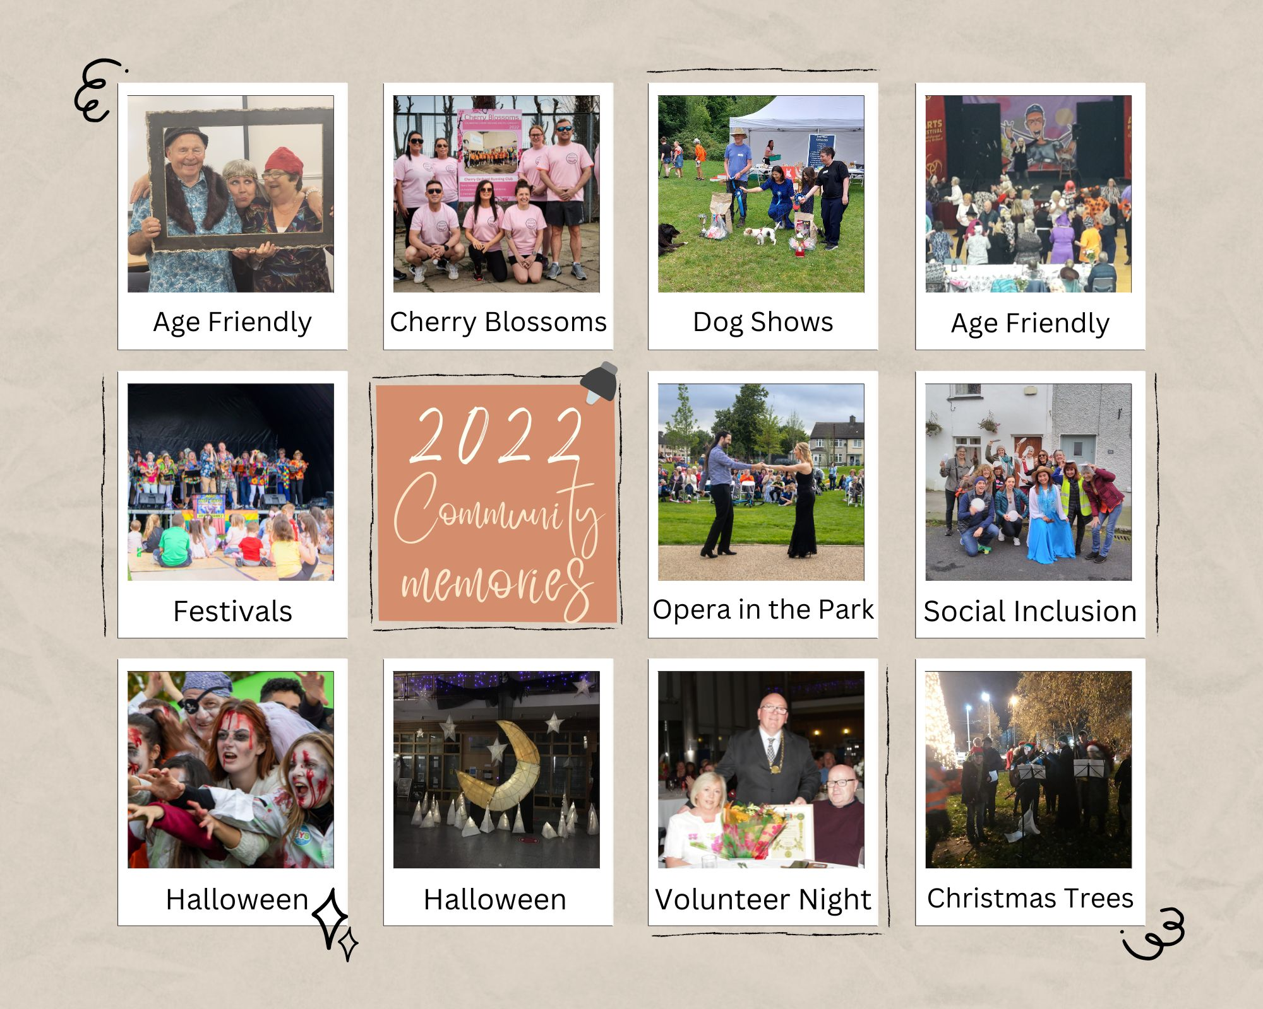

It has been a great year, filled with activities and community events that were organised locally by volunteers and supported by the City Council.

Orchard Community Centre

Indoor Bowling.
In October the new indoor bowling activity for older people in our community started. We had an open day during Social Inclusion Week and the group has now got up to 20 people participating every Tuesday. Anyone interested can come along every Tuesday morning from 11.30am-1.00pm. The activity is free and with tea/coffee/snacks after the session. The group provides a great opportunity for local people to have fun and a chat.

Meditation Mondays
If you’re looking for a relaxing evening then come to the centre any Monday night for 2 hours of Meditation and Relaxation. There are sessions every Monday from 7.00pm-9.00pm.

Elite Baton Twirlers
Congratulations to our resident Majorettes/Baton Twirlers group who won yet more awards and trophies recently at a nationwide competition held in Tallaght Stadium. Well done to the group and their leader Amanda Hendricks.

Leaders in Learning
We are holding our second Leaders in Learning event on 13th December. This event is an opportunity to recognize and celebrate what they have achieved.

Our Hearts Productions
This group started in the centre only a few weeks ago and is working with young people in the area on creating better futures for those they work with through film production. They produced an educational video on the dangers young people face around the Halloween period and this was shared widely on social media. The group have big ambitions going forward and plan on making more videos and even documentaries/films as they grow.

Christmas Community Breakfast.
The Centre will hold the annual community Christmas breakfast for all those volunteering and working in the community. This annual event is a great way to thank all those who work hard in the community to make the area a better place for all. The breakfast will be held Christmas week, date to be decided.

Park Consultation
Working closely with our colleagues in Parks Department we have a public consultation day upcoming on December 6th. This is the initial steps to the communities input into the redesign of Cherry Orchard Park.

Making Cherry Orchard Better
On November 11th a very worthwhile consultation took place in the Orchard Centre with key personnel invited to take part in a facilitated session on the direction the Making Cherry Orchard Better plan should take.
There were 47 key stakeholders in attendance and the feedback during and after was very progressive.
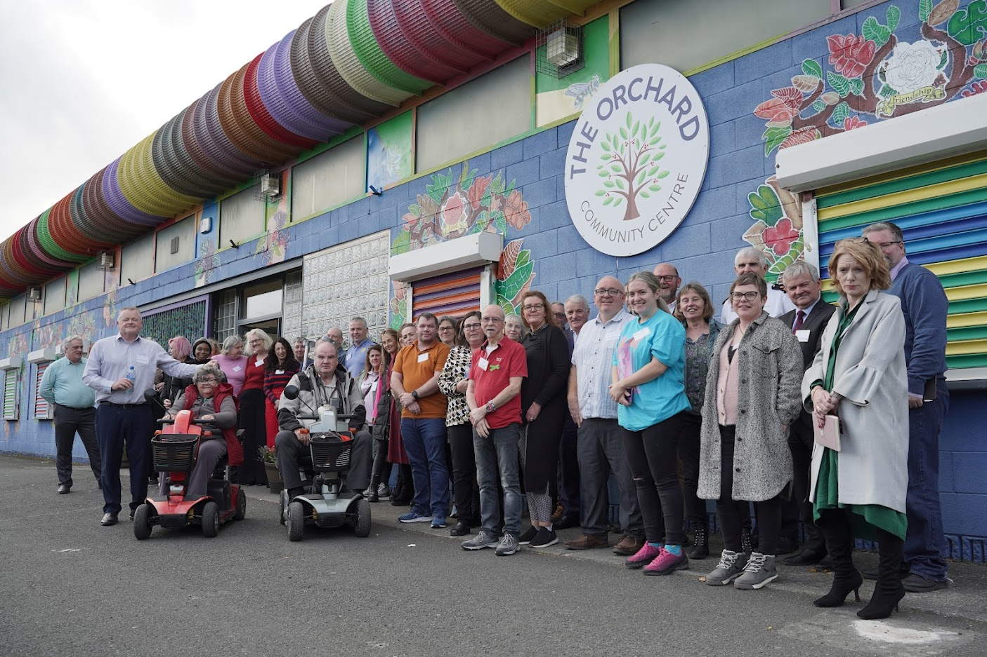

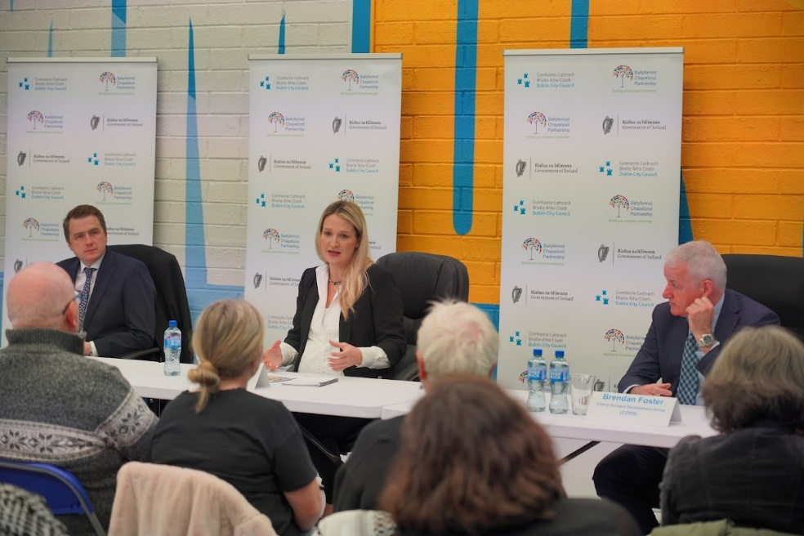
Ministerial Visit & New Structure

Minister for Justice Helen McEntee & Minster James Browne visited The Orchard Community Centre on 24th November and announced new structures and a way forward regards supporting the progressive movement of the Cherry Orchard area. The current independent chair of Cherry Orchard Development Group (CODG) has been appointed as the chair of the new Cherry Orchard Implementation Board (COIB)
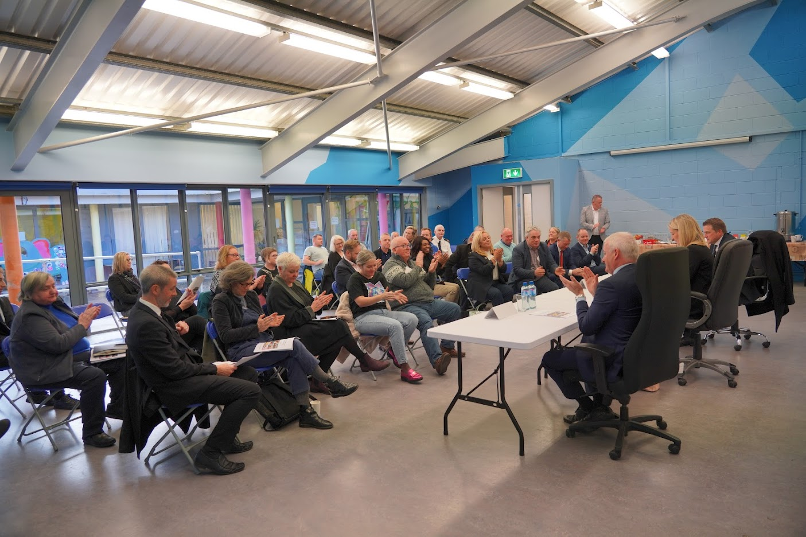

Details of the COIB were outlined to community leaders and elected representatives by Ms McEntee at a meeting in the community on Thursday 24th November.

Public Domain
- Weeding and scraping completed by waste management crews at: St Mary’s Park, Drive & Cres., Brandon Rd, Comeragh Road, Dromore Road, Knocknarea Road, Rafters Lane/Road.
- Leaf Sweeping was completed at Mourne Road, Sperrin Road, Lansdowne Valley, Dromard Road, S Mary’s Drive, Crumlin Village, Bunting Road, First Avenue, Ring Street Park, Tyrconnell Road, Glenaulin Drive, Chapelizod,
- 35 Community Clean-ups and Leaf Collections supported and compostable leaf bags and equipment supplied
- Graffiti removal at Kylemore Road.
- Irish Rail completion of repairs to guard rail at Cherry Orchard Ave Footbridge. Discussions on-going regarding further upgrades and work in that location
- Inspections of footpath/carriage way/street furniture repairs and painting underway for 2023 programme
- Waste compliance letters sent to householders Huband Road follow-up enforcement action in due course
- Public Domain working with Litter Enforcement at following areas: Maiden Row, Chapelizod, Lissadel Road, Drimnagh & Hardy’s Lane, Ballyfermot- issues presentation of waste & illegal dumping.

Report from: -

Alan Sherry,
Senior Executive Officer
Ballyfermot/Drimnagh Local Electoral Area.

