Dublin City Development Plan 2022-2028

Volume 2: Appendices



PAGE LEFT INTENTIONALLY BLANK

Table of Contents
Appendix 1: Housing Strategy 1
1.0 Advisory Note 3
2.0 Introduction 3
3.0 Housing Strategy Context 7
4.0 Baseline - Demographics 19
5.0 Baseline - Housing 22
6.0 Interim Housing Need Demand Assessment 35
7.0 Meeting Social & Affordable Housing Demand 60
8.0 Key Policy Recommendations 73
9.0 Annexes 74

Annex 1 to Appendix 1:Dublin City Housing Need Demand Assessment (HNDA) 76
1.0 Introduction 79
2.0 Methodology 80
3.0 HNDA Outputs 95
4.0 Conclusion 111

Annex 2 to Appendix 1:Dublin City Housing Supply Target Methodology 115

Annex 3 to Appendix 1:Dublin City Sub-City HNDA 121
1.0 Introduction 123
2.0 Future Housing: Projected Housing Need and Supply 126

Appendix 2: Retail Strategy 173
1.0 Introduction 175
2.0 Policy Context 176
3.0 Retail Trends 178
4.0 RSGDA 2008 – 2016 Floorspace Requirements versus Actual Provision of Retail in Dublin City between 2008 and 2021 182
5.0 Settlement Hierarchy and Level and Form of Retailing 183
6.0 Scale and Location of Retail Development 188
7.0 Retail Warehouse Parks and Retailing Warehouses 193
8.0 Strategy to Support the City Centre 194
9.0 Assessment of Planning Applications 202
10.0 Guidance on Specific Forms of Retail 204

Appendix 3: Achieving Sustainable Compact Growth 209
1.0 Introduction 211
2.0 Policy Context 211
3.0 Understanding Height and Density – the Strategic Approach 213
4.0 The Compact City – How to Achieve Sustainable Height and Density? 218
5.0 Landmark/Tall Buildings 230
6.0 Guidelines for Higher Buildings in Areas of Historic Sensitivity 237

Appendix 4: Development Plan Mandatory Requirements 239

Appendix 5: Transport and Mobility: Technical Requirements 243
1.0 Introduction 245
2.0 Development Management 245
3.0 Cycle Parking Standards 251
4.0 Car Parking Standards 255
5.0 Electric Vehicles (EV) 267
6.0 Motorcycle Parking 268
7.0 Shared Mobility 268
8.0 Design and Construction Standards and Processes for Roads and Footpaths 268
9.0 Technical Requirements for Dublin Tunnel and Luas 270

Appendix 6: Conservation 273
1.0 Historic Street Surfaces (1) 275
2.0 Historic Street Surfaces (2) 277
3.0 List of Architectural Conservation Areas (ACAs) 291
4.0 Monuments in the City 292

Appendix 7: Guidelines for Waste Storage Facilities 295
1.0 Design Considerations 297

Appendix 8: COMAH (Seveso) Establishments 299
1.0 COMAH (Seveso) Establishments 301

Appendix 9: Basement Development Guidance 303
1.0 Introduction 305
2.0 Basement Development – Potential Negative Impacts 305
3.0 Purpose of a Basement Impact Assessment 306
4.0 Content of Basement Impact Assessment 307
5.0 Basement Impact Assessment – Submission Checklist 318
Appendix 10: Infrastructure Capacity Assessment 321
1.0 Introduction 323
2.0 Methodology 323
3.0 Challenges 323
4.0 Strategic Infrastructure 324
5.0 City Scale Infrastructure 333
6.0 Core Strategy 335
7.0 Assessment Conclusion 338

Appendix 11: Technical Summary of Dublin City Council Green & Blue Roof Guide (2021) 339
1.0 Introduction 341
2.0 Green Blue Roof Requirements 343

Appendix 12: Technical Summary of Dublin City Council Sustainable Drainage Design & Evaluation Guide (2021) 345
1.0 Introduction 347
2.0 Integrating SuDS into New Development 349
3.0 SuDS Requirements 350

Appendix 13: Surface Water Management Guidance 354
1.0 Introduction 356
2.0 Requirement for Surface Water Management Planning for New Development 357
3.0 General Notes 360

Appendix 14: Statement Demonstrating Compliance with Section 28 Guidelines 362
1.0 Introduction 364
2.0 Legislative Requirements 364
3.0 Implementation of Policies and Objectives of S28 Guidelines in the City Development Plan 364

Appendix 15: Land Use Definitions 374
1.0 Land-Use Definitions 376

Appendix 16: Sunlight and Daylight 390
1.0 Introduction 392
2.0 Why Daylight? 392
3.0 Guidance, Standards and National Policy 392
4.0 Relevant Metrics 394
5.0 Assessment Methodologies 396
6.0 Designing for Daylight and Sunlight 398
7.0 Assessing Results 405
8.0 Independent Verification of Reports 405
9.0 Other Relevant Factors 406
10.0 References 406

Appendix 17: Advertising and Signage Strategy 408
1.0 Advertising and Signage 410
2.0 Digital Signage 412
3.0 Illuminated Signs 413
4.0 High Level Corporate Branding/ Signage 413
5.0 Advertising on Bus Shelters/ Phone Boxes 414
6.0 Temporary Advertising/ Artwork 414
7.0 Implementation of the Advertising and Signage Strategy 414
8.0 Advertising Development Management Standards 415

Appendix 18: Ancillary Residential Accommodation 416
1.0 Residential Extensions 418
2.0 Detached Habitable Rooms 421
3.0 Porches 421
4.0 Alterations at Roof Level/ Attics/ Dormers/ Additional Floors 421
5.0 Attic Conversions / Dormer Windows 422
6.0 Subdivision of Dwellings 425
7.0 Ancillary Family Accommodation 426
8.0 Home Based Economic Activities 426
9.0 Demolition and Replacement Dwellings 427

List of Figures
Figure 1: Chart of Dublin City Council DHTF Returns Q3 2017 – Q3 2022 –Residential Permissions and on Site Activity 24
Figure 2: Tenure Breakdown in Dublin City and the State (Census 2016) 28
Figure 3: HNDA Toolkit Preparation Stages 37
Figure 4: Dublin City HNDA Sub-Areas 41
Figure 5: Forecast Household Composition over the Plan Period - DCC 46
Figure 6: Forecast Household Composition over the Plan Period - NIC 47
Figure 7: Forecast Household Composition over the Plan Period - Liberties 47
Figure 8: Forecast Dwelling Type Distribution 2023-2028 – DCC 49
Figure 9: Forecast Dwelling Type Distribution 2023-2028 - NIC 50
Figure 10: Forecast Dwelling Type Distribution 2023-2028 - Liberties 50
Figure 11: Forecast Household Composition in Plan Period (2023 to 2028) 55
Figure 12: Households by Number of Rooms in Dublin City, 2016 56
Figure 13: Forecast Household Composition in Plan Period 59
Figure 14: Map of Dublin City Council Traveller Group Housing Schemes and Traveller Halting Sites 66
Figure 2.1: HNDA Toolkit Preparation Stages 81
Figure 2-2: Homeless Households and Individuals (Dublin City Social Housing Needs Assessment, June 2021) 85
Figure 2-3: Median Price Forecasts in Dublin City (Default and Custom Scenarios) 90
Figure 2-4: Tenure Breakdown in Dublin City and the State (Census 2016) 91
Figure 2-5: Median Rental Forecast for Dublin City (Default and Custom Scenarios) 94
Figure 3-1: Projected Median Weekly Rents, 2020-2028 101
Figure 3-2: Projected Housing Need in Dublin City by Tenure, 2023-2028 104
Figure 3-3: Projected Housing Need by Tenure – Annual Distribution, 2023-2028 104
Figure 3-4: Forecast Household Composition over the Plan Period 106
Figure 3-5: Households by Number of Rooms in Dublin City, 2016 108
Figure 3-6: Forecast Dwelling Type Distribution 2023-2028 in Dublin City 110
Figure 1-1: Overview of the HNDA Modelling 124
Figure 1-2: Dublin City HNDA Sub Areas 125
Figure 2-1: Summary of Needs - Dublin City 164
Figure 2-2: Summary of Needs - Dublin 1 164
Figure 2-3: Summary of Needs - Dublin 8 165
Figure 2-4: Forecast Household Composition over the Plan Period - DCC 166
Figure 2-5: Forecast Household Composition over the Plan Period - D1 167
Figure 2-6: Forecast Household Composition over the Plan Period - D8 167
Figure 2-7: Rooms Per Household (%), 2016 169
Figure 2-8: Forecast Dwelling type distribution 2023-2028 - DCC 170
Figure 2-9: Forecast Dwelling Type Distribution 2023-2028 - D1 171
Figure 2-10: Forecast Dwelling Type Distribution 2023-2028 - D8 171
Figure 1: The 5 Regional M50 Centres 180
Figure 2: Footfall % Change in Dublin City Retail Core During 1st Covid Lockdown in 2020 181
Figure 3: Key Routes from Office and Culture Clusters to Retail 195
Figure 4: City Activity Character Areas / Quarters 197
Figure 1: Height and Density 218
Figure 1: Street Trees and Vehicular Entrances 262
Figure 1: Scenarios A-D 314
Figure 1: EMR Water Supply Project (Source: Irish Water) 326
Figure 2: GDD Project (Source: Irish Water) 329
Figure 3: Dublin Proposed Public Transport Network, Source: National Development Plan 2021-2030) 332
Figure 4: Dublin Metropolitan Area Strategic Plan 336
Figure 1: Obstruction Angle 399
Figure 2: Obstructions to the South 399
Figure 3: Room Depth 400
Figure 4: Balcony Layouts 401
Figure 5: Balcony Access 402
Figure 6: Optimisation Studies 403
Figure 7: Optimisation Example 404
Figure 1: Zones of Advertising Control 411
Figure 1: Good Examples of Dormer Extensions 424
Figure 2: Poor Examples of Dormer Extensions 424

List of Tables
Table 1: Population Projection for County Dublin, 2016-2031 (as revised) 12
Table 2: ESRI NPF Scenario Housing Supply Target 12
Table 3: RSES Baseline Population Projections for Dublin City Council, 2016-2031 13
Table 3-1: Projected Housing Output (New Build) 2022- 2030 16
Table 4: Population Change 19
Table 5: Population of DCC as a Percentage of the Population of the State, 2006-2016 20
Table 6: Age Profile of Dublin City Council 2016 20
Table 7: Population Categorised by Family Cycle, 2016 21
Table 8: Total Housing Stock, Residential Vacancy in Dublin City Council, 2011-2016 22
Table 9: Dublin City Council DHTF Returns Q3 2022 23
Table 10: Dublin City Council DHTF Returns Q3 2022- Construction Site Activity 23
Table 11: Analysis of Dublin City Council DHTF Returns Q3 2017 – Q3 2022 – Ratio of Residential Permissions and on Site Activity 24
Table 12: Private Households in Dublin City Council 2011-2016 25
Table 13: Households by Dwelling Type in Dublin City, 2006-2016 26
Table 14: Historic Dwelling Type Change in Dublin City 2006-2016 26
Table 15: Historic Household Composition in Dublin City, 2002-2016 27
Table 16: Flats/Apartments in Purpose Built Blocks by Nature of Occupancy, Dublin City Council, 2016 27
Table 17: All Households Rented from Private Landlord in Dublin City Council 2011-2016 29
Table 18: Average Dwelling Price in Dublin City, 2013-2020 30
Table 19: Historic Average Rent in Dublin City 31
Table 20: Provision of Social Housing, Dublin City Council, 2016-2020 33
Table 21: Summary of Households Qualified for Social Housing Support in Dublin City Council (2019 -2020) 34
Table 22: Projected Housing Demand for Dublin City Area 2020 – 2031 ESRI NPF Scenario Housing Supply Target of S28 Housing Supply Target Methodology for Development Planning, December 2020 38
Table 23: HNDA Estimated Housing Need by Tenure, 2023-2028 40
Table 24: Custom Sub-City/City HNDA Methodology Components 42
Table 25: Overview of Social and Affordable Housing Requirements in DCC 44
Table 26: Overview of Social and Affordable Housing Requirements in NIC 45
Table 27: Overview of Social and Affordable Housing Requirements in Liberties 45
Table 28: Forecasted Annual Change in Household Size Cohorts 46
Table 29: Rooms per Household (%), 2016 48
Table 30: Forecast Change in Dwelling Type for Households 48
Table 31: Forecast Change in Tenure Composition of Households 51
Table 32: Intercensal Change in Tenure 51
Table 33: Historic Household Composition in Dublin City, 2002-2016 54
Table 34: Historic Household Composition Change in Dublin City, 2002-2016 54
Table 35: Forecasted Annual Change in Household Size Cohorts in DCC 55
Table 36: Households by Number of Rooms in Dublin City, 2016 56
Table 37: Mix of Residential Units, Minimum and Maximum Requirements 58
Table 38: Estimated Housing Need by Tenure, 2023-2028 (%) 59
Table 39: Estimated Social, Affordable Purchase & Cost Rental Housing Need over Plan Period 61
Table 40: Total Breakdown of Specialist Needs, Dublin City Council 2019, 2020 64
Table 41: Dublin City Council Traveller Group Housing Schemes and Traveller Halting Sites 65
Table 2-1: Historic Sales Growth - PPR 89
Table 2-2: Custom Sales Scenario 89
Table 2-3: Historic Rental Growth - RTB 93
Table 2-4: Custom Rental Scenario 93
Table 3-1: Population Projections for Dublin City, 2020-2031 97
Table 3-2: Forecast Additional Households Per Annum 98
Table 3-3: Forecast Household Incomes in Dublin City, 2019-2028 99
Table 3-4: Projected Sales Prices in Dublin City, 2020-2028 100
Table 3-5: Projected Median Rents in Dublin City, 2020-2028 101
Table 3-6: Total Annual Housing Need, 2023-2028 102
Table 3-7: Estimated Housing Need by Tenure, 2023-2028 (Households) 103
Table 3-8: Estimated Housing Need by Tenure, 2023-2028 (%) 103
Table 3-9: Historic Household Composition in Dublin City, 2002-2016 105
Table 3-10: Historic Household Composition Change in Dublin City, 2002-2016 106
Table 3-11: Forecasted Annual Change in Household Size Cohorts in DCC 106
Table 3-12: Households by Number of Rooms in Dublin City, 2016 107
Table 3-13: Households by Dwelling Type in Dublin City, 2006-2016 109
Table 3-14: Historic Dwelling Type Change in Dublin City 2006-2016 109
Table 3-15: Forecast change in dwelling type for households 109
Table 4-1: Estimated Housing Need by Tenure, 2023-2028 (%) 111
Table 2-1: HNDA Methodology Components 127
Table 2-2: Annual Housing Demand and Allocation for Dublin City and Sub Areas Over the Plan Period 130
Table 2-3: Gross and Disposable Income in DCC, Dublin 1 and Dublin 8 131
Table 2-4: Household Mortgage Capacity Per Decile in Dublin City 132
Table 2-5: Household Mortgage Capacity Per Decile in Dublin 1 133
Table 2-6: Household Mortgage Capacity Per Decile in Dublin 8 133
Table 2-7: Distribution of Property Transactions in Dublin City 134
Table 2-8: Distribution of Property Transactions in Dublin 1 and Dublin 8 135
Table 2-9: Historic and Forecasted Average Price in Dublin City 136
Table 2-10: Historic and Forecasted Average Price in Dublin 1 and Dublin 8 137
Table 2-11: Historic and Forecasted Average Rent in Dublin City 138
Table 2-12: Historic and Forecasted Average Rent in Dublin 1 139
Table 2-13: Demand by Unit Type in Dublin City and Sub Areas from RTB Tenancies 139
Table 2-14: Number of Households in Dublin City that do not Qualify for a Mortgage 142
Table 2-15: Number of Households in Dublin 1 that do not Qualify for a Mortgage 142
Table 2-16: Number of Households in Dublin 8 that do not Qualify for a Mortgage 142
Table 2-17: Ownership Assessment - DCC 143
Table 2-18: Ownership Assessment - Dublin 1 149
Table 2-19: Ownership Assessment - Dublin 8 155
Table 2-20: Number of Households that do not Qualify for a Mortgage and Cannot Afford Private Rental - DCC 161
Table 2-21: Number of Households that do not Qualify for a Mortgage and Cannot Afford Private Rental - Dublin 1 162
Table 2-22: Number of Households that do not Qualify for a Mortgage and Cannot Afford Private Rental – Dublin 8 162
Table 2-23: Overview of Social and Affordable Housing Requirements as in DCC 163
Table 2-24: Overview of Social and Affordable Housing Requirements as in D1 163
Table 2-25: Overview of Social and Affordable Housing Requirements as in D8 164
Table 2-26: Forecasted Annual Change in Household Size Cohorts 165
Table 2-27: Rooms Per Household, 2016 168
Table 2-28: Rooms Per Household (%), 2016 168
Table 2-29: Forecast Change in Dwelling Type for Households 170
Table 2-30: Forecast Change in Tenure Composition of Households 172
Table 2-31: Intercensal Change in Tenure 172
Table 1: Gross Lettable Floor Space Need (sq. m.) for Convenience and Comparison Retailing, RSGDA 2008 Retail Strategy for the GDA 2008 – 2016 for Dublin City 182
Table 2: Retail Hierarchy for Dublin City 184
Table 3: Location and Scale of Retail Development in Key Urban Villages 190
Table 1: Density Ranges 216
Table 2: Indicative Plot Ratio and Site Coverage 217
Table 3: Performance Criteria in Assessing Proposals for Enhanced Height, Density and Scale 225
Table 4: Performance Criteria in Assessing Proposals for Landmark Tall Building/s 232
Table 1: Bicycle Parking Standards for Various Land Uses 253
Table 2: Maximum Car Parking Standards for Various Land Uses 257
Table 1: Basement Impact Assessment Submission Checklist 318
Table 1: Strategic Water Supply Infrastructure (Source: Irish Water) 325
Table 2: Strategic Wastewater Infrastructure (Source: Irish Water) 327
Table 3: Key Public Transport Projects (Source: NDP and NTA/TII) 330
Table 4: MASP Strategic Development Areas (Residential) – Relevant to Dublin City Council functional area 335
Table 5: Capacity of SDRA Designated Lands for Residential Use or a Mixture of Residential and Other Uses 337
Table 6: Settlement Capacity Audit – Summary Table 338
Table 1: Green Blue Roof Minimum Coverage 343
Table 1: SuDS Requirements 352
Table 1: Implementation of Section 28 Guidelines 365
Table 2: Implementation of SPPRs from DLPLG (2018) Sustainable Urban Housing 370
Table 3: Implementation of SPPRs from DLPLG (2018) Urban Development and Building Heights 372
Table 4: Implementation of SPPRs from DHPCLG (2017) Interim Guidelines for Planning Authorities on Statutory Plans, Renewable Energy and Climate Change 373

Dublin City Development Plan 2022-2028

Appendix 1: Housing Strategy
Incorporating Interim Housing Need Demand Assessment (HNDA)

PAGE LEFT INTENTIONALLY BLANK

1.0 Advisory Note
It is essential that the Dublin City Housing Strategy is kept up-to-date to reflect any emerging trends in the housing market. Therefore, in accordance with the Planning and Development Act 2000 (as amended) it is necessary to review the housing strategy periodically. The Chief Executive of Dublin City Council must undertake this review within two years of the authority making the development plan. However, if significant changes take place in the housing market or in spatial planning policy this review should take place sooner. Where this review indicates that new or revised housing needs have been identified, the Chief Executive may recommend that the housing strategy be amended and the development plan varied accordingly.
This housing strategy is prepared pending the publication of updated national guidelines on the preparation of housing strategies. There is an intent by all four Dublin Authorities to prepare a regional Housing Need and Demand Assessment (HNDA) in partnership with the Eastern and Midland Regional Assembly (EMRA) as part of implementing the policies of the Regional Spatial and Economic Strategy (RSES).The HNDA produced here is therefore considered to be an interim measure until such time as the regional project is delivered and new national guidelines on Housing Strategies are published. Any such project will consequently inform future variations to the Dublin City Development Plan.

2.0 Introduction
The provision of quality, appropriate and affordable housing is essential to meet the needs of our growing population and provide for the development of sustainable, inclusive and vibrant communities in the city. It is important that the type and mix of housing provided in the city responds to the needs of all sectors of society as well as those with special needs, including persons with a disability, elderly households, homeless households and members of the Traveller community. The development plan housing strategy is the tool that the City Council uses to respond to the demand for housing provision in order to deliver sustainable residential development.
The preparation of this housing strategy has come at a time of unprecedented challenges for the city arising from the impacts of the Covid-19 pandemic, Brexit and climate change. This Strategy must meet these challenges and build on the success of the significant investment and housing regeneration seen in the city over the period of the 2016-2022 development plan. The housing strategy should be read in conjunction with Chapter 2, Core Strategy and Chapter 5, Quality Housing and Sustainable Neighbourhoods for further policy context and specific housing objectives.

2.1 Background and Scope of the Housing Strategy and Interim HNDA
A local authority housing strategy and interim HNDA must have regard to the proper planning and sustainable development of its administrative area and must address the overall supply of housing within the population context set at National and Regional level.
The housing strategy in combination with the interim HNDA informs the housing policies and objectives of the Dublin City Development Plan and provides detail in relation to housing provision, location, requirements for different house types, sizes and tenures and the requirements of zoned land which cater for housing for future populations.
The purpose of this housing strategy and interim HNDA is to address the requirements under Section 94 of the Planning and Development Act, 2000 as amended, (see paragraph 3.1) while also having regard to National, Regional and prevailing statutory and non-statutory planning policy for housing and planning.
Specific objectives for Dublin City’s Housing Strategy are:
- To identify the existing and likely future need for housing in the area of the development plan 2022-2028.
- To ensure that sufficient zoned and serviced land is provided to meet the different needs of different categories of households within Dublin City Council.
- To ensure that Dublin City Council provides for the development of sufficient housing to meet its obligations as set out in the Eastern Midlands Regional Spatial Economic Strategy.
- To counteract undue segregation between persons of different social backgrounds.
The housing strategy forms an integral part of the city development plan by incorporating national and regional housing policies and housing demand and supply requirements at a local level. Following the publication of National and Regional level planning policy, the housing strategy is now supported by an evidence-based interim HNDA.
The HNDA model is a tool developed to assist local authorities to (a) produce long term strategic views of housing need and effective housing market demand across all tenures: (b) provide a robust evidence base to inform policies around housing; and, (c) support the preparation of housing strategies. HNDAs are designed to give broad, long-run estimates of future housing need and market demand under various scenarios for population and economic growth.
Dublin City Council commissioned KPMG Future Analytics to undertake a HNDA analysis, the results of which underpin the preparation of the City’s Housing strategy. KPMG Future Analytics were also directed to complete analysis of two smaller sub-city areas of the inner city in order to provide a more granular analysis of housing market dynamics impacting local neighbourhoods in Liberties and the North Inner City.

2.2 Housing Strategy and HNDA - Guiding Principles
The City Council’s vision for the implementation of the NPF and RSES seeks to provide high quality new housing in a mixture of locations and settings, identified and defined in the Core Strategy, to deliver sustainable new and healthy communities within the city with a good mix of housing that responds to the many needs of society.
Dublin’s Housing Strategy 2022-2028 has three core principles that inform and guide the overall Core Strategy of the development plan related to housing. These are:
- To ensure the provision of good quality housing across owner-occupied and rental housing tenures in sustainable communities.
- To ensure the planning and building of housing and residential space in the city contributes to sustainable and balanced development.
- To ensure adequate provision of social and affordable housing (i.e. social and cost rental and affordable purchase) for households unable to afford housing from their own resources.
Furthermore, this housing strategy will support the implementation of the Core Strategy of the development plan by pursuing the following guiding principles:
- Supporting the RSES regional settlement strategy which seeks to manage future growth in the region and consolidate development in Dublin City and suburbs. The continued implementation of the Strategic Development Regeneration Areas remains as a central element in the provision of new housing at scale within the city.
- Providing for an appropriate quantity and quality of residential accommodation incorporating sustainable densities and designs.
- Engaging in active land management through the Dublin Housing Supply Coordination Taskforce and working closely with other key stakeholders such as the Land Development Agency (LDA) and Approved Housing Bodies (AHBs).
- Providing for a variety of housing typologies and tenures that are adaptable, flexible and meet changing family needs over the family lifecycle and throughout people’s lives.
- Providing for the right quantity of appropriate housing in the right locations that is accessible and affordable for all residents of the city through the implementation of the housing strategy.
- Providing for the creation of attractive mixed-use sustainable neighbourhoods that benefit from the phased delivery of supporting infrastructure.
The provision of Dublin’s housing also requires attention to the wider policies and Core Strategy of the development plan. These polices advance the delivery of quality dwellings at higher densities to help create and help maintain a consolidated urban form that fosters the development of compact city neighbourhoods.
In turn, compact neighbourhoods help ensure a critical mass of people can use and contribute to the viability of local residential infrastructure particularly as it relates to local social, economic, amenity, cultural and transport infrastructures. Planning for the production of compact, quality, accessible and affordable residential neighbourhoods must, therefore, ensure the realisation of the following key criteria for successful spaces and places to live and make a home:
- Affordable dwellings for social, cost rental and purchase to ensure a mixed-income profile that will reduce undue social segregation in any compact neighbourhood.
- Adaptable and flexible dwelling units that readily provide for changing needs over time and the life-cycle, including the needs of families with children and elderly households.
- High-quality spacious dwelling units with good levels of amenity in terms of green open space, daylight and sunlight;
- Sustainable building designs that are energy efficient and utilise renewable energy sources;
- Dwellings with high quality, well designed communal areas.
- Dwellings with good property management.
- The agreed phasing of larger developments to ensure appropriate infrastructure is provided in tandem with residential development.
This housing strategy and interim HNDA sets out the measures and options available to Dublin City Council to deliver social, cost rental and affordable purchase housing over the lifetime of this and subsequent development plans (Section 7). These options include:
- The construction of new dwellings for social rental, cost rental and affordable purchase (including estate and area-based regeneration schemes and renovation and renewal of unoccupied or vacant public housing stock);
- The provision of new dwellings for social and affordable housing under Part V arrangements;
- The purchase, acquisition and leasing of new or second-hand dwellings;
- Casual vacancies from within existing social housing stock;
- The Rental Accommodation Scheme (RAS); and,
- The Housing Assistance Payment Scheme (HAP).

2.3 Housing Strategy and Interim HNDA Structure
The structure of this housing strategy is set out as follows:
- Housing Strategy Context (3.0)
- Baseline Demographics (4.0)
- Baseline Demographics and Housing (5.0)
- Housing Needs Demand Assessment (6.0)
- Meeting Social and Affordable Housing Demand (7.0)
- Policy Recommendations (8.0)

3.0 Housing Strategy Context

3.1 Legislative Context
The housing strategy is a requirement under Section 94 of the Planning and Development Act 2000, as amended. Part V of the Planning and Development Act (as amended) requires each planning authority to prepare a housing strategy which will cover the period of its development plan. The Act specifies that:
“…each housing strategy should have regard to the proper planning and sustainable development of an area and should be concerned with the overall supply of housing within the planning authority”.
Section 94 (3) of the Act (as amended by the Affordable Housing Act 2021 and the Large-scale Residential Act 2021) specifies that in preparing such a housing strategy, a planning authority shall take into account:
- The existing need and likely future need for housing for the purposes of the provision of social housing support , affordable dwellings and cost rental housing;
- The need to ensure that housing is available for persons who have different levels of income;
- The need to ensure that a mixture of house types and sizes is developed to reasonably match the requirements of the different categories of households, as may be determined by the planning authority, and including the special requirements of older people and persons with disabilities; and,
- The need to counteract undue segregation in housing between persons of different social backgrounds,
- The existing need and the likely future need for housing, in particular houses and duplexes, for purchase by intending owner-occupiers.
It is required that each housing strategy be consistent with high level strategic plans such as the National Planning Framework (NPF) and Housing for All: A New Housing Plan for Ireland. Planning Authorities are required to demonstrate how the housing strategy aligns with the population projections contained in the Core Strategy and the relevant Regional Spatial and Economic Strategy (RSES) for the Region. Development plans are also required to be consistent with Specific Planning Policy Requirements (SPPRs) specified in Guidelines made under Section 28 of the Act.

Urban Regeneration and Housing Act 2015
The Urban Regeneration and Housing Act 2015 amended the Planning and Development Act 2000 to include that there will be a requirement for up to 10% social housing in developments with more than nine units.
It also introduces a series of measures to encourage urban regeneration, including the imposition of a vacant site levy to incentivise re-use of vacant and derelict sites for housing and urban renewal. Further legislative changes brought about by the Affordable Housing Act in 2021 have now altered and introduced further provisions with respect to the requirements for social and affordable housing.

Affordable Housing Act 2021
The Affordable Housing Act was enacted in July 2021. The purpose of the Act is to provide the legislative and policy framework for a number of schemes aimed at making housing for purchase and rent more affordable for eligible households. These include:
- The provision of affordable purchase housing by Local Authorities and the Land Development Agency;
- The introduction of a new Affordable Purchase Shared Equity Scheme for the delivery of homes by private developers; and,
- The introduction of a new form of rental tenure known as Cost Rental, which will initially see new dwellings delivered by the Land Development Agency, Approved Housing Bodies and Local Authorities for rent at least 25% below open market values.
This Act also provides the requirement that any new planning permission granted for housing subject to the Act will have a 20% Part V requirement on that land where:
- At least half of the land or equivalent net monetary value obtained under Part V must be used for social housing support;
- The remainder can be used for affordable purchase housing, cost rental housing or both; and,
- If there is no requirement for affordable housing, the remainder can be used as an additional discount on construction costs, or for more social housing.
In relation to housing strategies, the 2021 Act requires a housing strategy:
- To include an estimate of the amount of social, affordable purchase and cost rental housing which is required in the local authority area; and,
- To specify a percentage (not more than 20%) of land to be reserved for the delivery of social, affordable, and cost rental housing under Part V.
The Planning and Development (Amendment) (Large-scale Residential Development) Act 2021 was signed into law in December 2021. In addition to the provisions regarding large scale residential development, Section 7 amends Part V of the Planning and Development Act so that the housing strategy prepared by a local authority shall take into account the need to ensure that the existing need and the likely future need for housing, in particular houses and duplexes, for purchase by intending owner occupiers, is provided for and estimated in its Housing Strategy.

3.2 National and Regional Level Planning Policy
There has been significant change to planning policy at both national and regional level since the adoption of the Dublin City Development Plan 2016-2022. Housing Strategies must now be in conformity with a new, higher-tier planning and housing policy framework. This framework is made up of numerous policy documents, including.
- Part V of the Planning and Development Act 2000 – Guidelines for Planning Authorities (DoEHLG 2000).
- Sustainable Urban Housing, Design Standards for New Apartments: Guidelines for Planning Authorities (2020).
- Project 2040 – The National Development Plan and National Planning Framework (2018).
- Implementation Roadmap for the NPF (July 2018).
- Eastern and Midland Regional Spatial and Economic Strategy 2019-2031.
- Housing Supply Target Methodology for Development Planning, Guidelines for Planning Authorities’ (2020).
- Circular Letter Housing 14/2021, Re: Housing Need and Demand Assessment (HNDA).

Part V of the Planning and Development Act 2000 – Guidelines for Planning Authorities (DoEHLG 2000)
The original 2000 Guidelines provide details on the framework and methodology to be used in developing a Model Housing Strategy to implement Part V of the Act in a practical manner. With regard to the provision of social housing, the DHPLG published its latest Guidelines on Part V of the Planning and Development Act in 2017. These Guidelines, which address a number of specific issues (primarily relating to the making of Part V agreements), note the large number of circulars and guidance documents issued in the period from 2000 relating to Part V. The Guidelines go on to state that some of this guidance is either no longer relevant or requires updating. Specific reference is made to the 2000 Guidelines for Planning Authorities on Part V of the Planning and Development Act and the accompanying Model Housing Strategy and Step-by-Step Guide that are stated to require updating.

Sustainable Urban Housing, Design Standards for New Apartments: Guidelines for Planning Authorities (2020)
In 2020 the DHPLG issued its Sustainable Urban Housing, Design Standards for New Apartments: Guidelines for Planning Authorities. These Guidelines, which set out standards for apartment development, are an update of previous 2015 guidelines and include a number of new Specific Planning Policy Requirements (SPPRs) which must be applied by planning authorities and An Bord Pleanála in carrying out their functions.

SPPR1 provides that apartment developments may include up to 50% one-bedroom or studio type units (with no more than 20-25% of the total proposed development as studios) and there shall be no minimum requirement for apartments with three or more bedrooms. Statutory development plans may specify a mix for apartment and other housing developments, but only further to an evidence based Housing Need and Demand Assessment (HNDA) that has been agreed on an area, county, city or metropolitan area basis and incorporated into the relevant development plan.
SPPR 9 of the Guidelines introduces a presumption against granting planning permission for shared accommodation/co-living developments unless the development is “required to meet specific demand identified” by a HNDA process.

Project 2040 – The National Development Plan and National Planning Framework
Project Ireland 2040 is the Government’s overarching policy initiative for the country, and is comprised of the National Planning Framework (NPF) and the National Development Plan (NDP), 2018 - 2027. The vision for housing is to balance the provision of good quality housing that meets the needs of a diverse population, in a way that makes our cities, towns, villages and rural areas good places to live now and in the future.
The NPF predicts that between 2018 and 2040, an average output of at least 25,000 new homes will need to be provided in Ireland every year to meet people’s needs for well-located and affordable housing. Within this figure, there is a wide range of differing housing needs that will be required to be met. The Framework states that achieving this level of supply will require increased housing output into the 2020s to deal with a deficit that has built up since 2010. To meet projected population and economic growth as well as increased household formation, annual housing output will need to increase between 30,000 to 35,000 homes per annum in the years to 2027 and will be subject to monitoring and review.
The NPF identifies a number of national core principles to guide future housing as follows:
- Ensure a high standard quality of life for future residents as well as environmentally and socially sustainable housing and placemaking through integrated planning and consistently excellent design.
- Allow for choice in housing location, type, tenure and accommodation in responding to need.
- Prioritise the location of new housing provision in existing settlements as a means to maximising better quality of life for people through accessing services, ensuring a more efficient use of land and allowing for greater integration with existing infrastructure.
- Tailor the scale and nature of future housing provision to the size and type of settlement where it is planned to be located.
- Integrate housing strategies where settlements straddle boundaries (county and/or regional).
- Utilise existing housing stock as a means to meeting future demand.
National Policy Objective (NPO) 37 of the NPF states that a Housing Need Demand Assessment (HNDA) is to:
- Be undertaken for each Local Authority Area in order to correlate and accurately align future housing requirements;
- Be undertaken by Local Authorities with coordination assistance to be provided by the Regional Assemblies, and at a Metropolitan scale, particularly where inter-county and inter-regional settlement interactions are to be planned for and managed;
- Be undertaken to primarily inform housing policies, housing strategies and associated land use zoning policies as well as assisting in determining where new policy areas or investment programmes are to be developed; and,
- Be supported through the establishment of a coordination and monitoring unit to assist Local Authorities and Regional Assemblies in the development of the HNDA (DHPLG, Regional Assemblies and the Local Authorities). This will involve developing and coordinating a centralised spatial database for Local Authority Housing data that supports the HNDA being undertaken by Local Authorities.
The NPF references the fact that there are a number of key evidence inputs which inform and drive a HNDA model namely:
- Demographic trends, affordability trends and wider economic trends;
- Housing stock profile pressures; and,
- Estimating future housing need and demand.
The NPF provides additional clarification as to the nature and role of HNDAs and links their use to the need to ensure that the plan making system is supported by a robust methodology to inform policies around housing and to support the preparation of housing strategies with long term strategic views of housing need across all tenures, and providing a robust evidence base to support decisions about new housing supply.

Implementation Roadmap for the NPF (July 2018)
Subsequent to the publication of the NPF in 2018, a NPF ‘Roadmap’ circular was issued to all planning authorities, setting out projected county population ranges (in the format of minimum and maximum parameters), for both 2026 and 2031. These population projections, set out in Appendix 2 of the NPF Roadmap, have subsequently been incorporated into the statutory Regional Spatial and Economic Strategies (RSESs) adopted by each of three Regional Assemblies. Table 1 below shows the projection for County Dublin as a whole for 2016, 2026 and 2031.

Table 1: Population Projection for County Dublin, 2016-2031 (as revised)
Dublin | 2016 | 2026 | 2031
 | 1,347,500 | 1,489,000 - 1,517,500 | 1,549,000 - 1,590,000
Source: Government of Ireland (2018) NPF Implementation Roadmap, Appendix 2

Housing Supply Target Methodology for Development Planning, Guidelines for Planning Authorities’ (2020)
The Department of Housing, Local Government and Heritage issued Section 28 Guidelines on ‘Housing Supply Target Methodology for Development Planning’ in December 2020. These guidelines are intended to assist planning authorities in appropriately integrating the strategic national and regional population projections into their statutory planning processes, such as the preparation of their city/county development plan and the preparation of their housing strategy, informed by the Housing Need and Demand Assessment (HNDA) process. The Guidelines and associated Appendix give projected housing demand produced by the ESRI in each local authority area for the period of 2020-2031. Table 2 below details the Housing Supply Target given for Dublin City Council.
Table 2: ESRI NPF Scenario Housing Supply Target
Dublin City Council |  | Annual Average | Total Households
A | ESRI NPF scenario projected new household demand 2017 to 2031 | 3,864 | 57,960
B | Actual new housing supply 2017-19 | 1,755 | 5,266
C | Homeless households, and estimated unmet demand as at Census 2016 | N/A | 5,634
D | Housing Demand 2020-31 =Total (A-B+C)/12 | 4,861 | 58,328
Source: Appendix 1 – Housing Demand and Housing Supply Targets, DHLGH.

Circular Letter Housing 14/2021, Re: Housing Need and Demand Assessment (HNDA), DHLGH
The Department’s Circular Letter, 14/2021 clarifies that a HNDA is to be used as the central evidence base to inform the housing strategy preparation (under section 94 of the Planning and Development Act 2000).

The Circular letter further clarifies that the ESRI NPF Scenario Housing Supply Targets of December 2020 (see above) facilitate decisions regarding new housing supply targets for the six year period of development plans that are being formulated currently and that decisions on new housing supply targets are to be determined in advance of the full integration of new HNDA methodology into the housing strategy preparation process. Planning authorities are therefore advised to ensure that the relevant Housing Supply Target determined through applying the Housing Supply Target Methodology for Development Planning is used as the basis for the development plan process.
In this regard, ‘Guidance on the Preparation of a Housing Need and Demand Assessment’ issued by DHLGH and accompanying Circular Letter, 14/2021 provides detail on a consistent HNDA methodology that can provide local authorities with the necessary baseline information for the making of their housing strategies as they move through their development plan process.

The Eastern and Midland Regional Spatial and Economic Strategy 2019-2031
The Regional Spatial and Economic Strategy (RSES) for the EMRA area sets out a strategic plan and investment framework to shape development and manage planning in the Region. The RSES contains 16 Regional Strategic Outcomes (RSOs), which are aligned with the NPF and also sets out a suite of Regional Policy Objectives (RPOs).
The growth strategy for the region supports the continued sustainable growth of Dublin and its transition to a low carbon, climate resilient and environmentally sensitive region in accordance with the Dublin Metropolitan Area Strategic Plan (MASP), which is contained in the RSES. The RSES sets out specific population projections for Dublin City Council up to 2031 as per Table 3.
Table 3: RSES Baseline Population Projections for Dublin City Council, 2016-2031
Dublin City Council | 2016 | 2026 low - 2026 high | 2031 low - 2031 high
 | 554,500 | 613,000 - 625,000 | 638,500 - 655,000
Source: EMRA (2019) RSES, Appendix B Strategic Planning Area (SPA) and County Population Tables.
Section 9.3 of the RSES addresses the issue of housing and regeneration, focusing on housing supply and affordability, housing tenure and homelessness. The provision of affordable, appropriate and adaptable accommodation is identified as a key challenge facing the Eastern and Midland Region.
The importance of rigorously assessing housing need is also emphasised.
To this end, the RSES references NPO 37 on the preparation of Housing Need Demand Assessments, stating that a Regional HNDA is appropriate for the four Dublin local authorities, pending statutory guidance on the matter.
Regional Policy Objective (RPO) 9.5 provides to “support local authorities, either individually or combined, in the provision of a Housing Need Demand Assessment that will inform housing policy that provides for diverse housing demand and is in accordance with statutory guidelines”. The RSES goes on to note that new statutory guidelines on development plans will be provided in relation to housing provision and the gathering of housing data.

3.3 National Housing Policy

Programme for Government: Our Shared Future (2020)
The ‘Programme for Government: Our Shared Future’ was published in June 2020 and sets out key goals the Government will pursue over its term. This Programme places emphasis on housing policy through the ‘Housing for All’ mission and is based on eight pillars setting a five-year vision for housing policy:
- Put affordability at the heart of the housing system.
- Prioritise the increased supply of public, social and affordable homes.
- Progress a State-backed affordable home purchase scheme to promote home ownership.
- Increase the social housing stock by more than 50,000, with an emphasis on new builds.
- Tackle homelessness.
- Ensure local authorities are central to delivering housing.
- Work with the private sector to ensure an appropriate mix and type of housing is provided nationally.
- Improve the supply and affordability of rental accommodation and the security of tenure for renters.

The Government has expanded on the ‘Housing for All’ mission with the publication of Housing for All: A new Housing Plan for Ireland in September 2021. Housing for All replaces Rebuilding Ireland as the main national housing plan to 2030.

Housing for All - a New Housing Plan for Ireland (Sept 2021)
The government’s vision for the housing system over the longer term is to achieve a steady supply of housing in the right locations with economic, social and environmental sustainability built into the system. Launched in September 2021, ‘Housing for All - a New Housing Plan for Ireland’ is the government’s housing plan to 2030. It is a multi-annual, multi-billion euro plan which seeks to improve Ireland’s housing system and deliver more homes of all types for people with different housing needs. The plan aims to satisfy demand for housing across four tenures – affordable, social, private rental and private ownership. The plan estimates that that Ireland will need an average of 33,000 new homes to be provided each year from 2021 to 2030 to meet targets set out for additional households, as outlined in the National Planning Framework. This will include over 10,000 social homes each year over the next five years, with 9,500 of these being new-builds, and an average of 6,000 affordable homes for purchase or rent. The projected housing output is given in Table 3.1 below.

Table 3-1: Projected Housing Output (New Build) 2022- 2030
Tenure | 2022 | 2023 | 2024 | 2025 | 2026 | 2027 | 2028 | 2029 | 2030
Social Homes | 9,000 | 9,100 | 9,300 | 10,000 | 10,200 | 10,200 | 10,200 | 10,200 | 10,200
Affordable and Cost Rental | 4,100 | 5,500 | 6,400 | 6,400 | 6,100 | 6,300 | 6,400 | 6,300 | 6,300
Private Rental and Private Ownership | 11,500 | 14,400 | 17,750 | 18,200 | 19,800 | 20,400 | 21,500 | 23,000 | 24,000
Total | 24,600 | 29,000 | 33,450 | 34,600 | 36,100 | 36,900 | 38,100 | 39,500 | 40,500
Source: Housing for All: A new Housing Plan for Ireland pp32
The plan provides four pathways to achieving housing for all supported by actions to be taken by government departments, local authorities, State agencies and others to enable a sustainable housing system. Please refer to www.gov.ie/housing for the full detail of actions included in the plan. The four pathways to housing for all are:
- Supporting home ownership and increasing affordability.
- Eradicating homelessness, increasing social housing delivery and supporting social inclusion.
- Increasing new housing supply.
- Addressing vacancy and efficient use of existing stock.
An overarching governance structure will be established in the Department of the Taoiseach to oversee the implementation of Housing for All. Government departments, State agencies, Local Authorities, Approved Housing Bodies (AHBs), the Land Development Agency (LDA) and other delivery partners will work with the delivery office to achieve the implementation of the plan. Housing for All is supported by the Affordable Housing Act 2021.

Housing Options for Our Ageing Population (2019)
In 2019, the Department of Housing, Planning and Local Government (DHPLG) in conjunction with the Department of Health (DOH) issued a policy statement ‘Housing Options for Our Ageing Population ’. The purpose of the Statement is to provide a policy framework to support Ireland’s ageing population in a way that will increase the accommodation options available and give meaningful choice in how and where people choose to live as they age. It identifies a programme of 40 strategic actions to further progress housing options for older people under the themes of data gathering, collaborative working, delivering choice, support services, comfort and safety and maintaining momentum.

National Vacant Housing Reuse Strategy 2018-2021
Published in 2018, the National Vacant Housing Reuse Strategy supports Pillar 5 of the Rebuilding Ireland: Action Plan for Housing and Homelessness, drawing together relevant policy initiatives and actions to reduce vacancy in Ireland’s housing stock and bring as many habitable homes back into use as possible. To support this overall Strategic Objective the strategy sets out five key objectives and relevant Key Actions to support their accomplishment:
- Objective 1: Establish robust, accurate, consistent and up-to-date data sets on vacancy.
- Objective 2: Bring forward measures to ensure, to the greatest degree possible, that vacant and underused privately owned properties are brought back to use.
- Objective 3: Bring forward measures to minimise vacancy arising in Social Housing Stock.
- Objective 4: Continued engagement with and provision of support to key stakeholders to ensure suitable vacant properties held by banks, financial institutions and investors are acquired for social housing use.
- Objective 5: Foster and develop cross-sector relationships, collaborating in partnership to tackle vacant housing matters.
Housing First National Implementation Plan 2022-2026
Housing First is a housing-led approach that enables people with a history of rough sleeping or long-term use of emergency accommodation, and with complex needs, to obtain permanent secure accommodation, with the provision of intensive supports to help them to maintain their tenancies.

Residential Tenancies Board (RTB) Legislation 2017
The Residential Tenancies Act 2004 was revised to establish Rent Pressure Zones in the Dublin area and elsewhere as a means of controlling the evident increases in rental inflation for private rented accommodation and capping annual increases to a maximum of 4%. The Residential Tenancies (Amendment) Act 2019 was signed into law on May 31st, 2019. The Act provides the RTB with more effective powers to directly regulate the rental sector, particularly in relation to Rent Pressure Zones and associated Rent Exemptions, and in relation to Notice of Terminations. The legislation sets out a complaints, investigations and sanctions process that will allow the RTB to proactively monitor and enforce the legislation.

Rebuilding Ireland – An Action Plan for Housing and Homelessness (2016)
The overarching aim of Rebuilding Ireland is to significantly increase the supply of housing across all tenures to help individuals and families meet their housing needs. The Action Plan pledged to support the enhanced role of existing initiatives for Social Housing delivery and also introduced a number of new initiatives and schemes, as follows:

Local Authority Construction & Acquisition (Social Housing Investment Programme)
To provide funding to local authorities for the provision of social housing by means of construction and acquisition. It also covers expenditure under the Rapid Build Housing Programme, Part V acquisitions, Land Aggregation Scheme and the Special Resolution Fund for unfinished housing developments.

Capital Assistance Scheme (CAS)
To provide essential funding to AHBs for the provision of accommodation for persons with specific categories of housing need such as Homeless and Older Persons, People with Disabilities, Returning Emigrants and Victims of Domestic Violence.

Vacant Housing Repair and Leasing Initiative
This scheme enables local authorities, having identified appropriate vacant privately-owned properties in their functional areas, to provide upfront financial assistance to meet reasonable renovation works and to enter into long term lease arrangements with property owners.

Part V Delivery
The Action Plan sets out a commitment to ensure adequate resources are made available to both local authorities and Approved Housing Bodies, to allow them to purchase or lease newly built private dwellings to the fullest extent envisaged by Part V of the Planning and Development Act 2000, as amended. In addition, where appropriate, the leasing of additional privately developed dwellings beyond the extent envisaged by Part V is supported. Furthermore, the up-front purchase of the Part V social housing requirement will be facilitated.
Prior to the introduction of Rebuilding Ireland in 2016, there were a number of other government policy documents relating to housing provision in place including:
- Construction 2020 – A Strategy for a Renewed Construction Sector (2014)
- Social Housing Strategy 2020 – Support, Supply and Reform (2014)
- The National Statement on Housing Policy (2011)
- The National Housing Strategy for People with a Disability (2011)
As part of the development plan making process, this housing strategy and interim HNDA have been prepared having regard to all necessary and relevant government housing policy documents, including those listed above.

4.0 Baseline - Demographics
This section provides an overview of the existing population profile in Dublin City Council to inform the housing strategy. Most of the demographic information outlined is sourced from the Central Statistics Office (CSO) unless otherwise referenced.

4.1 Population Change
The population of Dublin city has increased on average by approximately 5% each intercensal period between 2006 -2016. The 2006 Census recorded a population figure of 506,211, rising to a recorded population figure of 527, 612 (+ 4.2%) in 2011 with a recorded population figure of 554,554 (+5%) in Census 2016.
Table 4: Population Change
Census year | Population | % increase
2006 | 506,211
2011 | 527,612 | +4.2% over 5 years
2016 | 554,554 | +5% over 5 years
2021 CSO population estimate | 600,600 | 8.3% over 5 years
Source: CSO Census
The CSO’s 2021 population estimate for the Dublin Region was 1,430,000* persons. Dublin City Council’s share of the 2016 Census regional population figure for Dublin was approximately 42%. Assuming the same share for the CSO 2021 estimated regional population figure for Dublin, this gives an estimated population figure of 600,600 for Dublin City Council in April 2021. This indicates an estimated 8.3% rise in the population of Dublin city over a five year period from 2016 through to 2021.
*new CSO population, see here for more: https://www.cso.ie/en/releasesandpublications/ep/p-pme/populationandmigrationestimatesapril2021/mainresults/
Table 5, shows the population of Dublin City Council, the other Dublin Authorities, County Dublin and the EMRA area as a percentage of the overall percentage of the state, and confirms Dublin City’s dominance in the region with nearly 12% of the State’s population.

Table 5: Population of DCC as a Percentage of the Population of the State, 2006-2016
Area | 2006 | 2011 | 2016
Dublin City | 506,211 | 527,612 | 554,554
% of State | (11.9%) | (11.5%) | (11.7%)
DLR | 194,038 | 206,261 | 218,018
% of State | (4.6%) | (4.5%) | (4.6%)
Fingal | 239,992 | 273,991 | 296,020
% of State | (5.7%) | (6.0%) | (6.2%)
South Dublin | 246,935 | 265,205 | 278,767
% of State | (5.8%) | (5.8%) | (5.9%)
County Dublin | 1,187,176 | 1,237,069 | 1,347,359
% of State | (28.0%) | (27.0%) | (28.3%)
EMRA | 2,025,467 | 2,209,463 | 2,328,517
% of State | (47.8%) | (48.2%) | (48.9%)
State | 4,239,848 | 4,588,252 | 4,761,865
Source: CSO Census

4.2 Age Profile
Table 6 shows the age of people living in Dublin City Council at the time of the 2016 Census by different age groups. Dublin City falls below county, regional and state percentages in the proportion of population in the 0-4 years age group as well as in the 5-19 years age group. For over 65’s Dublin City Council broadly aligns with the County, Region and State averages.
Table 6: Age Profile of Dublin City Council 2016
 | 0 - 4 years | 5 - 19 years | 20 - 39 years | 40 - 64 years | 65+
DCC | 58,620 | 53,374 | 213,801 | 156,404 | 72,355
(%) | (10.6%) | (9.6%) | (38.6%) | (28.2%) | (13.0%)
Co. Dublin | 181,831 | 156,870 | 447,522 | 396,152 | 164,984
(%) | (13.5%) | (11.6%) | (33.2%) | (29.4%) | (12.2%)
EMRA | 339,582 | 296,752 | 704,507 | 707,844 | 279,832
(%) | (14.6%) | (12.7%) | (30.3%) | (30.4%) | (12.0%)
State | 687,076 | 622,292 | 1,322,467 | 1,492,463 | 637,567
(%) | (14.4%) | (13.1%) | (27.8%) | (31.3%) | (13.4%)
Source: CSO Census

4.3 Family Profile
Table 7 presents data relating to household composition or the family cycle in Dublin City Council for 2016 based on the following CSO classification for family units:
- Pre- family: Family nucleus of married or cohabiting couple without children where female is under 45 years.
- Pre-school: Family nucleus where oldest child is aged 0-4 years.
- Early-school: Family nucleus where oldest child is aged 5-9 years
- Pre-adolescent: Family nucleus where oldest child is aged 10-14 years.
- Adolescent: Family nucleus where oldest child is aged 15-19 years.
- Adult: Family nucleus where oldest child is aged 20 years and over.
- Empty-nest: Family nucleus of married or cohabiting couple without children where female is aged between 45 and 64 years.
- Retired: Family nucleus of married or cohabiting couple without children where female is aged 65 years and over.
The data shows that Dublin City Council has a noticeably higher proportion of the Pre-family category (with 18.3%) than the County, Region or State.
Table 7: Population Categorised by Family Cycle, 2016
Area | Pre Family | Empty Nest | Retired | Pre-School | Early-School | Pre-Adol-escent | Adol-escent | Adult
DCC | 22,925 | 9,880 | 11,452 | 13,387 | 12,487 | 10,648 | 12,166 | 32,255
% total | (18.3%) | (7.9%) | (9.1%) | (10.7%) | (10.0%) | (8.5%) | (9.7%) | (25.8%)
Dublin | 43,144 | 27,104 | 31,525 | 5,775 | 39,251 | 34,502 | 35,678 | 84,809
% total | (13.0%) | (8.1%) | (9.5%) | (11.0%) | (11.8%) | (10.4%) | (10.7%) | (25.5%)
EMRA | 63,235 | 52,641 | 54,412 | 632,68 | 72,770 | 67,113 | 69,675 | 148,351
% total | (10.7%) | (8.9%) | (9.2%) | (10.7%) | (12.3%) | (11.3%) | (11.8%) | (25.1%)
State | 111,525 | 121,720 | 122,404 | 122,285 | 144,861 | 139,045 | 150,353 | 306,177
% total | (9.2%) | (10.0%) | (10.0%) | (10.0%) | (11.9%) | (11.4%) | (12.3%) | (25.1%)
Source: CSO Census

5.0 Baseline - Housing

5.1 Housing Stock and Vacancy
Table 8 presents CSO census data relating to the total housing stock, the number of vacant units as well as the percentage of vacant units in Dublin City Council in 2011 and 2016. The census data indicates that between 2011 and 2016, the growth in housing stock in Dublin was relatively static. This is consistent with the overall decline in construction activity associated with the recessionary impacts in Ireland of the Global Financial Crisis (GFC). The data also shows that there was a decrease in the total number and percentage of residential units which were classified as vacant at the time of the 2011 and 2016 census.
Table 8: Total Housing Stock, Residential Vacancy in Dublin City Council, 2011-2016
Area | Stock and Vacancy | 2011 | 2016 | Change 2011-2016
DCC | Total Stock | 241,678 | 240,553 | -1,125
 | Vacant | 24,638 | 19,446 | -5,192
 | (% total stock) | (10.19%) | (8.08%) | (-2.11%)
Co. Dublin | Total Stock | 900,589 | 906,960 | 6,371
 | Vacant | 84,503 | 64,906 | -19,597
 | (% total stock) | (9.38%) | (7.16%) | (-2.23%)
State | Total Stock | 1,994,845 | 2,003,645 | 8,800
 | Vacant | 289,451 | 245,460 | -43,991
 | (% total stock) | (14.51%) | (12.25%) | (-2.26%)
Source: CSO Census

While accurate and timely data on intercensal residential vacancy rates are not sufficiently available at present, housing policy objective 19.12 of Housing For All commits to collect data on vacancy levels in residential property with a view to introducing a vacant property tax. To this end, the Local Property Tax returns of November 2021 will be relied upon to provide data on vacancy levels in residential property.

5.2 Planning and Construction Activity for New Housing Supply
The Dublin Housing Task Force (DHTF) provides a quarterly update of residential planning and construction activity for the four Dublin Local Authorities. The DHTF figures provide a ‘snapshot’ in time that includes all extant permissions that are ‘live’ at the time the DHTF return is prepared and published. As of Q3 2022, there were 28,777 residential units with extant permissions across the city and there were a further 10,580 proposed residential units pending a planning decision. In addition, there were potentially 11,778 residential units at pre planning consultation (PACs) stage.
Table 9: Dublin City Council DHTF Returns Q3 2022
Planning Application Stage (Q3 2022) | No of residential units
Extant Planning Permissions (permitted) | 28,777
Pending Planning applications (proposed) | 10,580
Pre planning consultation [PACs] (potential) | 11,778
Source: DHTF Returns
A closer examination of the data provides further detail on the uptake of permissions. As detailed in Table 10, permission for 14,413 residential units has not yet been activated.
Table 10: Dublin City Council DHTF Returns Q3 2022- Construction Site Activity
Sites | No. of sites | No. of residential units
Active site | 65 | 9,247
Non active sites | 132 | 19,530
Total | 197 | 28,777
Source: Source: DHTF Returns
This low uptake of permissions has been a trend for a number of years. The figures in Table 11 have been taken from the third quarter (Q3) over the last 5 years of Housing Taskforce Returns to highlight the level of construction on the ground versus the level of extant permissions in the system. Whilst the data shows that the level of extant permissions has more than doubled in a five year period, from approximately 8,172 units in 2017 to over 28,777 in 2022, it also reveals that the average ratio of extant permissions to residential units under construction in Dublin City is approximately 1:4. This analysis demonstrates a trend that notwithstanding the high volume of extant permissions, only approximately one fifth of the permissions granted are being realised on the ground. The reasons for this are many, including the complex nature of site development, acquisition, land speculation and funding models in the city.
Table 11: Analysis of Dublin City Council DHTF Returns Q3 2017 – Q3 2022 – Ratio of Residential Permissions and on Site Activity
Permission / Construction | Q3 2017 | Q3 2018 | Q3 2019 | Q3 2020 | Q3 2021 | Q3 2022
Total No. of Extant Permissions | 8,172 | 12,298 | 13,324 | 21,989 | 27,720 | 28,777
No. of Extant Permissions Under Construction | 2,325 | 1,185 | 2,447 | 5,249 | 6,227 | 5,233
Approx. Ratio | 3.5:1 | 10:1 | 5:1 | 4:1 | 4.5:1 | 5.5:1
Source: DHTF Returns
Figure 1: Chart of Dublin City Council DHTF Returns Q3 2017 – Q3 2022 –Residential Permissions and on Site Activity

Source: DHTF Returns
According to CSO New Dwelling Completions figures for Q4 2016 – Q3 2022, a full six year development plan cycle, the number of new dwellings completed in Dublin City since the adoption of the last development plan is 12,982 units, averaging 2,164 units per annum.

5.3 Household Size
Table 12 presents Census data from 2011 and 2016 relating to the number of private households, the number of persons in private households and the average number of persons in private households in Dublin City Council as well as the same information at county, regional and national level.
According to the CSO, a ‘private household’ comprises either one person living alone or a group of people (not necessarily related) living at the same address with common housekeeping arrangements - that is, sharing at least one meal a day or sharing a living room or sitting room.
The table indicates that contrary to historical trends towards smaller household sizes, the average number of persons in private households in Dublin City Council, but also across the region and in the State as a whole increased between 2011 and 2016. This increase may in part, be attributed to economic conditions related to the GFC.
Table 12: Private Households in Dublin City Council 2011-2016
 | 2011 |  |  | 2016
 | Private house-holds | Persons in private households | Average number of persons in private households | Private households | Persons in private households | Average number of persons in private households
DCC | 208,008 | 499,659 | 2.40 | 211,747 | 525,229 | 2.48
DLR | 75,819 | 202,594 | 2.67 | 78,601 | 213,468 | 2.72
FCC | 93,146 | 271,958 | 2.92 | 96,812 | 292,989 | 3.03
SDCC | 90,019 | 263,723 | 2.93 | 92,523 | 277,168 | 3.00
Co. Dublin | 466,992 | 1,237,934 | 2.65 | 479,683 | 1,308,854 | 2.73
EMRA | 791,688 | 2,168,270 | 2.74 | 815,557 | 2,282,857 | 2.80
State | 1,654,208 | 4,510,409 | 2.73 | 1,702,289 | 4,676,648 | 2.75
Source: CSO Census

5.4 Housing Stock Type
Table 13 shows private households by type of private accommodation in Dublin City Council based on Census data from 2006-2016. The historic composition of the dwelling stock presented demonstrates a steady and consistent trend in Dublin City for apartments and flats comprising a growing proportion of the dwelling stock at 35.1% as of 2016.
Table 13: Households by Dwelling Type in Dublin City, 2006-2016
Households | 2006 | 2011 | 2016 | 2006 | 2011 | 2016
House/Bungalow | 125,357 | 133,014 | 133,709 | 69.7% | 67.0% | 64.8%
Flat/Apartment | 54,329 | 65,497 | 72,526 | 30.2% | 33.0% | 35.1%
Caravan/Mobile Home | 273 | 161 | 156 | 0.2% | 0.1% | 0.1%
Total (incl. Not Stated) | 190,984 | 208,008 | 211,747
Source: CSO Census

5.4.1 Change in Private Households by Type of Private Accommodation
Table 14 which shows the average change in selected types of private accommodation between 2006 and 2016. This confirms an increase in the provision of apartment developments over other dwelling types.
Table 14: Historic Dwelling Type Change in Dublin City 2006-2016
Persons Per Household | Change % |  | Average Change %
 | 06-11 | 11-16 | Intercensal Avg. | Annual Avg.
House/Bungalow | -2.7% | -2.2% | -2.4% | -0.49%
Flat/Apartment | 2.8% | 2.2% | 2.5% | 0.50%
Caravan/Mobile Home | -0.1% | 0.0% | 0.0% | -0.01%
Source: CSO Census

5.4.2 Number of Rooms and Bedrooms per Dwelling
Table 15 shows household size composition for DCC for each Census between 2002 and 2016. Compared to the State as a whole in 2016, Dublin City had a higher proportion of one-person households (28.3% compared to 23.5% nationally) and two-person households (32% compared to 28.6% nationally), and a lower proportion of four-person households (13.2% compared to 16.9% nationally) and five plus person households (9.4% compared to 13.5% nationally).
Table 15: Historic Household Composition in Dublin City, 2002-2016
Persons Per Household | 2002 | 2006 | 2011 | 2016 | 2002 | 2006 | 2011 | 2016
1 person | 52,517 | 55,957 | 63,795 | 60,001 | 29.0% | 29.3% | 30.7% | 28.3%
2 persons | 51,644 | 58,295 | 66,684 | 67,707 | 28.6% | 30.5% | 32.1% | 32.0%
3 persons | 30,086 | 32,144 | 34,557 | 36,277 | 16.6% | 16.8% | 16.6% | 17.1%
4 persons | 24,607 | 24,956 | 24,979 | 27,943 | 13.6% | 13.1% | 12.0% | 13.2%
5+ persons | 21,998 | 19,501 | 17,993 | 19,819 | 12.2% | 10.2% | 8.7% | 9.4%
Total | 180,852 | 190,853 | 208,008 | 211,747
Source: CSO Census

5.4.3 Flats/Apartments in Purpose Built Blocks by Nature of Occupancy
Table 16 presents Census data relating to the nature of occupancy associated with flats or apartments in purpose built blocks in 2016. This does not include flats or apartments in converted houses or buildings. The data shows that just over half of such apartments in Dublin City Council are rented from private landlords with less than 20% owner occupied.
Table 16: Flats/Apartments in Purpose Built Blocks by Nature of Occupancy, Dublin City Council, 2016
 | Owner Occupied | Rented Private Landlord | Rented LA / AHB | Free of Rent / Not Stated | Total
DCC | 10,365 | 30,932 | 13,506 | 5,546 | 60,349
(% total) | (17.2%) | (51.3%) | (22.4%) | (9.2%)
Co. Dublin | 24,709 | 53,184 | 18,814 | 8,388 | 105,095
(% total) | (23.5%) | (50.6%) | (17.9%) | (8.0%)
EMRA | 29,693 | 65,127 | 21,837 | 9,671 | 126,328
(% total) | (23.5%) | (51.6%) | (17.3%) | (7.7%)
State | 35,094 | 92,356 | 31,186 | 13,460 | 172,096
(% total) | (20.4%) | (53.7%) | (18.1%) | (7.8%)
Source: CSO Census

5.5 Housing Tenure
An examination of the 2016 census for household tenure indicates that 68% of households in the State are owner-occupied (both with and without mortgages). In Dublin City by comparison just 52.9% of households are owner-occupied. The breakdown of households by type of tenure are compared between Dublin City and the State in the Figure below.
Figure 2: Tenure Breakdown in Dublin City and the State (Census 2016)
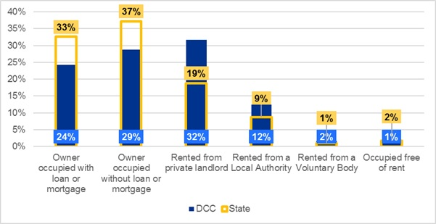
Source: CSO Census

5.5.1 Private Rental – Number of Households
Table 17 presents data from the 2011 and 2016 relating to households which rented from a private landlord differentiated by the broad housing categories. The emerging trend shows a decrease in rental of private houses with an increase of rental for Flats, Apartments and Bedsits.

Table 17: All Households Rented from Private Landlord in Dublin City Council 2011-2016
 | Detached House |  |  | Semi-Detached and Terraced House |  |  | Flat, Apartment  and Bedsit |  |  | All Households Rented from Private Landlord
 | 2011 | 2016 | 2011 |  | 2016 | 2011 |  | 2016 | 2011 |  | 2016
DCC | 2,907 | 2,273 | 20,041 |  | 18,918 | 42,553 |  | 41,017 | 66,613 |  | 62,865
Co. Dub | 8,017 | 6,751 | 43,605 |  | 41,535 | 63,120 |  | 64,844 | 116,935 |  | 114,462
(% total) | (6.9%) | (5.9%) | (37.3%) |  | (36.3%) | (54.0%) |  | (56.7%)
EMRA | 19,253 | 18,890 | 67,821 |  | 66,926 | 76,201 |  | 79,031 | 166,375 |  | 166,863
(% total) | (11.6%) | (11.3%) | (40.8%) |  | (40.1%) | (45.8%) |  | (47.4%)
State | 54,970 | 57,159 | 134,600 |  | 134,685 | 11,0519 |  | 114,085 | 305,377 |  | 309,728
(% total) | (18.0%) | (18.5%) | (44.1%) |  | (43.5%) | (36.2%) |  | (36.8%)
Source: CSO Census

5.6 House Price Trends
In this section, house prices (including. apartments) are examined based on data sourced from the CSO - Property Price Register. Property transaction prices in Dublin City Council have fluctuated significantly throughout the last ten years and it is anticipated that there will be a continuation of change throughout the plan period.
Table 18: Average Dwelling Price in Dublin City, 2013-2020
Year | Dublin City
 | % Change | Average Price
2013 | 12.3% | €283,575
2014 | 6.3% | €301,352
2015 | 6.2% | €320,085
2016 | 11.4% | €356,524
2017 | 10.5% | €394,112
2018 | 7.0% | €421,561
2019 | -2.1% | €412,828
2020 | 1.7% | €419,650
Source: KPMG FA.

5.7 Private Rental Trends
In this section, the costs of private rental in Dublin city are examined. To ensure a comprehensive capture of the rental market, analysis of the Residential Tenancies Board register and price index hosted by the CSO has been performed. The Table below sets out the average rent in Dublin City, based on the neighbourhood areas that were deemed representative of the local authority boundary along with the annual average percentage change in rent.
Table 19: Historic Average Rent in Dublin City
Year | % Change | Average Price
2013 | 3.2% | €1,019
2014 | 8.0% | €1,100
2015 | 8.3% | €1,191
2016 | 7.7% | €1,282
2017 | 7.2% | €1,375
2018 | 8.1% | €1,487
2019 | 6.3% | €1,580
2020 | 3.2% | €1,632
Source: KPMG FA.
Rental inflation in Dublin has been driven by a number of factors such as employment and wage growth, housing supply levels, continued population growth etc. It is noted that Dublin City Council is now contained in a Rent Pressure Zone to moderate the rise in rents and create a stable and sustainable rental market. Rents cannot be increased by more than 4% per annum for both new and existing tenancies in this area.

5.8 Social Housing Provision
Social housing is delivered by Local Authorities (LAs) and Approved Housing Bodies (AHBs) through a variety of mechanisms, including:
- Construction (new build and renovation/ renewal and regeneration)
- Acquisition
- Applicant Sourced Homes (ASH)
- Social Housing Leasing Initiative (SHLI)
- Rental Accommodation Scheme (RAS)
- Housing Assistance Payment (HAP)
The statutory basis for the Social Housing Leasing Initiative and RAS is provided for within the Housing (Miscellaneous Provisions) Act, 2009. The statutory provision for HAP is provided for within the Housing (Miscellaneous Provisions) Act, 2014. In accordance with Section 9 of the Housing Act 1988, housing authorities are required to undertake an assessment of housing need in their administrative area (discussed further under Section 5.9 below).
5.8.1 Dublin’s Social Housing Tenure
This section examines the breakdown of existing social housing provision in the city. Traditionally local authorities have been the largest providers of social housing in the state. Social housing is a vital part of the overall housing market and system, and is directed to those unable to provide accommodation from their own resources. Under Rebuilding Ireland, 50,000 social housing units are to be delivered by 2021. This is under the various social housing programmes, together with the expansion of the HAP scheme nationwide. As can be seen from Table 20 below, the data illustrates the increasing role of the voluntary housing sector in delivering social housing units. Since its introduction in Dublin City, the Housing Assistance Payment (HAP) has also ensured substantial demand for social housing options are being met.

Table 20: Provision of Social Housing, Dublin City Council, 2016-2020
Type | 2016 | 2017 | 2018 | 2019 | 2020
LA New Build ^{[1]} | 56 | 295 | 264 | 90 | 124
AHB New Build ^{[2]} | 99 (incl. Pt. Vs) | 214 | 282 | 302 | 114
Part V -New Build ^{[3]} | - | 56 | 104 | 119 | 81
Total New Build | 155 | 565 | 650 | 511 | 319
LA Acquisitions inc Housing Agency Acq (HAA) and Reg Acq (RA) | 147 | 217 | 265 | 424 | 240
AHB Acquisition excl. HAA | 68 | 116 | 280 | 123 | 45
CALF HAA Acquisition | - | - | - | - | 21
Acquisition Total ^{[8]} | 215 | 333 | 545 | 547 | 306
Leasing ^{[4]} | 25 | 79 | 61 | 115 | 246
RAS ^{[5]} | 31 | 60 | 1 | 62 | 113
HAP ^{[6] [7]} | 952 | 2,752 | 2,511 | 2,774 | 3,141
Source: Dept. of Housing, Local Government and Heritage, June 2021
Notes
1. LA New Build includes units delivered through Rapid, Traditional, Turnkey, PPP and Regeneration.
2. AHB New Build includes CAS and CALF New Build.
3. Part V New Build includes Part V's delivered under LA Build and AHB Build.
4. Previously Long Term Leasing Scheme.
5. RAS - New transfers is defined as the number of households which have moved from Rent Supplement to RAS in that specific year. It includes households who remained in their existing accommodation and those for whom the LA had to source new properties.
6. HAP - New Households Supported refers to the number of qualified households with an established housing need who are being accommodated under the HAP scheme for that year.
7. DRHE Delivery Output includes Homeless HAP which is administered by Dublin City Council on behalf of the 4 Dublin LA's and came to a total of 2,627 for 2020. The breakdown of this figure is DCC - 1486, DLR - 206, Fingal - 407 & SDCC - 528.
8. The LA Acquisitions total includes LA Acquisitions, CALF Acquisitions, HAA units which were delivered under the Housing Agency program and included as part of the LA and CALF Acquisitions numbers and Regen Acquisitions.

5.9 Social Housing Assessment
In accordance with Section 9 of the Housing Act 1988, housing authorities are required to undertake an assessment of housing need in their administrative area. The Summary of Social Housing Assessment (SSHA), prepared annually by the Housing Agency, brings together information provided by local authorities on households that are qualified for social housing support but whose social housing need is not currently being met. The SSHA is intended as a point-in-time assessment of the identified need for social housing support within Dublin City Council. Results of the most recent assessment were published in March 2021 and represents data collated in November 2020.
Table 21: Summary of Households Qualified for Social Housing Support in Dublin City Council (2019 -2020)
2019 |  | 2020 |  | Change 2019/2020
No. of HH | % | No. of HH | % | No. of HH | %
16,529 | 24.1 | 14,001 | 22.6 | -2,528 | -15.3
Source: https://www.gov.ie/en/publication/970ea-summary-of-social-housing-assessments-2020-key-findings/
It should be noted that the key figure reported in the SSHA is referred to as ‘net need’ which is the total number of households qualified for social housing support whose need for support is not being met. This total excludes those already in receipt of social housing support, for example: households currently living in local authority rented accommodation; voluntary/co-operative accommodation; accommodation provided under the HAP scheme; accommodation provided under the RAS; or accommodation provided under the Social Housing Current Expenditure Programme (SHCEP) schemes. It also excludes those who have a primary application with another Local Authority.
In terms of specific accommodation requirements where special needs can be identified, the Summary of Social Housing Assessment (SSHA) 2020 indicates that 300 persons identified as enduring physical, sensory, mental health or intellectual issues, 95 identified as Traveller persons and 1,061 persons indicated an age of 65 years or more.

5.9.1 Homeless Households and Individuals June 2021
Dublin City Council (DCC) in consultation with the Dublin Region Homeless Executive (DRHE) have provided an updated estimate of homeless household within the Council’s administrative area as of June 2021 to provide an up-to-date picture of homelessness in Dublin City. Data from DCC’s social housing waiting list indicates there are 1,976 homeless households, comprising 2,738 individuals. This comprises those housing applicants assessed as eligible for social housing due to homelessness, whose need is not currently met and who have their main application with DCC. The majority (82%) of the 1,976 homeless households consist of one person, with corresponding high demand for one-bedroom accommodation. This is further discussed at Section 7.0.

6.0 Interim Housing Need Demand Assessment

6.1 Introduction
Dublin City Council engaged KPMG Future Analytics to prepare an interim Housing Need Demand Assessment (HNDA) to inform the preparation of this development plan. This section briefly describes the methodology of HNDA and summarises the conclusions of the interim HNDA carried out for the plan. The full detail of the HNDA prepared is included as Annex 1 of this Strategy.
The requirement for local authorities to prepare a HNDA to support the preparation of statutory housing strategies and development plans was introduced in the National Planning Framework (NPF) in 2018. The NPF states that the role of the HNDA is to correlate and accurately align future housing requirements. The NPF intends for the HNDA to become a keystone of the plan-making system which will “inform housing policies, housing strategies and associated land-use zoning policies as well as assisting in determining where new policy areas or investment programmes are to be developed.”
Moreover, the NPF indicates that the purpose of the HNDA tool is to:
- Assist local authorities to develop long-term strategic views of housing need across all tenures.
- Provide a robust evidence base to support decisions about new housing supply, wider investment and housing related services that inform an overall national housing profile.
- Inform policies about the proportion of social and affordable housing required, including the need for different types and sizes of provision.
- Provide evidence to inform policies related to the provision of specialist housing and housing related services.
The NPF states that HNDAs are to give broad, long run estimates of potential future housing need, rather than precision estimates. This is a new way of assessing current and future housing need.

6.2 HNDA Model Overview
The DHLGH has collaborated with the Scottish Centre for Housing Market Analysis to produce an Irish version of the Scottish HNDA and its associated HNDA Tool. This was published in April 2021, together with a repository of housing-related data (see here: https://www.gov.ie/en/publication/eaa99-housing-need-and-demand-assessment-hnda/)
The HNDA Tool is an Excel-based model that uses calculative macros based on a set of stated assumptions adopted by the Department of Housing to assess a range of datasets in order to produce projections of the demographic housing demand by tenure type and to allow for a variety of scenarios to be investigated.
The HNDA Tool can project the future need for housing by tenure type. These projections are based on incomes, house prices and rents, structural demand for housing, existing need and projections for how these indicators will evolve over the coming years.
The HNDA model combines a range of data from public datasets across key housing market drivers, including data specially tabulated for the Tool. The most important of these drivers are demographic projections (published by the Economic and Social Research Institute (ESRI) in December 2020 ), household incomes, property sales prices, rental prices, and estimates of existing unmet housing need (through data on overcrowding and homelessness), as well as a number of assumptions and forecasts about the Irish housing market.
The HNDA Tool operates firstly by forecasting the number of newly formed households in a local authority in each year of the projection period (2020-2040), based on the selected projection scenario. It also forecasts future household incomes and distributions, house prices, and rental prices in the local authority. Based on the combination of forecast incomes, prices, and key assumptions about the market, the HNDA Tool assesses whether forecast new households can sustainably afford housing in the private sector (owner-occupation or private rental) or require either social or affordable housing.
The DHLGH guidance on using the HNDA Tool sets out five broad stages in setting up the HNDA model and setting these key inputs, as shown in Figure 3 below:
Figure 3: HNDA Toolkit Preparation Stages
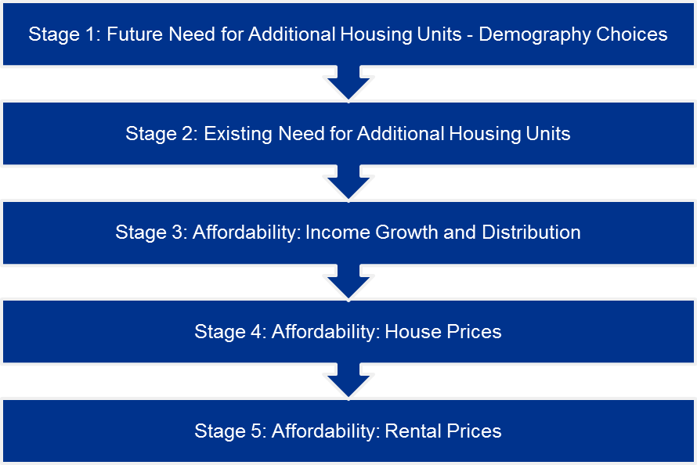
Source: KPMG FA.

6.3 HNDA Context and Findings

6.3.1 ‘Housing Supply Target Methodology for Development Planning’ Section 28 Guidelines
The immediate context for the new interim HNDA findings are the results of applying the Section 28 Guidelines methodology for calculated Housing Supply Targets for development planning. These Guidelines, issued in December 2020 ahead of the HNDA model and its Toolkit, set a methodology for the application of population and housing projections into local authority plan processes.

This sets a means of calculating the total housing demand and Housing Supply Target for the exact 6-year period of the development plan, to the nearest quarter. Accordingly, the Housing Supply Target methodology focuses on producing new housing supply targets to meet need and demand in a strict 6-year period, aligning to the lifetime of a single development plan.

KPMG Future Analytics have calculated a total Housing Supply Target of 40,138 households for the Dublin City Development Plan 2022-2028 (Table 22). This is the target that the development plan and its Core Strategy is required to follow. The methodology for this calculation is provided as Annex 2 of this strategy.

Table 22: Projected Housing Demand for Dublin City Area 2020 – 2031 ESRI NPF Scenario Housing Supply Target of S28 Housing Supply Target Methodology for Development Planning, December 2020
 |  | Total Households | Number of Relevant Years | Annual Average
A | ESRI NPF scenario projected new household demand 2017 to end Q4 2028350 | 47,941 | 12 | 3,995
 | ESRI Baseline scenario projected new household demand 2017 to end Q4 2028 | 47,534 | - | -
B | Actual new housing supply 2017 to end Q4 2022 (actual to Q4 2020 and estimated 2021 and 2022 Q1 – Q4;no COVID impact) | 11,708 | 6 | 1,951
C | Homeless households (latest Data), and unmet demand as at most recent Census – DCC Approved Values – 23 06 2021 | 3,905 | - | -
D | Plan Housing Demand = Total (A-B+C), (Projected ESRI NPF demand – new completions) = Unmet demand | 40,138  (Rounded to 40,000 for Core Strategy) | 6 | 6,690
Source: KPMG FA

6.3.2 HNDA Toolkit Methodology
The HNDA Tool includes forecasts over the whole period 2020-2040 to align with the long-term approach of the NPF, with a particular focus on the period to 2031 which is identified as a key milestone in the NPF. As it adopts a considerably longer timeframe for the calculation of overall housing need and effective housing demand, the HNDA Tool produces a significantly different estimate of overall housing need and demand for this plan period than that provided in Annex 2 using the Section 28 Housing Supply Target Methodology.

It should also be noted that according to the DHLGH, the HNDA Tool is intended to “give broad, long-run estimates of what future housing need might be, rather than precision estimates.” It offers ‘policy-off’ forecasts with its outputs subject to the inputs, scenarios, and assumptions built into the model and set out in this report. The HNDA as a result identifies potential issues and pressures in the housing market.
This allows Dublin City Council to formulate housing and planning policy to meet current and future housing need in Dublin City.

6.3.3 HNDA Forecasts
The interim HNDA for the Dublin City Development Plan 2022-2028, forecasts that housing need in the Dublin City administrative area will comprise 27,219 households over the plan period. This includes:
- 10,247 social rented households (of which 2,343 comprises existing need that is estimated to be met within the plan period, made up of 1,157 estimated overcrowded households based on Census 2016 and 1,186 of the homeless households on the DCC social housing waiting list as of June 2021);
- 4,997 households in the owner-occupied sector;
- 4,088 in the private rented sector; and,
- 7,887 ‘affordability constrained’ households who are ineligible for social housing but face affordability challenges in the private market.
The HNDA estimates a housing need for nearly 5,000 households during the Plan period in the owner-occupier sector. It is anticipated that apartment development will be the predominant housing type in this sector over the Plan period having regard to observed intercensal trends and to the policy framework set out at a national and regional level to promote compact growth and sustainable settlement patterns throughout the city.
The breakdown of this housing need is shown in Table 23 below. It is important to note here that the social and ‘affordability constrained’ components of the projected extent of ‘housing need’ during the plan period relates only to the additional anticipated households during that time and, thus, is in addition to the current extent of unmet need as per the existing social housing waiting list.
These findings confirm a higher need for social and affordable housing provision over the plan period. This is driven by several factors; it in part reflects high existing property prices and rents in Dublin City, as measured by 2019 baseline data. Although household incomes in Dublin city are relatively high by national standards, high housing costs result in relatively high numbers of households facing affordability challenges. As forecast rents in this interim HNDA are estimated to grow at a slightly faster pace than incomes, and as household incomes in lower deciles rise above the eligibility limits for social housing, consequentially the ‘affordability constraint sector’ is forecast to grow over the plan period.

Table 23: HNDA Estimated Housing Need by Tenure, 2023-2028
Tenure | 2023 | 2024 | 2025 | 2026 | 2027 | 2028 | Total
Social Rent | 2,024 | 1,816 | 1,661 | 1,612 | 1,564 | 1,570 | 10,247
Affordability Constraint | 1,306 | 1,296 | 1,231 | 1,301 | 1,330 | 1,423 | 7,887
Private Rented | 777 | 719 | 661 | 639 | 633 | 659 | 4,088
Buyers | 950 | 879 | 808 | 780 | 775 | 805 | 4,997
Total Housing Need | 5,057 | 4,710 | 4,361 | 4,332 | 4,303 | 4,457 | 27,219
Source: KPMG FA.

6.4 Supplementary Sub-City HNDA Analysis
Dublin City forms a unique and varied housing market area with strong existing and forecast future demand for housing. As part of the preparatory research for the development plan and alongside the preparation of the HNDA for the City, Dublin City Council additionally directed KPMG Future Analytics to prepare a further HNDA assessment of two smaller sub-city areas of the North Inner City and the Liberties in order to provide an additional insight into the operation of the housing market and related housing need in these areas (Figure 4). These areas were selected due to three main factors that differentiates them from the wider city in terms of residential developmental pressure-
- These areas have higher volumes of smaller housing stock (both historic and twentieth century);
- They have significant regeneration opportunity lands; and,
- They have in recent years experienced a high proportion of Strategic Housing Development applications, which have been dominated by BTR and a preponderance of smaller units.
Figure 4: Dublin City HNDA Sub-Areas
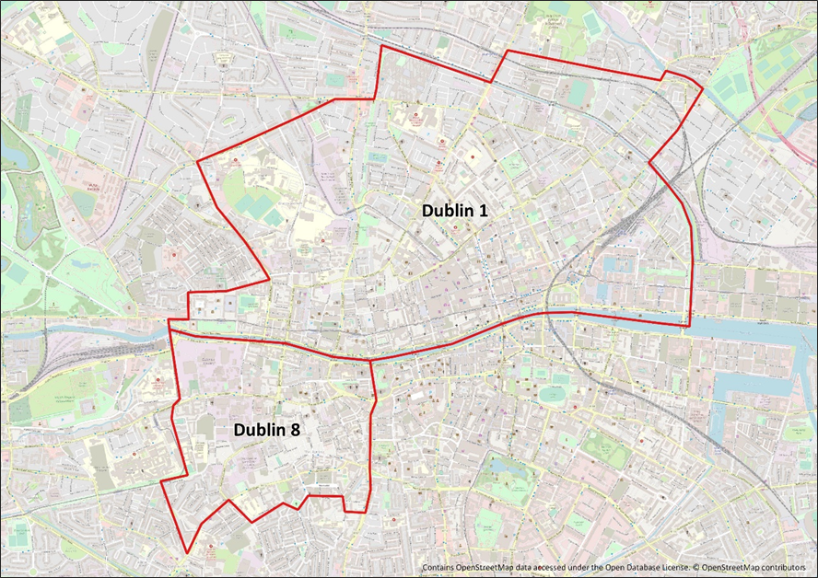
North Inner City
Liberties
Source KPMG FA/DCC.
In the absence of the current HNDA Toolkit allowing for modelling below local authority level, KPMG Future Analytics have developed a robust methodology and bespoke HNDA model to inform decision-making around the current and future housing supply these areas in accordance with the NPF and all other relevant statutory requirements. This approach is based on a combination of elements of the established ‘Louth Model’ affordability assessment along with additional considerations including private rental market affordability, mortgage capacity and Central Bank macro-prudential rules, and forecasts for household composition, dwelling type, and tenure. This modelling focuses the two inner-city areas with Dublin City as a whole also examined for comparison purposes.
This work is intended to build on the analysis of the main Dublin City HNDA (through the Toolkit model) and further inform the development plan at a more granular level, as well as provide useful context for and comparison with the HNDA Toolkit outputs. This analysis captures the complex housing market dynamics and specific housing needs of the Liberties and the North Inner City and in turn informs the development of housing policy and policies for these SDRAs in the development plan.

6.4.1 Custom Sub-City/City HNDA Methodology
The table below briefly describes the custom methodology used to examine these areas. A commentary on the conclusions of the analysis carried out is then provided. The full detail of the analysis prepared is given as Annex 3 of this Strategy.
Table 24: Custom Sub-City/City HNDA Methodology Components
Step | Objective | Method
1 | Determination of Housing Supply Targets and Household Demand | Determination of plan period housing supply targets (HSTs)/expected sub-area households and resulting annual housing demand based on Section 28 Guidelines.
2 | Calculation of Estimated Distribution of Household Disposable Incomes | Calculation of estimated distribution of household disposable incomes for the established deciles (by the CSO) based on weekly and annualised disposable incomes at national level and adjusted for the city based on application of an “inflator” or “deflator” rate.
3 | Calculation of Average Annual Household Disposable Income Distribution | Calculation of estimated distribution of annual disposable household incomes per decile during the plan period based on the preceding step and application of a forecast GDP growth rate.
4 | Calculation of Average Monthly Household Disposable Income Distribution | Calculation of estimated distribution of monthly disposable household incomes per decile during the plan period based on the preceding step and application of a forecast GDP growth rate.
5 | Determination of Distribution of Total Anticipated Households | Calculation of the estimated distribution of household units for each decile throughout the plan period as well as the distribution of housing units in the State from the Household Budget Survey (by the CSO).
6 | Determination of Distribution of Additional Anticipated Households | Calculation of the estimated distribution of additional anticipated households annually during the plan period as well as the distribution of housing units in the State from the Household Budget Survey (by the CSO).
7 | Calculation of Projected House Price Bands | Calculation of projected house price bands based on the percentage split of the established (by the DHLGH) eight price bands and a projected annual price increase or decrease.
8 | Calculation of Mortgage Capacity of Households | Calculation of the approximate affordable house price per decile per year based on the application of the “Annuity Formula”. This is based on the determination of an “Affordability Threshold”, a “Loan to Value Ratio”, an “Annual Percentage Rate (APR) - Interest Rate”, a “Monthly Percentage Rate (MPR) - Interest Rate”, and the determination of a “Loan Term (Years/Months)”.
9 | Calculation of Projected Needs for Ownership | Based on the application of the “Annuity Formula”, calculate the housing affordability for each of the 10 household deciles.
10 | Calculation of Projected Needs for Private Rental | Calculation of the households that will not meet the affordability criteria to privately rent a home during the plan period with respect to the number of households that cannot qualify for a mortgage.
11 | Calculation of Projected Social (and Affordable) Housing Need | Based on the determination of additional households required, the projected house price bands and the housing affordability, calculate the number of households not meeting the “Affordability Criteria”. This informs the necessary provision of social (and affordable) housing units within the local authority.
12 | Historic Data Analysis and Approximate Projection of Tenure, Size Cohort, and Dwelling Type. | Calculation of historic intercensal change for private household tenure, cohort sizes and dwelling type to determine annualised change. This informs the basis of an annual rate of change for which additional anticipated households can be roughly forecasted for household tenure, cohort sizes and dwelling type.
Source: KPMG FA.

6.4.2 Summary of Projected Housing Need and Demand
As, previously noted, Section 28 Guidelines provided by the DHLGH set a methodology for the application of recommended population and housing projections into Local Authority plan processes. Through this calculation, housing demand over the six-year plan period is determined to be 39,906 households or 6,651 households per annum for DCC.
The summary of the social (and affordable) housing requirements for Dublin City and the sub-areas over the plan period 2023 – 2028 is set out in the Tables below, based on the application of the ‘custom’ HNDA modelling described above in Table 24.
The outputs of the custom model for Dublin City Council as a whole are presented for comparison and to inform the context of the sub-area analysis. It should be noted that the findings presented here do not supersede the city-wide analysis undertaken through the HNDA Toolkit.

DCC
Throughout the plan period, 41.3% of 39,906 households identified using custom HNDA modelling are estimated to not qualify for a mortgage and not be able to afford rent. This equates to 16,484 households over the plan period.

North Inner City
In this sub area throughout the plan period, 61.5% of the 1,500 households allocated to the area are estimated to not qualify for a mortgage and not be able to afford market rent. This equates to 923 households over the plan period.

Liberties
In this sub area throughout the plan period, 61.5% of the 2,000 households allocated to the area are estimated to not qualify for a mortgage and not be able to afford market rent. This equates to 1,230 households over the plan period.
Table 25: Overview of Social and Affordable Housing Requirements in DCC
DCC | 2023 | 2024 | 2025 | 2026 | 2027 | 2028
No. Households | 6,651 | 6,651 | 6,651 | 6,651 | 6,651 | 6,651
Households That Do Not Qualify for a Mortgage | 2,747 | 2,747 | 2,747 | 2,747 | 2,747 | 2,747
Households That Do Not Qualify for a Mortgage & Cannot Rent | 2,747 | 2,747 | 2,747 | 2,747 | 2,747 | 2,747
Housing Shortfall (%) | 41.3% | 41.3% | 41.3% | 41.3% | 41.3% | 41.3%

Table 26: Overview of Social and Affordable Housing Requirements in NIC
North Inner City | 2023 | 2024 | 2025 | 2026 | 2027 | 2028
No. Households | 250 | 250 | 250 | 250 | 250 | 250
Households That Do Not Qualify for a Mortgage | 154 | 154 | 154 | 154 | 154 | 154
Households That Do Not Qualify for a Mortgage & Cannot Rent | 154 | 154 | 154 | 154 | 154 | 154
Housing Shortfall (%) | 61.5% | 61.5% | 61.5% | 61.5% | 61.5% | 61.5%

Table 27: Overview of Social and Affordable Housing Requirements in Liberties
Liberties | 2023 | 2024 | 2025 | 2026 | 2027 | 2028
No. Households | 333 | 333 | 333 | 333 | 333 | 333
Households That Do Not Qualify for a Mortgage | 205 | 205 | 205 | 205 | 205 | 205
Households That Do Not Qualify for a Mortgage & Cannot Rent | 205 | 205 | 205 | 205 | 205 | 205
Housing Shortfall (%) | 61.5% | 61.5% | 61.5% | 61.5% | 61.5% | 61.5%
Source: KPMG FA.

6.4.3 Household Composition, Dwelling Type and Tenure
In addition to the custom HNDA, analysis of historic intercensal trends for household composition (size), tenure and dwelling type has been conducted to enable estimation of future households under each component. This element is outlined in steps 13 through 15 in the custom HNDA methodology (Table 24) and the results of the analysis are presented below.

6.4.3.1 Household Composition
Analysis of historic Census data (2002-2016 for DCC and 2006-2016 for sub areas) in relation to the composition of households has been undertaken to understand the dynamics of change over time and estimate how they may change into the future. The intercensal average has been used to determine a trended annual average change in household composition as set out in Table 28 below. The composition forecast for all areas is illustrated in the Figures below.

Table 28: Forecasted Annual Change in Household Size Cohorts
Annual Change | 1 person household | 2 person household | 3 person household | 4 person household | 5+ person household
Dublin City | -0.05% | 0.23% | 0.03% | -0.03% | -0.19%
NIC | -0.10% | 0.20% | -0.03% | -0.05% | -0.01%
Liberties | -0.30% | 0.33% | 0.06% | -0.03% | -0.06%
Source: KPMG FA.

DCC
Based on the identified intercensal changes DCC sees a reduction in one and four person households at a relatively slow rate and five plus person households at a much higher rate. Two and three person households are on an upward trend with two person households increasing at the highest rate (0.23 percent per annum).

North Inner City
Based on the identified intercensal changes NIC sees a reduction in all household composition save for two person households, which are on an upward trajectory of 0.20% per annum.

Liberties
Based on the identified intercensal changes Liberties sees a reduction in four and five person households at a relatively slow rate and one person households at a much higher rate. Two and three person households are on an upward trend with two person households increasing at the highest rate (0.33% per annum).
Figure 5: Forecast Household Composition over the Plan Period - DCC
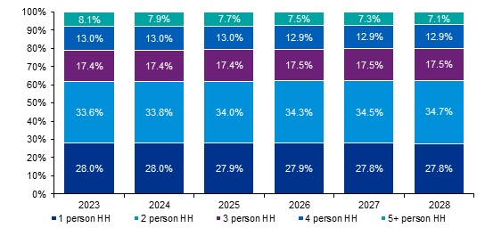
Figure 6: Forecast Household Composition over the Plan Period - NIC
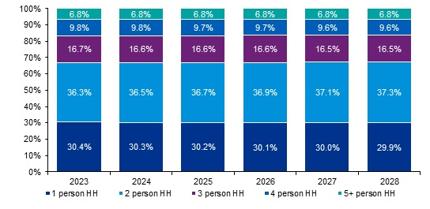
Figure 7: Forecast Household Composition over the Plan Period - Liberties
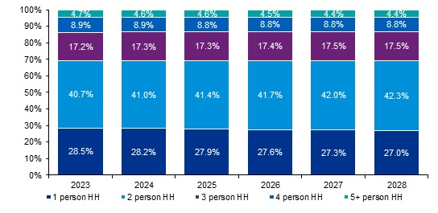
Source: KPMG FA.
In order to gain a further understanding of household size and composition and how it may relate to the dwelling stock, Census data has been examined on the number of rooms per household in 2016. Table 29 below indicates that households are fairly evenly distributed across the total room categories over Dublin City as a whole with a slight multiplicity of 5-room dwellings (18.6%). However, dwellings tend to have less rooms in the Sub-Areas, with 12.9% of households recording only one room in NIC.

Table 29: Rooms per Household (%), 2016
Number of rooms | DCC | NIC | Liberties
1 room | 5.4% | 12.9% | 6.5%
2 rooms | 12.3% | 25.3% | 26.8%
3 rooms | 14.9% | 19.5% | 28.2%
4 rooms | 15.0% | 14.2% | 19.0%
5 rooms | 18.6% | 8.0% | 6.7%
6 rooms | 13.7% | 4.0% | 2.2%
7 rooms | 6.5% | 1.3% | 0.3%
8 or more rooms | 5.4% | 0.7% | 0.2%
Not stated | 8.3% | 14.0% | 10.2%
Total | 100.0% | 100.0% | 100.0%
Source: KPMG FA.

6.4.3.2 Household Dwelling Type
Analysis of historic intercensal data on private household dwelling type has been undertaken to understand unit-mix dynamics and estimate how they may change over time. Specifically, the intercensal average has been used to determine a trended annual average change in dwelling type mix. The annual average change in dwelling type for Dublin City and sub areas is set out in Table 30 below.
Table 30: Forecast Change in Dwelling Type for Households
Annual Change | House/Bungalow | Flat/Apartment | Caravan/Mobile Home
Dublin City | -0.49% | 0.50% | -0.01%
NIC | -0.30% | 0.33% | -0.03%
Liberties | -0.43% | 0.44% | -0.01%
Source: KPMG FA.

DCC
Based on the identified intercensal changes DCC overall sees an increase in apartment type dwellings and an almost equal reduction in house type dwellings. By the end of the plan period this trend would see just over 40% of all dwellings in DCC being apartments.

North Inner City
Based on the identified intercensal changes and the current dwelling type distributions, new dwelling type in the NIC is estimated to predominantly be apartments by the end of the plan period.

Liberties
Based on the identified intercensal changes and the current dwelling type distributions, new dwelling type in the Liberties is estimated to predominantly be apartments by the end of the plan period.
The Figures 8, 9 and 10 below illustrate the forecast distribution by dwelling type for the plan period. It should be noted that these are an approximate continuation of observed trends as influenced by the market dynamics and it is noted that external market factors can influence the future dynamics in relation to unit mix and dwelling type throughout the plan period. The figures presented are based on a continuation of recent historic trends assigned to the additional anticipated households
Figure 8: Forecast Dwelling Type Distribution 2023-2028 – DCC
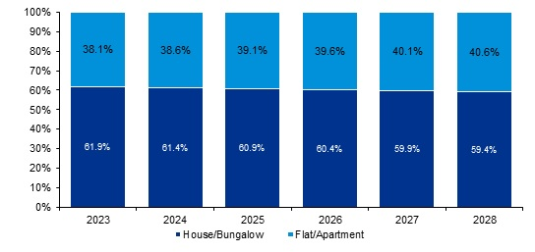
Source: KPMG FA.
Figure 9: Forecast Dwelling Type Distribution 2023-2028 - NIC
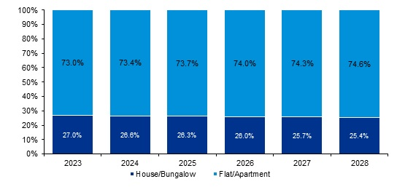
Source: KPMG FA.
Figure 10: Forecast Dwelling Type Distribution 2023-2028 - Liberties
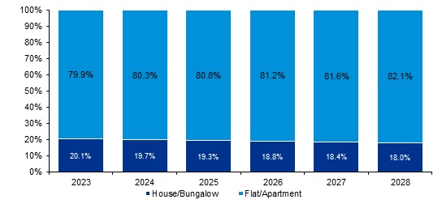
Source: KPMG FA.

6.4.3.3 Household Tenure
Analysis of historic Census data (2002-2016 for DCC and 2006-2016 for sub areas) in relation to the tenure of households has been undertaken to understand these dynamics and estimate how they may change over time. The intercensal average has been used to determine a trended annual average change in household tenure in DCC. It should be noted that this does not supersede the tenure analysis undertaken through the HNDA Toolkit and presents only a continuation of historic trends, primarily to ascertain these trends at local level. Household tenure has been grouped into owner-occupied (comprised of those with and without mortgages), private rental sector and social housing (rented from a local authority or voluntary organisation).
Table 31: Forecast Change in Tenure Composition of Households
Annual Change | Social Housing | Private Rental | Owner occupied
Dublin City | 0.18% | 0.64% | -0.82%
NIC | -1.12% | 1.62% | -0.50%
Liberties | -1.09% | 1.58% | -0.49%
Source: KPMG FA.
The impacts of the GFC are very much still represented in these estimates. This is due to the fundamental shift in tenure patterns that occurred arising from changes in post-2008 labour markets combined with economic and property market declines. The sheer number of households that transitioned from owner-occupancy into private rental tenure between 2006 and 2011 thus affects the long-term change. Table 32 below highlights the notable changes that took place between the 2006-2011 period as a direct result of the financial crisis.
Table 32: Intercensal Change in Tenure
 | Dublin City |  | NIC |  | Liberties
 | 2006-2011 | 2011-2016 | 2006-2011 | 2011-2016 | 2006-2011 | 2011-2016
Social Housing | -4.5% | 1.0% | -14.2% | 3.0% | -12.8% | 2.0%
Rented (Privately) | 12.7% | -1.1% | 19.6% | -3.4% | 17.5% | -1.8%
Owner Occupied (All) | -8.2% | 0.1% | -5.4% | 0.4% | -4.7% | -0.2%
Source: KPMG FA.

6.5 Specific Planning Policy Requirements (SPPRs)
In 2020, the DHPLG issued its Sustainable Urban Housing, Design Standards for New Apartments: Guidelines for Planning Authorities. These Guidelines, which set out standards for apartment development, are an update of previous 2015 guidelines and include a number of new Specific Planning Policy Requirements (SPPRs) which must be applied by planning authorities and An Bord Pleanála in carrying out their functions.
SPPR1 provides that apartment developments may include up to 50% one-bedroom or studio type units (with no more than 20-25% of the total proposed development as studios) and there shall be no minimum requirement for apartments with three or more bedrooms. Statutory development plans may specify a mix for apartment and other housing developments, but only further to an evidence based Housing Need and Demand Assessment (HNDA) that has been agreed on an area, county, city or metropolitan area basis and incorporated into the relevant development plan.
SPPR 9 of the Guidelines introduces a presumption against granting planning permission for shared accommodation/co-living developments unless the development is “required to meet specific demand identified” by a HNDA process.
To respond to SPPR1 and SPPR 9, and in the absence of any specific Departmental guidance, historic trends on dwelling type and household size from previous Census for Dublin City were projected to analyse potential changes in household and dwelling compositions. This makes use of historic intercensal trends to apply a projection to Census 2016 household composition and dwelling type rates. This is more fully described in Annex 1 and 3.
There are limitations that must be noted for this approach. It represents a continuation of historic trends that may not reflect subsequent policy choices and market dynamics. Furthermore, previous Census did not measure bedrooms per household (as distinct from other rooms). As such, there is no comprehensive profile of the number of bedrooms per dwelling in Dublin City to project forward or to otherwise more accurately address SPPR 1. Data on household composition (persons per household) has been used as a proxy and this allows a qualitative assessment of potential household sizes that future stock will need to address.
Finally, it should be noted that the Guidelines and SPPR 9 do not specifically define the type of demand for co-living that the HNDA may identify. The previous 2018 ‘Design Standards for New Apartments’ Guidelines (updated in 2020) refer to demand for co-living primarily in terms of accommodation needs in particular employment sectors and locations rather than demographic need. As a highly site- and sector-specific assessment is beyond the scope of this HNDA, one-person households and private rented sector need are used as the main indicators of demand for this type of accommodation.

SPPR1 Evidential Response
The provision of a mix of quality dwellings of different size, type and mix, that is suitable for citizens throughout their lives and adaptable to people’s changing circumstances (e.g. aging, disability, a growing family) is fundamental to creating a properly functioning city with sustainable neighbourhoods. It is critical that any new residential development provided over the plan period provides choice for people throughout the lifecycle. This is key to the creation of future stable communities and is of benefit to us all at a societal level.
Evidential analysis of carried out below as part of this housing strategy and interim HNDA using historical trends indicates a forecast gradual decline in the proportion of one-person, four-person, and five plus person households and an increase in the proportion of two-person and three-person households.
Table 33 shows household size composition for DCC for each Census between 2002 and 2016.
Compared to the State as a whole in 2016, Dublin City had a higher proportion of one-person households (28.3% compared to 23.5% nationally) and two-person households (32% compared to 28.6% nationally), and a lower proportion of four-person households (13.2% compared to 16.9% nationally) and five+ person households (9.4% compared to 13.5% nationally).

Table 33: Historic Household Composition in Dublin City, 2002-2016
Pers Per House-hold | 2002 | 2006 | 2011 | 2016 | 2002 | 2006 | 2011 | 2016
1 person | 52,517 | 55,957 | 63,795 | 60,001 | 29.0% | 29.3% | 30.7% | 28.3%
2 persons | 51,644 | 58,295 | 66,684 | 67,707 | 28.6% | 30.5% | 32.1% | 32.0%
3 persons | 30,086 | 32,144 | 34,557 | 36,277 | 16.6% | 16.8% | 16.6% | 17.1%
4 persons | 24,607 | 24,956 | 24,979 | 27,943 | 13.6% | 13.1% | 12.0% | 13.2%
5+ | 21,998 | 19,501 | 17,993 | 19,819 | 12.2% | 10.2% | 8.7% | 9.4%
Total | 180,852 | 190,853 | 208,008 | 211,747
Source: KPMG FA.
Table 34 below indicates the percentage change for each household size cohort in Dublin City between each of the four Census periods. The intercensal average for this period has been used to determine a trended annual average change in household composition as set out in Table 34 and Table 35 below. This trend is then applied forward from 2016 to 2028 to provide a forecast for the plan period, as presented in Figure 11.
Table 34: Historic Household Composition Change in Dublin City, 2002-2016
 | Change % |  |  | Average Change %
Persons Per Household | 2002-2006 | 2006-2011 | 2011-2016 | Intercensal Avg. | Annual Avg.
1 person | 0.3% | 1.4% | -2.3% | -0.2% | -0.05%
2 persons | 2.0% | 1.5% | -0.1% | 1.1% | 0.23%
3 persons | 0.2% | -0.2% | 0.5% | 0.2% | 0.03%
4 persons | -0.5% | -1.1% | 1.2% | -0.1% | -0.03%
5+ persons | -1.9% | -1.6% | 0.7% | -0.9% | -0.19%
Source: KPMG FA.

Table 35: Forecasted Annual Change in Household Size Cohorts in DCC
Annual Change | 1 person household | 2 person household | 3 person household | 4 person household | 5+ person household
Dublin City | -0.05% | 0.23% | 0.03% | -0.03% | -0.19%
Source: KPMG FA.
Based on the identified intercensal changes, DCC will sees a reduction in one- and four- person households at a relatively slow rate and five+ person households at a much higher rate. Two- and three- person households are on an upward trend with two- person households increasing at the highest rate (0.23% per annum). The composition forecast for DCC is illustrated in Figure 11 below.
Figure 11: Forecast Household Composition in Plan Period (2023 to 2028)
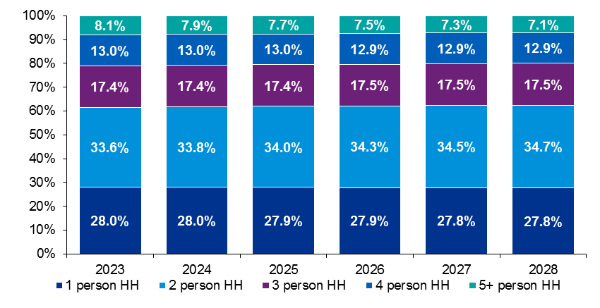
Source: KPMG FA.
To gain a further understanding of household size and composition and how it may relate to the dwelling stock, Census data has been examined on the number of rooms per household in 2016. Table 36 and Figure 12 below indicate that households in Dublin City tended to have access to less rooms than the national average, with an average of 4.3 rooms per household in Dublin City compared to 5.4 for the State overall.

Table 36: Households by Number of Rooms in Dublin City, 2016
Number of rooms | DCC | DCC
1 room | 11,337 | 5.4%
2 rooms | 26,105 | 12.3%
3 rooms | 31,446 | 14.9%
4 rooms | 31,796 | 15.0%
5 rooms | 39,358 | 18.6%
6 rooms | 28,889 | 13.7%
7 rooms | 13,698 | 6.5%
8 or more rooms | 11,370 | 5.4%
Not stated | 17,592 | 8.3%
Total | 211,591 | 100.0%
Source: KPMG FA.
Figure 12: Households by Number of Rooms in Dublin City, 2016
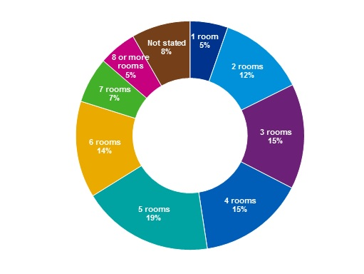
Source: KPMG FA.
Census 2022 will provide more detail on recent housing trends but overall the picture coming forward is of a city that is both growing and attracting new households comprising a variety of household types.
The outcome of the two local HNDAs indicates increased demand for two and three person households and declining demand regarding single person households. (Section 2.4.1 of Appendix 01.03 refers.). Taking into account;
- the modelled changing demand over the lifetime of the plan which indicates a declining demand for one bed units, and
- the current pattern of applications for development that have high proportions of studio and one bed units and no three bed units;
It is considered appropriate that a policy response is made to address this issue within these locations. This is required to ensure the provision of a mix of dwelling types and sizes so as to best cater for the expected future household needs in these areas, so that as household needs change, the need of citizens, in all stage of lifecycle and family circumstance can be met within or adjoining their existing neighbourhoods.

6.5.1 Sub-City Residential Mix Requirements
Based on the analysis in the interim HNDA and custom HNDA it is recommended that the development plan will require planning applications for residential schemes in the North Inner City and Liberties Sub-City areas to include a residential mix as per Table 37. SPPR1 is applicable to the remainder of the Dublin City Council administrative area.

Table 37: Mix of Residential Units, Minimum and Maximum Requirements
Sub-City Residential Mix
Geographic Area:  (Figure 4) | - NIC Sub-City Area.  - Liberties Sub-City Area.
Thresholds: | - Applies to proposals of 15 units for more.
Each multi-unit residential development shall contain: | - A minimum of 15% three or more bedroom units.  - A maximum of 25%-30% one bedroom/studio units.
Exemptions: | - Council Part 8 or Part 10 residential schemes may propose a different mix having regard to the specific needs of the Housing & Community Services Department.  - Standards may be relaxed for other social housing needs and/or where there is a verified need for a particular form of housing, e.g. for older people, subject to the adjudication of the Housing & Community Services Department.  - In accordance with Specific Planning Policy Requirement 2, all building refurbishment schemes on sites of any size, or urban infill schemes on sites of up to 0.25ha, where up to 9 residential units are proposed, notwithstanding SPPR 1, there shall be no restriction on dwelling mix, provided no more than 50% of the development (i.e. up to 4 units) comprises studio-type units. For clarity, in accordance with SPPR 8, the unit mix requirement does not apply to units that are designed to a BTR standard.  - It is noted in the guidelines that all standards set out shall generally apply to building refurbishment schemes on sites of any size, or urban infill schemes, but there shall also be scope for planning authorities to exercise discretion on a case-by-case basis, having regard to the overall quality of a proposed development.
Notes:
- SPPR1 is applicable to the remainder of the Dublin City Council administrative area.
- Subject to variation, the mix may be altered and/or a further residential mix requirement may be applied to other areas of the city where an evidential need has been identified by Dublin City Council.

SPPR 9 Evidential Response
The interim HNDA indicates a relatively strong need in the ‘Affordability Constraint’ tenure category (Table 38) compared to the private rented sector, indicating that proportion of households who would be both reliant on and able to sustainably afford the private rental sector is relatively low.
Table 38: Estimated Housing Need by Tenure, 2023-2028 (%)
Tenure | 2023 | 2024 | 2025 | 2026 | 2027 | 2028 | 2023-2028
Social Rent | 40.0% | 38.6% | 38.1% | 37.2% | 36.3% | 35.2% | 37.6%
Affordability Constraint | 25.8% | 27.5% | 28.2% | 30.0% | 30.9% | 31.9% | 29.0%
Private Rented | 15.4% | 15.3% | 15.2% | 14.7% | 14.7% | 14.8% | 15.0%
Buyers | 18.8% | 18.7% | 18.5% | 18.0% | 18.0% | 18.1% | 18.4%
Source: KPMG FA.
Over the period of the plan, Forecast Household Composition (Figure 13), indicates a continuing decline in the proportion of one-person households, which may be considered the principle target household type for co-living. It would be, therefore, appropriate for the Dublin City Development Plan 2022-2028 to plan for a dwelling mix appropriate to future household need and wider policy goals of securing a broad mix of housing types and sizes.
Figure 13: Forecast Household Composition in Plan Period
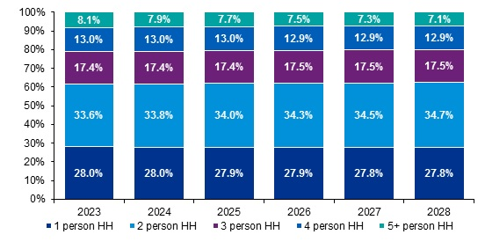
Source: KPMG FA.

The Minister’s foreword to the December 2020 Guidelines, ‘Sustainable Urban Housing: Design Standards for New Apartments’ indicates that “given the scale, location and potential impact of co-living development permitted to date… there are sufficient shared accommodation/co-living units either permitted or subject to consideration within the planning system” to demonstrate the concept and support the presumption against the granting of planning permission for co-living development.
Accordingly, the results of the HNDA analysis do not indicate a strong or specific demand for shared accommodation/co-living in Dublin City. It is considered appropriate, therefore, for the Dublin City Development Plan 2022-2028 to provide a policy presumption against shared accommodation/ co-living type developments. This policy recommendation seeks to avoid mono tenure and mono type schemes and ensure provision of sustainable, liveable, mixed neighbourhoods in line with policies set out in Chapter 5, Quality Housing and Sustainable Neighbourhoods.

7.0 Meeting Social & Affordable Housing Demand

7.1 Estimate of Social, Affordable Purchase and Cost Rental Housing Required.
The Affordable Housing Act 2021 requires housing strategies to include an estimate of the amount of Social, Affordable Purchase and Cost Rental Housing which is required in the local authority area during the period of the development plan.
The HNDA Tool (as described in Section 6.0) has been used to development estimates of housing requirements and affordability over the period of this development plan. Based on the combination of forecast incomes, prices, and key assumptions about the market, the Tool assesses whether forecast new households can sustainably afford housing in the private sector (owner-occupation or private rental) or require either social or affordable housing.
Definitions of housing affordability are manifold across and within different housing tenures and measurements of affordability are often taken from the qualifying criteria required for access to market provided housing and as applied for eligibility state supported housing options, including affordable purchase, cost and social rental.
For example, for access to owner occupation Central Bank of Ireland macro-prudential rules apply to borrowing limits and set fixed multiples of household income that can be borrowed. In addition, mortgage providers lending criteria stress test first time borrower’s capacity to withstand shocks to their ability to avoid missed payments and default due to income loss and changed interest rates. Debt based ratios such as mortgage repayment rate to income (MRTI) are commonly deployed to adjudicate on mortgage stress and overall house price ‘affordability’, particularly to low and intermediate income households. Elsewhere, and particularly for social rental tenure, residual income measures that consider the impact housing costs make on overall income are more commonly deployed and used.
The HNDA Tool carries out an assessment for owner-occupation first (assessed against the 25th percentile property price identified for the local authority) followed by an assessment for private rental (against median rental cost for a 2 bed unit) for those households who cannot afford to buy plus an assumed proportion of those who could afford to purchase but do not do so.
Households with less than the maximum household income eligibility for social housing (€35,000 a year in Dublin City) are assigned to social housing. Households above this threshold who cannot afford to purchase or rent privately are assigned to the ‘affordability constraint’ category. KPMG Future Analytics have developed a number of custom scenarios for use in the Dublin City HNDA to better reflect a Dublin City Context.
The output of the HNDA modelling carried out for Dublin City using the HNDA Toolkit (Section 3 of Annex 1) is given in Table 39 below. It shows that over the six year plan period, there is an estimated need for 10,247 social homes in Dublin City (2,343 comprise existing unmet need). The estimated demand for affordable purchase and cost rental homes is 7,887.
Table 39: Estimated Social, Affordable Purchase & Cost Rental Housing Need over Plan Period
Tenure | Total
Social Rental Housing | 10,247
Affordable Purchase & Cost Rental Housing | 7,887
Source: KPMG FA.
For clarity, Dublin City Council will require the maximum allowable provision under the Planning Act (as amended) for social, affordable purchase & cost rental housing need as part of future planning permissions, reflecting the high levels of demand within the city, i.e. this means that Dublin City Council will require that 20% of land zoned for residential use, or for a mixture of residential and other uses for development of four or more units or development of units on land more than 0.1 hectares be reserved for the provision of, social, affordable purchase and cost rental housing in accordance with Part V of the Planning and Development Act, as amended by the Affordable Housing Act 2021.

7.2 Meeting Social Housing Needs
The statutory context for the provision of social and affordable housing has changed under the Affordable Housing Act 2021 and while the provision of social housing via the established Part V mechanism will continue to play a role in the delivery of social housing in Dublin City Council, other delivery channels for social housing are likely to be more significant in terms of their potential to contribute to the social housing targets set out in this Strategy.
For Part V developments, a minimum 10% social housing requirement will be applied in relation to all sites that are residentially zoned or proposals where a mixed-use development, including residential is proposed on any zoning in Dublin City Council, unless otherwise stated in the strategy, or exempt from the provisions of Part V. Dublin City Council may increase this provision or require an additional discount on construction costs if there is no requirement for affordable housing in accordance with Part V of the Planning and Development Act as amended by the Affordable Housing Act 2021.
The Affordable Housing Act 2021 provides for a requirement that any new planning permission granted for housing subject to the Act will have a 20% Part V requirement on that land where;
- At least half of the land or equivalent net monetary value obtained under Part V must be used for social housing support.
- The remainder can be used for affordable purchase housing, cost rental housing or both.
- If there is no requirement for affordable housing, the remainder can be used as an additional discount on construction costs, or for more social housing.
The Planning Authority will review the Part V of the requirements contained in this plan if the legislation underpinning this requirement is amended.
Dublin City Council will continue to meet identified social housing provision requirements via a combination of existing delivery schemes. Social housing support is administered by the Housing and Community Services Department and there are mechanisms in the social housing system to meet assessed social housing need and broader demand for affordable purchase and cost rental housing from qualifying households. The range of social rental housing options is as summarised below:
- A social rented tenancy in a property owned and managed by the local authority.
- A tenancy in a property the local authority is renting or has leased from a private owner.
- A social rented tenancy in property owned and managed by an approved housing body (AHB).
- A social rented tenancy in property owned by a private individual or body (Housing Assistance Payment).
- Accommodation provided specifically for Travellers and for people with specific housing needs such as older persons, people with disabilities and homeless households.
- A tenancy where the local authority arranges short or long-term leases with private landlords for particular properties.

7.2.1 Delivering Social Rental Tenancy via the Local Authority
Social rented tenancy can be provided in any property that is owned and managed by Dublin City Council, or alternatively, can relate to any tenancy in a property that Dublin City Council is managing or has leased from a private property owner for the purpose of providing social housing. These can include properties arising from:
- Construction Projects: This is housing specifically constructed by Dublin City Council.
- Portfolio Acquisitions: Suitable portfolios of vacant properties can be acquired by Dublin City Council from financial institutions and investors.
- Turn-keys: Dublin City Council buy a new property from a developer.
- Acquisitions: This is the purchase by Dublin City Council of a second-hand house on the open market.
- Buy and Renew: Under this scheme, Dublin City Council can buy sub-standard properties, which have been vacant for over a year, refurbish them and bring them back into use through the Council’s housing stock. This initiative, which complements the Repair and Leasing Scheme (private owners), is designed to assist local authorities and AHBs (Approved Housing Bodies) to harness the accommodation potential that exists in certain vacant properties for social housing use.
- Part V: Provision of Social Housing under Part V of the Planning and Development Acts 2000 (as amended).

7.2.2 Social Rental Tenancy from Approved Housing Bodies
Dublin City has the nomination rights to a social rented tenancy in any property that is owned and managed by an Affordable Housing Body (AHB). AHBs have been formed for the purpose of relieving housing need and the provision and management of social housing. They are established by a voluntary management board to benefit the community in which they are based and are approved and funded by the Department of Housing, Local Government and Heritage. AHBs can also include self-help and jointly owned member/user housing associations or societies operating as housing cooperatives for rental and purchase. Projects undertaken by any AHB may be in response to the needs of older persons, people with disabilities, homeless persons or families and single people on low incomes.
Specifically, some AHBs have been formed to specialise in meeting a particular housing need, whilst others develop with broader aims in relation to the provision of social housing. The specific housing services offered by the AHB can depend on the aims or concerns of the members, the needs of tenants as well as the financial and other resources available for both capital costs and ongoing management running costs.

7.2.3 Specialist Provision Support from Dublin City Council
Dublin City Council recognises how the housing needs for distinct cohorts and categories of households require special attention under the city’s housing strategy.
This part of the strategy deals with the assessment of need for specialist provision for households requiring a specific housing solution suited to their needs and that addresses complex issues where the objective is to support independent living and allow people to live well and with dignity. Dublin City Council provides accommodation specifically for individual groups including Travellers and for people with specific housing needs such as people with disabilities, homeless and Older Persons. As per the Department of Housing’s annual summary of Social Housing Assessments, Table 40 shows the breakdown of specialist needs for 2019 and 2020.
Table 40: Total Breakdown of Specialist Needs, Dublin City Council 2019, 2020
 | 2020 | 2019
Enduring physical, sensory, mental health or intellectual Issues | 300 | 368
Homeless | 2,933 | 2,795
Traveller | 95 | 117
Aged 65 years or more | 1,061 | 1,124
Source: The Housing Agency

Meeting the Housing and Accommodation Needs of the Travelling Community
Dublin City Council’s policy is to recognise the identity, culture, tradition and history of the Travelling people and to work to reduce the levels of disadvantage that Travellers experience. Dublin City Council is committed to the provision of quality Traveller accommodation in accordance with the aspirations and desires of the majority of Traveller families identified in the annual assessment of needs. It is Dublin City Council’s policy to provide choice in both housing tenure and location insofar as is possible.

Table 41: Dublin City Council Traveller Group Housing Schemes and Traveller Halting Sites
North Central Area

Cara Park/ Close | Group Housing | Belcamp Lane, Coolock, D17
Tara Lawns | Halting Site | Belcamp Lane, Coolock, D17
Northern Close | Group Housing | Belcamp Lane, Coolock, D17
Grove Lane | Group Housing | Malahide Road, D17
North West Area

Avila Park/Close/ Gardens | Group Housing | Cappagh Road, Finglas, D11
St. Margaret’s Park | Halting Site | St Margaret’s Road, Ballymun, D11
St. Mary’s Park | Group Housing | Dunsink Lane, Finglas, D11
St. Joseph's Park | Halting Site | Dunsink Lane, Finglas, D11
South Central Area

Labre Park/ Kylemore Grove | Group Housing | Kylemore Road, Ballyfermot, D10
St. Oliver’s Park | Halting Site | Cloverhill Road, Clondalkin, D22
Bridgeview | Group Housing | Cloverhill Road, Clondalkin, D22

Figure 14: Map of Dublin City Council Traveller Group Housing Schemes and Traveller Halting Sites
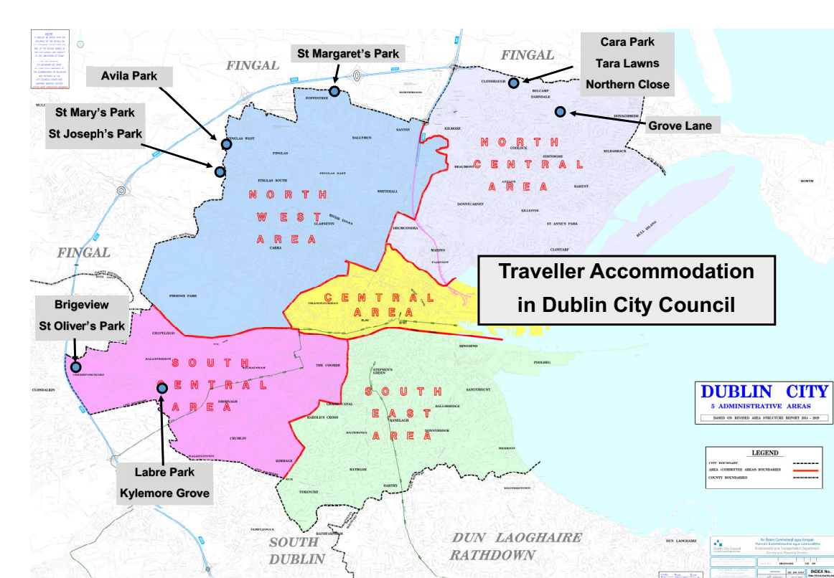
In accordance with the provisions of the Housing (Traveller Accommodation) Act 1998, Dublin City Council prepared and adopted a five year Traveller Accommodation Programme (TAP) for 2019–2024 to meet the existing and projected accommodation needs of Travellers in its administrative area. This details a comprehensive housing programme and includes a commitment to examine the city’s landholding to identify new sites for development.
The TAP identified that as of November 2018, there are 293 families in the Dublin City Council area in need of accommodation. The TAP intends to meet this housing need through the following methods:
- Proposed new house builds (47)
- Proposed new halting bay builds (7)
- The refurbishment of vacant houses (6)
- De-tenanting priorities (12)
- The allocation of vacant/unauthorised occupied bays and houses (7)
- Temporary bays to facilitate upgrades (16)
- The refurbishment of bays (50)
- Standard housing allocations (56).
- Traveller standard void allocations (25)
- Private rented accommodation
It is recommended that development plan policy seeks to implement the ‘Traveller Accommodation Programme 2019-2024’ and that in accordance with the Programme, Traveller specific accommodation for the city’s normally resident Traveller Community be provided through the development of new sites, the refurbishment and extension of existing sites, Part V Developments, casual vacancies and general needs housing.

Households Experiencing Homelessness and Rough Sleeping
The Dublin Region Homeless Executive (DRHE) is a shared service operation, provided under the aegis of Dublin City Council as the lead statutory authority for the Dublin Region in respect of the co-ordination and funding of homeless services. The DRHE provides a range of supports and services to homeless service providers in collaboration with the Dublin Joint Homelessness Consultative Forum and through the Statutory Management Group. It has specific responsibilities for the operational co-ordination of the Homelessness Action Plan, regional service provision and the disbursement of Section 10, 1988 Housing Act funding for homeless services and in commissioning new service provision.
In line with Chapter 6 Housing (Miscellaneous Provisions) Act 2009, the Dublin Joint Homelessness Consultative Forum and Management Group adopt the regional action plan for Dublin for the provision of services. The current plan, the Dublin Region Homeless Executive’s ‘Homeless Action Plan 2022 - 2024 - A Framework for Dublin’ is available at www.homelessdublin.ie. Successor plans will be proposed and adopted over the period of the development plan.
The Homeless Action Plan sets out a strategic approach for implementation across the Region and identifies actions required to prevent, protect and progress those at risk of or experiencing homelessness in the Dublin region. The four strategic aims of the Action Plan are:
- Prevention - providing early intervention to people at risk of homelessness.
- Protection - protecting people experiencing homelessness through emergency accommodation provision and targeted support.
- Progression - identifying and enabling pathways to long term housing solutions.
- Proper Governance and Finance Oversight - ensuring that appropriate governance and accountable structures are in place for all service providers.
For each year of the action plan, a business plan is issued that sets out the key actions to be achieved to meet the overall strategic aims of the business plan. This business plan sets an annual target for the provision of housing to ensure exits to independent living with support (as required) for all households experiencing homelessness and rough sleeping.
Dublin City Council is committed to addressing the issue of homelessness in its functional area. It has adopted the Homeless Action Plan 2022 – 2024 – A Framework for Dublin, which was prepared in conjunction with the four other Dublin Local Authorities in accordance with Section 37 of the Housing (Miscellaneous Provisions) Act, 2009.
Dublin City Council will support the implementation of the Homeless Action Plan 2022 – 2024 – A Framework for Dublin or any subsequent review and the Housing First National Implementation Plan 2022-2026 and support related initiatives to address homelessness.

Meeting the Housing Needs of Older Persons and Persons with Disabilities
This housing strategy will facilitate the implementation of Dublin City Council’s Strategic Plan for Housing People with a Disability 2016, and its successor currently being drafted. Dublin City Council is also committed to implementing the framework for the delivery of housing for persons with disabilities set out under the National Housing Strategy for Disabled People 2022 – 2027. The strategy is about facilitating the provision of housing options and related services to persons with disabilities to allow individual choice and support independent living.
Dublin City Council is committed to implementing Universal Design models to all new developments and encouraging private developers to incorporate them into all residential dwelling design proposals having regard to the Universal Design Guidelines for Homes in Ireland, published by the National Disability Authority in 2015. All new housing should be designed in a way that is adaptable and flexible to the changing needs of the homeowner as set out in the Lifetime Homes Guidance contained in Section 5.2 of the Department of Environment, Heritage and Local Government ‘Quality Housing for Sustainable Communities – Best Practice Guidelines for Delivering Homes Sustaining Communities’ (2007) and to the Department’s Design Manual for Quality Housing 2022. In line with Part M of the Building Regulations (as amended), all public and private buildings must also have provision for suitable access and use for all persons.
Through the Council, persons with a disability can apply for a number of grants to partly fund necessary improvements to their home. The Housing Adaptation Grant for People with a Disability Scheme provides grant aid to applicants to assist them with carrying out works that make their house more suitable for the accommodation needs of a person with a disability.
The Mobility Aids Grant Scheme provides grant aid to applicants to carry out works designed to address mobility problems that they may have. Both of these grants are available to applicants in owner-occupied housing, houses being purchased from a local authority under the tenant purchase scheme, private rented accommodation, accommodation provided under the voluntary housing Capital Assistance and Rental Subsidy schemes and accommodation occupied by persons living in communal residence.
Housing for older people is becoming an increasingly significant issue. In 2016, 72,355 people were aged 65 years and over, comprising 13% of the city’s population and representing an 8.8% increase since 2011. Under most recent Central Statistics Office (CSO) population projections, trends indicate that the number of people over the age of 65 is expected to increase nationally by approximately 34% in the period 2021-2031. The quality of life of older people can be improved through planning and the incorporation of universal design principles in the design of the built environment, particularly, housing, community and care facilities and accessible transportation including public transport and footpaths.
The Dublin City Age Friendly Strategy 2020-2025 recognises that there is insufficient life-cycle appropriate, alternative accommodation for older persons (including sheltered accommodation and nursing homes) in local communities. In this context, the provision of specific accommodation for older people is supported by the objectives of this housing strategy to provide alternative residential choices for older people not requiring access to a nursing home with the goal of supporting older people across the city to age comfortably in the communities they belong to.
This housing strategy supports the concept of independent living and assisted living for older people, the increased provision of supported housing units, the provision of specific purpose built accommodation, including retirement villages, and rightsizing proposals that allow independent living for older people (as well as those living with a disability).
This housing strategy supports projects by Approved Housing Bodies and other organisations which enable older homeowners to reconfigure their family-sized homes in a way that meets the needs of an ageing population, creates new single occupancy rentals in an efficient and sustainable way, promotes intergenerational living and helps to regenerate mature urban neighbourhoods.
This Strategy supports HomeShare. Typically a HomeShare is a not-for-profit enterprise that can be described as an au pair for older people. Householders are generally older, or those who need support to continue to live in their own homes, whereas Home Sharers are often younger working professionals or students who cannot afford housing where they work/study. HomeShare is being promoted by the City Council’s Housing Department. Further information is available on www.thehomeshare.ie.
This housing strategy will support a commitment whereby a minimum of 7% of new allocations or acquired developments will be fully accessible for older persons, persons with disabilities or those with mobility issues, to support independent living in line with Universal Design principles, having regard to the National Disability Authority’s, Universal Design Guidelines for Homes in Ireland, 2015.
This housing strategy will support an objective to ensure that 50% of apartments in any development that are required to be in excess of minimum sizes should be designed to be suitable for older people/mobility impaired people, people living with dementia and people with disabilities in accordance with the guidelines set out in the Universal Design Guidelines for Homes in Ireland 2015, the DHLG&H’s Design Manual for Quality Housing 2022 and the DHP&LG & DH’s Housing Options for Our Ageing Population Policy Statement 2019.
Please refer to Chapter 5, Quality Homes and Sustainable Neighbourhoods for specific policy provision based on the recommendations of this housing strategy.

International Protection Applicants
Dublin City Council will have regard to emerging Government policy, in consultation with the Department of Children, Equality, Disability, Integration and Youth, in responding to the accommodation needs of international protection applicants and those in need of refuge.

Students
Rebuilding Ireland: Action Plan for Housing and Homelessness (2016), identifies the important contribution that increased student accommodation provision can make to resolving the overall housing supply problem.
The Government’s National Student Accommodation Strategy (2017) is designed to ensure that there is an increased level of supply of purpose built student accommodation (PBSA) to reduce the demand for accommodation in the private rental sector by both domestic and international students attending Higher Education Institutions (HEIs). The strategy states that the increase in the number of students participating in higher education is creating unprecedented demand for suitable, affordable student accommodation.
Dublin City Council recognises that there continues to be demand for high quality professionally-managed student accommodation developments in the city. In line with Government policy, the provision of purpose-built student accommodation is supported by the development plan. It is anticipated that increased supply of PBSA can result in increased overall access to housing by releasing housing stock in multiple occupation in the private residential sector.
It is recommended that development plan policy supports the provision of high-quality, professionally managed and purpose-built third-level student accommodation in line with the provisions of the National Student Accommodation Strategy (2017), on campuses or in appropriate locations close to the main campus, in the inner city or adjacent to high-quality public transport corridors and cycle routes, in a manner which respects the residential amenity and character of the surrounding area. In this regard, the development plan will include policies to prevent the over-provision of PBSA in any given area.

7.2.4 Local Authority Support for Leases with Private Landlords
A tenancy can be created for social housing purposes where the local authority arranges short or long-term leases with private landlords for particular properties.
The increase in social leasing units reflects government policy aimed at facilitating local authorities to deliver social housing by leasing houses and apartments from private owners and allocating them to tenants from their social housing lists. Local Authorities can enter into a lease arrangement with a property owner for periods of up to a maximum of 25 years
Tenant households can be supported in this way under the Rental Accommodation Scheme (RAS) or Repair and Lease.
The Rental Assistance Scheme (RAS) is an initiative to cater for the accommodation needs of certain persons in receipt of rent supplement, normally for more than 18 months. Qualifying individuals have been assessed as having a long-term housing need and under the RAS Dublin City Council pays rent directly to the accommodation providers on behalf of the tenant (which is a maximum of 92% of the market rent).
The Rebuilding Ireland Action Plan for Housing and Homelessness introduced a new scheme, the Vacant Housing Repair and Leasing Initiative (i.e. Repair and Lease). This scheme specifically targets the delivery of social housing and seeks to ensure that existing housing stock is used to the maximum degree possible. The basis of the Repair and Lease scheme is that repair and improvement works to suitable vacant properties are funded in order to bring them up to the standard for rented accommodation and the cost of the works is then deducted from lease payments over an agreed lease term.

7.2.5 Housing Assistance Payment (HAP)
Housing Assistance Payment is a scheme established under the Housing Miscellaneous Provisions Act 2014 for people who have a long-term housing need and who qualify for social housing support. It is administered by housing authorities and it is envisaged it will eventually replace long-term rent supplement (i.e. RS). The HAP scheme aims to allow all social housing supports to be accessed via Dublin City Council to enable people to take up full-time employment whilst keeping their housing support.

Under the HAP scheme, the housing applicant finds appropriate private rented accommodation (within specific caps) and Dublin City Council then pays the landlord directly as the tenant pays rent to the local authority based on the differential rent scheme.

7.3 Meeting Affordable Purchase and Cost Rental Housing Needs
Urban regeneration proposals will play a key role in delivering new homes in the city. There is a renewed emphasis over the period of the development plan on delivering housing through the redevelopment of key brownfield sites.
The Core Strategy of the development plan identifies a number of Strategic Development and Regeneration Areas (SDRA) where most new housing delivery will take place. Given the quantum of development that can be provided through regeneration and urban redevelopment in the SDRAs, this will be an important means of meeting social and affordable housing needs through Part V of the Planning and Development Act 2000, as amended.
Dublin City Council will work with the Land Development Agency and Approved Housing Bodies as delivery partners to facilitate the delivery Affordable Purchase and Cost Rental housing across the city. Under Housing For All: A new Housing Plan for Ireland, the Land Development Agency (LDA) is envisaged as playing an important role in delivering cost rental and affordable housing as a delivery partner with Dublin City working through regeneration projects in the city. The LDA was established to coordinate land within State control for more optimal uses where appropriate, with a focus on the provision of housing and providing a stronger supply of housing land in urban centres. The LDA will pursue the new forms of affordable housing as set out under the Affordable Housing Act 2021 to meet growing demand for housing among households that are not eligible for traditional social housing but may qualify for state supports through affordable purchase or cost rental schemes. In developing public land owned by Dublin City, and subject to national legislation and requirements, Dublin City seeks to maximise its overall public housing provision of social, cost rental and affordable purchase housing provision in a manner that contributes to sustainable communities and healthy place making. The findings of the interim HNDA for this development plan period will be relied upon to help inform the proposed balance of dwelling types and tenure in locales and neighbourhoods where public lands are located.
Dublin City Council will seek to ensure any selection of land or housing units obtained or provided by Dublin City Council, including Part V, counteracts undue segregation of persons with different social backgrounds. In far as practicable, it will be a requirement that in all new developments, Part V allocations can be pepper potted across developments to ensure full access to available amenities and services for residents.

7.4 Housing Land Supply
Dublin City Council has undertaken a review of housing land as part of the drafting the development plan.
A land capacity analysis was carried out by the Planning Department to calculate the yield of undeveloped land; with a particular focus on the 17 Strategic Development Regeneration Areas that are prioritised for development over the plan period. Of 5,800 hectares of land zoned for residential or mixed (including residential) uses; it has been estimated that there are approximately 550 hectares available to develop during this development plan cycle which can provide approximately 49,175 residential units.
In line with the statutory requirements of the development plan, based on this housing capacity, there is evidently sufficient zoned land to meet the needs of the population and housing targets set by the Ministerial Guidelines and the NPF, as the analysis undertaken demonstrates that Dublin City Council has the capacity to accommodate the required need of 40,000 residential units over the plan period within its administrative area.
In addition to this, there are also significant regeneration lands as yet not zoned for housing/mixed use that have potential to deliver additional housing which can be expedited to ensure that the Core Strategy is implemented in the appropriate timescale. Please refer to Chapter 2, Section 2.4.5, Future development Areas, of the Core Strategy for further detail.
In light of the Government strategy Housing for All, these land areas currently identified for housing beyond the 6 year life of this plan, will be considered to bring forward for variation where they are associated with projects led by Dublin City Council and/or the Land Development Agency; with the Core Strategy updated to remain in accordance with the NPF and RSES.

8.0 Key Policy Recommendations

8.1 Housing Strategy and Interim HNDA Key Policy Recommendations
This housing strategy and the integrated city and sub-city HNDA findings contain an analysis of the existing and future housing needs of Dublin City, setting out an evidence base for Dublin City Council to plan for housing over the plan period.
Dublin City Council will monitor and review the housing strategy as appropriate in accordance with any forthcoming guidance on HNDA methodology issued by the Department of Housing, Local Government and Heritage.
The following sets out the housing strategy and interim HNDA overarching policy recommendations which inform the development plan to guide housing delivery in the city. Please refer to the development plan written statement and to individual chapters for full policy context.

Policy Recommendations to inform the Dublin City Development Plan 2022-2028 and as required by the Planning and Development Act 2000 (as amended):
- To ensure adequate and appropriately zoned land is available to facilitate and implement the aims of the Core Strategy, as informed by the National Planning Framework 2018, the Regional Spatial and Economic Strategy for the Eastern and Midland Region 2019 (including the Metropolitan Area Strategic Plan) and the Ministerial Circular relating to Structural Housing Demand in Ireland and Housing Supply Targets, and the associated Section 28 Guidelines: Housing Supply Target Methodology for Development Planning, to deliver sustainable development, and to meet likely future housing need as identified by the housing strategy and interim HNDA.
- To facilitate the maximum allowable provision under the Planning Act (as amended) for affordable and social housing provision as part of future planning permissions, reflecting the high levels of demand within the city.
- To require that 20% of land zoned for residential use, or for a mixture of residential and other uses for development of four or more units or development of units on land more than 0.1 hectares be reserved for the provision of, social, affordable purchase and cost rental housing in accordance with Part V of the Planning and Development Act, as amended by the Affordable Housing Act 2021.
- To provide for social, affordable purchase and cost rental housing over the plan period to meet forecast future housing need as identified in the housing strategy and interim HNDA.
- To provide for social, affordable purchase and cost rental housing accommodation through a range of delivery mechanisms including new builds, acquisitions, renovations and acquisitions of vacant homes, leasing, and housing supports including RAS and HAP or any other mechanism promoted or forthcoming under Government Housing Policy.
- To include a defined mix of dwelling unit types for the city and addressing the particular challenges of the inner city areas identified, that responds to the demographic changes in households and taking into account the current housing stock.

9.0 Annexes

PAGE LEFT INTENTIONALLY BLANK

Dublin City Development Plan 2022-2028

Annex 1 to Appendix 1: Dublin City Housing Need Demand Assessment (HNDA)

PAGE LEFT INTENTIONALLY BLANK

Executive Summary
This summary has been written using the National Adult Literacy Agency’s Plain English Guidelines.
All local authorities in Ireland must make a development plan for their area every six years. These must include a housing strategy that assesses current and future need for housing, including social and affordable housing.
The National Planning Framework requires local authorities to carry out a Housing Need and Demand Assessment (HNDA). This is a new way of assessing current and future housing need. This evidence will support decisions about housing and planning. In April 2021, the Government published a new HNDA Tool. This assesses housing need using the latest statistics on the economy and housing. This HNDA Tool gives broad, long-run estimates of housing need over the next decade.
KPMG Future Analytics have used this HNDA Tool for the Dublin City Development Plan 2022-2028. This HNDA assesses:
- The forecast population and households for Dublin City over the new plan period.
- How the economy, household incomes, house prices, and rents will grow over the plan period.
- What future incomes, prices and rents will mean for housing affordability.
- The housing need for the plan period for private ownership, private renting, social housing, and affordable housing.
- How household sizes and the housing stock may change. This is to help Dublin City Council plan for the future housing stock needed in the new Development Plan.
The HNDA finds that for the years 2023 to 2028, about 38% of new households will need social housing, 15% will be able to buy a home, 18% will be able to rent, and 29% will need affordable housing (such as cost rental or affordable purchase). The population of Dublin City will grow to 638,000 in 2031, and there will be over 52,000 new households in Dublin City between 2020 and 2031.
This evidence shows potential issues in the housing market. It will inform new housing and planning policy in the Dublin City Development Plan 2022-2028. This will support Dublin City Council’s democratic responsibility for planning for the future of Dublin City.

1.0 Introduction

1.1 HNDA Overview
This annex describes the Housing Need and Demand Assessment (HNDA) that has been prepared by KPMG Future Analytics to inform the Dublin City Development Plan 2022-2028.
The requirement for local authorities to prepare a HNDA to support the preparation of statutory Housing Strategies and Development Plans was introduced in the National Planning Framework (NPF) in 2018. The NPF states that the role of the HNDA is to correlate and accurately align future housing requirements. The NPF intends for the HNDA to become a keystone of the plan-making system which will “inform housing policies, housing strategies and associated land use zoning policies as well as assisting in determining where new policy areas or investment programmes are to be developed.”
Moreover, the NPF indicates that the purpose of the HNDA tool is to:
- Assist local authorities to develop long-term strategic views of housing need across all tenures.
- Provide a robust evidence base to support decisions about new housing supply, wider investment and housing related services that inform an overall national housing profile.
- Inform policies about the proportion of social and affordable housing required, including the need for different types and sizes of provision.
- Provide evidence to inform policies related to the provision of specialist housing and housing related services.
The NPF states that HNDAs are to give broad, long run estimates of potential future housing need, rather than precision estimates. Additionally, a logical, sequential framework will allow for updating, monitoring and evaluation.

1.1.1 HNDA Toolkit and Guidance
The Department of Housing, Local Government and Heritage (DHLGH) published ‘Guidance on the Preparation of a Housing Need and Demand Assessment’ and a HNDA Tool in April 2021. This is intended to be the first iteration of the DHLGH’s HNDA Tool for use by local authorities in the preparation of housing strategies and development plans.
The HNDA Tool produces an estimate of total future housing need in a local authority over the period 2020-2040 and an estimate of this need broken down into four tenure types:
- Owner-occupation.
- Private rented.
- Social rented.
- Affordability constraint (i.e. households that are above the eligibility threshold for social housing but cannot afford to buy or rent privately and may require a form of affordable housing such as affordable purchase or cost rental).
The HNDA Toolkit may be amended in a number of ways to reflect custom scenarios and updated assumptions. Section 2 sets out an overview of how the Toolkit models housing need and sets out all of the custom changes that have been made for Dublin City. Section 3 provides presents the outputs of the HNDA model including the housing need by tenure for the period of the Dublin City Development Plan 2022-2028, while Section 4 provides a concise conclusion of the issues raised by the HNDA.

2.0 Methodology
This Section sets out the sequential steps involved in the development and application of the HNDA model undertaken for Dublin City. This modelling has made use of the latest version available of the HNDA Toolkit and Guidance issued by the DHLGH.

2.1 HNDA Toolkit Structure

2.1.1 Modelling Overview
The HNDA Tool has been development by the DHLGH for Local Authorities in collaboration with the Scottish Centre for Housing Market Analysis and is very closely based on the HNDA model used by Scottish local authorities. This Tool is an Excel-based system using macros to assess a range of datasets (some of which may be customised or varied) to produce the demographic housing demand by tenure type.
It combines a range of data from public datasets across key housing market drivers, including data specially tabulated for the Tool. The most important of these drivers are demographic projections (published by the Economic and Social Research Institute (ESRI) in December 2020 ), household incomes, property sales prices, rental prices, and estimates of existing unmet housing need (through data on overcrowding and homelessness), as well as a number of assumptions and forecasts about the Irish housing market.
The HNDA Tool operates firstly by forecasting the number of newly formed households in a local authority in each year of the projection period (2020-2040), based on the selected projection scenario It also forecasts future household incomes and distributions, house prices, and rental prices in the local authority. Based on the combination of forecast incomes, prices, and key assumptions about the market, the Tool assesses whether forecast new households can sustainably afford housing in the private sector (owner-occupation or private rental) or require either social or affordable housing.
Affordability is defined by default as a household being required to pay either no more than 3.9 times the household income for owner-occupation (equivalent to the household taking out a mortgage which has a loan to value of 90% and a mortgage to income ratio of 3.5,) or no more than 35% of the household net income for private rental. The Tool carries out an assessment for owner-occupation first (assessed against the 25th percentile property price identified for the local authority) followed by an assessment for private rental (against median rental cost for a 2 bed unit) for those households who cannot afford to buy plus an assumed proportion of those who could afford to purchase but do not do so (see Section 2.1.5; this in part reflects those who do not have a deposit). Households with less than the maximum household income eligibility for social housing (€35,000 a year in Dublin City) are assigned to social housing. Households above this threshold who cannot afford to purchase or rent privately are assigned to the ‘affordability constraint’ category.
The HNDA Toolkit may be customised and used to assess scenarios in several areas, through setting data inputs and scenarios. The DHLGH instructions on using the HNDA Tool sets out five broad stages in setting up the HNDA model and setting these key inputs, as shown in Figure 2.1 below:
Figure 2.1: HNDA Toolkit Preparation Stages
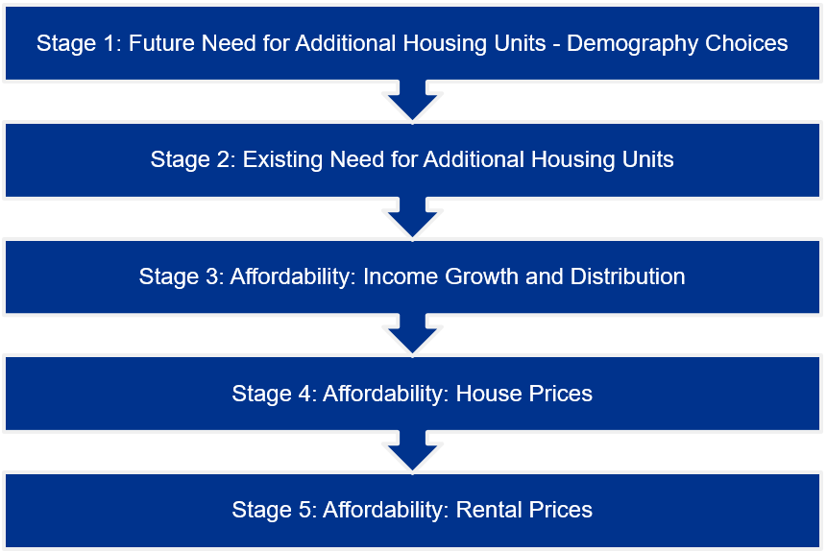
The following sections set out each of these stages in detail, and what assumptions and inputs KPMG Future Analytics have applied in the Dublin City HNDA.

2.1.2 Stage 1: Future Need for Additional Housing Units – Demography
Data on forecast demography and forecast population and household growth to 2040 at local authority level has been provided by the ESRI and is built into the Toolkit. The model includes five different scenarios (based on different international migration scenarios and other assumptions):
- Convergence scenario (default scenario): 50:50 city scenario adjusted for new housing supply since 2017, and to facilitate convergence to NPF strategy per the section 28 Planning Guidelines ‘Housing Supply Target Methodology for Development Planning’.
- 50:50 city scenario with population increase roughly equally split between the East and Midlands regions and urban areas/cities in the rest of the country and allows for a more even spread across the country.
- Baseline based on net international migration declining linearly from +33,700 in 2019 to +15,000 by 2024 and remaining constant thereafter.
- High migration, based on net international migration of +30,000 in 2020 and remaining constant thereafter; and
- Low migration, based on net international migration dropping to +5,000 by 2022 and adjusting towards the baseline scenario over the following years.
In all situations the default scenario (convergence with ESRI forecasts and standard rate of inflation) must be run. Local Authorities are required to comply with the Section 28 Guidelines ‘Housing Supply Target Methodology for Development Planning’ from December 2020 when drafting their statutory development plans. The DHLGH’s HNDA Guidance states that the ‘Convergence’ Scenario is intended to be consistent with the methodology from the Section 28 Guidelines. Accordingly, KPMG Future Analytics have applied the Convergence Scenario for undertaking the Dublin City HNDA.
However, although both the Convergence Scenario and the Housing Supply Target methodology have been produced by the DHLGH for use by Local Authorities, they are calculated in a slightly different way and can produce significantly different results over a single plan period for the reasons explained below.

2.1.2.1 Housing Supply Target Methodology and the Convergence Scenario
As part of the development plan process, local authorities must demonstrate how their development plan is consistent with the NPF and the NPF Implementation Roadmap population projections for their area. In December 2020, the DHLGH issued the ‘Housing Supply Target Methodology for Development Planning’ Section 28 Guidelines to translate these more consistently into development plans. These Guidelines build on research undertaken by the ESRI into regional demographics and structural housing demand at county level, taking the ESRI’s 50:50 City Scenario household projections as the recommended housing demand scenario to be used by local authorities.
The Guidelines set a methodology for the application of population and housing projections into local authority plan processes. This sets a means of calculating the total housing demand and Housing Supply Target for the exact 6-year period of the development plan, to the nearest quarter. This methodology is as follows:
- Total 50:50 City projected new households from 2017 to the end of the plan period (in this case 2017 to Q4 2028, a total of 47,941 for DCC),
- Minus actual and estimated new housing supply between 2017 and the start of the plan period (2017 to Q4 2022, a total of 11,708 for DCC),
- Plus existing ‘unmet demand’ (latest homeless households and an estimate of overcrowded households from the 2016 Census) (3,905 for DCC).
Using this method, KPMG Future Analytics have calculated a total Housing Supply Target of 40,138 households for the Dublin City Development Plan 2022-2028. This is the target that the Development Plan and its Core Strategy is required to follow.
However, the HNDA Toolkit’s Convergence Scenario produces a significantly different estimate of housing demand for this period, as it is based on a longer-term approach to calculating housing demand. The Housing Supply Target methodology focuses on need in a strict 6-year period, aligning to the lifetime of a single development plan. The HNDA Toolkit includes forecasts over the whole period 2020-2040 to align with the long-term approach of the NPF, with a particular focus on the period to 2031 which is identified as a key milestone in the NPF. As a result, the Convergence Scenario for each local authority is based on:
- Total ESRI 50:50 City scenario projected new household demand 2017 to 2031 (57,960 for Dublin City),
- Minus actual new housing supply for 2017-19 only (5,266 for Dublin City).
This gives a total housing demand for Dublin City of 52,694 between 2020 and 2031. The resulting proportional uplift to the 50:50 City Scenario is applied for the 50:50 City forecasts each year, resulting in 24,876 households for Dublin City for the plan period. It does not include unmet demand (this is included separately in the Toolkit, spread by default over 10 years instead of 6), and it does not carry forward some of the shortfall between forecast demand and actual supply for 2020 onwards as with the Housing Supply Target.
As a result, the Convergence Scenario as used in the HNDA Toolkit gives a total new household demand (not including existing unmet need) of 24,876 households for the plan period – significantly lower than the Housing Supply Target of 40,138. This is because DHLGH’s HNDA Toolkit is intended to give broad, long-run estimates of housing need from 2020 to 2040, rather than condensing housing need, housing shortfalls and unmet demand into a tight six-year period as required by DHLGH’s Housing Supply Target methodology. Therefore, the Convergence Scenario should be considered as a broad demographic estimate rather than a planning target.
Finally, it should be noted that this step defines the total number of new households that subsequently go through the affordability assessment and does not affect the metrics used in that assessment. As a result, the tenure percentage breakdown of need would remain the same whatever total new household scenario or figure is used.

2.1.3 Stage 2: Existing Need for Additional Housing Units
The Toolkit includes built-in data on existing unmet housing need. This is a combination of two datasets: an estimate of overcrowded households by local authority (based on a special tabulation of Census 2016 data) and data on homelessness households (based on maximum numbers of households interacting with homelessness services in the last week December 2019, comprising 1,542 households for Dublin City). Local Authorities may substitute their own estimate of unmet need with sufficient justification. The model can be modified to apportion existing need across all tenures or to assign all existing need to social rent. It can also be modified to set an assumption on how many years it will take to clear existing need (the default setting being 10 years).
In compiling this section for the Dublin City HNDA, KPMG Future Analytics have made use of the default estimate of overcrowded households (1,929 households in 2016). However, Dublin City Council (DCC) in consultation with the Dublin Region Homeless Executive have provided an updated estimate of homeless household within the Council’s administrative area as of June 2021. Data from DCC’s social housing waiting list indicates there are 1,976 homeless households, comprising 2,738 individuals. This comprises those housing applicants assessed as eligible for social housing due to homelessness, whose need is not currently met and who have their main application with DCC. The majority (82%) of the 1,976 homeless households consist of one person, with corresponding high demand for one-bedroom accommodation. Further detail is presented in Figure 2.2 below.
Figure 2-2: Homeless Households and Individuals (Dublin City Social Housing Needs Assessment, June 2021)
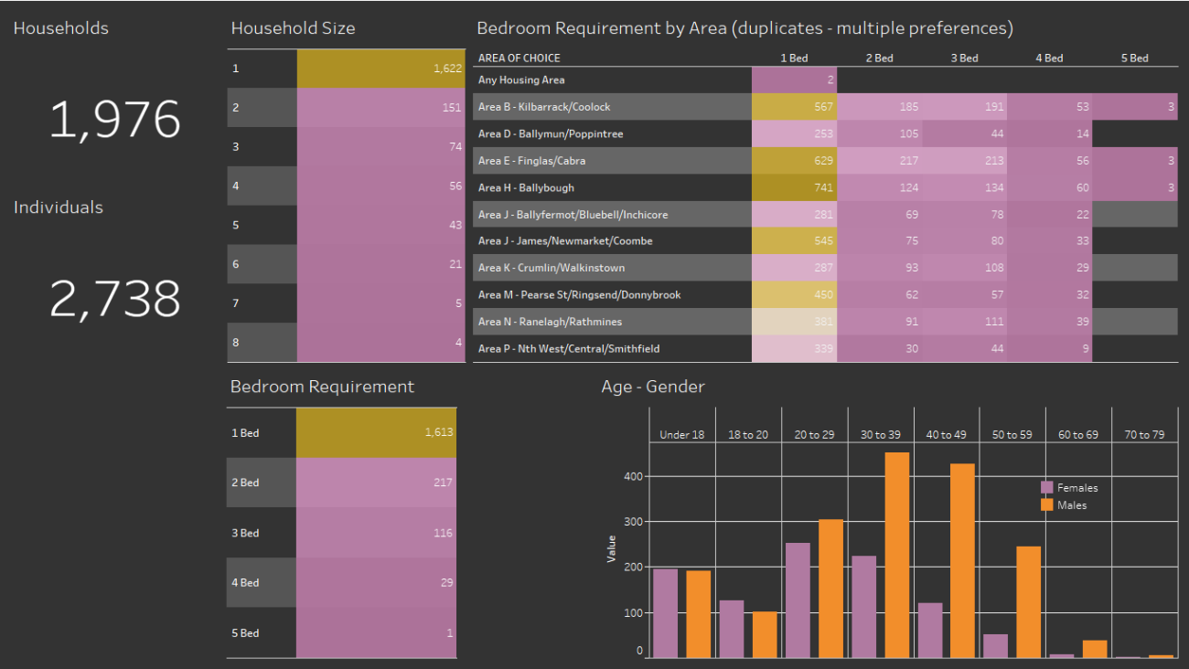
This data has been used to represent a more up-to-date picture of homelessness in Dublin City. Homelessness is a highly fluid and varied phenomenon, with several potential ways of counting homeless households. Homelessness has been affected by the COVID-19 pandemic and public policies introduced during the pandemic to prevent a rise in homelessness (including restrictions on private rent increases and the use of former short-term lets for homeless services), with the number of households presenting as homeless to service providers declining over 2020 and the first half of 2021 as a result. More recent data captures this change. Furthermore, the use of data from the social housing waiting list (as opposed to the number of households accessing emergency accommodation, as used by default in the HNDA Toolkit) is used to better capture the variety of forms of homelessness present in Dublin City and not solely those in contact with emergency homeless services.
KPMG Future Analytics have also applied the default assumption of 10 years to clear existing need for this HNDA.
It should be noted that the HNDA Toolkit does not by default make use of local authority social housing needs assessments. In practice, the HNDA Toolkit by default only makes use of a portion of existing need for social housing in a local authority (assuming those classed as homeless or estimated as overcrowded are on the social housing waiting list). This reflects the HNDA’s focus on forecast, future demographic need for housing from newly created households. It also reflects the December 2020 Section 28 Guidelines on Housing Supply Targets, which require Housing Supply Targets to include homeless households and estimates of overcrowding in their calculation. The Housing Supply Target methodology does not include other forms of existing housing need or existing households such as the rest of a social housing waiting list, as it also focuses on forecast demographic need.
As a result, this HNDA does not account for the portion of the existing social housing waiting list in DCC which is not classed as homeless and may not yet be housed at the beginning of the plan period.

2.1.4 Stage 3: Affordability – Income Growth and Distribution
The HNDA Toolkit is prepopulated with CSO data on household incomes sourced from Census 2016, the Revenue Commissioners and Department of Social Protection data and forecasted to 2019 using county incomes from national accounts and the CSO Earnings and Labour Costs annual data. Several assumptions on future income growth and changes may be set at this stage in the Toolkit:

Income Growth Scenarios:
Three pre-set scenarios may be used to forecast how household income will grow over the projection period (to 2040). These are:
- Modest real-terms growth (household income growth of 3.5% per annum in nominal terms, 1.5 percentage points above the European Central Bank (ECB) inflation rate target of 2% per annum);
- No real terms growth – Inflation target (household income growth of 2% per annum in nominal terms to 2040, the same the ECB inflation target – this is the default setting);
- Below real terms growth (household income growth of 0.5% per annum in nominal terms 1.5 percentage points below the ECB inflation target and falling in real terms).
Custom income scenarios may also be developed and used, with appropriate justifications and evidence-bases.
KPMG Future Analytics have developed a custom income growth scenario for use in the Dublin City HNDA, based on a review of recent available economic forecasts. This has been developed to reflect historic trends more accurately, including the ongoing economic effects of the COVID-19 pandemic and post-pandemic recovery as well as the latest economic forecasts from a range of agencies.
This scenario has been derived from an economic review undertaken to forecast Gross Domestic Product (GDP) growth to 2025 and beyond.
The sources reviewed include:
- 2021 Outlook paper published by Davy in January 2021;
- Q2 2021 Quarterly Bulletin published by the Central Bank of Ireland in April 2021;
- Q1 2021 Economic Outlook published by IBEC in Q1 of 2021;
- Quarterly Economic Commentary published by the ESRI in March 2021;
- Winter 2021 Economic Forecast published by the European Union in February 2021; and
- IMF World Outlook in April 2020.
Based on this review, the following forecast income growth rates are applied in the Dublin City HNDA:
- 2020: 3.4% GDP/income growth which is consistently reflected across the following sources: Central Bank, Davy, IBEC, EU, CSO and ESRI.
- 2021: 4.4% GDP/income growth which aligns with the latest forecasts.
- 2022: 4.5% GDP/income growth which aligns with the latest forecasts.
- 2023: 3.7% GDP/income growth.
- 2024: 2.8% GDP/income growth.
- 2025 onwards: 2.6% GDP growth which aligns with the IMF outlook and represents conservative tapering for the remainder of the plan period.
This approach allows a flexible growth rate to be applied over the forecast period, to reflect an expected post-COVID recovery and a tapered return to a lower growth rate thereafter.

Changes in Income Distributions
Assumptions on how different household income distributions will grow for a given overall growth rate may also be set in the Toolkit. This defines how household income at the 10th and 90th percentiles grow relative to median household income (the 50th percentile). Three pre-set scenarios are built into the Toolkit:
- Greater equality: The income growth rate for the least affluent households (the 10th percentile of the income distribution) is one percentage point per annum above the growth rate in median household income, while the income growth rate for the most affluent households (90th percentile) is one percentage point below the median.
- No change (core/default scenario): The incomes of the least affluent (10th percentile) and the most affluent (90th percentile) increase at the same rate as median household income.
- Greater inequality: The income growth rate for the least affluent (10th percentile) is one percentage point per annum below the median, while the income growth rate for the most affluent households (90th percentile) is one percentage point above the median.
Custom scenarios may also be developed and used, with appropriate justifications and evidence-bases. KPMG Future Analytics have applied the default scenario with no change in income distributions for this HNDA.

Parts of the Income Distribution of Interest
The Tool is set up to analyse affordability (incomes divided by house prices and rent prices) at the 25th percentile of income, house prices and rental prices; however, another point in the income distribution can be examined for a given year for illustrative purposes only. By default, this is set to the 75th percentile.

2.1.5 Stage 4: Affordability – House Prices
The Tool is pre-programmed with house price data sourced from the CSO’s Property Price Register (PPR) index, and with five house price scenarios for how house prices are forecast to change over the projection period (2020-2040):
- Strong growth: Nominal house price growth is 6% per annum, every year to 2040.
- Modest growth: Nominal house price growth is 4% per annum, every year to 2040.
- Weak growth (no real-terms growth): Nominal house price growth is 2% per annum, every year to 2040, in line with the ECB’s inflation target.
- Flat growth (real-terms decline): Average house prices are unchanged in nominal terms, and declining in real terms if inflation is in in line with the ECB’s inflation target of 2%.
- Economic and Social Research Institute Forecast (core/default): This scenario is based on the ESRI’s model and assumes a 2.25% increase in prices.
Custom scenarios may also be developed and used, with appropriate justifications and evidence-bases. KPMG Future Analytics have developed a custom house price scenario for use in the Dublin City HNDA, based on the review of recent available economic forecasts used for income growth described above. This is also based on consideration of historic house price growth in Dublin City. Specifically, the distribution of the price of units in the housing market during 2012-2020 have been reviewed for Dublin City.
Following review of information from the Residential Property Price Register (RPPR) for Dublin City between the years 2012-2020 the average house price change over the past four years (2017-2020) of 4.27% has been used as a basis for future changes in average house price from 2021 onwards (i.e. future baseline), as can be seen in Table 2.1 and Table 2.2 below.
Table 2-1: Historic Sales Growth - PPR
Dublin City | Growth | Sales
2012 | -2.07% | Actual
2013 | 12.30%
2014 | 6.27%
2015 | 6.22%
2016 | 11.38%
2017 | 10.54%
2018 | 6.96%
2019 | -2.07%
2020 | 1.65%
2017-2020 Average | 4.27%

Table 2-2: Custom Sales Scenario
Dublin City | Growth | Sales
2019 | -2.07% | Actual
2020 | 1.65%
2021 | 4.27% | Forecast
2022 | 4.00%
2023 | 4.00%
2024 | 3.50%
2025 | 3.50%
2026 | 3.00%
2027 | 3.00%
2028 | 2.50%
2029 | 2.50%
2030 | 2.00%
The custom scenario sees the growth rate reduce by 0.5% every two years towards a sustained 2% growth by 2030. This scenario is an attempt to show variation over time, which is evident in the historic data, while also being reflective of the Dublin City market. The staggered reduction aims to align with the ESRI forecast scenario of 2.25% per year by the end of the modelling timeline.
Figure 2.3 below shows that the custom scenario sees sale prices grow at a greater rate than the ESRI and “Weak Growth” scenarios but below those of the “Modest” and “Strong” growth scenarios, which were shown to push modelled sales prices to very high levels by 2030.
Figure 2-3: Median Price Forecasts in Dublin City (Default and Custom Scenarios)
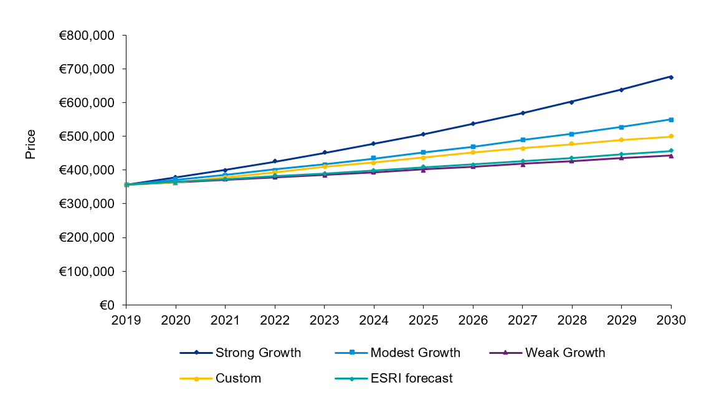
Toolkit users can also set an affordability criterion to decide a cut-off point for who can afford to buy in the private market and who cannot (and will need to rent). The default setting in the Tool assumes that a household is suitable for home ownership provided that they could afford to purchase a house at the lower quartile (25th percentile) of the house price distribution. The test for affordability is that the house price is no more than 3.9 times the household’s income. This is equivalent to the household taking out a mortgage which has a loan to value of 90% and a mortgage to income ratio of 3.5, which are both based on the Central Bank’s macro-prudential rules. The income ratio (3.9 by default) may be varied by users with sufficient justification and evidence base. KPMG Future Analytics have applied the default affordability criteria for this HNDA.

2.1.6 Stage 5: Affordability – Rental Prices
In addition to assumptions on house prices, several assumptions on the rental market may be made for the projection period.

Proportion of Purchasers
Toolkit users may set the proportion of those who can afford to purchase in the market and will actually go on to do so. The default in the Tool is set at 70%. This assumes, of those who can afford mortgage repayments, only 70% also have the deposit to go on to buy. This in based on data from the Banking and Payments Federation Ireland (BPFI) on average numbers of first-time buyer mortgage drawdowns between 2011 and 2020.
An examination of the 2016 census for household tenure indicates that 68% of households in the State are owner-occupied (both with and without mortgages). In Dublin City by comparison just 52.9% of households are owner-occupied. The breakdown of households by type of tenure are compared between Dublin City and the State in Figure 2.4.
Figure 2-4: Tenure Breakdown in Dublin City and the State (Census 2016)
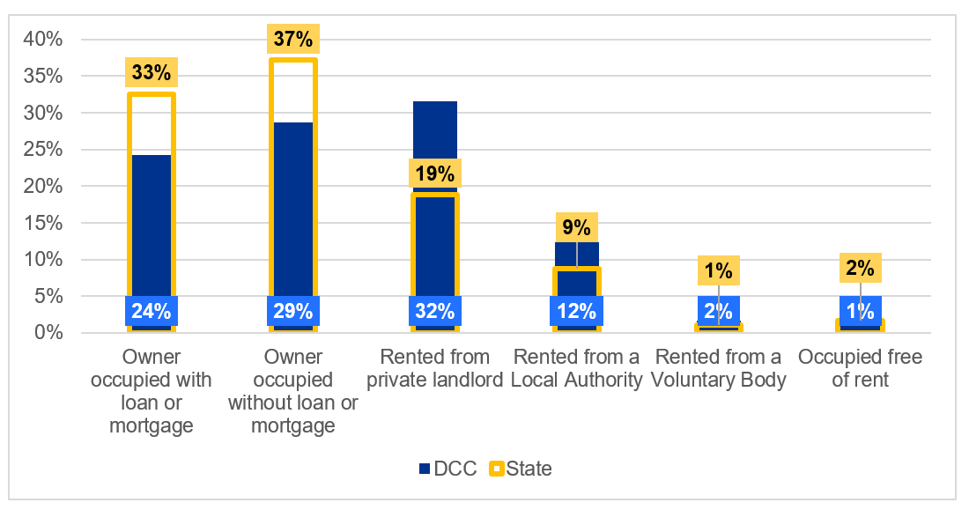
Based on the substantial difference between the default value, of 70%, and the proportion of homeowners from the latest Census in Dublin City of 53%, there is a strong case for modifying this value within the Toolkit to be more representative of Dublin City.
Therefore, KPMG Future Analytics have applied a proportion of 55% in the HNDA Toolkit to better align data available for Dublin City from the latest census. This 55% value represents a slight increase on the 2016 tenure profile; this reflects the slight increase in the Toolkit between Census 2016 data and the Toolkit default of 70% as well as an aspiration in national and local policy more broadly to support home ownership at sustainable levels.

Affordability Thresholds
The Toolkit uses thresholds to split the remainder of need into three rental sectors:
- The 1st threshold determines those who can afford to rent in the private sector. If a household can afford median rent with less than or equal to 35% of their net income, the Tool assumes they can afford to rent in the private sector.
- The 2nd threshold determines those who may be eligible for social housing. If household income is less than the minimum cut-off for social housing (up to €35,000 for Dublin City), the Tool assumes they are suitable for social rent.
- The remainder is allocated to an “affordability constraint” category in cases of households not being eligible for social housing but facing affordability constraint (with regard to income and house prices). This is in effect those households requiring ‘affordable’ tenure types (such as Cost Rental or affordable purchase).
KPMG Future Analytics have applied the default settings for these affordability thresholds.

Rental Price Forecasts
The Tool is pre-programmed with rental price data sourced from the Residential Tenancies Board (RTB), and with five rental price scenarios for how rents are forecast to change over the projection period (2020-2040). These are the same scenarios as those for house prices (including the default ESRI scenario of 2.25% per annum), although the model can run different scenarios for sales prices and rents at the same time.
Custom scenarios may also be developed and used, with appropriate justifications and evidence-bases. KPMG Future Analytics have developed a rental price scenario for use in the Dublin City HNDA, based on the review of recent available economic forecasts used for income growth and house price growth described above. This is also based on consideration of historic rental growth in Dublin City.
To ensure the most up to date market context, 2020 has been selected as the baseline year and rental information as recorded by the Residential Tenancies Board (RTB) during that year has been considered representative. Information has been extracted for Dublin City for 2010-2020. Utilising the standardised average rent for “All Bedrooms” from the RTB/CSO , varying growth rates across the timeline were identified. Due to this variance the period of 2017-2020 has been selected, where the average growth over this period was 6.22%, to be representative of the average rental growth for Dublin City. The custom scenario applies this value to the 2021 baseline values, following which the growth rate reduces by 0.5% per annum until reaching 4% where it holds constant for the remainder of the forecast period. The rental growth rate is held at 4% per annum due to Dublin City being fully within a Rent Pressure Zone (RPZ), where rental increases are capped at 4% per annum.

Table 2-3: Historic Rental Growth - RTB
Dublin City | Growth | Rental
2012 | 0.72% | Actual
2013 | 3.16%
2014 | 7.97%
2015 | 8.27%
2016 | 7.70%
2017 | 7.23%
2018 | 8.11%
2019 | 6.31%
2020 | 3.23%
2017-2020 Average | 6.22%

Table 2-4: Custom Rental Scenario
Dublin City | Growth | Rental
2019 | 6.31% | Actual
2020 | 3.23%
2021 | 6.22% | Forecast
2022 | 6.00%
2023 | 5.50%
2024 | 5.00%
2025 | 4.50%
2026 | 4.00%
2027 | 4.00%
2028 | 4.00%
2029 | 4.00%
2030 | 4.00%

Figure 2.5 shows that by 2030 the custom scenario forecasts higher rental costs than those of the “Modest”, “Weak” and “ESRI” forecasts but below that of the “Strong Growth” scenario. Due to both the observed historic variance and high growth rates in the rental market and the presence of the RPZ the custom scenario is seen as more representative of the Dublin City rental market.
Figure 2-5: Median Rental Forecast for Dublin City (Default and Custom Scenarios)
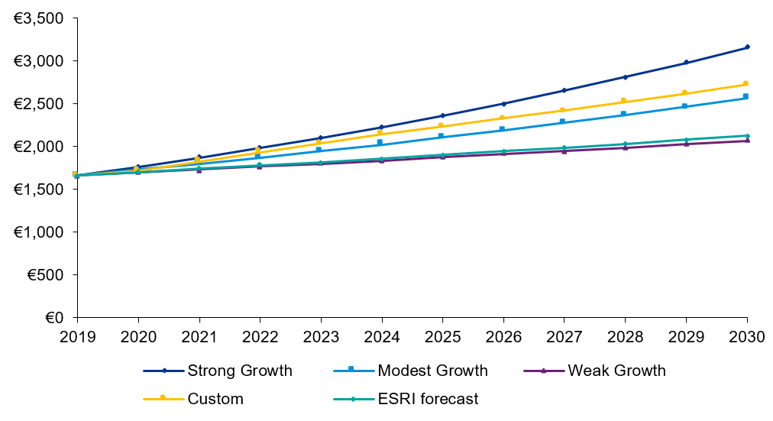

2.1.7 Additional HNDA Elements – Composition and Dwelling Type
KPMG Future Analytics have also carried out additional research and modelling for Dublin City to meet further requirements of the HNDA which are not currently dealt with in the HNDA Toolkit. This includes elements included in the December 2020 updated version of the ‘Sustainable Urban Housing: Design Standards for New Apartments’ Section 28 Guidelines. In particular, these Guidelines include two Specific Planning Policy Requirements (SPPRs) relevant to the HNDA:
- SPPR 1 allows a local authority development plan to specify a dwelling size mix for apartment and other housing developments, where supported by a HNDA.
- SPPR 9 introduces a presumption against granting planning permission for shared accommodation/co-living developments unless the development is “required to meet specific demand identified” by a HNDA process.
To examine these elements in the absence of specific treatment of dwellings in the HNDA Toolkit, KPMG Future Analytics have examined historic trends on dwelling type and household size from previous Censuses for Dublin City to project potential changes in household and dwelling compositions. This makes use of historic intercensal trends to apply a projection to Census 2016 household composition and dwelling type rates.
There are two limitations that must be noted for this approach. Firstly, these represent a continuation of historic trends and are a ‘policy-off’ approach that may not reflect subsequent policy choices and market dynamics. Furthermore, previous Censuses did not measure bedrooms per household (as distinct from other rooms). As such, there is no comprehensive profile of the number of bedrooms per dwelling in Dublin City to project forward or to otherwise more accurately address SPPR 1, and data on household composition (persons per household) has been used as a proxy. This allows a qualitative assessment of potential household sizes that future stock will need to address.
Finally, it should be noted that the Guidelines and SPPR 9 do not specifically define the type of demand for co-living that the HNDA may identify. The previous 2018 ‘Design Standards for New Apartments’ Guidelines refer to demand for co-living primarily in terms of accommodation needs in particular employment sectors and locations rather than demographic need. As a highly site- and sector-specific assessment is beyond the scope of this HNDA, KPMG Future Analytics have considered one-person households and private rented sector need as the main indicators of demand for this type of accommodation.

2.1.8 Other Modifications and Changes
KPMG Future Analytics have made use of the most recently available version of the Toolkit, obtained in June 2021. Technical changes were made to the Toolkit to fix formula issues in the model to allow calculation of custom scenarios, as the unamended version would not otherwise read custom scenarios correctly. Changes were also made to ensure consistency in how the model applies custom projections for income, rents, and sales prices for each year, which were calculated on an inconsistent basis in the original model. A technical fix was applied to ensure that the custom ‘existing need’ figure for DCC was wholly assigned to social housing and not partially run through the affordability assessment as in the unamended model. Some issues in aligning years to the plan period correctly were also addressed. The model ‘start year’ was set to 2020 (as per the default), as a later start year does not project baseline (2019) values for interim years.
A technical note has been prepared separately that provides greater detail on the issues identified and the technical fixes applied for the Dublin City HNDA. This note is intended to constructively inform the further refinement and development of the HNDA Toolkit and will accordingly be shared with the DHLGH.

3.0 HNDA Outputs
This section summarises the outputs of the HNDA modelling carried out for Dublin City using the HNDA Toolkit (incorporating the custom variations set out in Section 2). The Toolkit outputs show potential need for housing across tenures (ownership, private rental, social rental, and ‘affordability constrained’).
Throughout this section, data has been given for the period of the Dublin City Development Plan 2022-2028, with some data presented for future periods for context. As the Plan is currently due to come into force in late 2022, and in order to align with the Housing Supply Target methodology, for this HNDA the plan period has been rounded up to the nearest quarter (Q1 2023) and is presented as the full six calendar years 2023 to 2028. All results presented have been rounded to the nearest whole number to remove any decimalisation of people or households.

3.1 Future Population
While the HNDA Toolkit does not directly model population, it includes updated population and household projections produced by the ESRI as a key evidence base (originally published by the ESRI in December 2020 ). Population projections under the four scenarios modelled by the ESRI are included for each local authority in supplementary material released by DHLGH. The four scenarios are:
- Baseline: net international migration nationally declines linearly from +33,700 in 2019 to +15,000 by 2024 and remains constant thereafter;
- 50:50 city: 50% of population nationally growth between 2016 and 2040 in Eastern/Midlands region and additional population growth focused on major cities within each region, aligning with the NPF;
- High migration: net international migration of nationally +30,000 in 2020 and remaining constant thereafter;
- Low migration: net internal migration nationally drops to +5,000 by 2022 and adjusts towards baseline scenario over following five years.
Population projections for Dublin City are presented in Table 3.1 below up to 2031 (a key milestone year in the National Planning Framework), with baseline population for 2016 included:

Table 3-1: Population Projections for Dublin City, 2020-2031
Year | Baseline | 50:50 City | High Migration | Low Migration
2016 (Actual) | 554,554 | 554,554 | 554,554 | 554,554
2020 | 592,234 | 593,120 | 592,020 | 587,786
2021 | 599,612 | 600,654 | 599,720 | 591,141
2022 | 605,998 | 607,165 | 606,984 | 593,964
2023 | 611,537 | 612,793 | 613,969 | 597,278
2024 | 616,152 | 617,459 | 620,604 | 601,019
2025 | 620,145 | 621,464 | 627,211 | 604,674
2026 | 623,725 | 625,023 | 633,465 | 607,937
2027 | 626,921 | 628,163 | 639,394 | 610,850
2028 | 629,863 | 631,010 | 645,121 | 613,564
2029 | 632,548 | 633,562 | 650,639 | 616,064
2030 | 635,111 | 635,949 | 656,072 | 618,485
2031 | 637,448 | 638,068 | 661,310 | 620,756
Source: DHLGH HNDA Tool Data Source List.

3.2 Future Households – Structural Household Projections
The HNDA Tool incorporates household projections produced at county and local authority level by the ESRI (alongside the population projections described above) in December 2020. There are five scenarios inbuilt into the tool which form a basis for the calculation of housing need across all tenures:
- Convergence: based on ESRI 50:50 City Scenario and incorporating unmet demand in years 2017-2019 inclusive over the period 2020-2031.
- Baseline
- 50:50 city
- High migration
- Low migration
The additional, newly-formed households forecast under these scenarios form the structural housing demand for Dublin City over the plan period and beyond and are shown in Table 3.2 below. The figures presented in this table do not include the existing unmet need of 3,905 subsequently inputted into the HNDA Tool.
Table 3-2: Forecast Additional Households Per Annum
Year | Convergence | Baseline | 50:50 City | High Migration | Low Migration
2020 | 5,515 | 4,504 | 4,573 | 4,428 | 2,929
2021 | 5,295 | 4,333 | 4,391 | 4,446 | 2,886
2022 | 4,926 | 4,039 | 4,085 | 4,350 | 2,737
2023 | 4,666 | 3,838 | 3,870 | 4,354 | 3,002
2024 | 4,320 | 3,564 | 3,582 | 4,293 | 3,223
2025 | 3,970 | 3,289 | 3,292 | 4,237 | 3,159
2026 | 3,941 | 3,278 | 3,268 | 4,252 | 3,176
2027 | 3,912 | 3,267 | 3,244 | 4,264 | 3,191
2028 | 4,067 | 3,408 | 3,372 | 4,423 | 3,356
2029 | 4,009 | 3,374 | 3,325 | 4,403 | 3,338
2030 | 4,047 | 3,419 | 3,356 | 4,459 | 3,396
2031 | 4,025 | 3,415 | 3,338 | 4,460 | 3,404

3.3 Forecast Household Incomes
As set out in Section 2.1.4 previously, KPMG Future Analytics have applied a custom scenario for household income rises in the HNDA (based on a review of historic data and recent economic forecasts), with a forecast rise in incomes of 4.4% in 2021 and gradually falling to an annual increase of 2.6% by 2026. As a result, forecast incomes across the income spectrum are forecast to grow strongly over the HNDA period, with median incomes in Dublin City growing from a baseline of €50,869 in 2019 to €67,788 in 2028.
Table 3-3: Forecast Household Incomes in Dublin City, 2019-2028
Year | Median Income | 75th Percentile Income | 25th Percentile Income
2019 | €50,869 | €88,760 | €27,583
2020 | €52,598 | €91,778 | €28,521
2021 | €54,913 | €95,816 | €29,776
2022 | €57,384 | €100,128 | €31,116
2023 | €59,507 | €103,832 | €32,267
2024 | €61,173 | €106,740 | €33,171
2025 | €62,764 | €109,515 | €34,033
2026 | €64,396 | €112,362 | €34,918
2027 | €66,070 | €115,284 | €35,826
2028 | €67,788 | €118,281 | €36,757

3.4 Forecast Property Prices
As set out in Section 2.1.4 previously, KPMG Future Analytics have applied a custom scenario for property sales prices in the HNDA, with a forecast price rise of 4.27% in 2021 gradually falling to an annual increase of 2% by 2030. Table 3.4 below shows how mean, median and 25th percentile (i.e. the price of the property at the 25th percentile point on the overall sales distribution) are forecast to change over the period 2020-2028, with the median property price in Dublin City forecast to rise from €362,899 in 2020 to €476,760 in 2028.
Table 3-4: Projected Sales Prices in Dublin City, 2020-2028
Year | Mean Price | Median Price | 25th Percentile Price
2020 | € 437,868 | € 362,899 | € 279,544
2021 | € 456,574 | € 378,403 | € 291,487
2022 | € 474,837 | € 393,539 | € 303,146
2023 | € 493,831 | € 409,281 | € 315,272
2024 | € 511,115 | € 423,605 | € 326,307
2025 | € 529,004 | € 438,432 | € 337,727
2026 | € 544,874 | € 451,585 | € 347,859
2027 | € 561,220 | € 465,132 | € 358,295
2028 | € 575,251 | € 476,760 | € 367,252

3.5 Rental Forecasts
As set out in Section 2.1.5 previously, KPMG Future Analytics have applied a custom scenario for rents in the HNDA, with a forecast of median rent increases of 6.2% in 2021 (based on analysis of historic rent growth in recent years) and gradual slowing of growth to 4% in 2026 onwards (based on Rent Pressure Zone caps). While this gives a higher growth rate than the HNDA Tool default (ESRI forecast of 2.25%), this reflects recent historic trends in Dublin City. Table 3.5 and Figure 3.1 below show the projected rise in median weekly rents over the period 2020-2028.
Table 3-5: Projected Median Rents in Dublin City, 2020-2028
 | 2020 | 2021 | 2022 | 2023 | 2024 | 2025 | 2026 | 2027 | 2028
Median rent - weekly | €411 | €437 | €463 | €489 | €513 | €536 | €558 | €580 | €603

Figure 3-1: Projected Median Weekly Rents, 2020-2028
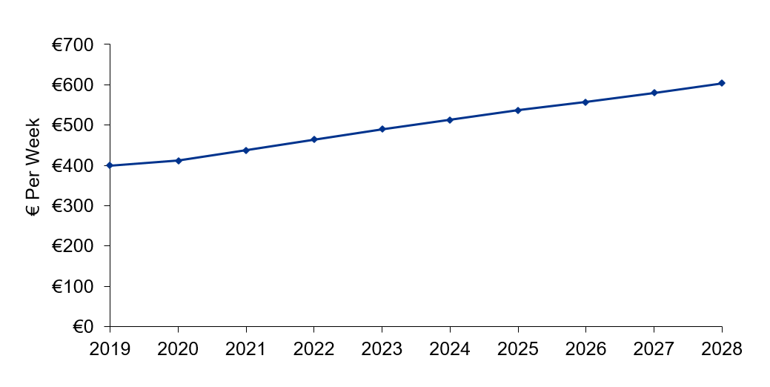

3.6 Total Forecast Housing Need
The total housing need figure over the plan period used in the HNDA is a combination of a household projection scenario (in this case the Convergence scenario) and an estimate of existing unmet housing need, as discussed in Section 2.1.2. This estimate of unmet need includes an estimate of overcrowded households from the 2016 Census (1,929 households in Dublin City) combined with existing homeless households. DCC and the Dublin Region Homeless Executive have provided a total figure of 1,976 homeless households as of June 2021. This results in a combined unmet need of 3,905 households. As discussed in Section 2.1.2, the assumption included in the HNDA Tool is that this need will be cleared over 10 years, and thus is equally distributed over the years 2020 (model start year) to 2030. As a result, 2,343 households are classified as existing need falling within the plan period (9.4% of total housing need over the period). For the purposes of the tenure assessment in Section 3.7 below, these households have all been classified as social housing need.
Table 3.6 below shows the total housing need for Dublin City over the plan period, combining structural housing demand forecasts (the Convergence scenario) and existing need:
Table 3-6: Total Annual Housing Need, 2023-2028
 | 2023 | 2024 | 2025 | 2026 | 2027 | 2028 | Total
Total Housing Need | 5,057 | 4,710 | 4,361 | 4,332 | 4,303 | 4,457 | 27,219
Convergence Projections | 4,666 | 4,320 | 3,970 | 3,941 | 3,912 | 4,067 | 24,876
Existing need | 391 | 391 | 391 | 391 | 391 | 391 | 2,343

3.7 HNDA Outputs: Housing Need by Tenure
Based on the application of the additional anticipated households in the HNDA model and the scenarios for existing need, incomes, affordability criteria, house prices, and rental prices as described in Section 2, the HNDA Tool calculates total housing need for each year and how many forecast households can afford to purchase homes in the private market. Of those who cannot, it calculates how many can afford to rent privately, how many require social housing, and how many are ‘affordability constrained’ and require a form of affordable housing tenures (such as Cost Rental or affordable purchase).
The following tables summarise this estimate of housing need across all tenures. Over the six-year plan period of 2023-2028, there is an estimated need for 10,247 social homes in Dublin City (37.6%% of the total, of which 2,343 comprise existing unmet need as described in the previous section), as well as 7,887 affordable homes (29% of the total); 4,997 households (18.4%) are estimated to be able to access private ownership in Dublin City, while 4,088 households (15%) are estimated to be able to meet their needs in the private rental market.
Table 3-7: Estimated Housing Need by Tenure, 2023-2028 (Households)
Tenure | 2023 | 2024 | 2025 | 2026 | 2027 | 2028 | Total
Social Rent | 2,024 | 1,816 | 1,661 | 1,612 | 1,564 | 1,570 | 10,247
Affordability Constraint | 1,306 | 1,296 | 1,231 | 1,301 | 1,330 | 1,423 | 7,887
Private Rented | 777 | 719 | 661 | 639 | 633 | 659 | 4,088
Buyers | 950 | 879 | 808 | 780 | 775 | 805 | 4,997
Total Housing Need | 5,057 | 4,710 | 4,361 | 4,332 | 4,303 | 4,457 | 27,219

Table 3-8: Estimated Housing Need by Tenure, 2023-2028 (%)
Tenure | 2023 | 2024 | 2025 | 2026 | 2027 | 2028 | 2023-2028
Social Rent | 40.0% | 38.6% | 38.1% | 37.2% | 36.3% | 35.2% | 37.6%
Affordability Constraint | 25.8% | 27.5% | 28.2% | 30.0% | 30.9% | 31.9% | 29.0%
Private Rented | 15.4% | 15.3% | 15.2% | 14.7% | 14.7% | 14.8% | 15.0%
Buyers | 18.8% | 18.7% | 18.5% | 18.0% | 18.0% | 18.1% | 18.4%

Figure 3.2 and Figure 3.3 below illustrate the estimate of housing needs by tenure over the plan period.
This shows that the need for social housing remains high over the plan period but declines steadily from 40% in 2023 to 35.2% in 2028, reflecting the effect of housing incomes in lower income cohorts rising above the social housing upper income threshold. By contrast, the ‘affordability constraint’ estimate grows steadily over the same time from 25.8% in 2023 to 31.9% in 2028. This suggests a growing cohort above the eligibility threshold for social housing who cannot afford housing in the private market. The estimated proportions of those who can afford to buy or to privately rent remain relatively stable over the plan period, marginally declining by less than a percentage point.
Figure 3-2: Projected Housing Need in Dublin City by Tenure, 2023-2028
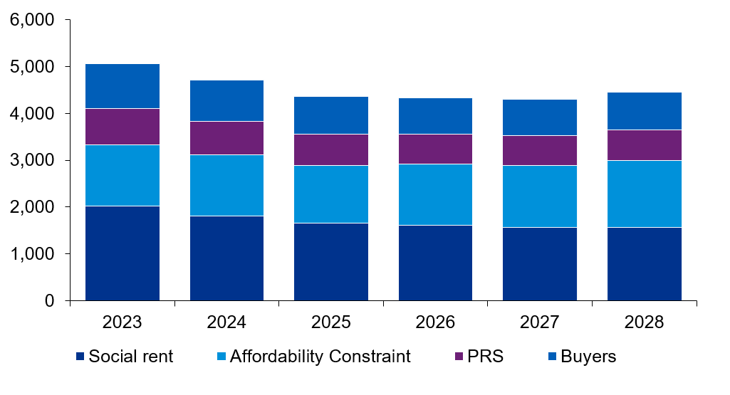
Figure 3-3: Projected Housing Need by Tenure – Annual Distribution, 2023-2028
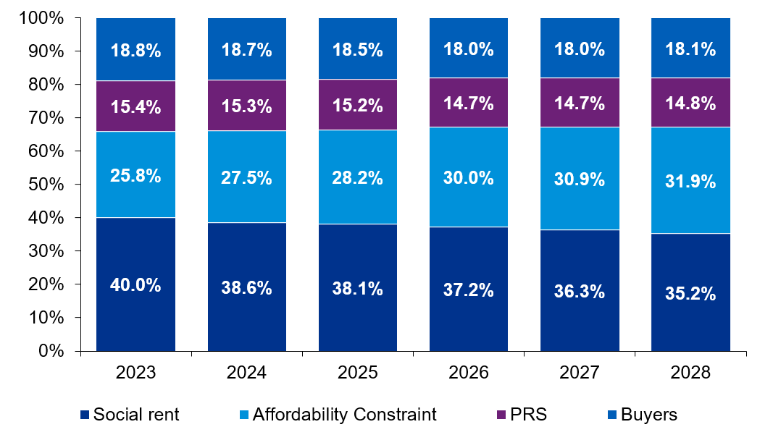

3.8 Additional HNDA Elements – Household Composition
Analysis of historic Census data over the period 2002-2016 for DCC of the composition of households has been undertaken to understand the dynamics of change over time and estimate how this may change into the future. Table 3.9 below shows household size composition for DCC for each Census between 2002 and 2016. Compared to the State as a whole in 2016, Dublin City had a higher proportion of one-person households (28.3% compared to 23.5% nationally) and two-person households (32% compared to 28.6% nationally), and a lower proportion of four-person households (13.2% compared to 16.9% nationally) and five+ person households (9.4% compared to 13.5% nationally).
Table 3-9: Historic Household Composition in Dublin City, 2002-2016
Persons Per Household | 2002 | 2006 | 2011 | 2016 | 2002 | 2006 | 2011 | 2016
1 person | 52,517 | 55,957 | 63,795 | 60,001 | 29.0% | 29.3% | 30.7% | 28.3%
2 persons | 51,644 | 58,295 | 66,684 | 67,707 | 28.6% | 30.5% | 32.1% | 32.0%
3 persons | 30,086 | 32,144 | 34,557 | 36,277 | 16.6% | 16.8% | 16.6% | 17.1%
4 persons | 24,607 | 24,956 | 24,979 | 27,943 | 13.6% | 13.1% | 12.0% | 13.2%
5+ persons | 21,998 | 19,501 | 17,993 | 19,819 | 12.2% | 10.2% | 8.7% | 9.4%
Total | 180,852 | 190,853 | 208,008 | 211,747

Table 3.10 below indicates the percentage change for each household size cohort in Dublin City between each of the four Censuses examined. The intercensal average for this period has been used to determine a trended annual average change in household composition as set out in Table 3.10 and Table 3.11 below. This trend is then applied forward for DCC from 2016 to 2028 to provide a forecast for the plan period, as presented in Figure 3.4.

Table 3-10: Historic Household Composition Change in Dublin City, 2002-2016
 | Change % |  |  | Average Change %
Persons Per Household | 2002-2006 | 2006-2011 | 2011-2016 | Intercensal Avg. | Annual Avg.
1 person | 0.3% | 1.4% | -2.3% | -0.2% | -0.05%
2 persons | 2.0% | 1.5% | -0.1% | 1.1% | 0.23%
3 persons | 0.2% | -0.2% | 0.5% | 0.2% | 0.03%
4 persons | -0.5% | -1.1% | 1.2% | -0.1% | -0.03%
5+ persons | -1.9% | -1.6% | 0.7% | -0.9% | -0.19%

Table 3-11: Forecasted Annual Change in Household Size Cohorts in DCC
Annual Change | 1-person household | 2-person household | 3-person household | 4-person household | 5+ person household
Dublin City | -0.05% | 0.23% | 0.03% | -0.03% | -0.19%

Based on the identified intercensal changes, DCC sees a reduction in one- and four- person households at a relatively slow rate and five+ person households at a much higher rate. Two- and three- person households are on an upward trend with two- person households increasing at the highest rate (0.23% per annum). The composition forecast for DCC is illustrated in Figure 3.4 below.
Figure 3-4: Forecast Household Composition over the Plan Period
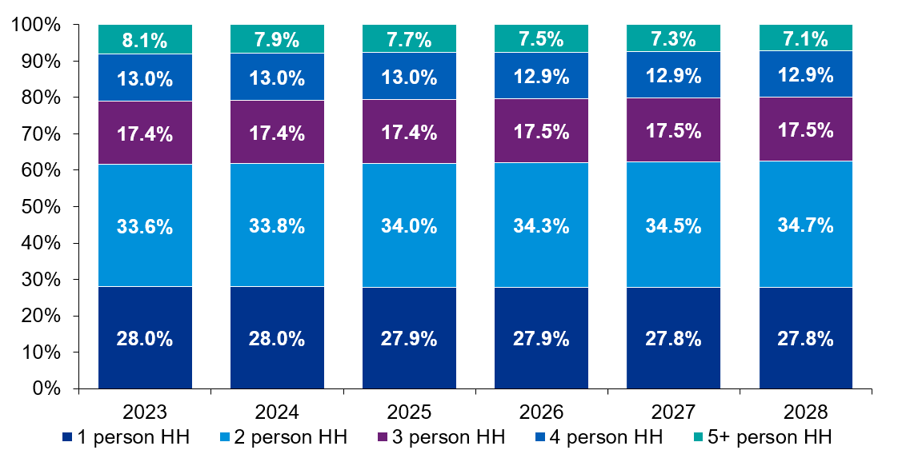
As noted previously, the 2016 Census did not differentiate between bedrooms and all other rooms, and as a result it is not possible to obtain a full dwelling size mix for Dublin City.
To gain a further understanding of household size and composition and how it may relate to the dwelling stock, Census data has been examined on the number of rooms per household in 2016. This data is contextual and does not solely indicate bedrooms. Census respondents were instructed not to count bathrooms, toilets, kitchenettes, utility rooms, consulting rooms, offices, shops, halls or landings, or rooms that can only be used for storage such as cupboards – these are therefore not included in the data below. They were instructed to count all other rooms such as kitchens, living rooms, bedrooms, conservatories, and studies. The data in Table 3.12 and Figure 3.5 below indicate that households in Dublin City are fairly evenly distributed across the room number categories; however, households tended to have access to less rooms than the national average, with an average of 4.3 rooms per household in Dublin City compared to 5.4 for the State overall.
Table 3-12: Households by Number of Rooms in Dublin City, 2016
Number of rooms | DCC | DCC
1 room | 11,337 | 5.4%
2 rooms | 26,105 | 12.3%
3 rooms | 31,446 | 14.9%
4 rooms | 31,796 | 15.0%
5 rooms | 39,358 | 18.6%
6 rooms | 28,889 | 13.7%
7 rooms | 13,698 | 6.5%
8 or more rooms | 11,370 | 5.4%
Not stated | 17,592 | 8.3%
Total | 211,591 | 100.0%

Figure 3-5: Households by Number of Rooms in Dublin City, 2016
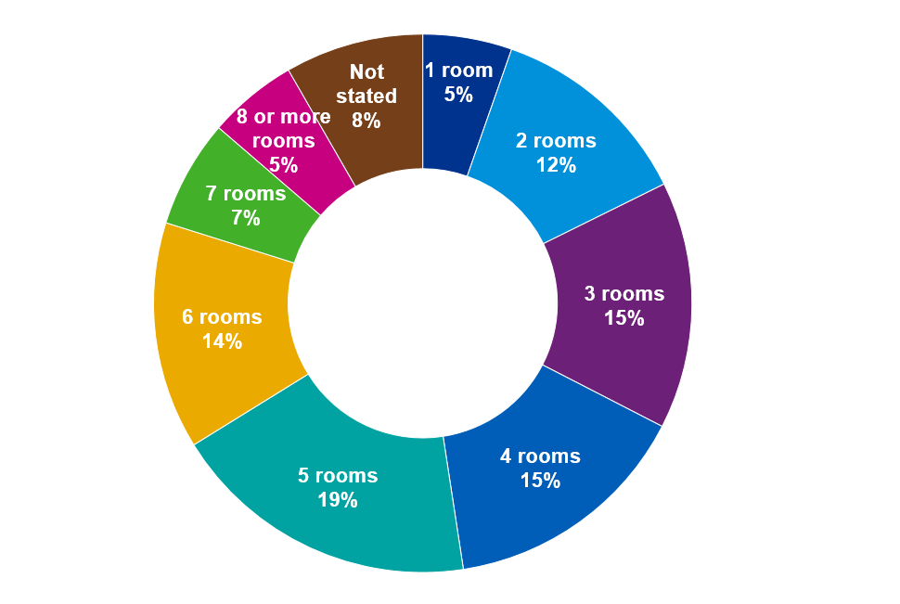

3.9 Additional HNDA Elements – Dwelling Type
Analysis of historic intercensal data on private household dwelling type has been undertaken to understand unit-mix dynamics and estimate how they may change over time. Specifically, the intercensal average has been used to determine a trended annual average change in dwelling type mix. It should be noted that estimated trends do not account for ‘bed-sits’ or ‘not stated’ dwelling types as categorised by the Census. Therefore, forecasts for house/bungalow, flat/apartment and caravan/mobile homes are set out from 2023 to 2028 with the intercensal average determined from a reduced sample size. The historic composition of the dwelling stock is presented in Table 3.13 below. This demonstrates a steady and consistent trend in Dublin City for apartments and flats comprising a growing proportion of the dwelling stock.

Table 3-13: Households by Dwelling Type in Dublin City, 2006-2016
Households | 2006 | 2011 | 2016 | 2006 | 2011 | 2016
House/Bungalow | 125,357 | 133,014 | 133,709 | 69.7% | 67.0% | 64.8%
Flat/Apartment | 54,329 | 65,497 | 72,526 | 30.2% | 33.0% | 35.1%
Caravan/Mobile Home | 273 | 161 | 156 | 0.2% | 0.1% | 0.1%
Total (incl. Not Stated) | 190,984 | 208,008 | 211,747

The annual average change in dwelling type in DCC is set out in Table 3.14 below. The annual average forms the basis of the forecast for the plan period.
Table 3-14: Historic Dwelling Type Change in Dublin City 2006-2016
Persons Per Household | Change % |  | Average Change %
 | 06-11 | 11-16 | Intercensal Avg. | Annual Avg.
House/Bungalow | -2.7% | -2.2% | -2.4% | -0.49%
Flat/Apartment | 2.8% | 2.2% | 2.5% | 0.50%
Caravan/Mobile Home | -0.1% | 0.0% | 0.0% | -0.01%

Table 3-15: Forecast change in dwelling type for households
Annual Change | House/Bungalow | Flat/Apartment | Caravan/Mobile Home
Dublin City | -0.49% | 0.50% | -0.01%

Figure 3.6 illustrates the forecast distribution by dwelling type for the plan period. It should be noted that these are an approximate continuation of observed trends from 2016 to the end of the plan period as influenced by the market dynamics during that historic period and it is noted that external market factors can influence the future dynamics in relation to unit mix and dwelling type throughout the strategy period. The graph presented is based on a continuation of recent historic trends assigned to the additional anticipated households.
It should also be noted that “caravan/mobile home” is not visible on these graphs as it represents a very small portion of the housing stock and due to the forecast estimating that they will either no longer be present in DCC or constitute less than 0.03% of all dwellings by the plan period.
Based on the identified intercensal changes, DCC overall sees an increase in apartment type dwellings and an almost equal reduction in house type dwellings. By the end of the plan period this trend would see just over 40% off all dwellings in DCC being apartments. It should be highlighted that duplex units are classified as apartments, which could indicate that not all new apartments would necessarily be in higher-density blocks.
Figure 3-6: Forecast Dwelling Type Distribution 2023-2028 in Dublin City
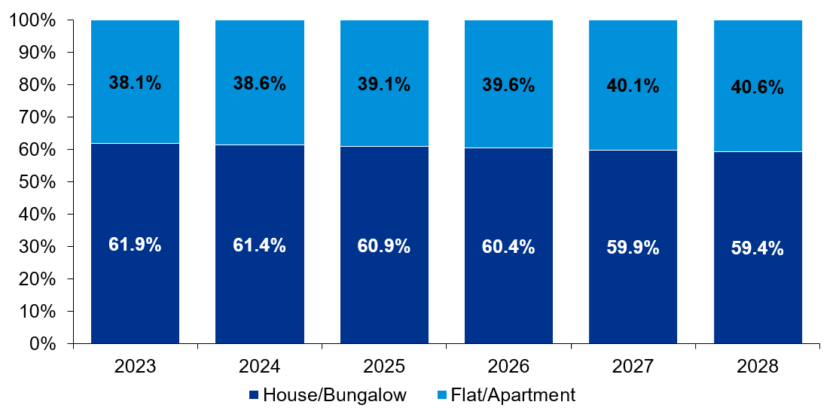

4.0 Conclusion
The HNDA for the Dublin City Development Plan 2022-2028 forecasts that housing need in the Dublin City administrative area will comprise 27,219 households over the plan period. This includes 10,247 social rented households (of which 2,343 comprises existing need that is estimated to be met within the plan period, made up of 1,157 estimated overcrowded households based on Census 2016 and 1,186 of the homeless households on the DCC social housing waiting list as of June 2021), 4,997 households in the owner-occupied sector, 4,088 in the private rented sector, and 7,887 ‘affordability constrained’ households who are ineligible for social housing but face affordability challenges in the private market.
Table 4-1: Estimated Housing Need by Tenure, 2023-2028 (%)
Tenure | 2023 | 2024 | 2025 | 2026 | 2027 | 2028 | Total
Social Rent | 2,024 | 1,816 | 1,661 | 1,612 | 1,564 | 1,570 | 10,247
Affordability Constraint | 1,306 | 1,296 | 1,231 | 1,301 | 1,330 | 1,423 | 7,887
Private Rented | 777 | 719 | 661 | 639 | 633 | 659 | 4,088
Buyers | 950 | 879 | 808 | 780 | 775 | 805 | 4,997
Total Housing Need | 5,057 | 4,710 | 4,361 | 4,332 | 4,303 | 4,457 | 27,219

This represents a relatively high need for social and affordable housing over the plan period. This is driven by several factors; it in part reflects high existing property prices and rents in Dublin City, as measured by 2019 baseline data. Although household incomes in Dublin City are relatively high by national standards, high housing costs result in relatively high numbers of households facing affordability challenges. As forecast rents in this HNDA are estimated to grow at a slightly faster pace than incomes, and as household incomes in lower deciles rise above the eligibility limits for social housing, the ‘affordability constraint sector’ is as a result forecast to grow over the plan period.
The estimated social housing need of 9,987 also comprises 2,343 estimated existing households with unmet needs (those in overcrowded accommodation and homelessness) whose needs are estimated to be met within the plan period, with the remainder comprising forecasted new households. It should be noted also that only a portion of the existing social housing needs assessment for Dublin City Council is included in the model as unmet need (plus an estimate of overcrowding), with only those classed as homeless included.
This is due to the requirements of the HNDA Guidance and the December 2020 Guidelines on the Housing Supply Target Methodology. The HNDA Tool does not account for additional existing social housing need that may not be met by the commencement of the plan period.
It should be noted that according to the DHLGH, the HNDA Tool is intended to “give broad, long-run estimates of what future housing need might be, rather than precision estimates.” It offers ‘policy-off’ forecasts with its outputs subject to the inputs, scenarios, and assumptions built into the model and set out in this report. The HNDA as a result identifies potential issues and pressures in the housing market. This will allow Dublin City Council to formulate housing and planning policy to meet current and future housing need in Dublin City.

4.1 Additional HNDA Elements and Implications
KPMG Future Analytics’ additional demographic analysis based on historic trends indicates a forecast gradual decline in the proportion of 1-person, 4-person, and 5+ person households and an increase in the proportion of 2-person and 3-person households. It would be therefore appropriate for the Dublin City Development Plan 2022-2028 to plan for a dwelling mix appropriate to future household need and wider policy goals of securing a broad mix of housing types and sizes.
SPPR 9 of the December 2020 ‘Sustainable Urban Housing: Design Standards for New Apartments’ guidelines introduces a presumption against granting permission for shared accommodation/co-living development unless required to meet specific demand identified in the HNDA. The following considerations may inform the approach of the Dublin City Development Plan 2022-2028 to co-living/shared accommodation:
- This HNDA has indicated a relatively strong need in the ‘affordability constraint’ tenure category compared to the private rented sector, indicating that proportion of households who would be both reliant on and able to sustainably afford the private rental sector is relatively low.
- Forecast household composition indicates a slight decline in the proportion of one-person households, which may be considered the principle target household type for co-living.
- The Minister’s foreword to the 2020 Guidelines indicates that “given the scale, location and potential impact of co-living development permitted to date… there are sufficient shared accommodation/co-living units either permitted or subject to consideration within the planning system” to demonstrate the concept and support the presumption against the granting of planning permission for co-living development.
Accordingly, the results of this HNDA analysis do not indicate a strong or specific demand for shared accommodation/co-living in Dublin City and it may be appropriate for the Dublin City Development Plan 2022-2028 to continue the presumption against shared accommodation/co-living development.

Glossary
25th/75th percentile In a data set ranked by value, these represent the value at which 25%/75% of data points lie below that value.
DHLGH Department of Housing, Local Government and Heritage.
DRHE Dublin Regional Homeless Executive – the shared body for providing statutory homelessness services in the four Dublin Local Authorities.
ESRI Economic and Social Research Institute.
HNDA Housing Need and Demand Assessment – an assessment of existing and forecast housing need in a local authority as required by the National Planning Framework.
Housing Supply Target A calculation of housing need for a local authority for a six-year development plan period, following a methodology set out in Section 28 Guidelines in December 2020.
Mean The average or central value of a set of numbers.
Median In a data set ranked by value, the value separating the upper half from the lower half of the data set (the midpoint or middle value).
NPF National Planning Framework (2018)
Section 28 Guidelines Guidelines for Local Authorities on planning policy issued by the Minister for Housing under Section 28 of the Planning and Development Act 2000 (as amended), which Local Authorities must have regard to in carrying out their planning functions.
SPPR Specific Planning Policy Requirement – a policy set out in Section 28 Guidelines which local authorities also must have regard to in carrying out their planning functions.

Dublin City Development Plan 2022-2028

Annex 2 to Appendix 1: Dublin City Housing Supply Target Methodology

PAGE LEFT INTENTIONALLY BLANK

Scenario 1: Baseline Scenario (As-is):
Worked Example of Section 28 Guidelines Table 1 - Assuming Plan Period of 6 years covering Q1 2023 – Q4 2028 Inclusive
 |  | DCC | Total Households | Number of Relevant Years | Annual Average Households
PART 1 | A | ESRI NPF scenario projected new household demand 2017 to end Q4 2028 | 47,941 | 12 | 3,995
 | - | ESRI Baseline scenario projected new household demand 2017 to end Q4 2028 | 47,534 | - | -
 | B | Actual new housing supply 2017 to end Q4 2022 (actual to Q4 2020 and estimated 2021 and 2022 Q1-Q4; no COVID impact) | 11,708 | 6 | 1,951
 | C | Homeless households (latest data), and unmet demand as at most recent Census - DCC Approved values - 23.06.2021 | 3,905 | - | -
 | D | Plan Housing Demand = Total (A-B+C), (Projected ESRI NPF demand - new completions) = Unmet demand | 40,138 | 6 | 6,690
PART 2 | E | Potential adjustment 1 to end 2026 portion of plan period to facilitate convergence to NPF strategy (where justified) | Adjusted Total Demand | - | Mid-point between ESRI NPF and baseline scenarios to Q3 2028 in lieu of A above
 | E1 | ESRI Baseline scenario projected new household demand 2017, to Q4 2026 | 40,859 | 10 | 4,086
 | E2 | ESRI NPF scenario projected new household demand 2027 - Q4 2028 | 6,617 | 2 | -
 | E3 | Mid-point between ESRI NPF (A - E2) and baseline scenarios to Q4 2026 (E1) | 41,092 | 10 | 4,109
 | E4 | Adjusted Total Demand calculation based on E2 + E3 in lieu of A above... (E2+E3-B)+C | 39,905 | 6 | 6,651
PART 3 | F | Potential adjustment 2 (plus 25%) to end 2026 is not applicable for DCC because B (actual housing supply 2017-2020) does not exceed or close to D (plan period housing demand) | Mid-point between ESRI PF and baseline scenarios to 2026 in lieu of A above, plus up to 25% | - | Adjusted Total Demand
 | F1 | E3 + 25% | 51,365 | 10 | 5,137
 | F2 | Remainder plan period demand to Q4 2028 | 6,617 | - | -
 | F3 | Adjusted Total Plan Demand calculation based on E3 in lieu of A above and F1+F2 ... (F1+F2-B)+C | 50,178 | 6 | 8,363

NOTES:
PART 1 - this determines the housing requirement over the Development Plan period.
PART 2 - this determines the housing requirement over the Development Plan period to facilitate convergence to NPF strategy.
PART 3 - this determines the housing requirement over the Development Plan period to facilitate convergence to NPF strategy and to include an additional 25% provision of units where justified.

PAGE LEFT INTENTIONALLY BLANK

Dublin City Development Plan 2022-2028

Annex 3 to Appendix 1: Dublin City Sub-City HNDA

PAGE LEFT INTENTIONALLY BLANK

1.0 Introduction

1.1 Overview
This report sets out the supplementary Housing Need and Demand Assessment (HNDA) modelling prepared by KPMG Future Analytics on the behalf of Dublin City Council to inform the Dublin City Development Plan 2022-2028. This analysis complements and builds on the full HNDA modelling and analysis carried out for Dublin City using the Department of Housing, Local Government and Heritage’s (DHLGH’s) HNDA Toolkit by providing additional analysis at a local, sub-city level.
The National Planning Framework (NPF) requires each local authority to develop a Housing Need and Demand Assessment (HNDA) which must outline existing and future housing need and underpin and support the preparation of housing strategies and housing policy. KPMG Future Analytics have applied the DHLGH HNDA Toolkit for Dublin City to fulfil this requirement for the Dublin City Development Plan 2022-2028.
However, the HNDA Toolkit does not at present allow for modelling below local authority level. Dublin City forms a unique housing market area with strong local variation and high existing and forecast future demand for housing. National, regional, and local planning policy places a strong emphasis on the crucial social and economic role of Dublin City, including the role of housing delivery and regeneration in the existing inner city. This presents a complex challenge for spatial planning.
In order to assist Dublin City Council in planning for homes and communities in the Dublin City Development Plan 2022-2028, KPMG Future Analytics have carried out additional sub-city HNDA modelling. This modelling focuses on two inner-city areas, broadly capturing Dublin 1 and Dublin 8 (based on custom area definitions provided by Dublin City Council), with Dublin City as a whole also examined for comparison purposes only. This analysis captures the complex housing market dynamics and specific housing needs of the Liberties and the North Inner City.
In the absence of HNDA Toolkit modelling below local authority level, KPMG Future Analytics have developed a robust methodology and bespoke HNDA model to inform decision-making around the current and future housing supply these areas in accordance with the NPF and all other relevant statutory requirements. This approach is based on a combination of elements of the established ‘Louth Model’ affordability assessment along with additional considerations including private rental market affordability, mortgage capacity and Central Bank macro-prudential rules, and forecasts for household composition, dwelling type, and tenure.
This is intended to build on the analysis of the main Dublin City HNDA (through the Toolkit model) and further inform the Development Plan at a more granular level, as well as provide useful context for and comparison with the HNDA Toolkit outputs.

1.2 Housing Need and Demand Assessment (HNDA)
An evidence-based and future-proofed methodological approach has been adopted to ensure that the HNDA aligns with local, regional and national guidelines. Specifically, the NPF indicates that the purpose of the HNDA tool is to:
- Assist local authorities to develop long-term strategic views of housing need across all tenures.
- Provide a robust evidence base to support decisions about new housing supply, wider investment and housing related services that inform an overall national housing profile.
- Inform policies about the proportion of social and affordable housing required, including the need for different types and sizes of provision.
- Provide evidence to inform policies related to the provision of specialist housing and housing related services.
KPMG Future Analytics’ HNDA model incorporates current socio-economic data for Dublin City and projects future need over the lifetime of the Development Plan. The analysis examines household growth/housing supply targets, incomes, mortgage capacity and rental affordability, social housing and housing needs as well as tenure, type, and dwelling size using evidence-based assumptions relating to employment growth, income levels and affordability in the housing market.
The NPF states that HNDAs are designed to give broad, long run estimates of potential future housing need, rather than precision estimates. Additionally, a logical, sequential framework will allow for updating, monitoring and evaluation. The HNDA assesses three core areas: Population, Housing and Economy. The sequential steps are presented in further detail in Section 1.3.

1.3 Methodology
This Section sets out the sequential steps involved in the development and application of the KPMG Future Analytics HNDA model undertaken for the study areas. There are three components to the modelling that has been undertaken by KPMG Future Analytics on behalf of Dublin City Council as shown in Figure 1.1.
Figure 1-1: Overview of the HNDA Modelling
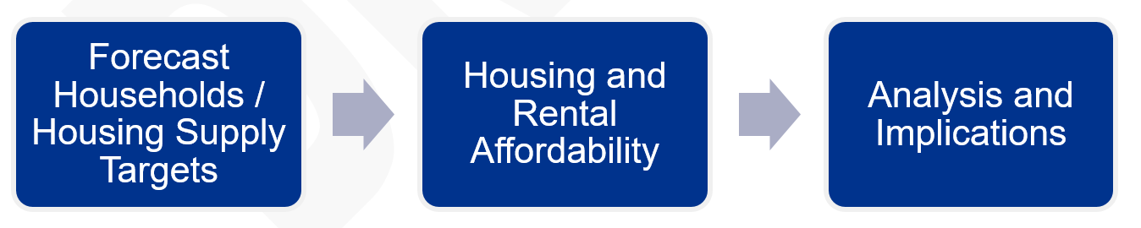
The first component of the modelling examines expected household growth. The Housing Supply Target as required by recent Departmental Guidelines under Section 28 of the Planning and Development Act 2000 (as amended) is set out for Dublin City. This provides plan period targets and annualised figures for housing demand which have been analysed in the HNDA. In addition, Dublin City Council have provided household estimates for the two sub-areas, based on information from the draft Core Strategy.
The third component relates to an assessment of housing affordability. This assessment supports the identification of social housing needs for the local authority during the plan period with the relevant information presented in Section 2.3.
Following this, analysis has been undertaken in relation to specific requirements of the additional anticipated households as set out in the NPF in relation to the existing market forces, composition, tenure, and dwelling type. This information is presented in Section 2.4.

1.3.1 Study Areas
KPMG Future Analytics have applied this analysis for two areas in Dublin City, termed ‘Dublin 1’ and ‘Dublin 8’. These areas are not entirely coterminous with postcode areas, as they are composed of Electoral Divisions (EDs) and reflect area definitions provided by Dublin City Council. These areas are used to examine housing need in the Liberties (covering the area of the Liberties Local Area Plan 2009) and the North Inner City. The two areas are shown in Figure 1.2 below.
In addition, outputs from KPMG Future Analytics’ HNDA model for Dublin City Council as a whole are presented for comparison and to inform the context of the sub-area analysis.
Figure 1-2: Dublin City HNDA Sub Areas
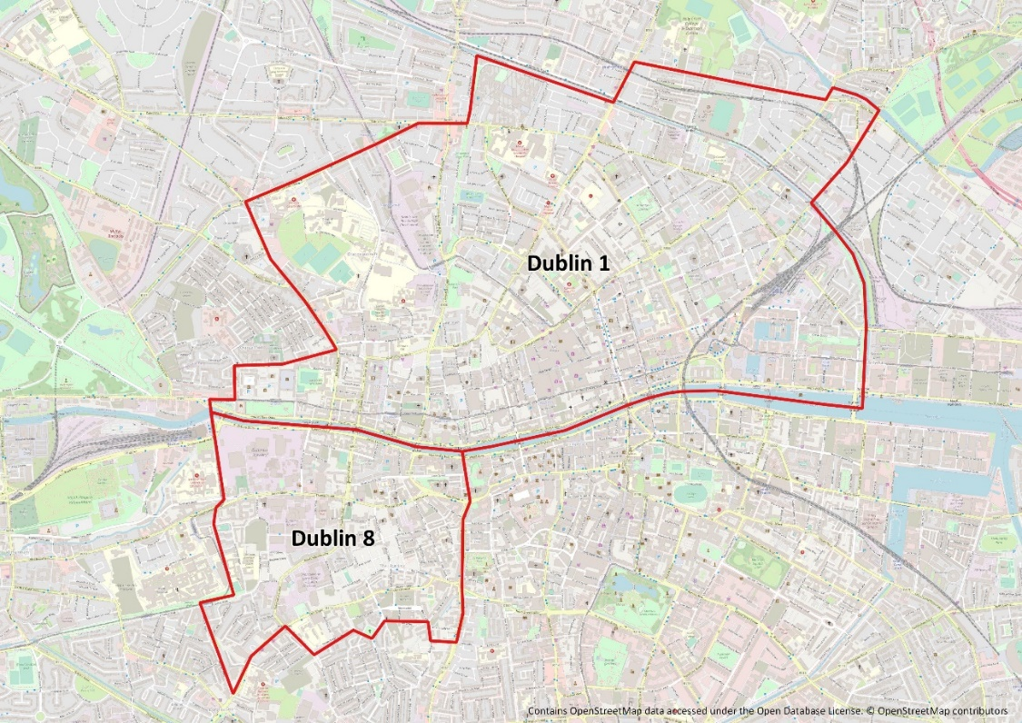

2.0 Future Housing: Projected Housing Need and Supply

2.1 Introduction
This section summarises the methodology, inputs and outputs of the Dublin City sub-area Housing Need and Demand Assessment (HNDA) which has been processed and analysed to inform the Dublin City Development Plan 2022-2028. This provides details relating to the demographic, economic and social inputs to the HNDA model and enables an estimate of forecasts of projected population and households and relative demand for housing throughout the plan period. This HNDA model and associated elements have been processed as set out in the methodology as described below in Table 2.1.
This chapter establishes the consideration and application of the demographic and market factors as part of the assessment of the future needs and demands for housing in Dublin City. Given that the Section 28 Guidelines on Housing Supply Targets as identified in Section 2.2.1 require calculation of housing demand to the nearest plan period quarters, and given the Dublin City Development Plan 2022-2028 is expected to come into force in late 2022, the start of the plan period has been rounded up to the nearest quarter (Q1 2023) and the full six calendar years 2023 Q1 to 2028 Q4 have been used for modelling purposes.

2.1.1 Methodology
An overview of the process for the HNDA modelling and relevant sections within this chapter is provided below:

Table 2-1: HNDA Methodology Components
Step | Objective | Method | Relevant Section
1 | Determination of Housing Supply Targets and Household Demand | Determination of plan period housing supply targets (HSTs)/expected sub-area households and resulting annual housing demand based on Section 28 Guidelines. | Section 2.2.1
2 | Calculation of Estimated Distribution of Household Disposable Incomes | Calculation of estimated distribution of household disposable incomes for the established deciles (by the CSO) based on weekly and annualised disposable incomes at national level and adjusted for the City based on application of an “inflator” or “deflator” rate. | Section 2.2.2 and Section 2.2.3
3 | Calculation of Average Annual Household Disposable Income Distribution | Calculation of estimated distribution of annual disposable household incomes per decile during the plan period based on the preceding step and application of a forecast GDP growth rate.
4 | Calculation of Average Monthly Household Disposable Income Distribution | Calculation of estimated distribution of monthly disposable household incomes per decile during the plan period based on the preceding step and application of a forecast GDP growth rate.
5 | Determination of Distribution of Total Anticipated Households | Calculation of the estimated distribution of household units for each decile throughout the plan period as well as the distribution of housing units in the State from the Household Budget Survey (by the CSO).
6 | Determination of Distribution of Additional Anticipated Households | Calculation of the estimated distribution of additional anticipated households annually during the plan period as well as the distribution of housing units in the State from the Household Budget Survey (by the CSO).
7 | Calculation of Projected House Price Bands | Calculation of projected house price bands based on the percentage split of the established (by the DHLGH) eight price bands and a projected annual price increase or decrease. | Section 2.2.5
8 | Calculation of Mortgage Capacity of Households | Calculation of the approximate affordable house price per decile per year based on the application of the “Annuity Formula”. This is based on the determination of an “Affordability Threshold”, a “Loan to Value Ratio”, an “Annual Percentage Rate (APR) - Interest Rate”, a “Monthly Percentage Rate (MPR) - Interest Rate”, and the determination of a “Loan Term (Years/Months)”. | Section 2.2.4
9 | Calculation of Projected Needs for Ownership | Based on the application of the “Annuity Formula”, calculate the housing affordability for each of the 10 household deciles.
10 | Calculation of Projected Needs for Private Rental | Calculation of the households that will not meet the affordability criteria to privately rent a home during the plan period with respect to the number of households that cannot qualify for a mortgage. | Section 2.2.6
11 | Calculation of Projected Social (and Affordable) Housing Need | Based on the determination of additional households required, the projected house price bands and the housing affordability, calculate the number of households not meeting the “Affordability Criteria”. This informs the necessary provision of social (and affordable) housing units within the local authority. | Section 2.3.1 and Section 2.3.2
12 | Historic Data Analysis and Approximate Projection of Tenure, Size Cohort, and Dwelling Type. | Calculation of historic intercensal change for private household tenure, cohort sizes and dwelling type to determine annualised change. This informs the basis of an annual rate of change for which additional anticipated households can be roughly forecasted for household tenure, cohort sizes and dwelling type. | Sections 2.4.1, 2.4.2 and 2.4.3.

2.2 Key Inputs: Affordability Assessment and HNDA

2.2.1 Housing Supply Targets and Future Households
This section demonstrates how the Section 28 Guidelines provided by the DHLGH have been considered as part of the assessment of future housing needs and demands.
As part of the development plan process, planning authorities must demonstrate the manner in which their plan is consistent with the NPF and established NPF Implementation Roadmap population projections for their local authority area. In December 2020, the DHLGH issued guidelines to assist planning authorities to incorporate these projections into the preparation of development plans and housing strategies in a consistent and coherent approach.
These Guidelines build on research undertaken by the Economic and Social Research Institute (ESRI) into regional demographics and structural housing demand at county level. The ESRI’s research applies a projection model to four different development scenarios, including the ‘NPF 50:50 City Scenario.’ The Section 28 Guidelines indicate that this is the recommended housing demand scenario to be used by local authorities to plan for the provision of housing to meet projected levels of demand.
Thus, planning authorities must now demonstrate how their development plans are consistent with the NPF 50:50 City housing demand projection scenario identified by the ESRI.
The Guidelines set a methodology for the application of recommended population and housing projections into Local Authority plan processes. Dublin City Council have approved calculations of these targets to be applied in the City-wide HNDA comparison by KPMG FA. Through this calculation, housing demand over the six-year plan period is determined to be 39,906 households or 6,651 households per annum for DCC.
DCC have also provided household allocations for the Dublin 1 and Dublin 8 areas based on emerging Core Strategy allocations. The Dublin 1 sub area has an allocation of 1,500 new households for the plan period, or 250 per annum and Dublin 8 has an allocation of 2,000 new households for the plan period, or 333 per annum.
Table 2-2: Annual Housing Demand and Allocation for Dublin City and Sub Areas Over the Plan Period
 | 2023 | 2024 | 2025 | 2026 | 2027 | 2028 | Total
Dublin City | 6,651 | 6,651 | 6,651 | 6,651 | 6,651 | 6,651 | 39,906
Dublin 1 | 250 | 250 | 250 | 250 | 250 | 250 | 1,500
Dublin 8 | 333 | 333 | 333 | 333 | 333 | 333 | 2,000

2.2.2 Income Analysis
Disposable (or net) income is the amount of income, after tax is deducted, that is available for spending and saving. It functions as an important measure of the ability of a household to purchase their own home (i.e. housing affordability). The weekly, monthly and annual disposable incomes at national level from the CSO’s Household Budget Survey have been adjusted to local authority level for DCC based on the application of an adapter rate through inflation or deflation of the state figure. This process was also applied to the sub area in order to more accurately represent the income in these areas.
Gross (or total) income is the amount of income prior to tax deductions earned by an individual or household. The calculation of gross (or total) and disposable incomes has been undertaken for DCC, Dublin 1 and Dublin 8 as set out in Table 2.3.
To estimated income per decile, CSO published gross incomes (2018) and disposable income (2018) have been applied. In both cases these have been adapted over time using applied GDP rates for relevant years. The income figures have been further disaggregated into ten roughly equal income segments or ‘deciles’ by application of proportion of households from the CSO Household Budget Survey. This has been undertaken to represent income distribution by households per decile, for use in the affordability assessment.
Table 2-3: Gross and Disposable Income in DCC, Dublin 1 and Dublin 8
Income | Gross Income [2018] | Gross Income Adaptor | Disposable Income [2018] | Disposable Income Adaptor
Dublin City | €35,197 | 1.144 | €24,969 | 1.174
Dublin 1 | €26,214 | 0.852 | €18,596 | 0.874
Dublin 8 | €26,469 | 0.861 | €18,777 | 0.883

2.2.3 Economic Outlook
The local and regional economy is a key aspect of the housing market. Specifically, economic conditions can impact on housing needs and household incomes which can affect demand and supply within the market. In order to reflect the longer-term economic outlook for Dublin city growth rates have been forecasted for Gross Domestic Product to assess household income change over time.
This HNDA has been prepared during the COVID-19 pandemic, which is ongoing at the time of preparation and publication, and as such impacts on the economy are subject to change. The economic forecast that has been applied has considered several data sources that reflect the latest available evidence considering the COVID-19 pandemic.
Publications indicate that national GDP growth was 8.1% in 2017, 8.2% in 2018 and 5.6% in 2019 respectively and hence these rates of GDP growth have been applied in the HNDA.
Based on a review of the most recently available economic forecasts at time of writing, the following GDP growth rates have been applied in the HNDA to reflect projected growth in household income:
- 2020: 3.4% GDP growth;
- 2021: 4.4% GDP growth;
- 2022: 4.5% GDP growth;
- 2023: 3.7% GDP growth;
- 2024: 2.8% GDP growth;
- 2025 onwards: 2.6% GDP growth per annum.

2.2.4 Central Bank Rules and Mortgage Capacity
The Central Bank of Ireland have implemented measures on mortgages to manage the amount that consumers can borrow to purchase a home, in order to strengthen the resilience and stability of the housing market. These measures are enforced via the loan-to-value (LTV) and loan-to-income (LTI) limits for mortgages. This HNDA has therefore analysed whether households could qualify for a mortgage that would enable them to purchase a house in the lowest price band under these rules.
The key variables used to determine whether households in a decile can qualify for a mortgage to purchase a house within a given year are:
- Loan-to-Value (LTV) ratio of 0.90;
- a maximum Loan-to-Income (LTI) ratio of 3.5; and
- the upper value of the first house price band for that year.
As such, if a household does not have sufficient income to meet the Central Bank rules (i.e. 3.5 times their gross income is less than 90% of the value of purchase a house in the lowest projected price band for that year), they will not qualify for a mortgage that would enable them to purchase a home in their relevant area.
The household mortgage capacity per decile in DCC, Dublin 1 and Dublin 8 are set out in Table 2.4, Table 2.5 and Table 2.6 respectively. These values were used to evaluate a household’s ability to purchase. This HNDA assumes that households without the capacity to purchase a home progress to a rental assessment. Deciles that cannot afford to purchase, and subsequently move into the rental analysis, are coloured light blue.
Table 2-4: Household Mortgage Capacity Per Decile in Dublin City
Decile | 2023 | 2024 | 2025 | 2026 | 2027 | 2028
1st Decile | €51,812 | €53,263 | €54,648 | €56,069 | €57,527 | €59,022
2nd Decile | €87,344 | €89,789 | €92,124 | €94,519 | €96,977 | €99,498
3rd Decile | €126,881 | €130,434 | €133,825 | €137,305 | €140,875 | €144,537
4th Decile | €166,385 | €171,044 | €175,491 | €180,054 | €184,736 | €189,539
5th Decile | €212,299 | €218,244 | €223,918 | €229,740 | €235,713 | €241,842
6th Decile | €261,978 | €269,313 | €276,315 | €283,500 | €290,871 | €298,433
7th Decile | €318,857 | €327,785 | €336,307 | €345,051 | €354,023 | €363,227
8th Decile | €387,119 | €397,958 | €408,305 | €418,921 | €429,813 | €440,988
9th Decile | €492,789 | €506,587 | €519,759 | €533,272 | €547,137 | €561,363
10th Decile | €803,807 | €826,314 | €847,798 | €869,841 | €892,457 | €915,660

Table 2-5: Household Mortgage Capacity Per Decile in Dublin 1
Decile | 2023 | 2024 | 2025 | 2026 | 2027 | 2028
1st Decile | €38,589 | €39,669 | €40,701 | €41,759 | €42,845 | €43,959
2nd Decile | €65,052 | €66,873 | €68,612 | €70,396 | €72,226 | €74,104
3rd Decile | €94,499 | €97,145 | €99,670 | €102,262 | €104,921 | €107,648
4th Decile | €123,920 | €127,390 | €130,702 | €134,101 | €137,587 | €141,164
5th Decile | €158,116 | €162,543 | €166,770 | €171,106 | €175,554 | €180,119
6th Decile | €195,116 | €200,579 | €205,794 | €211,145 | €216,634 | €222,267
7th Decile | €237,478 | €244,127 | €250,475 | €256,987 | €263,669 | €270,524
8th Decile | €288,318 | €296,391 | €304,097 | €312,004 | €320,116 | €328,439
9th Decile | €367,019 | €377,296 | €387,106 | €397,170 | €407,497 | €418,092
10th Decile | €598,659 | €615,422 | €631,423 | €647,839 | €664,683 | €681,965

Table 2-6: Household Mortgage Capacity Per Decile in Dublin 8
Decile | 2023 | 2024 | 2025 | 2026 | 2027 | 2028
1st Decile | €38,964 | €40,055 | €41,096 | €42,165 | €43,261 | €44,386
2nd Decile | €65,684 | €67,523 | €69,279 | €71,080 | €72,928 | €74,824
3rd Decile | €95,417 | €98,088 | €100,639 | €103,255 | €105,940 | €108,694
4th Decile | €125,125 | €128,628 | €131,972 | €135,404 | €138,924 | €142,536
5th Decile | €159,653 | €164,123 | €168,390 | €172,768 | €177,260 | €181,869
6th Decile | €197,012 | €202,528 | €207,794 | €213,196 | €218,739 | €224,427
7th Decile | €239,786 | €246,500 | €252,909 | €259,484 | €266,231 | €273,153
8th Decile | €291,120 | €299,271 | €307,052 | €315,035 | €323,226 | €331,630
9th Decile | €370,586 | €380,962 | €390,867 | €401,030 | €411,456 | €422,154
10th Decile | €604,476 | €621,402 | €637,558 | €654,135 | €671,142 | €688,592

2.2.5 Ownership Analysis
This section sets out background information on house price trends in the current housing market within Dublin City, Dublin 1 and Dublin 8 sub areas. To ensure the most up to date market context, data from 2012-2020 has been selected to form the baseline analysis and property transactions as recorded on the Residential Property Price Register (PPR) during that period have been used to understand house prices and the distribution of housing units per price band.
Data on transactions from 2012 to 2020 has been analysed to understand the breakdown of properties sold by price bands across Dublin City which will be a determining factor for the ownership assessment within the HNDA model. The distribution of property transactions by price in Dublin City has changed significantly over the past ten years. As such a more recent sample has been applied to determine the appropriate distribution. The following bands are reflective of market volume during the 2017-2020 period:
Table 2-7: Distribution of Property Transactions in Dublin City
Band | Price | % Transactions
1st Band | €50,000 - €200,000 | 7.4%
2nd Band | €200,001 – €275,000 | 20.7%
3rd Band | €275,001 - €350,000 | 21.5%
4th Band | €350,001 – €425,000 | 17.2%
5th Band | €425,001 - €500,000 | 11.4%
6th Band | €500,001 - €575,000 | 5.6%
7th Band | €575,001 - €650,000 | 4.2%
8th Band | €650,001 | 12.0%
Total | - | 100.0%
In order to allow comparisons to the overall Dublin City market the sub area modelling needs to align with these price bands. Both the sub areas have differing sale value distributions when compared to Dublin City as a whole, as set out in Table 2.8.

Table 2-8: Distribution of Property Transactions in Dublin 1 and Dublin 8
Band | Price Range | D1 % Transactions | D8 % Transactions
1st Band | €50,000 - €200,000 | 14.2% | 11.0%
2nd Band | €200,001 – €275,000 | 38.1% | 39.7%
3rd Band | €275,001 - €350,000 | 21.3% | 33.1%
4th Band | €350,001 – €425,000 | 11.0% | 9.6%
5th Band | €425,001 - €500,000 | 5.9% | 1.5%
6th Band | €500,001 - €575,000 | 2.6% | 1.5%
7th Band | €575,001 - €650,000 | 1.6% | 2.2%
8th Band | €650,001 | 5.3% | 1.5%
Total | - | 100.0% | 100.0%

Property transaction prices in DCC and the sub areas have fluctuated significantly throughout the last ten years and it is anticipated that there will be continuation of change throughout the plan period. Historic house prices have been investigated through analysis of the Residential Property Price Register from 2012 onwards to also analyse general trends and rates of change.
Given significant market change over the last decade, the average house price change over the past four years (2017-2020) has been used as a basis for future changes in average house price from 2021 onwards (i.e. the future baseline).
It is anticipated, therefore, that average house prices may change over time as described in Table 2.9 below.

Table 2-9: Historic and Forecasted Average Price in Dublin City
Year | Dublin City
 | % Change | Average Price
2013 | 12.3% | €283,575
2014 | 6.3% | €301,352
2015 | 6.2% | €320,085
2016 | 11.4% | €356,524
2017 | 10.5% | €394,112
2018 | 7.0% | €421,561
2019 | -2.1% | €412,828
2020 | 1.7% | €419,650
2021 | 4.3% | €437,578
2022 | 4.0% | €455,082
2023 | 4.0% | €473,285
2024 | 3.5% | €489,850
2025 | 3.5% | €506,994
2026 | 3.0% | €522,204
2027 | 3.0% | €537,870
2028 | 2.5% | €551,317

Assessment of the Dublin 1 and Dublin 8 markets using the same methodology results variation to the forecast for Dublin City, but is more representative of the dynamics in the respective local markets. The historic and forecast average sale prices for Dublin 1 and 8 are set out in Table 2.10.

Table 2-10: Historic and Forecasted Average Price in Dublin 1 and Dublin 8
Year | Dublin 1 |  | Dublin 8
 | % Change | Average Price | % Change | Average Price
2013 | 7.5% | €194,527 | 20.4% | €155,545
2014 | 20.9% | €235,105 | 11.2% | €172,927
2015 | 16.0% | €272,758 | 8.2% | €187,037
2016 | -2.6% | €265,646 | 16.2% | €217,416
2017 | 13.9% | €302,701 | 16.0% | €252,211
2018 | 9.4% | €331,161 | 9.2% | €275,417
2019 | 2.5% | €339,371 | 3.9% | €285,987
2020 | -2.5% | €330,780 | 1.6% | €290,566
2021 | 5.8% | €350,046 | 4.9% | €304,746
2022 | 5.5% | €369,299 | 4.5% | €318,460
2023 | 5.5% | €389,610 | 4.5% | €332,790
2024 | 5.0% | €409,091 | 4.0% | €346,102
2025 | 5.0% | €429,545 | 4.0% | €359,946
2026 | 4.5% | €448,875 | 3.5% | €372,544
2027 | 4.5% | €469,074 | 3.5% | €385,583
2028 | 4.0% | €487,837 | 3.0% | €397,151

2.2.6 Rental Analysis
This section sets out the data inputs and assumptions that relate to the Dublin City rental market both historically and forecast throughout the plan period. To ensure a comprehensive capture of the rental market, analysis of the Residential Tenancies Board register and price index hosted by the CSO have been performed. Table 2.11 sets out the historic average rent in Dublin City, based on the areas that were deemed representative of the LA boundary, for all units (all bedrooms) along with the annual average change in rent. Table 2.12 details the same information for the Dublin 1 and Dublin 8 sub areas.
As with the property prices analysis, historic information has been considered to forecast future changes in market rents by unit type. Analysis of the change in average rental price for all bedroom units over the period 2018-2020 has been used in the absence of any statistically robust scenarios for accounting for the impact of COVID-19 and thus the same assumptions as those for house prices in the ownership analysis have been applied for forecasting market rents. Table 2.11 and Table 2.12 illustrate the forecast annual change in market prices for private rental in Dublin City and the sub areas respectively for the plan period.
Table 2-11: Historic and Forecasted Average Rent in Dublin City
Year | % Change | Average Price
2013 | 3.2% | €1,019
2014 | 8.0% | €1,100
2015 | 8.3% | €1,191
2016 | 7.7% | €1,282
2017 | 7.2% | €1,375
2018 | 8.1% | €1,487
2019 | 6.3% | €1,580
2020 | 3.2% | €1,632
2021 | 6.2% | €1,733
2022 | 6.0% | €1,837
2023 | 5.5% | €1,938
2024 | 5.0% | €2,035
2025 | 4.5% | €2,127
2026 | 4.0% | €2,212
2027 | 4.0% | €2,300
2028 | 4.0% | €2,392
Table 2-12: Historic and Forecasted Average Rent in Dublin 1
Year | Dublin 1 |  | Dublin 8
 | % Change | Average Price | % Change | Average Price
2013 | 5.3% | €925 | 1.0% | €963
2014 | 8.0% | €999 | 5.0% | €1,033
2015 | 7.6% | €1,075 | 7.3% | €1,121
2016 | 9.1% | €1,172 | 8.6% | €1,221
2017 | 7.9% | €1,265 | 8.9% | €1,337
2018 | 7.4% | €1,358 | 9.5% | €1,457
2019 | 5.0% | €1,425 | 9.0% | €1,542
2020 | 5.6% | €1,504 | 5.9% | €1,590
2021 | 6.4% | €1,601 | 6.9% | €1,700
2022 | 6.0% | €1,697 | 6.5% | €1,810
2023 | 5.5% | €1,790 | 6.0% | €1,919
2024 | 5.0% | €1,880 | 5.5% | €2,024
2025 | 4.5% | €1,964 | 5.0% | €2,125
2026 | 4.0% | €2,043 | 4.5% | €2,221
2027 | 4.0% | €2,125 | 4.0% | €2,310
2028 | 4.0% | €2,210 | 4.0% | €2,402

Demand by unit type has been determined through analysis of the Residential Tenancies Board register which provides a count of tenancies in Dublin City by unit size (number of beds) and Postcode, which is applied to determine demand by unit type in the private rental market for the purpose of the HNDA. Table 2.13 sets out the varying demand for individual unit types according to present registered tenancies and is considered reflective of the overall demand per unit type within Dublin City and its sub areas. As such, this information has been used to understand future demand per unit type.
Table 2-13: Demand by Unit Type in Dublin City and Sub Areas from RTB Tenancies
 | 1 Bed Unit | 2 Bed Unit | 3 Bed Unit | 4+ Bed Unit
Dublin City | 37.9% | 41.4% | 15.3% | 5.4%
Dublin 1 | 51.5% | 40.2% | 6.5% | 1.9%
Dublin 8 | 42.4% | 44.4% | 11.1% | 2.1%

2.3 Assessment of Needs

2.3.1 Ownership
Housing affordability is connected to disposable household income, which has been determined for DCC as described in detail in Section 2.2.2. Section 93 of the Planning and Development Act 2000 (as originally enacted) defined affordability by setting the parameters for an ‘eligible person’ as:
“A person who is in need of accommodation and whose income would not be adequate to meet the payments of a mortgage for the purchase of a house to meet his or her accommodation needs because the payments calculated over the course of a year would exceed 35% of that person's annual income net of income tax and pay related social insurance..."
Although this part of the Act was amended and removed by the Housing (Miscellaneous Provisions) Act 2009, it was included in the ‘Louth Model’ through the DoECLG Model Housing Strategy’s annuity formula as a definition of affordability. Following this definition, if housing costs exceed 35% of a household’s disposable income, housing is considered to be unaffordable as housing costs consume a disproportionately high amount of income. Based on this information, this HNDA has calculated the number of households not meeting the ‘Affordability Criteria’ (i.e. those households where household costs would be greater than 35% of disposable household income).
The projections for household income during the plan period described above are applied to the DoECLG Model Housing Strategy annuity formula for the relevant spatial scales in the following tables. This formula determines the maximum affordable house price for each of the ten income deciles based on several evidence-based variables that have been established through analysis of historic mortgage data from the Central Bank of Ireland. The key variables used in the annuity formula include an affordability threshold of a maximum of 35% expenditure of household income on mortgage costs, a loan to value ratio of 0.90, an annual interest rate (APR) of 3%, and a loan term of 29 years.
Based on the determination of additional households required, the projected house price bands and the calculation of housing affordability; the number of households that can qualify for a mortgage, and the housing surplus/deficit per price band has been set out for each area.
Analysis of ownership potential evaluated via the above variables (of which variables for each area are unique due to varying affordability dynamics such as income and costs) enabled determination of affordability and housing surplus and deficit per price band. Within this analysis, decile affordability thresholds were benchmarked against price bands to determine the theoretical demand and compare projected delivery within each price band.
This analysis was prepared in the following steps:

Component 1:
- Step 1: Determine house price affordability under each decile in a given year
- Step 2: Determine the household band position (i.e.1st band, 2nd band, etc.)
- Step 3: Determine the house price band for the year of analysis
- Step 4: Calculate the number of houses expected within each band
- Step 5: Determine the percentage of housing units projected to be provided within each band

Component 2:
- Step 6: Calculate the number of housing units projected to be provided within each band

Comparison:
- Step 7: Determine the housing surplus/deficit (difference between Step 4 and Step 6)
Where delivery (based on historic market distribution) was higher than demand within a given price band a surplus was identified and therefore if anticipated demand exceeded projected supply a deficit was identified. Throughout this assessment an overriding logic was applied whereby cases in which a decile had no financial capacity within a price band, the proceeding decile would apply downward pressure and purchase a unit within this band (e.g. if the 5th decile had no capacity to afford a house in the 3rd price band, it is assumed that the 6th decile households would purchase within this band). This was applied throughout the relationship between decile income and price bands in all years in each area. The following tables summarises the outcome of the ownership assessment in DCC and the sub areas:

Table 2-14: Number of Households in Dublin City that do not Qualify for a Mortgage
Year | Households | Pass Mortgage Qualification | Fail Mortgage Qualification
2022 | 6,651 | 3,904 | 2,747
2023 | 6,651 | 3,904 | 2,747
2024 | 6,651 | 3,904 | 2,747
2025 | 6,651 | 3,904 | 2,747
2026 | 6,651 | 3,904 | 2,747
2027 | 6,651 | 3,904 | 2,747
2028 | 6,651 | 3,904 | 2,747

Table 2-15: Number of Households in Dublin 1 that do not Qualify for a Mortgage
Year | Households | Pass Mortgage Qualification | Fail Mortgage Qualification
2022 | 250 | 96 | 154
2023 | 250 | 96 | 154
2024 | 250 | 96 | 154
2025 | 250 | 96 | 154
2026 | 250 | 96 | 154
2027 | 250 | 96 | 154
2028 | 250 | 96 | 154

Table 2-16: Number of Households in Dublin 8 that do not Qualify for a Mortgage
Year | Households | Pass Mortgage Qualification | Fail Mortgage Qualification
2022 | 333 | 128 | 205
2023 | 333 | 128 | 205
2024 | 333 | 128 | 205
2025 | 333 | 128 | 205
2026 | 333 | 128 | 205
2027 | 333 | 128 | 205
2028 | 333 | 128 | 205

Table 2-17: Ownership Assessment - DCC
Year | Range | No. of Additional Anticipated Households That Qualify for a Mortgage | Running Total | Affordability Threshold | Household Price Band(s) | Upper Value of Price Band | No. of Households That Qualify for a Mortgage Able to Purchase at Upper Value | % of Housing Units Anticipated per Price Band | No. Housing Units Anticipated per Price Band | Housing Surplus (+) or Deficit (-) per Price Band
2023 | 1st Decile | 0 | 0 | 113,947 | 1st Band | 225,562 | 0 | 7.4% | 290 | 290
 | 2nd Decile | 0 | 0 | 189,704
 | 3rd Decile | 0 | 0 | 272,681 | 2nd Band | 310,147 | 0 | 20.7% | 807 | 807
 | 4th Decile | 0 | 0 | 347,509 | 3rd Band | 394,733 | 632 | 21.5% | 838 | 206
 | 5th Decile | 682 | 682 | 425,539 | 4th Band | 479,318 | 638 | 17.2% | 671 | 32
 | 6th Decile | 661 | 1,343 | 506,569 | 5th Band | 563,904 | 608 | 11.4% | 444 | -164
 | 7th Decile | 640 | 1,983 | 595,110 | 6th Band | 648,489 | 564 | 5.6% | 220 | -344
 | 8th Decile | 642 | 2,625 | 696,624 | 7th Band | 733,075 | 420 | 4.2% | 163 | -258
 | 9th Decile | 639 | 3,264 | 835,464 | 8th Band | None | None | 12.0% | 470 | -
 | 10th Decile | 640 | 3,904 | 1,250,581
 |  | 3,904 |  |  |  |  |  | 100.00% | 3,904
2024 | 1st Decile | 0 | 0 | 117,137 | 1st Band | 233,456 | 0 | 7.4% | 290 | 290
 | 2nd Decile | 0 | 0 | 195,016
 | 3rd Decile | 0 | 0 | 280,316 | 2nd Band | 321,002 | 0 | 20.7% | 807 | 807
 | 4th Decile | 0 | 0 | 357,239 | 3rd Band | 408,548 | 637 | 21.5% | 838 | 202
 | 5th Decile | 682 | 682 | 437,454 | 4th Band | 496,094 | 643 | 17.2% | 671 | 28
 | 6th Decile | 661 | 1,343 | 520,753 | 5th Band | 583,640 | 612 | 11.4% | 444 | -168
 | 7th Decile | 640 | 1,983 | 611,773 | 6th Band | 671,187 | 568 | 5.6% | 220 | -348
 | 8th Decile | 642 | 2,625 | 716,129 | 7th Band | 758,733 | 423 | 4.2% | 163 | -261
 | 9th Decile | 639 | 3,264 | 858,857 | 8th Band | None | - | 12.0% | 470 | -
 | 10th Decile | 640 | 3,904 | 1,285,597
 |  | 3,904 |  |  |  |  |  | 100.00% | 3,904 | 550.20
2025 | 1st Decile | 0 | 0 | 120,183 | 1st Band | 241,627 | 0 | 7.4% | 290 | 290
 | 2nd Decile | 0 | 0 | 200,086
 | 3rd Decile | 0 | 0 | 287,605 | 2nd Band | 332,237 | 0 | 20.7% | 807 | 807
 | 4th Decile | 0 | 0 | 366,527 | 3rd Band | 422,848 | 642 | 21.5% | 838 | 196
 | 5th Decile | 682 | 682 | 448,828 | 4th Band | 513,458 | 648 | 17.2% | 671 | 22
 | 6th Decile | 661 | 1,343 | 534,292 | 5th Band | 604,068 | 618 | 11.4% | 444 | -173
 | 7th Decile | 640 | 1,983 | 627,679 | 6th Band | 694,678 | 573 | 5.6% | 220 | -353
 | 8th Decile | 642 | 2,625 | 734,749 | 7th Band | 785,288 | 427 | 4.2% | 163 | -264
 | 9th Decile | 639 | 3,264 | 881,188 | 8th Band | None | - | 12.0% | 470 | -
 | 10th Decile | 640 | 3,904 | 1,319,023
 |  | 3,904 |  |  |  |  |  | 100.00% | 3,904
2026 | 1st Decile | 0 | 0 | 123,307 | 1st Band | 248,876 | 0 | 7.4% | 290 | 290
 | 2nd Decile | 0 | 0 | 205,288
 | 3rd Decile | 0 | 0 | 295,082 | 2nd Band | 342,204 | 0 | 20.7% | 807 | 807
 | 4th Decile | 0 | 0 | 376,057 | 3rd Band | 435,533 | 645 | 21.5% | 838 | 194
 | 5th Decile | 682 | 682 | 460,498 | 4th Band | 528,861 | 651 | 17.2% | 671 | 20
 | 6th Decile | 661 | 1,343 | 548,184 | 5th Band | 622,190 | 620 | 11.4% | 444 | -176
 | 7th Decile | 640 | 1,983 | 643,999 | 6th Band | 715,518 | 576 | 5.6% | 220 | -356
 | 8th Decile | 642 | 2,625 | 753,852 | 7th Band | 808,847 | 429 | 4.2% | 163 | -266
 | 9th Decile | 639 | 3,264 | 904,099 | 8th Band | None | - | 12.0% | 470 | -
 | 10th Decile | 640 | 3,904 | 1,353,317
 |  | 3,904 |  |  |  |  |  | 100.00% | 3,904
2027 | 1st Decile | 0 | 0 | 126,513 | 1st Band | 256,342 | 0 | 7.4% | 290 | 290
 | 2nd Decile | 0 | 0 | 210,626
 | 3rd Decile | 0 | 0 | 302,755 | 2nd Band | 352,471 | 0 | 20.7% | 807 | 807
 | 4th Decile | 0 | 0 | 385,835 | 3rd Band | 448,599 | 647 | 21.5% | 838 | 191
 | 5th Decile | 682 | 682 | 472,470 | 4th Band | 544,727 | 653 | 17.2% | 671 | 17
 | 6th Decile | 661 | 1,343 | 562,437 | 5th Band | 640,856 | 623 | 11.4% | 444 | -178
 | 7th Decile | 640 | 1,983 | 660,743 | 6th Band | 736,984 | 578 | 5.6% | 220 | -358
 | 8th Decile | 642 | 2,625 | 773,452 | 7th Band | 833,112 | 430 | 4.2% | 163 | -268
 | 9th Decile | 639 | 3,264 | 927,605 | 8th Band | None | - | 12.0% | 470 | -
 | 10th Decile | 640 | 3,904 | 1,388,503
 |  | 3,904 |  |  |  |  |  | 100.00% | 3,904
2028 | 1st Decile | 0 | 0 | 129,803 | 1st Band | 262,751 | 0 | 7.4% | 290 | 290
 | 2nd Decile | 0 | 0 | 216,102
 | 3rd Decile | 0 | 0 | 310,626 | 2nd Band | 361,282 | 0 | 20.7% | 807 | 807
 | 4th Decile | 0 | 0 | 395,866 | 3rd Band | 459,814 | 647 | 21.5% | 838 | 192
 | 5th Decile | 682 | 682 | 484,755 | 4th Band | 558,345 | 653 | 17.2% | 671 | 18
 | 6th Decile | 661 | 1,343 | 577,060 | 5th Band | 656,877 | 622 | 11.4% | 444 | -177
 | 7th Decile | 640 | 1,983 | 677,922 | 6th Band | 755,409 | 577 | 5.6% | 220 | -357
 | 8th Decile | 642 | 2,625 | 793,562 | 7th Band | 853,940 | 430 | 4.2% | 163 | -267
 | 9th Decile | 639 | 3,264 | 951,723 | 8th Band | None | - | 12.0% | 470 | -
 | 10th Decile | 640 | 3,904 | 1,424,605
 |  | 3,904 |  |  |  |  |  | 100.00% | 3,904

Table 2-18: Ownership Assessment - Dublin 1
Year | Range | No. of Additional Anticipated Households That Qualify for a Mortgage | Running Total | Affordability Threshold | Household Price Band(s) | Upper Value of Price Band | No. of Households That Qualify for a Mortgage Able to Purchase at Upper Value | % of Housing Units Anticipated per Price Band | No. Housing Units Anticipated per Price Band | Housing Surplus (+) or Deficit (-) per Price Band
2023 | 1st Decile | 0 | 0 | 84,865 | 1st Band | 235,571 | 0 | 14.2% | 14 | 14
 | 2nd Decile | 0 | 0 | 141,287
 | 3rd Decile | 0 | 0 | 203,087
 | 4th Decile | 0 | 0 | 258,817 | 2nd Band | 323,910 | 0 | 38.1% | 37 | 37
 | 5th Decile | 0 | 0 | 316,933
 | 6th Decile | 0 | 0 | 377,282 | 3rd Band | 412,249 | 22 | 21.3% | 20 | -2
 | 7th Decile | 24 | 24 | 443,226 | 4th Band | 500,588 | 24 | 11.0% | 11 | -14
 | 8th Decile | 24 | 48 | 518,831 | 5th Band | 588,928 | 22 | 5.9% | 6 | -16
 | 9th Decile | 24 | 72 | 622,237 | 6th Band | 677,267 | 2 | 2.6% | 3 | 1
 | 10th Decile | 24 | 96 | 931,407 | 7th Band, 8th Band | None | - | 6.9% | 7 | -
 |  | 96 |  |  |  |  |  | 100.00% | 96
2024 | 1st Decile | 0 | 0 | 87,241 | 1st Band | 247,350 | 0 | 14.2% | 14 | 14
 | 2nd Decile | 0 | 0 | 145,244
 | 3rd Decile | 0 | 0 | 208,774
 | 4th Decile | 0 | 0 | 266,064 | 2nd Band | 340,106 | 0 | 38.1% | 37 | 37
 | 5th Decile | 0 | 0 | 325,807
 | 6th Decile | 0 | 0 | 387,846 | 3rd Band | 432,862 | 23 | 21.3% | 20 | -2
 | 7th Decile | 24 | 24 | 455,636 | 4th Band | 525,618 | 25 | 11.0% | 11 | -14
 | 8th Decile | 24 | 48 | 533,359 | 5th Band | 618,374 | 22 | 5.9% | 6 | -17
 | 9th Decile | 24 | 72 | 639,659 | 6th Band | 711,130 | 2 | 2.6% | 3 | 1
 | 10th Decile | 24 | 96 | 957,486 | 7th Band, 8th Band | None | - | 6.9% | 7 | -
 |  | 96 |  |  |  |  |  | 100.00% | 96
2025 | 1st Decile | 0 | 0 | 89,510 | 1st Band | 259,717 | 0 | 14.2% | 14 | 14
 | 2nd Decile | 0 | 0 | 149,020
 | 3rd Decile | 0 | 0 | 214,202
 | 4th Decile | 0 | 0 | 272,982 | 2nd Band | 357,111 | 0 | 38.1% | 37 | 37
 | 5th Decile | 0 | 0 | 334,278
 | 6th Decile | 0 | 0 | 397,930 | 3rd Band | 454,505 | 23 | 21.3% | 20 | -3
 | 7th Decile | 24 | 24 | 467,483 | 4th Band | 551,899 | 37 | 11.0% | 11 | -27
 | 8th Decile | 24 | 48 | 547,226
 | 9th Decile | 24 | 72 | 656,290 | 5th Band, 6th Band | 746,687 | 12 | 8.5% | 8 | -4
 | 10th Decile | 24 | 96 | 982,381 | 7th Band, 8th Band | None | - | 6.9% | 7 | -
 |  | 96 |  |  |  |  |  | 100.00% | 96
2026 | 1st Decile | 0 | 0 | 91,837 | 1st Band | 271,404 | 0 | 14.2% | 14 | 14
 | 2nd Decile | 0 | 0 | 152,894
 | 3rd Decile | 0 | 0 | 219,771
 | 4th Decile | 0 | 0 | 280,080 | 2nd Band | 373,181 | 0 | 38.1% | 37 | 37
 | 5th Decile | 0 | 0 | 342,969
 | 6th Decile | 0 | 0 | 408,276 | 3rd Band | 474,958 | 24 | 21.3% | 20 | -3
 | 7th Decile | 24 | 24 | 479,637 | 4th Band | 576,734 | 38 | 11.0% | 11 | -27
 | 8th Decile | 24 | 48 | 561,454
 | 9th Decile | 24 | 72 | 673,354 | 5th Band | 678,511 | 3 | 5.9% | 6 | 3
 | 10th Decile | 24 | 96 | 1,007,923 | 6th Band, 7th Band, 8th Band | None | - | 9.5% | 9 | -
 |  | 96 |  |  |  |  |  | 100.00% | 96
2027 | 1st Decile | 0 | 0 | 94,225 | 1st Band | 283,618 | 0 | 14.2% | 14 | 14
 | 2nd Decile | 0 | 0 | 156,870
 | 3rd Decile | 0 | 0 | 225,485
 | 4th Decile | 0 | 0 | 287,362 | 2nd Band | 389,974 | 0 | 38.1% | 37 | 37
 | 5th Decile | 0 | 0 | 351,886
 | 6th Decile | 0 | 0 | 418,891 | 3rd Band | 496,331 | 42 | 21.3% | 20 | -21
 | 7th Decile | 24 | 24 | 492,108
 | 8th Decile | 24 | 48 | 576,051 | 4th Band | 602,687 | 21 | 11.0% | 11 | -11
 | 9th Decile | 24 | 72 | 690,861 | 5th Band | 709,044 | 3 | 5.9% | 6 | 3
 | 10th Decile | 24 | 96 | 1,034,129 | 6th Band, 7th Band, 8th Band | None | - | 9.5% | 9 | -
 |  | 96 |  |  |  |  |  | 100.00% | 96
2028 | 1st Decile | 0 | 0 | 96,674 | 1st Band | 294,962 | 0 | 14.2% | 14 | 14
 | 2nd Decile | 0 | 0 | 160,948
 | 3rd Decile | 0 | 0 | 231,348
 | 4th Decile | 0 | 0 | 294,833
 | 5th Decile | 0 | 0 | 361,035 | 2nd Band | 405,573 | 0 | 38.1% | 37 | 37
 | 6th Decile | 0 | 0 | 429,782 | 3rd Band | 516,184 | 42 | 21.3% | 20 | -22
 | 7th Decile | 24 | 24 | 504,903
 | 8th Decile | 24 | 48 | 591,029 | 4th Band | 626,795 | 22 | 11.0% | 11 | -11
 | 9th Decile | 24 | 72 | 708,824 | 5th Band | 737,406 | 3 | 5.9% | 6 | 3
 | 10th Decile | 24 | 96 | 1,061,016 | 6th Band, 7th Band, 8th Band | None | - | 9.5% | 9 | -
 |  | 96 |  |  |  |  |  | 100.00% | 96
Table 2-19: Ownership Assessment - Dublin 8
Year | Range | No. of Additional Anticipated Households That Qualify for a Mortgage | Running Total | Affordability Threshold | Household Price Band(s) | Upper Value of Price Band | No. of Households That Qualify for a Mortgage Able to Purchase at Upper Value | % of Housing Units Anticipated per Price Band | No. Housing Units Anticipated per Price Band | Housing Surplus (+) or Deficit (-) per Price Band
2023 | 1st Decile | 0 | 0 | 85,690 | 1st Band | 229,063 | 0 | 11.0% | 14 | 14
 | 2nd Decile | 0 | 0 | 142,660
 | 3rd Decile | 0 | 0 | 205,061
 | 4th Decile | 0 | 0 | 261,332 | 2nd Band | 314,962 | 0 | 39.7% | 51 | 51
 | 5th Decile | 0 | 0 | 320,012 | 3rd Band | 400,861 | 29 | 33.1% | 42 | 14
 | 6th Decile | 0 | 0 | 380,948
 | 7th Decile | 32 | 32 | 447,533 | 4th Band | 486,759 | 31 | 9.6% | 12 | -19
 | 8th Decile | 32 | 64 | 523,873 | 5th Band | 572,658 | 28 | 1.5% | 2 | -26
 | 9th Decile | 32 | 96 | 628,283 | 6th Band | 658,557 | 2 | 1.5% | 2 | 0
 | 10th Decile | 32 | 128 | 940,457 | 7th Band, 8th Band | None | - | 3.7% | 5 | -
 |  | 128 |  |  |  |  |  | 100.00% | 128
2024 | 1st Decile | 0 | 0 | 88,089 | 1st Band | 238,226 | 0 | 11.0% | 14 | 14
 | 2nd Decile | 0 | 0 | 146,655
 | 3rd Decile | 0 | 0 | 210,803
 | 4th Decile | 0 | 0 | 268,650 | 2nd Band | 327,560 | 0 | 39.7% | 51 | 51
 | 5th Decile | 0 | 0 | 328,973 | 3rd Band | 416,895 | 29 | 33.1% | 42 | 13
 | 6th Decile | 0 | 0 | 391,615
 | 7th Decile | 32 | 32 | 460,064 | 4th Band | 506,230 | 31 | 9.6% | 12 | -19
 | 8th Decile | 32 | 64 | 538,541 | 5th Band | 595,565 | 28 | 1.5% | 2 | -26
 | 9th Decile | 32 | 96 | 645,875 | 6th Band | 684,899 | 2 | 1.5% | 2 | 0
 | 10th Decile | 32 | 128 | 966,790 | 7th Band, 8th Band | None | - | 3.7% | 5 | -
 |  | 128 |  |  |  |  |  | 100.00% | 128
2025 | 1st Decile | 0 | 0 | 90,379 | 1st Band | 247,755 | 0 | 11.0% | 14 | 14
 | 2nd Decile | 0 | 0 | 150,468
 | 3rd Decile | 0 | 0 | 216,283
 | 4th Decile | 0 | 0 | 275,635 | 2nd Band | 340,663 | 0 | 39.7% | 51 | 51
 | 5th Decile | 0 | 0 | 337,526
 | 6th Decile | 0 | 0 | 401,797 | 3rd Band | 433,571 | 29 | 33.1% | 42 | 13
 | 7th Decile | 32 | 32 | 472,025 | 4th Band | 526,479 | 32 | 9.6% | 12 | -19
 | 8th Decile | 32 | 64 | 552,543 | 5th Band | 619,387 | 29 | 1.5% | 2 | -27
 | 9th Decile | 32 | 96 | 662,668 | 6th Band | 712,295 | 2 | 1.5% | 2 | 0
 | 10th Decile | 32 | 128 | 991,927 | 7th Band, 8th Band | None | - | 3.7% | 5 | -
 |  | 128 |  |  |  |  |  | 100.00% | 128
2026 | 1st Decile | 0 | 0 | 92,729 | 1st Band | 256,426 | 0 | 11.0% | 14 | 14
 | 2nd Decile | 0 | 0 | 154,380
 | 3rd Decile | 0 | 0 | 221,907
 | 4th Decile | 0 | 0 | 282,801 | 2nd Band | 352,586 | 0 | 39.7% | 51 | 51
 | 5th Decile | 0 | 0 | 346,302
 | 6th Decile | 0 | 0 | 412,243 | 3rd Band | 448,746 | 30 | 33.1% | 42 | 13
 | 7th Decile | 32 | 32 | 484,298 | 4th Band | 544,906 | 32 | 9.6% | 12 | -20
 | 8th Decile | 32 | 64 | 566,909 | 5th Band | 641,066 | 29 | 1.5% | 2 | -27
 | 9th Decile | 32 | 96 | 679,897 | 6th Band | 737,226 | 2 | 1.5% | 2 | 0
 | 10th Decile | 32 | 128 | 1,017,717 | 7th Band, 8th Band | None | - | 3.7% | 5 | -
 |  | 128 |  |  |  |  |  | 100.00% | 128
2027 | 1st Decile | 0 | 0 | 95,140 | 1st Band | 265,401 | 0 | 11.0% | 14 | 14
 | 2nd Decile | 0 | 0 | 158,394
 | 3rd Decile | 0 | 0 | 227,676
 | 4th Decile | 0 | 0 | 290,154 | 2nd Band | 364,927 | 0 | 39.7% | 51 | 51
 | 5th Decile | 0 | 0 | 355,306
 | 6th Decile | 0 | 0 | 422,962 | 3rd Band | 464,452 | 30 | 33.1% | 42 | 12
 | 7th Decile | 32 | 32 | 496,890 | 4th Band | 563,978 | 32 | 9.6% | 12 | -20
 | 8th Decile | 32 | 64 | 581,649 | 5th Band | 663,503 | 29 | 1.5% | 2 | -27
 | 9th Decile | 32 | 96 | 697,574 | 6th Band | 763,028 | 2 | 1.5% | 2 | 0
 | 10th Decile | 32 | 128 | 1,044,177 | 7th Band, 8th Band | None | - | 3.7% | 5 | -
 |  | 128 |  |  |  |  |  | 100.00% | 128
2028 | 1st Decile | 0 | 0 | 97,614 | 1st Band | 273,363 | 0 | 11.0% | 14 | 14
 | 2nd Decile | 0 | 0 | 162,512
 | 3rd Decile | 0 | 0 | 233,596
 | 4th Decile | 0 | 0 | 297,698 | 2nd Band | 375,874 | 0 | 39.7% | 51 | 51
 | 5th Decile | 0 | 0 | 364,543
 | 6th Decile | 0 | 0 | 433,959 | 3rd Band | 478,386 | 30 | 33.1% | 42 | 12
 | 7th Decile | 32 | 32 | 509,809 | 4th Band | 580,897 | 32 | 9.6% | 12 | -20
 | 8th Decile | 32 | 64 | 596,772 | 5th Band | 683,408 | 29 | 1.5% | 2 | -27
 | 9th Decile | 32 | 96 | 715,711 | 6th Band | 785,919 | 2 | 1.5% | 2 | 0
 | 10th Decile | 32 | 128 | 1,071,326 | 7th Band, 8th Band | None | - | 3.7% | 5 | -
 |  | 128 |  |  |  |  |  | 100.00% | 128

2.3.2 Rental
Analysis of affordability in relation to private rental market has been undertaken in order to ensure a comprehensive understanding of the housing market in accordance with the requirements of the NPF. As stated previously, only households that fail to qualify for a mortgage are considered in this analysis. The key variables used to determine whether households in a decile can qualify for a private rental for a specific unit are:
- Disposable income per decile per year (monthly) as described in Section 2.2.2;
- Projected market rents per unit type per year as set out in Section 2.2.6;
- Additionally, the demand for a specific unit type (as set out in Section 2.2.6) has been factored in to estimate what type of unit the additional anticipated households are likely to prefer to rent.
Specifically, households are tested for the rental cost of each unit size forecasted under the RTB demand by unit type component.
Analysis of the above factors indicates that if a household has sufficient income to meet the private rental rates for a unit in a given year (i.e. the average market rent is less than 35% of their monthly disposable income), they can sustainability afford the rent. It should also be noted that it is just those additional anticipated households that do not qualify for a mortgage are considered as part of the assessment for private rental. The number of households that cannot afford a mortgage nor to privately rent are set out in Table 2.20 for DCC, Table 2.21 for Dublin 1 and Table 2.22 for Dublin 8. These tables include the distribution by unit size.
Table 2-20: Number of Households that do not Qualify for a Mortgage and Cannot Afford Private Rental - DCC
Year | 2023 | 2024 | 2025 | 2026 | 2027 | 2028
1 Bed | 1,040 | 1,040 | 1,040 | 1,040 | 1,040 | 1,040
2 Bed | 1,138 | 1,138 | 1,138 | 1,138 | 1,138 | 1,138
3 Bed | 421 | 421 | 421 | 421 | 421 | 421
4+ Bed | 148 | 148 | 148 | 148 | 148 | 148
Total | 2,747 | 2,747 | 2,747 | 2,747 | 2,747 | 2,747

Table 2-21: Number of Households that do not Qualify for a Mortgage and Cannot Afford Private Rental - Dublin 1
Year | 2023 | 2024 | 2025 | 2026 | 2027 | 2028
1 Bed | 79 | 79 | 79 | 79 | 79 | 79
2 Bed | 62 | 62 | 62 | 62 | 62 | 62
3 Bed | 10 | 10 | 10 | 10 | 10 | 10
4+ Bed | 3 | 3 | 3 | 3 | 3 | 3
Total | 154 | 154 | 154 | 154 | 154 | 154

Table 2-22: Number of Households that do not Qualify for a Mortgage and Cannot Afford Private Rental – Dublin 8
Year | 2023 | 2024 | 2025 | 2026 | 2027 | 2028
1 Bed | 87 | 87 | 87 | 87 | 87 | 87
2 Bed | 91 | 91 | 91 | 91 | 91 | 91
3 Bed | 23 | 23 | 23 | 23 | 23 | 23
4+ Bed | 4 | 4 | 4 | 4 | 4 | 4
Total | 205 | 205 | 205 | 205 | 205 | 205

2.3.3 Summary of Projected Needs During the Plan Period
Following the application of the preceding steps in the HNDA model, the summary of the social (and affordable) housing requirements for Dublin City and the sub areas over the plan period 2023 – 2028 is set out in Table 2.23, Table 2.24 and Table 2.25 below.
The Social (and Affordable) Requirements reflect the projected extent of ‘housing need’ during the plan period. This relates only to the additional anticipated households during that time and thus it is in addition to the current extent of unmet need as per the existing social housing waiting list.

DCC
Throughout the plan period 41.3% of the 39,906 households are estimated to not qualify for a mortgage and not be able to afford rent. This equates to 16,484 households over the plan period.

Dublin 1
In this sub area throughout the plan period 61.5% of the 1,500 households allocated to the area are estimated to not qualify for a mortgage and not be able to afford rent. This equates to 923 households over the plan period.

Dublin 8
In this sub area throughout the plan period 61.5% of the 2,000 households allocated to the area are estimated to not qualify for a mortgage and not be able to afford rent. This equates to 1,230 households over the plan period.
Table 2-23: Overview of Social and Affordable Housing Requirements as in DCC
DCC | 2023 | 2024 | 2025 | 2026 | 2027 | 2028
No. Households | 6,651 | 6,651 | 6,651 | 6,651 | 6,651 | 6,651
Households That Do Not Qualify for a Mortgage | 2,747 | 2,747 | 2,747 | 2,747 | 2,747 | 2,747
Households That Do Not Qualify for a Mortgage & Cannot Rent | 2,747 | 2,747 | 2,747 | 2,747 | 2,747 | 2,747
Housing Shortfall (%) | 41.3% | 41.3% | 41.3% | 41.3% | 41.3% | 41.3%

Table 2-24: Overview of Social and Affordable Housing Requirements as in D1
D1 | 2023 | 2024 | 2025 | 2026 | 2027 | 2028
No. Households | 250 | 250 | 250 | 250 | 250 | 250
Households That Do Not Qualify for a Mortgage | 154 | 154 | 154 | 154 | 154 | 154
Households That Do Not Qualify for a Mortgage & Cannot Rent | 154 | 154 | 154 | 154 | 154 | 154
Housing Shortfall (%) | 61.5% | 61.5% | 61.5% | 61.5% | 61.5% | 61.5%

Table 2-25: Overview of Social and Affordable Housing Requirements as in D8
D8 | 2023 | 2024 | 2025 | 2026 | 2027 | 2028
No. Households | 333 | 333 | 333 | 333 | 333 | 333
Households That Do Not Qualify for a Mortgage | 205 | 205 | 205 | 205 | 205 | 205
Households That Do Not Qualify for a Mortgage & Cannot Rent | 205 | 205 | 205 | 205 | 205 | 205
Housing Shortfall (%) | 61.5% | 61.5% | 61.5% | 61.5% | 61.5% | 61.5%

Figure 2-1: Summary of Needs - Dublin City
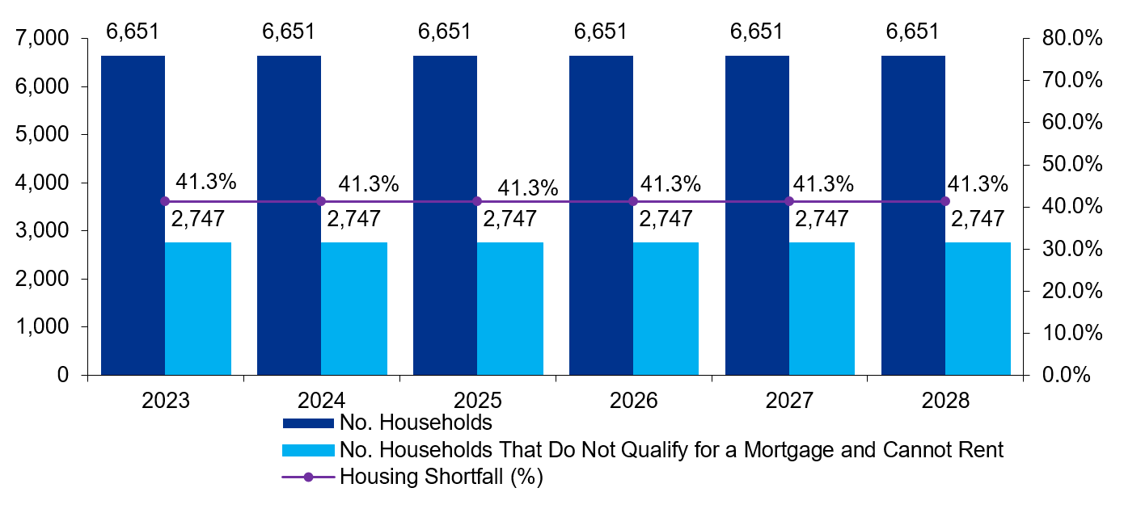
Figure 2-2: Summary of Needs - Dublin 1
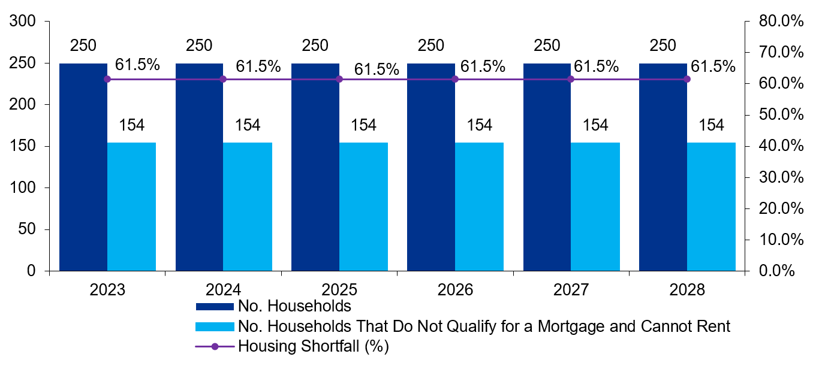
Figure 2-3: Summary of Needs - Dublin 8
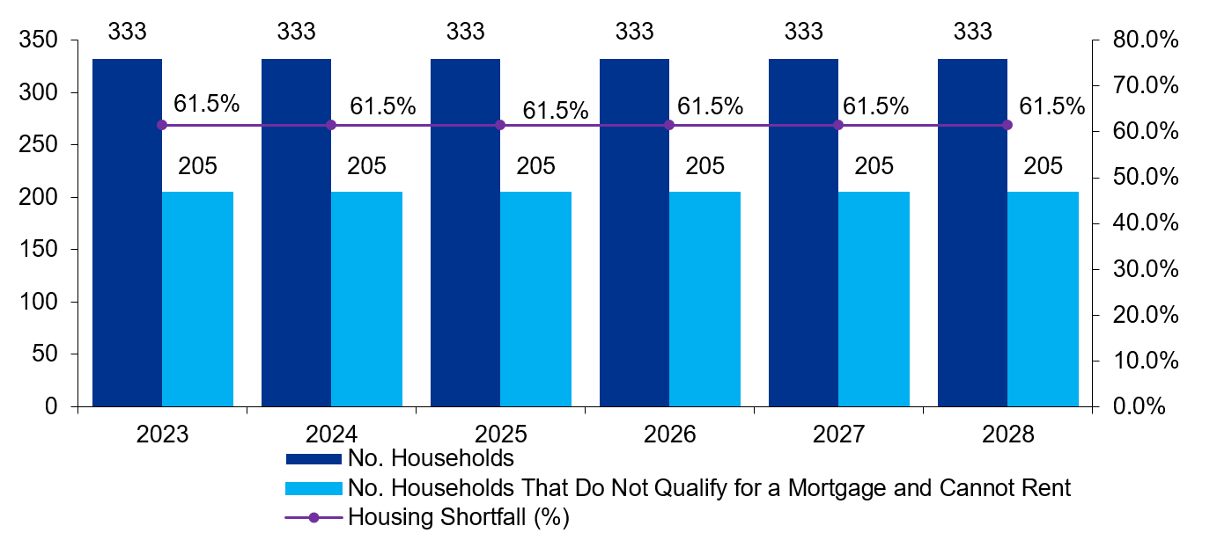

2.4 HNDA Components
In addition to the HNDA, analysis of historic intercensal trends for household composition (size), tenure and dwelling type has been conducted to enable estimation of future households under each component. This element is outlined in steps 13 through 15 in the HNDA methodology in Table 2.1 and the results of the analysis are presented below.

2.4.1 Household Composition
Analysis of historic Census data (2002-2016 for DCC and 2006-2016 for sub areas) in relation to the composition of households has been undertaken to understand the dynamics of change over time and estimate how they may change into the future. The intercensal average has been used to determine a trended annual average change in household composition as set out in Table 2.26 below. The composition forecast for DCC is illustrated in Figure 2.4, while the sub areas of Dublin 1 and Dublin 8 are illustrated in Figure 2.5 and Figure 2.6 respectively.
Table 2-26: Forecasted Annual Change in Household Size Cohorts
Annual Change | 1 person household | 2 person household | 3 person household | 4 person household | 5+ person household
Dublin City | -0.05% | 0.23% | 0.03% | -0.03% | -0.19%
Dublin 1 | -0.10% | 0.20% | -0.03% | -0.05% | -0.01%
Dublin 8 | -0.30% | 0.33% | 0.06% | -0.03% | -0.06%

DCC
Based on the identified intercensal changes DCC sees a reduction in 1 and 4 person households at a relatively slow rate and 5+ person households at a much higher rate.
2 and 3 person households are on an upward trend with 2 person households increasing at the highest rate (0.23% per annum).

Dublin 1
Based on the identified intercensal changes Dublin 1 sees a reduction in all household composition save for 2 person households, which are on an upward trajectory of 0.20% per annum.

Dublin 8
Based on the identified intercensal changes Dublin 8 sees a reduction in 4 and 5+ person households at a relatively slow rate and 1 person households at a much higher rate. 2 and 3 person households are on an upward trend with 2 person households increasing at the highest rate (0.33% per annum).
Figure 2-4: Forecast Household Composition over the Plan Period - DCC
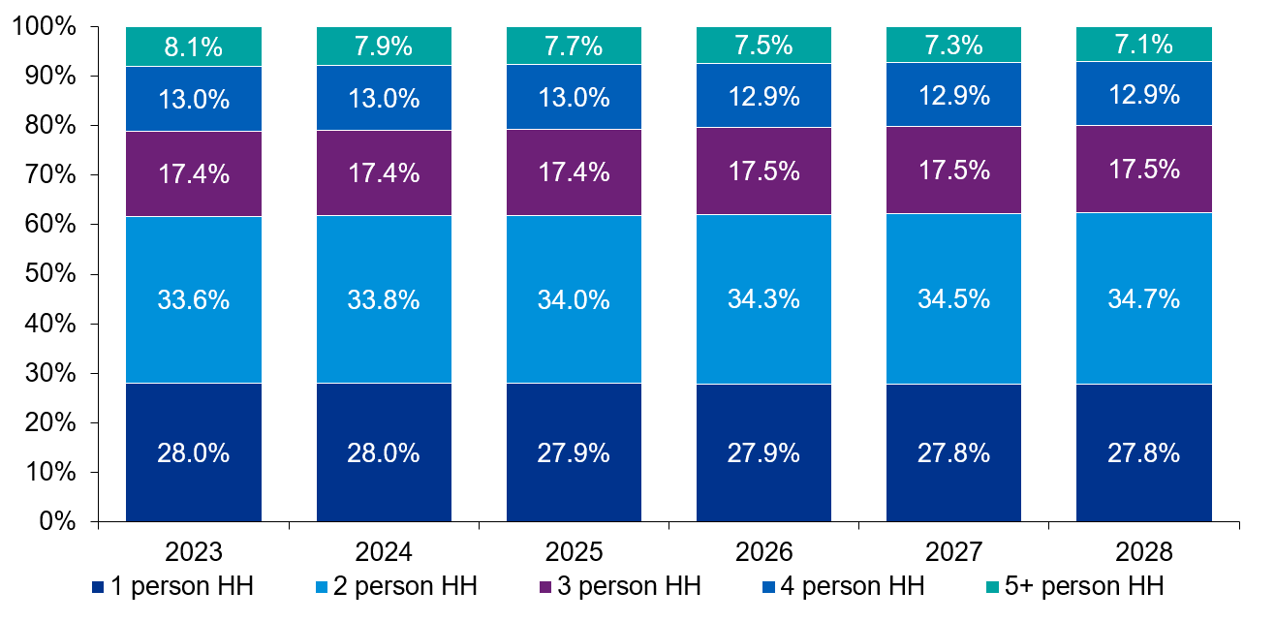
Figure 2-5: Forecast Household Composition over the Plan Period - D1
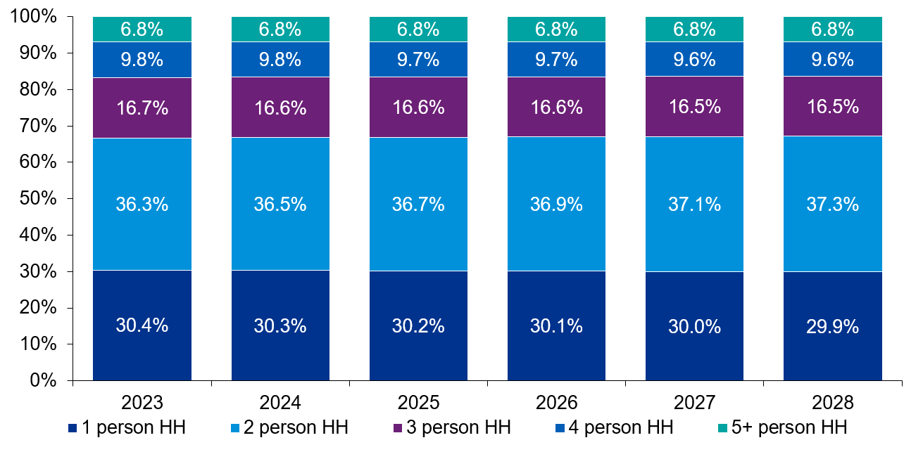
Figure 2-6: Forecast Household Composition over the Plan Period - D8
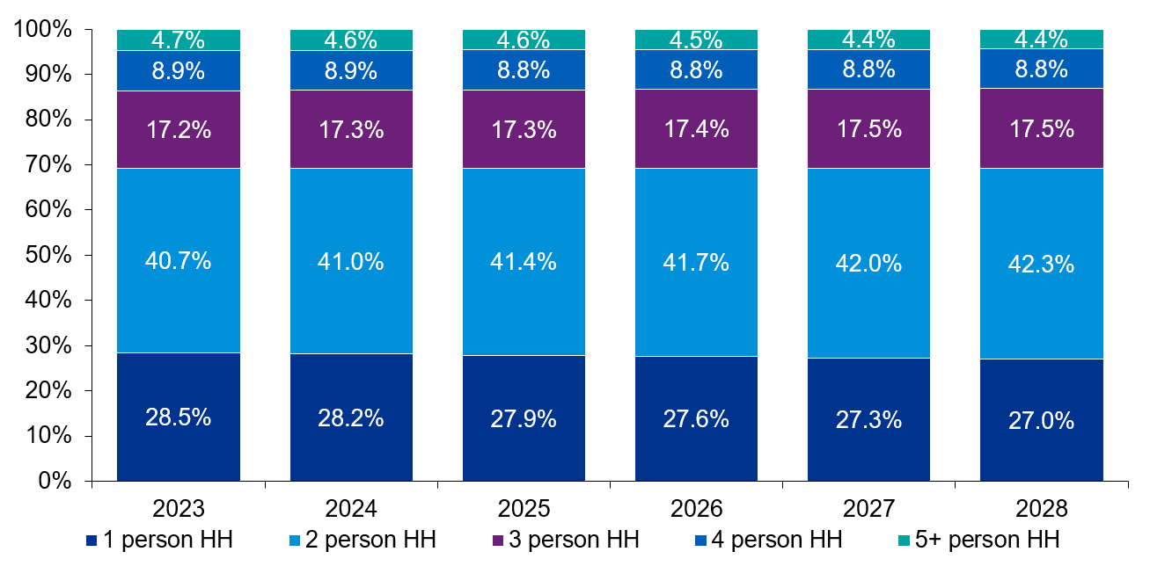
In order to gain a further understanding of household size and composition and how it may relate to the dwelling stock, Census data has been examined on the number of rooms per household in 2016. Unfortunately, the 2016 Census did not differentiate between bedrooms and all other rooms, and as a result it is not possible to obtain a full dwelling size mix for Dublin City. This data is therefore contextual and does not solely indicate bedrooms. Census respondents were instructed not to count bathrooms, toilets, kitchenettes, utility rooms, consulting rooms, offices, shops, halls or landings, or rooms that can only be used for storage such as cupboards – these are therefore not included in the data below. They were instructed to count all other rooms such as kitchens, living rooms, bedrooms, conservatories, and studies.
Table 2.27 and Table 2.28 below indicate that households are fairly evenly distributed across the total room categories over Dublin City as a whole with a slight plurality of 5-room dwellings (18.6%). However, dwellings tend to have less rooms in D1 and D8, with 12.9% of households recording only one room in D1.
Table 2-27: Rooms Per Household, 2016
Number of rooms | DCC | D1 | D8
1 room | 11,337 | 2,658 | 425
2 rooms | 26,105 | 5,222 | 1,759
3 rooms | 31,446 | 4,024 | 1,854
4 rooms | 31,796 | 2,933 | 1,244
5 rooms | 39,358 | 1,650 | 437
6 rooms | 28,889 | 831 | 142
7 rooms | 13,698 | 267 | 21
8 or more rooms | 11,370 | 148 | 10
Not stated | 17,592 | 2,887 | 671
Total | 211,591 | 20,620 | 6,563

Table 2-28: Rooms Per Household (%), 2016
Number of rooms | DCC | D1 | D8
1 room | 5.4% | 12.9% | 6.5%
2 rooms | 12.3% | 25.3% | 26.8%
3 rooms | 14.9% | 19.5% | 28.2%
4 rooms | 15.0% | 14.2% | 19.0%
5 rooms | 18.6% | 8.0% | 6.7%
6 rooms | 13.7% | 4.0% | 2.2%
7 rooms | 6.5% | 1.3% | 0.3%
8 or more rooms | 5.4% | 0.7% | 0.2%
Not stated | 8.3% | 14.0% | 10.2%
Total | 100.0% | 100.0% | 100.0%

Figure 2-7: Rooms Per Household (%), 2016
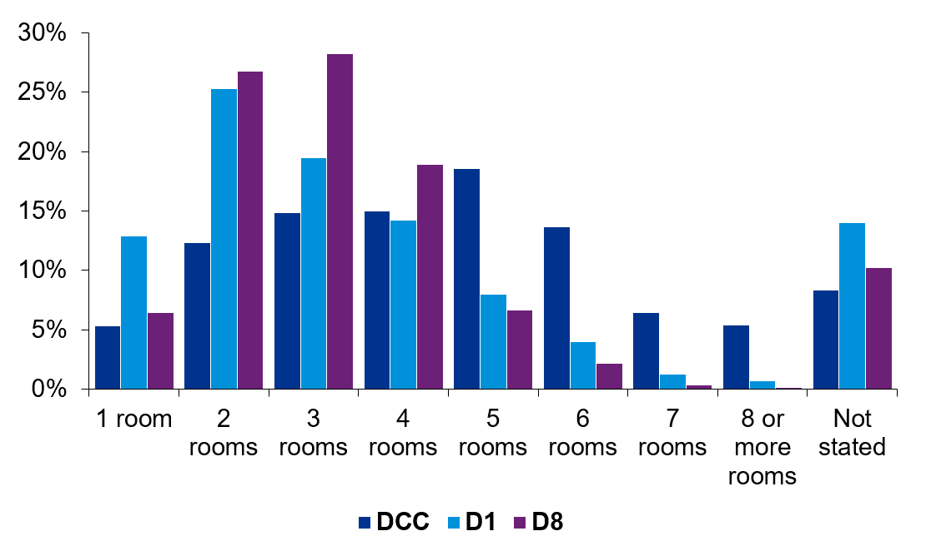

2.4.2 Household Dwelling Type
Analysis of historic intercensal data on private household dwelling type has been undertaken to understand unit-mix dynamics and estimate how they may change over time. Specifically, the intercensal average has been used to determine a trended annual average change in dwelling type mix. It should be noted that estimated trends do not account for ‘bed-sits’ or ‘not stated’ dwelling types as categorised by the Census. Therefore, forecasts for house/bungalow, flat/apartment and caravan/mobile homes are set out from 2023 to 2028 with the intercensal average determined from a reduced sample size. The annual average change in dwelling type DCC and sub areas is set out in Table 2.29
Figure 2.8, Figure 2.9 and Figure 2.10 illustrate the forecast distribution by dwelling type for the plan period. It should be noted that these are an approximate continuation of observed trends as influenced by the market dynamics during that historic period and it is noted that external market factors can influence the future dynamics in relation to unit mix and dwelling type throughout the plan period. The graphs presented are based on a continuation of recent historic trends assigned to the additional anticipated households.
It should also be noted that “caravan/mobile home” is not visible on these graphs due the forecast estimating that they will either no longer be present in the areas or constitute less than 0.03% of all dwellings by the plan period.

Table 2-29: Forecast Change in Dwelling Type for Households
Annual Change | House/Bungalow | Flat/Apartment | Caravan/Mobile Home
Dublin City | -0.49% | 0.50% | -0.01%
Dublin 1 | -0.30% | 0.33% | -0.03%
Dublin 8 | -0.43% | 0.44% | -0.01%

DCC
Based on the identified intercensal changes DCC overall sees an increase in Apartment type dwellings and an almost equal reduction in house type dwellings. By the end of the plan period this trend would see just over 40% off all dwellings in DCC being apartments. It should be highlighted that duplex units are classified as apartments, which could indicate not all the apartments will be in blocks.

Dublin 1
Based on the identified intercensal changes Dublin 1 and the current dwelling type distributions Dublin 1 is estimated to predominantly Apartments by the end of the plan period.

Dublin 8
Based on the identified intercensal changes Dublin 8 and the current dwelling type distributions Dublin 8 is estimated to predominantly Apartments by the end of the plan period.
Figure 2-8: Forecast Dwelling type distribution 2023-2028 - DCC
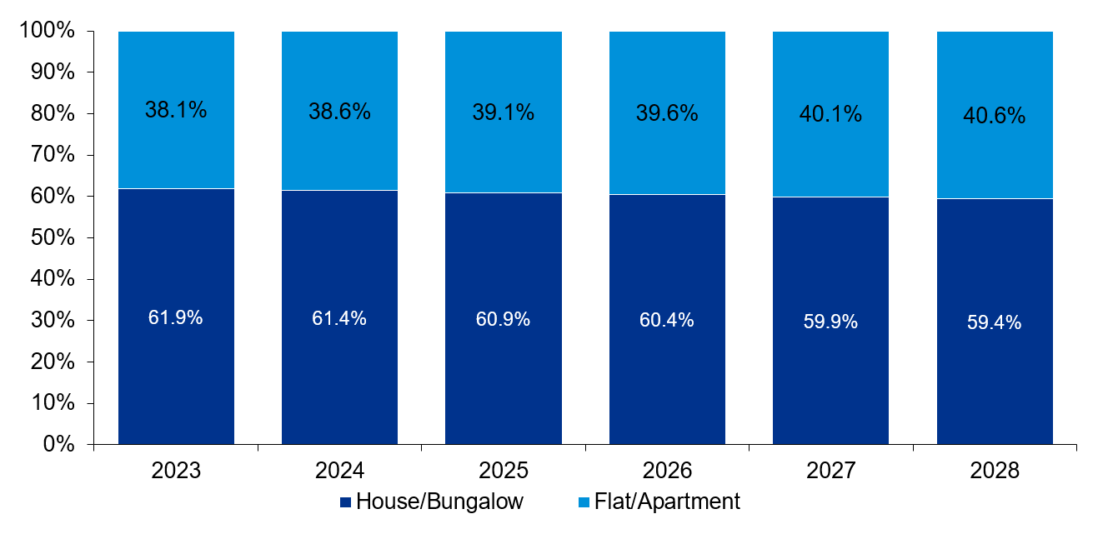
Figure 2-9: Forecast Dwelling Type Distribution 2023-2028 - D1
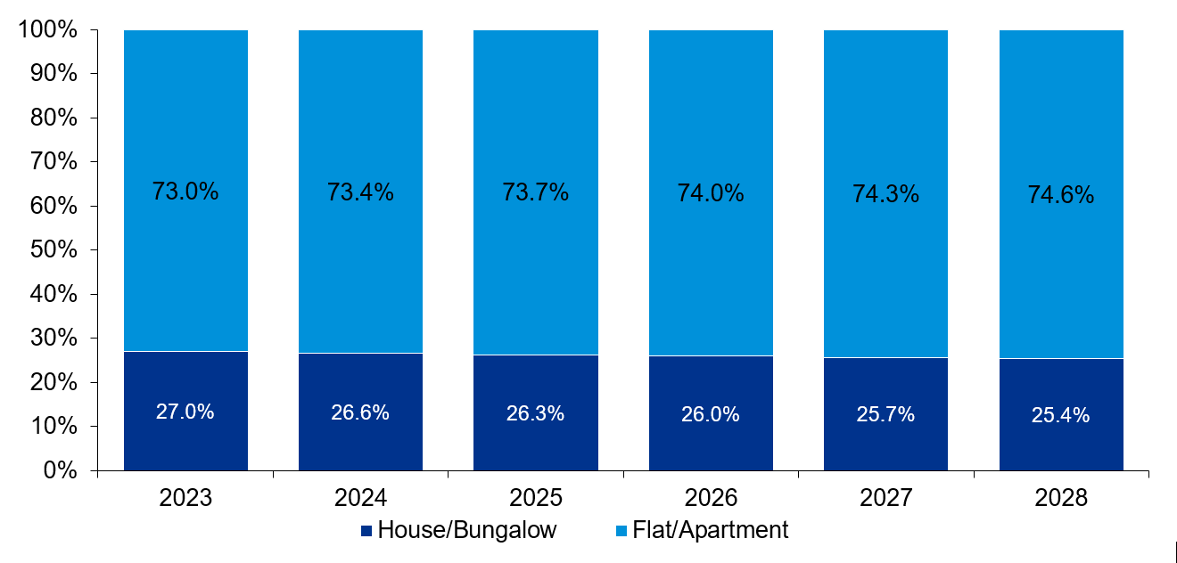
Figure 2-10: Forecast Dwelling Type Distribution 2023-2028 - D8
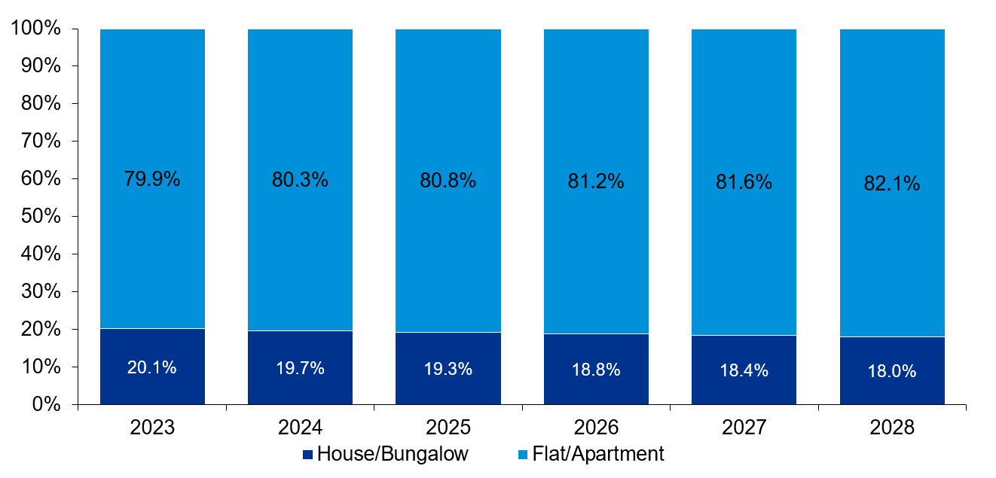

2.4.3 Household Tenure
Analysis of historic Census data (2002-2016 for DCC and 2006-2016 for sub areas) in relation to the tenure of households has been undertaken to understand these dynamics and estimate how they may change over time. The intercensal average has been used to determine a trended annual average change in household tenure in DCC and its sub areas and have been set out in Table 2.30 below. It should be noted that this does not supersede the tenure analysis undertaken through the HNDA Toolkit and presents only a continuation of historic trends, primarily to ascertain these trends at local level.
Household tenure has been grouped into owner-occupied (comprised of those with and without mortgages), private rental sector and social housing (rented from a local authority or voluntary organisation).
Table 2-30: Forecast Change in Tenure Composition of Households
Annual Change | Social Housing | Private Rental | Owner occupied
Dublin City | 0.18% | 0.64% | -0.82%
Dublin 1 | -1.12% | 1.62% | -0.50%
Dublin 8 | -1.09% | 1.58% | -0.49%

KPMG Future Analytics’ HNDA model approach of historic intercensal change to estimate the future distribution of composition and dwelling type is based on historic property market trends. These trends are also driven by historic economic trends and policies and may not reflect future trends and policies. Estimates of tenure are as a result very susceptible to wider political and economic forces.
The impacts of the financial crisis are very much still represented in these estimates. This due to the fundamental shift in tenure that occurred because of the post-2008 economic and property market declines. The sheer volume of households that shifted from owner-occupancy into private rental between 2006 and 2011 thus affects the long-term change.
Table 2.31 highlights the extreme changes that took place between the 2006-2011 period as a direct result of the financial crisis.
Table 2-31: Intercensal Change in Tenure
 | Dublin City |  | Dublin 1 |  | Dublin 8
 | 2006-2011 | 2011-2016 | 2006-2011 | 2011-2016 | 2006-2011 | 2011-2016
Social Housing | -4.5% | 1.0% | -14.2% | 3.0% | -12.8% | 2.0%
Rented (Privately) | 12.7% | -1.1% | 19.6% | -3.4% | 17.5% | -1.8%
Owner Occupied (All) | -8.2% | 0.1% | -5.4% | 0.4% | -4.7% | -0.2%

Dublin City Development Plan 2022-2028

Appendix 2: Retail Strategy

PAGE LEFT INTENTIONALLY BLANK

1.0 Introduction
This Retail Strategy for the Dublin City Development Plan 2022 – 2028 takes full cognisance of national and regional policy guidance on retail planning, spatial settlement policy and transport. Specifically, it reflects the Guidelines for Planning Authorities, Retail Planning 2012, (Department of the Environment, Community and Local Government, 2012) and the Regional Spatial and Economic Strategy (RSES), Eastern and Midland Regional Assembly (EMRA), 2019. The Strategy should be read in conjunction with Chapter 7.
In accordance with the Retail Planning Guidelines 2012, retail policy for the city must be informed by a multi-authority retail strategy for the region. The 2008 – 2016 Retail Strategy for the Greater Dublin Area (RSGDA) is now considered out of date. It is an objective of the RSES that EMRA will support the preparation of a Retail Strategy / Strategies for the Region in accordance with the Retail Planning Guidelines for Planning Authorities 2012, or any subsequent update, to update the retail hierarchy and apply floorspace requirements for the Region (RPO 6.10 refers). This Retail Strategy for Dublin City has, therefore, been prepared having regard to the requirements of Sections 3.3 and 3.7 of the 2012 Retail Planning Guidelines which detail the methodology for preparing a retail strategy for a development plan.
To inform retail policy in the city centre for the 2022 – 2028 period, Dublin City Council commissioned Bannon Property Consultants to prepare a report on the state/future of retailing in Dublin city centre. The report - ‘Role and Function of Retail in the City Centre’, December 2020 –considers:
- the performance of the retail sector in the city centre in the last 10 years against the backdrop of changing retail trends;
- the growth of Regional Shopping centres;
- the changing shopper profile in the city;
- retail floor space supply and
- the Covid 19 Pandemic.
It considers the impacts of these factors on the city centre in the longer term. The report sets out actions and policy recommendations to support the Council’s vision for a vibrant shopping retail core in the city.
The retail sector is facing a challenging environment as a result of the Covid 19 crisis as well as from other established trends. The way we shop and the way we use / interact with / experience our urban centres has and continues to change. Consequently, and arising from a number of factors not least the growth of online retailing and changing consumer demands, the retail sector and our urban centres are evolving. Having regard to these factors and in accordance with national retail policy, this Retail Strategy seeks to guide sustainable retail provision in the city over the development plan period.
The Retail Strategy sets out the following:
- The planning policy context for retail development.
- International and metropolitan retail trends influencing the retail sector in Dublin City.
- A high level overview of retail floorspace provision in the city centre and Key Urban Villages (KUV) in the last decade to allow a comparison with estimated retail floorspace requirements for the city as set out in the Retail Strategy for the Greater Dublin Area 2008 – 2016.
- The retail hierarchy for the city, and the level and form of retailing appropriate to this hierarchy.
- Strategic guidance on the location and scale of retail development in the city.
- An overview of Retail Warehouse Park / Retail Warehouse provision in the city.
- A strategy for the city centre.
- Criteria for the assessment of planning applications.
- Guidance on specific forms of retail development.

2.0 Policy Context

2.1 Retail Planning Guidelines (DECLG, 2012)
The Retail Planning Guidelines aim to ensure that the planning system continues to play a key role in supporting competitiveness and choice in the retail sector commensurate with promoting the vitality and viability of town centres. The guidelines identify that the retail sector is an essential part of the Irish economy and that a strong retail sector is a key element of the vitality and competitiveness of cities, towns and villages. Shops play a major role in attracting people to urban centres, thus contributing to their overall economic vitality and supporting their role as centres of social and business interaction in the community.
The Retail Planning Guidelines identify five policy objectives:
- to ensure retail development is plan-led;
- to promote city / town centre vitality through the sequential approach to development;
- to enable good quality development in appropriate locations so ensuring competitiveness;
- to facilitate a modal shift towards sustainable transport options, particularly walking and cycling, in all existing and new developments;
- to deliver quality, urban design outcomes.

2.2 Retail Design Manual, A Companion Document to the Retail Planning Guidelines for Planning Authorities, (DECLG, 2012)
The Retail Design Manual is intended as a guide for planning authorities in formulating appropriate design policies and development management responses when dealing with retail development. The manual also provides relevant parties with evidence based quality principles to ensure that new retail development meets the highest standards for design, streetscape integration and connectivity. The manual places an emphasis on ‘environmental responsibility’ and ‘sustainable construction’ considerations for retail development.

2.3 Regional Spatial & Economic Strategy (RSES), Eastern & Midland Regional Assembly (EMRA), 2019
The RSES recognises that the retail sector is a significant employer and economic contributor in the Region. As a significant attractor, it enables the creation of strong mixed-use commercial cores and can play a key role in the regeneration of areas and placemaking. It states that larger scale trip intensive developments, such as retail, should primarily be focused in locations which are well served by existing or proposed high capacity public transport corridors.
The RSES acknowledges that the floorspace requirements set out in the ‘Retail Strategy for the Greater Dublin Area, (RSGDA) 2008’ are still to be reached. EMRA is to support and drive the preparation of a new Retail Strategy for the region which will update the retail hierarchy and apply floorspace requirements in the region. Until that time, future provisions of significant retail development within the Region must be consistent with the Retail Planning Guidelines for Planning Authorities 2012 and the retail hierarchy for the Region as set out in table 6.1 of the RSES (RPO 6.11 refers).

2.4 The Retail Strategy for the Greater Dublin Area 2008 – 2016 (RSGDA)
The RSGDA sets out the retail hierarchy for Dublin City and retail floor space thresholds for each urban centre. It is now largely recognised that the 2008 Strategy is out of date and was written at a time of unprecedented growth in the Irish economy. It was based on data at a time of record in migration, economic growth and expenditure. In this context, the floorspace projections are very ambitious and also do not reflect the pivotal changes that have occurred in the retail sector, particularly in the last number of years with the growth of online sales etc.

3.0 Retail Trends

3.1 International Retail Trends
Changing consumer behaviours and coupled with technological innovation continue to have a significant impact on the retail sector.
Online sales have been taking an increasing share of retail sales each year, amounting to €5 billion in 2018, or 11%. In Ireland, clothes, sports goods, household goods, electronic equipment and books are some of the main items increasingly being bought online. Following the onset of the Covid 19 crisis, online sales accelerated as people moved online due to restrictions and retailers increased their online presence. In Ireland online sales grew to 15.5% of all turnover in early 2020.
Notwithstanding the growth of online sales and its likely growth in the future, according to the Bannon Report, 2020, the vast majority of retailing globally still takes place in a physical store. The report states that the true trend is to omni-channel retailing with retailers combining a physical network of stores with an online presence or a combination of the two platforms e.g. ‘click and collect’. Omni channel retailing such as ‘click and collect’ can support urban centres by ensuring footfall back into the city.
Other trends influencing the retail market include:
- the growth of ‘shop local’ which places an importance on the local availability of products and services; ‘independent / specialist retailing’ -which places an importance on locally unique stores / locally produced goods;
- ‘environmentally aware consumerism’ - a consumer reaction to the environmental impact of fast fashion which may impact on fast fashion retail multiples;
- and ‘experiential shopping’, where people are looking for a range of experiences when they visit a city or town, from leisure to culture to accessing social / community facilities.

3.2 Existing Retail Trends within Metropolitan Area
In early 2020, retail sales had largely recovered after the 2007 recession. Traditional retail metrics (footfall, retail sales and consumer sentiment etc.) were largely positive . The retail sector was the biggest contributor to the Irish exchequer, generating 21% of total tax receipts in Ireland in 2019 and accounted for 40% of personable spending. According to the Regional Spatial and Economic Strategy (EMRA 2019), 19% of the Dublin City workforce were employed in the Wholesale and Retail Sector, which equates to c.60,000 people.
Notwithstanding this recovery, Dublin City and its suburbs has seen little investment in new retail floorspace. Approved large scale developments in the city centre and in suburban centres were in many instances not built and these permissions have now expired. In the city centre, new retail development has generally formed part of refurbishment / mixed use schemes such as the redevelopment of the former Clery’s Department Store on O’Connell Street; the repurposing of the Former Central Bank building and the redevelopment of Hibernian House. In the suburbs, new retail development has been almost exclusively convenience based.
According to the Bannon Report, the city centre is also under constant pressure to compete with the five regional M50 centres (see Figure 1). The report notes that the M50 centres have solidified their position as regional destinations within Dublin’s suburbs, displacing comparison retail focussed shopping trips that were once the exclusive remit of the city centre. These five centres combine to offer over 300,000 sq. m. of retail space. Most of these centres have continued to expand slowly since their completion. Many have active plans to develop further with increased floorspace and civic and amenity improvements.
Figure 1: The 5 Regional M50 Centres
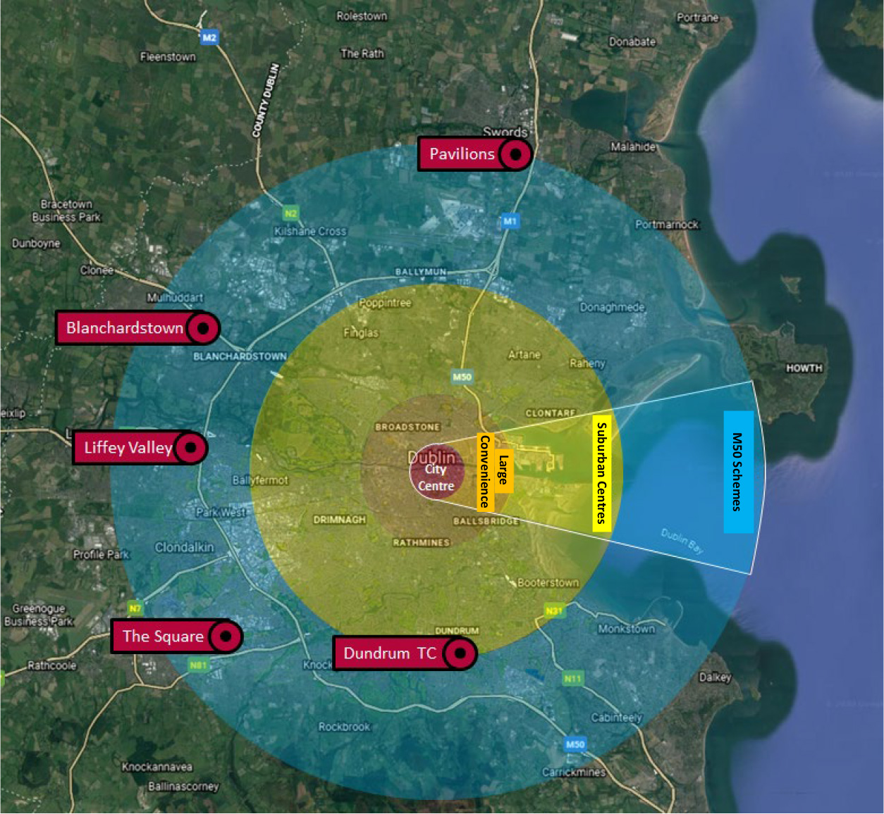
Since 2008, retailing in the UK has undergone significant restructuring demonstrating its move away from traditional retailing. This has led to the closure of a significant number of well-known shops in the UK and Dublin, including Karen Miller, Monsoon, Mothercare, Coast, Gap and Debenhams as well as the entire Arcadia Group which included a number of well-known brands such as Top Shop, Warehouse, Oasis and Wallis. This will have ongoing implications for vacancy rates and a requirement to redevelop and repurpose some of the larger floor plate retail units that are no longer in demand.
The food and beverage sector and retail services sector has seen exceptional growth in Dublin in the last 10 years, largely as a result of growth in employment and increased tourist numbers in the city and as a by-product of the growth in experience motivated trips. These uses are making a significant contribution to the overall commercial functioning of Dublin City and suburban centres and have become an increasingly important occupier of retail space.
The above international and metropolitan trends / challenges have implications for the type of retail format and offer in the future as well as the demand for retail floorspace in the City.
The retail sector is now facing further challenges as a result of the Covid 19 crisis. In 2020/21, Dublin City Centre in particular, was very negatively impacted by the pandemic. Footfall in Dublin City Centre fell due to office workers working from home, the drop in tourist numbers and the cancellation of cultural and sporting events in the City, see Figure 2 (source: Bannon Report, 2020).
Figure 2: Footfall % Change in Dublin City Retail Core During 1st Covid Lockdown in 2020
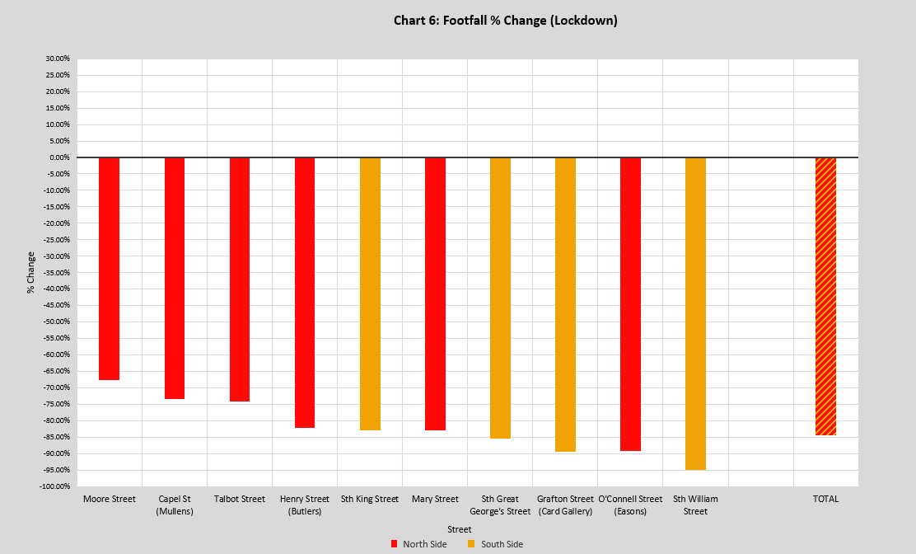
The city centres’ reliance on footfall generated by tourism, students and offices workers has become apparent as has the fact that the city centre’s residential population - 169,000 people inside the canal ring - is not of a sufficient level to support the current scale of retail in the city.
With a large proportion of the city’s workforce continuing to work from home in 2021 and beyond, and government policy supporting full time and part time remote working, it is likely the challenges of the pandemic and new ways of working will continue to impact on the retailing sector in the city.
In view of the above, for the city’s urban centres to remain viable they must adapt and evolve to these changing circumstances. In the case of the city centre, it must provide attractive shopping and experiential attractions to attract people to shop and spend time in the city centre and to encourage them to stay and spend. In the case of the city’s other urban centres, they must develop as local hubs with a wide range of retail, retail services, local employment, community services and residential use.

4.0 RSGDA 2008 – 2016 Floorspace Requirements versus Actual Provision of Retail in Dublin City between 2008 and 2021
The Retail Strategy for the Greater Dublin Area, 2008, provided indicative advice on the scale, location and need for new retail floorspace in the Region’s urban centres and how such floor-space should be allocated between the centres. For Dublin city, it identified a Gross Lettable floor space need for convenience and comparison retailing up to 2016. An additional 20% headroom was incorporated to take account of the long lead in time for retail development and to enable retail development to be planned up to 2021 as set out in Table 1. As noted above, these floorspace targets were ambitious.
Table 1: Gross Lettable Floor Space Need (sq. m.) for Convenience and Comparison Retailing, RSGDA 2008 Retail Strategy for the GDA 2008 – 2016 for Dublin City
Floorspace Type | Floorspace Need
Convenience | 38,586 sq. m. – 46,303 sq. m.*
Comparison | 181,256 sq. m. (low projection) – 247,168 sq. m. (high projection)  217,508 sq. m.** (low projection) – 296,601 sq. m.**(high projection)  *20% to facilitate future demand post 2016  **20% to facilitate future demand post 2016

4.1 Convenience Retail Floorspace
Convenience retailing (supermarkets) has expanded significantly in Dublin City over the last 10 years helped by population growth and policy support in the last development plan, specifically in the inner city. The city has seen the development of a number of significant new convenience stores, particularly in the discount food store sector. This new convenience retail provision has provided greater consumer choice and competition and in many areas, has had regeneration benefits and provided much needed neighbourhood scale retail provision.
Whilst the scale of convenience provision permitted in the city is within the target range envisaged in the 2008 study, it is not considered that this should limit future provision of convenience floorspace in the city. It is the policy of the Council to continue to promote the development of appropriately scaled convenience retail development in the city, particularly in new regeneration areas, and where such development can provide an important anchor to secure the vitality and viability of urban villages and neighbourhood centres. See section 10.0 below for further detail.

4.2 Comparison Retail Floorspace
As stated in section 3.0 above, retail development in the city centre has remained relatively static since 2008/9. In the suburban centres, there has also been little growth and expansion. Ambitious retail schemes were proposed for Ballymun Town Centre, Crumlin Shopping Centre, and Northside Shopping Centre; however, these permissions withered and were not considered viable after the economic crash. In some centres, there has been a contraction of retail floorspace and Crumlin Shopping centre is currently vacant with the exception of a convenience anchor and Ballymun Shopping Centre has been demolished. Other centres had a poor take up of retail floorspace, particularly Clongriffin, and the Point Village was not occupied by an intended anchor store. Traditional villages such as Finglas, Ballyfermot and Phibsborough have not seen any retail development of note in the last decade or so.
The only centre that saw some enhancement of offer was the Omni Centre with the development of significant new convenience floorspace. The centre however, in recent times, has seen the closure of some comparison units. The Swan Centre in Rathmines was refurbished but this did not yield any significant increase in comparison floorspace. Retail development in regeneration areas such as the Naas Road and Poolbeg have not commenced.
Having regard to the limited extent of new comparison retail floorspace in these centres, it can be concluded that the projected thresholds for comparison retailing in the city set out under the 2008 strategy have not been met and are unlikely to be met and are no longer appropriate in the current changed market context.

5.0 Settlement Hierarchy and Level and Form of Retailing
The retail hierarchy for the city, as set out in Table 2 below, accords with that set out in the Regional Spatial and Economic Strategy, 2019 (RSES) and with the Core Strategy of the development plan (chapter 2) and comprises, in descending order, the City Centre, Key Urban Villages, urban villages and neighbourhood centres and local shops.
This Retail Strategy for Dublin city adopts the single-tier designation - District Centre Level 3 - as set out in the RSES. For clarity, the Level 3 district centres set out in the RSES are identified and termed ‘Key Urban Villages’ for the purposes of this Retail Strategy.
Under level 4, there are considered to be two different typology of centres, comprising ‘urban villages’ and ‘neighbourhood centres’.
The terms ‘Key Urban Villages’ and ‘urban villages’ are used in order to align with the broader principles of the plan and the concept of the 15 minute city.
The purpose of the retail hierarchy is to indicate the level and form of retailing activity appropriate to the various centres across the city and in doing so, to protect each centre’s vitality and viability, while allowing each centre to perform its role within the hierarchy. The hierarchy emphasises the primacy of the City Centre.
Table 2: Retail Hierarchy for Dublin City
Level | RSES Classification | Dublin City Settlement Hierarchy
Level 1 | Metropolitan Centre | Dublin City Centre
Level 2 | Major Town Centres & County (Principal) Town Centres | None
Level 3 | Town and/or District Centres & Sub-County Town Centres (Key Service Centres) | Key Urban Villages – The RSES identifies the following Level 3 district centres for the city:  Finglas, Northside Shopping Centre, Ballyfermot, Rathmines, Crumlin Shopping Centre, Donaghmede Shopping Centre, Omni, Ballymun, Point Village and Poolbeg, Clongriffin / Belmayne, Phibsborough and Naas Road.
Level 4 | Neighbourhood Centres, Local Centres-Small Towns and Villages | Urban Villages – These include:  Ringsend, Merrion Shopping Centre, Donnybrook, Ranelagh, Baggot Street, Rathgar, Harold’s Cross, Artane Castle, Terenure, Kimmage, Inchicore, Finglas Clearwater, Drumcondra, Fairview, Killester, Edenmore, Raheny, Kilbarrack, and Market Streets / Villages in the inner city such as Thomas Street, Meath Street, Francis Street, Camden Street / Wexford Street / Aungier Street, Clanbrassil Street, Cork Street, Dorset Street and Manor Street/ Stoneybatter. This list is not exhaustive.
Neighbourhood Centres:
Distributed throughout the city comprising, in the main, small parades of local shops.
Level 5 | Corner Shops/Small Villages | Corner/Local Shops  Distributed throughout the city.

5.1 Level 1 - Dublin City Centre
Dublin City Centre at the apex of the hierarchy, serves as the pre-eminent shopping destination in the country, providing a wide range of retail offer and flagship stores of leading international and domestic retailers. It supplies retail functions of a specialist nature not found elsewhere in the State, as well as providing the broadest range of higher order comparison goods shopping. In addition to shopping, the city centre provides additional functions including significant culture and entertainment destinations. The city is also home to a significant quantum of office headquarters, government buildings and is a significant international tourist destination with a range of tourist accommodation and attractions. The city also has existing and planned high quality public transport and an accessible public realm.

5.2 Level 3 - Key Urban Villages
There are 12 Key Urban Villages in the city. The spatial distribution of these around the city is shown in Figure 7.1 in Chapter 7 and Map K. These Key Urban Villages generally attract a level of spend that does not position them as significant competitors with the city centre. Such centres add to the vibrancy of their area and provide an important retail and service role to a wide local catchment. Whilst the scale, function and character of these centres varies widely across the city, they play a key role and contribute to the diversity of the retail environment across the greater Dublin area.
The ongoing development, consolidation and rejuvenation of the Key Urban Villages is a key objective of the plan in order to ensure that these centres continue to develop as local hubs with a wide range of retail, retail services, local employment, social infrastructure and community development. It is also envisaged that the quantum of residential and office floorspace in such centres could be increased, particularly above ground floor level. This approach aligns with the strategic vision of the plan and aligns with the principle of the 15 minute city. Further commentary on the KUVs is set out below.

Finglas, Ballymun, Point Village and Poolbeg, Clongriffin / Belmayne, and lands at Naas Road – Strategic Development and Regeneration Areas
Finglas, Ballymun, Point Village and Poolbeg, Clongriffin / Belmayne and lands at Naas Road are identified as forming part of Strategic Development and Regeneration Areas (SRDAs) in the Core Strategy and are, therefore, identified for large scale regeneration / development. The guiding principles for the SRDAs anticipate that these Key Urban Villages should evolve into mixed use urban centres based around existing / planned high quality rail public transport to serve these emerging regeneration areas.
- Finglas Village: The existing centre largely comprises large / small convenience retailing, one large comparison goods store, retail services, food / beverage outlets and civic and community uses. The planned extension of the Luas Green Line to the village, along with the planned expansion of population on the former industrial lands at Jamestown coupled with the ongoing consolidation of Finglas Village (an indicative 2,800 residential units), should support further local retail provision.
- Ballymun: The existing centre comprises convenience retailing, retail services and civic and community uses. Planned residential (c. 2,200 - 2,350 units), commercial and employment opportunities in Ballymun based around the provision of Metro will support the redevelopment of the Ballymun Shopping Centre site which has been demolished.
- Point Village and Poolbeg: Point Village in the Docklands was built in 2008. The retail element of this development, however, has still to be occupied. It is envisaged that the viability of this centre will come to fruition as the continued roll out of development across the docklands area is completed. At Poolbeg, large-scale residential (between 3,000 to 3,500 residential units), commercial and office space (100,000 sq. m.) is planned. Retail provision in the planned commercial heart is capped at 5,000 sq. m. and will serve the needs of this new community.
- Clongriffin Belmayne: The primary retail development serving this area is the Clarehall shopping centre anchored by Tesco and it provides a range of other local retail outlets and services. There is ongoing vacancy along the main street at Clongriffin and at the DART station. However, some units have been occupied by a range of local retail services, food and beverage uses as well as convenience and community uses. Over 7,000 residential units are to be provided in Clongriffin Belmayne over the coming years. It is envisaged that there will be further uptake of vacant units over the plan period as the planned residential development for this area is completed and the population increases. The area will also be enhanced with the planned delivery of a completed town centre at Clongriffin (permission granted in 2020 including c.5,000 sq. m. of retail space) and with the delivery of a new town centre at Belmayne as set out in the Belmayne and Belcamp Lane Masterplan 2020, which envisages a retail quantum of c. 3,000 sq. m. to serve this emerging residential area.
- Lands at Naas Road: Anticipated residential, commercial and employment development has not been provided to date at the Key Urban Village at Naas Road. The Local Area Plan proposed for the area identifies the need for a district centre at Naas Road to be developed in tandem with future population growth and development. The Local Area Plan for the Naas Road, identifies a retail quantum of c.35,000 sq. m. to serve this developing area. The appropriateness of this retail quantum is discussed below in section 6.

Northside, Crumlin, Donaghmede and Omni - Suburban Shopping Centres
Northside, Crumlin, Donaghmede and Omni are suburban shopping centres, typically ranging from 10,000 – 20,000 sq. m. in size with convenience / low to middle order comparison / food and beverage offer. Of the four, Omni shopping centre is the largest centre, as its former retail park has been converted to comparison retail / food and beverage. It also has an 11 screen cinema. Most of these centres serve a localised catchment except for Omni which has some evening appeal. These centres have low vacancy levels with the exception of Crumlin Shopping Centre which is largely vacant. All these centres are easily accessible by bus, walking and cycling.

Ballyfermot, Rathmines and Phibsborough - Traditional Key Urban Villages
Ballyfermot, Rathmines and Phibsborough are traditional Key Urban Villages typically 10,000 sq. m. or less with the exception for Rathmines which includes the Swan Shopping Centre. These centres have large convenience anchors, a range of small comparison outlets, local retail services, ancillary specialist convenience outlets and often community and social facilities.

5.3 Level 4 Urban Villages and Neighbourhood Centres

Urban Villages
Urban villages are located throughout the inner city and in the inner and outer suburbs. They are of a smaller scale compared to the KUVs and tend to have a more limited role and offer. They continue, however, to promote an important economic, social and physical focal point for their communities. Examples of urban villages in the inner and outer suburban area are shown on Figure 7.1 in Chapter 7. Urban villages range from suburban Victorian villages to small shopping centres. Their functions include local / weekly convenience; small comparison retail; food and beverage; cultural and leisure functions; specialist / niche / independent retailing and community and social services. These centres by reason of their variety of offer and level of concentration around the city add to the vibrancy and vitality of the city.

Neighbourhood Centres
These centres support the other centres in the hierarchy and are within reasonable walking distance of the communities they serve. They generally provide important top up and day to day shopping and retail service functions. They normally consist of a shopping parade with a small supermarket / grocery store with a limited range of supporting shops such as a butcher or chemist and retail services like hairdressers and possibly other services such as post offices serving a small, localised catchment population. These centres play an important role in serving the needs of those without access to a car.

5.4 Level 5 Corner/Local Shops
The lowest level of the hierarchy relates to small corner / local shops. Such local retail facilities provide a valuable local and walk in role and function to the local communities that they serve.

6.0 Scale and Location of Retail Development
Guidance on the Location and Scale of Retail Development to Support the Settlement Hierarchy
The city’s urban centres provide a mix of retailing forms serving a local, neighbourhood, district or citywide community. It is essential that new retail floor-space is appropriately located in order to maintain the vitality and viability of existing and planned centres, to avail of improved public transport access and to cater for population growth areas. Retail developments should relate to the hierarchy, should locate within designated centres and should be of a scale that is compatible with the function of the centre.

6.1 Dublin City Centre
The City Centre Retail Core is shown on Figure 7.1 in Chapter 7. The Retail Core is primarily subject to Land Use Zoning Objective Z5: city centre.
To ensure its long-term sustainability, viability and vitality, it is important that the city centre can adapt to changing consumer demands and behaviours, and the challenges posed by online retail and the Covid 19 Pandemic. To attract shoppers to the city centre, there must be a vibrant mix of shopper experiences which will add to the retail experience and ultimately support the retailing sector. The Council will continue to support the development of higher order comparison retail as well as convenience provision in the city centre. A strategy to support the city centre retail core is set out in section 8.0 below.

6.2 Key Urban Villages
The spatial extent of each KUV is shown on Map K of this development plan. These centres are subject to Land Use Zoning Objectives (a) Z4: a district centre with mixed services facilities, or, (b) Z14: for social, physical and economic rejuvenation with mixed uses.
The Retail Planning Guidelines 2012 do not provide guidance on the appropriate size for a District Centre (referred to as a KUV in this strategy), in terms of the required level of retail floorspace that is suitable. The guidelines state that District Centres are usually a feature of an area containing 10,000 people or more. As a general rule however, and having regard to the 2008 Retail Strategy, an appropriate scale for such centres ranges from 10-20,000 sq. m. of net lettable retail floor space catering for a population of 10,000- 15,000. The 2008 Strategy also states that in certain instances there may be scope for district centres to extend by 10-15,000 sq. metres of lettable floorspace in areas of extensive or intensive high density development. It is noted however, that given the radical changes that have occurred in the retail sector in the intervening time from when the 2008 strategy was published, coupled with the relatively stagnant growth of the retail sector, that this scale and ambition of retail development is unlikely to be achieved in any of the district centres within the city over the plan period.
Notwithstanding this, the limited provision of new retail development in Key Urban Villages over the last plan period would suggest that there is scope for further retail floorspace expansion in all centres. However, retail floorspace in the different Key Urban Villages varies considerably and some centres will have greater capacity for greater retail provision than others. In line with the Core Strategy, those centres located in areas identified for new population and commercial growth, with availability of high quality public transport and those centres in need of regeneration, particularly the SRDAs, are particularly appropriate for increased retail floorspace.
Other factors such as the scale and density of the relevant population catchment, a demonstrable level of under-provision of retail in a centre, vacancy levels, extant permissions, the availability of potential sites, and the relevant provisions of statutory plans also need to be considered and will form the basis for the assessment of development proposals for increased retail provision within Key Urban Villages. The overall strategy is to continue to promote and consolidate the role of the Key Urban Villages with a level of retail development commensurate to the catchment.
Large scale redevelopment proposals that would increase the size of any Key Urban Village (level 3 district centre) to in excess of 20,000 sq. m. net will be the subject of a detailed Retail Impact Assessment.
Guiding principles regarding the scale of retail development to be promoted in each Key Urban Village over the plan period is set out in Table 3.
Table 3: Location and Scale of Retail Development in Key Urban Villages
Key Urban Villages | Location and Scale of Retail Development In Key Urban Villages
Northside Shopping Centre | Significant new retail floor space is not anticipated in this Key Urban Village over the lifetime of the Development Plan. The shopping centre is trading well and has low levels of vacancy. Lands to the west of Clonshaugh Road provide opportunities for retail expansion.  It is acknowledged that the shopping centre has extensive areas of surface parking and has scope for further intensification and consolidation. Any development proposal for the comprehensive redevelopment of the shopping centre should provide for a diverse mix of uses to realise the full potential of this Key Urban Village including residential uses.  Development proposals at this KUV should provide for reduced car use and dependency, improved access by walking, cycling and public transport and for significant public realm and urban greening opportunities.
Finglas | Low/modest growth for new retail floorspace is anticipated for Finglas Village. A policy of consolidation, regeneration and placemaking for the village will be pursued to make the best use of the village’s existing capacity and planned high quality public transport (Luas and Bus Connects).  A mix of development in the village will be sought, including retail, retail services, community / civic infrastructure and cultural uses. New residential development will be sought in order to maintain and grow the critical mass necessary to support the continued economic viability of the village, while supporting proposed investment in public transportation.  An Urban Framework Plan and a set of guiding principles for the development of identified opportunity sites in the village and brownfield lands at Jamestown is set out in Chapter 13.
Ballyfermot | It is envisaged that there is likely to be limited new retail floor space in this Key Urban Village over the lifetime of the Development Plan other than small infill opportunities The centre would benefit from public realm enhancement and urban greening opportunities. It will be an objective to enhance and diversify the retail offer in this centre over the lifetime of the plan.
Rathmines | Significant convenience retail has been provided in Rathmines in the last decade and the Swan Shopping Centre has been refurbished and extended. These developments along with the provision of civic and cultural development in the centre have served to considerably enhance its retail function. Consequently, limited new retail floor space is anticipated in this Key Urban Village over the lifetime of the Development Plan other than small scale infill opportunities.
Crumlin Shopping Centre | The redevelopment of the shopping centre will be supported. This redevelopment is required in order to achieve / support regeneration objectives for Crumlin including urban, environmental and economic renewal. A mixed use, residential led scheme with commercial / community / civic uses, is desirable. It is anticipated that the retail element will be convenience focused to serve the local community.
Donaghmede Shopping Centre | Limited new retail floor space is anticipated in this Key Urban Village over the lifetime of the Development Plan due to the fact that the centre is largely developed and there are limited opportunities for expansion.  Any development proposal for the comprehensive redevelopment of the shopping centre should provide for a diverse mix of uses in line to realise their full potential for housing intensification, reducing car use and dependency, and improving access by walking, cycling and public transport. There is significant scope to improve the public realm, boundary treatment and landscaping.
Omni Shopping Centre | Limited new retail floor space is anticipated in this Key Urban Village over the lifetime of the Development Plan. The planning authority will support a greater mix of community / civic uses at the Shopping Centre in order to further enhance its Key Urban Village function.
Ballymun | Retail floorspace provision will be supported in this Key Urban Village over the lifetime of the Plan. Retail is likely to come forward on Site 1 (see the Ballymun LAP), the former Ballymun Shopping Centre site. The adopted LAP sets out a development framework for Site 1 and other lands within the centre.
Point Village & Poolbeg | The development frameworks for these two areas include objectives for retail development as set out in the North Lotts and Grand Canal Dock SDZ Scheme 2014 and the Poolbeg West SDZ Planning Scheme 2019.  Future land uses will accord with the requirements of the planning schemes.
Clongriffin / Belmayne | There is significant vacancy within the core retail area of Clongriffin with over 80% vacancy as well as some significant pipeline developments approved at Clongriffin (5,000 sq. m.) and c. 3,000 sq. m. of retail floorspace anticipated in Belmayne. In this regard, a cautious approach shall be taken to the development of further large scale retail floorspace in this centre pending the provision of pipeline floorspace and the occupation of vacant units.
Phibsborough | Limited new retail floor space is anticipated in this Key Urban Village over the lifetime of the Development Plan. The ongoing regeneration and redevelopment of the shopping centre will be supported as well as sensitive infill development to further consolidate and enhance the role of the village.
Naas Road | Large scale residential, commercial and employment development is anticipated in the Naas Road environs under the current Local Area Plan for the area. The lands adjoining to the west are within South Dublin County Council, and these will be intensively developed over the same period as the Naas Road lands. Whilst a new district centre scaled development to serve this area is supported by the council, it is not envisaged that such a centre would exceed 20,000 sq. metres net retail floorspace in order to ensure that the vitality and viability of the city centre is not adversely impacted.

6.3 Urban Villages
Most urban villages in the outer suburbs are defined by the Land Use Zoning Objective Z4 (mixed use services). In the inner city, a number of these villages are defined by the Land Use Zoning Objective Z5, reflecting their central location and mixed use role.
The consolidation and enhancement of urban villages is an objective of this plan to ensure that these centres continue to develop their mixed use inner city, inner / outer suburban role and function with a level of retail appropriate to their location. It is an objective of this plan that large scale comparison retail proposals be directed to the City Centre Retail Core. It is envisaged that over the plan period, that enhancement strategies will be prepared for a number of these villages to support the objective of improving the public realm and attractiveness of these centres (see Chapter 2 Core Strategy).

6.4 Neighbourhood Centres
Neighbourhood centres are typically zoned Z3. Dublin City Council will facilitate small scale expansion of existing neighbourhood centres where the uses and scale of development proposed is consistent with a neighbourhood scale.

6.5 Corner / Local Shops
Local shops play an important role in providing for daily top up shopping. They are also often easily accessible to the elderly and disabled. The development of such local shops will be encouraged in large residential areas. Such developments should be designed to a high standard and be easily accessible to all members of society.

7.0 Retail Warehouse Parks and Retailing Warehouses
A retail warehouse is a large, single-level store specialising in the sale of bulky household goods such as furniture and electrical appliances. Where such stores are grouped, they are referred to as a retail warehouse parks. Retail parks and warehouses do not fit easily into the formal retail hierarchy. Given their size requirements and the need for good car parking facilities and ease of servicing often mean they are located in suburban locations.
There are limited retail parks in the city area and there has been no demonstrable demand for such development in the city in the last decade. Such developments are most typically found in highly accessible locations, readily accessible by car, in proximity to the M50, outside of the city’s administrative area.
Generally Retail Warehouse Park floor space in the city is contracting. Some larger parks such as the Royal Liver Park are being redeveloped for high intensity mixed use development. This is likely to be an ongoing trend as the city continues to densify and these sites, which are often considered underutilised, are seen as opportunities for redevelopment.
There continues, however, to be pressure in the city for the provision of individual retail warehouse units in industrial estates / employment lands around the city. Proposals for individual retail warehouse units should not undermine the employment objectives pertaining to industrial estates / employment lands. Further guidance on the criteria for assessing retail warehouse development is set out in section 9 below.
The loss of retail parks / warehouses to high intensity residential development in the city demonstrates that there is an ongoing need to provide for retail warehouse development in the city at accessible locations. Dublin City Council will promote retail warehouses at ground level in regeneration areas in the city as part of residential led / mixed use development.

8.0 Strategy to Support the City Centre
According to the Bannon Report, Dublin remains an attractive proposition for retailers and shoppers. To ensure its long-term sustainability, viability and vitality, it is important that the city centre can adapt to changing consumer demands and behaviours, and the challenges posed by online retail and the Covid 19 Pandemic. To attract the shopper to the city centre there must be a vibrant mix of shopper experiences which will add to the retail experience and ultimately support the retailing sector. Ongoing and new measures to achieve this are detailed below.

8.1 Creating a Welcoming and Inclusive Public Realm
Within the city centre retail core, the ‘City Centre Public Realm Masterplan, 2016, The Heart of Dublin’ seeks to transform the quality and improve the experience of the shopper/visitor/worker/resident in the Retail Core as a place to spend time, shop, socialise. It presents a detailed vision and project proposals to provide more space and an animated, accessible public realm for the pedestrian in the city centre core. Ongoing / future projects include inclusive / universal design, more space for pedestrians in the public realm, legible pedestrian networks, increased permeability, strengthening of north/south links between Grafton Street and Henry Street, living streets, major civic spaces, micro spaces for lingering, places to sit / play and urban greening. The programme of works runs to 2034.
This strategy supports a review of the Council’s 2012 Public Realm Strategy which will provide a further opportunity for the consideration of future projects inside and outside of the retail core which could strengthen the city centre retail core, to attract workers / suburban shoppers into the city centre. Such measures would include strengthening and enhancing / animating links between the retail core and centres of employment / suburban transport nodes / cultural attractions (see Figure 3 below which highlights key routes from office and culture clusters to the retail core).
Figure 3: Key Routes from Office and Culture Clusters to Retail
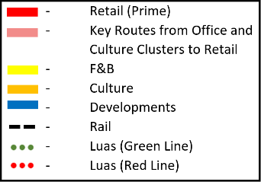
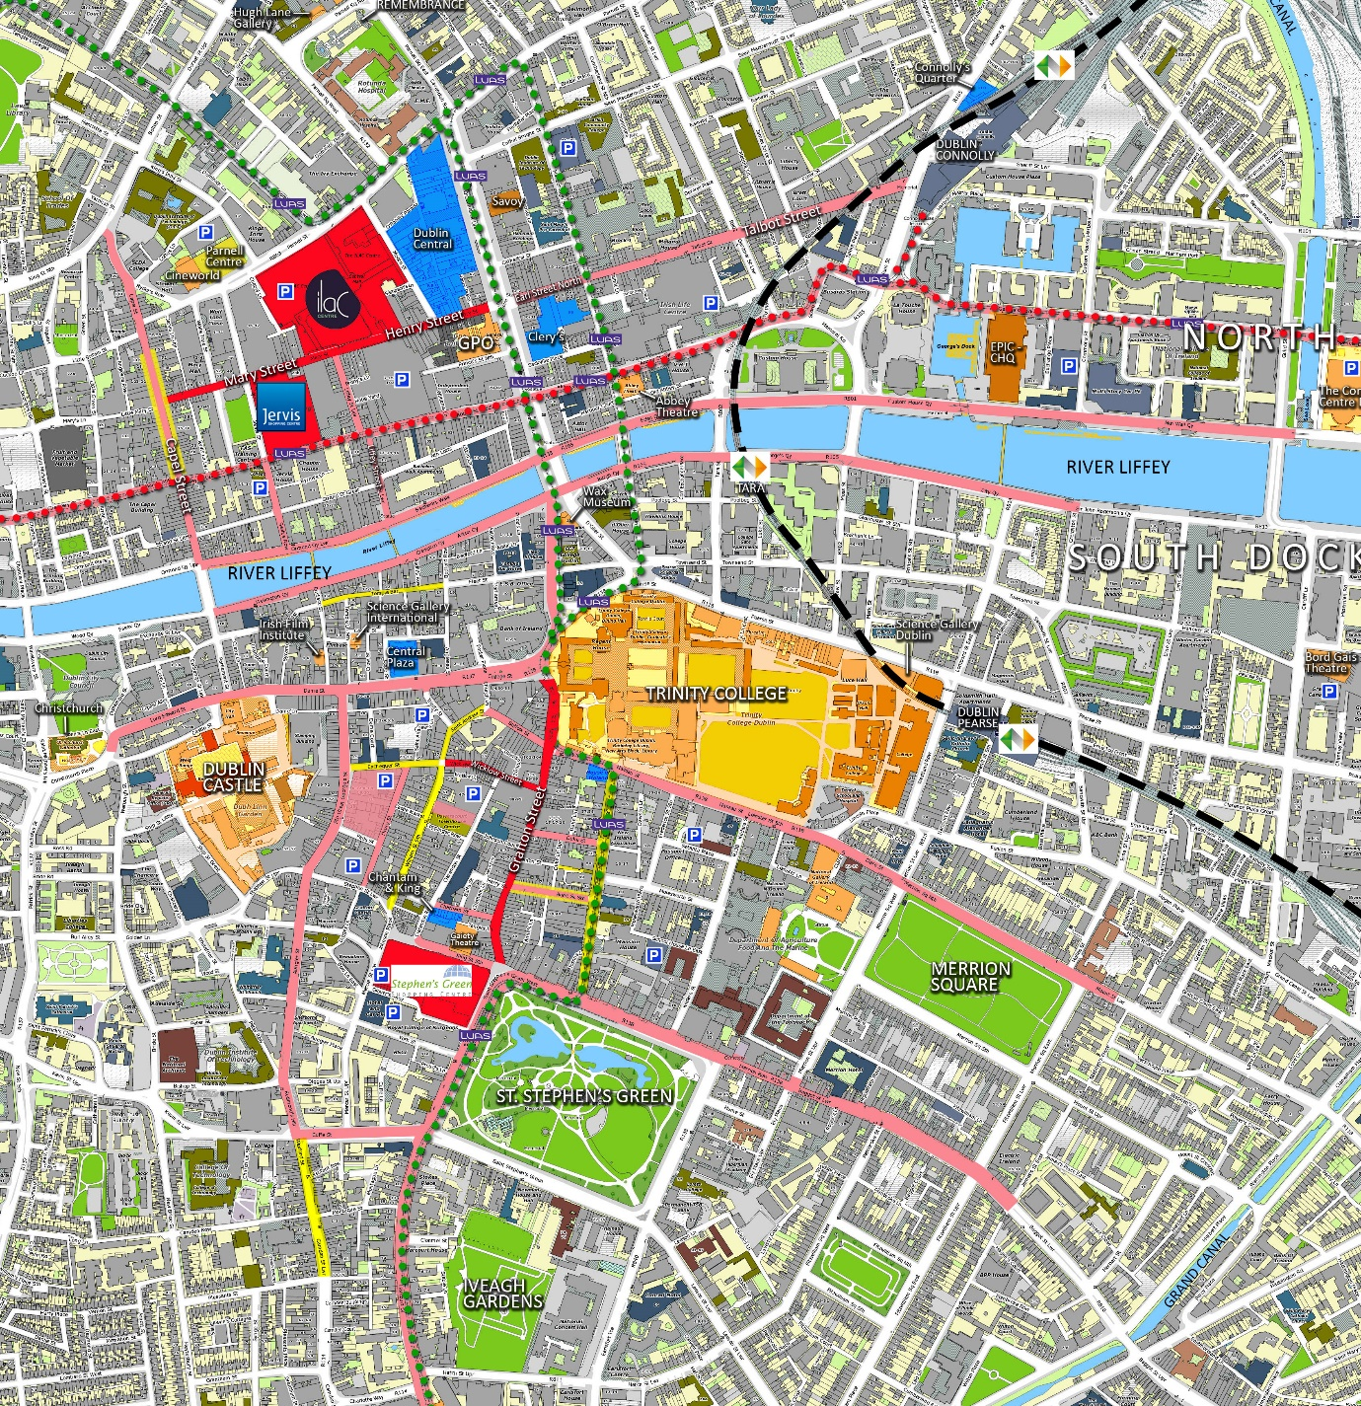

8.2 Diversifying the City Centre Offer
It is recognised internationally that the retail sector has become one element of a wider leisure and cultural city experience. A vibrant mix of shopping and leisure and cultural uses such as cafes, restaurants, exhibition spaces, cultural and leisure uses and family friendly attractions, can support the future success of the city centre. Such uses are an important part of a shopping experience and will attract people to the city centre and encourage them to stay longer. A key objective of this strategy is to diversify the city centre as a place to shop, work and spend leisure time without compromising the importance of retaining a strong retail function.

8.3 Supporting Cultural Vibrancy in the City
Cultural attractions and facilities such as theatres and museums as well as activities such as street entertainment play a key role in attracting additional day and evening footfall in the city and boosting the day and evening economy. Policy CU7 in Chapter 12 Culture of this plan outlines how Dublin City Council will continue to support, develop and nurture the city’s existing and new cultural clusters and hubs.
Utilising / providing spaces in the public realm that enable a wider range of cultural activities, events, festivals, street markets, street art / art installations, buskers / street entertainers and tourist trails attracts visitors, creates a lively and vibrant street scene thereby, attracting people to the city centre. Dublin City Council will continue to invest in and seek to expand and grow the role of the public domain as a cultural space to help boost the city economy (Policy CU29 Chapter 12 refers).

8.4 Reactivation of Underutilised and Inactive City Centre Streets and Lanes
The reactivation of underutilised and inactive city centre streets and lanes can help distribute pedestrian movement over a wider city network and can add to the vibrancy of the city centre, through the inclusion of art, landscaping, street furniture, outdoor dining, activity spaces and residential uses. The potential activation of what are largely underutilised areas of the city (streets and lanes) in Dublin 1 are being explored as part of the ‘Reimagining Dublin 1 Laneways’ project and the ‘North Lotts Planning Study’. This strategy supports the implementation of ongoing works and measures to activate these areas. See also Objective CCUVO5 Chapter 7.

8.5 Creating Character Areas / Quarters
Distinctive character areas/quarters exist / are emerging in the Retail Core that are linked to cultural attractions and food and beverage provision. These areas support vibrant shopping / destination experiences and also play an important role in the night time economy. Figure 4 shows the main food and beverage and cultural attractions around the Retail Core. This also identifies the potential for the creation of a Food and Beverage cluster(s) around the Henry Street area, the realisation of which would have the potential to enhance the appeal of the north retail core. The ongoing development, consolidation and enhancement of these character areas and quarters is supported in this strategy.
Figure 4: City Activity Character Areas / Quarters

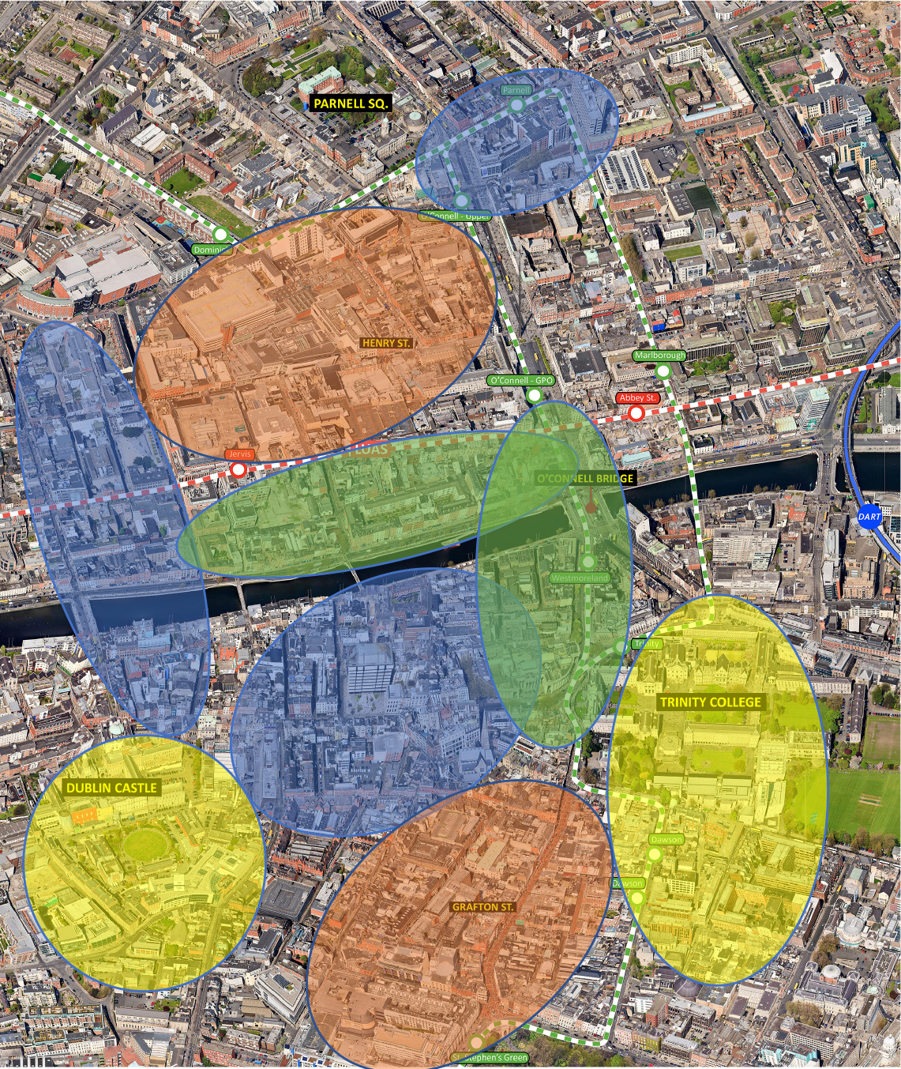

8.6 Supporting Outdoor Dining
The emergence of outdoor dining around the city centre is one of a number of Council led responses to support city centre business during the Pandemic. The benefits that outdoor dining can bring to a streetscape such as vibrancy and colour, are clearly visible around the city centre. It is an objective of the development plan to support outdoor dining in the city centre and wider city, where it does not diminish space for / impede pedestrian movement. In those areas of the city identified as food and beverage quarters in Figure 4 above, outdoor dining will be supported – see Policy CCUV32 Chapter 7.

8.7 Promoting Independent / Specialist Retailing
It is an objective of this strategy that independent and niche retailers will be supported throughout the city centre and Dublin City Council will promote the further diversification of the retail offer throughout the Retail Core by seeking a range of retail floor space sizes including provision of smaller units.

8.8 Supporting Residential Use in the City Centre
A larger residential population within the city centre will support shops and services in the city, enliven the city centre and increase the likelihood of a safer 24 hour city. The Council will encourage, support and promote more residential apartments as part of mixed-use developments or through the reuse / retrofit of the upper floors of existing building including through targeted schemes such as the ‘Living Cities Initiative’ – see also Chapter 4 and Policy SC3. Residential development however, should not compromise the retail functions of the city’s shopping streets and needs to be carefully planned to avoid challenging existing night time economy uses on key streets.

8.9 Providing for Mixed Use Development
Mixed use developments provided by redevelopment or through the repurposing of existing floor space which provide activity at street level in the city will be supported. A mix of retail, office, cultural and entertainment uses can generate footfall in the city and support city centre uses. The provision of a range of retail floorplates, including smaller units can provide opportunities to integrate independent retailer into streets.

8.10 Supporting Active Travel Modes / Sustainable Movement
The rebalancing of space for pedestrians in the public realm as outlined in the ‘City Centre Public Realm Masterplan, 2016, The Heart of Dublin’ will require a review of the competing demands for space in the city centre including by the private car and logistics / servicing vehicles.
Dublin City Council will develop a strategy to prioritise active travel modes and public transport use in the city centre (Objective SMTO1 refers). This will include consideration of providing for car parking on the periphery of the retail core to allow for an improved pedestrian environment within the retail core. Dublin City Council will also prepare a Servicing/Logistics Strategy for the city centre (Objective SMTO6 refers). This will include a review of potential supports for omni-channel distribution for retailers.

8.11 Indoor and Outdoor Markets
Indoor and street based markets including Georges Street Arcade, Moore Street, the Temple Bar Book and Food Market and the Designer Market on Cows Lane, add vibrancy and interest to the City as well as supporting local produce/enterprise. The proposed redevelopment of the Victorian Wholesale Fruit & Vegetable Market on Mary’s Lane and a regenerated Iveagh Market and Moore Street Market, have the potential to provide major visitor attractions in the city as well as new local amenities for the communities that they serve. See also Chapter 7 Policies CCUV33 and CCUV34.

8.12 Category 1 and 2 Streets
Dublin City is already a major destination for shopping, culture and leisure activities. It will be important that offer on the shopping streets and within the Retail Core is broadened to build on the city’s unique experiences and to attract visitors to shop and explore its entirety.
Category 1 Streets - In order to reinforce Grafton Street and Henry Street as the premier shopping streets in the city, it is essential to ensure that higher order retail outlets will be the principal use on these streets. This will allow surrounding streets to be promoted for a wider range of retail, restaurant, and cultural activities complementing the higher order comparison shops.
In order to strengthen the retail offer of the city centre, the land-use objectives will favour higher order retail use at ground floor level and on upper floors.
Applications for retail service outlets such as call centres, phone shops, take-aways, off-licences (other than those selling wine only), car rental and financial institutions will not be permitted at ground floor level.
Other non-retail uses, i.e., pubs, cafés, restaurants, will be considered on their merits; such developments will be only permitted where it can be demonstrated that the primary retail function of the Category 1 Street will not be undermined.
Category 2 Streets – Streets in this category are those that already have a mix of retail and non-retail uses which complement the primary retail function of the Category 1 Streets. Further development of retail units will be encouraged along with complementary non-retail uses such as cafés and restaurants, cultural, tourist and entertainment uses as well as retail services that add to the vibrancy of the street and create a mixed use environment to provide for a more integrated shopping and leisure experience. The overarching objective of the Category 2 Street designation is to create a rich and vibrant experience with a broad range of land uses and activities with active frontage, that contribute positively to the character and appearance of the Category 2 Streets. This plan extends the extent of Category 2 streets in the Core Retail Area.
Applications for other retail service outlets such as internet cafés, call centres, phone shops, take-aways, off-licences (other than those selling wine only), car rental and financial institutions at ground floor level will be assessed on their merits, and may only be permitted where such development would not result in a predominance of such similar frontages on the street.
Dublin City Council will seek to prohibit adult shops, betting shops and gaming arcades on Category 1 and 2 principle shopping streets in Dublin. Figure 7.2 in Chapter 7 identifies the Category 1 and 2 Streets. Policy CCUV16 also refers.

8.13 Protection and Enhancement of Built Heritage Assets Architectural Conservation Areas (ACAs)
The historic environment of the city creates a desirable city centre experience. Dublin City Council has designated four Architectural Conservation Areas (ACAs) within the City Centre Retail Core: South City Retail Quarter ACA, 2007, the Grafton Street and Environs ACA, 2006, the O’Connell Street and Environs ACA, 2001 and the Capel Street and Environs ACA, 2009. Moore Street was designated as an ACA by the Council in 2021 and is listed as a priority ACA in this development plan.
The policy on land-use as set out in the Architectural Conservation Areas (ACAs), with particular regard to complementary non-retail uses, shall be revised accordingly to reflect the approach as set out in the Category 1 and Category 2 Streets, in order to create the rich mix and diversity of complementary uses in the vicinity of the principal shopping streets – see Objective CCUV08 Chapter 7.

8.14 Special Planning Control Schemes
Special Planning Control Schemes (SPCS) apply to areas within Grafton Street and Environs, designated in 2013, renewed in 2019, and O’Connell Street and Environs, designated in 2003 and renewed in 2009 and again in 2016. These SPCS follow the boundaries of the ACAs. The Special Planning Control Schemes give the planning authority greater control in maintaining a balance in the mix of uses on the street and were prepared to address the predominance of certain uses inappropriate to the city’s two principal streets which also serve an important civic function.
The land-use policy set out in these schemes shall apply to all applications within the designated areas of Special Planning Control. The policy includes protection of existing uses that contribute to the special interest or character of a protected structure; the promotion of an appropriate mix and balance of uses with an emphasis on higher order comparison retail and the control of new uses; the control of changes within use classes and the control of changes to lower order retail and non-retail uses.
The policy on maximising the use of buildings shall also apply to applications within the designated areas of the schemes.

8.15 Greening the City Centre Core
Compared to other European cities, Dublin’s city centre has a low level of street tree planting. To improve the visual quality and environmental richness of the city, the ‘City Centre Public Realm Masterplan, 2016, The Heart of Dublin’ seeks the greening of the city centre and habitation creation. It also supports the further development and expansion of the urban tree canopy where feasible; street planting as part of public realm projects and through the incorporation of sustainable drainage systems (SuDs) into development proposals to strengthen the green infrastructure of the city. This strategy supports the ongoing implementation of such measures to enhance the physical environment of the city. See also Chapter 10 Green Infrastructure and Recreation.

8.16 Supporting the Evening and Night Time Economy
There has been growing recognition of the role that the evening and night time sector plays / can play in the economy, vibrancy and attractiveness of international cities. Dublin City Council will support the ongoing development of a vibrant evening and night time economy in the city where all citizens and visitors are welcome in the evenings, with places to socialise, dance, to enjoy arts and culture and evening indoor and outdoor activities / attractions. A Government Task Force on the Night Time Economy, which includes the Lord Mayor of Dublin City, is to publish a Night Time Economy Strategy with recommendations on supporting the development of a vibrant night time culture and economy and on addressing the challenges facing the night-time economy, and as a consequence of the Pandemic. See also Policies CCUV35 and CCUV36, Chapter 7.

8.17 Working with DublinTown BIDS (Business Improvement District)
The City Council will continue to work with city stakeholders such as the BIDs group ‘DublinTown’ – see Objective CCUVO18, Chapter 7. The organisation, which represents 2,500 businesses in the city centre, promotes Dublin City Centre, online, at international conferences etc., as a place for shopping and socialising and through practical initiatives such as cleaning / graffiti removal services (including a night crew) in the City, enhancement measures (planters etc.) and through a Street Ambassador Service. The BIDS group, in consultation with Dublin City Council and the Gardaí, regularly hold events in the City to promote footfall in the city centre.

8.18 Marketing the City Centre
Dublin City Council will actively market the city centre utilising publicly available information from the CSO, CSRI, OECD and other reliable research sources in order to benchmark Dublin internationally – see Objective CCUVO7, Chapter 7.

9.0 Assessment of Planning Applications
Planning applications for retail development must comply with the criteria on location, suitability of use, size and scale and accessibility set out in the Retail Guidelines 2012 and in this Retail Strategy.
Any application for retail development must demonstrate to the satisfaction of the planning authority, that it complies with the policies and objectives of the development plan and this Retail Strategy to support the city centre and to promote an appropriate form and scale of development in the Key Urban Villages and urban villages/neighbourhood centres; otherwise it must be subject to the sequential approach, its policy principles and order of priority. A Retail Impact Assessment may be required, where the development is considered to be of a significant scale.

9.1 Sequential Approach
It is a national policy objective to promote greater vitality in the city centre and urban centres by promoting a sequential approach to retail development. Where a retail development proposal is not consistent with the Plan’s objectives to support the city centre, KUVs and UVs/neighbourhood centre, and is located outside of these centres, then it must be subject to the sequential approach. The order of priority of the sequential approach is set out below:

1. City Centre and Key Urban Villages Centres/Urban Villages/Neighbourhood Centres
The overall preferred location for new higher order fashion and comparison goods is within the city centre retail core. Retail development will also be appropriate within Key Urban Villages and in urban villages/neighbourhood centres of a form and a scale appropriate to the needs of the catchment that these centres are serving.

2. Edge of Centre Sites
Where retail development on an edge of centre site is being proposed, only where it can be demonstrated and the planning authority is satisfied that there are no sites or potential sites including vacant units within the city centre or a KUV/UV or neighbourhood centre that are (a) suitable (b) available and (c) viable, can an edge of centre site be considered. An edge of centre site is normally within walking distance of and easily accessible to an urban centre.

3. Out of Centre Sites
Where retail development on an out of centre site is being proposed, only in exceptional circumstances where it can be demonstrated and the planning authority is satisfied that there are no sites or potential sites either within either (1) or (2) above, can an out of centre site be considered and where demand exists which cannot be met in other established centres.
All options in a centre should be assessed before other sites are considered. Dublin City Council will work with relevant parties to identify a range of sites to meet the improvements needed in retail provision.
Any deviation from the overarching policy principle of locating retail development in accordance with the sequential approach must be justified. For further guidance see the Retail Planning Guidelines, 2012, (pages 30 - 33).
The sequential approach must also be used to assess proposals for the extension or material change of use of existing developments where they are of a scale which could have a significant impact on the role and function of existing urban centres.

9.2 Retail Impact Assessment
Development proposals for significant retail development must be supported by a full Retail Impact Assessment. In general, significant retail development means 2,000 sq. m. + net comparison floorspace and 1,500 sq. m. + net convenience floorspace, located outside the city centre retail core and Key Urban Villages. Notwithstanding these thresholds, where Dublin City Council considers a retail development proposal, due to its scale and or location, may impact on the vitality and viability of a designated centre, applicants will be requested to submit a Retail Impact Assessment.
Given the city centre’s retail function at the apex of the retail hierarchy for the city, region and state and the need to further promote and consolidate retail development in the city centre retail core, the assessment of retail proposals in the city centre retail core will only have regard to the qualitative aspects of the proposal rather than the quantitative need for the retail proposal.
Retail Impact Assessments (RIAs) shall be prepared in accordance with the criteria set out in Section 4.9 of the Retail Planning Guidelines. In addition to this criteria, RIAs should be based on an appropriate catchment area and regard should be had to relevant extant permissions and existing vacancy in the relevant centre(s). The applicant will be required to demonstrate in the Retail Impact Assessment compliance with the development plan and that there will not be a material adverse impact on the vitality and viability of any existing centre.

9.3 Trans-boundary Impacts
Retail catchment areas by their nature cross administrative boundaries and it is possible that a proposal for a significant retail development in one local authority area may have impacts on the shopping patterns of an adjoining council. In order to facilitate an integrated approach to retail development in the city region, Dublin City Council will consult with adjoining local authorities regarding the impact of retail plans or schemes, with particular regard to the potential for significant cross-boundary impacts on the retail hierarchy or the retail areas in adjoining councils.

10.0 Guidance on Specific Forms of Retail
This section sets out the criteria for assessing planning applications for different types of retail development.

10.1 Convenience Retail
Large convenience goods stores provide primarily for weekly convenience goods shopping. According to the Retail Planning Guidelines the maximum size of convenience retail floorspace in Dublin City is 4,000 sq. m. net retail floorspace.
Convenience retailing provision has expanded significantly in Dublin City in the last decade; a number of convenience stores have opened in the inner city and around the city. It is notable that a number of operators have adapted their store model to suit urban / city centre sites with limited or no car parking in some cases. This is supported by the Council. It is anticipated that the convenience sector will continue to expand in the city commensurate with population growth. Convenience retailing is suitable at all levels in the retail hierarchy; large convenience stores should to be located in the City Centre, Key Urban Villages and urban villages and smaller convenience stores are appropriate in neighbourhood centres.
Edge of centre locations for such developments may be appropriate subject to the provisions of the sequential approach as outlined above. It is acknowledged that many urban centres due to their historic layout, land use patterns and site ownership have a lack of sites suitable to accommodate the larger format convenience operators. This is also acknowledged in the Retail Planning Guidelines, 2012.
Where a proposal for a large convenience store involves a significant amount of comparison goods, the application drawings should clearly delineate the floor area to be devoted primarily for the sale of convenience goods. A detailed assessment of the comparison element of such proposals should be undertaken including a full quantitative assessment of the potential impact of that element on existing comparison goods stores within the catchment area.
Small scale supermarkets will also be considered favourably in large industrial / employment zones where there is an identified need and where they serve the daily shopping needs of workers and employees.
All convenience goods stores, regardless of their type, will also be expected to contribute positively to the existing urban environment and be able to integrate in design terms. The Retail Design Manual 2012 details how this can be achieved.

10.2 Retailing Parks and Retail Warehouses
Retail Warehouse Parks, due to their scale and access / car parking requirements, are typically located at out of centre / suburban locations. There are examples, however, of operators adapting this retail format to suit urban / city centre sites as part of high density residential / office schemes. A successful example of this is Meadows and Byrne furniture shop at Belmayne on the Malahide Road. It is notable also that ‘click n collect’ and home deliveries are increasingly a feature of Retail Park / Warehouse operations, thereby enabling their siting in urban centres.
Any development proposal will be carefully considered in the context of location, scale and design of the development, appropriate vehicular access and the quantitative need for such development.
The range of goods sold in planned parks / individual units should be restricted to bulky goods as defined in Annex 1 of the Retail Planning Guidelines 2012.These include carpets, furniture (including flat pack furniture), household appliances, bulky DIY items, tools and equipment for the house and garden, bulky pet products, catalogue shops, bulky nursery furniture, audio visual, photographic and information processing equipment and goods which are such a size that they would normally be taken away by car and not be manageable by customers travelling by foot, cycle or bus, or that require large floor areas to display them. As noted in the Guidelines, it is acceptable that up to 20% of the total net floor space be used for the sale of ancillary products associated with an otherwise bulky good. Such space is to be clearly delineated on planning application drawings to facilitate future monitoring and enforcement.
Individual retail warehouse units should not be less than 700 sq. metres in size in out of centre locations. The Retail Guidelines place a cap on large scale single retail warehouse units in excess of 6,000 sq. m. gross (including any ancillary garden centre). The planning authority will attach conditions to planning permissions to prevent coalescence or linking together of stores.
Innovative types of large scale retail warehouses may be considered on the merits of individual development applications in the city. Subject to the criteria set out in the guidelines, the development of flagship retail warehouse operators in the city is supported in appropriate locations. The location of such a development should be well served by existing or planned public transport services and it must be demonstrated that such a proposal would not adversely affect the efficiency of the national road network. An application for such developments must be accompanied by a detailed traffic impact assessment and should also include a retail impact assessment which in particular considers the vitality and viability of city/KUV centres and demonstrate that the development would not include uses and activities which are more appropriate to the city centre or a Key Urban Village location.
Due to the nature of goods sold in retail parks in suburban locations, extensive car parking is typically required. In the case of a city centre / KUV site extensive car parking will not be supported. All planning applications in this respect should be accompanied by a traffic and transport assessment as well as a mobility management strategy and operational servicing strategy to manage the movement of goods and services in the area.

10.3 Factory Shops
Such units, usually located as part of or adjacent to the production facility, should be restricted by way of condition to the sale of products produced by the relevant factory. Proposals for individual factory shops may be appropriate, provided the scale of the shop is appropriate to its location and raises no issues in relation to the vitality and viability of nearby urban centres.

10.4 Outlet Centre
Outlet centres consist of groups of stores, particularly designer fashion labels retailing end-of-season or discontinued items at discounted prices, and are often located in out-of-centre locations. Due to the specific niche that outlet centres operate within, applicants must demonstrate that the products sold will not be in competition with those currently on sale in the city centre retail core. Applications for the development of outlet centres should be considered having regard to the provisions of the Retail Strategy and assessed in accordance with the sequential test. The preferred location for outlet centres is in the city centre and in Key Urban Villages.

10.5 Markets / Casual Trading
Dublin City Council will support the provision of casual trading and markets throughout the city. Casual trading, e.g. Christmas Markets and Farmers’ Markets, is an increasingly popular form of retail and can add vitality and colour to retail centres, especially at festive times of the year. It is regulated by the Casual Trading Act 1995, as amended.
The provision of permanent indoor marketplaces comprising a range of activities such as food and beverage services and retail services will also be supported. Permanent markets, temporary / weekly outdoor markets will also be supported and encouraged in certain locations, particularly in KUV’s and urban villages.
Applications for the provision of marketplaces will be required to demonstrate how the overall management of the facility will be operated on a day to day basis and provide sufficient information regarding noise impact, odour and ventilation. Mobility management and associated traffic and transport impacts should also be provided.

10.6 Petrol Filling Station Shops
According to the Retail Planning Guidelines, the size of retail units associated with petrol filling stations should not exceed 100 sq. metres. Where permission is sought for a shop associated with a filling station with floor space in excess of 100 sq. m., the sequential approach to retail development shall apply.

10.7 Shopping Centres
Proposals for shopping centres, where it is demonstrated they are acceptable in principle, shall have regard to the overall city policy to promote vibrant streets and also to the Retail Design Manual accompanying the Retail Planning Guidelines 2012. The design must ensure that the proposed shopping centre will be integrated with and be complementary to the streetscape where it will be located. Particular elements to be addressed include:
- The creation of a legible and attractive pedestrian environment through appropriate design.
- The creation of attractive and safe new streets and linkages, where feasible.
- The provision and design of quality street furniture, including fully accessible public facilities and support facilities for shoppers, e.g. toilets, childcare areas, changing facilities and a dedicated room for breastfeeding/maternity related purposes. Such facilities should be provided in shopping centres, larger department stores and retail developments over 800 sq. metres (net).
- The inclusion of residential uses, where appropriate, as an integral part of the centre, in order to increase the evening activity and security of the centre.
- Ease of access to the centre for public transport, cyclists and pedestrians; in the interests of both ease of access and civic design concerns, the centre should have frontage to the street and should not be surrounded by car parking.
- The overall design strategy will normally reflect variety and diversity (by the use of differing shop fronts, setbacks, signs etc.) within a unified design distinctive and specific to its location.
- Shopping centres should be designed along passive design principles and landscaped to ensure safety for visitors, with a good mix of uses encouraging day and evening uses, while passive surveillance design principles can deter casual graffiti and vandalism. Materials used in their construction should be robust and suitable for climatic conditions over an extended period. Service areas etc. should be out of sight of surrounding residential and pedestrian areas.
- Tree planting and landscaping must form part of the overall design of the shopping centre.
- Universal design and access for all to be integral to any development design.
Note: Guidance on shopfront and signage design are set out in Chapter 15.

PAGE LEFT INTENTIONALLY BLANK

Dublin City Development Plan 2022-2028

Appendix 3: Achieving Sustainable Compact Growth
Policy for Density and Building Height in the City

PAGE LEFT INTENTIONALLY BLANK

1.0 Introduction
It is adopted planning policy at both national and regional level to promote compact growth and provide for increased density and height on underutilised lands within core urban areas in order to promote consolidation, prevent further sprawl and address climate change. Increasing height and density however, can also bring challenges in terms of design and sustainability.
The purpose of this Appendix is to set out guidance on how to achieve appropriate and sustainable compact growth in the city and specifically, to ensure consistency with the Urban Development and Building Heights Guidelines for Planning Authorities (December 2018) and the SPPR’s contained therein. Guidance is set out regarding appropriate areas for increased density and height. A comprehensive set of performance based criteria are detailed for the assessment of applications where significant urban intensification is proposed. These criteria are to ensure that a form and intensity of urban development is achieved that contributes to the overarching objectives of the plan to create sustainable communities and high quality places for people to live and work. The guidance is to ensure the highest standard of design and the protection of existing amenities and the natural and historical assets of the city. Guidance regarding landmark buildings is also set out.

2.0 Policy Context
As detailed in Chapter 1 of the Plan and in the Core Strategy, both the National Planning Framework and the Regional Spatial and Economic Strategy including the Metropolitan Area Spatial Plan promote urban consolidation and the delivery of new homes and employment opportunities within the built up footprint of existing settlements. The development of brownfield lands, particularly those that are well served by public transport, for attractive, well designed and liveable neighbourhoods is promoted. NPO 13 identifies building height as an important measure to achieve compact growth and states that:
“In urban areas, planning and related standards including in particular building height and car parking will be based on performance criteria that seek to achieve well-designed high quality outcomes in order to achieve targeted growth. These standards will be subject to a range of tolerance that enables alternative solutions to be proposed to achieve stated outcomes, provided public safety is not compromised and the environment is suitably protected”.
National Policy Objective 35 states:
“Increased residential density in settlements, through a range of measures including reductions in vacancy, re-use of existing buildings, infill development schemes, area or site-based regeneration and increased building heights”.
In December 2018, the Urban Development and Building Heights Guidelines for Planning Authorities were published. This policy document sets out a new approach to the consideration of building height in our urban areas. The Guidelines are published under Section 28 of the Planning and Development Act 2000 (as amended). They include a number of Specific Planning Policy Requirements (SPPRs) which a Planning Authority is required to have regard to and shall apply in the carrying out of their functions, including the preparation of the development plan.
The guidelines recognise the role that height plays in the achievement of compact cities and densification. It is noted that increased height is a significant component in making the optimal use of sites in urban areas where public transport, employment, services and retail development can achieve a requisite level of intensity for sustainability. The guidelines also note that increased building height is a factor in assisting modern placemaking and improving the overall quality of our urban environments.
The guidelines are explicit that it is inappropriate for a development plan to include generic height limits across their functional areas. It is considered that this approach undermines wider national policy objectives to provide more compact forms of urban development. It is also considered that such blanket limitations can hinder architectural innovation and urban design.
The guidelines set out both an area based and performance criteria driven approach. The achievement of height is linked to increasing densities, although it is recognised that increased height does not necessarily mean higher densities.
Key points from the guidelines include:
- Development plans should identify locations where increase height is appropriate/promoted.
- The consideration of the appropriateness of such locations must take account of any particular environmental sensitivities.
- Key locations will include brownfield infill opportunities, old industrial areas, docklands, low density suburban shopping centres and public transport corridors.
- For sites larger than 2ha – a master planning exercise regarding their future development may be required.
- Development plans must set out a series of performance criteria in which to assess high buildings. The guidelines also set out a number of assessment criteria.
- Development plans should include specific guidance regarding building height in historic settings.
- In driving general increases in building heights, planning authorities shall also ensure appropriate mixture of uses.
The guidelines set out 4 SPPRs. Full details of the Building Height Guidelines can be found at the following link: https://www.gov.ie/en/publication/93d22-urban-development-and-building-height-guidelines-ud-bhg-2018/
Other relevant guidance regarding building height and density are:
- Sustainable Urban Housing: Design Standards for New Apartments – Guidelines for Planning Authorities 2018 which set out a comprehensive suite of qualitative and quantitative standards for assessing apartment developments and ensuring well designed, high quality outcomes.
- Design Manual for Urban Roads and Streets (DMURS) 2019 which notes the importance of the relationship between building height and street width, and the role that this plays in providing appropriate enclosure of streets and spaces.
- Sustainable Residential Development in Urban Areas: Guidelines for Planning Authorities and the accompanying Urban Design Manual 2009 which provides guidance on planning for sustainable neighbourhoods in differing locations and urban density.

3.0 Understanding Height and Density – the Strategic Approach

3.1 Height

Introduction
Building heights significantly define the character of cities and neighbourhoods. They are generally expressed in terms of either their overall height or their number of storeys. Height to width ratio can also be used to help define the slenderness of a taller building. Consideration of what constitutes a tall building can be subjective and also depends on context. For example, a 6 storey building in the city centre may not be considered as high, whereas such a proposal in a low density suburb, may be construed differently.

Dublin Context
There are considered to be three general categories of height in the Dublin Context.
- Prevailing Height: This is the most commonly occurring height in any given area. It relates the scale, character and existing pattern of development in an area. Within such areas, there may be amplified height. This is where existing buildings within the streetscape deviate from the prevailing height context, albeit not to a significant extent, such as local pop up features. Such amplified height can provide visual interest, allow for architectural innovation and contribute to a schemes legibility.
- Locally Higher Buildings: These are buildings that are significantly higher than their surroundings and are typically up to 50 metres in height. Higher buildings can act as Local or District landmarks.
- Landmark/Tall Buildings: A landmark or tall building is one that is a significant intervention in the cityscape and skyline. They are typically located in an area that denotes a specific function such as a public transport interchange or a key urban quarter/ regeneration site. Landmark/tall buildings are typically in excess of 50 metres in height, of exceptional architectural quality, can help people navigate through the City and form memorable reference points.

Strategic Approach
The main determining factor in considering appropriate heights is the need to create exemplar urban development with attractive streets, spaces and public areas that integrate successfully with the surrounding area. The key factors that will determine height will be the impact on adjacent residential amenities, the proportions of the building in relation to the street, the creation of appropriate enclosure and surveillance, the provision of active ground floor uses and a legible, permeable and sustainable layout. At a European level, best practice examples indicate that appropriate density and layouts that create appropriate street scale and enclosure are achieved with mid-rise typologies of buildings 4 to 8 storeys in height. Scope for taller or landmark feature buildings is generally limited to marking key areas of note.
At a strategic level, Dublin City has an intrinsic quality as a predominantly low rise city. There is a recognised need to protect conservation areas and the architectural character of existing buildings, streets and spaces of artistic, civic or historic importance. In particular, development proposals must be sensitive to the historic city centre, the River Liffey and quays, Trinity College, Dublin Castle and medieval quarter, the historic squares and the canals. It is important to protect the skyline of the inner city and to ensure that any proposals for high buildings make a positive contribution to the urban character of the city and create opportunities for place making and identity. Opportunities for height will be promoted on sites identified in section 4 below and in accordance with the performance criteria set out in Tables 3 and 4.

3.2 Density

Introduction
Density is defined as the intensity of development on any given area of land. It can have a significant influence on the quality of a development and successful placemaking. Residential densities are predominantly expressed as dwellings per hectare. Habitable rooms per hectare or bed spaces per hectare also give an indication of the intensity of development and the likely numbers of occupants. Appropriate densities are essential to ensure the efficient and effective use of land. It is important to make the best use of the city’s limited land supply in order to meet the need for new homes, jobs and infrastructure required by the city’s growing population. More compact forms of development, ensuring a mix of uses, the containment of ‘urban sprawl’ and achieving social and economic diversity and vitality are critical for the future of the city and addressing climate change.
Excessive density however, can be problematic. Significantly higher density schemes, particularly when coupled with high buildings, can generate problems in terms of creating successful, well designed and sustainable communities. In some instances, it can have impacts on the amenities of existing residential communities and for the future occupiers of such schemes, as well as how such developments integrate with the existing urban fabric. There can also be concerns regarding the capacity of existing social and physical infrastructure to absorb denser developments.
Appropriate higher density schemes are considered to be ones that combine mixed tenure homes, public space and community infrastructure. This can often be achieved by using building forms of 4 to 8 storeys and in this regard, higher density does not necessarily equate to high rise buildings – see Figure 1 below. High quality design and placemaking are however, the critical factors when developing higher density developments.
In recent years, there has been a move towards higher densities across the city. In Dublin Docklands under the North Lotts and Grand Canal Dock Planning Scheme, densities in the range of 200 to 250 units per hectare are achieved, whereas under the Poolbeg West Planning Scheme, densities in the range of 300 units per hectare are proposed. This is achieved by developing buildings typically 5 to 8 storeys, with carefully considered landmark buildings, in order to achieve appropriately framed streets and sustainable neighbourhoods.

Strategic Approach
The strategic approach is that the highest densities should be located at the most accessible and sustainable locations. Sustainable densities in accordance with the standards set out in the Guidelines on Sustainable Residential Development in Urban Areas 2009 will be supported. An urban design and quality led approach to creating sustainable development will be promoted. There should be a focus not just on maximising density to maximise yield, but on a range of qualitative criteria and the consideration of a wide range of other factors including architecture, urban design, community facilities and infrastructure, green infrastructure and quality placemaking.
Sustainable densities promoting the highest quality of urban design and open space will be sought by the City Council in all new developments. The density of a proposal should respect the existing character, context and urban form of an area and seek to protect existing and future residential amenity. Public transport accessibility and capacity will also determine the appropriate density permissible. A varied typology of units will be encouraged to ensure a diverse choice of housing options in terms of tenure, unit size and design in order to ensure demographic balance in residential communities. All proposals for higher densities must demonstrate how the proposal contributes to healthy place making, liveability and the identity of an area, as well as the provision of community facilities and/or social infrastructure to facilitate the creation of sustainable neighbourhoods.
As a general rule, the following density ranges will be supported in the city.
Table 1: Density Ranges
Location | Net Density Range (units per ha)
City Centre and Canal Belt | 100-250
SDRA | 100-250
SDZ/LAP | As per SDZ Planning Scheme/LAP
Key Urban Village | 60-150
Former Z6 | 100-150
Outer Suburbs | 60-120

There will be a general presumption against schemes in excess of 300 units per hectare. Recent research has shown that very high density can challenge positive responses to context, successful placemaking and liveability aspirations, sometimes resulting in poor quality development. Schemes in excess of this density will be only be considered in exceptional circumstances where a compelling architectural and urban design rationale has been presented.
It is acknowledged that schemes of increased density are often coupled with buildings of increased height and scale. Where a scheme proposes buildings and density that are significantly higher and denser than the prevailing context, the performance criteria set out in Table 3 shall apply.

Plot Ratio and Site Coverage
Tools such as plot ratio and site coverage can be used as part of a suite of measures to ensure higher density schemes are appropriately developed to a high standard.
Plot Ratio: gross floor area of the building (s) divided by the site area.
Site Coverage: the percentage of the site covered by building structures excluding public roads and footpaths.
Plot ratio can help control the bulk and mass of buildings. It expresses the amount of floorspace in relation (proportionally) to the site area. Plot ratios can determine the maximum building floorspace area or volume on a given site, but on their own cannot determine built form. The same area or volume can be distributed on a site in different ways to generate different environments. Plot ratio should, therefore, be considered in conjunction with other development control measures including site coverage, building heights, public and private open space, parking provision etc.
Site coverage is a control for the purpose of preventing the adverse effects of over development, thereby, safeguarding sunlight and daylight within or adjoining a proposed layout of buildings. It is a tool that is particularly relevant in urban locations where open space and car parking standards may be relaxed.
All applications should be accompanied by a calculation of density: units per ha and bed spaces per ha, plot ratio and site coverage. Table 2 below sets out indicative plot ratio and site coverage standards for different areas of the city.
Table 2: Indicative Plot Ratio and Site Coverage
Area | Indicative Plot Ratio | Indicative Site Coverage
Central Area | 2.5-3.0 | 60-90%
Regeneration Area | 1.5-3.0 | 50-60%
Conservation Area | 1.5-2.0 | 45-50%
Outer Employment and Residential Area | 1.0-2.5 | 45-60%
Higher plot ratio and site coverage may be permitted in certain circumstances such as:
- Adjoining major public transport corridors, where an appropriate mix of residential and commercial uses is proposed.
- To facilitate comprehensive re-development in areas in need of urban renewal.
- To maintain existing streetscape profiles.
- Where a site already has the benefit of a higher plot ratio.
- To facilitate the strategic role of significant institution/employers such as hospitals.
Any development with a plot ratio over 3.0 must be accompanied by a compelling case.
Figure 1: Height and Density
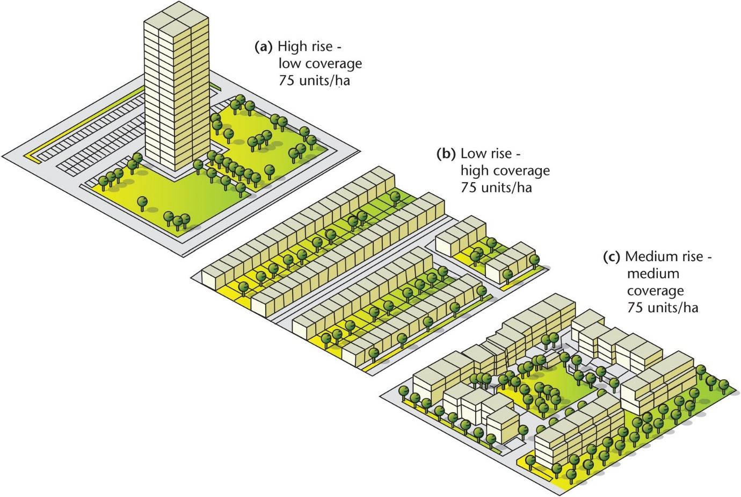

4.0 The Compact City – How to Achieve Sustainable Height and Density?

4.1 Introduction
This section sets out a policy approach for the assessment of development of increased height, scale and density in the city that aligns with the Section 28 Guidelines. In accordance with the guidance set out therein and specifically SPPR 1, areas are identified where increased height will be supported. As per the requirements of SPPR 3, a series of performance based development management criteria are set out to ensure protection of residential, heritage, streetscape and landscape amenity. All proposals with significant increased height and density over the existing prevailing context must demonstrate full compliance with the performance criteria set out in Table 3.

Identification of Areas for Increased Height and Density
The general principle is to support increased height and higher density schemes in the city centre, Strategic Development Regeneration Areas, Key Urban Villages, areas close to high frequency public transport and some other areas (as identified) considered as suitable for increased intensity of development.
The Building Height Guidelines note that general building heights of at least three to four storeys, coupled with appropriate density in locations outside what is defined as city centre, and which would include suburban areas, must be supported in principle at development plan level. The guidance also states that within the canal ring in Dublin, it would be appropriate to support the consideration of building heights of at least 6 storeys at street level as the default objective, subject to keeping open the scope to consider even greater building heights by the application of certain criteria.
In considering locations for greater height and density, all schemes must have regard to the local prevailing context within which they are situated. This is particularly important in the lower scaled areas of the city where broader consideration must be given to potential impacts such as overshadowing and overlooking, as well as the visual, functional, environmental and cumulative impacts of increased building height.
As a general rule, the development of innovative, mixed use development that includes buildings of between 5 and 8 storeys, including family apartments and duplexes is promoted in the key areas identified below. Greater heights may be considered in certain circumstances depending on the site’s location and context and subject to assessment against the performance based criteria set out in Table 3.

Key Criteria- (See Table 3)
Key criteria which all proposals for increased urban scale and height must demonstrate include:
- The potential contribution to the development of new homes, economic growth and regeneration in line with the compact urban growth principles set out in the NPF and Project Ireland 2040.
- Proximity to high quality public transport connectivity, including key public transport interchanges or nodes.
- Proximity to a range of employment, services and facilities.
- Provision of adequate social and community infrastructure.
- The availability of good walking, cycling and public transport infrastructure.
- Appropriate mix of uses, housing typologies and tenures.
- The provision of high quality public open space and public amenities.
- The resilience of the location from a public access and egress perspective in the event of a major weather or emergency or other incidents.
- That the ecological and environmental sensitivities of the receiving environments have been adequately assessed and addressed.
- Appropriate design response that considers the characteristics of the site, any development constraints and prevailing character.
- Adequate infrastructural capacity.
In accordance with SPPR 1, the following locations are identified as generally suitable and appropriate for accommodating a more intensive form of development, including increased height.

Key Locations

City Centre and within the Canal Ring (inner suburbs)
In general, and in accordance with the Guidelines, a default position of 6 storeys will be promoted in the city centre and within the canal ring subject to site specific characteristics, heritage/environmental considerations, and social considerations in respect of sustaining existing inner city residential communities. Where a development site abuts a lower density development, appropriate transition of scale and separation distances must be provided in order to protect existing amenities.
Proposals for increased height within key sensitive areas of the city including the city centre, the River Liffey and quays, Trinity College, Dublin Castle and medieval quarter, the historic Georgian core and squares and the canals etc. must demonstrate that they do not have an adverse impact on these sensitive environments and that they make a positive contribution to the historic context. Heights greater than 6 storeys within the Canal Ring will be considered on a case by case basis subject to the performance criteria set out in Table 3.

Strategic Development Zones (SDZ’s)
- North Lotts and Grand Canal Dock
- Poolbeg West
- Grangegorman
There are existing Planning Schemes for these areas which include detailed development frameworks that promote an appropriate scale, form and density of development. Detail is set out regarding the appropriate location for taller local landmarks as well as block layouts to ensure an appropriate scale of development. Development proposals in these areas must be in accordance with the provisions and framework set out in the relevant Planning Scheme.

Local Area Plans (LAPs)
- Ballymun
- Park West/Cherry Orchard
- Ashtown/Pelletstown
- Clongriffin-Belmayne
- Naas Road
Local Area Plans have been prepared for a number of areas, all of which promote appropriate intensification and consolidation of these strategic areas. In these areas, proposals will be assessed in accordance with the overall objectives and policies set out in the LAP. Ballymun, Park West/Cherry Orchard, Naas Road and Clongriffin-Belmayne (North Fringe) are also identified as Strategic Development Regeneration Areas, and proposals should have regard to the guiding height principles set out in Chapter 13. Where an LAP expires over the lifetime of the development plan, proposals will be considered on their merits and in accordance with the performance criteria set out in Table 3.

Strategic Development Regeneration Areas
A number of Strategic Development Regeneration Areas have been identified in the city. These areas are to be the focus of compact growth over the plan period with the objective to facilitate ongoing intensification, infill and compaction. A series of guiding principles has been set out for each SDRA (Chapter 13) which promote appropriate heights and local landmarks depending on the SDRA location and context. Development proposals that align with these guiding principles will be supported. All proposals for greater height than the prevailing context and intensification in SDRA’s must demonstrate compliance with the performance based criteria set out in Table 3.
The following SDRA locations are considered particularly appropriate for higher buildings and density as per the guiding principles and Framework Plans set out in Chapter 13 in each case:
- Heuston and Environs
- Liberties and Newmarket Square
- Grangegorman / Broadstone
- St. James’s Healthcare Campus and Environs
- Clongriffin/Belmayne and Environs
- Naas Road
- Docklands
- St. Theresa’s Gardens and Environs
- Finglas Village Environs and Jamestown Lands
- North East Inner City
- Emmet Road

Key Urban Villages
12 Key Urban Villages are identified and policies and objectives regarding their future development are set out in Chapter 7. Urban villages are at the heart of residential communities. They function to serve the needs of the local communities providing a range of commercial and community uses for surrounding neighbourhoods. A number of the Key Urban Villages have the potential to fulfil the ‘15 Minute City’ role with compact urban and mixed use development; higher urban densities; viable commercial cores with a comprehensive range of high quality community and commercial facilities; high quality urban environments; and high levels of access to quality public transport / the development of sustainable transport modes.
Many of the city’s urban villages are underdeveloped and have scope for greater intensification and consolidation. It is acknowledged however, that some of the urban villages have a prevailing low density character and any proposals for increased height and density will need to have regard to the existing pattern and grain of development to ensure sensitive and successful integration with the existing urban fabric.

Former Z6 Industrial Lands
There are significant pockets of low intensity brownfield industrial lands in the city. Many of these sites are strategically located in city and have potential for significant intensification. Some of these sites have been zoned for residential or mixed use development and provide opportunities to develop significant new mixed use and residential neighbourhoods that will contribute to the overall sustainable growth of the city. Such areas have the capacity to provide a variety of housing typologies including apartments, houses and duplex units to provide sustainable neighbourhoods.
In general, heights of 4-6 storeys is supported on such sites, subject to compliance with the key criteria set out above and the performance criteria set out in Table 3. Where such sites abut existing lower density residential areas, appropriate transition of scale and separation distances must be provided in order to protect existing amenities. Heights greater than 6 storeys may be considered on a case by case basis where there is a strong placemaking and urban design rationale.

Public Transport Corridors
There is recognised scope for height intensification and the provision of higher densities at designated public transport stations and within the catchment areas of major public transport corridors including:
- Bus connects/Core Bus Corridors (CBC’s)
- Luas
- Metrolink
- DART
Development proposals will primarily be determined by reference to the proximity of new public transport infrastructure and to the area character. Locations for intensification must have reasonable access to the nearest public transport stop. In line with national guidance, higher densities will be promoted within 500 metres walking distance of a bus stop, or within 1km of a light rail stop or a rail station in the plan. Highest densities will be promoted at key public transport interchanges or nodes.
The capacity of public transport will also be taken into consideration in considering appropriate densities and must be demonstrated by the applicant, particularly where such public transport infrastructure is in the pipeline and not yet developed.
Where a proposal for increased height and density is planned adjacent to proposed public transport infrastructure, the applicant must consider appropriate phasing and sequencing of development to ensure that an appropriate scale and intensity of development, coupled with adequate social and physical infrastructure, is delivered in tandem with the delivery of such public transport infrastructure.
It is acknowledged that many sites along such transport corridors are smaller infill sites. Particular regard must be had to ensure that proposals are of a coherent scale and provide a sustainable and viable extension to the existing urban fabric.

Outer City (Suburbs)
Outside of the canal ring, in the suburban areas of the city, in accordance with the guidelines, heights of 3 to 4 storeys will be promoted as the minimum. Greater heights will be considered on a case by case basis, having regard in particular to the prevailing site context and character, physical and social infrastructure capacity, public transport capacity and compliance with all of the performance criteria set out in Table 3.

Criteria for Assessment

Masterplan
A design-led approach to optimise density and height is advocated and this should be based on an evaluation of the site’s attributes, its surrounding context and capacity for growth and the most appropriate development form. In considering higher density proposals including buildings of enhanced height, international best practice indicates that it is possible to create successful places based around streets and a variety of urban typologies, including houses and medium-rise apartment blocks, as well as some carefully integrated taller buildings. Schemes that use urban typologies of 4 – 8 storeys can create better homes and neighbourhoods at surprisingly high densities, and are more cost-effective than other solutions.
There will be a requirement that for any significant scheme (on sites greater than 0.5ha) seeking to increase densities and height that a masterplan is prepared. The masterplan should provide a vision for the development of the entire site area, including how new buildings, streets, blocks, pedestrian and cycling routes, parks, and publically accessible and private open spaces will fit within the existing and planned context. It should include urban design studies to inform the architectural approach and to allow for the early testing of open space quantums, sunlight, daylight, visual impact and wind effects.
Proposals seeking to optimise densities need to demonstrate how they assist in delivering a vibrant and equitable neighbourhood - walkable, compact, green, accessible, mixed and balanced - responding positively to the existing or emerging context. Where extensive development is proposed, clear phasing and sequencing of development should be set out to ensure the appropriate delivery of social and physical infrastructure in tandem with the development. Such masterplans should also incorporate an Integrated Surface Water Management Strategy to ensure necessary public surface water infrastructure and nature based SUDS solutions are in place to service new development – see Appendices 11, 12 and 13 of the plan.
Higher density proposals including enhanced building height should be accompanied by a landscape and visual impact assessment with appropriate computer generated images (CGI’s) and photomontages to demonstrate how the development will assimilate appropriately with the existing urban context.

Performance Based Criteria
Successful urban living and the creation of a compact city is all about forming urban areas where people can live, work and play. The use of urban land must be optimised in terms of sustainable densities. This however, must be balanced with the provision of an appropriate mix and range of uses; scale and integration with surrounding areas; high quality public realm and green infrastructure; appropriate pedestrian, cycle and public transport connections as well as accessibility to community facilities and social infrastructure. A ‘healthy placemaking’ approach (see also Chapter 5) should be taken as the key focus of all higher density proposals.
The performance criteria to be used in assessing urban schemes of enhanced density and scale is set out in the table below. In proposing urban scale and building height, the highest standard of urban design, architectural quality and placemaking should be achieved. Further criteria for the assessment of landmark buildings is set out separately below.
Table 3: Performance Criteria in Assessing Proposals for Enhanced Height, Density and Scale
 | Objective | Performance Criteria in Assessing Proposals for Enhanced Height, Density and Scale
1. | To promote development with a sense of place and character | Enhanced density and scale should:  - respect and/or complement existing and established surrounding urban structure, character and local context, scale and built and natural heritage and have regard to any development constraints,  - have a positive impact on the local community and environment and contribute to ‘healthy placemaking’,  - create a distinctive design and add to and enhance the quality design of the area,  - be appropriately located in highly accessible places of greater activity and land use intensity,  - have sufficient variety in scale and form and have an appropriate transition in scale to the boundaries of a site/adjacent development in an established area,  - not be monolithic and should have a well-considered design response that avoids long slab blocks,  - ensure that set back floors are appropriately scaled and designed.
2. | To provide appropriate legibility | Enhanced density and scale should:  - make a positive contribution to legibility in an area in a cohesive manner,  - reflect and reinforce the role and function of streets and places and enhance permeability.
3. | To provide appropriate continuity and enclosure of streets and spaces | Enhanced density and scale should:  - enhance the urban design context for public spaces and key thoroughfares,  - provide appropriate level of enclosure to streets and spaces,  - not produce canyons of excessive scale and overbearing of streets and spaces,  - generally be within a human scale and provide an appropriate street width to building height ratio of 1:1.5 – 1:3,  - provide adequate passive surveillance and sufficient doors, entrances and active uses to generate street-level activity, animation and visual interest.
4. | To provide well connected, high quality and active public and communal spaces | Enhanced density and scale should:  - integrate into and enhance the public realm and prioritises pedestrians, cyclists and public transport,  - be appropriately scaled and distanced to provide appropriate enclosure/exposure to public and communal spaces, particularly to residential courtyards,  - ensure adequate sunlight and daylight penetration to public spaces and communal areas is received throughout the year to ensure that they are useable and can support outdoor recreation, amenity and other activities – see Appendix 16,  - ensure the use of the perimeter block is not compromised and that it utilised as an important typology that can include courtyards for residential development,  - ensure that potential negative microclimatic effects (particularly wind impacts) are avoided and or mitigated,  - provide for people friendly streets and spaces and prioritise street accessibility for persons with a disability.
5. | To provide high quality, attractive and useable private spaces | Enhanced density and scale should:  - not compromise the provision of high quality private outdoor space,  - ensure that private space is usable, safe, accessible and inviting,  - ensure windows of residential units receive reasonable levels of natural light, particularly to the windows of residential units within courtyards – see Appendix 16,  - assess the microclimatic effects to mitigate and avoid negative impacts,  - retain reasonable levels of overlooking and privacy in residential and mixed use development.
6 | To promote mix of use and diversity of activities | Enhanced density and scale should:  - promote the delivery of mixed use development including housing, commercial and employment development as well as social and community infrastructure,  - contribute positively to the formation of a ‘sustainable urban neighbourhood’,  - include a mix of building and dwelling typologies in the neighbourhood,  - provide for residential development, with a range of housing typologies suited to different stages of the life cycle.
7 | To ensure high quality and environmentally sustainable buildings | Enhanced density and scale should:  - be carefully modulated and orientated so as to maximise access to natural daylight, ventilation, privacy, noise and views to minimise overshadowing and loss of light – see Appendix 16,  - not compromise the ability of existing or proposed buildings and nearby buildings to achieve passive solar gain,  - ensure a degree of physical building adaptability as well as internal flexibility in design and layout,  - ensure that the scale of plant at roof level is minimised and have suitable finish or screening so that it is discreet and unobtrusive,  - maximise the number of homes enjoying dual aspect, to optimise passive solar gain, achieve cross ventilation and for reasons of good street frontage,  - be constructed of the highest quality materials and robust construction methodologies,  - incorporate appropriate sustainable technologies, be energy efficient and climate resilient,  - apply appropriate quantitative approaches to assessing daylighting and sun lighting proposals. In exceptional circumstances compensatory design solutions may be allowed for where the meeting of sun lighting and daylighting requirements is not possible in the context of a particular site (See Appendix 16),  - incorporate an Integrated Surface Water Management Strategy to ensure necessary public surface water infrastructure and nature based SUDS solutions are in place – see Appendix 13,  - include a flood risk assessment – see SFRA Volume 7.  - include an assessment of embodied energy impacts – see Section 15.7.1.
8 | To secure sustainable density, intensity at locations of high accessibility | Enhanced density and scale should:  - be at locations of higher accessibility well served by public transport with high capacity frequent service with good links to other modes of public transport,  - look to optimise their development footprint; accommodating access, servicing and parking in the most efficient ways possible integrated into the design.
9 | To protect historic environments from insensitive development | Enhanced density and scale should:  - not have an adverse impact on the character and setting of existing historic environments including Architectural Conservation Areas, Protected Structures and their curtilage and National Monuments – see section 6 below.  - be accompanied by a detailed assessment to establish the sensitives of the existing environment and its capacity to absorb the extent of development proposed,  - assess potential impacts on keys views and vistas related to the historic environment.
10 | To ensure appropriate management and maintenance | Enhanced density and scale should  - Include an appropriate management plan to address matters of security, management of public/communal areas, waste management, servicing etc.

5.0 Landmark/Tall Buildings

Introduction
Landmark/tall buildings have a role to play in the future development of Dublin as a compact city. Such buildings can have advantages in terms of increasing density, promoting regeneration and helping people navigate through and around the city. Appropriately located landmark/tall buildings can contribute to the development of sustainable communities and neighbourhoods particularly to optimise the capacity of sites which are well-connected by public transport and have good access to services and amenities. If well designed, they can make a positive contribution to the cityscape.
Conversely landmark/tall buildings can also have a significant detrimental impact on local character and the wider city, if the location or design is unsuitable. They can also have other adverse impacts including putting undue pressures on social and physical infrastructure, impacting negatively on existing residential amenities and significant adverse environmental impacts. Landmark/tall buildings can also be deemed more unsustainable and involve more embodied energy with greater energy consumption and carbon emissions. It is, therefore, essential that such landmark/tall buildings are directed to locations that can absorb their built form without significant adverse impacts, protect areas of sensitive urban character particularly the city’s heritage assets and achieve excellent quality both in terms of architectural design and environmental sustainability.
Whilst such buildings have a role to play in the fabric and evolution of the urban form of the city, their development should only be in instances where there is a compelling architectural and urban design rationale for them and where it can be demonstrated that they make a significant contribution to regeneration and the economic, strength, performance and resilience of the city. There are limited areas in the city that are capable of sustaining the economic and environmental impact of such landmark/tall buildings.

Identification of Areas for Landmark/Tall Buildings
Landmark/tall buildings are generally considered to be those that are substantially taller than their surroundings and cause a significant change to the skyline. They are typically buildings greater than 50 metres in height.
In terms of suitable locations, it is considered that landmark/tall building proposals are most appropriate in locations that are identified as a significant public transport interchange and/or areas for large scale regeneration and redevelopment; that are well connected centres of employment, which have the capacity to create their own character and identity and where the existing character of the area would not be adversely affected by the scale, mass and height of a landmark/tall building.
Generally, larger sites (2ha and over) offer the greatest potential for such buildings, as these sites are more able to set their own context than smaller sites. Locations considered appropriate for landmark/tall buildings have been identified at a local policy level within existing LAPs and SDZs. In addition, a number of the Strategic Development Regeneration Areas identify locations that are considered appropriate for the development of taller building/s.
The onus is on the applicant to demonstrate in their application documentation that the site is appropriate for a landmark/tall building. Any proposal for a landmark/tall building/s must undertake a thorough context and urban design analysis and a Cityscape Assessment including detailed modelling and photomontages. It must be demonstrated that the landmark/tall building proposal will not have an adverse impact on sensitive locations including conservation areas and protected structures and sensitive views. Even where a site has been identified as an appropriate location for a landmark/tall building, the proposal must meet all of the performance based assessment criteria for landmark/tall buildings.

Criteria for Assessment
All proposals for a landmark/tall building must be assessed in accordance with the performance criteria set out in Table 4 below. It is acknowledged that landmark buildings have been identified in existing Planning Schemes. Such proposals do not need to demonstrate compliance with the criteria below and will be assessed in accordance with the framework and policy provisions set out in the relevant Planning Scheme.
Table 4: Performance Criteria in Assessing Proposals for Landmark Tall Building/s
 | Objective | Performance Criteria in Assessing Proposals for Landmark/Tall Building/s
1 | Exemplary Architecture | - All proposals must be accompanied by a detailed design statement that demonstrates the achievement of excellent design and the highest standards for future occupants.  - The development should make a significant contribution to the built environment of the city. Detailed consideration must be given to the scale, form, massing and proportions of the building. A slenderness ratio of 3:1 is desirable.  - The facades must be carefully articulated and animated. This can be achieved through the use of high quality materials, colour, fenestration, reflectiveness and/or expression of depth. Large, blank or inactive gables should be avoided.  - The building form and layout must have regard to the density and character of the surrounding development. The applicant will be required to demonstrate the relationship and potential impacts of the proposal to the surrounding context, including topography, built form, scale, height, urban grain, streetscape, public realm, open spaces, rivers and waterways, important views and prospects, skyline and that these factors have been considered in the design approach.  - Detailed consideration will be required for all lighting proposals to ensure that they are energy efficient, contribute to the design and quality of the building whilst limiting the potential for excessive light spill, glare and sky glow.  - The impact of the roofscape (including telecommunications apparatus and plant rooms) must be considered and it should be designed to make an appropriate contribution to the city’s skyline.  - Where a landmark/tall building/s proposal abuts a lower density areas, such sites should be planned to provide lower level buildings at the perimeter assisting the transition in scale from the landmark/tall building/s down to the surrounding context.  - Where a proposal of significant height is proposed, the process of design selection should preferably be by means of an architectural competition.
2 | Sustainable Design and Green Credentials | - Landmark/tall buildings should set exemplary standards in terms of sustainability. Proposals should incorporate appropriate technologies and design features to minimise energy use.  - The applicant must demonstrate that the design is innovative and flexible and can be adapted overtime.  - Include an assessment of embodied energy impacts – see Section 15.7.1.
3 | Public Realm | - The development should contribute positively to its surroundings at street level, help create a ‘sense of place’, provide appropriate passive surveillance and active ground floor uses. The design of the base of landmark/tall building/s must be of a proportion, composition and scale that appropriately defines and enhances the public realm, and provides for a safe and comfortable pedestrian experience. Particular attention must be paid to the design and location of public entrances to ensure that they are legible and accessible.  - Detailed design and hard and soft landscape measures for the treatment of the public realm both within and external to the development must be provided.  - Opportunities to improve the permeability of the site and wider area should be maximised, particularly where increased pedestrian and cycle flows are envisaged.
4 | Environmental Impacts | - Applications must be accompanied by detailed technical analysis and supporting reports to demonstrate how potential environmental impacts can be appropriately mitigated and avoided. It must be proven that the development will not affect the surroundings adversely in terms of microclimate, wind turbulence, overshadowing, noise and reflected glare. This should be done through the testing of accurate physical and three dimensional models, conducting wind tunnel studies, sun path studies, as well as other suitable impact simulation methods. Impacts on adjacent properties should be tested through detailed section analysis and three dimensional (3D) computer models.  - Potential impacts to sensitive bird or bat species should be considered where appropriate.  - Where the development would have a significant environmental impact, EIA screening will be required and an Environmental Impact Statement may be required.
5 | Public Safety and Functional Impacts | - Landmark/tall building proposals must demonstrate that the development creates a pleasant, safe and healthy environment for its future occupants. The design of the building should follow best practice to minimise the threats from fire, flood and other hazards.  - All applications must be accompanied by an assessment on potential interference with aviation, navigation and telecommunications.  - It must be demonstrated that buildings can be serviced, maintained and managed in a manner that will not cause disturbance or inconvenience to surrounding public realm.  - Entrances, access routes, and ground floor uses should be designed and placed to allow for peak time use and to ensure there is no unacceptable overcrowding in the surrounding areas.  - All tall building proposals must be submitted by a full transport capacity assessment. The intensity of use associated with tall buildings will only be appropriate if it is supported by an appropriate level of transport capacity to ensure good pedestrian, disability and public transport access.
6 | Visual Impact and Cityscape Analysis | - All applications must be accompanied by a detailed visual impact and cityscape assessment to illustrate the impact on the context, especially on residential amenities, conservation areas and significant views.  - The cityscape analysis should include a detailed assessment including accurate visual modelling of the existing characteristics of the built form. It should identify strategic views and present detailed verifiable fully rendered photomontages (day and night) of the proposed tall building in the context of the surrounding area (existing, proposed and cumulative). It should be demonstrated that the development makes a positive contribution to long range, mid-range and immediate views.  - It must be demonstrated that the landmark/tall building/s will reinforce the spatial hierarchy of the local and wider context and aid legibility and wayfinding.  - The cityscape study should include a simulation of the building within a 3D digital model to demonstrate the impact of the proposal.  - The cumulative impact of a tall building proposal in the context of other existing and proposed tall building proposals must be considered.  - Landmark/tall building proposals must demonstrate the impacts on the historic context, including the need to ensure that the proposal will preserve and/or enhance historic buildings, sites, landscapes and skylines. Landmark/tall building proposals must address their effect on the setting of, and views to and from historic buildings, sites and landscapes over a wide area. It must be demonstrated that the building will have no adverse impact on the built cultural or historical heritage of the city including Architectural Conservation Areas and Protected Structures and their curtilage and National Monuments.
7 | Tall Building Clusters | - In general, opportunities for singular landmark/tall buildings in the city is likely to be limited. It is acknowledged from an architectural and land use perspective that it is preferable that landmark/tall buildings are clustered and the City Council supports this approach in the locations identified as suitable for taller buildings. A cohesive group of landmark/tall buildings maximises their economic and sustainable advantages.  - Where clusters of landmark/tall buildings are proposed, careful attention must be paid to the roof profile in the context of the whole cluster. Clusters of such towers should be composed with the tallest at the centre of the group, falling away to the edges.

There is a general presumption against landmark/tall buildings outside of the locations specifically identified as being suitable for the provision of same in this plan or in LAPs/SDZs unless in exceptional circumstances and where it can be demonstrated by the applicant that there is a compelling architectural and urban design rationale for such a development. In such exceptional cases, all of the following criteria must be demonstrated:
- That the landmark/tall building complies with all of the performance criteria set out in Table 4.
- The landmark/tall building/s will emphasise a point of particular civic of visual significance and that such a proposal will contribute in a meaningful way to the legibility of the city and contribute positively to the skyline. Any such proposal for a landmark/tall building must be supported by a detailed spatial analysis demonstrating that the design and location of the landmark/tall building is appropriate and optimal.
- The landmark/tall building will act as a strategic intervention, a catalyst for regeneration and make a significant economic or cultural contribution. The landmark/ tall building proposal must also demonstrate that it is economically viable and implementable in the lifetime of the plan.
- That the landmark/tall building is located in an area with excellent high frequency, high capacity public transport accessibility and excellent pedestrian and cyclist infrastructure. The onus will be on the applicant to demonstrate the capacity of public transport and the quality of existing links between public transport and walking and cycling infrastructure and the site.
- The landmark/tall building will bring significant planning gain to the community including measures such as:
- substantial upgrades to the public realm;
- environmental enhancements including open space and green infrastructure to be enjoyed by residents and the wider community;
- significant new social and community infrastructure for the benefit of the wider area;
- where the landmark/tall building is for residential use, the provision of a broad range of accommodation for people living in different household sizes and throughout various life cycle stages.

6.0 Guidelines for Higher Buildings in Areas of Historic Sensitivity
The Urban Development and Building Heights Guidelines for Planning Authorities Guidelines state that appropriate identification and siting of areas suitable for increased densities and height will need to consider the environmental sensitives of the receiving environment as appropriate throughout the planning hierarchy.
There are a number of environmental sensitivities in the city which contribute to its overall quality, uniqueness and identity. Developments of significant height and scale are generally not considered appropriate in historic settings including conservation areas, architectural conservation areas, the historic city centre, the River Liffey and quays, Trinity College, the Cathedrals, Dublin Castle and medieval quarter, the Georgian core and historic squares and the canals or where the setting of a protected structure would be seriously harmed by the inappropriate locating of such a proposal.

Architectural Conservation Areas
There are 24 designated Architectural Conservation Areas in the city. While the purpose of a designation is to protect and enhance the special character of an area, it does not preclude any appropriate forms of new development. Potential impact on ACA’s is included in the performance criteria in Tables 3 and 4 above.

Protected Structures/National Monuments
The city has a wealth of built heritage including over 8,000 protected structures and a number of significant national monuments (see Volume 4, Appendix 6 and Map L). A balance must be struck between protection and enhancement of our protected structures/national monuments whilst ensuring appropriate and sustainable development. New development must respond to local character and protect and enhance the built heritage. New development should not have an adverse impact on a protected structure or its curtilage or on a national monument in terms of scale, height, massing, alignment and materials. Impact on protected structures/national monuments are included in the performance based criteria set out in Tables 3 and 4.

PAGE LEFT INTENTIONALLY BLANK

Dublin City Development Plan 2022-2028

Appendix 4: Development Plan Mandatory Requirements

PAGE LEFT INTENTIONALLY BLANK

Development Plan Mandatory Requirements
The following objectives, as set out in section 10(2) of the 2000 Act (as amended), shall be included in a development plan. This list is a summary only of the list contained in the legislation.
- The zoning of land.
- The provision of infrastructure, including transport, energy, communication facilities, water supplies and wastewater services, waste recovery and disposal facilities and any ancillary facilities/services.
- The conservation and protection of the environment, including archaeological and natural heritage and the conservation/protection of European sites.
- The encouragement of the management of features of the landscape.
- The promotion of compliance with environmental standards and objectives – surface water, groundwater, etc.
- The integration of the planning and sustainable development with the social, community and cultural requirements of the area and its population.
- The preservation of the character of the landscape.
- The protection of structures of special architectural, historical, archaeological, artistic, cultural, scientiﬁc, social or technical interest.
- The preservation of the character of architectural conservation areas.
- The development and renewal of areas in need of regeneration.
- The provision of accommodation for Travellers.
- The preservation, improvement and extension of amenities and recreational amenities.
- The control of establishments under the EU Major Accidents Directive.
- The provision of community services including schools, crèches and other education and childcare facilities.
- The protection of the linguistic and cultural heritage of any Gaeltacht within the area.
- The promotion of sustainable settlement and transportation strategies including the promotion of measures to reduce energy demand, reduce anthropogenic greenhouse gas emissions, and address adaptation to climate change having regard to the location, layout and design of new development.
- The preservation of certain specified public rights of way, which shall be illustrated on at least one map and also listed.
- Requirements in accordance with government policies or objectives relating to protection, management, and planning of landscapes, having regard to the Florence Convention 2000.
In addition to the above, the Planning Act requires that the written statement includes a ‘core strategy’ to include the requirements of Section 10(2A) of the Planning and Development Act as amended. In summary, these requirements include:
- Relevant information to show that the development plan and housing strategy are consistent with the National Planning Framework, Regional Spatial and Economic Strategy and specific planning policy requirements specified in section 28 ministerial guidelines.
- Information demonstrating consistency with the national planning framework/regional spatial and economic strategy.
- Cognisance of policies of the minister regarding national/regional population targets and housing supply targets.
- The following details of residential lands or mixed residential uses: size of area in hectares and number of housing units to be included.
- For proposed residential lands or mixed residential uses: number of hectares, and demonstration of accordance with national policy regarding phasing.
With regard to statutory retail guidelines:
- Details of the city centre, areas designated for significant development and regeneration and /or local area plans, availability of public transport, retail centres in the city (this to include a diagrammatic map within the core strategy section).
In addition, the first schedule of the Planning and Development Act, 2000 (as amended) sets out a wide range of other objectives which may be indicated in a development plan. These objectives relate to the following areas addressed in Part I to Part V (inclusive) of the said schedule:
- Location and pattern of development
- Control of areas and structures
- Community facilities
- Environment and amenities
- Infrastructure and transport
Please note: This above list provides summary information only and does not purport to be a legal interpretation. For full details, see Section 10 and the first schedule of the Planning and Development Act, 2000 (as amended).

Dublin City Development Plan 2022-2028

Appendix 5: Transport and Mobility: Technical Requirements

PAGE LEFT INTENTIONALLY BLANK

1.0 Introduction
This Appendix which addresses transport and mobility technical requirements should be read in conjunction with Chapter 8 of the Plan, Sustainable Movement and Transport.

2.0 Development Management

2.1 Layout and Access
The layout for all developments shall seek to maximise pedestrian permeability within the development and to improve pedestrian and cycle linkages to the wider road network, as far as possible. A walkability and/or cyclability audit may be required depending on the location of the development and existing provisions within the local road network.
All developments, from one-off housing to large scale mixed use development, shall demonstrate safe vehicular access and egress arrangements. All vehicular access shall be considered, including private car, service, delivery and vehicles, and emergency vehicles, in addition to applicable vehicular access requirements. Where possible, service areas shall be provided within the curtilage of the site to minimise the impact on the local road network.
All developments shall be constructed in accordance with the design guidance and requirements set out in DMURS. The latest version is available to download on www.dmurs.ie.
All planning applications for retail / commercial developments are to include the following:
- A place to park adjacent to the building or complex for passengers with disabilities / mobility issues as well as for drivers with disabilities / mobility issues.
- Dished or level crossings at all traffic junctions and the use of tactile paving and audible signals, where appropriate.
- Parking bays which are sufficiently wide to allow access for wheelchairs.
- A route from a parking place to the building that is level or ramped and unimpeded by steps.
- A visible, accessible entrance-way and door to the building – not a separate ‘disabled’ entrance – which is easy to distinguish and must be under cover (revolving doors and frame-less glass doors are considered to be hazardous).
- Sign-posting for the buildings which is legible and well-illuminated, with lettering and numerals on doors at eye level.
- Pedestrian routes in open spaces or between buildings which are free from obstructions, pathways which are wide enough for people who use wheelchairs i.e. 2000mm /Irish Wheelchair Association Best Practice Guidelines, and surfaces which are slip resistant.
- In the case of changes in level, shallow ramps in addition to steps and stairways which are clearly marked and equipped with handrails.
- The careful sitting of bollards, gully gratings and signposts to avoid hazards.
- Public toilets for people with disabilities which are sited so that they are accessible and usable. Large scale developments are required to install ‘Changing Places’ toilets.
- Floor surfaces inside the building which are slip-resistant, and where there are changes in level, ramps as well as steps or stairways which are clearly marked.
- Where a building is multi-storey, a lift large enough for a wheelchair and a minimum of one other person with controls that are usable from a seated position to serve all main circulation areas which provide facilities.
- Clear sign-posting and usability of amenities e.g. lavatories and telephone.
- The improvement of access to existing buildings and their surroundings as opportunities arise, through alterations, extensions and changes of use.
- An explanation of how surrounding roads, footpaths and sight-lines will be linked.
- Illustrations of access to and access within the building itself.
- Diagrams showing how people can move to and through the place –including vehicles, bikes and pedestrians.
- Description of how levels change within the public spaces, including pavement and dropped kerbs.
- Specifications to show that disabled people will not be segregated but will be able to move around within a building at all levels and use the same entrances, corridors and rooms as everyone else without a detour.
- Details of how access for the emergency services will be provided.
- Where appropriate with a building, sign-posting, illustrations and diagrams to inform the public in accessible formats for people with impaired vision.
- Landscape design which takes into account the needs of people with disabilities i.e. pathways should not be encroached upon and the future possibility of low overhanging branches should be avoided. All specimen trees should be selected with consideration for people with disabilities e.g. root damage to surfaces and over-hanging branches etc.

2.2 Transport Assessments
The traditional function of a Traffic Impact Assessment is to assess the nature and extent of the impact of any substantial development on the immediate and surrounding road network and, if deemed necessary, on the wider transportation system.
Traffic Impact Assessments will be required to demonstrate that sufficient, realistic and verifiable levels of road capacity will be provided for, in a sustainable, phased manner, so as to cater for all new trips to be generated by the development. Traffic Impact Assessments will be required to take account of up-to-date traffic surveys and of the cumulative quantum of traffic to be generated as a result of planned developments (which are subject to current planning applications or have been granted permission and not yet developed or which may be permitted in line with an approved plan) which would result in traffic using the same immediate road network and junctions as the development which is subject to the Traffic Impact Assessment. Where travel to school has an impact on traffic, assessments should be done during school term time when movements are at a maximum.
Transport Assessments, while incorporating Traffic Impact Assessments, are wider in scope. They set the development in the context of existing and proposed public transport, seek to promote walking and cycling and may, as a result, identify where improvements could be made in the pedestrian and cycling networks.
Traffic and Transport Assessments (TTA) and Road Safety Audits will be required for major developments, in accordance with the National Roads Authority (NRA) (now Transport Infrastructure Ireland (TII) Traffic and Transport Assessment Guidelines (2014) and any subsequent review, to assess the traffic impacts on the surrounding road network and provide measures to mitigate any adverse impacts. The requirements for a TTA should be ascertained at pre-planning stage.
Applications which comprise of, but not limited to, the construction of new roads, amendments to existing roads, any project which materially affects vulnerable road users, or any development that generates significant road movements, shall be accompanied by a Road Safety Audit and Quality Audit to assess the existing road network and set out the appropriate traffic management strategy for the new development.
Traffic and Transport Assessments shall project forward 5 years and 15 years after opening date in accordance with the TII Traffic and Transport Assessment Guidelines and the UK’s Institution of Highways and Transportation Guidelines, and shall, in their analysis, consider all major road and traffic schemes and existing and proposed developments in an area.

2.3 Mobility Management and Travel Planning
Dublin City Council regards mobility management as an important element in the promotion of sustainability and in the achievement of a substantial increase in the modal share of public transport, walking and cycling during peak and off-peak travel times. Mobility management is a pro-active approach to influencing how people travel. While it plays an important role at a strategic level, the adoption of this approach at a site or business level can be very influential in achieving sustainable travel patterns.
Travel planning is a tool for implementing mobility management in specific situations and environments such as workplaces, schools/colleges and mixed-use developments by pro-actively encouraging sustainable travel. A Travel Plan consists of a package of measures, initiatives and incentives aimed at encouraging a target group of people to shift from travelling individually by private car to walking, cycling, public transport and car-sharing. Proposals such as carpooling, dedicated priority car parking for car-sharers, flexible working hours, off-peak shift working, e-working from home, free/ subsidised bicycles and public transport promotions should also be considered.
Mobility Management and Travel Plans will be required for developments of different types and scales, to be determined at pre-application stage in consultation with Dublin City Council. The plans will set out percentage targets for modal splits to be achieved over a specified time period and will outline the range of integrated measures that will be put in place to support mode shift. Where appropriate, the plans may also identify improvements to the local environment which will be implemented in tandem with the development to support sustainable travel by the users of and visitors to the development. Regular monitoring and updating of the plan is required as travel planning is an on-going process.
As a general guideline, Dublin City Council may request a Travel Plan if an existing or proposed commercial development has the potential to employ over 100 workers. Such developments may include office and commercial buildings, warehousing and wholesaling, and integrated multiple occupancy shopping centres.
Where a zero or reduced quantum of car parking is proposed for a residential development, a proactive mobility management strategy is essential at the early design stages to identify measures that will promote the use of sustainable modes within the development and ensure any associated infrastructure can be incorporated into the design. A Residential Travel Plan will be required to support the zero/reduced provision of car parking to serve a development.
There are many developments below the threshold scale which would benefit from travel planning and which could make a positive contribution to sustainability. The potential to prepare a Travel Plan as part of a development can be discussed at pre-application stage.
The requirement for the submission of a Travel Plan will be assessed on a case-by-case basis. Account will be taken of the location, scale of development, the precise nature of the uses proposed and the anticipated impact on the surrounding area, in terms of congestion and the existing and proposed transport network.
Guidance on the preparation of Travel Plans for both workplaces and schools is available on the National Transport Authority’s website (www.nationaltransport.ie).
Guidance on the preparation of Residential Travel Plans can be taken from the Department for Transport, UK (2007) Making Residential Travel Plans Work.

2.4 Service Delivery and Access Strategy
As outlined in Chapter 8 Sustainable Movement and Transport, the city centre and urban villages have limited capacity on the streets to accommodate the wide range of activities generated by existing and new developments. Having regard to this limited capacity, service areas shall be provided where possible within the curtilage of the site. These areas are to be used exclusively for service and delivery vehicles, details of which will be determined by the planning authority. The servicing requirements for any development should be established early in the preplanning process. Swept-path analysis shall also be submitted demonstrating the safe manoeuvrability of all vehicles servicing the site.
Where no off-street services or on-street storage can be provided, it shall be a requirement of all new developments to submit full details of all new deliveries, including their time, frequency and manner, to the planning authority.
For residential developments, details of access for service vehicles shall be considered at an early stage in the design process. Access for emergency vehicles, refuse collections and general servicing needs (i.e. domestic/household deliveries) shall be adequately demonstrated. Identifying the location of drop off/pick up areas for deliveries, in particular for car free developments which may be reliant on third party services to meet their household requirements, shall also be considered early in the design process.
For student accommodation and co-living/shared accommodation, details on how arrivals/departures will be managed shall also be submitted as part of a planning application, as well as detailing how the overall servicing and delivery needs for the multiple residents will be managed for the development.
For larger developments (residential and non-residential), a Delivery and Service Management Plan shall contain, but is not limited to, the following information:
- Details how the proposed development will be accessed and served by deliveries, including refuse vehicles and emergency vehicles;
- Confirm the number, type and frequency of service vehicles envisaged for the development and detail the locations from which servicing will occur and how it will be managed;
- Swept-path analysis demonstrating the safe manoeuvrability of all vehicles servicing the site.
Where a development is located in close proximity to a Luas line, consideration to the impact of deliveries and services during the operation of the development on the Luas line shall be determined and associated mitigation measures outlined (See also section 9.2 below).

2.5 Car Parking and Cycle Management
The management of car parking provision within a development is an integral part of ensuring there is limited impact or overspill onto the adjoining road network. Where car parking is provided for residential or non-residential developments, a Car Parking Management Plan shall be provided regarding the continual management and assignment of spaces to uses and residents over time.
Generally car parking spaces shall not be sold with units but shall be assigned and managed in a separate capacity via leasing or permit arrangements. A management scheme for any visitor car parking shall also put in place. Where car club spaces are provided within a development, a letter of confirmation from the relevant provider shall be included with an application and details submitted regarding the operation of the service within a development.
The maximum standards for car parking provision are set out in Table 2. Dublin City Council proactively works with developers to develop appropriate mobility strategies for new developments, including appropriate parking ratios. Car parking ratios for new developments are dependent on a number of factors in order to deliver a sustainable community. In particular locations, active travel (walking and cycling) infrastructure and provisions to support active travel modes and access to operational high frequency public transport corridors within 10 minutes walking distances are all key components for reduced car parking provision. Other applicable factors include access to services and amenities located within walking distance, high quality shared mobility provision, and service vehicles access and strategy which all seek to minimise the impact on the public transport corridors and other users of the surrounding road network.
Where car parking is provided for a residential development, a rationale for the quantum of car parking proposed shall be provided. This should include an analysis of census data in relation to the car ownership levels by occupiers of a similar development (i.e. houses or apartments) in the relevant electoral area and existing mode split. Reference shall also be included to the quantum of parking in the immediate area as a result of planned developments (which are subject to current planning applications or have been granted permission and not yet developed).
The standards for cycle parking are set out in Table 1 below. See section 3.0 for guidance on cycle parking.
Where a number of covered and secure bicycle stores are to be provided, consideration shall be given on how access to these stores will be managed for users through the submission of a Bicycle Parking Management Plan. Bicycle stores shall be fully accessible to users of varying ability i.e. the use of ramps/lift access shall be facilitated where possible. The reliance on wheel ramps located on stair cases to access bicycle parking, especially for large residential and commercial developments with zero or reduced car parking provision is not conducive to fully accessible bicycle parking and is discouraged by Dublin City Council.
Where large bicycle stores are proposed i.e. in excess of 100 spaces in a single store, consideration shall be given at an early design stage to providing additional measures within these stores where further segregation of bicycle storage could occur e.g. provision of bicycle cages that would hold a smaller number of bicycles and could be effectively numbered/labelled for ease of use. The management of bicycle parking should also detail how access to stores for cargo bikes and adapted bikes will be facilitated.

3.0 Cycle Parking Standards
Cycling provides a flexible, efficient and attractive transport option for urban living in accordance with sustainable development principles and the promotion of the 15 minute city. With increasing numbers of people cycling and a growing number of options for cycle mobility, including cargo bikes, adapted bikes, bike trailers and e-bikes, all of which increase the range of uses and needs which cycling can respond to, it is essential that well integrated, accessible and secure cycle parking, to cater for all types of bikes, is provided within new developments. This will help to encourage the use of new cycle mobility solutions for everyday mobility needs such as shopping, delivery and childcare/school drop off / collection.
All new developments are required to fully integrate cycle facilities into the design and operation of the schemes, in accordance with Table 1.
Having regard to the Sustainable Urban Development: Guidelines for New Apartments (2020), cycle parking for residential apartment units shall be provided at a rate of 1 secure cycle parking space per residential bedroom and 1 visitor cycle parking space for every two units. Relaxations of this standard may be considered in certain instances where the applicant can justify the proposed quantum having regard to location, quality of facilities, flexibility for future enhancement / enlargement and availability of alternative transport facilities.
Secure cycle parking stations/facilities shall be provided in new public transport interchanges, Luas stops (in association with TII), Park and Ride facilities, office blocks, apartment blocks, shopping centres, hospitals, etc., in accordance with the standards set out in Table 1, unless otherwise agreed with the planning authority.
Secure bicycle parking stands shall be provided in all cases where bicycle parking is deemed to be necessary by the planning authority. Such cycle stands shall be within 25 m of a destination for short-term parking (shops) and within 50 m for long-term parking (school, college, office). All long-term (more than three hours) cycle stands shall be protected from the weather. Cyclists shall be able to secure both frame and wheels to the cycle parking stand.
All on-street cycle stands shall be capable of performing the basic functions of supporting the bicycle and protecting it against theft or vandalism. Off-street storage/parking facilities shall provide adequate shelter, lighting, safety and security, ease of access and egress, and an appropriate level of supervision. As such, publicly accessible cycle parking shall be of Sheffield stand type; toaster racks or similar are not acceptable for publicly accessible cycle parking. Where high density cycle parking is provided in a secure location, stacked/tiered cycle parking may be acceptable provided it is easily used and secure. Secure cycle compounds shall be provided where feasible and, in particular, in large office developments, multi-storey car parks and railway stations.
Guidance for selecting the most appropriate type of bicycle parking facility depending on location and user needs is outlined in the National Cycle Manual, ‘Bicycle Parking Facilities’. Dublin City Council will have regard to this document when considering applications where bicycle parking is a requirement. Planning applications shall clearly demonstrate cycle parking capacity and user accessibility. It is an objective of this Plan over its lifetime (Objective SMT13) to develop a guidance document for the design and provision of cycle parking. All developments must outline how they comply with said guidance when completed.

3.1 Bicycle Parking Standards for Various Land Uses
Bicycle parking is divided into two categories- Long term spaces are designed for use by residents and employees and shall be located in a secure and well lit area. Short stay/visitor spaces are designed for use by the general public and shall be located in highly visible areas for ease of access.

Table 1: Bicycle Parking Standards for Various Land Uses
Category | Land-Use | Zone | Long Term | Short Stay/Visitor
Accommodation | Hotel¹ | All Zones | 1 per 5 staff | To be determined by the planning authority on case by case basis
 | Nursing Home  Elderly Persons Accommodation/ Sheltered Housing² | All Zones | 1 per 5 staff  1 per 5 residents | 1 per 10 residents
 | Residential Apartment³ | All Zones | 1 per bedroom | 1 per two apartments
 | Residential Dwelling | All Zones | 1 per unit | 1 per 5 dwellings
 | Student Accommodation | All Zones | 1 per bedroom | 1 per 5 bedrooms
Civic, Community and Religious | Bank  Community Centre Library  Public Institution | All Zones | 1 per 5 staff | 1 per 100 sq. m. Gross Floor Area (GFA)
 | Place of Worship | All Zones | - | 1 per 20 seats
 | Funeral homes | All Zones | - | To be determined by the planning authority on case by case basis
Education | College of  Higher Education | All Zones | 1 per 5 staff  1 per 2 students
 | Crèche/Childcare Services⁴ | All Zones | 1 per 5 staff | 1 per 10 children
 | Primary Schools | All Zones | 1 per 5 staff  1 per 5 students
 | Post Primary Schools | All Zones | 1 per 5 staff  1 per 5 students
Medical | Clinics and Group Practices | All Zones | 1 per 5 staff | To be determined by the planning authority on case by case basis
 | Hospital | All Zones | 1 per 5 staff | 1 per 10 beds
Retail and Retail Service | Café Restaurant | All Zones | 1 per 5 staff | 1 per 10 seats
 | Public Houses | All Zones | 1 per 5 staff | 1 per 150 sq. m. GFA
 | Retail | All Zones | 1 per 5 staff | 1 per 100 sq. m. GFA
 | Retail Warehousing | All Zones | 1 per 5 staff | 1 per 100 sq. m. GFA
Enterprise and Employment | Offices⁵ | All Zones | 1 per 75 sq. m. GFA | To be determined by the planning authority on case by case basis
 | Manufacturing/ Warehousing | All Zones | 1 per 200 sq. m. | -
 | Clubhouse  Gymnasium⁶ | All Zones | 1 per 5 staff | 1 per 50 sq. m. GFA
 | Courts  Pitches | All Zones | 1 per 5 staff | 4 per pitch or court
Venue | Auditoriums  Cinema  Conference Centre  Theatre  Stadia | All Zones | 1 per 5 staff | 1 per 20 seats
¹ Includes Guest House, Bed and Breakfast, Hostel Accommodation.
² Includes Adapted Bikes/Mobility Scooters
³ Include provision for e-bikes/cargo bikes/bike trailers/adapted bikes
⁴ Include provision for scooter parking/cargo bikes/bike trailers
⁵ Includes Business/Professional, Office Based Industry, Science and Technology Based Enterprise, Business Park. Incorporate opportunities for future expansion should demand arise.
⁶ Includes Leisure and Recreation Centres.
A departure from the standards set out in Table 1 may be acceptable in limited circumstances on a case by case basis at the discretion of Dublin City Council. The applicant must fully engage with Dublin City Council at pre-application stage to ascertain any deviations from the above standards. For any land use not outlined in Table 1, the default parking rate will be calculated based on those of a comparable use and/or determined as part of a Transport and Traffic Assessment and/or Mobility Management Strategy.

3.2 Shower/Changing Facilities
Suitable shower and changing facilities shall be made available in developments incorporating staff cycle parking. Facilities shall be secure, lockable and located in well-lit locations.
The following standards shall be adhered to:
- 1 shower per commercial development over 75 sq. m.
- A minimum of 2 showers for commercial developments over 500 sq. m.
- 1 shower per 1,000 sq. m. thereafter
Changing/drying areas, toilets and lockers should be provided in association with shower facilities. The number of lockers provided shall relate to the number of cycle parking spaces. Lockers shall be well ventilated, secure and lockable. Lockers that facilitate multiple short-term users are recommended.

4.0 Car Parking Standards
Parking is an integral element of overall land-use and transportation policy within the City, and the purpose of the parking standards set out in Table 2 is to ensure that an appropriate level of parking is provided to serve all new development. The Dublin City Council area is divided into three areas for the purpose of parking control, as shown on Map J.
- Parking Zone 1 is generally within the Canal Cordon and within North Circular Road in recognition of active travel infrastructure and opportunities and where major public transport corridors intersect;
- Parking Zone 2 occurs alongside key public transport corridors and;
- The remainder of the City falls under Parking Zone 3.

Where a potential development site falls on the boundary of two or more parking zones, it is at the discretion of the planning authority to decide the appropriate level of car parking to serve the development having regard to the location of the site and its accessibility to existing and proposed public transport facilities.
Table 2 specifies the requisite level of on-site parking to be provided for residents, staff and visitors for various types of development. These car parking standards shall be generally regarded as the maximum parking provision and parking provision in excess of these maximum standards shall only be permitted in exceptional circumstances e.g. boundary areas, or where necessary for the sustainable development of a regeneration area (see Chapter 13).
A relaxation of maximum car parking standards will be considered in Zone 1 and Zone 2 for any site located within a highly accessible location. Applicants must set out a clear case satisfactorily demonstrating a reduction of parking need for the development based on the following criteria:
- Locational suitability and advantages of the site.
- Proximity to High Frequency Public Transport services (10 minutes’ walk).
- Walking and cycling accessibility/permeability and any improvement to same.
- The range of services and sources of employment available within walking distance of the development.
- Availability of shared mobility.
- Impact on the amenities of surrounding properties or areas including overspill parking.
- Impact on traffic safety including obstruction of other road users.
- Robustness of Mobility Management Plan to support the development.
There is a predisposition to consider residential off-street car parking, subject to design and safety criteria, particularly along Core Bus Corridors (CBCs) and to facilitate traffic management proposals. However, proposals for off-street parking in the front gardens of single dwellings in predominantly residential areas will not be permitted where residents are largely reliant on on-street car parking and there is a strong demand for such parking.
Residential parking spaces are mainly to provide for car storage to support family friendly living policies in the City. It is not intended to promote the use of the car within the City. If the car space is not required in the short-term, it should be given over to other residential storage or utility uses. Car parking for housing developments can be provided in the form of on street or curtilage car parking. Car parking located on-street that is proposed to be taken in charge at a future time cannot be allocated to any specific use and are considered public car parking spaces.
In all new developments, where car parking is provided within the curtilage of a dwelling, the car parking should not dominate the front garden and should be discrete, set within the landscaping features. Further details with regards parking in front gardens are provided in Section 4.3 below.
Dublin City Council will seek to discourage commuter parking while continuing to facilitate adequate car-parking provision for shopping, business and leisure use in the city through the implementation of proactive parking policies.
Table 2: Maximum Car Parking Standards for Various Land Uses
Category | Land-Use | Zone 1 | Zone 2 | Zone 3
Accommodation | Hotel¹ | None | 1 per 3 rooms | 1 per room
 | Nursing Home  Retirement Home | 1 per 3 residents | 1 per 2 residents | 1 per 2 residents
 | Elderly Persons Housing  Sheltered Housing | 1 per 4 dwellings | 1 per 2 dwellings | 1 per 2 dwellings
 | Student Accommodation | None² | 1 per 20 bed spaces | 1 per 10 bed spaces
 | Houses  Apartments/ Duplexes | 0.5 per dwelling | 1 per dwelling | 1 per dwelling
Civic, Community and Religious | Bank  Community Centre  Library  Public Institution | 1 per 350 sq. m. GFA | 1 per 275 sq. m. GFA | 1 per 75 sq. m. GFA
 | Place of Worship | 1 per 100 seats | 1 per 25 seats | 1 per 10 seats
 | Funeral Home | 4 off street parking spaces | 4 off street parking spaces | 4 off street parking spaces
Education | College of Higher Education | None | 1 per classroom plus  1 per 30 students | 1 per classroom plus  1 per 30 students
 | Crèche/  Childcare Services³ | 1 per 100sq.m. GFA | 1 per 100 sq. m. GFA | 1 per 100 sq. m. GFA
 | School⁴ | None | 1 per classroom | 1 per classroom
Medical | Clinics and Group Practices | 1 per consulting room | 2 per consulting room | 2 per consulting room
 | Hospital | 1 per 150 sq. m. GFA | 1 per 100 sq. m. GFA | 1 per 60 sq. m. GFA
Retail and Retail Service | Café Restaurant and Takeaways | None | 1 per 150sq. m.  seating area | 1 per 150sq. m.  seating area
 | Public Houses | None | 1 per 300 sq. m. NFA | 1 per 50 sq. m. NFA
 | Club⁵ | None | 1per 10 sq. m. floor area | 1 per 3 sq. m. floor area
 | Retail Supermarkets exceeding 1,000sq.m. GFA | None | 1 per 100 sq. m. GFA* | 1 per 30 sq. m. GFA*
 | Other Retail and Main Street | 1 per 350 sq. m. GFA | 1 per 275 sq. m. GFA | 1 per 75 sq. m. GFA
 | Retail Warehousing (non-food) | 1 per 300 sq. m. GFA | 1 per 200 sq. m. GFA | 1 per 35 sq. m. GFA
Enterprise and Employment | Offices⁶ | None⁷ | 1 per 200 sq. m. GFA | 1 per 100 sq. m. GFA
 | Manufacturing /Warehousing | 1 per 450 sq. m. GFA | 1 per 450 sq. m. GFA | 1 per 200 sq. m. GFA
Sports and Recreation | Clubhouse  Gymnasium⁸  Courts  Pitches |  | Dependent on nature and location of use
Venue | Auditoriums  Cinema  Conference Centre  Stadia⁹  Theatre | 1 per 100 seats | 1 per 25 seats | 1 per 10 seats
¹ Includes Guest House, Bed and Breakfast, Hostel Accommodation.
² Include Mobility Management Plan outlining how arrivals/departures will be managed.
³ Include Mobility Management Plan outlining how drop offs/pickups will be managed.
⁴ Includes Primary School and Post Primary School
⁵ Includes Dance Halls, Function room, Lounge, Private Dance Clubs and Night Club.
⁶ Includes Business/Professional, Office Based Industry, Science and Technology Based Enterprise.
⁷ Parking for Car Share and Accessible Parking only. Quantum to be determined in consultation with Dublin City Council.
⁸ Includes Leisure and Recreation Centres.
⁹ Include 1 coach space per 500 spectators
* Car parking above maximum permitted standards may be acceptable in very limited circumstances at the discretion of Dublin City Council. Such circumstances could include proposals where overspill car parking may arise, where the need to protect the primacy of the City in the regional retail hierarchy is identified, or where the need to accommodate car parking as part of a larger scheme of civic importance is apparent. In all cases, the applicant must fully engage with Dublin City Council at pre-application stage regarding the acceptability of departure from maximum standards.
For any land use not outlined in Table 2, the default parking rate will be calculated based on those of a comparable use and/or determined as part of a Transport and Traffic Assessment and/or Mobility Management Strategy.

4.1 On Street Parking
Public on-street parking is a necessary facility for shoppers and business premises and is necessary for the day-to-day functioning of the city. Dublin City Council will preserve available on-street parking, where appropriate. However, the space currently occupied by on-street parking may be needed in the future for strategic transportation projects or active travel infrastructure.
There will be a presumption against the removal of on-street parking spaces to facilitate the provision of vehicular entrances to single dwellings in predominantly residential areas where residents are largely reliant on on-street car-parking spaces or where there is a demand for public parking serving other uses in the area. Where new residential developments result in the removal of on-street parking spaces or where no parking is provided for new residential developments, residents of these dwellings will not automatically be entitled to a parking permit. In this instance, the issuing of a parking permit will be based on the current capacity of the permit parking scheme in question.

4.2 Accessible Car Parking
Where car parking is provided, whether for residents, employees, visitors or others, a number of car-parking spaces for people with accessibility requirements shall be provided on a proportional basis. At least 5% of the total number of spaces shall be designated car-parking spaces, with a minimum provision of at least one such space, which ever one is the greatest. In particular circumstances, the planning authority may require a higher accessible parking content depending on the nature of development. All accessible parking shall be allocated and suitably signposted for convenient access.

4.3 Parking in Front Gardens
Planning Permission is required for the alteration of a front garden in order to provide car parking by creating a new access, or by widening of an existing access. Proposals for off-street parking in the front gardens of single dwellings in mainly residential areas may not be permitted where residents rely on on-street car parking and there is a strong demand for such parking.

4.3.1 Dimensions and Surfacing
Vehicular entrances shall be designed to avoid creation of a traffic hazard for passing traffic and conflict with pedestrians. Where a new entrance onto a public road is proposed, the Council will have regard to the road and footway layout, the impact on on-street parking provision (formal or informal), the traffic conditions on the road and available sightlines.
For a single residential dwelling, the vehicular opening proposed shall be at least 2.5 metres or at most 3 metres in width and shall not have outward opening gates. Where a shared entrance for two residential dwellings is proposed, this width may increase to a maximum of 4 metres.
Detailed requirements for parking in the curtilage of Protected Structures and in Conservation Areas are set out below in section 4.3.7.
The basic dimensions to accommodate the footprint of a car within a front garden are 3 metres by 5 metres. It is essential that there is also adequate space to allow for manoeuvring and circulation between the front boundary and the front of the building. A proposal will not be considered acceptable where there is insufficient area to accommodate the car safely within the garden without overhanging onto the public footpath, or where safe access and egress from the proposed parking space cannot be provided, for example on a very busy road, opposite a traffic island or adjacent to a pedestrian crossing or traffic junction or where visibility to and from the proposed access is inadequate. In certain circumstances, applicants may be required to demonstrate that vehicles can turn within the site and exit in forward motion.
Any works to the public road to facilitate the provision of an entrance including the removal or relocation of utility poles/boxes and public lighting are carried out at the applicant/developers own expense to the requirements of the relevant utility provider and Dublin City Council. Applications for new vehicular entrances or works to existing entrances shall clearly delineate in the submitted drawings the location of any existing street trees, utility boxes/poles, public lighting and other relevant infrastructure located in the immediate vicinity of the entrance.

4.3.2 Impact on Street Trees
In all cases, the proposed vehicular entrance shall not interfere with any street trees. Proposals to provide a new entrance or widen an existing vehicular entrance that would result in the removal of, or damage to, a street tree will not generally be permitted and where permitted in exceptional circumstances, must be mitigated. Where a street tree is located in close proximity to a vehicular entrance, protective measures shall be implemented during construction to safeguard against any damage caused and a financial security required to cover any damage caused (see Chapter 15 for further details).
The extent of the associated dishing of the footpath and kerb for a vehicular entrance shall not negatively impact on existing street trees and tree root zone. A minimum clearance will be required from the surface of the tree trunk to the proposed edge of the dishing. Figure 1 illustrates the various minimum clearance distances required, based on the maturity of the street tree. In the event the minimum clearance cannot be achieved, consultation with the Parks, Biodiversity and Landscape Services Department will be required to ascertain the acceptability of the potential loss of a street tree as a result of the proposed development and associated dishing.

Figure 1: Street Trees and Vehicular Entrances
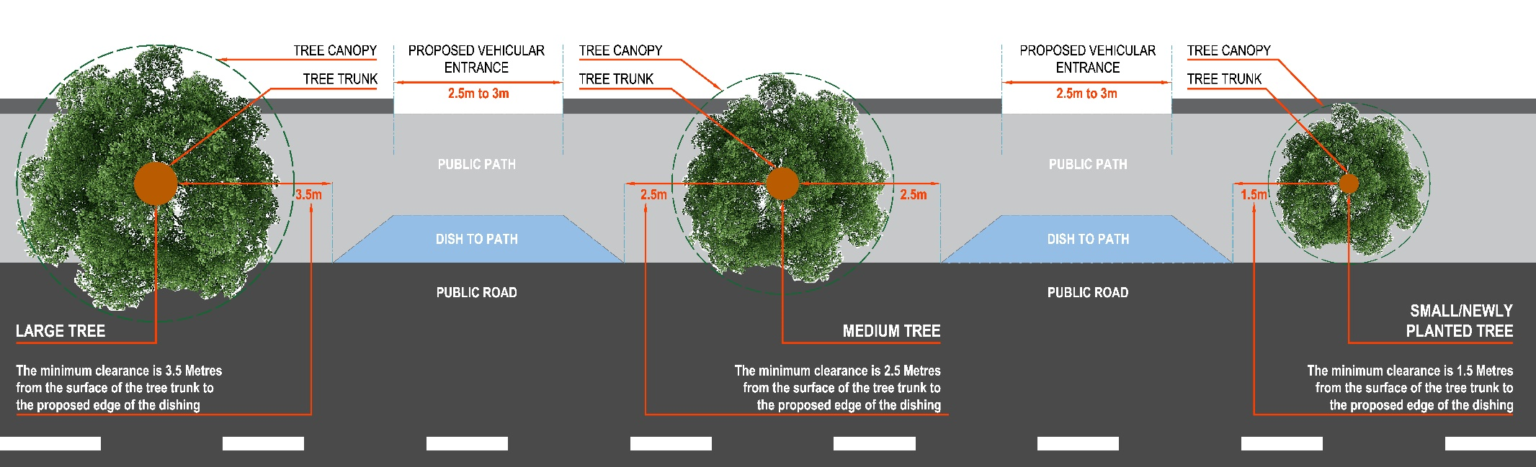

4.3.3 Impact on Public Transport Infrastructure
Where a vehicular entrance is located in proximity to a bus stop or shelter, the Council will consider the impact of any conflict between vehicles and pedestrians at this location. The removal or relocation of a bus stop or bus shelter to accommodate a vehicular entrance may not be possible having regard to the impact on the overall bus route and will be considered on a case by case basis, in consultation where necessary, with Dublin Bus and the National Transport Authority (NTA). The impact of a proposed vehicular entrance or widening of an existing entrance on existing Kassel Kerbs, which provide improved access to buses for people with mobility impairment and/or disabilities, will also be taken into consideration and determined on a case by case basis.

4.3.4 Sustainable Urban Drainage
The combined effect of paving a number of gardens in a street or area increases the risk of flooding and pollution (oil, brake dust, etc.). The use of Sustainable Drainage Systems (SuDS) can help remove pollutants from surface water runoff and reduce overall flood risk in the city while also enhancing amenity and biodiversity.
In accordance with Policy SI22, proposals should indicate how the design aims to control surface water runoff in a sustainable fashion through the use of permeable or porous surfaces such as gravel and green areas etc. rather than excessive hard surfacing (for further design guidance please refer to the Dublin City Council Sustainable Drainage Design and Evaluation Guide (2021) which is summarised in Appendix 12. Large unrelieved areas of paving or other impermeable surface treatments will not be considered acceptable. Precast or natural slabs, setts, cobble or other such materials are preferable to the use of concrete or tarmacadam for the paved area. This minimises the visual impact when the car is not parked in the garden. Where unbound material is proposed for driveway, parking and hardstanding areas, it shall be contained in such a way to ensure that it does not transfer on to the public road or footpath on road safety grounds.

4.3.5 Treatment of Front Boundaries
There are many different types of boundary treatment in existence. When considering any alterations, minimal interventions are desirable and proposals should aim to be complementary or consistent to others in the area which are of a high standard and in keeping with the overall character and streetscape. Vehicular entrances with splayed entrance walls or fences will not generally be permitted. All boundary treatment shall take cognisance of the need to provide adequate visibility.

1. Hedges with or without a fence
Hedges of privet, thorn, Griselinia, etc. can form very attractive boundaries. In widening an entrance gate care should be taken to ensure that the roots of the existing hedge are not disturbed beyond what is necessary for the insertion of the wider gate. The existing hedging can then grow and improve the appearance of the new entrance.

2. Boundary walls of limestone, granite or rubble, either plastered or unplastered.
These may have granite piers. The widening of the entrance should be carried out carefully to move one of the existing piers to a new position, with a revised gate design similar to the existing. Some existing gates can be extended to provide increased width by welding on additional sections.

3. Iron railing with or without a plinth
This type of boundary sometimes incorporates an iron gatepost or stone pier. The entrance should be widened on one side by moving the gatepost or stone pier and extending one leaf of the gate. A very disruptive effect is caused by the insertion of a completely different type of gate and gate pier. Minimal intervention is desirable where the gate pier is of an ornamental wrought iron design.

4. Low walls (without railings)
There are usually two gate piers, one which can be moved back to provide for the extra entrance width and any hedge or shrub trimmed accordingly.

5. Open plan with low plinth or kerb
This is typically found in housing estates and preferably no change should be made. It is very undesirable to erect gates, gate piers and enclosing walls in such circumstances as they disrupt the character of the estate.

6. Brick or plastered concrete walls
Existing gate piers should be duplicated, and replacement of plaster and brickwork should match the existing.

7. Wooden fencing
This is not very common and has a limited life in the Irish climate. In replacing decayed timber fencing, a consistent approach with neighbouring boundaries should be considered. It may be worthwhile to agree a common approach with neighbours.

4.3.6 Landscape Treatment of Front Gardens
By reducing the paved area to the front garden to a minimum, space can be left for the planting of shrubs and ground cover. The front boundary wall or fence should always be provided with a screen of ornamental small trees or hedging to give visual definition to the extent of the front garden and soften the appearance of the parked car. Importantly, any planting incorporated in the garden must not obscure visibility for drivers when exiting the driveway.

4.3.7 Parking in the Curtilage of Protected Structures, Architectural Conservation Areas and Conservation Areas
In accordance with Section 13.4.3 of the Architectural Heritage Protection Guidelines 2011, “proposals to remove or alter boundary features could adversely affect the character of the Protected Structure and the designed landscape around it. Widening an entrance or altering railings will alter the scale and visual impact of the gate and gate piers. Relocating a gateway may destroy a carefully designed relationship between the entrance and the main building.”
Features including boundary walls, railings and gardens make an important contribution to the character and setting of protected structures, ACAs and conservation areas. Therefore, poorly designed parking within the curtilage and front gardens of protected structures and in conservation areas can have a negative impact on the special interest and character of these sensitive buildings and areas. For this reason, proposals for parking within the curtilage and front gardens of such buildings will not normally be acceptable where inappropriate site conditions exist, particularly in the case of smaller gardens where the scale of intervention is more significant, and can lead to the erosion of the character and amenity of the area and where the historic plinths, decorative railings and gates, historic gate piers, and historic ground surfaces are still intact.
Where site conditions exist which can accommodate car parking provision without significant loss of visual amenity and/or historic fabric, proposals for limited off-street parking will be considered where the following criteria can be met:
- A high standard of design and layout will be expected to integrate the proposal into the sensitive context, the use of natural materials that would complement the special character of the Protected Structure i.e. gravels, granite etc.;
- The retention of most of the original boundary wall and/or railings and plinth wall and the re-use of the removed railings for new access gates will be sought;
- The outlook of rooms with regard to light, including basement rooms, should not be obstructed;
- Works which would involve the loss of mature and specimen trees (those in good condition) which contribute to the character of a protected structure or conservation area, both within the private and public domain, will be discouraged;
- High quality appropriate surface treatment, which should be influenced by the surrounding context and buildings, will be sought, particularly traditional materials such as gravel or other permeable materials. Bituminous or concrete surfacing are not acceptable;
- Every reasonable effort is made to protect the integrity of the protected structure and/or conservation area;
- There is sufficient depth available in the garden to accommodate a private parked car;
- Access to and egress from the proposed parking space will not give rise to a traffic hazard;
- The remaining soft landscaped area to the front of the structures should generally be in excess of half of the total area of the front garden space, exclusive of car parking area, footpaths and hard surfacing. SuDS features should be incorporated as appropriate (see also Appendix 12);
- Car parking shall be designed so that it is set-back from the house and front boundary wall to avoid excessive impact on the protected structure;
- Car parking bays shall be no greater than 5 m x 3 m metres wide;
- The proposed vehicular entrance should, where possible, be combined with the existing pedestrian entrance so as to form an entrance no greater than 2.6 m and this combined entrance should be no greater than half the total width of the garden at the road boundary. The gates shall not swing outwards so as to cause an obstruction on the public footpath;
- Where cast or wrought iron or other historic railings exist and historic brick and stone boundary walls, which contribute to the special character of the structure, every effort will be made to preserve and to maintain the maximum amount of original form and construction through minimum intervention. Any original existing gates, piers and cast iron or other railings that require alterations shall be reused and integrated with all new parking proposal. The use of automatic gates will be discouraged as the mechanisms required to operate them could have a significant impact on the legibility of the historic gates.
- Special regard shall be given to circumstances where on-street parking facilities are restricted as a consequence of the introduction of bus priority measures or other traffic management changes. In such situations, every reasonable effort will be made to facilitate proposals for off-street parking in the front gardens of protected structures and in conservation areas subject to the above criteria being met.

4.3.8 Mews Parking
All parking provision in mews lanes, where provided, will be in off-street garages, forecourts or courtyards, subject to conservation and access criteria. Car free mews developments may be permitted in certain circumstances where there are specific site constraints and where alternative modes of transport are available. Each development will be assessed on a case by case basis. However, if the introduction of car parking spaces within the mews development would have an impact on the volume of the proposal and would render it inconsistent with the historic terrace, then in order to protect the legibility of the historic coach house terrace, car parking will be discouraged.
Potential mews laneways must provide adequate accessibility in terms of private vehicular movements, emergency vehicles and refuse vehicles. A minimum carriageway of 4.8m in width (5.5m where no verges or footpaths are provided) is required. In circumstances where these widths cannot be provided, safe access and egress for all vehicles and pedestrians must be demonstrated.
All mews lanes will be considered to be shared surfaces, and footpaths need not necessarily be provided, save for lanes where existing footpaths are present. Where historic materials exist, roof materials, stone, paving surfaces, windows, joinery, ironmongery etc. these should be retained in order to protect the special character of the original mews lanes.

4.3.9 Non-Residential and Commuter Off-Street Parking in the Curtilage of Protected Structures and in Conservation Areas
In parts of the city centre, the large scale provision of commercial and commuter off-street car parking in the curtilage of protected structures and conservation areas significantly detracts from the special interest and visual character of protected structures and sensitive areas and has caused serious injury to the special character of its curtilage.
In assessing development schemes where off-street parking is proposed, or where such parking exists and is proposed to be retained as part of the overall scheme, the impact on the integrity, setting, character and amenities of the protected structure and/or conservation area will be critically assessed. In all cases, the objective to eliminate unauthorised and excessive off-street car parking will be sought.

5.0 Electric Vehicles (EV)
In accordance with Policy SMT29, EV charging stations on public and private land will be supported in this Plan.
All new developments must be futureproofed to include EV charging points and infrastructure. In all new developments, a minimum of 50% of all car parking spaces shall be equipped with fully functional EV Charging Point(s). The remaining spaces shall be designed to facilitate the relevant infrastructure to accommodate future EV charging. Space for EV charging infrastructure shall be clearly detailed in planning applications.
In publicly accessible spaces, appropriate signage indicating the presence of a Charge Point or Points shall be erected. All Charge Points fitted in publicly accessible areas shall be capable of communicating usage/pricing data with the National Charge Point Management System and use the latest version of the Open Charge Point Protocol (OCCP). They should also support a user identification system such as Radio Frequency Identification (RFID).
Publicly accessible EV Charging locations shall allow for ad-hoc payment methods for users. EV Charging enabling works for accessible and other reserved parking spaces shall also be included in the development where these exist.
All new or upgraded commercially operated car parking development shall be required to provide for a minimum of 50% of spaces with EV charging facilities.
All newly installed EV charge points and associated infrastructure shall comply with all relevant Acts, Statutory Instruments and regulations.
When detailed Guidance for EV charge points, which is currently in preparation by Dublin City Council in association with the other Dublin local authorities, the SEAI and the Department of Transport becomes available, it shall replace the above standards.

6.0 Motorcycle Parking
New developments shall include provision for motorcycle parking in designated, signposted areas at a rate of 5% of the number of car parking spaces provided. Motorcycle parking areas shall have limited gradients to enable easy manoeuvrability and parking. Fixed and robust features such as rails, hoops or posts should be provided to secure a motorcycle using a chain or similar device.

7.0 Shared Mobility
In accordance with Policy SMT24, the Council will support the use and expansion of shared mobility services across all areas of the City.
The provision of car club parking spaces in all developments will be supported. Where a development, residential and/or commercial, seeks to include car sharing services as part of the car parking provision on site, details of the operational management of the car club must be provided. All car club spaces shall be fully equipped with EV infrastructure.

8.0 Design and Construction Standards and Processes for Roads and Footpaths

8.1 Design Criteria for Car Parking
The car parking standards in Table 2 and the associated circulation and manoeuvring space must be provided within the curtilage of the building, clear of the carriageways and footways, whether public or private, giving access to the premises.
The basic dimensions required for the layout of commercial car parking shall be 2.5m wide by 4.75m in length.
Parking bay widths for people with accessibility requirements shall be in accordance with the requirements under Part M of the Building Regulations (2010) and any subsequent review.

8.2 Road and Footpath Standards
The Design Manual for Urban Roads and Streets (DMURS) provides guidance in relation to the design of urban roads and streets, encouraging an integrated design approach that views the street as a multi-functional space and focuses on the needs of all road users.
All developments shall be constructed in accordance with the design guidance and requirements set out in DMURS. The latest version is available to download on www.dmurs.ie
All roads and footpaths within developments shall be constructed to Taking-in-Charge standards. Dublin City Council sets out construction technical standards and specifications in Construction Standards for Road and Street Works in Dublin City Council (2020) and any subsequent review.
Full details of these construction requirements can be viewed on www.dublincity.ie.
Any works proposed to alter or amend existing public footpaths / roadways must be agreed with the planning authority at an early stage in the pre-application process. A letter of consent may be required from the Environment and Transportation Department for these works and submitted with the planning application which details the proposed amendments to the public footpath or roadway.

8.3 Taking in Charge
Section 180 of the Planning and Development Act 2000, as amended, provides for the taking-in-charge of residential developments by local authorities. This section provides that when a development has been completed in accordance with planning permission, the planning authority shall initiate procedures under Section 11 of the Roads Act 1993, as amended, to take it in charge, if requested to do so by the developer or by a majority of owners of the houses involved. A mandate from owners may be requested or a plebiscite of owners may be held to confirm their intent.
All areas to be taken in charge by Dublin City Council shall be maintained free of development both above and below ground. No part of a development shall overhang and no basements should extend under footpaths, roads and areas of public realm if these areas are intended to be taken in charge by the Road Maintenance Services Section of Dublin City Council. Where an existing overhang is already permitted, the development will be assessed on its merits on a case by case basis.
Planning applications comprising of areas to be taken in charge shall be accompanied by a taken in charge site layout plan at a scale of 1:500 which indicates the area of the site sought to be taken in charge. The details and specification of the road and footpath layout of these areas should be set out as part of the planning application.
Full details on the Taking in Charge Procedure for a Developer or a Home Owner and the necessary requirements can be viewed on www.dublincity.ie.

8.4 Road Opening License
A Road Opening Licence (ROL) is a licence that allows the holder to excavate a specified section of the public road, (the public road includes carriageway/footway and associated grass verge), and carry out reinstatement (which may be permanent or temporary). A ROL may be issued for the purposes of installing service connections to a new development, reconstructing a portion of the public road if damaged over the course of a development, or as required by Planning Permission.
The applicant/developer must familiarise themselves with the Department of Transport, Tourism and Sport’s Guidelines for Managing Openings in Public Roads (2017) and any subsequent review.
The applicant/developer is advised to engage at an early stage following a grant of planning permission with the relevant departments in Dublin City Council to ensure that all necessary agreements required through compliance are completed prior to the making of an application for a ROL.
Details on how to apply for a Road Opening Licence are available on www.dublincity.ie.

9.0 Technical Requirements for Dublin Tunnel and Luas

9.1 Dublin Tunnel Structural Safety
Dublin City Council is committed to conserving the structural integrity of Dublin Tunnel and special requirements relate to structural engineering of any proposed development that lies over the tunnel corridor area.
The Dublin Tunnel meets the City boundary at the Coolock Interchange and the route follows a south-easterly direction to East Wall Road. A suitably qualified structural engineer must prepare a Development Assessment. If the proposal is within 6 metres of the outer edges of the tunnel bore, a suitably qualified tunnelling engineer must prepare the assessment.
Assessment of the structural suitability of proposals and submitted applications is at present carried out by Transport Infrastructure Ireland (TII), acting on behalf of the Environment and Transportation Department of Dublin City Council.
To assist prospective developers of lands along the tunnel route, Dublin Tunnel Guidance Notes, The Assessment of surface and subs-surface developments in the vicinity of the Dublin Port Tunnel (March 2009), may be downloaded from www.dublincity.ie or at www.dublintunnel.ie.

9.2 Luas
Luas is Dublin’s Light Rail Transit system, also known as the tram network. The Luas network is made of 2 tram lines, the Luas Red Line and the Luas Green Line which interchange in Dublin City centre.
To assist prospective developers of lands in the vicinity of a Luas line, Transport Infrastructure Ireland (TII) have developed guidelines providing important information for the design and execution of developments and related works. These guidelines, Light Rail Environment- Technical Guidelines for Developments (December 2020) may be downloaded from www.tiipublications.ie.
Where a proposed development is located in close proximity to the Luas line, the developer shall ensure there is no adverse impact on Luas operation and safety during construction and operation of the development. The development shall comply with the Code of engineering practice for works on, near or adjacent the Luas light rail system (2016), published by Transport Infrastructure Ireland (TII).

PAGE LEFT INTENTIONALLY BLANK

Dublin City Development Plan 2022-2028

Appendix 6: Conservation

PAGE LEFT INTENTIONALLY BLANK

1.0 Historic Street Surfaces (1)

1.1 Stone Setts and Associated Features to be Protected, Conserved or Reintroduced
In accordance with Policy BHA 18(a), historic and traditionally laid stone setts to the streets listed in the schedule below are to be protected, conserved and reintroduced; together with any associated:
- gutter row(s) of setts; gutter flags or flat diorite gutters; diorite strip between central and side paving, and
- traditional gullies, gratings and covers.

Abbey Cottages
Anglesea Row
Anglesea Street
Arran Street East (lane at Market)
Arran Street West (Stable Lane)
Asdill’s Row
Aston Place
Bedford Row
Bellevue / Crane Street South
Bow Street
Castleforbes Road
Cecilia Street
Clanbrassil Close
Cope Street
Cork Hill
Crane Lane
Crane Street
Crow Street
Crown Alley
Cuckoo Lane
Digges Lane
Essex Gate
Essex Street East
Essex Street West
Eustace Street
Exchange Street Upper
Fleet Street
Foley Street
Foster Place (South)
Fownes Street Lower
Fownes Street Upper
Glover’s Alley
Grand Canal Dock/Liffey Docks
Green Street East
Halston Street
Hanover Quay
Haymarket
Hendrick Place
Henrietta Street/Kings Inns
Jervis Lane Upper
John’s Lane East
John’s Lane West
Kelly’s Row (Royal Canal Bank)
Kings Inns
Kirwan Street
Litton Lane
Magennis Place
Mansion House
New Church Street
North Lotts
Portland Street West (Guinness)
Price’s Lane
Rainsford Street
Red Cow Lane
Robert Street South (Guinness)
St. Augustine Street
St. Catherine’s Lane West
Sheriff Street Lower
Ship Street Little
Ship Street Great
Sir John Rogerson’s Quay (campshires)
Smithfield
Stable Lane
Stanley Street
Sycamore Street
Temple Bar
Temple Lane South
Wards Hill
Wolfe Tone Street

This schedule is based on the Survey of Historic Setted Streets (June 2010) compiled by Lotts Architecture for the Dublin City Council Heritage Office and the Historic Surface Inventory provided in the Draft Manual for Working with Historic Surfaces (December 2014) prepared by the City Council’s Environment and Transportation Department.
The schedule will be reviewed during the period of this plan.
All works to historic surfaces shall follow the provisions of the City Council’s Historic Street Surfaces in Dublin: Conservation Study and Guidance Manual (2009), and the Advice Series on Paving – The Conservation of Historic Ground Structures (2015).
Stocks of historic ground/street surface materials in storage, including setts and granite, are to be reserved for use in the streets and spaces listed in Appendix 6, section 1.0 and 2.0.

2.0 Historic Street Surfaces (2)

2.1 Historic Granite Kerbing, Granite Pavers/Flags and Associated Features To Be Protected, Conserved and Reintroduced
In accordance with Policy BHA 18(a), the following paved areas and streets with historic (antique) granite kerbing and pavers/flags to be protected, conserved and reintroduced under the programme for areas with historic ground/street surfaces, together with any associated historic features:
- historic milestones, boundary markers, bollards, boot scrapers, troughs, guard or jostle stones, cast iron basement lights, street skylights and prisms, and
- historic and traditional gratings, historic gutter setts, decorative manholes, coal hole and other covers.
Coal hole covers and boot scrapers are in many cases part of the building with which they are associated. Where the building is a protected structure, the coal hole cover and/or boot scraper is also protected. Nevertheless, these historic features require protection and conservation where street and paving works are undertaken in the area.

Anglesea Street
Blessington Street (west Berkeley Street)
Capel Street
Castle Street
Cecelia Street
Chancery Place (at Four Courts)
Chancery Street (at Bridewell)
Charles Street Great (at Free Church)
Christ Church Place (at Cathedral)
City Hall
College Green (Bank of Ireland and Trinity College)
Custom House Quay (at Custom House)
Dominick Street Lower (at Church)
Earlsfort Terrace (at Concert Hall)
Essex Gate
Essex Street East
Eustace Street
Exchange Court
Exchange Street Lower
Exchange Street Upper
Fitzwilliam Square
Fitzwilliam Street Lower
Fitzwilliam Street Upper
Fleet Street (southern side, east of Westmoreland Street)
Foster Place South
Fownes Street Lower
Fownes Street Upper
Frederick Street South
Green Street (at Courthouse)
Halston Street (at Courthouse)
Harcourt Street
Henrietta Street
Huband Bridge
Inns Quay (at Four Courts)
John’s Lane West
Lord Edward Street
Merrion Street Lower (at Government Buildings)
Merrion Street Upper
Moore Street
North Great George’s Street
O’Connell Bridge
O’Connell Street Lower (at GPO)
Palace Street
Parliament Street
Pearse Street (at St. Mark’s Church)
Pembroke Street Lower
Pembroke Street Upper
St. Patrick’s Close
Stephen Street Upper
Sycamore Street
Temple Bar
Temple Lane South
Werburgh Street (at Bishop’s House)
Winetavern Street (at Civic Offices)
Wood Quay (at Civic Offices)

This schedule is based on the Historic Surface Inventory provided in the Draft Manual for Working with Historic Surfaces (December 2014) prepared by the City Council’s Environment and Transportation Department; updated by GIS referenced survey of antique kerbs by Roads Maintenance Services (2019).
This schedule will be reviewed during the life of this plan.
All works to historic surfaces shall follow the provisions of the City Council’s Historic Street Surfaces in Dublin: Conservation Study and Guidance Manual (2009), and the Advice Series on Paving – The Conservation of Historic Ground Structures (2015).
Stocks of historic ground/street surface materials in storage, including setts and granite, will be reserved for use in the streets and spaces listed in Appendix 6, section 1 and 2.

2.2 Historic Granite Kerbing and Associated Features to be Protected, Conserved and Reintroduced
In accordance with Policy BHA 18(a), the following paved areas and streets with historic (antique) granite kerbing are to be protected, conserved and reintroduced under the programme for areas with historic ground/street surfaces, together with any associated historic features:
- historic and traditional gratings, historic gutter setts, decorative manholes and other covers.

Abbey Street Lower
Abercorn Road
Aberdeen Street
Achill Road
Addison Road
Adelaide Road
Ailesbury Drive
Ailesbury Gardens
Ailesbury Grove
Ailesbury Park
Ailesbury Road
Albany Road
Albert Court East
Albert Place East
Albert Terrace
Aldborough Parade
Aldborough Place
Alexandra Terrace
Alma Terrace
Almeida Avenue
Amiens Street
Anglesea Road
Anglesea Row
Anglesea Street
Anna Villa
Annamoe Parade
Annamoe Road
Anne Street North
Anne Street South
Annesley Park
Arbour Hill
Arbour Place
Arbutus Place
Ard Righ Place
Ard Righ Road
Ardee Grove
Ardee Road
Ardee Street
Ardmore Avenue
Argyle Road
Arklow Street
Armstrong Street
Arran Quay
Arran Quay Terrace
Arran Road
Arran Street East
Arran Street West
Arranmore Road
Asdill's Row
Ash Grove
Ash Street
Ashdale Road
Ashfield Avenue
Ashfield Park
Ashfield Road
Ashford Street
Ashworth Place
Aston Quay
Auburn Avenue
Auburn Road
Auburn Street
Auburn Villas
Aughrim Lane
Aughrim Place
Aughrim Street
Aungier Street
Avondale Avenue
Avondale Road
Bachelors Walk
Baggot Court
Baggot Lane
Baggot Street Lower
Baggot Street Upper
Baggotrath Place
Balfe Street
Balls Lane
Ballsbridge Avenue
Ballsbridge Terrace
Ballybough Lane
Ballybough Road
Ballyfermot Road
Ballygall Road West (Nw)
Ballymun Road
Bannaville
Bantry Road
Barrack Lane
Barrow Street
Basin Street Lower
Basin View
Bath Avenue
Bath Avenue Gardens
Bath Avenue Place
Bayview Avenue
Beach Road
Beaver Row
Beaver Street
Beechwood Avenue Lower
Beechwood Avenue Upper
Beechwood Road
Belgrave Road
Belgrave Square North
Belgrave Square South
Belgrave Square West
Belgrove Road
Belmont Avenue
Belmont Park
Belvedere Court
Belvedere Place
Ben Edair Road
Beresford Place
Berkeley Avenue
Berkeley Place
Berkeley Road
Berkeley Street
Bessborough Avenue
Bishop Street
Black Street
Blackberry Lane
Blackhall Place
Blackhorse Avenue
Blackpitts
Blessington Street
Bloomfield Park
Bonham Street
Botanic Avenue
Botanic Road
Botanic Villas
Bow Lane West
Bow Street
Boyne Street
Brabazon Square
Brabazon Street
Brainboro Terrace
Branavilla
Brendan Road
Brian Avenue
Brian Boru Avenue
Brian Road
Bride Street
Bridge Street Lower
Bridgefoot Street
Brighton Avenue
Brighton Gardens
Brighton Road
Brighton Square East
Brighton Square South
Brighton Square West
Brighton Square E, S & W
Broadstone Avenue
Brookfield Road
Brookfield Street
Brookvale Road
Brookwood Grove
Brunswick Place
Brunswick Street North
Brunswick Villas
Buckingham Street Lower
Buckingham Street Upper
Bulfin Road
Bull Alley Street
Burgh Quay
Burlington Road
Bushfield Terrace
Bushy Park Road
Butt Bridge
Byrne's Lane
Cabra Road
Cadogan Court
Cadogan Road
Caledon Road
Camac Close
Cambridge Avenue
Cambridge Road
Cambridge Terrace
Cambridge Villas
Camden Row
Camden Street Lower
Camden Street Upper
Cameron Street
Campbells Row
Capel Street
Carlisle Avenue
Carman's Hall
Carnew Street
Caroline Row
Carrick Terrace
Casimir Avenue
Casimir Road
Castle Street
Castle View
Castlewood Avenue
Castlewood Park
Castlewood Terrace
Cathal Brugha Street
Cathedral Street
Catherine Street
Cavendish Row
Ceannt Fort
Cecil Avenue
Cecilia Street
Chamber Street
Chancery Place
Chapel Avenue
Chapelizod Road
Charlemont Road
Charlemont Street
Charles Street Great
Charles Street West
Charleston Avenue
Charleston Road
Charleville Avenue
Charleville Mall
Charleville Road
Charlotte Way
Chatham Street
Cherryfield Avenue Lower
Chesterfield Avenue
Christchurch Place
Church Avenue
Church Avenue South
Church Gardens
Church Lane
Church Lane South
Church Road
Church Square
Church Street
Church Street East
Church Street New
Churchill Terrace
City Wall
Clanbrassil Street Lower
Clanbrassil Street Upper
Clanbrassil Terrace
Clanwilliam Place
Clanwilliam Square
Clare Park Villas
Clare Road
Clare Street
Claremont Avenue
Claremont Road
Clarence Mangan Road
Clarence Street Great North
Clarendon Street
Clareville Road
Clarke's Bridge
Claude Road
Clifton Mews
Cliftonville Road
Clinch's Court
Clogher Road
Clonard Road
Clonliffe Avenue
Clonliffe Road
Clonmel Street
Clonmore Road
Clonskeagh Road
Clonturk Park
Coleraine Street
College Green
College Street
Connaught Parade
Connaught Street
Connolly Avenue
Conquer Hill Road
Constitution Hill
Convent Avenue
Convent Close
Cook Street
Coolevin Road
Cope Street
Cork Hill
Cow Parlour
Cowper Gardens
Cowper Road
Cowper Street
Cows Lane
Crampton Quay
Crane Lane
Crane Street
Cranfield Place
Crawford Avenue
Crescent Place
Cross Lane South
Crosstick Alley
Crow Street
Crown Alley
Croydon Park Avenue
Crumlin Road
Cuckoo Lane
Cuffe Street
Cullenswood Road
Cumberland Road
Cumberland Street North
Cumberland Street South
Custom House Quay
Dalymount Lane
Dame Court
Dame Lane
Dame Street
Daniel Street
Dargle Road
Darley Street
Dartmouth Lane
Dartmouth Place
Dartmouth Road
Dartmouth Square East
Dartmouth Square North
Dartmouth Square South
Dartmouth Square West
Dartmouth Terrace
Dartmouth Walk
Dartry Cottages
Dartry Park
Dartry Road
David Road
Davis Place
Dawson Street
De Burgh Road
De Courcey Square
Dean Swift Square
Denzille Lane
Dermot O'Hurley Avenue
Desmond Street
Digges Lane
Digges Street Upper
Dillon Place South
Distillery Road
D'Olier Street
Dolphin's Barn
Dominick Lane
Dominick Street Lower
Donnybrook Road
Donore Avenue
Donovan Lane
Doon Avenue
Doris Street
Dorset Lane
Dorset Street Upper
Dromard Terrace
Drumcondra Park
Drumcondra Road Upper
Drummond Place
Drury Street
Duke Street
Dunne Street
Dunville Avenue
Durham Road
Earl Place
Earlsfort Terrace
Eastmoreland Place
Eaton Road
Eaton Square
Ebenezer Terrace
Eccles Place
Eccles Street
Echlin Street
Eden Quay
Edenvale Road
Eglinton Road
Eglinton Terrace
Elgin Road
Elizabeth Street
Ellesmere Avenue
Ellis Quay
Elmpark Avenue
Elmwood Avenue Lower
Elmwood Avenue Upper
Ely Place
Ely Place Upper
Emerald Cottages
Emerald Place
Emerald Square
Emerald Street
Emmet Road
Emmet Street
Emor Street
Enaville Avenue
Enaville Road
Enniskerry Road
Erne Place
Erne Place Little
Erne Street Lower
Erne Street Upper
Erne Terrace Front
Erne Terrace Rear
Essex Quay
Essex Street East
Eustace Bridge
Eustace Street
Everton Avenue
Exchange Court
Exchange Street Lower
Fade Street
Fairfield Avenue
Fairfield Park
Fairfield Road
Fairview
Fairview Avenue Lower
Fairview Close
Fairview Passage
Fairview Terrace
Father Mathew Bridge
Fenian Street
Ferguson Road
Findlater Street
Fingal Place
Finglas Road
Finglas Road Old
Finn Street
First Avenue
Fishamble Street
Fitzgerald Street
Fitzgibbon Street
Fitzroy Avenue
Fitzwilliam Lane
Fitzwilliam Place
Fitzwilliam Place North
Fitzwilliam Square East
Fitzwilliam Square North
Fitzwilliam Square South
Fitzwilliam Square West
Fitzwilliam Street
Fitzwilliam Street Lower
Fitzwilliam Street Upper
Fleet Street
Fleming's Place
Florence Street
Fontenoy Street
Fortfield Road
Fortfield Terrace
Foster Place
Foster Place North
Foster Terrace
Fownes Street Lower
Fownes Street Upper
Foyle Road
Francis Street
Frankfort Avenue
Frankfort Cottages
Frederick Lane North
Frederick Street North
Frederick Street South
Frenchman's Lane
Fumbally Lane
Gaelic Street
Garden Terrace
Gardiner Place
Gardiner Row
Gardiner Street Lower
Gardiner Street Middle
Gardiner Street Upper
Gartan Avenue
Garville Avenue
Garville Avenue Upper
Garville Lane
Garville Road
Geoffrey Keating Road
George's Place
George's Quay
Gerald Street
Geraldine Street
Gilford Avenue
Gilford Park
Gilford Road
Gilford Terrace
Glenard Avenue
Glenarm Avenue
Glengarriff Parade
Gloucester Place Lower
Gloucester Street South
Godfrey Place
Golden Lane
Goldsmith Street
Gordon Street
Grace Park Avenue
Grace Park Gardens
Grace Park Road
Gracepark Terrace
Grafton Street
Granby Row
Grand Canal Place
Grand Canal Quay
Grand Canal Street Upper
Grand Parade
Grangegorman Lower
Grangegorman Upper
Grantham Place
Grant's Row
Grattan Court East
Grattan Street
Great Western Square East
Great Western Square North
Great Western Square South
Great Western Villas
Greek Street
Green Street
Greenfield Place
Greenmount Avenue
Greenmount Lane
Greenmount Road
Greenore Terrace
Greenville Avenue
Grenville Street
Griffith Avenue
Grosvenor Lane
Grosvenor Place
Grosvenor Road
Grosvenor Square
Grove Road
Guildford Place
Gulistan Cottages
Gulistan Place
Gulistan Terrace
Haddington Place
Haddington Road
Halliday Road
Halliday Square
Halston Street
Hamilton Street
Hammond Lane
Hampstead Avenue
Hanbury Lane
Hannaville Park
Hanover Lane
Hanover Street East
Hanover Street West
Harbour Court
Harcourt Terrace
Hardwicke Lane
Hardwicke Street
Harman Street
Harold Road
Harold's Cross Cottages
Harold's Cross Road
Harty Court
Harty Place
Hastings Street
Hatch Place
Hatch Street Lower
Hatch Street Upper
Hatter's Lane
Havelock Square
Hawkins Street
Hawthorn Avenue
Hawthorn Terrace
Henrietta Place
Henrietta Street
Henry Place
Herbert Cottages
Herbert Lane
Herbert Park
Herbert Place
Herbert Street
Herberton Road
Heytesbury Street
High Street
Highfield Grove
Highfield Road
Hogan Avenue
Holles Row
Holles Street
Hollybank Avenue Lower
Hollybank Road
Hollybrook Park
Hollybrook Road
Home Farm Park
Home Farm Road
Homelee
Hope Street
Hospital Lane
Howard Street
Huband Bridge
Hume Street
Hyacinth Street
Inchicore Road
Infirmary Road
Inn's Quay
Inverness Road
Iona Avenue
Iona Crescent
Iona Drive
Iona Park
Iona Road
Ivar Street
James Joyce Street
James Street East
James Street North
James's Street
Jane Ville
Jerome Connor Place
Jervis Lane Upper
Jervis Street
John Dillon Street
John Street North
John Street South
John Street West
John's Lane West
Johnson Place
Jones's Road
Josephine Avenue
Joy Street
Kearns Court
Kearn's Place
Kellys Row
Kenilworth Lane
Kenilworth Park
Kenilworth Road
Kenilworth Square East
Kenilworth Square North
Kenilworth Square South
Kenilworth Square West
Kevin Street Lower
Kevin Street Upper
Kildare Street
Killarney Avenue
Killarney Parade
Killarney Street
Killeen Road
Kilmainham Lane
Kimmage Road Lower
Kinahan Street
Kincora Road
Kings Avenue
King's Inns Street
Kingsland Parade
Kingsland Park Avenue
Kirwan Street Cottages
Kylemore Road
Lad Lane
Lamb Alley
Lansdowne Road
Larkfield Avenue
Le Vere Terrace
Lea Road
Leahy's Terrace
Leeson Lane
Leeson Park
Leeson Park Avenue
Leeson Place
Leeson Street Lower
Leeson Street Upper
Leicester Avenue
Leinster Avenue
Leinster Road
Leinster Road West
Leinster Square
Leinster Street East
Leinster Street North
Leinster Street South
Lennox Place
Lennox Street
Leo Avenue
Leo Street
Liberty Lane
Liffey Street South
Lincoln Lane
Lincoln Place
Lindsay Road
Linenhall Street
Lisburn Street
Little Britain Street
Litton Lane
Loftus Lane
Lombard Street East
Lomond Avenue
Long Lane
Longford Street Great
Lord Edward Street
Loreto Road
Love Lane
Love Lane East
Lucky Lane
Luke Kelly Bridge
Lullymore Terrace
Lurgan Street
Mabel Street
McCartney Bridge
Madden Road
Madison Road
Magennis Place
Magennis Square
Maiden Row
Malachi Road
Mallin Avenue
Manor Place
Margaret Place
Marguerite Road
Marine Drive
Mark Street
Market Street South
Mark's Alley West
Mark's Lane
Marlborough Place
Marlborough Street
Marrowbone Lane
Martin Street
Martin's Row
Mary Aikenhead House
Mary Street
Mary Street Little
Mary's Lane
Maxwell Road
May Street
Mayfield Road
Mayfield Road East
Mc Kenny Bridge
Mc Mahon Street
McDowell Avenue
Meade's Terrace
Meath Market
Meath Place
Meath Street
Meetinghouse Lane
Mellowes Bridge
Melrose Avenue
Memorial Road
Mercer Street Lower
Merchant's Quay
Merchants Road
Merrion Road
Merrion Row
Merrion Square East
Merrion Square North
Merrion Square South
Merrion Square West
Merrion Street Lower
Merrion Street Upper
Merrion View Avenue
Merton Avenue
Merton Road
Merville Avenue
Mespil Road
Michael’s Hill
Military Road
Mill Street
Millbourne Avenue
Millmount Avenue
Millmount Place
Milltown Path
Milltown Road
Moira Road
Moland Place
Molesworth Place
Molesworth Street
Montpelier Hill
Moore Lane
Morehampton Lane
Morehampton Road
Morehampton Terrace
Mornington Road
Morrogh Terrace
Moss Street
Mount Brown
Mount Drummond Avenue
Mount Eden Road
Mount Street Crescent
Mount Street Lower
Mount Street Upper
Mount Temple Road
Mountain View Road
Mountjoy Parade
Mountjoy Square East
Mountjoy Square North
Mountjoy Square South
Mountjoy Square West
Mountjoy Street
Mountjoy Street Middle
Mountpleasant Avenue Lower
Mountpleasant Avenue Upper
Mountpleasant Place
Mountpleasant Square
Mountpleasant Terrace
Mountpleasant Terrace Upper
Mountpleasant Villas
Mountshannon Road
Moyne Road
Muckross Parade
Mulberry Lane
Munster Street
Murtagh Road
Myrtle Street
Nash Street
Nassau Street
Nelson Street
Neville Road
New Bride Street
New Road
New Row
New Street North
Newcomen Avenue
Newcomen Court
Newgrove Avenue
Newmarket
Newport Street
Niall Street
Norfolk Road
Norseman Place
North Circular Road
North Great Clarence Street
North Great George's Street
North Lotts
North Strand Road
North Wall Quay
Northbrook Avenue Lower
Northbrook Avenue Upper
Northbrook Lane
Northbrook Road
Northbrook Terrace
Northumberland Place
Northumberland Road
Norton's Avenue
Nottingham Street
Nutley Lane
Oakfield Place
Oaklands Park
Oaklands Terrace
Oakley Road
Oblate Drive
O'Carolan Road
O’Connell Avenue
O’Connell Bridge
O'Curry Avenue
O'Curry Road
O'Donoghue Street
O’Donovan Road
O'Donovan Rossa Bridge
O’Hara Avenue
Olaf Road
Old Abbey Street
Old Cabra Road
Old Kilmainham Village
Old Mountpleasant
Oliver Bond Street
Oliver Plunkett Avenue
O'Rahilly Parade
Orchard Road
O’Reilly Avenue
Oriel Street Lower
Oriel Street Upper
Ormeau Street
Ormond Place
Ormond Quay Lower
Ormond Quay Upper
Ormond Road
Ormond Road South
Orwell Mews
Orwell Road
Oscar Square
Ossory Road
Ostman Place
O’Sullivan Avenue
Oswald Road
Ovoca Road
Owen's Avenue
Oxford Road
Oxmantown Road
Palace Street
Palmerston Gardens
Palmerston Park
Palmerston Place
Palmerston Road
Palmerston Villas
Park Avenue
Park Drive
Park Lane East
Park Street West
Parkgate Street
Parliament Row
Parnell Bridge
Parnell Road
Parnell Square East
Parnell Square North
Parnell Square West
Parnell Street
Partridge Terrace
Patrick Street
Pearse Square
Pearse Street
Pembroke Cottages
Pembroke Gardens
Pembroke Lane
Pembroke Park
Pembroke Place
Pembroke Road
Pembroke Row
Pembroke Street Lower
Pembroke Street Upper
Penrose Street
Percy Lane
Percy Place
Peter Row
Petrie Road
Phibsborough
Phibsborough Road
Philipsburgh Avenue
Philipsburgh Terrace
Pim Street
Pimlico
Pimlico Cottages
Pleasants Place
Pleasants Street
Poolbeg Street
Poplar Row
Portland Place
Portland Street North
Portobello
Portobello Harbour
Portobello Road
Power's Court
Power's Square
Preston Street
Primrose Avenue
Primrose Street
Prince of Wales Terrace
Prince's Street North
Prospect Avenue
Prospect Road
Prospect Square
Protestant Row
Prussia Street
Quays From Grattan Bridge to O’Connell Street
Quinn Avenue
Quinns Lane
Raglan Road
Railway Avenue
Railway Street
Rainsford Avenue
Rainsford Street
Ranelagh
Ranelagh Avenue
Ranelagh Road
Rathdown Park
Rathdown Road
Rathdown Villas
Rathfarnham Road
Rathgar Avenue
Rathgar Road
Rathlin Road
Rathmines Road Lower
Rathmines Road Upper
Rathmore Villas
Red Cow Lane
Redmond's Hill
Reuben Avenue
Rialto Buildings
Rialto Cottages
Rialto Park
Rialto Street
Richmond Avenue
Richmond Avenue South
Richmond Cottages
Richmond Cottages North
Richmond Hill
Richmond Lane
Richmond Place
Richmond Road
Richmond Street North
Richmond Street South
Ring Street
Ring Terrace
Ringsend Road
Riverside Walk
Robert Emmet Bridge
Robert Street South
Rock Lane
Roger's Lane
Ross Street
Rostrevor Terrace
Rowserstown Lane
Royal Canal Bank
Royse Road
Royston
Rugby Road
Rugby Villas
Russell Avenue
Russell Avenue East
Rutland Place
Rutledge Cottages
Rutledge Terrace
Sackville Avenue
Sackville Gardens
Sackville Place
Saint Agnes Road
Saint Aidan's Park
Saint Aidan's Park Avenue
Saint Albans Road
Saint Alphonsus' Avenue
Saint Andrew Street
Saint Anne's Road
Saint Anthony's Road
Saint Audoen's Terrace
Saint Augustine Street
Saint Barnabas Gardens
Saint Brigid's Road
Saint Brigid's Road Upper
Saint Broc's Cottages
Saint Catherine's Avenue
Saint Clare's Avenue
Saint Clement's Road
Saint Columba's Road Lower
Saint Columba's Road Upper
Saint David's Terrace
Saint George's Avenue
Saint Ita's Road
Saint James Avenue
Saint James's Avenue
Saint James's Terrace
Saint Joseph's Avenue
Saint Joseph's Road
Saint Kevin's Avenue
Saint Kevin's Cottages
Saint Kevin's Gardens
Saint Kevin's Parade
Saint Kevin's Park
Saint Kevin's Road
Saint Laurence Place East
Saint Laurence Place West
Saint Lawrence Road
Saint Malachy Road
Saint Margaret's Avenue
Saint Marys Avenue West
Saint Mary's Lane
Saint Mary's Road
Saint Mary's Road North
Saint Michael's Close
Saint Michael's Cottages
Saint Michaels Hill
Saint Michael's Road
Saint Nicholas Place
Saint Patrick's Close
Saint Patrick's Parade
Saint Patrick's Place
Saint Patrick's Road
Saint Patrick's Terrace
Saint Peter's Avenue
Saint Peter's Road
Saint Peters Square
Saint Philomena's Road
Saint Stephen's Green East
Saint Stephen's Green North
Saint Stephen's Green South
Saint Stephen's Green West
Saint Thomas Road
Saint Vincent Street West
Sallymount Avenue
Sandford Avenue
Sandford Gardens
Sandwith Street Lower
Sandwith Street Upper
Sandymount Avenue
Sandymount Green
Sandymount Road
Sarsfield Road
School House Lane East
Schoolhouse Lane West
Seafield Road West
Sean MacDermott Street Lower
Sean MacDermott Street Upper
Seaview Avenue East
Seaview Avenue North
Selskar Terrace
Serpentine Avenue
Serpentine Road
Setanta Place
Seville Place
Seville Terrace
Shamrock Cottages
Shamrock Street
Shamrock Terrace
Shandon Drive
Shandon Park
Shandon Road
Shannon Terrace
Shaw Street
Shaws Lane
Shelbourne Road
Shelmartin Avenue
Shelmartin Terrace
Sheriff Street Upper
Sherkin Gardens
Sherrard Avenue
Sherrard Street Lower
Sherrard Street Upper
Ship Street Great
Ship Street Little
Shrewsbury Road
Sigurd Road
Simmons Court
Simmons Place
Simmonscourt Road
Sion Hill Avenue
Sitric Place
Somerset Street
South Circular Road
South Dock Place
South Dock Street
South Great George's Street
South Lotts Road
Spa Road
Spafield Terrace
Spencer Place
Spencer Street North
Spitalfields
Spring Garden Lane
Spring Garden Street
Stable Lane
Stamer Street
Stephen Street Lower
Stephen Street Upper
Stephen's Lane
Stephen's Place
Stirrup Lane
Stoney Road
Store Street
Strand Road
Strand Street
Strand Terrace
Strandville Avenue
Strangford Road East
Suffolk Street
Sugar House Lane
Suir Bridge
Sullivan Street
Summer Street North
Summer Street South
Summerhill
Summerville
Summerville Park
Sunbury Gardens
Sundrive Road
Susan Terrace
Susanville Road
Swanville Place
Sweeney's Terrace
Swift's Alley
Swords Street
Sycamore Street
Sydney Parade Avenue
Synge Street
Talbot Place
Talbot Street
Tara Street
Temple Bar
Temple Gardens
Temple Lane South
Temple Road
Temple Street West
Templemore Avenue
Templeogue Road
Terenure Park
Terenure Place
Terenure Road East
Terenure Road North
Terenure Road West
The Appian Way
The Coombe
The Crescent
The Mageough
The Paddocks
The Square
The Stiles Road
Thomas Davis Street South
Thomas Davis Street West
Thomas Street
Thomas Street West
Thompson Cottages
Thor Place
Tivoli Avenue
Tower Avenue
Townsend Street
Trinity Street
Tritonville Crescent
Tritonville Road
Tudor Road
Tyrconnell Park
Tyrconnell Street
Ulster Street
Usher Street
Usher's Island
Usher's Quay
Vavasour Square
Vergemount Hall
Vergemount Park
Vernon Grove
Vernon Street
Verschoyle Court
Victoria Lane
Victoria Quay
Victoria Road
Victoria Street
Victoria Villas
Viking Road
Villiers Road
Walworth Road
Warner's Lane
Warren Street
Warrenmount Place
Warrington Lane
Warrington Place
Wasdale Grove
Wasdale Park
Washington Street
Waterloo Avenue
Waterloo Lane
Watling Street
Waverley Avenue
Wellesley Place
Wellington Lane
Wellington Place North
Wellington Quay
Wellington Street Upper
Wellpark Avenue
Werburgh Street
Wesley Road
West Road
Western Way
Westland Court
Westland Row
Westmoreland Street
Wexford Street
Whitefriar Place
Whitworth Avenue
Whitworth Place
Whitworth Road
Whitworth Terrace
Wigan Road
William Street North
William Street South
Williams Place South
Wilton Terrace
Windmill Road
Windsor Place
Windsor Road
Windsor Terrace
Winetavern Street
Winton Avenue
Winton Road
Wolfe Tone Street
Wolseley Street
Wood Quay
Woodfield Avenue
Wynnefield Road
Yarnhall Street
Yewlands Terrace
York Road
York Street
Zion Road

This schedule is based on the Historic Surface Inventory provided in the Draft Manual for Working with Historic Surfaces (December 2014) prepared by the City Council’s Environment and Transportation Department; updated by GIS referenced survey of antique kerbs by Roads Maintenance Services (2019).
This schedule will be reviewed during the period of this plan.
All works to historic surfaces shall follow the provisions of the City Council’s Historic Street Surfaces in Dublin: Conservation Study and Guidance Manual (2009), and the Advice Series on Paving – The Conservation of Historic Ground Structures (2015).
Stocks of historic ground/street surface materials in storage, including setts and granite, will be reserved for use in the streets and spaces listed in Appendix 6, section 1 and 2.

3.0 List of Architectural Conservation Areas (ACAs)
- Belmont Avenue-Mount Eden Road & Environs
- Capel Street & Environs ACA
- Chapelizod & Environs ACA
- Collier's Avenue ACA
- Crumlin Village ACA
- Dartmouth Square & Environs ACA
- DeCourcy Square-Prospect Square & Environs ACA
- Elmpark Avenue and Elmwood Avenue ACA
- Fitzwilliam Square & Environs ACA
- Grafton Street and Environs ACA
- Great Western Square & Environs ACA
- Haddon Road - Victoria Road ACA
- Hollybrook Road ACA
- Marino Casino ACA
- Mountjoy Square ACA
- North Great George’s Street ACA
- O'Connell Street ACA
- Phibsborough Centre ACA
- Ranelagh Avenue ACA
- Sandymount Village & Environs ACA
- South City Retail Quarter ACA
- Temple Place ACA
- Thomas Street & Environs ACA
- Westmoreland Park ACA

4.0 Monuments in the City

4.1 Introduction
The 1992 European Convention on the Protection of Archaeological Heritage (Valletta, January 1992) was ratified by Ireland in 1997. The Convention provides the basic framework for policy on the protection of the archaeological heritage. In summary, the obligations on the State under the Convention relate to:
- Providing statutory protection measures;
- Authorisation and supervision of archaeological activities;
- Measures for the physical protection of the archaeological heritage;
- Providing consultation between archaeologists and planners;
- Providing financial support for research or rescue archaeology;
- Facilitating the study of archaeological discoveries by making or bringing up to date maps, surveys and inventories of archaeological sites;
- Facilitating national and international exchanges of elements of the archaeological heritage for scientific purposes;
- Educating the public in relation to the value of and threat to the archaeological heritage;
- Preventing the illicit circulation of elements of the archaeological heritage;
- Providing for the exchange of information and experts on the archaeological heritage between States party to the Convention.

4.2 Legislative Context
Irish legislation for the protection of archaeological heritage is based on the National Monuments Acts 1930 to 1994. This is in accordance with the Valletta Convention (as above). The Planning and Development Act 2000 (as amended) works in tandem with the National Monuments Acts to provide for the protection of monuments and the referral of planning applications to the Department. The Minister for Housing, Local Government and Heritage has a specific role in relation to the protection of the archaeological heritage through powers provided by these Acts and the National Cultural Institutions Act 1997. The overall State archaeological service is provided by the Department of Housing, Local Government and Heritage (DHLGH) and delivered through the National Monuments Service of the Department and the National Museum of Ireland (Irish Antiquities Division) on behalf of the Minister. The National Monuments Acts secure the archaeological heritage in several key areas through the DHLGH:
- The Record of Monuments and Places
- Register of Historic Monuments
- Preservation Orders and Temporary Preservation Orders

4.3 Department of Housing, Local Government and Heritage (DHLGH) Guidelines
The following policy and guidance documents are issued by the Department of Housing, Local Government and Heritage and available to view on the National Monuments Service’s website www.archaeology.ie
- Policy and Guidelines on Archaeological Excavation
- Framework and Principles for the Protection of the Archaeological Heritage
- Archaeology in the Planning Process (Planning Leaflet 13; 2021)
- Built and Archaeological Heritage Climate Change Sectoral Adaptation Plan, (2019)
- Guidelines for Authors of Reports on Archaeological Excavations
- National Policy on Town Defences
- Guidelines for Directions
- Guidelines for Consents

4.4 Monuments in State Care in Dublin City
The following monuments in Dublin City are in State care (Ownership and Guardianship):
- St. Mary’s Abbey
- St. Audoen’s Church
- St. Stephen’s Green
- Kilmainham Gaol
- Casino, Marino
- 14–17 Moore Street
Details of all monuments in Dublin City are available to view on www.archaeology.ie
Ministerial Consent under Section 14 of the National Monuments Acts may apply to monuments in Dublin City Council/State ownership. This is determined on a case by-case basis and includes those protected by a Temporary Preservation Order and Preservation Order.

PAGE LEFT INTENTIONALLY BLANK

Dublin City Development Plan 2022-2028

Appendix 7: Guidelines for Waste Storage Facilities

PAGE LEFT INTENTIONALLY BLANK

1.0 Design Considerations

1.1 Standards for Residential Developments / Apartments
The requirements set out in the Dublin City Council Waste Management (Storage, Presentation and Segregation of Household and Commercial Waste) Bye-Laws, 2018 (or any subsequent revision) must be adhered to and, in particular, the requirement in the bye-laws to segregate waste to facilitate the collection of recyclables, organic food/garden waste and residual waste in line with the Waste Management (Food Waste) (Amendment Regulations) 2015 (S.I. 190/2015) and the European Union (Household Food Waste and Bio-waste) Regulations 2015 (S.I. 430/2015), the Waste Management (Food Waste) Regulations 2009 (S.I. 508/2009) and the Eastern Midlands Regional Waste Management Plan 2015 – 2021.
Waste storage issues should be considered at the initial design and pre-planning stage of all residential developments to ensure access for all (including people with disabilities), in a brightly lit, safe and well-signed area, spacious enough for easy manoeuvrability, with good ventilation and ready access if required for the control of potential vermin. Where storage is provided in a basement area, sufficient access and egress must be provided to enable receptacles to be moved easily from the storage area to an appropriate collection point on the public street nearby. Provision shall also be made for the storage and collection of waste materials in apartment schemes in accordance with the Sustainable Urban Housing: Design Standards for New Apartments Guidelines for Planning Authorities 2020.
The following are also requirements:
- Receptacles that are designed for reuse, with the exception of a specific area designated by a local authority as being only suitable for the collection of non-reusable receptacles such as bags, ideally of 1,100 litre capacity, must be used.
- To provide a three-bin collection system for residents in communal collection schemes, for each type of waste: general (residual) waste, dry mixed recyclables and organic waste. A proposal on the three-bin system including bin quantity, type and frequency of collection must be submitted in writing to the Waste Regulation Unit in Dublin City Council for agreement.
- Sufficient space must be provided to accommodate the collection of dry mixed recyclables and organic waste.
- Suitable wastewater drainage points should be installed in the receptacle bin storage area for cleaning and disinfecting purposes.

1.2 Standards for Commercial/ Industrial Developments
The requirements set out in the Dublin City Council Waste Management (Storage, Presentation and Segregation of Household and Commercial Waste) Bye-Laws, 2018 (or any subsequent revision) must be adhered to and, in particular, the requirement to segregate waste into separate fractions to facilitate the collection of recyclables, organic waste and residual waste in line with Waste Management (Food Waste) Regulations 2009 (S.I. 508/2009) and the Waste Management (Food Waste) (Amendment Regulations) S.I. 190/2015, and the Eastern-Midlands Region Waste Management Plan 2015–2021.
The following are also requirements:
- Receptacles that are designed for reuse, with the exception of in specific areas designated by a local authority as being only suitable for the collection of non-reusable receptacles such as bags, ideally of 1,100 Litre capacity, must be used.
- Adequate storage space for a minimum of one No. 1,100 Litre receptacle.
- Sufficient space must be provided to accommodate the collection of dry mixed recyclables and organic waste.
- Adequate space and height for a standard refuse collection vehicle (RCV) to access site.
- Sufficient access and egress must be provided to enable receptacles to be moved easily from the storage area to an appropriate collection point on the public street nearby.
- Receptacle storage areas must not be on a public street nor be visible or accessible from there.
- The receptacle storage areas should be designed so that each bin within the storage area is accessible to occupants/ employees of the development (including people with disabilities).
- Suitable wastewater drainage points should be installed in the bin storage area for cleaning and disinfecting purposes.
- Waste storage areas should not present any safety risks to users and should be well-lit.
- Adequate ventilation of waste storage areas so as to minimise odours and potential nuisance from vermin/flies.
- For further information on waste, see www.dublincity.ie.

Dublin City Development Plan 2022-2028

Appendix 8: COMAH (Seveso) Establishments

PAGE LEFT INTENTIONALLY BLANK

1.0 COMAH (Seveso) Establishments
COMAH (Seveso) establishments are recognised as posing an identified risk to public and environmental health and safety, and are regulated by the Health and Safety Authority (HSA). The HSA advise planning authorities on the consultation distance relating to each establishment in order to inform their forward planning and development management activities. The consultation distances specified mean that the HSA needs to be informed of any planning applications for development located within these distances. The resulting technical advice from the HSA will be taken into account in the consideration of applications for planning permission.
This Appendix contains a list of the COMAH establishments whose consultation distances are relevant to Dublin City Council’s functional area. The approximate location of these COMAH establishments are illustrated on the relevant zoning maps (Maps D, F and G) using red dots and it should be noted that this graphic representation does not reflect their actual scale and extent. It should also be noted that a single COMAH establishment may extend over a number of different sites, and on this basis, the number of red dots on the zoning maps may not directly correspond with the number of establishments listed below.
As details change from time to time, it is important that the HSA website (https://www.hsa.ie) which lists the Upper Tier and Lower Tier establishments is examined and that the HSA is contacted, where relevant.

1.1 COMAH Establishments Located in the Dublin City Council Area
The following COMAH establishments are located inside the Dublin City Council area.

Upper Tier
- Calor Teoranta/ Calor Gas, Tolka Quay Road, Dublin Port, Dublin 1 (600m from perimeter). Please consult Map F.
- Fareplay Energy Ltd./ Circle K Energy Energy Ltd., Fareplay Terminal Dublin, Promenade Road, Dublin Port, Dublin 3 (400m from perimeter). Please consult Map F.
- Indaver Ireland Ltd., Tolka Quay Road, Dublin Port, Dublin 1 (700m from perimeter). Please consult Map F.
- National Oil Reserves Agency Ltd./ NORA, Shellybanks Road, Ringsend, Dublin 4 (300m from perimeter). Please consult Map F.
- National Oil Reserves Agency Ltd., Poolbeg Tankfarm, Pigeon House Road, Dublin 4
(300m from perimeter). Please consult Map F.
- Tedcastles Oil Products/ TOP Oil, Yard 2, Tolka Quay Road, Dublin Port, Dublin 1 (400m from perimeter). Please consult Map F.
- Tedcastles Oil Products, Yard 1, Promenade Road, Parish of St. Thomas, Dublin 3
(400m from perimeter). Please consult Map F.
- Valero Energy Ireland Ltd., Dublin Joint Fuels Terminal, Alexandra Road/ Tolka Quay Road, Dublin Port, Dublin 1 (400m from perimeter). Please consult Map F.

Lower Tier
- Electricity Supply Board, North Wall Generating Station, Alexandra Road, Dublin 1 (300m from perimeter). Please consult Map F.
- Synergen Ltd. t/a ESB Dublin Bay Power, Pigeon House Road, Ringsend, Dublin 4 (300m from perimeter). Please consult Map F.
- Iarnród Éireann, Alexandra Road, Dublin Port, North Wall, Dublin 1 (300m from perimeter). Please consult Map F.
- Iarnród Éireann, Iarnród Éireann Maintenance Works, Inchicore, Dublin 8 (300m from perimeter). Please consult Map D.
- Circle K/ Fareplay Energy Ltd., Terminal 1, Alexandra Road, Dublin Port, Dublin 1 (400m from perimeter). Please consult Map F.
- Circle K/ Fareplay Energy Ltd., Yard 3, Alexandra Road, Dublin Port, Dublin 1 (300m from perimeter). Please consult Map F.

1.2 Relevant COMAH Establishments Located Outside the Dublin City Council Area
The following COMAH establishments, while physically located outside of the Dublin City Council area, have a consultation distance which incorporate part of the city.

Upper Tier Establishments
- BOC Gases Ireland Ltd., PO Box 201, Bluebell Industrial Estate, Dublin 12 (700m from perimeter). Please consult Map G.

Lower Tier Establishments
- Irish Distillers Ltd./ Pernod Ricard, Robinhood Road, Fox & Geese, Clondalkin, Dublin 22 (300m from perimeter). Please consult Map G.
- Kayfoam Woolfson, Bluebell Industrial Estate, Bluebell Avenue, Naas Road, Dublin 12 (1,000m from perimeter). Please consult Map G.

Dublin City Development Plan 2022-2028

Appendix 9: Basement Development Guidance

PAGE LEFT INTENTIONALLY BLANK

1.0 Introduction
There are an increasing number of basement developments in the city. Whilst basement accommodation can be a useful means to increase the floor space of a development, it can also have significant geological, hydrological and hydrogeological impacts which have an additional significance in the context of climate change.
A basement or underground development is considered as being an accessible area which may comprise one or more levels positioned below the existing street level or ground level and would include any works that will remain permanently in the ground, such as embedded wall construction below the base of the accessible area. It is the policy of the City Council that a Basement Impact Assessment (BIA) shall accompany all planning applications that include a basement.
This document sets out general guidance regarding basement developments, and in particular, an outline of the information to be contained in a Basement Impact Assessment. The extent of information to be contained within such studies will vary depending on site specific circumstances. This guidance document is intended, therefore, not to be prescriptive, but rather to provide general guidance on the typical scope of information to be included in such assessments. It is advised that applicants engage with the Environment and Transportation Department prior to lodgement of the application to agree the scope and detail of the Basement Impact Assessment.

2.0 Basement Development – Potential Negative Impacts
The potential impacts to arise from basement development are typically:
- There is potential to alter groundwater levels or flow. An impermeable subsurface structure may impede water movement underground and the water table can rise or fall as a result of a new basement. Seasonal changes in groundwater levels can also influence potential impacts. Such impacts can have adverse consequences for adjacent properties including a risk of flooding and increased filtration into sewers. A decline in groundwater levels may affect wells, streams and ponds and can cause subsidence.
- Basement construction can induce ground movements in the surrounding area and impact negatively on adjacent properties and infrastructure. Adjacent land stability can also be compromised, particularly where there is a proposal to dewater a site during construction or excavate close to or below the level of existing foundations. Structural damage to existing properties and infrastructure may arise due to specific geotechnical conditions and the works being undertaken.
- Ground anchors that extend outside the property boundaries, unless of a particular type can impact on the possible long term development options of adjacent areas and need to be licensed accordingly by the Roads Authority and relevant utility agencies.
- Surface water flow and flooding can be impacted on.
- The construction of basements including piling, deep excavation as well as associated impacts such as noise, dust, traffic management and discharge of groundwater can have an adverse effect on existing communities. Installation of temporary works can also have adverse impacts.
- Excavated material may require analyses for potential contamination.
- Basement excavation may have archaeological implications.
- Basements can have negative impacts on underground services and infrastructure which may need to be addressed.
- Cumulative impacts from all of the above factors can arise from the incremental development of basements in close proximity, and can create significant impacts on hydrological and hydrogeological conditions.

3.0 Purpose of a Basement Impact Assessment
The purpose of the Basement Impact Assessment is to identify potential impacts, short and long term; to inform whether a proposed basement is acceptable; and to identify whether appropriate mitigating measures can be incorporated. It must also demonstrate:
- That the construction of the basement will not unduly impact on groundwater conditions and that groundwater quality, quantity and classification will be protected.
- That groundwater or surface water flows will be not be impacted on to the extent that there is likely to be an increase in the risk of flooding.
- That the basement development will not increase groundwater infiltration into existing sewers and drains beyond permitted levels.
- That the basement development will not have an adverse effect on existing patterns of surface water drainage, including infiltration into groundwater and is consistent with best practice in SuDS.
- That the structural stability/integrity of adjoining and neighbouring buildings will not be compromised.
- That the design of the basement relates to the characteristics/proportions of the site. Domestic basements, save for exceptional circumstances, should not exceed the footprint of the original building and be no deeper than one storey below ground level. They should generally not extend to more than 50% of the amenity/garden area.
- That the basement has been designed to an appropriate standard and will be constructed in accordance with a detailed Construction Management Plan during the excavation and construction stages and that an appropriate suite of mitigation measures are proposed to address potential adverse impacts.
- That the construction of the basement will not cause undue nuisance to the residential amenities of existing communities and will not adversely impact on the built and natural environment.
- That the design of the basement considered impacts on future planting including trees and where possible, enhances the biodiversity value of the site.
- That the basement development will not adversely impact on existing protected structures, heritage sites, conservation areas or sites of archaeological interest. The City Council in general does not support the construction of basements in close proximity to protected structures. However, in instances where this is proposed, the applicant must demonstrate that the basement construction will have no adverse impact on the structural stability of this structure, including at excavation/construction stage e.g. vibration, settlement.
- That the design of the basement provides for adequate ventilation; a suitable means of escape to a place of safety at the external ground level and that depending on the intended use of the basement accommodation, adequate sunlight/daylight penetration is provided. The design should be compliant with all relevant building regulations.

4.0 Content of Basement Impact Assessment
The BIA will be specific to the site and the proposed development and should be undertaken by a person(s) with the appropriate qualifications and experience (Chartered Structural and/or Geotechnical Engineer or equivalent). The level of detail to be contained within a BIA will depend on the location of the proposed basement, its size and complexity, setting and relationship to existing development on and adjacent to the site. The content of the BIA shall also reflect the scale of the potential impacts identified during the scoping and site investigation stages. Any other information relevant to BIA should be included in appendices and reports. Set out below is a guide to the format and information typically to be contained in a BIA.

4.1 Baseline Characteristics of the Project
This will include details such as:
- Development extent and description. The BIA should provide details of the retaining wall and basement design for the basement excavation. Details should be provided regarding all temporary and permanent works including where piles and ground anchors or similar are proposed to be used.
- A plan showing the site location and boundary of the development including land required temporarily during construction.
- Maps and photographs showing the location of the project relative to surrounding buildings and structures, topography, protected structures and man-made features.
- An assessment and description of the ground conditions, surface water and groundwater regime including groundwater levels and history of any previously built infrastructure on the site of the proposed excavation including the potential for contamination.
- Schematic and details of the water table level and groundwater flow direction (conceptual site model during construction phase and in the longer, post-construction phase).
- A work programme for construction, operation and commissioning phases and restoration and after use where appropriate.
- Construction methods including any temporary/permanent works.
- Details of any other permits required.

4.2 Site Investigation and Geotechnical Analysis
An appropriate level of site investigation including groundwater studies, monitoring and geotechnical analysis should be demonstrated having regard to the location of the basement and its relationship to adjacent properties. The preparation of the BIA will be an iterative process and the scope and content of the assessment may evolve due to ongoing site investigations and analysis. The applicant should account for potential impacts outside of the site boundary when planning for suitable site investigations to ensure all relevant information is included in the BIA.
It is envisaged that the BIA will include:
- Desktop study and site inspection.
- Field investigation, including intrusive investigations, pumping tests, water chemistry and bacteriology sampling. Details of the ground conditions, drill logs, geology and groundwater conditions should be provided.
- Monitoring of seasonal and as appropriate, tidal groundwater levels at different levels below and around the site.
- Pre-condition external survey of adjacent properties and structures and internal survey where feasible.
- Identification of existing basements in the vicinity of proposed development with an analysis of potential cumulative impact.
The scope of testing on the site will depend on the nature of the proposed development. The following general guidance should be noted:
- Boreholes or trial pits should extend to a depth of at least 3 metres below that of the proposed basement and foundation excavations and typically further into the ground if possible.
- Construction design and methods for boreholes and trial pits should be specified in accordance with site investigation best practice.
- The location of site investigation boreholes adopted for groundwater monitoring, groundwater dewatering boreholes and groundwater recharge boreholes should be such that monitoring can continue both during and after construction works have taken place. It is recommended that the location of piezometers utilised on the site should be digitally recorded and coordinates provided. Piezometers should where feasible, be positioned in areas accessible post construction and be maintained for future monitoring and reference.
- A sufficient number of boreholes or trial pits will be required in order to determine the groundwater flow direction.
- All data should be referenced to a common geographic coordinate system and the reference given to an appropriate level of resolution.
- Elevation data (including water levels, the observed increased inflows of water during drilling and soil and lithological changes in boreholes and trial pits) should be quoted with reference to Malin Head Ordnance Datum. This allows sub surface data to be correlated with topographic data which is related to Ordnance Datum.
- A consistent approach to borehole numbering should be provided.
- It may be necessary to perform calculations on the data collected during intrusive investigation and monitoring phases of site investigation in order to derive parameters, for example hydraulic conductivity, or to estimate ground responses to certain effects, for example groundwater level response to dewatering. Standard calculation methods should be used where possible.
- The data and information collected in the site investigation will be analysed and interpreted by the developer to provide baseline data which can be used in order to make an assessment of the potential impacts.
- As appropriate, and depending on the location, extent and nature of the development, to account for seasonal variations, the applicant may need to monitor ground water levels and movement over a hydrological year. Such data will be required to inform the final design phase of the basement.

4.3 Impact Assessment

General
The report should set out the potential direct and indirect impacts of the proposed basement construction, during and post construction.
Identifying potential impacts may be facilitated by the preparation of a conceptual ground model developed for the proposed site. A conceptual ground model includes the flow of groundwater through the site and the known and suspected features on, below and adjacent to a proposed site, including geotechnical details. Consideration should be given to the preparation of a 3D dimensional block model showing adjacent buildings, trees, gardens and buried infrastructure. The use of appropriate groundwater/seepage/slope/ground stability and other structural modelling tools should also be considered.
Potential impacts beyond the site boundary are of particular importance. Where work, including any temporary works are proposed external to the applicant’s site to assess existing groundwater conditions or monitor the impact of dewatering during basement construction, the applicant is required to demonstrate that they have the necessary permissions from the relevant land owner and/or authority. Where permission is not given by adjacent landowners for structural surveys or subsurface investigations to be carried out, the undetermined structural conditions and ground conditions beyond the site boundary should be identified as a significant risk and should be assessed and mitigated against accordingly.

Groundwater Flow
Potential impacts to groundwater conditions must be assessed in the BIA. The BIA shall demonstrate insofar as practical, that the proposed width between the boundary and any permanent structure is adequate to account for the anticipated flow, levels and quality of groundwater through and within the site. Account should be taken of proposed groundwater velocities and any impact that may have on adjoining structures.
Each basement development shall implement measures to ensure that the volume of groundwater, within and passing through the site pre development shall be maintained during construction and post development and there should be no impact upon groundwater quality or levels upstream or downstream of the groundwater gradient. In this regard, a hydrogeological assessment of the site pre development, during construction stage and post development will be required and accounted for in the BIA. Boreholes should be retained for the monitoring of ground water levels and quality during and post construction.
It is recommended that all basement development provide at least 0.5m wide of clear space between the site/property boundary and the outer extent of the basement development of 0.5m is retained. Such a space shall extend over the full height and around the perimeter of the basement and shall be accounted for in the hydrological, geotechnical and structural assessments within the BIA. The intention in maintaining the 0.5m space is to reduce the potential for cumulative effects if further basements are to be constructed nearby. Consideration will be given to a reduction in the 0.5m width where the applicant can provide an innovative design solution and/or compensating measures and where it can be demonstrated that the design and construction methods will protect against any potential adverse impacts to adjoining structures and/or groundwater levels and flows within or adjacent to the site.
Groundwater outside the boundary of the site can be affected by dewatering during construction. It is recommended that appropriate modelling techniques with site specific parameters are utilised to assess potential impacts. An analysis shall be undertaken to identify impacts during and post construction of a change in groundwater levels i.e. for example, an increase may impact upon existing neighbouring basements, whereas a decrease in groundwater levels may impact upon the stability of adjoining structures. Limit values should be determined so they can be incorporated into the construction phase and construction management plan with an analysis of the levels in the longer, post-construction phase. Any breaches of these limits should be reported to DCC’s Environment and Transportation Department.
It should be demonstrated how dewatering of the site during construction is to be undertaken over the entire duration of the construction period. Consideration of suitable locations for groundwater re-charging within the site area or discharge off site should be accounted and provided for. The location of a groundwater recharge point should be accounted for at the basement design stage, if appropriate and the location should be included as part of the construction methodology. Calculations should be provided as part of the BIA demonstrating the expected level of groundwater discharge and expected recharge capacity back to the groundwater. A discharge licence shall be required from the relevant owners of any pipeline into which the discharge is proposed. If there is an intention to continue to dewater the basement post construction, this should be highlighted and the discharge accounted for. Dewatering volumes and quality of discharge along with groundwater level variations on the site in question during the construction phase are to be recorded and made available to the City Council.

Land Stability and Ground Movement
It should be demonstrated that the structural stability of adjoining or neighbouring buildings and structures will not be compromised. Calculations of predicted ground movements and structural impacts should be provided. Potential land stability impacts from dewatering should also be considered. A structural/geotechnical design report should be included e.g. as per guidance in IS EN 1997.
Such an assessment will be particularly pertinent where there are protected structures/old buildings adjacent to the proposed basement. It is the developer’s responsibility to ensure adverse ground movements and/or instability is guarded against through proper investigation and design of mitigation measures at planning stage. Pre and post condition surveys may be required. Basement pumps in adjacent buildings should also be identified.

Surface Flow and Flooding
An evidence based approach must be provided that the development will not significantly impact on groundwater or surface water flows to the extent that there would be an increased risk of flooding. A Site Specific Flood Risk Assessment should be undertaken in accordance with The Planning System and Flood Risk Management – Guidelines for Planning Authorities 2009. There is a general restriction against the development of basements below the estimated flood levels for flood zones A or B.
The impact of the development on proposed or existing SuDS measures must also be considered as the construction of a basement typically removes the permeable shallow ground that previously occupied the site footprint thus reducing the capacity of the ground to allow rainfall to be stored. It is recommended that a thickness of at least 1m of soil on the roof of a basement is required to minimise surface water runoff.

Cumulative Effects
The cumulative impacts of the incremental development of basements (existing and planned) in close proximity to each other should be assessed.
The cumulative effect - if any - of several underground developments in a given street could potentially differ from the impact of the initial single basement. It is, therefore, appropriate for the Planning Authority to consider the layout and proximity of existing basements and/or where multiple basements are proposed. It should again be noted that this guidance provides a schematic that assumes a homogeneous aquifer with isotropic hydrogeological properties.
The shape of the structure in relation to the groundwater flow direction and soil strata should be considered to assess whether any damming effect could potentially arise. If the basement is to be constructed perpendicular to the flow of groundwater it shall have the greatest impact.
Scenarios B1, B2 and B3 of Figure 1 illustrate the principle of groundwater flow around a single basement structure. The diversion of flow paths around the basement structure leads to an increase in groundwater levels upstream, and a similar reduction in groundwater levels downstream.
Scenarios C1, C2 and C3 of Figure 1 demonstrate the effect of several basements acting cumulatively. Scenario C provides a notional example where a one house width gap is always present between adjacent basements. Groundwater flows through the gaps between basement structures and is prevented from passing beneath the houses with new basements. The effect is an increase in groundwater levels upstream of the structures, and a decrease downstream.
For hydraulic cut-off structures such as sheet piles, the purpose of which is to form a barrier to groundwater flow. In the notional case shown in Scenarios C1, C2 and C3, the space remaining open between buildings, as a proportion of the original flow channel, is approximately 40%. The flow velocity through the narrowed channel will be higher than before, which might conceivably result in piping and subsurface erosion of loose sandy material if this is present, but the greater impact will be to the groundwater levels. The higher flow velocity is due to the increased hydraulic gradient resulting from the rise in water levels upstream, and lowering downstream of the row of basements.
The change in water levels could be assumed to be in proportion to the increase in the length of the flow path. In the case of a site measuring 10m in the direction of groundwater flow, the natural difference in groundwater level might be one or two centimetres. Introducing a basement of dimension 10m by 10m will increase the flow path from 10m before to approximately 20m.
Where several basements effectively act as a single barrier to groundwater flow such as in Scenario D1, D2 and D3 of Figure 1, the impact will be larger. In this case, the water will be forced to follow a longer flow path, with greater energy loss as a consequence, and, therefore, the changes in groundwater levels upstream and downstream will be greater.
The extent to which the cumulative effects of basements may impact groundwater flow and levels is likely to depend on the properties of the aquifer materials. In highly permeable formations groundwater flow can easily be diverted around basements, and will not ultimately lead to a groundwater level rise upstream of the basement.
Therefore, a single basement in extensive sand and gravel deposits is unlikely to have a significant impact, whereas a single basement blocking a narrow linear gravel deposit with clay in either side, will have a very significant impact.
Detail of groundwater flows due to cumulative effects shall need to be accounted for in the basement design. In order to make basement construction fair and equitable for all parties, the Planning Authority shall require a Hydrogeological Assessment of the site to determine the extent of existing groundwater passing through the site pre-development (relative to depths etc.). Each development shall then be required to account for the groundwater flows and volumes of groundwater below and through their own site ensuring that there shall be minimal change to the groundwater flows, levels and volumes post-completion of the works when compared to the pre-development scenario. These proposals should be described in detail within the BIA.

Figure 1: Scenarios A-D
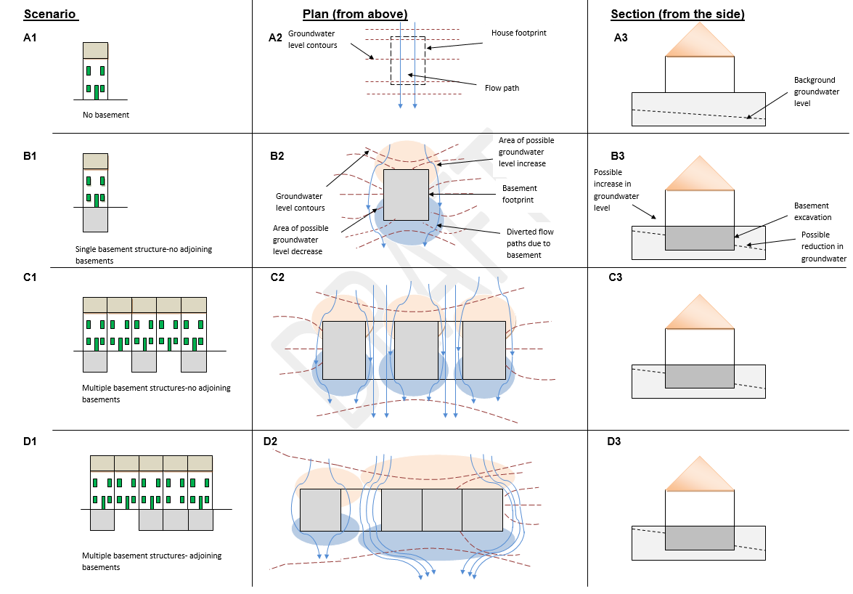

Construction Related Impacts
Basement construction has the potential to cause significant nuisance. Potential impacts during the construction phase include piling, excavation, noise, air quality, vibration and traffic movements. Dewatering, groundwater discharge and potential for hazardous/contaminated ground should be considered and assessed.

Temporary Works
No works should take place on or below private land without the owner’s written permission. If temporary works are required to facilitate the construction of the proposed basement, these are not permitted within public lands without a Ground Anchor Installation Licence (GAIL). The application, if required, should form part of the BIA and should be completed in conjunction with the GAIL guidance document. The relevant application form and guidance can be found at the following link –https://www.dublincity.ie/residential/transportation/apply-licence-or-permit/ground-anchor-installation-licence
All ground anchors shall be temporary in nature, decommissioned upon completion of the development and shall not inhibit future infrastructure schemes. They should be “cuttable” in design to allow for the installation of future infrastructure. A detailed survey of existing utilities and infrastructure is required to establish locations and depths as part of the GAIL.

Heritage and Biodiversity Impacts
Work beneath a protected structure or historic building may require underpinning specialists and appropriate detail and information should be provided. It must be demonstrated that there will be no adverse impacts during the demolition and construction phase to protected structures. Impacts to archaeology should also be considered. All works should stop on site if any archaeological or heritage material is found and the National Museum of Ireland and the City Archaeologist contacted. It should be noted that there is a general presumption against the development of basements in Zones of Archaeological Interest except in exceptional circumstances.
The BIA should consider impact to existing green infrastructure and in particular, the impact on the future planting including mature trees on the site.

Land Use
The impact of the proposal in land use terms should also be considered and it should be demonstrated that the intended use of the basement is appropriate and in the interests of the proper planning and sustainable development of the area. The environmental sustainability of the proposal should also be considered.

4.4 Construction Management Plan
A Construction Management Plan should be incorporated into the BIA. The level of content of the CMP should be proportional to the scale and complexity of the proposed development.
The CMP should contain as a minimum:
- Detailed information regarding the structural and geotechnical design of the basement and how the design and construction of the basement has been prepared in order to minimise the impacts on neighbouring properties, public lands and the water environment.
- Details demonstrating that the basement has been designed using evidence of local factors including ground conditions, the local water environment and structural condition of neighbouring properties in order to minimise the impact on them.
- Method statement detailing the proposed method of ensuring the safety and stability of neighbouring properties/structures and land throughout the construction phase. It should be clearly identified as to how potential for ground movements are to be mitigated and how monitoring of movement of buildings/structures and land will be addressed. A search for existing private basements and possible monitoring of these may also be required.
- Provision to monitor groundwater levels during and post construction. Appropriate limits of groundwater fluctuation to be accounted for and detailed. Critical groundwater threshold levels to be identified such that alarm set points can be established and constantly monitored. Appropriate mitigation measures to be detailed if these limits are reached or exceeded with provision for reporting breaches to DCC.
- Proposed site working hours and provision for site management, safety and supervision. Provision for phasing of works should be considered.
- Management of noise, vibration and dust.
- Construction and Demolition Waste Management Plan including provisions for the removal of hazardous waste.
- Management of construction traffic including traffic movements/routes to and from the site.
- The location(s) of a groundwater recharge point(s) should be accounted for (if appropriate), taking into account and with reference to the local site geology, hydrogeology, ground conditions and development extent and site boundary.
- If discharge is proposed to a local sewer, details related to the anticipated pumped volumes and discharge quality are to be detailed and the relevant licence approved/granted and enclosed in the BIA.
- Details of temporary or permanent works within the site boundary with an additional explanation if they are to extend outside the site boundary.
  - Boreholes required to monitor groundwater.
  - Ground anchors/soil nails for which a GAIL shall be required.
  - Sheet piles, contiguous bored piles details, retaining walls.
  - Depths of proposed walls and piles with reference to water table levels, groundwater flow direction, geology, hydrogeology etc.
- Appropriate monitoring measures including risk assessment thresholds and contingency measures for ground movement, groundwater levels, surface water flooding and pre condition surveys. The frequency and duration of monitoring must be chosen with reference to the specific effect which is being investigated.
- The locations of an appropriate number of groundwater monitoring points facilitating monitoring during the pre-planning, pre-construction phase.
- Provision to retain where necessary at the property throughout the construction phase of a suitably qualified engineer supported as required by a hydrogeologist from a recognised relevant professional body to monitor impacts, adjust pumping rates, inspect dewatering arrangements, review and apply the threshold groundwater levels (pumping controls) and approve the permanent and temporary basement construction works.
- Cumulative construction impacts of adjacent development should also be considered.

4.5 Impact Assessment and Mitigation
The impact assessment should describe, quantify and aggregate the effect of the development (for both construction and post-construction phase) as identified in the report. Where it is identified that the construction of the basement will have negative consequences and impacts, mitigation measures should be set out and where appropriate, incorporated onto the scheme design. A comparison of the assessed impacts with the baseline studies should be included.
Mitigation measures which may be included in basement development proposals comprise (but are not limited to):
- Controlled or adequate drainage;
- Grout injection to prevent vertical flow from lower groundwater flow systems;
- Underpinning of neighbouring structures and
- Setting the basement in from property boundaries.

4.6 Non-technical summary
A non-technical summary of the report is to be incorporated outlining the conclusions at each stage of the report.

5.0 Basement Impact Assessment – Submission Checklist
Note this check list is not exhaustive and the scope of information required is dependent on the scale and location of the basement construction proposed. The scope of the BIA should be agreed in advance with the Environment and Transport Department of Dublin City Council (as per details provided on the DCC website). The BIA must be completed by a suitably qualified professional with the necessary expertise to complete such an assessment (Chartered Structural/Geotechnical Engineer or equivalent).
Table 1: Basement Impact Assessment Submission Checklist
 | Item | Yes/No
1 | Description of proposed development.
2 | Plan showing boundary of development including any land required temporarily during construction.
3 | Plan, maps and photographs to show the location of basement relative to surrounding structures.
4 | Plans, maps and or photographs to show topography of surrounding area with any nearby watercourses/waterbodies including consideration of the relevant maps on the SFRA (Vol 7).
5 | Plans and sections to show foundation details of adjacent structures (reference to pre-condition reports).
6 | Plans and sections to show layout and dimensions of proposed basement and all proposed foundation details.
7 | Modelling evaluation of baseline groundwater levels and flows.
8 | Modelling and evaluation of groundwater levels and flows during construction and following construction of basement.
9 | Programme of enabling works and construction and restoration.
10 | Identification of potential risks to land stability (including surrounding structures and infrastructure and groundwater flooding.
11 | Assessment of potential risks on neighbouring properties and surface groundwater.
12 | Identification of significant adverse impacts.
13 | Ground Investigation Report and Conceptual Site Model including:  - Desktop study  - Exploratory hole record  - Results from monitoring the local groundwater regime  - Confirmation of baseline conditions  - Factual site investigation report
14 | Ground Movement Assessment.
15 | Plans, drawings, reports to show extent of affected area.
16 | Construction Sequence Methodology (CSM) referring to site investigation and containing basement, floor and roof plan, sections, sequence of construction and temporary works.
17 | Proposals for monitoring during and post construction (groundwater movement and levels, ground movement, vibration with comparisons to baseline) – limits to be advised in BIA and monitored. Any breaches should be reported to DCC’s Environment and Transportation Department.
18 | Consideration of potential impacts to protected structures, conservation areas and archaeology where relevant.
19 | Consideration of potential impacts to biodiversity and amenity.
20 | Construction Management Plan.
21 | Impact assessment and specific mitigation measures to reduce or offset significant adverse impacts with comparisons to baseline study.
22 | Provision for monitoring post construction (post-condition surveys, groundwater levels/flows etc.).
23 | Non-technical summary of full report.

PAGE LEFT INTENTIONALLY BLANK

Dublin City Development Plan 2022-2028

Appendix 10: Infrastructure Capacity Assessment

PAGE LEFT INTENTIONALLY BLANK

1.0 Introduction
Project Ireland (National Planning Framework 2018 and the National Development Plan 2021-2030) seeks the alignment of spatial planning and capital investment. The National Planning Framework (NPF) requires the capacity of the city’s infrastructure to be assessed in accordance with National Policy Objective (NPO) 72a. This NPO requires planning authorities to apply a standardised, two-tier approach to differentiate between land that is serviced (Tier 1 lands) and land that is serviceable within the lifetime of the Development Plan (Tier 2 lands). This Infrastructure Capacity Assessment allows an informed decision to be made as to whether or not to zone land for residential development as part of the Core Strategy.

This Infrastructure Capacity Assessment has been prepared in accordance with the methodology provided in the NPF and the Development Plan Guidelines for Planning Authorities (2022), and has been used to inform the approach to land use zoning taken in the Core Strategy.
This assessment does not comprise an exhaustive list of requisite infrastructures across the city and is not to be relied upon for development management purposes.

2.0 Methodology
The following sections set out an assessment of the capacity of the city’s strategic enabling infrastructure, together with more localised infrastructure provided by the City Council.
The assessment focuses predominantly on the provision of strategic infrastructure, as it is considered that the delivery of minor and/or local level infrastructure will be facilitated the through the Council’s capital investment works or development management process as part of standard developer/ service provider operational works. This assessment has considered the approved delivery programmes of relevant infrastructure providers in accordance with NPO 73c and Regional Policy Objective (RPO) 5.1.

3.0 Challenges
The strategic infrastructure projects identified in the Eastern and Midlands Region Spatial and Economic Strategy (RSES) are of significance to the future growth of Dublin City and the wider region. The overall water supply and wastewater situation for the Greater Dublin Area (GDA) is critical and urgently requires significant infrastructure investment. The timely provision of integrated region wide public transport projects are also crucial to meeting the prescribed growth targets for Dublin City and region.
The delivery of strategic infrastructure in the areas of transport and water services is ultimately dependent upon government policy, the macro-economic environment and the availability of capital, with such projects being within the remit of external infrastructure providers such as Irish Water and the National Transport Authority. In some instances, the timeframe of these provider’s strategic infrastructure capital investment plans and projects is not aligned with the fixed statutory timeframe of the Development Plan.
Most of the land targeted for new housing in Dublin City is located in Strategic Development and Regeneration Areas (SDRAs), which are for the most part, brownfield and regeneration sites. These SDRAs are aligned to existing and planned public transport corridors and guided by national policy set out in the NPF and RSES. The full build-out of these strategic areas will accord with the timeframes of the RSES until 2031 and the NPF until 2040, with many running across two or more Development Plan cycles to reach completion. To achieve this high quality, integrated approach to regeneration, it is critical that all of the envelope of these lands are zoned for development and subject to detailed master planning or local statutory plans that address how they will be delivered over time. This necessary, coordinated approach to brownfield regeneration is recognised in the recently published Development Plan Guidelines (2022).
This assessment reflects a point-in-time and it is acknowledged that infrastructure requirements may change. The full extent of requisite enabling infrastructure will continue to be assessed through the development management process whereupon detailed assessment will be undertaken. All reasonable efforts have been made to include infrastructure delivery costings where a verifiable source for same has been identified.

4.0 Strategic Infrastructure

4.1 Water Services Infrastructure
The City Council has engaged with Irish Water (IW) during the plan-making process in order to understand the status and capacity of the city’s water service infrastructure in accordance with the requirements of the draft Water Service Guidelines for Planning Authorities (2018) and Development Plan Guidelines (2022).
The Irish Water Services Strategic Plan (2015) sets out a number of key projects to maintain and improve existing water services and service further growth. The following infrastructural investments programmed by IW in its Investment Plan are of particular importance in the context of the strategic growth areas identified in the Core Strategy.

4.1.1 Water Supply
Dublin City falls within the water supply zone for the Greater Dublin Area (GDA) and supply in the region is limited at present. IW are currently progressing a number of projects in order to increase supply and improve water quality standards. The long-term development of the Region will be dependent on the Water Supply Project – Eastern and Midlands Region.

Table 1: Strategic Water Supply Infrastructure (Source: Irish Water)
Project Name | Project Delivery | Zoning Tier
Water Supply Project – Eastern and Midlands Region  The long-term development of the Eastern and Midland Region (EMR) will be dependent on this project. The NPF provides that a new long-term water supply source for the EMR, which includes the Dublin Water Supply Area, is needed by the mid 2020’s, to provide for projected growth up to 2050 and contribute to resilience and security of supply.  The project involves a 170km pipeline with supporting infrastructure (water treatment plant, pumping stations and terminal point reservoir) to ensure that the long-term water supply needs of the Region are met in a sustainable manner. IW has concluded a four-phase public consultation process and identified the preferred scheme:  - Abstraction of water from the Lower River Shannon at Parteen Basin.  - Water treatment at Birdhill.  - Treated water piped to a termination point reservoir at Peamount in south County Dublin, with supplies of treated water available to Midland communities along the route. | Identified in the National Development Plan (NDP) ‘Strategic Investment Priorities Water Quality.  Estimated cost of €1billion+ (source: NDP).  IW are in the process of preparing a SID planning application to An Bord Pleanála for the scheme. | Tier 1 - All sites subject to connection agreement with Irish Water (in line with existing standard practice).

Figure 1: EMR Water Supply Project (Source: Irish Water)
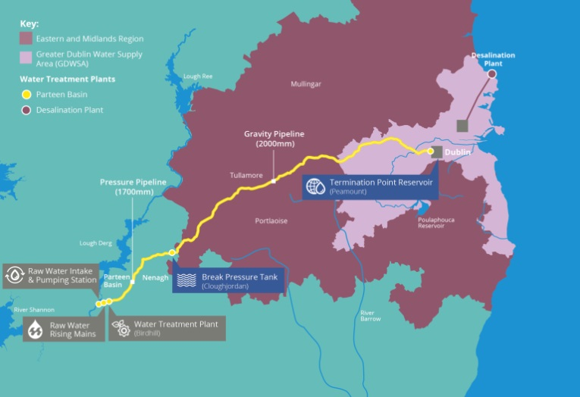

4.1.2 Wastewater Infrastructure
Dublin City is served by Ringsend Waste Water Treatment Plant which is currently undergoing significant upgrades which will allow the plant to treat increasing volumes of wastewater. In the longer term, the GDA will be dependent on the Greater Dublin Drainage Project to free up capacity at the Ringsend plant. Localised pressures on the city’s sewerage system are also being addressed through the proactive management of surface water inflows all facilitated through proactive Council policy (see policies SI22-25).
Table 2: Strategic Wastewater Infrastructure (Source: Irish Water)
Project Name | Project Delivery | Zoning Tier
Ringsend Wastewater Treatment Plant Upgrade Project  The Ringsend Waste Water Treatment Plant which, whilst currently overcapacity, is undergoing significant upgrades in response to capacity issues which will allow the plant to treat increasing volumes of wastewater by 2025.  This upgrade project will increase the capacity of the Ringsend plant from c. 1.64m population equivalent (PE) to c. 2.4m PE. This will provide for both existing population and future growth, and bring benefits in terms of health, environmental protection and improved water quality. The project includes:  - Additional secondary treatment capacity.  - Works to facilitate the use of aerobic granular sludge technology in the existing secondary treatment tanks.  - Expansion of the plant’s sludge treatment facilities. | Identified in the NDP.  Currently under construction and due for completion in 2025.  Phased increase in capacity (2.1m PE in 2023 and 2.4m PE in 2025).  Estimated cost of c. €400m (source: Irish Water). | Tier 1 - All sites subject to connection agreement with Irish Water (in line with existing standard practice).
Greater Dublin Drainage Project (GDDP)  The GDDP aims to provide long-term sustainable wastewater drainage and treatment to facilitate the continued social and economic development of the Region.  The project involves the provision of new wastewater treatment works, a marine outfall and a new drainage network in the northern part of the GDA.  Together, with the upgrade of the Ringsend Wastewater Treatment Plant, these projects are intended to provide adequate wastewater treatment to serve the GDA to 2050. It is anticipated that the GDDP will provide the additional treatment capacity required from the mid-2020s. | Identified in the NDP within the category ‘Strategic Investment Priorities Water Quality  Planning application is under determination. Construction scheduled for 2022-2026.  Estimated cost of c. €500m - €1bn (source: NDP). | Tier 1 - All sites subject to connection agreement with Irish Water (in line with existing standard practice).
Source: Irish Water

Figure 2: GDD Project (Source: Irish Water)
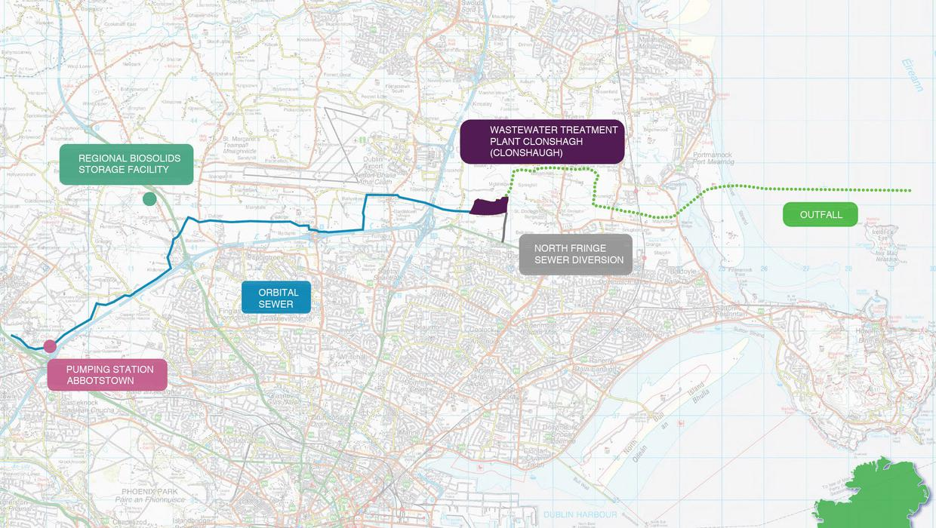

4.2 Transport Infrastructure

4.2.1 Key Public Transport Projects
The National Transport Authority Strategy for the GDA 2022-2042, provides for a number of key transport projects of strategic importance which will improve public transport provision across the city, and support ongoing sustainable growth focussed on the integration of land use and transportation. The following projects are of particular importance in the content of the strategic growth areas identified in the Core Strategy.
Table 3: Key Public Transport Projects (Source: NDP and NTA/TII)
Project Name | Project Delivery | Zoning Tier
Luas Green Line Upgrade / Capacity  This project seeks to incrementally increase capacity on the network through the provision of additional fleet and necessary infrastructure to meet forecast passenger demand. | Identified in the NDP and the NTA’s Transport Strategy for the GDA 2022-2042.  Delivery over the period 2022-2030. Cost estimate not currently available. | Tier 1 - Subject to assessment on site-by-site basis.
Luas to Finglas 2031-2042  The preferred route for the extended Luas Tram line to Finglas has recently been released by TII and NTA with a decision to be made on final alignment.  Luas Finglas will create a new public transport connection between the communities of Charlestown, Finglas Village, Finglas west, St. Helena’s, Tolka Valley and the city centre and will include the delivery of new cycle and pedestrian infrastructure. | Identified in the NDP and the NTA’s Transport Strategy for the GDA 2022-2042.  NDP commits to undertake appraisal, planning and design of LUAS network expansion to Finglas. A public consultation on its Emerging Preferred Route has been completed and it is expected that a Railway Order application will be submitted in 2023/2024.  Luas likely to become operational after 2028.  Cost estimate not currently available. | Tier 1 - Subject to assessment on site-by-site basis.
BusConnects (2021 – 2024)  BusConnects Dublin aims to overhaul the current bus system in Dublin through a 10-year programme of integrated actions to deliver a more efficient, reliable and better bus system. BusConnects includes:  - Redesign of the bus network with high frequency spines, orbital routes and increased bus services.  - New cycle network.  - New ticketing and cashless payment system.  - New bus stops and shelters with better signage and information.  - Bus-based park and rides in strategic locations.  - New bus livery and transitioning to a new bus fleet with low emission vehicle technologies. | The NDP identifies BusConnects as a Strategic Investment Priority over the period 2021-2030.  Project is at public consultation stage.  Estimated cost of €2billion (source: NDP). | Tier 1 - Subject to assessment on site-by-site basis.
Metrolink: (Dublin Airport/Swords)  MetroLink is the proposed high-capacity, high-frequency, automated rail line running from Swords to Charlemont, linking Dublin Airport, Irish Rail, DART, Dublin Bus and Luas services, creating fully integrated public transport in the Greater Dublin Area. As well as linking major transport hubs, MetroLink will connect key destinations including Ballymun to the city centre. | TII applied for a Railway Order and planning consent for Metrolink in Quarter 4 2022.  12-18 month planning process will commence once Railway Order granted and following this, work can commence on site. No estimated completion date is currently available for the project.  Estimated cost is €1billion+ (source: NDP) | Tier 1 - Subject to assessment on site-by-site basis.

Figure 3: Dublin Proposed Public Transport Network, Source: National Development Plan 2021-2030)
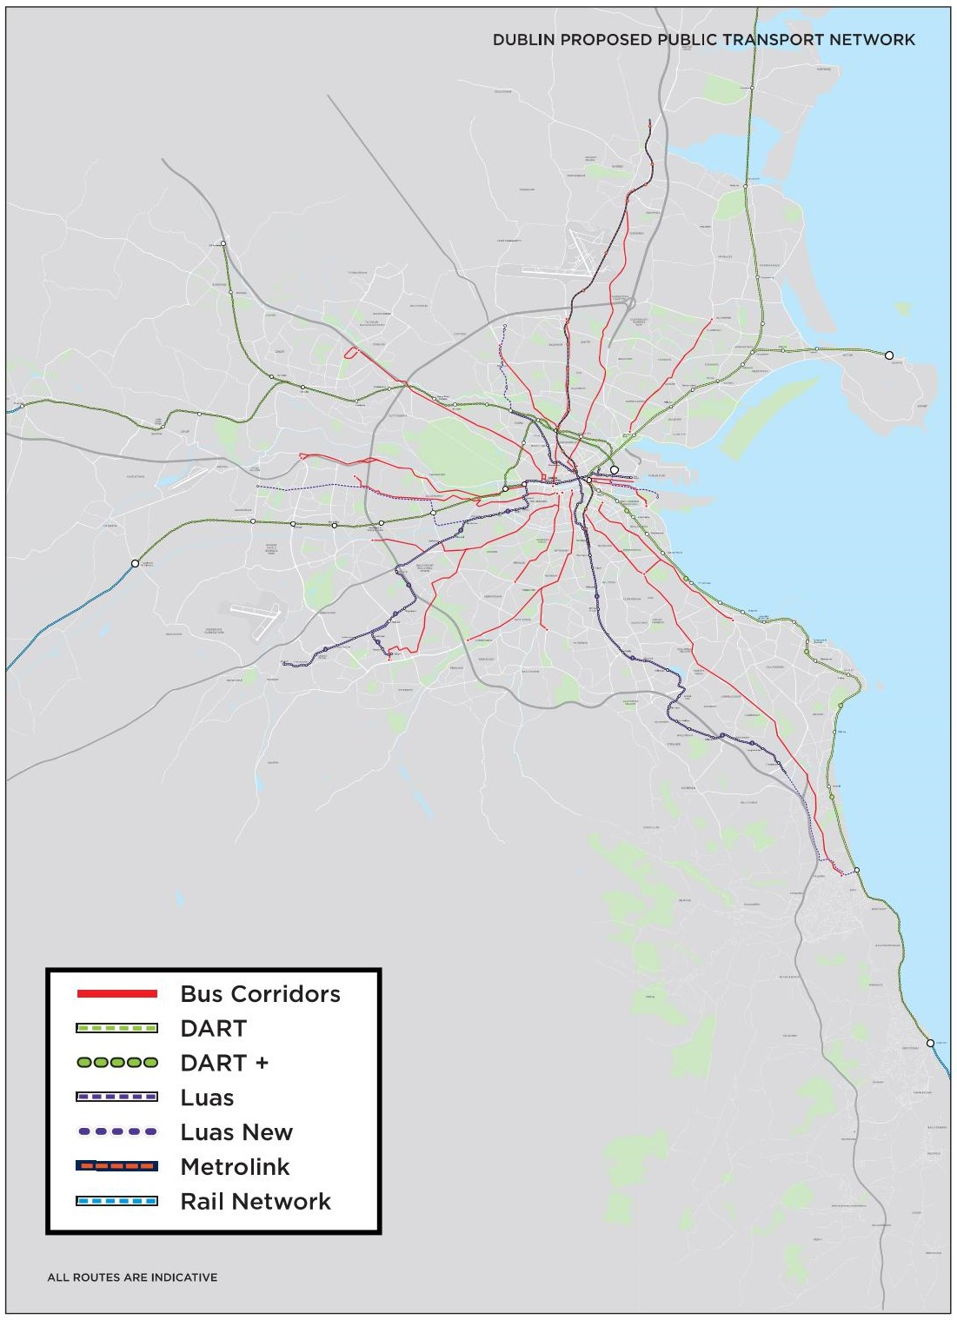

5.0 City Scale Infrastructure

5.1 Roads and Bridges
It is acknowledged that new street/ road infrastructure and improvements to existing streets/ roads will be required over the period of the Development Plan and in some instances, the development of new areas is predicated on the delivery of new street/ road connections such as the new networks in Belmayne, Ballymun, and Cherry Orchard.
New bridge infrastructure will also facilitate the continued development of the city such as the Dodder Public Transport Bridge, which is linked to development of the Poolbeg West Strategic Development Zone (SDZ), and pedestrian/cycle bridges which will improve connectivity between the north and south docklands areas.
The Dublin Tunnel is a road traffic tunnel which forms part of the M50 motorway and serves as a key route for heavy goods vehicles (HGVs) travelling to and from Dublin Port. Dublin City Council, working together with Transport Infrastructure Ireland, recognises the need to safeguard the structural integrity of the existing Dublin Tunnel from developments.
The Council’s commitments in respect to roads and bridge infrastructure are fully detailed in Objective SMTO27.

5.2 Active Travel – Walking and Cycling
Certain critical factors are required to make active travel an attractive alternative choice to car-based transport on the existing public road network, and to facilitate the 15 minute city concept of creating active, healthy communities with ease of access to amenities and services.
A significant allocation of Government funding was announced in 2021 for investment in walking and cycling and Dublin City Council is committed to supporting the roll out of the relevant infrastructure within the lifetime of this plan in line with Objectives SMTO7-12 and SMTO27-32.
The City Council will support the development of mobility hubs, the aim of which is to encourage varied and sustainable types of transport in areas that are close to existing public transport links with high concentrations of employment, housing, shopping, amenities and recreation (see policy SMT5). A mobility hub is a place of connectivity where different travel options such as walking, cycling, public transport and shared mobility services, are located together to facilitate ease of access and transition between transport modes. Together with quality public realm and place making, mobility hubs can help create vibrant and liveable places to support the transportation experience.
This City Council is seeking to increase the mode share of cycling and to support a cycling culture in the city by continuing to expand the cycle network, bike share schemes, cycling promotion campaigns, speed calming measures and increased publicly accessible cycle parking. The City Council will continue to work with the NTA’s ‘Cycle Network Plan for the Greater Dublin Area’ and its forthcoming review in order to develop a more comprehensive cycle network in accordance with objective SMTO8.
The Council are also committed to providing accessibility for all and to improving the city’s pedestrian infrastructure through the development management process. Policy SMT11 seeks to deliver on this objective to protect, improve and expand on the pedestrian network inclusive of facilities for people with mobility impairment and/ or disabilities linking key public buildings, shopping streets, public transport points and tourist and recreational attractions.

5.3 Surface Water Drainage Infrastructure
The City Council is actively working with IW to rehabilitate and upgrade the city’s water main infrastructure through the roll out of Drainage Action Plans, higher drainage infrastructure design standards and by requiring the separation of foul and surface water drains as part of all new developments. The Council have also implemented a range of new Surface Water Management and Sustainable Drainage Systems (SuDS) development management policies which seek to encourage nature-based solutions to managing surface water at local level in order to reduce the overall volume of surface water run-off and improve water quality of our rivers in line with the requirements of the Water Framework Directive.

5.4 Community Infrastructure
The NPF tiered approach to zoning does not focus on the community infrastructure element but it is considered of importance in creating sustainable neighbourhoods.
Dublin City Council is responsible for the provision of local community infrastructure such as sports facilities and public realm, with capital investment in the city’s local and community infrastructure governed by the Council’s rolling three-year Dublin City Capital Programme (2022-2024). The programme is informed by the objectives of the Development Plan and supported by a number of associated development contribution schemes designed to use the development management process to fund its capital projects to deliver greater community amenities and placemaking in line with the 15-minute city concept. The Development Plan has also introduced the requirement for a community and social audit to be undertaken in support of all residential applications comprising 50 or more units (policy QHSN48) in order to identify whether there is a need to provide additional facilities to cater for the proposed development.

The Council has also undertaken consultation with the Department of Education as part of the plan-making process to ensure that sufficient land is provided to meet the need for new schools and/ or expansion of existing schools, in line with the requirements of anticipated population growth.

6.0 Core Strategy

6.1 Metropolitan Area Strategic Plan (MASP)
The RSES Metropolitan Area Strategic Plan (MASP) for Dublin identifies a regional framework which aligns population and employment growth in designated Strategic Development Areas (SDAs) with associated transport and infrastructure investment priorities.
A key aim of the MASP is to unlock the development capacity of the SDAs by identifying the sequencing of enabling infrastructure. A phased sequence of infrastructure investment is identified to enable the accelerated delivery of strategic development corridors; within the short term to 2026; the medium term to 2031; and in the long term to 2040.
MASP identifies a number of large scale strategic sites (strategic development lands) based on key corridors that will deliver significant development (housing and employment development) up to the year 2031. The strategic housing development lands within the City Council’s area identified in the RSES are as follows:
Table 4: MASP Strategic Development Areas (Residential) – Relevant to Dublin City Council functional area
Corridor | Residential Areas | Phasing/Enabling Infrastructure
Multi-Modal Location - City Centre within the M50 | Docklands / North East Inner City lands | Short to Medium term:  Dodder bridge, LUAS extension to Poolbeg, local and wider area water upgrades, waste water upgrades and district heating.
 | City Centre / Parkwest – Cherry Orchard / St. James – Heuston Lands / Ashtown-Pelletstown / Ballymun | Short to Medium term:  Waste water upgrades, social infrastructure.  Long term: Long term capacity supported by DART underground.
 | Naas Road/ Ballymount | Medium to Long term:  Multi-modal public transport, new Luas stop, site assembly, waste water upgrades and local area water network upgrades.
DART Corridor (North South) | North Fringe (Clongriffin / Belmayne) | Short to Medium term:  Access to rail station, bus upgrades, new road connections, drainage, parks and social infrastructure.
Figure 4: Dublin Metropolitan Area Strategic Plan

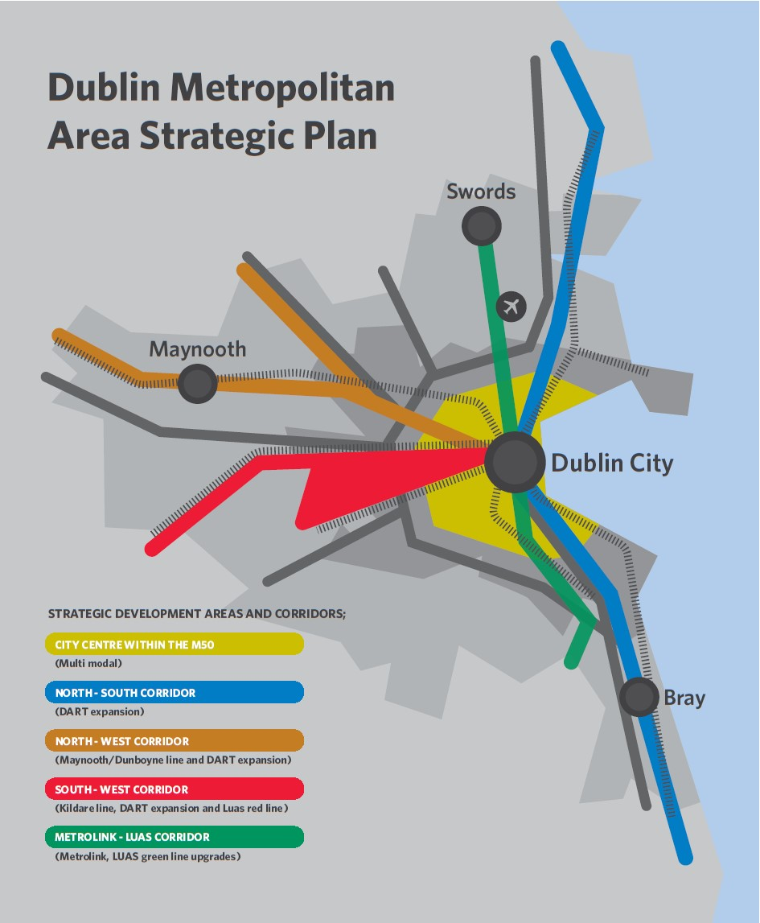

The development plan’s SDRAs are aligned with the MASP SDAs and are, for the most part, informed by short to medium term phasing schedules capable of being implemented over the lifetime of the development plan (as illustrated by Tables 2, 3 and 4 above).

Table 5: Capacity of SDRA Designated Lands for Residential Use or a Mixture of Residential and Other Uses
SDRA Ref. | City Area Name | Estimated housing capacity
SDRA 1 | Clongriffin/Belmayne and Environs | 6,950 -7,350
SDRA 2 | Ballymun | 2,200 - 2,350
SDRA 3 | Finglas Village Environs and Jamestown Lands | 2,800
SDRA 4 | Park West/Cherry Orchard | 2,500 - 3,100
SDRA 5 | Naas Road | 3,300
SDRA 6 | Docklands | 7,900
SDRA 7 | Heuston and Environs | 1,250
SDRA 8 | Grangegorman/Broadstone | 1,200
SDRA 9 | Emmet Road | 1,050
SDRA 10 | North East Inner City | 850
SDRA 11 | St. Teresa’s Gardens | 1,500
SDRA 12 | Dolphin House | 350
SDRA 13 | Markets Area and Environs | 400
SDRA 14 | St. James’s Healthcare Campus and Environs | -
SDRA 15 | Liberties and Newmarket Square | 2,500
SDRA 16 | Oscar Traynor Road | 850
SDRA 17 | Werburgh Street | 0
 | Total | 35,600-36,750

All SDRA lands identified in Table 5 above are aligned with the RSES SDAs and have a short to medium term phasing schedule which can be implemented at any time independently, with the exception of the Kylemore Road/Naas Road lands which are given a medium to long term phasing schedule by RSES. Notwithstanding this, SDRA 5 – Naas Road (former LAP lands) will be implemented in the short term, reflecting the long standing zoning of this area for regeneration purposes.

6.2 Other Lands
National and regional policy places an emphasis on compact growth and supports the sustainable development of brownfield and infill lands, through consolidation to support the optimal use of the finite resource of land.
Infill opportunities on vacant sites within zoned areas across the city which are likely to come forward during the lifetime of the development plan, will also play an important role in contributing to meeting the housing targets and is recognised within the Core Strategy.
The implementation of a proactive land and development management strategy, enhanced partnership-working and coordination, and the effective utilisation of URDF funding, will be crucial to achieving the delivery of c. 13,000 housing units on these non-SDRA lands.

6.3 Future Development Areas
The RSES applies a medium to long term phasing schedule to the Naas Road/ Kylemore Road/ Ballymount lands in response to their large scale and requirement for significant transport and water services infrastructural investment and further statutory planning. The development plan has responded by identifying these lands, together with the Glasnevin (Dublin Industrial Estate) lands, as ‘future development areas’. It is the intent of the Council that, following feasibility studies and/or the preparation of a Local Area Plan (or, if designated, a Strategic Development Zone) as per Objectives CSO1 and CSO2, that these industrial lands will be brought forward as regeneration lands during the lifetime of the development plan. In line with the NPF and Development Plan Guidelines (2022), any feasibility carried out on these lands over the course of the development plan period will include an infrastructure capacity assessment.

7.0 Assessment Conclusion
Dublin City is exceptional in that the entire development plan area is fully zoned and located within the built-up metropolitan area of Dublin. Whilst there may be local infrastructural needs and upgrades needed for certain sites, all lands within Dublin City are capable of being serviced and/ or are connected to public water services and other essential infrastructure. All are located proximate to public transport networks and public road and cycle routes.
Table 6: Settlement Capacity Audit – Summary Table
Tier | Settlement | Existing Population | Potential Housing Estimate
Tier 1 - Serviced lands | Dublin City other lands (excluding SDRAs) | 600,600  (2021, CSO Estimate) | 13,000
 | Dublin City SDRA lands |  | 35,600 – 36,750
Tier 2 - Serviceable lands | Potential lands at Glasnevin & Naas Road, Phase 1 |  | 6,000

Dublin City Development Plan 2022-2028

Appendix 11: Technical Summary of Dublin City Council Green & Blue Roof Guide (2021)

PAGE LEFT INTENTIONALLY BLANK

1.0 Introduction
‘Green blue roofs’ are a vital component in improving the urban environment of Dublin by supporting drainage infrastructure, enhancing biodiversity, creating recreational opportunities and greening the city.
Green blue roofs support the vision of a greener and more liveable city.
This Appendix identifies what constitutes a green blue roof and sets out a series of ‘green blue roof requirements’ which will be considered in the assessment of planning applications.
Dublin City Council’s (DCC) Green & Blue Roof Guide (2021) [hereafter referred to as the Green Blue Roof Guide] has been published as a standalone document.
Applicants should consult this Appendix together with the Green Blue Roof Guide for guidance on how to comply with DCC development plan Policy SI23, which sets out the requirement for green blue roofs on all new development with roof areas in excess of 100 sq. metres.
The DCC Green Blue Roof Guide expands on how schemes should deliver in accordance with Development Plan policy and sets out the required standards for green blue roofs.

1.1 What are Green and Blue Roofs?
A green roof is a roof or podium deck onto which vegetation is grown, or habitats for wildlife are established. There are various types of green roofs including: extensive and intensive roofs, semi-intensive, roof gardens, biodiverse roofs and brown roofs. Green roofs can also serve an amenity function where designed for this purpose.
‘Extensive green roofs’ are defined as having a minimum substrate depth of 80mm and ‘intensive green roofs’ are defined as having a minimum substrate depth of 200mm. Extensive roofs are typically planted with sedums or grass while a less restricted planting palette is found on intensive roofs. ‘Brown roofs’ provide a soil substrate which is left to self-seed and vegetate.
Blue roofs hold rainwater run-off directly on roofs and podium decks and release rainfall/stored surface water slowly/at a controlled flow rate through a ‘flow control’. Green roofs are converted to a blue roof through the incorporation of flow control. Storing rainwater that falls on the roof provides the potential to reduce or remove the requirement for attenuation storage elsewhere on a proposed development site. Blue roofs do not have to be vegetated. Flow/ rainwater that falls on the roof can be stored within open or closed hard landscape structures on roofs and podium decks.
Green roofs which provide attenuation of rainfall on the roof/ podium deck are the approach preferred by Dublin City Council.

1.2 Benefits of Green Blue Roofs
The provision of green blue roofs supports many of the Development Plan’s core policies. Green and blue roofs where designed appropriately can:
- Reduce the volume and rate of run-off/surface water entering the drainage system (Policies SI21 and SI22)
- Help to improve air quality by absorbing airborne pollutants (Policy SI34).
- Assist in addressing the loss of habitat and biodiversity which occurs from development and provides for new opportunities as part of redevelopment (Policies GI16 and GI17).
- Facilitate green infrastructure being incorporated to site design (Policies GI6 and GI7), particularly where the building takes up the entire footprint of the site.
- Minimise the relative heating of urban areas and reduce the need for heating and cooling within buildings, therefore, reducing carbon emissions (Policy CA8).
- Potential to contribute to the requirements of communal open space in residential developments (see Chapter 15 and Policy GI3).
This Appendix should be read in conjunction with:

Dublin City Council Development Plan (2022 – 2028)
- Chapter 3: Climate Action
- Chapter 9: Sustainable Environmental Infrastructure and Flood Risk
- Chapter 10: Green Infrastructure and Recreation
- Chapter 15: Development Standards, Section 15.6
- Appendix 12: Technical Summary of Dublin City Council’s Sustainable Drainage Design & Evaluation Guide (2021)
- Appendix 13: Dublin City Council Surface Water Management Guidance

European/National Policy
- Nature-based Solutions to the Management of Rainwater and Surface Water Runoff in Urban Areas: Water Sensitive Urban Design Best Practice Interim Guidance Document (2021)
- National Biodiversity Action Plan (2017-2021) or any successor plan

Dublin City Policy
- Dublin City Biodiversity Action Plan 2021 – 2025
- Dublin City Parks Strategy 2019 – 2022

2.0 Green Blue Roof Requirements

2.1 Green Blue Roof Requirement 1 - Applicable Development Types
All development types are considered appropriate for green blue roof application.

Exemptions
Exemptions will only apply in exceptional circumstances and will be considered by the planning authority on a case-by-case basis.
Residential development will be considered for exemption where there is not a continuous roof that is centrally managed i.e. the owner of each dwelling is responsible for their own roof. This will include individual dwellings and extensions to same.
An exemption may also be applicable where the green blue roof is considered to be incompatible with conservation (built heritage) requirements or other over-riding design requirements.
Exemptions will only be granted by DCC where it is demonstrated that suitable provision is made for SuDS measures (in accordance with Dublin City Council Sustainable Drainage Design & Evaluation Guide (2021) and all other planning requirements – see Appendix 12) and that appropriate sustainable drainage measures can be delivered on the site without the use of a green blue roof.

2.2 Green Blue Roof Requirement 2 – Areal Coverage
Planning applications which include roof areas of greater than 100 square metres with flat and gently sloped roofs are considered appropriate for green blue roof application.
The extent of roof area which provides growing medium for vegetation must meet the following coverage requirements as a percentage of total roof area.
Table 1: Green Blue Roof Minimum Coverage
Type of green roof | Minimum coverage  (% of total roof area being developed)
Extensive | 70%
Intensive | 50%
The percentage coverage is considered to make a reasonable allowance for the provision of overruns, roof lights, fire breaks, service penetrations and hard landscape.

Exemptions
Where roofs include photovoltaic (PV) panels, the design should consider the appropriateness of the PV panels being positioned over the vegetated areas of the roof.
Roof areas that are not considered for a green roof due to the presence of solar panels should still be considered for a blue roof.

2.3 Green Blue Roof Requirement 3 – Hydraulic Operation
The design of green blue roofs will make provision for suitably sized emergency/ exceedance overflow(s).

2.4 Green Blue Roof Requirement 4 – Use
The design of the green blue roof should maximise biodiversity and/ or amenity benefits.
Green blue roof designs should be designed to ensure that any amenity use (e.g. use as communal open space) can be facilitated without effecting storage capacity or drainage function of the green blue roof.

2.5 Green Blue Roof Requirement 5 - Access, Operation and Maintenance
All green blue roofs shall be designed with consideration of their future maintenance requirements.
Sedums, succulents and soils with low organic content are considered to be naturally fire-retardant and do not present a unique risk to propagating flame spread relative to a conventional flat or gently sloped roof. All green blue roofs shall be designed in consideration of current fire safety requirements.

Dublin City Development Plan 2022-2028

Appendix 12: Technical Summary of Dublin City Council Sustainable Drainage Design & Evaluation Guide (2021)

PAGE LEFT INTENTIONALLY BLANK

1.0 Introduction
The need for control of rainfall/surface water run-off using more sustainable approaches has been recognised in Dublin since the 1990’s. This led to the inclusion of Sustainable Drainage Systems (SuDS) policy within the Greater Dublin Strategic Drainage Strategy (GDSDS) (2005).
Since the GDSDS was first published, it has been commonplace for drainage schemes to include underground tanks or ‘end of pipe’ structures to hold surface water and restrict the rate of flow leaving the development. However, this simplistic approach does not accord with the original vision for SuDS as outlined by the GDSDS. Underground tanks offer no benefits in terms of improved water quality, nor do they make provision for amenity or biodiversity.
The National Planning Framework (2018) seeks to enhance water quality and resource management by ensuring that flood risk management and RBMP objectives are fully considered through the physical planning process and through the integration of sustainable water management solutions into place-making. The forthcoming 3rd cycle RBMP for the period 2022 to 2027 will address the impact of urban run-off on our water environment by strengthening the delivery of water sensitive urban design in how local authorities and others plan for, build and maintain our urban areas. Nature-based solutions to the management of rainwater and surface water run-off surface water management (i.e. SuDS) will be central to delivering on this objective in line with government policy published in the SuDS Interim Guide (2021).
This Appendix provides a high-level summary of the ‘key principles of SuDS design’ which are further explained in Dublin City Council’s Sustainable Drainage Design & Evaluation Guide (2021) [hereafter referred to as the SuDS Design Guide], which has been published as a standalone document.
The main objectives of the SuDS Design Guide are:
- To create a shared vision around SuDS for all involved in the planning, design and evaluation process.
- To enable the design of SuDS to meet Dublin City Council requirements/ agreed standards.
- To ensure SuDS are maintainable now and in to the future.
This Appendix identifies a series of ‘SuDS requirements’ which will be considered in the assessment of planning applications.
Those submitting planning applications should consult this Appendix together with the SuDS Design Guide and Greater Dublin Regional Code of Practice for Drainage Works for guidance on how to comply with Development Plan Policy SI22.
The integration of a predominantly nature-based SuDS approach will support many of the Development Plan’s core policies.
This Appendix should be read in conjunction with:
Dublin City Council Development Plan (2022 – 2028)
- Chapter 3: Climate Action
- Chapter 9: Sustainable Environmental Infrastructure and Flood Risk
- Chapter 10: Green Infrastructure and Recreation
- Chapter 15: Development Standards, Section 15.6
- Appendix 11: Technical Summary of Dublin City Council Green & Blue Roof Guide (2021)
- Appendix 13: Dublin City Council Surface Water Management Guidance
European/National Policy
- Water Framework Directive
- National Planning Framework 2018
- River Basin Management Plan (2nd and 3rd cycles)
- Nature-based Solutions to the Management of Rainwater and Surface Water Runoff in Urban Areas: Water Sensitive Urban Design Best Practice Interim Guidance Document (2021)
- National Biodiversity Action Plan 2017– 2021 or any successor plan
Dublin City Policy
- Dublin City Biodiversity Action Plan 2021 – 2025
- Dublin City Parks Strategy 2019 – 2022
- Dublin City Climate Action Plan 2019 – 2024

1.1 What are SuDS?
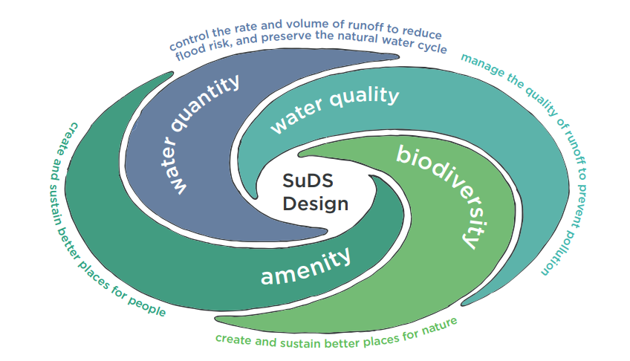
The following definition for Sustainable Drainage Systems (SuDS) is based on the SuDS Manual 2015, which was published by the Construction Industry Research and Information Association (CIRIA):
“Sustainable Drainage or SuDS is a way of managing rainfall that minimises the negative impacts on the quantity and quality of runoff whilst maximising the benefits of amenity and biodiversity for people and the environment”.
SuDS design should seek to manage rainfall run-off close to where it falls. Dublin City Council advocates the prioritisation of SuDS techniques that are situated at the surface, are nature-based and are integrated with the site layout.
There are four critical objectives that SuDS seek to meet:
- Quantity: preserve natural hydrological systems/ surface water resources by managing flows and volumes to match the rainfall characteristics before development, in order to prevent flooding on-site and within the receiving catchment.
- Quality: preventing and treating pollution to ensure that clean water is available as soon as possible to provide amenity, biodiversity and climate resilience benefits within the development, as well as protecting watercourses, groundwater and the sea.
- Biodiversity: protecting natural habitats, providing ecological connectivity and creating/ supporting sustainable ecosystems through the design and management of SuDS.
- Amenity: enhancing people’s quality of life through integrated place-making and design that provides for climate resilient, useful and attractive multi-functional spaces.

2.0 Integrating SuDS into New Development
Dublin City Council expect the designer to consider SuDS at the earliest point in scheme design.
SuDS designs will explore opportunities for: sustainable reuse of rainfall (see Policy SI6); recharge of aquifers; interception and evapotranspiration of surface water; and, direct discharge to open channel watercourses, thus reducing the pressure on the piped drainage network.
SuDS structures should be integrated into the fabric of a development using the available landscape spaces as well as the construction profile of buildings. Consideration of existing site topography, landscape resources and how the site is used is vital in determining the most appropriate SuDS measures in a scheme.
Areas that store surface water during regular rainfall events, except ponds or wetlands, shall not normally be included in the calculation of open space provision. However, where SuDS proposals enhance biodiversity and amenity value and would be readily available for use in most weather conditions, a portion of the SuDS area could be incorporated as part of the communal or public open space provision. Dublin City Council want to promote a high standard of multi-functional spaces and developments in accordance with other policies in this plan. The proportion of SuDS which would be allowable as part the public open space allocation would be decided on a case-by-case basis by the planning authority. The following points will be considered in determining the areal extent of SuDS which serve as multifunctional space and/ or contribute to the public open space allocation:
- That sufficient open space remains available (except in response to extreme rainfall events) to allow for passive and active recreation including organised sport, informal play or active recreational use.
- How often a particular feature would hold surface water.
- The duration that feature would hold surface water.
- Period between rainfall ending and the area being available for use.
- Whether the SuDS features could be deemed to be providing an open space benefit even when holding surface water (for example, ponds and wetlands).

3.0 SuDS Requirements
The following SuDS requirements will apply to all developments reviewed by Dublin City Council as part of the planning process:

3.1 SuDS Requirement 1 - Runoff Destination
The following methods of utilising or releasing rainfall run-off from development are set out in order of preference:
- Use surface water run-off as a resource.
- Provide interception of rainfall through the use of nature based SuDS approaches.
- Where appropriate, infiltrate run-off into the ground.
- Discharge to an open surface water drainage system.
- Discharge to a piped surface water drainage system.
- Discharge to a combined sewer.
Discharging run-off from a site may utilise one or more means of discharge. Full advantage should be taken of each method of discharge on the list in turn, prior to considering the next sequential option.

3.2 SuDS Requirement 2 - Hydraulic Control
Hydraulic criteria are as set out in the GDSDS and Regional Drainage Code of Practice.
Surface run-off from new development will be restricted to 2 l/s/ha for the 1 in 100 year rainfall event (with allowance for climate change and urban creep) where surface water leaving the site:
- poses a pollution risk to the environment arising from (overflow from a combined sewer to a receiving watercourse);
- has the potential to impact upon property or infrastructure (where property or infrastructure is identified as being at flood risk from a 1 in 100 year flood / rainfall event).
In all other instances, the following criterion tabled below shall apply.

Table 1: SuDS Requirements
Criterion | Sub- criterion | Return Period (Years) | Design Objective
Criterion 1  River Water Quality Protection | 1.1 | <1 | Interception storage of at least 5mm, and preferably 10mm, of rainfall where run-off to the receiving water can be prevented.
Criterion 2  River Regime Protection | 2.1 | 1 | Discharge rate equal to 1-year greenfield site peak runoff rate or 2 l/s/ha, whichever is the greater site critical duration storm to be used to assess attenuation storage volume.
 | 2.2 | 100 | Discharge rate equal to 1 in 100 year greenfield site peak run-off rate. Site critical duration storm to be used to assess attenuation storage volume.
Criterion 3  Level of Service (Flooding) for the Site. | 3.1 | 30 | No flooding on site except where specifically planned flooding is approved. Summer design storm of 15 or 30 minutes are normally critical.
 | 3.2 | 100 | No internal property flooding. Planned flood routing and temporary flood storage accommodated on site for short high intensity storms. Site critical duration events.
 | 3.3 | 100 | No internal property flooding. Floor levels at least 500mm above maximum river level and adjacent on-site storage retention.
 | 3.4 | 100 | No flooding of adjacent urban areas. Overland flooding managed within the development.
Criterion 4  River Flood Protection  (Criterion 4.1, or 4.2 or 4.3 to be applied) | 4.1 | 100 | “Long-term” floodwater accommodated on site for development run-off volume which is in excess of the greenfield run-off volume.  Temporary flood storage drained by infiltration on a designated flooding area brought into operation by extreme events only.  100 year, 6 hour duration storm to be used for assessment of the additional volume of run-off.
 | 4.2 | 100 | Infiltration storage provided equal in volume to “long term” storage.  Usually designed to operate for all events.  100 year, 6-hour duration storm to be used for assessment of the additional volume of run-off.
 | 4.3 | 100 | Maximum discharge rate of QBAR or 2 l/s/ha, whichever is the greater, for all attenuation storage where separate “long term” storage cannot be provided.

3.3 SuDS Requirement 3 - Water Quality
SuDS designs will demonstrate sufficient number of SuDS techniques which are sufficiently sized to manage and remove pollution, to provide protection of groundwater, surface waters and sensitive coastal waters. The SuDS design will demonstrate that water is suitably cleansed prior to entry to SuDS components that are intended for amenity use and biodiversity benefit. Preference should be given to SuDS techniques which generate interception losses.

3.4 SuDS Requirement 4 - Amenity
Designs should seek to generate amenity benefits using SuDS, through the creation of multi-functional places and landscapes.

3.5 SuDS Requirement 5 - Biodiversity
Designs should seek to generate biodiversity benefits using SuDS.
Dublin City Development Plan 2022-2028

Appendix 13: Surface Water Management Guidance

PAGE LEFT INTENTIONALLY BLANK

1.0 Introduction
Climate change impacts manifest in changes to the water cycle, with extreme events such as floods affecting our city. Sustainable and climate resilient water management is now critical to achieving climate resilience and meeting the objectives of the National Climate Action Plan 2021.
Early consideration and application of a sustainable and climate resilient approach to surface water management at project concept stage can deliver benefits for whole communities in terms of biodiversity, climate resilience, creating public places that support people, health and general wellbeing in the city.
The Dublin City Development Plan 2022-2028, identifies the need for Sustainable Environmental Infrastructure as part of all development proposals in the city. New development is expected to integrate the principles of Sustainable Drainage Systems (SuDS) with all other environmental aspects of new development, using best practice solutions to develop a high standard of sustainable development – for further guidance see Appendix 12 - Technical Summary of Dublin City Council Sustainable Drainage Design & Evaluation Guide (2021).
Dublin City Council (DCC) will require a softer engineered or nature-based approach to be used to manage surface water at source as it is a greener, more environmentally effective approach for managing surface-water on development lands.
In compliance with Policy SI25, development proposals must be accompanied by a Surface Water Management Plan (SWMP) which sets out the proposed strategy for managing surface water. The preparation of SWMP’s will also be required to inform the preparation of frameworks/ masterplans/ plans (statutory and non-statutory). SWMP requirements for development proposals and frameworks/ masterplans/ plans are set out in sub-sections A and B below.
This Appendix sets out the requirements of such plans which will be considered in the assessment of planning applications. This Appendix should be read in conjunction with:
Dublin City Council Development Plan (2022 – 2028)
- Chapter 3 - Climate Action
- Chapter 9 - Sustainable Environmental Infrastructure and Flood Risk
- Chapter 10 – Green Infrastructure and Recreation
- Chapter 15 – Development Standards, Section 15.6
- Strategic Flood Risk Assessment for Dublin City Development Plan 2022-2028 – Volume 7
- Appendix 11 - Technical Summary of Dublin City Council Green & Blue Roof Guide (2021)
- Appendix 12 - Technical Summary of Dublin City Council Sustainable Drainage Design & Evaluation Guide (2021)

2.0 Requirement for Surface Water Management Planning for New Development
The objective of producing a SWMP is for the developer/ project proposer to consider all the opportunities and constraints in developing a design solution that will manage surface water in a way that utilises and mimics natural processes, whilst protecting and enhancing the built and natural environment. This ensures that the optimal design solutions are integrated into a development in order to provide more resilient and adaptable infrastructure, to mitigate against future flooding and climate change disruption. For the avoidance of doubt, drainage/ SuDS plans will be required to reflect the proposals for SuDS as set out in the SWMP.

A. Surface Water Management Requirements for Development Proposals

(i) Development including or in excess of 2 no. residential units or 100 sq. m. of non-residential uses (including social and community uses)
All developments with surface water implications which fall within these thresholds will be required to prepare a SWMP as part of their project design process.
The SWMP prepared for submission to the planning authority as part of a planning application shall include the following:
- Site location map with proposed planning boundary indicated in red
- Overall surface water drainage layout indicating:
  - Existing public surface water infrastructure
  - Proposed connection points to existing public sewers
  - Spine sewers (if any)
  - Detail of any surface water sewer extension, diversions, surface water sewer upgrades etc. to be clearly indicated
- Report detailing existing site conditions including:
  - Topography
  - Ground conditions
  - Land drain features
  - Overland flow paths
  - Floodplains
  - Utilities
- Detail of proposed surface water management strategy shall include:
  - Longitudinal section details of proposed surface water pipe runs if required indicating route, levels, pipe size, gradient etc. A well-designed SuDS scheme will reduce or even eliminate the need for significant piped drainage.
  - Identify proposed location to discharge to stream or public drainage system.
  - Identification of appropriate SuDS features to meet the key criteria of the GDSDS and reference in Section 16.3 of the Greater Dublin Regional Code of Practice for Drainage Works - source control and interception storage provided and volumes defined – no run-off from site for events up to 5mm. See also the Council’s Sustainable Drainage Design & Evaluation Guide (2021) and Appendix 12.
  - Provide a clear explanation of the SuDS proposals proposed for each hardstanding area including defined control structures and sizes of same.
  - Discharge rate applied.
  - Attenuation storage provided and volumes defined – storage for 1% and 3.3% annual probability with factor in accordance with the SFRA for climate change shall be applied. A figure of 20% will be applicable in most cases.
  - Exceedance and overland flow routes.
  - Phased development – where development under a planning application/permission is phased, coordination of the overall surface water management strategy shall be implemented at the first phase in order to ensure the overall integrated design is implemented. This would allow different parts of a site to be developed at different times, while ensuring that the final developed site shall meet the overall design criteria as set out in this Appendix.
  - Identify green space and public space locations including any that are designed to be multifunctional – integrating SuDS (see also Section 15.6 – Green Infrastructure and Landscaping).
  - Details of any proposed wayleaves or land transfers in relation to surface water drainage.
  - An undertaking that SuDS will be completed to taking in charge standards (in accordance with Policy SI26).

(ii) Development proposals under 2 no. residential units or 100 sq. m. of non-residential uses (including social and community uses) and all other developments likely to have surface water implications
The following requirements shall be addressed as part of drainage submission for all other smaller scale development likely to have surface water implications:
To meet the requirements of the development plan on SuDS (Policy SI22 and Appendix 12), the design shall incorporate SuDS measures appropriate to the scale of the proposed development such as water butts, filter drains, infiltration systems, soakaways, permeable paving, rain gardens etc. that would minimise discharges to the public drainage system and maximises infiltration potential. All SuDS measures must be designed in accordance with the relevant industry standards, see Policy SI26 and the recommendations outlined in the Council’s Sustainable Drainage Design & Evaluation Guide (2021).

B. Surface Water Management Requirements – Frameworks/ Masterplans/ Plans
Frameworks/ Masterplans/ Plans typically involve multiple sites or a bank of land (which may or may not be in different ownerships), the development of which requires a coordinated approach through a statutory or non-statutory plan (please refer to Chapter 2 Core Strategy, Chapter 13 Strategic Development Regeneration Areas and Appendix 3 for further details). Examples of statutory plans include Local Area Plans and SDZ Planning Schemes. Examples of non-statutory plans include masterplans for large scale regeneration or development sites.
A SWMP will be required to be prepared as part of the plan-making/ master planning process.
The SWMP will provide a description of the relevant area characteristics and a vision for SuDS and how they are proposed to be integrated into the planning and layout of the area subject to the plan.
The SWMP for a plan area shall specifically include:
- A location layout with site boundary indicated in red
- Report detailing the existing site conditions including:
  - topography (high and low points)
  - existing land drainage features e.g. existing open drains/ditches and where they drain to
  - existing public drainage network
  - existing flood risk
  - existing ground conditions (including infiltration rates)
  - identification of any existing overland flow paths for flood events
  - any physical restrictions e.g. existing trees or buildings to be retained
The SWMP should also provide details on the following:
- Phasing arrangements – where development under the plan is likely to be phased, coordination of the overall SWMP shall be implemented at the first phase in order to ensure the overall integrated design is implemented. This would allow different parts of lands subject to the plan to be developed at different times, while ensuring that the full and final development shall meet the overall design criteria as set out here.
- Proposed overland flow paths - existing drainage patterns and natural flow paths should be mimicked.
- Identify discharge options e.g. water reuse, infiltration, discharge to water body etc.
- Identify SuDS sub-catchments.
- Provision of treatment stages based on land use for each sub-catchment.
- Estimate attenuation volumes - from the types of land use and density of the development, a general assumption can be made about the percentage of the area which is impermeable and will generate runoff.
- The amount of source control (management where rain falls to prevent runoff such as rainwater harvesting, permeable surfaces and green roofs) should be estimated through discussions with the design team to give a realistic estimate of runoff. The volume calculated does not need to be delivered as one storage area, and better solutions are often found by breaking down the storage volume into smaller parts and combining these with multi-functional spaces e.g. paved public areas, open spaces, roads, gardens etc.
- Structure conveyance paths - natural flow paths and ‘man-made’ connection routes (roads, green corridors) should be examined at this point to establish a structured grid for surface water conveyance to storage areas and discharge points. Runoff should be kept at or near ground level, where possible.
- Identify green space and public space locations including any that are designed to be multifunctional – integrating SuDS (see also Section 15.6 – Green Infrastructure and Landscaping).
- Details of any proposed wayleaves or land transfers in relation to surface water drainage.
- An undertaking that SuDS will be completed to taking in charge standards (in accordance with Policy SI26).

3.0 General Notes

Attenuation tanks
- The management of surface water at source is the priority and ideally, only flows in larger weather events shall be directed to main surface water infrastructure. As a result, discharge managed via a pipe and an attenuation tank system will only be considered by the planning authority in exceptional circumstances and on a case-by -case basis.

Excluded Development
- It should be noted that this guidance does not apply to development that would not have surface water implications (i.e. building elevation modifications, change of use applications etc.).

Consultation with Local Authority
- Proposers of non-statutory plans should consult with the Council’s Drainage Department so that the SWMP is agreed in principle by key stakeholders, ensuring national and DCC policies are implemented.
- Consultation on the SWMP for any new development is advised where there is a flood risk or the development is located adjacent to a watercourse.
- Consultation with DCC’s Parks, Biodiversity and Landscape Services Division is required where a plan has landscape and/ or biodiversity implications.

General Drainage Requirements for Planning Applications
All submissions shall meet the standard requirements outlined in the Greater Dublin Regional Code of Practice for Drainage Works Version 6.0.
Any submission which includes piped surface water drainage shall include a layout on which all surface water manholes shall be numbered with a manhole schedule to be provided specifying cover and invert levels.

Dublin City Development Plan 2022-2028

Appendix 14: Statement Demonstrating Compliance with Section 28 Guidelines

PAGE LEFT INTENTIONALLY BLANK

1.0 Introduction
This Appendix constitutes the statement demonstrating how Dublin City Council has implemented the relevant policies and objectives of the Minister when considering their application to the city in the development plan.

2.0 Legislative Requirements
Section 28(1) of the Planning and Development Act 2000 (as amended) allows for issuing of Guidelines to planning authorities (such as Dublin City Council) regarding their functions under the Act and specifies planning authorities shall have regard to those Guidelines in the performance of their functions.
Under Sections 28(1A)(b) and 28(1B) of the Act 2010 (as amended), a planning authority is required to append a statement to their development plan to include information which demonstrates:
(a) how the planning authority has implemented the relevant policies and objectives of the Minister contained in the Guidelines when considering their application to the area or part of the area of the draft development plan and the development plan, or
(b) if applicable, that the planning authority has formed the opinion that it is not possible, because of the nature and characteristics of the area or part of the area of the development plan, to implement certain policies and objectives of the Minister contained in the Guidelines when considering the application of those policies in the area or part of the area of the draft development plan or the development plan and shall give reasons for the forming of the opinion and why the relevant policies and objectives of the Minister have not been so implemented.
In addition, Section 28(1C) of the Act includes a provision that Guidelines made under Section 28(1) may contain specific planning policy requirements (SPPRs) with which planning authorities, regional assemblies and the Board shall, in the performance of their functions, comply.

3.0 Implementation of Policies and Objectives of S28 Guidelines in the City Development Plan
Tables 1 to 4 on the following pages provide the requisite information as to how this development plan has fully implemented all relevant Section 28 Guidelines and has complied with all relevant special planning policy recommendations.
Table 1: Implementation of Section 28 Guidelines
Section 28 Guidelines | Implementation
DHLGH: (2022) Development Plans: Guidelines for Planning Authorities | The relevant policies and objectives of these Guidelines have been implemented throughout the plan-making process.
Government of Ireland: (2022) Residential Zoned Land Tax: Guidelines for Planning Authorities | The provisions of these Guidelines are consistent with Development Plan implementation.
DHLGH: (2022) Strategic Environmental Assessment: Guidelines for Regional Assemblies and Planning Authorities | These Guidelines informed the preparation of the Strategic Environmental Assessment (SEA) of the development plan, which is included as an accompanying volume 5 of the Plan. All recommendations and mitigation measures from the SEA process have been incorporated into the Plan. The SEA process and report implements the relevant policies and objectives of these Guidelines.
DHLGH: (2021)Nature-based Solutions to the Management of Rainwater and Surface Water Runoff in Urban Areas: Water Sensitive Urban Design: Best Practice Interim Guidance Document | The provisions of these Guidelines are consistent with Development Plan policy and implementation.
DHLGH (2021) Regulation of Commercial Institutional Investment in Housing | The provisions of these Guidelines are implemented by Dublin City Council as part of the development management process. Chapter 5 Quality Housing and Sustainable Communities, Chapter 15 Development Standards and Appendix 1 Housing Strategy also address the principles of the Guidelines in relation to the consideration of new housing developments.
DHLGH (2021) Enforcement of Certain Planning Conditions during the Coronavirus (COVID-19) Outbreak | The provisions of these Guidelines are implemented by Dublin City Council as part of the development management and planning enforcement process.
DHLGH (2020) Housing Supply Target Methodology for Development Planning | Chapter 2 Vision and Core Strategy, Chapter 5 Quality Housing and Sustainable Communities and Appendix 1 Housing Strategy implement the methodology and other relevant requirements set out in these Guidelines.
DHPLG (2019) Design Manual for Urban Roads and Streets | Chapter 8 Sustainable Movement and Transport, Chapter 15 Development Standards and Appendix 5 Transport and Mobility: Technical Requirements implement the relevant policies and objectives of these Guidelines.
DHPLG (2018) Urban Development and Building Heights | Chapter 4 Shape and Structure of the City, Chapter 5 Quality Housing and Sustainable Communities, Chapter 15 Development Standards and Appendix 3 Achieving Sustainable Compact Growth Policy for Density and Building Height in the City, implement the relevant policies and objectives of these Guidelines (See below for SPPR compliance).
DHPLG 2020 Sustainable Urban Housing, Design Standards for New Apartments: Guidelines for Planning Authorities | Chapter 5 Quality Housing and Sustainable Communities and Chapter 15 Development Standards implement the relevant requirements of these Guidelines.
DHPLG (2018) Guidelines for Local Authorities and An Bord Pleanála on Carrying Out Environmental Impact Assessments | Chapter 15 Development Standards references requirements in relation to EIAR and has regard to the Guidelines.
DHPCLG (2017) Part V of the Planning and Development Act 2000 – Guidelines | Chapter 5 Quality Housing and Sustainable Communities and Appendix 1 Housing Strategy implement the relevant policies and objectives contained in these Guidelines.
DHPCLG (2017) Interim Guidelines for Planning Authorities on Statutory Plans, Renewable Energy and Climate Change | Chapter 3 Climate Action has regard to national policy on renewable energy and climate change.
DECLG (2013) Local Area Plans: Guidelines for Planning Authorities | These Guidelines are not considered directly applicable to the development plan process but any future Local Area Plans shall have regard to these Guidelines.
DECLG (2013) Development Contributions: Guidelines for Planning Authorities | Future development contribution schemes will be made post adoption of the development plan shall have regard to these Guidelines.
DECLG (2012) Spatial Planning and National Roads: Guidelines for Local Authorities | Chapter 6 Sustainable Movement and Travel, Chapter 15 Development Standards and Appendix 5 Transport and Mobility: Technical Requirements implement the relevant policies and objectives of these Guidelines.
DECLG (2012) Retail Planning: Guidelines for Planning Authorities | Chapter 7 City Centre and Retail and Appendix 2 Retail Strategy implement the relevant policies and objectives of these Guidelines.
DAHG (2011) Architectural Heritage Protection: Guidelines for Planning Authorities | Chapter 11 Built Heritage and Archaeology, Chapter 15 Development Standards, Appendix 6 Conservation and Volume 4 Record of Protected Structures implement the relevant policies and objectives of these Guidelines.
DEHLG (2009) Appropriate Assessment of Plans and Projects in Ireland: Guidance for Planning Authorities | The relevant policies and objectives of these Guidelines have been implemented throughout the iterative plan-making process.  These Guidelines informed the preparation of the Appropriate Assessment (AA) of the development plan, which is included as an accompanying volume to the plan. All recommendations and measures from the AA process have been incorporated into the Plan. The AA process and report implements the relevant policies and objectives of these Guidelines.
DEHLG (2009) The Planning System and Flood Risk Management: Guidelines for Planning Authorities | Chapter 9 Sustainable Environmental Infrastructure, Chapter 10 Green Infrastructure and Recreation and Appendix 13 Surface Water Management Plan implement the relevant policies and objectives of these Guidelines. They are also addressed in the Strategic Flood Risk Assessment contained in Volume 7.
DEHLG (2009) Sustainable Residential Development in Urban Areas (Cities, Town and Villages): Guidelines for Planning Authorities (and the accompanying Urban Design Manual: a Best Practice Guide) | Chapter 4 Shape and Structure of the City, Chapter 5 Quality Housing and Sustainable Communities, Chapter 15 Development Standards and Appendix 3 Achieving Sustainable Compact Growth Policy for Density and Building Height in the City implement the relevant policies and objectives of these Guidelines.
DEHLG, DES (2008) The Provision of Schools and the Planning System: A Code of Practice | Chapter 5 Quality Housing and Sustainable Communities and Chapter 15 Development Standards implement the relevant policies and objectives of these Guidelines.
DEHLG (2007) Development Management: Guidelines for Planning Authorities | Chapter 15 Development Standards implements the relevant policies and objectives of these Guidelines.
DEHLG (2007) Development Plans: Guidelines for Planning Authorities | The relevant policies and objectives of these Guidelines have been implemented throughout the plan-making process.
DEHLG (2006) Wind Energy Development: Guidelines for Planning Authorities | The issue of renewable energy is addressed in Chapter 3 Climate Action.
DEHLG (2006) Redevelopment of Certain Lands in the Dublin Area Primarily for Affordable Housing: Guidelines for Planning Authorities | The issue of housing is addressed in detail in Chapter 5 Quality Housing and Sustainable Communities and in Appendix 1 Housing Strategy.
DEHLG (2005) Sustainable Rural Housing: Guidelines for Planning Authorities | There Guidelines are not considered as being directly applicable to the Dublin City Council area.
DEHLG (2004) Implementation of the SEA Directive: Guidelines for Regional Authorities and Planning Authorities | These Guidelines informed the preparation of the Strategic Environmental Assessment (SEA) of the development plan, which is included as an accompanying volume 5 of the Plan. All recommendations and mitigation measures from the SEA process have been incorporated into the Plan. The SEA process and report implements the relevant policies and objectives of these Guidelines.
DEHLG (2004) Quarries and Ancillary Activities: Guidelines for Planning Authorities | There Guidelines are not considered as being directly applicable to the Dublin City Council area.
DEHLG (2003) Part V of the Planning and Development Act 2000 Further Guidance on Implementation Issues | Chapter 5 Quality Housing and Sustainable Communities and Chapter 15 Development Standards implement the relevant policies and objectives of these Guidelines.
DEHLG (2002) Part V of the Planning and Development Act, 2000: Implementation Issues | Chapter 5 Quality Housing and Sustainable Communities and Appendix 1 Housing Strategy implement the relevant policies and objectives contained in these Guidelines.
DOELG (2001) Childcare Facilities: Guidelines for Planning Authorities | Chapter 5 Quality Housing and Sustainable Communities and Chapter 15 Development Standards implement the relevant policies and objectives of these Guidelines.
DOELG (1996) Telecommunications Antennae Support Structures: Guidelines for Planning Authorities | Chapter 9 Sustainable Environmental Infrastructure and Chapter 15 Development Standards implement the relevant policies and objectives of these Guidelines.
DOELG (1994) Tree Preservation Guidelines | Chapter 10 Green Infrastructure and Recreation and Chapter 15 Development Standards implement the relevant policies and objectives of these Guidelines.

Table 2: Implementation of SPPRs from DLPLG (2018) Sustainable Urban Housing
Specific Planning Policy Recommendation | Implementation
SPPR 1: Apartment developments and unit type/mix | A Housing Strategy and HNDA has been prepared (see Appendix 1) and has demonstrated that there is a requirement for a mix in order to cater for the housing needs of the existing and future population in the Dublin City Council Area. This is also addressed in and Chapter 15 Development Standards and Chapter 5 Quality Housing and Sustainable Communities.
SPPR 2: Building refurbishment and urban infill schemes | Chapter 15 Development Standards, which sets out the relevant standards relating to unit mix and refurbishment/ infill schemes, complies with SPPR2.
SPPR 3: Apartment floor areas | Chapter 15 Development Standards, which sets out the relevant standards relating to apartment floor areas, complies with SPPR3.
SPPR 4: Dual aspect apartments | Chapter 15 Development Standards, which sets out the relevant standards relating to dual aspect apartments, complies with SPPR4.
SPPR 5: Ground level apartment floor to ceiling heights | Chapter 15 Development Standards, which sets out the relevant standards relating to ground level apartment floor to ceiling heights, complies with SPPR5.
SPPR 6: Number of apartments per floor per core | Chapter 15 Development Standards, which sets out the relevant standards relating to apartment floor areas, complies with SPPR6.
SPPR 7: BTR development | Chapter 15 Development Standards, which sets out the relevant standards relating to BTR developments, complies with SPPR7.
SPPR 8: Proposals that qualify as specific BTR development | Chapter 15 Development Standards, which sets out the relevant standards relating to BTR developments, complies with SPPR8.
SPPR 9: Shared accommodation | Chapter 15 Development Standards, which sets out the relevant standards relating to shared accommodation, complies with SPPR9.

Table 3: Implementation of SPPRs from DLPLG (2018) Urban Development and Building Heights
Specific Planning Policy Recommendation | Implementation
SPPR 1: Identification of areas where increased building height will be pursued | Chapter 4 Shape and Structure of the City, Chapter 13 Strategic Development and Regeneration Areas and Appendix 3 Achieving Sustainable Compact Growth Policy for Density and Building Height in the City identify areas where increased building height will be pursued in accordance with national and regional planning policy and this SPPR.
SPPR 2: Appropriate mixes of uses | Chapter 4 Shape and Structure of the City, Chapter 13 Strategic Development and Regeneration Areas, Chapter 14 Land Use Zoning, Chapter 15 Development Standards and Appendix 3 Achieving Sustainable Compact Growth Policy for Density and Building Height in the City ensure an appropriate mix of uses as required by this SPPR.
SPPR 3: Approval of certain development and review of planning schemes | Chapter 4 Shape and Structure of the City, Chapter 13 Strategic Development and Regeneration Areas, Chapter 15 Development Standards and Appendix 3 Achieving Sustainable Compact Growth Policy for Density and Building Height in the City provides guidance in relation to the approval of developments as specified in this SPPR.
SPPR 4: Housing development on greenfield or edge of city/town locations | Chapter 4 Shape and Structure of the City, and Appendix 3 Achieving Sustainable Compact Growth Policy for Density and Building Height in the City implement the requirements of this SPPR.

Table 4: Implementation of SPPRs from DHPCLG (2017) Interim Guidelines for Planning Authorities on Statutory Plans, Renewable Energy and Climate Change
Specific Planning Policy Recommendation | Implementation
SPPR 1: Acknowledgement of National policy on renewable energy | Chapter 3 Climate Action acknowledges national policy on renewable energy in compliance with this SPPR.
SPPR 2: Contribution to National targets on renewable energy and climate change mitigation | Chapter 3 Climate Action acknowledges national targets on renewable energy and climate change mitigation in compliance with this SPPR.
SPPR 3: Setback distances from wind turbines | It is not considered that this SPPR applicable to the Dublin City Council area.

Dublin City Development Plan 2022-2028

Appendix 15: Land Use Definitions

PAGE LEFT INTENTIONALLY BLANK

1.0 Land-Use Definitions
The definitions of various uses, which appear in the land-use zoning chapter, are for guidance only. Where a use is not defined in this appendix, the definition to be used will be as set out in the planning acts and regulations.

Advertisements and Advertising Structures
Any word, letter, model, balloon, inflatable structure, kite, poster, notice, device or representation employed for the purpose of advertisement, announcement or direction. The definition includes any structure on which the advertisement is mounted, such as a hoarding, scaffold, framework, pole, standard, device or sign (whether illuminated or not), and which is used or intended for the use of exhibiting advertisements, or any attachment to a building or structure used for advertisement purposes.

Allotments
An area of land comprising approximately 100 square meters (sq. m.) or less that is let annually to, or available for annual letting to and cultivation by, one or more than one person, who is a member of the local community and lives adjacent or near to the allotment, for the purposes of the production of vegetables, fruit or flowers for non-commercial purposes.

Amusement/ Leisure Complex
A building, or part thereof, used for the playing of gaming machines, video games or other amusement machines as defined in Article 5 of the Planning and Development Regulations, 2001, as amended. It may also include a bowling alley, quasar complex, pool or snooker hall, or children’s indoor play centre.

Aparthotel
See definition of hotel.

Assisted Living/ Retirement Home
Semi-independent housing accommodation specifically designed to meet the needs of older people and persons with disabilities in which dining, recreation, hygiene and health care facilities can be shared on a communal basis.

Beauty/ Grooming Services
A building, or part thereof, used for grooming or beauty-related personal maintenance services, such as waxing, tanning, piercing, tattooing, eyebrow, nail and other aesthetic treatments, offered to visiting members of the public.

Bed and Breakfast
A building, or part thereof, where sleeping accommodation and breakfast are available solely to residents. Such an establishment is distinguished from a guesthouse, which is regarded as a more intensive form of land-use where the possibility of additional meals to be provided for residents exists.

Betting Office
Premises for the time being registered in the Register of Bookmaking Offices kept by the revenue commissioners under the Betting Act, 1931, as amended.

Boarding Kennel
A building, or part thereof, or land used for the temporary accommodation of dogs and cats for reward.

Buildings for the Health, Safety or Welfare of the Public
Use of a building, or part thereof, as a health centre or clinic or for the provision of any medical or health services (but not the use of a house of a consultant or practitioner; or any building attached to the house or within the curtilage thereof, for that purpose), hospital, nursing home, day centre and any other building for:
- The provision of residential accommodation and care to people in need of care (but not the use of a dwelling house for that purpose);
- The use as a residential school, college or training centre.

Build to Rent Residential Accommodation
Purpose-built residential accommodation and associated amenities built specifically for long-term rental that is managed and serviced in an institutional manner by an institutional landlord (see also section 5.0 of the DHPLG Section 28 Guidelines, Sustainable Urban Housing: Design Standards for new Apartments (2020)).

Café/Tearoom
Use of a building (including a kiosk), or part thereof, used as a café serving tea/ coffee and light refreshments. It is not a full restaurant facility.

Car Park
A building, or part thereof, or land (not being part of the public roadway) used for the parking of mechanically propelled vehicles, excluding heavy commercial vehicles. Car parks are to be taken also as multi-storey and underground structures.
Car parks for public transport users: see under Park and Ride.
Car parks, if ancillary to a use such as recreation, may be included within the definition of the principal use.
Car parks may also incorporate micro-mobility hubs and cycling infrastructure.

Caravan Park/ Camp Site (holiday)
The use of land for the accommodation of vehicle caravans, temporary chalets (includes “glamping” pods) and or touring tent pitches during the period from 1st March to 31st October each year.

Car Trading
Premises/ dealership used for sale/ leasing of new and second hand vehicles.

Cemetery
Land used as a burial ground.

Chemical Processing and Storage
Facility used for chemical processing and storage of hazardous materials.

Childcare Facility
Use of a building, or part thereof, for the provision of facilities for the care and education of pre-school children and for after-school care. This includes sessional services, part time day care, full day care, drop-in centres, child minding and crèche services.

Civic and Amenity/ Recycling Centre
A facility to which materials can be brought for sorting and subsequent recycling. This can include bring banks and bring centres which are facilities to which materials such as glass, cans, paper, textiles and plastics as well as packaging waste and harmful wastes (e.g. batteries, oils and paints), which often cannot be put in the household green bin collection, can be brought for sorting, storage and subsequent recycling.

Community Facility
A building, or part thereof, used for (community) activities organised primarily by the local community and to which the public may be admitted on payment of a charge or free of charge and includes community meeting space, parish centres, social/ non-sporting clubs such as youth clubs, bridge clubs and scouts’ dens, clubhouses and family resource centres.

Conference Centre
A building, or part thereof, used to host conferences, exhibitions, large meetings, seminars, training sessions, etc. A conference centre often also provides office facilities and a range of leisure activities.

Craft Centre/ Craft Shop
A building, or part thereof, typically having one or more workshops, an exhibition gallery and a shop.

Crèche
See definition of childcare facility.

Crematorium
A structure housing a furnace for burning human remains to ashes.

Cruise Shipping and Marine Services (in Port Area and Ancillary Services)
The facilitation of marine-related services taking place in a port area, including the provision of any supporting buildings or infrastructure. In relation to cruise shipping, this also relates to the provision of a terminal facility/ facilities that would also provide for ancillary, supporting retail uses.

Cultural/ Recreational Building and Uses
A building, or part thereof, used for cultural/ recreational purposes to which the public may be admitted on payment of a charge or free of charge such as:
- A concert hall/ music hall/ music recital
- A theatre
- A cinema
- An art gallery (but not for the sale or hire of works of art)
- A museum
- A public library or public reading room
- A public hall
- An exhibition hall
- A social centre, community centre, or non-residential club, but not a dance hall.
- Display or exhibition of items of interest
- Bingo hall, skating rink etc.

Cultural, Creative and Artistic Enterprises and Uses (Creative Industries)
Those industries which have their origin in individual creativity, skill and talent and which have a potential for wealth and job creation through the generation and exploitation of intellectual property. It includes the creative sectors of: Advertising; Architecture; Arts (including artists’ workspaces) and Antique Markets; Crafts; Design; Designer Fashion; Film, Video and Photography; Software, Computer Games and Electronic Publishing; Music and the Visual and Performing Arts; Publishing; Television and Radio.

Data Centre
A data centre is a physical facility composed of networked computers and storage that businesses and other organisations use to organise, process, store and disseminate large amounts of data.

Delicatessen
A shop premises, or part thereof, primarily selling mainly gourmet cold food which is a distinct use from the shop class and includes grocers.

Education
The use of a building, or part thereof, or land as a school, college, technical institute, academy, lecture hall or other educational function. Such activities may be controlled in particular land use zonings regarding hours of operation.
Where a building, or part thereof, on the same site as an educational use or on an adjoining site, is designed for use or is used as a residence for staff or pupils, such a use is regarded as educational.

Embassy
A building, or part thereof, or land used by a foreign government for diplomatic purposes or conduct of relations between nations. The use may include a residential content for the staff of the embassy which is ancillary to the embassy activities. The use does not include a foreign trade delegation or trade office.

(i) Embassy: Residential
A building, or part thereof, or land used by a foreign government for diplomatic purposes, primarily being a residence for embassy staff or consular officials where non-residential use is subordinate and ancillary to the use of that building as a residence. The use does not include a foreign trade delegation or trade office.

(ii) Embassy: Office
A building, or part thereof, or land used by a foreign government for diplomatic purposes, where the use of the building is primarily commercial and where the residential content is minimal, which may include a foreign trade delegation, trade office or public embassy offices.

Enterprise Centre
Use of a building, or part thereof, or land for small-scale ‘starter type’ or micro-enterprise industries and/or services usually sharing grouped service facilities.

Financial Institution
Building, or part thereof, used for the purpose of financial services primarily for the visiting public and includes a bank or building society but not a post office or betting office.

Funeral Home
Use of a building, or part thereof, for the laying out of remains, the holding of burial services, and the assembling of funerals. A building, or part thereof, used solely for making funeral arrangements is considered to be an office use.

Garage (Motor Repair/ Service)
A building, or part thereof, or land used for providing lubrication, repair or mechanical services to vehicles. It may also be used for the supply of fuel, washing facilities and the sale of vehicles or spare parts. (See also definition of Petrol Stations.)

Garden Centre/ Plant Nursery
The use of land, including buildings, for the cultivation, storage and/or the display and sale of horticultural products and the display and sale of related goods and equipment.

General Industrial Uses
The use of a building, or part thereof, or land for any industry other than a light industry or a special industry and includes a service garage but not a petrol station.

Golf Course and Clubhouse
An area of land laid out for golf with a series of 9 or 18 holes each including tee, fairway, and putting green and often one or more natural or artificial hazards. Includes pitch and putt courses, ancillary car parking and the provision of a clubhouse.
A municipal golf course is a typology of golf course run by the local authority.

Guesthouse
A building, or part thereof, where sleeping accommodation, meals and other refreshments are available generally to residents only and which has a minimum of five rooms and no more than nineteen rooms.

Halting Site
An area provided for residential use by members of the Travelling Community to include both caravan parking and limited storage by members of the Travelling Community residing on the site.

Heavy Vehicle Park
A building, or part thereof, or land (not being part of a public road) used for the temporary parking (overnight or weekend) of heavy goods vehicles, excluding the storage of containers or trailers unattached from a cab.

Home-Based Economic Activity
Small-scale commercial activities carried out by residents of a dwelling being subordinate to the use as a single-family dwelling.

Hostel (Tourist)
A building, or part thereof, which would provide meals/ refreshments, sleeping accommodation and entertainment to residents/ tourists only, and is other than a hostel where care or short term homeless accommodation is provided.

Hotel
A building, or part thereof, where sleeping accommodation, meals and other refreshments and entertainment, conference facilities, etc., are available to residents and non-residents, and where there is a minimum of twenty rooms en-suite. Function rooms may also be incorporated as part of the use.
A hotel includes an aparthotel. An aparthotel is a building, or part thereof, containing a minimum of eight self-serviced short-term accommodation units that share a reception area. The building is professionally managed in the same manner as a hotel, where accommodation is provided in the form of apartments or suites within a fully serviced building, offering the comfort and security of a hotel with the amenity of a fully furnished apartment.

Household Fuel Depot
Use of a structure or land for the storage of solid fuel or bottled gas for retail sale.

Industry (Light)
The use of a building, or part thereof, or land for industry (not being a special industry) in which the processes carried on or the machinery installed are such as could be carried on or installed in any residential area without detriment to the amenity of that area by reason of noise, vibration, smell, fumes, smoke, soot, ash, dust or grit and may include a service garage but not a petrol station.

Internet Café/ Call Centre
An internet café is an outlet where the service is principally to visiting members of the public and consists of the provision of access to online computer services including the internet and email with or without limited restaurant facilities.
A call centre is an outlet where the service is to visiting members of the public and consists principally of the provision of telephone and communication services.

Laundromat
A self-service laundry facility/ or fully serviced facility with washing machines, dryers, and sometimes ironing or pressing machines, open to the public for washing clothing and household cloth items. Can occur in a variety of formats including free standing facilities such as those found in petrol station forecourts.

Live-work Units
A live-work unit is intended to function predominantly as living space with incidental accommodation for work-related activities that are beyond the normal scope of a home occupation.

Media-Associated Uses
Uses include: photography/audio visual/cinema/digital art/ music production/recording studios/ broadcasting studios/publishing that involves the production or creation of digital/ audio or visual forms of mass communication.

Medical and Related Consultants
This applies to the use of building (including a dwelling, or part thereof,) by a medical doctor or related consultant or those engaged in medical consultancy including dental, physiotherapy, chiropractor, osteopath etc.

Mobility Hub
A mobility hub is a place that brings together public, shared and active travel modes to facilitate ease of access and movement between transport options.

Motor Sales Showroom
A building or part thereof or land used for the display and sale of motor vehicles, agricultural machinery and related equipment.

Nightclub
A building, or part thereof, in which dancing or the performance of music or cabaret with the service of food or beverages is the primary function, between six p.m. and six a.m.

Office
A building in which the sole or principal use is the handling and processing of information and research, or the undertaking of professional, administrative, financial, marketing or clerical work. Can also include civic offices including community based initiatives and remote working/ co-working hubs – community and commercial types. The definition of office also includes office-based activities that are concerned with the output of a specified product or service, including: data processing, software development, information technology, technical and consulting, commercial laboratories/ healthcare, research and development, media recording and general media associated uses, publishing, telemarketing.

Off-Licence
A building which is licensed and used for the sale of intoxicating liquor for consumption off the premises, including wines, beers and spirits.

Off-Licence (Part)
A part off-licence is a building where the main use is the sale of convenience retail goods to members of the public and contains a subsidiary area of the premises which is licensed and used for the display and sale of intoxicating liquor, including wines, beers and spirits, for consumption off the premises.

Open Space
Any land (active or passive use), including water bodies such as rivers and canals, whether enclosed or not, on which there are no buildings, (or not more than 5% is covered with buildings), and the remainder of which is laid out as a garden/ community garden or for the purposes of recreation, or lies vacant, waste or unoccupied. It also includes beaches, school playing fields, sports pitches, playgrounds, urban farms, forests, allotments and outdoor civic spaces, green space, pocket parks passive play areas and outdoor exercise facilities.

Outdoor Poster Advertising
See definition for advertisement and advertising structures.

Park and Ride Facility
Car park to facilitate the users of private cars to complete their journey by public transport.

Petrol Station
A structure or land used for the retail sale of petrol, diesel, gas for motor vehicles, motor oils, car parts or accessories, and the provision of minor services required in transit (air, water or car wash and vacuum). It excludes a commercial garage for motor sales but may include a convenience retail element, depending on location and subject to the controls outlined in Chapter 14 and 15.

Pigeon Loft
Any structure, whether purpose-built or not, used for the housing of pigeons which are kept for the purpose of pigeon racing or for any other purpose related to pigeon keeping.

Place of Public Worship
A building, or part thereof, or land used as a church, chapel, oratory, mosque, temple, synagogue, meeting house or other place of public devotion. It also includes use of such a structure for the social or recreational activities of the religious body using the structure. This definition also includes use as a monastery or convent.

Port-Related Industries and Facilities
Port related and marine industry including buildings, infrastructure and installations necessary to the functioning and operation of the Port. Also includes services and facilities relating to the unloading, loading, distribution and processing of goods to/ from marine related vessels.

Postal Hotel / Motel
Postal Hotel/ Motel offers a 'virtual address' that allows for the management of online shopping deliveries easily. It typically includes a series of lockers, accessible to the public at a convenient collection and drop-off location.

Primary Health Care Centre
A centre which facilitates teams of multidisciplinary professionals (i.e. GPs, nurses, therapists, home care services, social workers) that serve the needs of small populations.

Public House
A building, or part thereof, or land licensed for the sale of intoxicating liquor to the public, and may also include an off-licence premises as an ancillary use. Such premises are regarded as business premises.

Public Service Installation
A building, or part thereof, a roadway or land used for the provision of public services including those provided by statutory undertakers. Public services include all service installations necessary for electricity, gas, telephone, radio, telecommunications, television, data transmission, drainage, including wastewater treatment plants. It also includes bring centres, green waste composting centres, public libraries, public lavatories, public telephone boxes, bus shelters, water fountains, moorings, jetties etc. It does not include incinerators/waste to energy plants. The offices of such undertakers and companies involved in service installations are not included in this definition.

Recycling Facility
See Civic and Amenity/ Recycling Centre.

Residential
The use for human habitation of a building, or part thereof, including houses, apartments, studios and residential mews buildings. The definition of house and habitable house in Section 2 of the Planning and Development Act 2000 (as amended) shall apply.

Residential Institution
A building, or part thereof, or land used as a residential institution and includes a monasteries and convents.

Restaurant
A building where the primary function is for the sale of food, meals/ refreshment for consumption on the premises.

Retail Park
A single development of at least three retail warehouses selling bulky household goods with associated car parking.

Science and Technology-Based Industry
Knowledge-based processes and industrial activities (including ancillary offices) in which research, innovation and development play a significant part, and which lead to and accommodate the commercial production of a high-technology output, i.e. commercial laboratory, enterprise centre, film production, healthcare, information technology, light industry, media recording and general media-associated uses, publishing, research and development, software development, telemarketing, teleservicing and training, renewable energy and green technology research and consultancy services.

Scrap Yard
Land used for the reception, dismantling, packing and storing of waste and used materials and goods before transport for processing and recycling elsewhere.

Shop: Local
A local shop relates to a small convenience store, newsagent or other tertiary services such as butcher and vegetable shop, hairdresser and other similar basic retail services.

Shop: Neighbourhood
A neighbourhood shop is one which primarily serves a local community and does not generally attract business from outside that community. They will primarily serve a ‘walk-in’ population and have limited car parking. A neighbourhood shop may include a supermarket or discount food store ranging in size from 1,000 sq. m to 2,500 sq. m. net retail floorspace.

Shop: District
A shop (excluding retail warehousing) which is larger in scale and more varied in what it may sell than a neighbourhood shop, and, therefore, serves a wider area and catchment. A district centre (key urban village) would usually contain at least one food supermarket or superstore and non-retail services.

Shop: Factory Shop
A shop adjacent to the production unit and specialising in the sale of manufacturers’ products direct to the public.

Shop: Major Comparison
Shops selling comparison goods (excluding retail parks/ warehouses) which are larger in scale than neighbourhood or district shops, or are very specialised and, therefore, serve a wider area.

Social and Community Infrastructure
Is the physical infrastructure necessary for successful communities, i.e. community infrastructure such as schools, libraries, community centres, cultural spaces, health centres, facilities for the elderly and persons with disabilities, childcare facilities, parks, and other facilities and spaces for play and recreational activity.

Sports Facility and Recreational Uses
A building, or part thereof, or land used for organised and competitive sporting activity and/or recreational use that aims to promote physical activity and well-being e.g. sports hall, gym, health studio, squash centre, tennis club, golf club, swimming pool, sports pitch, athletic track, skate park, racecourse and most indoor sports facilities not involving the use of firearms or motorised vehicles and including ancillary meeting or activity rooms and clubhouses.

Storage Depot (open)
An external area used for the storage and distribution of goods/ equipment.

Student Accommodation
A building or part thereof used or to be used to accommodate students whether or not provided by a relevant provider (within the meaning of Qualifications and Quality Assurance (Education and Training) Act 2012), and that is not for use (i) as permanent residential accommodation, or (ii) subject to (b), as a hotel, hostel, apart-hotel or similar type accommodation, and (b) includes residential accommodation that is used as tourist or visitor accommodation but only if it is so used outside of academic term times (see also Planning and Development (Housing) and Residential Tenancies Act 2016).

Take-Away
A premises used for the sale of hot food for consumption off the premises.

Training Centre
Use of a building, or part thereof, or land for the training or re-training of persons of an industrial or service nature.

Transfer Station
A structure or land, usually enclosed and screened, which is used for the temporary storage of refuse and waste materials pending transfer to a final disposal facility or for re-use. The definition includes a baling station, recycling facility, civic amenity facility, materials recovery facility and materials recycling facility.

Transport Depot
Use of a building or land as a depot associated with the operation of transport business to include parking and servicing of vehicles, particularly HGVs.

Veterinary Surgery
Use of a building, or part thereof, or land as a clinic or surgery for the treatment and care of animals. Animals may be housed on the premises for short periods for treatment purposes but not as part of a boarding kennel operation.

Warehousing
A structure, or part thereof, where the business, principally of a wholesale nature, is transacted and where goods are stored or bonded prior to distribution and sale elsewhere.

Warehousing (Retail/Non-food)/ Retail Park
A large single-level store specialising in the display and retail sale of bulky non-food, non-clothing household goods, such as carpets, furniture and electrical goods, and bulky DIY items, catering mainly for car-borne customers and generally in out-of-centre locations.

Water-Based Recreational Activities
Activities that involve frequent engagement with the water including swimming, diving, snorkelling, paddle boarding, kayaking, canoeing, surfing, wakeboarding, rafting, water-skiing, rowing, fishing, sailing etc.

Wholesale Outlet
A building, or part thereof, or land used for the sale of goods in bulk to traders on a cash-and-carry basis or the sale of goods by wholesale to traders only. Processing and manufacturing of such goods is excluded. See also definition for Shop: Factory Shop.

PAGE LEFT INTENTIONALLY BLANK

Dublin City Development Plan 2022-2028

Appendix 16: Sunlight and Daylight

PAGE LEFT INTENTIONALLY BLANK

1.0 Introduction
To date, the introduction of a new European standard for daylight¹ has caused uncertainty as to how daylight and sunlight assessments are completed in Ireland. There is lack of clarity regarding the appropriate standards, methods and metrics that need to be applied as well as how presented results should be interpreted and benchmarked. These issues have led to a variance in the methods used in daylight and sunlight assessments. They have also resulted in a series of judicial reviews² on the topic.
This guide is intended to provide direction to applicants and consultants carrying out such assessments. Its purpose is to offer clarity on the required technical approach, such that a standardised methodology and set of metrics are used by consultants for completing daylight and sunlight assessments. The guide also contains information on what standards are appropriate and what information should be contained in daylight and sunlight reports to enable the planning authority to complete a robust assessment of potential impacts and mitigation measures.
The intended outcome of this guide is to ensure a consistent approach to completing daylight and sunlight assessments. This guide does not outline exact, city wide, expected results or a suite of results that are likely to be considered acceptable by the planning authority. Proposals will continue to be assessed on a case-by-case basis depending on site specific circumstances and location.

2.0 Why Daylight?
The benefits of daylight are well documented^{3, 4}. Access to daylight is vital for our health and daylight is the only true source of sustainable light. These are two key reasons why prioritising daylight in developments is important for developers, architects and society as a whole.

3.0 Guidance, Standards and National Policy
There is a lack of clarity in Ireland over the standards and guidance documents that are applicable to daylight and sunlight assessments. There are four key documents that relate to this topic. Further information on each is given in the following section.

3.1 BR 209 (2011) – Site Layout Planning for Daylight and Sunlight, A Guide to Good Practice (Second Edition)
This document⁵ is referenced in local and national planning policy. It is widely used to inform the methodologies applied for daylight and sunlight assessments. It offers information that aims to guide designers of new developments on how to produce well daylit spaces. It also gives clear guidance on how new developments will impact on existing developments in the surrounding area.

3.2 BS 8206-2:2008 – Lighting for Buildings, Part 2: Code of Practice for Daylighting
This standard⁶ describes good practice in daylight design and presents criteria intended to enhance the well-being and satisfaction of people in buildings. BS 8206-2 is referenced multiple times within BR 209. There is significant overlap between BS 8206-2 and BR 209, and they are intended to be applied in tandem.
BS 8206-2 was superseded in 2018. It was replaced by BS EN 17037:2018 – Daylight in Buildings. Whilst it has been superseded, the associated and overlapping information within BR 209 has not yet been updated. As such, it retains relevance.

3.3 BS EN 17037:2018 – Daylight in Buildings
In 2018, a new European wide standard for daylight was introduced, being EN 17037. In the UK, this standard⁷ was published as BS EN 17037 and importantly, it contains a national annex. The national annex in BS EN 17037 attempts to align the guidance and expectations of the new European standard with the now superseded BS 8206-2. BS EN 17037 does not offer any guidance on how new developments will impact on existing surrounding developments. The minimum daylight provision targets given within the national annex have relevance.

3.4 IS EN 17037:2018 – Daylight in Buildings
Prior to 2018, Ireland had no standard for daylight. In 2018, the National Standards Authority of Ireland⁸ adopted EN 17037 to directly become IS EN 17037. It is important to note that no amendments were made to this document and unlike BS EN 317037, it does not contain a national annex. It offers only a single target for new buildings (there are no space by space targets – e.g. a kitchen would have the same target as a warehouse or office). It does not offer guidance on how new developments will impact on surrounding existing environments. These limitations make it unsuitable for use in planning policy or during planning applications. BR 209 must still be used for this purpose.

3.5 National Policy
Beyond guidance given in the Dublin City Development Plan 2022 – 2028, direction and information on daylight and sunlight is given within the Urban Development and Building Height Guidelines for Planning Authorities (2018)⁹ and the Sustainable Urban Housing: Design Standards for New Apartments (December 2020)¹⁰. Both documents refer to BR 209 and BS 8206-2. Neither document refers to BS EN 17037 or IS EN 17037.
For clarity, appropriate and reasonable regard should be taken of government policies, including the Urban Development and Building Height Guidelines for Planning Authorities (2018) and the Sustainable Urban Housing: Design Standards for New Apartments (December 2020), in the completion of sunlight and daylight assessments.

3.6 Understanding and Expectations
The planning authority understand that, at present, there is some ambiguity in what may be considered the appropriate standard to apply for daylight and sunlight assessments. There is a period of transition at present, during which BS 8206-2 has been superseded, but the relevant guidance within BR 209 has not yet been updated. Thus, both BS 8206-2 and BS EN 17037 have relevance. As such, both for clarity and as an interim measure during this transition period, the planning authority will look to receive relevant metrics from BR 209, BS 8206-2 and BS EN 17037. If, over the coming years, a revised version of BR 209 is to be issued, the guidance within this new version will take precedence.

4.0 Relevant Metrics
Daylight and sunlight assessments require the application of a range of metrics and methods. The standards and guidance documents described in the section prior give a full and complete description of the relevant metrics, but the section below provides a brief overview for reference. Where the text below is unclear or where there is ambiguity over a particular piece of information, the relevant standard and guidance document shall always take precedence. Where the term daylight is used, this describes the combined effect of both skylight and sunlight. Skylight is the light available from the sky but excludes direct light from the sun. Sunlight is light experienced directly from the sun.

4.1 Annual Probable Sunlight Hours (APSH – sunlight metric)
Probable sunlight hours are defined in BR 209 as “the total number of hours in the year that the sun is expected to shine on unobstructed ground, allowing for average levels of cloudiness for the location in question”. Clause 3.1.10 within BR 209 outlines “BS 8206-2 recommends that interiors where the occupants expect sunlight should receive at least one quarter (25%) of APSH”.

4.2 Winter Probable Sunlight Hours (WPSH – sunlight metric)
In addition to annual probable sunlight hours, BR 209 outlines that at least 5% of annual probable sunlight hours should occur in the winter months between the 21st of September and the 21st of March. This is typically referred to as the winter probable sunlight hours.

4.3 Sun on Ground (SOG – sunlight metric)
BR 209 makes recommendations for the quantity of sunlight that is appropriate in external amenity spaces. It suggests that for an amenity space to appear reasonably sunlit, at least half the area within amenity spaces should receive two hours sunlight on the 21st of March.

4.4 Average Daylight Factor (ADF – skylight metric)
The average daylight factor is defined in BR 209 as the “average illuminance on the working plane in a room, divided by the illuminance on an unobstructed horizontal surface outdoors. The Commission Internationale de l'Eclairage (CIE) overcast sky is used, and the ratio is usually expressed as a percentage”. BR 209 lays out the following:
If a predominantly daylit appearance is required, then the average daylight factor should be 5% or more if there is no supplementary lighting, or 2% or more if supplementary electric lighting is provided. There are additional recommendations for dwellings of 2% for kitchens, 1.5% for living rooms and 1% for bedrooms. The additional recommendations are minimum values of average daylight factor which should be attained even if a predominantly daylit appearance is not achievable.
Where a room consists of more than one use, BS 8206-2 offers clarity:
“Where one room serves more than one purpose, the minimum average daylight factor should be that for the room type with the highest value. For example, in a space which combines a living room and a kitchen the minimum average daylight factor should be 2%”.

4.5 No Sky Line (NSL – skylight metric)
BR 209 describes the no sky line as “The outline on the working plane of the area from which no sky can be seen”. Appendix C in BR 209 lays out “If a significant area of the working plane (normally no more than 20%) lies beyond the no sky line (i.e., it receives no direct skylight), then the distribution of daylight in the room will look poor and supplementary electric lighting will be required”.

4.6 Target Illuminance (E_{t} – illuminance metric, combined skylight and sunlight)
Target illuminance is as defined within EN 17037, being the given illuminance target for the space that is achieved over 50% of the target area, and for greater than half of the daylight hours available in a year. Target illuminance can be calculated using two separate methods. A detailed explanation of these simulations methods is given within EN 17037¹. In short, method (a) uses a standard sky type that represents the median external sky condition and completes a single calculation and method (b) completes a simulation for every hour of the year with illuminance values taken from a local climate or weather file.
BS EN 17037 gives target illuminance values for residential settings, being 200 lux for kitchens, 150 lux for living rooms and 100 lux for bedrooms. Similar to BS 8206-2, it outlines that where one room has two usages, the most onerous of the targets shall be delivered:
Where one room in a UK dwelling serves more than a single purpose, the UK committee recommends that the target illuminance is that for the room type with the highest value – for example, in a space that combines a living room and a kitchen the target illuminance is recommended to be 200 lx.

4.7 Vertical Sky Component (VSC – skylight metric)
The Vertical Sky Component is defined in BR 209 as the “Ratio of that part of illuminance, at a point on a given vertical plane that is received directly from a Commission Internationale de l'Eclairage (CIE) standard overcast sky, to illuminance on a horizontal plane due to an unobstructed hemisphere of this sky”.

5.0 Assessment Methodologies
The following section outlines the expected methodology for daylight and sunlight reports to be submitted with planning applications. Daylight and sunlight assessments will generally consist of two parts, being (a) how the proposed development performs and (b) how the proposed development impacts levels of daylight and sunlight availability in surrounding existing buildings. Until such time when BR 209 is updated and all relevant and required information is included (i.e. removal of reference to BS 8206-2 and inclusion of metrics within BS EN 17037), the planning authority will request metrics from both BS 8206-2 and BS EN 17037. These are outlined below for clarity.

5.1 Performance of the Proposed Development
- Annual Probable Sunlight Hours on all relevant windows
- Winter Sunlight Hours on all relevant windows
- Sunlight on Ground in all amenity spaces
- Average Daylight Factor in all habitable rooms
- No Sky Line in all habitable rooms
- Target Illuminance in all habitable rooms

5.2 Impact on the Surrounding Properties
- Vertical Sky Component on all relevant surrounding windows
- Annual Probable Sunlight Hours on all relevant surrounding windows
- Winter Sunlight Hours on all relevant surrounding windows
- Sunlight on Ground in all surrounding amenity spaces

5.3 Other Criteria and Considerations
In addition to the above metrics, the planning authority will require consideration of the points below, save in agreed exceptional circumstances:
- When assessing the impact of a proposed development, it is expected that all surrounding properties are assessed. It is not acceptable to assess only the surrounding residential properties. Residential properties should be clearly marked out and results for these presented separately.
- When assessing the impact of a proposed development on the existing surrounding properties, it is expected that the rule within clause 2.2.4 of BR 209 is applied. This rule outlines that “Loss of light to existing windows need not be analysed if the distance of each part of the new development from the existing window is three or more times its height above the centre of the existing window”. Thus, all surrounding buildings that sit within three times the height of the proposed development shall be included within the assessment. The assessment can then use methods typically applied in BR 209 to determine the correct approach to investigating loss of light.
- When analysing the results found to investigate the impact of a proposed development on the surrounding existing buildings, it is expected that the nomenclature and associated descriptions from within Appendix I of BR 209 are used. The wordings of negligible, minor adverse, moderate adverse and major adverse have defined meanings. These meanings have associated descriptors, and these shall be applied during the analytics section of reports. Appendix I in BR 209 provides these descriptions in full.
- The use of average daylight factor in assessing the impact of a new development on surrounding existing developments is not permitted.
- Where alternate target values are being set, this shall be completed in line with Appendix F of BR 209.
- When analysing the performance of a proposed development, it is expected that all rooms with an expectation for daylight are assessed. Assessing only a sample of rooms is not permitted.
- When determining input factors for simulations, applicants shall clearly state their assumptions.
- For residential developments, the internal daylight levels shall be benchmarked against the relevant targets in both BS 8206-2 and BS EN 17037. These are given below for clarity.
Table 1: Internal Daylight Levels
Room Type | BS 8206  Average Daylight Factor | BS EN 17037  Target Illuminance
Bedroom | 1.0 % | 100 lux
Living Room | 1.5 % | 150 lux
Kitchen | 2.0 % | 200 lux
Kitchen, Living & Dining | 2.0 % | 200 lux

- When assessing target illuminance, it shall be clearly stated which of the two methodologies within BS EN 17037 has been applied. Where the climatic data approach is used, the minimum time step shall be hourly and the weather file chosen shall be stated. Assessments shall not combine both methods (e.g., where the median external sky method is used to assess north facing rooms, this shall also be used to assess all other rooms).
- For combined kitchen, living and dining rooms, the full extent of the area within these spaces shall be included in assessments of internal daylight. Where galley type kitchens are provided, the application shall clearly set out how they were unavoidable in the design. It is expected that developments will not consist entirely of units that rely on galley type kitchens.

6.0 Designing for Daylight and Sunlight
There are a number of tools, design approaches and techniques that can be used to improve access to daylight and sunlight in new developments, but also to limit the impact to daylight and sunlight availability in surrounding existing properties. The planning authority will support developments that demonstrate evidence of how these techniques have been applied to maximise daylight and sunlight availability.
The sections below offer insight into some of these techniques, but more comprehensive guidance on designing for daylight and sunlight is given in other supporting resources ^{5, 11}.

6.1 Massing and Placement
Massing, orientation and separation distances have a direct link to daylight and sunlight availability, both within new developments and considering how new developments will impact upon existing surrounding developments. New developments should give due attention to the size, shape and massing of proposals, along with separation distances between them and placement within the wider site. BR 209 offers guidance on a range of other considerations that will facilitate access to daylight and sunlight within new developments.
On separation distances, massing and obstruction angles, BR 209 states that with an obstruction angle of less than 25°, “conventional window design will usually give reasonable results”. Where that obstruction angle changes to between 25° and 45°, BR 209 suggests that “special measures (larger windows, changes to room layout) are usually needed to provide adequate daylight”. Where the obstruction angle is between 45° and 65°, BR 209 suggests that “it is very difficult to provide daylight unless very large windows are used”. Once the obstruction angle goes beyond 65°, BR 209 states “it is often impossible to achieve reasonable daylight, even if the whole window wall is glazed”.

Figure 1: Obstruction Angle
Managing the design of height, width and spacing between new developments will help with producing appropriate obstruction angles. The obstruction angle has a direct impact on all relevant daylight and sunlight metrics and ultimately, on the quality of daylight that is experienced within developments, either new or existing.
When obstruction angles have been given consideration, the placement of new blocks within a site should be considered. Avoiding self-obstruction to the south will increase sunlight penetration.
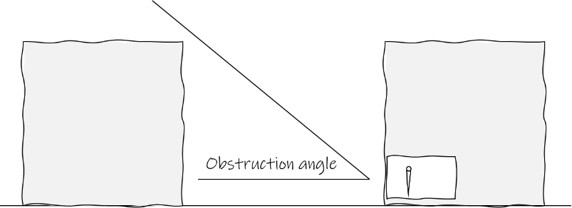
Figure 2: Obstructions to the South
Avoiding obstructions to the south can increase sunlight penetration to both amenity spaces and rooms within the new development. On the left, the site is unobstructed to the south. On the right, Block 2 in new development will obstruct sunlight to within its own site. Placement of massings needs careful consideration such that a balance is struck between improving the performance of the proposed development and not impacting on surrounding existing developments.
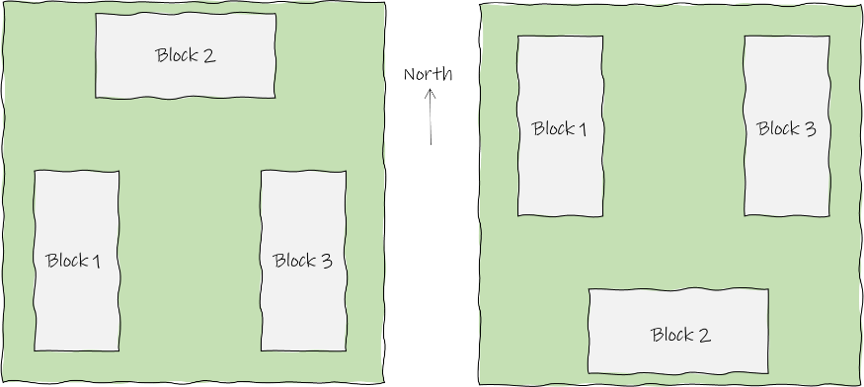

6.2 Layouts and Balconies
Alongside the massing, orientation and obstruction angle, layouts and balcony placement have a significant impact on both daylight quantity and daylight distribution. A room with large windows and no external obstructions will still experience poor daylight if the depth of the room is disproportionate to the width and height. BS 8206-2 outlines the room depth metric, stating:
“The uniformity of daylight is considered to be unsatisfactory if:
- in a room lit by windows in one wall only, the depth of the room is too large in comparison with the height and the width of the windows.”
Figure 3: Room Depth
BR 209 describes the room depth criteria. The formula and associated values for this are given in the sketch above. By way of example, a room with a width of 4 m, a window head height of 2.4 m and an average room surface reflectance of 50 %, the limiting depth for this room would be approximately 5 m.
Balconies significantly reduce the quantum of light entering windows below them. The placement of balconies can be delivered such that levels of daylight and sunlight to important rooms below is prioritised (e.g., in an apartment development, balconies would be placed above bedrooms below, rather than stacked above the living rooms below).

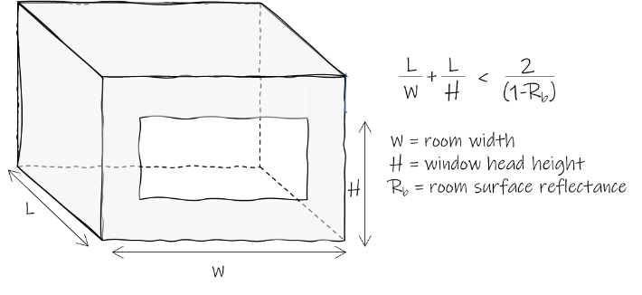

Figure 4: Balcony Layouts
Where identical apartment layouts are stacked one on top of the next, the impact of balconies off living rooms on the units below is significant (left). An improved alternative is to swap the layouts as they rise through the building (right). The outcome of this is main living rooms not having a balcony directly above them, thus experiencing better daylight and sunlight conditions within.
Beyond the room depth and balcony placement, care should be given in choosing the location of various space functions within a new development. Within residential developments, spaces that have a defined requirement for natural light (kitchens, living rooms and bedrooms) should take priority in their proximity to the facade. In apartment developments, spaces with this requirement for natural light can be arranged such that access to natural light is maximised.

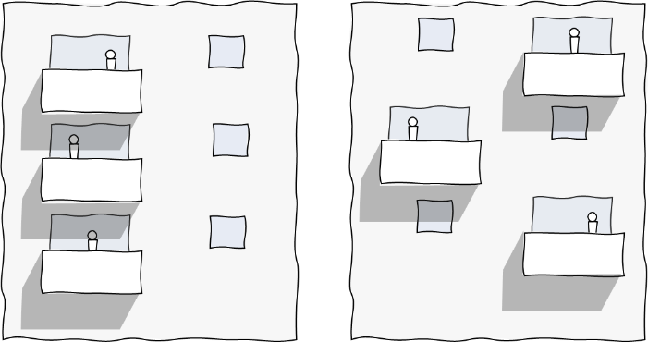

Figure 5: Balcony Access
On the left, an apartment with a long, narrow kitchen, living and dining room. The balcony is accessed directly off the living room space. Daylight distribution to the rear of this space will be poor. The store and bathroom occupy space closer to the façade than necessary. If the apartment layouts are stacked and not handed, then the balcony directly off the living space will obstruct the living room below and be obstructed by a balcony above. On the right, the store and bathroom are reorganised to occupy space furthest from the façade. The balcony is switched such that it sits in front of the bedroom and is accessed from the side. The apartments are handed such that balconies will not obstruct living rooms below. The overall depth of the kitchen, living and dining room reduces, so the distribution of daylight will improve, bringing more daylight to the rear of the room.

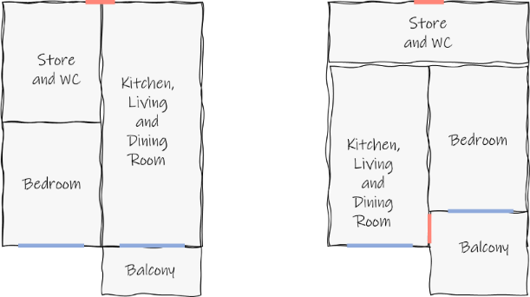

6.3 Optimisation Studies
How a new development impacts on the existing surrounding buildings can be approached parametrically. Optimisation tools are widely available that will define an outline massing for any given site, such that this ‘optimised’ massing will have a negligible impact on the surrounding properties. An optimisation study will consider all of the metrics required in assessing the impact of a new development on the existing surrounding properties.
Once an optimised massing is known within a particular site, the project architects can then choose to define a building outline that sits within the optimised massing. Following this process will ensure a negligible impact on the surrounding existing buildings.

Figure 6: Optimisation Studies
On the right, an existing development. On the left, new developments can complete optimisation studies such that outline massings (theoretical dashed red line) are produced for architects to use within their designs. If a new development is then designed to sit inside this optimised massing, the developer and project architect can be assured that the impact of any proposal will result in a negligible impact to the surrounding existing properties.

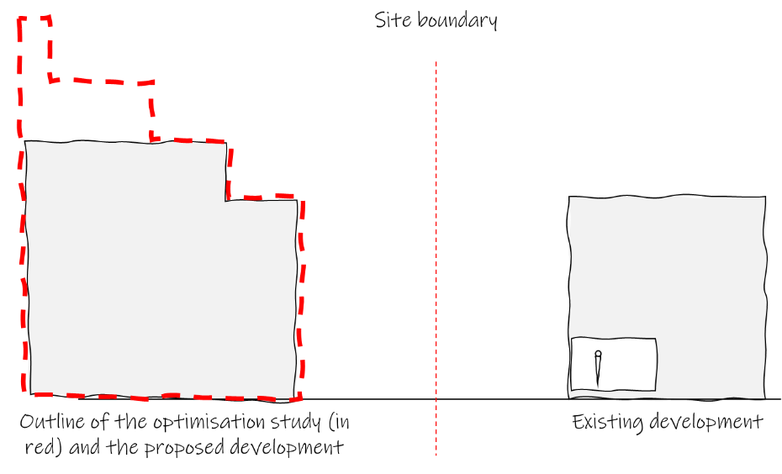

Figure 7: Optimisation Example
An example of how the optimisation process works is included below. On the left is the existing development. In the centre is the output of the optimisation study, being the largest massing possible within the site such that none of the existing surrounding buildings experience an impact to levels of daylight and sunlight availability. On the right is the final proposed massing drawn by the project architects. This sits within the optimised outline, meaning that all surrounding properties experience a negligible impact on daylight and sunlight availability.
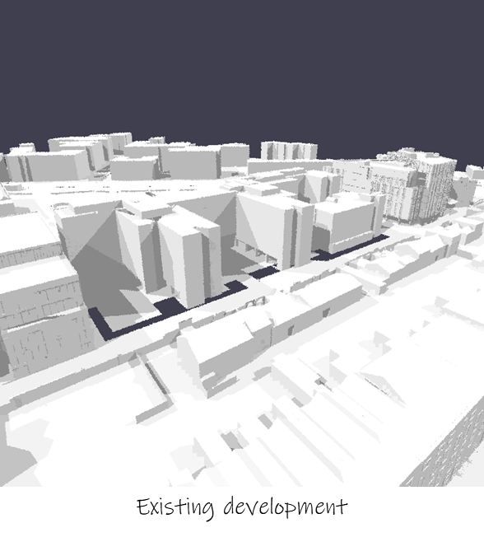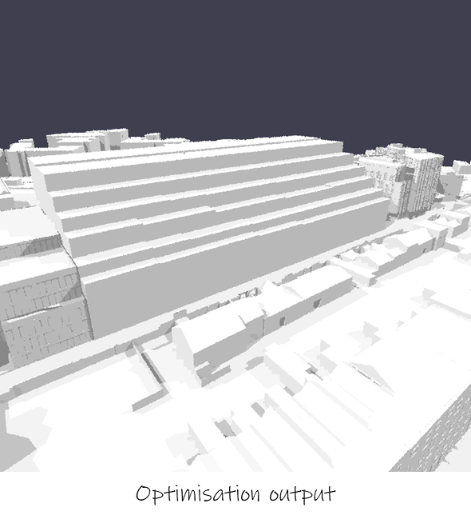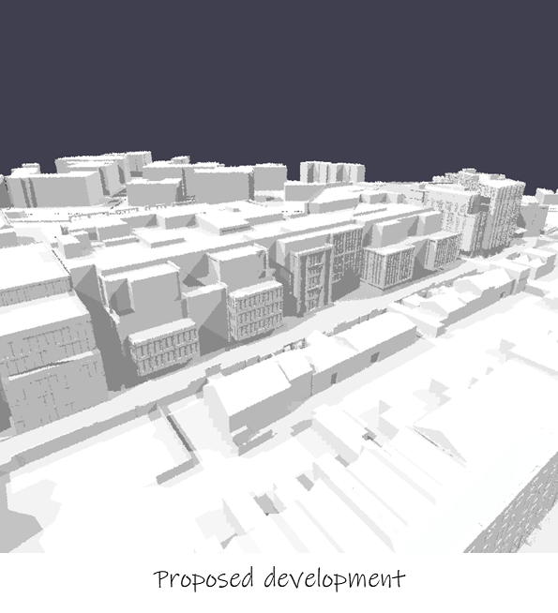

7.0 Assessing Results
In determining the suitability of a daylight and sunlight report, the planning authority note the sentiment within BR 209 that the results presented should be interpreted with flexibility. Whilst results may be interpreted with some flexibility depending on site specific circumstances, it is the intended outcome of this guide that all reports and assessments submitted use the same methodology and metrics. This will offer direct comparability for the planning authority across any given proposal that is reviewed.
When reviewing the suitability of results, the planning authority will apply rationale and reason on a case-by-case basis. For example, it stands to reason that a high-density apartment development in the city centre will have a different expectation from an apartment development in the suburbs, and the same logic applies for a new residential development on a green field site. It also stands to reason that the levels of daylight and sunlight availability will vary in line with both the site coverage, development height and density.
Notwithstanding this, it is noted that both BS 8206-2 and BS EN 17037 present minimum values for residential developments, rather than best practice values. This is very clearly laid out in clause 5.6 of BS 8206-2 and clause NA.2 of BS EN 17037. These minimum values will not produce spaces that are well daylit or be considered predominantly daylit. The planning authority also acknowledge that national policy aligns with the understanding that these values are minimum provisions. In this regard, there will be a general presumption against schemes where units fall below these minimum standards and it is the expectation of the planning authority that a significant proportion of units should exceed the minimum standard in order to ensure high quality sustainable developments.
In exceptional circumstances, for example on a tightly configured urban site, where these minimum criteria cannot be achieved, the applicant should very clearly identify this and put forward a clear and robust rationale for compensatory measures applied to mitigate any shortfall in the minimum standards. From here, the planning authority will apply an exercise in discretion and balance that considers the wider impact of the development beyond matters relating to daylight and sunlight.

8.0 Independent Verification of Reports
To provide greater confidence in results and to ensure a level playing field for all applicants, the planning authority may, from time to time, commission an independent review or verification of the submitted report. Where required, this will be funded by the applicant. Independent reviews or verification are likely to be required where there is ambiguity in the submitted report or the methods, metrics, results or analysis presented could be called into question.

9.0 Other Relevant Factors
Where adverse impacts of reflected sunlight are possible, either through reflected glare or through reflected irradiance, the planning authority may request that an assessment and report addressing these matters is provided. Guidance on completing assessments is available within BR IP 3/87.
Rights to light is not covered in this guide or under the planning process. The planning authority note that the granting of any planning permission does not override a legal right to light.

10.0 References
¹ EN 17037:2018, Daylight in Buildings, ICS 91.160.01, European Committee for Standardisation, CEN-CENELES, Brussels (2018).
² The High Court of Ireland, Judicial Review, Atlantic Diamond Limited and An Bord Pleanála and EWR Innovation Park Limited, Judgement of Humphreys J. delivered on Friday the 14th day of May 2021, (available www.courts.ie) (2021).
³ Boyce, PR, Humans Factors in Lighting, ISBN 9781439874882, CRC Press (2014).
⁴ Knoop et al, Daylight: What makes the difference? Lighting Research and Technology, DOI - https://doi.org/10.1177/1477153519869758 (2019)
⁵ Littlefair P, Site Layout Planning for Daylight and Sunlight, A guide to good practice, BR 209, ISBN 978-1-84806-178-1, BRE (2011).
⁶ British Standards Institute, BS 8206-2:2008 Lighting for Buildings – Part 2: Code of Practice for Daylighting, ICS 91.060.50; 91.160.10, BSI (2008).
⁷ British Standards Institution, BS EN 17037, Daylight in Buildings, ICS 91.160.01, ISBN 978 0 580 94420 8, Dublin (2018).
8 National Standards Authority of Ireland, IS EN 17037:2018, Daylight in Buildings, ICS 91.160.01, CEN-CENELES, Dublin (2018).
9 Government of Ireland, Urban Development and Building Height Guidelines (UD) (BHG) (2018), available – https://www.gov.ie/en/publication/93d22-urban-development-and-building-height-guidelines-ud-bhg-2018/
¹⁰ Government of Ireland, Sustainable Urban Housing: Design Standards for New Apartments (December 2020), available – https://www.gov.ie/en/publication/15f0b-design-standards-for-new-apartments-dsfna-2018
¹¹ Chartered Institute of Building Services Engineers, Lighting Guide 10: Daylighting – A guide for designers, ISBN9781906846480, CIBSE, (2014).

PAGE LEFT INTENTIONALLY BLANK

Dublin City Development Plan 2022-2028

Appendix 17: Advertising and Signage Strategy

PAGE LEFT INTENTIONALLY BLANK

1.0 Advertising and Signage
The outdoor advertising strategy seeks to set out guidance for the provision of various types of signage within certain locations in the city. In order to manage an effective programme of outdoor advertising, the City Council has developed a policy based on geographical zones. These zones cover all parts of the city, ranging from areas of architectural, historical and cultural sensitivity, to residential areas, to areas of little architectural or historic significance. Based on these zones, a range of controls and policies have been developed for each zone ranging from the prohibition of outdoor advertising in the most sensitive areas to more general controls in less sensitive areas where certain types of advertising will be considered. Consideration will be also be given to the need for sensitive treatment and an appropriate transition at the interface between zones. These zones have been organised into development management categories, which can be classified as follows:
- Zone 1: This zone encompasses those areas that are most vulnerable and sensitive and primarily relates to the Georgian area of Dublin City. There is a strong presumption against outdoor advertising in this zone.
- Zone 2: This zone of significant urban quality comprises retail and commercial uses. In this zone, outdoor advertisement may be permitted subject to special development management measures.
- Zone 3: The radial routes leading into and out of the city are areas where opportunity exists for the managed provision of outdoor advertising. Subject to compliance with the development management standards, as set out in Section 6, the development of outdoor advertising in this zone will be open for consideration.
- Zone 4: Zone of existing and potential high amenity related to the waterways and the coast is inappropriate for advertising. This zone includes the River Liffey corridor, other river corridors, the canal corridors and along the campshires in the Docklands. There is a strong presumption against outdoor advertising in this zone.
- Zone 5: Zone of significant urban development where advertising could form an integral part of newly created streetscapes. This zone relates to certain Strategic Development and Regeneration Areas (SDRAs) where advertising may form part of new streetscapes, having regard to the need to protect residential amenities. Subject to compliance with development management standards, the development of outdoor advertising in this zone will be open for consideration.
- Zone 6: This zone consists of areas predominantly residential in character where outdoor advertising would be visually inappropriate. Within this zone, there are also large-scale tracts of commercial land-use which have a separate robust character and may have the potential to accommodate outdoor adverting.

Figure 1: Zones of Advertising Control
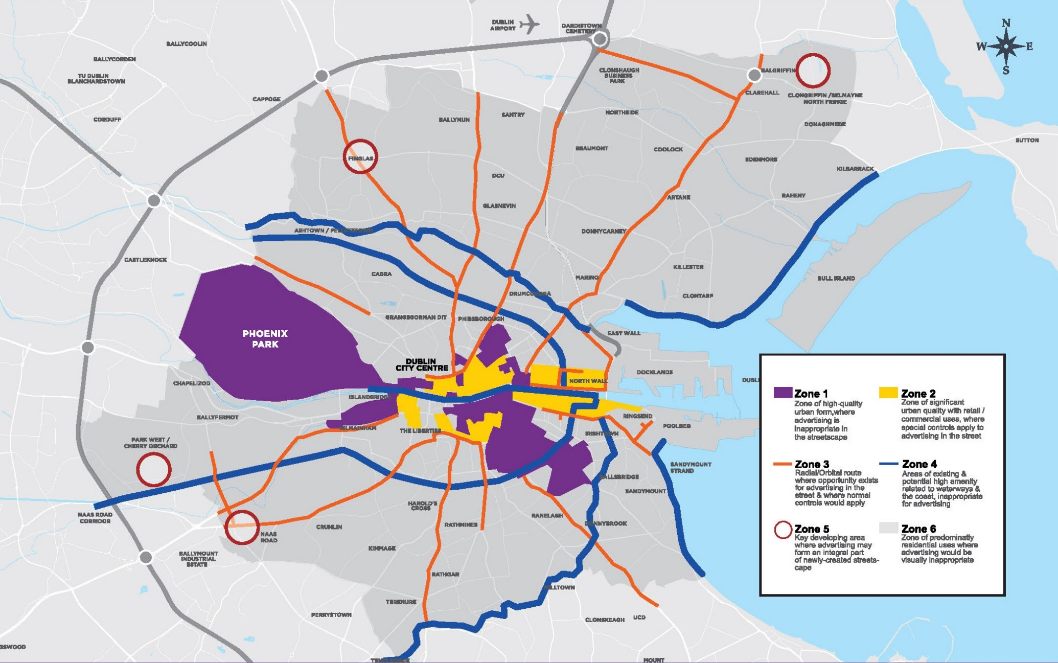

The preferred location for outdoor advertising panels in the city is on public thoroughfares, distributor roads and radial routes contained within Zones 2, 3 and 5 as indicated in Figure 1 showing Zones of Advertising Control.
In order for Dublin City Council to create a clutter-free, high-quality public domain complete with appropriate and complementary street furniture, the Council will seek the removal of unsightly and outdated advertising structures. The exception to this are signs with historic, cultural or social significance, which the Council will seek their maintenance and repair.
Any new applications for outdoor advertising structures will generally require the removal of existing advertising panels, to rationalise the location and concentration of existing advertising structures.
Ninety-six sheet and forty-eight sheet advertising panels will no longer be permitted and any new applications for advertising structures must relate to the scale of the buildings and streets in which they are to be located. The use of light box structures are also not supported.
In order to achieve a coherent and standardised typology for outdoor display panels, Dublin City Council has a preference for smaller types of advertising panels such as six-sheet size advertising panels and 8 sq. m. advertising structures. The appropriate size will be determined with regard to the streetscape quality and character of the urban fabric and in accordance with the provisions of this outdoor advertising strategy.
Any upgrading and/ or replacement of existing outdoor advertising (e.g. trivision, scrolling, electronic, digital) will only be permitted if it is acceptable in amenity/ safety terms and an agreement is made to decommission at least one other display panel in the city and to extinguish the licence for that panel. The purpose of this measure is to ensure that other operators do not use the site. Where such an arrangement is not feasible, consideration may be given to replacement signage which would be of a significantly smaller scale; sensitive to the setting; and, of high quality, robust design and materials.

2.0 Digital Signage
The use of digital signage is becoming more prevalent in the city and is beginning to replace the more traditional paper advertising signs. In this regard, the design and location of digital signage will be controlled as to prevent any adverse impact to road users and pedestrians.
Applications for digital signage should comply with the following design criteria:
- Set out the details for the material, finishes and colours of the signage structure.
- The maximum luminance of the advertisement display between dusk and dawn shall not exceed 300 candelas per square metre.
- Only static images without movement shall be permitted, i.e. no animation, flashing, three dimensional effects, noise, smoke or full motion video shall be permitted without a prior grant of planning permission.
- No more than one advertisement shall be displayed every ten seconds.
- The mechanism of changing the digital advertising display shall be by means of a fade transition of the display at intervals of 10 seconds or more.

3.0 Illuminated Signs
Illuminated signs in appropriate locations can provide both information and colour in the townscape after dark. Accordingly, the following guidelines will apply, in conjunction with the provisions of the general outdoor advertising strategy and with regard to the zones of sensitivity:
- The type of illuminated signs, internally or externally illuminated, individual letters, and neon tubes should be determined by consideration of the design of the building/ site and its location, as well as the potential for low-energy options.
- The design of an illuminated sign should be sympathetic to the building on which it is to be displayed and should not obscure architectural features such as cornices or window openings in the area; on new buildings they should be part of the integral design.
- The daytime appearance when unlit will be considered.
- Sky signs i.e. signs that project in any part above the level of a building parapet or obtrude on the skyline, are not acceptable in principle and will not be permitted.
- Internally illuminated scrolling signs, or signs with exposed neon tubing (except for established historic/ culturally significant signs), are generally not acceptable.
- Illuminated signs with the use of electronic visual display technology such as LED (light emitting diode) and LCD (liquid crystal display) will be considered having regard to the Advertising Management Standards.
- The number of illuminated signs in the vicinity of the site will be taken into consideration when assessing proposals.

4.0 High Level Corporate Branding/ Signage
High level corporate signage/ branding (e.g. located on the top floor) on buildings will be assessed on a case-by-case basis having regard to the location of the development and the visual impact of the proposed branding/ signage.
The provision of high level signage/ branding will be limited to one main elevation and should be used for navigational purposes only to identify the location of the development on key thoroughfares. The design of the signage/ branding should be modest and in keeping with the surrounding materials and finishes and should respect the surrounding character of the area.
The applicant is required to demonstrate the visual appearance of the signage through the production of photomontages in order for the planning authority to assess the overall visual impact of the development. Internal illumination of such signage will only be considered in exceptional circumstances where the planning authority are satisfied that it would have no material adverse visual impacts.

5.0 Advertising on Bus Shelters/ Phone Boxes
Large, internally illuminated advertising panels on bus shelters/ phone boxes can detract from the visual appearance of protected structures, conservation areas and residential conservation areas, and in these instances, will not generally be permitted.
In considering applications for bus shelters/ phone boxes, the planning authority will have regard to the particular circumstances of each case, such as location, scale and type of advertising proposed, and the effect on the amenities of the area and the streetscape, as well as the provisions and zones of sensitivity as set out the general outdoor advertising strategy.

6.0 Temporary Advertising/ Artwork
Applications for temporary advertising display panels and temporary artwork will be considered on a case-by-case basis. In such instances, temporary display panels may be approved where they can be used for the screening of building sites or land which are aesthetically unsightly.
Notwithstanding the temporary nature of such signage, it will still be necessary to ensure the protection of the special architectural quality and character of conservation areas. Under no such circumstances, however, will permanent permission be granted and all such permissions will be of a temporary nature.

7.0 Implementation of the Advertising and Signage Strategy
The Council will take enforcement measures to secure the removal of unauthorised advertisements from private property and will remove unauthorised advertisements from public areas. Where appropriate, the Council will use the powers available under section 209 of the Planning and Development Act, 2000, (or as may be amended) to repair, tidy or remove advertisement structures or advertisements, or the provisions of the Litter Act.
Dublin City Council will evaluate all planning applications for signs in relation to the surroundings and features of the buildings on which they are to be displayed, to the number and size of signs (both existing and proposed) and the potential for the creation of undesirable visual clutter.
Permissions for outdoor advertising in certain instances, where appropriate as determined by the planning authority, may be limited to a maximum of three years in the first instance to enable the position to be reviewed by Dublin City Council in the light of changing circumstances at the end of that period.
Non-essential advertising structures, or any advertising structures which would impact injuriously on amenity, the built environment or road safety will be restricted.

8.0 Advertising Development Management Standards
Applications for new advertising structures will, in addition to the above considerations, be considered having regard to the following:
- The geographical zone in which the site is located, as set out in the figure showing zones of advertising control. The rationale for the proposed advertising structure, including proposals for the removal and/ or rationalisation of existing outdoor advertising structures.
- The concentration of existing advertising structures in the area.
- The design of the advertising panel and the use of high-quality materials.
- The scale of the panel relative to the buildings, structures and streets in which the advertising panel is to be located.
- Impact on the character of the street and the amenities of adjoining properties.
- Advertising panels will not be permitted where they interfere with the safety of pedestrians, the accessibility of the public footpath or roadway, the safety and free flow of traffic or if they obscure road signs.
- Impact on the character and integrity of Architectural Conservation Areas, Protected Structures and Conservation Areas.
- Proposals must meet the safety requirements of the Transport Infrastructure Ireland (TII), where appropriate.
- To ensure that all proposals do not interfere with the safety and accessibility of pedestrians and wheelchair users on the public footpaths.

Dublin City Development Plan 2022-2028

Appendix 18: Ancillary Residential Accommodation

PAGE LEFT INTENTIONALLY BLANK

1.0 Residential Extensions
The Planning and Development Regulations, 2001, (as amended) give exemptions for the construction of extensions to residential dwellings and there is a wide range of works which will fall within these exempted development provisions. The applicant’s architect or agent should be able to advise on the extent of these exemptions and whether proposed works would require planning permission to be obtained.
Given the wide variety of house types and styles within Dublin City, it is not possible to deal with every type of addition. Rather, this section sets out a number of general principles that should be addressed in all cases and which will be applied by the planning authority in assessing applications for permission. The guidelines should be interpreted in the context of the development plan Core Strategy, which promotes a compact city, sustainable neighbourhoods and areas where a wide range of families can live.

1.1 General Design Principles
It is acknowledged that the development of residential extensions plays an important role in promoting a compact city in line with the core strategy as well as providing for sustainable neighbourhoods and areas where a wide range of families can live.
The design of residential extensions should have regard to the amenities of adjoining properties and in particular, the need for light and privacy. In addition, the form of the existing building should be respected, and the development should integrate with the existing building through the use of similar or contrasting materials and finishes.
Innovative, contemporary design will be encouraged. A contemporary or modern approach, providing unique designs, can offer a more imaginative solution. However, such proposals are still required to take account of the design issues outlined in this document.
Applications for extensions to existing residential units should:
- Not have an adverse impact on the scale and character of the existing dwelling
- Not adversely affect amenities enjoyed by the occupants of adjacent buildings in terms of privacy, outlook and access to daylight and sunlight
- Achieve a high quality of design
- Make a positive contribution to the streetscape (front extensions)
There is a general presumptions against front extensions that significantly break the building line, unless it can be justified in design terms and demonstrated that such a proposal would have no adverse impact on the character of the area or the visual/ residential amenities of directly adjoining dwellings.

1.2 Extensions to Rear
Ground floor rear extensions will be considered in terms of their length, height, proximity to mutual boundaries and quantum of usable rear private open space remaining. The extension should match or complement the main house.
First floor rear extensions will be considered on their merits, noting that they can have potential for negative impacts on the amenities of adjacent properties, and will only be permitted where the planning authority is satisfied that there will be no significant negative impacts on surrounding residential or visual amenities. In determining applications for first floor extensions the following factors will be considered:
- Overshadowing, overbearing, and overlooking - along with proximity, height, and length along mutual boundaries
- Remaining rear private open space, its orientation and usability
- Degree of set-back from mutual side boundaries
- External finishes and design, which shall generally be in harmony with existing

1.3 Extension to Side
Ground floor side extensions will be evaluated against proximity to boundaries, size, and visual harmony with existing (especially front elevation) and impacts on adjoining residential amenity. First floor side extensions built over existing structures and matching existing dwelling design and height will generally be acceptable. However, in certain cases a set-back of an extension’s front façade and its roof profile and ridge may be sought to protect amenities, integrate into the streetscape, and avoid a ‘terracing’ effect. External finishes shall normally be in harmony with existing.
Any planning application submitted in relation to extensions, basements or new first/ upper floor level within the envelope of the existing building, shall clearly indicate on all drawings the extent of demolition/ wall removal required to facilitate the proposed development and a structural report, prepared by a competent and suitably qualified engineer, may be required to determine the integrity of walls/ structures to be retained and outline potential impacts on adjoining properties. This requirement should be ascertained at pre-planning stage. Side gable, protruding parapet walls at eaves/ gutter level of hip-roofs are not encouraged.
The proposed construction of new building structures directly onto the boundary with the public realm (including footpaths/ open space/ roads etc.), is not acceptable and it will be required that the development is set within the existing boundary on site and shall not form the boundary wall. The provision of windows (particularly at first floor level) within the side elevation of extensions adjacent to public open space will be encouraged in order to promote passive surveillance, and to break up the bulk/ extent of the side gable as viewed from the public realm.

1.4 Privacy and Amenity
Extensions should not result in any significant loss of privacy to the residents of adjoining properties. Generally, windows overlooking adjoining properties (such as in a side wall) should be avoided. Where essential, the size of such windows should be kept as small as possible and consideration should be given to the use of high-level windows and/ or the use of obscure glazing where the window serves a bathroom or landing. Bedrooms in general should not be lit by obscure glazed windows as a means to prevent undue overlooking of adjacent properties.
There will be a general presumption against the development of rear balconies and roof terraces. However, in inner urban areas, where there are limited opportunities for ground floor amenity provision, innovative design solutions for private amenity space will be considered on a case-by-case basis where it can be demonstrated that provision of same would not have a significant adverse impact on the residential amenities of adjacent properties.
It is important to make sure that any extension does not unacceptably affect the amenities of neighbouring properties. This includes privacy, outlook, daylight and sunlight. It is advisable to discuss proposals with neighbours prior to submitting a planning application.

1.5 Separation Distances
In cases where the backs of dwellings face each other or where the side of one dwelling faces the rear of a neighbouring property, a certain degree of separation is required to avoid any overbearing effect of one dwelling upon the other. With the emphasis on increased residential densities and the consequent incorporation of a variety of unit types and sizes in schemes, the requirement for 22 metre separation in such cases may no longer be applicable in certain instances. The acceptable reduction of such distances, however, requires a high standard of building design and layout particularly having regard to the height and inter-relationship between buildings, the use and aspect of rooms and relative floor levels.
The exact distances applicable in such cases will be determined on a case-by-case basis having regard to the above criteria and other relevant development plan standards. The planning system does not give neighbours ‘a right to a view’ and does not always prevent people’s view from being blocked. However, extensions should be designed so as not to dominate or appear unduly overbearing when viewed from adjoining properties.

1.6 Daylight and Sunlight
Large single or two-storey rear extensions to semi-detached or terraced dwellings can, if they project too far from the main rear elevation, result in a loss of daylight to neighbouring houses. Furthermore, depending on orientation, such extensions can have a serious impact on the amount of sunlight received by adjoining properties. On the other hand, it is also recognised that the city is an urban context and some degree of overshadowing is inevitable and unavoidable. Consideration should be given to the proportion of extensions, height and design of roofs as well as taking account of the position of windows including rooms they serve to adjacent or adjoining dwellings.

1.7 Appearance and Materials
The extension should not dominate the existing building and should normally be of an overall scale and size to harmonise with the existing house and adjoining buildings; the appearance of the existing structure should be the reference point for any consideration of change that may be proposed. The materials used should complement those used on the existing building; features such as windows and doors on the new extension should relate to those on the original building in terms of proportion and use of materials.

2.0 Detached Habitable Rooms
Detached habitable rooms refer to backland development within the curtilage of an existing dwelling that does not contain a separate vehicular access point. In this respect, access to the individual room to the rear of the existing dwelling will be provided by way of side passage/ access but with shared entranceway.
The purpose of these rooms is to provide for additional space within the rear garden of an existing dwelling for study/ home office use or additional living/ children’s play room. These rooms shall only be used as ancillary residential accommodation.
All planning applications for detached habitable rooms will be subject to a condition to restrict the use of the room as ancillary living space to the main dwelling. The room may not be sold or rented separately from the main dwelling unit.

3.0 Porches
Porches will be considered where the design complements the existing building and provides for simple proportions and materials. It is important to try to avoid abutting porches close to existing windows, and where front doors are paired, a joint scheme with the neighbouring owner should be considered. The design should complement the main house. If existing car parking is provided in curtilage, it is important to ensure that there is adequate depth remaining for safe parking of vehicles.

4.0 Alterations at Roof Level/ Attics/ Dormers/ Additional Floors
The roofline of a building is one of its most dominant features and it is important that any proposal to change the shape, pitch or cladding of a roof is carefully considered. Alterations at roof level can include the conversion of an attic space and inclusion of dormer windows or the provision of an additional storey modifying the roof profile entirely.
The following criteria will be considered in assessing alterations at roof level:
- Careful consideration and special regard to the character and size of the structure, its position on the streetscape and proximity to adjacent structures.
- Existing roof variations on the streetscape.
- Distance/ contrast/ visibility of proposed roof end.
- Harmony with the rest of the structure, adjacent structures, and prominence.

5.0 Attic Conversions / Dormer Windows
The conversion of attic spaces is common practice in many residential homes. The use of an attic space for human habitation must be compliant with all of the relevant design standards, as well as building and fire regulations. Dormer windows, where proposed should complement the existing roof profile and be sympathetic to the overall design of the dwelling. The use of roof lights to serve attic bedrooms will be considered on a case-by-case basis.
Where it is proposed to extend the ridge height to accommodate an increased floor-to-ceiling height, the design should avoid an overly dominant roof structure. The proposed scale of the roof should retain similar proportions to the building where possible.
Dormer windows may be provided to the front, side or rear of a dwelling. Guidelines for attic conversions and the provision of dormer windows is set out as follows:

 | 
Use materials to complement the existing wall or roof materials of the main house. | Do not obscure the main ridge and eaves features of the roof, particularly in the case of an extension to the side of a hipped roof.
Meet building regulation requirements. | Avoid extending the full width of the roof or right up to the gable ends.
Be visually subordinate to the roof slope, enabling a large proportion of the original roof to remain visible. | Avoid dormer windows that are over dominant in appearance or give the impression of a flat roof.
Relate to the shape, size, position and design of the existing doors and windows on the lower floors. | Avoid extending above the main ridge line of the house.
Be set back from the eaves level to minimise their visual impact and reduce the potential for overlooking of adjoining properties. | Side dormer windows shall not be located directly on the boundary of adjoining/ adjacent property.
In the case of a dormer window extension to a hipped/ gable roof, ensure it sits below the ridgeline of the existing roof.
Where a side dormer is proposed, appropriate separation from the adjoining property should be maintained.
Side dormers should be set back from the boundary.
Table 18.1 Dormer Window Guidance

Figure 1: Good Examples of Dormer Extensions
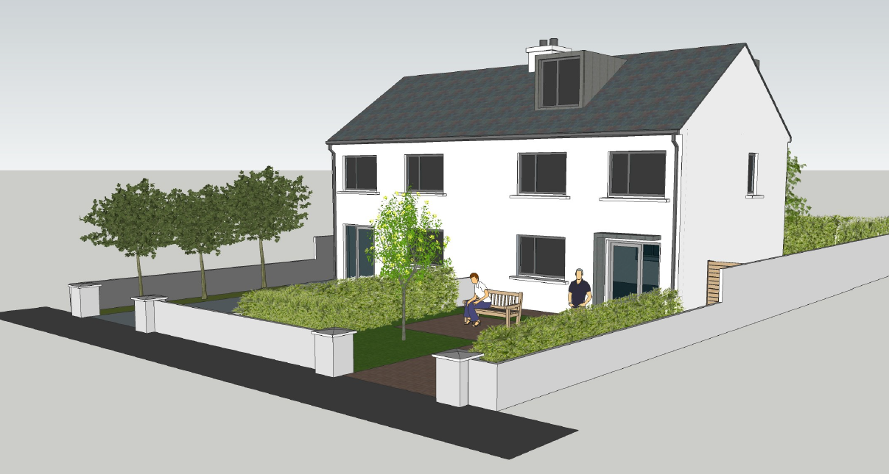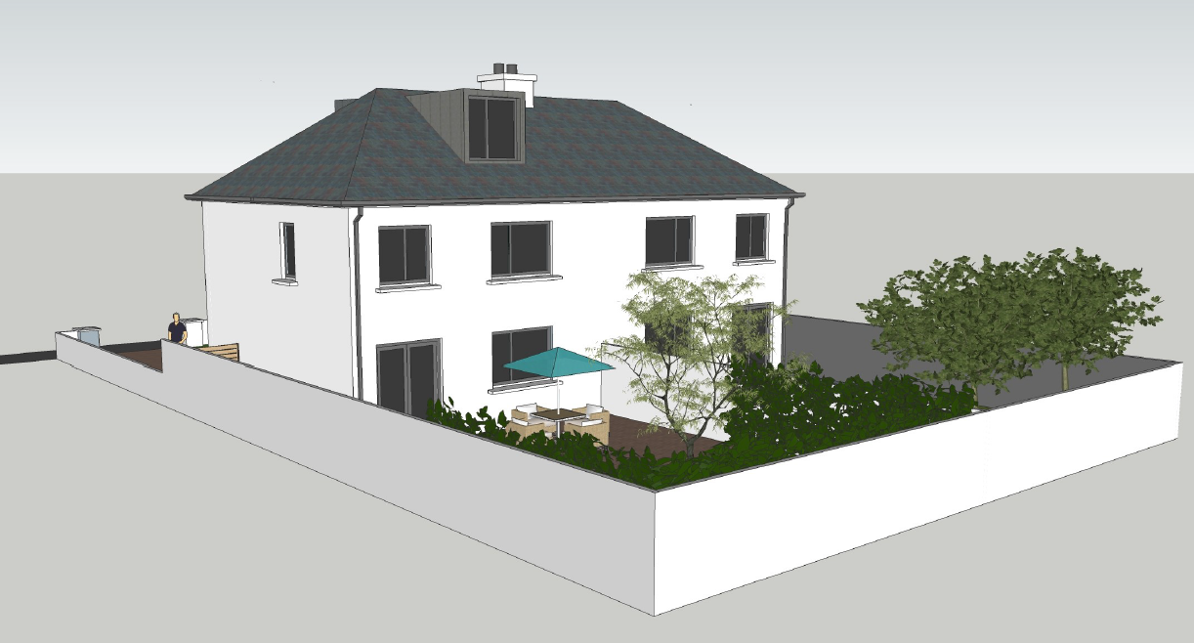
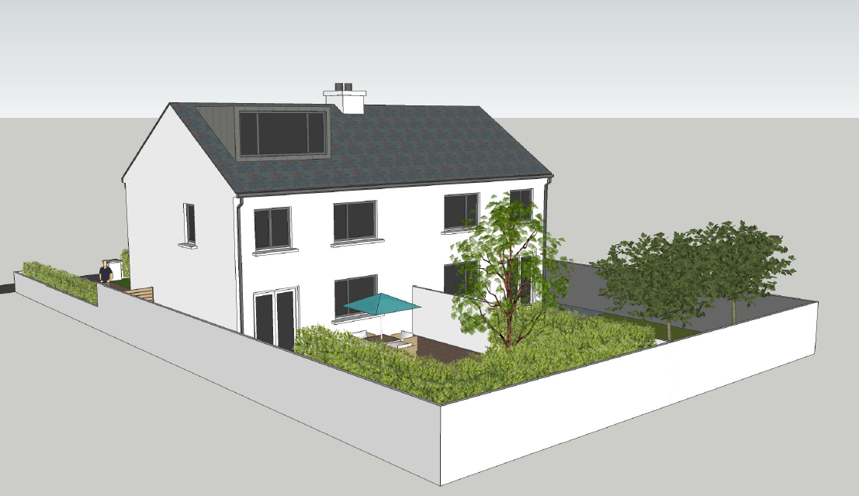
Figure 2: Poor Examples of Dormer Extensions
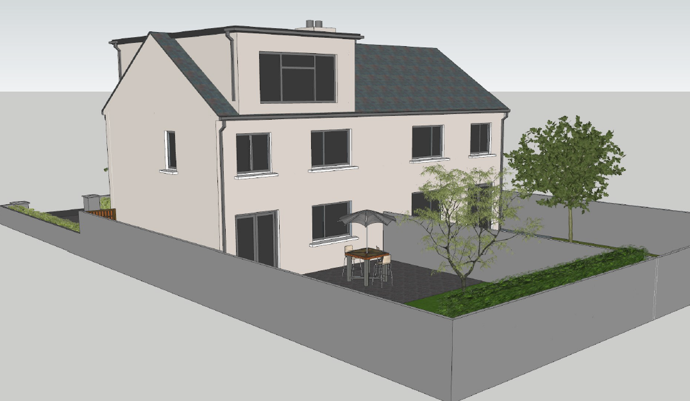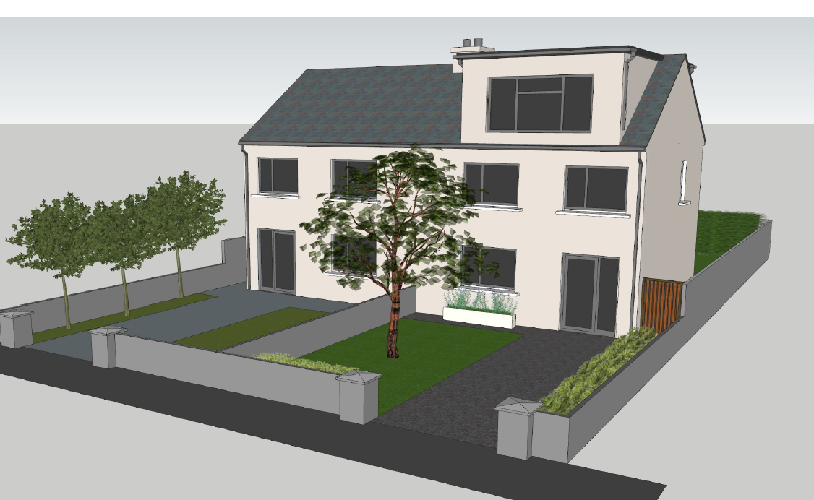

5.1 Additional Floors
It is acknowledged that converting an attic as a full floor to the elevation of a dwelling can often be successfully achieved without effecting or impacting the overall character of the area or the residential amenity.
Dublin City Council will support innovative design responses to the densification of suburban housing to consolidate existing built up areas. Converting existing attic space to provide a full additional floor will be considered in this context, where it can be demonstrated that such a proposal makes a positive contribution to the streetscape and has no adverse impact on the residential amenities of adjacent properties.
The provision of such densification solutions are often more suitable at the end of terrace or corner house sites where a feature/ bookend design can be facilitated. Each proposal will be assessed on a case-by-case basis.
Applications for an additional storey must ensure that all of the relevant internal residential standards are complied with as set out in this Appendix. Additional requirements such as demonstrating safe and secure access will also be required as part of any planning application.

6.0 Subdivision of Dwellings
Subdivision of a property can allow for the creation of additional residential units within the space occupied by the existing individual dwelling. The subdivision of homes can be utilised to densify the existing urban area and utilise the existing housing stock in a more effective way to cater for additional population and for the demographic changes occurring in the city.
Dublin City Council will consider the subdivision of larger homes in the city subject to compliance with the relevant standards for apartment units (see guidance on apartment developments – Chapter 15, Section 15.9). Where subdivision is being considered, factors such as minimum floor space, the extent of open space within the site boundaries, landscaping including the retention and planting of trees, the provision of on-site parking, the retention of existing railings and gates and screened refuse storage areas will be evaluated as part of the assessment.
When subdivisions are permitted, they should be compatible with the architectural character of the building. An appropriate mix of accommodation in particular areas will be determined by Dublin City Council, taking account of the mix of residential accommodation in an area.
The subdivision of the typical 2 storey, semi-detached/ terraced home in suburban areas will also be considered in certain circumstances to utilise homes in a more effective way in accordance with Objective QHSNO4 to encourage the densification of the suburbs.
Dublin City Council will encourage models by approved housing bodies. These models are an early intervention housing solution for older people leading towards retirement. The concept seeks to retrofit an existing family home into multi-occupancy unit, typically dividing the home into a ground floor and first floor unit. An additional 2nd floor may also be converted if applicable. The breakup of the unit allows for older people to remain in the family home while also providing much needed additional accommodation within the city, generating additional income and a sense of security throughout retirement age.
Dublin City Council will encourage such subdivision of residential units in certain circumstances where the proposal is carried out by an approved housing body and subject to the necessary consent.

7.0 Ancillary Family Accommodation
Ancillary family accommodation refers to a subdivision or extension of a single family dwelling unit to accommodate an immediate family member for a temporary period (e.g. elderly parent) or where an immediate relative with a disability illness or specific temporary housing need may need to live in close proximity to their family.
Generally, the purpose of ancillary family accommodation is to provide an amenable living area offering privacy, manoeuvrability and independence while maintaining a direct connection to the main dwelling. Usually, there is no exterior difference in appearance between an extension and ancillary family accommodation and is still considered a single residential unit.
Ancillary family accommodation should:
- Be contained within the existing unit or provided as an extension to the main dwelling (exempted development principles for residential extensions can apply where applicable. Where an extension is not exempt, planning permission is required).
- Preferably have a direct connection to the main home.
- Not be let separately for the purpose of rental accommodation.
- Not be a separate detached dwelling unit.
- Be reintegrated back into the original unit when no longer occupied by a member of the family.
Conditions will be attached to the permission limiting the use of the accommodation for ancillary family use only on a temporary basis.

8.0 Home Based Economic Activities
Home-based economic activity is defined as small scale commercial activity carried out by residents of a house, being subordinate to the use of the house as a single dwelling unit and including working from home.
The planning authority recognises that such working arrangements can benefit individuals, families and the local community in addition to contributing to more sustainable land use patterns by reducing the need for commuting.
In determining applications for developments involving home based economic activity, the planning authority will have regard to the following considerations:
- The nature and extent of the work.
- The effects on the amenities of adjoining occupiers, particularly in relation to hours of work, noise and general disturbance.
- Anticipated levels of traffic generated by the proposed development.
- Arrangements for the storage of refuse and collection of waste.

9.0 Demolition and Replacement Dwellings
The demolition and replacement of dwellings will be discouraged for sustainability reasons. Applications will be considered on a case-by-case basis. Dublin City Council will encourage deep retro-fit of structurally sound, habitable dwellings in good condition as opposed to demolition and replacement unless a strong justification in respect of the latter has been put forward by the applicant such as that the dwelling is uninhabitable and unsuitable for reuse, or that its demolition is necessary to facilitate the comprehensive redevelopment of a site.
Demolition of an existing house in single occupancy and replacement with multiple new build units will only be considered where it can be demonstrated that a high level of amenity is provided and that there is a strong justification to alter the setting and character of the area.
See Chapter 3 - Climate Action, Chapter 15 - Development Standards, Section 15.7.1 for more details.

National Planning Framework, National Policy Objective 17, p. 97.
Bergin and García-Rodríguez, ‘Regional demographics and structural housing demand at a county level‘ (ESRI, December 2020). [Online: https://www.esri.ie/publications/regional-demographics-and-structural-housing-demand-at-a-county-level]. The HNDA Toolkit makes use of the full projection dataset at local authority level.
DHLGH, ‘Housing Need and Demand Assessment – HNDA Tool Instructions’ (April 2021).
Two further adjustments may be made where justified for some local authorities to converge with the NPF projections to 2026; these were not applied for Dublin City.
For reference, the most recent Social Housing Needs Assessment published by the Housing Agency indicated a ‘net need’ of 14,001 households as of November 2020, of whom 2,957 were classed as homeless. Housing Agency, ‘Summary of Social Housing Assessments 2020: Key Findings’ [Online: https://www.housingagency.ie/sites/default/files/2021-03/SSHA-2020.pdf].
https://www.davy.ie/market-and-insights/insights/marketwatch/2021/outlook-2021/looking-past-the-pandemic.html
https://www.centralbank.ie/publication/quarterly-bulletins
https://www.ibec.ie/influencing-for-business/economy-and-tax/quarterly-economic-outlook-q1-2021
https://www.esri.ie/publications/quarterly-economic-commentary-spring-2021
https://ec.europa.eu/info/business-economy-euro/economic-performance-and-forecasts/economic-performance-country/ireland/economic-forecast-ireland_en
https://www.imf.org/en/Countries/IRL#countrydata
CSO, Online [https://data.cso.ie/], PXStat Table RIQ02
DHLGH, ‘Sustainable Urban Housing: Design Standards for New Apartments – Guidelines for Planning Authorities issued under Section 28 of the Planning and Development Act, 2000 (as amended)’, December 2020. [Online: http://www.housing.old.gov.ie/sites/default/files/publications/files/december_2020_-_design_standards_for_new_apartments.pdf
DHLGH, ‘Sustainable Urban Housing: Design Standards for New Apartments – Guidelines for Planning Authorities,’ March 2020. [Online: https://www.housing.old.gov.ie/sites/default/files/publications/files/december_2020_-_design_standards_for_new_apartments.pdf
DHLGH, ‘Housing Supply Target Methodology for Development Planning: Guidelines for Planning Authorities issued under Section 28 of the Planning and Development Act, 2000 (as amended),’ December 2020/
Bergin and García-Rodríguez, ‘Regional demographics and structural housing demand at a county level,‘ (ESRI, December 2020). [Online: https://www.esri.ie/publications/regional-demographics-and-structural-housing-demand-at-a-county-level]. Full local authority-level data from this research is used in the HNDA Toolkit.
DHLGH, ‘Housing Supply Target Methodology for Development Planning: Guidelines for Planning Authorities issued under Section 28 of the Planning and Development Act, 2000 (as amended),’ December 2020.
Consumer Market Monitor, UCD, Q4 2019
JP Morgan – 2020 Economic Payments Trends Report Ireland.
Ireland Bi-Monthly Research Report, November 2018
Revenue 2020
Consumer Market Monitor, UCD, Q4 2019
The Retail Strategy for the Greater Dublin Area 2008 – 2016 (RSGDA)
Large convenience goods stores comprise supermarkets (less than 2,500 sq. m. net floorspace), superstores (at least 2,500 sq. m. and < 5,000 sq. m. net retail floorspace including non food goods) and hypermarkets (in excess of 5,000 sq. m. net retail floorspace including comparison goods).
Superdensity The Sequel, HTA, PTE, 2015.
The gross floor area is the sum of floorspace within the external wall of the building(s), excluding basements but including plant and tank rooms and car parking areas above ground level. In the case of a group of buildings with a common curtilage, the floor area will be aggregated. The site area includes only such land as lies within the curtilage of the related building.
Source; The GRO Green Roof Guide [https://livingroofs.org/wp-content/uploads/2016/03/grocode2014.pdf last accessed 28/07/2021]
Flow control – opening through which peak flows are restricted to a predetermined rate
Urban creep is defined as the loss of permeable surfaces within urban areas creating increased run-off which contributes to flooding. Typical examples of urban creep include building extensions or paving over front gardens for car parking spaces.

