Director of Services Report
South Central Area Committee Meeting
19th July, 2023

SOUTH WEST INNER CITY ELECTORAL AREA

Public Realm & Capital Programmes

Brabazon/ Weaver/Newmarket Street Environs: Contractors for Roads Maintenance Services will be undertaking extensive footpath and carriageway refurbishment works in this area later in August. The works are provided for in this year’s Road Maintenance Services Works Programme. Provision will be made for some additional tree planting on Weaver Street later in the year. In addition, Parks Services have commenced work to install a new green wall feature to the long wall along St Luke’s Avenue.

St James Walk Linear Park – Phase II: Works continue until August.

Housing
Oliver Bond Regeneration
The Estate management Team are working in conjunction with our Community Section and the Residents Committee to hold three events over the course of the summer in three separate areas of the complex, to improve community development and interaction and also to deter Anti-social behavior. The dates have been finalised and are as follows: 21st July in high blocks, 11th August in C Block and 25th August in Blocks S and T.

The new playground has be installed and is completed, it will be open for community use when the final inspection occurs week 17th July 2023.

A contract professional cleaning crew have been assigned to commence intense cleaning of the stairwells in the complex.

Oliver Bond Celtic are arranging a Fun Day 6th August which the area office are supporting, they will also be running 5-a-side competition that week

Choice Based Lettings: A number of units have been allocated and the CBL’s are continuing

Emmet Buildings

A graffiti removal programme was carried out in the complex and is ongoing

Removal of overgrown shrubbery has completed and some new planting was supplied to the residents of the complex

The Painting programme for the complex has now completed

Our housing maintenance mobile crew carried out inspections of the drains and baited the drains in the complex after reports of rodent activity were received. The Area office also reported this to the HSE who were on site to carry out their own inspections, works are ongoing

Bonham Street Volumetric
It is envisaged that units will be ready to let Q1 2024. DCC have designated a Project Officer (Eric Brennan) to engage with residents. eric.brennan@dublincity.ie

Basin Street
The proposed variation of rezoning the Basin View Site was passed on 12th June 2023 by our Elected Representative, the variation will go out to public consultation which will run for a four week period. The c losing date is 14th July 2023 at 4.30pm after which the Planning Department will review submission and bring it to the Area Committee in September for finalization.
We are in the process of rolling out the Building Community Resilience Project the first part of the programme has completed and the next stage will commence shortly
The Area Office are meeting the steel crew week ending 16th July to progress the installation of increased fencing at the rear of the southern block backing onto the Haven Centre.
Meetings between the Residents Committee for the complex are continuing and interactions regarding the proposed PPP for the area are ongoing.
Mary Aikenhead
Works are reaching completion on the new bin chambers for the complex.
The local Area Office has begun the process of setting up a residents committee in Mary Aikenhead House.

Robinsons Court
The Housing Team met with the Residents of the complex recently and addressed some improvements that we were proposing to increase the security of the complex.
We had our public lights section carry out a survey of the lighting in the complex which came back that there was adequate lighting in the complex. We are looking to upgrade our CCTV and are proposing to have a camera installed giving improved visibility to the entrance of the complex.
Our electrical service section will commence installation of Video Doorbells for all residents in the coming weeks.
Our Senior Engineering team and currently looking at options and as soon as we receive a report we will notify our elected members and the community in Robinson’s court.

Tyrone Place
A property for the Project Estate Officers Clinic still has not been sourced after discussions with the local family resource services, who use the community rooms in the complex. However the discussions are ongoing for use as a temporary measure.
Islandbridge Court
A new residents committee has been established in the complex. We have also a unit selected to hold weekly clinics which will cater for Islandbridge/Memorial Courts and also Sarah Place. These clinics should commence in the coming weeks. The first Residents Committee meeting will take place early August.
Dolphin House Regeneration
The Dolphin House Regeneration Masterplan was approved on the 4th Feb 2021 by the Dolphin House Regeneration Board. We are progressing the masterplan in conjunction with the Dolphin House Regeneration Board and the Dolphin House Community.
Regeneration Board
The Regeneration Board have been advised of revised timeline for the masterplan which will reduce the delivery of Phase 2.
Phase 1B to proceed for planning permission in July. The Housing Delivery Manager and the Area Housing Manager will meet with the residents who are opposed to this ahead of submission.

De-tenanting
Three families relocated to Block F Herberton. The Area Housing Manager and the Project Estate Officer met with the remaining tenants of the long block who have a de-tenanting priority. A number of voids have been identified in Area L for offer to the remaining tenants and they will also be offered the option of applying for all of the CBL’s in Area L.

Interim Playground Facilities
The new playground and additional surface works have been completed. Date to be agreed for official opening. Dog Wardens have been contacted informing them of the situation of dog fouling. Signage has been erected. Bins due to be installed in June. Safety Barrier to be installed outside of the bollards at the entrance – agreed with Santry Steel.

Old Football Pitch Site
Housing Delivery Manager & Area Housing Manager met with Regeneration Board Co-ordinator Thursday June 15th June to progress.
Inspections carried out and quotes received to enhance and upgrade the area, works commenced and the site has been cleaned, awaiting confirmation date of the demolition programme for Dolphin Park before progressing any further. Public Lighting are investigating the reinstatement of the floodlighting. –

Community Centre
Fire Safety Audit commenced – awaiting report.

A number of upgrading works & repairs have commenced to include roof repairs, gutter replacement, boiler upgrade and electrics repaired in the home work club.
Quotes for further works to include ramps, handrails and fire doors received.

Painting of Complex
Painting crew back onsite and they will complete the painting of all the railings and also have the hoist onsite to paint the balcony walls. – No change on this – still on schedule.

St Teresa’s Gardens Development Site
LDA
Planning permission granted on 29th June for 534 social and cost rental homes.
On-going reports of anti-social behavior on the site, teenagers accessing the units above Donore Boxing Club – Area Housing Manager met with the Project Manager Martin Donlon on-site on the 16th May and it has been agreed that all windows in the units in the front block will be secured. Housing maintenance will complete this over the coming weeks. Ongoing dumping in and around the site. Project Estate Officer has implemented a regular cleaning programme. Housing Delivery Manager Laura O Gorman has confirmed that the demolition will be carried out in two phases and is likely to commence Quarter 4.
Margaret Kennedy Road/Court
The Area Office have engaged a specialist door company to supply and fit a new front door with a more robust locking mechanism to Margaret Kennedy Court. These works are due to be completed in 6-8weeks.
Two 3 bed properties currently secured on Mary Kennedy Road, one serious ASB. These properties will in due course be advertised through CBL.
Margaret Kennedy Court /Road on list for weeding.
Cork Street / Chamber St Volumetric - 55 Units
Current Estimated Completion of scheme – beginning of Q4 2023
It is anticipated that these units will be allocated under CBL.
An on-site meeting took place between DCC and residents of Oscar Square to address concerns raised about the installation of the ESB access gates installed at the boundary of the development in Oscar Square. Residents believe these gates will become a magnet for ASB and youths entering the new development. Residents requested that a metal sheet be installed on these gates so they cannot be used as a climbing frame. DCC design team have agreed to liaise with the ESB & Sisk to find a solution, advised this could take a number of months. These works are not yet completed.
DCC have designated a community liaison (Laura Kenny) to engage with residents.
Laura can be contacted at laura.kenny@dublincity.ie

Reuben / Herberton
The Project Estate Officer has started a drop in clinic in the F2 Centre. This is for locals who have any housing or maintenance queries that they wish to have dealt with. This clinic operates one day a week from 10.00am -12.00 noon.
Herberton 39 units Part V.
On-going remedial works -28 of the 39 units have been allocated – selections for all units are completed.

Ash Grove
Funding of €5,000 has been allocated for improvement works, to include cleaning and planting. Quotes received and approved. Works to commence in the coming weeks.
Allocations - SWIC 2023 - 59 units allocated to date.

Community

Summer Garden Parties
A Series of Summer Garden Parties will take place in the SWIC over the course of the Summer. The first two events will take place in Robinsons Court and Memorial Court.
Musical entertainment will be provided by Gerry Noonan (Baritone) and Pauline Cooper (Pianist). Refreshments will also be served.

Holistic Therapies

The community team are organising a day of holistic therapies for young parents in the Liberties area. This event will take place in the Robert Emmet Community Centre on Wednesday 19th July.
Participants are invited to pop in (while their children are in summer camp) to avail of a range of treatments including: Aroma Therapy, Indian Head Massage, Reflexology, Neck and Back Massage and Aura Soma Readings.

Outings

A number of outings aimed at younger parents will take place in the coming weeks.
The outings will be of historical and horticultural interest. First on the list is a trip to the National Botanic Gardens followed by a visit to the Pearse Museum in Rathfarnham.

Summer Activities

The community team continue to support local summer activities programmes throughout the area as follows:

Two Voluntary Summer Projects
Island Bridge Court and Bridgefoot Street.

Eleven Non Voluntary Summer Projects – Solas Youth Service, CORE Youth Service, Fatima Groups United, Meath Street Youth Activities Company, Margaret Kennedy Summer Project, SIDDCA After Schools Project, Solas After Schools Project, Robert Emmet After Schools Project, Rialto Youth Project, School Street Family Resource Project and The Ukrainian Group Summer Project.

Viking Lodge Homeless Hub

The Little Fitness project which was initiated by Bruce Philips has proven to be a tremendous success.
Over the course of eight weeks, the children who are residing at the hub participated in dance, art, and fitness programmes. Each child received a Little Fitness T Shirt and a certificate of completion.
There was much sadness among the children when Little Fitness came to an end so it has been decided to extend the project for a further eight weeks in September.
The community team will also be linking in with the case worker for Viking lodge with a view to organising some outings and other summer activities for the children in the coming weeks.

Family Fun Days

Family Fun Days will take place in the Oliver Bond Flat Complex on Friday 21st July, Friday 11th August and Friday 25th August.

puBLIC DOMAIN REPORT FOR SWIC

INTENSIVE WASH & STAIN REMOVAL MERCHANTS QUAY BY APPROVED CONCTRACTOR
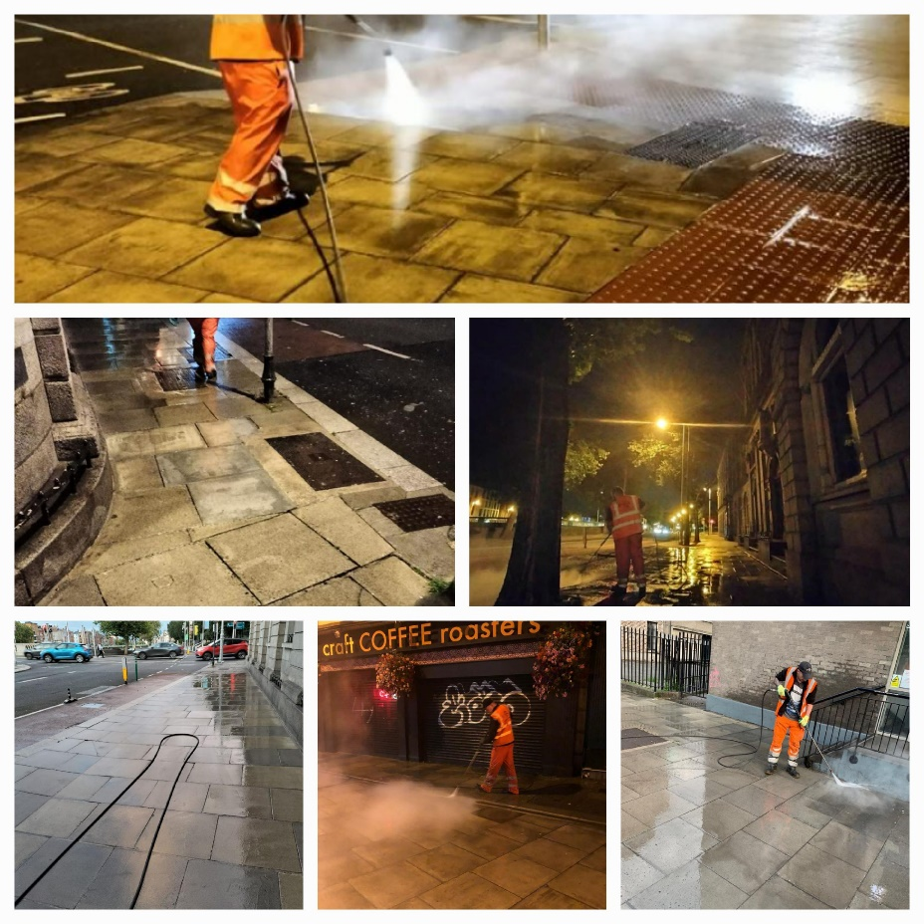

WASTE MANAGEMENT STREET WASHING - THOMAS STREET, THE GUINNESS STOREHOUSE ENVIRONS AND MARROWBONE LANE.

The Storehouse and Marrowbone Lane are now on wash schedule. Cycle Lanes Merchants Quay, Rothe Abbey and South Circular Road deep clean completed. Street sweep & illegal dumping removed Rialto Cottages.

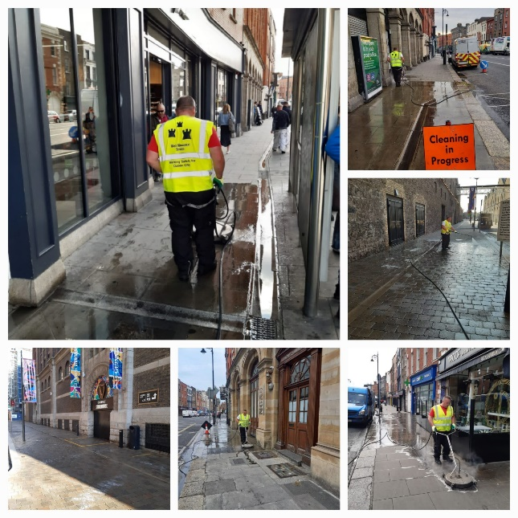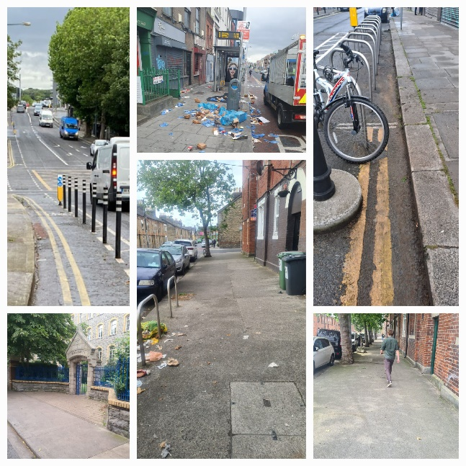
DUBLIN CANVAS

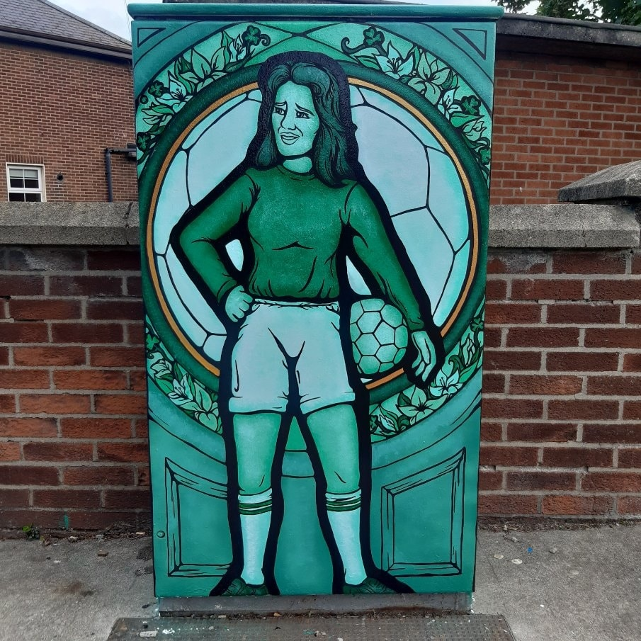
The project for artworks on Traffic signal utility boxes is underway. Two boxes completed below - tribute to the great female footballer Ann O’Brien 1956-2016, late of Inchicore. The box is located on Bulfin Road. Inchicore Environmental Group suggested this as it is close to St.Patrick’s Football Club

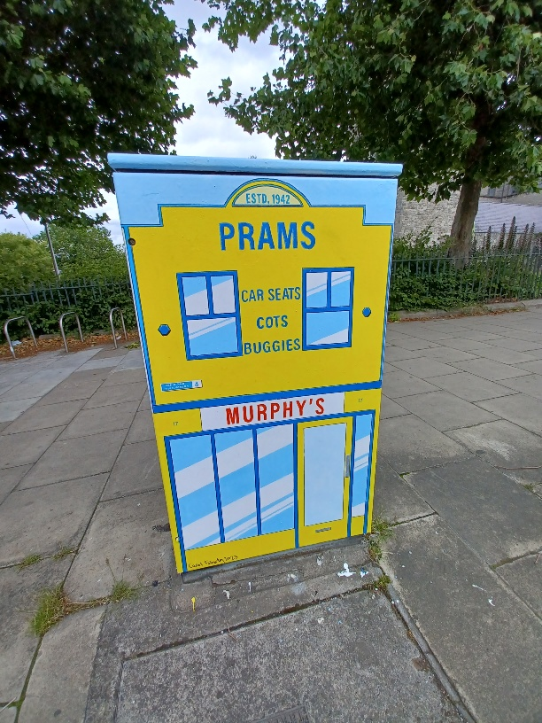

“Murphy’s Prams” High Street. Original Shop established 1942 - 14 High St. Art work by Carol Faherty located on High Street outside St Audeon’s Park.
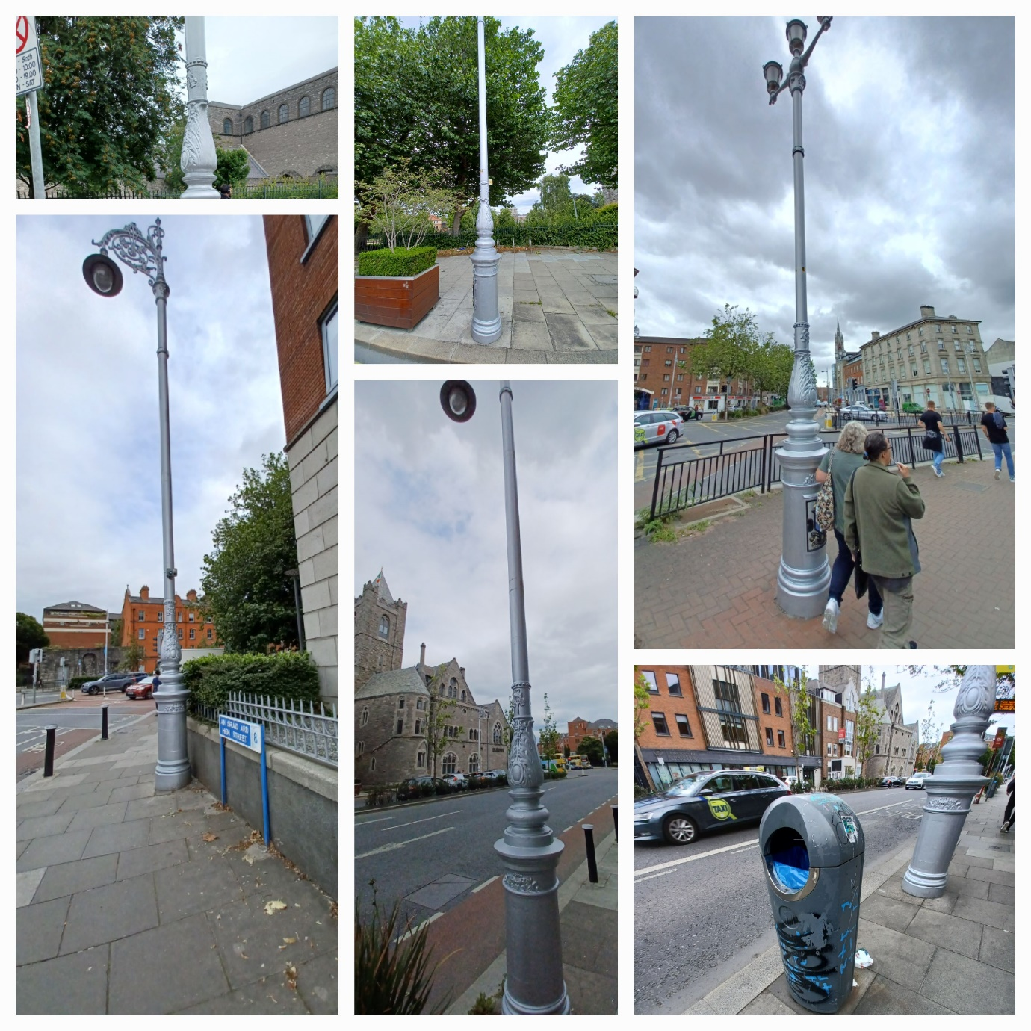

Public Lighting Poles painted by Housing Maintenance Painting Crew.
Public Lighting and Public Domain shared cost of painting Lighting columns in High Street, Nicholas Street, Thomas Street, Meath Street and Bulfin Road. More pictures to follow next area report.

GRAFFITI PROGRAMME 2023
Graffiti treated at: Hanbury Lane, Engine Alley, Lambe Alley, Catherine’s Lane, Meath Place, Cow Parlour. 285 Meters across the area treated.

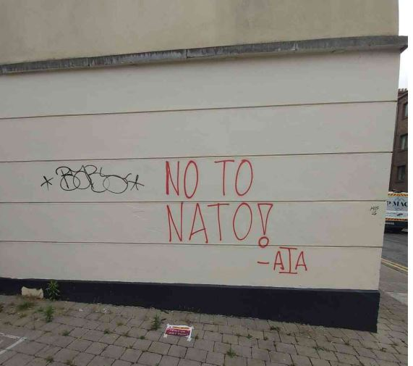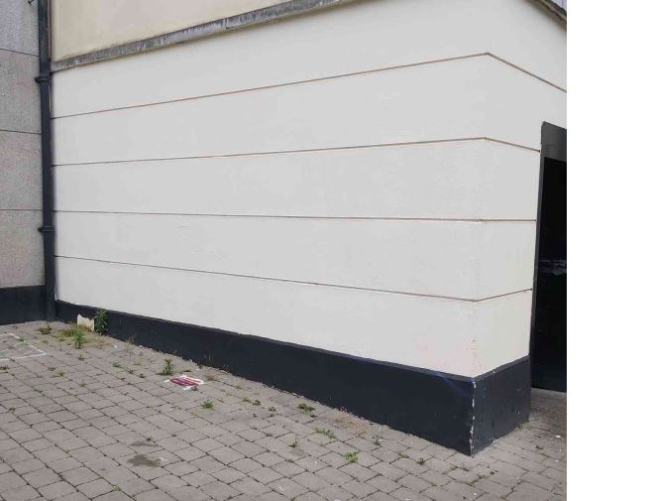

CLEAN-UPS
62 Community Clean-up bag collections requested across the city.
2023 WEED PROGRAMME
Greentown Environmental have completed the first spray in SWIC appox 12km of roads/junctions and modular pavement treated. Three remaining sprays to follow over the Summer. The Coombe, Pimlico, Rialto and Inchicore treated.

CITY NEIGHBOURHOODS
34 applications received. The local judging has taken place and winners will be announced at the South Central Area City Neighbourhoods Awards due to take place Tuesday 12th September, 2023 (TBC). Winners will go through to the City Wide Competition. The City Wide Awards Ceremony will be held in Croke Park on Thursday 5th October, 2023 at 5 p.m.

Report from: -

Bruce Phillips,
Senior Executive Officer
South West Inner City Local Electoral Area.

BALLYFERMOT / DRIMNAGH ELECTORAL AREA

Housing

Cornamona
Over 40 sets of keys have been issued to tenants.

Springvale
The anticipated completion date remains quarter 3, 2023 with the possibility of the units being occupied on a phased basis being examined.

Lissadel Maisonettes
The Feasibility study for submission to the Department of Housing, Local Government & Heritage is currently being costed. The retrofit works should be completed by the end of August.

La Touche Court
The repainting of the units in Bernard Curtis House is completed and work is now underway in La Touche Court.

Hillside Manor
Cluid have signed tenancy agreements will all tenants and occupation will take place over the coming weeks.

Labre Park
The meeting with the Department of Housing, Local Government and Heritage officials took place on the 29th June in relation to the stage 2 application which is still being assessed by the officials. It is anticipated that a further meeting will take place at the end of August or early September
Bluebell
The LDA has very recently appointed a design team.
Cherry Orchard Point
Engagement with stakeholders in relation to the design for this development (Cherry Orchard Point) commenced on Wednesday, 14th June and has been extended to 4th August.

Sons of Divine Providence
Dublin City Council Housing and Community Services anticipates that draft heads of terms will be issued to the Sons of Divine Providence for the proposed title transfer arrangements shortly. Once heads of terms are agreed progress will be made on the Stage 2 funding application, including the appointment of a Design Team.

Slievebloom Court, Drimnagh.
Some additional works are being carried out on the development. It is anticipated that the units should be available for occupation by the end of July.

Rafters Road
The integrated design team has been progressing with design proposals and is currently working to achieving Stage 2 approval to enable Dublin City Council to continue with the planning approval process.
Voids
There are currently 39 void units in the area with 4 properties from the previous monthly list allocated. Of the 39 properties it is anticipated that 3 new tenants will have signed tenancy agreements by the end of July. 1 property has had an offer issued and is awaiting a response and keys are awaited on another property with the tenant selected. 2 prospective tenants are undergoing vetting with AGS.

Community

The community festivals held in Drimnagh, Ballyfermot, Cherry Orchard and Chapelizod were a roaring success and a great outcome for the hard work put in by the local voluntary committees.
The City Council is the primary funder of the festivals and community staff have worked in the background with most of the committees to encourage, support and provide logistical advice for the many events that took place, particularly around insurance, event plans and health and safety.
The Council supported the groups to organise family fun days, which animated all the public Parks across the area during the month and feedback has been very positive from residents that were delighted to have big events, free of charge on their doorstep.
Great credit is due to the local voluntary committees that organised the festivals, the involvement of local residents and community groups ensures that there is “buy in” locally, celebrates local achievements and builds community capacity.
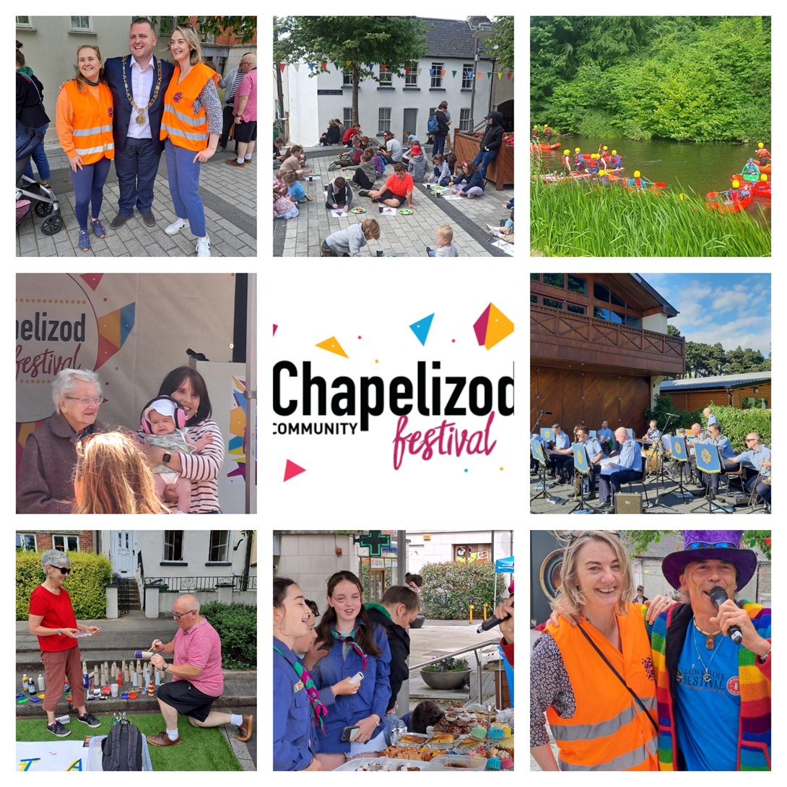

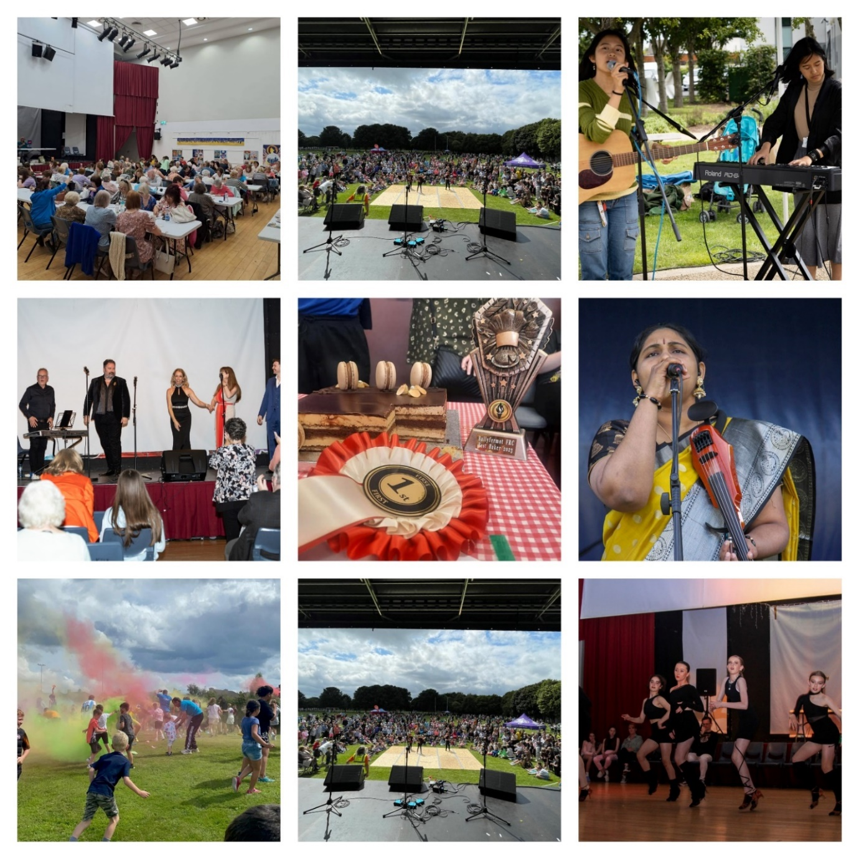

Walkinstown Festival
The Council is working with the Walkinstown Festival Committee with the planning for the summer festival which will take place on Sunday 27th of August in Walkinstown Park.

Bluebell Summer Festival
The Council has been in contact with the Bluebell Festival Committee who are still hoping to organise a family fun day during August.

Summer Play Days
The Summer Play Days organised by the City Council with local environmental groups and resident associations have been very successful at getting residents and children out onto their local greens again.
Despite the weather the children and parents have enjoyed the days and the feedback from the resident’s associations/groups/communities has been wonderful. It has been noted that in the areas where play days were organised children have continued to play outdoors in the days that followed.

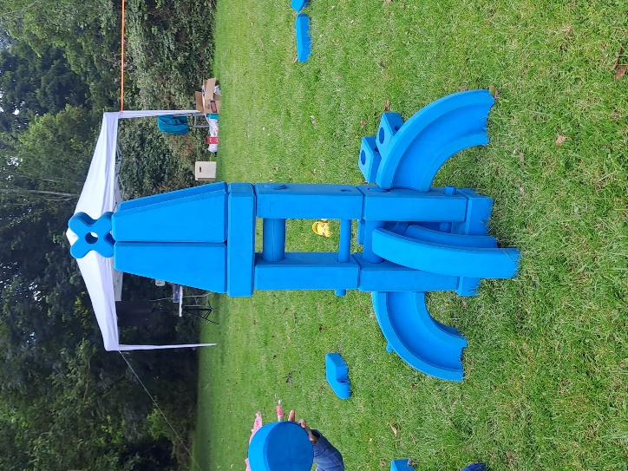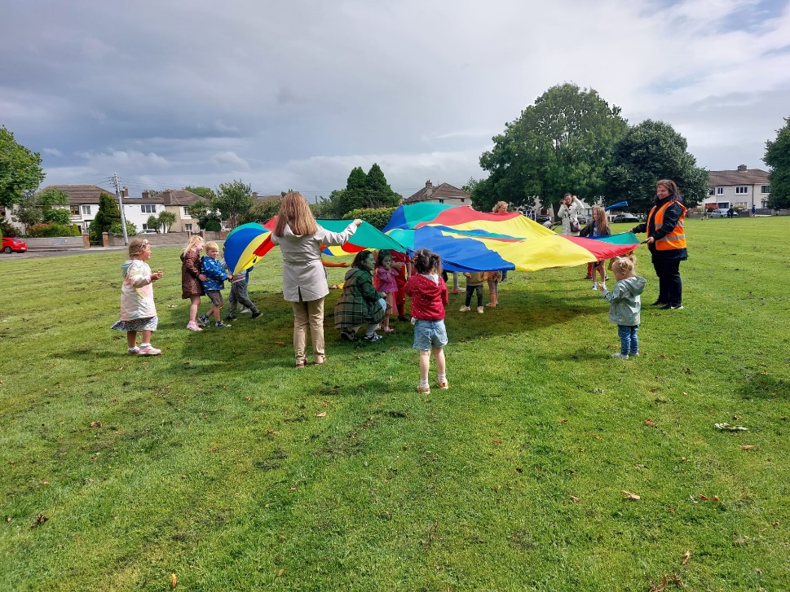

Community Grants
The 2023 Community Grant and Informal Education Scheme opened on July 6th.
The annual scheme is open to a range of local resident, community, environmental and festival groups throughout the city to apply for local area grants. Community activity and active citizenship will be supported with an emphasis placed on community development and social inclusion initiatives.

The maximum value of the Local Area Community Grant is €1,500.
The closing date for completed application forms is the 18th August 2023.

Full details are available on: www.dublincity.ie/residential/improving-my-community/community-grants-and-funding

The Community Development team will be hosting workshops for groups over the next number of weeks to support local groups and organisations with completing the online form.

Age Friendly Programme
The Age Friendly Programme will start back in September/October with events based in the Ballyfermot Community Civic Centre.
The City Council is working in co-operation with MABS and the housing liaison officers to bring information sessions to the sheltered housing complexes in July and August. The information sessions will consist of advice on issues such as the cost of living & rent arrears and support in applying for funding towards rising energy costs.
Sports Capital & Equipment Programme
The Sports Capital and Equipment Programme (SCEP) will open for applications on July 17th. Further information available on www.sportscapitalprogramme.ie

Orchard Centre

“I CAN” Book launch.
On Thursday 22nd June the “I Can” Women’s group from St. Ultan’s School launched their very own book of stories, I CAN I WILL I DID Cherry Orchard to the Big Apple. The launch was hosted by the Lord Mayor, Cllr. Caroline Conroy in the Mansion House. In attendance were local Councillors, members of Cherry Orchard Implementation Board, members of the Board of Management of St. Ultan’s NS and family and friends of the members of the group.
This was the realisation of an idea presented by Dave O’Donovan to the group last September overcoming the challenges they faced in relation to reading and writing.
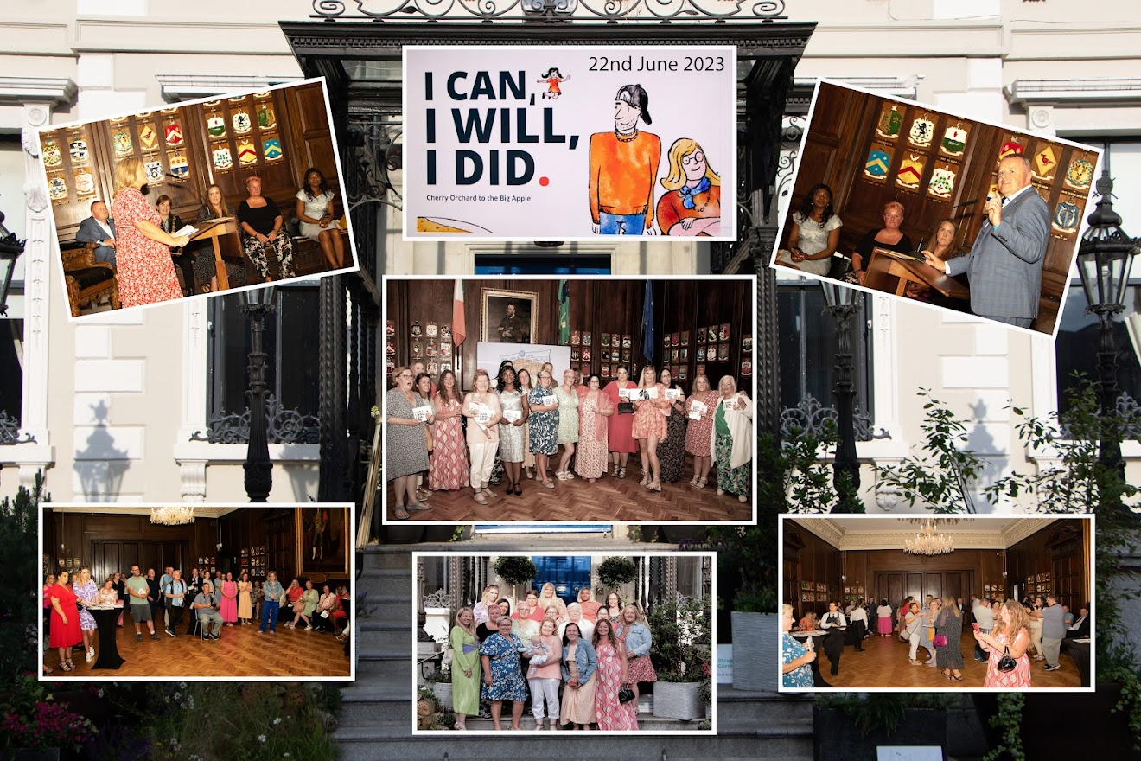

Family Fun & Sports Day
The family fun and sports day took place on Sunday 9th July in Cherry Orchard Park with approximately 1,000 visitors taking part in various games, obstacle courses and a “colours” run organised by Cherry Orchard Running club, along with performances from local people and the Garda Band! The Orchard Centre was on hand to provide food, refreshments and public use of the facilities on the day.

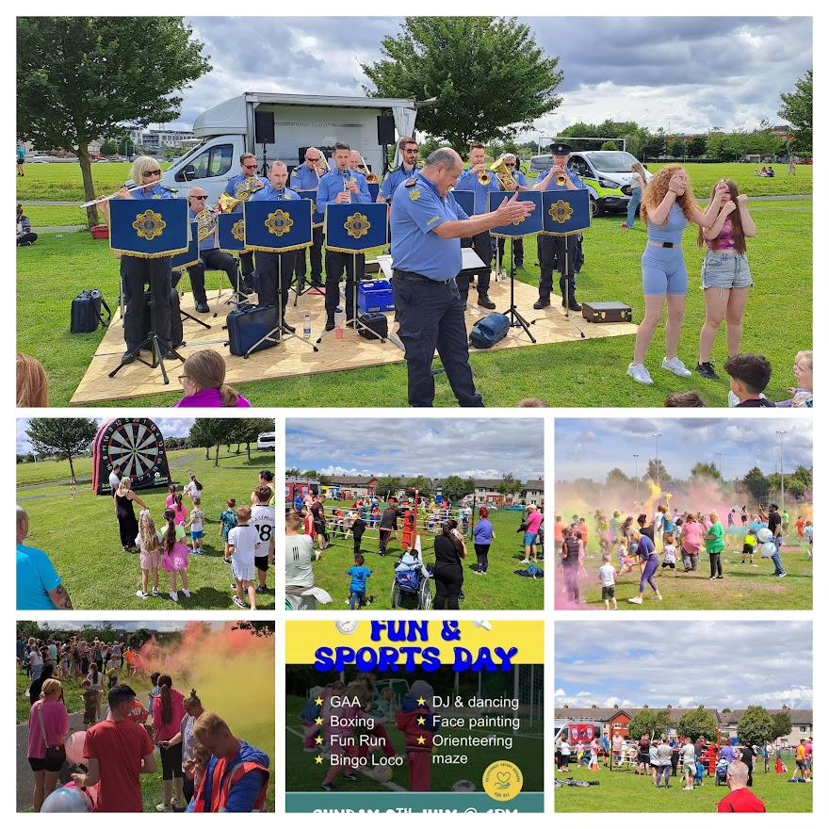

Public Feedback
There have been a number of sessions in the area to seek ways in which to improve the estate and combat fly tipping which is a huge cause of concern and frustration for local residents. This feedback will feed into plans to tackle the situation and improve the amenity value for local residents.
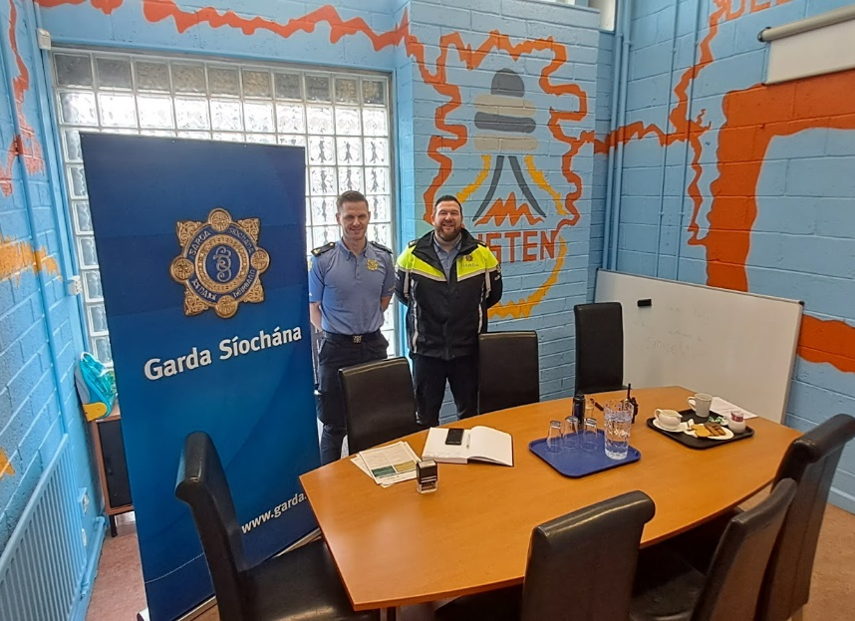
GARDA Clinic Orchard Centre
From Thursday 6th July and every 2nd week thereafter from 11am – 1pm Ballyfermot Garda staff will be on hand to meet and deal with any issue residents may have.
Everyone in the area is encouraged to avail of this worthwhile service for the community.

puBLIC DOMAIN REPORT FOR Ballyfermot/Drimnagh

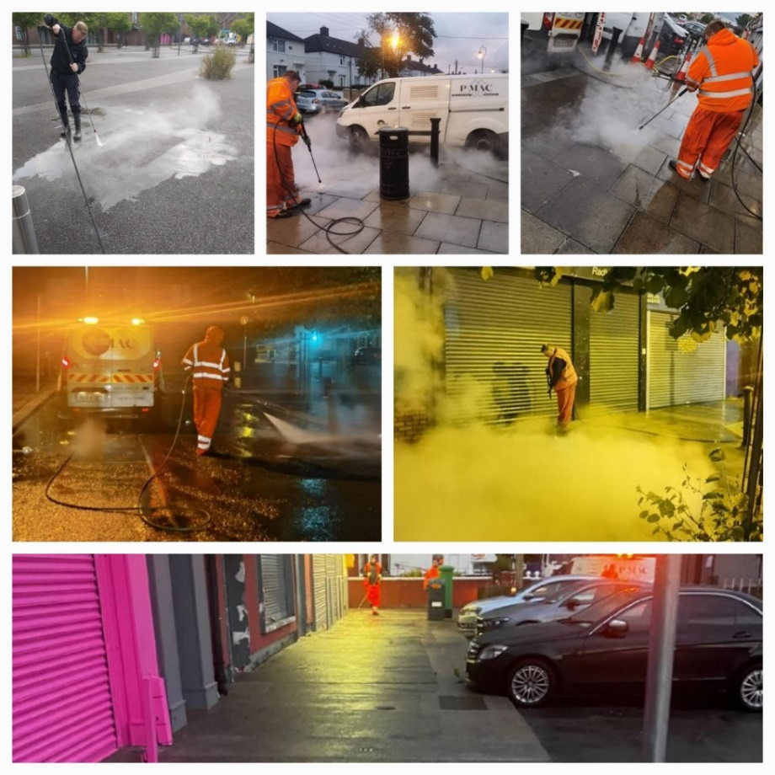
INTENSIVE CLEANING Ballyfermot Shopping Areas: Ballyfermot Road, Drumfinn Road, Claddagh Green and Decies Road.
Intensive gum & stain removal carried out by approved contractor over the past two weeks. All areas inspected and cleaning carried out to highest standard.

WASTE MANAGEMENT
Lanes at Drimnagh Road and Ballyfermot Road Shops cleared of illegal dumping. Convent Lawns scheduled for a deep clean with manual weed removal over the next two weeks.
Le Fanu Road Shops inspected and Litter Management, Litter Enforcement and Public Domain working together to ensure illegal dumping removed and carpark cleaned up. (Owner/occupiers are responsible for Cleaning/maintenance of communal areas
Dublin Canvas
Traffic Control Utility Box- The Following artworks are complete “Pat Mustard” by Conor Ó Lochlainn Tesco, Ballyfermot Road,” and “Bloomin Thought” by Shyanne Dunne Sarsfield Road. More to follow next report
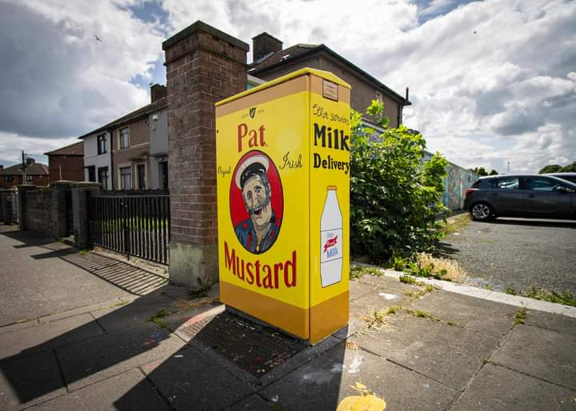
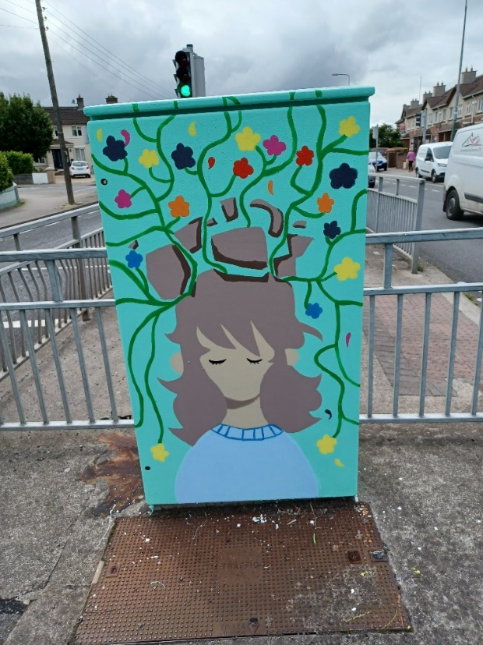

COMMUNITY CLEAN-UPS
62 requests for community bag collections in South Central Area. Bluebell Environmental completed a big clean-up around the shops. Chapelizod Tidy Drimnagh, Make Walkinstown Great and Ballyfermot Environmental Group also very active in the area. Community Clean-ups facilitated. Bags, gloves and pickers supplied.

WEED PROGRAMME 2023
Greentown Environmental are the appointed contractor for weed control. The first Spray is completed with three more to follow. Streets treated in Ballyfermot, Bluebell, Drimnagh and Walkinstown. Traffic Island at Sarsfield and Drimnagh Roads. Modular Paving treated at Claddagh Plaza and Ballyfermot Road.
CITY NEIGHBOURHOODS
15 applications received. The local judging has taken place and winners will be announced at the South Central Area City Neighbourhoods Awards due to take place Tuesday 12th September, 2023 (TBC). Winners will go through to the City Wide Competition. The City Wide Awards Ceremony will be held in Croke Park Thursday 5th October, 2023 at 5 p.m.

Report from: -

Alan Sherry,
Senior Executive Officer
Ballyfermot/Drimnagh Local Electoral Area.

