**THE FOLLOWING PROPERTIES WILL BE ALLOCATED USING**

**THE CHOICE BASED LETTINGS SCHEME AT**

**23 Woodhazel Terrace, Ballymun, Dublin 9**

**Closing Date for Applications: Friday 6th October 2023 at 5.00pm**

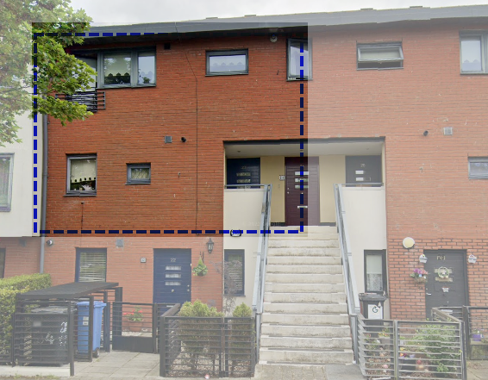

**PLEASE NOTE THAT ONLY SUCCESSFUL APPLICANTS WILL BE NOTIFIED**

23 Woodhazel Terrace is a two bedroom apartment. The property comprises of a kitchen/dining room, living room, bathroom and two bedrooms.

It is strongly recommended that you familiarise yourself with this dwelling/location before applying.

Only applicants who have a current live application and their requirements are for a two bedroom accommodation and have selected Area D as a preference under the Scheme of Letting Priorities will be considered for the properties.

**Please note late applications will not be considered.**

**Only one application per applicant(s)**

**Procedure and Application Form**

1. All applicants must be listed for Area D**.** Do not apply if you do not have Area D as a preference.
2. Applicants are invited to register their interest with Dublin City Council. Properties that become available for re- let in this area will be advertised in the Ballymun Civic Centre, Main Street, Ballymun, Dublin 9 or Housing Allocations, Civic Offices, Fishamble Street, Dublin 8 and the Dublin City Council website, <https://www.dublincity.ie/residential/housing/i-am-looking-home/choice-based-lettings>
3. Start date of Choice Based Letting advertisement is Friday 15th September until Friday 6th October 2023 at 5.00pm
4. This application form must be returned to the Ballymun Area Office or email completed application to  **ballymuncbl@dublincity.ie**
5. If a number of applicants express an interest in the same property, the final offer will be made to the applicant with the highest position on the list. This will be subject to estate management clearance.  As the final offer is made to the applicant in the highest position, there is no supporting documentation required as only position on your waiting list is considered.
6. All applications will be examined on estate management grounds including rent arrears.
7. A successful applicant who refuses a Choice Based Letting offer will not be eligible for consideration for another Choice Based Letting unit for a period of one year.
8. Under the Choice Based Letting Scheme only the successful candidates will be notified.
9. If you need further information regarding the Choice Based Letting Scheme, please contact the Ballymun Area Office on 01 222 5610.
10. Please note late applications will not be considered.
11. As per your Social Housing Application form, Dublin City Council will process your Choice Based Letting application in line with GDPR Guidelines. Please see Dublin City Council Privacy Statement on Dublin City Council’s website.

**Application Form**

**23 Woodhazel Terrace, Ballymun, Dublin 11**

**Name: ______________________________ ____________**

**Address: ______________________________________________ ______________**

**Family Size: ____________________ _______ ______**

**Housing Reference Number: ___ _________ ________**

**PPS Number: ___ _________ ________**

**Telephone/ Mobile Number: _______________________________ ___**

**Did you read and understand the procedures above: Yes ___ ___ No __________**

**Signature: ________________________________ ________**