Dublin City Council begins work on homes for Older People
23rd June 2023

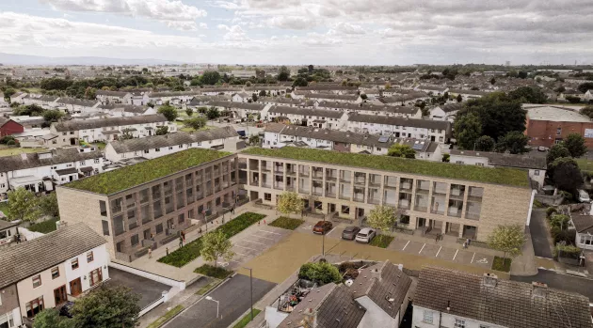

The new development will replace the existing housing complex with the construction of 32 quality homes for Older People. As well as delivering modern homes, the Older Persons housing scheme will also provide a landscaped residential courtyard to be enjoyed by the new residents. A new modern community centre and kitchen will serve both the residents of Glin Court and the wider area with a meals-on-wheels service.
All the units are designed in accordance with the recommendations of the National Disability Authority’s Buildings for Everyone, and the ground floor units are designed to be fully accessible for wheelchair users and are capable of adaptation for wheelchair dependable living at any time in the future. Level access is proposed throughout the scheme, both internal and externally. The approach to the community building and its main entrance and all facilities provided within the building shall be fully wheelchair accessible.
Visiting the site today the Lord Mayor of Dublin Caroline Conroy said, “I am delighted to see the redevelopment of Glin Court in Coolock begin. The redevelopment will see the transformation of older persons accommodation from small bedsits into modern one bed apartments. The new apartments will be designed to Universal Standards to allow older people to remain living with independence in their homes for as long as possible.”
The total budget for this project is €14.5 million and the work is expected to take 18 months to complete.
Cllr Alison Gilliland Chair of Dublin City Council’s Housing SPC said, “Today is an important milestone in housing delivery in our local area. Following local consultation on the design of the redevelopment of Glin Court it’s now time to realise that design and start on site. While the old development served this community for many, many decades the new one will be modern, energy efficient and increase the number of new homes on the site. I very much look forward to seeing the building progress and ultimately new tenants move in to beautiful new homes.”
Dublin City Council appointed an integrated design team led by Paul Keogh Architects to design the residential redevelopment.

ENDS
