1. **Open the app, and click on "search for a route”**

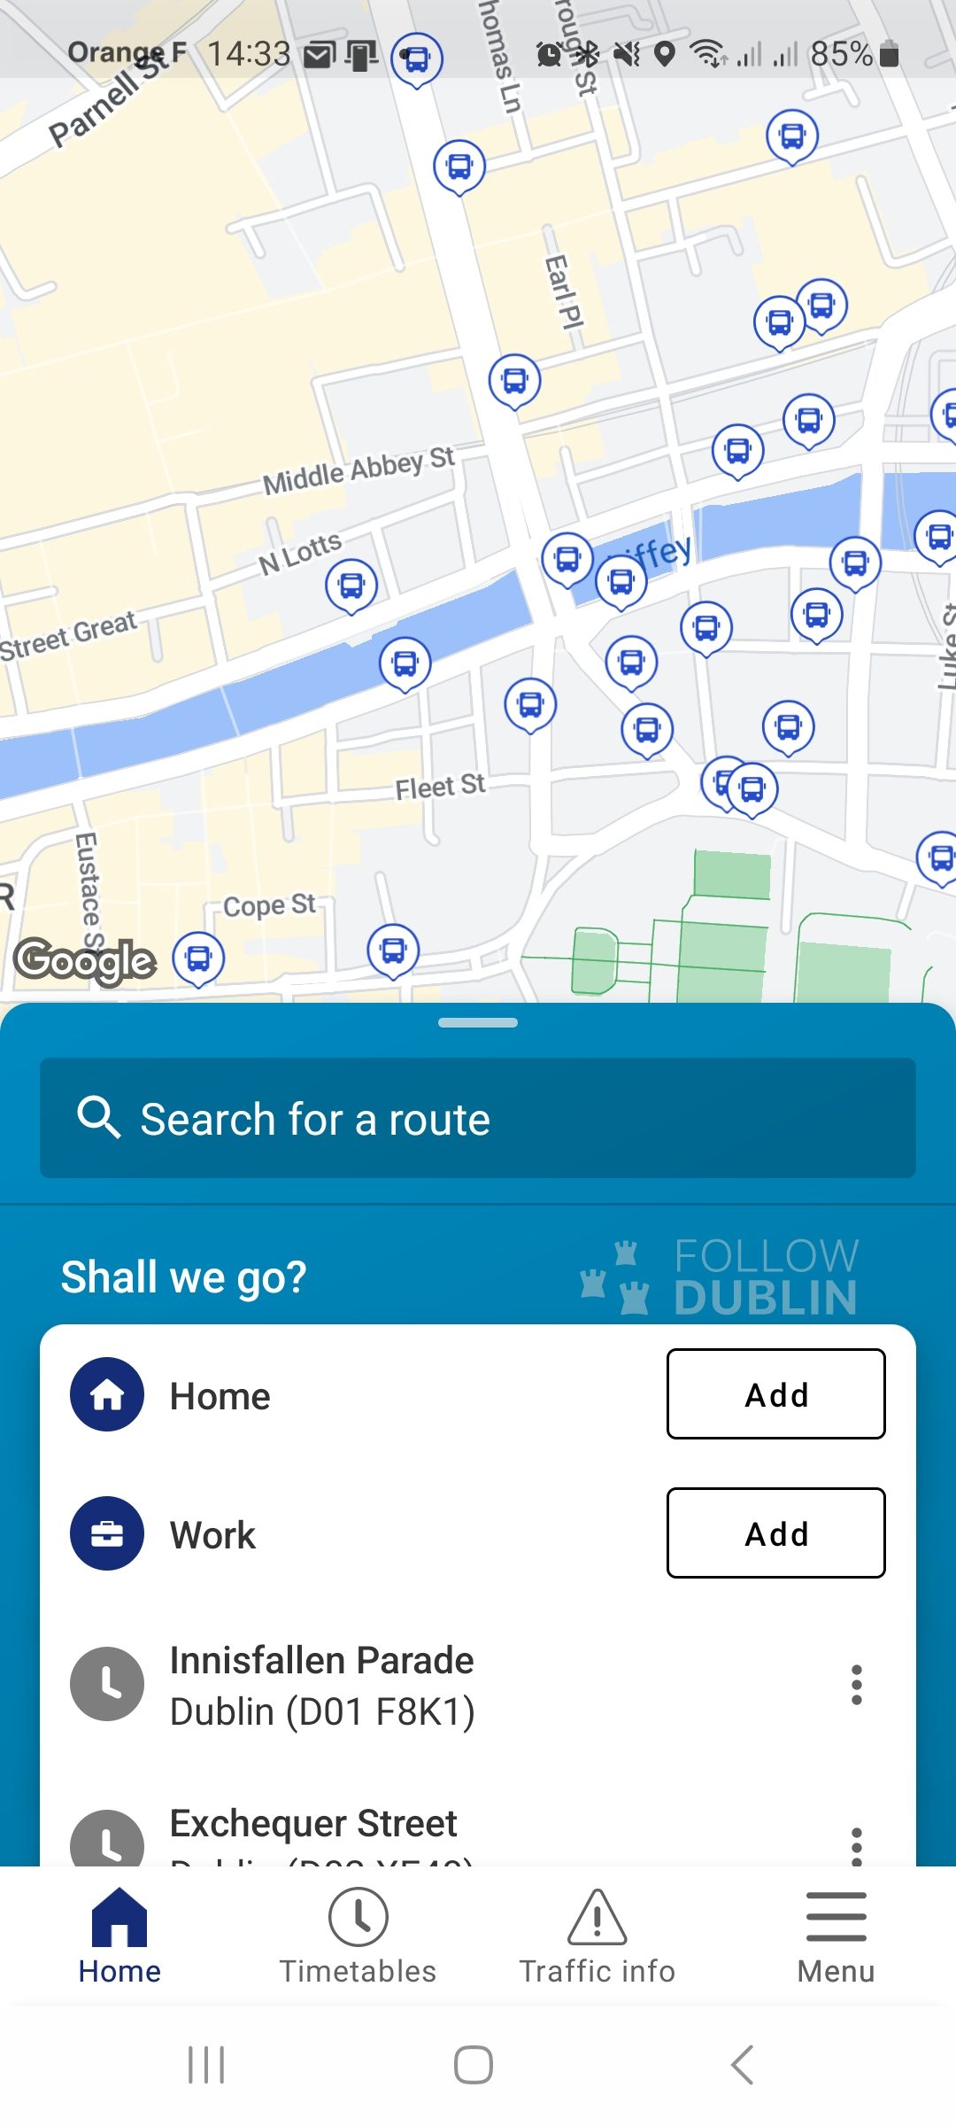

1. **Type your Arrival and Departure**

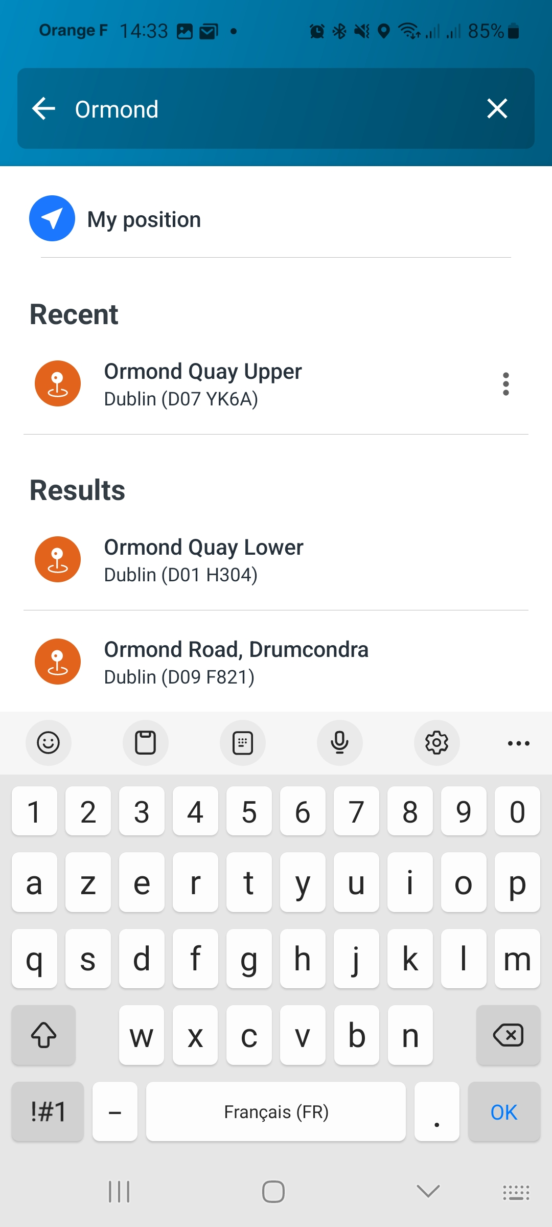

1. **Go into your travel options**

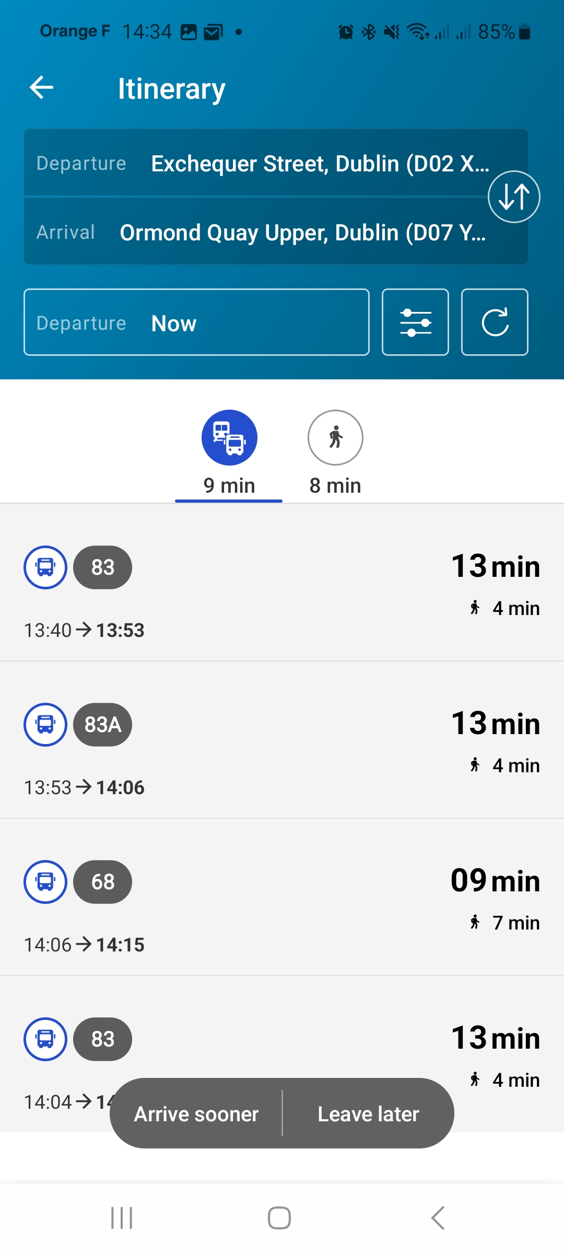

1. **Activate the option "Reduced mobility"**

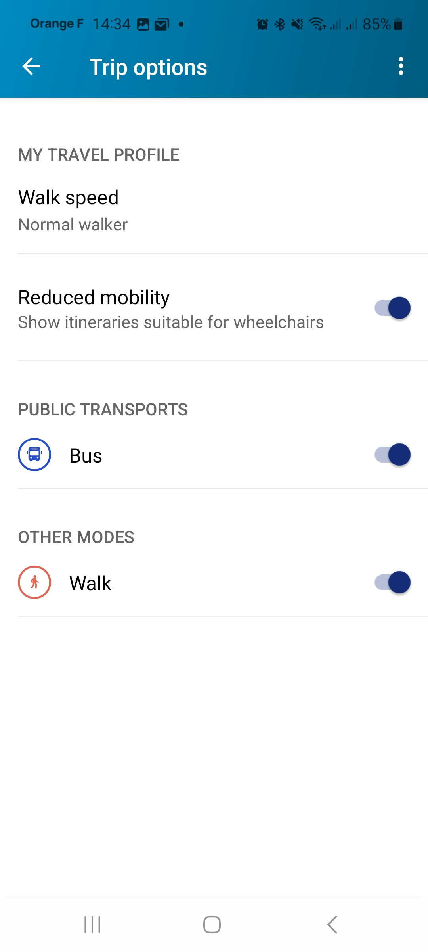

1. **Go back to your travel results and select your itinerary**

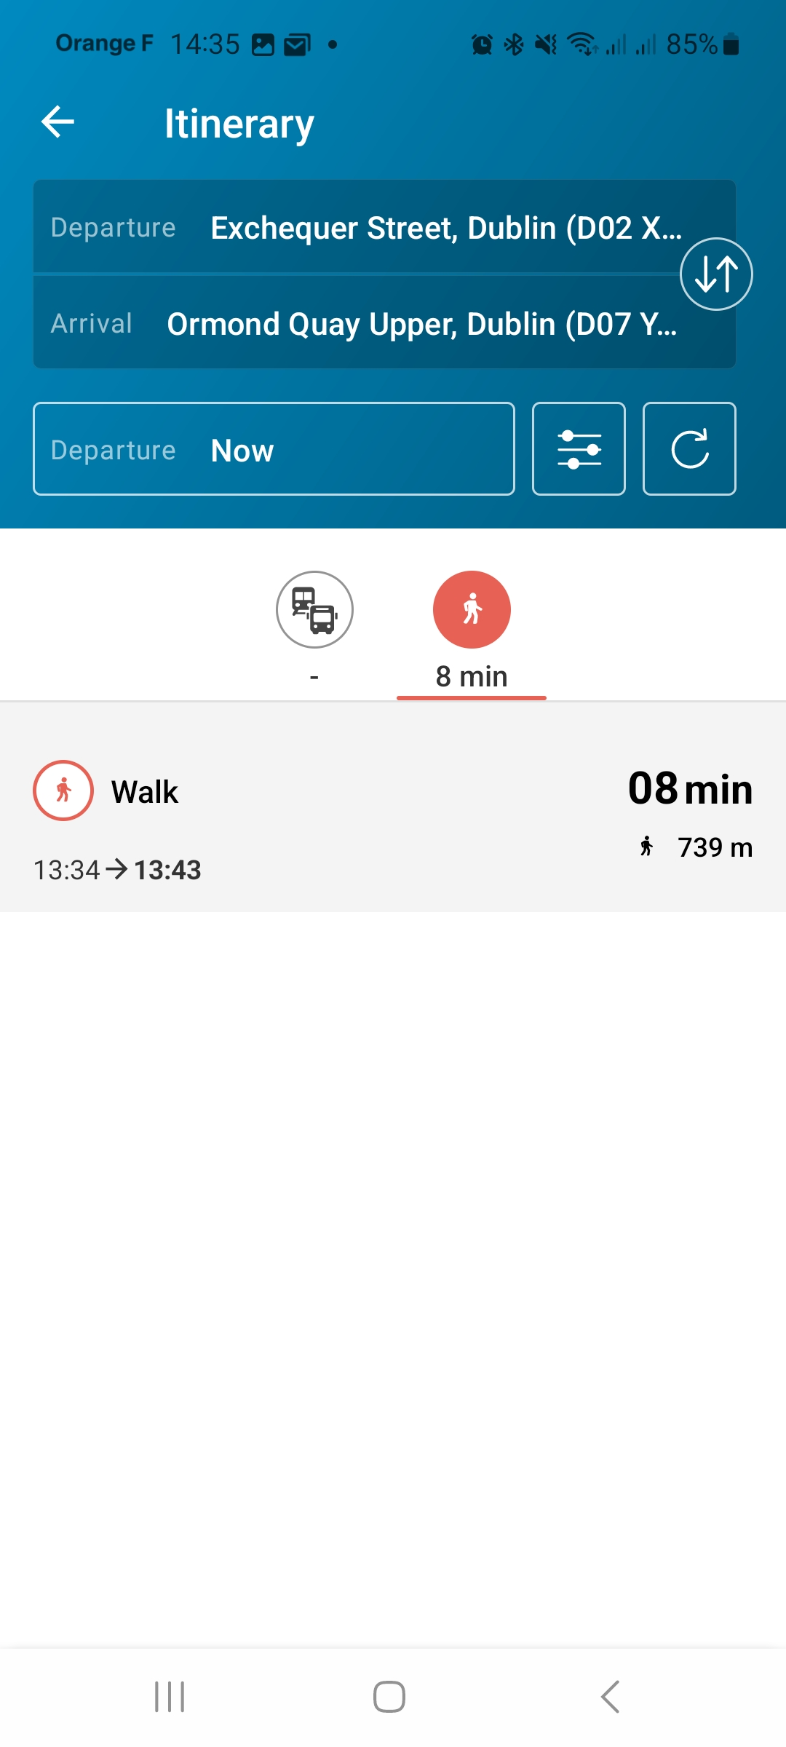

1. **Click on the obstacles on the map or in your roadmap to get more information**

