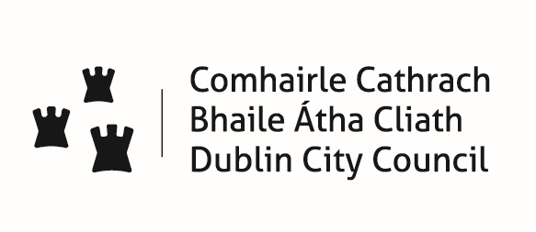
An Roinn Pleanála agus Forbairt Maoine An Roinn Pleanála agus Forbairt Maoine
Photo ID
2 Passport photos
Permit No:
Narrative: Name
Date Issued:
Receipt No:
Expiry date:
An tAonad Ceadúnúcháin & Forfheidhmiúcháin, Oifig um Théarnamh Cathrach, Bainistíocht Ceantair, Bloc 4, Urlár 0, Comhairle Cathrach Bhaile Átha Cliath, An Ché Adhmaid, Baile Átha Cliath 8.
Licensing & Enforcement Unit, Office of City Recovery, Area Management, Block 4, Floor 0, Dublin City Council, Wood Quay, Dublin 8.
Tel: 2222165 Fax: 2222366 Email: streetperformers@dublincity.ie

T: 2222165 F: 2222366 E:streetperformers@dublincity.ie

STREET PERFORMANCE PERMITS APPLICATION FORM
I wish to apply for a Street Performers Permit for the Dublin City area Yearly €30 Visitors €10 (ECSPP)
I wish to apply for an Amplification Permit for the Dublin City area Yearly €60 Visitors €20 (ECSPA)
Name: _______________________________________ Performance Name: ___________________________________________
Address: (Proof of address required)_________________________________________________________________
_______________________________________________________________________________________________
Telephone: __________________________________ Email: _______________________________________________________
Please give brief description of your performance: ______________________________________________________________________________________
Are you performing in a group: YES ◻ NO ◻ SOMETIMES ◻
If yes, each member will need Street performance and Amp permit.
Important Privacy Information
Declaration I declare that all the information that I have given on this form together with the supporting documentary evidence is complete and accurate.
Signature: __________________________________________ Date: __________________
If you are under 18 permission of parent/guardian is required:
Parent/Guardian signature: ____________________________ Date: ___________________ _ _ _ _ _ _ _ _ _ _ _ _ _ _ _ _ _ _ _ _ _ _ _ _ _ _ _ _ _ _ _ _ _ _ _ _ _ _ _ _ _ _ _ _ _ _ _ _ _ _ _ _ _ _ _ _ _ _ _
Please Note: It can take up to ten working days to issue a permit. If you wish to visit the office, you must make an appointment in advance.
_ _ _ _ _ _ _ _ _ _ _ _ _ _ _ _ _ _ _ _ _ _ _ _ _ _ _ _ _ _ _ _ _ _ _ _ _ _ _ _ _ _ _ _ _ _ _ _ _ _ _ _ _ _ _ _ _ _ _
Dublin City Council Street Performers Bye-Laws 2016
A Performer Must:
- Display a street performance permit and have it clearly visible at all times during a performance in a public place.
- Hold and display a permit to use amplification, if using amps.
- Start and end the performance on the hour mark.
- Ensure a performance does not cause offense.
- Comply with a lawful request of an authorised officer of the Council or a member of An Garda Siochána (Police officers).
- Street Performers or circus act performers using potentially dangerous props must hold public liability insurance and indemnify Dublin City Council.
A Performer Must Not:
- Perform before 9:00am (11:00am) on a pedestrianised streets where delivery vehicles operate).
- Perform after 11:00pm.
- Perform in a prohibited area.
- Perform twice in the same location on the same day.
- Offer merchandise or C.D’s for sale, if not licensed to do so.
- Outstay the maximum performance time of 2 hours or 1 hour on Grafton Street.
- Block entrances or cause obstructions on a street.
- Exceed a volume level of 80db (75db in Temple Bar area).
- Use backing tracks or other recorded music.
- Charge members of the public a fee for the performance.
- Solicit, coerce or otherwise encourage members of the public into making a donation.
- Use lewd, offensive or derogatory language or conduct.
A Performer Using Amplification Must:
- Display a valid permit for the use of amplification and have it clearly visible at all times during a performance in a public place.
A Performer Using Amplification Must Not:
- Use backing tracks or other recorded music.
- Perform in the prohibited places in Temple Bar and at the GPO.
- Exceed a volume level of 80db (75db in Temple Bar area other than the prohibited places shown on the map below).
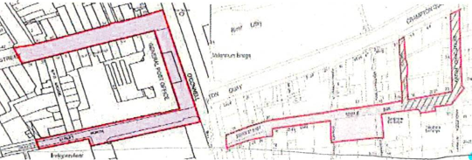

Declaration:
I confirm that I have read and understand the Street Performers Bye-Laws 2016. I agree to abide by the Bye-Laws and, in particular, the requirements listed above.
I acknowledge that any breach of the Bye-Laws may result in revocation of the Street Performance Permit and /or the permit to use amplification granted to me by Dublin City Council.

GDPR
Reasons for requesting your personal information
- Your information is required in order to process your application for a Street Performance Permit.
- If your application is successful it may be necessary to share your information with other statutory bodies i.e. An Garda Siochána, Revenue Commissioners, Minister for Social Welfare.
- If the Street Performance Permit is granted, the information supplied by you will be kept securely for a period of up to seven years.
- If you do not provide the personal data required under the Street Performance Bye-Laws Dublin City Council will not be in a position to process your application.

For more information on the Dublin City Council Privacy Statement please click on
http://www.dublincity.ie/privacy-statement

If you would like more information on the Street Performance Bye-Laws please look at https://www.dublincity.ie/sites/default/files/content/RecreationandCulture/Documents/Street%20Performers%20Bye-Laws%202016.pdf

Signed: _________________________________________ Date: ______________________

