Director of Services Report
South Central Area Committee Meeting
21st February, 2024

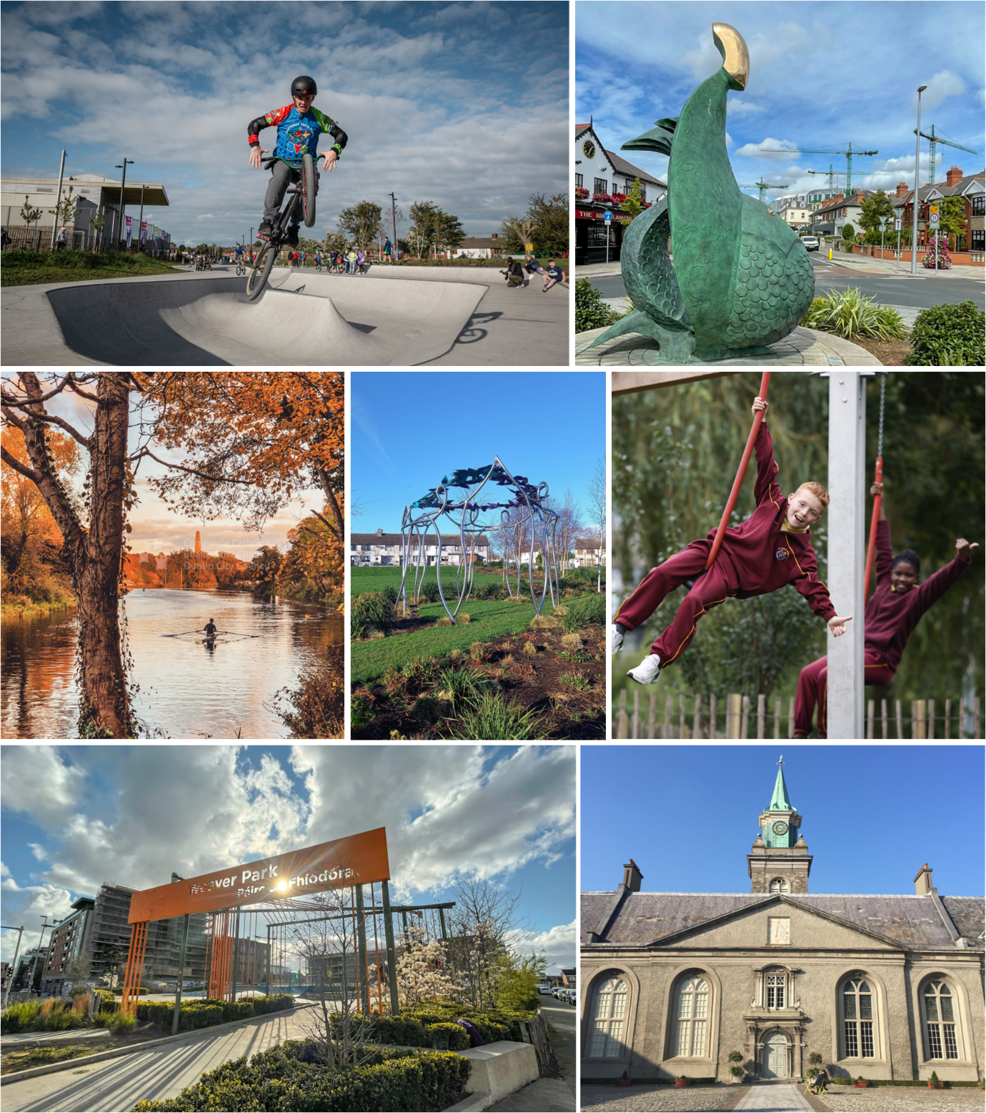

Table of Contents

SOUTH WEST INNER CITY ELECTORAL AREA 2

Public Realm & Capital Programmes 5
Kilmainham Inchicore Network 6
Housing 7
Community 13
Public Domain 14

BALLYFERMOT DRIMNAGH ELECTORAL AREA 18

Housing 18
Community 21
Public Domain 24

SOUTH WEST INNER CITY ELECTORAL AREA
Kilmainham Mill

Following the purchase of the mill, DCC commissioned detailed surveys of the building, resulting in a programme of essential repairs and stabilisation works, which were completed in Autumn 2023. These works included repairs to roofs, removal of asbestos and protection of machinery. Costing €1.7 million, these works have stabilised and made the buildings safe. There is limited accessibility and facilities for widespread use.

DCC also commissioned a Conservation Management Plan which will inform the potential and limitations on the mill’s future use. This is due for completion shortly. Additionally, DCC’s Culture Company has initiated research on the social and industrial history of the mill. This research will also inform the narrative and potential uses of the mill.

• A project steering group, comprising relevant executive and staff at DCC, has been established to oversee a strategy for the sustainable development of Kilmainham Mill.
• A limited public engagement programme of events and talks was also developed and implemented at the end of 2023, aimed primarily at the local community and those interested in the mill’s history.

Master vision:

Dublin City Council’s put in place a process to establish a master vision that will inform the ultimate reuse of Kilmainham Mill. This process was initiated in late 2023 and involved community and stakeholder engagement. The master vision will determine the scope for the long-term use of the mill, as well as establishing interim potential uses, such as markets, exhibitions, and events.
The master vision will:
• Consider the rich industrial, architectural, and social heritage of the mill.
• Consider the needs of the community, including the existing broader business and cultural infrastructure.
• Consider sustainability, as this relates to climate, biodiversity, and reuse potential of the mill.
• Consider a funding and income-generation model to enable the mill to become self-sustaining.

Next Steps:

The master vision process is almost complete and it is the intention to circulate and publish the report in the coming weeks. DCC will also publish the completed Conservation Management Plan at that time. DCC is also working with the DCC Culture Company in order to develop and implement a programme of meanwhile uses for the Mill in 2024.

Iveagh Markets
DCC issued a tender invite following which an Integrated Design Team (IDT) was appointed led by Howley Hayes Cooney Architecture & including CORA Structural Engineers, Homan O’Brien Mech. & Elec., IAC Archaeology and Austin Reddy QS. DCC has established a Steering Group and appointed an experienced Project Manager to oversee and drive the stabilisation works programme.
Since appointment, the Integrated Design Team have completed initial site examinations and commissioned and completed a range of surveys including, asbestos survey, lead paint survey, invasive species survey, bat survey, drone and measured surveys, services surveys, an archaeological desktop assessment, detailed roof survey etc.

As previously advised the IDT have agreed a 2 Stage Works Programme with DCC for the Iveagh Markets as follows -

Stage 1
Following completion of the above surveys a tender invitation was issued to the market in recent weeks for advanced works including removal of loose materials, installation of safe access routes, installation of crash decks & removal of vegetation. These works to be completed in Q1 2024. DCC will facilitate a site visit for the Elected Representatives once these works are complete and safe access can be granted. DCC will also provide information updates to the community and other stakeholders as works progress.
Stage 2
Following completion of Stage 1 works above the IDT will have full and safe access to all areas which will allow them to complete the detailed design process and prepare tender documentation for a comprehensive repair programme. The repair programme will include – extensive repairs to roofs, valleys and rainwater disposal systems; protect & secure windows/doors; secure structural columns which have been exposed; repair walls and parapets; remove lead paint throughout and provide safe access to structures to facilitate a regular inspection and maintenance. The Stage 2 works are scheduled to commence in Q3 2024 and are likely to take between 12 and 18 months to complete.

Donore Community Centre Reinstatement
The Design Team have now completed the Stage 1 Design Process which included significant investigations, strip out and surveys. The Design team will agree the scope of works by the end of February at which time we would propose an option for Elected Representatives to visit site.
The next stage will include the development and completion of a tender package between March and May, following which tenders are scheduled to be issued to the market in June. It is anticipated that a contract will be awarded in August. A significant amount of work will be undertaken in this period in terms of design, costings, tendering, appointment etc before a successful contractor can begin reinstatement works and will include the following -
The development of –
- Fire Safety Strategy
- Detail design drawings, specifications, schedules for all works including, structural, mechanical & electrical, fit out etc
- Risk Assessments & Design Reports
- H&S Strategy
- Construction Management Plans
- Value Management etc.
- Preparation and approval of Bill of Quantities and Cost Plan
- Preparation and review of final tender package
- Issue of tender package to existing framework (at least 5 week tender period to include site visits, tender queries etc)
- Receipt and evaluation of tender package (this includes commercial review, compliance checks and detailed evaluation of all qualifying criteria)
- Issue of letter of intent to preferred bidder
- Cooling off period (two weeks)
- Approval by DCC Project Management Board to award contract
- Contract award
- Contractor mobilisation

Within this DCC and the Design Team will consult extensively with the insurance underwriters in relation to the scope of reinstatement, costs etc, as well as keeping all other stakeholders informed of progress. The reinstatement of Donore Community Centre remains the highest priority to DCC and we will continue with any and all efforts to progress with the implementation of the programme with the greatest efficiency. To this end DCC has expanded the project team locally to strengthen the process of community engagement which will be expanded shortly.
Cois Abhann Liffey Vale – Biodiversity Education Centre
Following the completion of extensive surveys and inspections, consultation and the examination of best practice exemplar projects, the proposal is for the redevelopment of Liffey Vale as a site for biodiversity and education, Cois Abhann.
The site will offer the opportunity for all to spend time in nature, and learn about the animals, plants, and ecological systems that thrive in close proximity to the city and along the river’s edge. The house and gardens will intertwine to form one unique experience of nature with learning opportunities throughout.
Cois Abhann will include interpretation on biodiversity and the history of the Liffey, a learning space that is large enough for school groups, a small café and public toilets. Cois Abhann will host a range of programmes to visitors focused on biodiversity e.g. Biodiversity workshops, training courses, the Young Environmentalist Awards (with a particular focus on biodiversity) which promotes action projects in young people.

Detailed design is now complete and it is intended to complete and issue tender documents for a construction contract this in the coming months. The construction programme is expected to take 16 months. A separate invite for expressions of interest to develop and manage the biodiversity education programme for Cois Abhann will be issued shortly.

Proposed Operational at St. Michael’s Inchicore and Clogher Road, Crumlin
Dublin City Council (DCC) has been managing and running sports and recreation services from the City of Dublin Educational & Training Board (CDETB) owned properties at St. Michael’s Inchicore and Clogher Road Crumlin for a number years. The general approach has been that DCC provide staff and pay the day-to-day costs of the centres through a Service Level Agreement with the CDETB. Students of Inchicore College and Pearse College have use of the facilities from Monday to Friday 9am to 5pm. The community and public have access to the facilities in the evenings, at weekends and during the college holidays.
CDETB contribute towards the running cost of the two centres each year. Separate significant funding of €330,000 is also provided by the Department of Rural and Community Development, through Pobal, to Dublin City Council for operation of the two centres. The annual shortfall of funding required to maintain all services at Inchicore and Clogher Road (c. €150,000 annually) is provided for by DCC.
Pobal informed DCC in 2023, that they are no longer in a position to provide funding to any public body. An appeal by DCC to Pobal was unsuccessful. Pobal have however indicated that should DCC and CDETB identify a community led organisation with the skills, ability and interest in taking on this work, that Pobal would supportive. A community led group would be in a position to apply for funding to Pobal and continue providing the community services and benefits currently enjoyed, and ideally to expand on the current arrangements.
Discussions have been ongoing between DCC, CDETB and Dublin South City Partnership (DSCP) to explore the option of DSCP taking over operation of the two centres and availing of the same financial supports to allow this to be achieved. The Board of the DSCP have indicated their willingness to explore and develop proposals for an application to Pobal to take over operations at both Centres and these discussions will continue. It is anticipated that an application will be made by DSCP in early summer and if all is in order, they will take over the operations of both centres from October 2024.
DCC and CDETB will provide all necessary supports to DSCP in terms of the application process and any transition of service provision from October onwards. Existing community uses and users in both centres would be maintained and existing DCC staff will be relocated to other sports/recreation centres managed by DCC.
Further updates will be provided to members as the process develops in the coming months.

Public Realm & Capital Programmes
Newmarket – Improved Pedestrian Space: A series of rapid-install measures are currently being developed for Newmarket to increase the extent of pedestrian space on the square, to reduce the extent of car parking, and to better regulate and manage traffic flows on the square. The suggested measures include creating a large pedestrian space on the south side of the square; widening the footpath on the north side; creating a defined traffic route through the square (in both directions); reordering car parking on the west end of the square; and installing street furniture. The measures are intended to be an interim solution that will begin the process of re-ordering Newmarket and its environs in line with the approved public realm improvement scheme (Part VIII 2017).
The measures are intended to reduce traffic speeds; improve facilities for pedestrian and create a more relaxing environment on this important public space; and substantially reduce the extent of car parking on the square. Traffic into Newmarket and the wider network of streets will continue to be facilitated and the current HOHO tourist bus access to Newmarket will also be maintained.
The need for the measures arises from the expected significant increase in pedestrian use of the square arising from new developments in its vicinity.
It is shortly proposed to publish the interim plan and engage with local residents and stakeholders on Newmarket.
Blackpitts Landscaping: Tendering for this project to install landscaping along the section of Blackpitts between Donovan Lane and Clanbrassil Terrace, has now been completed. It is expected that our contractor will commence work in March and take approximately 5-6 weeks. Notices to advise the public of impending work will be posted closer to the time.
Thomas Street to Suir Road Cycle & Walking Route: The Kilmainham to Thomas Street Cycle Route will provide 2.6km walking & cycling improvements from Kilmainham Gaol to Thomas Street from the South Circular Road Kilmainham Lane junction to the Thomas Court Thomas Street junction. The project is being delivered in phases:
- Suir Road to Thomas St (Interim Scheme)
The interim works are close to completion with the works on South Circular Road at Rialto Bridge (cyclist & pedestrian crossings) due to be completed over the coming weeks. The coloured surfacing, red on the cycletracks at Marrowbone Lane & James Walk and buff colour on Forbes Lane will be installed once daytime temperature are consistently high enough for the material to be applied.

- Suir Road Junction Upgrade
The project team and design consultants are developing options for the upgrade of the Suir Road Junction and it is expected that public consultation for this will take place in Q2 2024 with works to commence in Q4 2024

- Kilmainham to Thomas St (Permanent measures)
The project team and design consultants are progressing with option appraisals for the permanent scheme which is for the full length of the Kilmainham to Thomas Street route. Public consultation for the permanent design is planned for later in 2024 with construction in 2025.

Full details of the scheme can be found on the Active Travel webpage. www.activetravel.ie
Dolphin’s Barn: The Area Office has requested the installation of pay parking at the commercial area between 333 and 345 SCR and 408 and 404 SCR to improve the availability of short-term car parking serving businesses in Dolphin’s Barn. Existing loading provision will remain as is.
Bridgefoot Street Park: Additions to Bridgefoot Street Park including additional lighting (northwest corner), improved CCTV coverage and additional play features are expected to be installed in coming months.

Kilmainham Inchicore Network - next meeting 26th February 2024, 5.30pm @ 6 Tyrconnell Rd
At the February meeting the 2024 KIN work plan will be presented, discussed and determined.
New Camac Collective - Artist Collective is starting up for creatives living in the Inchicore and Kilmainham areas. This new initiative has been facilitated by KIN and DCC. To join the email list and find out more (next meeting Tuesday 27th January) email: camaccollective@tutanota.com.
Inchicore Regeneration Consultative Forum – next meeting 26th February 2024, 7pm at 6 Tyrconnell Road.
Lord Mayor of Dublin Dáithí de Roiste will be in attendance for part of the February meeting.
The IRCF February 2024 meeting will review the purpose/function of the IRCF as it heads into this next stage of the design.
The new Emmet Road Development design team were introduced to the IRCF at their January (15th) 2024 meeting.
The Project team were appointed mid November 2024 and the first meeting took place 28th November 20024. Stage 2(i) was the first task carried out with the new team reviewing the planning application material approved by An Bord Pleanála. A Concept review and agreement meeting with DCC was held on 9th January 2024 with the new Design Team presenting their findings and suggestions to DCC.
The next steps have been approved by DCC for the Design Team to continue onto Stage 2b – detailed design.
O Mahony Pike Architects gave a presentation to the IRCF (15th January 2024) and answered questions from delegates. Including seeking clarification on the consultation process engagement with the IRCF. They will give an update at the March or April 2024 meeting.
Inchicore Regeneration Consultative Forum “Name It” Public Consultation Workshop – 31st January 2024
The Inchicore Regeneration Consultative Forum held an evening public consultation workshop in Richmond Barracks on Wednesday 31.1.24. A widely circulated invite for public participation with regard to proposing names for Emmet Road Development led to attendance of almost 50 on the evening. An informed discussion, post relevant presentations, took place with everyone present having an opportunity to voice their opinion. The outcome of 12 proposed names for the overall development /buildings/ public spaces / street/path at the New Emmet Road is captured in a Report available: here. This Report (circulated to attendees, IRCF and KIN members) has been sent into DCC with proposal names for the Development. The next steps in the naming approval process includes a review by: DCC Heritage Department, DCC Offig an Gaeilge, An Post and finally the proposed names will be brought for a vote to the DCC SCA Committee meeting in March 2024.
Inchicore Regeneration Consultative Forum Civic and Community Space subcommittee - next meeting to be confirmed
Inchicore Regeneration Consultative Forum and Consultative Forum and Civic and Community Space Sub Committee met twice with Dublin City Council Libraries and have started the clarification process with regard to breakdown of Community Hub space between Libraries and Community; they have established lines of communication with quarterly meetings scheduled to work in partnership, and also to schedule discussions with regard to future management and maintenance of the facility.
Dublin City Council / Waterways Ireland Partnership - Grand Canal Activation and Animation Programme 2024
Dublin City Council and Waterways Ireland are at planning stage, determining priorities for 2024 including rolling out a seasonal water sports participation programmes for adult and youth residents along the corridor as part of the Grand Canal Activation and Animation Programme. Engaging existing community organisations and groups as the link between activities and communities is a priority in order to build capacity and long term interest and sustainability of water sports on the Grand Canal here. Once the programme is determined engagement with relevant organisations will commence.

Housing
Choice Based Lettings – Bonham Court and Poplin/Weaver Place
The majority of the units in Bonham Court and Poplin/Weaver Court have now been allocated. There are 3 remaining units in Poplin/Weaver and 4 in Bonham, and the allocation/estate management process is ongoing. One of the Apartments in Bonham requires additional works as it is being adapted for person with medical needs.
Basin St
PPP is scheduled to go for Planning permission in April/May next.
The provision of a weekly clinic in the complex is currently being arranged. The clinic will be operated by the local office & will provide information on the PPP & deal with EM queries & general requests for information. A suitable unit has been identified within the flat complex and it is planned it will operate weekly on Tuesdays from 11am to 1pm.
The Community Development Officer is to commence linking in with the Residents Group with regard to the planned community space in the proposed new development.
Pimlico
Bin chutes are down to be welded up in coming months once new communal bins have been built. Tenants are being consulted & feedback received back. Tenants are concerned that vermin & dumping are discouraged as much as possible.

Mary Aikenhead
Vehicle gate is repaired. We’re currently looking at installing additional CCTV cameras.
Islandbridge Court - Playground upgrade works
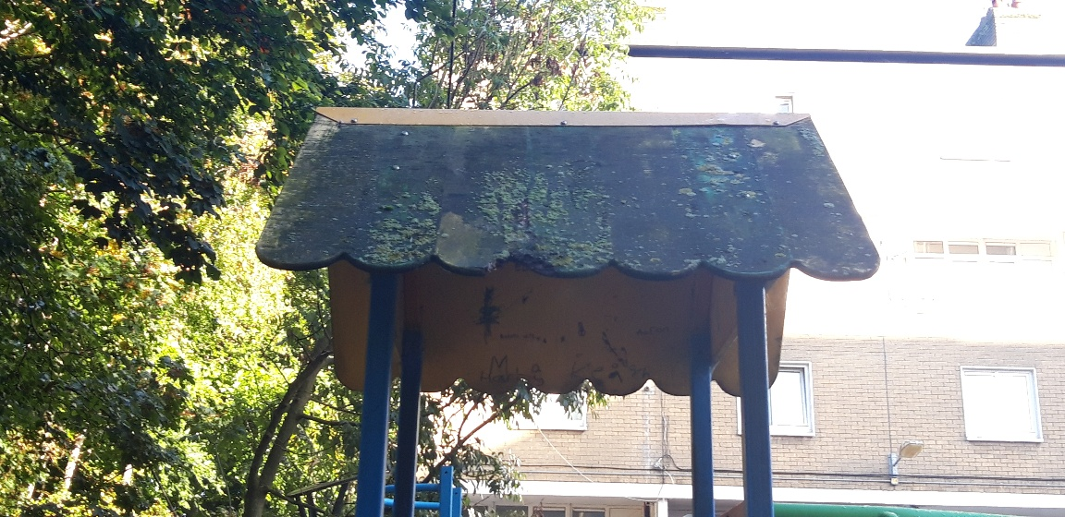

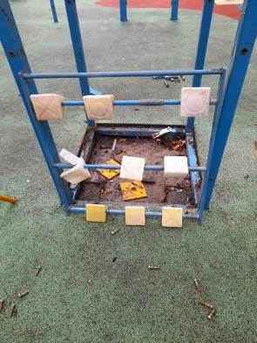

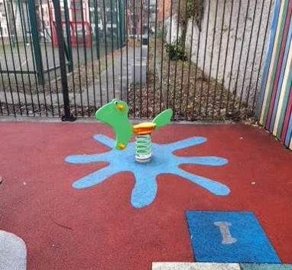
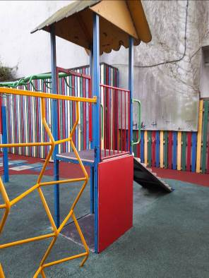

40 Steps Bow Lane Kilmainham
The Area Office Housing team were contacted by the Garda Liaison Officer for St. James Hospital regarding concerns for employees and the public using the steps as access, overgrown bushes and lighting was an issue. In conjunction with Roads Maintenance and the Public Domain Section all the overgrowth on the 40 steps from James St to Bow Lane has been cleared off improving the lighting also.
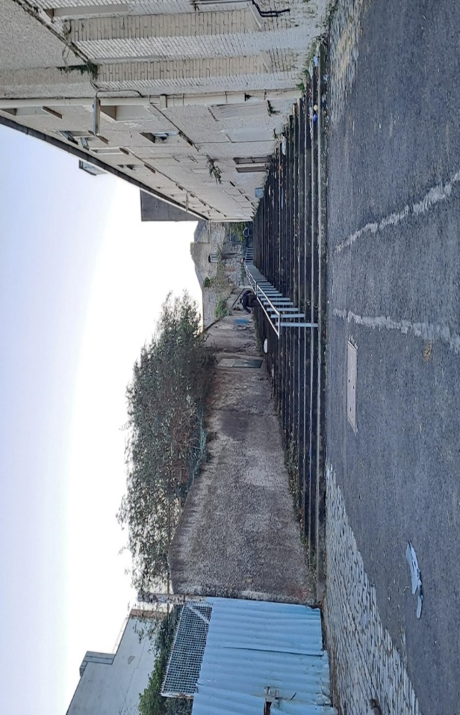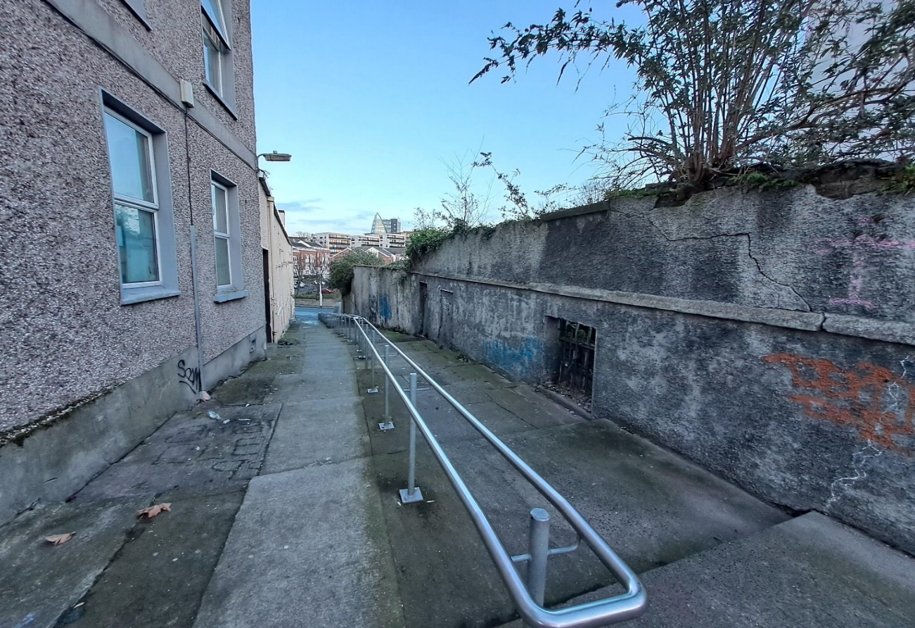

Memorial Court - The painting works have been completed
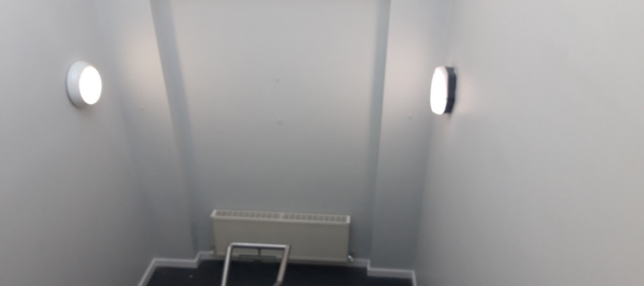
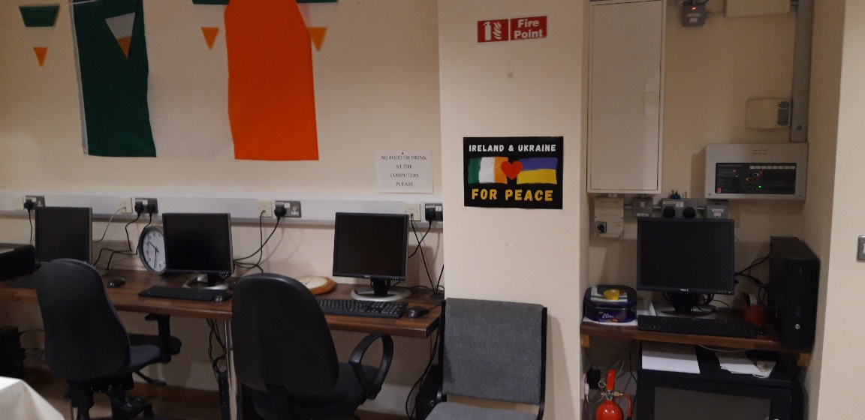
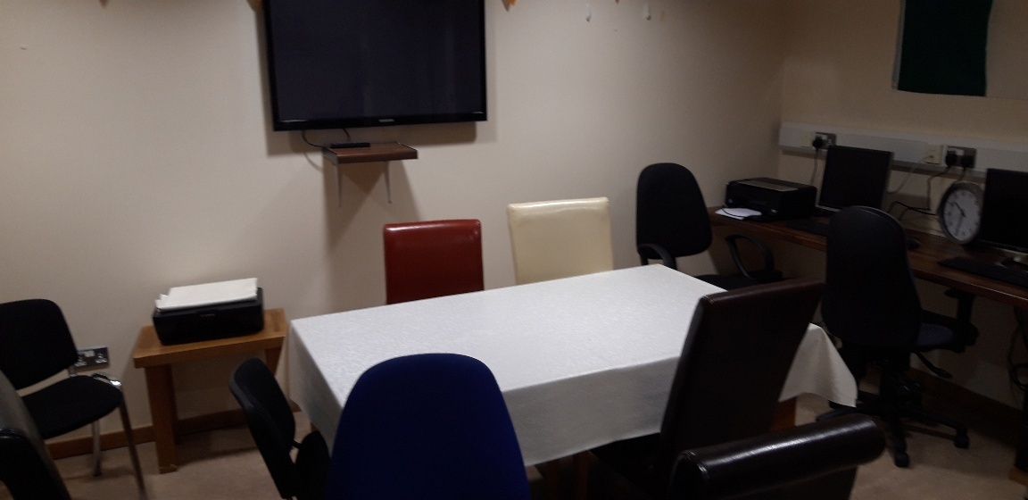

Bowbridge Court
The complete intercom system in block 1 to 24 has to be completely replaced. A new handset with a camera video will be installed in each property and the units at the front entrance will be upgraded.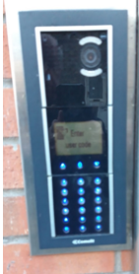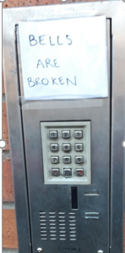
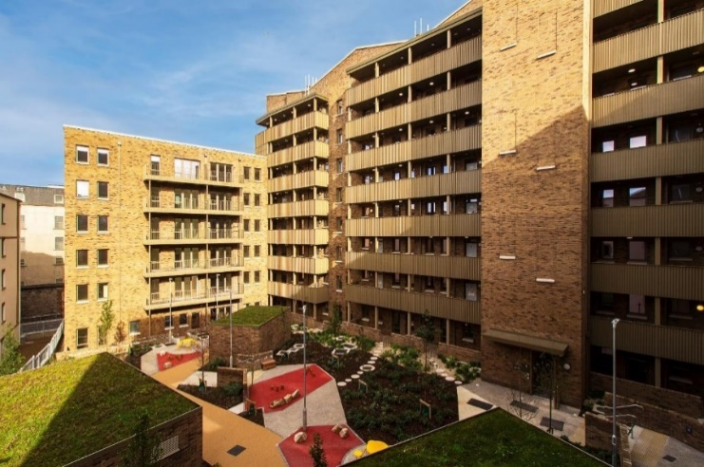

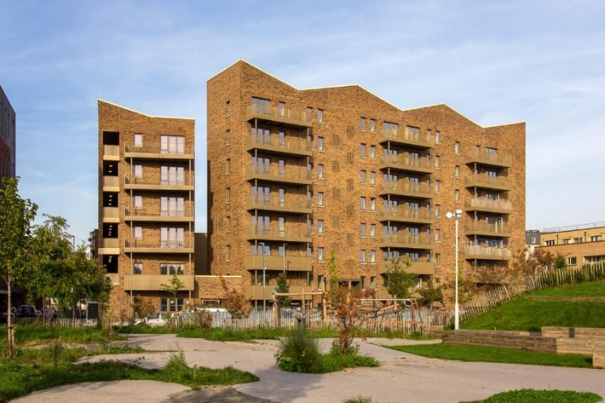

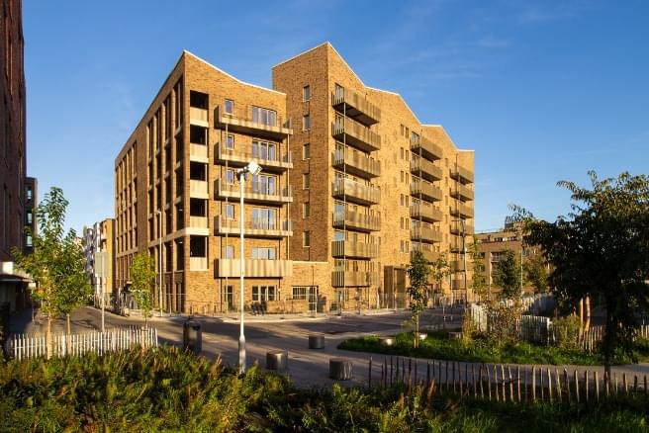

Bonham Court
Bonham Court is almost 95% occupied and allocations are ongoing. The Local area office is coordinating the snagging list between tenants and city architects.
A proposal for additional cameras & CCTV coverage is currently being reviewed. The access code system on the external doors is proving problematic and a new fob system is being examined with a view to having it installed to replace existing system.
It is proposed to run an information evening for the new residents with Housing, Community Section and local services such as Youth Projects, afterschool’s to information on what local resources. Following on from this, would be hoped to then set up a residents group with reps from the 3 blocks.

Weaver/Poplin Place
3 units are left to allocate. The estate management and pre sign up interviews are in progress.
The snagging of the units is ongoing. A proposal for additional cameras and extended CCTV system is currently being reviewed. The access code system on the external doors is proving problematic and a new fob system is being examined with a view to having it installed to replace existing system.

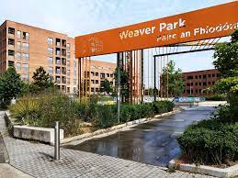
It is proposed to run an information evening for the new residents with Housing, Community Section and local services such as Youth Projects, afterschool’s to information on what local resources. Following on from this, would be hoped to then set up a residents group with reps from both blocks.
School Street/Thomas Court
New bin sheds are to be erected at the complex week starting 19th February 2024. PEO and AHM met with the contractor and agreed on a suitable location for these. All residents have been notified of scheduled works.
St Teresa’s Gardens Site
A lot of illegal dumping has taken place at the site since the New Year. On inspection asbestos was found on site therefore halting cleaning works.
Specialists have removed asbestos on 07/02/2024. A full clean-up of the site has taken place.
Dolphin House
DCC Engineer called out to the estate and is going to arrange for some of the paths to be dished. This is being carried out to provide accessibility for all residents.
Dolphin House New Phase
Roly Poly fencing was fitted to the railings of blocks D1 and D2 (first floor). This was installed to further reduce Anti-Social behaviour in the blocks.
Two Fire doors to be replaced in Block A.
Bulfin Court
New tenant due to move in to one of the bungalows.
Herberton/Reuben
DCC Project Estate Officer holds a weekly clinic in the F2 Centre on Thursday from 10am – 12pm
The clinic is well attended and is a good point of contact for the residents.
Community
St Brigid’s Day
To celebrate St Brigid’s Day Dublin City Council Community Section supported the Liberties Weavers with their exhibition which was hosted by the Pallas Project Studio on Thursday 1st February 5-8p.m. and Friday 2nd February 12- 6p.m
The exhibition centred on the revered figure of Brigid, Celtic goddess of fire, wisdom and creativity.
The celebration was very well attended and showcased the weaver’s talent, skill and insight into their vision of Brigid, with colourful weaving pieces on display.
BERA Hall
Dublin City Council Community Team in conjunction with the Bulfin Estate Residents Association hosted a one man Show the ‘Importance of Being Oscar,’ performed by Michael Judd on Friday 16th February at 7p.m.
The show gave the audience a spirited and entertaining journey from Dublin to Paris via London and New York recounting the wit, triumphs and tragedy of Oscar Wilde, and was very well received by all in attendance.
Love your Heart
The annual Love your Heart Event took place took place on Wednesday 14th February from 10a.m. -2p.m. in St Andrews Community Centre.
As in previous years the event was very well attended with attendees availing of holistic therapies, blood pressure checks by the Irish Heart foundation, defibrillator demonstrations and health information.
International Women's Day
Dublin City Council Community Team are supporting St Andrews Community Centre with their event ‘Sources of Power,’ to celebrate Women’s day on Thursday February 7th 2024 at 7.30p.m.
The event is open to the public and will include, art, dance, music, poetry and talks, showcasing the many talents, history and diversity of women within the community.
Public Domain
GRAFFITI REMOVAL

Richmond Barracks
BEFORE
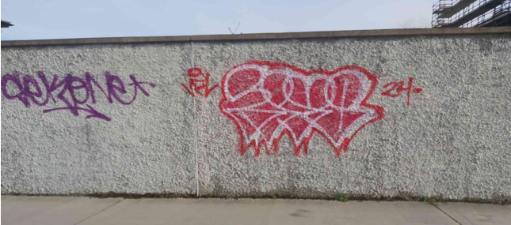

AFTER
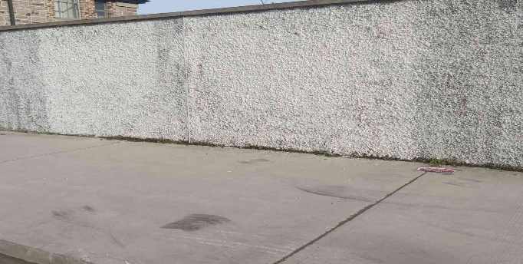

Saint Augustine Street
BEFORE
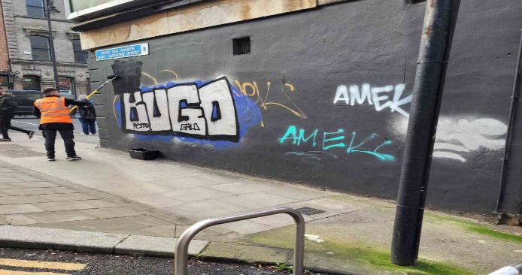

AFTER
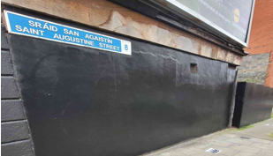

Hanover Lane Arch
BEFORE

AFTER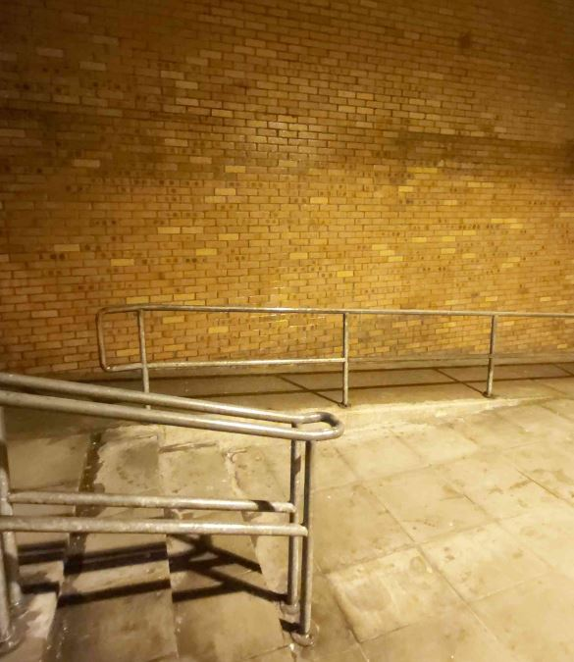

ENVIRONMENTAL IMPROVEMENTS

Projects
Sandra Bell Sculpture- Shrine Lighting Rialto Roundabout
The Civil works are complete and the connection was energized in early February.

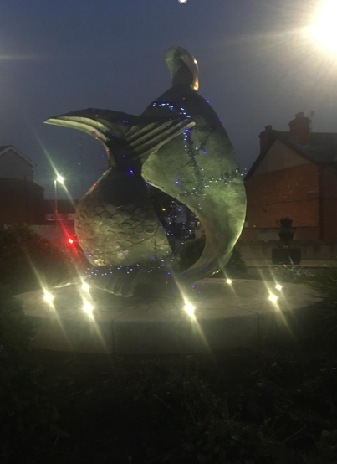

Clean Slate (Bridge Project) Social Enterprise –Environmental Works

The City Council supports local Social Enterprises –some of the works completed this month.

Patriots Path (Emmet Road)
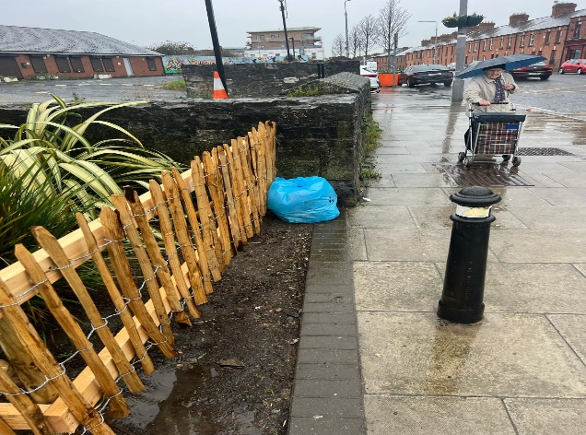

The Team Dublin Clean-Up

The Team Dublin Clean-up will take place on the 27th April 2024 from 11am to 1pm.

To make it extra special, Dublin City Council are calling on all volunteer groups to come out at the same time on the same day to help to clean-up Dublin City. Let’s get together to clean-up our streets, laneways, and canal walks and make Dublin a Fair City again.

April is also the month when the National Spring Clean 2024 takes place. Groups that register with an Taisce will be covered by their insurance for any clean ups done during the National Spring Clean. When registered it will also cover groups while they participate in The Team Dublin Clean-Up on Saturday the 27th of April.

All groups that participate in this year’s Team Dublin Clean-Up will automatically be entered in the City Neighbourhoods Competition 2024, and could be in with a chance to win €1,000.

Register for the National Spring Clean with An Taisce online by clicking here https://nationalspringclean.org/

WASTE MANAGEMENT REPORT
29 Community Clean-up bag collections requested across South Central Area
379 Illegal Dumping Requests actioned
82 Street Cleaning Requests actioned
34 public litter bin maintenance requests actioned
13 Report Fallen Leaves

Swan Alley Deep Clean
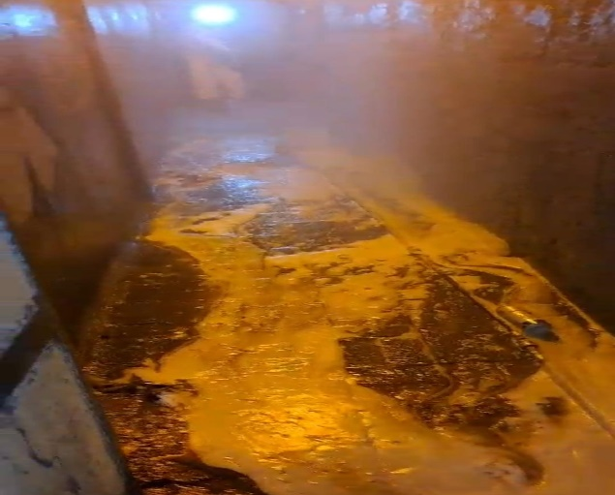
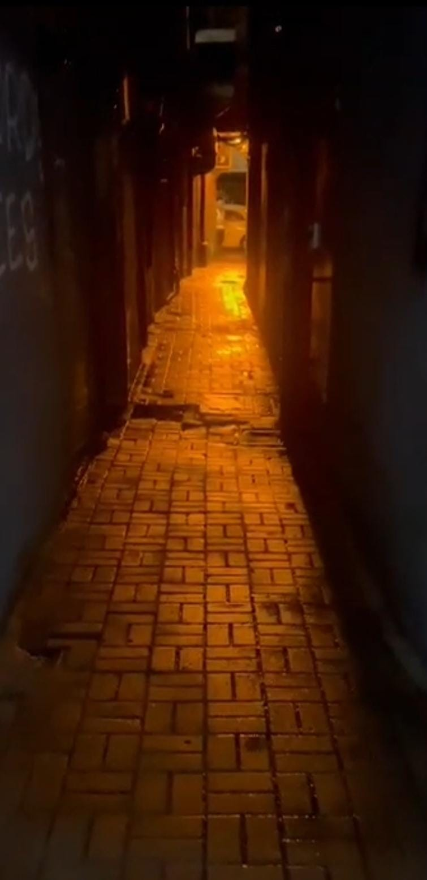

Market Street (Guinness Storehouse)
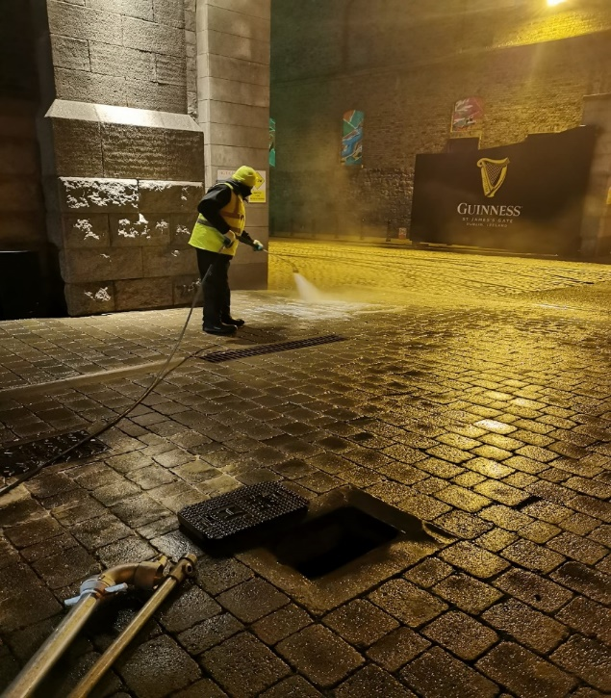
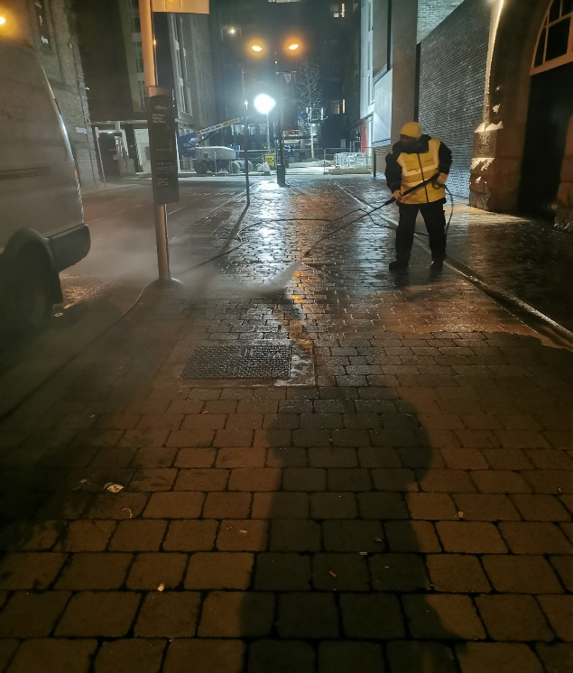
Wilson Terrace and Jame’s Walk
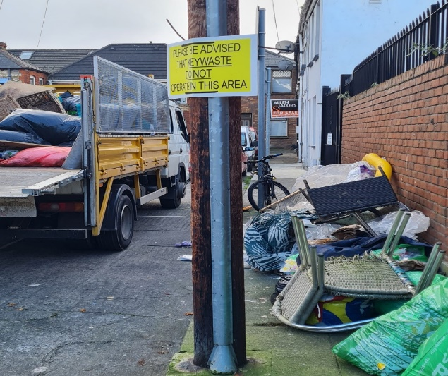
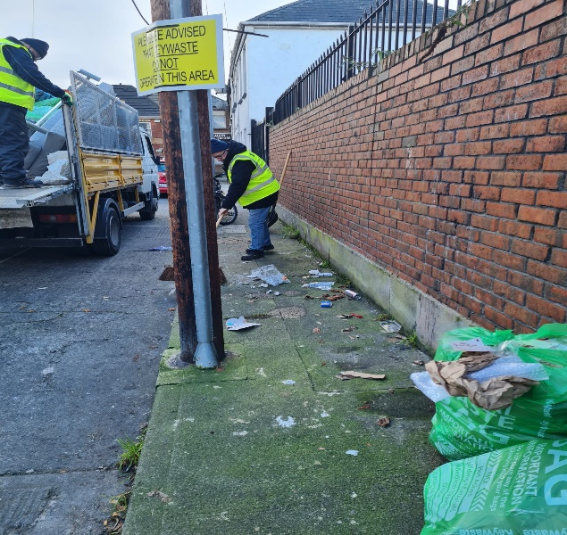
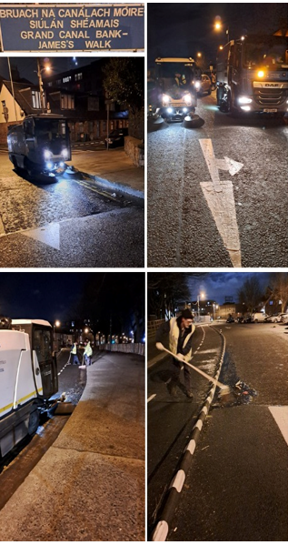
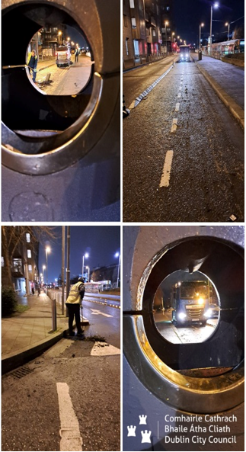

BALLYFERMOT DRIMNAGH ELECTORAL AREA
Housing
Elanora Court
A number of applicants have signed their tenancy agreements and are in the process of moving into their new homes.
Springvale
All successful applicants have been notified and the vetting process is underway. The snagging of the properties is continuing.
Bluebell
The LDA launched the regeneration website on Friday, 16th at an event attended by representatives of the local community groups Further communication will be aimed at the wider community over the coming months.
Lissadel
The aim is to have the conditional surveys of the properties undertaken by the end of Q1 2024, an additional works programme will be developed on the basis of that information.
Sons of Divine Providence
A draft agreement in relation to title exchange is currently being reviewed by a number of Council departments and is likely to take a number of weeks, after which it will be referred to the City Architects for further negotiation with the Sons of Divine Providence. It is still the aim to convene a meeting of the steering group at the end of quarter 1 2024.

Cherry Orchard
Site 1 of the Local Area Plan:
The door-to-door surveying of 400 local non-home owners is underway and continuing.

Site 2 of the Local Area Plan:
Work is continuing in relation to the preparation of the technical design for the project with the public consultation likely to take place in early March
Site 4 of the Local Area Plan:
The planning application for this development is with an Bord Pleanala and the deadline for submissions has passed. The outcome of the application will be reported to the members when it is known. However, it could take up to 6 months for the Bord to carry out its deliberations.
Labre Park
As stated previously the soil testing will take place by the end of quarter 1 2024 and the steering group will continue to meet on a quarterly basis.

The following is a summary of the vacant units in the Ballyfermot Drimnagh area.

Property Type
House | 44
Maisonette | 3
Apartment | 10
Senior Citizens | 19
Total | 76

Type | Location | Bedrooms | Vacant possession date | Status | Estimated Completion date/Status
House | CHERRY ORCHARD GREEN | 2 | N/A | Awaiting vacant possession | N/A
House | CHERRY ORCHARD GROVE | 3 | N/A | Awaiting vacant possession | N/A
House | CROFTWOOD GARDENS | 2 | N/A | Awaiting vacant possession | N/A
House | CROFTWOOD GARDENS | 3 | N/A | Awaiting Vacant Possession | N/A
House | CROFTWOOD PARK | 3 | N/A | Awaiting Vacant Possession | N/A
House | ELMDALE DRIVE | 2 | N/A | Awaiting Vacant Possession | N/A
House | ROSSMORE ROAD | 3 | N/A | Awaiting Vacant Possession | N/A
House | BALLYFERMOT ROAD | 4 | 01/09/2023 | Issued to Contractor | 08/02/2024
Apartment | BALLYMOUNT SQUARE | 2 | 08/05/2023 | Issued to Contractor | 30/11/2023
House | BARNEVILLE PARK | 1 |  | Tenant selected - AGS checks being carried out
Apartment | BERNARD CURTIS HOUSE | 1 | 15/01/2024 | For framework | TBC
Apartment | BERNARD CURTIS HOUSE | 2 | 06/08/2023 | Issued to Contractor | 13/02/2024
Apartment | BERNARD CURTIS HOUSE | 1 |  | Offer refused - New nominee being checked through AGS
House | BENMADIGAN ROAD | 2 | 04/07/2023 | Issued to Contractor | 07/02/2024
Senior Citizens | BLACKDITCH COURT | 1 | 21/02/2023 | Offer refused - New nominee to be selected
Senior Citizens | BLACKDITCH ROAD | 1 |  | Tenant selected
Senior Citizens | BLACKDITCH ROAD | 1 | 05/07/2023 | Issued to Depot | 13/02/2024
House | BLUEBELL AVENUE | 3 | 23/06/2023 | Issued to Contractor | 04/12/2023
House | CHERRY ORCHARD AVENUE | 4 | 16/08/2023 | Issued to Contractor | 10/02/2024
House | CHERRY ORCHARD GREEN | 2 | 13/09/2023 | Issued to Contractor | 16/02/2024
Senior Citizens | CLADDAGH COURT | 1 | 26/11/2023 | Issued to Depot | 26/01/2024
Senior Citizens | CLADDAGH COURT | 1 | 24/09/2023 | Issued to Depot | 08/01/2024
Senior Citizens | CLADDAGH COURT | 1 | 27/09/2023 | Issued to Depot | 12/01/2024
House | CLIFDEN DRIVE | 3 | 19/10/2023 | Issued to Contractor | 05/02/2024
House | CLIFDEN DRIVE | 3 | 01/09/2023 | Issued to Contractor | 05/02/2024
House | CLOVERHILL ROAD | 3 | 13/09/2023 | Issued to Contractor | 13/02/2024
House | COMERAGH ROAD | 2 | 10/07/2023 | Issued to Contractor | 10/02/2024
House | COMERAGH ROAD | 2 | 21/11/2023 | For framework | 10/02/2024
House | COLEPARK AVENUE | 3 | 22/01/2024 | Acquisition | TBC
House | CROFTWOOD DRIVE | 3 | 12/09/2023 | Issued to Contractor | 10/02/2024
House | CROFTWOOD GARDENS | 2 |  | CBL closing date 8/12/23
House | CROFTWOOD GARDENS | 4 | 28/07/2023 | Issued to Contractor | 28/02/2024
House | CROFTWOOD PARK | 3 | 22/08/2023 | Tenant Selected | 07/02/2024
Apartment | DAVITT HOUSE | 0 | 21/02/2023 | Issued to Contractor | 03/03/2024
Apartment | DAVITT HOUSE | 0 | 25/11/2023 | Issued to Depot | 10/02/2024
Apartment | DAVITT HOUSE | 0 | 20/09/2023 | Issued to Depot | 09/02/2024
Apartment | DAVITT HOUSE | 0 |  | Offer refused - new tenant selected
House | DRUMFINN AVENUE | 3 | 20/10/2023 | For Framework | 29/02/2024
House | DRUMFINN AVENUE | 2 | 25/09/2023 | For Framework | 30/01/2024
House | ERRIGAL ROAD | 3 | 15/08/2023 | Issued to contractor | 15/02/2024
Senior Citizens | FATHER KITT COURT | 1 |  | Awaiting keys
Senior Citizens | FATHER KITT COURT | 1 | 18/01/2024 | Issued to Depot | TBC
Senior Citizens | FATHER KITT COURT | 1 | 18/09/2023 | Issued to Depot | 09/02/2024
Senior Citizens | FATHER LEMASS COURT | 1 | 20/06/2023 | Issued to Depot | 13/02/2024
Senior Citizens | FATHER LEMASS COURT | 1 | 29/06/2023 | Issued to Depot | 13/02/2024
Senior Citizens | FATHER LEMASS COURT | 1 |  | Tenant selected | 08/01/2024
House | GALTYMORE ROAD | 3 | 03/10/2023 | Issued to Contractor | 17/02/2024
Maisonette | HUBAND ROAD | 2 |  | Tenant Selected
House | KILWORTH ROAD | 2 | 28/06/2023 | Issued to Contractor | 07/02/2024
Apartment | KINGS HALL | 1 | 19/10/2023 | For framework | 01/03/2024
House | KNOCKMAREE | 3 |  | Temporary maintenance let
House | KYLEMORE ROAD | 2 | 14/07/2023 | Issued to Contractor | 08/02/2024
Senior Citizens | LA TOUCHE COURT | 1 | 20/09/2023 | Issued to Depot | 09/02/2024
Senior Citizens | LA TOUCHE COURT | 1 |  | Issued to Depot | 09/02/2024
House | LANDEN ROAD | 3 | 10/01/2024 | For framework | TBC
House | LANDEN ROAD | 3 | 28/08/2023 | Issued to Depot | 08/02/2024
House | LANDEN ROAD | 3 | 24/05/2023 | Issued to Depot | 08/02/2024
House | LANDEN ROAD | 2 | 01/09/2023 | Issued to Contractor | 07/02/2024
House | LANDEN ROAD | 2 | 18/07/2023 | Issued to Contractor | 29/02/2024
Maisonette | LISSADEL ROAD | 3 |  | Issued to Contractor | 29/03/2024
Maisonette | LISSADEL ROAD | 2 |  | Issued to Contractor | 29/03/2024
House | LE FANU ROAD | 3 | 28/07/2023 | Issued to Contractor | 07/02/2024
House | O'DWYER ROAD | 3 | 25/05/2022 | Legal issue with boundary
House | ORANMORE ROAD | 3 | 12/12/2023 | For framework | 29/03/2024
House | ORANMORE ROAD | 2 | 03/12/2023 | For framework | 29/03/2024
House | ORANMORE ROAD | 3 | 12/06/2023 | Issued to Contractor | 08/02/2024
Senior Citizens | RIVER VIEW COURT | 1 | 09/10/2023 | Issued to Depot | 08/01/2024
Senior Citizens | RIVER VIEW COURT | 1 | 20/07/2023 | Issued to Depot | 08/01/2024
Senior Citizens | ROSSAVEAL COURT | 1 |  | Issued to Depot | 25/02/2024
Senior Citizens | ROSSAVEAL COURT | 1 | 03/12/2023 | Issued to Depot | TBC
Senior Citizens | ROSSAVEAL COURT | 1 | 09/10/2023 | Issued to Depot | TBC
Apartment | Seven Oaks | 1 | 26/10/2023 | Issued to Contractor | 06/02/2024
House | THOMOND ROAD | 2 | 02/08/2023 | Issued to Depot | 10/02/2024
House | WALKINSTOWN AVENUE | 4 | 03/08/2023 | Issued to Contractor | 08/02/2024
House | WALKINSTOWN DRIVE | 4 | 20/12/2023 | For Framework | TBC
House | WALKINSTOWN PARADE | 2 | 05/09/2023 | Issued to Contractor | 08/01/2024

Community

Community Participation

Community Festivals
The Cherry Blossoms group are up and running and are planning a month long programme of events to celebrate all that is good in Cherry Orchard. The programme will be launched by the Lord Mayor Cllr. Daithi De Róiste on Tuesday 19th March in St. Ultans School at 12:30.

The committee meet every Wednesday at 10:30AM in the equine centre and all local organisations and voluntary groups have been encouraged to organise an event.

Ballyfermot Festival: The Council is working with the Ballyfermot Cherry Orchard Festival committee who will hold their first public meeting of 2024 on Tuesday 13th February at
7:00PM in the Ballyfermot Civic Centre to put in place a steering committee to co-ordinate this year’s event.

Seachtain Na Gaeilge
The City Council is supporting Coiste Bhaile Thormaid to organise a programme of events to promote Seachtain Na Gaeilge. Events will include:

Scoileanna:
- Tráth na gCeist,
- Ceilí,
- Scríobh Leabhair,
- Ceolchoirm,
- Postaeir le Seanfhocail,
- Rince

Ongoing Events in the Community:
- Caife Glic gach Máirt 10.30 -12.30
- Cómhrá Gaelach gach 2nd Déardaoin 6.30 -8.30
- Conradh na Gaeilge in Inchicore – Cómhrá gach Máirt

Sheltered Housing Complexes
During the months of February and March the City Council will be holding meetings with residents from the sheltered housing complexes to re-establish committees in the complexes where necessary and to organise a programme of events. Community Staff are working with the older peoples groups to once again encourage activities in the common rooms.

The City Council is working with the residents in Camac Park to install a commemorative stone at the entrance to the park. This will also involve support to organise a celebratory event to mark the unveiling of the 100 year commemorative stone.

Environment

The closing date for applications for the Community Climate Action Program (CCAP) is March 6th to support groups with their applications a workshop will be held on Thursday 15th February at 7.00 PM in the Ballyfermot Community Civic Centre. There will be the option for participants to attend online. This workshop will focus on providing support for groups to address any issues that may arise and submit comprehensive applications.
Further details on the programme are available dean.eaton@dublincity.ie or
https://citizenhub.dublincity.ie/service/Climate_Action_Fund_Strand_1

Social inclusion

Grant information
The latest edition of the Dublin City Focussed Funding Point Local Digest is available to download on the Dublin City Council website at https://www.dublincity.ie/residential/improving-my-community/community-grants-and-funding
It provides up to date detailed information and links to sources of local, national and EU funding to which local community groups can apply.
The Community Staff are currently promoting the Community Heritage Grant Scheme 2024 which will open in February for community/voluntary and not-for-profit organisations to apply for funding for heritage projects. https://www.heritagecouncil.ie/funding/funding-schemes
The Community staff continue to liaise with community and voluntary groups to ensure drawdown of the 2023 community grants.

Cruinniú na nÓg
Community Development Staff are in contact with local groups to encourage their involvement in this year’s Cruinniú na nÓg, the national day of free creativity for children and young people which will take place on Saturday 15th June 2024 across Dublin City.
All proposals must be submitted by 12:00 noon, Wednesday 21st February 2024.
Further information is available from our Creative Communities Engagement Officer for Dublin City Council: alison.clarke@dublincity.ie

Labre Park Play Area
Community Development Staff are engaged in ongoing work to support B-TAP and DCC Traveller Accommodation Unit and local residents, including children and young people regarding the development of a comprehensive design brief and subsequent tender for Design & Build Proposal for a ‘Play Area’ at Labre Park. Following appointment of a preferred tenderer, the proposed date for completion of overall project is approximately end of Q2 2024.

AGE Friendly Programme
The Spring Age-Friendly Activity Programme for Walkinstown/Drimnagh/Bluebell and Linkage is currently being developed and is due to commence in Mid-February 2024.
WSAF Moeran Road Hall and Fr Kitt Common Room Committees have agreed to participate in joint initiative where activities at both venues will be made available to the wider community and in particular those living at Fr Kitt Court.

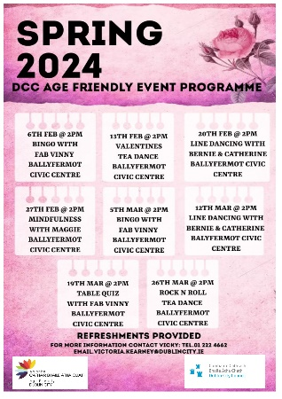
The Age Friendly Programme of events for the Ballyfermot area began on Tuesday 6th February and will run every week until Tuesday 26th March. Activities range from Bingo, Line Dancing, table quiz and two themed tea dances (Valentines and Rock n Roll). We are also including a new Mindfulness afternoon, which was suggested by the participants.

Together FM in partnership with the Dublin City Community Development Team are also delighted to host two films Casablanca which took place on Thursday 8th February and Darby O’Gill and the Little People on Thursday 14th March @ 11:00am in the Ballyfermot Civic Centre.
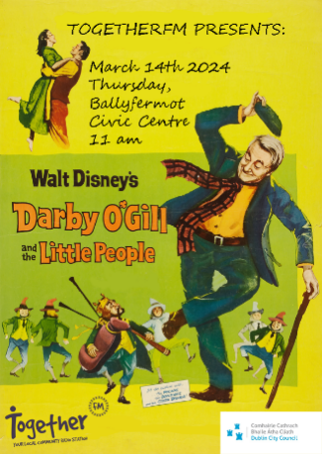

During February and March the Lord Mayor will host a series of Afternoon tea events for up to 200 older residents from the Ballyfermot Dementia Choir, Maryfield, Glenaulin and Cherry Orchard Care Centres and groups from Drimnagh, Walkinstown and Bluebell. The older people really enjoy this event and having the opportunity to visit the Mansion House.
The Local Enhancement Programme 2024 is funded by the Department of Rural and Community Development. Minister for Rural and Community Development Heather Humphreys and Minister of State with responsibility for Community Development and Charities Joe O’Brien have today announced €6 million in capital funding under the “Department of Rural and Community Development Local Enhancement Programme 2024”.
Dublin City Council has been allocated €503,189.38
The Programme has a focus on supporting groups in disadvantaged areas. Typical enhancements under the CEP include:
- IT equipment
- improvements to buildings
- renovation of community centres
- development of community amenities
- purchase of equipment for community usage
- improvements to town parks, common areas and energy-saving projects

The Enhancement Programme will go live on Monday 19th of February 2024, the community team will circulate all the information to the groups and advertise on the social media pages.

Orchard Centre

The new kickboxing club is up and running and the centre continues to support the community regarding uses of space and creative ideas going forward.
We are now back to pre-Christmas levels of use across the week in the building and preparation is underway for Cherry Orchard Blossoms Festival, Summer Projects and Halloween 2024.

On international Women’s Day 8th March the Centre will be used as a polling station for the upcoming referendum.
For the St Patricks Day Parade on 15th March we are delighted to host Lord Mayor De Róiste as Grand Marshall and the Lord Mayor will also join us in April during the Cherry Blossoms Festival for some events and we look forward to welcoming him to the Orchard Centre.

Public Domain
New Public Realm Infrastructure
This is the newly installed, double sided public display cabinet, located on the footpath outside Tesco carpark on the Ballyfermot Road, displaying the Ballyfermot Heritage Group, Heritage Walking Trail & Map Guide, in both Irish & English.
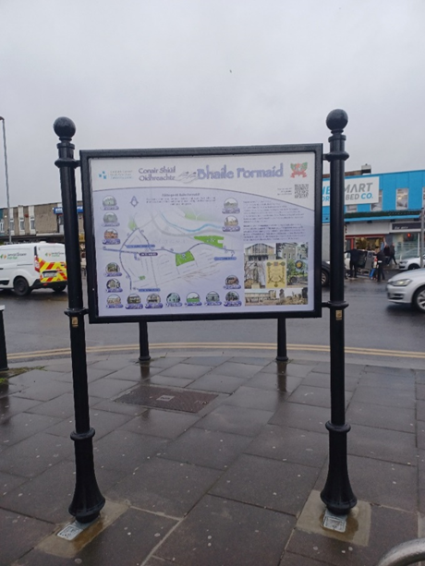
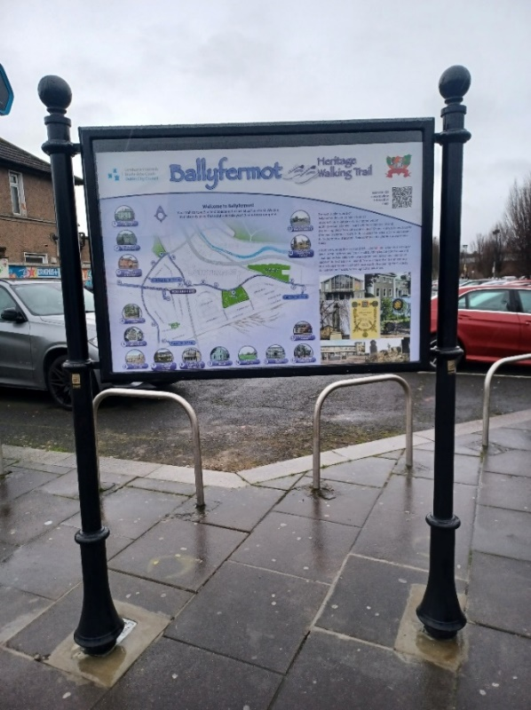

Leaf fall
Following local residents contacting the Public Domain unit, the footpaths on Martin’s Row, Chapelizod were cleared by Waste Management Services to ensure safe passage for members of the public/local residents many of whom are elderly.
Graffiti
The Public Domain Office continue to address the anti-social issue of Graffiti in the area, both by engaging contractors to remove graffiti from public infrastructure/property and by engaging with private property owners, and utility companies such as the ESB, Dublin Bus and EIR to remove graffiti from their infrastructure located in the public realm.
Below are some of the more recent and prominent graffiti removals in the Area:

The Grotto House, Tyrconnell Road
BEFORE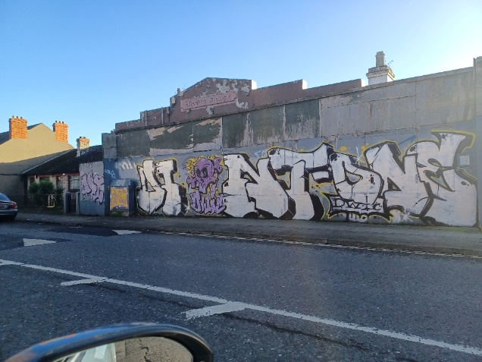
AFTER
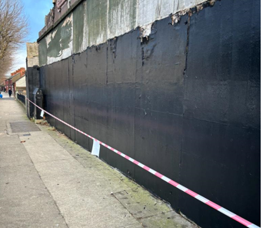

Home Savers, Ballyfermot Road (Gala)
BEFORE
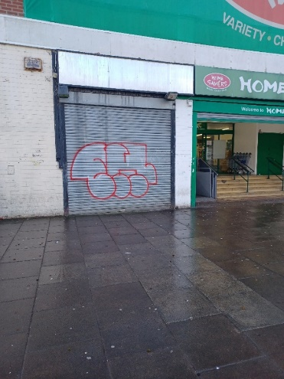

BEFORE
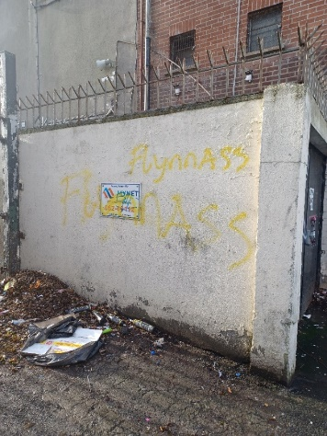

AFTER
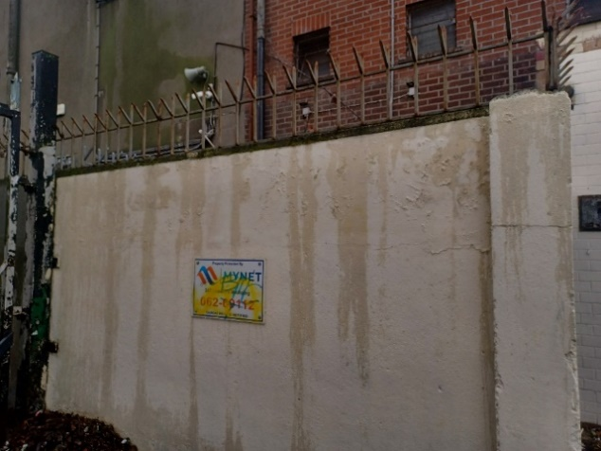

AFTER
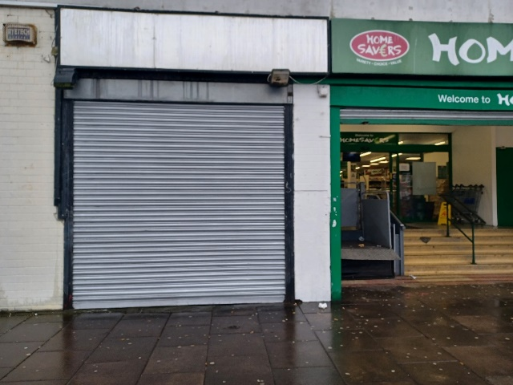

Chapelizod By-Pass Bridge – Which require the hiring of a mobile heist and traffic management to be put in place, to enable these works to be carried out
BEFORE
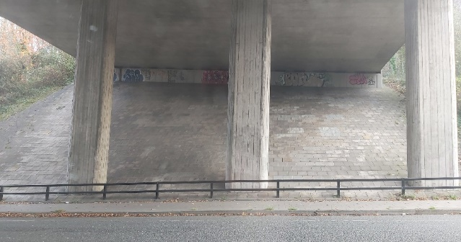
AFTER
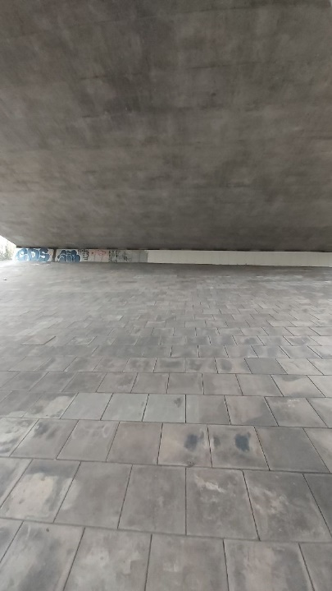
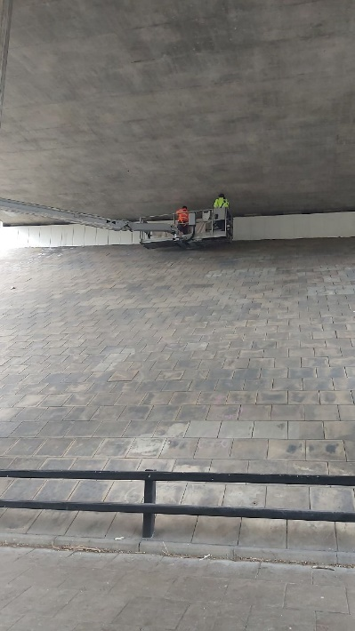
Kileen Bridge - protected structure
BEFORE
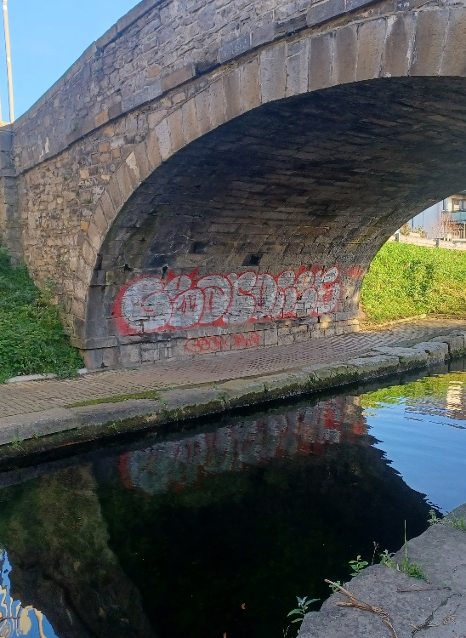
AFTER
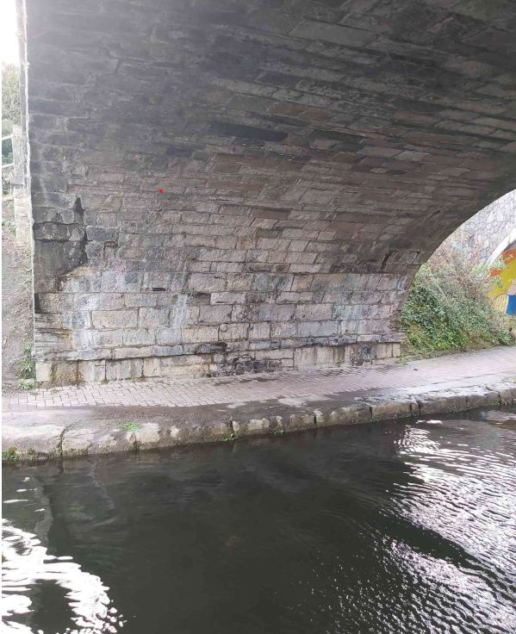

ESB, EIR Infrastructure
Claddagh Rd, Ballyfermot - Runners removed from overhead line attached to ESB pole
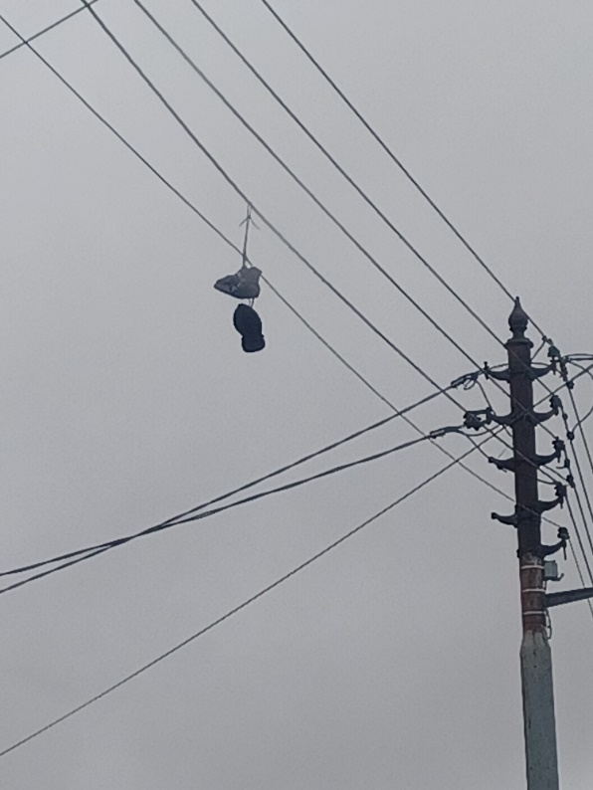
Errigal Road, Drimnagh - Graffiti removed from this ESB pole
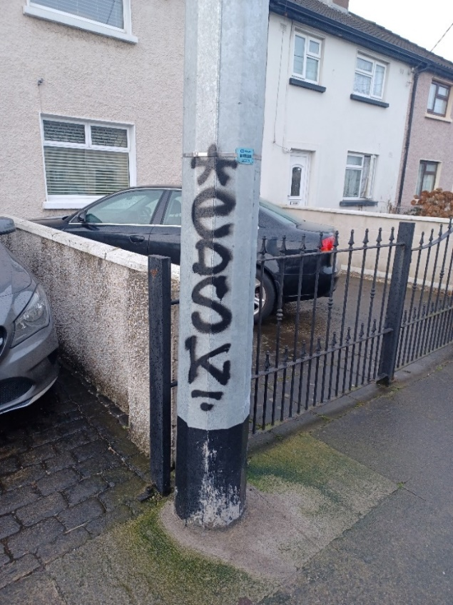

Claddagh Road/ Green - Graffiti removed EIR utility boxes.
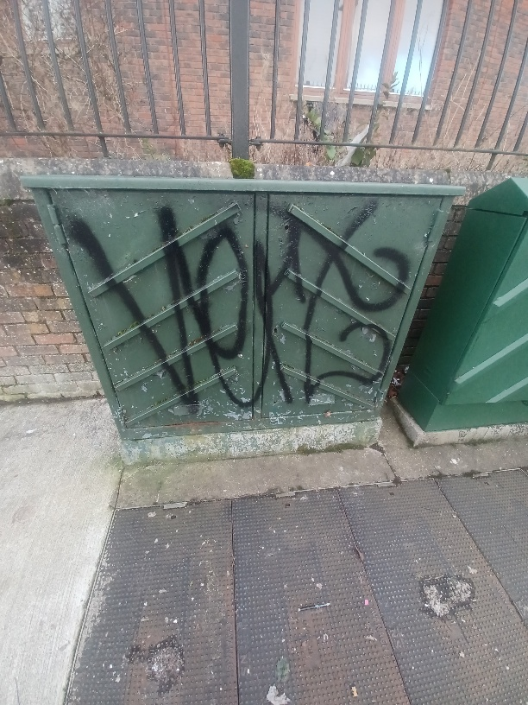

Litter viewable from a public place
On foot of representations, the Public Domain Unit investigated this issue of illegal dumping on private industrial land located beside residential housing on Ballyfermot Road. With the support of the Litter Warden Service, this illegal dumping of tyres and general rubbish was removed, by the owners of the land, at no cost to the City Council.

BEFORE
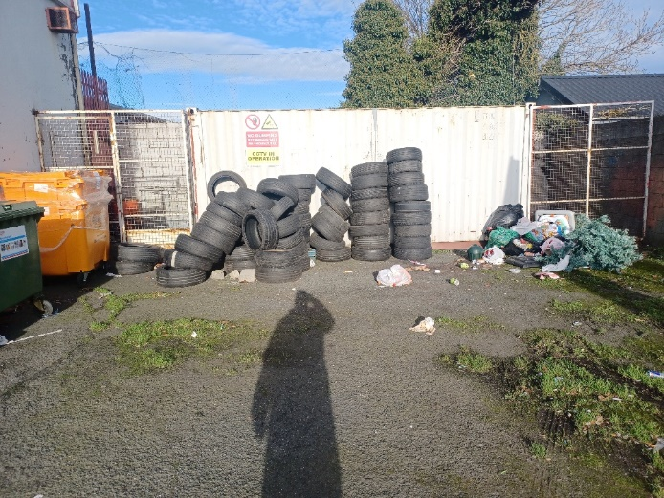
AFTER
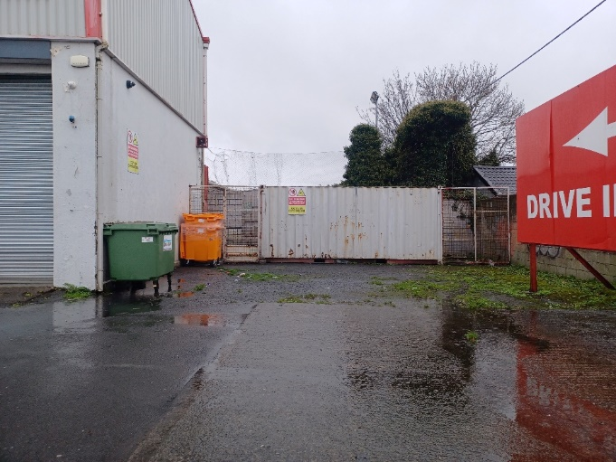
Illegal Dumping– Below images of some recent illegal dumping which occurred in the Area.
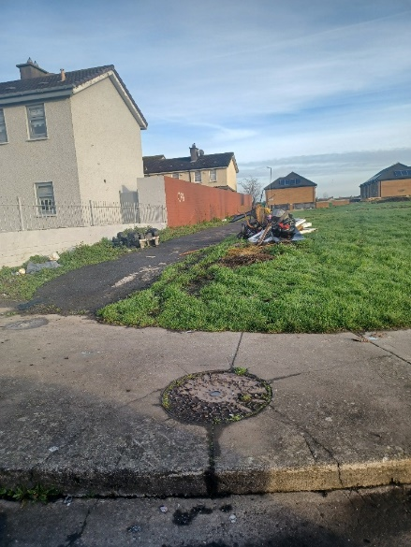

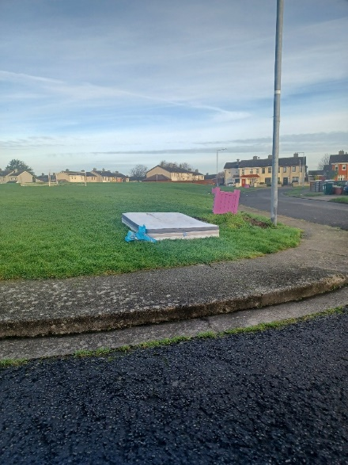
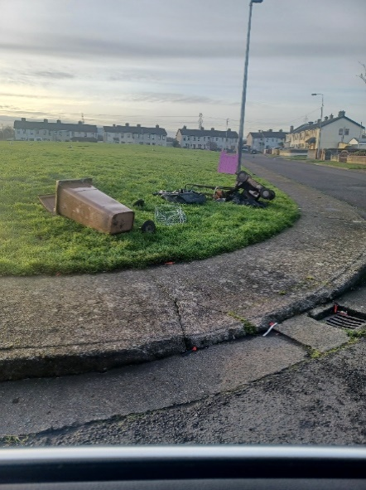

Unfortunately we continue to have a major issue with illegal dumping, particularly people leaving rubbish out on the streets, pavement or grass verges.
Dublin City Council does not provide a domestic or commercial kerbside waste collection service. Below is a list Domestic Waste Operators operating in the Dublin City Council Area.

Company name | Phone | Email
Greyhound | Local: 01 4577777 | info@greyhound.ie
The City Bin Co. | Free phone: 1800 24 89 24 | home@citybin.com
Panda | Local: 01 829 8992
KeyWaste | +353 1 4299846 | info@keywaste.ie
Ecoway | 018748340 | info@ecoway.ie

Under the Dublin City Council Waste Management (Storage, Presentation and Segregation of Household and Commercial Waste) Bye-Laws 2018 there is an obligation to participate in a Waste Collection Service and not present waste to any other person other than an authorised waste collector, under contract or by delivering your waste directly to an authorised waste facility.
Leaving or throwing litter in a public place is an offence. You can get an on-the-spot fine of €150, or a maximum fine of €4,000 if you are convicted in the District Court.
If you continue littering after a conviction, you may be fined up to €600 for every day you continue to litter. If you are convicted of a litter offence, you may have to pay the local authority’s legal costs.
It is an offence to put your household waste in street litter bins. If you do this, you may be prosecuted by the local authority. Burning household waste in your garden or home is also illegal

Dublin City Council do provide a bulky household waste collection service to all households in its administrative area for a nominal fee. This service is for items that are too large to be accepted by the regular waste collection service, e.g. furniture, carpets, bikes and kitchen & bathroom units. Collection charge is €40 for up to 5 items. Please note an additional charge will apply for more than 5 items, €80 for 6-10 items, and €120 for 11-15 items and so on.
All collection charges must be paid in advance before any collection can be arranged.
Requests for a bulky household waste collection can be made on Citizen Hub using the following link’
https://citizenhub.dublincity.ie/service/Bulky_Household_Waste_Collection

If you require assistance with this please contact Dublin City Council's Customer Services Department on 01 222 2222.

Civic Amenity Sites
People can also dispose of their own
household bulky waste items by bringing
them to a Civic Amenity Site. Ballymount
Civic Amenity Site, located in Ballymount
Industrial Estate is approximately only
5km away. Below is a list of rates:

Car (green waste only)
Car & Trailer (green waste only)
Car (general waste)
Car Van/Estate Car/Jeep (general waste)
Car & Trailer (single axle only) general waste
Small Van (Citreon Berlingo, VW Caddy, Nissan Courier, Renault Kangoo, Fiat Doblo, Ford Connect, etc.,)
Maximum Volume: 3.4m³ Excluding High Roof Vehicles
Medium Van: (Renault Traffic, Toyota Hiace, etc,)
Maximum Volume 5.8m³ Excluding High Roof Vehicles
Large Van: (Ford Transit, V.W. Transporter, Mercedes Sprinter, etc.,)

