# **Dublin City Active Travel Network.**

# **Gracefield Road to Vernon Avenue Walking And Cycling Scheme.**

**Plain English Project Summary.**

Document Reference: DCC 21 0009 PEPS 01

Date of Issue: 12th September 2024

Revision: Rev 01

This communication is in plain English, intended for members of the public of all abilities. Its wording, structure, and design are intended to be clear and straightforward so that readers can easily find what they need, understand what they find, and use that information.

# **Overview.**

The Gracefield Road to Vernon Avenue scheme will provide 2.5km of Walking and Cycling Improvements along the route, which has been deemed suitable for active travel measures.

The Gracefield Road to Vernon Avenue Walking and Cycling Scheme will deliver protected cycle lanes in both directions and numerous pedestrian improvements over a length of 2.5km, along Gracefield Road, Brookwood Avenue, Sybill Hill Road and Vernon Avenue.

A non-statutory public consultation took place during July and August last year and this leaflet provides an update on the key design changes since then. There were 802 responses to that consultation. Of those, 60% expressed a positive sentiment towards the scheme proposed; 35% expressed a more negative sentiment; and 5% were neutral.

The design team have taken into account the feedback from the public and where appropriate have amended the designs. Additionally, changes have been made in accordance with the new NTA Cycle Design Manual.

The consultation process has now concluded. Members of the community will be invited to an information event to discuss the scheme with the design team members on September 26th in the Artane Coolock Family Recourse Centre.

**Location**

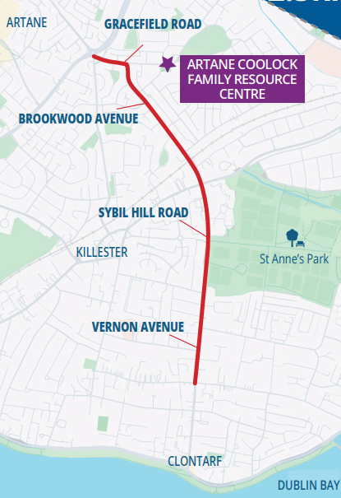

The scheme runs along Gracefield Road, Brookwood Avenue, Sybill Hill Road and Vernon Avenue, which have been identified as suitable roads for active travel measures. A scheme extents map is included illustrating the route as set out above.

This Scheme will deliver 2.5km of protected cycle paths and improved pedestrian facilities along the route.

A map is included indicating the proposed route, set out as described above.

# **Need for the Scheme.**

* Provide a link into adjacent active travel and public transport schemes including; Harmonstown Dart Station, Bus Connects: D and H Spines, S2S East Coast Trail and Baldoyle to Fairview Active Travel Schemes.

* Increased access to amenities: The project will also improve walking and cycling access to Saint Anne’s Park and other community amenities.

* Improve links to numerous education centres along the route including; Saint Paul’s College, Saint Brigid’s National School and Saint Mary’s Holy Faith Catholic School.

# **Benefits of the Scheme.**

* Provide quality, protected cycling facilities to cater for cyclists of all ages and abilities.

* Facilitate a more active lifestyle for all ages bringing multiple benefits for physical and mental wellbeing.

* Contribute to a reduction in transport emissions in line with the objectives of the Climate Action Plan by encouraging a modal shift to active travel use.

# **Key Changes.**

In summary the main changes from the original preliminary designs that were included in the public consultation in 2023 are as follows;

## **Change 1:** Howth Road Junction Improvements.

The existing Howth Road signalized junction is proposed to be upgraded to a protected cycle friendly junction. The right pocket turns will remain. The new design will ensure the junction will continue to operate efficiently for all road users. The upgrade will allow safe passage for people walking and cycling through the junction.

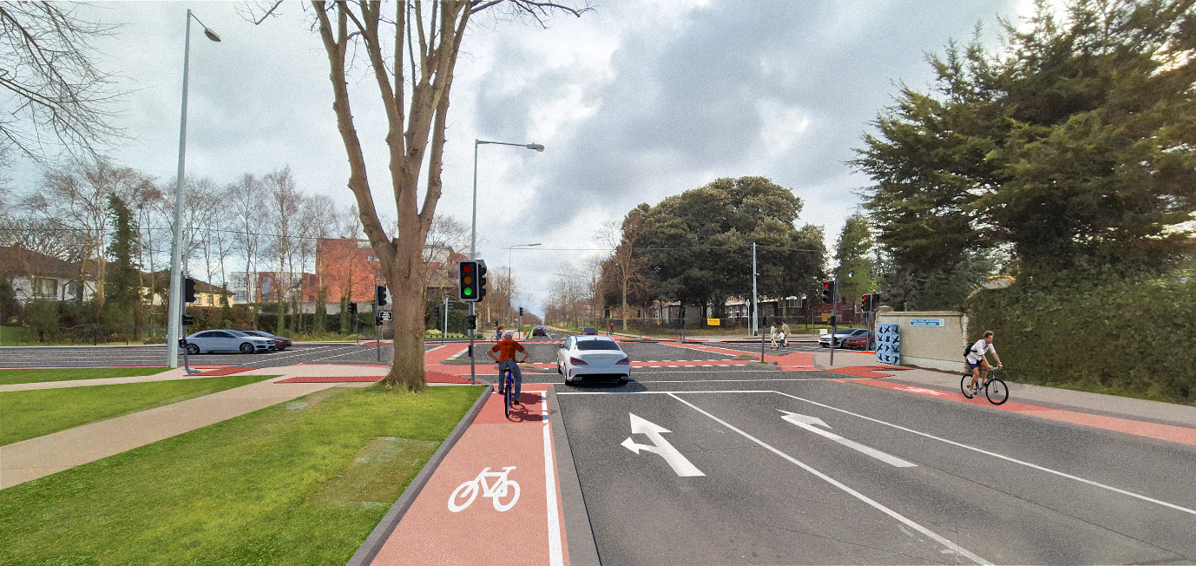

An image is included, the image is a photomontage of the Howth Road / Brookwood Avenue / Sybill Hill Road signalized Junction. The photomontage, taken from Brookwood Avenue facing south, shows a one-way protected cycle track on both sides of the road, and signalized crossings for bicycles and pedestrians.

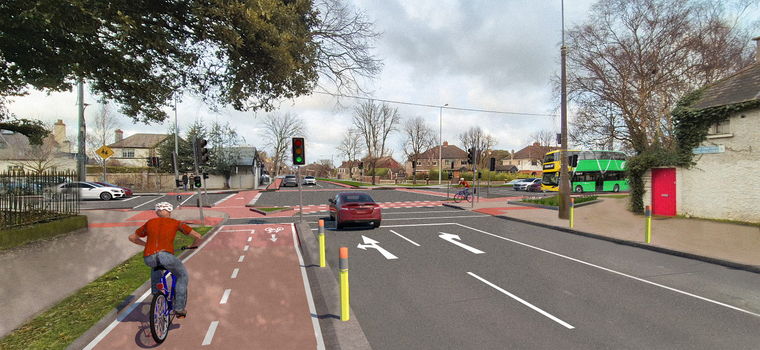

A photomontage image is included to illustrate the Howth Road / Brookwood Avenue / Sybill Hill Road signalized Junction. The photomontage, taken from Sybill Hill Road facing north, shows a two-way protected cycle track on the left side of the road, and signalized crossings for bicycles and pedestrians.

## **Change 2:** Sybill Hill Road Two-Way Cycle Track.

A new two-way cycle track is proposed on the western side of Sybill Hill road. The original design proposals consisted of one-way cycle tracks on both sides of the road. The on-street parking will be maintained on the eastern side of the road. The two disabled parking bays located at the Saint Anne’s Park gate of the Sybill Hill Road will be maintained.

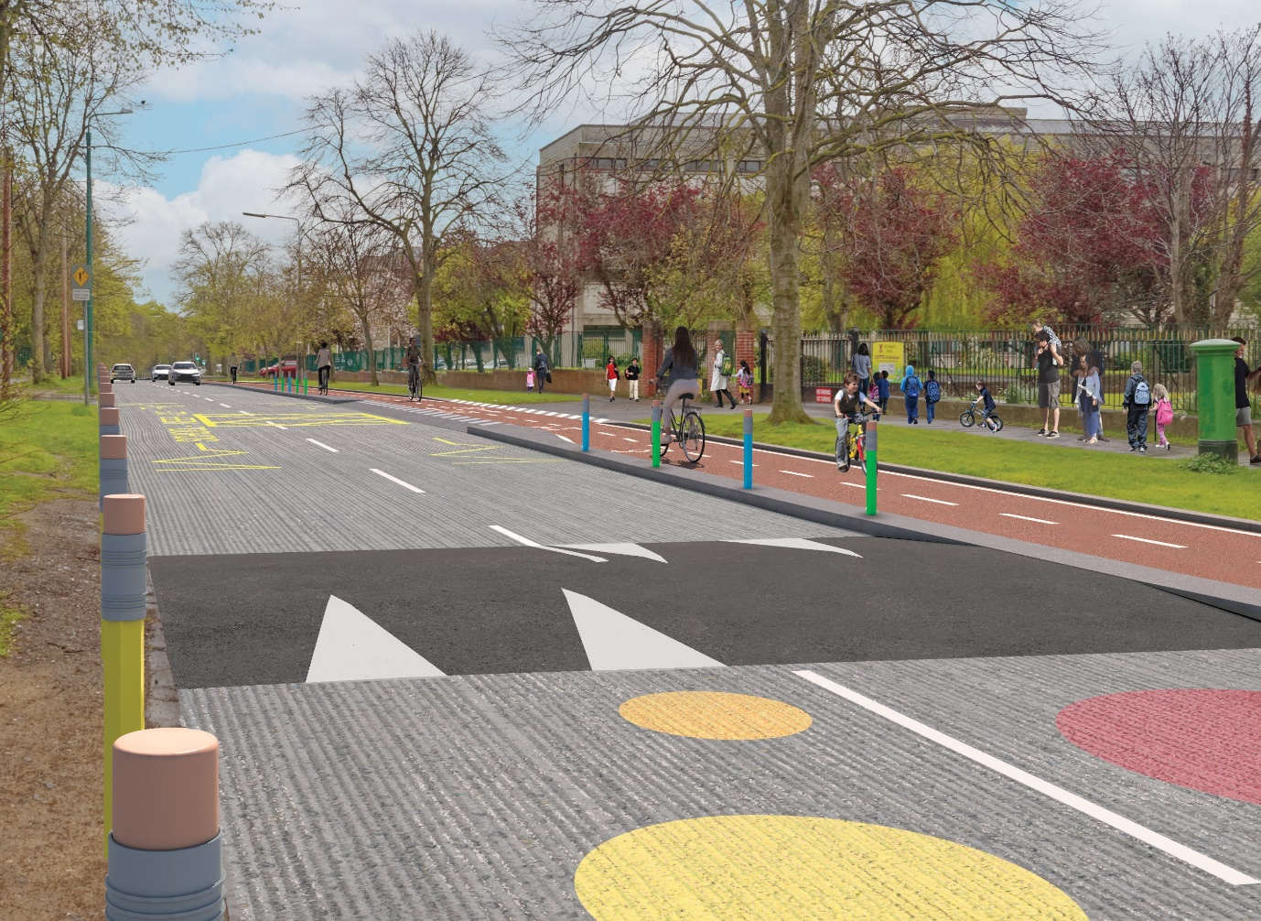

A photomontage image is included of the proposed walking and cycling scheme along Sybil Road facing south, outside of Saint Brigid's Boys' National School. The photomontage shows a two-way protected cycle track on the right hand side with pencil bollards along both sides of the road. The photomontage also shows a speed ramp and school zone road markings along the carriageway.

## **Change 3.** Additional Improvements.

Smaller junctions along the route will be upgraded to improve safety and comfort for pedestrians and cyclists.

Bus Stops along the route have also been modified in line with the NTA Cycle Design Manual.

Additional landscaping and greenery will also be placed along the route.

A public consultation report will outline the responses from Dublin City Council Active Travel Programme Office to the key suggestions / concerns raised during the public consultation.

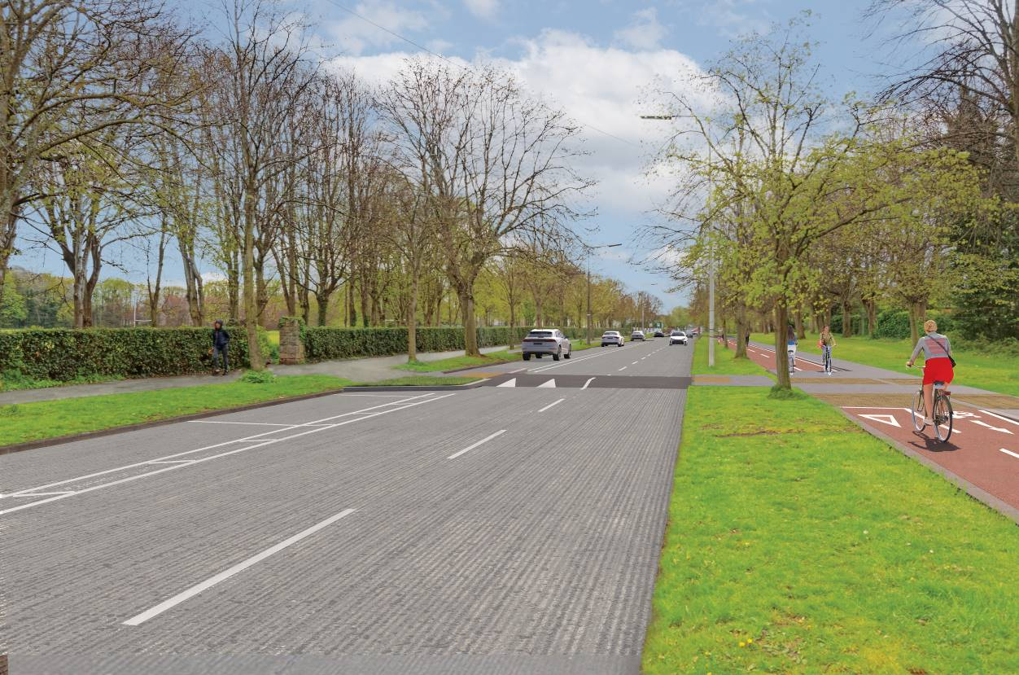

A photomontage image is included to illustrate the proposed walking and cycling scheme along Sybil Road facing south next to the Saint Anne’s Park. The photomontage shows a two-way cycle track on the right hand side separated from the carriageway by a grass verge. On the left hand side, the photomontage shows marked parallel parking bays directly adjacent Saint Anne's Park, and a raised pedestrian crossing.

An image is included below;

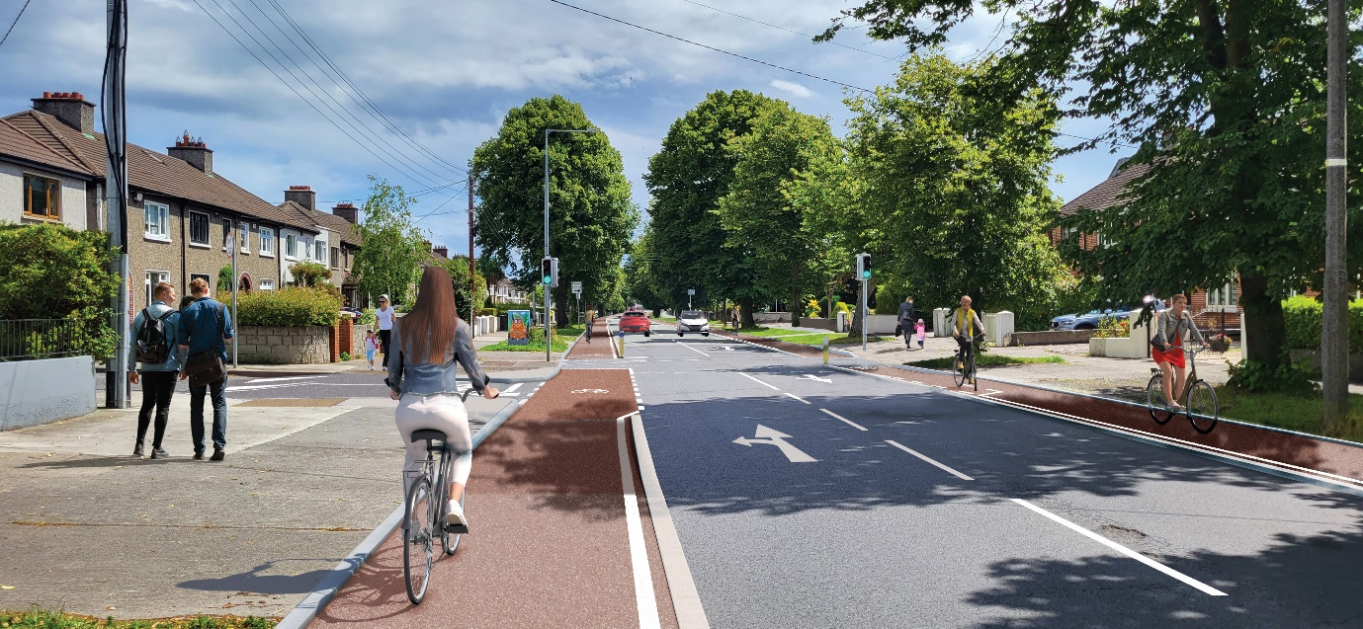

A photomontage image is included to illustrate the proposed walking and cycling scheme at the Brookwood Avenue and Brookwood Grove junction. The photomontage, taken from Brookwood Avenue facing south, shows a one-way stepped cycle track both sides of the road and a signalized pedestrian crossing on Brookwood Avenue.