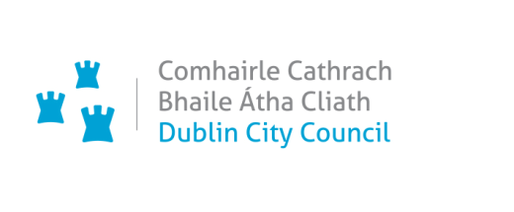
Chief Executive’s Office,
Civic Offices, Wood Quay, Dublin 8.

Oifig an Phríomhfheidhmeannaigh,
Oifigí na Cathrach, An Ché Adhmaid, Baile Átha Cliath 8
T. 01 222 3762 / 0872910633
Email: Shannon.kelly@dublincity.ie | www.dublincity.ie

Ms. Máire Igoe,
A/Executive Manager,
Planning & Property Development Department,
Floor 3 Block 4,
Civic Offices.

08th October 2024
Our Ref: SK/LB1007-9

Dear Máire,

I wish to inform you that Dublin City Council at the Monthly Council meeting held on the 7th of October 2024, having considered Report No. 180/2024 of the A/Assistant Chief Executive (M. Igoe) Park West - Cherry Orchard Local Area Plan, adopted the following resolution:

“That Dublin City Council In accordance with Section 19 (1) (d), (e) & (f) of the Planning & Development Act 2000 (as amended) Dublin City Council notes the opinion of the Chief Executive in Report 180/2024 that the local area plan remains consistent with the objectives and core strategy of the development plan and that the objectives of the local area plan remain to be secured and hereby approves, by resolution the extension of The Park West – Cherry Orchard LAP 2019, and defers the sending of a notice under section 20(3)(a)(i) and publishing a notice under section 20(3)(a)(ii), for a further period of five years to the 4th November 2029.”

The motion was put and carried.

Yours sincerely,

Lorraine Brogan
Meetings Administrator

