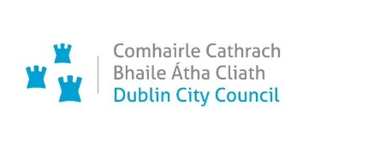

1



**Dublin City Active Travel Network**

**Report on Non – Statutory Consultation**

**Fitzwilliam Quay to Londonbridge Road**

**(Dodder Greenway Route)**

**December 2024**

# TABLE OF CONTENTS

1. TABLE OF CONTENTS 2

2. INTRODUCTION 3

3. CONSULTATION PROCESS 4

4. CONSULTATION RESULTS 6

5. SUBMISSION THEMES AND RESPONSES 8

Theme 1: Pedestrian Safety 8

Theme 2: Removal Of On Street Parking 8

Theme 3: Shared Space 9

Theme 4: Access/Egress Concerns at Pumphouse Apartments 9

Theme 5: Green Space 10

Theme 6: Connectivity 10

Theme 7: Method of Segregation 11

Theme 8: Drainage 11

Theme 9: Heritage 11

Theme 10: Junction Design 12

Theme 11: Trees 12

6. CONCLUSION AND NEXT STEPS 12

Planning Determination 13

Appendix A: Promotion of Public Consultation and Public Information Session 14

# INTRODUCTION

Dublin City Council’s (DCC’s) Active Travel Network will enhance quality of life by connecting people through the delivery of a walk-wheel-cycle network. This will be achieved by improving access, connectivity and sustainable mobility. The Network will also contribute to the reduction of transport-related carbon emissions. Over the lifetime of the programme, the Active Travel Network will grow from 10km to a connected network of 310km across the city.

Fitzwilliam Quay to Londonbridge Road has been identified as a suitable location for rapid build measures along the Dodder Greenway corridor. It will provide 0.5km of walking and cycling facilities from Fitzwilliam Quay to Londonbridge Road. When complete, the project will deliver high quality walking and cycling facilities along the Dodder River from the sea to the mountains through DCC, Dún Laoghaire Rathdown County Council and South Dublin County Council.

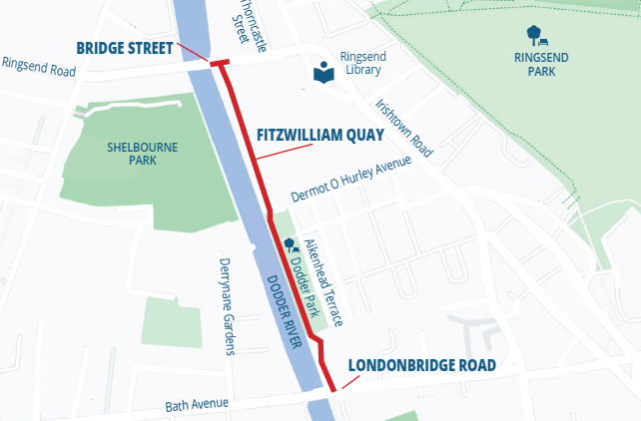

Figure 1: Fitzwilliam Quay to Londonbridge Road

This scheme intends to provide an active travel link along the Dodder River and into future cycle and public transport schemes. The overall aim is to improve walking and cycling facilities for the local communities, including people of all ages and abilities, facilitating a modal shift towards more sustainable modes for commuting and leisure.

# CONSULTATION PROCESS

A non-statutory public consultation was held to obtain people’s views on the Dodder Greenway-Fitzwilliam Quay to Londonbridge Road Section. The purpose of the consultation was to inform the public of the key features of the scheme and to gather any comments or observations they may have, to better inform the decision-making process for the implementation of the scheme.

This consultation consisted of the following:

* Online public consultation via DCC’s Consultation Hub for 5 weeks, from Monday 29th May 2023 to Friday 30th June 2023
* Information leaflets distributed to 2,071 houses and apartments in the vicinity of the route
* Drawings available to view in hard copy format in Ringsend Library, Fitzwilliam Street, Dublin 4 for the during of the consultation period.
* Public information event held on 15th June in Sandymount Community Centre to provide the public with an opportunity to meet the project team and discuss the proposals
* Awareness raising via social media across DCC’s social media channels (X(Twitter), Facebook, LinkedIn and Instagram)
* Information circulated through Newspaper Advertisement, Press release and FAQs on DCC website

The methods by which the public could make submissions on the consultation were via the DCC Consultation Hub through an online questionnaire and comment form, or alternatively by email or post. Submissions were also accepted on June 15th at the Public Information event.

Following the public consultation, detailed design drawings have been prepared and the design has been modified where appropriate, taking into account the feedback from the public. Once approval and funding are obtained from the National Transport Authority, a contractor will be procured and the scheme installed.

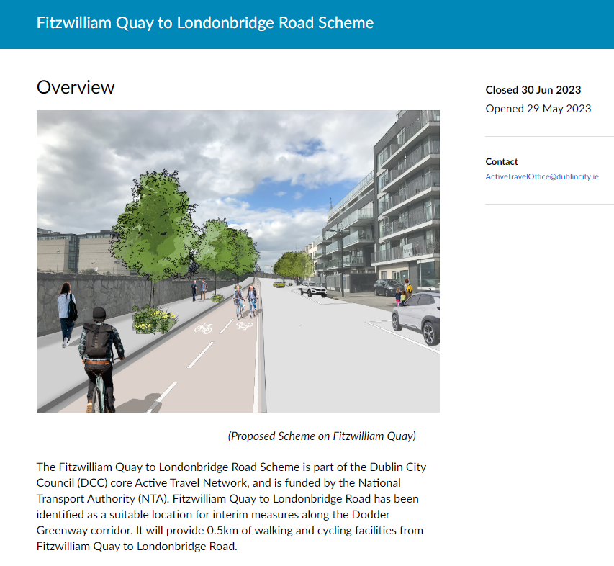 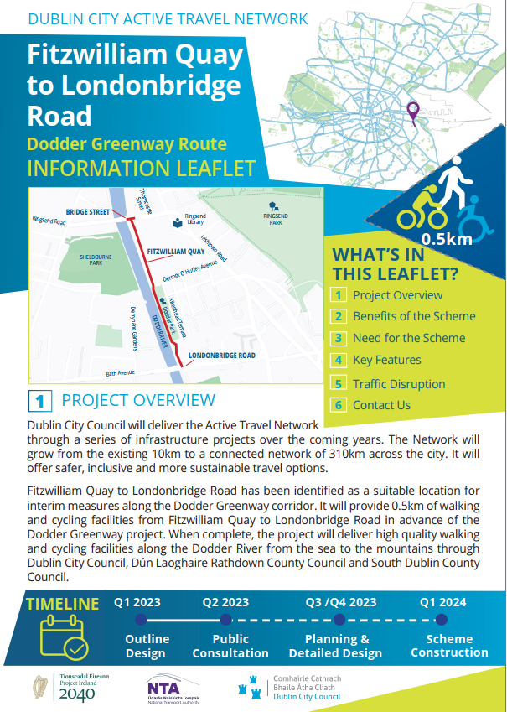

**Figure 2: Extract from the DCC Public Consultation Hub and** **Copy of Information Leaflet for the *Fitzwilliam Quay to Londonbridge Road Scheme***

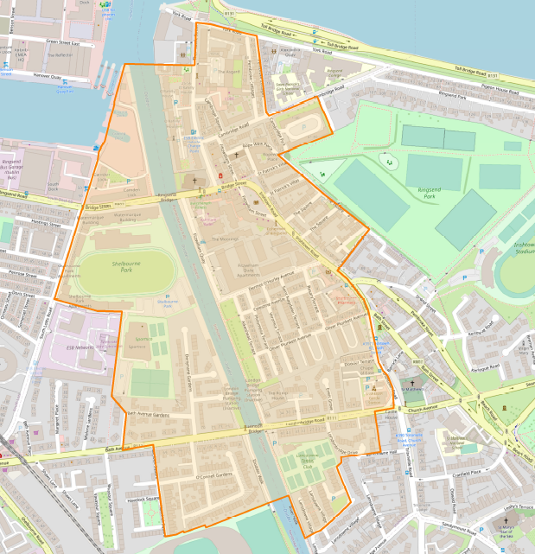

**Figure 3: Extent of Leaflet Distribution**

# CONSULTATION RESULTS

In total, there were 79 responses to the public consultation made through the online questionnaire and email submissions. Those responding to the online questionnaire were asked a series of questions on whether they walk, wheel or cycle, what they use Fitzwilliam Quay to Londonbridge route for, and their perception of potential benefits and impacts of the scheme.

A detailed review of all submissions was carried out, and an analysis of submission sentiments reveals that the majority are in favour of the scheme, which is evident from the results below.

**Table 1: Submission Sentiment**

|  |  |  |
| --- | --- | --- |
| Opinion Categories: | Number of submissions | % of submissions |
| Fully supports the scheme | 26 | 32.9% |
| Supports the scheme with alterations | 24 | 30.4% |
| Does not support the scheme | 18 | 22.8% |
| Neutral | 11 | 13.9% |
| Total | 79 | 100% |

Figure 4: Submission Sentiment Analysis

The results indicate that 63% of the respondents support the scheme, of which 30% suggest some alterations to the proposals to make it more acceptable.

Most importantly many respondents submitted a number of different suggestions and concerns. The main suggestions/concerns can largely be grouped into 13 distinct themes. Some of the respondents dealt with multiple themes in one response. The 13 themes are outlined in Table 2 below.

A number of the comments could not be categorised specifically as they represented the respondents overall opinion of the scheme, rather than a specific issue. Therefore, all general comments like ‘I support the scheme’ or ‘I do not support the scheme’ have been labelled as “General Comments”. Finally, a number of respondents did not leave a comment or have any particular suggestion and therefore were counted as “No Comment”.

**Table 2: Public Consultation Response Themes**

|  |  |  |
| --- | --- | --- |
| Themes: | Occurrence | Occurrence % |
| Pedestrian safety | 13 | 15.9% |
| Removal of on-street parking | 5 | 6.1% |
| Shared space | 2 | 2.4% |
| Access/Egress Concerns at Pumphouse Apartments | 2 | 2.4% |
| Green space | 4 | 3.7% |
| Connectivity | 7 | 8.5% |
| Method of segregation | 6 | 7.3% |
| Drainage | 4 | 4.9% |
| Heritage | 1 | 1.2% |
| Junction Design | 1 | 1.2% |
| Trees | 1 | 1.2% |
| General comments | 34 | 41.5% |
| No Comments | 3 | 3.7% |

**Note:** some of the themes outlined above were also expressed verbally on June 15th at the Information day-in particular the theme of Access/Egress to Pumphouse Apartments and pedestrian safety outside Dodder Park.

# SUBMISSION THEMES AND RESPONSES

The review of the submission showed that there are a number of key recurring themes which generally address most of the issues raised. Therefore, various themes identified and DCC’s responses to these are as summarised below.

# Theme 1: Pedestrian Safety

Submissions have highlighted concerns about the safety of pedestrians at the top of the steps from Dodder Park, where it meets the proposed segregated cycle track. Many respondents feel that the proposal would be hazardous to vulnerable pedestrians like children and older people coming out of the park, as they will be required to cross the cycle track to get to the footpath on the riverside.

Some suggestions by respondents include switching the cycle track to the riverside to minimise pedestrian-cyclist conflict or maintaining the existing shared facility as is, which was felt to be safer by respondents.

**DCC Response:**

*As part of the detailed design, it is now proposed to increase the green space between the cycle track and the existing wall, this will create further separation between pedestrians at the steps and cyclists on the cycle track. The width of the cycle track on approach to the steps will also be narrowed to encourage cyclists to reduce their speed on approach. The cyclist will also be required to navigate a ramp on the approach to the crossing area, providing another speed control measure.*

# Theme 2: Removal Of On Street Parking

Submissions raised concerns about the removal of car parking along Fitzwilliam Quay to facilitate the proposed two-way cycle track. Respondents stated that it will affect residents with more than one car as they currently have one parking space per apartment. Respondents also highlighted that the removal of parking spaces would add additional pressure on already saturated parking spaces in the vicinity. Some submissions questioned the rationale for removing so many of the parking spaces to facilitate a short 0.5km of cycling facility.

***DCC Response:***

*The 0.5km cycle route forms part of the overall Dodder Greenway route which will be implemented in stages over the coming years. While it is acknowledged that reconfiguration of the existing carriageway to provide cycle facilities will impact motorists who use the existing road space for parking, it is a scheme objective to provide cycle provision along Fitzwilliam Quay. When considering design options, segregation of cyclists from pedestrians is considered the preferable option where possible. Segregation can be achieved by the proposed removal of the free on-street parking without any amendments to the existing kerb line or trees along the west side of Fitzwilliam Quay. Overall 33 free parking spaces on the west side will be removed, while parking on the east side will be retained. Residents of the houses on Fitzwilliam Quay can apply for Permit/Pay & Display parking schemes subject to relevant provisions of the Parking Bye-Laws.*

*It is also worth highlighting that elimination of free on-street parking is in line with the Dublin City Development Plan (2022-2028) objective provided below.*

*Dublin City Development Plan (2022-2028) objective- SMTO23*

*Elimination of ‘Free’ On-Street Parking to progressively eliminate all ‘free’ on-street parking, both within the canals and in adjacent areas where there is evidence of ‘all day’ commuter parking, through the imposition of appropriate parking controls, including resident permit parking, pay and display parking, or by the provision of new cycle parking, public realm or greening.*

# Theme 3: Shared Space

Some respondents are not in favour of shared use facilities for pedestrians and cyclists proposed at various locations along the scheme. It is felt that it is less safe and undesirable for people with disabilities. Respondents also expressed doubts about how priority of pedestrians will be ensured at such locations. Some suggestions included provision of a parallel cyclist and pedestrian crossing instead of a toucan crossing at Bridge Street.

However, some respondents suggested retaining the existing shared use facility along Dodder Park instead of the proposed segregated two-way cycle facility.

***DCC Response:***

*The use of shared areas has been avoided where possible to reduce the potential for conflict between cyclists and pedestrians. On review, the proposed layout at Bridge Street has been amended to remove the shared areas at this point. However, the shared area at the Pumphouse is retained due to constrained geometry on the east and west sides.*

*It should be noted that Greenways have a range of functions and attract different users, including pedestrians with different needs, including joggers, people with mobility aids, and dog walkers, among others. Due consideration is given to the needs of all users when designing the schemes, mindful of localised constraints, such as limited available space for full separation paths for cyclists and pedestrians.*

# Theme 4: Access/Egress Concerns at Pumphouse Apartments

Submissions expressed concerns regarding the impacts of the proposals on the current access/egress arrangements at the Pumphouse apartment complex. Concerns are mainly about the potential conflict between cyclists and residents exiting/ entering the complex, especially the disabled and more vulnerable residents.

Disabled vehicles from the complex currently reverse out onto the road, which will become more dangerous because cyclists will now be directed onto the road. Currently, the cyclists take the path on the opposite side of the road along the Dodder wall.

It is suggested to employ some traffic calming measures to reduce the speed of cyclists or any other interventions that would minimise this conflict.

***DCC Response:***

*The Active Travel Team have engaged with the DCC Housing Department on the operation of the entrance to the Pumphouse Apartments. Additional traffic calming interventions to minimise impacts of potential conflict between residents and cyclists have been provided with build-outs and road markings proposed to position cyclists away from the existing entrance.*

*However, it is worth highlighting that the current legislation on reversing under Road Traffic (Traffic and Parking) Regulations, 1997, states that ‘A driver shall not reverse from a place adjacent to a public road onto a public road save where it is clear to the driver that to so reverse would not endanger other traffic or pedestrians’.*

# Theme 5: Green Space

Respondents have highlighted issues regarding the green space along Dodder Park and requested to retain it in its current condition. Some respondents feel that the removal of green space and the introduction of hard surfaces will have potential impacts on rain water drainage in this area. Also, it is highlighted that the green space currently serves as a safety buffer between cyclists and pedestrians coming out of Dodder Park.

***DCC Response:***

*The design team propose to increase the green space from the 0.5 metres currently proposed to 1metre along the wall. Furthermore, the use of permeable materials* *has been specified for the cycle track to enhance drainage along Dodder Park.*

# Theme 6: Connectivity

A number of submissions emphasised that the scheme needs to be extended on both ends to achieve better connectivity. Requests were made to consider the existing section from Londonbridge Road/Bath Avenue to Lansdowne Road/Herbert Road, as currently the facilities on both sides of the river are narrow and not sufficient for all active travel users. It is also requested to consider interventions between the east side of Ringsend Bridge and Thorncastle Street to ensure connectivity to the River Liffey cycling link.

***DCC Response:***

*The 0.5km cycle route forms part of the overall Dodder Greenway which will be implemented in stages over the coming years. This scheme is one of a number of rapid deployment schemes proposed along the Dodder River corridor. When complete, the overall project will deliver walking and cycling facilities along the Dodder River from the sea to the mountains through DCC, Dún Laoghaire Rathdown County Council and South Dublin County Council. Implementation of these initial schemes will support delivery of adjoining schemes in the future.*

# Theme 7: Method of Segregation

Many submissions welcome the kerb-separated cycle facility and questioned why it is not extended throughout the length of the scheme. Some respondents feel that bollards or other methods of segregation should be looked at, as drivers may still mount the kerb and park along Fitzwilliam Quay. However, some respondents are against the use of bollards for segregation.

***DCC Response:***

*A segregated kerb is proposed along Fitzwilliam Quay to protect cyclists from general traffic. Gaps will be provided along the length of the segregated kerb for drainage purposes and to allow permeability of cyclists. These gaps will be supplemented with a bollard.*

*A concrete kerb is proposed along Dodder Park, between the proposed cycle track and pedestrian footpath, with a level difference between cyclists and pedestrians. The existing kerbs are retained along Londonbridge Road.*

# Theme 8: Drainage

A number of submissions suggest that a complete review of drainage is conducted with respect to any works proposed for this route. Respondents specifically indicated that green space along Dodder Park retains significant water during rains and its removal may have potential impacts on drainage in the area.

***DCC Response:***

*As part of detailed design it is proposed to increase the green space by an additional 0.5 metres to a total 1m space. Furthermore, we have also specified the use of permeable materials for the cycle track to enhance drainage along Dodder Park.*

# Theme 9: Heritage

A question was raised about the impact of the proposal on the vent marked 1911, located outside Dodder Park.

***DCC Response:***

*The current design intention is that this vent will remain undisturbed. A buffer of circa 1 metre will remain between the vent and the new cycle track.*

*A Conversation and Heritage Impact Assessment has been undertaken to identify any appropriate mitigation measures needed in the vicinity of this vent and to identify any other heritage items.*

# Theme 10: Junction Design

It is suggested that the junctions are not up to the highest safety standards, as these are often the most dangerous parts for cycling and walking. Few respondents questioned how the new toucan crossings at Bridge Street will work in conjunction with the existing pedestrian cross at the Oarsman Pub considering their proximity. Some requests were made to improve safety at junctions including the provision of raised table crossings across Fitzwilliam Quay and across the junction at Londonbridge Road.

***DCC Response:***

*The scheme has undergone Stage 1 & 2 Road Safety Audits with all observations being addressed in the design.*

*The design of the Bridge Street junction has been reviewed and amended to provide segregation of cyclists and pedestrians. A wrap around layout for pedestrians is proposed improving the existing situation. DCC’s Active Travel Team have engaged with DCC Traffic to discuss the best operation of the existing pedestrian crossing at the Oarsman pub.*

# Theme 11: Trees

It is requested that there are no negative impacts on the health of the trees along the scheme and any opportunity to further improve greening should be considered.

***DCC Response:***

*A tree survey has been undertaken along the extent of the scheme with the knowledge that the low-lying branches will need to be cut back and maintained to ensure cyclists can pass beneath. The tree survey did not raise any issues with this approach, and it should be noted that the scheme does not propose to remove any of the existing trees.*

# CONCLUSION AND NEXT STEPS

A non-statutory public consultation was carried out for the Fitzwilliam to Londonbridge scheme which presented the proposed designs to obtain feedback from the public. The non-statutory public consultation commenced on 29th May 2023 and ran until 30th June 2023 and included an online questionnaire and comment form, media advertisements, leaflet drops and an information event. Seventy nine submissions were made through the online questionnaire and email.

All submissions received have been reviewed by the design team, the themes above illustrate the frequency of different items raised. Each individual submission is not responded to directly in this report, responses in this report relate the themes as described above. Additional items outside the above themes have also been reviewed by the design team and have been considered in the detailed design process for the scheme.

The feedback from the non-statutory public consultation indicates that there is a high level of support for the scheme with a number of concerns raised as summarised in the themes set out previously.

The issues raised have been thoroughly reviewed and were considered in the detailed design, which is now complete. The following significant changes were made to the design based on the public consultation feedback:

1. The proposed layout at the Bridge Street-Fitzwilliam Quay junction has been amended to remove the shared area.
2. Outside Dodder Park, the width of the green space has been increased to 1.0 metre. The width of the cycle track on the approach to steps from the park has been reduced, and ramps have been introduced for cyclists at crossing areas as speed control measures.
3. Outside the Pumphouse apartments, traffic calming interventions have been introduced to minimise the impacts of potential conflict between residents and cyclists.

A Tender pack for construction works has been prepared, and procurement will commence when funding is confirmed by the NTA.

# Planning Determination

The Active Travel Programme Office (AcTPrO) has received a determination from the Planning Department confirming that the recommendations from the Environmental Impact Assessment (EIA) Screening and the Appropriate Assessment (AA) Screening. The reports recommend that neither an EIA Report nor an AA Natura Impact Statement is required.

In addition, and in accordance with the provisions of Section 4(1) (e) and Section 179(6) (bb) of the Planning and Development Act 2000, as amended, the proposed project is exempt from the statutory planning processes as set out under Part 8 of the Planning and Development Regulations 2001, and Part 10 of the Planning and Development Regulations 2001 (submission to An Bord Pleanála).

Therefore, the proposal scheme will now proceed to implementation under the provisions of Section 95 of the Road Traffic Act, 1961 as amended by Section 37 of the Road Traffic Act 1994, and under Section 38 of the Road Traffic Act 1994 as required.

The detailed design drawings may be viewed on the [Dublin City Council Active Travel website.](https://www.dublincity.ie/residential/transportation/active-travel/projects/dodder-greenway-project/dodder-greenway-fitzwilliam-quay-londonbridge-road-scheme/dodder-greenway-0)

# 

# Appendix A: Promotion of Public Consultation and Public Information Session

**DCC Online publications**

**Newspaper notice**

**Public Consultation Event**

