# **Dublin City Active Travel Network.**

**Fitzwilliam Quay to Londonbridge Road Walking And Cycling Scheme, part of Dodder Greenway Route.**

**Plain English Project Summary.**

Date of Issue: 21 March 2025

This communication is in plain English, intended for members of the public of all abilities. Its wording, structure, and design are intended to be clear and straightforward so that readers can easily find what they need, understand what they find, and use that information.

## **Overview.**

The Fitzwilliam Quay to Londonbridge Road Walking and Cycling Scheme will provide 0.5 kilometres of walking and cycling facilities from Fitzwilliam Quay to Londonbridge Road.

This scheme is part of the Dodder Greenway project. When complete, this project will deliver high-quality walking and cycling facilities along the Dodder River from the sea to the mountains through Dublin City Council (DCC), Dún Laoghaire Rathdown County Council and South Dublin County Council.

A non-statutory public consultation took place in May and June 2023. “Non-statutory” consultation means that it isn’t required by law. The results of the consultation can be found in the [Public Consultation Report](https://www.dublincity.ie/residential/transportation/active-travel/projects/dodder-greenway-project/dodder-greenway-fitzwilliam-quay-londonbridge-road-scheme/dodder-greenway-0)

The design team reviewed the feedback from the public and made some changes to the designs. These changes will be explained briefly later in this document.

## **Location.**

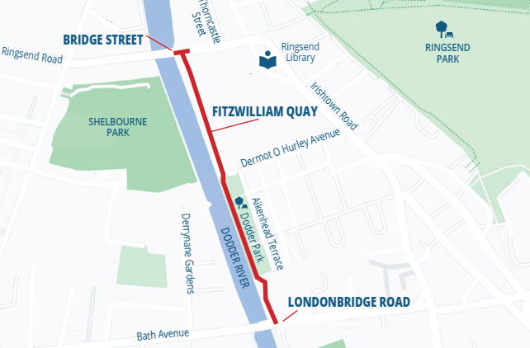

Fig 1 - The image above is a map illustrating the route as explained in this document.

The scheme is 0.5 kilometres in length. It runs from the junction of Bridge Street and Fitzwilliam Quay in Ringsend to the junction of Londonbridge Road at the entrance to Lansdowne Tennis Club.

## **Why are we building this scheme?**

We aim to make walking and cycling safer and more pleasant for people. We hope this will encourage more people to walk and cycle rather than use the car if possible. This will reduce traffic and make the area feel nicer for everyone.

## **Key Features of the Scheme.**

**Fitzwilliam Quay.**

A signalised junction is proposed at the Bridge Street / Fitzwilliam Quay junction with new pedestrian crossings across Bridge Street and Fitzwilliam Quay. A 3 metre wide, two-way cycle lane will be provided on the western side of Fitzwilliam Quay, separating cyclists from traffic by way of segregation kerbs. The existing footpath and trees remain unaffected. Road space will be reallocated for cycling facilities by removing the existing free parking on the riverside and relocating the existing taxi rank to the eastern side of Fitzwilliam Quay.

**Dodder Park.**

A 3 metre wide, two-way cycle track will be provided along the existing green space outside the western wall of Dodder Park. The existing footpath along the Dodder is unaffected. Shared pedestrian and cyclist space will be provided at locations of restricted width at the pump house and at the entrances to Dodder Park.

**Pumphouse to Londonbridge Road.**

A quiet street, where there is a mix of cyclists and vehicles, will be provided along the existing road section which links the Pumphouse Apartments to Londonbridge Road by way of road markings. Cyclists will share the existing carriageway with traffic along this low traffic volume street. Existing footpaths and parking will be unaffected along this section of road way.

## **Key Changes to the Design.**

In summary the main changes from the initial designs that were included in the public consultation in 2023 are as follows:

**Change 1.** The proposed layout at the Bridge Street-Fitzwilliam Quay junction has been changed to remove the shared area.

**Change 2.** Outside Dodder Park, the width of the green space has been increased to one metre. The width of the cycle track on the approach to the shared space at the entrance/exit to the park has been reduced, and ramps have been introduced for cyclists as speed control measures.

**Change 3.** Outside the Pumphouse apartments, traffic calming measures in the form of road markings have been introduced to minimise the impacts of potential interactions between vehicles and cyclists.

The [public consultation report](https://www.dublincity.ie/residential/transportation/active-travel/projects/dodder-greenway-project/dodder-greenway-fitzwilliam-quay-londonbridge-road-scheme/dodder-greenway-0) is available on the DCC website.